Project Report — AWS Static Website Hosting (Project #1)
Engineer: Afrooz Habib
Role: DevOps Engineer (Fresher)
Portfolio Tagline: Engineer | DevSecOps | Cloud Automator | Open Source Builder

1. Project Overview
This project demonstrates how to host a static website using Amazon S3 and CloudFront, forming the base of cloud deployment fundamentals in DevOps. The objective is to deploy and deliver a static web application with global reach and HTTPS security — using AWS services instead of traditional web servers.

2. Objective
- Deploy a static website using AWS S3 (Simple Storage Service).
- Distribute content globally using AWS CloudFront (CDN).
- Enable HTTPS access via CloudFront default SSL.
- Document the complete process as a DevOps project.

Architecture Diagram
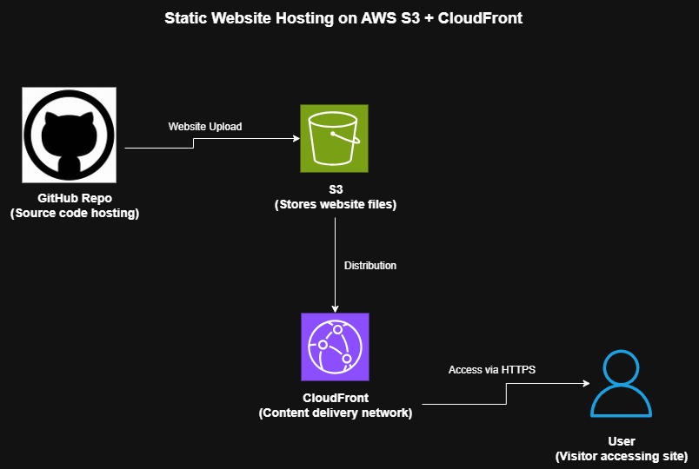
Flow Description:
1. Developer uploads website files to an S3 bucket.
2. The bucket is configured for static website hosting.
3. Bucket Policy allows public read access.
4. CloudFront Distribution uses the S3 website endpoint as its origin.
5. Users access the website through CloudFront URL (HTTPS).

4. Tools and Technologies Used
Tool / Service | Purpose
AWS S3 | Host static website files
AWS CloudFront | Content Delivery Network (CDN) for performance & HTTPS
AWS IAM | Bucket access permissions
Git & GitHub | Version control and portfolio repository
draw.io | Architecture diagram design
HTML, CSS | Website frontend content

5. Implementation Steps
- Step 1: Create S3 Bucket
Name: afrooz-portfolio-site
Region: us-east-1 (or nearest)
Unchecked “Block all public access”
- Step 2: Upload Website Files
index.html, error.html, and assets/ uploaded to the bucket root.
- Step 3: Enable Static Website Hosting
Enabled in bucket Properties
Index: index.html
Error: error.html
- Step 4: Set Bucket Policy (Public Access)
{
"Version": "2012-10-17",
"Statement": [
{
"Sid": "PublicReadForStaticWebsite",
"Effect": "Allow",
"Principal": "*",
"Action": "s3:GetObject",
"Resource": "arn:aws:s3:::YOUR_BUCKET_NAME/*"
}
]
}
- Step 5: Create CloudFront Distribution
Origin Domain: S3 website endpoint
Viewer Protocol Policy: Redirect HTTP → HTTPS
Default cache settings used
- Step 6: Verify and Test
CloudFront URL: https://d3998dtb6pgfad.cloudfront.net/
Verified website loads globally via HTTPS.

6. Screenshots
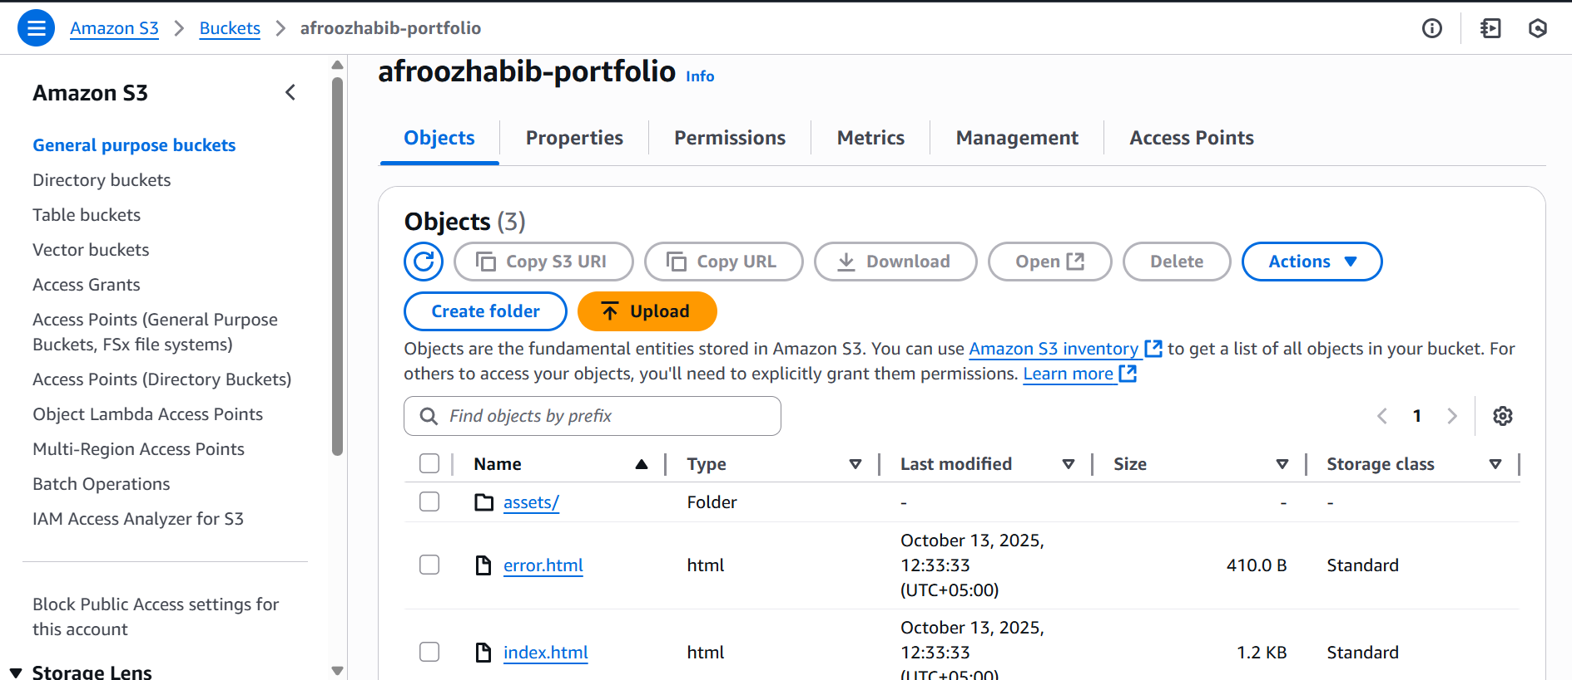
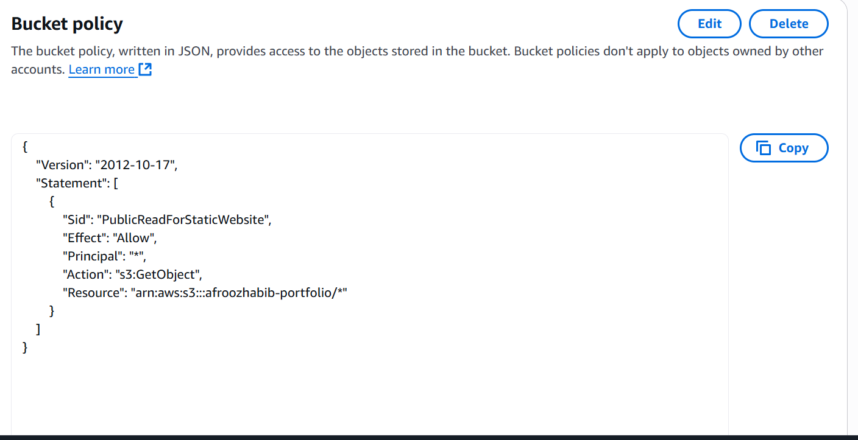

Live Demo

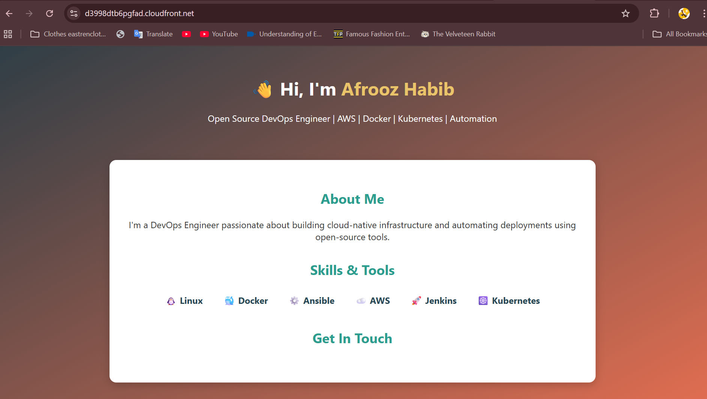

8. Learnings and Outcomes
- Understood how AWS S3 can act as a static web server.
- Learned to use CloudFront for global CDN distribution.
- Configured IAM policies for secure object access.
- Gained hands-on experience integrating AWS services.
- Practiced project documentation and Git-based version control.

9. Key Takeaways
• Cloud + DevOps synergy begins with hands-on AWS basics.
• Static site hosting teaches permissions, routing, and networking.
• Real-world understanding of DevOps using cloud-native services.

