CURRICULUMN VITAE

Md Abdul Mannan Hridoy

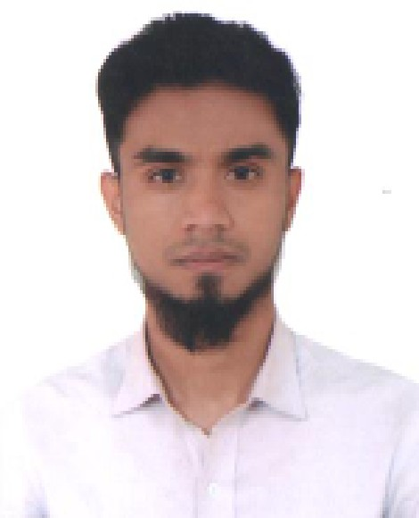

3/1 Puranlane, D-Block, Bondor Bazar, Sylhet-3100 [hridoyking5464@gmail.com](mailto:hridoyking5464@gmail.com)

01772434208

# OBJECTIVE

Seeking position as System or network engineering and support of all IT Needs,position in management. To further my experience and knowledge in the field of IT sector.

# WORK EXPERIENCE

N/A

# EDUCATION

2020 : B.Sc (Engg) In Computer Science and Engineering

*Metropolitan University*

3.09 ( Computer Science and Engineering )

2015 : HSC

*Sylhet Govt College*

3.67 ( Science )

2013 : SSC

*The Aided High School*

4.75 ( Science )

# TRAINING

Conquer Your Career

Android Developer Course

: Topic: Leadership Skills and Microsoft Excel 2016 **Institution** - everjobs.com.bd & GDN SUST ( SUST ) **Duration** - 18 March (Full Day)

: Complete Android Developer Course-Build 5 Apps Project.Certificate Code: 3092688-38487-28010

**Institution** - Eshikhon.Com ( Eshikhon.com(Online) ) **Duration** - 3 months, 1 week

# SKILLS

* C
* Java
* Javascript
* Html5
* CSS3
* Bootstrap 3
* PHP
* Laravel Framework
* MS Office

# PROJECTS

* **Java & MySql**

Restaurant Management System

Student Management System

* **Laravel Framework**

Employee Management System

# ACHIEVMENT

Participated in Programming Contest (Senior) held on 16 November 2017 at Metropolitan University,Organized by the Department of CSE.

Participated in Poster Design Contest held on 16 November 2017 at Metropolitan University,Organized by the Department of CSE.

# PERSONAL

**Fathers Name** : Md Rafiqul Alam

**Mothers Name** : Ummey Kulsum

**Date of Birth** : 1996-12-15

**Gender** : Male

**Marital Status** : Unmarried

**Religion** : Islam

**NID No :** 6452291138

# REFERENCE

**Md. Belayet Hossain** Police Inspector (Unarmed)

Incharge of Haydorgonj Police Fahri, Lokhipur Mobile: +8801711263297

+8801612263297