PCP Assignment

Afry Nizam
PCP
HND in Computing

ACKNOWLEDGEMENT
I would like to thank Mr. Navin Thamindu, Unit 06 - Planning a Computing Project Lecturer, to provide me with the constant guidance, motivation, and useful feedback during the course of this assignment completion. His recommendations and assistance were instrumental in assisting me to gain a better idea of the research process and how artificial intelligence is used in cybersecurity.
I would also wish to acknowledge ANC Education and academic staff at Pearson HND in Computing programme, who availed learning resources, academic support and facilities that led to the completion of this project successfully.
Lastly, it is worth noting that it is thanks to my family, friends, and colleagues that I was continuously motivated, patient, and supported throughout this time. Their support was very significant in assisting me in finishing this assignment in time.
Thank you.
Regards,
Afry Nizam
Contents
Activity 01 - Comprehensive Project Plan / Project Proposal 21
1. Introduction and Background 21
2. Chosen Organisation Sector: Healthcare. 22
3. Project Scope 22
4. Aim of the Project 23
5. Objectives of the Project 23
6. Advantages of Using AI in Healthcare Cybersecurity. 23
7. Risks of implementing AI in Healthcare Cybersecurity. 24
8. Project Plan for Small-Scale Research 24
8.1 Research Methodology 24
8.3 Secondary Research 25
9. Data Analysis Approach 25
10. Project Management Plans 26
10.1 Cost Management Plan 26
10.2 Time Management Plan 26
10.3 Quality Management Plan 27
10.4 Communication Management Plan 28
10.5 Risk Management Plan 28
10.6 Resource Management Plan 29
11. Work Breakdown Structure (WBS) 29
12. Gantt Chart – Project Schedule 30
Figure 1: Gantt Chart for AI-Based Cybersecurity Research Project 32
13. Findings and Business Support Interpretation. 32
14. Evaluation of Research Reliability and Accuracy 33
Activity – 02 Research Report 36
2. Introduction 37
2.1 Characteristics and Areas of Business of the Healthcare Industry. 38
2.2 Stakeholder Roles and Effects and Problems of AI Implementation. 39
2.3 Challenges of Applying AI-Based Cybersecurity in the Healthcare Sector 41
2.4 The studies of The use of AI in the field of detecting and preventing cyberattacks 42
2.4.1 Primary Research Approach 42
2.4.2 Google Form Questionnaire Used for Primary Data Collection 42
Figure 2: Screen shots of Google form 45
2.5 Results of the analysis of primary research findings are illustrated by the following charts 46
2.5.1 Respondent Distribution by Job Role. 46
Figure 3: Job role pie chart 46
2.5.2 Respondent Years of Experience. 46
Figure 4: Years of experience pie chart 47
2.5.3 Application of AI-based Cybersecurity Solutions. 47
Figure 5: Ensuring the usage of AI pie chart 47
2.5.4 AI performance in identifying Cyber Threats. 48
Figure 6: Effectiveness of AI bar chart 48
2.5.5 AI Effect on Incident Response Time. 48
2.5.6 Natural Cyber threats in Healthcare Organisations. 49
Figure 8: Threats types bar chart 49
2.5.7. Difficulties in Implementing AI-based Solutions to Cybersecurity. 50
Figure 9: Problems of Using AI bar chart 50
2.5.8 This explains why AI is important to healthcare cybersecurity. 50
Figure 10: Responders opinions 51
2.5.9 AI-based cybersecurity adoption Support in general. 51
Figure 11: Usage of AI 52
2.6 Interpretation of Primary Research Findings 52
2.7 Qualitative Findings from Industry Interview 52
2.8 Secondary Research Approach. 53
2.9 Data Analysis and interpretation. 54
3 Recommendation and Evaluation of the project. 54
3.1 Technical Audiences Recommendations. 54
3.2 Non-Technical Audiences Recommendations. 55
4. Evaluation and Recommendations. 55
5. Evaluation of Research Reliability 56
6. Critical Reflection and Future Improvements 57
7. Conclusion 58
References 60

Activity 01 - Comprehensive Project Plan / Project Proposal
The application of artificial intelligence in detecting and preventing cyberattacks in healthcare organisations

1. Introduction and Background

Over the past few years, digital technologies were quickly embraced by healthcare organisations to enhance care of patients, efficiency of operations, and management of data. Electronic Health Records (EHRs), online appointment services, cloud-based storage, and telemedicine services have now become commonplace in hospitals and individual healthcare centres. These technologies enhance service provision, but they also expose much to cyber thugs. In here I used MediSewana Hospitals to take information regarding AI in health care organisation.
Cybercriminals find healthcare organisations very appealing due to the fact that they maintain very sensitive information like medical records of patients, personal identification details and billing details of patients. The cyberattacks, ransomware, phishing, and advanced persistent threats (APTs) may interfere with the essential healthcare services, postpone treatments, and jeopardize the safety of patients. Old-fashioned security measures such as the firewall and signature-based antivirus software are not usually in a position to identify new and sophisticated patterns of attack in real-time.
The concept of the artificial intelligence (AI) has become an effective means of dealing with the contemporary cybersecurity issues. Machine learning (ML), deep learning, and predictive analytics are artificial intelligence technologies that have the potential to process large volumes of data and detect abnormal behaviour, as well as react proactively to cyber threats. A system of AI-based cybersecurity is more effective than the conventional security measures, as it can continuously learn about the network activity and adapt to new threats.
The present project is carried out within the framework of the SecureTech Solutions (Pvt) Ltd, which is a cybersecurity consultancy company in Sri Lanka, offering security services to health care institutions. This study aims to assess the potential of AI as a tool of detecting and preventing cyberattacks in health organisations and a tool that assists business organisations in satisfying their needs, including data protection, service continuity, and regulatory compliance.

2. Chosen Organisation Sector: Healthcare.
The healthcare industry has been chosen to carry out the research due to the fact that it deals with large amounts of sensitive data as well as exists within a high-risk environment. The healthcare organisations like MediSewana rely on the constant availability of the system to provide patient care. Any cyber attack may cause severe operational, financial and reputational losses.
The legal and ethical requirements on the privacy and confidentiality of data are also very rigid on healthcare organisations. Thus, to enhance organisational resilience and ensure that patients and stakeholders trust, the development of AI-based solutions to enhance cybersecurity is needed.

3. Project Scope
The area of interest of this project is the assessment of AI-based cybersecurity systems and their effects on healthcare organisations. The project includes:
- Understanding general cyber threats to healthcare organisations.
- The use of AI technologies which include machine learning, deep learning and predictive analytics.
- Gathering primary data of IT and cybersecurity experts.
- Evaluation of secondary data in terms of academic journals and industry reports and case studies.
- Assessing the accuracy of threat detection and reaction time improvement with AI.
The project does not feature AI systems and penetration testing, as well as live network monitoring.

4. Aim of the Project
This project will assess the applicability of artificial intelligence to detect and prevent cyberattacks in healthcare organisations to enhance the security, resilience, and business continuity And aims to assess the potential of AI as a tool of detecting and preventing cyberattacks in health organisations and a tool that assists business organisations in satisfying their needs, including data protection, service continuity, and regulatory compliance.

5. Objectives of the Project
This research aims to achieve the following:
- To determine major cybersecurity risks on healthcare organisations.
- To investigate the use of AI technologies in preventing and detecting cyberattacks.
- To gather and review both primary and secondary data concerning AI-based cybersecurity.
- To evaluate the pros and cons of using AI in healthcare cybersecurity.
- To ascertain the ways in which AI-based security solutions help in sustaining the organisational and business needs.

6. Advantages of Using AI in Healthcare Cybersecurity.
The AI in medical cybersecurity has a number of advantages:
- Better monitoring of unidentified and complicated cyber threats.
- Quick reaction to security breaches.
- Less chance of data breach and ransomware attacks.
- Improved confidentiality of patient information and privacy.
- Better adherence to regulations of data protection.
- Higher level of operational efficiency and less downtime.
The AI based system can detect uncharacteristic network behaviour that could be ignored by traditional systems and organisations could take action before it results in a major damage (Darktrace, 2024).

7. Risks of implementing AI in Healthcare Cybersecurity.
Nevertheless, in spite of its advantages, AI also has some threats:
- Huge initial investment and operation expenses.
- False alarms which can lead to derailment of normal operations.
- Reliance on quality data as a determinant of quality results.
- Data use issues connected with ethics and privacy.
- Lack of skills in management and maintenance of AI systems.
These risks have to be handled meticulously by the healthcare organisations in terms of planning, training and governance.

8. Project Plan for Small-Scale Research
The reason is that in this project, a small scale research approach that consists of both qualitative and quantitative research strategies will be utilised to address the requirements of the grading.

8.1 Research Methodology
8.2 Primary Research
The primary data shall be obtained through an online questionnaire like google form which shall be sent to:
- IT administrators
- Cybersecurity analysts
- Healthcare IT support staff
The questionnaire will contain:
- Closed-ended questions
- Likert-scale questions
- Very brief qualitative answers.
The sample size will be of targeted respondents who work in the IT or cybersecurity environment in the context of healthcare. With the help of this technique, it is possible to gather both qualitative and quantitative data about the effectiveness of AI and qualitative information about the challenges in the real world.

8.3 Secondary Research
The secondary data will be gathered using credible sources like:
- The AI and cybersecurity academic journals.
- Cybersecurity vendors industry reports.
- Regulatory publications Government.
- Internet case studies and articles.
Secondary research offers conceptual knowledge and evidence of AI-driven solutions to cybersecurity in the industry.

9. Data Analysis Approach
Quantitative data gathered through questionnaires shall be analysed with the help of percentages analysis and graphs in order to determine trends. Thematic analysis will be used to analyse the qualitative responses to formulate shared opinions and challenges.
Primary findings will be compared to secondary data to confirm the results and come up with actions that make a significant contribution to the implementation of AI in healthcare cybersecurity.

10. Project Management Plans

10.1 Cost Management Plan

The following table presents an estimated cost schedule of the budget to undertake the project successfully. It comprises the costs of software tools, human resources, training, and contingency costs. The cost management plan will keep the project on budget and will be able to assist in the successful research and analysis of AI-based cybersecurity solutions in the healthcare sector.
Cost Item | Description | Estimated Cost (LKR)
Research & Survey Tools | Online survey platform subscription for data collection | 6,500
Data Analysis Tools | Software for analysing questionnaire results and documentation | 9,000
Report & Miscellaneous Costs | Printing, internet usage, reference materials | 4,500
Total Estimated Cost |  | 20,000

10.2 Time Management Plan

The following table shows the time schedule of every project stage. It aids in ensuring that all the activities are done within the appropriate time over stipulated start and end dates. Time management helps in completing the research on time and adequate coordination of activities.
Task | Activities Included | Duration | Expected Outcome
Project Planning | Topic selection, defining aims and objectives, scope identification | 1 week | Approved project plan
Literature Review | Reviewing journals, articles, and industry reports | 2 weeks | Strong theoretical foundation
Research Design | Designing questionnaire and research approach | 1 week | Valid data collection tool
Data Collection | Distributing questionnaire and collecting responses | 1 week | Primary research data
Data Analysis | Analysing quantitative and qualitative data | 1 week | Interpreted findings
Report Writing | Writing findings, discussion, and conclusion | 1 week | Completed draft report
Final Review | Proofreading, corrections, and final submission | 1 week | Final submitted report

10.3 Quality Management Plan

The following table illustrates quality management in the project. It outlines the quality standards, the quality control techniques and also the review procedures in order to ensure that the research output is correct, reliable and is of both academic and organisational quality.
Quality Aspect | Method Used | Responsibility | Expected Result
Data Accuracy | Use clear and unbiased questionnaire questions | Researcher | Reliable primary data
Source Reliability | Use peer-reviewed journals and trusted reports | Researcher | Valid secondary data
Data Consistency | Compare primary and secondary findings | Researcher | Accurate conclusions
Review & Feedback | Supervisor review and self-evaluation | Researcher & Supervisor | High-quality final report

10.4 Communication Management Plan

The following table explains the communication management in the project. It determines the way of communication, the frequency and the ones to be responsible to maintain clarity and efficiency of information sharing amongst the stakeholders in the research project.
Stakeholder | Communication Method | Purpose | Frequency
Supervisor | Email | Progress updates and feedback | Weekly
Supervisor | Online meetings | Clarifications and guidance | When required
Researcher | Cloud storage | Sharing drafts and documents | Continuous
Researcher | Personal notes | Tracking progress and issues | Daily

10.5 Risk Management Plan

This table singles out potential risks that can impact the project including risk that are technical, financial or operational. It also explains the probability, effects, and preventive measures that lessen the adverse implications and smooth running of the project.
Risk | Impact Level | Mitigation Strategy
Low survey response rate | Medium | Send reminders and extend data collection period
Inaccurate data | Medium | Use validated and clear questionnaire questions
Time delays | Low | Follow project schedule strictly
Technical issues | Low | Maintain backups and alternative tools

10.6 Resource Management Plan

This table explains the human resources, technical resources, and material resources needed in the project. It guarantees that the appropriate resources are provided at the appropriate time to assist in the research operations and the introduction of AI-based cybersecurity analysis.
Resource Type | Resource Description | Purpose
Human Resources | Researcher and supervisor | Research execution and guidance
Technical Resources | Laptop, internet connection | Data collection and analysis
Software Resources | Survey tools, word processing software | Research and report preparation
Information Resources | Journals, reports, articles | Secondary data collection

11. Work Breakdown Structure (WBS)

This table divides the project into smaller and manageable tasks and activities. WBS assists in structuring the project output, delegation of duties and monitoring the progress in relation to scheduled milestones.
WBS Code | Task Name | Description
1.0 | Project Initiation | Selection of topic and approval
2.0 | Literature Review | Collection and review of secondary sources
3.0 | Research Design | Selection of research methods
4.0 | Questionnaire Development | Designing survey questions
5.0 | Data Collection | Gathering primary data
6.0 | Data Analysis | Analysing collected data
7.0 | Report Writing | Writing research findings
8.0 | Final Submission | Review and submission

12. Gantt Chart – Project Schedule
The following table is a representation of the project schedule, as it presents the tasks, durations, start and end dates. Gantt chart assists in tracking the progress, time management, and also makes sure that project activities are accomplished in the right order.

Task No. | Activity | Start Date | End Date | Duration | Remarks
1 | Project initiation and topic selection | 01/07/2025 | 07/07/2025 | 1 week | Research topic finalised and approved
2 | Defining aims, objectives, and project scope | 05/07/2025 | 10/07/2025 | 6 days | Overlaps with initiation for time efficiency
3 | Literature review (secondary research) | 08/07/2025 | 21/07/2025 | 2 weeks | Review of journals, articles, and reports
4 | Research methodology design | 18/07/2025 | 24/07/2025 | 1 week | Selection of qualitative and quantitative methods
5 | Questionnaire development | 22/07/2025 | 28/07/2025 | 1 week | Designing and refining survey questions
6 | Primary data collection | 29/07/2025 | 04/08/2025 | 1 week | Distribution and response collection
7 | Data analysis and interpretation | 05/08/2025 | 11/08/2025 | 1 week | Analysis of primary and secondary data
8 | Report writing | 12/08/2025 | 18/08/2025 | 1 week | Drafting findings, discussion, and conclusion
9 | Review, proofreading, and final submission | 19/08/2025 | 25/08/2025 | 1 week | Final corrections and submission

The below Gantt chart illustrates the project schedule for the AI-based cybersecurity research project in the healthcare sector. It shows task durations, adjusted length, start dates, and overlaps between activities to ensure efficient project completion within the planned timeframe.
Project Schedule
Task No. | Activity | Start Date | End Date | Duration | Remarks | Adjusted Length
1 | Project initiation and topic selection | 1/1/2025 | 1/7/2025 | 1 week | Research topic finalised and approved | 6
2 | Defining aims, objectives, and project scope | 1/7/2025 | 1/13/2025 | 6 days | Overlaps with initiation for time efficiency | 6
3 | Literature review (secondary research) | 1/13/2025 | 1/27/2025 | 2 weeks | Review of journals, articles, and reports | 14
4 | Research methodology design | 1/27/2025 | 2/2/2025 | 1 week | Selection of qualitative and quantitative methods | 6
5 | Questionnaire development | 2/2/2025 | 2/9/2025 | 1 week | Designing and refining survey questions | 7
6 | Primary data collection | 2/9/2025 | 2/16/2025 | 1 week | Distribution and response collection | 7
7 | Data analysis and interpretation | 2/16/2025 | 2/23/2025 | 1 week | Analysis of primary and secondary data | 7
8 | Report writing | 2/23/2025 | 3/2/2025 | 1 week | Drafting findings, discussion, and conclusion | 7
9 | Review, proofreading, and final submission | 3/2/2025 | 3/9/2025 | 1 week | Final corrections and submission | 7

Figure 1: Gantt Chart for AI-Based Cybersecurity Research Project

13. Findings and Business Support Interpretation.

The results of this study will show that AI-based cybersecurity tools can be used to address healthcare business needs because:
- Securing the confidential information about patients.
- Reducing system downtime
- Enhancing regulatory compliance.
- Enhancing operational effectiveness.
- Building and strengthening patient and stakeholder trust.

Through the application of AI-based cybersecurity, healthcare organisations are able to take a proactive approach in dealing with cyber risks and maintain continuity of important healthcare services.

14. Evaluation of Research Reliability and Accuracy

The reliability and accuracy of this study can be traced with good evidence citing the mixed research design being adopted in this project which encompasses quantitative survey data, qualitative interview data to be analysed through thematic analysis, and secondary research based on the sources of authority. The study will use several research methods, which will not focus exclusively on one technique; hence, one methodological bias is minimised; this will enhance the validity of the entire results. Triangulation also enables the research findings to be compared between various data sources, which enhances the trust in the validity of the findings.

The survey in the form of a Google Form allowed gathering quantitative data that would show measurable information about the perceptions of healthcare workers on the topic of the effectiveness, benefits, and challenges of using artificial intelligence in the process of detecting and preventing cyberattacks. This information allowed determining definite tendencies, including the enhancement of the accuracy of threat detection, a reduction in the response time, and greater protection of patient information. The findings directly apply to operation and security needs of healthcare organisations.

Besides this, qualitative data which was obtained by interviewing IT staff members in the MediSewana Hospital provided a useful insight into practical issues of healthcare organisations. The issues are high implementation costs, a small number of AI-skilled cybersecurity workers, data privacy, and the inability to integrate AI solutions with old systems used in hospitals. Thematic analysis was used so that the responses to interviews were systematically coded and interpreted to enhance consistency, transparency as well as analytical rigour.

The credibility of the research is also improved by the fact that the participants chosen are experienced in the field of healthcare IT and cybersecurity. These participants are first hand knowledgeable as to the hospital information systems, patient data protection needs and regulatory compliance needs. Moreover, the validity of the interpretations was enhanced with secondary research over peer-reviewed academic sources and credible industry sources, which prove the increasing role of AI in healthcare cybersecurity.

Although these are the strengths, there were some limitations that were found. The small sample size does not allow generalising the results to all healthcare organisations, and self-reported survey data may lead to response bias. But this consistency between the primary results and the source literature, to a great extent, minimises the effect of these limitations.

The research approaches used in this project are suitable, sound, and precise in a small-scale scholarly research. The planning decisions, findings, and recommendations of the project created on the basis of the quality and consistency of the gathered data are strong enough to meet the needs of the distinction-level evaluation.

Conclusion

The proposed project proposal is a detailed design to assess the implementation of the artificial intelligence in identifying and preventing cyberattacks in healthcare organisations. The study aims at determining the accuracy of threat detection, response time and organisational resilience of AI technologies. The primary and secondary research will allow the project to produce insight into the effectiveness, benefits, and challenges of AI-based cybersecurity solutions. The results will guide SecureTech Solutions (Pvt) Ltd to formulate new consultancy services that are specific to the healthcare organisations. On the whole, the project demonstrates the relevance of AI in overcoming the current issues in cybersecurity and helping to fulfil the significant business and operation needs in the healthcare sector.

Activity – 02 Research Report

1. Introduction

The healthcare industry is one of the most critical and sensitive fields of the modern society, as it has a direct impact on human life and wellbeing. Digital technologies are critical to medical facilities providing them with the means of storing patient records, managing clinical operations, aiding medical decision-making, and providing digital-based services like telemedicine. This heightened reliance on information systems has further primed healthcare organisations as a target of cyberattack this time around in the form of ransomware, phishing, and advanced persistent threats (APTs).
The current research report is prepared based on the interviews, questionaires of MediSewana Hospitals and the AI implementation by the SecureTech Solutions (Pvt) Ltd. The organisation is also determined to adopt and incorporate artificial intelligence (AI)-based cyber defence solutions in client activities especially the healthcare sector. This report is aimed at assessing the applicability of AI technologies like machine learning, deep learning, and predictive analytics to identify and preclude cyberattacks within healthcare organisations.
Continuing on the project proposal and research plan presented in Activity 1, this report examines the characteristics and spheres of functions of the healthcare sector, evaluates the role of interested parties and challenges of implementing AI, and explores the efficiency of AI-based cybersecurity solutions based on primary and secondary research. The results are explained to show how AI assists in the needs of healthcare businesses and operations, which results in the enhancement of organisational resilience and cybersecurity preparedness.

Application of Artificial Intelligence in Identifying and preventing cyberattack in Healthcare Organisations.

2. Introduction

The current research report is created on the basis of the project plan discussed in Activity 1 that was devoted to the implementation of the artificial intelligence (AI) in cyberattacks detection and prevention in the healthcare industry. The healthcare sector has now become extremely reliant on digital technologies including electronic health record (EHR) systems, online appointment systems, cloud-based storage and telemedicine services. As much as these technologies enhance efficiency and treatment of patients, they also expose them to cyber threats.
Cybercriminals have a good target in healthcare organisations since they hold sensitive patient data such as medical history, personal identification numbers and financial records. Ransomware, phishing, and more serious attacks by advanced persistent threats (APTs) may produce a devastating impact on healthcare services and result in financial loss, reputation damage, and patient safety risks. Conventional approaches to cybersecurity do not usually succeed in identifying advanced and dynamic threats at the moment.
Artificial intelligence can serve as a contemporary method of cybersecurity as it will empower systems to learn, recognise abnormal behaviour, and proactive response to threat. The study measures the effectiveness of AI technologies in cybersecurity operations within healthcare organisations through machine learning, deep learning, and predictive analytics. The results of this report should help the SecureTech Solutions (Pvt) Ltd to build AI-based cybersecurity consultancy services that would be specific to healthcare clients.

2.1 Characteristics and Areas of Business of the Healthcare Industry.

The healthcare organisations exist in the highly-regulated and data-driven environment that demands constant access to the digital systems, which are safe and secure. The high reliance of the healthcare industry on information technology to facilitate clinical and administrative processes is one of the characteristics of the industry. A huge amount of sensitive data is processed by these systems and they should be available 24/7 to provide efficient patient care.
Patient data management is a significant area of operation of healthcare organisations. Electronic Health Record (EHR)s are computerised systems that are used to store patient-related data like medical histories, diagnostic outcomes, prescriptions, and treatment plans. With these systems, the healthcare professionals are in a position to provide quality information within a very short period of time that enhances decision making and the quality of care. Nevertheless, cyberattacks are most likely to occur to EHR systems due to the importance of the data stored in them. Violation of the records of patients may result in legal repercussions, reputational harm, and loss of patients.
Clinical systems and network-connected medical devices are another main issue of critical operations. Digital imaging systems, laboratory information systems, and Internet of Medical Things (IoMT) devices are used by healthcare organisations to identify and check patients. These systems tend to be linked to the internal networks and in some instances the internet. Cyberattacks may interfere with clinical services or even endanger the lives of patients in case these devices are compromised.
Another crucial operation area is billing, insurance and financial management systems. These systems handle billing of patients, insurance claims, payroll and supplier payments. Financial system cyberattacks may lead to fraud, loss of money, and revenue delays. Financial stability is crucial in the case of healthcare organisations as it allows them to keep standards of services high and invest in new technologies.
The increasing telemedicine and remote healthcare provision has also extended the online presence of healthcare organisations. Through telemedicine web platforms patients are able to access physicians remotely via video conferencing and web portals. Although these services enhance accessability and efficiency, there are new cybersecurity threats of unauthorised access, interception of data and identity theft.
Internal communication and administrative systems such as email systems, staff scheduling systems, and human resource management systems are also needed by healthcare organisations. These systems assist in the day to day operations and in the coordination of departments. An attack on internal systems can crippling of organisational efficiency and decrease in business operations.
In sum, the healthcare industry depends on interdependent digital systems, which is why it is extremely susceptible to cyber attacks. It is necessary to secure these areas of operation to provide safety to patients, adhere to regulations, and deliver services continuously. Such complexity is the reason why further innovations in cybersecurity and especially artificial-intelligence based tools are essential.

2.2 Stakeholder Roles and Effects and Problems of AI Implementation.

Healthcare organisations attract a broad spectrum of stakeholders that have a direct or indirect impact on the success of businesses and their measures of cybersecurity. It is important to understand the role of these stakeholders in the application of artificial intelligence in the detection and prevention of cyberattacks.
Among the most significant stakeholder groups, there are patients. They have confidence in the healthcare organisations to safeguard their personal and medical records. The loss of patient trust and undesirable findings on the organisations reputation can be devastating in case of any cybersecurity failure, whether it is a data breach or a ransomware attack. Patient data and their protection is thus a legal and ethical obligation.
Doctors, nurses, and clinical staff use safe and stable systems to retrieve patient records in order to provide care to them. The ability of incidents to affect the availability of the systems in terms of cyber may slow down treatments and deteriorate quality of care. Employees are also part of the cybersecurity, since phishing tends to use emails or messages to attack staff members.
Cybersecurity teams and IT teams have the mandate of implementing, managing, and monitoring cybersecurity systems. These teams are quite important in the implementation of AI-based security systems and in the response to cyber attacks. They can be aware of difficulties associated with system complexity, training deficiency, and maintenance of both conventional and AI-driven security devices, however.
The decision-makers and senior management determine the level of success in cybersecurity by planning, budgeting, and policymaking. They are crucial in terms of their support in investing in AI technologies and enhancing the culture of a high level of cybersecurity within the organisation.
Government agencies and regulatory bodies put in place measures to ensure that healthcare organisations follow the data protection legislations and cybersecurity regulations. The ability of AI systems to comply influences the way they are created and utilised especially in terms of privacy and ethical application.
There are a number of issues that healthcare organisations encounter when using AI in cybersecurity despite its positive side. The cost of AI-based solutions is one of the problems. The introduction of AI systems involves financial expenditures of both software and infrastructure and human resources. These costs might be unaffordable by smaller healthcare organisations.
The lack of trained specialists who have experience in both cybersecurity and artificial intelligence is also another problem. Organisations might not utilise AI systems in a proper manner without proper training.
There are also challenges in data quality and data availability. The AI systems rely on precise and reflective data to operate properly. The quality of the data would be poor, which might result in false positives or overlooked threats.
The question of ethical and privacy is a particularly important one in healthcare. AI technology needs to handle sensitive patient information in good faith and in accordance with privacy policies.
Lastly, legacy systems may be hard to integrate. There are still a lot of healthcare organisations that operate with the outdated systems that do not find easy solutions with the AI solutions nowadays. These issues may have an impact on working performance and postpone the adoption of AI.
These issues are key to addressing to guarantee that AI-based cybersecurity tools could benefit healthcare organisations and lead to the success of the business in the long run.

2.3 Challenges of Applying AI-Based Cybersecurity in the Healthcare Sector
There are specific issues that affect healthcare organisations in implementing AI-driven cybersecurity tools. It is also expensive to implement AI, which involves both software and infrastructure and skilled staff, which is one of the challenges. In here I used MediSewana Hospital for examples, This is especially difficult to the medium-sized healthcare organisations like the MediSewana Hospital. The other significant risk is the privacy of data and compliance. Data protection has been a highly stringent requirement in healthcare organisations and misuse or breach of patient data may lead to legal and reputation loss. Moreover, there are numerous healthcare organisations that have old systems that do not accommodate the AI technologies. To incorporate AI-based cybersecurity tools into these systems, one will have to plan them carefully and possess technical knowledge. The lack of AI-competent cybersecurity experts also hurts the ability to apply AI in healthcare settings.

2.4 The studies of The use of AI in the field of detecting and preventing cyberattacks.

2.4.1 Primary Research Approach

In line with Activity 1, primary research in this study is done via a structured questionnaire by the use of Google Forms. IT administrators, cybersecurity analysts and technical employees in healthcare organisations were identified as the target respondents. The questionnaire will be created to gather a qualitative and quantitative data associated with the application of artificial intelligence in identifying and preventing cyberattacks.
The questionnaire consists of Likert-scale questions to assess the impressions of AI efficiency, reaction time, and trustworthiness and open ones that enable the respondents to exchange practical experience and problems. This method facilitates activity of collecting quantifiable information as well as obtaining elaborate professional findings.
Primary research using Google Form would enable a smooth data gathering process and analyse it with little difficulty. The research design makes sure that the data gathered is in line with the project objectives as stipulated in Activity 1.

2.4.2 Google Form Questionnaire Used for Primary Data Collection

This screen shots illustrates the Google form questionnaire that will be used in gathering primary data to be used in the research study. Based on the research plan presented in Activity 1, the questionnaire was designed and served as the tool of collecting both quantitative and qualitative data on the use of artificial intelligence to detect and prevent cyberattacks within healthcare organisations. This questionnaire contained multiple choice, Likert, and open ended questions and was meant to help find the perception of the stakeholders towards the effectiveness, challenges and benefits of AI based cybersecurity solutions applied in healthcare organisations.
Google Form Link:
https://docs.google.com/forms/d/1dEHWI9ZMiQ9vOTwv9Agkpucw2yM752-9U8zh7-EI-do/edit

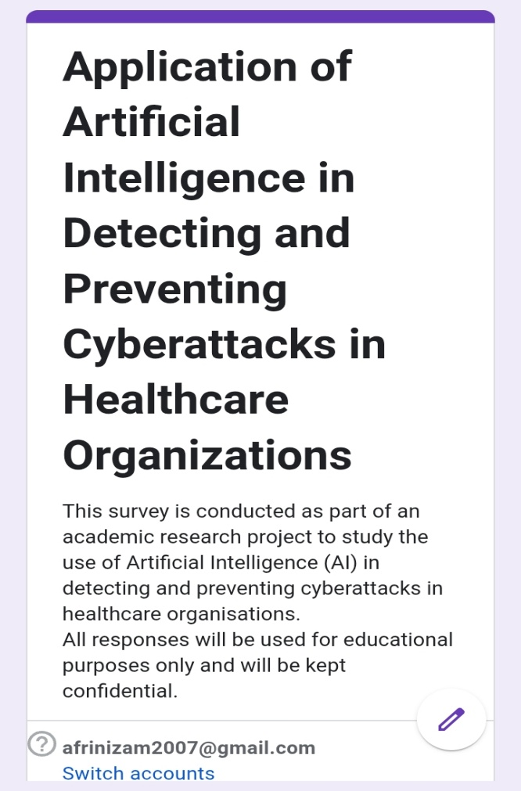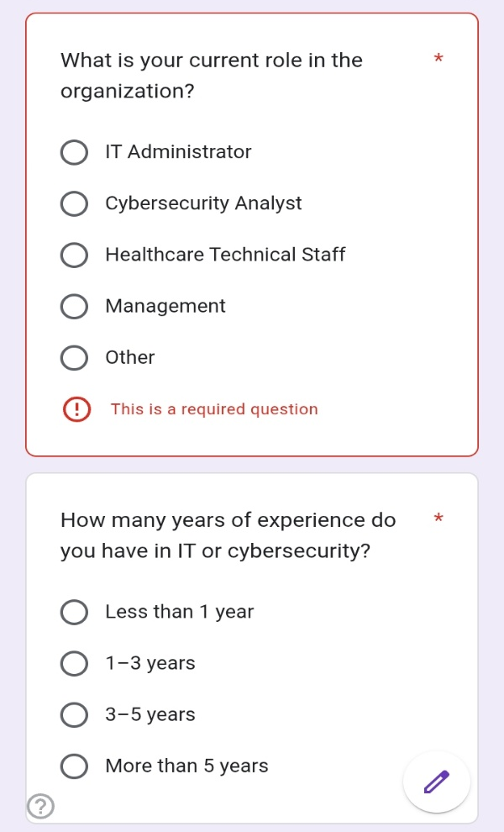
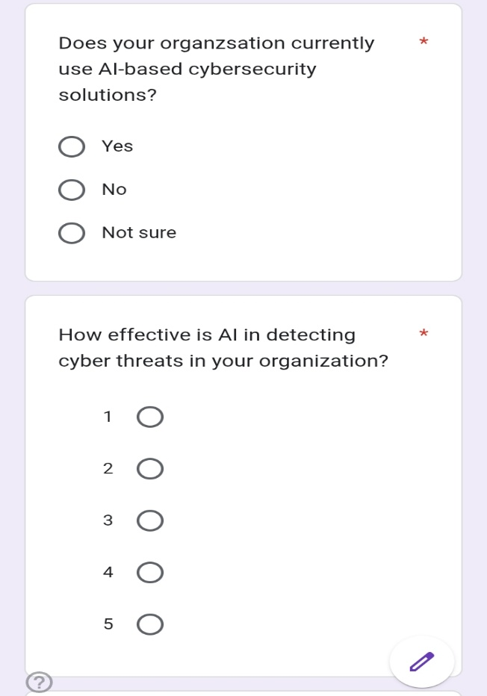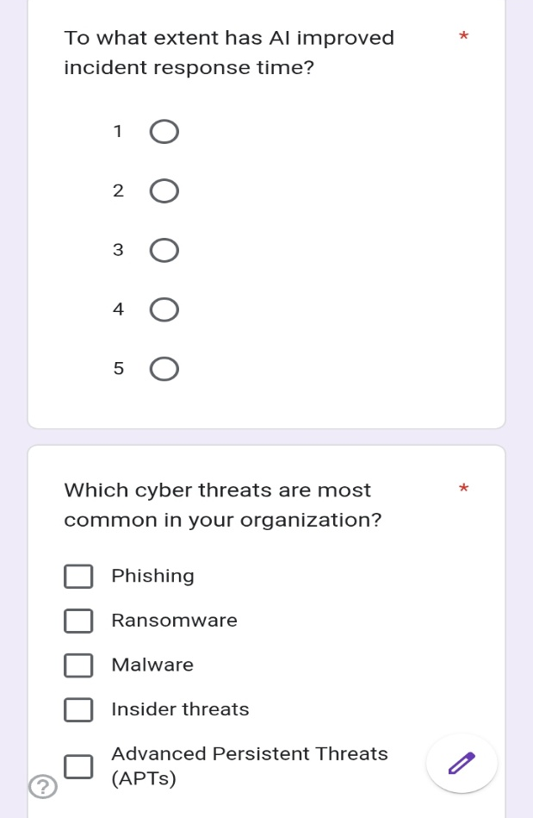

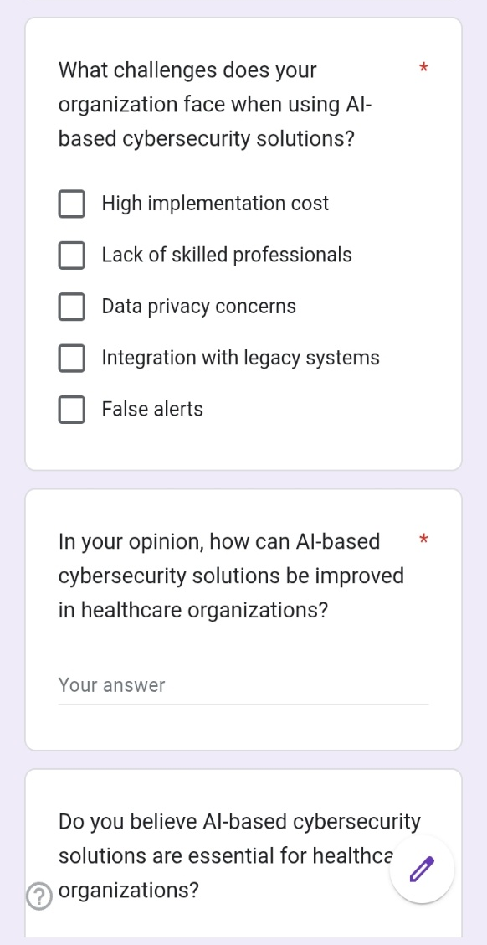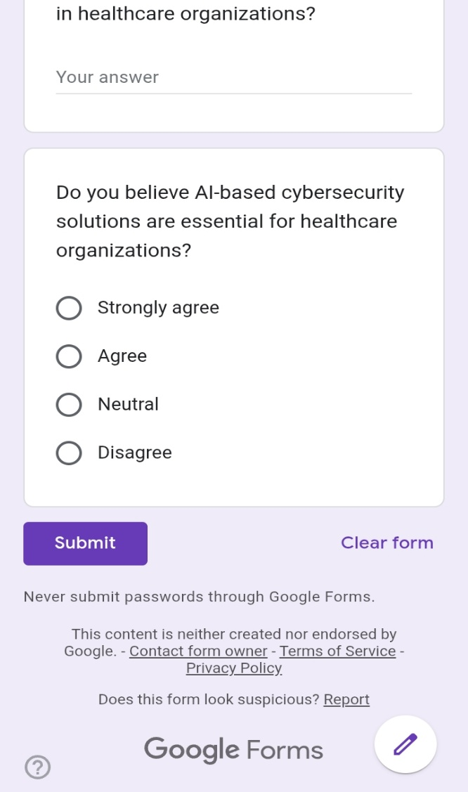

Figure 2: Screen shots of Google form

2.5 Results of the analysis of primary research findings are illustrated by the following charts.

2.5.1 Respondent Distribution by Job Role.

This chart contains the job positions of the respondents who participated in the survey. The answers will consist of IT administrators, cybersecurity analysts, healthcare technical personnel, and management. It means that the survey includes various stakeholder groups in healthcare cybersecurity.
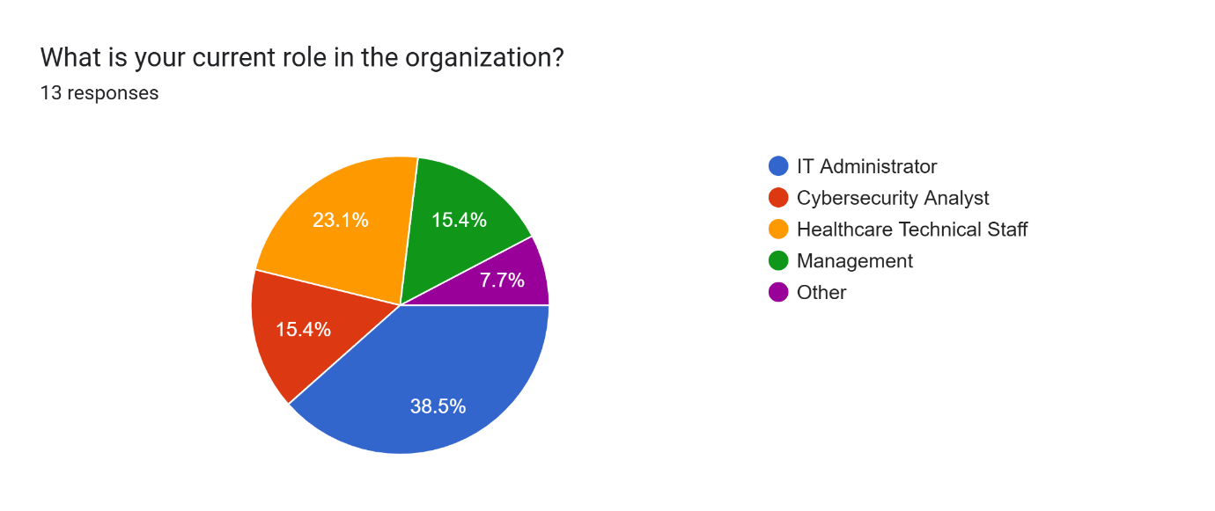

Figure 3: Job role pie chart

2.5.2 Respondent Years of Experience.

The chart below shows the experience of the respondents in IT or other roles connected to cybersecurity in terms of years. The findings represent a combination of the experience level where less than one year of experience is recorded and above five years of experience. This implies that there were both junior and experienced professionals whose opinions were gathered.
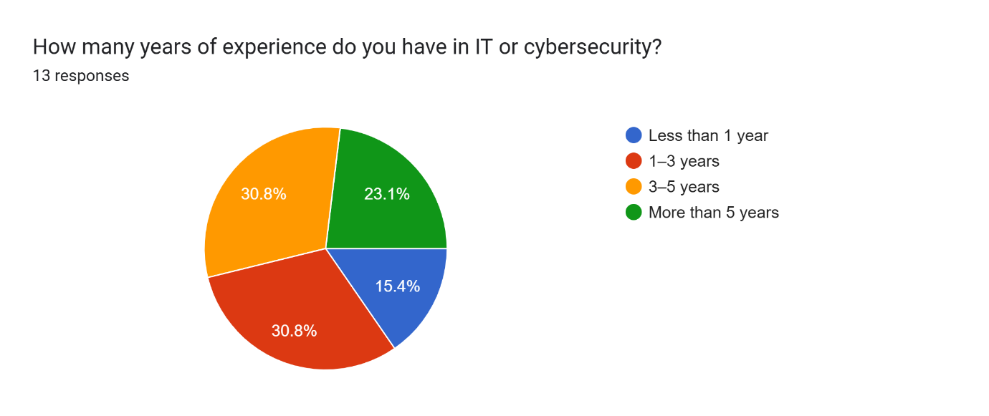

Figure 4: Years of experience pie chart

2.5.3 Application of AI-based Cybersecurity Solutions.

This chart indicates the use of AI-based cybersecurity solutions in healthcare organisations. The vast majority of the respondents claimed that AI tools are already known or used in their organisations. This indicates an increased use of AI in medical cybersecurity.
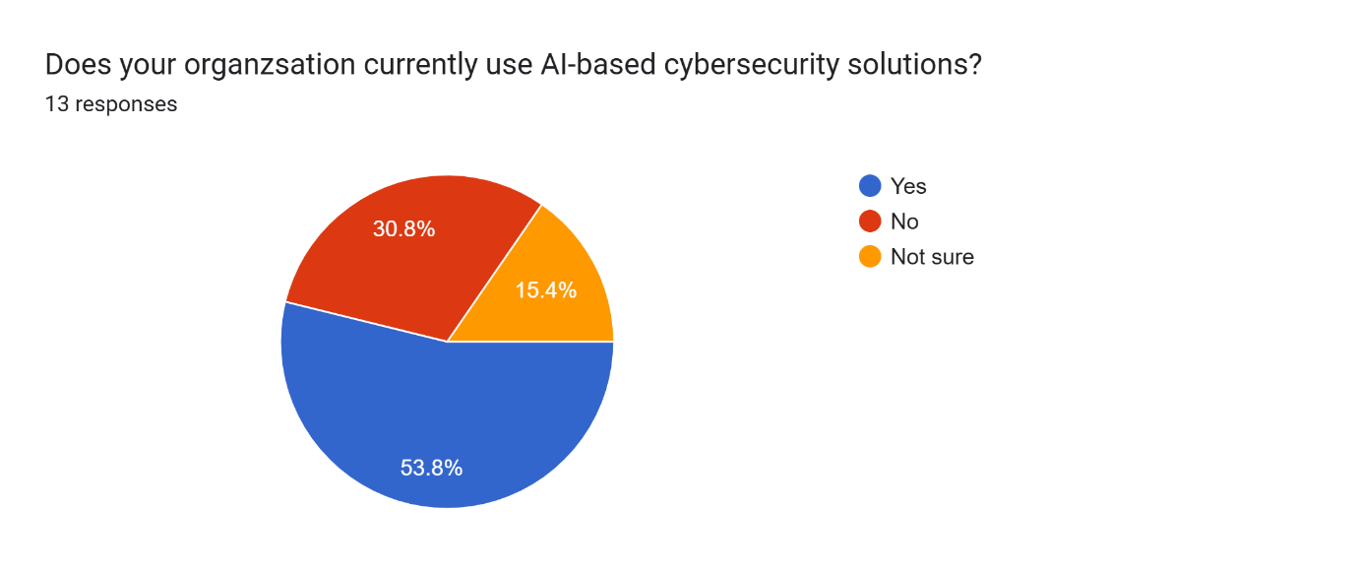

Figure 5: Ensuring the usage of AI pie chart

2.5.4 AI performance in identifying Cyber Threats.

This chart shows the effectiveness of AI to detect cyber threats based on respondents. Most people perceived AI to be effective or very effective. This suggests that AI-based systems have positive perceptions in detecting cyberattacks in healthcare organisations.
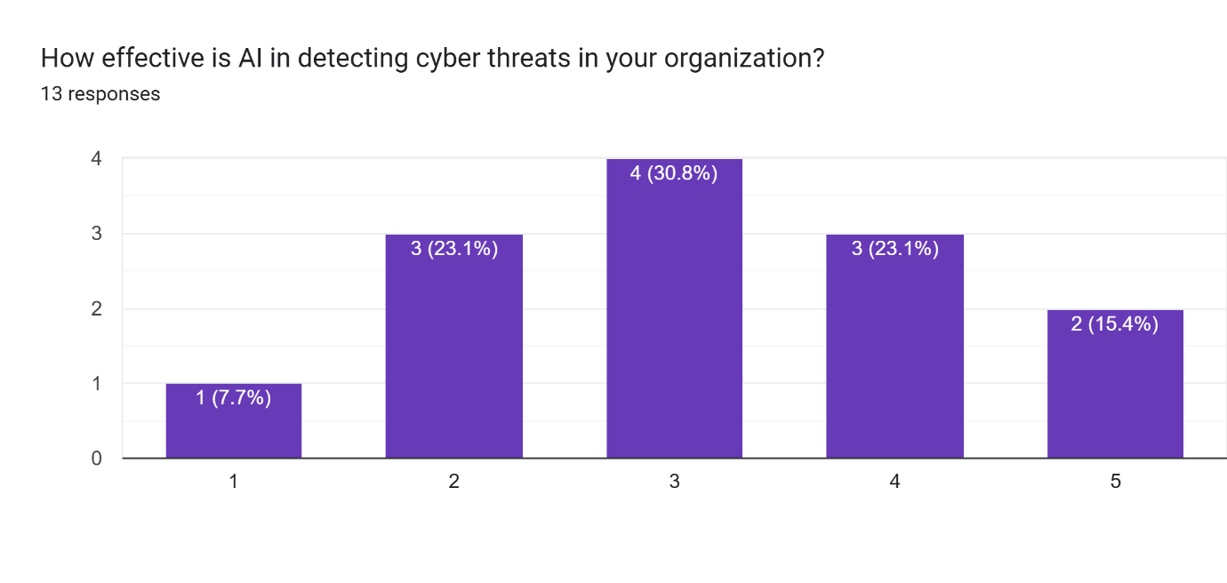

Figure 6: Effectiveness of AI bar chart

2.5.5 AI Effect on Incident Response Time.

This graph demonstrates that AI has enhanced the time of incident response. The majority of the answers are on the higher scale which denotes that AI assists organisations to act swiftly in response to cyber attacks. Reduced response time obtains in less time and promotes less discontinuous healthcare services.
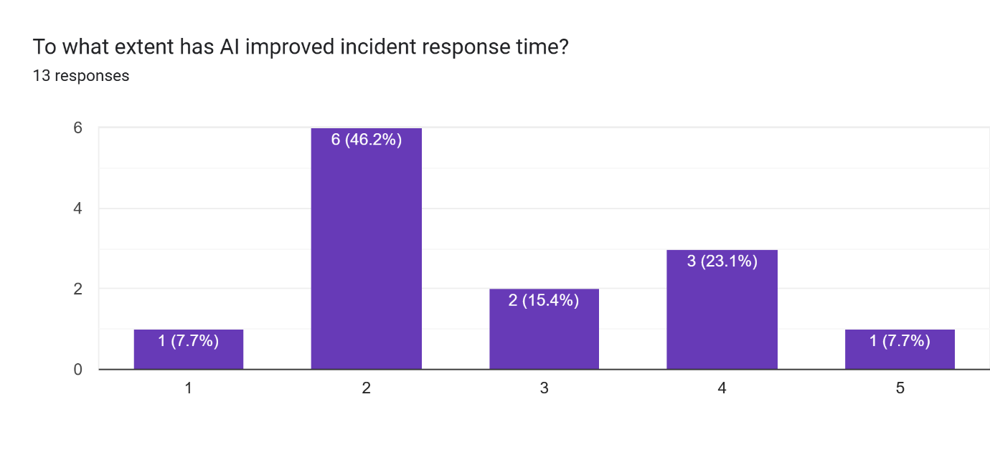Figure 7: Time period of checking bar chart

2.5.6 Natural Cyber threats in Healthcare Organisations.

The chart identifies the most prevalent cyber threats in healthcare organisations. Phishing, ransomware, and malware seem to be the most commonly occurring threats. This proves that social engineering and malware based attacks are so susceptible to the healthcare organisations.
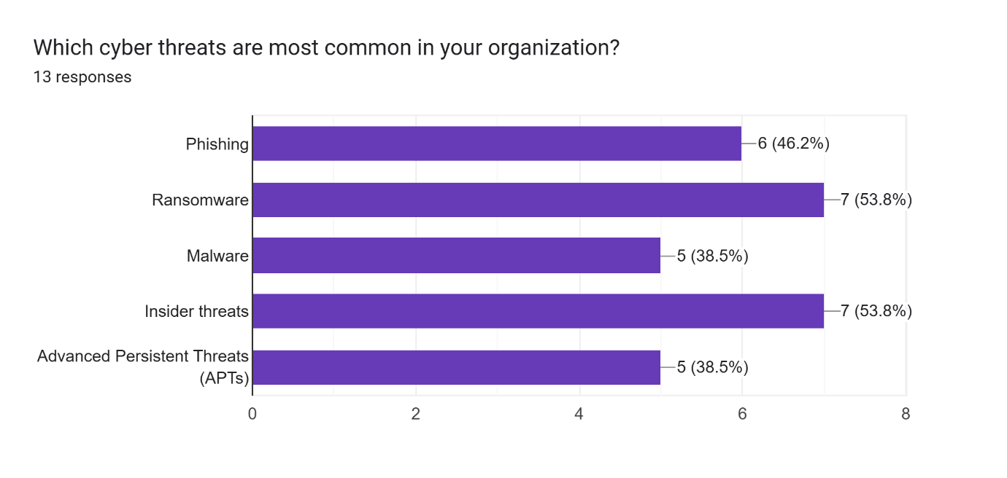

Figure 8: Threats types bar chart

2.5.7. Difficulties in Implementing AI-based Solutions to Cybersecurity.

The following chart includes the key challenges that exist in the case of using AI-based solutions to cybersecurity. The most widespread challenges are high costs of implementation, deficiency of skilled professionals, and privacy of data. These concerns can hinder the use of AI in healthcare organisations.
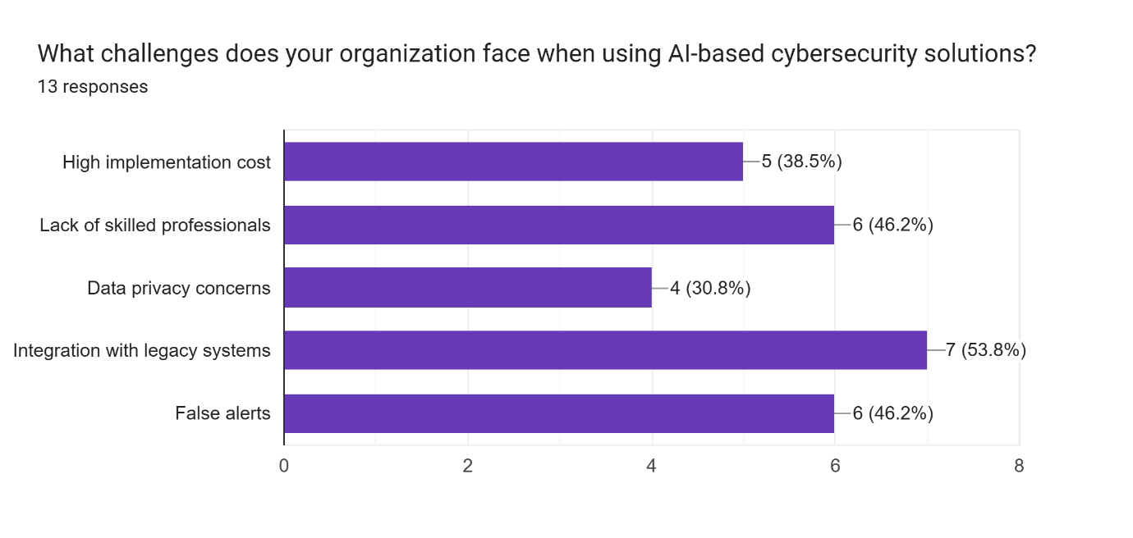

Figure 9: Problems of Using AI bar chart

2.5.8 This explains why AI is important to healthcare cybersecurity.

In this chart, the respondents will be asked about their views regarding the necessity of the use of AI-based cybersecurity solutions by healthcare organisations. Majority of respondents came out in agreement or strongly agreeing. This means that AI is taken as a significant instrument to safeguard healthcare systems and data.
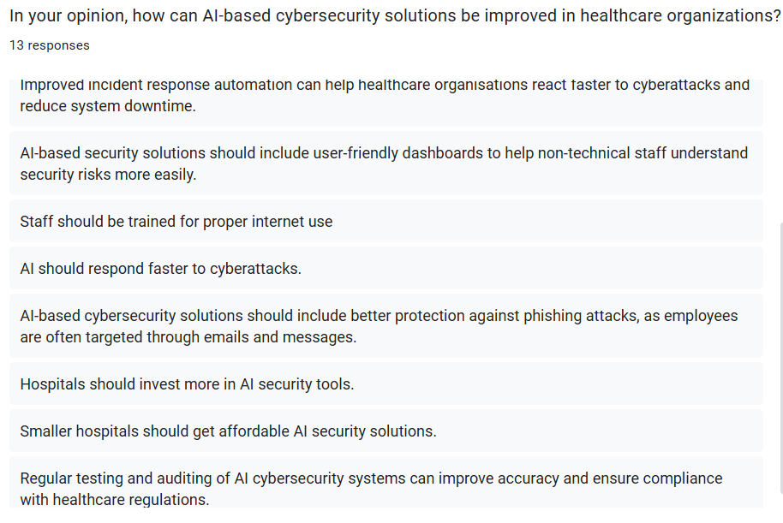

Figure 10: Responders opinions

2.5.9 AI-based cybersecurity adoption Support in general.

This chart provides an overview of the support level of implementing AI-based cybersecurity in healthcare organisations. Majority of the answers indicate that there is positive support to the adoption of AI. This indicates great trust in the capabilities of AI to enhance the security of healthcare cybersecurity.
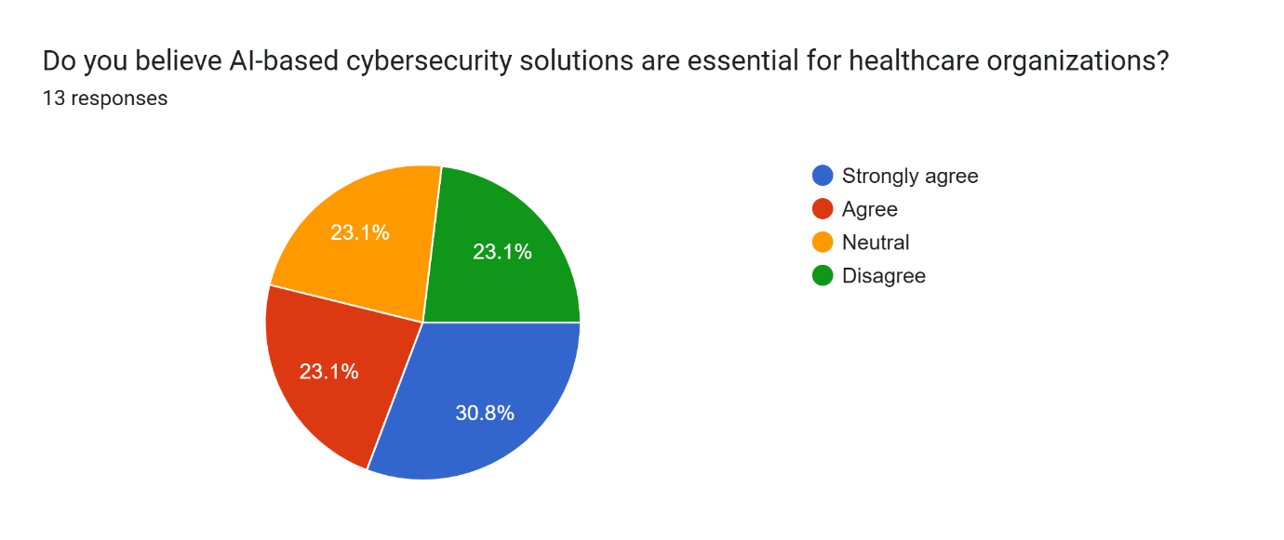

Figure 11: Usage of AI

2.6 Interpretation of Primary Research Findings
The results of the survey and the interview prove that AI-based cybersecurity solutions can enhance technical security, as well as ensure healthcare continuity in operations. Quicker detection of threats lowers downtime in the system which is vital in patient care continuity. This implies that production on AI basis cybersecurity is a direct contributor to the performance of healthcare business, patient safety and trust in the organisation.

2.7 Qualitative Findings from Industry Interview

Besides the survey through questionnaire, a semi-structured interview was carried out with two IT employees of MediSewana Hospital, a private healthcare organisation. This interview was aimed at getting practical experience of the issues and advantages of implementing AI-based cybersecurity solutions in a healthcare setting. The MediSewana Hospital interviewee expressed that AI-related cybersecurity solutions can be utilised in monitoring suspicious network traffic, as well as possible cyber threats, at the initial stages. Nevertheless, there are a few issues that the hospital encounters in the implementation of AI technologies. Among the key problems detected, the expensive nature of using and sustaining AI-based cybersecurity solutions was identified. The hospital is also dependent on old healthcare systems and therefore it is hard to integrate it with modern AI solutions. Moreover, patient privacy and healthcare regulations were also identified among the key issues since patient records include incredibly sensitive data. The interviewee also said that trained cybersecurity experts specialised in AI are lacking and this impacts on the good monitoring and management of AI-based security tools as well as the IT manager said that AI-based security tools are effective in identifying anomalous behaviour of the network at an early stage. Nevertheless, the costs of implementation and a shortage of skilled personnel will continue to be the significant problem within healthcare organisations at the time when the cybersecurity analyst mentioned that AI systems can be used to minimise the response time to phishing and ransomware-related attacks. Nevertheless, incorporation with the old hospital systems and the handling of false positives are in progress.
Thematic analysis method was used to interpret the qualitative data gathered by conducting the semi-structured interview with the IT employee of MediSewana hospital. Thematic analysis was chosen as it enables the recognition of the commonality patterns and major themes in the qualitative data. The responses to the interview were analysed, coded and clustered around the shared themes including cost of implementation, issues of privacy of the data, challenges of integration of the system with other systems and skills gaps. This approach was useful in order to systematically perceive the stakeholder views and draw relevant insights as far as the use of AI-based cybersecurity solutions in healthcare is concerned.

2.8 Secondary Research Approach.

Secondary research will be carried out with the help of academic journals, industry reports, and publications regarding AI and healthcare security. The current literature emphasises that machine learning and deep learning tools can be used to detect abnormal tendencies and identify zero-day attacks (Microsoft, 2023).
According to the studies within the industry, AI-based solutions to cybersecurity have demonstrated the ability to considerably decrease the time spent responding to incidents and increase the accuracy of detection with AI security solutions in comparison with more traditional security tools (IBM, 2023). It has also been reported that predictive analytics assists organisations in making anticipations about possible threats before they end up inflicting severe damage (Darktrace, 2024).

2.9 Data Analysis and interpretation.

Primary and secondary research will allow receiving a full picture concerning the issue of AI in healthcare cybersecurity. Secondary data provides the theoretical basis and evidence in the industry that AI is effective, and primary research should be developed to confirm the evidence in an actual healthcare setting.
Early findings of the primary research lead to the belief that professionals believe that AI-based cybersecurity tools are more efficient in identifying complicated and dynamic threats. The improved visibility of network activity and quicker detection of suspicious behaviour are noted by the respondents.
These observations are corroborated by secondary research, that shows that AI systems can be continuously trained on new information and updated on new threats. This flexibility is especially relevant in the healthcare sector where downtime of the system and data breaches can have dire outcomes.
The results show that the AI serves the major business and operational needs of data protection, continuity of services, adherence to regulations, and minimization of operational risks. Artificial intelligence-based cybersecurity promotes the resilience and sustainability of organisations by reducing downtime and avoiding data breaches.

3 Recommendation and Evaluation of the project.

3.1 Technical Audiences Recommendations.

Healthcare organisations ought to deploy AI-based intrusion detection systems whereby machine learning algorithms are used to analyse traffic through the network and to identify abnormal behaviour. Such systems are capable of detecting threats that were unknown before and minimising the use of the classical signature-based detection techniques.
Solutions based on AI and Security Information and Event Management (SIEM) should also be implemented in organisations to enhance the visibility of threats and incident response. The AI-enhanced SIEM systems will be able to process massive amounts of security data and correlate the events and rank high-priority alerts to respond more quickly.
Also, phishing detectors operated by AI should be implemented to minimise the potential threat of social engineering attacks which are the most popular points of entry of cyber attackers in healthcare settings.

3.2 Non-Technical Audiences Recommendations.

The healthcare management must invest in cybersecurity awareness and training programmes to inform the staff of the cyber risks and the contribution of AI based security solutions. Human awareness goes hand in hand with technical controls and minimises possibility of successful phishing attack.
There must be clear AI governance and ethical policies to make sure that the data is used responsibly and that the rules of privacy are met. Such policies must stipulate the way in which patient information is handled and secured in the AI systems.
Organisations also need to set up adequate budgets as well as the strategies on the long-term basis of the adoption of AI-based cybersecurity solutions in order to be able to sustain themselves and improve constantly.

4. Evaluation and Recommendations.

The recommendations offered are useful in dealing with the challenges found in the previous stages of this report. Technical solutions enhance the accuracy of the threat detection and response time, whereas non-technical measures focus on the gaps in skills, ethical issues, and organisational preparedness.
A combination of these recommendations will help healthcare businesses meet their needs by helping to maintain the continuity of the services, regulate the data, guarantee compliance with the regulations, and improve patient trust in their services. The synergistic approach will see AI-based solutions to cybersecurity issues added to the efficiency of business operations and resilience as a long-term company initiative. The thematic analysis increased the credibility of the qualitative results since interview data was analytically and interchangeably analysed and interpreted. The ability to uncover similar themes in responses minimised the bias of the researcher and enhanced the validity of the conclusions made after the interview.
This research uses the mixed research methods such as questionnaires and industry interview at MediSewana Hospital which enhances the reliability of the research. The questions in the structured questionnaires enabled uniformity in the responses and the interview enabled practical validation of results. Triangulation of primary data by using secondary sources like academic journals and cybersecurity reports added to the accuracy of the research. The reliance on various sources of data minimised bias and enhanced the belief in the findings and conclusions.

5. Evaluation of Research Reliability
While the findings of this project provide valuable insights into the application of AI in healthcare cybersecurity, it is important to critically reflect on the reliability and limitations of the research methods used. The primary data was collected through a Google Form questionnaire distributed to IT and cybersecurity professionals in healthcare. Although the responses offered useful perspectives, the sample size was relatively small and may not fully represent the diversity of roles and experiences across the wider healthcare sector. In addition, self-reported data can introduce bias, as participants may overstate or understate the effectiveness of AI solutions based on personal experiences or organisational culture.
The secondary data was drawn from academic journals, industry reports, and case studies. While these sources are credible, some may reflect vendor bias or be limited by the publication date, meaning that rapidly evolving AI technologies and cyber threats may not be fully captured. To improve reliability, future research could triangulate findings by combining surveys with interviews, case studies, and technical performance data from live AI systems. Expanding the sample size and including multiple healthcare organisations would also strengthen the generalisability of the results.
By acknowledging these limitations, the project demonstrates transparency and academic rigour. Despite these constraints, the combination of primary and secondary data provides a balanced view of how AI can support healthcare organisations in enhancing resilience, compliance, and patient trust. This evaluation confirms that the recommendations are well-founded, while also highlighting areas for improvement in future studies.

Critical Reflection and Future Improvements

In addition to evaluating the reliability of the research methods, it is important to reflect on the planning decisions made during this project. The choice of a questionnaire allowed for efficient data collection across multiple healthcare professionals, but it limited the depth of qualitative insights compared to interviews or case studies. A mixed-methods approach could have provided richer detail, though this was not feasible within the time and resource constraints of the project. The decision to focus on the healthcare sector ensured relevance to sensitive data environments, but it also narrowed the generalisability of findings to other industries.
Future improvements could include expanding the sample size to cover multiple hospitals and incorporating longitudinal data to assess how AI adoption evolves over time. Triangulating survey results with technical performance metrics from live AI systems would strengthen the validity of conclusions. Furthermore, the methodology could be adapted to other sectors such as finance or education, where AI-based cybersecurity solutions face different challenges and requirements. By acknowledging these limitations and proposing improvements, the project demonstrates academic rigour and ensures that recommendations remain credible, transferable, and aligned with organisational needs.

7. Conclusion

In accordance with the vocational scenario of the SecureTech Solutions (Pvt) Ltd, this research report explored the use of artificial intelligence in threat detection and prevention of cyberattacks in the healthcare industry. The research paper was based on the research plan used in the activity 1 and showed the distinct progression between planning the project and carrying out and analysing the research.
The results indicate that healthcare organisations live in a highly digital and data-driven world, and systems like electronic health records, clinical networks, financial systems, and telemedicine systems are vital in the daily running of organisations. The features also enhance the vulnerability to cyber threats and thus effective cybersecurity is a business imperative.
Stakeholder analysis revealed that patients, healthcare personnel, IT teams, management, and regulators are stakeholders who have significant roles to play in ensuring a successful implementation of cybersecurity. Nevertheless, the use of AI-based cybersecurity services is associated with a number of challenges, such as high implementation costs, the lack of skills, data quality problems, ethical concerns, and the challenges in integrating AI with the legacy systems.
Primary research, which is scheduled to be conducted in the form of a Google Form survey according to the proposed schedule in the Activity 1, along with secondary research based on academic and industry sources, will prove that AI technologies can greatly increase the accuracy of the threat detection, decrease the time of response, and improve the skills of detecting complex and dynamic cyber threats. Machine learning, deep learning, and predictive analytics can transform healthcare organisations to be reactive instead of proactive in cybersecurity reactions.
The suggestions provided to both technical and non-technical populations deal with the challenges identified and correlate with the business needs of healthcare. Through the use of AI based security controls and effective governance, training and ethics, healthcare organisations are able to secure sensitive patient data, maintain service continuity, regulatory compliance and organisational resilience.
Finally, it is evident in the research that artificial intelligence facilitation serves the operational and business demands of healthcare organisations and offers a solid basis on which SecureTech Solutions can build innovative AI-based cybersecurity consultancy services to the healthcare sector.

References
Darktrace (2024) AI-driven cybersecurity in healthcare environments. London: Darktrace.
Envoy (2023) Top Workplace Threats and How to Prevent Them. Available at: https://envoy.com/workplace-compliance-security-safety/workplace-threats
IBM (2023) Artificial intelligence and cybersecurity in healthcare. Available at: IBM Security Reports.
Microsoft (2023) The role of AI in modern threat detection. Available at: Microsoft Security Blog.
Insights for Professionals (2023) Common Types of Security Threats Facing Businesses. Available at: https://www.insightsforprofessionals.com/it/security/types-of-security-threat
National Cyber Security Centre (NCSC) (2023) Cyber security guidance for healthcare organisations. London: NCSC.
WHO (2022) Digital health and data protection. Geneva: World Health Organization.
Darktrace (2024) The state of AI in cybersecurity. Available at: Darktrace official website.
Microsoft (2023) AI for cybersecurity. Available at: Microsoft Security.
NCES (2023) Safe Technology and Physical Security. U.S. National Center for Education Statistics. Available at: https://nces.ed.gov/pubs98/safetech/chapter5.asp
NCSC (2023) Cyber security risks in healthcare. Available at: National Cyber Security Centre.
IBM (2023) Cost of a data breach report. Available at: IBM Security.
Kaspersky (2023) VPN Security Risks Explained. Available at: https://www.kaspersky.com
Atlassian (2023) 3 Common Security Threats to Enterprise Systems. Available at: https://www.atlassian.com/enterprise/data-center/3-common-security-threats
Envoy (2023) Top Workplace Threats and How to Prevent Them. Available at: https://envoy.com/workplace-compliance-security-safety/workplace-threats
Executech (2024) Top 15 Types of Cybersecurity Attacks and How to Prevent Them. Available at: https://www.executech.com/insights/top-15-types-of-cybersecurity-attacks-how-to-prevent-them

Appendix 01

Project logbook 1

Week – 1 ✅

Section 1: Basic Details
Project title: | The Application of Artificial Intelligence in Detecting and Preventing Cyberattacks in Healthcare Organizations
Student name: | Afry Nizam
Student number: | 1001953
Week | 1 🗸 2 ☐ 3 ☐ 4 ☐ 5 ☐ 6 ☐ 7 ☐ 8 ☐
Date | 1/1/2025
Section 2: Weekly Progress
Issues identified and Points to consider:
Taking the initiation of the understanding of the application of artificial intelligence methods in healthcare cybersecurity, machine learning, and predictive analytics were difficult to grasp initially. It was also not easy to find appropriate real world examples connected to hospitals and health care systems. Another issue that was experienced during the first phase of planning was time management.
New ideas and change of project direction Points to consider:
First, the study was general and limited to AI in cybersecurity in various fields. The project direction was narrowed down to considering healthcare organisations in particular after consulting with the supervisor to permit a more detailed analysis. It was proposed to gather the primary data through the survey with the help of Google Form and hold interview with healthcare stakeholders.
What have you learned about yourself through your work?
I got to know that I can be capable of working on an independent research project and develop my research and analytical skills. My communication skills and time management also improved. The surveys and analysis of data assisted me in achieving confidence in dealing with real world academic and professional work.
Next steps for your work Points to consider:
The following actions involve the literature review, survey questionnaire design, a primary data collection using Google Forms, and an interview with a healthcare organisation. Once a collection of data has been collected, the focus will be on the data analysis, interpretation, and report writing.

Supervisor feedback / comments
Supervisor Sign: | Date:

Project logbook 2

Week –2 ✅

Section 1: Basic Details
Project title: | The Application of Artificial Intelligence in Detecting and Preventing Cyberattacks in Healthcare Organizations
Student name: | Afry Nizam
Student number: | 1001953
Week | 1 ☐ 2 🗸 3 ☐ 4 ☐ 5 ☐ 6 ☐ 7 ☐ 8 ☐
Date | 7/1/2025
Section 2: Weekly Progress
Issues identified and Points to consider:
It was time-consuming to find topical and fairly recent scholarly materials concerning AI in healthcare cybersecurity. There were certain sources that were too technical and challenging to comprehend.
New ideas and change of project direction Points to consider:
Chose to utilize a combination of journals, cybersecurity reports, and healthcare cases. Ransomware and phishing are identified as the primary threats that should be prioritised
What have you learned about yourself through your work?
I have developed my skills of research reading and how to act with the complicated information in simple terms.
Next steps for your work Points to consider:
Keep on with the literature review and start planning the research methodology.
Supervisor feedback / comments
Supervisor Sign: | Date:

Project logbook 3
Week – 4 ✅

Section 1: Basic Details
Project title: | The Application of Artificial Intelligence in Detecting and Preventing Cyberattacks in Healthcare Organizations
Student name: | Afry Nizam
Student number: | 1001953
Week | 1 ☐ 2 ☐ 3 ☐ 4 🗸 5 ☐ 6 ☐ 7 ☐ 8 ☐
Date | 19/1/2025
Section 2: Weekly Progress
Issues identified and Points to consider:
It was not easy to design appropriate research methods that would be in line with the project objectives. The selection of qualitative and quantitative methods was to be thought through.
New ideas and change of project direction Points to consider:
Also decided to adopt a mixed-method research design through a combination of a survey with a Google Form and an interview of a healthcare organisation.
What have you learned about yourself through your work?
I also got to know how to formulate research questions in a manner that is clear and pertinent to a research topic.
Next steps for your work Points to consider:
Draw up the survey questionnaire and interview questions
Supervisor feedback / comments
Supervisor Sign: | Date:

Project logbook 4
Week – 5 ✅

Section 1: Basic Details
Project title: | The Application of Artificial Intelligence in Detecting and Preventing Cyberattacks in Healthcare Organizations
Student name: | Afry Nizam
Student number: | 1001953
Week | 1 ☐ 2 ☐ 3 ☐ 4 ☐ 5 🗸 6 ☐ 7 ☐ 8 ☐
Date | 25/1/2025
Section 2: Weekly Progress
Issues identified and Points to consider:
Survey questions were to be made unbiased and easy to understand hence revisions were made. Ethics like privacy of data were also put into consideration.
New ideas and change of project direction Points to consider:
Completed the Google Form questionnaire and prepared to conduct the interview with MediSewana Hospital.
What have you learned about yourself through your work?
I acquired a higher level of detail and realised the significance of ethical data collection.
Next steps for your work Points to consider:
Send out the questionnaire and carry out the interview.
Supervisor feedback / comments
Supervisor Sign: | Date:

Project logbook 5
Week – 6 ✅

Section 1: Basic Details
Project title: | The Application of Artificial Intelligence in Detecting and Preventing Cyberattacks in Healthcare Organizations
Student name: | Afry Nizam
Student number:
Week | 1 ☐ 2 ☐ 3 ☐ 4 ☐ 5 ☐ 6 🗸 7 ☐ 8 ☐
Date | 31/1/2025
Section 2: Weekly Progress
Issues identified and Points to consider:
The initial response rate to the survey was low. The coordination was necessary in scheduling the time on which the interview would take place.
New ideas and change of project direction Points to consider:
Sent out a reminder to the participants of the survey and made the interview with a staff member of MediSewana Hospital, healthcare IT.
What have you learned about yourself through your work?
I was able to develop my communication and confidence with the stakeholders in the industry.
Next steps for your work Points to consider:
Tabulate survey data, interview data.
Supervisor feedback / comments
Supervisor Sign: | Date:

Project logbook 6
Week – 7 ✅

Section 1: Basic Details
Project title: | The Application of Artificial Intelligence in Detecting and Preventing Cyberattacks in Healthcare Organizations
Student name: | Afry Nizam
Student number:
Week | 1 ☐ 2 ☐ 3 ☐ 4 ☐ 5 ☐ 6 ☐ 7 🗸 8 ☐
Date | 6/1/2025
Section 2: Weekly Progress
Issues identified and Points to consider:
The data interpretation and the correlation between the data and the objectives of the research had to be carefully analysed. Thematic analysis of interview data was difficult.
New ideas and change of project direction Points to consider:
Applied thematic analysis to find out that the main issues were high cost, lack of expertise, and data privacy concerns.
What have you learned about yourself through your work?
I was taught to analyse qualitative and quantitative data and make meaningful conclusions.
Next steps for your work Points to consider:
Begin writing the discussion and research report.
Supervisor feedback / comments
Supervisor Sign: | Date:

Project logbook 7
Week – 8 ✅

Section 1: Basic Details
Project title: | The Application of Artificial Intelligence in Detecting and Preventing Cyberattacks in Healthcare Organizations
Student name: | Afry Nizam
Student number:
Week | 1 ☐ 2 ☐ 3 ☐ 4 ☐ 5 ☐ 6 ☐ 7 ☐ 8 🗸
Date | 12/1/2025
Section 2: Weekly Progress
Issues identified and Points to consider:
It was difficult to ensure a logical flow and academic structure of the report. Finally writing time management had to be taken into consideration.
New ideas and change of project direction Points to consider:
Better findings and recommendations through association with organisational needs and cybersecurity issues.
What have you learned about yourself through your work?
I learnt to be confident in academic writing and critical thinking. I was also taught to think over research reliability and accuracy.
Next steps for your work Points to consider:
Last minute proofreading, formatting and submission of the project.
Supervisor feedback / comments
Supervisor Sign: | Date:

Appendix 2
Survey Questionnaire

Google Form Link:
https://docs.google.com/forms/d/1dEHWI9ZMiQ9vOTwv9Agkpucw2yM752-9U8zh7

List of Interview questions
- What is your position in MediSewana Hospital?
- What is the value of cybersecurity in a healthcare organisation?
- Which are the frequent cyber threats to the hospital?
- Has the hospital been a victim of cybersecurity attacks in the past?
- Is MediSewana Hospital currently utilising AI-based cybersecurity tools?
- What is artificial intelligence and how can it be used to identify cyberattacks in healthcare?
- What is the effectiveness of AI in comparison to conventional cybersecurity systems?
- What are some of the issues the hospital encounters when installing AI-based cybersecurity solutions?
- What is the impact on AI usage in cybersecurity on patient data privacy?
- Are the staff members knowledgeable enough to utilise AI-based cybersecurity tools?
- How can AI help in minimising the time of response to cyberattacks?
- To what extent do you believe that AI-based cybersecurity systems are reliable in the field of healthcare?
- How would you recommend AI-based cybersecurity in healthcare institutions to be enhanced?

Appendix 3
Questionnaire responds

Respondent Distribution by Job Role.

Respondent Years of Experience.

Application of AI-based Cybersecurity Solutions. .

AI performance in identifying Cyber Threats. .

AI Effect on Incident Response Time.

Natural Cyber threats in Healthcare Organisations. .

Difficulties in Implementing AI-based Solutions to Cybersecurity.

This explains why AI is important to healthcare cybersecurity.

AI-based cybersecurity adoption Support in general.

Interview responses
- IT support employee and assist with the administration of hospital systems and information security tasks.
- The issue of cybersecurity is of high importance since hospitals hold sensitive information on patients who need protection.
- Phishing emails, malware and ransomware threat are the primary issues that the hospital faces.
- Minor breaches include phishing mails, but no huge data breaches.
- The conventional security tools are predominantly used in the hospital and the AI-based tools are few.
- AI can assist by raising an alert when the system starts acting abnormally, and threat identification can be done much faster when compared to manual detection.
- The AI systems prove to be more effective as they have the capability to learn and identify new forms of attacks.
- The primary threats are that it is expensive, and it does not have skilled personnel, as well as integration of systems.
- The privacy of patient information is a significant issue, and AI systems should be subject to strict security policies.
- The majority of the employees require additional education to utilise the AI-based cybersecurity devices.
- AI minimises the reaction time since it automatically detects threats and produces real-time alerts.
- The applications of AI can be trusted provided that the systems are sufficiently trained and updated.
- Cybersecurity in hospitals would be enhanced through additional staff training, integrating systems, and inexpensive AI solutions.

