Machine Learning Assignment

Afry Nizam
ANC
HND in Computing

ACKNOWLEDGEMENT

I would like to thank my Machine Learning lecturer Ms. Prarthana Weerasekara for the guidance, constant support and encouragement she has given during the completion of this assignment. The explanations provided were very clear, the feedback from the teacher was helpful and the practical exercises provided helped me to better understand the concepts, algorithms and their applications in the real world and to successfully complete this assignment.

I also wish to express my gratitude to the academic staff of the Pearson HND in Computing programme and ANC Education for providing the learning materials, facilities and academic support needed to successfully complete this assignment.

At last, I want to thank all my family and friends who have been patient, motivated and given me constant support during this journey. They were very helpful in motivating me to complete this assignment on Machine Learning on time.

Thank you.

Regards,
Afry Nizam

Contents
Introduction 18
Part A - ALGORITHM TESTING AND LOGBOOK 19
1. What is Machine Learning and How Does it Learn from Data? 19
3. Training, Testing, Training Dataset and Testing Dataset 24
4. Why Should the Test Dataset Not Be Used for Training? 25
5. How do Prediction possible with Machine Learning Algorithms? 26
6. Classification, Regression, Clustering and Optimisation 27
7. Five Popular Machine Learning Algorithms 29
Logistic Regression 30
Decision Tree 30
Random Forest 30
Support Vector Machine 30
k-Nearest Neighbours 31
8. Illustration of Algorithms 32
9. Implement and Compare Two Algorithms 33
Why These Two Algorithms? 34
10. Supervised vs Unsupervised Learning 42
11. Data Pre-processing and Its Importance 44
Critical Evaluation of Machine Learning for Intelligent Systems 46
Part B - PRESENTATION ON MACHINE LEARNING 49
Slide 1 - Introduction to Machine Learning 49
Slide 2 - How Machines Learn 49
Slide 3 - Types of Machine Learning 50
Slide 4 - Bank Data Set and Practical Machine Learning Example 51
Slide 5 - Model Evaluation 51
Slide 6 - Role in Financial Analytics and Customer Insight 52
Slide 7 - Benefits, Challenges and Ethical Considerations 53
Slide 8 - Conclusion and Recommendation 53
Part C - DEMONSTRATION AND ANALYSIS OF THE MACHINE LEARNING SOLUTION 55
1. Data Preparation 55
2. Algorithm Implementation 57
3. Results and Comparison 58
4. Confusion Matrix and ROC Analysis 58
5. Underfitting, Overfitting and Model Balance 60
6. Critical Evaluation 61
7. Recommendation 62
Conclusion 63
Reference 64
Appendix A - Part A Code 65
Appendix B - Part C Code 75

Introduction
Machine Learning (Machine Learning) is one of the crucial areas of Artificial Intelligence (AI) that allows the computer to learn patterns from a set of data and apply them for prediction or decision making. It is utilized in numerous fields like finance, marketing, customer behaviour, risk management and product quality (James, Witten, Hastie, & Tibshirani, 2021). This assignment relates to a vocational scenario from a technology company specializing in financial analytics and client behaviour modelling called Data Coordinators. The company is assisting a newly established Sri Lankan winery which is going to manufacture Sri Lankan wine with local products and sell to foreign markets. The open-source Wine Quality dataset will be used in the winery to explore factors that influence wine quality and create a machine learning solution to predict wine quality. These variables include physicochemical properties like acidity, residual sugar, sulphates, pH and alcohol, as well as wine quality scores, from (Cortez, 2009). There are three parts to the assignment. Part A introduces the basic concepts of machine learning and presents algorithms, types of learning and data pre-processing. In Part B, students will explore how machine learning can be applied to financial analytics and customer insight systems, its advantages, obstacles and ethical concerns. Part C then works through the concepts in the context of the Wine Quality dataset. Python and Google Colab were used to develop Logistic Regression and Random Forest, evaluating them with the accuracy, precision, recall, F1-score, confusion matrix and ROC analysis. Overall, the assignment is a good example of the development of a machine learning theory into a real-world implementation and proof of success.

Part A - ALGORITHM TESTING AND LOGBOOK
1. What is Machine Learning and How Does it Learn from Data?
Machine Learning is the technique to build computer systems that can learn a pattern from data and make a prediction or decision based on that pattern. It is a major component of AI as it enables a system to carry out a task without having to write a rule for each and every instance of it.

Normally, in the traditional programming pattern the programmer supplies rules and data to yield an output:

The process is various in machine learning:

The learning algorithm takes in data + known outcomes for the model to be trained.

The trained model is then able to process new data:

For instance, a bank may know details about their customers like the age, occupation, education and past responses to campaigns, among other things. If historical data also includes the financial product customers subscribed to, a machine learning algorithm can learn relationships between these and the final result.
This is a type of problem that can be found in the UCI Bank Marketing database. Its goal variable, y, tells if a client took out a term deposit, yes and no are the values.

The learning process has four significant steps:
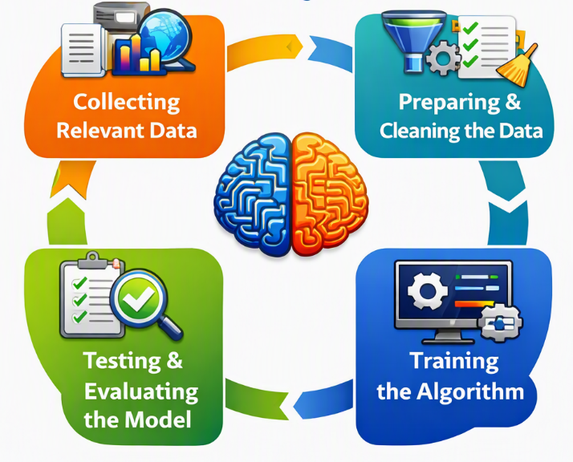
Figure 1: Learning Process
The quality of the final prediction is highly dependent on the quality of the data and the choice of the algorithm. So, when it comes to machine learning, it's not just about picking an algorithm. The other two stages of data preparation and model selection and assessment are also crucial.

2(a). Machine Learning Life Cycle
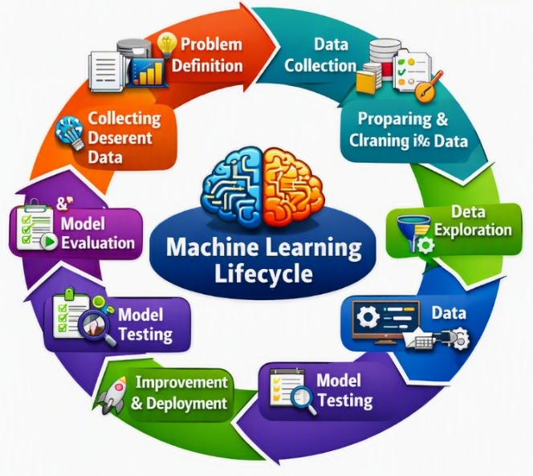
Figure 2: Machine Learning Life Cycle
Machine learning lifecycle is a series of steps that are followed to create, test and deploy a machine learning solution.

Stage 1: Problem Definition
The first phase is to have a clear idea of the problem.
The problem for the bank dataset might be:
Is it possible to predict whether or not a customer will sign up for a financial product using machine learning?

If there is a clearly defined problem, that will help to determine which data and algorithm is needed.

Stage 2: Data Collection
Appropriate data is gathered from relevant sources.
Customer and campaign data may be employed for the banking instance.

Stage 3: Data Exploration
The data set is analysed to determine:
- Number of records
- Number of variables
- Data types
- Missing values
- Duplicate records
- Distribution of target values
- Unusual values

This stage allows to discover potential issues in data quality before training is started.

Stage 4: Data Pre-processing
Typically, raw data must be transformed into an appropriate form before it can be fed into a machine learning algorithm.
This can include:
- Handling missing values
- Encoding categorical variables
- Removing duplicates
- Handling outliers
- Scaling numerical variables
- Identifying the independent and dependent variables.
- Defining the independent and dependent variables.

Stage 5: Splitting the Dataset
The data is split into training and testing data sets.
For example:
80% Training + 20% Testing

The model is trained on the training data and then evaluated on the test data.
The train_test_split function has been introduced in scikit-learn, which can serve to split the data into random training and testing sets and can also be used to stratify when class proportions are important.

Stage 6: Algorithm Selection
The algorithm selected is appropriate for the problem.
Some possible algorithms for classification are:
- Logistic Regression
- Decision Tree
- Random Forest
- Support Vector Machine
- k-Nearest Neighbours

Stage 7: Model Training
The algorithm chosen is able to learn patterns from the training data.
For instance, Logistic Regression can learn from the characteristics of the customers how likely they are to say yes or no to the outcome.

Stage 8: Model Testing
Test data used to test trained model is unseen data.
This will provide a more realistic assessment of generalisation from the model to new observations.

Stage 9: Model Evaluation
Appropriate parameter values are used to assess the results.
These can be used for classification and include:
- Accuracy
- Precision
- Recall
- F1-score
- Confusion matrix

Stage 10: Improvement and Deployment
In case the model's performance is not satisfactory, the process can be repeated with improved pre-processing or other features with other algorithms or with the tuning of algorithm parameters.
If a model is successful, it can be used in an actual system, at a later stage.
Thus, lifecycle is not just a one-way thing.

2(b). Variable and Observation
A characteristic or attribute that can take on various values for various observations is called a variable.
For instance, in a customer data:
- age
- job
- education
- housing
- loan
- campaign
are variables.

An observation also known as a one individual record or row in a set of data.
One row corresponding to one customer is an observation.
Therefore:
- Variable = column/characteristic
- Observation = individual row/record
The difference is crucial because machine learning algorithms analyse patterns of variables over numerous instances.

3. Training, Testing, Training Dataset and Testing Dataset

a. Training
Training is the task of learning the patterns from past data that the machine learning algorithm is given.
For instance, a model could be given a large number of customer records where the outcome of a customer's subscription is known and be able to discover the relationships between the features of the customers and the target outcome.

b. Testing
Testing refers to a process of testing trained model with data other than the data used to train the model.
This is to see if the model can apply to new observations.

c. Training Dataset
The training data set is the set of data that is used to create the model.
For example:
80% of data → Training
This data is then used to learn relationships using the algorithm.

d. Testing Dataset
A separate test dataset is used as testing data.
For example:
20% of data → Testing
Such observations are not used in the model when it is learning. When training is finished, the results of the test observations are fed into the model and the model's predictions and the actual results are compared.
The separation is key because a model can be very accurate on data it has been presented with, but fail to be accurate on data that it has never been presented with.

4. Why Should the Test Dataset Not Be Used for Training?
The test set should not be used to train the model as it is intended to test the model in an independent fashion.
Using the same observations for training and testing could lead the model to learn the answers in the observations. This would then lead to an unrealistic evaluation of performance.

Suppose that a model reaches:
Training accuracy = 99%
It's not necessarily a great model. It could have learned patterns that are unique to the training data.

Also, if test data is used during training, it can be hard to look at the results of the test and tell whether the model can generalise to new observations.
In this problem, the problem of overfitting is associated. Overfitting takes place when a model learns the training data too well and fails on data it doesn't see.
Therefore:
- Training data → Learn
- Testing data → Evaluate
Separate these purposes to obtain a more reliable performance estimate.

The tool for splitting a dataset into training and test sets differs from the tool for evaluating the model, so that the separation of evaluation data is important in the development of reliable machine learning models.

5. How do Prediction possible with Machine Learning Algorithms?
The ability to make predictions using machine learning algorithms is attributed to the ability to recognize patterns and relationships from past data.

The overall procedure is:
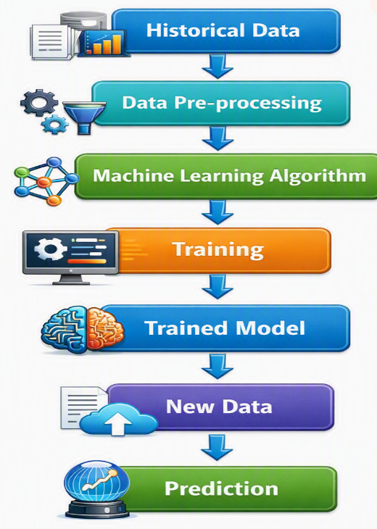
Figure 3: Predictions Using ML Algorithm
For instance, if certain combinations of customer characteristics and campaign information have been identified by the model as being related to subscription, then these characteristics and messages will be associated with the attributes of the model. For instance, combinations of customer characteristics and campaign information that were found to be related to subscription will be related to the attributes of the model.

If additional data of a new customer is given, the model would make a prediction based on the learned relationship.
The result for a binary classification problem might be:
- Yes: This customer will most likely agree to a subscription.
- Probably: Customer may be considering subscribing, but with some hesitation

It is important to note that the model is not a "guessing machine". Uses mathematical patterns that have been learned from training data.
But predictions are not always accurate. They are reliable depending on the quality and representativeness of training data, the features, algorithm, parameters and evaluation process used.
Hence, model evaluation is a must.

6. Classification, Regression, Clustering and Optimisation

(a). Classification
A supervised machine learning problem in which the model is used to classify or categorize something is a classification problem.
The Bank Data Set can be considered a binary classification problem since there are two possible target y values, such as:
- yes
- no

The model can learn from past customers and for a new customer predict the class he or she is likely to belong to.

Example
Customer information is sent to the classification model, which makes a decision of whether the customer's information belongs to the Yes or No class.

Classification is suitable if the output does not measure a continuous level but is a classification.
There are various classification algorithms such as:
- Logistic Regression
- Decision Tree
- Random Forest
- Support Vector Machine
- k-NN

The UCI Bank Marketing dataset is a clearly-defined classification problem.

(b). Regression
If the target is a numbers value (continuous) then regression is used.
Depending on the company, a company may predict:
- Sales revenue
- Customer spending
- Product demand
- Temperature
- House price

However, regression differs from classification as regression makes a prediction of numbers and classification makes a prediction of a class.

(c). Clustering
A technique for finding natural groups in data is called clustering.
In contrast to classification, there is no target label that the algorithm should be trying to achieve.
For instance, a bank may partition the customer base into groups by the similarities in their:
- Age
- Job
- Account activity
- Loans
- Previous campaign behaviour

The algorithm could find clusters of:
- Cluster 1 → Younger customers
- Cluster 2 → Customers with loans
- Cluster 3 → Highly responsive customers
These labelling would not be given beforehand. The algorithm finds the clusters according to similarities.
According to (IBM, 2024), clustering is a technique that discovers groups of similar records, but no specific field is being targeted.

(d). Optimisation
Optimisation is a method that looks for a solution which meets a specific objective in the most optimal way.
Optimisation is applied in various aspects of machine learning, such as selecting parameters and training the model.

A model might have various configurations that affect its operation. The aim may be to identify the settings which minimise the prediction error with good generalisation.
The goal for a bank may be to create a model to accurately predict who will become a customer but at the same time minimize the amount of marketing contacts required.

Optimisation therefore becomes important as the best machine learning model does not necessarily need to be the most complicated model. The best model should be a good compromise between performance, reliability, complexity and business requirements.

7. Five Popular Machine Learning Algorithms
Algorithm | Type | Suitable Problem | Example
Logistic Regression | Supervised | Classification | Predict customer subscription
Decision Tree | Supervised | Classification/Regression | Predict customer
Random Forest | Supervised | Classification/Regression | Predict customer behaviour
Support Vector Machine | Supervised | Classification/Regression | Classify customer outcomes
k-Nearest Neighbours | Supervised | Classification/Regression | Classify similar customers

Logistic Regression
Logistic Regression is the most common method used for classification. It predicts the likelihood of an observation being in a class.
It can predict the likelihood of a customer subscribing to the Bank Data Set.

Decision Tree
A Decision Tree is used to make predictions by taking a series of decisions.
For example:
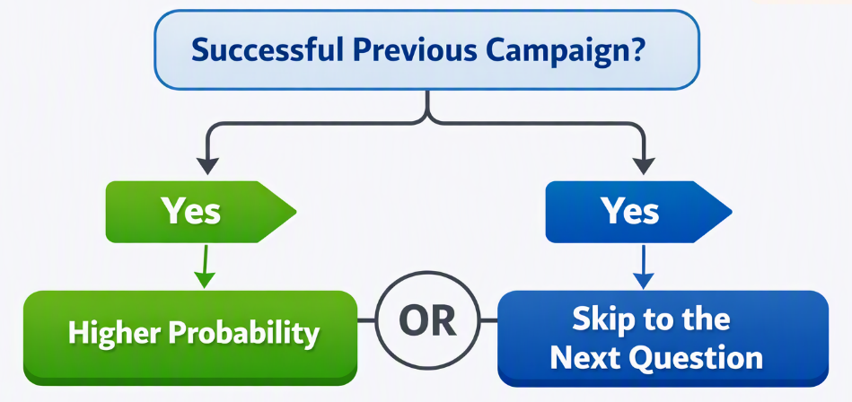
Figure 4: Decision Tree
Primary benefit is that the decision process is relatively comprehensible.

Random Forest
Random Forest is an ensemble of decision trees. Instead of relying on one tree, it utilizes numerous trees and adds them together.
This can enhance the predictive accuracy and mitigate some of the disadvantages of a single decision tree.
Support Vector Machine

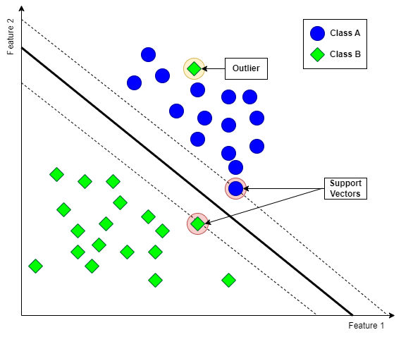
Figure 5: Support Vector Machine
SVM tries to choose an appropriate decision boundary to maximize the separation between classes.
It is useful in cases where the differentiation of classes is not possible using simple boundaries.

k-Nearest Neighbours
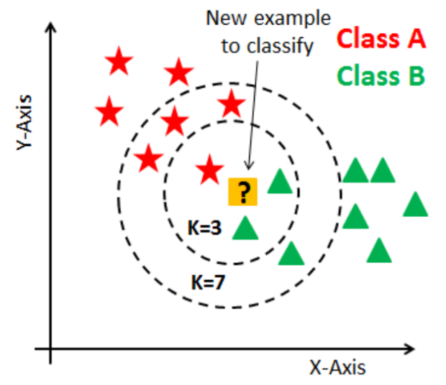
Figure 6: k-NN
k-NN's makes prediction based on the nearby observations.
For instance, if the new customer is near some existing customers who are mostly subscribed, the model might assume that the new customer is a subscription customer.

These algorithms have various strengths and weaknesses, comparing algorithms is important, do not expect the same algorithm to always work best. Machine learning techniques used in industry include Decision Trees, Logistic Regression, SVM and other supervised machine learning techniques.

8. Illustration of Algorithms

Decision Tree
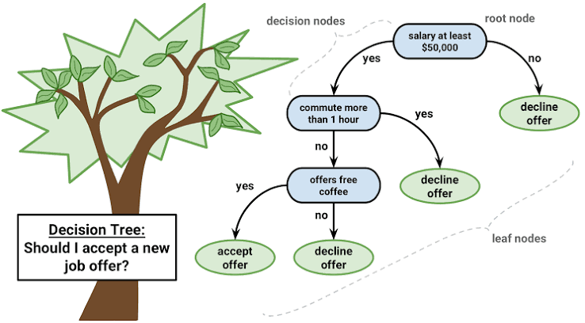
Figure 7: Decision Tree
The Decision Tree repeatedly segments the observations based on the value of features.

Logistic Regression
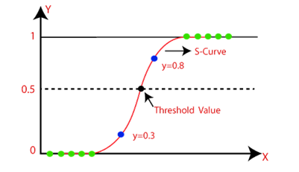
Figure 8: Logistic Regression
The model predicts the probability of a class and classifies it based on some threshold.

Random Forest
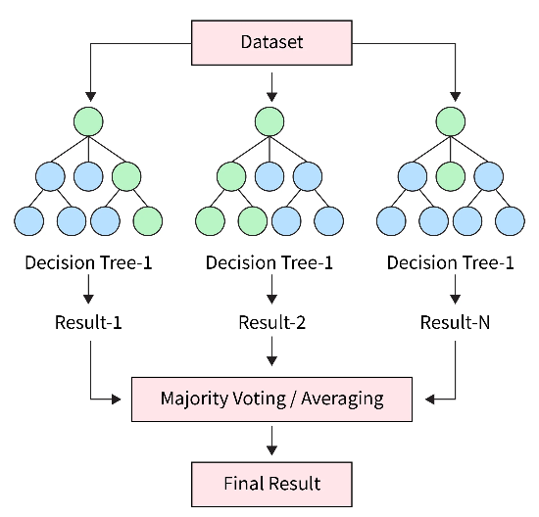
Figure 9: Random Forest
Random Forest fuses predictions of multiple decision trees.

Support Vector Machine
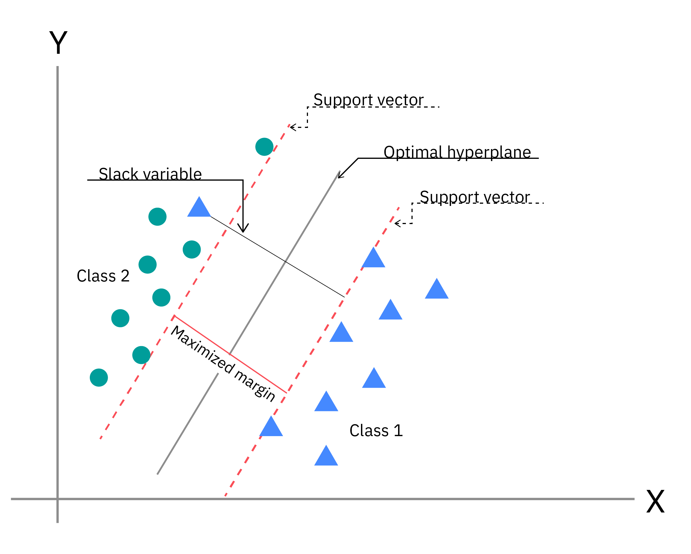
Figure 10: Support Vector Machine
The prediction is based on the classes of the nearby observations.

9. Implement and Compare Two Algorithms

Decision Tree and Logistic Regression can be used for binary classification and are suitable for this assignment.
The Bank Data Set is good for this practical demonstration because the target variable in the data set reflects a binary customer outcome. The UCI Bank Marketing dataset also has the classification task as determining whether a person has subscribed to a term deposit or not.

Why These Two Algorithms?

Decision Tree
The following is captured as to why a Decision Tree is useful:
- It is relatively easy to understand.
- A process can be visualised for its decision-making process.
- It is able to represent non-linear relationships.
- It can be used for classification and regression.

Logistic Regression
Logistic Regression can be used because:
- It is designed for classification purposes.
- It produces probabilities.
- It is relatively simple.
The coefficient of its polynomial terms can be used to gain insight into feature relationships.
These models can be compared to get a better assessment than when using just one algorithm.

9.1 Dataset preparation and Initial Investigation
The data was uploaded to Google Colab through the help of Python and Pandas libraries. This dataset consists of 10,000 observations and 21 columns in an Excel file called Bank Data Set.xlsx. The variables include details on the individuals such as demographics, employment data, return on previous campaign efforts and economic indicators.

The dataset was first visualized to gain insight into its structure, data types and possible missing data. The investigation revealed there were no missing values in the dataset for the 21 variables in the dataset, so there were no observations dropped due to missing information. Categorical variables contained attributes for such things as job, marital status, education, housing, loan and previous campaign outcome, while numerical variables contained attributes for age, duration and economic indicators.

The ML algorithms were not able to be directly applied to the categorical variables in their textual form. Hence, they were transformed to numerical representation by One-Hot Encoding. The numerical variables were also scaled with the StandardScaler. A pre-processing pipeline was employed to ensure the same data preparation procedure was utilized throughout the model training and testing.

We load in this dataset into Google Colab and view the shape of this dataset as well as the first 5 observations and the column names.
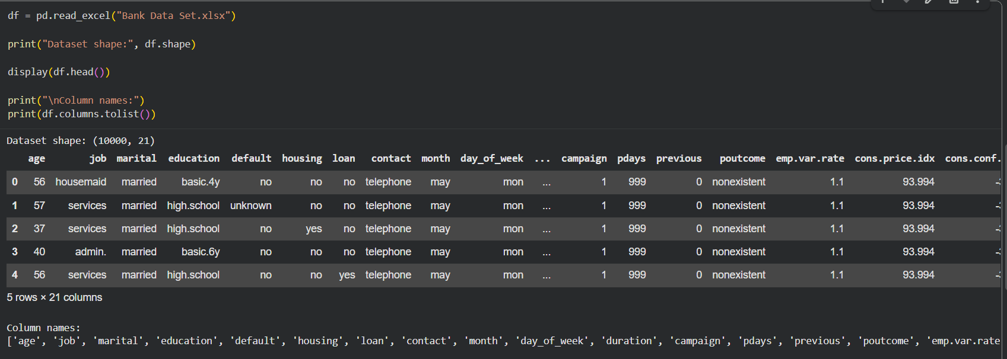
Figure 11: Loading and initial inspection of the Bank Data Set

9.2 Target Variable and Class Imbalance
The target variable chosen was y, which is a yes or no value indicating whether or not a customer subscribed to a term deposit. In model implementation these were then translated into numeric labels:
- 0 = No subscription
- 1 = Subscription

There was significant class imbalance in the target distribution. A total of 9,666 people were not subscribed and 334 people were subscribed. Thus, the positive class was only about 3.34% of the entire data set.

This imbalance is significant when comparing the models as a model can be very successful with the majority class and fail with the minority class. (James, Witten, Hastie, & Tibshirani, 2021) argues for looking beyond a single metric when evaluating a model, as it depends on the nature of the data and the intended purpose of the model.
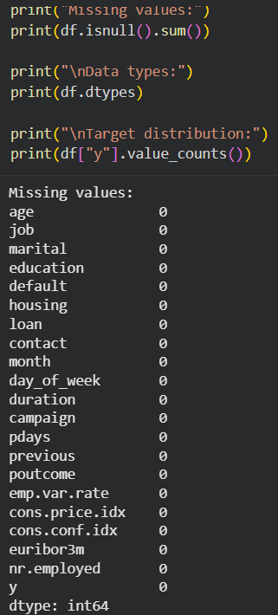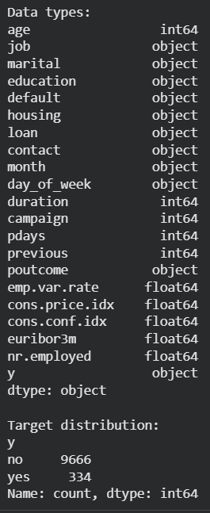
Figure 12: Data quality checks and target-class distribution
The class imbalance also had an impact on the interpretation of the final results. The business goal would be the identification of customers who are likely to subscribe where correctly identifying the minority class of “yes” is more important than simply achieving high overall accuracy.

9.3 Training and Testing Dataset
The train_test_split() function from Scikit-learn was used to split the dataset into training and testing sets. The data set was split into training and test sets, with 80% of the data being used for training and 20% for testing.

The following parameters were used:
- Training data: 8,000 observations
- Testing data: 2,000 observations
- Test size: 20%
- Random state: 42
- Stratification: stratify=y
The stratify=y parameter was used to ensure that the ratio of yes and no classes is the same in training and testing sets. This was important as only 3.34% of the initial observations were in the positive class.

Logistic Regression and Decision Tree were trained on the same set of data and tested on the same set of data. This enabled a more honest comparison since it removed the possibility of the models being compared on different observations causing differences in model performance.

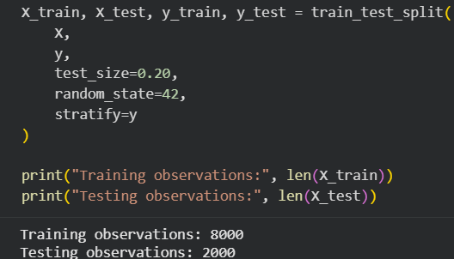
Figure 13: Training and testing dataset split

9.4 Logistic Regression Implementation
Logistic Regression was the first algorithm implemented. Logistic Regression is a supervised classification technique that works out the chance of a data point being classified into a specific class. This experiment was used to predict if a customer would be in the yes or no subscription class.

The Logistic Regression model was put together using the Scikit-learn library. Pre-processing of data was performed before the classification. The pre-processing pipeline was performed to ensure that the numerical and categorical data were pre-processed appropriately before the classification. The model was trained on the 8,000 training observations and then predictions were made for the remaining 2,000 observations in the test set.
The Logistic Regression model obtained the following results:

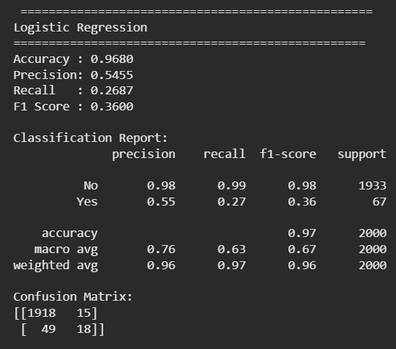
Figure 14: Logistic Regression evaluation results and confusion matrix

A score of 0.9680 is a measure of accuracy - it means that 96.80% of all predictions made during the test were right. The recall of 0.27 reveals that the model only identified around 27% of the customers that had a subscription. So, the accuracy value is not sufficient to determine the usefulness of the model.

The precision of 0.55 indicates that approximately 55% of the customers predicted as subscribers were actually subscribers. The F1-score is equal to 0.36, which is a combination of precision and recall and is another indicator of the fact that the model performed much worse at predicting the positive class than it did its overall accuracy.

9.5 Decision Tree Implementation
The second algorithm used was Decision Tree Classifier. A Decision Tree makes predictions by sequentially breaking down observations into various classes based on decision rules. The structure can be pictorially represented as a tree with decision nodes, branches and final prediction leaves.

The same pre-processing pipeline, training observations and testing observations were used for the Decision Tree model. The maximum depth of the tree was set at 5 to keep the model simple.
With the Decision Tree, the following results were obtained:

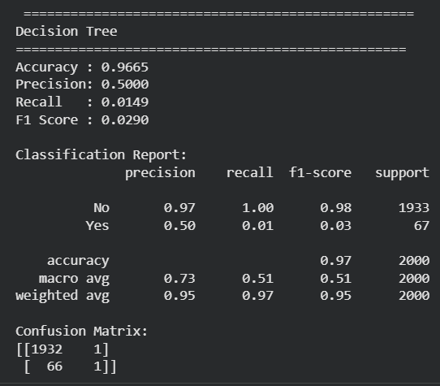
Figure 15: Decision Tree evaluation results and confusion matrix

Regression accuracy of 0.9680. However, it was far less effective on the positive class. As seen in the above recall, the Decision Tree only caught about 1% of the customers who subscribed.
This outcome proves this to be an important limitation in the use of accuracy as a measure to evaluate an imbalanced classification problem. The Decision Tree was reasonably accurate (over 96% accuracy), but not very successful in picking out the yes class that was a minority.

9.6 Comparison of Algorithm Performance
Here are some results that can be used to compare the performance of the two algorithms:
The results for the two models are presented as follows.
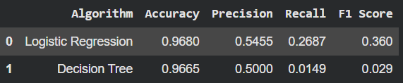
Figure 16: Comparative performance of Logistic Regression and Decision Tree
The results indicate that Logistic Regression was more successful than the DT on all four reported assessment measures. The accuracy was 0.9680 which is higher than 0.9665 for the Decision Tree. Although the difference in accuracy was small, the differences in the minority-class metrics were much more significant.

For instance, Logistic Regression had a recall of 0.27, while Decision Tree had 0.01. So Logistic Regression was able to correctly classify many more of the customers that actually subscribed. The F1 score also showed a significant difference, Logistic Regression score is 0.36, while Decision Tree is just 0.03.

9.7 Critical Analysis of the Results
On a first glance both models look very accurate as the accuracy is greater than 96%. The target variable is however highly imbalanced and accuracy can be misleading.

The number of observations on which no observations were made was 9666 and the total number of observations was 10000. So, just a simple classifier that would predict no to all of the customers would already achieve:
9,666 ÷ 10,000 × 100 = 96.66% accuracy.

The accuracy of the Decision Tree is 96.65%, which is slightly less than the accuracy that could be achieved by predicting the majority class on every prediction. More importantly, the recall for the yes class with the Decision Tree was only 0.01. Hence this high accuracy does not mean that the model performs useful for the actual business goal.

This problem can be better illustrated by the confusion matrices. The test set consisted of 67 customers who were truly customers. Logistic Regression correctly identified 18 of these customers, Decision Tree correctly identified only 1.
Therefore:
- Using the Logistic Regression model, about 27% of the real subscribers were identified.
- About 1% of the actual subscribers were identified by Decision Tree.

There's a lot of difference. While both models have a comparable accuracy, Logistic Regression has much better minority class identification capabilities.
The results can be correlated with the high-class imbalance in the data set. A classification model can have a very high overall accuracy, correctly predicting the majority class and relatively few successful predictions for the minority class, since the minority class is much smaller than the majority class. The Decision Tree is able to achieve 96.65% accuracy with a mere 0.01 recall for the positive class, which is why.

This experiment demonstrated that Logistic Regression outperformed the Decision Tree configuration used in the experiment because it used a probability-based classification method that yielded improved separation between the minority class, compared to that of the Decision Tree configuration. Higher precision, recall and F1-score show that it was more useful when it comes to recognizing potential subscribers.

Logistic Regression should not be assumed to be "ready to use" in a business environment. A recall of 0.27 indicates that about 73% of the customers who subscribed were not captured by the model. Many potential valuable customers may then not be identified if the bank targeted a marketing campaign based on this model.

The advantage of the Decision Tree is that it is easy to understand and visualize, since the predictions can be expressed as a series of decision rules. However, in this experiment it does not have a very high recall and in this context is not suitable for the business objective without further optimisation.
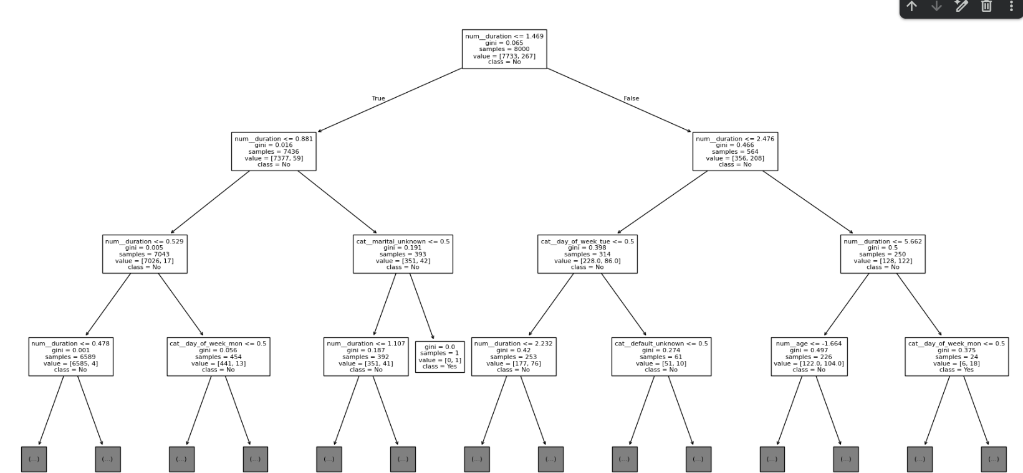
Figure 17: Visualisation of the Decision Tree model
From here on, the comparison shows that picking the machine learning algorithm should not be only based on its accuracy. The choice of the evaluation measure will depend on the purpose of the model. For this reason, the information of potential subscribers is more meaningful than the overall accuracy and recall and F1-score are more important.

10. Supervised vs Unsupervised Learning

Supervised Learning
Labelled data is used in supervised learning.
The model receives:
Input Variables + Known Target → Learning
For example:
Customer information + Subscription outcome → Model

The Bank Data Set can be used for supervised classification as the target variable has known outcomes.
Typical supervised tasks:
- Classification
- Regression

Some typical supervised algorithms are:
- Logistic Regression
- Decision Tree
- Random Forest
- SVM
- k-NN

Supervised learning algorithms are trained on labelled data sets and predicting outcomes is one of the most important problem. IBM explains that among the supervised learning problems are classification and regression.

Unsupervised Learning
Unsupervised learning is a type of learning that is done on data that does not have a predefined target.
The algorithm will try to find some patterns or structures from itself.
For example:
The K-Means process takes the customer data and results in customer groups.
The system could segment the customer population into various groups based on the similarities in the customers characteristics.
One of the major unsupervised learning methods is called clustering.

Comparison
Feature | Supervised | Unsupervised
Target variable | Available | Not available
Main purpose | Predict outcome | Discover patterns
Examples | Classification, Regression | Clustering
Bank example | Predict subscription | Customer segmentation
Evaluation | Accuracy, precision, recall etc. | Cluster quality and usefulness

Both methods have their merits and demerits and there is no one right or wrong.

Supervised learning works well with an organisation that has labels on historical data and a desired prediction.
Unsupervised learning is helpful when the organisation is looking to find out any patterns which are not known.

11. Data Pre-processing and Its Importance
The task of data pre-processing is to transform raw data to a suitable format for machine learning.
This is one of the critical stages as the quality and structure of the data fed into the machine learning algorithms is crucial.

11.1 Data Cleaning
Before using data, they should be first examined for:
- Missing values
- Duplicate records
- Invalid values
- Incorrect data types
- Inconsistent categories
- Extreme values

For instance, if this CustomerRecord is present multiple times in the same record where it is the wrong one, it may have an impact on the model.

11.2 Handling Missing Values
There are various methods to cope with missing values.

For numerical variables:
mean value is used instead of the missing value.
For categorical variables:
frequent category
The proper application will depend on the reason for this data loss and how much data has been lost.

11.3 Encoding Categorical Variables
Most of the machine learning algorithms work on numerical data.
However, customer data includes categorical data like:
- Job
- Education
- Marital status
- Contact method

One-Hot Encoding can be used to convert categorical columns to numeric.

For example:
- University
- School
- Other

Could be converted to dichotomous variables.

11.4 Feature Scaling
There are some algorithms that are sensitive to the scale of the features.
For example:
Age = 20–80
while:
Duration = multi hundreds of seconds

Numerical features can be transformed so that they are more comparable by using Standardisation.
It is very crucial in implementing algorithms based on distance or numeric optimisation like k-NN and SVM.

11.5 Removing Irrelevant Features
Not all variables may be warranted.
Eliminating variables with no relevance are problematic, They can:
- Reduce complexity
- Improve processing speed
- Reduce noise
- Improve generalisation

Features should not be eliminated without analysis, as a feature that may seem inconsequential could contain useful data.

11.6 Splitting the Dataset
The prepared data set needs to be split into training and testing sets.
For example:
- 80% Training
- 20% Testing

The data used for testing the model should not be seen when developing the model.

Critical Evaluation of Machine Learning for Intelligent Systems
It directly affects the effectiveness of the model by data pre-processing. No matter how sophisticated a model is, if the data it is trained on is inadequate, then it can generate unreliable predictions.
But a list of fixed steps for pre-processing is not the most suitable approach. The pre-processing strategy should be different depending on different algorithms.

For instance, in the case of Decision Trees, they are not much affected by feature scaling as they make decisions by using feature thresholds. However, in other algorithms, like k-NN that rely heavily on distances between observations, feature scaling can have a much greater impact.
Also, when categorical data is being processed, it is not possible to simply approximate its values with arbitrary numbers like:
- Male = 1
- Female = 2
Without taking into account if there is any sort of numerical connection. One-Hot Encoding is a better method for nominal (categorical) categories.

The other crucial one is data leakage. The decisions made in the pre-processing of the test data should not be based on information from the training data. For instance, it can compute the parameters for scaling the whole data set before partitioning it, in this way, information from the test set can guide the training process. Instead, it is better to fit pre-processing transformations and then transform the test data with the fitted model.

The pipeline above taken from Google Colab includes a Pipeline and ColumnTransformer, which allows for the pre-processing task to be part of the modelling process. This results in a cleaner and safer process.

Thus, pre-processing is not just simply about data “cleaning”. It's actually about making certain the information provided to the algorithm is suitable, consistent and doesn't leak info.
For intelligent systems to function in complex environments and to be able to describe them fully with manually written rules, machine learning is important.

However, if all customer attributes were combined the creation of a traditional rule would be very complex. Each bank has customers who have various ages, occupations, levels of education and students, loans, and results from past campaigns and communications.
A machine learning model may be able to find patterns in past examples that might not be apparent to the programmer.

The machine learning model can learn from past information’s to create rules for all combinations, rather than having to do it manually.
But machine learning shouldn't be thought of as "smart" by itself.
A model can give bad predictions in the following ways:
- It is difficult to get enough training data.
- Data contains errors.
- There are any number of key variables that are missing.
- Classes are imbalanced.
- The model overfits.
- Test process is not well-designed.
- The actual world is in a state of flux.

More than an algorithm is needed for an intelligent system. It requires, the intersection of appropriate algorithm, the good data, proper evaluation and human oversight.
In financial applications, the predictions can affect marketing decisions and treatment of customers, making it all the more important.
The model should thus be used to assist, not supplant, the human decision-making process.

Part B - PRESENTATION ON MACHINE LEARNING
Part B will cover Machine Learning's applications in financial analytics and customer insight systems. It demonstrates the capability of the machine learning algorithm to learn from data, recognize patterns and make business decisions. Bank Data Set is used as an illustrative example to illustrate model evaluation and financial applications.

Slide 2 - Introduction to Machine Learning

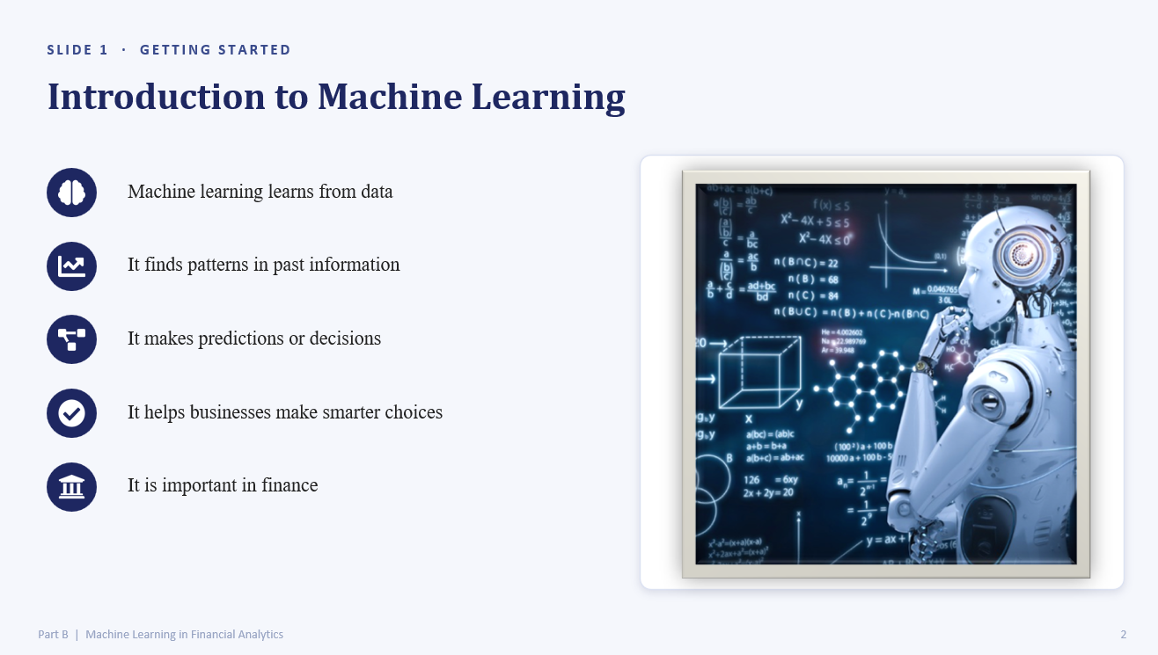
Figure 18: Introduction to Machine Learning

This slide presents Machine Learning as a technology that learns patterns in the data for the purpose of predicting or making decisions. It provides an explanation of its significance in business decision making when based on data. The slide also provides an introduction to its importance in financial analytics and customer behaviour analysis.

Slide 3 - How Machines Learn

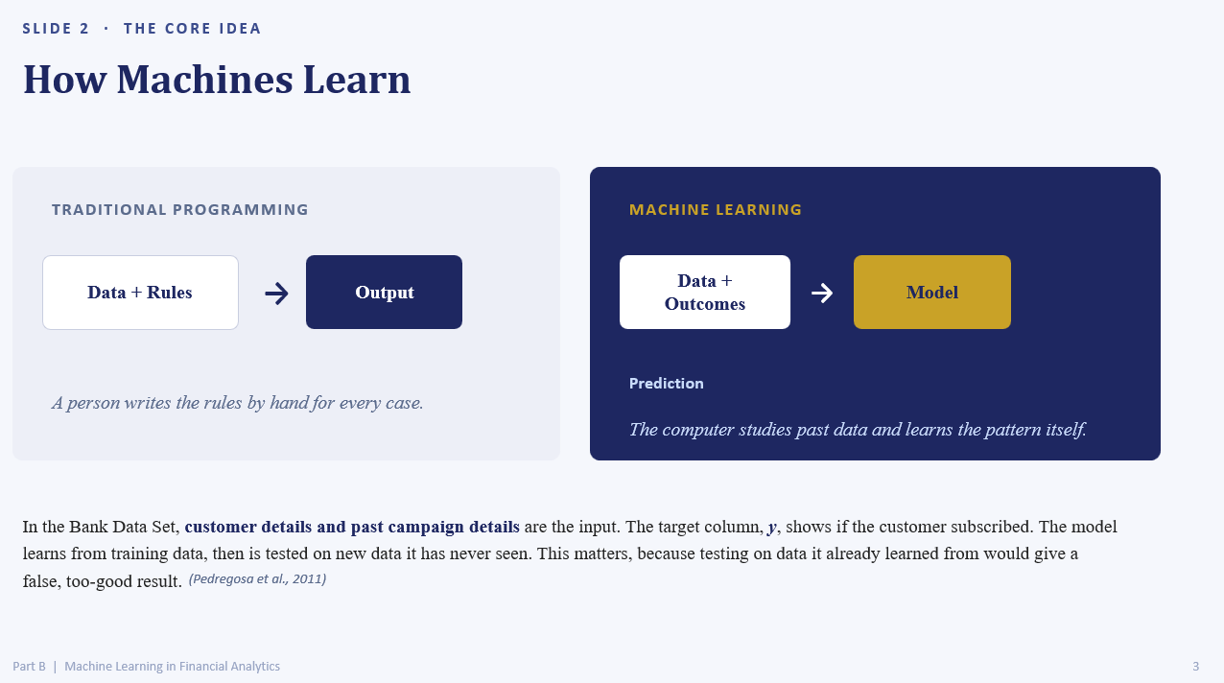
Figure 19: How Machines Learn

This slide describes the concept of a traditional program vs machine learning. It demonstrates the application of machine learning through the use of historical data and known results to create a model that can make predictions. This learning process is illustrated with an example of the Bank Data Set.
Slide 4 - Types of Machine Learning

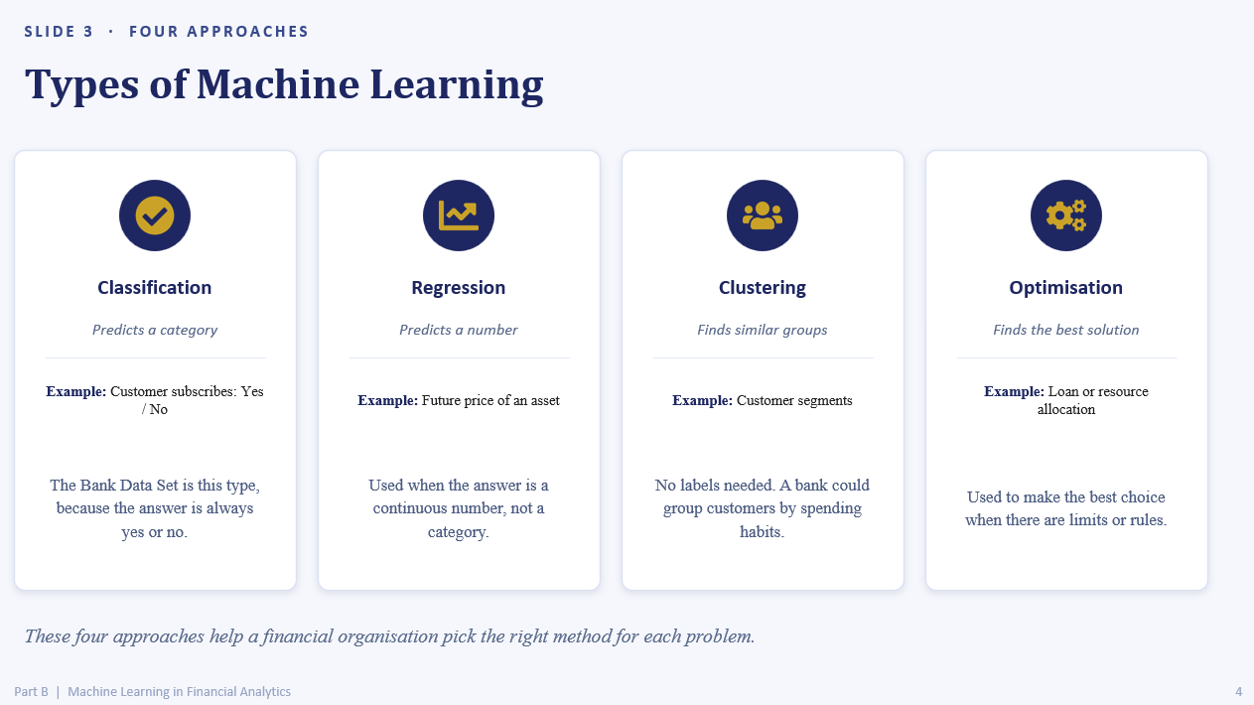
Figure 20: Types of Machine Learning

This slide presents four important machine learning approaches; classification, regression, clustering and optimisation. Each method has an example to illustrate its use. This helps demonstrate the different algorithms which can be used based on the business problem.
Slide 5 - Bank Data Set and Practical Machine Learning Example

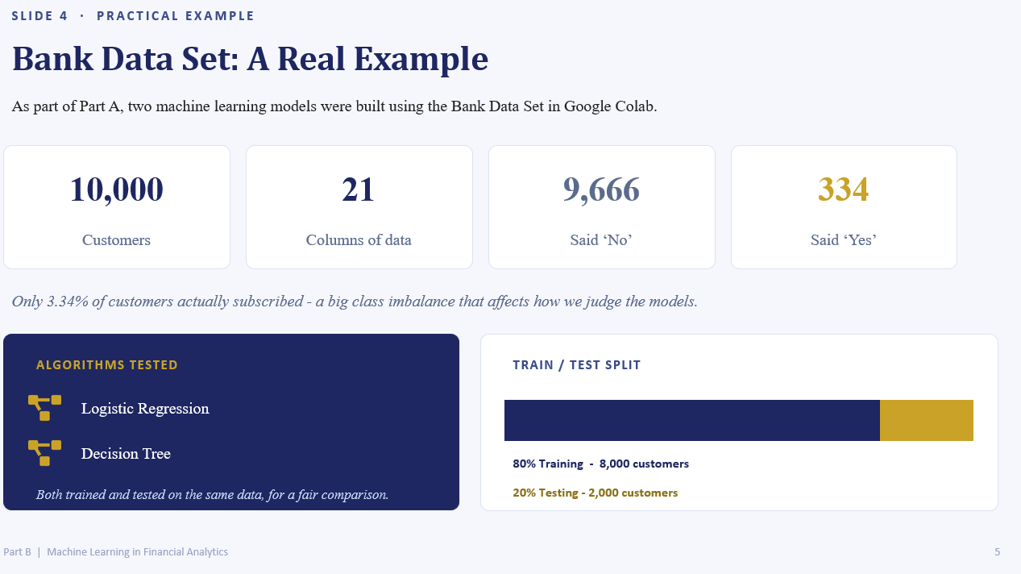
Figure 21: Bank Data Set and Practical Machine Learning Example

This slide link up the theory behind machine learning with the experiment performed in Part A. It presents the size of the Bank Data Set, the target variable and the significant class imbalance. It also points out that Logistic Regression and Decision Tree are two algorithms tested.

Slide 6 - Model Evaluation

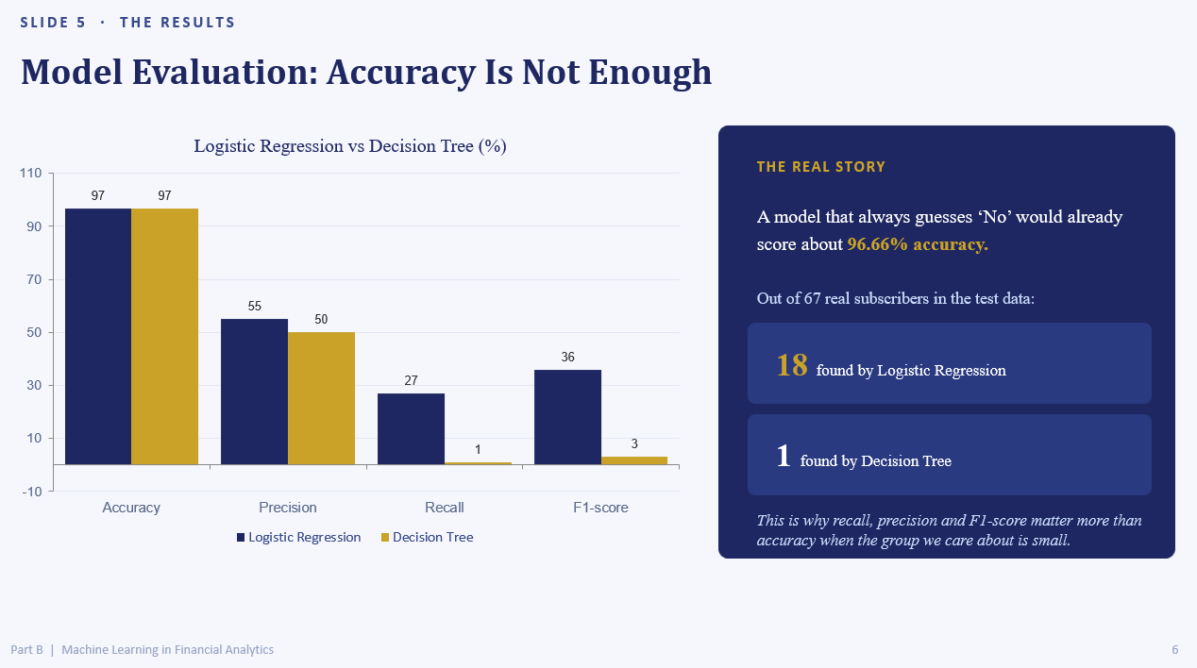
Figure 22: Model Evaluation

This is the actual result that is achieved using the two machine learning algorithms. Logistic Regression had a slightly higher accuracy and much better recall and F1 score than the Decision Tree. The results will show the importance of not only taking accuracy into account, but also the highly imbalanced nature of the target classes.
Slide 7 - Role in Financial Analytics and Customer Insight
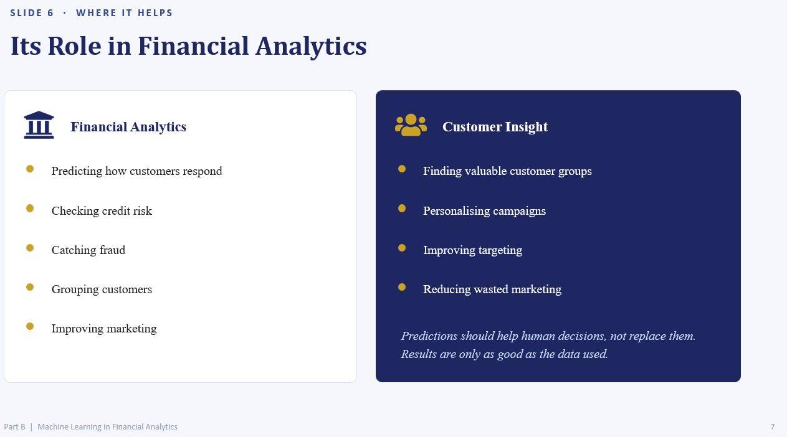
Figure 23: Roles in Financial Analytics

This slide provides an explanation on how machine learning can assist financial organisations in three different ways through customer prediction, risk analysis and fraud detection as well as customer segmentation. It also demonstrates the ways in which customer insights can be utilized for marketing and targeting. The applications show how valuable machine learning is for business application.
Slide 8 - Benefits, Challenges and Ethical Considerations

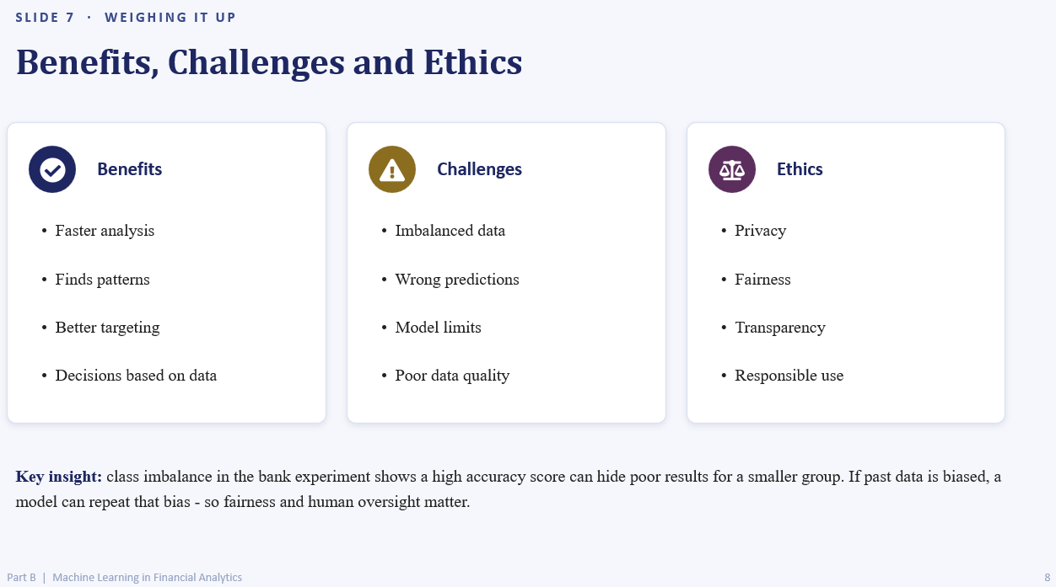
Figure 24: Benefits, Challenges and Ethical Considerations.

This slide provides a summary of key benefits and challenges of using machine learning in financial applications. It points to problems of data imbalance, wrong predictions, privacy, fairness and transparency. These are all points to keep in mind because they will have a direct impact on customers financial decisions.

Slide 9 - Conclusion and Recommendation

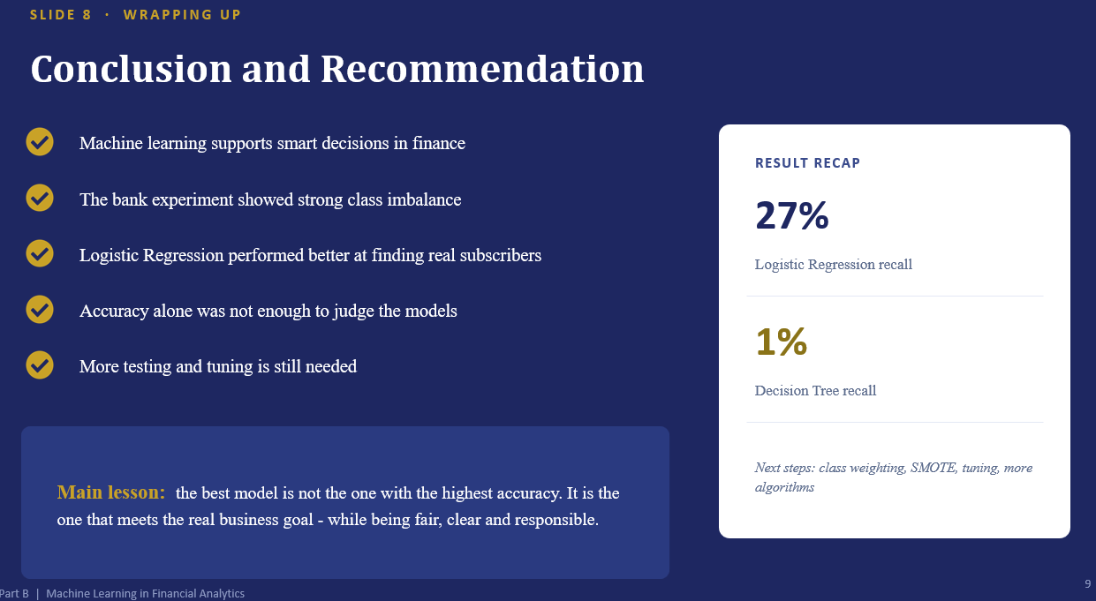
Figure 25: Conclusion and Recommendation

This slide gives a quick summary of the results of the machine learning experiment and presentation. The Logistic Regression model gave a better accuracy than the Decision Tree model but has potential for further improvement to identify the minority subscription class. The slide ends with the conclusion that the business objective is to take into account when deciding on a model and not just the accuracy.

Part C - DEMONSTRATION AND ANALYSIS OF THE MACHINE LEARNING SOLUTION
1. Data Preparation

Before merging the datasets, a variable called wine_type was added to differentiate red and white wines. The entire dataset was checked for missing data, data type and distribution of data quality. There were no missing values found in cleaned datasets.

The original quality score was transformed to the binary classification target. The wines were divided into Low Quality (scores 5 and below) and High Quality (scores 6 and above). This led to 1988 Low Quality and 3332 High Quality observations.

Some of the original quality variables were excluded from input features to avoid data leakage. This variable “wine_type” was coded numerically. The data was then split into 80% training data and 20% testing data which gave 4256 training observations and 1064 testing observations. A similar class distribution was achieved in both sets using stratification.

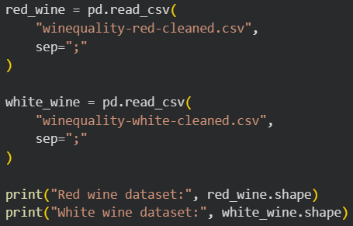
Figure 26: Loading and combining the red and white Wine Quality datasets

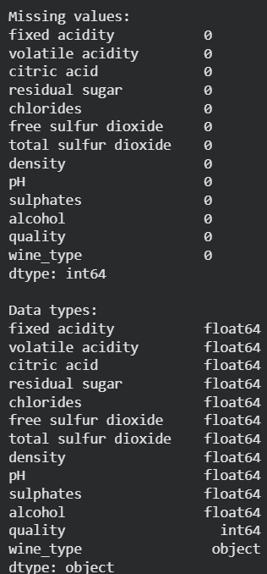
This is the screen shot of the loading and merging of both cleaned sets of data.

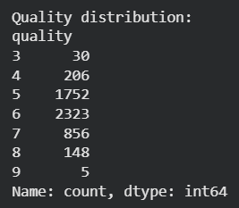

Figure 27: Missing-value check, data types and quality distribution

This is a sample of the data-quality controls that were carried out prior to the development of the model.

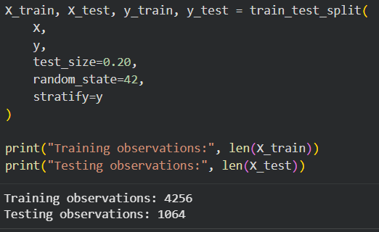
Figure 28: Training and testing dataset split

Here is a screenshot of the 80/20 training & testing split.
2. Algorithm Implementation

Logistic Regression and Random Forest classifiers were chosen as two supervised classifiers.

The relatively simple logistic regression was used as a baseline model to estimate the probability of a wine being associated to a particular quality class (James et al., 2021). Random Forest was chosen because it involves the use of several decision trees and is able to detect nonlinear relationships between the wine characteristics and the quality.

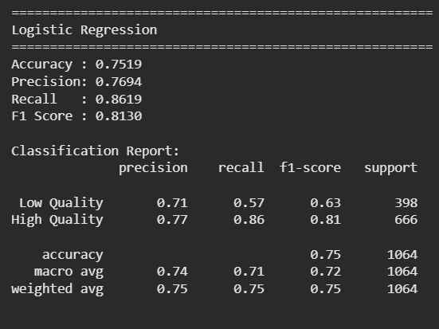
Figure 29: Logistic Regression classification results

The accuracy, precision, recall and f1 score in the Logistic Regression model for the testing data is shown in the screenshot.

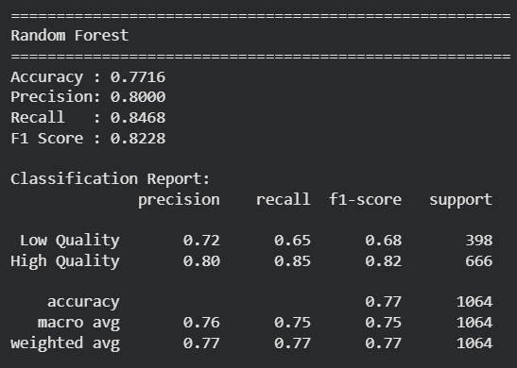
Figure 30: Random Forest classification results

The same testing set was used to get the performance measures of the Random Forest model as shown in the screenshot.
3. Results and Comparison

The results of the models were as follows:

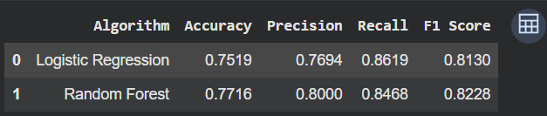
Figure 31: Comparison of Logistic Regression and Random Forest performance

The random forest outperformed all other models on the four metrics. This screen shot shows a direct comparison of the two algorithms performances. It provided an accuracy of around 2% better than Logistic Regression. Moreover, it also provided better precision, recall and F1 scores. This means that the system will be more balanced in recognising Low Quality and High-Quality wines.
4. Confusion Matrix and ROC Analysis

To see the correct and incorrect predictions, confusion matrices were created. What is important in this is that it is not only accuracy that is important but also the nature of the errors produced by a model.

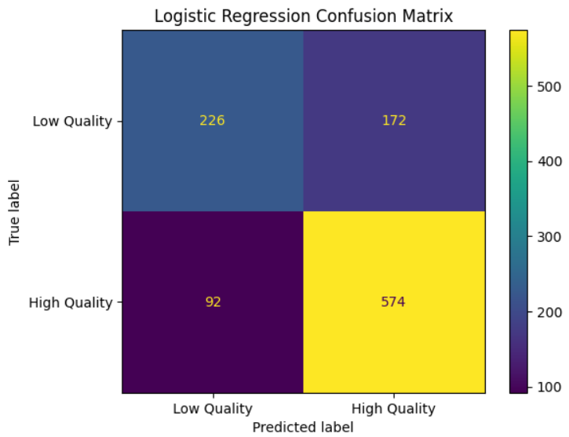
Figure 32: Logistic Regression confusion matrix

The confusion matrix illustrates the accuracies and inaccuracies made by the Logistic Regression model.

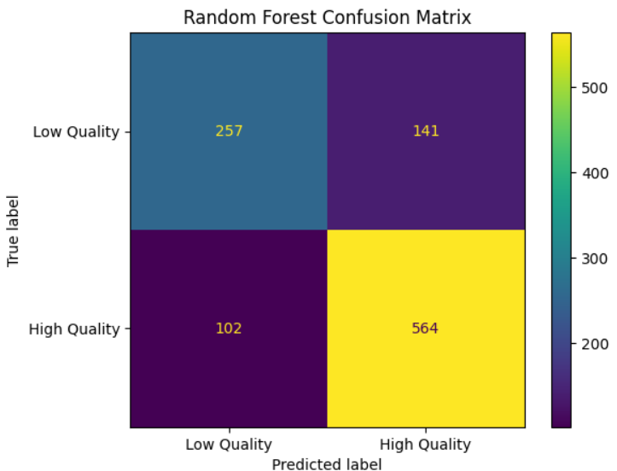
Figure 33: Random Forest confusion matrix

The confusion matrix is another indicator of the classification accuracy of the Random Forest.

A ROC curve was also plotted to assess the performance of both models for different classification levels in order to compare their ability to classify wines between Low Quality and High Quality.

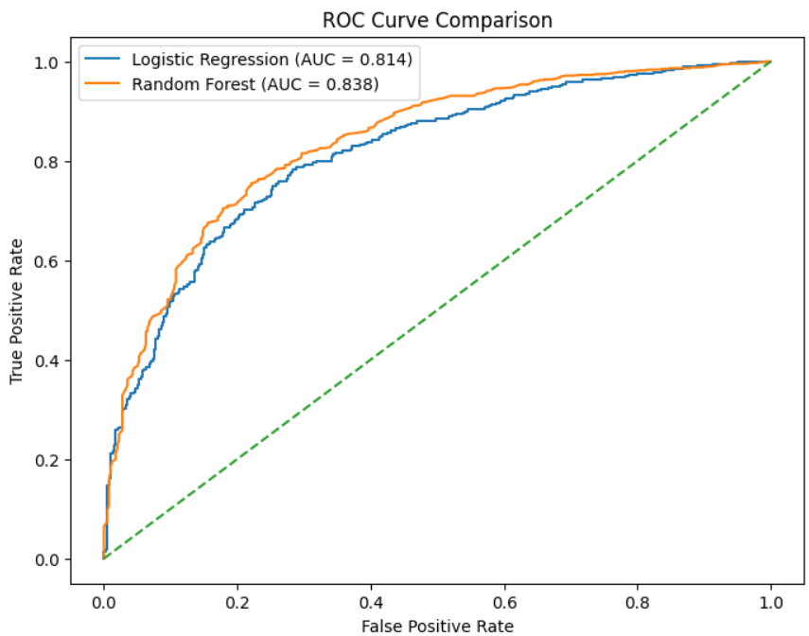
Figure 34: ROC curve comparison

An extra test of the ability to discriminate between the 2 quality classes is given by the ROC curve for the 2 models.
5. Underfitting, Overfitting and Model Balance

Underfitting is when the model is too simple to capture the important pattern in the training data and thus performs poorly on both the training and testing data. When a model learns the training data too well, including all the noise and patterns in the data, it will be very good at the training data and very bad at the testing data.

Testing results in this implementation cannot be used to determine the extent of overfitting as the training performance was not compared to the testing performance. So, neither of them is a right overfitting or underfitting. For this dataset, Random Forest performed better in the testing set than Logistic Regression, indicating that it was useful to model the nonlinear relationships for this data.

Precision, recall and F1-score were used instead of accuracy to assess model balance. Logistic Regression had a higher Recall score (86.19%) which indicated that it was able to capture a greater percentage of the relevant High-Quality cases. Random Forest obtained a better overall precision (80.00%) and F1-score (82.28%) which shows a better precision-recall balance. As a result, the choice of random forest was made as it performed better overall, while logistic regression is useful if the utmost goal is to maximise recall.
6. Critical Evaluation

Random Forest performed better than the other models, as it had the highest accuracy, precision, recall and F1-score. It has a recall of 84.68% which means that it was able to identify a higher percentage of High-Quality wines and a higher F1-score of 82.28% which represents a better balance between precision and recall.

But the difference between the models was not that great. However, there is no need to use Random Forest algorithm merely for accuracy. It has been selected based on the consistent improvement in a number of evaluation measures.

Another way of examining the random forest feature importance was to test which physicochemical variables were the most important for its predictions. The results can be used to help the winery identify variables to study further but do not imply that a variable is directly responsible for the improved wine quality.

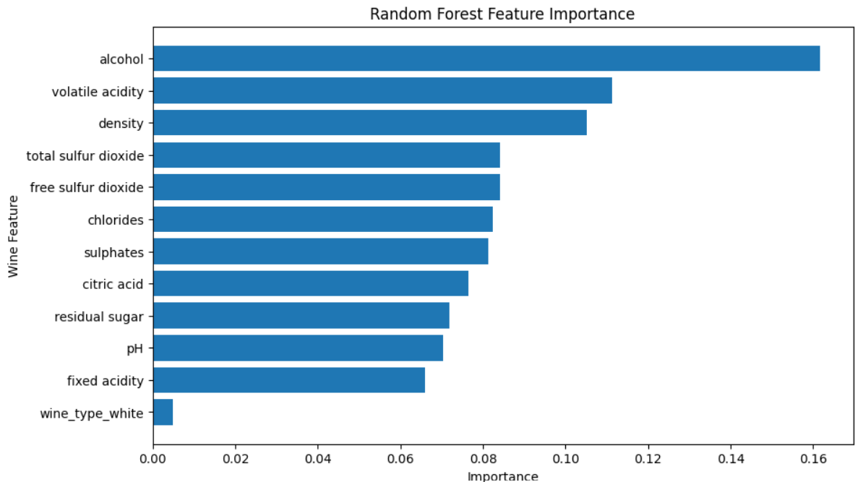
Figure 35: Random Forest feature importance

This is a plot of the relative contribution of the physicochemical features to the Random Forest predictions.

The solution comes with some restrictions as well. The data is not necessarily a representation of the winery's own production, grape varieties or processes. Thus, the model needs to be validated with local winery data prior to commercialization for decision-making purposes. Furthermore, the classification of the original quality score into two classes discards information and there is potential for further development of regression models which predict the numerical quality score.
7. Recommendation

The results indicated that out of all the models, the Random Forest model is the best and is recommended for use. It should, however, be utilized as a decision-support tool as opposed to replacing laboratory analysis or expert sensory assessment, but should be used first.

The winery will gather local production information, test the model against expert evaluations and continually check its performance as new information is received. Overall, the implementation is a proof of the feasibility of using machine learning to help understand wine quality based on the measurable physicochemical characteristics of the wine, but it also shows that the proper test and human expertise are still crucial for good quality decisions.
Overall Conclusion

This assignment showed all the way of investigating and applying machine learning to a real-world business scenario. Part A covered a theoretical background by providing understanding of machine learning, its lifecycle, algorithms, training and testing, types of learning and data pre-processing. In Part B, the concepts were applied to financial analytics and customer insight systems and how machine learning can be used to aid customer prediction, marketing and risk analysis were discussed, along with data quality, bias, privacy and responsible use. The knowledge from the previous sections was used with the Wine Quality dataset in Part C. The red and white wines which were cleaned were merged together and they were prepared for classification. The classifiers Logistic Regression and Random Forest were trained and tested with test data not used during training. Random Forest achieved 77.16% accuracy, 80.00% precision, 84.68% recall and 82.28% F1-score, while Logistic Regression achieved 75.19% accuracy, 76.94% precision, 86.19% recall and 81.30% F1-score. While Logistic Regression had better recall, Random Forest has better performance overall in terms of accuracy, precision and F1-scores. But the data set may not be a true sample of the true conditions of the winery. Therefore, that the model may only be used as a decision-making aid and not as a substitute for laboratory testing or expert evaluation. More validation with local wineries would be desirable to make it more reliable. In general, the assignment presents the entire process of machine learning from theory to business application, implementation, evaluation and evidence-based decision making.

References
Alpaydin, E. (2021) Machine Learning. Cambridge, MA: MIT Press.
IBM (2024) What is clustering? Available at: https://www.ibm.com/think/topics/clustering?utm
Pedregosa, F. et al. (2014) 'Scikit-learn: Machine Learning in Python', Journal of Machine Learning Research, 12, pp. 2825–2830.
IBM (2024) Supervised vs. unsupervised learning: What's the difference? Available at: https://www.ibm.com/think/topics/supervised-vs-unsupervised-learning?utm
Moro, S., Rita, P. and Cortez, P. (2014) Bank Marketing [Dataset]. UCI Machine Learning Repository. Available at: UCI Machine Learning Repository: Bank Marketing
Scikit-learn (2026) train_test_split. Available at: https://scikit-learn.org/stable/modules/generated/sklearn.model_selection.train_test_split.html?utm
Scikit-learn (2026) User Guide. Available at: https://scikit-learn.org/stable/user_guide.html?utm
James, G., Witten, D., Hastie, T. and Tibshirani, R. (2021) An Introduction to Statistical Learning: with Applications in R. 2nd edn. New York: Springer.
Cortez, P., Cerdeira, A., Almeida, F., Matos, T. and Reis, J. (2009) ‘Modeling wine preferences by data mining from physicochemical properties’, Decision Support Systems, 47(4), pp. 547–553.
James, G., Witten, D., Hastie, T. and Tibshirani, R. (2021) An Introduction to Statistical Learning. 2nd edn. New York: Springer.
Pedregosa, F. et al. (2011) ‘Scikit-learn: Machine learning in Python’, Journal of Machine Learning Research, 12, pp. 2825–2830.
UCI Machine Learning Repository (n.d.) Wine Quality Dataset. Available at: https://archive.ics.uci.edu/dataset/186/wine+quality

Appendix A - Part A Codes

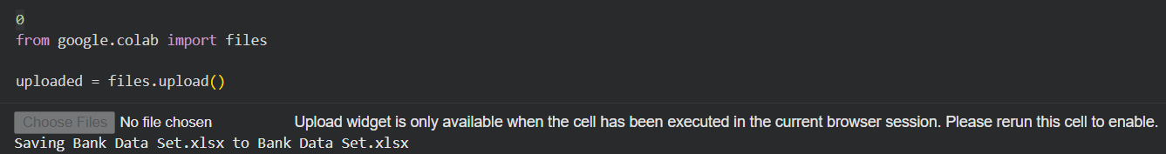
Figure 36: Uploading Bank Data Set

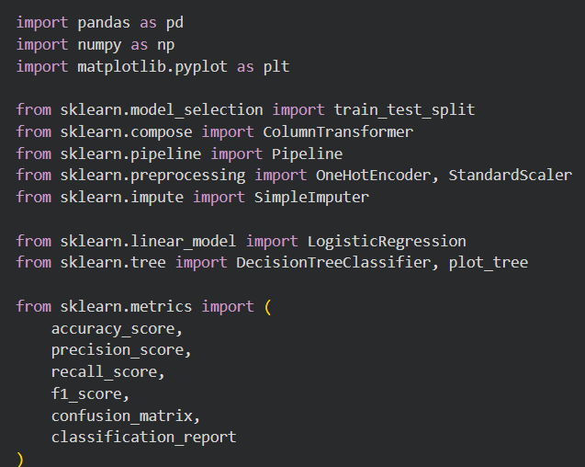
Figure 37: Importing Data Set
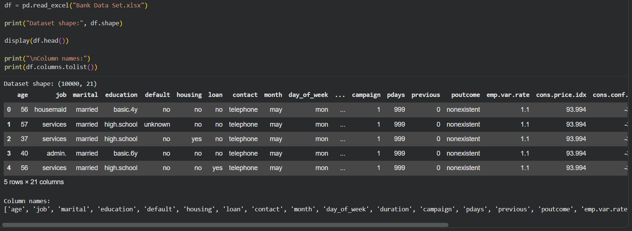
Figure 38: Loading and initial inspection of the Bank Data Set

Figure 39: Data quality checks and target-class distribution
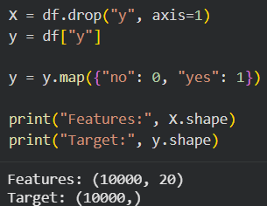
Figure 40: Separate Input and Output

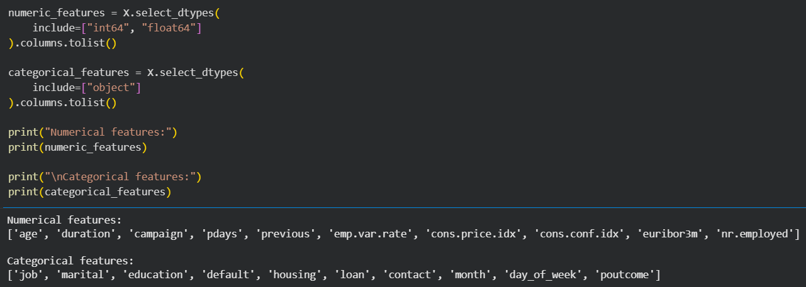
Figure 41: Identifying numerical and categorical variables

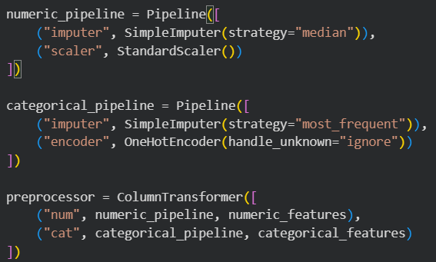
Figure 42: Pre-processing the data
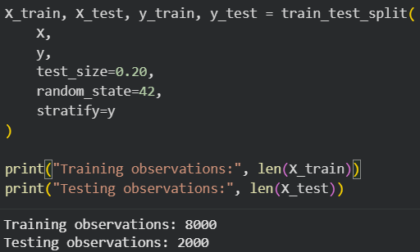
Figure 43: Splitting the dataset

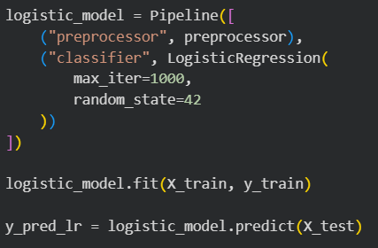
Figure 44: Training Logistic Regression

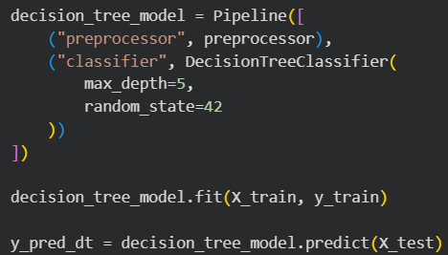
Figure 45: Training Decision Tree
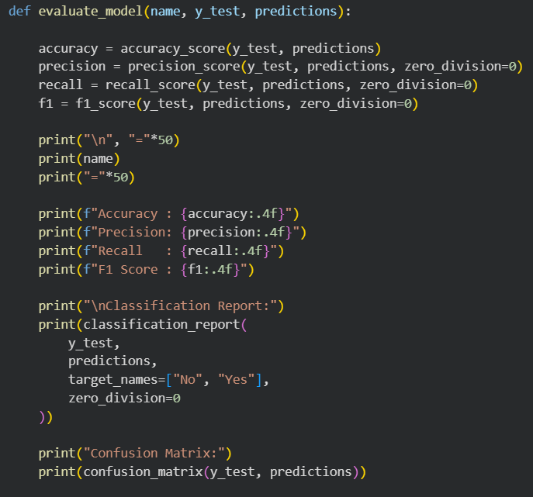
Figure 46: Evaluating both models

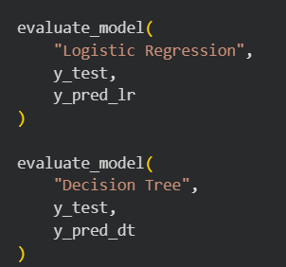
Figure 47: Evaluating both models
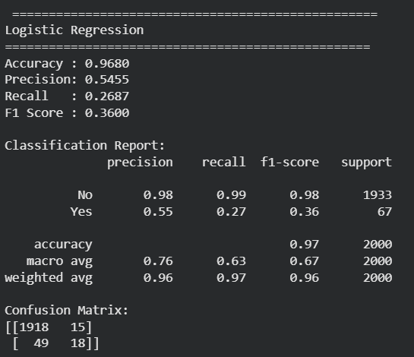
Figure 48: Logistic Regression evaluation results and confusion matrix

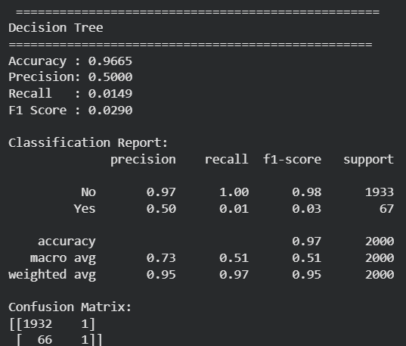
Figure 49: Decision Tree evaluation results and confusion matrix

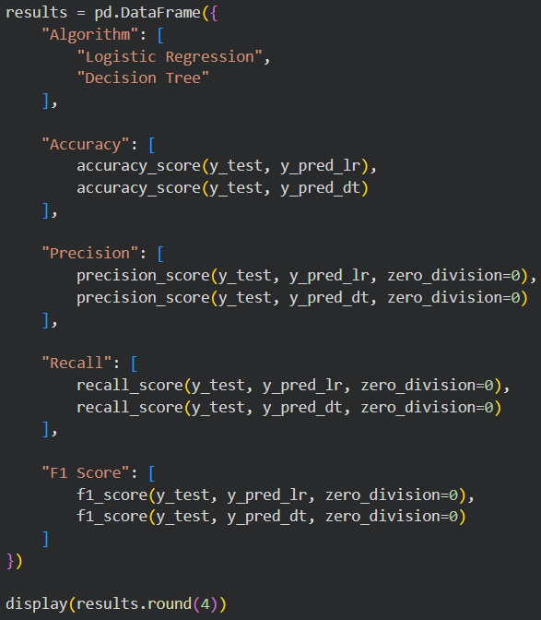
Figure 50: Creating the comparison table

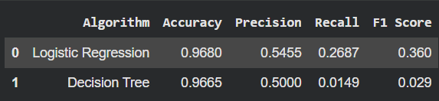
Figure 51: Comparative performance of Logistic Regression and Decision Tree
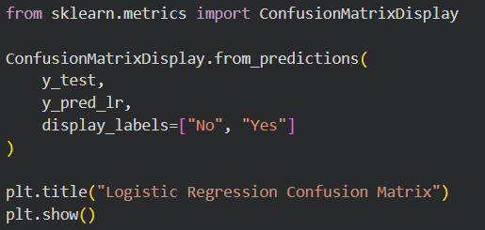
Figure 52: Creating Logistic Regression Confusion Matrix

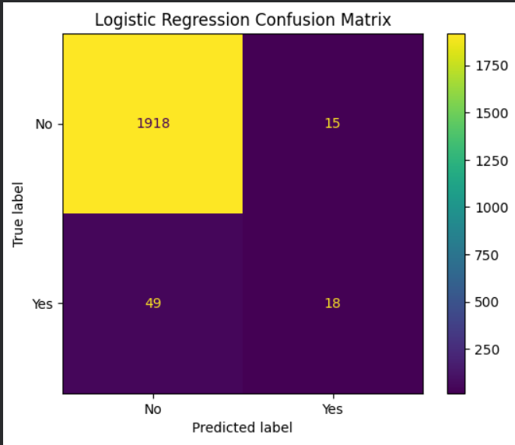
Figure 53: Logistic Regression Confusion Matrix

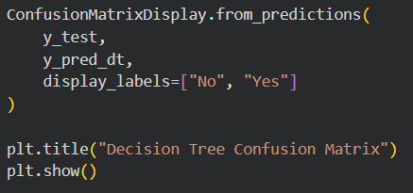
Figure 54: Creating Decision Tree Confusion Matrix

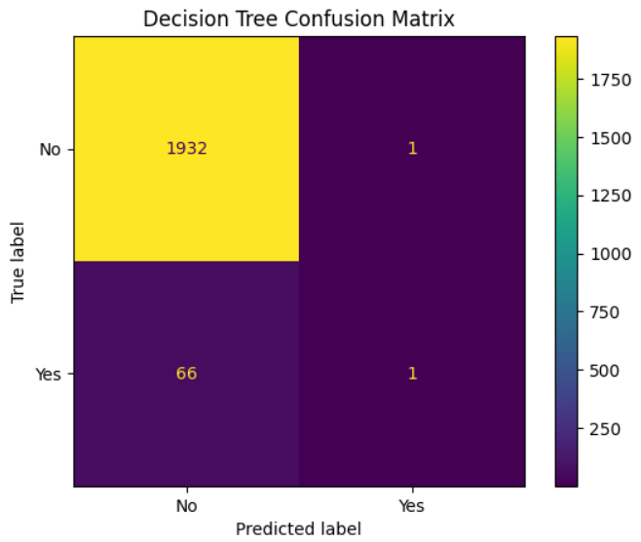
Figure 55: Decision Tree Confusion Matrix

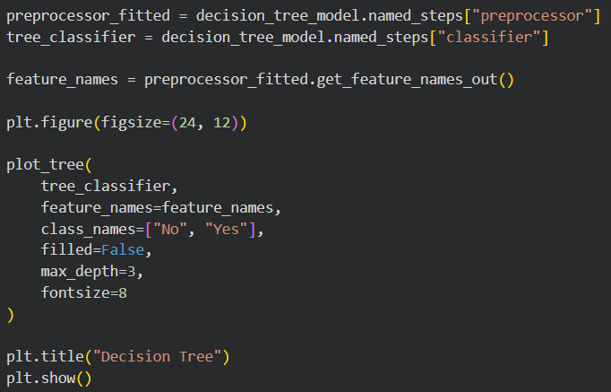
Figure 56: Visualising the Decision Tree

Figure 57: Decision Tree

Appendix B - Part C Codes

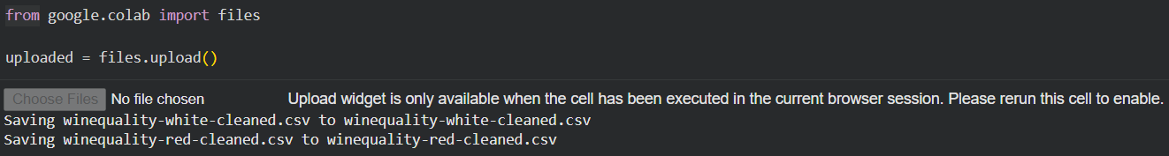
Figure 58: Uploading Both Wine Data Sets

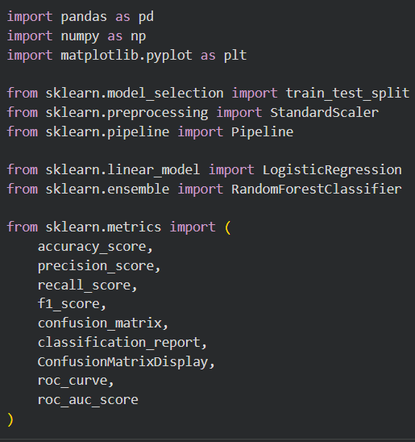
Figure 59: Importing the libraries
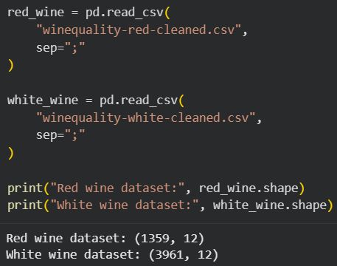
Figure 60: Loading the both datasets

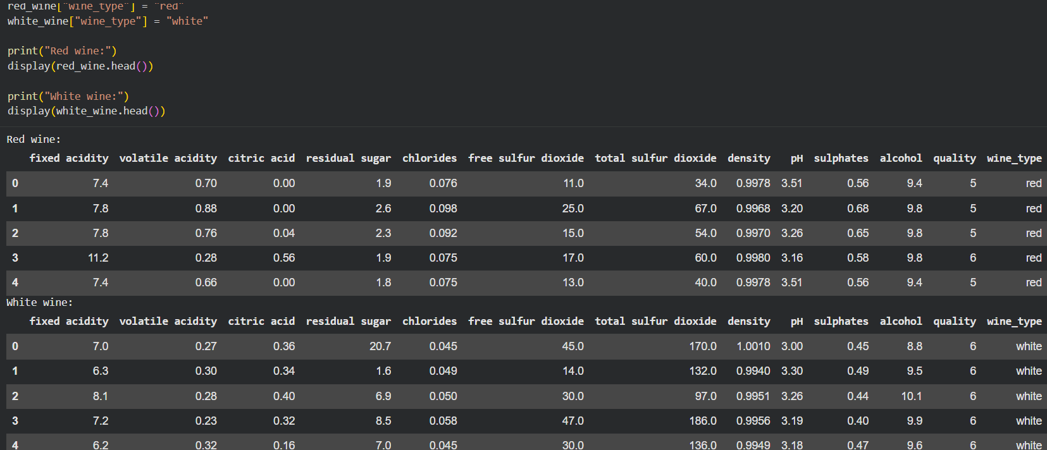
Figure 61: Adding wine type
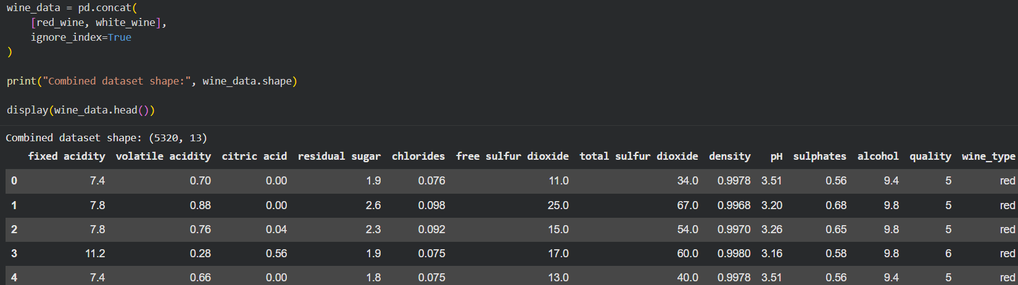
Figure 62: Combining the datasets

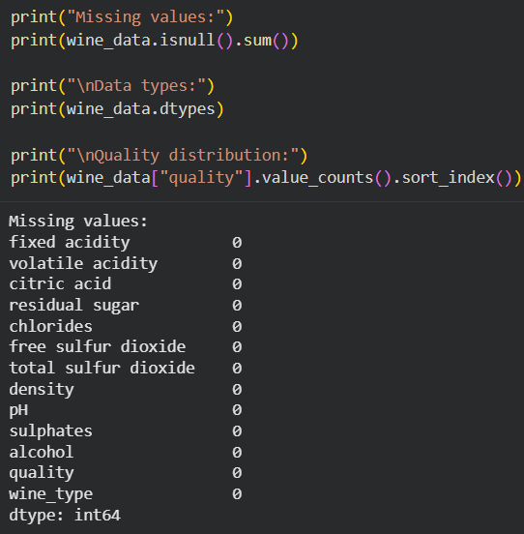
Figure 63: Checking the cleaned dataset
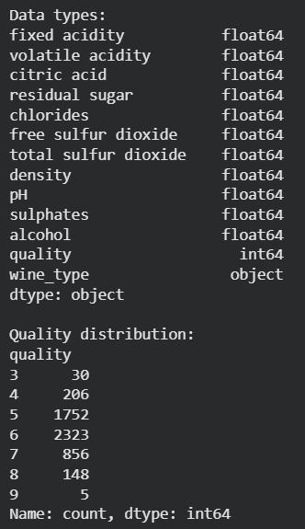
Figure 64: Cleaned data set output

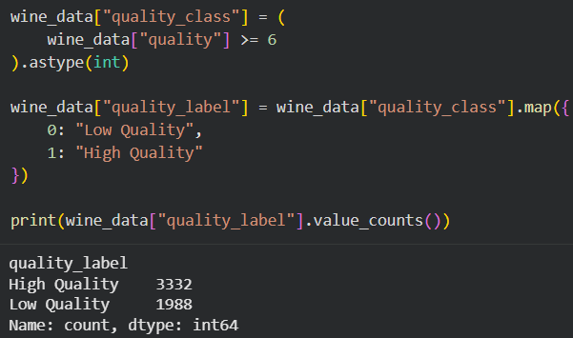
Figure 65: Creating the target variable
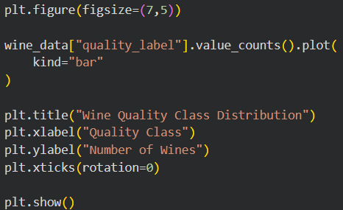
Figure 66: Visualising the target distribution

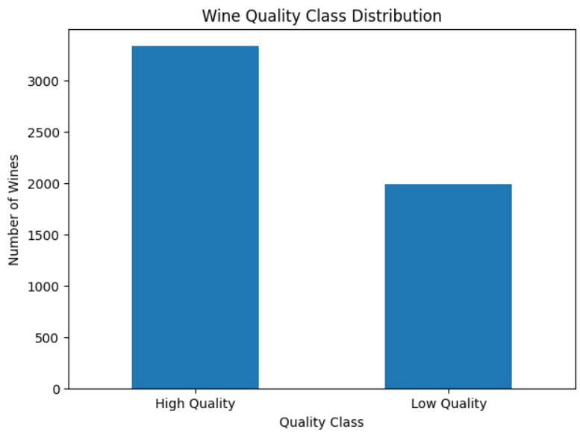
Figure 67: Visual target distribution
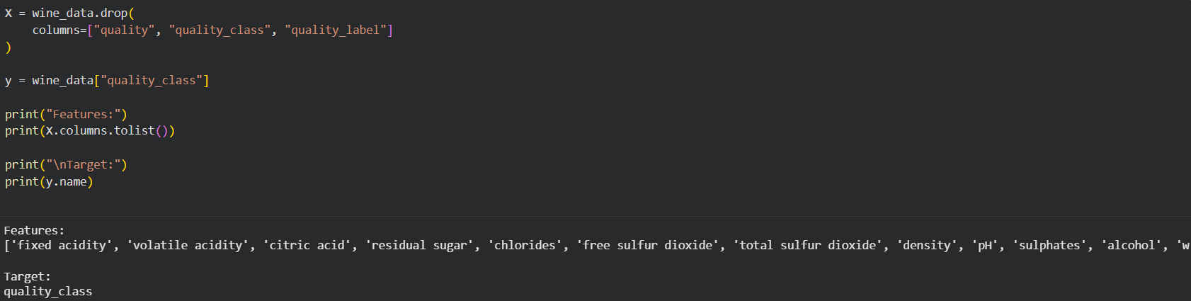
Figure 68: Separating X and y

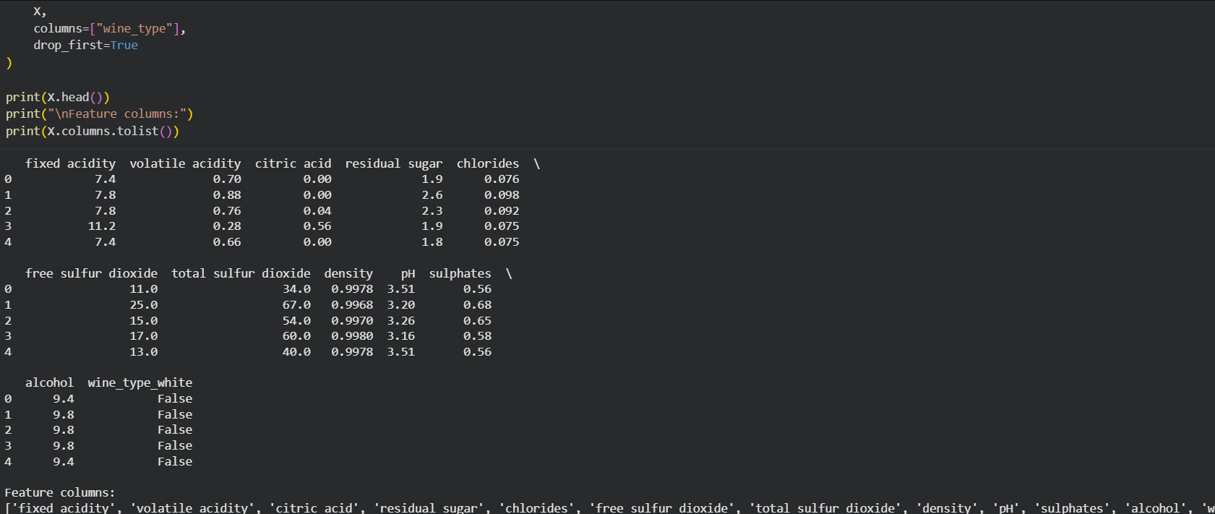
Figure 69: Converting wine type into numerical form

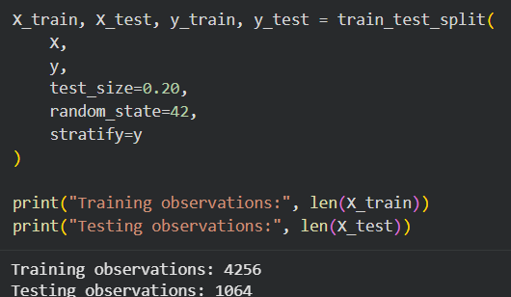
Figure 70: Splitting training and testing data
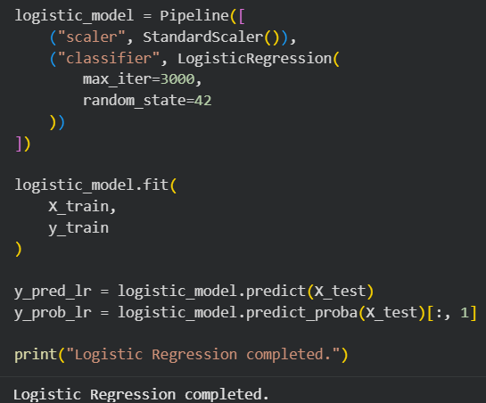
Figure 71: Logistic Regression

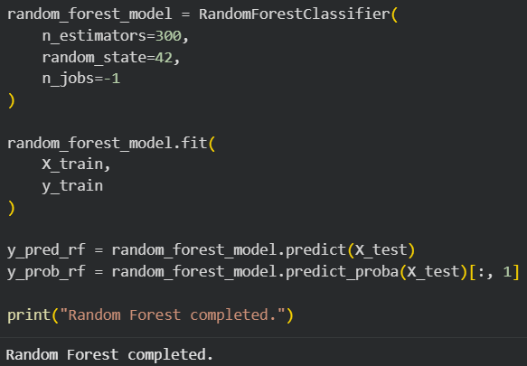
Figure 72: Random Forest
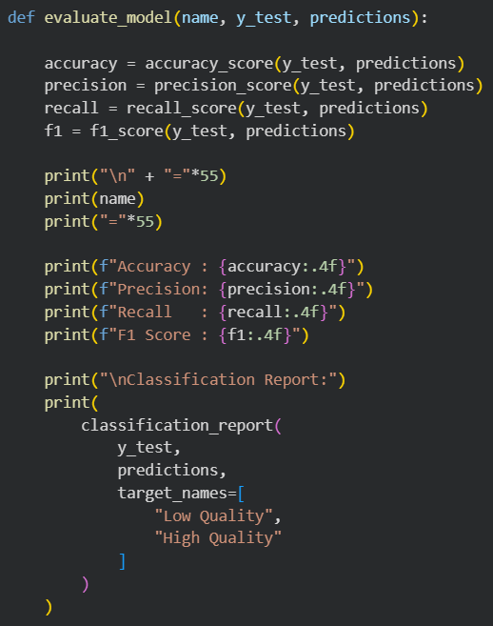
Figure 73: Evaluating BOTH models
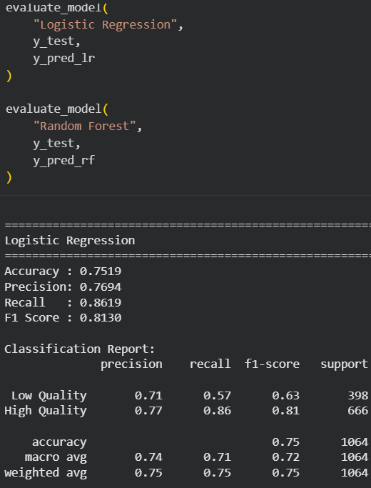
Figure 74: Evaluating BOTH models
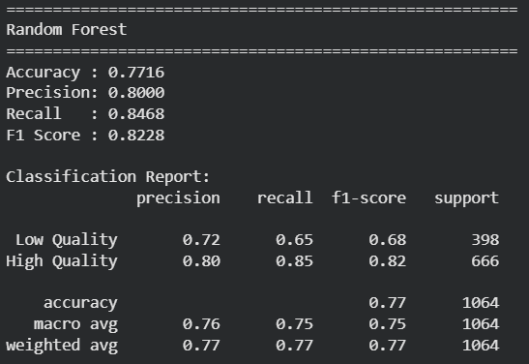
Figure 75: Random Forest Evaluation
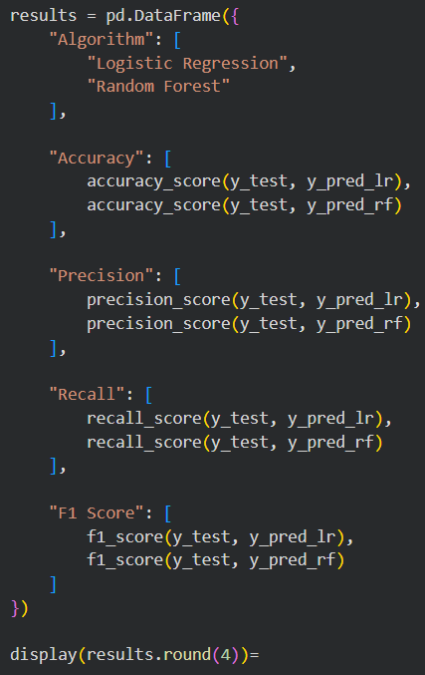
Figure 76: Creating the comparison table

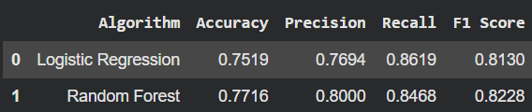
Figure 77: Comparison Table

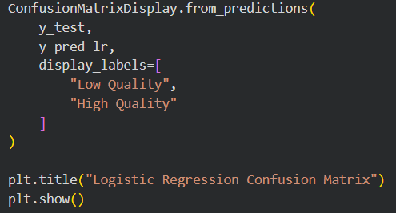
Figure 78: Visualise Logistic Regression Confusion Matrix

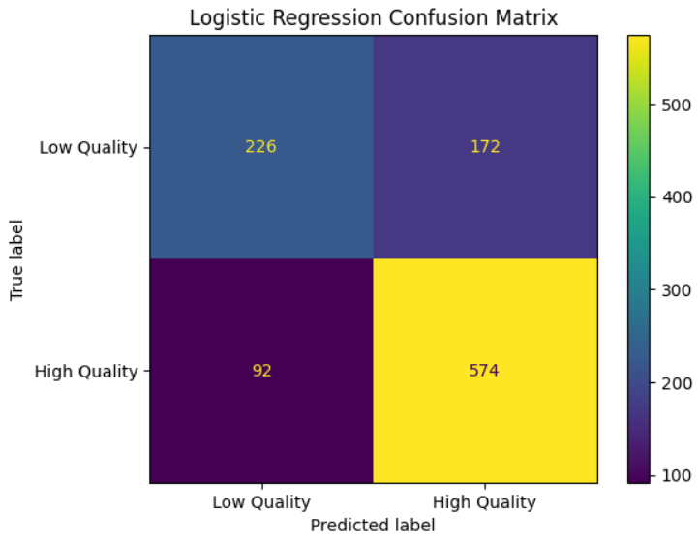
Figure 79: Visual Logistic Regression Confusion Matrix
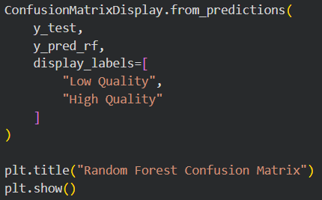
Figure 80: Visualise Random Forest Confusion Matrix

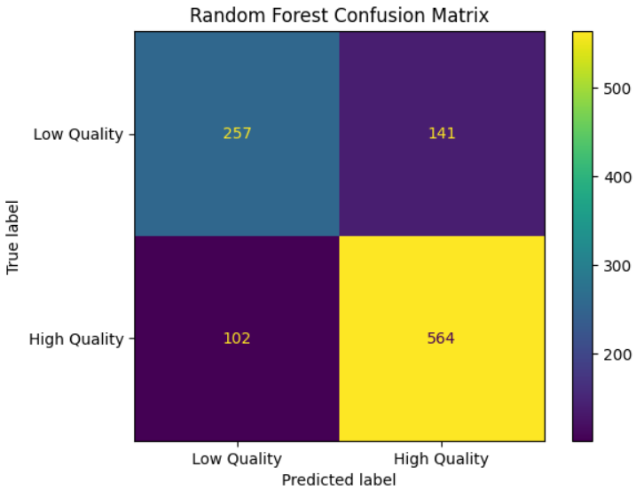
Figure 81: Visual Random Forest Confusion Matrix
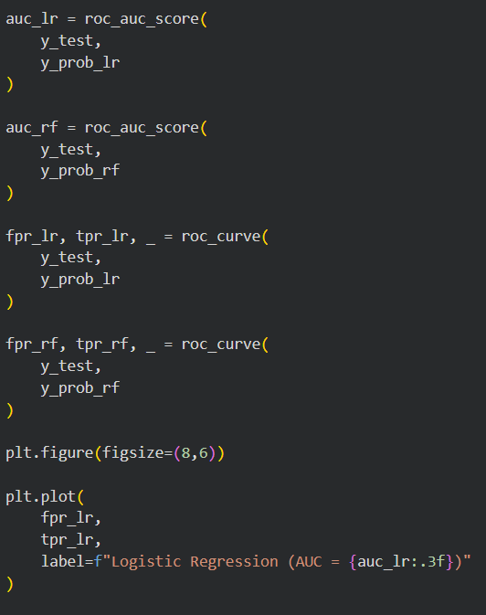
Figure 82: Visualise ROC Curve
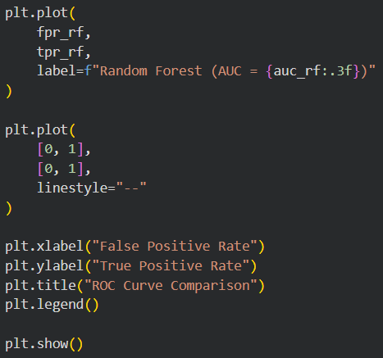
Figure 83: Visualise ROC Curve
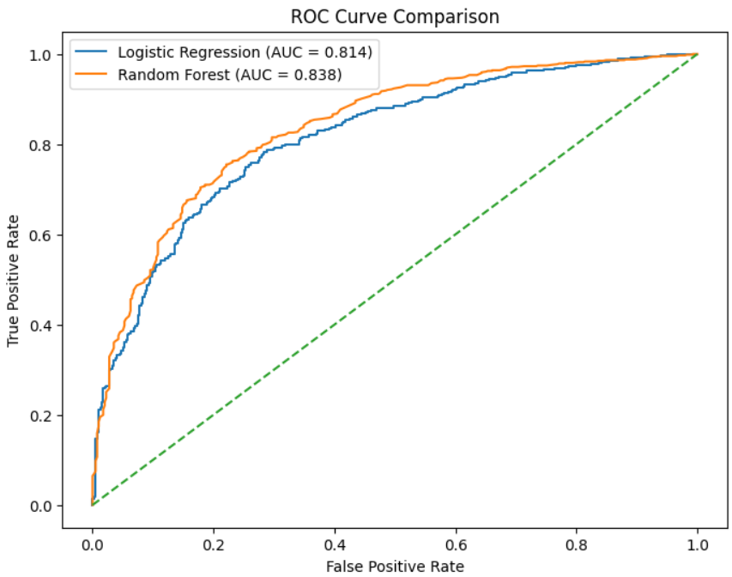
Figure 84: Visual ROC Curve
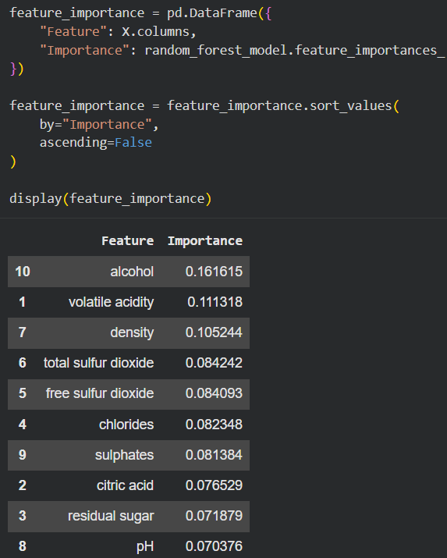
Figure 85: Random Forest Feature Importance
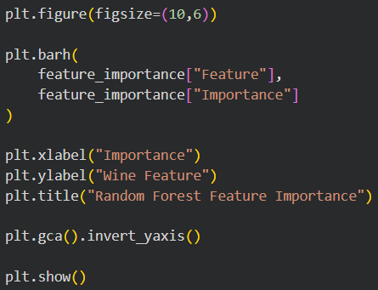
Figure 86: Visualise Random Forest Feature Importance

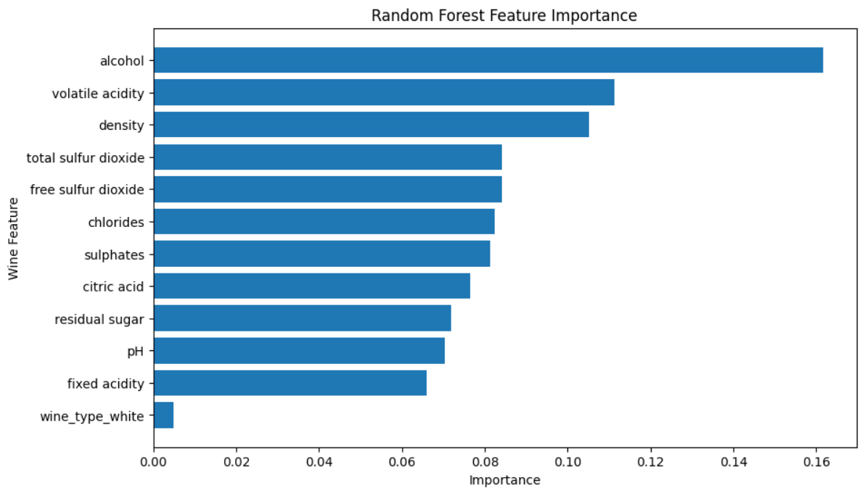
Figure 87: Random Forest Feature Importance
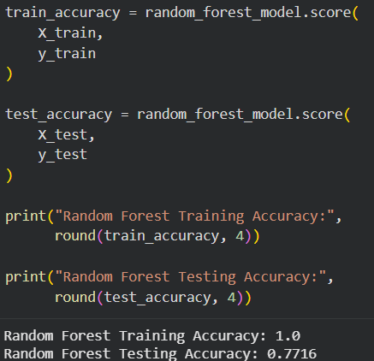
Figure 88: Checking for overfitting

