Big Data Assignment

Afry Nizam
ANC
HND in Computing

Contents
Overall Introduction 5
Task 1 - Big Data and Data-Driven Decision Making 6
1.1 Characteristics and Meaning of Big Data 6
1.2 Complex Data Sources and Forms of LankaMart 7
1.3 Business Value of Big Data 8
1.4 Data-Driven Decision Making 8
1.5 Advantages of Big Data and DDDM 10
1.6 Challenges and Limitations 10
1.7 Future impact on Users and the Organisation 11
Task 2 - Statistical and Graphical Tools and Techniques 15
2.1 Statistical Techniques Used in Industry 15
2.2 Summary of Statistical Techniques 17
2.3 Graphical Techniques 17
2.4 Matching Graphs to Business Questions 22
2.5 Industry-Standard Software and Tools 23
2.6 Assessment of Tool Suitability for LankaMart 24
2.7 Recommended Combination for LankaMart 25
2.8 Critical Evaluation 26
Task 3 - Practical Big Data Analysis and Visualisation 27
3.1 Data Curation, Data Quality and Data Validation 27
3.2 Data Manipulate Automation 28
3.3 Final Interactive Dashboard 29
3.4 Statistical Analysis and Visualisation 30
3.5 Interpretation and Impact on the Decision-Making Process 36
3.6 Recommendations 37
Task 04 - Data Professionals and the Data-Driven Culture. 38
4.1 Data Specialists Roles at LankaMart 38
4.2 Challenges Faced by Data Professionals 39
4.3 Strategies for Effective Data Compliance 40
4.4 Impact on LankaMart's Data-Driven Culture 41
4.5 Recommendations 42
Overall Conclusion 44
References 45

Table of Figures
Figure 1: DDDM Process 9
Figure 2: Bar Chart 18
Figure 3: Line Chart 18
Figure 4: Stacked Column Chart 19
Figure 5: Histogram 19
Figure 6: Scatter Plot 20
Figure 7: Box Plot 20
Figure 8: Map 21
Figure 9: KPI Cards 22
Figure 10: Data Analysis Workflow 25
Figure 11: Data preparation and transformation 28
Figure 12: DAX measure for calculating total revenue 28
Figure 13: DAX measure for calculating total transactions 29
Figure 14: DAX measure for calculating total discount 29
Figure 15: DAX measure for calculating average customer rating 29
Figure 16: DAX measure for calculating total quantity sold 29
Figure 17: DAX measure for calculating average transaction value 29
Figure 18: Power BI dashboard 30
Figure 19: Key Performance Indicators showing overall sales performance 31
Figure 20: Revenue comparison by product categories 31
Figure 21: Revenue performance by branches 32
Figure 22: Revenue contribution of different customer segments 33
Figure 23: Revenue by marketing campaign 34
Figure 24: Revenue distribution by sales channel 35
Figure 25: Top 10 LankaMart products 35
Figure 26: Monthly revenue trend 36

ACKNOWLEDGEMENT

I would like to thank my lecturer of Big Data Analytics and visualization, Ms. Prarthana Weerasekara on her guidance, constant support and encouragement given during the completion of this assignment. The clear explanations and constructive feedback provided along with the real-world examples for Big Data Analytics, Data Visualization and Data Driven Decision Making has immensely helped me develop some understanding of the topic and its use in real world business.

I would also like to express my gratitude ANC Education, especially the academic staff for their support in the academic environment, learning facilities and resources which have enabled the successful implementation of this assignment.

Lastly, I wish to thank my family and friends for all their patient support, inspiration and ongoing encouragement during this time. Their support and encouragement were essential to successfully completing this Big Data Analytics and Visualization assignment on time.

Thank you.

Regards,
Afry Nizam

Overall Introduction

Organisations today gather a lot of data from various sources, such as offline and online transactions, customer loyalty programs, stock management, reviews and marketing initiatives. LankaMart Retail Group gathers the same information, but not using a robust data collection system. LankaMart is tasked with analyzing its complex data and draw conclusions from it and support its effective Data-Driven Decision Making (DDDM).

This report delves into the core principles of Big Data and how the unique characteristics of Big Data and its sources can bring value to LankaMart in various aspects including sales, customer behaviour, marketing, inventory and operational efficiency. It also discusses the DDDM process and the advantages and challenges of using complex datasets. The report then focuses on appropriate statistical and graphical methods such as descriptive statistics, correlation, regression, clustering and forecasting. Other industry-standard tools, which are appropriate for LankaMart are also taken into account. Industry standard tools like Microsoft Power BI, Excel, SQL and Python are counted as suitable depending on their suitability for LankaMart.

The prepared LankaMart dataset is analyzed using a practical analysis in MS Power BI. The data is cleansed, transformed and then analysed in interactive visualisations to gain insight into revenue, transactions, product categories, branches, customer segments, marketing campaigns, sales channels and monthly trends. Findings are explained based on the business needs of LankaMart.

Lastly, the report explores the data professionals and governance as well as data needed to build a data-driven culture. It takes into account roles, data quality, privacy, security, ethical use of data, bias, compliance and skills needs. The report overall shows that there are five pillars for successful implementation of Big Data: reliable data, adequate analytical tools, competent workers, effective visualisation and responsible data governance.

Task 1 - Big Data and Data-Driven Decision Making

1.1 Characteristics and Meaning of Big Data
Big Data refers to dataset which is too big, too fast or too complex to be processed using traditional data-processing techniques. It can help organisations find valuable patterns, relationships and trends in various forms of data (IBM, 2024).
Big Data can assist LankaMart management to know what customers are buying, when they are buying, which products are gaining popularity and how their buying patterns differ between the physical store and online.
These are the major characteristics of Big Data, which can be explained in terms of these V’s.

Characteristic | Explanation | LankaMart example
Volume | Refers to the large quantity of data produced and stored. | Thousands of daily sales transactions, customer records and website visits.
Velocity | Refers to the speed at which data is generated and processed. | Online orders, mobile clicks and payment transactions are produced continuously.
Variety | Refers to the different formats and types of data. | Sales tables, customer profiles, JSON website data, reviews and images.
Veracity | Refers to the reliability, accuracy and quality of data. | Incorrect customer details or duplicate transactions can reduce analysis accuracy.
Value | Refers to the useful business benefit gained from analysing data. | Sales analysis can help LankaMart improve stock planning and reduce waste.
Variability | Refers to changes in data patterns over time. | Demand for certain products may increase during festivals or special promotions.
Visualization | Refers to presenting complex information in an understandable visual form. | A Power BI dashboard can show stock levels, sales trends and high-demand products.

So, it is not enough to have a large database, Big Data is about more than that. The true objective is to convert various data types into valuable information that can help make business-related decisions.

1.2 Complex Data Sources and Forms of LankaMart
LankaMart is fed data in various ways. It is important to understand these forms, since the methods of processing and analysing the data vary depending on the type of data.

Structured data is data that is in rows and columns that are well defined. Some examples are product identification numbers, product pricing, quantity sold, customer identification numbers and dates of transactions. LankaMart can keep this information in relational databases and derive sales and inventories data from the information.

Semi-structured data is not in the form of a table but is somewhat organised. Examples include website logs and data from the mobile application in the form of JSON. This information can reflect customers browsing behaviour, including which products customers look at prior to buying.

The data is not organized in a particular database structure. The customer reviews, social media comments, photographs and written feedback can be categorized as unstructured data. It can be challenging to analyse, but can be helpful for understanding customer satisfaction and opinions about products.
These sources provide LankaMart with a more comprehensive insight into their customers and business. For instance, it could be seen that a customer bought a product and it could be seen that the customer had a number of similar products displayed on a website, before buying the one. The review can then be used to give details of the customer's experience.

1.3 Business Value of Big Data
Big Data has the potential to generate value to LankaMart in a number of critical areas.
Inventory management: LankaMart can predict products that are likely to be required by analysing past sales, seasonal trends and the demand at hand. This can be of benefit in minimising stock out and overstocking.

Customer behaviour: Loyalty data and data on transactions can be used to detect purchasing patterns. Customers, who have been frequent buyers of baby items can even buy specific home items. This data can be used for personalised offers.

Marketing performance: LankaMart can monitor the performance of their marketing efforts by measuring the change in sales in relation to their campaign spending. This can enable management to determine which campaigns generate good results and which campaigns are not adding a lot of value.

Product performance: Management can compare the products according to the sales quantity, revenue, the rating of customers and the number of products being returned. This will enable a review of poorly performing products.

Operational efficiencies: Data from stores and on the web can be used to determine periods of high demand, low periods and differences in demand. This information can be used by managers to optimize staffing and distribution of stock.
Hence, Big Data can assist LankaMart to transition from a reporting-based operation towards understanding the “how” and “what if?” of the situation.

1.4 Data-Driven Decision Making
Data-Driven Decision Making is to rely on solid data and analysis in the decision-making process, not on assumptions or personal opinion to a large extent (Provost, 2013).
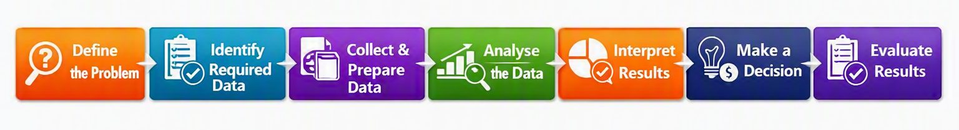
Figure 1: DDDM Process
In the case of LankaMart, the DDDM process can be used in solving the following business problem:
“How can LankaMart minimize their stock out and keep the inventory without needless excesses?”
The process can be done in the following stages.

Stage | Application at LankaMart
1. Define the problem | Identify frequent stock-outs and excess inventory as the main business problem.
2. Identify required data | Collect sales history, stock levels, supplier information, product details, promotions and seasonal information.
3. Collect and prepare data | Combine data from stores, online sales and inventory systems. Remove duplicates and correct obvious errors.
4. Analyse the data | Use averages, trends, correlation and forecasting to understand demand.
5. Interpret results | Identify products with increasing demand, slow-moving products and periods of high demand.
6. Make a decision | Adjust reorder quantities and stock allocation based on evidence.
7. Implement the decision | Apply the new stock-planning approach in selected branches and online operations.
8. Evaluate results | Compare stock-outs, excess inventory and sales before and after the change.

For instance, if a certain product has been identified as having an increased demand during weekends and promotional events, it may be valuable to consider promoting it during those periods. LankaMart can now restock the products ahead of time rather than when they're out of stock. Meanwhile, those products that consistently have low demand can be ordered in smaller quantities.
This is a good illustration of the way that DDDM can relate data analysis directly to a real business decision.

1.5 Advantages of Big Data and DDDM
This has several benefits, among them being increased decision accuracy. Managers can make use of evidence provided by multiple data sets, not just from assumptions. But a right decision is dependent on right data. The conclusions that can be drawn from poor quality data are misleading.
The other benefit is quick identification of business trends. Automated dashboards can enable managers to check sales and inventory more often than the time-consuming time required to create spreadsheet reports.

Big Data also enhances customers understanding. When there is integration between loyalty data and buying activity and online activity, LankaMart can better understand the various groups of customers and be able to offer more targeted promotions.
Improved forecasting is another advantage that may be offered by it. The estimates of future demand can be based on the historical sales patterns. This is particularly helpful in case of planning stocks for a specific occasion of the year.
Lastly, Big Data can give a competitive edge. A retailer who knows the customer's needs before they are known to the market will be able to react to the market changes more effectively.

1.6 Challenges and Limitations
However, Big Data presents some challenges.
Data quality is an issue of very great concern. Results may be impacted by missing data, duplicate transactions and incorrect product data.

Data integration can also be challenging as LankaMart's systems might be storing data in various formats. A combination of online, store and customer data demand proper data preparation.
This is also important privacy and security. Ensuring that customer information is protected against access from unauthorised users. LankaMart should implement the necessary security measures and abide by the relevant data protection laws.
Bias has the potential to influence decision making. As the data available may be limited to a subset of customers, the analysis may not be representative of the entire customer base.

There is a skills and cost problem too. Along with the training of employees, the appropriate software, secure infrastructure and constant upkeep are necessary requirements for Big Data systems.
Lastly, information overload can be created by giving too much information. Having dozens of useless charts on a dashboard can make decisions more difficult than decisions would be with less clutter. Thus, the measures that should be taken by LankaMart should be those related to business.

1.7 Future impact on Users and the Organisation
LankaMart Retail Group is likely to undergo significant changes in terms of how it will operate in the future as it adopts Big Data Analytics. These changes may impact manager, employee, customer, supplier and the organisation. Big Data can deliver significant advantages, like quicker decisions, more accurate forecasting and better customer service. It can also present privacy and cybersecurity challenges, as well as skill and quality of data issues among employees. Hence the future effects would be dependent on how responsible LankaMart is in the implementation and management of its Big Data systems.

Impact on Management and Decision Making
Big Data can transform the decision-making process of managers. Currently, LankaMart is operating with spreadsheets and static reports, which may not make it easy to detect significant trends promptly. Interactive dashboards and real-time alerts could enable managers to keep track of sales and inventory more efficiently in the future. For instance, managers can be alerted to when a well-known product is running low. This would enable them to act before it's too late as product is no longer available.

Big Data can also help LankaMart transcend from reactive decision making to predictive decision making. Past sales activity, seasonal patterns, promotions and customer behaviour can be used to predict future customer demand. This can help to optimize inventory management and minimize stock-outs and overstocking. But predictions aren't always accurate, as there are unpredictable market conditions which can alter customer demand. Managers will thus still have to take a creative approach to using analytical findings and combining them with human judgement.

Impact on Employees
LankaMart employees will have to acquire different skills with the introduction of Big Data. The use of manual data entry in spreadsheets and the process of reporting could be reduced if more data is collected and reported automatically. New skills like data analysis, creating dashboards and interpreting data could be more valuable.

This can help the worker avoid repetitive tasks and concentrate on more value-added tasks. But staff who lack the appropriate digital skills can struggle to adapt. Thus, training and development programmes should be offered by LankaMart. This will help employees familiarise themselves with new technologies and minimise resistance to change in the organisation.

Impact on Customers
Customers can be provided with improved access to products and more tailored services. LankaMart can then use that information to make more relevant product recommendations and promotional offers, based on the purchase history, loyalty information and the online activity of its users. More accurate demand prediction can also help mitigate the risk of best sellers out of stock.
But with more personalisation, there can be privacy issues. Excessive monitoring of customers shopping and online activities may cause them to be uncomfortable. LankaMart have to responsibly handle the information provided by their customers and offer adequate privacy protection. When customers feel good about the organisation, personalisation can build trust and enhance the customer relationship, but when it’s performed improperly, it may harm trust.

Impact on Suppliers and Operations
By enabling LankaMart to gain more insights into the demand of products in the future, Big Data can benefit the relationship between LankaMart and its suppliers. For instance, if they find that the demand for a product rises regularly during a specific time period, LankaMart can place an order for more stock ahead of schedule and can let suppliers know about the need.

This can help to make the supply chain more efficient and avoid stockouts. But the wrong or incomplete information can lead to erroneous forecasts and poor purchasing decisions. Thus, supplier planning should be updated often to check with actual sales.

Impact on Organisational Performance and Competition
The use of Big Data can help to streamline LankaMart's reporting process, making it less time-consuming and easier to handle, while also providing valuable assistance to automation processes. Predictive analytics can be used to forecast demand and products that are moving slowly and enable the organisation to allocate its resources and budget more efficiently.

Big Data can also give a competitive edge as LankaMart can get a better indication of customer preferences and market demand sooner. But, buying Big Data technology is not the answer to success. Competitors can employ comparable technologies and the importance of analytics lies in its ability to generate effective business actions from them if LankaMart can.

Cybersecurity and long-term Risks
With the addition of more and more customer and business data in LankaMart, Cyber Security is becoming more important. Leaks of customer information may lead to a loss of that data, which in turn may disrupt operations and result in financial loss. It could also harm the organisation's reputation and customer trust.

Thus, LankaMart must invest in robust access control systems, data protection measures and security awareness initiatives among their employees. Data quality and governance needs to be reviewed on an on-going basis, as poor-quality data can result in poor quality decisions.

Task 2 - Statistical and Graphical Tools and Techniques

2.1 Statistical Techniques Used in Industry
Descriptive Statistics
Descriptive statistics are used to summarise a dataset by using mean, median, minimum, maximum and standard deviation.

The mean can represent the average number of items sold per day in a particular branch or product at LankaMart. If there are some sales days which are extremely high, then the median can be useful. The standard deviation can indicate the amount of variation or dispersion in a set of sales data from their average.
For instance, two branches with a similar mean number of sales may have a vastly different standard deviation and thus more variable sales for the second branch. This information can be used to help the management determine the reason for performance changes.

Correlation Analysis
A correlation is a measure of the direction and strength of the relationship between two variables. LankaMart could study the correlation that exists between promotional expenditure and sales turnover.

If there is a strong positive correlation this is suggestive that a higher spend on promotion equals a higher sale. But correlation does not necessarily mean causation. Other details, like seasonality, discount and customers demand also can affect sales.

Regression Analysis
Regression can help to interpret relationships between variables and predict values.
For instance, LankaMart may be able to predict the number of sales by considering factors such as spending on advertising and the discount offered, as well as the previous sales and the seasonal climate. This may aid managers in their knowledge of what factors are related to revenue changes.

A regression would thus be more useful than just comparing two values as it could take into account several variables.

Forecasting
Forecasting, based on the historical patterns, estimating what is likely to happen in the future. This is helpful for the inventory problem of Task 1.

LankaMart can determine the demand of the previous weeks or months and predict the demand of the next week/month. If there is a period of high demand, forecasting could be used to decide on the order of units prior to the demand.
Forecasts are only estimates. The actual demand may change, as a result of unforeseen events, economic shifts or customer behaviour.

Sampling
For some investigations, not all records might need to be analysed as the dataset is very large. Sampling is a process of choosing a smaller group that is representative of a larger group.

LankaMart may conduct a study on a representative sample of customers on their satisfaction with their mobile app. The choice of an appropriate sample can save in time and expense of analysis and yet yield useful information.
However, bias can be a problem if the samples are not collected properly. The sample should be representative of those segments of customers who are relevant.

Classification
Classification allows records to be categorized in a predetermined manner. LankaMart can categorize its customers into a number of segments like low, medium and high purchasing activity.
It may also break down the products into categories like High-Risk Stock Out, Stock Level and Slow-Moving Stock. This might assist managers to prioritize actions.

Clustering
A method of grouping records together without having known categories.
By analysing the purchasing behaviour of their customers, LankaMart might uncover groups of customers with similar characteristics. One group might tend to purchase household items, whereas the other might purchase mainly personal-care items and electronics.
These groups can then be a basis for segmentation and targeted marketing of customers.

2.2 Summary of Statistical Techniques
Technique | Main purpose | LankaMart application
Descriptive statistics | Summarise existing data | Average and variation in branch sales
Correlation | Identify relationships | Promotion spending and sales
Regression | Analyse and predict relationships | Factors affecting revenue
Forecasting | Estimate future values | Future product demand
Sampling | Analyse a representative subset | Customer satisfaction survey
Classification | Assign data to known groups | Product stock-risk categories
Clustering | Discover natural groups | Customer segmentation

These techniques should not be used as alternatives. The proper technique will vary depending on the question of the business and the type of data involved.

2.3 Graphical Techniques
Visualizing statistical results makes it easier for non-technical managers to understand.

2.3.1 Bar Chart
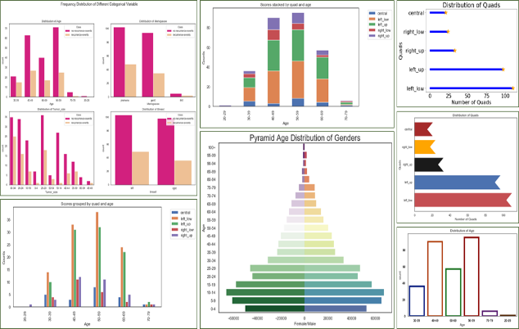
Figure 2: Bar Chart
A bar chart is used to compare values of two categories. Each category will typically be plotted on one axis and the value for each category on the other axis. LankaMart could compare the sales revenues of various product categories like groceries, electronics and household products by using a bar chart. It can also measure different branches performance. This enables the managers to easily tell which branch/category is selling the most and the least. Hence, a bar graph would be appropriate for use when LankaMart wants to show comparisons among distinct groups.

2.3.2 Line Chart
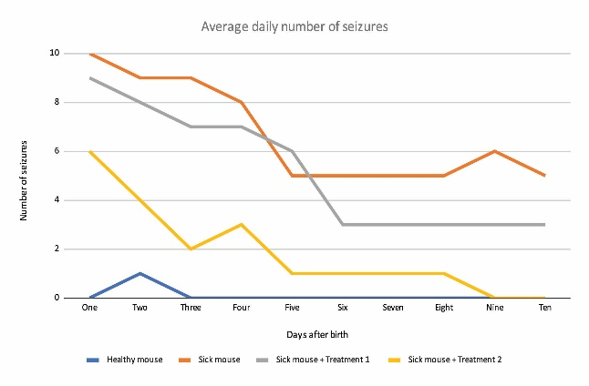
Figure 3: Line Chart
A line chart is primarily used to record the changes of values over a period of time. It's helpful in detecting trends, rising or falling data and repeating patterns related to business data. LankaMart can utilize a line chart to show the monthly sale, weekly order or changes in inventory levels. For instance, in the case of the product, it can be determined if the product demand is going to rise before the season. This can also be compared online vs in store. So, line charts can be used to track trends and to plan for the future.

2.3.3 Stacked Column Chart
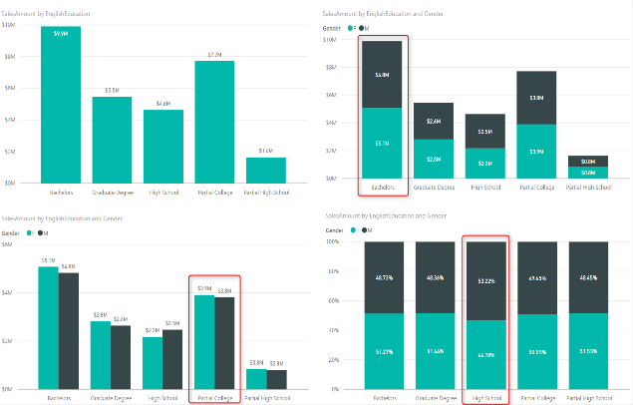
Figure 4: Stacked Column Chart
A stacked column chart is a chart that uses multiple columns in each column to represent a total value and how it is split. This chart can be used to compare sales of products of different categories from different branches of LankaMart. For instance, one column might be a branch and the various parts of the column groceries, electronics and household items. This enables managers to view the overall sales as well as the contribution of each category. Can also be used to make comparisons of sales for different months. When LankaMart wants to know total performance and the contribution of each category, then stacked column charts will be useful.

2.3.4 Histogram
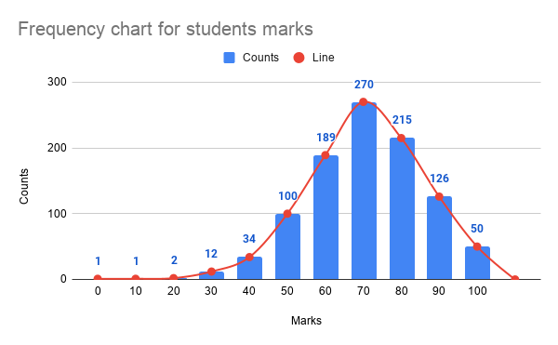
Figure 5: Histogram
Histograms represent the distribution of data that are numerical and are divided into ranges or intervals. A histogram is different to a bar chart because the intervals or classes are continuous numerical values. LankaMart can use histogram to examine the distribution of values of the transactions by its customers. For instance, it might present the number of transactions that are in a range, e.g., Rs. 1,000 to Rs. 2,000 or Rs. 2,000 to Rs. 3,000. This can assist managers to determine if the majority of customers make small, medium or large purchases. Thus, a histogram can help to determine the general shape and range of a set of numbers.

2.3.5 Scatter Plot
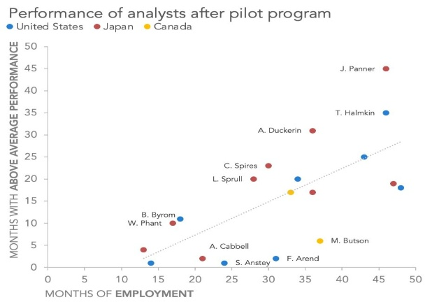
Figure 6: Scatter Plot
To investigate the relationship between two numerical variables a scatter plot is used. The points are observations and each point has data for both variables. A scatter plot could be used to compare sales revenue with the marketing expenditure of LankaMart. When the points are trend upward, it could mean that the higher the amount invested in marketing, the higher the number of sales. We need to analyze the graph along with some information about the context in order to determine whether or not the increase in sales was directly caused by the increase in marketing expenditures. Thus, a scatter plot can be used to determine if there is a potential relationship that can be analyzed statistically in the future correlation or regression.

2.3.6 Box Plot
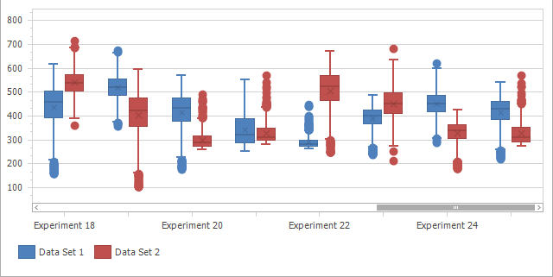
Figure 7: Box Plot
The distribution and variation of numerical data are displayed by a box plot. It can display the median, the range of values and potential outliers. Box plots can be used to compare the values of the transactions made in various branches of LankaMart. For instance, some transactions in one branch may be very high value, but there are also some very unusual transactions as well. This data can assist managers to recognise the variations in the way customers spend at different stores. So, box plots are helpful if LankaMart wants to look at how values are spread out across a data set and determine if there are any values that are unusual.

2.3.7 Map
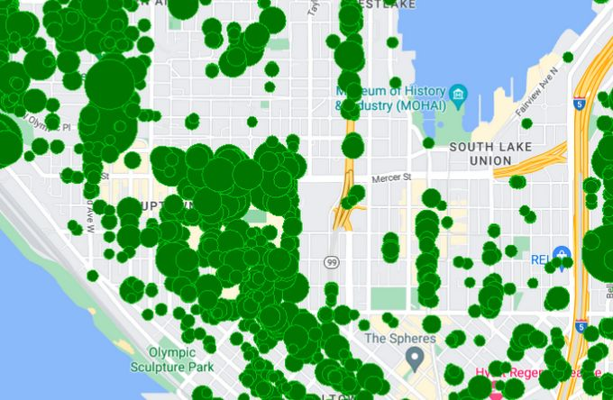
Figure 8: Map
A map visualisation can be beneficial when the whereabouts of the data is significant. With maps, LankaMart can visualize the sales result of different Cities, Districts or Regions in Sri Lanka. The size or shading of a cell can be used to represent different values to indicate a high or low number of sales. For instance, the management may recognize areas in which demand for products is especially high. This data can aid in the stock distribution, new branches and regional marketing campaigns decisions. Therefore, maps are suitable for analysing geographical patterns that may not be obvious in a normal table.

2.3.8 KPI Cards
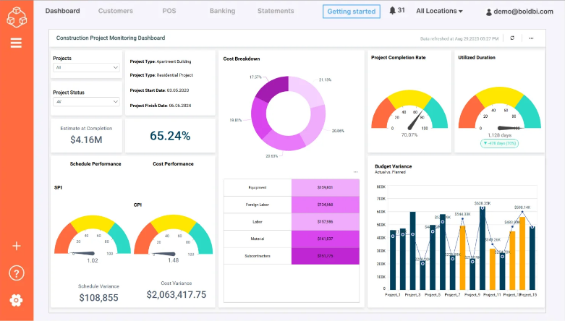
Figure 9: KPI Cards
KPI cards are simple pieces of visual information that show vital business metrics in a comprehensible manner. Using KPI cards, LankaMart can display statistics like total sales, total orders, inventory value, stock-out rate and average transaction value. These key players can be viewed easily by managers without having to delve into a long list of data. KPI cards can be particularly beneficial at the top of a management dashboard to give a quick overview of business performance. They can also be contrasted with other periods or against business goals to help determine if they are improving. Hence, KPI cards can be used for tracking the key business metrics.

2.4 Matching Graphs to Business Questions
Business question | Suitable visualisation | Reason
Which category generates the highest revenue? | Bar chart | Easy comparison between categories
How are sales changing each month? | Line chart | Shows time-based movement
Which branches have the highest sales? | Bar chart or map | Supports branch comparison
Is marketing spending related to sales? | Scatter plot | Shows possible relationships
Which products have unusual sales values? | Box plot | Highlights variation and outliers
How is inventory changing? | Line chart | Shows stock movement over time
What are the main KPIs? | Dashboard/KPI cards | Gives managers a quick overview
Choosing the correct graph is important. A visually attractive chart is not automatically a useful chart. The visualisation should answer a specific business question and avoid unnecessary complexity.

2.5 Industry-Standard Software and Tools
Microsoft Excel
Data cleaning, calculations, pivot tables, charts and basic statistical analysis is a common use of Excel. It is commonly known to workers and can be used for smaller datasets.
But it can be challenging to manage very large data sets in Excel. Manual methods can also have the potential for errors.

Microsoft Power BI
Power BI is highly appropriate for LankaMart, due to its interactive dashboards, data transformation and data modelling and visualisation capabilities. It will be multi data source and managers can filter information based on branch, product, date and sales channel.
One area where Power BI shines particularly well is when users can interact with dashboards rather than read huge static reports, which helps to present complex results to management.

SQL
SQL plays a crucial role in accessing and managing data stored in the relational databases. LankaMart can fetch sales, inventory and customer data from the database using SQL prior to sending the data to a visualisation platform.
As the organisation gets bigger its database becomes more and more relevant to SQL.

Python
The libraries are excellent in Python for statistical analysis, machine learning, forecasting and data preparation. It could be useful to advanced demand forecasting and predictive models.
But generally, Python needs more programming expertise than Excel or Power BI.

Tableau
Tableau is another pro level visualisation platform. It has interactive dashboards and good capabilities of visual analytics. It can be helpful when a higher level of visual exploration is a critical need.

R
R is a statistical programming environment with a strong capability in statistical analysis, modelling and data work based on research. It can facilitate high-level analysis but it could take a more specialised skill set in the organisation.

2.6 Assessment of Tool Suitability for LankaMart
Factor | Excel | Power BI | SQL | Python | Tableau
Data preparation | High | High | High | Very high | Medium
Statistical analysis | Medium | Medium | Low | Very high | Medium
Visualisation | High | Very high | Low | High | Very high
Large datasets | Low to medium | High | Very high | Very high | High
Automation | Medium | High | High | Very high | High
Ease of use | Very high | High | Medium | Medium to low | High
Scalability | Medium | High | Very high | Very high | High
Technical skills | Low | Medium | Medium | High | Medium
Best use at LankaMart | Initial analysis | Dashboards and reporting | Data access | Advanced analytics | Advanced visualisation

2.7 Recommended Combination for LankaMart
At this time, Power BI should be the primary visualisation and reporting tool and Excel/Power Query should be used for preliminary data preparation and SQL should be used to access larger databases.

This combination offers a realistic compromise in the capabilities, usability and scalability.
Quick checking and smaller data-preparation tasks can be done using Excel. Power Query can be used to clean and merge data prior to analysis. Power BI can then generate interactive dashboards to display inventory levels, stock-out rates, sales trends and product performance.

As LankaMart's databases grow it will become more important to use SQL. SQL can return the necessary data from the database, rather than having to import huge quantities of raw data into a spreadsheet.

The introduction of Python can happen as LankaMart starts working on advanced forecasting, machine learning or predictive analytics. This provides the organisation with a step-by-step progression trajectory as opposed to people being thrust into using very technical tools without any time for acclimatisation.
The suggested procedure is:

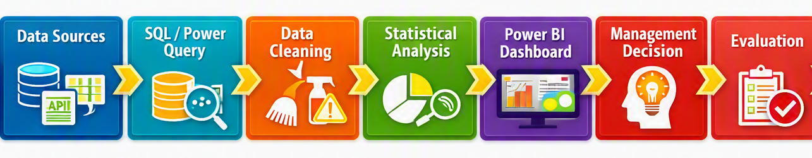
Figure 10: Data Analysis Workflow
This workflow is directly related to the inventory problem described in Task 1.

2.8 Critical Evaluation
There is no one tool that is perfect for all the stages of Big Data analysis. Use Excel is simple, but becomes cumbersome as the number of data increases. Power BI offers better dashboard and reporting features, but cannot replace programming-based statistical analysis. SQL is great to query structured databases, but not a database visualisation tool. Python offers powerful analytical tools and is more technically challenging.
Hence, LankaMart should refrain from selecting software just for the sake of having a lot of features. Business needs, size of the data, skills of the employees, cost, security and future expansion should be taken into account.

In the current landscape, Power BI offers the greatest advantage as management wants to have some visual information on reports. The data preparation stage can be supported using SQL and Power Query and can be introduced later for more advanced predictive analytics using Python.

Task 3 - Practical Big Data Analysis and Visualisation

3.1 Data Curation, Data Quality and Data Validation
Data includes details about retail transactions, such as transaction ID, date, customer details, product details, product category, branch, sale channel, quantity, unit price, revenue, customer ratings and information about marketing campaigns.

The data was then cleaned and processed in Power Query prior to analysis. Values that could not be found for CustomerID were substituted with the value of “Unknown Customer” and those that could not be found for ProductName were substituted with the value of “Unknown Product”. This method saved valid sales transactions rather than deleting entire sales records due to the absence of an identifier.

The data was also checked for appropriate data types and consistency before being used for analysis. This was significant because the quality of the data can give a false impression and influence management decisions. The importance of Data Quality in the analytics process is that the quality of the analytics results depends on the quality of the data that is used to create the results (Provost, 2013).

The main business questions investigated were:
- Which product categories generate the highest revenue?
- Which branches perform best?
- Which customer segments generate the most revenue?
- Which marketing campaigns are associated with higher revenue?
- Which sales channel generates the most revenue?
- Which products generate the highest revenue?
- How does revenue change over time?
- Are there unusual relationships between quantity sold and revenue?

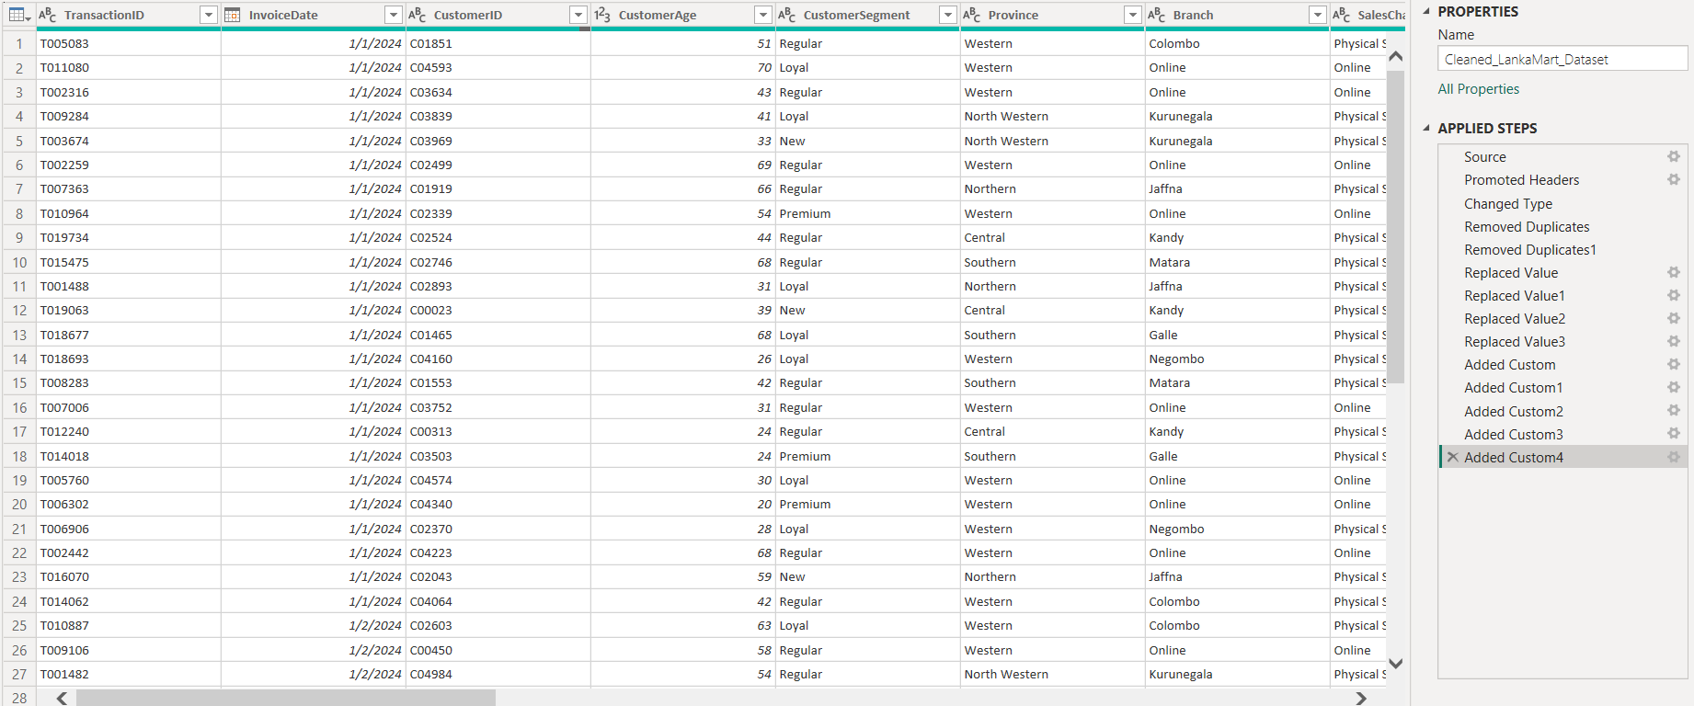
Figure 11: Data preparation and transformation

3.2 Data Manipulate Automation
Power BI was used to automate calculations through DAX (Data Analysis Expressions). Reusable measures were developed to compute results without having to do it in a spreadsheet. These measures will automatically update when filters or slicers are added.

The primary measures were Total Revenue, Total Transactions, Total Quantity Sold, Average Transaction Value, Average Customer Rating and Total Discount. For instance, Total Revenue was determined by adding the Revenue_LKR field and Average Transaction Value was calculated by dividing the total revenue by number of transactions.

This method ensures efficiency since manual to-do lists of the same calculations are not needed. It also minimizes the chances of possible mismatch calculation across reports. According to (Microsoft, 2024), analytical models in Power BI can be used to create measures and calculated values using DAX.

Figure 12: DAX measure for calculating total revenue
Figure 13: DAX measure for calculating total transactions

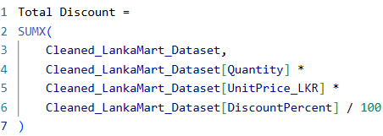
Figure 14: DAX measure for calculating total discount

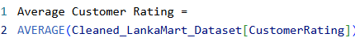
Figure 15: DAX measure for calculating average customer rating

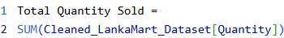
Figure 16: DAX measure for calculating total quantity sold

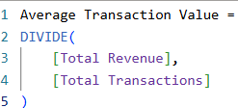
Figure 17: DAX measure for calculating average transaction value

Hence the dashboard offers a more flexible option than LankaMart's existing static reports.

3.3 Final Interactive Dashboard
The final Power BI dashboard is an interactive business performance overview that LankaMart management can use. It integrates KPIs, product categories, branches, customer segments, marketing campaigns, sales channels, top products and monthly revenue trends in a single interface. Users can view specific years, provinces, categories and sales channels, avoiding the need for static reports and enabling quicker decision making.

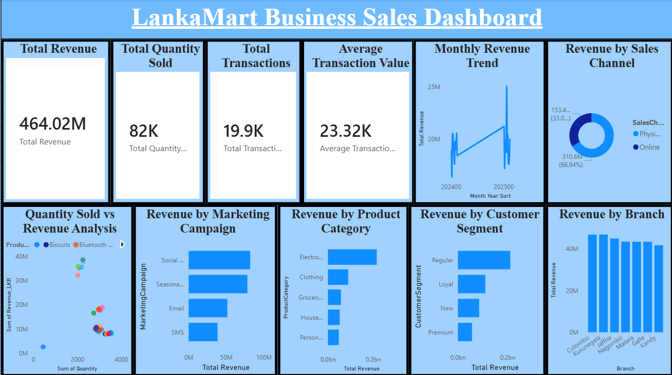
Figure 18: Power BI dashboard
Interactive visualisations on the dashboard help to interpret the ready-to-use data. Overall performance is summarised on KPI cards and comparisons are made across important business areas on charts. But the accuracy of these conclusions is dependent upon the accuracy of the data. Hence, the steps of preparation and transformation in Power Query were significant as incorrect data types, missing values or inconsistencies could lead to misleading results.

3.4 Statistical Analysis and Visualisation
Total Revenue, Transactions and Quantity sold
The total revenue as per the dashboard is LKR 464.02 million with total transactions of around 19.9K and the total number of units sold is 82K. The average transaction value calculated is around LKR 23.32K.

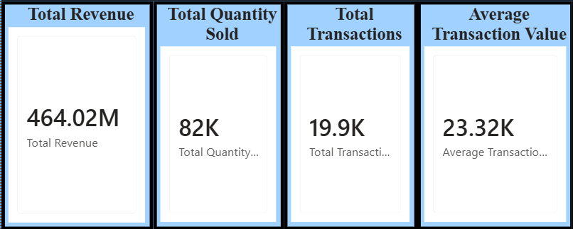
Figure 19: Key Performance Indicators showing overall sales performance
These are descriptive and give management a snapshot of how well business is doing. These KPIs can help managers drill down to investigate individual transactions later, rather than having to look at thousands of transactions.

Revenue by Product Category
Use of a horizontal bar chart was chosen for comparing revenue by product category because a bar chart is effective for comparing separate categories (Few, 2023).
The results show that Electronics generates the highest revenue, followed by Clothing, Groceries, Household and Personal Care.

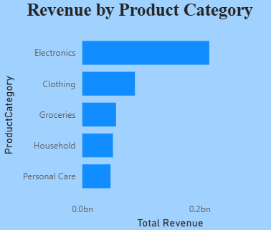
Figure 20: Revenue comparison by product categories
Based on this finding Electronics is an important revenue generating category for LankaMart. Management should thus track the availability of good electronic products and consider whether more promotion or stock planning might generate still more sales. Those that are not performing well should also be examined to see if their performance is impacted by demand, product availability or pricing.

Revenue by Branch
The branch analysis is used to compare the revenue of the branch in Colombo with the revenue of the branch in Kurunegala, Jaffna, Negombo, Matara, Galle and Kandy.

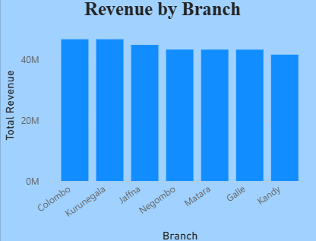
Figure 21: Revenue performance by branches
The above results indicate that the revenue of the various branches is relatively similar, with Colombo and Kurunegala being some of the strong performers. Kandy has the lowest revenue of the branches listed. This indicates that LankaMart is not solely reliant on a physical outlet for its sales.

Management may look at the performance of each branch and consider the difference between their performance and what the other branches are offering customers, promotions, local purchasing behaviour etc. to find out why there is a difference.

Revenue by Customer Segment
The comparison of revenue generated by customer segments was done using a bar chart.

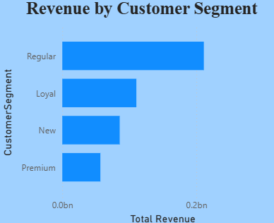
Figure 22: Revenue contribution of different customer segments
It is seen from the analysis that the Regular customers are the top category of business revenue followed by Loyal, New and Premium customers. This suggests that the loyal customer base of LankaMart plays a major role in terms of revenues.

The discovery would help marketing strategies for retaining customers. LankaMart can implement loyalty schemes, customised offers etc. to keep Regular customers and these can be done to entice new customers to return.

Revenue by Marketing Campaign
The marketing analysis is a comparison of revenues from Social Media, Seasonal Promotions, Email and SMS campaigns.
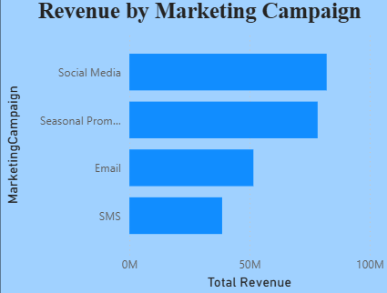
Figure 23: Revenue by marketing campaign
The dashboard indicates that Social Media is the highest revenue campaign category followed by Seasonal Promotions, Email and SMS. This means that the social media ad campaigns have turned out to be fruitful in terms of income generation.

The findings should not be seen as evidence of a direct link between social media and the boost in revenue. Product demand, seasonality and the nature and characteristics of the customers may also have an impact on sales. Therefore, by analyzing customer and time data along with campaign data, LankaMart should make bigger decisions regarding marketing investment.

Sales Channel Analysis
A donut chart is an illustration that is used to compare the income of a physical store versus the income of an online-based store. The contribution of the physical stores is about LKR 310.6 million (66.94%) and online sales is about LKR 153.42 million (33.06%).
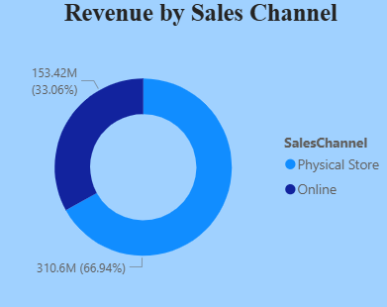
Figure 24: Revenue distribution by sales channel
The findings reveal that currently physical stores are producing a bigger revenue. But online sales account for about one-third of the recorded sales already. LankaMart should continue its efforts of offering a great in-store experience, but explore ways to boost customer engagement and sales conversion online.

Top 10 Products Trend and Monthly Revenue
The Top 10 Products chart will list the top 10 products that are contributing the most revenue. The most impressive products displayed in the dashboard are USB Cable, Keyboard and Power Bank.

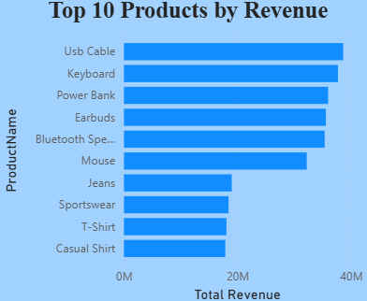
Figure 25: Top 10 LankaMart products

A monthly revenue chart was used to identify the changes in the revenue over time.
The trend can be seen to vary from month to month, even with a higher and lower earning month. This can assist LankaMart to know when to enhance their stock levels or marketing assistance. More historical information would be helpful to determine if there are a consistent seasonal pattern in these changes.

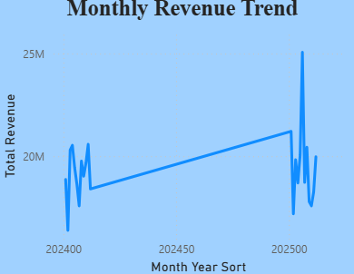
Figure 26: Monthly revenue trend

3.5 Interpretation and Impact on the Decision-Making Process
The analysis shows that data preparation and visualisation can be extremely useful to LankaMart's decision making. The dashboard empowers managers to shift from guesswork to data-driven choices.

For instance, if Electronics is one of the strong categories, attention should be paid to inventory planning for this category. The significant contribution from Regular customers indicates that activities in relation to retaining customers should continue to be of a high priority. The increase in the physical-store revenue also suggests that LankaMart needs to prevent its physical-store performance from deteriorating as it builds its ecommerce business.

Using Power Query allowed for more reliable analysis, as it would not remove valid transactions when there were missing values. The downside of the "Unknown" is that it also imposes a restriction as these transactions are not fully traceable back to any specific customer or product. This is one of the key considerations in data prep.
Interactive filtering and automatic measures with DAX were also enhanced in Power BI to support decision making. Managers are not limited to a report per branch or per category, but can work with the same report. This helps to speed up business queries exploration.

3.6 Recommendations
On the basis of the results, LankaMart should:
- Plan stock and promotions using high-performing Electronics products.
- Focus on improving customer-retention programs as their contribution is the highest.
- Do due diligence research on Social Media campaigns before investing more in marketing.
- Develop online sales channel and run strong physical-store operations.
- Track monthly revenue trends, for improved stock and promotions planning.
- Enhance the collection of data, especially missing identifiers for customers and products.
- Rely less on static spreadsheets, continue to use Power BI dashboards.

Task 04 - Data Professionals and the Data-Driven Culture.

4.1 Data Specialists Roles at LankaMart
Data Analyst
Tasked with analysing data to find patterns, trends and useful business information, a Data Analyst is a job role within the information industry that supports the decision-making process. The Data Analyst at LankaMart can then analyze the sales, customer base, product performance and marketing results. This is directly related to the Task 3 and comparing revenue by category, branch, customer segment and sales channel using Power BI. The analyst also presents his/her analysis to managers on dashboards and reports. Thus, this position contributes to making sense of raw data into information that can be used for management decisions.

Data Scientist
Advanced statistics, machine learning and predictive techniques are employed by a Data Scientist to solve more complex business problems. Data science could be applied to predict future product demand, customer purchasing behaviour or even customer who might not continue to use the loyalty programme at LankaMart. This would further the descriptive analysis done in Task 3 to predictive analysis. The job might thus enable LankaMart to shift from the “What happened?” to the “What will happen next?” question.

Data Engineer
A Data Engineer creates and sustains systems for large data collection, storage and processing. To ensure effective connection with the sources, LankaMart receives information from the stores, its online platform, mobile applications and other systems. The Data Engineer might be able to develop data pipelines to transfer data to a data warehouse or analytics tool. Reliable pipelines are essential as the quality of the data in the pipelines will impact on the Power BI dashboards and management decisions created in Task 3.

Business Intelligence Analyst
A Business Intelligence (BI) Analyst works to convert business data into valuable reports, dashboards and performance metrics. LankaMart may evolve to develop management dashboards which display revenue, transaction performance, branch performance and campaign performance. The BI Analyst also collaborates with the manager to determine the most beneficial KPIs, making sure that dashboards are meaningful for the business and not just a barrage of data.

Database Administrator
The Loki Database Administrator (DBA) is responsible for the performance, availability and security of LankaMart's databases. The DBA is able to manage user permissions, backups and database maintenance. This is relevant as customer information, transaction and loyalty data can include sensitive information. Poor database protection can have a negative impact on customer trust and business functions if unauthorised access to databases or loss of data occurs.

Data Architect
Data Architect is a person who designs the structure of a data and how the various systems are connected. The architect could create a space for LankaMart which would combine physical and online sales, customer, product and inventory information. Good architectures make it easier to access consistent information by analysts. Additionally, it enables future expansion as LankaMart can gather much more data with an expansion of its online and physical operations.

Data Protection Officer
Organisations have a Data Protection Officer (DPO) to help them fulfil their data protection duties and help safeguard the personal information of individuals. LankaMart gathers customer data, loyalty data, online activity among other details, which is significant. The Personal Data Protection Act No. 9 of 2022 has a specific law for protecting personal data and defining rights of data subjects. The Data Protection Authority is the body that regulates the processing of data relating to the personal data of Sri Lankans.

4.2 Challenges Faced by Data Professionals
Data quality is one of the significant problems. Data from various sources is collected by LankaMart, which means that there are possibilities of duplication, missing values, wrong format and inconsistent information. For Task 3, no CustomerID or ProductName was left out, instead "Unknown Customer" and "Unknown Product" were used. This protected this revenue data, however it meant that less detail was available for customer/product analysis. Hence, data professionals need to do an appropriate trade-off between data completeness and analytical correctness.

One of the other challenges is data ownership and data governance. Information might be thought to be owned by various departments, causing problems when information is to be shared. LankaMart should have a clear responsibility matrix and make clear who is responsible for creating, modifying, accessing and approving data sets that are critical.

However, privacy and security are also significant issues. Employees should not have access to customer information from loyalty programs and online activities that they don't need to access. Poor password, too many permissions or phishing attacks or poor system security may lead to data breaches. The main purpose of the Sri Lankan PDPA is to safeguard personal information and enhance citizens confidence in digital services.

Bias and fairness are challenge as well. Analytical models might lead to biased results if there is bias in historical data. For instance, a customer segmentation or marketing model might be skewed towards one customer group due to the imbalance between the training data. It is important to test models and results for unfair patterns, hence the need for data professionals.

Lastly, there are skills shortages that can impact LankaMart. To work with advanced analytics, you need to be familiar with Power BI, SQL, statistics, Python, databases and data governance. If LankaMart invests in the technology, but does not have appropriate staff and future training, then they may be getting a lot for nothing.

4.3 Strategies for Effective Data Compliance
LankaMart should have a proper data governance structure with clear responsibilities, data ownership, data quality, access to data, and acceptable usage. This would establish definite accountability between departments.
It is also recommended that the organisation put in place role-based access control. Employees should only have access to the information that they need for their job. For instance, a sales analyst should be provided aggregated sales data, but not be provided with unnecessary personal data from customers.

LankaMart should apply the policies of data classification and retention to categorize sensitive information and decide on the period of data storage of various types of data. Personal information that is not necessary and should not be stored long-term.
If possible, data supplied to the customer for purposes of analysis should be anonymised or pseudonymised. This will minimise the presentation of directly identifiable information while retaining valuable analyses.

Training and awareness of employees should also be provided. Staff should be aware of what privacy is, why to use secure passwords, phishing and what the implications are for individuals in terms of using data responsibly and correctly.
Unusual access, data quality issues and compliance gaps should be detected by means of regular audits and monitoring. The organisation should also have procedures in place to deal with security incidents and respond to data-related requests.

LankaMart needs to keep a close eye on updates in the data protection laws of Sri Lanka. The PDPA has also undergone amendments with the Personal Data Protection (Amendment) Act No. 22 of 2025, highlighting the need to consider compliance as a continuous process, not just a one-off exercise.

4.4 Impact on LankaMart's Data-Driven Culture
All these would have a significant impact on the success of LankaMart in building a data-driven culture. Bad data can create distrust in employee usage of their dashboards and reports. Managers who are still getting the numbers wrong can head back over to the spreadsheet or their personal judgment. The data quality is thus directly tied to the trust employees have in the Power BI dashboard in Task 3.
Customer behavior can also be impacted by privacy issues. When the customers feel that the LankaMart stores and uses too much of their personal data, they might not be so motivated to use the loyalty programmes or online services offered by the company. Effective privacy controls can then shield customers and the company's reputation.

A wider impact can be caused by security incidents. If there is a serious breach it can result in financial costs, legal issues and damage to the reputation. Conversely, robust security and clear data management can boost the trust of customers and employees.
The absence of Analytical ability can be the other factor that blocks change within culture. Just getting Power BI or other technologies will not turn employees into data-driven employees. Staff should be able to interpret information and consider the credibility of information.

Bias is present in culture when employees see that reports are weighted toward specific branches and groups of customers. If there is an imbalance in historical data from a segmentation or campaign analysis, managers can lose faith in analytics and fall back to opinion. A lack of government effectiveness is similar. With no clear data owners or definitions, there are disagreements between different departments over the same measure, resulting in incongruous decisions and casting doubt on the trust required to establish a data-driven culture.

Most importantly, the management support is required for LankaMart. Managers should promote the use of evidence for decision making and yet be guided by professional judgement. Data should guide and inform decisions, not dictate them. For instance, a low-performing branch might be flagged in the dashboard but before making a big decision on the business, management should look into operational factors.

4.5 Recommendations

- Appoint data owners and publish one agreed definition for each KPI, to remove conflicting reports.
- Establish data quality rules and monitoring for missing and duplicate records, as this is a key foundation of trust in dashboards.
- Train managers and staff to understand dashboard and data literacy.
- Adopt role-based access, consent logs and frequent checks in compliance with PDPA.
- Before using the results from tests for marketing or staffing purposes, check test results for bias.
- Support managers to use data with professional judgment and to share successes of the dashboard to gain confidence.

Overall Conclusion
In conclusion, the study highlights the potential of Big Data Analytics and Data-Driven Decision Making (DDDM) in enhancing LankaMart Retail Group's ability to derive meaningful business insights from complex retail data. It demonstrates the adoption of the Big Data concepts, along with the V’s and how the data needs to be analyzed appropriately instead of just using traditional spreadsheet and static reports on it. DDDM is a systematic framework to help identify business problems, interpret evidence, make decisions and assess results.

This study also revealed that other statistical methods like descriptive statistics, correlation, regression, forecasting, classification and clustering can be applied to fulfil various business need. These results are presented using graphical techniques and interactive dashboards which are easier for managers to understand and use. The tools identified were deemed suitable for LankaMart, Power BI was selected as the most suitable option as it allows for the preparation of data, DAX calculation, interactive visualisation and dashboard-based reporting.
The hands-on session showed how ready data was for being turned into KPIs, charts and an interactive dashboard for revenue, products, branches, customer segments, marketing campaigns and sales channels. Besides, it revealed that data preparation is a critical process as missing information, inconsistencies and inadequate past data can impact business insights.

Lastly, it takes more than technology to have a successful data-driven culture. This requires the expertise of skilled data professionals, good governance, robust security, privacy protection, ethical use of data and ongoing staff training. LankaMart, with its trust in data, an appropriate analytical tool, skilled professionals and responsible governance can enhance the decision-making process, ensure operational efficiency, ensure the trust of analytics and through its expanding data resources, create sustainable business value.

References
Microsoft (2024) What is Power BI? Microsoft.
Data Protection Authority of Sri Lanka (2026) Guidelines and Important Information. Available at: https://www.dpa.gov.lk/guidelines.php?utm
R Core Team (2024) R: A Language and Environment for Statistical Computing. Vienna: R Foundation for Statistical Computing.
Tableau (2024) Business Intelligence and Analytics. Tableau.
IBM (2024) What is Big Data? IBM.
NIST (2020) NIST Privacy Framework: A Tool for Improving Privacy through Enterprise Risk Management. National Institute of Standards and Technology.
Data Protection Authority of Sri Lanka (2022) Personal Data Protection Act, No. 9 of 2022. Colombo Available at: https://www.dpa.gov.lk/acts/Data%20Protection%20Act%20SL%20-%20English%20%282%29.pdf?utm
Few, S. (2013) Information Dashboard Design: Displaying Data for At-a-Glance Monitoring. 2nd edn. Burlingame, CA: Analytics Press.
Microsoft (2024) Power BI documentation. Microsoft Learn.
Data Protection Authority of Sri Lanka (2023) Data Protection Authority of Sri Lanka. Available at: https://www.dpa.gov.lk/?utm
Provost, F. and Fawcett, T. (2013) Data Science for Business: What You Need to Know about Data Mining and Data-Analytic Thinking. Sebastopol, CA: O'Reilly Media.
Sharda, R., Delen, D. and Turban, E. (2020) Analytics, Data Science, and Artificial Intelligence: Systems for Decision Support. 11th edn. Harlow: Pearson.
Personal Data Protection (Amendment) Act, No. 22 of 2025. Colombo: Data Protection Authority of Sri Lanka. Available at: https://www.dpa.gov.lk/acts/22-2025_E_251104_201549.pdf?utm

