Network Security Assignment

Afry Nizam
ANC
HND in Computing
Table of Contents
Task 1 - Network Security Principles and Devices 18
Introduction 18
1.1 Rationale for Selecting Networking Devices for the Prototype 18
Router 18
Layer 3 Switch 18
Access Switches 19
ASA Firewall 19
Servers 19
DHCP Server 19
DNS Server 19
Email Server 19
Web Server 19
Syslog Server 19
Wireless Access Points (Optional) 20
1.2 Network Security and Objectives 20
Meaning of Network Security 20
Main Objectives of Network Security 20
Confidentiality 20
Integrity 20
Availability 20
Different types of network security devices 20
Firewall 20
Intrusion Detection System (IDS) 20
Proxy Server 21
VPN Gateway 21
Antivirus Systems 21
Switches with Port Security 21
1.3 Network Security Protocols and Their Layers 21
HTTPS 21
SSH 21
SSL/TLS 22
IPsec 22
WPA2/WPA3 22
1.4 Cryptographic types and quality of service (QoS) 22
Symmetric Encryption 22
Asymmetric Encryption 22
Hashing 22
Quality of Service (QoS) in Network Security Configuration 23
1.5 Compare and contrast two major network security protocols 23
Comparison Between SSH and Telnet 23
Importance of Network Security to Health First Channelling 24
Conclusion 24
Task 2 - Design of a Secure Network 26
Introduction 26
2.1 Purpose and Requirements of a Secure Network 26
Requirements of the Secure Network 26
Hierarchical Network Design 26
VLAN Segmentation 27
Inter-VLAN Routing 29
DHCP Requirement 30
ACL Requirements 31
Firewall Protection 32
SSH Remote Access 33
Port Security 34
Syslog Monitoring 35
2.2 Network Hardware and Software Used 35
Network Hardware 35
Network Software 36
2.3 Network Model Design 38
2.3.1 VLAN Design 39
2.3.2 Different Subnets for Each VLAN 39
2.3.3 Subnetting Based on 192.168.1.0 39
Importance of Network Security to the Organization 40
Conclusion 41
Task 3 - Implementation of Secure Network with Evidence 42
Introduction 42
3.1 Implementation of a Secure Network Prototype 42
3.1.1 Configuration of Secure Network Using Cisco Packet Tracer 43
ASA Firewall Configuration 44
VLAN Configuration 45
Example Configuration: 46
Inter-VLAN Routing Configuration 46
DHCP Configuration 47
DNS, HTTP, Email Server Configuration 48
DNS Server 48
HTTP Server 48
Email Server 48
ACL Configuration 49
SSH Configuration 49
Port Security Configuration 50
Syslog Configuration 51
3.1.2 Device Configurations, IP Addressing, and Subnetting 52
3.2 Justification of Implemented Network Security Configuration 52
VLAN Segmentation 52
ACLs 52
ASA Firewall 52
SSH 53
DHCP 53
Port Security 53
Syslog 53
3.3 Critical evaluation of the design, planning and configuration 53
Strengths of the Network 54
Weaknesses of the Network 54
Future Improvements 54
Conclusion 54
Task 4 - Test Plan for Secure Network 56
Introduction 56
4.1 Test Plan for the Security Configuration 56
4.2 Network Testing According to the Test Plan 57
DHCP Testing 57
VLAN Communication Testing 57
Inter-VLAN Routing Testing 58
ACL Testing 59
SSH Remote Access Testing 60
HTTP Server Testing 61
Email Server Testing 61
Port Security Testing 62
Firewall Testing 63
4.3 Analysis of Test Results 63
Critical Evaluation of Testing Process 64
Weaknesses Identified During Testing 64
Single Point of Failure 64
Limited Redundancy 64
No IDS/IPS System 64
Wireless Security Not Implemented 64
Recommendations for Improvement 65
Implement Redundant Devices 65
Add IDS/IPS Systems 65
Implement VPN Services 65
Add Wireless Infrastructure 65
Enable Centralized Monitoring 65
Importance of Testing in Network Security 65
Conclusion 65
Task 5 - Recommendations and Critical evaluation 67
Introduction 67
5.1 Critical Evaluation of the Test Plan Against the Test Results 67
Evaluation of DHCP Testing 68
Evaluation of VLAN and Inter-VLAN Routing Testing 68
Evaluation of ACL Testing 69
Evaluation of SSH Testing 69
Evaluation of Firewall Testing 70
Evaluation of Syslog and Port Security Testing 70
Critical Evaluation of the Overall Network Design 71
Strengths of the Network 72
Strong VLAN Segmentation 72
Secure Access Control 72
Secure Remote Management 72
Perimeter Protection 72
Automatic Network Management 72
Monitoring and Logging 72
Weakness of the Network 72
Single Point of Failure 72
No Redundant Links 72
No Wireless Security 72
No IDS/IPS Systems 72
Limited Advanced Authentication 73
5.2 Recommendations to Improve Network Security 73
Recommendation 1 - Implement Redundant Devices 73
Recommendation 2 - Implement IDS/IPS Systems 73
Recommendation 3 - Implement VPN Services 73
Recommendation 4 - Implement Wireless Security 73
Recommendation 5 - Use Multi-Factor Authentication (MFA) 74
Recommendation 6 - Implement SIEM Systems 74
Recommendation 7 - Regular Security Audits 74
Importance of Continuous Network Improvement 74
Conclusion 75
References 76

Task 1 - Network Security Principles and Devices

Introduction
Businesses rely on computer networks to store, manage and share information, making network security a vital concern for modern organizations. Health First Channelling is a medical service that manages patient information, doctor appointments, medicine, and communication services. So, the company requires a network system, which is secure and reliable to protect sensitive information from cyber-attacks, unauthorized access, and data loss. NetSol (Pvt) Ltd is tasked by the provided vocational scenario to design and implement a secure network infrastructure to Health First Channelling. The organization needs Web services, email services, DHCP services, DNS services, VLAN segmentation, ACLs and firewall services in order to ensure proper communications in the network while keeping it secure.
This report identifies the principles of network security, devices required for the prototype, the network security protocols, the cryptographic methods, and Quality of Service (QoS). The report also examines two widely used network security protocols and assesses the significance of network security to organisations like Health First Channelling.

1.1 Rationale for Selecting Networking Devices for the Prototype
Various networking devices are needed to construct a safe and successful health care network for Health First Channelling. The devices that were selected assist the organization to stay in touch, perform better and offer network security.

Router
A router is a device that joins various networks and enable an internal and external network to communicate. In this case, there is a core router in the server room which links the internal network to the internet. The router also can perform routing operations and facilitate the exchange of traffic between VLANs (Cisco, 2024).

Layer 3 Switch
Inter-VLAN routing is accomplished with a Layer 3 switch. In such an organization, having a few departments like Reception, Pharmacy, Administration and Radiology, it is required that each department be divided logically. It is necessary to divide the departments in an organization that has several departments such as Reception, Pharmacy, Administration and Radiology as VLANs do this. The Layer 3 switch enhances the speed of routing operations because routing takes place at a faster rate within the LAN environment (CompTIA, 2023).

Access Switches
There are access switches on every floor to which computers, printers and other end-user equipment are connected. These switches enable other devices in the network to communicate with each other and enable port security and VLAN configuration features (Stallings 2020).

ASA Firewall
Protected from external cyber threats, the ASA's firewall is deployed between the Internet and internal network. The firewall enforces security rules to control incoming and outgoing traffic. It helps prevent unauthorized access, network intrusions, and malware attacks (Cisco, 2024).

Servers
This type of network infrastructure needs several servers.

DHCP Server
All devices in the network get IP addresses automatically assigned by the DHCP server. This minimizes the manual mistakes and simplifies network administration.

DNS Server
The DNS server converts domain names into IP addresses, making communication easier for users.

Email Server
Allows communication between employees and doctors in the organisation via the email server.

Web Server
The web server offers web-based services including appointment systems and medical info on the web.

Syslog Server
The Syslog server is used for monitoring and storing network logs, which are then used for troubleshooting and security monitoring.

Wireless Access Points (Optional)
Wireless points may be installed in the future to offer wireless web access to physicians, workers and visitors.

1.2 Network Security and Objectives

Meaning of Network Security
Network security is the protection of computer networks, devices, and data from unauthorized access, cyber-attacks, misuse, and damage. This encompasses technologies, software, policies and hardware designed to ensure the safety of the network infrastructure (Kizza, 2022).
The healthcare sector handles sensitive patient information; therefore, strong network security is necessary for Health First Channelling.

Main Objectives of Network Security

Confidentiality
Confidentiality: Sensitive information is accessed by only authorised users. For instance, the patient's medical records should be accessible by only the authorized personnel.

Integrity
Integrity is the property of information that is not altered or changed by unauthorized users. This enables to keep a proper patient and medical records.

Availability
Availability ensures that network services are always available to those who are authorized to use them. Hospitals and medical organizations must always have access to systems and databases (Whitman and Mattord, 2021).

Different types of network security devices

Firewall
A firewall is a device that enforces the security policies on network traffic. This prevents unauthorized access attempts and malicious traffic.

Intrusion Detection System (IDS)
An IDS is used to monitor network traffic and identify suspicious activity in the network.
Intrusion Prevention System (IPS)
An IPS can not only identify attacks, but also automatically blocks malicious traffic.

Proxy Server
Proxy servers are used to provide access to the internet via an intermediary. This enhances privacy and security.

VPN Gateway
A VPN gateway is used to establish encrypted tunnels between a remote user and the network.

Antivirus Systems
Anti-virus is used to guard against ransomware, viruses, spyware, and malware.

Switches with Port Security

Managed switches have port security capabilities that prevent unauthorized devices from connecting to the network.

1.3 Network Security Protocols and Their Layers
Network security protocols are rules and standards to secure communication on networks.
Protocol | Purpose | OSI Layer
HTTPS | Secure web communication | Application Layer
SSH | Secure remote access | Application Layer
SSL/TLS | Encryption and secure communication | Session Layer
IPsec | Secure IP communication | Network Layer
DNSSEC | Secure DNS responses | Application Layer
WPA2/WPA3 | Wireless network security | Data Link Layer

HTTPS
HTTPS encrypts the data that is sent between the web browser and the web server. Secure sensitive information like usernames and passwords (NIST, 2023).

SSH
Secure remote access to routers and switches is offered by SSH. Encrypts communications and replaces insecure protocols like Telnet.

SSL/TLS
The SSL/TLS protocols offer encryption to secure online communication and prevent data from being captured.

IPsec
IPsec is used for network layer security and is widely implemented in Virtual Private Networks (VPNs).

WPA2/WPA3
WPA2 and WPA3 encrypt wireless communications between devices and access points to secure wireless networks.

1.4 Cryptographic types and quality of service (QoS)
In Network Security, one will learn about Cryptographic Types.
Encryption of data: Cryptography is used for the protection of data by converting readable information into encrypted data.

Symmetric Encryption
In Symmetric encryption, both the key for encryption to decrypt are the same. Quick and applicable to lots of data.
Example:
- AES (Advanced Encryption Standard)

Asymmetric Encryption
Asymmetric encryption involves two keys:
- Public key
- Private key
It has a higher level of security for communication and authentication.
Example:
- RSA

Hashing
Hashed functions transform data of arbitrary size into a fixed-length value known as a hash. It is primarily used to protect passwords and for data integrity checks.
Example:
- SHA-256
The Health First Channelling network (Kizza, 2022) uses cryptographic techniques to ensure patient information and communication are safe.

Quality of Service (QoS) in Network Security Configuration
Quality of Service (QoS) is a way of giving priority to important network traffic and enhancing network performance.
The QoS can prioritize in Health First Channelling:
- Video consultations
- VoIP communication
- Radiology image transfers
- Critical healthcare applications
By enhancing user experience and prioritizing critical medical services, QoS ensures that all operations run smoothly and efficiently.QoS guarantees smooth and efficient operations, improving user experience and ensuring high network priority for critical medical services.

1.5 Compare and contrast two major network security protocols

Comparison Between SSH and Telnet
Feature | SSH | Telnet
Security | Encrypted | Unencrypted
Port Number | 22 | 23
Authentication | Secure authentication | Weak authentication
Data Protection | High | Low
Usage | Modern secure remote access | Old remote access protocol

Unlike Telnet, SSH encrypts all communications between devices, making it a more secure way to communicate than Telnet. The information sent over Telnet is in plain text and is thus easily accessible to attackers. SSH needs to be used securely to manage routers, switches, and servers remotely for Health First Channelling (Cisco, 2024).
While Telnet is simpler to set up, it is not an adequate level of security for today's healthcare setting. Secure network administration is thus handled at the best using SSH.

Importance of Network Security to Health First Channelling
Network security is a critical topic because Health First Channelling has medical records, patient information and other confidential data which is crucial to safeguarding. A cyber-attack or data breach can ruin the organization's reputation and negatively affect the healthcare services.
Good network security helps:
- Protect patient information
- Prevent unauthorized access
- Take steps to limit the spread of malware and ransomware.
- Improve communication security
- Maintain system availability
- Support business continuity
The security level of the organization can be enhanced using VLAN segmentation, ACLs, ASA firewalls, SSH, and port security. If there is no network security in place, hackers can penetrate the sensitive healthcare systems and inflict losses on the health organization and also the finances (Whitman and Mattord, 2021).
In addition, health care entities need to be trusted and reliable. Thus, it is essential to have a secure network infrastructure in place for both efficiency and protection of data.

Conclusion
To wrap up, network security is essential to the safety and security of modern organisations against cyber attacks and unauthorised entry. A robust and scalable network infrastructure is essential to ensure that Health First Channelling can maintain its medical services, communication systems, and patient information management.
This report covered the networking devices to be used for the prototype: Routers, Switches, Firewalls, Servers. It also discussed the goals of network security and various security devices, protocols, cryptographic techniques and QoS. Moreover, the study revealed that secure communication protocols are crucial for healthcare environments, having compared the two; SSH and Telnet.
In conclusion, using robust network security solutions like VLANs, ACLs, ASA firewalls, SSH, and port security will contribute to the goals of Health First Channelling for maintaining confidentiality, integrity, and availability as well as secure and reliable network operations.

Task 2 - Design of a Secure Network

Introduction
Network security plays a crucial role in modern healthcare organizations, where hospitals and medical centres deal with delicate patient details, medical records, and communications. To meet the demands of the business, communication among departments, and online services, Health First Channelling must have a secure and reliable network infrastructure. As per the provided vocational scenario, NetSol (Pvt) Ltd is tasked to design and deploy a secure corporate network for the organization. The network should be able to support Web services, email, DHCP, DNS, VLAN segmentation, ACLs, SSH, Syslog monitoring, firewall protection, and port security.
This report explores the question of why and what a secure network will be needed for Health First Channelling. Additionally, it defines the necessary network hardware and software, creates a secure network model, and describes how to use VLANs and subnetting with the provided IP address range 192.168.1.0. In addition, this report assesses the significance of network security to the organization and connects the design to the scenario design using Cisco Packet Tracer.

2.1 Purpose and Requirements of a Secure Network
A secure network should help to safeguard the organization's data, systems and communication against cyber attacks, unauthorized access and network attacks. Health First Channelling manages confidential patient information, doctor details, medicine information, and appointment management. Thus, it is essential to have a strong network security to ensure the confidentiality, integrity, and availability of information (Whitman and Mattord, 2021).
Health First Channelling relies on computer systems and internet based services and therefore a secure network is important. In the event that the attackers can enter the network, patient records can be stolen, altered or destroyed. This may be a financial and legal liability for the organisation.

Requirements of the Secure Network
The following requirements are needed for the vocational scenario.

Hierarchical Network Design
The network should be designed according to the hierarchical design model which is composed of:
- Core Layer
- Distribution Layer
- Access Layer
This design enhances scalability, performance, troubleshooting and network management (Cisco, 2024).
In the implemented Cisco Packet Tracer design:
- The Core Router is in the server room.
- Inter-VLAN routing is done through layer 3 switches.
- Each floor has access switches on board.
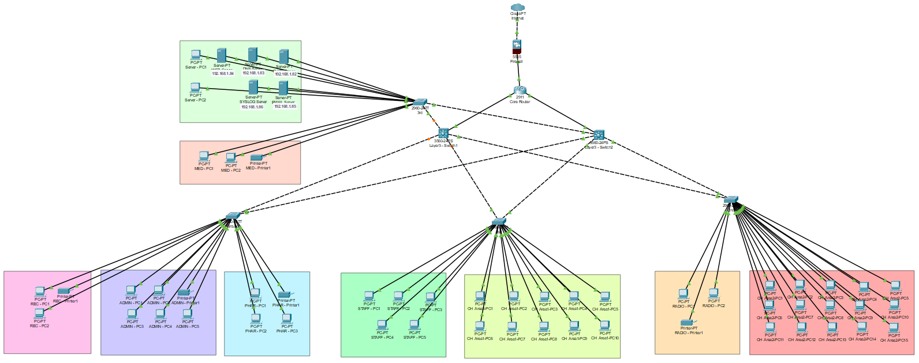
Figure 1: Hierarchical Network Topology of Health First Channelling

VLAN Segmentation
VLANs are used to logically segment departments to form separate networks. This enhances security since unauthorised departments can no longer have immediate access to the sensitive systems.
The following VLAN structure has been put in place:
- Reception VLAN
- Administration VLAN
- Pharmacy VLAN
- Staff VLAN
- Channelling VLANs
- Radiology VLAN
- Server VLAN
- Medicine Storage VLAN
VLAN segmentation helps to reduce broadcasts and the extent of the network's spread of attacks (Stallings, 2020).
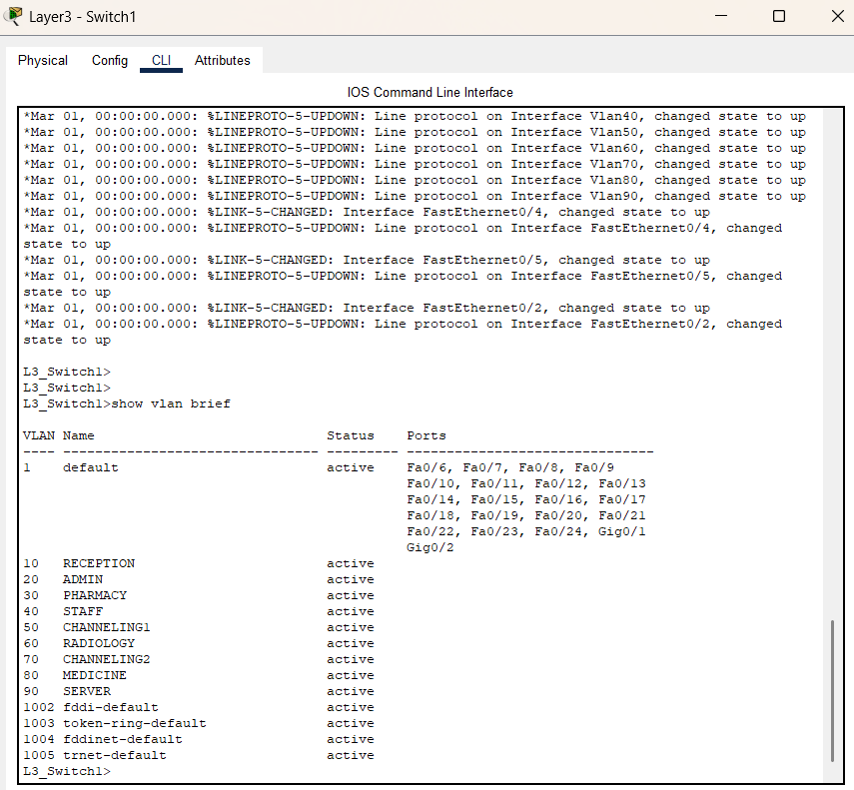
Figure 2: VLAN Configuration on Access Switch

Inter-VLAN Routing
Departments require controlled communication with each other, for which inter-VLAN routing is required. For example:
- Servers can be accessed by administration.
- The school will provide limited resources for pupils in the reception class.
Switch Virtual Interfaces (SVIs) are used for inter-VLAN routing in the network by the Layer 3 switches.
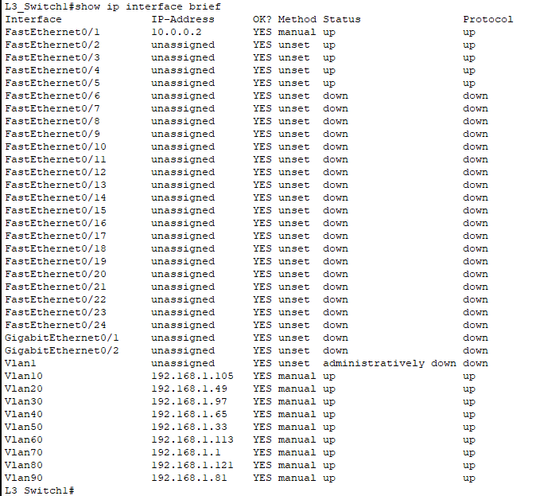
Figure 3: Inter-VLAN Routing Configuration on Layer 3 Switch

DHCP Requirement
Scenario: All devices MUST be assigned to auto-configure their IPv4 addresses via DHCP. The DHCP server dynamically assigns IP addresses to devices in different VLANs.
This improves:
- Network management
- Scalability
- Ease of configuration
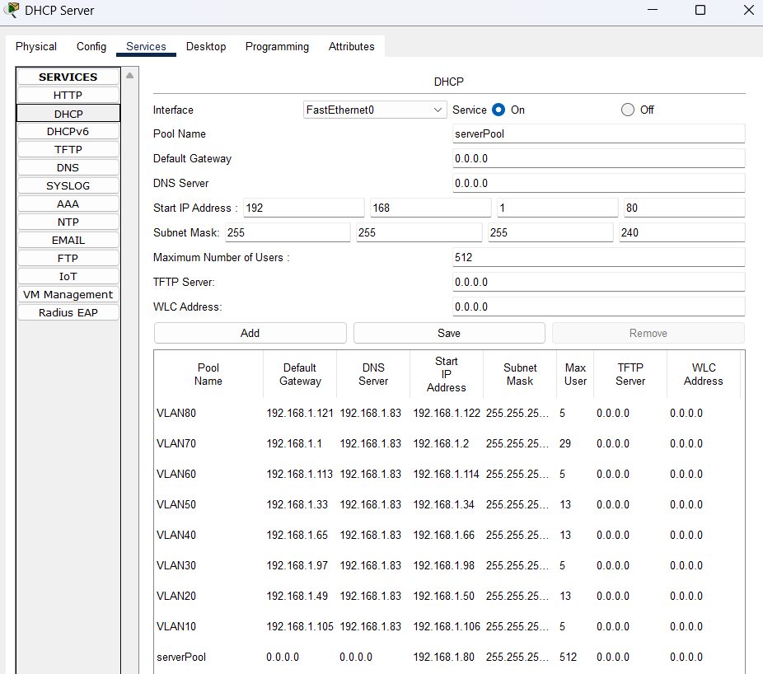
Figure 4: DHCP Configuration
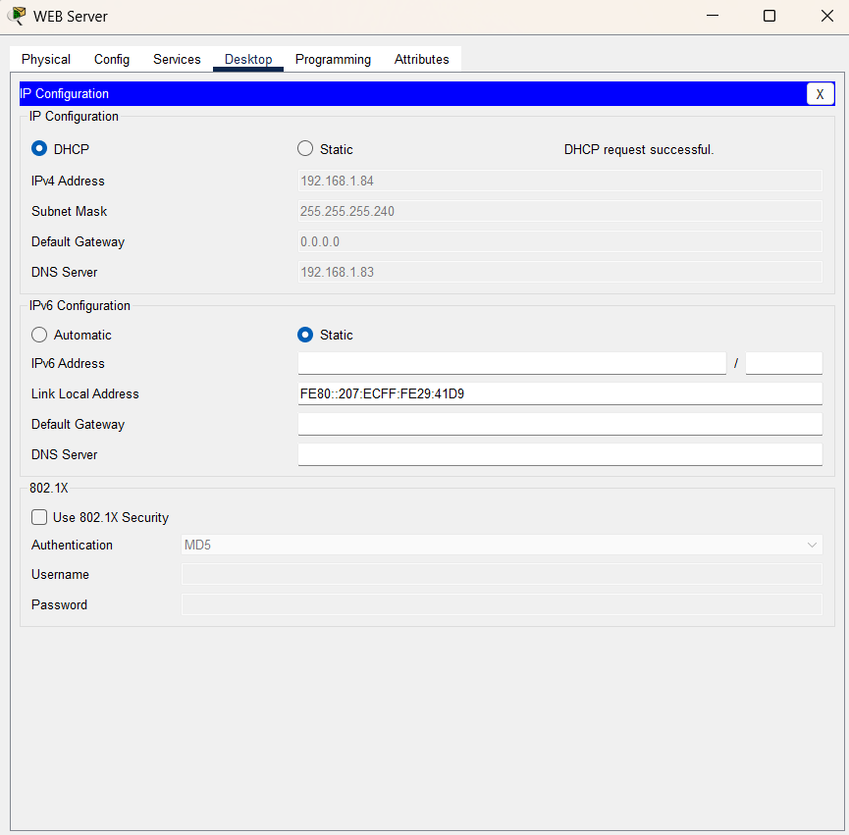Figure 5: Automatic IP Address Allocation

ACL Requirements
VLANs use Access Control Lists (ACLs) to regulate communications between VLANs. This will help to block unwanted traffic to the Server VLAN, etc.
Example policy:
- Reception VLAN cannot access Server VLAN
- Only Administration VLAN can access servers
The purpose of the ACLs is to increase the internal security and prevent insider threats (Kizza, 2022).
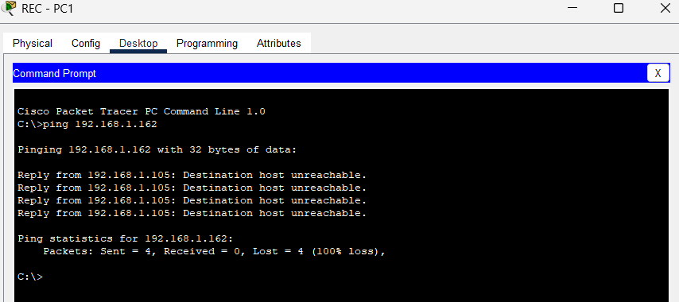
Figure 6: Failed Ping Test Due to ACL Restriction

Firewall Protection
An ASA firewall is deployed between the internet and the internal network to safeguard the organisation against cyber threats from outside its network.
The firewall:
- Filters traffic
- Blocks unauthorized access
- Improves perimeter security
This is particularly crucial since healthcare organizations are frequently vulnerable to ransomware and malware attacks.
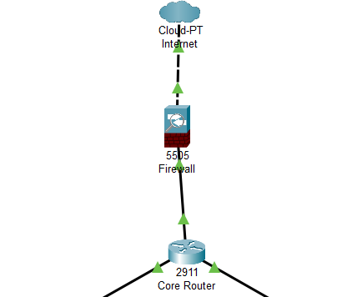

Figure 6(a): ASA Firewall Topology

SSH Remote Access
SSH has been enabled to make routers and switches manageable from a remote location. SSH is used to secure communications and login information.
More secure than Telnet, which sends data in plain text (Cisco, 2024).
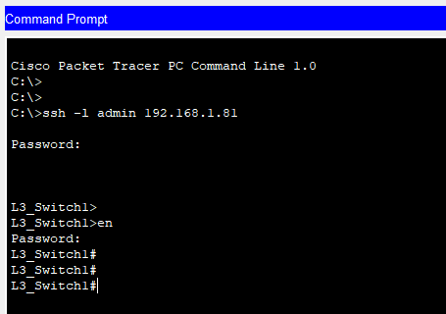
Figure 7: Secure Remote Access using SSH

Port Security
Port security: Disables unauthorized devices from connecting to switch ports. This enhances physical network security within the organisation.
If a device is not recognized:
- The port may shut down automatically.
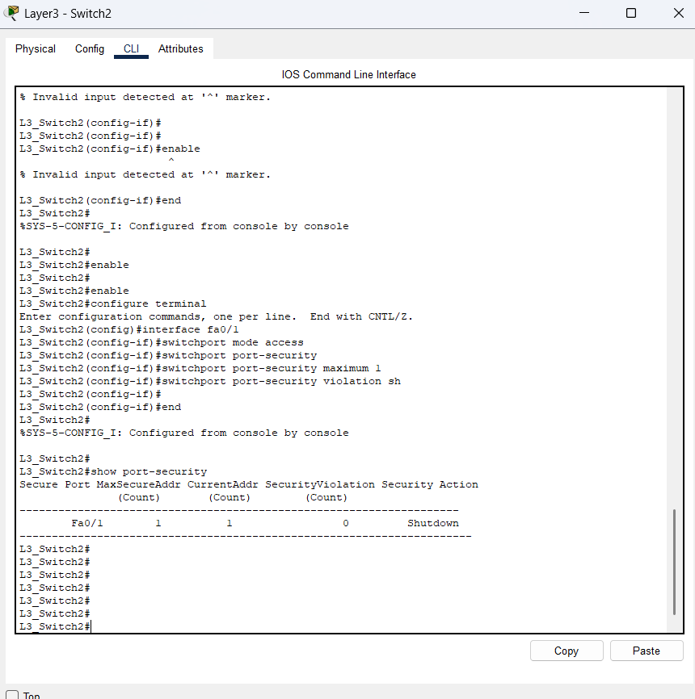Figure 8: Port Security Configuration on Switch Ports

Syslog Monitoring
The syslog has been set up to keep track of network activity and to store logs for troubleshooting and security analysis.
Syslog helps administrators:
- Detect attacks
- Monitor login attempts
- Troubleshoot network problems
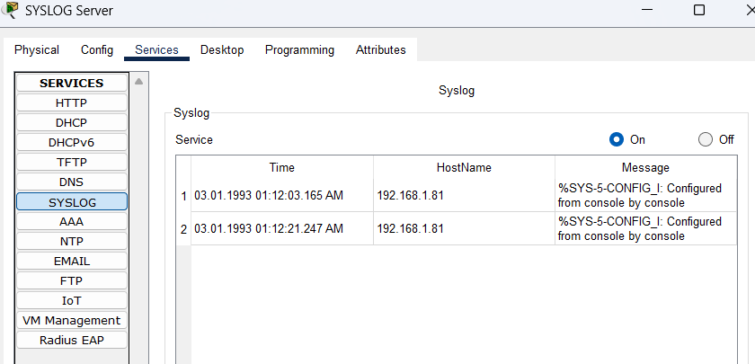Figure 9: Syslog Monitoring Server.

2.2 Network Hardware and Software Used

Network Hardware
Hardware | Purpose
Core Router | Connect internal network to internet
Layer 3 Switches | Inter-VLAN routing
Access Switches | Connect end-user devices
ASA Firewall | Perimeter security
Servers | DHCP, DNS, Email, Web, Syslog
PCs and Printers | End-user devices
Copper Cables | Device connectivity

The chosen hardware technology is scalable, secure, and capable of meeting the organization's performance demands.

Network Software
Software | Purpose
Cisco Packet Tracer | Network simulation
DHCP Service | Automatic IP assignment
DNS Service | Domain name resolution
Email Service | Internal communication
HTTP Service | Web services
Syslog Service | Log monitoring
SSH | Secure remote access

The simulated and implemented secure network environment was done in Cisco Packet Tracer.

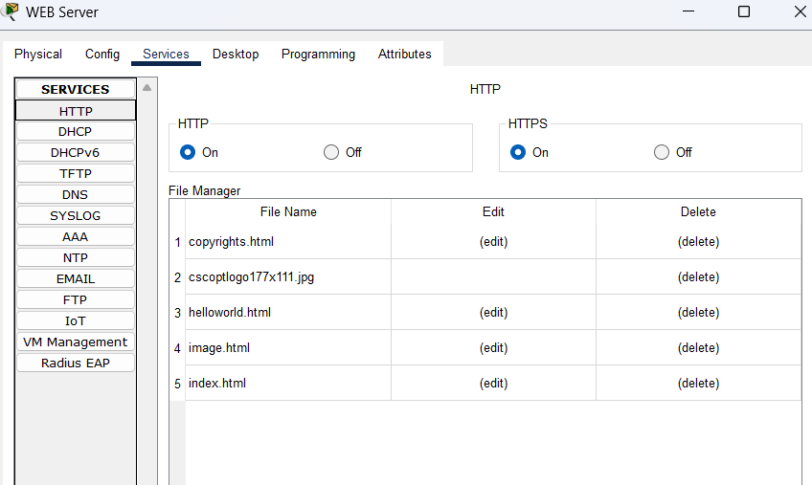

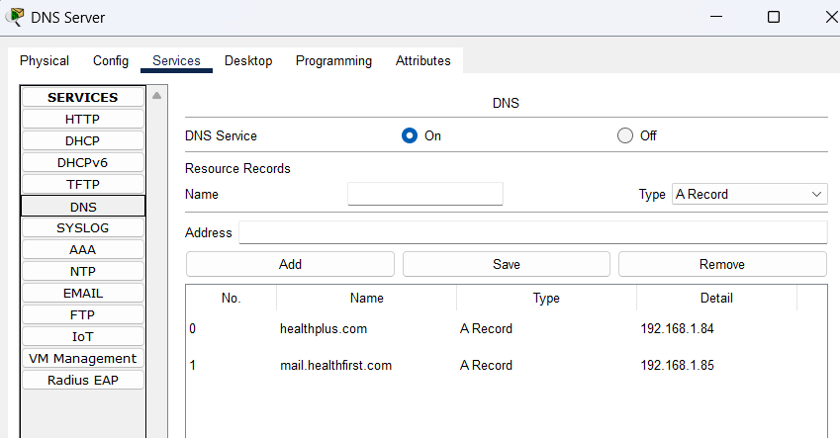

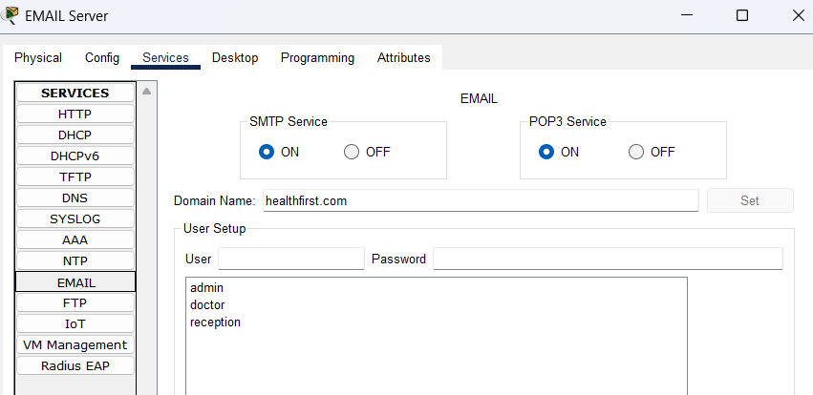
Figure 10: Network Services Configuration

2.3 Network Model Design
The network model was designed based on the vocational scenario and the topology designed in Cisco Packet Tracer.
The design includes:
- Hierarchical architecture
- VLAN segmentation
- Inter-VLAN routing
- DHCP services
- Firewall protection
- Secure remote access
- ACL implementation
The topology improves:
- Security
- Scalability
- Network performance
- Department isolation

2.3.1 VLAN Design
VLAN ID | Department
VLAN 10 | Reception
VLAN 20 | Administration
VLAN 30 | Pharmacy
VLAN 40 | Staff Room
VLAN 50 | Channelling Area 1
VLAN 60 | Radiology
VLAN 70 | Channelling Area 2
VLAN 80 | Medicine Storage
VLAN 90 | Server Room

This VLAN topology is the same as the Cisco topology implementation.

2.3.2 Different Subnets for Each VLAN
Security and traffic management is enhanced by each VLAN having its own subnet.

2.3.3 Subnetting Based on 192.168.1.0
VLAN | Network Address | Subnet Mask | Usable Range | Broadcast Address
VLAN 10 | 192.168.1.0/28 | 255.255.255.240 | 192.168.1.1 – 192.168.1.14 | 192.168.1.15
VLAN 20 | 192.168.1.16/28 | 255.255.255.240 | 192.168.1.17 – 192.168.1.30 | 192.168.1.31
VLAN 30 | 192.168.1.32/28 | 255.255.255.240 | 192.168.1.33 – 192.168.1.46 | 192.168.1.47
VLAN 40 | 192.168.1.48/28 | 255.255.255.240 | 192.168.1.49 – 192.168.1.62 | 192.168.1.63
VLAN 50 | 192.168.1.64/27 | 255.255.255.224 | 192.168.1.65 – 192.168.1.94 | 192.168.1.95
VLAN 60 | 192.168.1.96/28 | 255.255.255.240 | 192.168.1.97 – 192.168.1.110 | 192.168.1.111
VLAN 70 | 192.168.1.112/27 | 255.255.255.224 | 192.168.1.113 – 192.168.1.142 | 192.168.1.143
VLAN 80 | 192.168.1.144/28 | 255.255.255.240 | 192.168.1.145 – 192.168.1.158 | 192.168.1.159
VLAN 90 | 192.168.1.160/28 | 255.255.255.240 | 192.168.1.161 – 192.168.1.174 | 192.168.1.175

Importance of Network Security to the Organization
Health First Channelling is sensitive to network security, as it deals with healthcare-related data. Without proper security:
- Patient records may be stolen
- Systems may be hacked
- Services may stop functioning
The network design implemented is improved:
- Confidentiality
- Integrity
- Availability
The use of:
- VLANs
- ACLs
- Firewalls
- SSH
- Port security
Protects organisation from within and without.
The network also enhances operational efficiency by the proper organization of departments and effective communication handling.

Conclusion
To wrap up, Health First Channelling is a network that needs to be robust and scalable to meet the requirements of healthcare operations and to help safeguard sensitive information. This report examined why and what a secure network is needed in the vocational scenario. It also determined the hardware and software needed and created secure network model with VLAN, inter-VLAN routing, ACL, DHCP, Syslog, SSH and firewall security.
The topology designed using Cisco Packet Tracer is implemented in the network and the minimum requirements provided in the assignment brief are met. In addition, subnetting and VLAN segmentation increase the manageability, scalability, and security of the network.
In summary, robust network security is crucial for safeguarding organizational information, ensuring business continuity, and facilitating secure communication in Health First Channelling.

Task 3 - Implementation of Secure Network with Evidence

Introduction
Task 3 involves implementing a secure network prototype for Health First Channelling, using Cisco Packet Tracer. The implementation was planned based on the identified requirements from Task 1 and Task 2. It supports VLAN segmentation, inter-VLAN routing, DHCP services, DNS services, email servers, web servers, Access Control Lists (ACLs), SSH remote access, Syslog monitoring, ASA firewall protection and port security.
The designed network is a hierarchical network with Core, Distribution and Access layer. This design enhances the scalability, security, and network performance of the system. The network was set up to safeguard any private information of the healthcare facility and to establish secure communication between various departments including the Reception, Administration, Pharmacy, Radiology and the Server Room.
This report provides an explanation of the implementation process, configuration considerations, and an evaluation of the secure network prototype built in Cisco Packet Tracer.

3.1 Implementation of a Secure Network Prototype
Cisco Packet Tracer was used to create the secure network prototype. The implementation includes:
- Core router
- Layer 3 switches
- Access switches
- ASA firewall
- VLANs
- ACLs
- DHCP services
- DNS services
- Web server
- Email server
- Syslog monitoring
- SSH remote access
- Port security
The topology used is the same as the vocational scenario and network topology discussed in Task 2.

3.1.1 Configuration of Secure Network Using Cisco Packet Tracer
The core router was installed in the server room as per the requirements of the assignment. The router is used to connect the internal network with the Internet via the ASA firewall.
The router was set up with:
- IP addresses
- Routing
- Default gateway
- Secure passwords
Example Configuration:
hostname CoreRouter
enable secret cisco123
service password-encryption
The router is the point where all the communications of the network will go through.
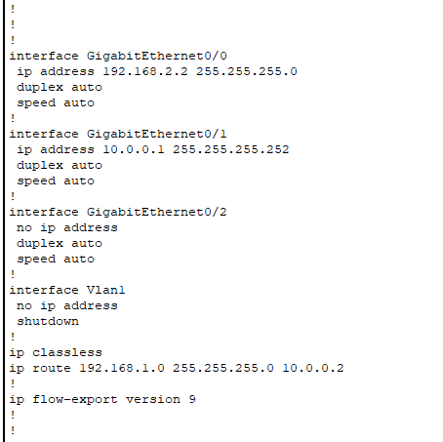
Figure 11: Router Configuration

ASA Firewall Configuration
A perimeter security device (ASA) was placed between the internet and the internal network.
The firewall:
- Filters incoming traffic
- Blocks unauthorized access
- Protects internal servers
- Improves network security
The ASA firewalls are configured for:
- Inside interface
- Outside interface
- NAT configuration
- Access rules
Example Configuration:
interface vlan 1
nameif inside
security-level 100
ip address 192.168.1.1 255.255.255.0
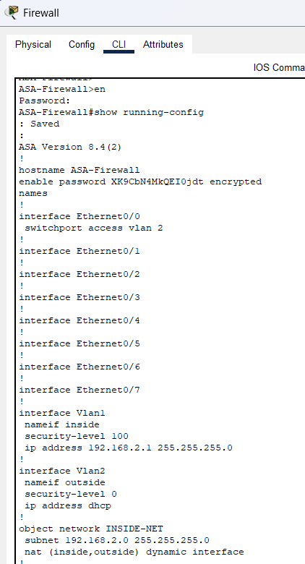
Figure 12: Router Configuration

VLAN Configuration
VLANs were used to logically partition departments. This enhances network security and helps to cut down on broadcast traffic.
The VLAN structure implemented is:
VLAN ID | Department
10 | Reception
20 | Administration
30 | Pharmacy
40 | Staff Room
50 | Channelling Area 1
60 | Radiology
70 | Channelling Area 2
80 | Medicine Storage
90 | Server Room

Example Configuration:
vlan 10
name Reception

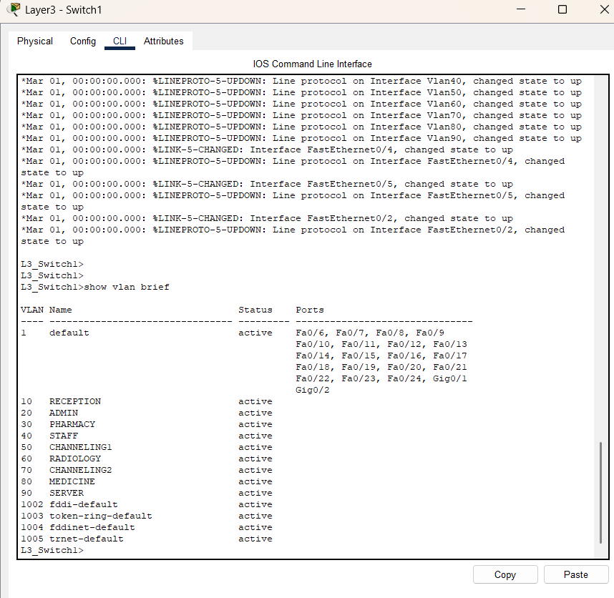
Figure 13: VLAN Configuration on Switches

Inter-VLAN Routing Configuration
Layer 3 switches were used for Inter-VLAN routing. Switch Virtual Interfaces (SVIs) have been created for each VLAN.
This enables you to communicate between VLANs with security controls in place.
Example Configuration:
interface vlan 10
ip address 192.168.1.1 255.255.255.240
no shutdown

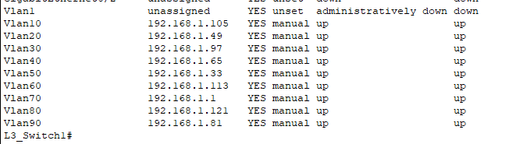
Figure 14: Inter-VLAN Routing Configuration

DHCP Configuration
An automatic IP assignment was set up for all end user devices using a DHCP server.
This improves:
- Ease of management
- Scalability
- Automatic IP allocation
Different DHCP pools were created for each VLAN subnet.
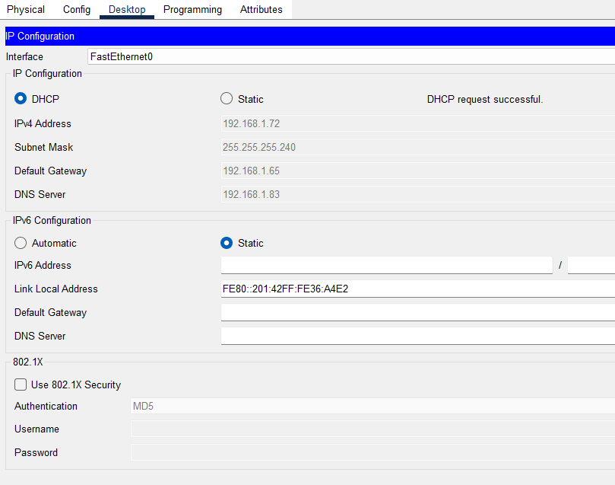
Figure 15: DHCP Configuration and Automatic IP Assignment

DNS, HTTP, Email Server Configuration
The network includes:
- DNS Server
- Web Server
- Email Server
These services enable intra-org communication and online services.

DNS Server
Converts domain names to ip addresses.

HTTP Server
Exposes services to Web users.

Email Server
Enables staff to communicate by email to doctors.

ACL Configuration
ACLs are used to limit the communications of unauthorized devices between VLANs.
Example:
- Reception VLAN cannot access Server VLAN
- Only Administration VLAN can be used by servers.
This enhances the security of the internal network.
Example Configuration:
access-list 101 deny ip 192.168.1.0 0.0.0.15 192.168.1.160 0.0.0.15
access-list 101 permit ip any any
show access-lists

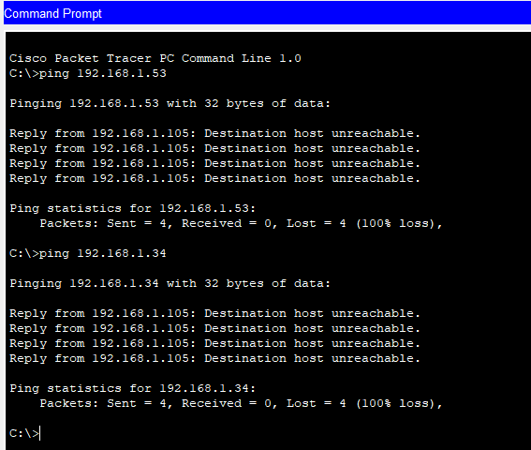
Figure 16: ACL Restricting Unauthorized Access.

SSH Configuration
A secure remote access method for router and switch (SSH) was setup.
SSH encrypts messages and guards login data.
Example Configuration:
ip domain-name healthfirst.com
crypto key generate rsa
username admin secret cisco123

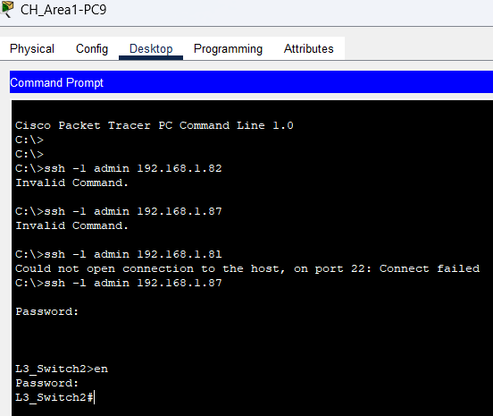
Figure 17: SSH Remote Access Configuration

Port Security Configuration
Switch ports were setup to not allow any unauthorized devices to connect to port security.
Example Configuration:
switchport port-security
switchport port-security maximum 1
switchport port-security violation shutdown
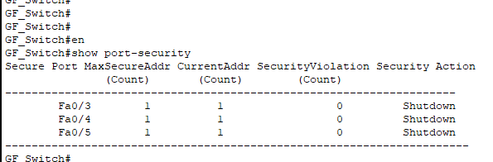
Figure 18: Port Security Configuration

Syslog Configuration
An event and security monitoring system using a Syslog server was set up.
Syslog helps administrators:
- Monitor attacks
- Detect errors
- Troubleshoot network issues
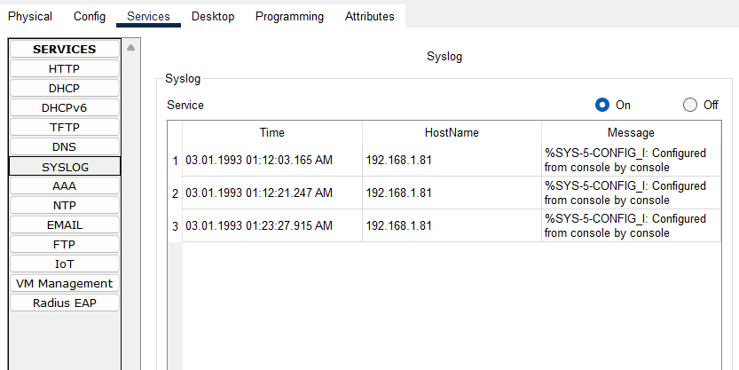
Figure 19: Syslog Monitoring Configuration

3.1.2 Device Configurations, IP Addressing, and Subnetting
All the devices were set up per the subnetting plan which was designed in Task 2.
Each VLAN has its own separate subnet to enhance:
- Security
- Traffic management
- Scalability
Example:
VLAN | Network
VLAN 10 | 192.168.1.0/28
VLAN 20 | 192.168.1.16/28
VLAN 50 | 192.168.1.64/27
VLAN 70 | 192.168.1.112/27

The subnetting structure will allow for efficient utilization of IP addresses and communication between departments.

3.2 Justification of Implemented Network Security Configuration
Security settings that were put in place were chosen to provide the best overall protection for Health First Channelling.

VLAN Segmentation
VLANs were used to create logical separation of departments. This helps to avoid unapproved communications between departments and minimize broadcast traffic.

ACLs
Access to sensitive resources, like the Server VLAN, was limited using ACLs. This ensures patient data and important services are kept safe.

ASA Firewall
The firewall guards the outside boundary of the network against attacks from the Internet and other external sources.

SSH
It is implemented with the use of SSH instead of Telnet which encrypt traffic, and offers secure remote management.

DHCP
DHCP simplifies network management and minimizes manual IP address configuration mistakes.

Port Security
Port security helps to exclude unauthorized devices from connecting to switch ports and helps to enhance physical security.

Syslog
Syslog monitoring helps administrators detect suspicious activities and troubleshoot network issues quickly.
Combined, these configurations form a robust and scalable network infrastructure ideal for healthcare operations (Cisco, 2024).

3.3 Critical evaluation of the design, planning and configuration
The network design that has been carried out is able to meet the needs of the vocational scenario. The hierarchical model is more scalable and will make troubleshooting and future expansion easier.
The VLAN structure provides an effective separation of the departments and enhances security. ACLs allow for a limited amount of communication between VLANs and secure the important systems like servers.
The implementation of:
- SSH
- Firewall
- Port security
- Syslog
Enhances internal/external security.
However, several limitations still exist.

Strengths of the Network
- Strong VLAN segmentation
- Centralized management
- Firewall protection
- Secure remote access
- Automatic IP addressing
- Good scalability

Weaknesses of the Network
- Single core router makes it a single point failure situation.
- No secondary layer of protection with a firewall in place.
- Not having any wireless network infrastructure.Lack of wireless network infrastructure.
- There was no implementation of IDS/IPS systems

Future Improvements
These are some ways the network can be improved:
- Adding redundant routers
- Implementing IDS/IPS systems
- Adding on wireless access points
- Implementing VPN services
- Cloud backup systems are a great way to add.
Overall, the network implemented is very secure, scalable and performant to the needs of Health First Channelling.

Conclusion
Finally, the secure network prototype for Health First Channelling was successfully established by using Cisco Packet Tracer. The deployment was conducted with VLAN segmentation, inter-VLAN routing, DHCP, DNS, Web services, email services, ACLs, SSH, Syslog, and ASA firewall protection, as well as port security.
The network design meets the needs of the vocational scenario and is based on the hierarchical network model from Task 1 and Task 2. The security configurations implemented enhance the confidentiality, integrity, and availability of the healthcare setting.
While there are some constraints, the network offers a solid base for secure communication, network management and future scalability within the Health First Channelling.

Task 4 - Test Plan for Secure Network

Introduction
Implementation of network security is not without its testing significance, since it may be used to validate whether the network runs efficiently, securely and flawlessly. The network that is implemented in Health First Channelling is comprised of critical healthcare systems, patient records, web services, email services, DHCP, DNS, VLAN segmentation, Access Control Lists (ACLs), SSH remote access, Syslog monitoring, ASA firewall protection, and port security. Therefore, it is necessary to make sure that all devices, services and security mechanisms work as expected in the specific vocational context that they are working in.
This task is about creating a detailed test plan for the secure network that has been implemented in Cisco Packet Tracer. The report contains details of the test procedure, test results, analysis of outcomes and recommendations for future improvement. The testing process is directly related to the network design and implementation covered in Task 1, Task 2 and Task 3.

4.1 Test Plan for the Security Configuration
A test plan is used to ensure the functionality and security of the implemented network function. The Health First Channelling network was subjected to the following tests.
Test ID | Test Description | Expected Result | Actual Result | Status
T1 | Test DHCP IP allocation | PCs should receive IP automatically | Successful | Pass
T2 | Test VLAN communication | Devices in same VLAN should communicate | Successful | Pass
T3 | Test inter-VLAN routing | Authorized VLANs should communicate | Successful | Pass
T4 | Test ACL restriction | Reception VLAN should not access Server VLAN | Access denied | Pass
T5 | Test SSH remote login | Secure login should work | Successful | Pass
T6 | Test HTTP server access | Website should open successfully | Successful | Pass
T7 | Test Email server | Emails should send successfully | Successful | Pass
T8 | Test Syslog monitoring | Logs should appear on Syslog server | Successful | Pass
T9 | Test port security | Unauthorized device should be blocked | Successful | Pass
T10 | Test firewall protection | External unauthorized traffic should be blocked | Successful | Pass

4.2 Network Testing According to the Test Plan

DHCP Testing
DHCP testing was conducted to ensure that all end user devices were getting their IP address from DHCP.
The PCs in different VLANs successfully received:
- IP address
- Subnet mask
- Default gateway
- DNS server address
This verifies that the DHCP pools and VLAN configurations were correct.
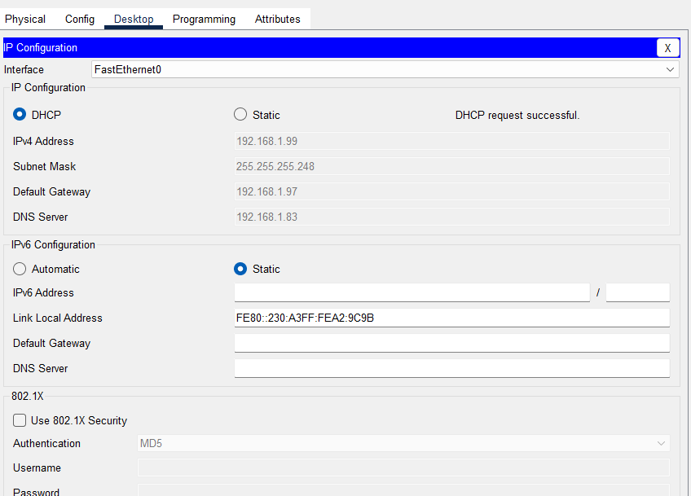
Figure 20: Successful DHCP IP Address Allocation

VLAN Communication Testing
Communication testing was conducted to ensure there was communication between devices within the same VLAN.
Example:
- Reception PC1 was able to ping Reception PC2.
This confirms:
- Proper VLAN configuration
- Ensure that switch ports are properly assigned.
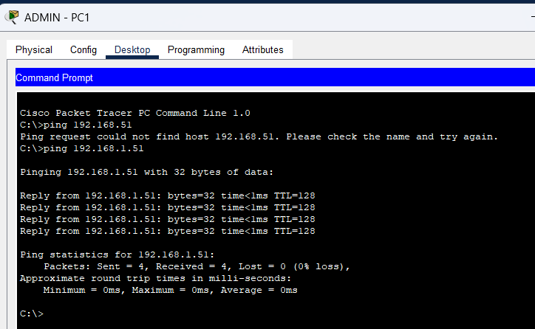
Figure 21: Successful Communication within Same VLAN

Inter-VLAN Routing Testing
Testing of Inter-VLAN routing was done to ensure communication between allowed VLANs via the Layer 3 switches.
Example:
- Administration VLAN has successfully communicated with Pharmacy VLAN.
This confirms:
- Correct SVI configuration
- Proper Layer 3 routing
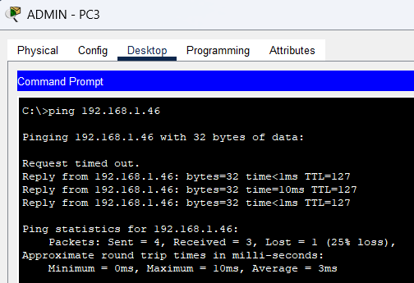
Figure 22: Successful Inter-VLAN Routing Test

ACL Testing
To ensure sensitive resources like the Server VLAN were not being accessed by unauthorized VLANs, ACL testing was carried out.
Example:
- The ping operation to the Server VLAN was tried for the Receiver VLAN – "Reception VLAN".
- Communication was denied successfully!
This verifies that the ACL was properly working.

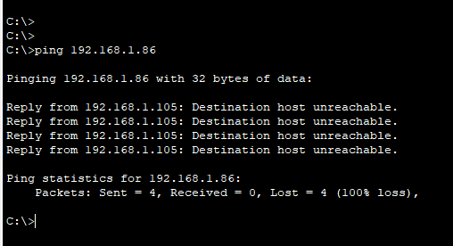
Figure 23: ACL Blocking Unauthorized Access to Server VLAN

SSH Remote Access Testing
Secure remote login to routers and switches has been tested using SSH.
Administrator logged in to the switch using SSH credentials.
This confirms:
- RSA key generation
- Secure encrypted communication
- Correct VTY configuration
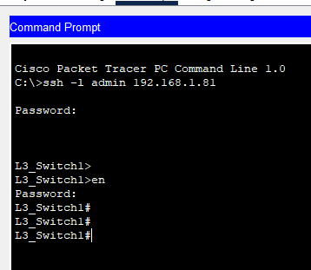
Figure 24: Successful SSH Remote Login

HTTP Server Testing
HTTP testing was done to ensure functionality of the web server.
The Web server was able to open the website from client PCs.
This confirms:
- Proper server configuration
- Correct DNS functionality
- Network connectivity
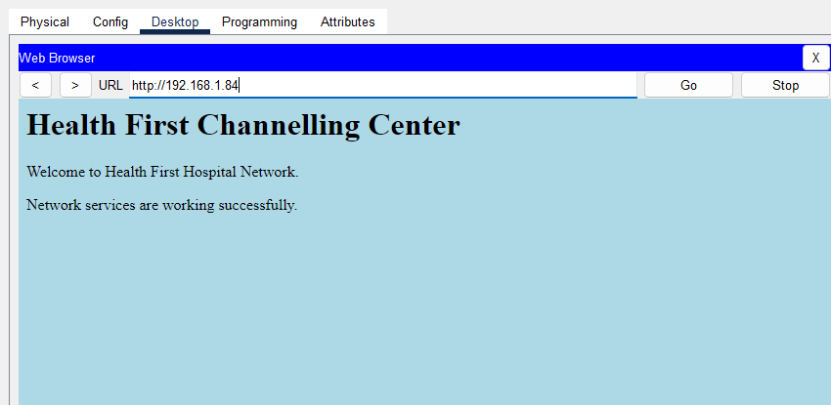
Figure 25: Successful HTTP Web Server Test

Email Server Testing
Testing using email was conducted to ensure that communication between the users within the organization was working.
Emails were successfully sent and received between users.
This confirms:
- Correct SMTP/POP3 configuration
- Proper DNS functionality
Syslog Monitoring Testing
The testing involved testing the Syslog for checking if the network devices were sending logs to the Syslog server.
The following message was received by the Syslog server:
- Login attempts
- Interface changes
- Configuration logs
This validates the correct monitoring capability.
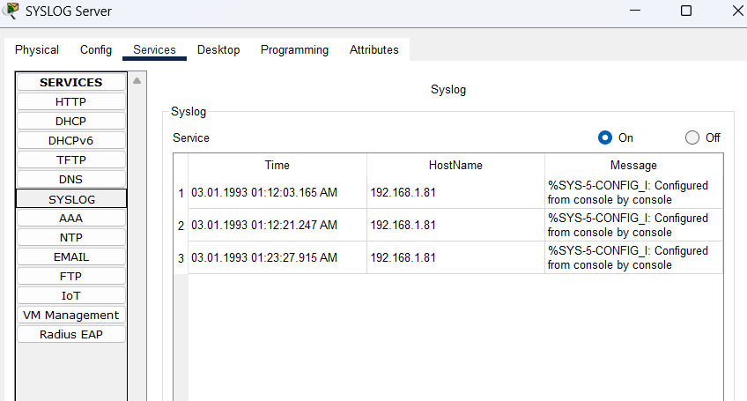Figure 26: Syslog Monitoring Test

Port Security Testing
The port security testing was done by bringing an unauthorized device to a secured port of the switch.
Access was automatically restricted based on the configured security policy.
This confirms:
- Ensure that ports are properly secured.
- Improved physical security

Firewall Testing
Testing of the ASA firewall was carried out to ensure that external traffic was not allowed to pass through.
The firewall was able to filter traffic based on the rules that were configured.
This confirms:
- Proper perimeter security
- A better defense against outside dangers
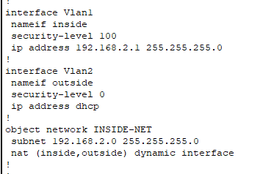
Figure 27: ASA Firewall Security Test

4.3 Analysis of Test Results
The outcomes of the tests indicate that the secured network is able to meet the vocational situation requirements.

Successful Results
The following features worked:
- DHCP automatic IP assignment
- VLAN segmentation
- Inter-VLAN routing
- ACL restrictions
- SSH secure access
- HTTP services
- Email services
- Syslog monitoring
- Port security
- ASA firewall protection
Test ID | Test Description | Expected Result | Actual Result | Status
T1 | Test DHCP IP allocation | PCs should receive IP automatically | Successful | Pass
T2 | Test VLAN communication | Devices in same VLAN should communicate | Successful | Pass
T3 | Test inter-VLAN routing | Authorized VLANs should communicate | Successful | Pass
T4 | Test ACL restriction | Reception VLAN should not access Server VLAN | Access denied | Pass
T5 | Test SSH remote login | Secure login should work | Successful | Pass
T6 | Test HTTP server access | Website should open successfully | Successful | Pass
T7 | Test Email server | Emails should send successfully | Successful | Pass
T8 | Test Syslog monitoring | Logs should appear on Syslog server | Successful | Pass
T9 | Test port security | Unauthorized device should be blocked | Successful | Pass
T10 | Test firewall protection | External unauthorized traffic should be blocked | Successful | Pass

The success of these results indicates that the network has been set up properly and secure.

Critical Evaluation of Testing Process
The testing process was effective, as it validated both of the following:
- Network functionality
- Security functionality
The combination of:
- VLANs
- ACLs
- Firewall protection
- SSH
- Port security
Gave Health First Channelling a better security overall.
The implemented test plan also assisted in finding configuration problems early in the implementation process.

Weaknesses Identified During Testing
The testing process was largely successful, but there are some weaknesses found.

Single Point of Failure
There is only one core router in the network. In the event of router failure, the network may go down.

Limited Redundancy
No backup firewall or backup Layer 3 switch was put in place.

No IDS/IPS System
There are no intrusion detection and prevention systems (IDPS) in place for the network.

Wireless Security Not Implemented
Wireless access points and wireless security configuration were not included.

Recommendations for Improvement
To improve the network in the future, the following enhancements are recommended.

Implement Redundant Devices
Network redundancy should be obtained through the use of backup routers and switches.

Add IDS/IPS Systems
Intrusion Detection and Prevention Systems should be implemented to improve threat detection.

Implement VPN Services
Physicians and administrators should have access to the VPN for secure remote connections.

Add Wireless Infrastructure
WPA3 encryption for securing wireless access points can enhance flexibility.

Enable Centralized Monitoring
Enhanced monitoring solutions like SIEM systems can enhance security analysis and incident response.

Importance of Testing in Network Security
Testing is very significant in the healthcare setting because of the possible consequences of failure in the services rendered to patients and in the functioning of the organization.
Proper testing helps:
- Identify security weaknesses
- Verify network reliability
- Improve troubleshooting
- Ensure policy compliance
- Ensure the security of sensitive health-care data
As a result, it is essential to continuously test and monitor networks to ensure a secure healthcare network environment (Kizza, 2022).

Conclusion
To sum up, the secure network that was implemented for Health First Channelling was tested to prove its success, following a well-designed test plan. The testing process confirmed the functions and security of DHCP, VLANs, inter-VLAN routing, ACLs, SSH, web services, email services, Syslog monitoring, port security, and ASA firewall configurations.
The outcomes showed the network implementation meets the demands of the vocational scenario and delivers robust security, scalability, and performance in the healthcare setting.
Security weaknesses were found, including the lack of system redundancy and IDS/IPS systems, but the network offers a solid base for secure communication and management of healthcare services. The network infrastructure can be further strengthened in the future through improvements to the security and reliability.

Task 5 - Recommendations and Critical evaluation

Introduction
In task 5, the implemented secure network for Health First Channelling will be analysed and recommendations for improvement in the future will be made. The principles of network security, security protocols and security devices were discussed in Task 1. Task 2 involved designing a secure network with VLANs, subnetting and hierarchy. For Task 3, the secure network was created in Cisco Packet Tracer, enabled with technologies like VLANs, ACLs, DHCP, SSH, Syslog, ASA firewall, and port security. The network was then subjected to a comprehensive test plan in Task 4, to ensure proper operation and security of the network.
This task will critically assess the effectiveness of the test process and examine network design, planning, implementation and security setup. Moreover, suggestions for enhancing the future security, reliability, and scalability of the network infrastructure for future organizational development are presented.

5.1 Critical Evaluation of the Test Plan Against the Test Results
The testing process carried out in task 4 was really significant since it allowed to confirm the suitability of the network developed in terms of requirements of the vocational scenario. The test plan was able to successfully assess:
- DHCP functionality
- VLAN communication
- Inter-VLAN routing
- ACL restrictions
- SSH remote access
- HTTP services
- Email services
- Syslog monitoring
- Port security
- ASA firewall security
The test results demonstrated the successful and secure functioning of the network prototype implemented.

Evaluation of DHCP Testing
All the end user devices were able to automatically obtain the IP address from the DHCP server in the DHCP testing results. This confirms that:
- DHCP pools were properly set up
- VLAN interfaces were functioning properly
- The design of the subnetting was successful.
The testing also verified the assignment of addresses from different VLAN subnet ranges to each VLAN. This enhanced network organization and minimized manual configuration mistakes.
In the implementation phase, however, some VLANs were experiencing DHCP problems, due to trunking and VLAN assignments problems. These problems were subsequently resolved by setting up the correct VLAN access ports and trunk links.
This shows that testing is required to detect configuration errors at an early stage of implementation (CompTIA, 2023).

Evaluation of VLAN and Inter-VLAN Routing Testing
Testing of the VLANs was performed and it was verified that the devices within the same VLAN were in communication. Testing of Inter-VLAN routing was also performed to ensure that authorized VLANs could communicate between each other when using layer 3 switches.
The use of VLAN segmentation significantly improved:
- Security
- Traffic management
- Department isolation
The VLAN design implemented are in line with the structure of the department Health First Channelling:
- Reception
- Administration
- Pharmacy
- Staff Room
- Radiology
- Server Room
- Medicine Storage
This design helped to minimize redundant broadcast traffic and enhance network performance (Stallings, 2020).
But, network still relies heavily on proper VLAN management. If the departments are communicating incorrectly because of a mis-assignment of VLANs or because of a trunk failure, communication will be impacted.

Evaluation of ACL Testing
The ACL testing was one of the most significant security tests, as it ensured that unauthorized users were unable to enter sensitive network areas.
The following ACL configuration was used to successfully block:
- Reception VLAN
from accessing:
- Server VLAN
This enhanced the internal security by safeguarding:
- Patient records
- DNS server
- Email server
- Syslog server
Because the implementation of ACLs allows only users to have access to authorized resources, it follows the principle of least privilege (Kizza, 2022).
The existing ACL-based implementation is fairly simple however. For larger healthcare providers, more sophisticated access control systems might be necessary, including:
- Role Based Access Control (RBAC)
- Dynamic ACLs
- Identity-based access systems

Evaluation of SSH Testing
Testing for SSH showed that network administrators could remotely access routers and switches without compromising security.
The use of SSH has increased:
- Confidentiality
- Secure authentication
- Data encryption
It was a critical security enhancement as health care institutions deal with sensitive data which should not be exposed to interception.
The SSH configuration was successful because:
- The keys were successfully generated with RSA.
- User credentials functioned correctly
- VTY lines were secured
But further steps in the form of stronger password policies and Multi-Factor Authentication (MFA) might provide another level of security for remote management.

Evaluation of Firewall Testing
The ASA firewall testing was successful in blocking unwanted external traffic. The firewall was a key improvement to the perimeter security and mitigated exposure to attacks from the internet.
The implementation of the firewall that is set to protect:
- Internal VLANs
- Servers
- End-user devices
This is quite significant as healthcare organisations are one of the most frequent victims of:
- Malware attacks
- Ransomware attacks
- Unauthorized access attempts
Traffic filtering and security management were also enhanced on the firewall.
Only one firewall device, however, was implemented. This will cause a potential single point of failure problem if the firewall is not available.

Evaluation of Syslog and Port Security Testing
Syslog collection from network devices using syslog monitoring was successful. This improved:
- Security monitoring
- Troubleshooting
- Event analysis
Port security testing also proved that unauthorized devices were prevented from connecting to the network.
The configurations enhanced the physical security and operational security of the network.
But in the present network, there are no advanced monitoring tools like:
- IEM systems
- Intrusion Detection Systems (IDS)
- Intrusion Prevention Systems (IPS).
These systems would enhance real-time threat detection and incident response.

Critical Evaluation of the Overall Network Design
The requirements of the vocational scenario and grading were met by the network design implemented.
The network achieved:
- VLAN segmentation
- Secure inter-VLAN communication
- Automatic IP assignment
- Secure remote management
- Firewall protection
- Internal access control
- Network monitoring
The hierarchical design model was further enhanced:
- Scalability
- Troubleshooting
- Network organization
The design used:
- Core Router
- Layer 3 Switches
- Access Switches
- ASA Firewall
This represents an enterprise network structure in the real world (Cisco, 2024).

Strengths of the Network

Strong VLAN Segmentation
VLANs helped to isolate departments and to minimise unnecessary traffic.

Secure Access Control
ACLs effectively limited unwanted communications.

Secure Remote Management
SSH enhanced security of administrators' access.

Perimeter Protection
The ASA firewall shielded the network from any outside attacks.

Automatic Network Management
DHCP made handling IPs easier.

Monitoring and Logging
Network monitoring and troubleshooting was enhanced by Syslog.

Weakness of the Network

Single Point of Failure
The network contains:
- One core router
- One firewall
Failure of these devices could interrupt the entire network.

No Redundant Links
There are no links that provide protection between switches and routers in the network.

No Wireless Security
There was no application of wireless infrastructure.

No IDS/IPS Systems
There are no advanced intrusion detection/prevention systems in place to perform active inspection of the network.

Limited Advanced Authentication
Basic username/password authentication was only used.

5.2 Recommendations to Improve Network Security
There are several enhancements that can be made to further improve the security and reliability of the Health First Channelling network.

Recommendation 1 - Implement Redundant Devices
To prevent single points of failure, add backup routers, switches and firewalls.
This will improve:
- Availability
- Reliability
- Business continuity
Healthcare systems must have a high level of availability to ensure that disruptions do not impact patient care.

Recommendation 2 - Implement IDS/IPS Systems
Intrusion Detection Systems (IDS) and Intrusion Prevention Systems (IPS) need to be deployed to detect and prevent cyber attacks in real time.
This would improve:
- Threat detection
- Security monitoring
- Attack prevention

Recommendation 3 - Implement VPN Services
VPN should be set up for doctors and administrators who need secure remote access.
The encryption on the VPN would be enhanced:
- Confidentiality
- Secure remote communication

Recommendation 4 - Implement Wireless Security
For staff mobility and flexibility secure wireless access points with WPA3 encryption must be installed.
Wireless security policies should be in place as well.

Recommendation 5 - Use Multi-Factor Authentication (MFA)
For administrator logins, MFA provided for the authentication process would be beneficial in terms of security.
This minimises the chances of:
- Password attacks
- Unauthorized access

Recommendation 6 - Implement SIEM Systems
Centralized monitoring and security analysis can be enhanced by using Security Information and Event Management (SIEM) systems.
SIEM systems help:
- Detect attacks faster
- Analyze logs
- Improve incident response

Recommendation 7 - Regular Security Audits
The organisation should conduct:
- Vulnerability assessments
- Penetration testing
- Security audits
regularly.
This allows finding new security openings in an early stage.

Importance of Continuous Network Improvement
Cyber threats are ever-changing. So companies like Health First Channelling need to continually enhance the security of their network to secure:
- Patient information
- Medical systems
- Communication services
- Organizational reputation
To keep the healthcare environment secure, regular upgrades, monitoring, and testing are required (NIST, 2023).

Conclusion
Finally, the VOs achieved the requirements of the vocational scenario used secure network techniques such as VLANs, ACLs, DHCP, SSH, Synology monitoring and ASA firewall protection.
Testing process validated a secure and efficient operation of the network. The hierarchical network design enhanced organizational structure, communication and management and increased the scalability of the organization.
Network implementation proved to be very secure, but some enhancements like redundancy, IDS/IPS, VPN, wireless security, and SIEM monitoring can further augment the security of the infrastructure.
The implemented network overall offers a solid basis for safe healthcare information exchange and organizational development.

References
Cisco, 2024. Cisco Networking and Security Solutions. Cisco Systems. Available at: https://www.cisco.com [Accessed 23 May 2026].
Kizza, J.M., 2022. Guide to Computer Network Security. 6th ed. Cham: Springer.
Stallings, W., 2020. Network Security Essentials: Applications and Standards. 7th ed. Pearson Education.
Whitman, M.E. and Mattord, H.J., 2021. Principles of Information Security. 7th ed. Boston: Cengage Learning.
CompTIA, 2023. Network+ Guide to Networks. 9th ed. CompTIA Publications.
NIST, 2023. Guidelines for Secure Network Protocols. National Institute of Standards and Technology. Available at: https://www.nist.gov [Accessed 24 May 2026].
Whitman, M.E. and Mattord, H.J., 2021. Principles of Information Security. 7th ed. B

