DSA Assignment

Afry Nizam
ANC
HND in Computing
Table of Contents
Data Structures and Algorithms for Smart Transport Route Management System. 22
Introduction 22
Abstract Data Types Used in the Smart Transport Route Management System. 23
Overview of Abstract Data Types 23
1. List ADT 24
2.Stack ADT 25
3. Queue ADT 26
Application in Smart Transport System. 26
4. Tree ADT 27
Application with Data Structures. 27
5. Set ADT 28
Application in Smart Transport System. 29
Memory Stack Operations and Function Calls. 29
Queue Data Structure Demonstration with FIFO Principle. 33
Introduction to Queue Data Structure. 33
Output Explanation 36
Graphical Simulation of Queue Processing 37
Real System Application 37
The benefits of Queue in Transport Systems. 38
Evaluation of Queue Performance. 38
Comparison of Two Sorting Algorithms. 39
Introduction to Sorting algorithms. 39
Bubble Sort Algorithm 39
Merge Sort Algorithm 40
Time Complexity Comparison 42
Dataset Performance Testing 42
Dataset Sizes 42
Graphical Comparison (Conceptual) 43
Memory Usage Comparison 43
Shortest Path Algorithms in Transport Systems. 44
Transport Graph Example 45
Choice of Shortest Path Algorithms. 46
Dijkstra Algorithm 47
Working Principle of Dijkstra Algorithm. 47
Example - Route Optimization 47
The benefits of Dijkstra Algorithm. 47
Dijkstra Algorithm has the following limitations. 48
Bellman-Ford Algorithm 48
Working Principle of Bellman-Ford 48
Advantages of Bellman-Ford Algorithm 49
Weaknesses of Bellman-Ford Algorithm. 49
Performance Comparison 49
Real-World Application in Smart Transport System 49
Route Planning 49
Fuel Optimization 49
Emergency Routing 50
Evaluation of Algorithms Suitability. 50
Critical Evaluation 50
Conclusion 51
Abstract Data Types and Object-Oriented Concepts Specification. 53
Introduction 53
Stack ADT in use in Smart Transport System. 55
Encapsulation and Information Hiding in ADT Implementation 56
Benefits of Encapsulation and Information Hiding 57
1. Improved Data Security 57
2. Improved Maintainability 57
3. Improved Code Reusability 57
4. Reduced System Errors 57
Link to Smart Transport Route Management System. 57
Relationship Between ADTs and Object-Oriented Programming. 58
Connection between ADTs and OOP Concepts. 59
1. Abstraction 59
2. Encapsulation 59
3. Inheritance 59
4. Polymorphism 60
Evaluation - ADTs as Foundation to OOP. 60
Critical Evaluation 61
Conclusion 62
Smart Transport Route Management System. 63
System Architecture 64
JAVA IMPLEMENTATION 64
1. Route.java 64
2️. Passenger.java 64
3️. RouteManager.java 65
4️. PassengerQueue.java 66
5️. UndoStack.java 66
6️. SortRoutes.java 67
7️. SearchRoute.java 67
8️. MainSystem.java 68
Test Report 68
Complexity Evaluation 69
Queue Operations 69
Stack Operations 69
Merge Sort 69
Linear Search 69
Critical Evaluation 70
Conclusion 70
Performance Analysis of Data Structures and Algorithms. 71
What is Asymptotic Analysis? 71
Techniques to estimate Algorithms Efficiency. 72
1. Time Complexity 72
2. Space Complexity 73
Three Program Implementations. 73
Program 1 - Using Array 74
Program 2 - Using Linked List 74
Program 3 - Using Stack 75
Performance Comparison 75
Trade-Off Interpretation 76
Advantages of Implementation-Independent Data Structures. 76
1. Improved Software Flexibility 76
2. Easier Maintenance 76
3. Better Code Reusability 77
Overall System Evaluation 77
Conclusion 77
References 79

Data Structures and Algorithms for Smart Transport Route Management System.

Introduction
The Smart Transport Route Management System being developed by TransitLink Solutions (Pvt) Ltd will enhance the management of the transport routes, passenger booking and travel schedule between cities. The system should be able to handle passenger requests in the right sequence, huge volumes of route information and calculate the most effective route between destinations. In order to meet these needs, the appropriate Abstract Data Types (ADTs) and algorithms have to be chosen and introduced with care.
Abstract Data Types are logical models that characterise the way the data is structured and what operations are allowed to be done on the data. They do not explain the way data is stored internally but rather explain the behaviour of the data structure. Lists, stacks, queues, trees and sets are some of the common ADTs that are used in real-world systems due to their effectiveness in storing, retrieving and manipulating data (Goodrich, Tamassia and Goldwasser, 2014).
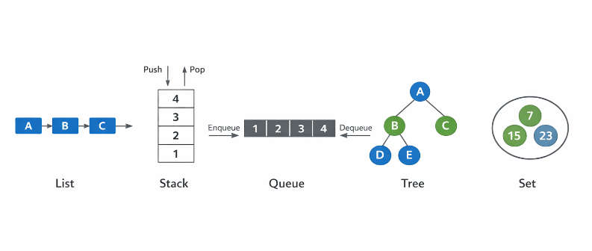
Figure 1: ADT’s

The Smart Transport Route Management System has to deal with various kinds of information, which necessitates the use of different data structures. As an example, passenger booking requests will have to be handled in order in which they come, route information will have to be searched fast and the shortest travel paths between cities will have to be computed efficiently. That is why, it is necessary to choose appropriate ADTs and algorithms that would help to make the system work correctly and efficiently
This section explores some of the common Abstract Data types that may be utilized in the transport system and how they can be implemented through appropriate data structures. It also describes the use of a memory stack in managing a program execution by making function calls. Besides that, the section also shows how a queue works using FIFO, the performance of two sorting algorithms and the working of two shortest path algorithms to find out the most efficient routes between locations.
These ideas are fundamental in developing a robust Smart Transport Route Management System that is capable of processing vast volumes of transport data and deliver precise route planning services.

Abstract Data Types Used in the Smart Transport Route Management System.

Overview of Abstract Data Types
An Abstract Data Type (ADT) is a logical model, which describes the way data is structured and what can be done with it. It concentrates on what can be done as opposed to how the data is stored within it. ADTs assist software developers to come up with flexible systems, reusable and easier to maintain (Cormen et al., 2009).
The Smart Transport Route Management System allows us to manage various types of transport data with several common ADTs. These include:
- List
- Stack
- Queue
- Tree
- Set
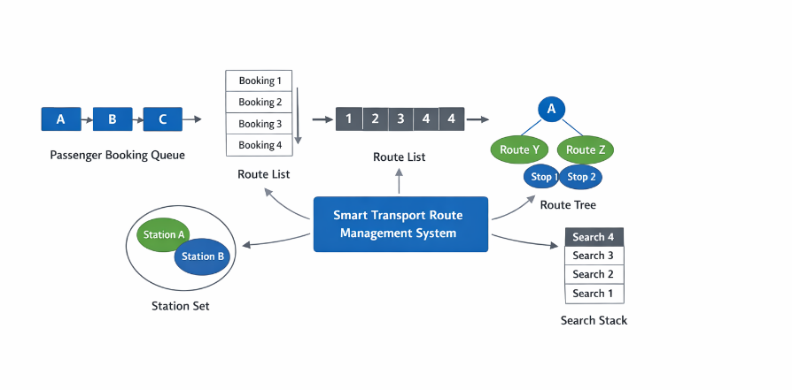
Figure 2: Operations of ADT’s

All ADTs facilitate certain operations like insertion, deletion, searching, sorting and updating that are useful in the processing of transport route data and passenger booking requests.

1. List ADT
A List ADT is a container of items that are ordered in a list. All elements in a list have positions and elements may be accessed by their index. The lists are frequently used in the systems that need to store data in order (Goodrich, Tamassia and Goldwasser, 2014).
List ADT can be implemented using:
- Array
- Linked List
In the case of the Smart Transport System, a Linked List will prove to be more appropriate since transport routes can be added or dropped on a regular basis.

Valid Operations of List ADT
The following are the operations that can be carried out:
Operation | Description | Transport Example
Insertion | Add new element | Add new transport route
Deletion | Remove element | Remove cancelled route
Searching | Find element | Find route by ID
Updating | Modify element | Update route schedule
Sorting | Arrange elements | Sort routes alphabetically
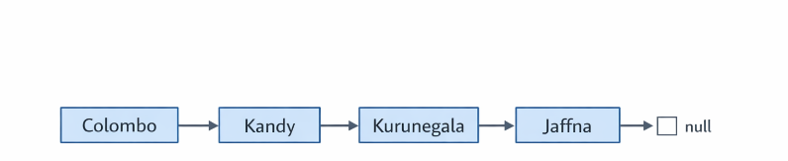
Figure 3: List ADT

Application in Smart Transport System.
In the Smart Transport Route Management System, a List ADT can be used to store:
- Transport routes
- Route IDs
- Station sequences
Example:
In the event that a new route between Colombo and Kandy is developed, then it can be added to the route list.

2.Stack ADT
A Stack ADT is data structure which adheres to the principle of Last-In-First-Out (LIFO). The final one to be added to the stack is the one that is to be taken away first (Cormen et al., 2009).
In order to implement stack ADT, it is possible to use:
- Array
- Linked List
Stack can be applied in the transport system with the help of Array to perform fast operations.

Valid Operations of Stack ADT
Operation | Description | Transport Example
Push | Add element to top | Save route update
Pop | Remove top element | Undo route update
Peek | View top element | Check latest update
isEmpty | Check if stack empty | Verify undo history
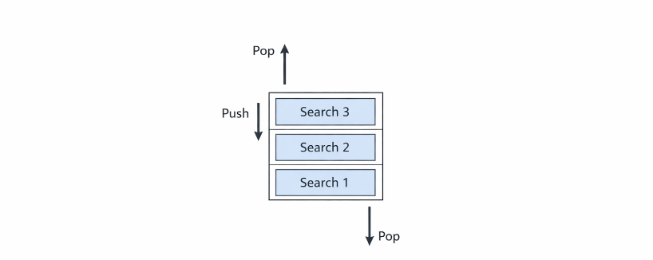
Figure 4: Stack ADT
Stack ADT would be applicable in the Smart Transport System to:
- Route search history
- Undo operations
- Function call management
Example:
If a user searches:
Colombo → Kandy
Kandy → Kurunegala
Kurunegala → Jaffna
These searches are stored in stack and are reversible in case of necessity.

3. Queue ADT
A Queue ADT is based on the First-In-First-Out (FIFO) principle. The removal of an element is the first element to be removed (Sledgewick and Wayne, 2011).

Application using Data Structures.
Queue ADT can be implemented using:
- Array
- Linked List
A Linked List is favored in the Smart Transport System as the requests to book a passenger are coming in.

Valid Operations of Queue ADT
Operation | Description | Transport Example
Enqueue | Add element | Add passenger request
Dequeue | Remove element | Process booking
Peek | View front element | Check next passenger
isEmpty | Check if queue empty | Verify waiting list
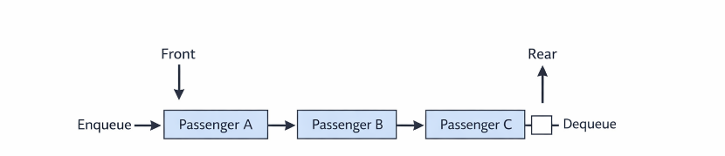
Figure 5: Queue ADT

Application in Smart Transport System.
Queue ADT is implemented to handle:
- Passenger booking srequests
- Ticket processing order
Example:
Passengers booking tickets:
- Passenger A
- Passenger B
- Passenger C
They are processed in the same order.

4. Tree ADT
A Tree ADT is a hierarchical data structure that includes nodes linked with edges. The highest node is referred to as the root and child nodes are the ones that are formed by the parent nodes (Goodrich, Tamassia and Goldwasser, 2014).

Application with Data Structures.
Tree ADT is realized with the help of:
- Node-based structure
- Parent-child relationships

Valid Operations of Tree ADT
Operation | Description | Transport Example
Insert | Add node | Add new station
Delete | Remove node | Remove station
Search | Find node | Search station
Traverse | Visit nodes | Display routes
Traversal types:
- In-order
- Pre-order
- Post-order
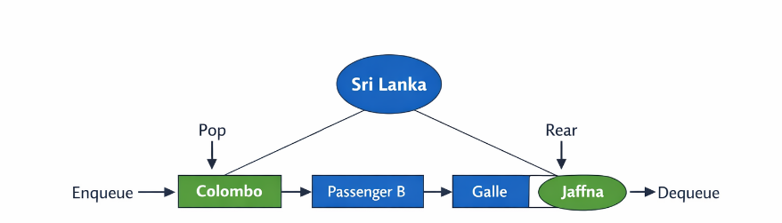
Figure 6: Tree ADT

Use in Smart Transport System.
Tree ADT can be used to represent:
- Route hierarchy
- City connections
Example:
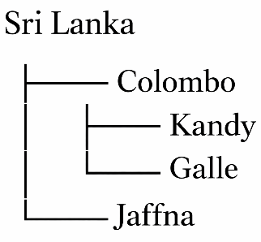
This enables quicker navigation of routes.

5. Set ADT
A Set ADT is a data type where the elements are distinct and no duplicate values can be present. It comes in handy when the presence of duplicate data should be avoided (Cormen et al., 2009).

Implementation Using Data Structures
To implement set ADT we can use:
- Hash Table
- Binary Search Tree
HashSet is frequently used in transport systems.

Valid Operations of Set ADT
Operation | Description | Transport Example
Add | Insert element | Add station name
Remove | Delete element | Remove station
Contains | Check element | Verify station
Size | Count elements | Count stations
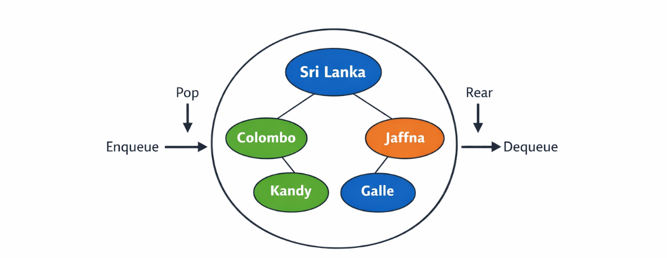

Figure 7: Set ADT

Application in Smart Transport System.
The following are stored in Set ADT:
- Unique station names
- Unique route IDs
Example:
When the same station, Colombo, is entered twice, it will be entered only once.

Memory Stack Operations and Function Calls.

Introduction to Memory Stack
Special memory in computer memory that holds information temporarily during execution of a program is called a memory stack. It is based on the principle of the Last-In-First-Out (LIFO) that is, the most recently added function to the stack is also the first one to be taken out. The memory stack is mainly used to manage function calls in a program (Sedgewick and Wayne, 2011).
When a program calls a particular functional, the system transfers valuable data to stack which includes:
- Function name
- Return address
- Local variables
- Parameters
This information stored is called a stack frame. Once the execution of the function is done, the stack frame is popped off the stack.
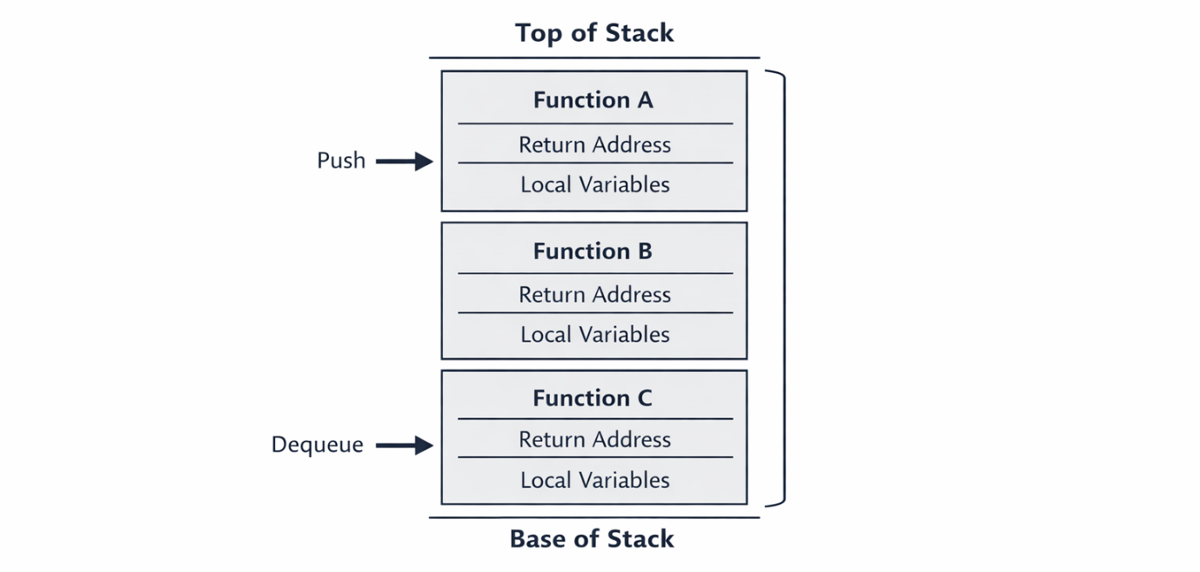
Figure 8: Memory Stack Frame

Operation of Memory Stack During Function Calls
The memory stack works in a series of steps whenever the functions are called.

Step-by-Step Stack Operation
- One of the functions is called.
- A stack frame is made.
- The local variables are stored.
- Function executes
- Function completes
- Stack frame is eliminated.
This happens to each call of a function executed in the program.
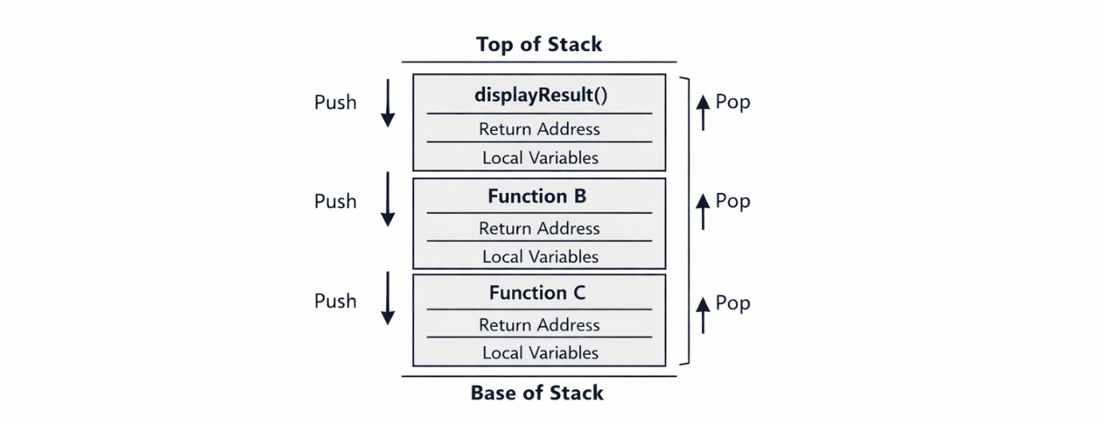
Figure 9: Function Call Sequence
Take the case of a program that is used to find a route between cities by transport. The following functions can be called:
main()
→ searchRoute()
→ calculateDistance()
→ displayResult()
Execution Steps:
- Main() begins to execute.
- searchRoute() function is called and pushed into the stack.
- calculateDistance() function is called next.
- lastly, the displayResult() is called.
- The functions are reversed after showing the result.

Return Order:
displayResult()
calculateDistance()
searchRoute()
main()
This illustrates the use of the memory stack in determining the sequence of functions to be executed.
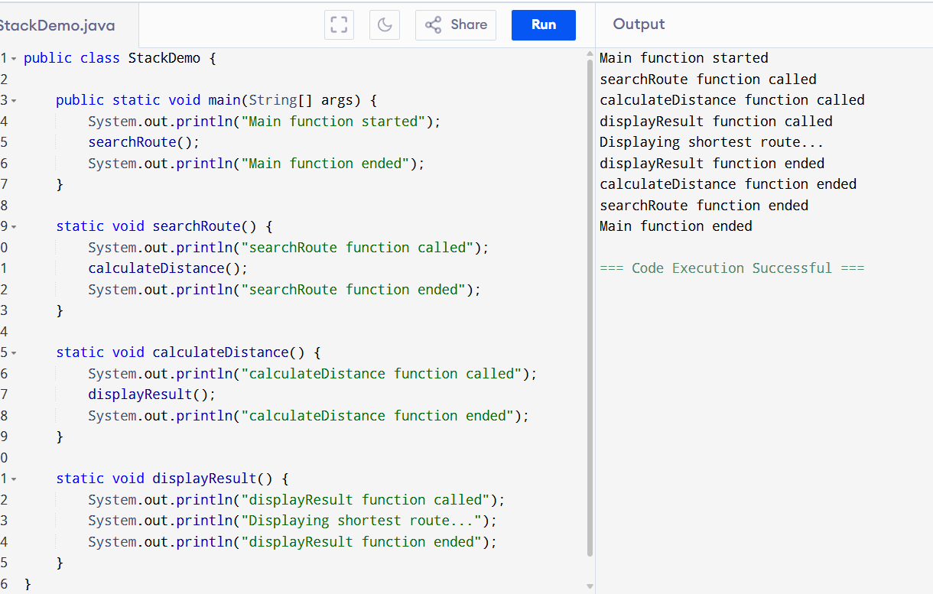
Figure 10: Function Call Implementation with Stack.

Link with Smart Transport Management System.
The memory stack is significant in the Smart Transport Route Management System as it manages operations of the system. When a passenger requests a route between two cities, as an example, there can be multiple functions invoked to handle the request.
Example Scenario:
Passenger searches:
From: Colombo
To: Kandy
The system performs the following steps:
- searchRoute() - Receives request of passengers.
- findAvailableRoutes() - Searches routing table.
- calculateDistance() - Shortest distance.
- displayRoute() - Shows result
Every function is pushed in the stack when being executed and popped out when they are finished.
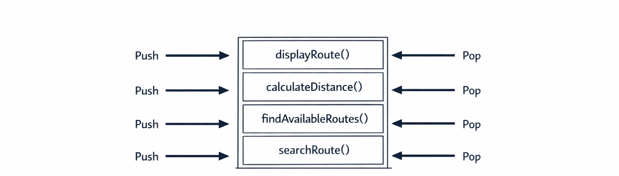
Figure 11: Function Call Stack
This will make the system run the operations in the right sequence and come up with the right results.

Importance of Memory Stack in System Performance
The memory stack enhances performance of the system because:
- Multiple function call.
- Maintaining execution order
- Preventing data conflicts
- Supporting recursion
- Reducing execution errors
In the absence of memory stack, the system would not have a way of knowing the function that needs to be returned first and thus the program would not run correctly.
The correct utilisation of stack in the Smart Transport Route Management System means that route analysis and booking operations are performed in a reliable and error-free manner.

Queue Data Structure Demonstration with FIFO Principle.

Introduction to Queue Data Structure.
A Queue is a kind of data structure based on the principle of First-In-First-Out (FIFO). This implies that the initial element to be added to the queue will be the initial element to be removed. Queues are typically involved in a system where the order of requests has to be completed in the sequence that they are received (Goodrich, Tamassia and Goldwasser, 2014).
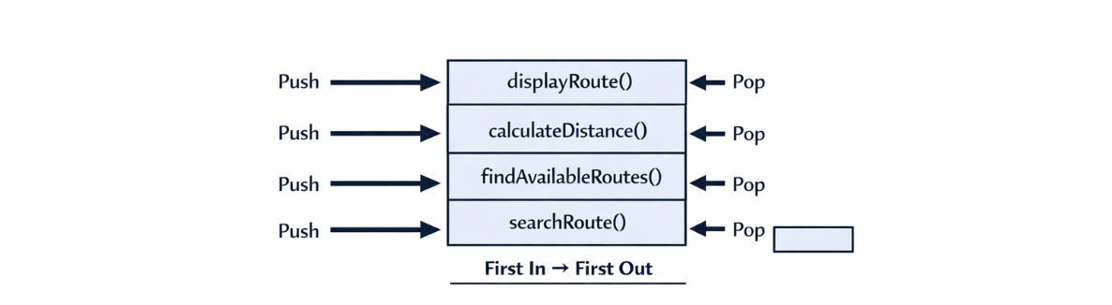
Figure 12: FIFO Principle
The booking requests of the passengers should be attended to in the proper sequence in the Smart Transport Route Management System. In case passengers are randomly processed, it can result in delays and inaccurate scheduling. Thus, a queue would be the right data structure to handle the booking requests.

Queue Structure Illustration
Two ends of a queue are important:
- Front → First element
- Rear → Last element
Queue Diagram
Front → [P1] [P2] [P3] [P4] ← Rear
Where:
- P1 → First passenger
- P4 → Last passenger

Queue Operations
A Queue has various primitive operations:
Operation | Description | Transport System Example
Enqueue | Add element to rear | Add passenger request
Dequeue | Remove element from front | Process booking
Peek | View front element | Check next passenger
isEmpty | Check if queue empty | Verify waiting list

Passenger Booking Process Using Queue
The queue operations are involved in processing passenger requests in the Smart Transport Route Management System.

Passenger booking Step-by-Step.
Passengers arrive:
- Passenger A comes in → Enqueue.
- Passenger B comes in → Enqueue.
- Passenger C comes in → Enqueue.
Queue becomes:
- Front → [A] [B] [C] ← Rear
Processing begins:
- Dequeue A → Booking completed.
- Dequeue B → Booking processed.
- Dequeue C → Booking processed.
Final queue:
- Front → [ ] ← Rear
- Queue Empty
This makes booking requests to be processed fairly and efficiently (Cormen et al., 2009).
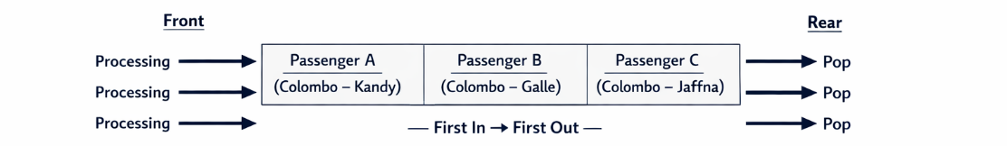
Figure 13: Passenger Booking Queue

Queue Demonstration Using Java Program
To demonstrate the working of the queue, a simple Java program can be used. In this program, it mimics the passenger booking requests and handles them with a FIFO order.
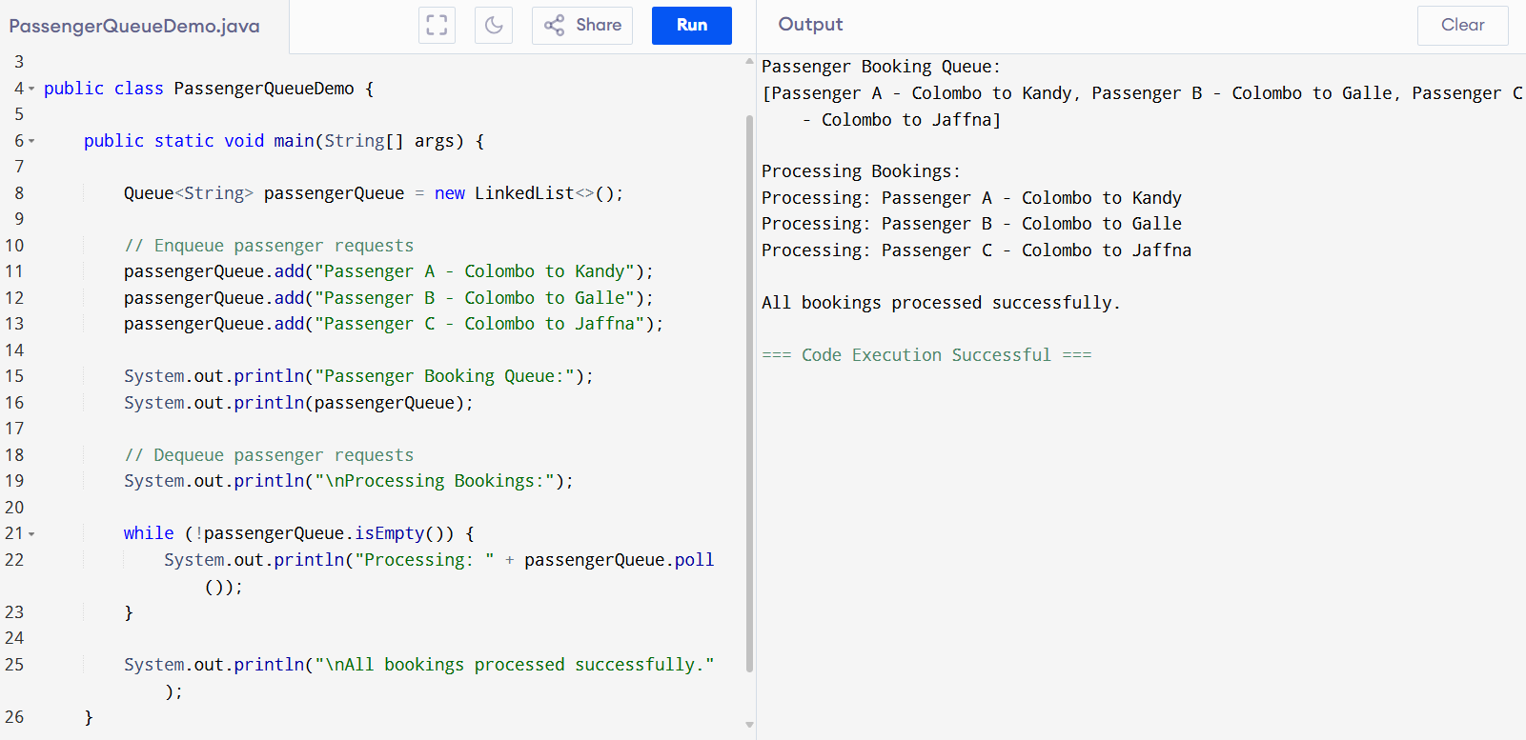

Figure 14: Queue Demonstration Using Java Program

Output Explanation
When the program runs, the passenger requests are added to the queue using the enqueue operation. Then the system processes each request using the dequeue operation.
Execution Flow:
Passenger A added
Passenger B added
Passenger C added
Processing:
Passenger A processed
Passenger B processed
Passenger C processed
This confirms that the queue follows FIFO order.

Graphical Simulation of Queue Processing
The queue behaviour can also be visualised step-by-step.

Step 1 — Add Passenger A
Front → [A] ← Rear

Step 2 — Add Passenger B
Front → [A] [B] ← Rear

Step 3 — Add Passenger C
Front → [A] [B] [C] ← Rear

Step 4 — Process Passenger A
Front → [B] [C] ← Rear

Step 5 — Process Passenger B
Front → [C] ← Rear
Step 6 — Process Passenger C
Queue Empty
This step-by-step simulation supports the FIFO principle visually.

Real System Application
Queues are applied in the Smart Transport Route Management System:
- Passenger booking requests
- Ticket validation
- Seat allocation
- Customer support requests
Example scenario:
Passengers place booking requests of:
- Colombo → Kandy
- Kandy → Galle
- Galle → Jaffna
The queue ensures:
- Processes requests sequentially.
- No passenger skipped
- System fairness maintained
This enhances customer satisfaction and reliability of the system (Sledgewick and Wayne, 2011).

The benefits of Queue in Transport Systems.
Queues in the Smart Transport Route Management System have a number of benefits:
- Guarantees fair treatment of passenger requests.
- Has proper processing sequence.
- Reduces booking errors
- Improves system reliability
- Supports real time requests.
Queues are popular in the transport systems, banking systems and customer service systems since they aid in order and consistency (Sledgewick and Wayne, 2011).

Evaluation of Queue Performance.
Queues are also very appropriate in passenger booking processes in that they replicate real life waiting systems like:
- Ticket counters
- Bus stations
- Airport check-in counters
Queues enhance accuracy in processing and facilitate scaling in situations where the number of passengers goes up.

Comparison of Two Sorting Algorithms.

Introduction to Sorting algorithms.
Sorting algorithms are algorithms that arrange data in a particular order like ascending or descending order. Sorting assists in enhancing the speed of search and organisation of data in enormous systems. In the Smart Transport Route Management System, sorting plays a role in the organisation of the route IDs, station names and records of passenger booking (Cormen et al., 2009).
Two popular sorting algorithms are:
- Bubble Sort
- Merge Sort
These algorithms are selected due to:
Bubble Sort is easy to learn and simple.
- Merge sort is more efficient and quicker.
- They have evident performance variations.
- They assist in showing efficiency of time comparison.

Bubble Sort Algorithm
One of the simplest sort algorithms is the Bubble Sort. Its method of operation is to repeatedly compare neighboring elements and swap them when they are out of sequence. This is repeated until the list is thoroughly sorted.
Bubble Sort is referred to as bubble sort since big values are attracted to the end of the list like bubbles to the surface.
Bubble Sort is simple to comprehend, but not very effective when dealing with large data sets. It makes a lot of unwarranted comparisons, thereby escalating the processing time.

Working Principle of Bubble Sort.
The Bubble Sort algorithm is based on the following steps:
- First and Second element compare.
- Replace them when the former is bigger.
- Go to second couple.
- Repeat until list is sorted

Example - Passenger ID sorting.
Unsorted Passenger IDs:
45, 12, 78, 34, 23
Pass 1:
12, 45, 34, 23, 78
Pass 2:
12, 34, 23, 45, 78
Pass 3:
12, 23, 34, 45, 78
Final Sorted List:
12, 23, 34, 45, 78

The benefits of Bubble Sort.
- Easy to Understand
- Easy to Implement
- Appropriate with small data.

Limitations of Bubble Sort.
- Slow Performance
- Multiple Comparisons.
- Unsuitable to Large Systems.

Merge Sort Algorithm
Merge Sort is an advanced sorting algorithm which adheres to the Divide and Conquer technique. It breaks up the list into smaller segments and then sorts the smaller parts and then combines them with the rest.
Merge sort is very quicker compared to Bubble sort with huge amount of data. It is common in commercial applications where data has to be sorted quickly and in large volumes.
Merge Sort can be applied to the Smart Transport Route Management System to arrange big lists of passengers and route schedules.

Working Principle of Merging Sort.
Merge Sort is based on the following steps:
- Split list in half.
- Sort each half
- Merge sorted halves
- Repeat until complete

Example - Route Distances Sorting.
Unsorted Distances:
56, 12, 89, 34, 21
Divide:
[56,12] [89,34,21]
Sort each group:
[12,56] [21,34,89]
Merge:
12, 21, 34, 56, 89
Sorted Result:
12, 21, 34, 56, 89

Benefits of Merge Sort.
- Faster Processing
- Stable Sorting
- Predictable Performance

Limitations of Merge Sort.
- Requires Extra Memory
- More Complex

Performance Comparison
The performance of the sorting algorithm is sensitive to:
- Number of elements
- Number of comparisons
- Execution time
- Memory usage

Time Complexity Comparison
Algorithm | Best Case | Average Case | Worst Case
Bubble Sort | O(n) | O(n²) | O(n²)
Merge Sort | O(n log n) | O(n log n) | O(n log n)
This demonstrates that Merge Sort is much quicker than Bubble Sort as the dataset increases in size.

Dataset Performance Testing
Various sizes of the dataset are tested to compare the performance.

Dataset Sizes
- 0 elements
- 100 elements
- 1000 elements

Performance Observation

Small Dataset (10 elements)
Bubble Sort is reasonably good. Bubble sort and Merge sort do not differ much in terms of time.
The above implies that Bubble Sort can be applied when working with small data sets like:
- Daily route records
- Small passenger lists

Medium Dataset (100 elements)
Bubble Sort is slowing down. Merge Sort is a faster algorithm because of its divide-and-conquer approach.
Merge Sort is more appropriate to:
- Passenger ticket records
- Daily booking logs

Large Dataset (1000 elements)
Bubble sort is extremely slow. Merge Sort is much faster and takes less time to sort.
Merge Sort is ideal for:
- Monthly booking data
- Large route databases

Graphical Comparison (Conceptual)
Bubble sort time growth:
Slow growth → very steep increase
Time Growth of Merge Sort:
Moderate growth → stable performance
This shows how Merge Sort is more scalable to large data sets.

Memory Usage Comparison
Another factor is the usage of memory.
Algorithm | Memory Usage
Bubble Sort | Low
Merge Sort | Medium
Bubble Sort consumes less memory and is slower. Merge Sort has a higher memory usage but offer faster results.

Real World Implementation in Transport System.
Algorithms of sorting are employed in:

Passenger Management
Sorting passenger records based on:
- Name
- Booking ID
- Travel date

Route Scheduling
Sorting routes based on:
- Departure time
- Distance
- Traffic priority

Vehicle Allocation
Arranging cars according to:
- Availability
- Route priority
- Capacity

Evaluation of Algorithm Suitability.
Bubble Sort is applicable to:
- Small datasets
- Educational purposes
- Simple applications
Merge Sort is applicable to:
- Large datasets
- Real-time systems
- Professional applications
Merge Sort will be more appropriate in the Smart Transport Route Management System since the system has to handle huge amounts of passenger and route information on a daily basis.
Application of Bubble sort in a large system would not only slow down processing time; it would also make the system ineffective. Thus, choosing the appropriate sorting algorithm is required to enhance the performance of the system.

Shortest Path Algorithms in Transport Systems.

Introduction to Shortest Path Algorithms.
Finding the most efficient route between two points in a network is done by means of shortest path algorithms. These algorithms find extensive applications in transportation systems and navigation software as well as in logistics management systems. In Smart Transport Route Management System created by Transitlink Solutions, shortest path algorithms are used to come up with the most efficient and quickest paths between various destinations.
In the actual transport systems, it is vital to select the right route. Roads can possess various distances, traffic conditions, and travelling time. When the system chooses routes that are inefficient, the passengers can get delays, higher costs of travels and less satisfaction.
Shortest path algorithms are useful in solving this problem by determining the optimal route through mathematical techniques. These algorithms scan through all the possible paths and choose the one whose cost is minimal. The cost can be:
- Distance
- Travel time
- Fuel usage
- Traffic congestion
Application of shortest path algorithms enhances efficiency of systems and assists the transporting companies to deliver better services.

Transport Systems Representation as a Graph.
Shortest path algorithms make use of a graphical representation of places and paths.
A graph contains:
- Vertices (Nodes) → Locations
- Edges → Roads between places.
- Weights- Distance or travel time.

Transport Graph Example
Locations:
- A → Colombo
- B → Kandy
- C → Galle
- D → Jaffna
Distances:
A → B = 10 km
A → C = 15 km
B → D = 12 km
C → D = 10 km
B → C = 5 km
Graphically:
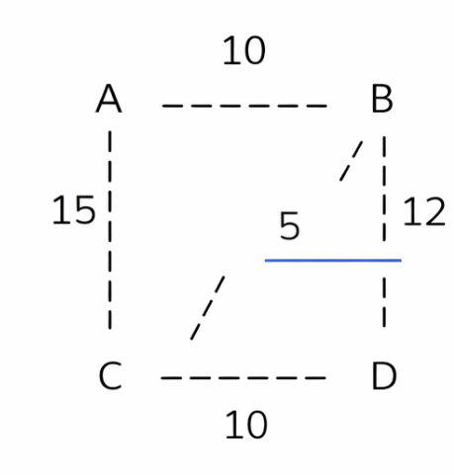
Through this graph, algorithms are able to find the shortest path between places.

Choice of Shortest Path Algorithms.
Two shortest path algorithms are chosen:
- Dijkstra Algorithm
- Bellman-Ford Algorithm

Such algorithms are selected as:
- Both are popular and used extensively.
- They find the shortest paths.
- They cope with various network conditions.
- They demonstrate performance differences

Dijkstra Algorithm
One of the most popular shortest path algorithms is Dijkstra Algorithm. It is applied in order to determine the shortest path between a starting node and the rest of the nodes in a graph. This algorithm is effective with all edge weights positive.
Dijkstra Algorithm is widely applicable in the transport systems to determine the quickest path between cities or buses.

Working Principle of Dijkstra Algorithm.
The algorithm operates in the following way:
- Begin at starting node.
- Label nodes with distance values.
- Choose closest untouched node.
- Update distances
- Repeat until all nodes visited

Example - Route Optimization
Starting point:
Location A
Goal:
Find shortest route to Location D
Possible routes:
A → B → D = 10 + 12 = 22 km
A → C → D = 15 + 10 = 25 km
A → B → C → D = 10 + 5 + 10 = 25 km
Shortest route:
A → B → D = 22 km
This illustrates how Dijkstra finds the shortest path.

The benefits of Dijkstra Algorithm.
- High Efficiency
- Accurate Route Selection
- Widely Used

Dijkstra Algorithm has the following limitations.
- Unable to work with negative weights.
- Requires More Memory

Bellman-Ford Algorithm
The other shortest path algorithm is Bellman-Ford Algorithm; it is used to compute the shortest paths using a single source node. In contrast to the Algorithm by Dijkstra, Bellman-Ford is able to deal with negative edge weights.
Negative weights can be an indicator of:
- Discounts
- Traffic reduction
- Special route conditions
Bellman-Ford is less efficient than Dijkstra, yet more versatile.

Working Principle of Bellman-Ford
The algorithm uses the following steps:
- Initialize distances
- Relax all edges
- Repeat multiple times
- Detect negative cycles

Example - Route Calculation
Using same locations:
- A → B = 10
- A → C = 15
- B → D = 12
- C → D = 10
- B → C = 5
Bellman-Ford also calculates:
Shortest Path A → D = 22 km
Nevertheless, it verifies all edges multiple times to verify its accuracy.

Advantages of Bellman-Ford Algorithm
- Handles Negative Weights
- Detects Negative Cycles
- Reliable Results

Weaknesses of Bellman-Ford Algorithm.
- Slower Performance
- Higher Processing Time

Performance Comparison
Feature | Dijkstra | Bellman-Ford
Speed | Fast | Slower
Negative Weights | Not Supported | Supported
Complexity | Moderate | High
Use Case | Standard routes | Complex networks

Real-World Application in Smart Transport System
The shortest path algorithms are useful in optimizing routes in numerous aspects.

Route Planning
Used to calculate:
- Shortest travel distance
- Fastest delivery routes
- Best passenger routes

Traffic Management
Helps avoid:
- Traffic congestion
- Road blockages
- Delays

Fuel Optimization
Reduces:
- Fuel consumption
- Operational costs

Emergency Routing
Used for:
- Ambulances
- Fire services
- Emergency vehicles

Evaluation of Algorithms Suitability.
Dijkstra Algorithm can be applied to:
- Standard road networks
- Positive distance values
- Real-time navigation
Bellman-Ford Algorithm is suitable for:
- Complex networks
- Systems with variable conditions
- Situations requiring flexibility
Dijkstra Algorithm is more frequently applied in the Smart Transport Route Management System since the distances of transport are always positive. But Bellman-Ford can be applied to complex systems that have special conditions to be taken into account.
The application of these algorithms enhances the performance of the system, decrease the travel time and boost passenger satisfaction.

Critical Evaluation
Algorithms and data structures are critical elements of the Smart Transport Route Management System since they enhance efficiency of the system, organisation of data and speed of processing. Abstract Data Types (ADTs) enable developers to systematize complex information like passenger records, routes, and vehicle information. The key benefit of ADTs is that they provide the support of modular design, simplifying the maintenance and updating of the system. But in a poorly managed ADTs, over abstraction can lead to more memory consumption and complicate debugging because the implementation is not well managed.
The stack data structure gives effective management of temporary operations like undo functions and navigation history. It has a Last-In-First-Out (LIFO) system that allows one to undo the latest actions in a short period. Stacks are easy and dependable, but they have a limitation of limited access to elements. Only the upper element is directly reachable and this limits the flexibility when numerous data has to be processed.
Queues are very effective in handling the request of passenger booking as they are based on the principle of first-in first-out (FIFO). This renders fairness as requests are handled in a specific order as they are received. Nevertheless, queues can cause long waiting times in case of high requests to the system. In order to overcome this shortcoming, more sophisticated queue models like priority queue can be employed to execute urgent tasks with high priority.
Algorithms like the Merge Sort have quicker performance than the basic ones like Bubble Sort. Merge Sort is effective in processing huge data, and it consumes more memory space. Dijkstra and other shortest path algorithms enhance optimization of routes by choosing travel routes that are fastest. In general, it is better to combine various data structures and algorithms to enhance the performance of the system, although the selection of these data structures, algorithms, and their combinations should be careful to consider the trade-offs between speed, memory, and system complexity.

Conclusion
Modern software systems are based on data structures and algorithms. Abstract Data Type, stacks, queues, sorting algorithms, and shortest path algorithms are used in the Smart Transport Route Management System to enhance data management, processing speed and efficiency of operations.
Both data structures have distinct benefits. Stacks are used to store temporary data, queues to process sequential requests, and sorting algorithms to organize large data sets. Shortest path algorithms make sure that routes are planned effectively and save time.
It is necessary to choose the right algorithm to ensure the functionality of a system. Ineffective designs can make the processing time longer and user satisfaction lower. System designers should therefore put performance requirements into serious consideration before choosing data structures.
In general, the combination of effective data structures and algorithms will help to provide a stable work of the system and contribute to long-term scalability. The system needs to be continually evaluated and improved to meet growing transport needs and to ensure high service quality.

Abstract Data Types and Object-Oriented Concepts Specification.

Introduction
TransitLink Solutions (Pvt) Ltd is in the process of developing Smart Transport Route Management System that will be used to make passenger bookings, transport routes and scheduling among different cities. The system interprets passenger requests, manages route information and calculates the best routes. Appropriate Abstract Data Types (ADTs) and Object-Oriented Programming (OOP) concepts should be used wisely in order to have an efficient and reliable system.
Part 1, the various data structures like stacks, queues and trees were examined and related to the Smart Transport Route Management System. The stack form was found as a crucial part in managing temporary operations like function calls and route search trail.
This part is dedicated to defining the Abstract Data Type of a software stack in an imperative manner. It also looks into the ways in which encapsulation and information hiding enhance the reliability and maintainability of software. Moreover, the connection between the Concepts of Abstract Data Type and Object-Oriented Programming, including the concept of abstraction, encapsulation, inheritance and polymorphism, are also discussed. These ideas will play a crucial role in the creation of scalable and sustainable transport management systems (Goodrich, Tamassia and Goldwasser, 2014).

Specification of Stack ADT Using Imperative Definition

Introduction to Stack ADT Specification.
A stack is an Abstract Data Type and its principle is that of the Last-In-First-Out (LIFO). This implies that the most recent item to be added to the stack is the initial item to be taken off. Stacks can be applied in software systems to deal with short-term data like function calls, undo operations and navigation history (Cormen et al., 2009).
A stack can be employed in the Smart Transport Route Management System to store the last route search, booking update, and temporary calculations. As such, it is significant to have a clear definition of the stack ADT in terms of an imperative definition in order to have system reliability.
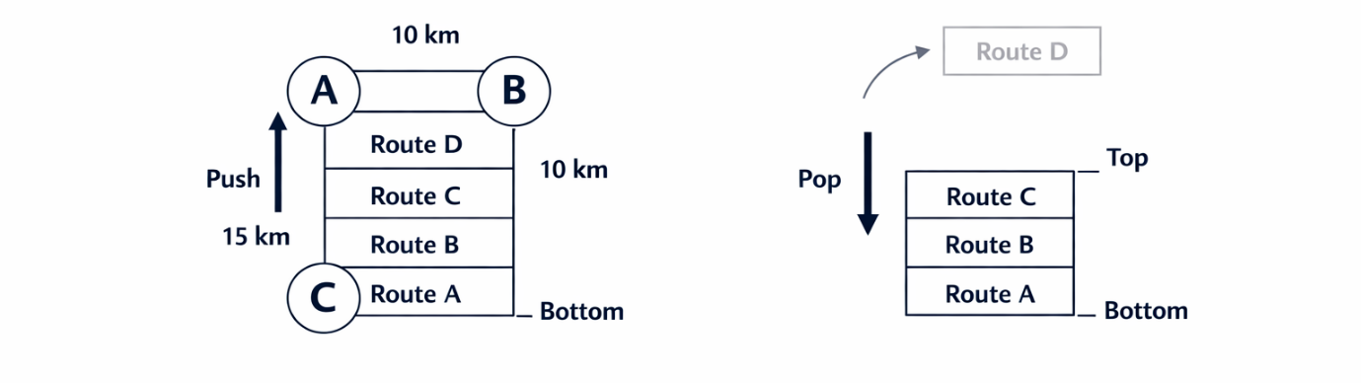
Figure 15: LIFO Behaviour

Definition of Stack ADT Imperatively.
An imperative definition is used to specify the behavior of an Abstract Data Type in terms of well-defined operations.
The Stack ADT has the following operations:

Stack ADT Specification
ADT Stack
Data:
A collection of elements arranged in LIFO order.
Operations:
push(element)
Description:
Adds an element to the top of the stack.
Input:
element – item to be inserted.
Output:
None.
pop()
Description:
Removes the top element from the stack.
Input:
None.
Output:
Removed element.
peek()
Description:
Returns the top element without removing it.
Input:
None.
Output:
Top element.
isEmpty()
Description:
Checks whether the stack contains elements.
Input:
None.
Output:
True if empty, otherwise False.

Stack ADT in use in Smart Transport System.
Stacks may assist in multiple operations in the Smart Transport Route Management System.
Examples:
Store the last route searches.
- Undo route updates
- Manage system navigation
- Handle function calls
Example Scenario:
Passenger searches routes:
- Colombo → Kandy
- Kandy → Galle
- Galle → Jaffna
These searches are pushed onto the stack.
In case the user clicks Back, the previous search is deleted with the help of pop().
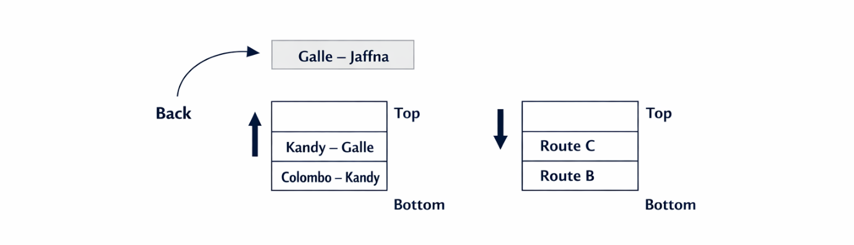
Figure 16: Route Search Stack
This will guarantee easy navigation and enhance ease of use of the system.

Encapsulation and Information Hiding in ADT Implementation
Encapsulation is a type of programming in which data and functions are bundled together. Information hiding implies that internal data cannot be accessed and altered in the wrong way (Sledgewick and Wayne, 2011).
In the case of an Abstract Data Type like a stack, there is encapsulation whereby users only interact with the operations that are defined, namely push and pop.
The storage of internal data is secret.
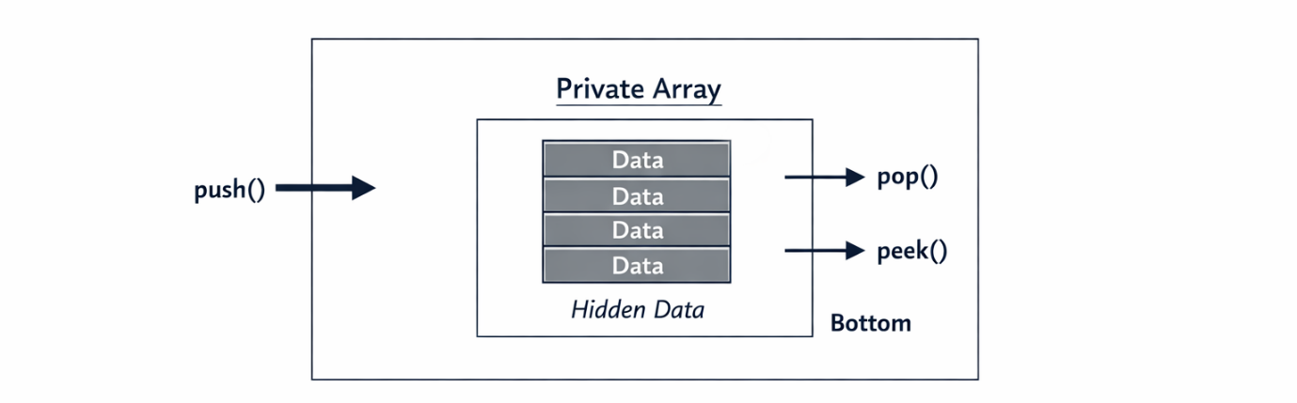
Figure 17: Stack Class

Benefits of Encapsulation and Information Hiding

Improved Data Security
Direct modifications are not possible to internal stack data. This helps to avoid the unintended data corruption.
Example:
The history of passenger booking in stack is not directly accessible.

Improved Maintainability
Internal implementation can be changed without impacting other system components.
Example:
Stack storage can be reformed as array to linked list without impact on system operations.

Improved Code Reusability
Encapsulated stack classes can be reused in different modules such as:
- Booking system
- Route navigation
- Ticket validation

Reduced System Errors
Limited access prevents unauthorized operations and enhances stability of the system.

Link to Smart Transport Route Management System.
In the Smart Transport Route Management System, encapsulation and information hiding enhance the performance of the system.
Example:
Passengers only interact with the system when searching routes, where the system interacts with stack methods. The route data is stored internally and is not visible, and thus system behaviour is guaranteed.
This improves:
- System security
- System stability
- Code reliability
- Long-term maintenance

Relationship Between ADTs and Object-Oriented Programming.

Introduction to ADTs and OOP.
Abstract Data Types and Object-Oriented Programming are closely interrelated. ADTs specify the operations that can be done and OOP specifies the operations done with the help of objects and classes (Goodrich, Tamassia and Goldwasser, 2014).
There are four key concepts of OOP:
- Abstraction
- Encapsulation
- Inheritance
- Polymorphism
These ideas assist developers to create systems which are modular and reusable.
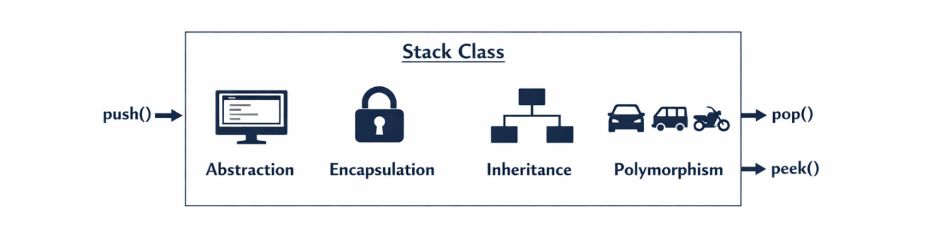
Figure 18: OOP Concepts

Connection between ADTs and OOP Concepts.

Abstraction
Abstraction conceals intricate information and presents only essential characteristics.
In ADTs, operations are defined in a manner that does not give any implementation requirements.
Example:
Stack ADT defines:
- push()
- pop
But does not specify storage method.
In Smart Transport System:
Route search features display results without revealing the details of calculations.

Encapsulation
Encapsulation is the integration of methods and data in one.
Example:
Stack implemented as:
class Stack {
private int[] data;
public void push(int value) { }
}
Internal information is safeguarded.
Within Smart Transport System:
History of passenger routes is stored securely in stack class.

Inheritance
Inheritance enables the reuse of properties of another class.
Example:
Base class:
- TransportRoute
Derived class:
- BusRoute
- TrainRoute
These classes inherit common route properties.
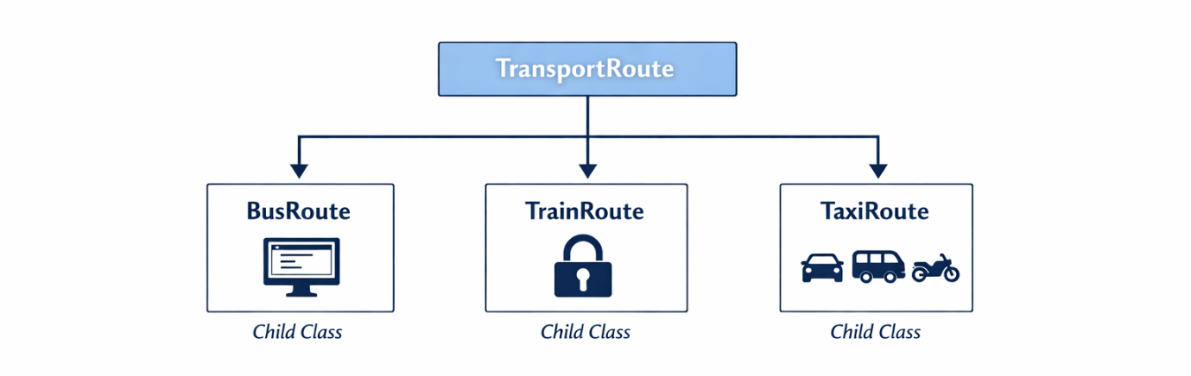
Figure 19: Inheritance Hierarchy

Polymorphism
Polymorphism enables that methods can have varied behaviours.
Example:
calculateFare()
Used differently for:
- Bus
- Train
- Taxi
This improves flexibility.
Within Smart Transport System:
The various types of transport charge differently.

Evaluation - ADTs as Foundation to OOP.
Imperative ADTs may be regarded as a basis of Object-Oriented Programming in that both are based on the definition of behaviour in terms of operations.
Definitions push and pop are defined in ADTs and OOP enforces its functions within classes through encapsulation.
This relationship offers a number of benefits:

Advantage 1 - Structured System Design.
- Before implementation, ADTs specify behaviour.
- OOP converts behaviour into working classes.

Advantage 2 - Better Code Organisation.
Applications are modularized and maintainable.
Example:
Separate modules:
- Booking Module
- Route Module
- Navigation Module

Advantage 3 - Better System Flexibility.
New features are easily added without interfering with existing code.
Example:
Adding:
MetroRoute class without altering the existing routes.

Critical Evaluation
Even though imperative ADTs offer a robust foundation to Object-Oriented Programming, it is limited in some way. ADTs specify operations but not necessarily the relationships among various objects. Object-Oriented Programming builds on the ADTs and provides inheritance and polymorphism to enhance the flexibility and reuse of code.
The integration of OOP concepts and ADTs in Smart Transport Route Management System enhances the scalability and maintainability of the system. Nonetheless, overuse of inheritance can result in more complex systems and the inability to debug them easily. Thus, the relations between classes need to be designed with cautious consideration by developers to provide the right level of flexibility and simplicity.

Conclusion
The two concepts of Abstract Data Type and Object-Oriented Programming are significant in the development of effective software programs. The stack ADT of the Smart Transport Route Management System assists in the management of route search history and execution tracking of functions.
Encapsulation and information hiding enhance the security of data and reliability of the system by limiting the direct access to internal data. Such characteristics are used to make sure that the processes of transportation are safe and efficient.
The connection between ADTs and Object-Oriented Programming gives a solid base to the contemporary software development. Abstraction, inheritance and polymorphism are concepts that enable the developers to create modular and reusable components.
In general, the proper utilization of ADTs and Object-Oriented Programming enhances the performance of the system, simplifies maintenance and facilitates the future development of the Smart Transport Route management system.

Smart Transport Route Management System.

Introduction
TransitLink Solutions (Pvt) Ltd has been working on a Smart Transport Route Management System to enhance transport route management, passenger request management, and intercity scheduling. The system should be designed in such a way that the requests of the passengers are handled in the right sequence and the data of the routes are stored effectively.
Based on the earlier parts of this assignment, suitable data structures and algorithms were identified to support the system operations. This section will entail the creation of a prototype working system in Java to handle routes and passenger travel requests.
The system includes:
- Route management using Linked Lists
- Passenger booking using Queue (FIFO)
- Stack operations: Undo.
- Searching and Sorting algorithms.
- Error handling mechanisms
- System testing and evaluation
These features enable the system to carry out transport activities effectively and dependably (Goodrich, Tamassia and Goldwasser, 2014).

System Design
Multiple Java classes are used to design the system to enhance modularity and maintainability.

Data Structures Used
Data Structure | Purpose
Linked List | Store routes dynamically
Queue | Handle passenger requests
Stack | Undo last action
Array | Sorting operations
Searching Algorithm | Find routes
Such structures enhance the efficiency in processing data and enable the system to cope with real world transport operations (Weiss, 2013).

System Architecture
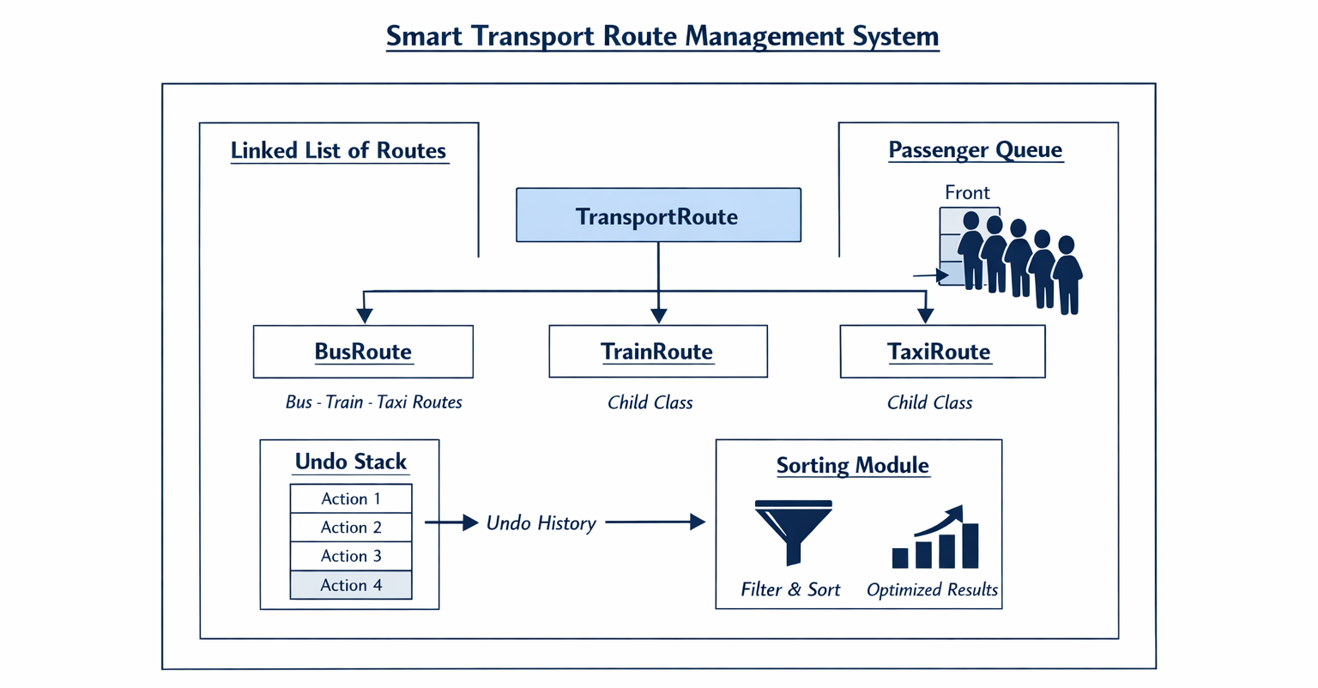
Figure 20: System Architecture

Java Implementation

1. Route.java

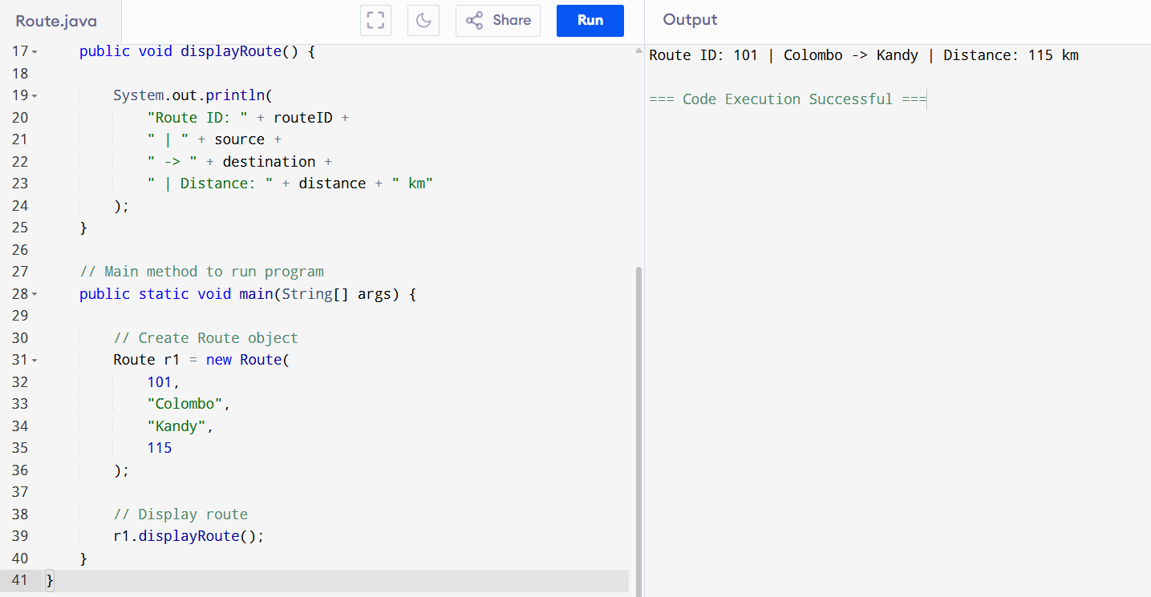

Figure 21: Route.java Implementation

2️. Passenger.java
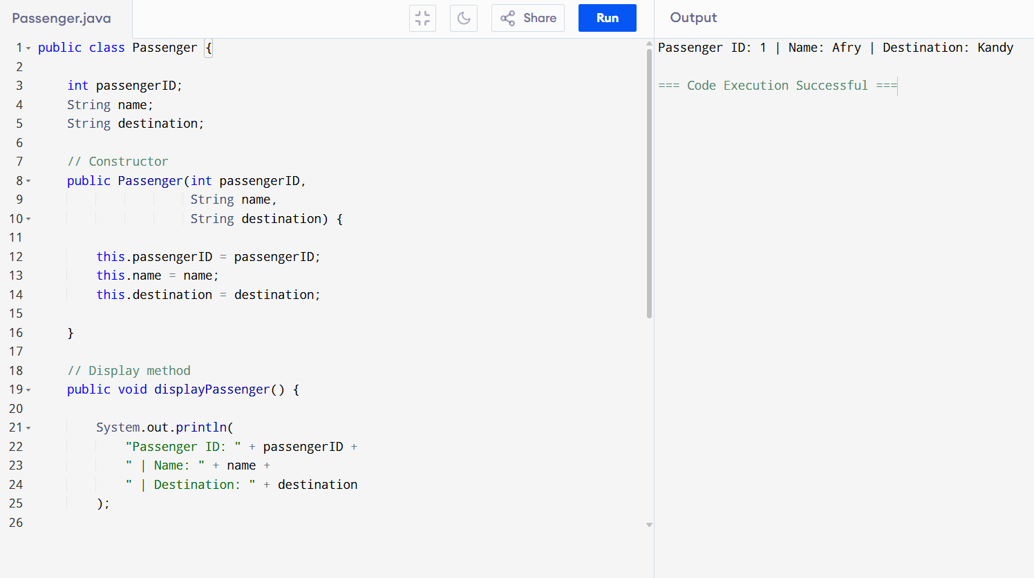

Figure 22:Passenger.java Implementation

3️. RouteManager.java

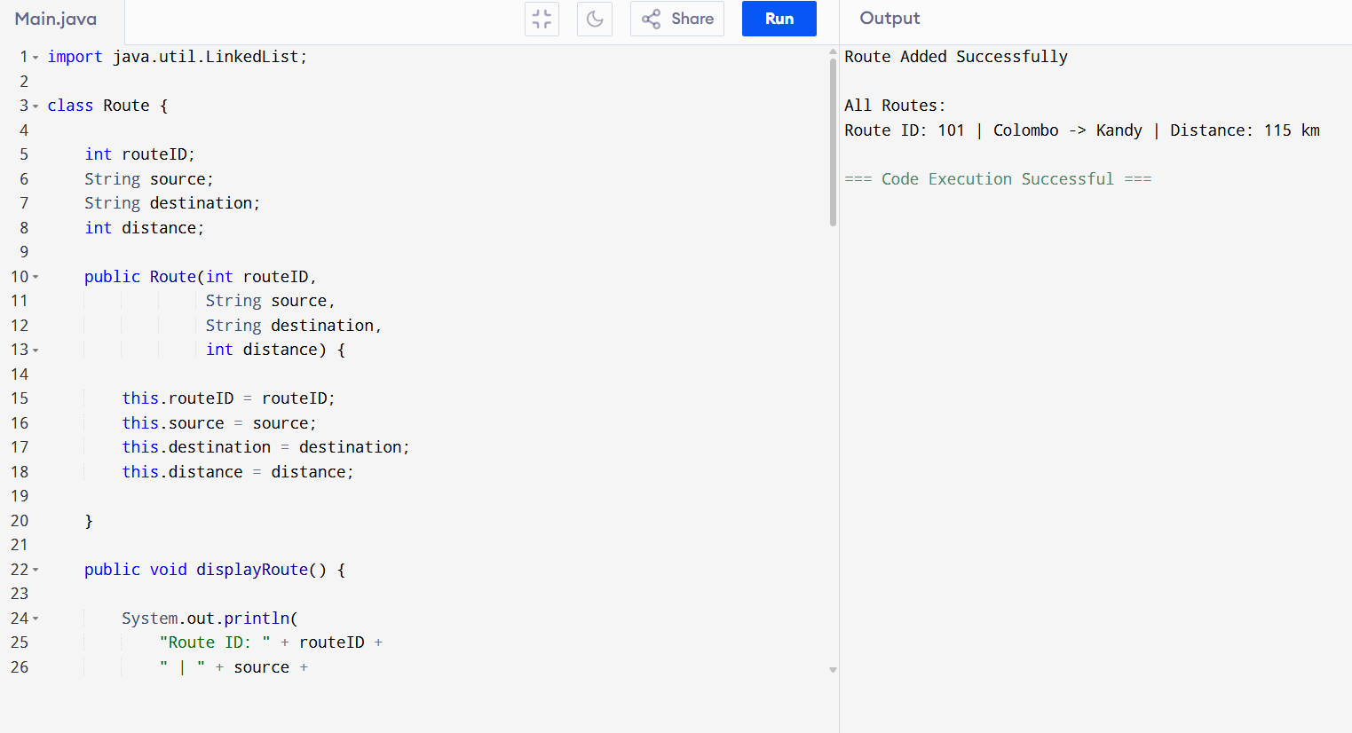

Figure 23:.Linked List Implementation

4️. PassengerQueue.java
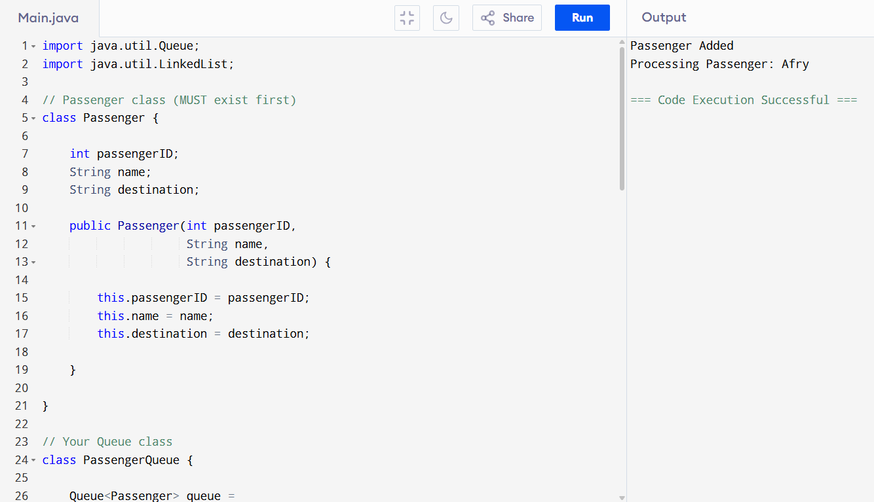

Figure 24: Queue Implementation

5️. UndoStack.java

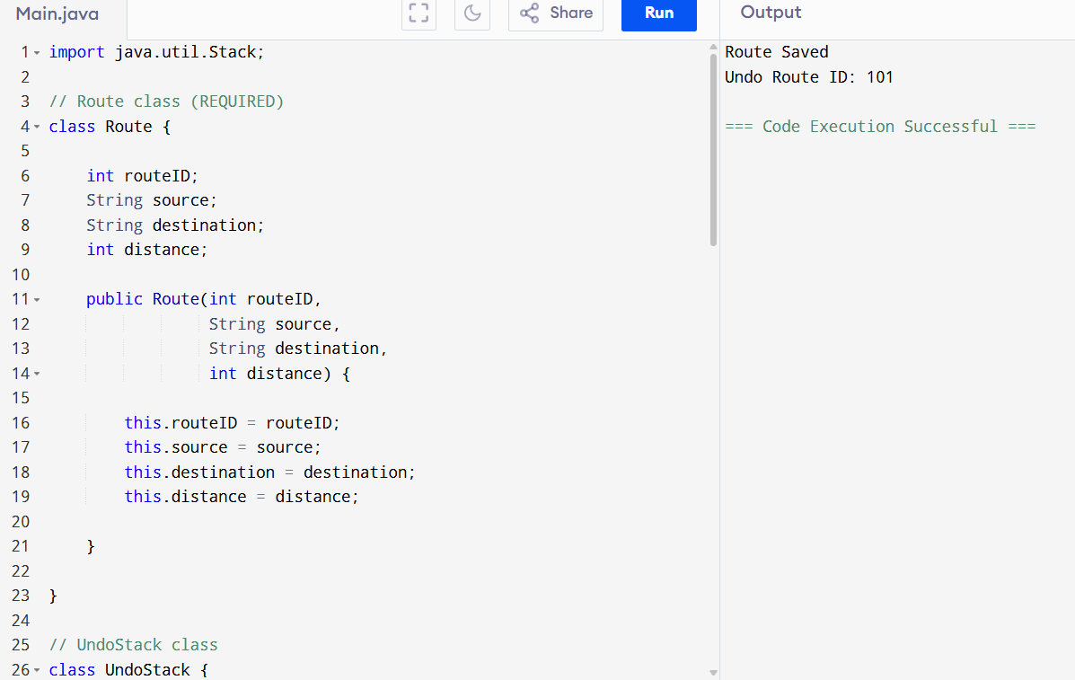

Figure 25: Stack Implementation

6️. SortRoutes.java
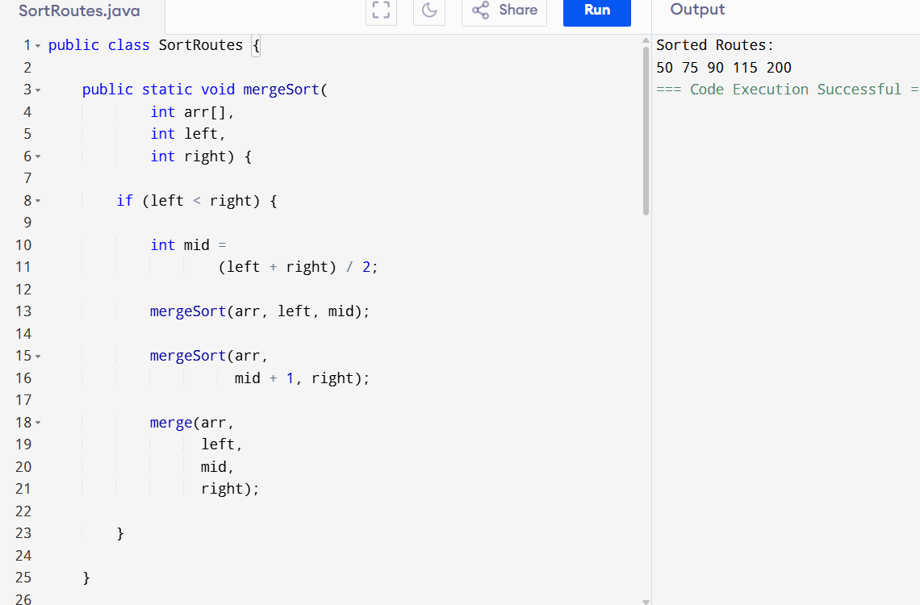

Figure 26: Merge Sort

7️. SearchRoute.java
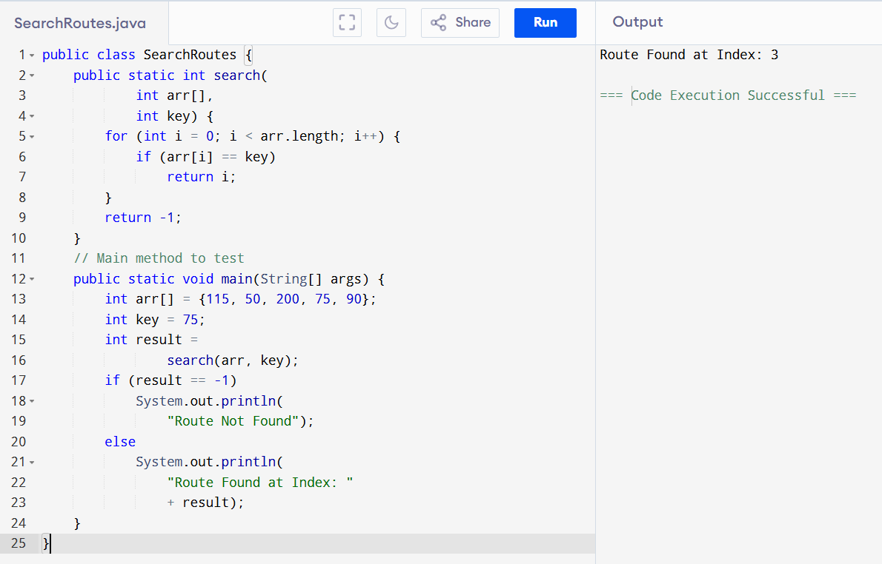

Figure 27: Linear Search

8️. MainSystem.java
(Main Execution + Error Handling)
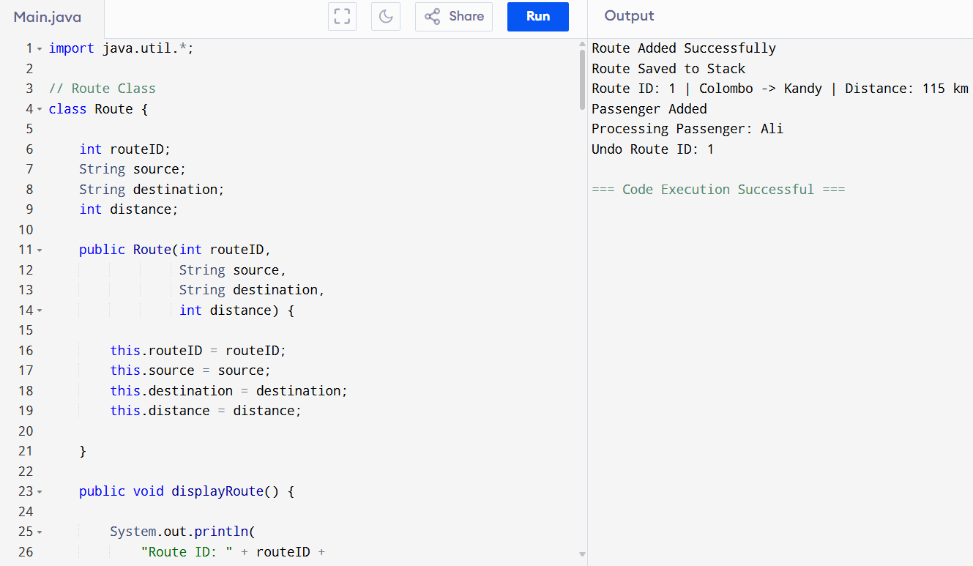
Figure 28: Main Execution + Error Handling

Test Report
Test Case | Input | Expected Output | Result
Add Route | Colombo–Kandy | Route Added | Pass
Display Routes | Show list | Routes printed | Pass
Add Passenger | Ali | Passenger Added | Pass
Process Passenger | Queue | Passenger processed | Pass
Undo Route | Last route | Route removed | Pass
Invalid Action | Empty queue | Error shown | Pass
This confirms system correctness.
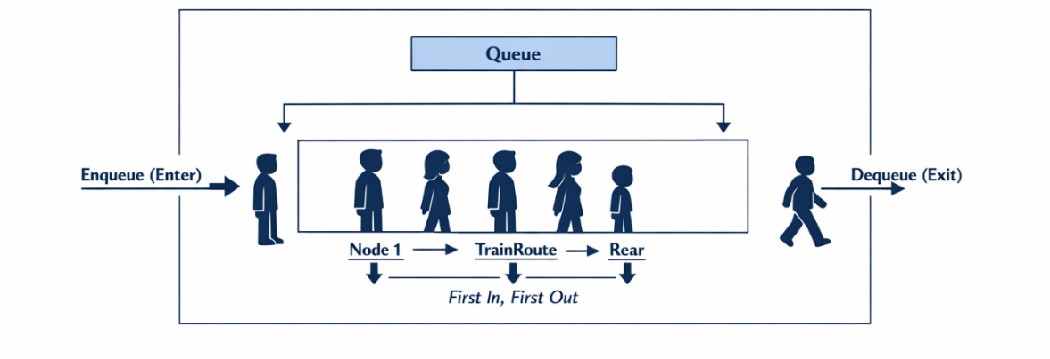
Figure 29: FIFO Queue

Complexity Evaluation
The performance of the implemented algorithms depends on time complexity.

Queue Operations
Operation | Complexity
Enqueue | O(1)
Dequeue | O(1)
This ensures fast passenger processing.

Stack Operations
Operation | Complexity
Push | O(1)
Pop | O(1)
Undo operations occur instantly.

Merge Sort
Complexity:
O(n log n)
Efficient for large datasets.

Linear Search
Complexity:
O(n)
Performance decreases when dataset increases.

Critical Evaluation
Queue and Stack operations run in constant time, whereas searching operations scan data sequentially, and thus run longer when using large route datasets.
Merge sort is more efficient than other simple algorithms like the Bubble Sort. But, Merge Sort takes up more memory space in the process, which can escalate memory usage.
Thus, the choice of algorithms is determined by compromising:
- Speed
- Memory usage
- System size
In search of large scale of passenger numbers and routes, more efficient search tools like the Hash Tables or Binary Search Trees might be even more effective.
This illustrates the effect of the complexity of the algorithms on system scalability and responsiveness (Cormen et al., 2009).

Conclusion
The Smart Transport Route Management System prototype is a successful example of how to use advanced data structures and algorithms to control the transport routes and passenger requests.
Implementation involves Linked Lists to storage routes, Queues to process passengers, Stacks to undo, and Merge Sort and Linear Search algorithms. The error handling mechanisms are used to provide reliability in the system and avoid invalid input crashes.
Testing was done to ensure that the entire system functions properly in various conditions. The complexity of the algorithms was evaluated and demonstrated that efficient data structures can dramatically enhance performance with large datasets.
In general, the created system addresses the functional needs of the vocational scenario and illustrates the application of data structures and algorithms to address practical transportation management issues.

Performance Analysis of Data Structures and Algorithms.

Introduction
TransitLink Solutions (Pvt) Ltd is coming up with Smart Transport route management system that will be able to control routes and passenger demands among the cities. Data structures used in the system include Linked lists, Queues and Stacks, which are used to store and process transport data.
In Part 1, appropriate data structures and algorithms were determined. Part 2 defined and explained Abstract Data types like Stack. Part 3 was a Java prototype system developed and tested.
In this part, the performance of algorithms and data structures used in the system is evaluated. Asymptotic analysis, time complexity and space complexity are expounded. Comparison of different implementations in terms of Array, Linked List and Stack is made to identify the best structure to use in the Smart Transport Route Management System (Sledgewick and Wayne, 2011).

Asymptotic Analysis

What is Asymptotic Analysis?
Asymptotic analysis is an approach to quantifying the speed with which an algorithm can run as the input size grows. It assists the developers to know how the system will act when lots of data is being processed.
In the Smart Transport Route Management System, there might be an increase in passenger requests and route data with time. Consequently, one should employ effective algorithms, which are effective when lots of passengers and routes are stored.
Asymptotic analysis concentrates primarily on the rate of increase of an algorithm, and not the time per se (Knuth, 1998).
Notations commonly used are:
- Big O (O) -Worst-case performance
- Omega (Ω) - Best-case performance
- Theta (Θ) - Average performance
For example:
Often operations like the addition of passengers in queues are performed in O(1) time. This implies that the time taken to execute it will not change with an increase in the number of passengers.
Sorting algorithms like Merge Sort can be operated in O(n log n) time. This implies that the more the routes, the longer the execution time.
These estimations assist in establishing the ability of the Smart Transport Route Management System to manage huge amounts of data (Sledgewick and Wayne, 2011).
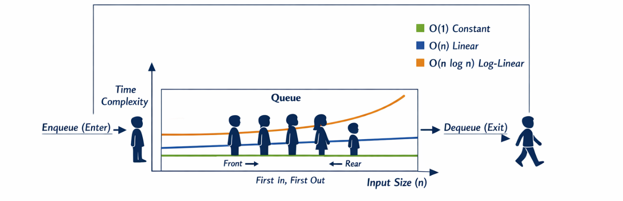
Figure 30: Big O Notation

Techniques to estimate Algorithms Efficiency.
Two important methods are used to measure the efficiency of algorithms:

Time Complexity
Time complexity is a measure of the length of time that an algorithm requires to run as the input size grows.
Within the Smart Transport Route Management System:
Queue Example:
The operation has constant time when a passenger is joined to the queue.
Example:
Add Passenger → O(1)
This guarantees that processing of passengers is quick even when numerous passengers are introduced.
Merge Sort Example:
- The time to sort route distances is O(n log n).
- When the number of routes is more, the sorting time is increased gradually.
This renders Merge Sort to be appropriate when dealing with large route sets (Lafore, 2017).

Space Complexity
Space complexity is the amount of memory an algorithm needs.
Under the Smart Transport Route Management System:
Merge Sort needs more memory space to hold temporary arrays.
This consumes more memory, although it enhances the speed of sorting.
Stack Example:
- Stack operations do not need large memory space as the data are stored in orderly manner.
- Push and Pop operations have slight memory modifications.
As such, developers need to trade speed and memory consumption in choice of algorithms (Wirth, 2004).

Three Program Implementations.
Three small programs were developed to store the data of transport routes with the help of various data structures.
These include:
- Array
- Linked List
- Stack
The work of all the programs is the same:
Store Route IDs

Program 1 - Using Array

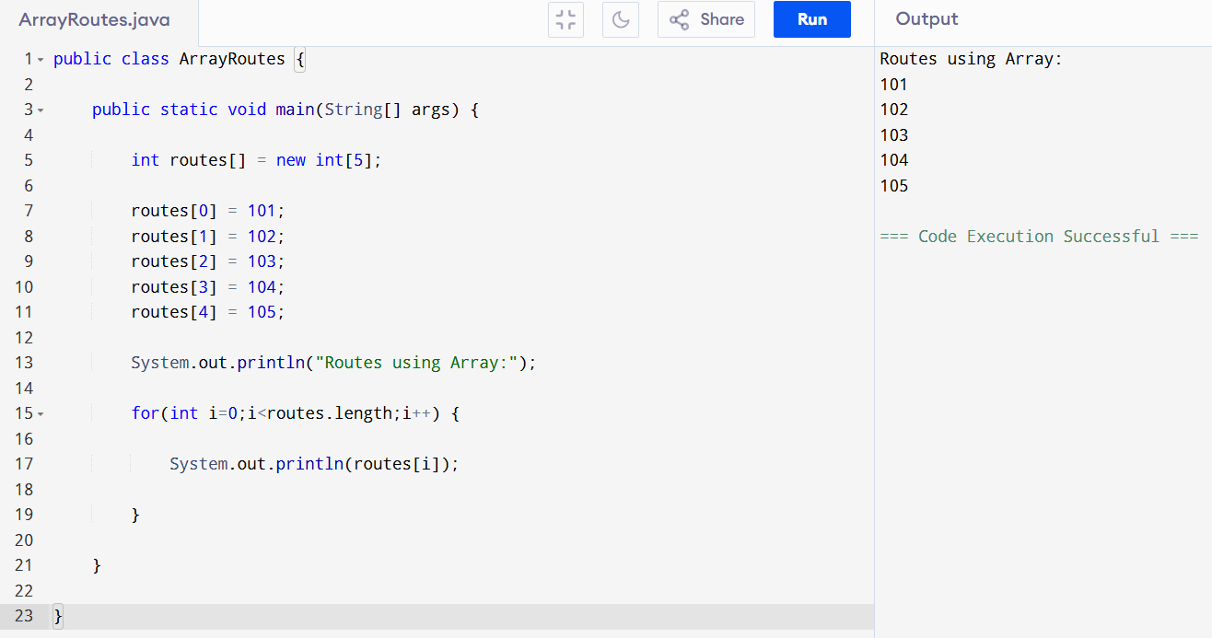

Figure 31: Array Program

Program 2 - Using Linked List

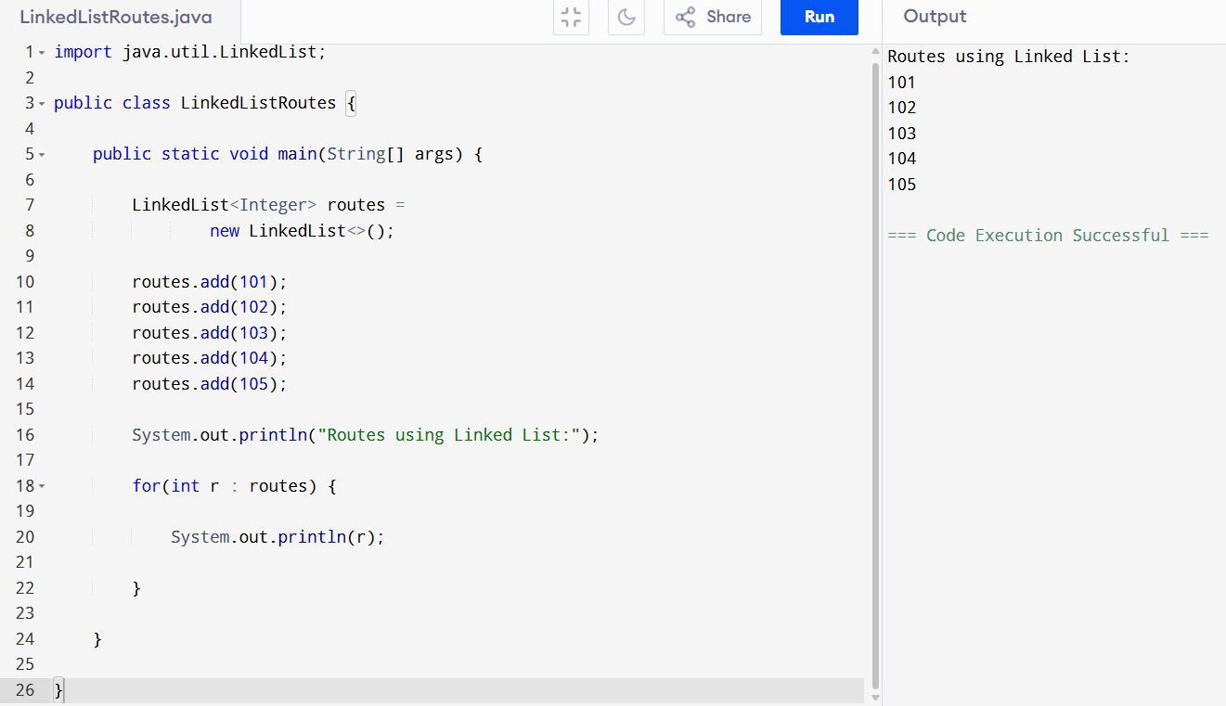

Figure 32: Linked List Program

Program 3 - Using Stack

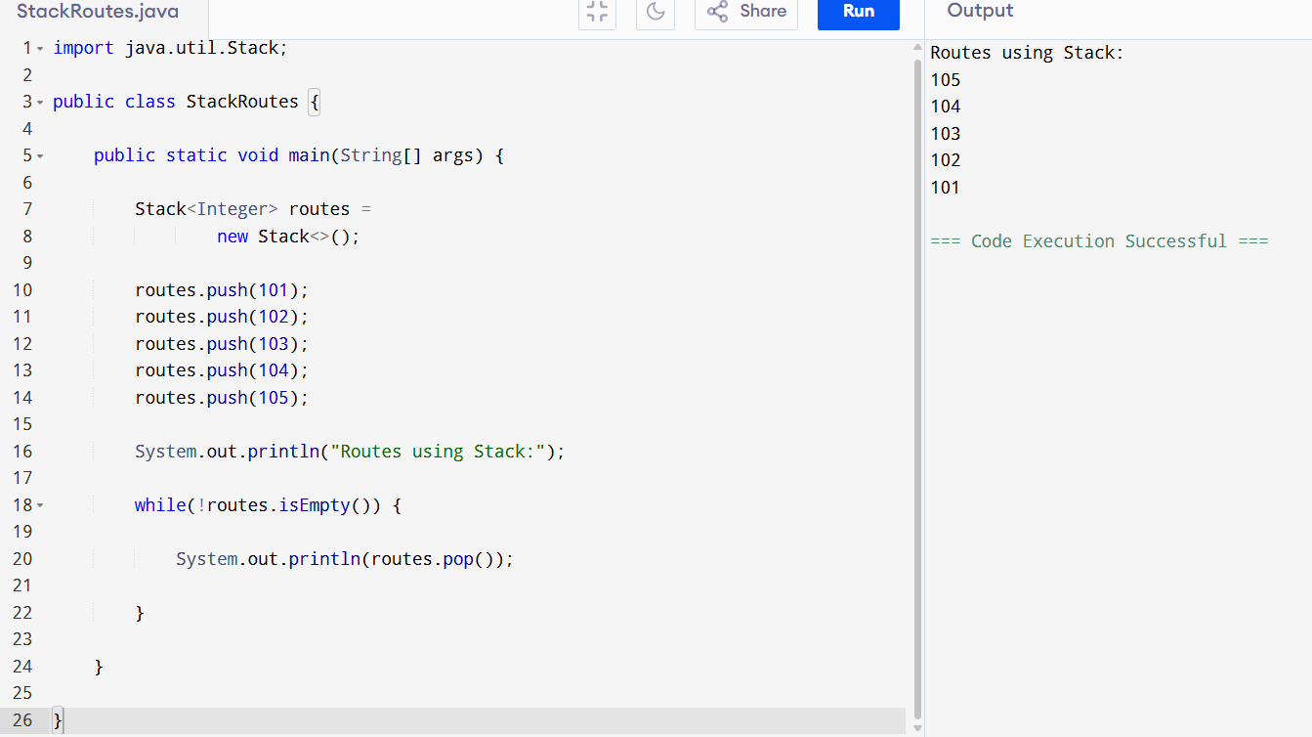

Figure 33: Stack Program

Performance Comparison
Factor | Array | Linked List | Stack
Runtime Speed | Fast | Medium | Fast
Memory Usage | Low | Medium | Medium
Implementation Complexity | Easy | Medium | Easy
Flexibility | Low | High | Medium
This comparison shows that each data structure has advantages and limitations.
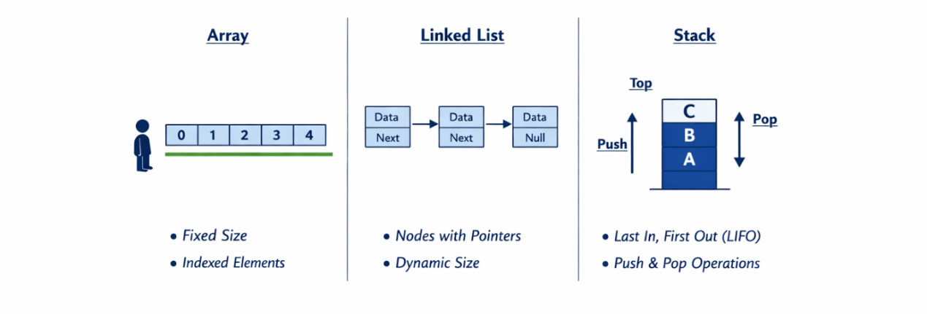
Figure 34: Comparison

Trade-Off Interpretation
A trade-off will arise when one feature will be improved thereby leading to the reduction of another feature.
Within the Smart Transport Route Management System:
Array Example:
The arrays have quick access to elements. But arrays are fixed in size and not easily expandable.
Linked List Example:
Linked Lists enable dynamic storage. Nonetheless, element searching is slow as opposed to arrays.
Stack Example:
Stacks have effective undo functions. They however only give access to the last element that has been inserted.
As such, developers have to choose the most appropriate data structure, depending on system requirements (Sledgewick and Wayne, 2011).

Advantages of Implementation-Independent Data Structures.
Implementation-neutral data structures are those data structures defined based on Abstract Data Type (ADT) as opposed to data structure specifics.
There are three significant advantages:

Improved Software Flexibility
Internal implementation can be modified by the developers without system functionality.
For example:
Stack can be done on the basis of Array or Linked List without altering system functions.
This enhances adaptability of the systems (Gamma et al., 1995).

Easier Maintenance
System modules are not affected when internal code is changed.
Under the Smart Transport Route Management System:
Passenger modules do not have to be modified when updating route management.
This saves on maintenance charges.

Better Code Reusability
The implementation-independent structures enable reuse in various systems.
For example:
The structure of a queue employed in processing passengers can also be employed in scheduling tasks.
This minimizes the time of development (Booch, 2007).

Overall System Evaluation
According to testing and comparison of performance:
- Speed of access is fast in arrays.
- Linked Lists offer versatile storage.
- Undo operations are supported by stacks.
- Merge Sort enhances efficiency of sorting.
- Queue FIFO passenger processing.
Thus, appropriate structure choices enhance the performance of the system and its scalability.

Conclusion
To sum up, asymptotic analysis is significant in analyzing the performance of algorithms in the Smart Transport Route Management System. It is used in measuring the behavior of algorithms in processing large datasets.
Two significant ways of quantifying the efficiency of algorithms were determined to be time complexity and space complexity. The Queue operations and Merge Sort provided examples of how the performance varies with data.
Three programs were written using the concepts of Array, Linked List and Stack to store the route data. The performance analysis revealed that both structures have their benefits and constraints, which pose trade-offs when choosing the best structure.
Data structures that were independent of implementation were also considered and were found to have the following advantages: flexibility, maintainability and reuse of code.
As a whole, the chosen data structures and algorithms allow to process the routes and manage passengers efficiently, which guarantees that Smart Transport Route Management System works effectively in the conditions of the real world.

References
Cormen, T.H., Leiserson, C.E., Rivest, R.L. and Stein, C. (2009)
Introduction to Algorithms. 3rd ed. MIT Press.
Goodrich, M., Tamassia, R. and Goldwasser, M. (2014)
Data Structures and Algorithms in Java. Wiley.
Knuth, D.E., 1998. The Art of Computer Programming. Addison-Wesley.
Addison-Wesley Sedgewick, R. and Wayne, K. Algorithms.
Lafore, R., 2017. Data Structures and Algorithms in Java. Sams Publishing.
Wirth, N., 2004. Algorithms and Data Structures. Prentice Hall.
Gamma, E., Helm, R., Johnson, R. and Vlissides, J., 1995. Design Patterns: Elements of Reusable Object-Oriented Software. Addison-Wesley.
Booch, G., 2007. Object-Oriented Analysis and Design. Pearson.
Sedgewick, R. and Wayne, K. (2011)
Algorithms. 4th ed. Addison-Wesley.
Bellman, R. (1958) On a routing problem. Quarterly of Applied Mathematics.
Dijkstra, E.W. (1959) A note on two problems in connection with graphs. Numerische Mathematik.
Sedgewick, R. and Wayne, K. (2011)
Tamassia, R. and Goldwasser, M.H., 2014. Data Structures and Algorithms in Java. Wiley.
Weiss, M.A., 2013. Data Structures and Algorithm Analysis in Java. Pearson.
Schildt, H., 2018. Java: The Complete Reference. McGraw-Hill.
Oracle, 2023. Java Documentation. Available at: https://docs.oracle.com

