**MODUL 11 PEMROGRAMAN BERBASIS WEB**

**PENGENALAN AJAX DAN JSON**

Source code: <https://github.com/afrzl/Pemrograman-Berbasis-Web/blob/679b7769f7643be352912b492e5b2a1030cd5b14/P11>

1. **Membuat Aplikasi AJAX Sederhana**

Source Code:

1. showtime.html

<!DOCTYPE html>

<html lang="en-ID">

  <head>

    <title>Ajax Demonstration</title>

    <meta charset="utf-8" />

  </head>

  <style>

    .displaybox {

      display: table-cell;

      vertical-align: middle;

      width: 250px;

      height: 40px;

      background-color: #ffffff;

      border: 2px solid #000000;

      padding: 10px;

      font: 1.5em normal verdana, helvetica, arial, sans-serif;

    }

  </style>

  <script>

    var ajaxRequest

    function **ajaxResponse**() {

*// check to see if we're done*

      if (ajaxRequest.readyState != 4) {

        return

      } else {

*// check to see if successful*

        if (ajaxRequest.status == 200) {

          var plholder = document.**getElementById**('showtime')

          plholder.innerHTML = ajaxRequest.responseText

        } else {

**alert**('Request failed: ' + ajaxRequest.statusText)

        }

      }

    }

    function **getServerTime**() {

      ajaxRequest = new **XMLHttpRequest**()

      var svcUrl = 'telltime.php'

      ajaxRequest.**onreadystatechange** = **ajaxResponse**

      ajaxRequest.**open**('GET', svcUrl)

      ajaxRequest.**send**(null)

    }

*// Write a function to auto-update the time*

    function **autoUpdateTime**() {

**setInterval**(**getServerTime**, 1000)

    }

  </script>

  <body onload="**autoUpdateTime**()">

    <h1>Ajax Demonstration</h1>

    <h2>Getting the server time without refreshing the page</h2>

    <form>

      <input type="button" value="Get Server Time" onclick="**getServerTime**()" />

    </form>

    <br />

    <div id="showtime" class="displaybox"></div>

  </body>

</html>

1. telltime.php

<?php

date_default_timezone_set('Asia/Jakarta');

echo date('Y-m-d H:i:s');

Output:

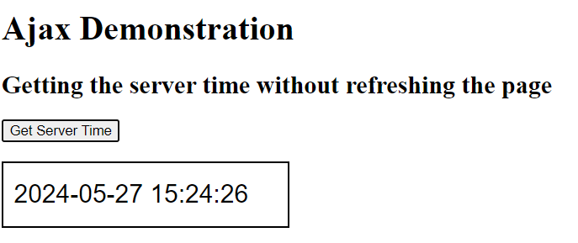

1. **Memproses data JSON dari API**

Source Code:

<?php

*//menggunakan file get contents*

$data = file_get_contents('https://reqres.in/api/users?page=1');

var_dump($data);

*//menggunakan curl*

echo '<br/><br/>Menggunakan cURL<br/>';

$ch = curl_init();

curl_setopt($ch, CURLOPT_URL, 'https://reqres.in/api/users?page=1');

curl_setopt($ch, CURLOPT_RETURNTRANSFER, true);

$output = curl_exec($ch);

curl_close($ch);

echo $output;

*// $data = json_decode($output, true);*

*// echo '<br/><br/>';*

*// var_dump($data);*

$parse_data = json_decode($data, true);

echo '<br/><br/>';

var_dump($parse_data);

echo '<br/><br/>';

?>

<!DOCTYPE html>

<html lang="en">

<head>

    <meta charset="UTF-8">

    <meta name="viewport" content="width=device-width, initial-scale=1.0">

    <meta http-equiv="X-UA-Compatible" content="ie=edge">

    <title>php11A</title>

    <style>

    table,

    th,

    td {

        padding: 10px;

        border: 1px solid black;

        border-collapse: collapse;

    }

    </style>

</head>

<body>

    <table>

        <thead>

            <tr>

                <th>ID</th>

                <th>Email</th>

                <th>First Name</th>

                <th>Last Name</th>

                <th>Avatar</th>

            </tr>

        </thead>

        <tbody>

            <?php foreach ($parse_data['data'] as $value) { ?>

            <tr>

                <td><?= $value['id'] ?></td>

                <td><?= $value['email'] ?></td>

                <td><?= $value['first_name'] ?></td>

                <td><?= $value['last_name'] ?></td>

                <td><img src="<?= $value['avatar'] ?>" alt=""></td>

            </tr>

            <?php } ?>

        </tbody>

    </table>

</body>

</html>

Output:

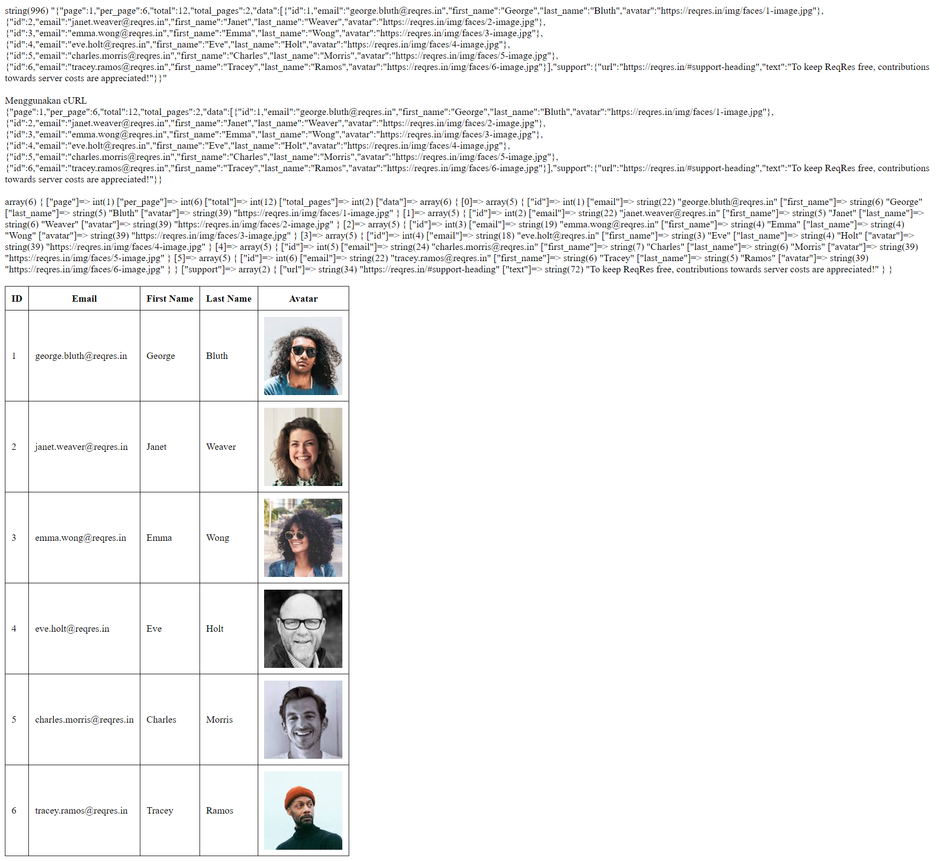

1. **Membuat Aplikasi AJAX untuk Pencarian**

Source Code:

1. php11F.php

<!DOCTYPE html>

<html lang='en-GB'>

<head>

    <title>PHP11 F</title>

    <style>

    table,

    th,

    td {

        border: 1px solid black;

        border-collapse: collapse;

        padding: 5px;

    }

    nav {

        background-color: #010417;

        overflow: hidden;

    }

    nav ul {

        list-style: none;

        width: 100%;

        margin: 0;

    }

    nav li {

        float: left;

        margin: 0;

    }

    nav a {

        display: flex;

        height: 30px;

        padding: 5px 1.5em;

        color: white **!important**;

        text-decoration: none **!important**;

    }

    .active,

    nav a:hover {

        background-color: #c74451;

    }

    </style>

</head>

<body>

    <h1>PHP and Databases</h1>

    <?php include 'php11F_header.php'; ?>

    <?php

    session_start();

    if (!isset($_SESSION['username'])) {

        header('Location: php11D.php');

    }

    require '../DB_CON.php';

    try {

        $pdo = new PDO($dsn, $db_username, $db_password, $opt);

        $stmt = $pdo->**query**('select * from meetings order by slot');

        $pdo = null;

    } catch (PDOException $e) {

        exit('PDO Error: ' . $e->**getMessage**() . '<br>');

    }

    ?>

    <h2>Data in meeting table</h2>

    <?php if (isset($_GET['msg'])) {

        echo "<p style='color: " .

            $_GET['color'] .

            "'>" .

            $_GET['msg'] .

            '</p>';

    } ?>

    Rows retrieved: <?= $stmt->**rowCount**() ?><br><br>

    <a href='php09E.php'><button style="margin-bottom: 10px">Tambah Data</button></a>

    <form action="">

        Cari Nama: <input type="text" id="txt1" onkeyup="**showHint**(this.value)">

    </form>

    <p>Suggestions: <span id="txtHint"></span></p>

    <table style='margin-top: 10px'>

        <thead>

            <tr>

                <th>Slot</th>

                <th>Name</th>

                <th>Email</th>

                <th></th>

            </tr>

        </thead>

        <tbody>

            <?php while ($row = $stmt->**fetch**()) { ?>

            <tr>

                <td><?= $row['slot'] ?></td>

                <td><?= $row['name'] ?></td>

                <td><?= $row['email'] ?></td>

                <td><a style="margin-right: 15px" href="php09G.php?slot=<?= $row[

                    'slot'

                ] ?>"><img src="edit.svg" style="width: 30px; height: 30px"></img></a>

                    <a onclick="return **confirm**(`Apakah kamu yakin akan menghapus data?`)" href="php09H.php?slot=<?= $row[

                        'slot'

                    ] ?>"><img src="delete.svg" style="width: 30px; height: 30px"></img></a>

                </td>

            </tr>

            <?php } ?>

        </tbody>

    </table>

    <script src="page11A_suggestion.js"></script>

</body>

</html>

1. php11_header.php

<header>

    <nav>

        <ul>

            <li><a class="active" href="#">Data Meeting</a></li>

            <li><a href="php11F_logout.php">Logout</a></li>

        </ul>

    </nav>

</header>

1. php11_logout.php

<?php

session_start();

session_unset();

session_destroy();

header('Location: php11D.php');

1. php11D.php

<!DOCTYPE html>

<html lang="en">

<head>

    <meta charset="UTF-8">

    <meta name="viewport" content="width=device-width, initial-scale=1.0">

    <title>Login</title>

</head>

<body>

    <?php

    session_start();

    if (isset($_SESSION['username'])) {

        header('Location: php11F.php');

    }

    $message = $_GET['msg'] ?? '';

    echo '<p style="color: red">' . $message . '</p>';

    ?>

    <form action="php11D_action.php" method="post">

        <table>

            <tr>

                <td><label>Username:</label></td>

                <td><input type="text" name="username"></td>

            </tr>

            <tr>

                <td><label>Password:</label></td>

                <td><input type="password" name="password"></td>

            </tr>

            <tr>

                <td><input type="submit" value="Login"></td>

                <td></td>

            </tr>

        </table>

    </form>

</body>

</html>

1. php11D_action.php

<?php

require '../DB_CON.php';

$username = $_POST['username'];

$password = $_POST['password'];

$pdo = new PDO($dsn, $db_username, $db_password, $opt);

$query = 'SELECT * FROM users WHERE username = :username LIMIT 1';

$stmt = $pdo->**prepare**($query);

$stmt->**bindparam**(':username', $username, PDO::PARAM_STR);

$stmt->**execute**();

if ($stmt->**rowCount**() > 0) {

    $user = $stmt->**fetch**(PDO::FETCH_ASSOC);

    if (password_verify($password, $user['password'])) {

        session_start();

        $_SESSION['username'] = $_POST['username'];

        header('Location: php11F.php');

    } else {

        $message = urlencode('Password salah');

        header('Location: php11D.php?msg=' . $message);

    }

} else {

    $message = urlencode('Akun tidak ditemukan');

    header('Location: php11D.php?msg=' . $message);

}

$pdo = null;

1. page11B_gethint.php

<?php

include '../DB_CON.php';

try {

*//Code 6*

    $keyword = '%' . $_GET['keyword'] . '%';

    try {

        $pdo = new PDO($dsn, $db_username, $db_password, $opt);

        $query = 'SELECT * FROM meetings WHERE name LIKE :keyword';

        $stmt = $pdo->**prepare**($query);

        $stmt->**bindparam**(':keyword', $keyword, PDO::PARAM_STR);

        $stmt->**execute**();

        $stmt = $stmt->**fetchAll**();

        $pdo = null;

    } catch (PDOException $e) {

        exit('PDO Error: ' . $e->**getMessage**() . '<br>');

    }

*// lookup all hints if query result is not empty*

    if ($stmt) {

        echo json_encode($stmt);

    } else {

*// Output "no suggestion" if no hint was found or output correct values*

        $response[] = [

            'name' => 'no suggestion',

        ];

        echo json_encode($response);

    }

    $pdo = null;

} catch (PDOException $e) {

    exit('PDO Error: ' . $e->**getMessage**() . '<br>');

}

1. page11A_suggestion.js

function **showHint**(*str*) {

  let text = document.**getElementById**("txtHint");

  if (*str*.length == 0) {

    text.innerText = "";

    return;

  }

  xhttp = new **XMLHttpRequest**();

*//Code 4b*

  xhttp.**onreadystatechange** = function () {

    if (this.readyState == 4 && this.status == 200) {

*//   Typical action to be performed when the document is ready:*

      let res = JSON.**parse**(xhttp.responseText);

      let output = res

        .**map**(function (*e*) {

          return *e*.name;

        })

        .**join**(", ");

      text.innerText = output;

    }

  };

  xhttp.**open**("GET", "page11B_gethint.php?keyword=" + *str*, true);

  xhttp.**send**();

}

Output:

