**MODUL 12 PEMROGRAMAN BERBASIS WEB**

**WEB FRAMEWORK**

Source Code: <https://github.com/afrzl/Pemrograman-Berbasis-Web/blob/679b7769f7643be352912b492e5b2a1030cd5b14/P12>

1. **Front-end framework: Bootstrap**
2. webbs

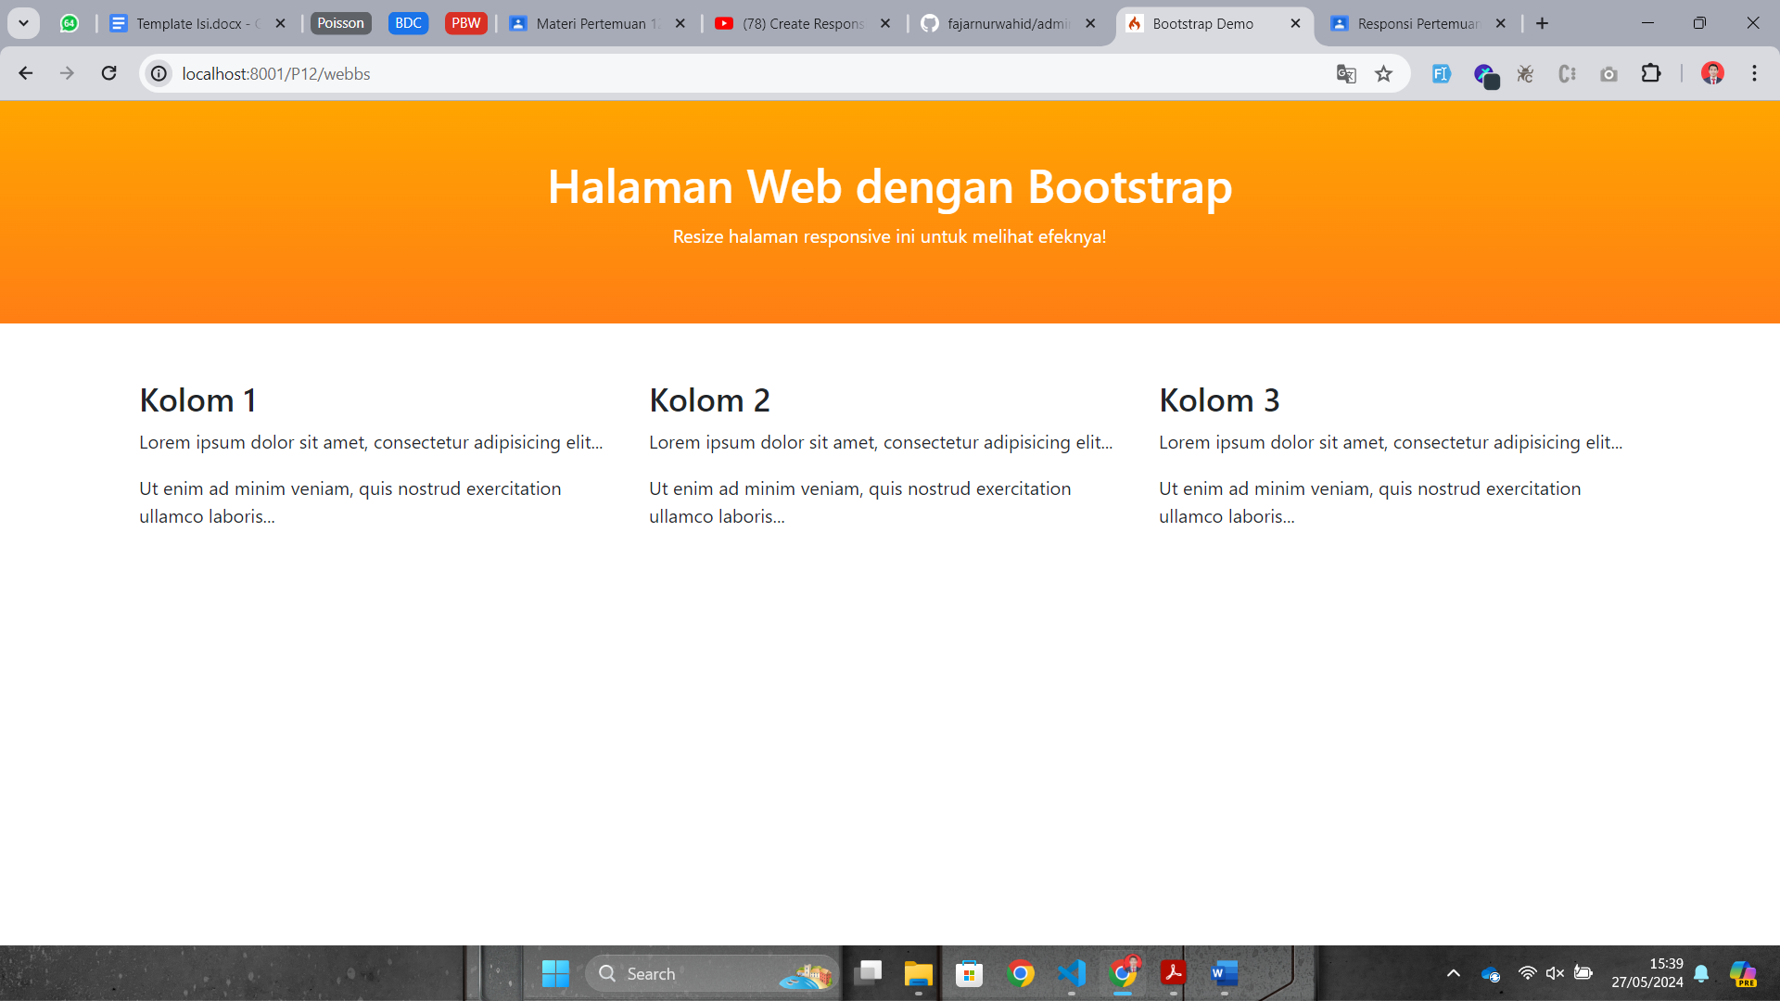 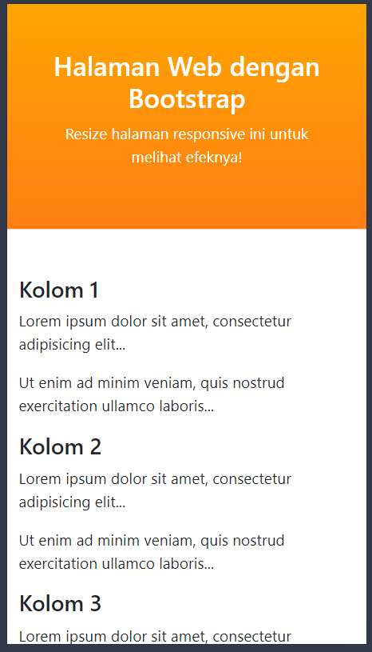

1. webbs_signin

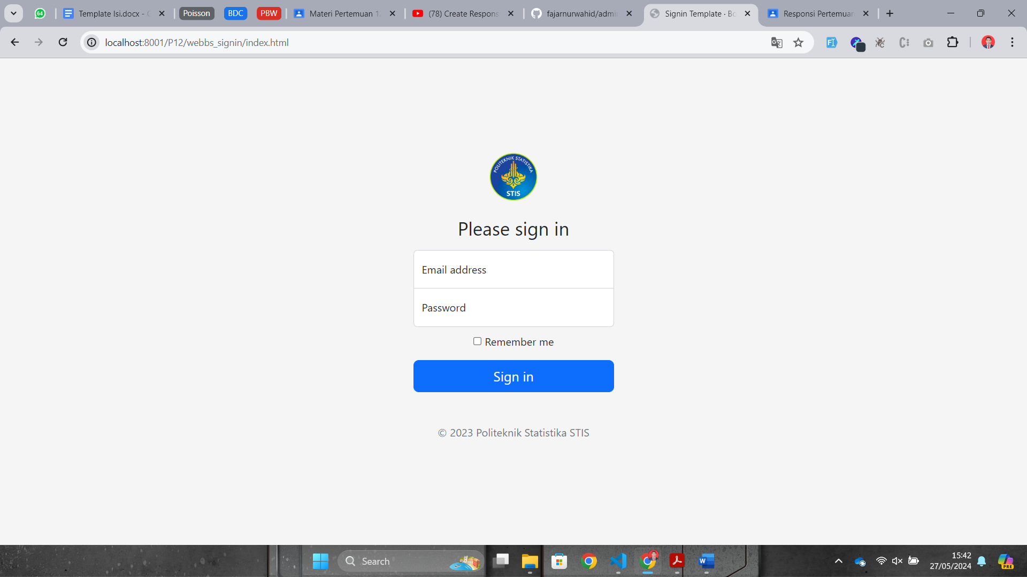

1. **Back-end framework: CodeIgniter**

