**erosion:**The basic effect of the operator on a binary image is to erode away the boundaries of regions of foreground pixels

**dilatacion:** The basic effect of the operator on a binary image is to gradually enlarge the boundaries of regions of foreground pixels

**opening**

**closing**

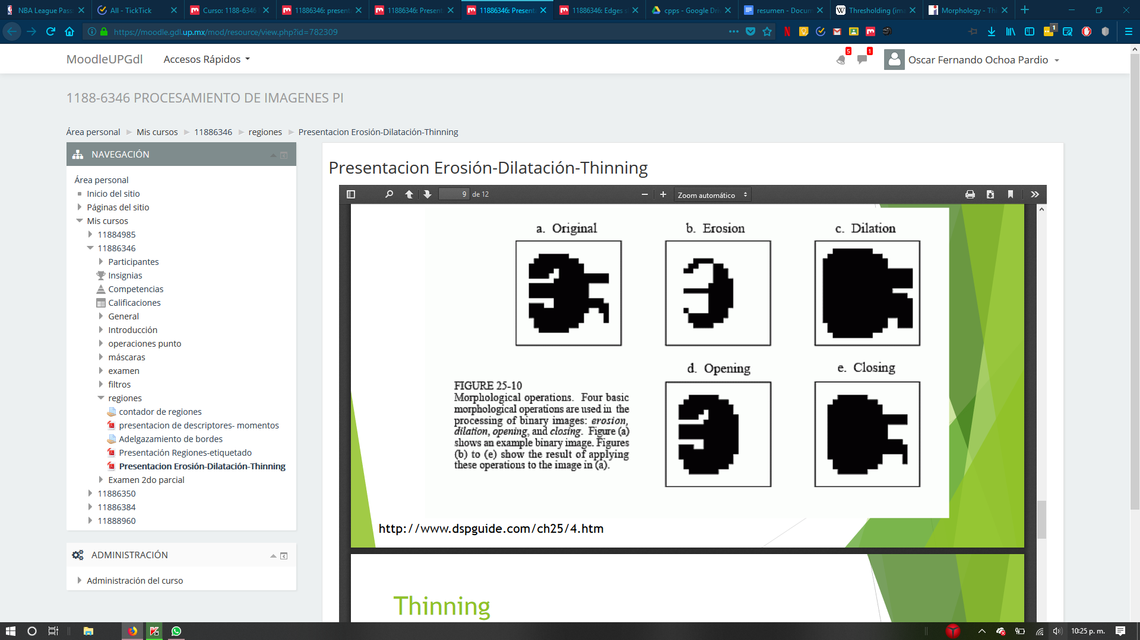

**threshold**: The simplest thresholding methods replace each pixel in an image with a black pixel if the image intensity or a white pixel if the image intensity is greater than that constant.

In the example image on the right, this results in the dark becoming completely black, and the white snow becoming completely white.

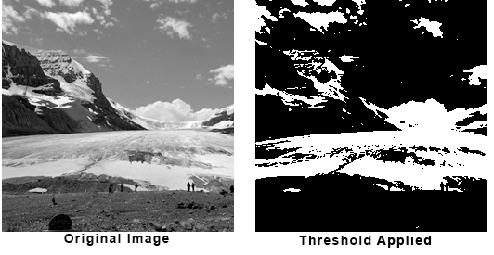

**thinning**: is used to remove selected foreground pixels from binary images

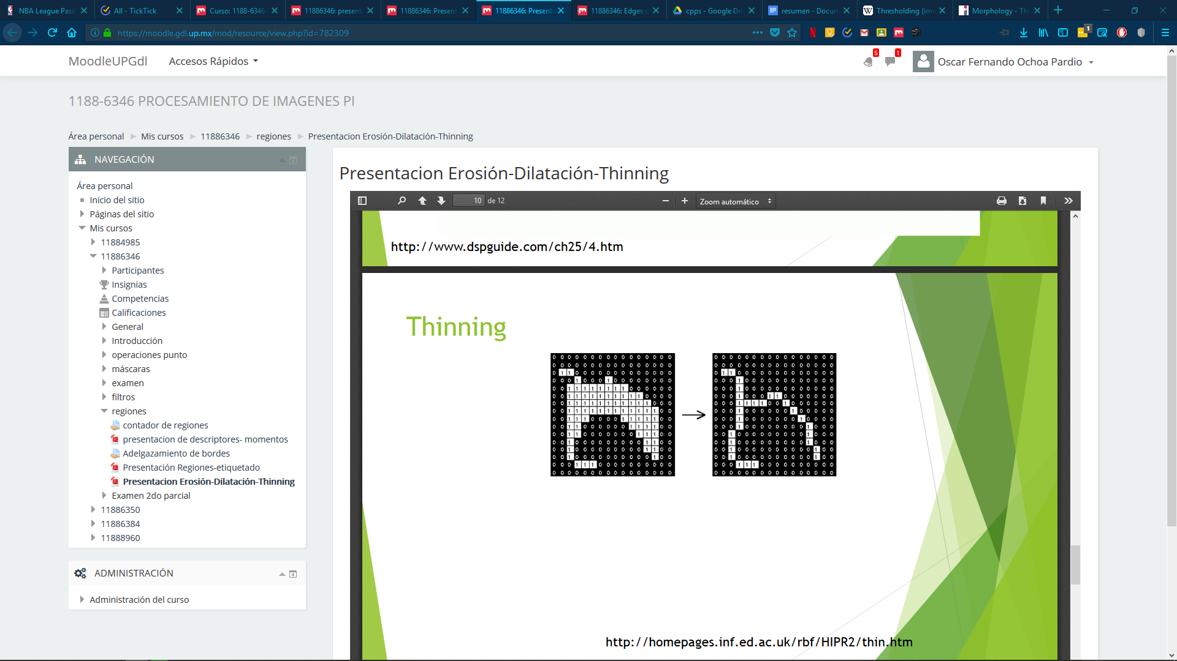

**The Roberts cross**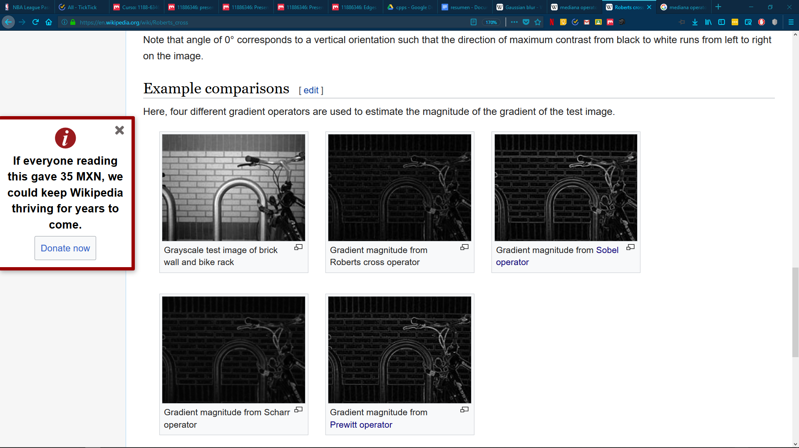

performs a simple, quick to compute, 2-D spatial gradient measurement on an image. It thus highlights regions of high spatial frequency which often correspond to edges. In its most common usage, the input to the operator is a grayscale image, as is the output. Pixel values at each point in the output represent the estimated absolute magnitude of the spatial gradient of the input image at that point. 

**Prewitt** operator is used for edge detection in an image

**The sobel** operator is very similar to Prewitt operator. It is also a derivate mask and is used for edge detection. edge detection algorithms where it creates an image emphasising edges.

**Difference with Prewitt Operator**

The major difference is that in sobel operator the coefficients of masks are not fixed and they can be adjusted according to our requirement unless they do not violate any property of derivative masks.

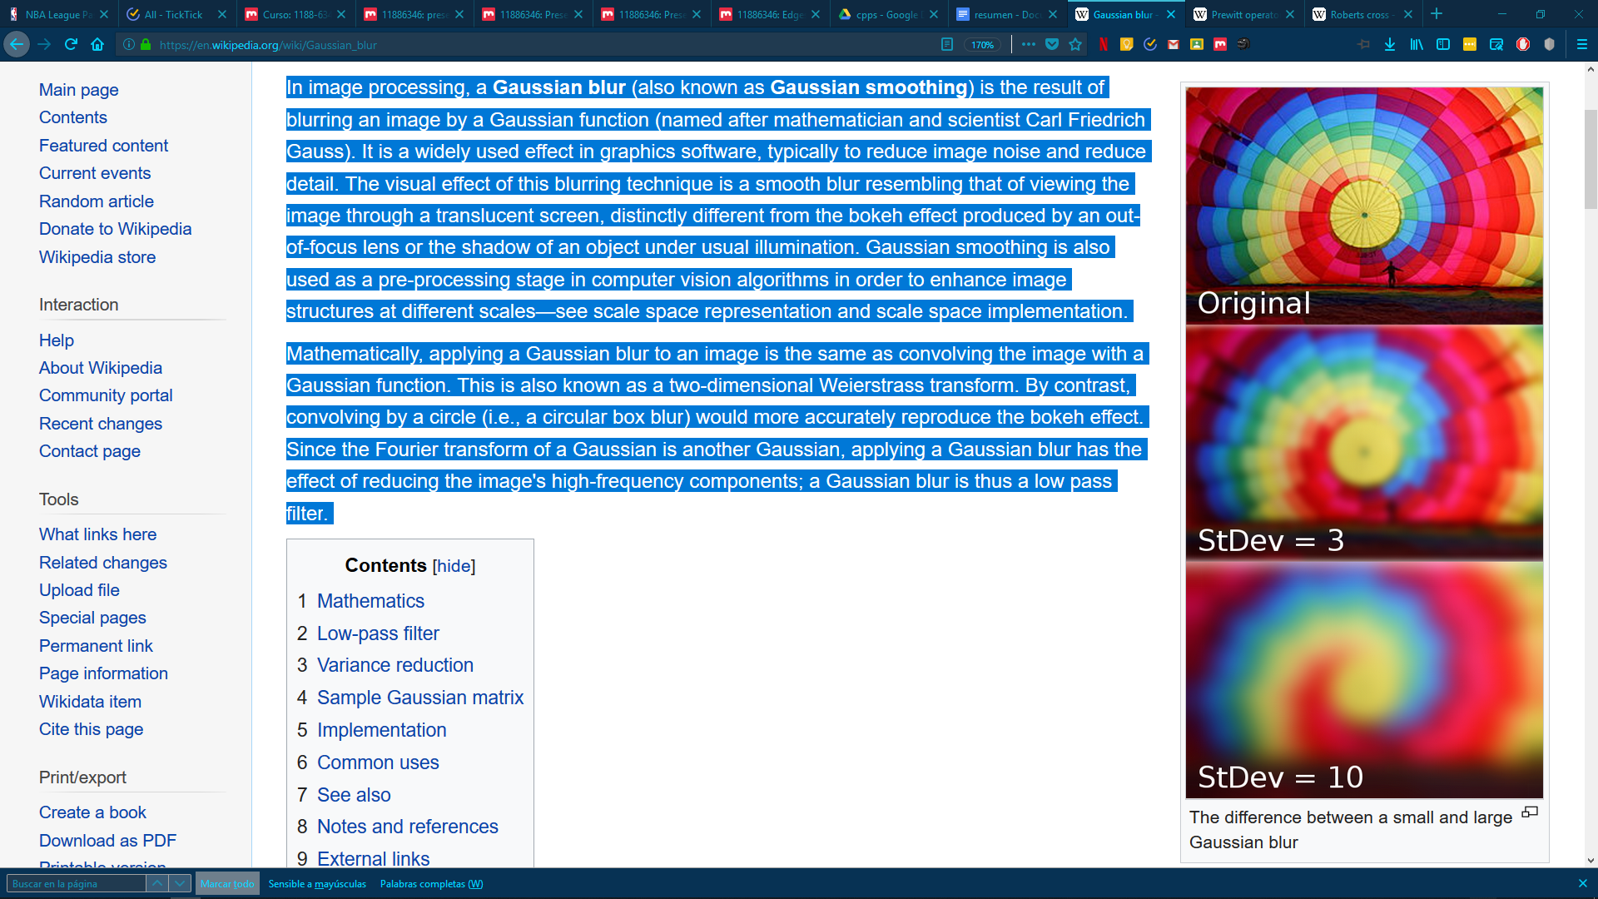

**Gaussian**

In image processing, a Gaussian blur is the result of blurring an image by a Gaussian function

It is a widely used effect in graphics software, typically to reduce image noise and reduce detail.

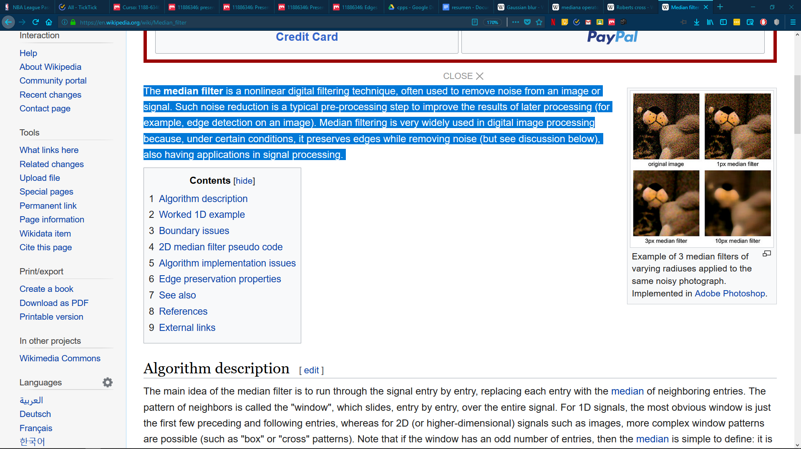

**The median filter** is a nonlinear digital filtering technique, often used to remove noise from an image or signal.

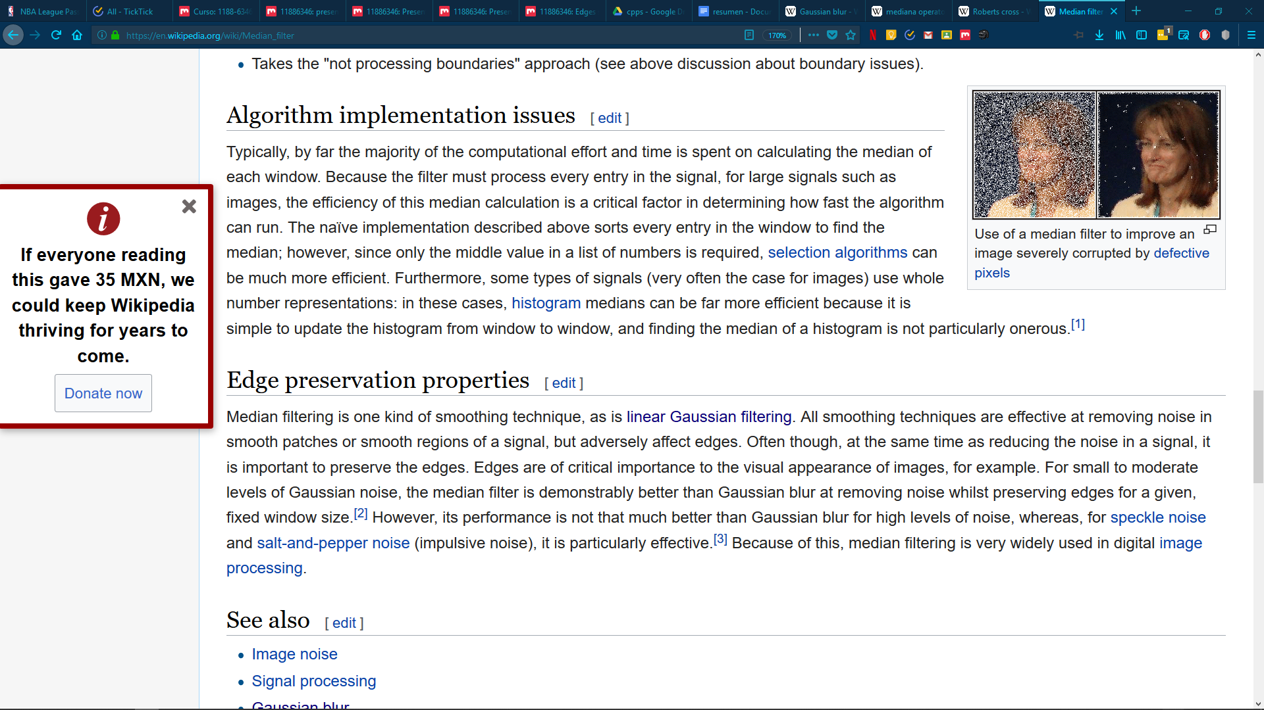

The median filter works by sorting each pixel’s neighbours or the pixels under a window nxn. The sorted list of pixels then outputs its middle member, becoming the new pixel value.

**The average filter**

Filter that computes a new pixel value by accumulating the neighbour values and dividing between the number of neighbours analized. Commonly used with windows of 3x3 or 5x5 for a desired blurred image.

+ Smooth

+ Pepper Noise

+ Gaussian Filter 3 y 5

+ Discrete Gaussian

Gaussian Filter dinámico

+ Structure Modifier

Te muestra los cambios bruscos

+ Border Detection

Sobel

Prewitt

Roberts

+ Segmentation

+ Erosion

Si el elemento toca todos los pixeles de la imagen, el pixel se queda

+ Dilatation

Recorres imagen, si elemento toca algún pixel de la imagen, se pinta pixel

+ Thinner

Algoritmo largo y raro de 1ra y 2da iteración y validar 4 condiciones