|  |  |
| --- | --- |
| download | COMSATS University Islamabad, Vehari Campus Department of Computer Science |

**Class: BCS-SP22-4A Submission Deadline: 10 Sep 2023**

**Subject: Data Structures and Algorithms-Lab Instructor: Yasmeen Jana Max Marks: 10 Reg. No: SP22-BCS-006**

**Email:** [**yasmeenjana@cuivehari.edu.pk**](mailto:yasmeenjana@cuivehari.edu.pk)

**You can ask queries related to Lab Activities on the above email.**

**Activity 1:**

Create a GitHub Account. Make a repository with the name “**DSA_Lab”. Mention the link here after the account creation.**

**Solution:**

https://github.com/afsahahmad/DSA_Lab?search=1#dsa_lab

**Activity 2:**

Write any 15 programs that will explain the concepts of pointers.

In this file, you should place the code and its output screenshot.

After completing the activities, Upload the final pdf and code to the “**DSA_Lab”** repository.

**Program 1:**

#include <iostream>

using namespace std;

int main()

{

int number=30;

int *p=&number;

cout<<"Address of number variable is:"<<&number<<endl;

cout<<"Address of p variable is:"<<p<<endl;

cout<<"Value of p variable is:"<<*p<<endl;

return 0;

}

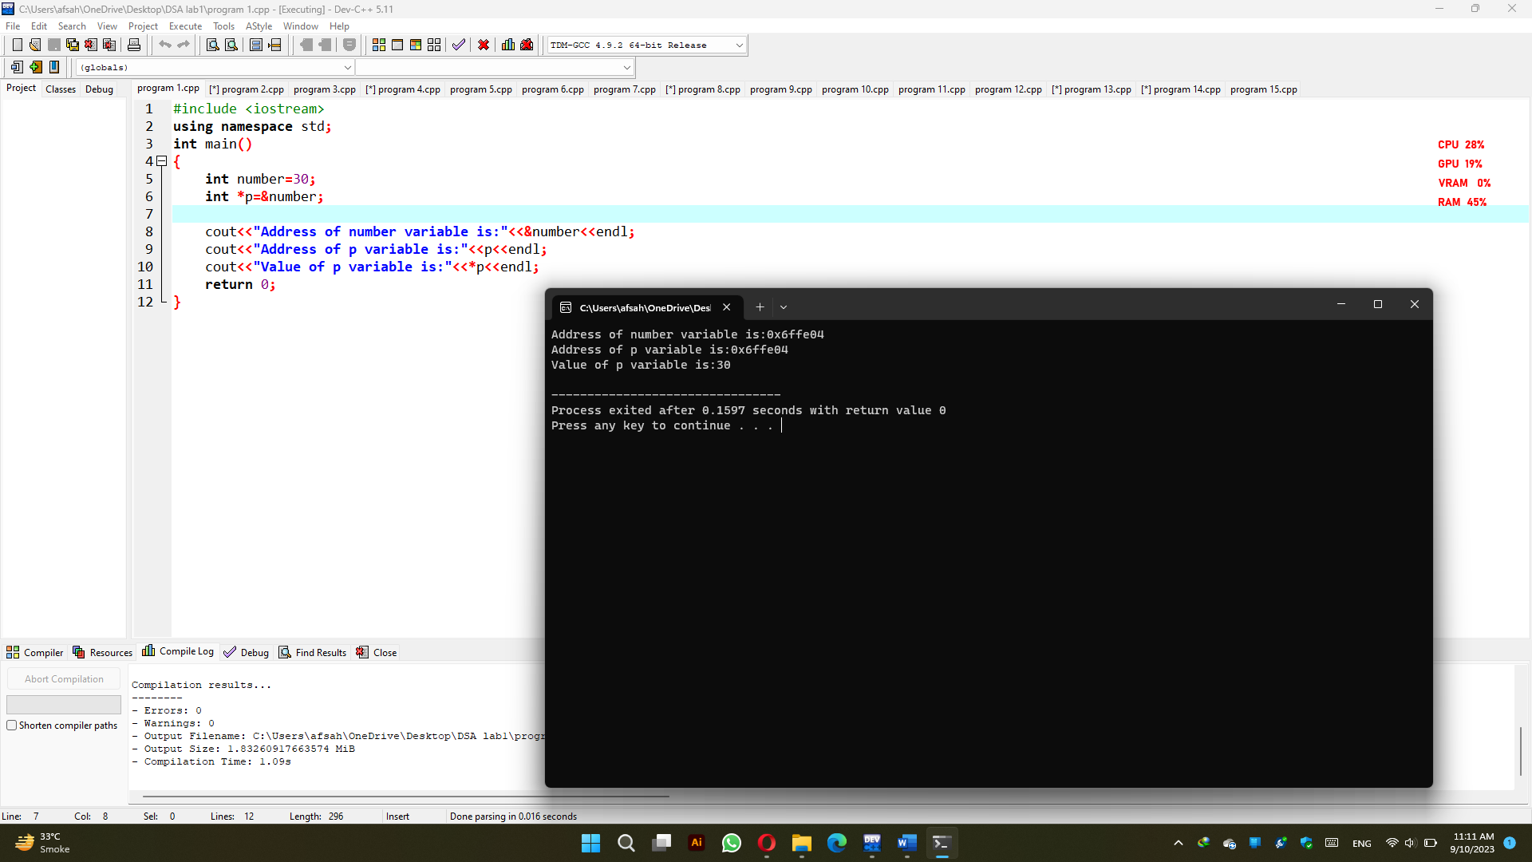

**Program 2:**

#include<iostream>

using namespace std;

int main()

{

int a=20;

int b=10;

int *pa=&a;

int *pb=&b;

cout<<"Before swap: "<<"a="<<*pa<<" "<<"b="<<*pb<<endl;

*pa=*pa+*pb;

*pb=*pa-*pb;

*pa=*pa-*pb;

cout<<"After swap: "<<"a="<<*pa<<" "<<"b="<<*pb<<endl;

return 0;

}

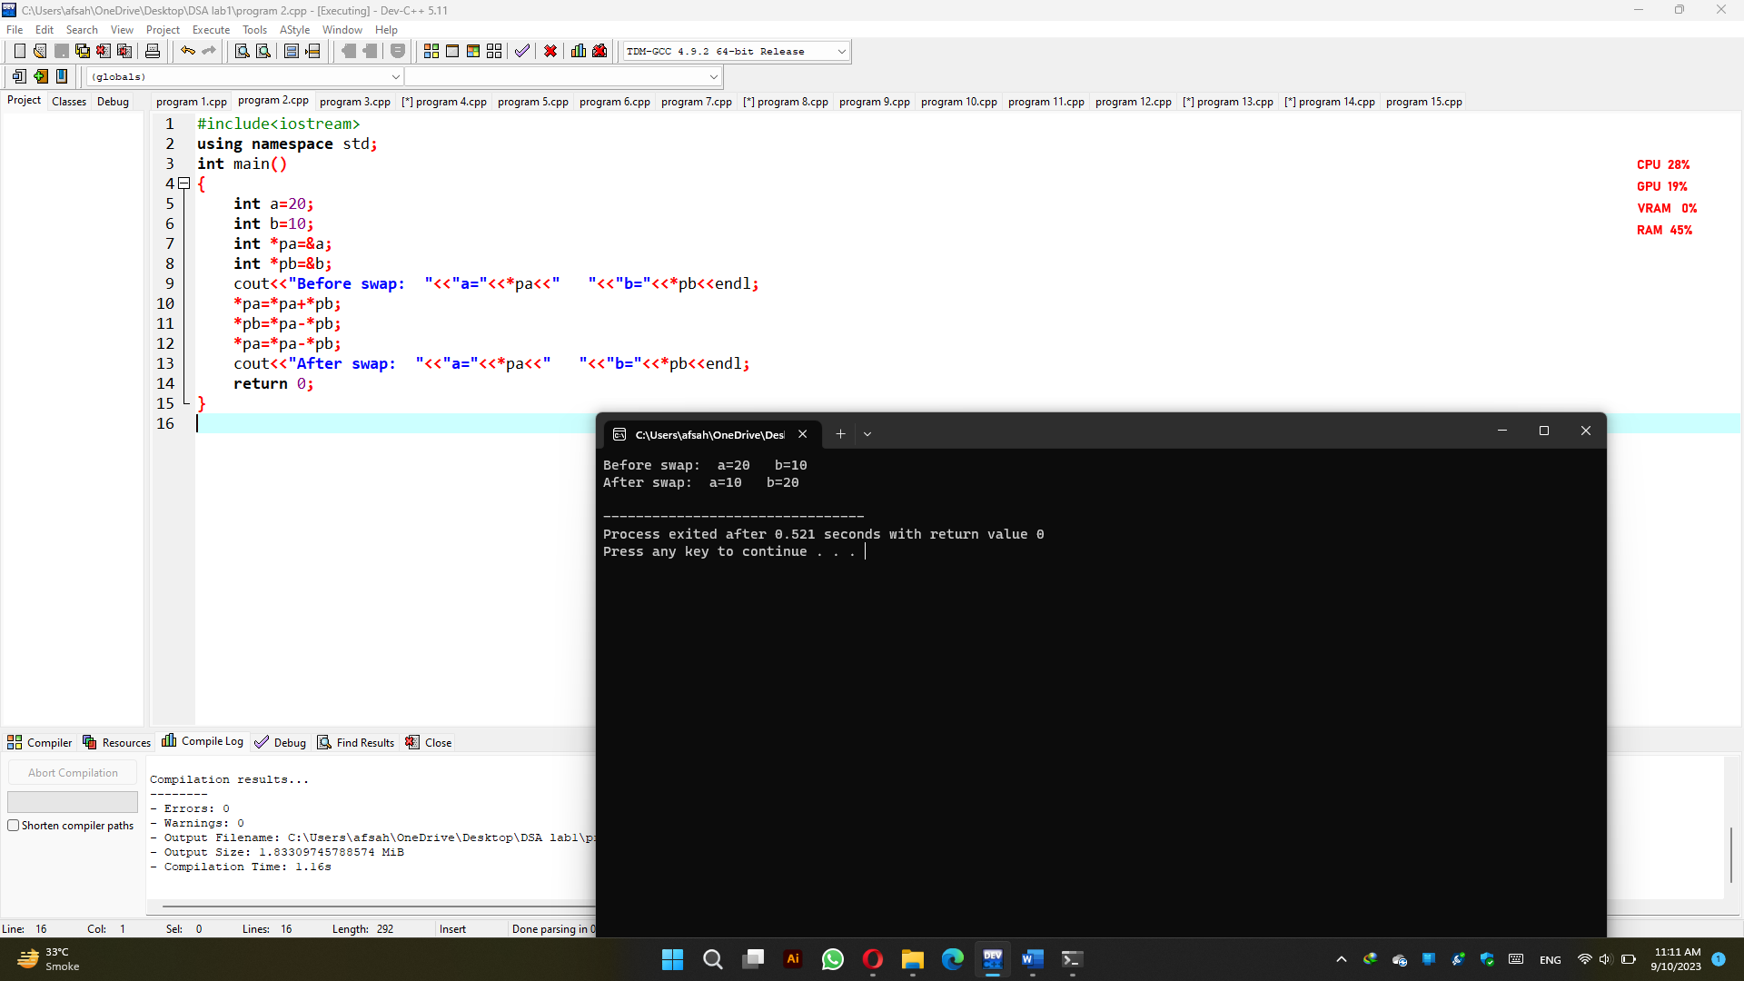

**Program 3:**

**#**include<iostream>

using namespace std;

int main()

{

int l=44;

int m=78;

int *pl=&l;

int *pm=&m;

int n;

int *pn=&n;

*pn=*pl+*pm;

cout<<"sum of two numbers is: "<<*pn<<endl;

return 0;

}

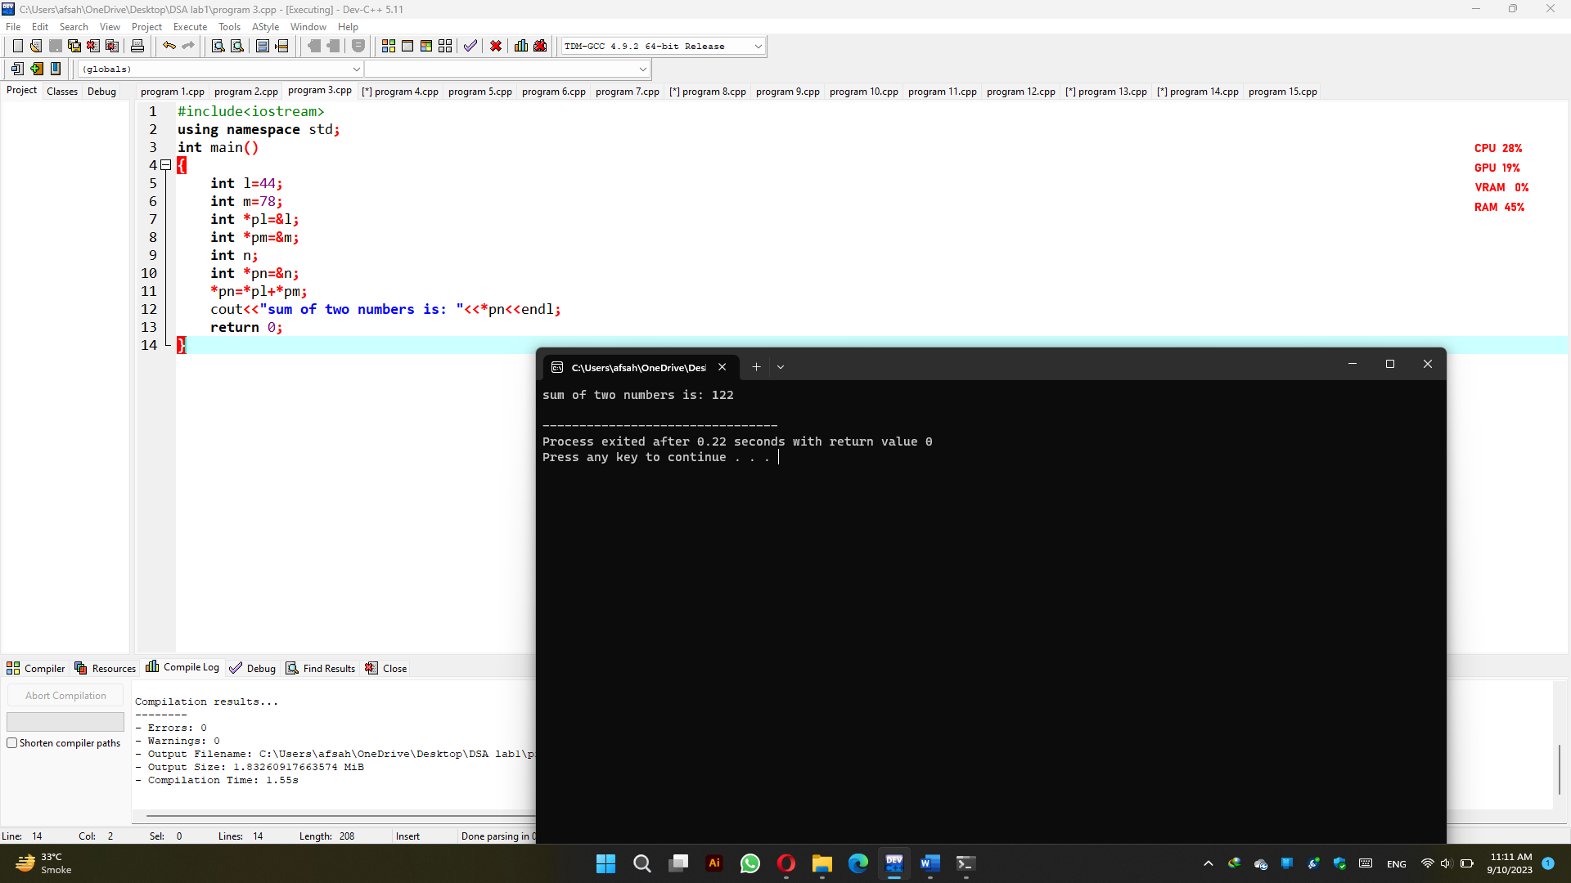

**Program 4:**

#include <iostream>

using namespace std;

int main()

{

int *p1, *p2;

int num1, num2, diff;

cout << "\nEnter Two Numbers for Find a Difference : \n";

cin>>num1;

cin>>num2;

p1 = &num1;

p2 = &num2;

diff = *p1 - *p2;

cout << "Difference :" << diff;

return 0;

}

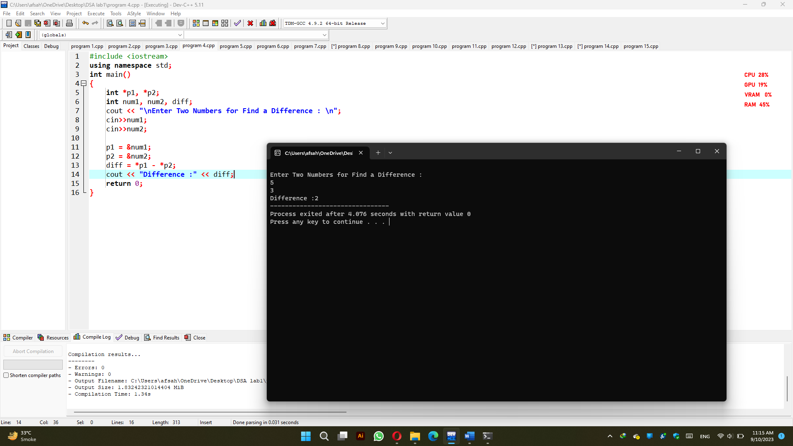

**Program 5:**

#include<iostream>

using namespace std;

int main()

{

int i;

int *x=&i;

for(*x=2; *x<=10; *x=*x+2)

{

cout<<*x<<" ";

}

return 0;

}

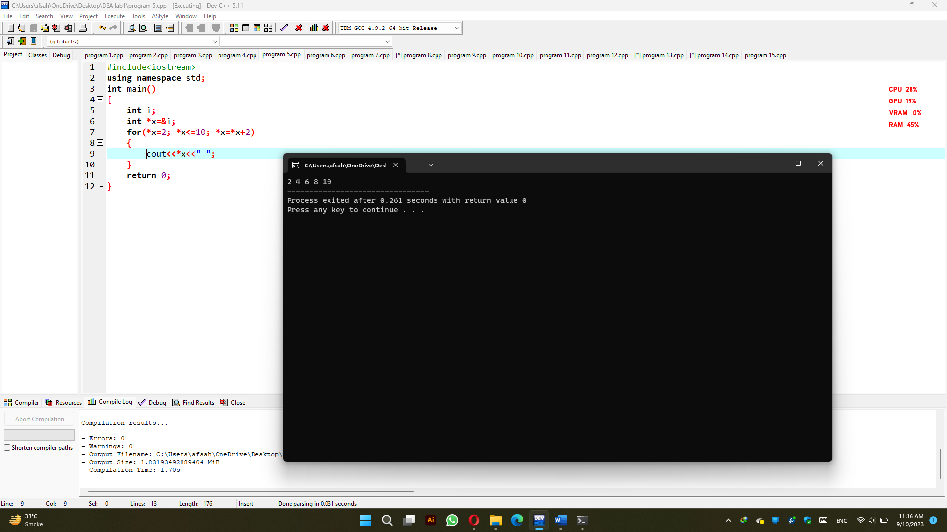

**Program 6:**

#include <iostream>

#include <conio.h>

using namespace std;

int main()

{

int i,n,c,*x,*nm,*fc;

x=&i;

nm=&n;

fc=&c;

*fc=0;

cout<<"Enter a number ";

cin>>*nm;

for(*x=1; *x<=*nm; *x=*x+1)

{

if(*nm % *x==0)

{

*fc=*fc+1;

}

}

if(*fc==2)

{

cout<<"Prime Number";

}

else

{

cout<<"Not Prime Number";

}

return 0;

}

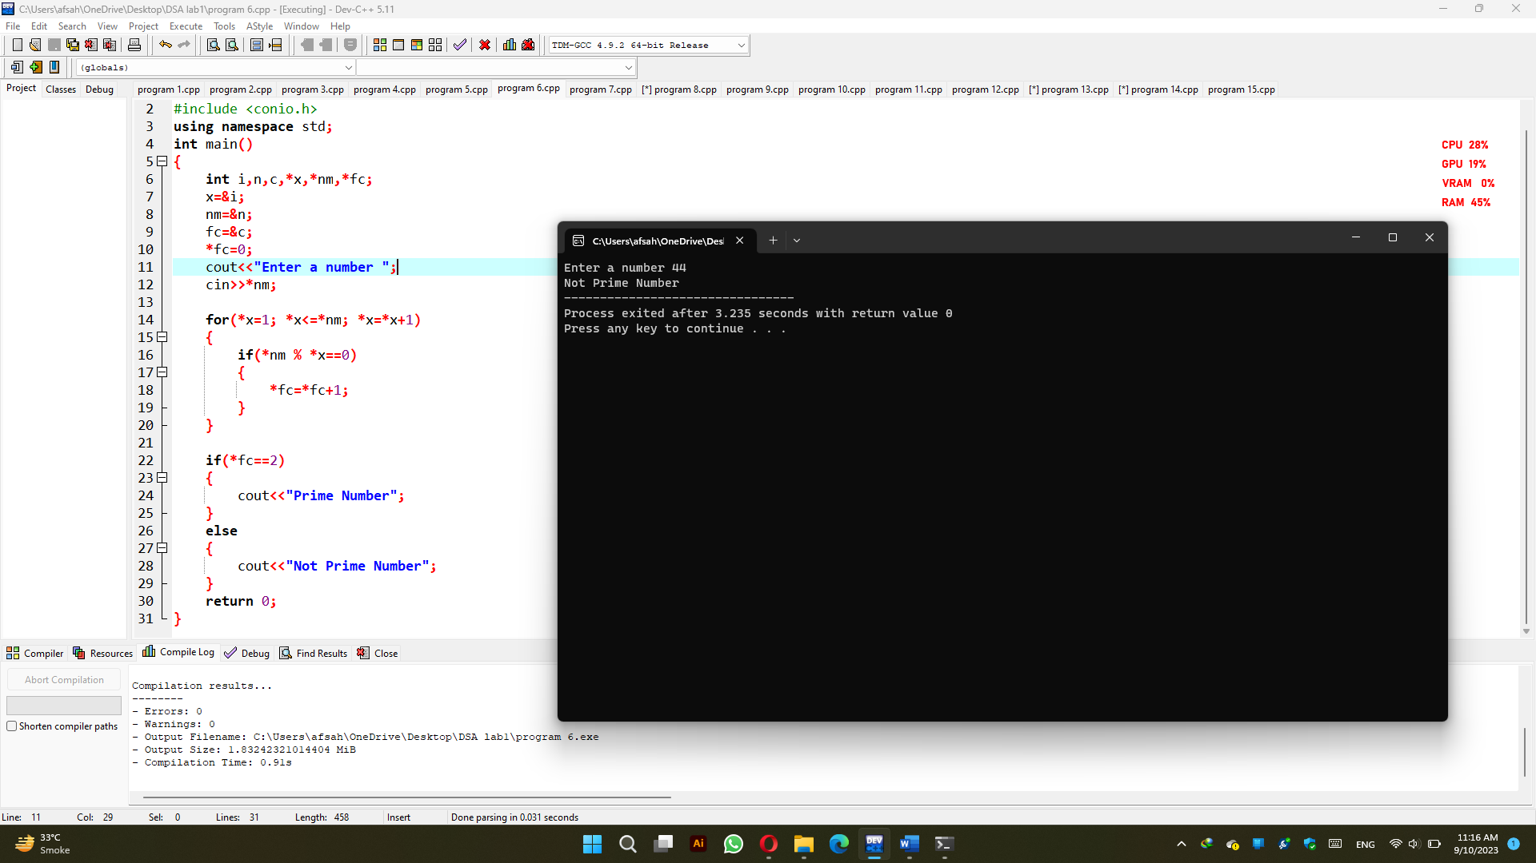

**Program 7:**

#include <iostream>

#include<conio.h>

using namespace std;

int main()

{

int a=10;

int *pt=&a;

(*pt)++;

cout<< "Post Increment = " <<a<<endl;

++(*pt);

cout<< "Pre Increment = " <<a<<endl;

(*pt)--;

cout<< "Post Decrement = " <<a<<endl;

--(*pt);

cout<< "Pre Decrement = " <<a<<endl;

return 0;

}

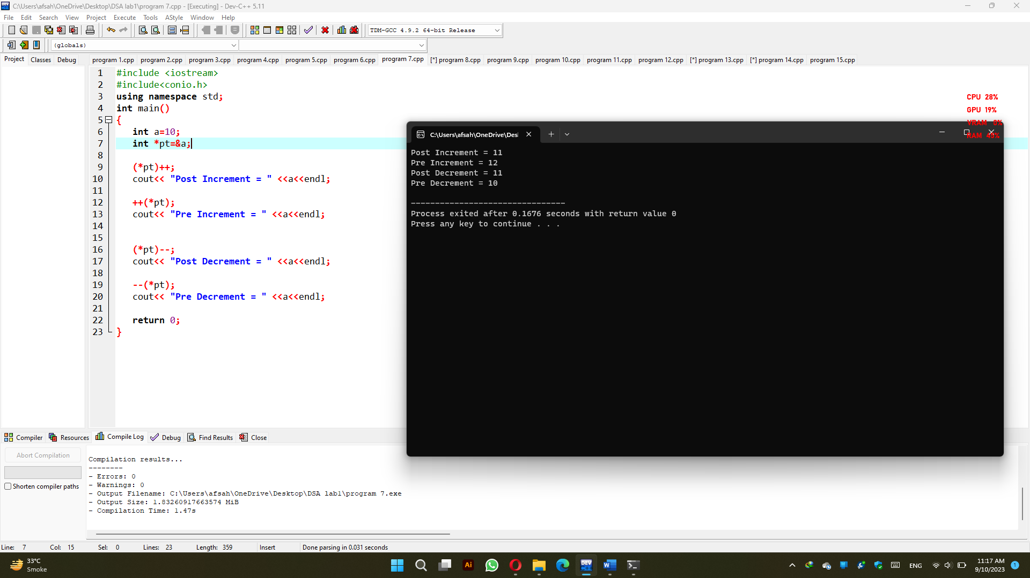

**Program 8:**

#include <iostream>

using namespace std;

void area_of_circle(float *value, float *result)

{

*result = 3.14 * (*value) * (*value);

}

int main()

{

float radius, area;

cout << "Enter the radius of Circle : "<<endl;

cin>>radius;

area_of_circle(&radius, &area);

cout << "Area of Circle : " << area<<endl;

return 0;

}

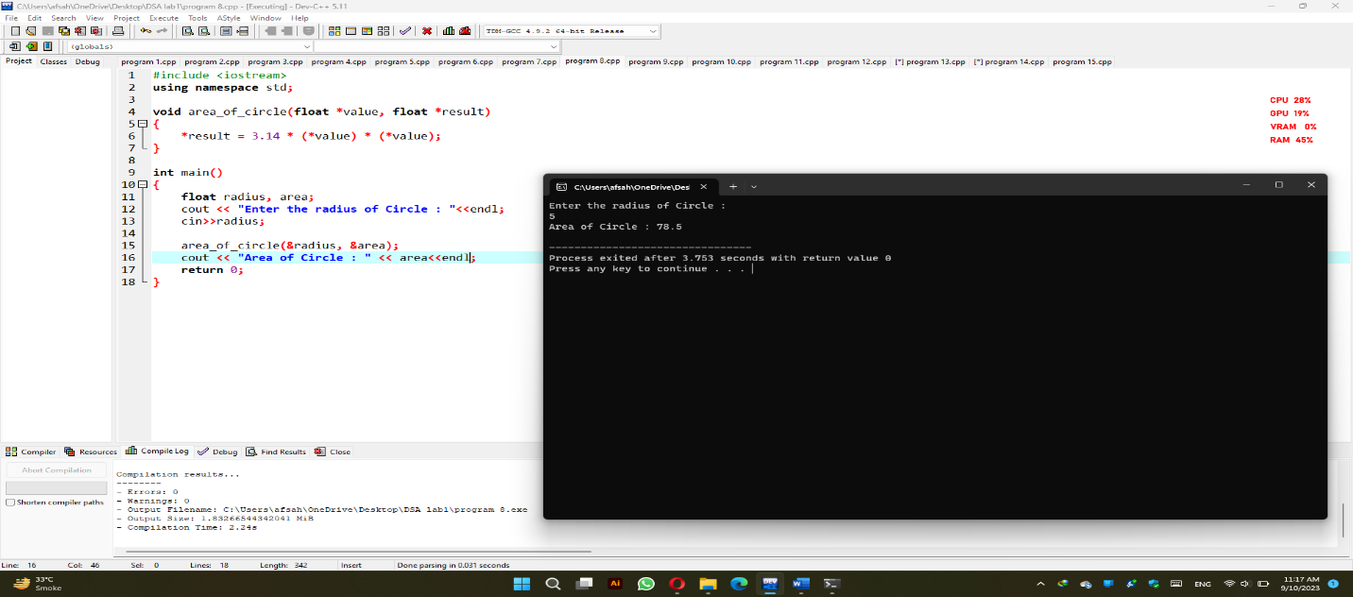

**Program 9:**

#include <iostream>

using namespace std;

int main()

{

int a = 10;

int *pa = &a;

char b = 'x';

char *pb = &b;

float c = 10.01;

float *pc = &c;

double d = 10.01;

double *pd = &d;

long e = 10.01;

long *pe = &e;

cout << "size of integer a : = " << sizeof (a)<<endl;

cout << "size of *pa : = " << sizeof (*pa)<<endl;

cout << "size of character b : = " << sizeof (b)<<endl;

cout << "size of *pb : = " << sizeof (*pb)<<endl;

cout << "size of float c : = " << sizeof (c)<<endl;

cout << "size of *pc : = " << sizeof (*pc)<<endl;

cout << "size of double d : = " << sizeof (d)<<endl;

cout << "size of *pd : = " << sizeof (*pd)<<endl;

cout << "size of long e : = " << sizeof (e)<<endl;

cout << "size of *pe : = " << sizeof (*pe)<<endl;

return 0;

}

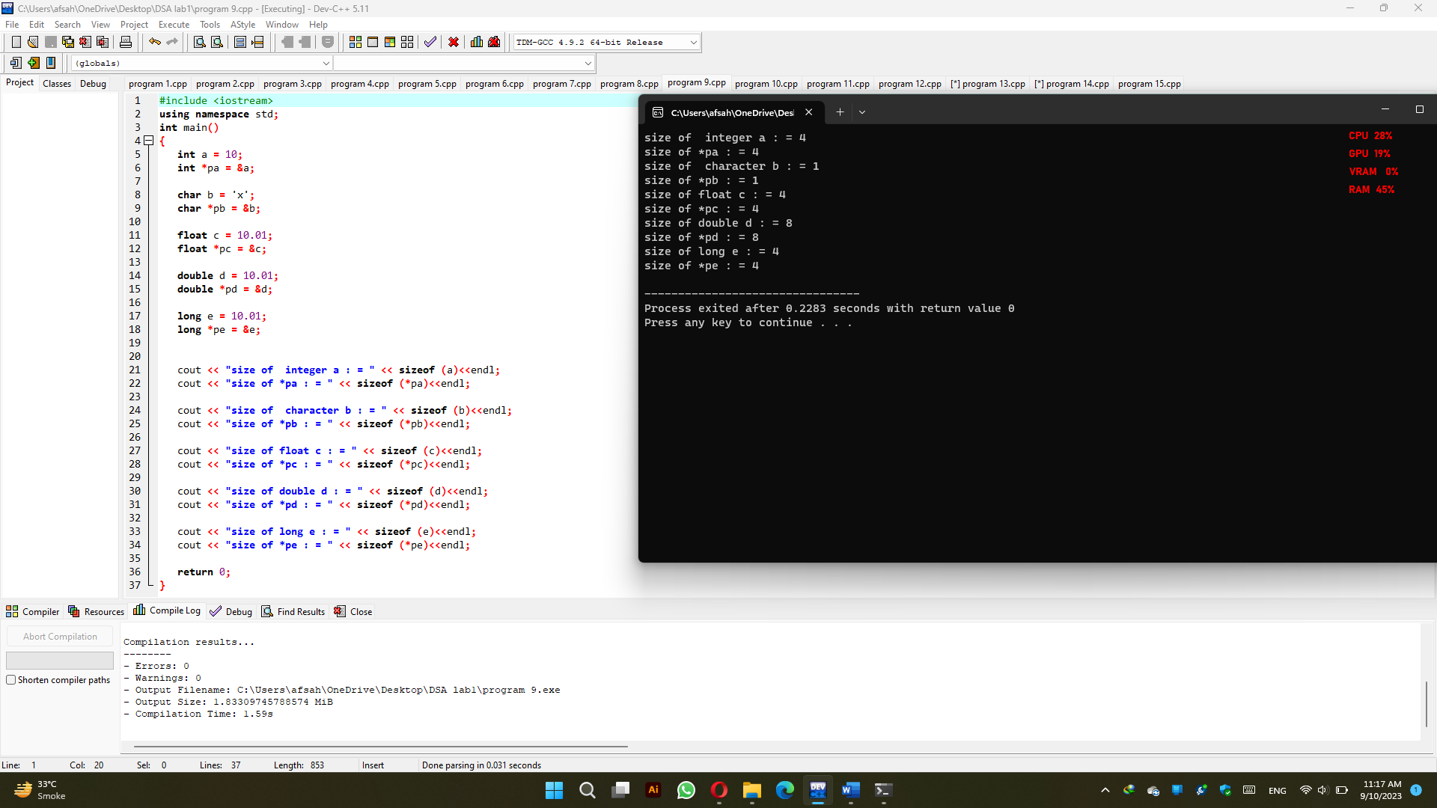

**Program 10:**

#include <iostream>

using namespace std;

#define MAX_SIZE 5

int main()

{

int var[] = {10, 20, 30, 40, 50};

int i = 0;

int *pt;

pt = &var[0];

while (i < MAX_SIZE)

{

cout << "Position : " << i << " # Actual Value : " << var[i] << " , Address = " << &var[i] << " \n";

cout << "Position : " << i << " # Pointer Value : " << *pt << " , Address = " << pt << " \n\n";

i++;

pt++;

}

return 0;

}

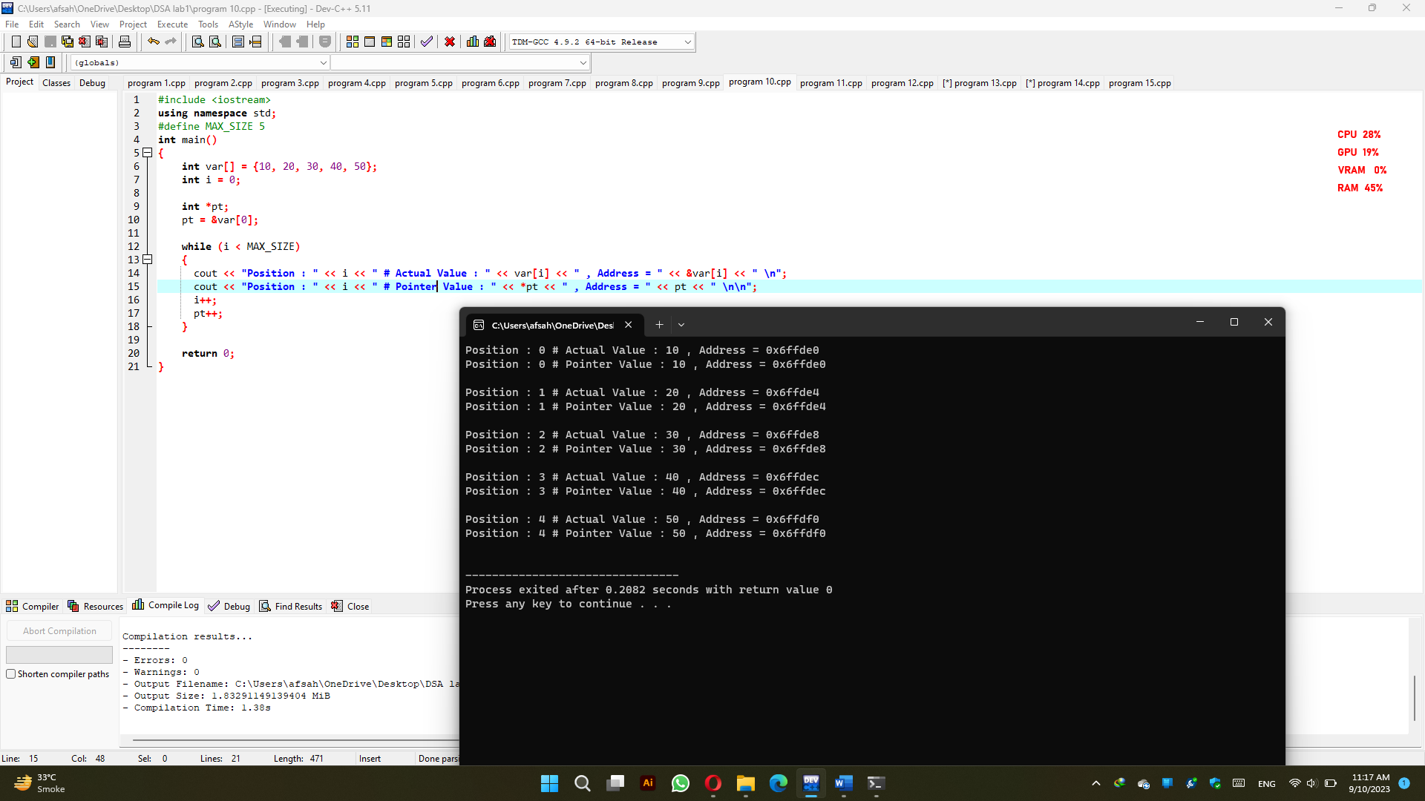

**Program 11:**

#include<iostream>

using namespace std;

int main()

{

int **p2;

int *p1;

int i=10;

p1=&i;

p2=&p1;

cout<<"Accessing i via i :"<<i<<endl;

cout<<"Accessing i via p1 :"<<*p1<<endl;

cout<<"Accessing i via p2 :"<<**p2<<endl;

return 0;

}

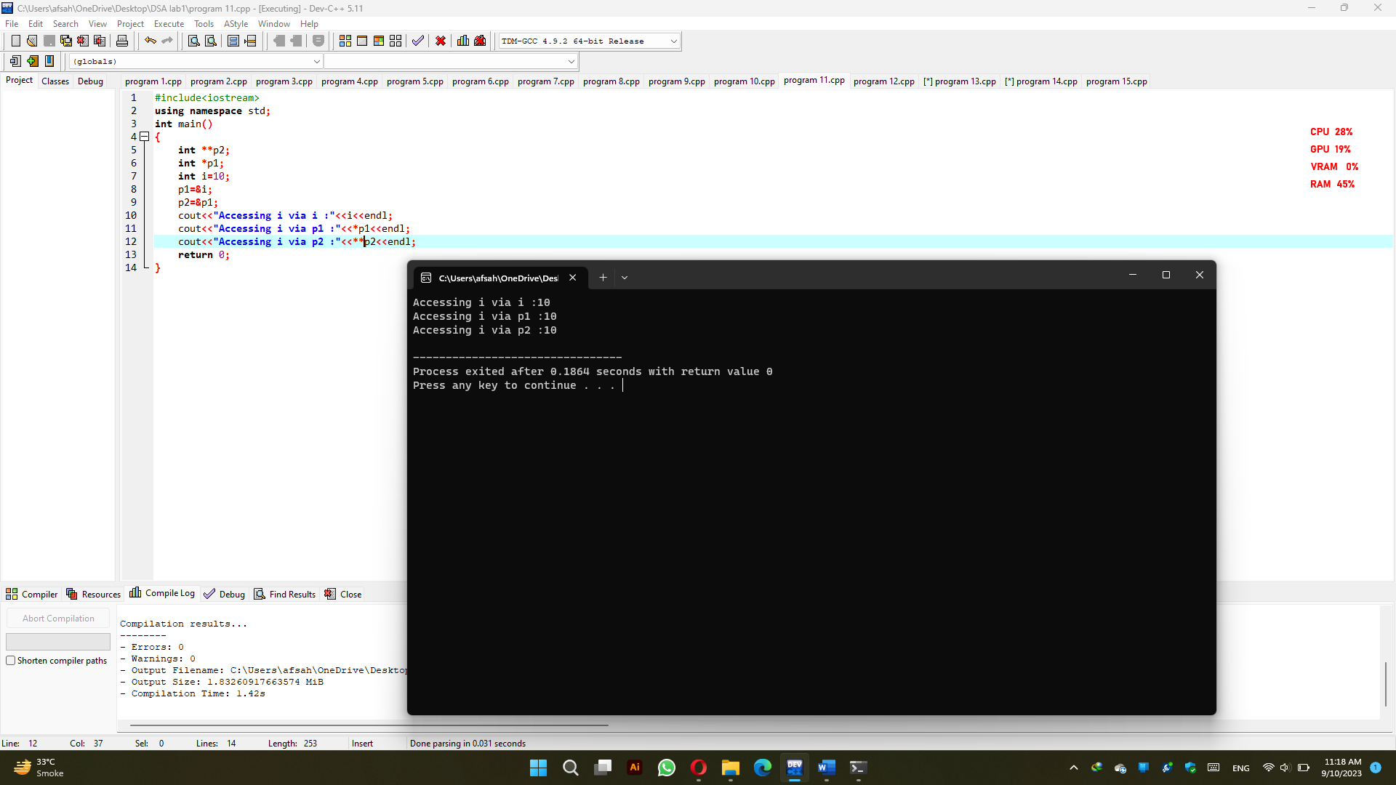

**Program 12:**

#include <iostream>

using namespace std;

int main()

{

int* pt;

int var;

var = 1;

cout << "Address of var :" << &var << "\n";

cout << "Value of var :"<< var << "\n\n";

pt = &var;

cout << "Address of Pointer pt :" << pt << "\n";

cout << "Content of Pointer pt :" << *pt << "\n\n";

var = 2;

cout << "Address of Pointer pt :" << pt << "\n";

cout << "Content of Pointer pt :" << *pt << "\n\n";

*pt = 3;

cout << "Address of var :" << &var << "\n";

cout << "Value of var :" << var << "\n\n";

return 0;

}

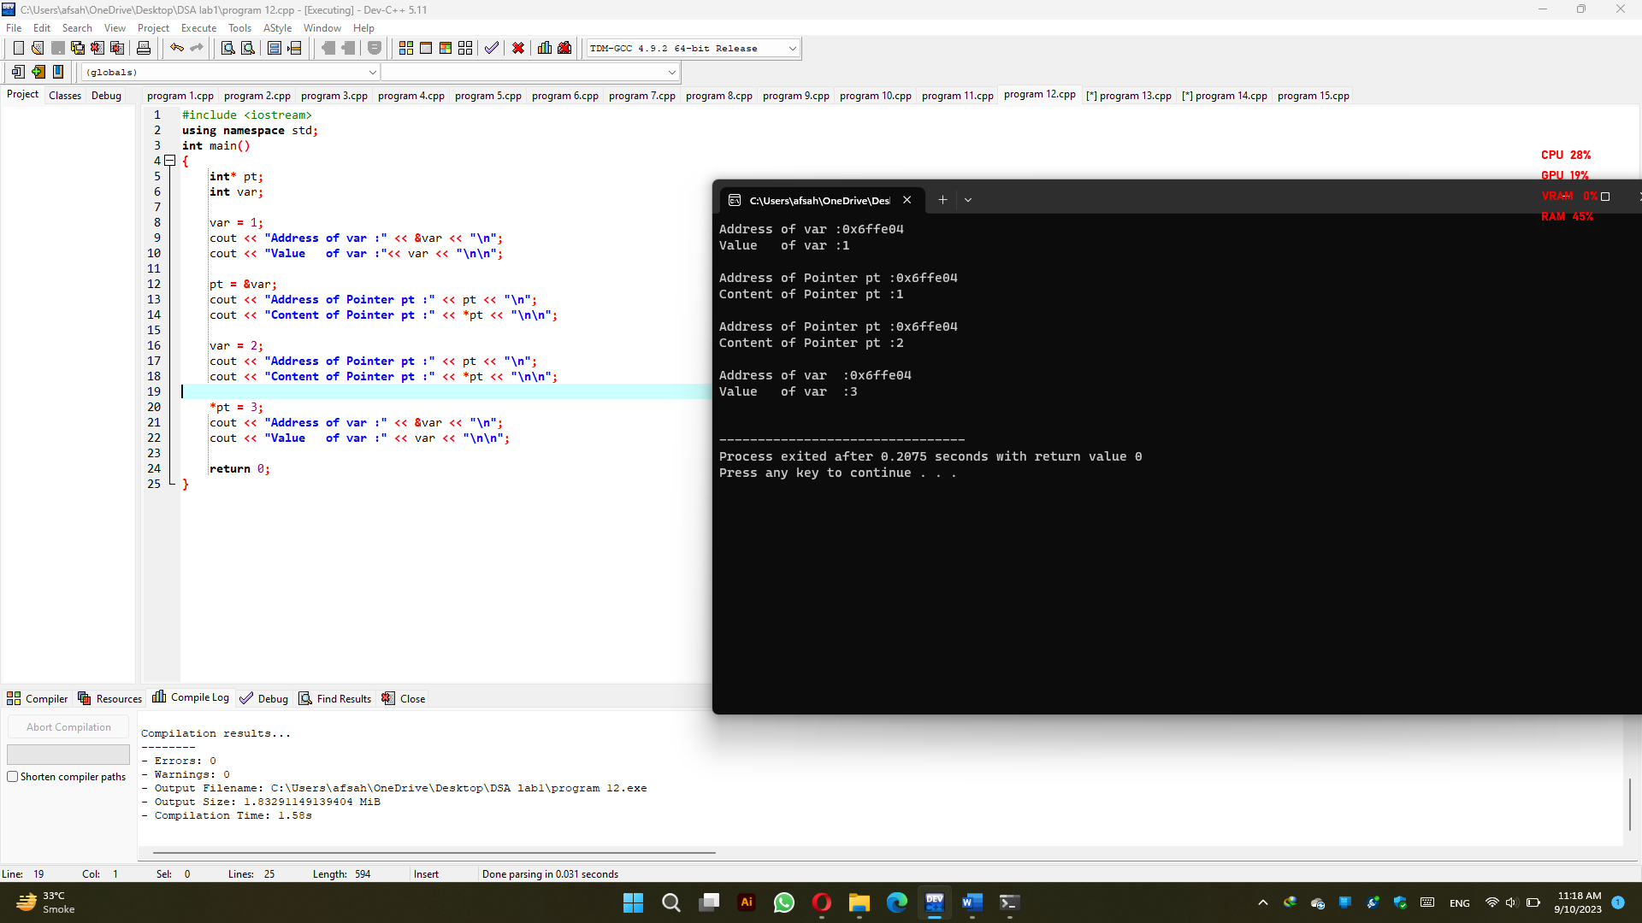

**Program 13:**

#include <iostream>

using namespace std;

int main()

{

char str[20], *pt;

cout << "Enter Any string (below 20 words) : ";

cin>>str;

pt = str;

while (*pt != '\0')

{

cout << *pt;

pt++;

}

return 0;

}

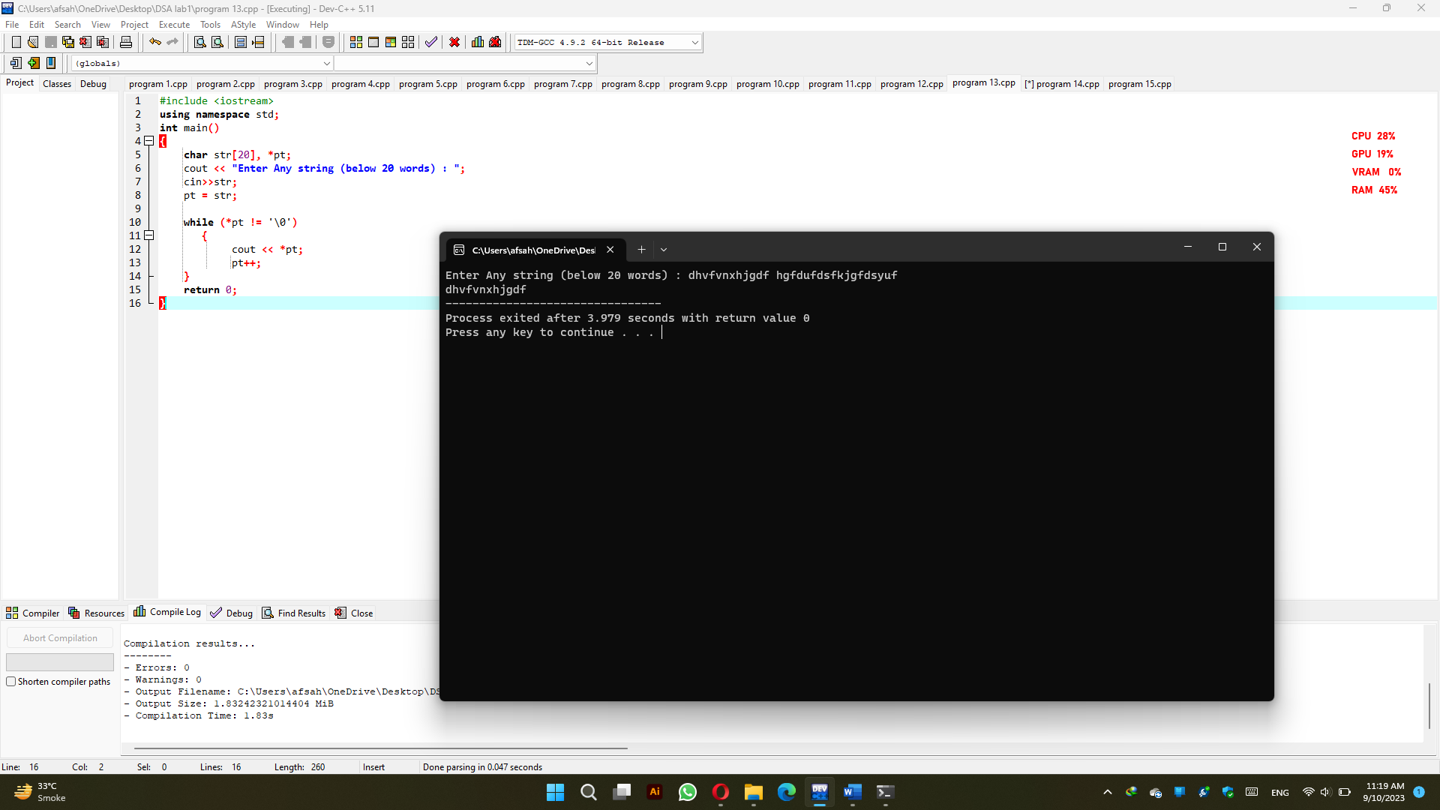

**Program 14:**

#include <iostream>

using namespace std;

int main()

{

char str[20], *pt;

int i = 0, c = 0;

cout << "Enter Any string (small letters) : ";

cin>>str;

pt = str;

while (*pt != '\0')

{

if (*pt == 'a' || *pt == 'e' || *pt == 'i' || *pt == 'o' || *pt == 'u')

c++;

i++;

pt++;

}

cout << "\nLength of String : " << i;

cout << "\nVowels Count In the String : " << c;

cout << "\nConstant Count in the String : " << (i - c);

return 0;

}

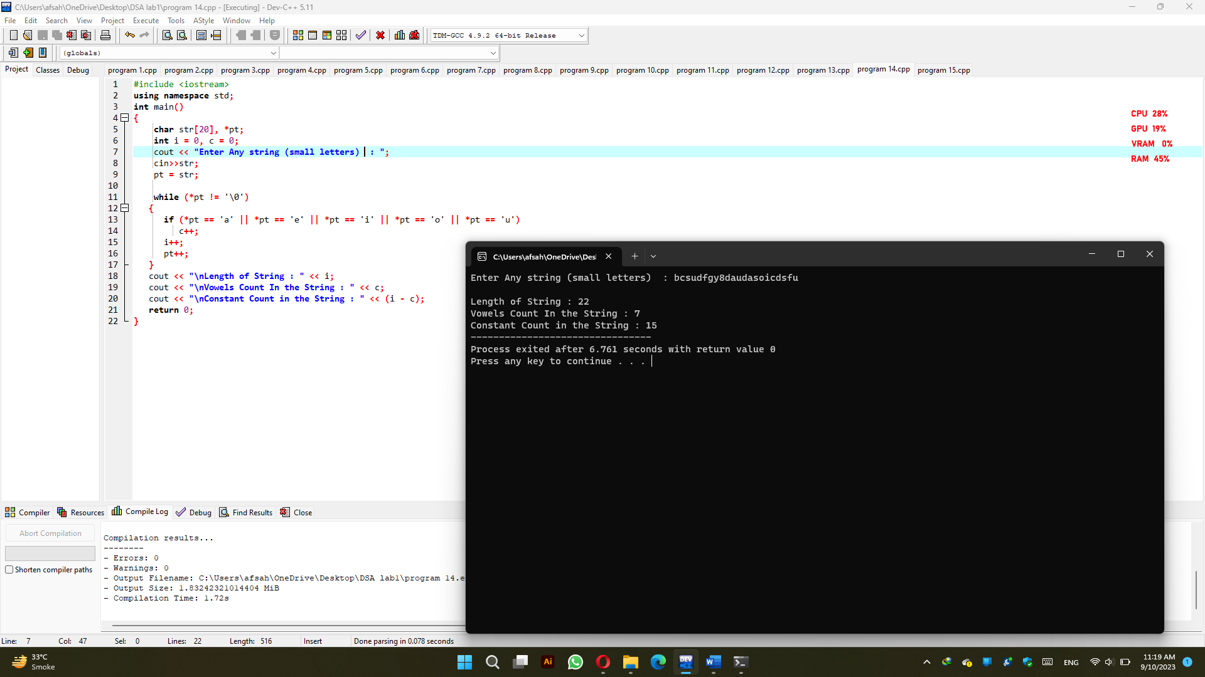

**Program 15:**

#include <iostream>

using namespace std;

int main()

{

char str[20], *pt;

int i = 0;

cout << "Enter Any string : ";

cin>>str;

pt = str;

while (*pt != '\0')

{

i++;

pt++;

}

cout << "\nLength of String : " << i;

return 0;

}

