Implementation of E-Commerce System By

Marzia Akter Mun
&
Afsana Shahariar Toma



Project for the Degree of Bachelor of Science In
Computer Science & Engineering
NATIONAL UNIVERSITY
September 2023

Project for the Degree of Bachelor of Science
Implementation of E-Commerce Website

Submitted By:
Marzia Akter Mun
Registration Number: 17502004785
&
Afsana Shahariar Toma
Registration Number: 17502004842

Supervised By:
Sk. Mamunur Rashid
Asst. Professor
Department of CSE(ISTT)

Submitted to the Department of Computer Science and Engineering of institute of
Science & Technology (ISTT)
In partial fulfillment of the requirements for the degree of Bachelor of Science
ACKNOWLEDGEMENT

In completing this E-commerce project, I have been fortunate to have help, support, and encouragement from many people. I would like to thank them for their cooperation. I am sincerely thankful to SK. Mamunur Rashid sir, for his wonderful supervision during this E-commerce project work in the field of Computer Science, at ISTT. I am also thankful for his continuous feedback and encouragement throughout this project work. His broad knowledge and hardworking attitude have left me with very deep and cool impressions, make me energetic and will greatly benefit me throughout my life. Last but not the least; Above all, we should not forget the great director of the world, ‘The Almighty’; let us thank the Almighty for His inspiration.

Institute of Science Trade and Technology (ISTT)

Date ,………..

Prof. SK. Mamunur Rashid  …………………………………..  Supervisor | Signature  Marzia Akter Mun  …………………………………….  (Name of the student 1)  Afsana Shahariar Toma  ……………………………………..  (Name of the student 2)

ABSTRACT

E commerce is a Business to Consumer online E-commerce application which is designed for creating a smart online shopping opportunity for consumers. This shopping platform has a lot of features for consumers. The system is developed using MERN Stack. It basically helps Customers who want to buy their necessary products in a user-friendly manner. The customers can simply visit the system, choose products from any category, register for an order, log into their accounts, and finally can make payment of their purchased amount. The customers can edit their order list before order confirmation. It provides 24x7 support. Customers can make inquiries about any products or services and place orders anytime, anywhere from any location. The present shopping website includes a range of electronic items, garments of all age groups, home appliances, and other necessary products that consumers require on a daily basis.
Table of Contents
ACKNOWLEDGEMENT 4------------------------------------------------------------------------------------
ABSTRACT ------------------------------------------------------------------------------------------------------
Chapter 1: Introduction .......................................................................................................
  - Project Background ..........................................................................................................
  - Aims and Objective ..........................................................................................................
Chapter 2:Planning and Requirement Analysis-3
2.1. Literature Review------------------------------------------------------------------------------------------
2.2. Existing system/Proposed System----------------------------------------------------------------------
2.3. Feasibility Study---------------------------------------------------------------------------------------------
2.3.1. Technical Feasibility----------------------------------------------------------------------------
2.3.2. Economical Feasibility--------------------------------------------------------------------------
2.4. Cost Benefit Analysis---------------------------------------------------------------------------------------
2.5. Hardware Requirement------------------------------------------------------------------------------------
2.6. Software Requirement--------------------------------------------------------------------------------------
Chapter 3: System Design/Software Design-------------------------------------------------------------
3.1. Methodology---------------------------------------------------------------------------------------------------
3.2. Data Flow Diagram (DFD) ---------------------------------------------------------------------------------
3.2.1. Context level DFD--------------------------------------------------------------------------------
3.2.2. Admin Panel level One DFD-------------------------------------------------------------------
3.2.3. Admin Panel Level Two DFD------------------------------------------------------------------
3.2.4. User Side Level One DFD----------------------------------------------------------------------
3.2.5. User Side Level Two DFD----------------------------------------------------------------------
3.2.6. User Side Level Three DFD---------------------------------------------------------------
3.3. Use case Diagram---------------------------------------------------------------------------------------
3.3.1. Use Case Diagram for User----------------------------------------------------------------
3.3.2. Use Case Diagram for Admin--------------------------------------------------------------
3.4. Entity Relationship (ER) Diagram---------------------------------------------------------------------
3.4.1. Entity Relationship (ER) Diagram Model One-----------------------------------------
3.4.2. Entity Relationship (ER) Diagram Model Two-----------------------------------------
3.5. Context --------------------------------------------------------------------------------------------
3.6. Data Schema-------------------------------------------------------------------------------------
Chapter 4: Implementation---------------------------------------------------------------------------------
4.1. Sample code------------------------------------------------------------------------------------------------
4.2. Screenshot---------------------------------------------------------------------------------------------------
Chapter 5: Testing Debugging and Maintenance --------------------------------------------------
5.1. Testing--------------------------------------------------------------------------------------------------------
5.2. Debugging--------------------------------------------------------------------------------------------------
5.3. Maintenance------------------------------------------------------------------------------------------------
Chapter 6: Conclusion---------------------------------------------------------------------------------------
6.1. Limitation-----------------------------------------------------------------------------------------------------
6.2. Future Work-------------------------------------------------------------------------------------------------
6.3. Conclusion---------------------------------------------------------------------------------------------------
References--------------------------------------------------------------------------------------------------------
Appendix----------------------------------------------------------------------------------------------------------
Sample code------------------------------------------------------------------------------------------------------
Chapter 01
Introduction
1.1 Project Background:
An E-Commerce which will allow formal and informal merchants in developing countries to advertise and sell their goods on the Internet. This would permit rural communities to make their wares available to the rest of the world via the World Wide Web. The objective of this project is to create an e-commerce web portal with a content management system which would allow product information to be updated securely using a mobile device. The web portal will have an online interface in the form of an e-commerce website that will allow users to buy goods from the merchants.We have a wonderful & generous dental community! We are thankful for the participating dentists, hygienists, and administrative volunteers for their kindness, generosity, and donation of their time to Supply a Smile's program.
1.2 Aims and Objective
The primary objective of this project is to develop a fully functional e-commerce mobile application that meets the following key goals:
User-Friendly Interface: Design an intuitive and visually appealing user interface that enhances the overall shopping experience and encourages user engagement.
Real-time Updates: Utilize the real-time capabilities of Firebase to ensure that users receive instant updates on product availability, prices, and order status
Seamless Shopping Process: Implement a comprehensive shopping cart system that allows users to effortlessly add products, review their selections, and complete the checkout process.
Secure User Authentication: Integrate Firebase's authentication services to ensure secure user registration and login processes, safeguarding user information.
Efficient Database Management: Utilize the Firebase database to efficiently manage product catalogs, user profiles, order histories, and other critical data.
Scalability and Performance: Architect the application in a way that allows for future scalability, ensuring that the app can handle increasing user loads without compromising performance

Chapter 2
Planning and Requirement Analysis
2.1 Literature Review: In this section, we outline the planning and requirement analysis for the development of the e-commerce mobile application. This includes the review of existing and proposed systems, feasibility assessment, and the identification of technical and economical considerations. Additionally, we outline the hardware and software requirements essential for the successful implementation of the project.
2.2 Existing System/Proposed System
Existing System
Currently, many e-commerce applications exist in the market, each offering varying levels of user experience, performance, and features. While these applications provide a means for online shopping, certain limitations such as sluggish responsiveness, complex navigation, and lack of real-time updates have been identified in the existing systems.
Proposed System
The proposed e-commerce application aims to overcome the limitations of existing systems by leveraging the Java programming language for native Android app development and integrating Firebase as the backend database. This approach will offer a responsive, user-friendly interface, real-time updates, secure authentication, and efficient data management. By combining these technologies, the proposed system aims to provide a superior shopping experience to users.

2.3 Feasibility Study:
2.3.1 Technical Feasibility
The technical feasibility of the project is high due to the availability of wellestablished tools and technologies. Android Studio, a widely used Integrated Development Environment (IDE), supports Java and facilitates native Android app development. Firebase offers real-time synchronization and offline data access, aligning with the project's technical goals. Here are the key points to consider in the technical feasibility assessment:
- System Architecture:
Describe the high-level architecture of the e-commerce system, including components, modules, and their interactions. Consider factors like scalability, flexibility, and modularity to accommodate various functions.
- Technology Stack:
Identify the technologies, programming languages, frameworks, and databases that will be used to build the system. Ensure that these technologies are up-to-date and appropriate for the system's requirements.
- Integration Capabilities:
Examine how well the new system can integrate with existing systems, third-party services, and APIs. Integration is important for functions like payment gateways, inventory management, and customer relationship management.
- Data Management:
Evaluate how the system will handle data storage, retrieval, and security. Consider database design, data encryption, and compliance with data protection regulations.
- Performance and Scalability:
Assess the system's expected performance under different loads and user traffic. Consider factors like response times, concurrent user handling, and the ability to scale resources to meet growing demand.
- User Experience (UX):
Examine how the system will provide a seamless and user-friendly experience. This includes aspects such as intuitive navigation, responsive design for different devices, and fast page loading times.
- Security Measures:
Detail the security measures that will be implemented to protect user data, prevent unauthorized access, and guard against cyber threats. This includes encryption, secure authentication, and regular security audits.
- Mobile Compatibility:
Consider whether the system will be accessible and usable on mobile devices through responsive design or a dedicated mobile app.
- Development Resources:
Assess the availability of skilled developers and other technical resources required for the project. If there are gaps, consider whether training, outsourcing, or hiring is necessary.
- Technical Challenges: Identify potential technical challenges that might arise during development and deployment. This could include complex features, integration difficulties, or compatibility issues.

- Technology Trends:
Stay informed about the latest technology trends in e-commerce systems to ensure that the proposed solution remains relevant and competitive in the long term.
- Prototyping and Testing:
Plan how the system will be prototyped and tested throughout the development process to catch and address technical issues early on.
- Maintenance and Updates:
Consider how the system will be maintained, updated, and upgraded to ensure its continuous functionality and security.
- Budget and Resources:
Estimate the technical resources, budget, and timeline required for the development and maintenance of the system. By conducting a comprehensive technical feasibility assessment, you can identify potential roadblocks and ensure that the proposed multi-functional e-commerce system project is built on a solid technical foundation, capable of delivering the desired functions reliably and efficiently

2.3.2 Economical Feasibility:
The economical feasibility of the project is supported by the fact that the required software tools and development environments are readily available at no cost. While Firebase provides a free tier with generous usage limits, the project's operational costs may increase with extended usage or additional features. However, the potential benefits, including increased user engagement and revenue generation, justify the costs. Here are the key factors to consider in the economic feasibility assessment.

- Cost Estimation:
Determine the total costs associated with the project, including development, infrastructure setup, operational, and maintenance costs. Break down costs into categories such as software development, hardware, licensing, staffing, marketing, and ongoing support.
- Development Costs:
Estimate the expenses related to software development, including hiring developers, designers, and other technical staff, as well as the costs of development tools and resources.
- Infrastructure Costs:
Consider the expenses for setting up the required hardware, servers, cloud services, and other infrastructure needed to run the e-commerce system.
- Operational Costs:
Calculate ongoing operational expenses such as hosting, server maintenance, bandwidth, security measures, payment gateway fees, customer support, marketing, and other operational overheads.
- Revenue Projection:
Based on your market analysis, project the potential revenue the e-commerce system can generate. Consider various revenue streams such as product sales, subscriptions, commissions, and advertising.
- Break-Even Analysis:
Determine the point at which the project's total costs are covered by its total revenue, resulting in neither profit nor loss. This break-even point helps determine the time required to start making a profit.
- Return on Investment (ROI):
Calculate the projected ROI by comparing the net profit (total revenue minus total costs) with the initial investment. ROI helps evaluate the financial attractiveness of the project.
- Payback Period:
Estimate the time it will take for the project to generate enough profits to recover the initial investment. A shorter payback period is generally more favorable.
- Sensitivity Analysis:
Assess how changes in key variables, such as sales volume, pricing, and operational costs, could impact the project's financial performance. This helps identify potential risks and uncertainties.

- Market Trends and Growth Potential:
Consider the projected growth of the e-commerce industry and market trends. Evaluate whether the proposed system aligns with these trends and whether it can capture a significant market share.
- Competitor Analysis:
Study the financial performance of existing competitors in the e-commerce market. Analyze their revenue, profit margins, and growth trajectory to gauge the potential financial success of your project.
- Risk Assessment and Mitigation:
Identify potential economic risks, such as slower-than-expected adoption, regulatory changes, or increased competition. Develop strategies to mitigate these risks.
- Long-Term Viability:
Evaluate the project's ability to generate sustainable profits over the long term, considering factors like changing market dynamics and evolving customer preferences.
- Decision and Recommendations:
Based on the economic feasibility analysis, provide a recommendation on whether the project should be pursued, modified, or abandoned. Clearly state the reasons behind your recommendation. Conducting a thorough economic feasibility analysis ensures that the multi-functional e-commerce system project aligns with the organization's financial goals and has the potential to deliver a positive return on investment.

Cost Benefit Analysis
A cost benefit analysis indicates that the benefits of developing the proposed e- commerce app outweigh the associated costs. The enhanced user experience, real- time updates, and scalability potential are expected to attract more users and increase sales. The initial development and operational costs are manageable in comparison to the projected revenue and improved brand reputation.

SN | Cost sector | Amount
01 | Design | 30,000 TK
02 | Development | 80,000 TK
03 | Hosting Charge(Annually) | 10,000 TK
04 | Domain Charge(Annually) | 1,000 TK
05 | Maintenance (Annually) | 20,000 TK
06 | Project Management | 25,000 TK
07 | Testing | 20,000 TK

Total Cost of Development: 1,86,000 TK

Hardware Requirement
Number | Description
1 | PC with 250GB and more than Hard disk
2 | PC with 4GB RAM.
3 | PC with Pentium 1 or above.
4 | CPU: for web 1.6 GHz, for web and database 4 *1.6 GHz

  - Software Requirement
- Android Studio: For native app development using Java.
- Firebase: As the backend database for real-time data management.
- Java Development Kit (JDK): Required for Java programming.
- Emulators: Android emulators for testing the app on different device configurations.
Chapter 3
System Design

Methodology

Selecting the right is crucial for its successful planning, development, and execution. Here are some popular methodologies you might consider:
A software process model is a simplified representation of a software process. Each model represents a process from a specific perspective.

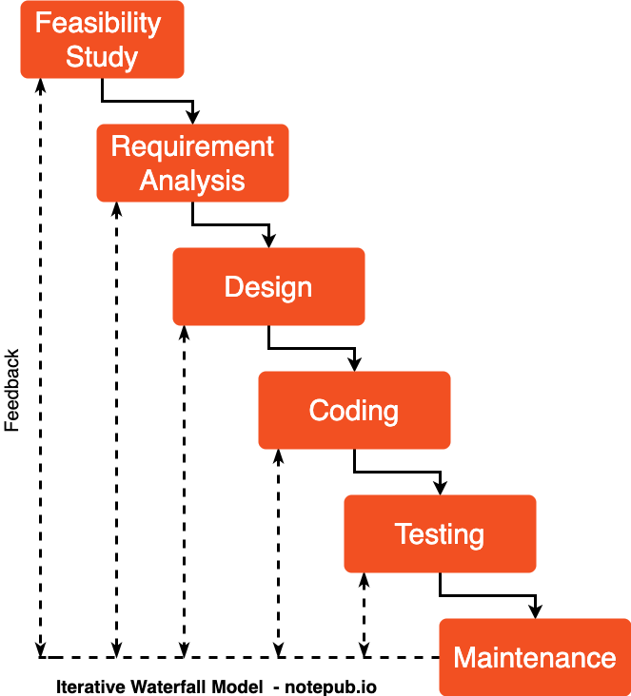

Fig 01 : Waterfall Model

3.1.1 Advantage of Waterfall Model
- This model is simple and easy to understand and use.
- It is easy to manage due to the rigidity of the model – each phase has specific deliverable and a review process.
- In this model phases are processed and completed one at a time. Phases do not overlap.
- Waterfall model works well for smaller projects where requirements are clearly defined and very well understood.
3.1.2 Disadvantage of Waterfall Model

- Once an application is in the testing stage, it is very difficult to go back and change something that was not well-thought out in the concept stage.

- No working software is produced until late during the life cycle.

- High amounts of risk and uncertainty.

- Not a good model for complex and object-oriented projects.

- Poor model for long and ongoing projects.

- Not suitable for the projects where requirements are at a moderate to high risk of changing.

3.2 Data Flow Diagram(DFD)
Level-0 Diagram
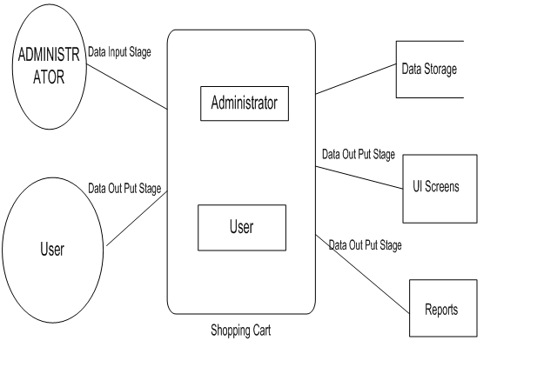

Fig: 0 – Level DFD for Multi-Functional E-Commerce System.

Level-1 Diagram
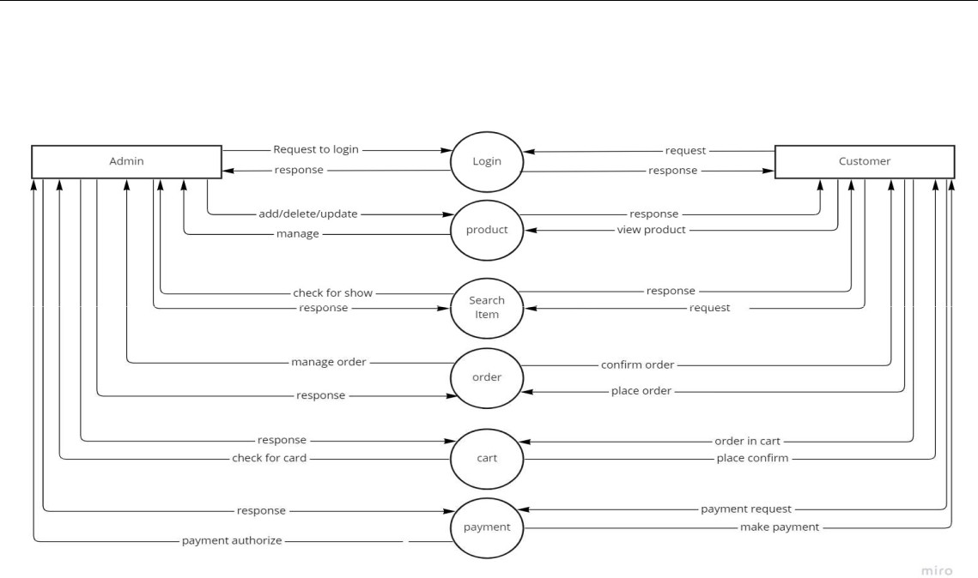

Fig: 1 – Level DFD for Multi-Functional E-Commerce System.

Level-2 Diagram
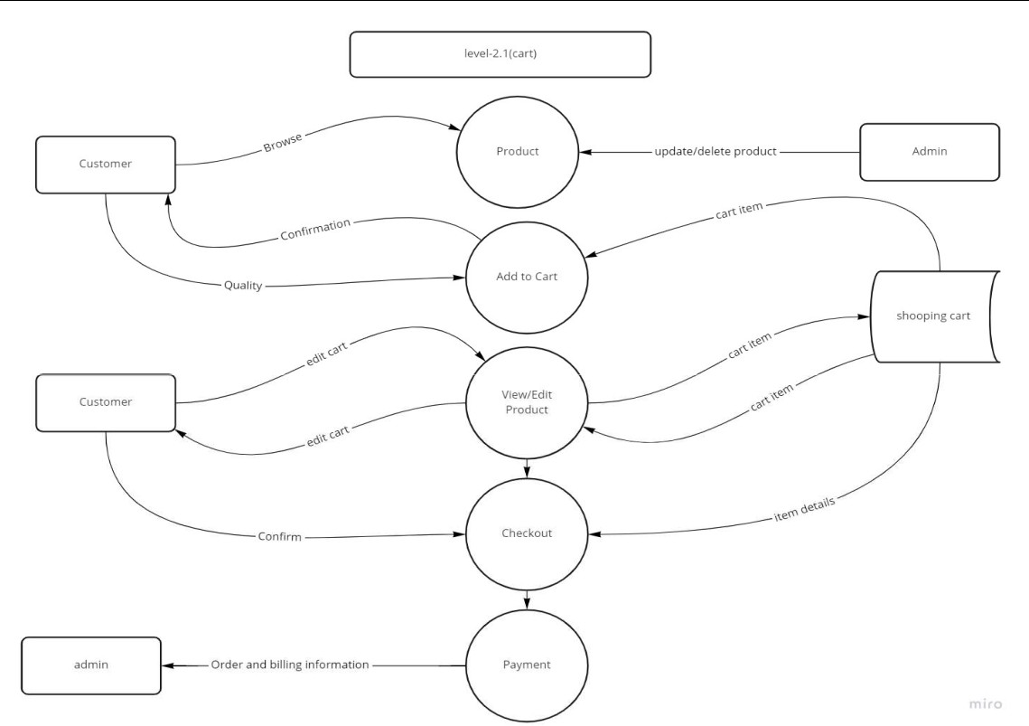

Fig: 2 – Level DFD for Multi-Functional E-Commerce System

Level-2.2 Diagram

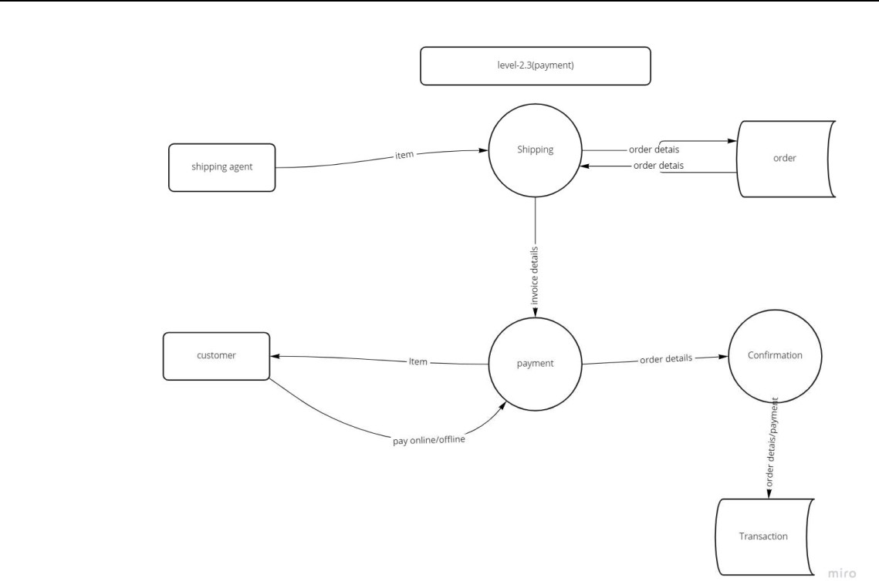

Level-2.3

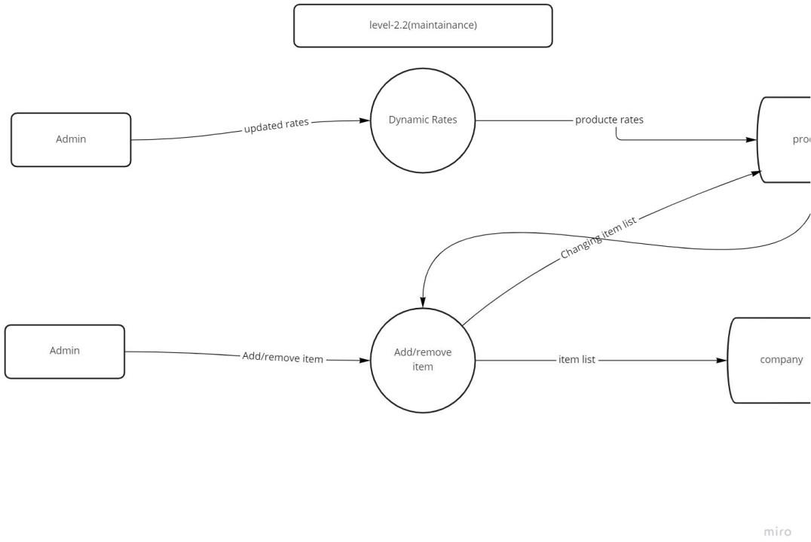
Level-2.4

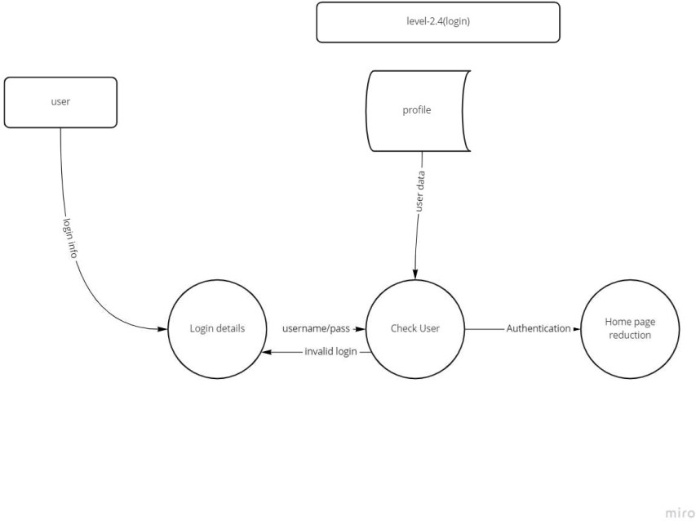

Level-2.5

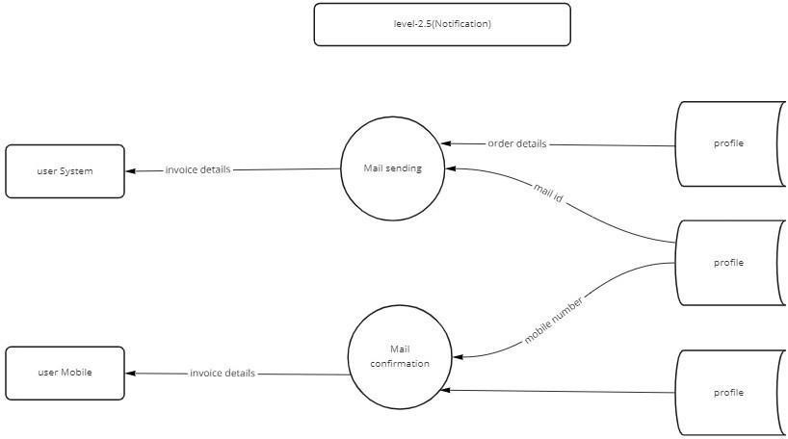

Fig: Data-flow Diagram

3.3Use Case Diagram
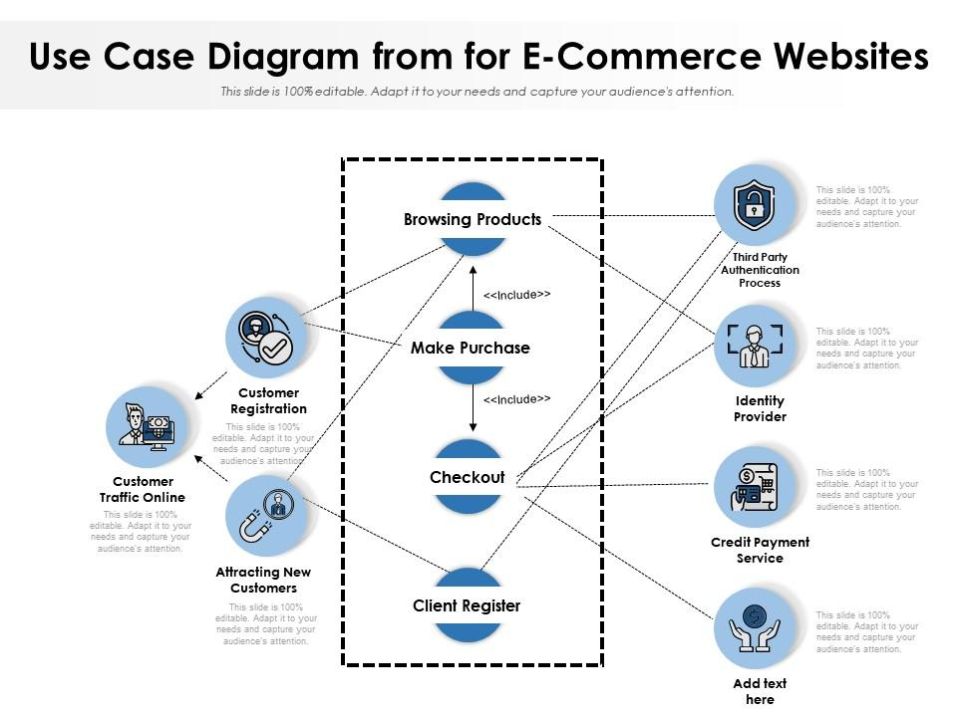

Fig: Use case Diagram

3.4E-R Diagram

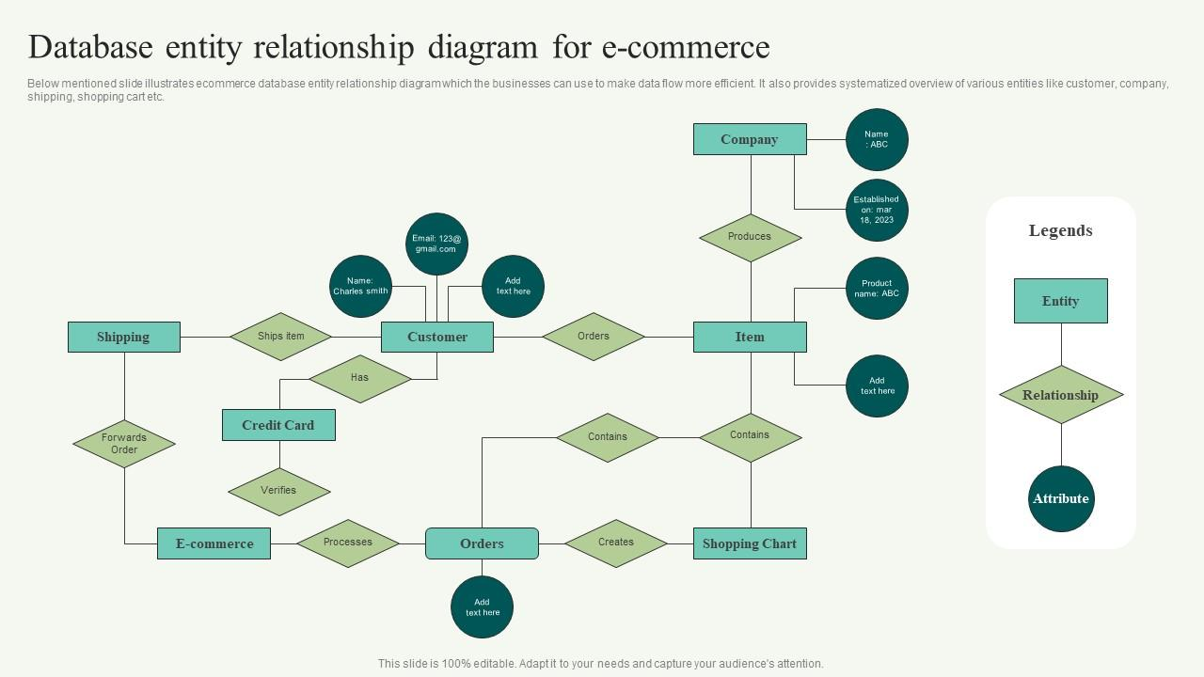
Fig: E-R Diagram

Context:
In the rapidly evolving landscape of e-commerce, mobile applications have become integral tools for businesses to engage with customers and provide seamless shopping experiences. The prevalence of smartphones and the increasing demand for on-the-go shopping have driven the need for innovative mobile app solutions.
Our project responds to this context by developing a native Android e-commerce application. Leveraging the power of Java programming language and Firebase back-end, our app aims to tackle the limitations of existing systems by offering real-time updates, intuitive navigation, secure user authentication, and efficient data management. With a user-centered approach, the proposed app seeks to enhance user experience and provide businesses with a competitive edge in the e-commerce market.

Data Schema:
The Firebase database for our e-commerce app will be organized into several collections, each containing documents that represent different types of data. The schema will follow a structured approach to efficiently manage user profiles, products, shopping carts, and orders.

Users Collection:
      - user_id: Unique identifier for each user.
      - email: User's email address for authentication.
      - username: User's chosen username.
      - name: User's full name.

Products Collection
      - product_id: Unique identifier for each product.
      - name: Product name.
      - description: Product description.
      - price: Product price.
      - image_url: URL to the product image.
      - category: Product category.

Cart Collection:
      - user_id: Reference to the user's document.
      - items: Array of cart items.
      - product_id: Reference to the product's document.
      - quantity: Quantity of the product in the cart.

Orders Collection:
      - order_id: Unique identifier for each order.
      - user_id: Reference to the user's document.
      - items: Array of order items.
      - product_id: Reference to the product's document.
      - quantity: Quantity of the product in the order.
      - total_amount: Total amount of the order.
      - status: Current order status (e.g., "pending," "shipped," "delivered").

Implementation
Brief introduction about MERN Stack Project:
The MERN Stack, which stands for MongoDB, Express.js, React, and Node.js, has gained significant popularity in web development due to its numerous advantages and versatility. Each component in the stack plays a crucial role in creating powerful and efficient web applications.
Firstly, MongoDB, allows developers to store data in a flexible and scalable manner, making it ideal for handling large and complex datasets. Its JSON-like structure simplifies the data integration process with the other components of the stack.
Secondly, Express.js is a minimalist web application framework for Node.js that enables developers to build robust and scalable backend APIs swiftly. It provides a streamlined and straightforward approach to handling HTTP requests, making it easier to manage routes, middleware, and error handling.
Thirdly, React, a JavaScript library, is utilized for building user interfaces. It offers a component-based architecture, allowing developers to create reusable UI elements, making the code more organized and maintainable. Additionally, React's virtual DOM efficiently updates only the necessary parts of the UI, resulting in improved performance and a better user experience.
Lastly, Node.js serves as the runtime environment for server-side applications, using JavaScript on the server. This unification of the front end and back end under a single language simplifies the development process and facilitates communication between different parts of the application, leading to enhanced productivity and reduced development time.

Chapter 2
Background analysis

2.1 Introduction
First of all React.js is JavaScript Library not any Framework. React.js makes our website so fast. React.js was Developed by Facebook to reduce time taken by browser DOM to update on any changes, to deep dive into these ocean first understand .

A Web page is a document and DOM is the one who represents the document as nodes and objects. The DOM is an object-oriented representation of the web page, which can be modified with a scripting language such as JavaScript. Browser DOM is the nothing else but our original browser , The code we see on our developer tool is nothing but our original DOM.
Virtual DOM is JavaScript object that is a representation of the browser DOM or in other words copy node. Virtual DOM are created in JavaScript from scratch from Browser DOM. In everyone’s minds rise a question Why we need this Virtual DOM ,we can directly update on Browser DOM? No this is not a efficient way because our Browser DOM is way slower than Virtual DOM. We can create 200000 node in just 1 second.

2.2 Correlated work
Many other Learning management companies did not have dedicated teacher penal . Also a teacher cannot upload their course . Whole process is completed by a company or a parson . For this reason many instructor they has talent be he/ she did not want to be a instructor .
- React JS comprises a collection of reusable JavaScript code snippets.
- It is neither a JavaScript framework (since it’s only responsible for rendering the components of an application’s view layer) nor a full-stack solution that manages everything from the database to real-time updates.
- The framework makes it possible to compose intricate UIs from small and isolated pieces of code known as ‘components’.

2.3 Theoretical Framework
The theoretical framework for the "Supple Smile" project draws upon several key theories and concepts from the fields of education, e-commerce, and technology. These theories provide a foundation for understanding the project's objectives, user interactions, and the overall impact on the online learning ecosystem.

2.3.1 Social Constructivism
The theory of social constructivism emphasizes that learning is a social process where individuals construct knowledge through interactions with their environment and peers. In the context of "Supple Smile" this theory underscores the importance of peer reviews and discussions among students, fostering a collaborative learning environment. Instructors play a role in guiding and facilitating learning, aligning with this theory's emphasis on the role of mentors in knowledge acquisition.

2.3.2 Technology Acceptance Model (TAM)
TAM explores factors influencing user acceptance and adoption of technology. In the "Supple Smile" project, the model helps analyze users' attitudes towards the platform's features, ease of use, and perceived usefulness. By understanding users' perceptions, the project team can refine the platform to meet user expectations and encourage widespread adoption.

2.3.3 Self-Determination Theory
We have a wonderful & generous dental community!
We are thankful for the participating dentists, hygienists, and administrative volunteers for their kindness, generosity, and donation of their time to Supply a Smile's program.

2.3.4 E-commerce Management Systems
Ecommerce management is the practice of maintaining an online business. Generally speaking, the goal of ecommerce management is to help brands reach their goals for product quality, customer acquisition, and customer retention.
An ecommerce manager helps select products and create pricing strategies and sees to it that products reach the customer as quickly (and as cost-effective) as possible.
Once these products are selected, the ecommerce manager (or operations team) makes sure inventory levels and inventory records are in alignment. From there, the manager or ops team joins forces with the marketing team to develop a digital strategy for customer acquisition, search engine optimization (SEO), and affiliate programs.
On top of that, the ecommerce manager also has a hand in customer retention. More specifically, they oversee a seamless user experience and buyer journey—and make recommendations on improving website performance so customers come back again and again.

2.4 Scope of E-Commerce
- Marketing, sales and sales promotion.
- Pre-sales, subcontracts, supply.
- Financing and insurance.
- Commercial transactions – ordering, delivery, payment.
- Product service and maintenance.
- Co-operative product development.
- Distributed co-operative working.
- Use of public and private services.
- Business-to-administrations
- Transport and logistics.
- Public procurement.
- Accounting and financial management.
- Legal advice
2.5 Challenges of This Project
These projects have many challenges.The main challenge of my projects is to assure security . The other challenges are given there:
- Efficiency should be maintained
- user interface(UI) design should be suitable.
- Exact data must be maintained.
- Database conjunction and data passing should be maintained.
- Approval should be maintained
- Reactivity should be maintained
- Accurate contract should be maintain

Chapter 3
System analysis & requirement specification

3.1 Literature review
Learning management systems are a huge force in technology in higher education today, presenting both some of the largest challenges and opportunities facing institutions. This area of research has many opportunities for study as learning management systems continue to be adopted and used in new ways. Considerations for how to develop or purchase a learning management system that fully meets the needs of learning, students and teachers remain at the forefront of research questions surrounding these systems. Further research can be done in the area of authentic learning and how to use the technology within the learning management system to foster a quality educational experience. Instructor and student feedback can be further captured to develop higher quality experiences within learning management systems. New features can be adopted as they are shown to serve various needs of learners. Learning management systems are only going to become further entrenched in the
higher education experience, so optimizing the software to fully serve students, faculty and the institutions themselves remains a priority for future and present research.

3.2 Proposed of System
The proposed approach in this project is to develop and design a beauty and skincare ecommerce mobile application with advanced searching module using image processing. The target users of this project could be anyone from teenagers to adults who own a mobile phone or tablets. Figure below describe the system modules of this mobile application together with titles and also description.

3.2.1 Multiple content support: Supple Smile supports multiple content types such as View Product, give review, add to cart, search the product, order and payment, Dashboard for user and admin panel for admin.

3.2.2 Admin panel support: Using NodeJS and ReactJS to Create Advanced Ecommerce Admin Panel in 2023.Admin can manage the all product and order, We have an inventory for admin to see the product situtation

3.2.3 Registration: A new user can register them

3.2.4 Fully responsive: High-quality responsive design makes the content accessible on different devices.

3.2.5 Separate panels: Supple smile includes separate panels for instructors, users, and Explore with different component.

3.3 Feasibility Study
This methodology work has been made to investigate the factors which affect the feasibility and readiness of learning management systems in developing nations. An online and offline survey has been carried out to collect feedback from the high school students,College students, University students and also different organizations. all over Ethiopia and their responses have been analyzed through descriptive statistics by using Statistical Package for the Social Sciences software program. The results and finding give a clear understanding of the feasibility and readiness of learning management system that the technological and organizational aspects, lack of Information and Communications Technology infrastructure, cross-country legal and regulatory differences, lack of digital literacy among consumers and businesses in terms of computer literacy, language barriers, lack of distribution system are the factors which affect the feasibility of learning management system. The feasibility can be improved by providing suitable information and communications technology infrastructure, improving cross-country regulatory differences, promoting ICTs in education targeting all levels of the educational system, facilitating foreign direct investment drive in ICTs, making a website attractive and user-friendly. The results of statistical analyses indicate all over the world has significant potential for the feasibility of learning management system.

3.3.1 Technical Feasibility

Not long ago, your primary options for contacting vendor support when you had an issue were either by phone or via email. Typically, you would end up paying extra for the phone support, which was immediate, versus the email option which meant a wait time of at least 24 hours, possibly longer. Now there are multiple options available for most platforms depending on your subscription.
ReactJS is the more feasible option for web application development. React Native is the more feasible option for mobile app development. ReactJS components are typically written in HTML. These components must be imported into the app before they can be used.

3.3.1.1 User Help Guides:
Many services will create a variety of help guides that can walk users through certain functions step by step. But when an user open this website they can easily go through with this.

3.2.1.4 User Forums:
Here are some great resources out there that will make your ecommerce journey a lot easier. Depending on your particular niche, you’ll be able to get great advice on how to further explore your brand. You won’t need to beat around the bush or search out online to find a good source that can help you along your social media awareness, viral content, or anything else you believe that can aid in developing your online business. Here are 24 ecommerce forums and communities you should join. It’s also beneficial to get performance marketing software.

3.2.1.5 Online Knowledge Base:
A knowledge base is a self-service portal that your customers can use to find answers to their most common queries, and today’s customers expect you to provide them with readymade answers at their fingertips. Imagine a customer is about to make a purchase on your site, and has a question about shipping, but you have no knowledge base. This customer is likely to abandon their cart rather than wait for a support agent to answer their question.

3.3.2 Economical Feasibility
With the escalating prominence of React JS in both web and mobile application development, businesses across various sectors are increasingly looking to hire competent React JS developers.
Economic feasibility is one of the most important aspects in the planning of a React js- project. An React js project generates revenue throughout its lifetime, although it requires substantial recurring investment too. Thus it is quite vital to perform economic and financial analysis. A project would be feasible financially if receipts over the project lifetime are more than the disbursements. In addition to the economic feasibility, the economic analysis also provides a basis for comparison of possible alternatives for achieving the intended benefits from a project.

3.4 Risk Analysis
It’s hardly an exaggeration to say that e-commerce saved many lives (and the retail industry) during the COVID-19 pandemic, allowing consumers to buy groceries, clothing and other essentials from the convenience and safety of their homes. In the U.S. alone, e-commerce sales increased by 42% from the previous year and accounted for 13.6% of total retail sales in 2020. Surveys show that many consumers intend to continue shopping online even after health and safety restrictions are lifted, which means the momentum of digital shopping will continue.
However, the very factors that enabled the rapid growth of e-commerce — direct access to consumers, low barriers to entry and 24/7 availability of online platforms — also increases the exposure to a distinct set of risks that could determine the fate of new e-commerce solutions. Here are some of the more pressing strategic and operational risks that online retailers face today, and the actions that risk managers can use to take control of their risk, including making use of relevant data and analytics.

3.4.1 Others threats and risks in E-commerce Website
E-commerce security threats are causing havoc in online trading. The industry experiences up to 32.4% of all successful threats annually. It is undeniable fact that the e-commerce security threats are causing havoc in online transactions. The industry experiences up to 32.4% of all successful threats annually. Hackers usually target e-commerce store admins, users, and employees using a myriad of malicious techniques.

1. Financial frauds
Ever since the first online businesses entered the world of the internet, financial fraudsters have been giving businesses a headache. There are various kinds of financial frauds prevalent in the e-commerce industry, but we are going to discuss the two most common of them.

a. Credit Card Fraud
It happens when a cybercriminal uses stolen credit card data to buy products on your e-commerce store. Usually, in such cases, the shipping and billing addresses vary. You can detect and curb such activities on your store by installing an AVS – Address Verification System.
Another form of credit card fraud is when the fraudster steals your personal details and identity to enable them to get a new credit card.

b. Fake Return & Refund Fraud
The bad players perform unauthorized transactions and clear the trail, causing businesses great losses. Some hackers also engage in refund frauds, where they file fake requests for returns.

2. Spamming
Some bad players can send infected links via email or social media inboxes. They can also leave these links in their comments or messages on blog posts and contact forms. Once you click on such links, they will direct you to their spam websites, where you may end up being a victim.

3. Cross-Site Scripting (XSS)
The attackers can plant a malicious JavaScript snippet on your e-commerce store to target your online visitors and customers. Such codes can access your customers’ cookies and compute. You can implement the Content Security Policy (CSP) to prevent such attacks.

4. Bots
Some attackers develop special bots that can scrape your website to get information about inventory and prices. Such hackers, usually your competitors, can then use the data to lower or modify the prices in their websites in an attempt to lower your sales and revenue.

5. e-Skimming
E-skimming involves infecting a website’s checkout pages with malicious software. The intention is to steal the clients’ personal and payment details.
Are you an e-commerce business person? Don’t downplay the seriousness of these e-commerce security threats.

3.5 Requirement Analysis
Requirement analysis is significant and essential activity after elicitation. We analyze, refine, and scrutinize the gathered requirements to make consistent and unambiguous requirements. This activity reviews all requirements and may provide a graphical view of the entire system. After the completion of the analysis, it is expected that the understandability of the project may improve significantly. Here, we may also use the interaction with the customer to clarify points of confusion and to understand which requirements are more important than others.
React is a JavaScript library for building web application user interfaces. CTOs frequently consider it because of its large number of handy features. With the help of React.js, software engineers can speed up the development process. They can also make the UI of their web applications fast and smooth.

3.6 Hardware Requirements
SN | Description
01 | 1 Desktop/ Laptop with500GB and more than Hard disk
02 | Minimum 4 GB RAM.
03 | Intel Core i5 or i3 processor
04 | A Monitor, Resolution : 1280x800; Recommended: 1920x1080

3.7 Software Requirements
SN | Description | Type
01 | Operating System | Windows , MacOs, Linux
02 | Front-end | HTML, CSS, Bootstrap, JavaScript, any other Framework, Like- React JS, Vue JS, Angular JS
03 | Language(back end) | Node JS
04 | Database | MongoDB
05 | IDE | Visual studio code
06 | Browser | Google Chrome

3.8 Design and Model requirements
This system has three types of panel, Admin panel, User Panel . If users want proper output then the database design would have been perfectible and systematic. The system has various parts for data storage where the information could be sorted in a systematic way.

Fig 01 : Waterfall Model

3.9.1 Advantage of Waterfall Model

- This model is simple and easy to understand and use.
- It is easy to manage due to the rigidity of the model – each phase has specific deliverable and a review process.
- In this model phases are processed and completed one at a time. Phases do not overlap.
- Waterfall model works well for smaller projects where requirements are clearly defined and very well understood.

3.9.2 Disadvantage of Waterfall Model

- Once an application is in the testing stage, it is very difficult to go back and change something that was not well-thought out in the concept stage.

- No working software is produced until late during the life cycle.

- High amounts of risk and uncertainty.

- Not a good model for complex and object-oriented projects.

- Poor model for long and ongoing projects.

- Not suitable for the projects where requirements are at a moderate to high risk of changing.

3.10 Cost of Benefit Analysis:
The Cost-Benefit Analysis (CBA) is a critical tool to evaluate the potential financial feasibility and benefits of a project. In the case of the "Supple Smile" project, which involves an online platform for selling lipsticks and managing the products and users and administrators, we will assess the costs involved and the benefits derived from the project's implementation.

3.10.1 Estimate Cost
SN | Cost sector | Amount
01 | Design | 50,000 Taka
02 | Development | 1,50,000 Taka
03 | Hosting Charge(Annually) | 20,000 Taka
04 | Domain Charge(Annually) | 1,000 Taka
05 | Maintenance (Annually) | 20,000 Taka
06 | Project Management | 25,000 Taka
07 | Testing | 10,000 Taka
Total Cost of Development : 2,76,000 Taka

Chapter 4
System design
4.1 Methodology
The agile software development methodology was employed in the development process. This is because it allows for visible results quickly and for quick iteration and advancement of the system .Features of the proposed system are the home page, the administrator login page, lecturer login page,contact page, help page, register student page, register instructor page, update instructor/student page,view instructor page and view student page; also security, delivery, interaction, reporting and recordkeeping will be put into place. The system will require the user to login to have access to the website to do the following tasks: view and download course materials, upload files, projects and other materials for people to see and also interact through live chats and discussion forums. Also the LMS will allow instructors to upload videos that will be viewed and downloaded. All users will not be allowed to login simultaneously on multiple systems.The hardware and software requirements are that there must be good internet connection, minimum RAM of 512MB and 1.5GHz processor speed for any user to have access to the LMS. Also, it will work with any operating system with an installed web browser but the web browser must meet the following specifications, Java runtime environment 1.4, Java script pop-ups and cookies set to enable.The system will be designed and structured to cut down the level of disjointedness and ease the learning process. Most of the time, there is break in the flow of study and information gathering because the student has to leave his/her current study location to look for the lecturer or get to the library to retrieve extra needed information.A mailing and real-time support will make it possible for a student to contact a lecturer or other students instantaneously from his/her very location, thus keeping the study session active and continuous. This will make the assimilation level higher since there are no breaks in communication. Course materials will also be made available for easy accessibility.

