

Green University Of Bangladesh
Department Of Computer Science & Engineering

Project Report For Online Food ordering Website

Afsana Kabir Sinthia
ID:182002068
Razia Sultana Urmi
ID:182002079
Asmaul Husna Rima
ID:182002003

Supervisor: Tanpia Tasnim
Lecturer
Dept. Of CSE
Department of Computer Science
Green University Of Bangladesh

Sinthi’s Chat Room

Table of Contents
Abstract 3
Project Specification 4
Chapter 1: Introduction 5
1.1 Objective 5
Chapter 2: Design Method 6
Chapter 3: Tools 8
Chapter 4: Procedure 9
4.1 Steps 9
Chapter 5: Result Analysis 10
5.1 Figures, Charts and Tables 10
5.2 Source Code 10
Chapter 6: Discussion 11
Chapter 7: References 12

Abstract
The main idea of this project is to study the Socket Programming Of Networking.
The aim of this project is to develop an multi-user chat system to facilitate communicate between users .

Project Specification
Teleconferencing or Chatting, is a method of using technology to bring people and ideas together despite of the geographical barriers. The technology has been available for years but the acceptance it was quite recent. Our project is an example of a chat server.
To start chatting client should get connected to server where they can do group chat.
Chat application called ‘Sinthi’s Chat Application’ has been created with graphic
user interface (GUI) capable of exchanging text chat between two or multiple computers over the network using java socket programming and Java Swing has been created. The server application will present the user with the information regarding the number of connections made and the user activity.
The client will present user with the active user list in the chat server as well as messages that been shared by users as well as notification send by server to let users know of new user joining or leaving the chat.

Introduction
Communication is a mean for people to exchange messages. It has started since the beginning of human creation. Distant communication began as early as 1800 century with the introduction of television, telegraph and then telephony. Interestingly enough, telephone communication stands out as the fastest growing technology, from ﬁxed line to mobile wireless, from voice call to data transfer. The emergence of computer network and telecommunication technologies bears the same objective that is to allow people to communicate. All this while, much eﬀorts has been drawn towards consolidating the device into one and therefore indiscriminate the services. Chatting is a method of using technology to bring people and ideas together despite of the geographical barriers. The technology has been available for years but the acceptance it was quit recent. Our project is an example of a chat server. It is made up of applications the client application which runs on the users mobile and server application which runs on any pc on the network. To start chatting our client should get connected to server where they can do Group chatting.

1.1 Objective
- The aim of this project is to develop an multi-user chat system to facilitate communicate between users using Socket Programming.
1.2 Problem Statement This project is to create a chat application with a server and users to enable the users to chat with each others.
1. To develop an instant messaging solution to enable users to seamlessly communicate with each other. The project should be very easy to use enabling even a novice person to use it.

Design Method
Stream-oriented socket programs generally follow a prescribed sequence.
A typical client-server session
- Step 1: Server and client create a stream socket s with the socket() call.
- Step 2: (Optional for client) Sever bind socket s to a local address with the bind() call.
- Step 3: Server uses the listen() call to alert the TCP/IP machine of the willingness to accept connections.
- Step 4: Client connects socket s to a foreign host with the connect() call.
- Step 5: Server accepts the connection and receives a second socket, for example ns, with the accept() call.
- Step 6 and 7: Server reads and writes data on socket ns, client reads and writes data on socket s, by using send() and recv() calls, until all data has been exchanged.
- Step 8: Sever closes socket ns with the close() call. Client closes socket s and end the TCP/IP session with the close() call. Go to step 5.
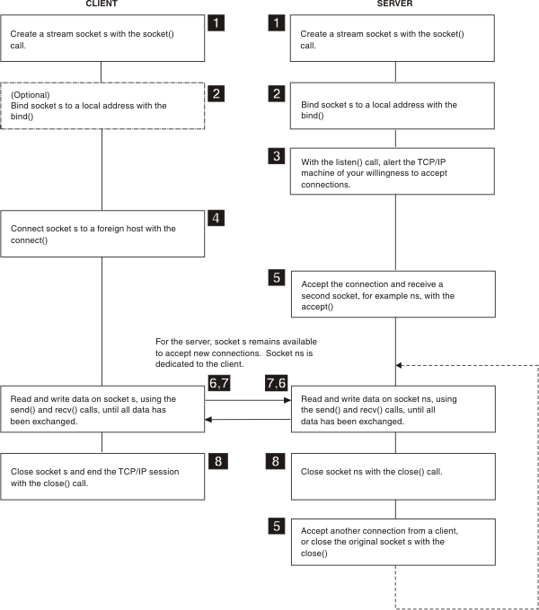

- Server and client connection design diagram.

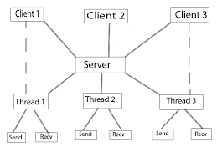

- Multiple client and server flow chart.
Single Thread Socket Program is running. In that case there is only one client can communicate with the server. It will not allow simultaneous client connections. Try to start another client. You will see that the second client cannot be connected until the first client closes its connection. To allow simultaneous connections we should know multithreaded programming. Here in the following Multithreaded Socket Programming, you can connect more than one client connect to the server and communicate.

Tools

- Netbeans
- windows 10

Socket programming is a way of connecting two nodes on a network to communicate with each other. One socket(node) listens on a particular port at an IP, while other socket reaches out to the other to form a connection. Server forms the listener socket while client reaches out to the server.

Procedure
In this part I will divided two parts client side and server side procedure . We have used the localhost and the port number as 5000. There are 3 members in the group: Urmi, Nabila, and Sinthia.

Steps

Server class :
- The server runs an infinite loop to keep accepting incoming requests.
- When a request comes, it assigns a new thread to handle the communication part.
- The sever also stores the client name into a vector, to keep a track of connected devices. The vector stores the thread object corresponding to the current request. The helper class uses this vector to find the name of recipient to which message is to be delivered. As this vector holds all the streams, handler class can use it to successfully deliver messages to specific clients.
- Invoke the start() method.
Client class:
SendMessage : This thread will be used for sending the message to other clients. The working is very simple, it takes input the message to send and the recipient to deliver to. Note that this implementation assumes the message to be of the format message , where recipient is the name of the recipient. It then writes the message on its output stream which is connected to the handler for this client. The handler breaks the message and recipient part and deliver to particular recipient. Lets look at how this thread can be implemented.
readMessage : A similar approach is taken for creating a thread for receiving the messages. When any client tries to write on this clients input stream, we use readUTF() method to read that message.
To send a message from any client, type the message, followed by a “#” and then the name of the recipient client. Please note that this implementation gives names as “client 0”, “client 1″….”client n” and so carefully names must be appended int the end. After that press Send Button.
Once a message is sent, the handler for all clients will receive the message and it will be delivered to all the clients.

Result Analysis

Figures
This application has separated server and client application and as socket programming require server to be present for client to connect, server application called ‘Server’ need to be run first before running ‘Client’.
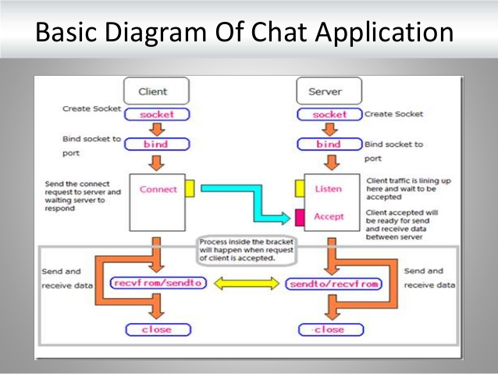.

Source Code

Server Code:

package groupchatting;
import java.io.*;
import java.net.*;
import java.util.Vector;

public class Server implements Runnable{
Socket socket;

public static Vector client = new Vector();

public Server(Socket socket){
try{
this.socket = socket;
}catch(Exception e){

}
}
public void run(){
try{
BufferedReader reader = new BufferedReader(new InputStreamReader(socket.getInputStream()));
BufferedWriter writer = new BufferedWriter(new OutputStreamWriter(socket.getOutputStream()));

client.add(writer);

while(true){
String data = reader.readLine().trim();
System.out.println("Received "+data);

for(int i=0;i < client.size();i++){
try{
BufferedWriter bw = (BufferedWriter) client.get(i);
bw.write(data);
bw.write("\r\n");
bw.flush();
}catch(Exception e){

}
}
}

}catch(Exception e){

}
}

public static void main(String[]args) throws Exception{
ServerSocket s = new ServerSocket(5000);

while(true){
Socket socket = s.accept();
Server server = new Server(socket);
Thread thread = new Thread((Runnable) server);
thread.start();
}
}
}
Clientone code:

package groupchatting;

import java.awt.Color;
import java.awt.Font;
import java.awt.Image;
import java.awt.event.ActionEvent;
import java.awt.event.ActionListener;
import java.awt.event.MouseAdapter;
import java.awt.event.MouseEvent;
import java.io.DataInputStream;
import java.io.DataOutputStream;
import java.net.Socket;
import javax.swing.ImageIcon;
import javax.swing.JButton;
import javax.swing.JFrame;
import javax.swing.JLabel;
import javax.swing.JPanel;
import javax.swing.JTextArea;
import javax.swing.JTextField;
import java.io.*;
import static java.nio.file.Files.write;

public class Userone extends JFrame implements ActionListener, Runnable{

JPanel p1;
JTextField t1;
JButton b1;
static JTextArea a1;

static Socket s;
// static DataInputStream din;
// static DataOutputStream dout;
BufferedWriter writer;
BufferedReader reader;

Userone(){
p1 = new JPanel();
p1.setLayout(null);
p1.setBackground(new Color(0,106,255));
p1.setBounds(0,0,450,70);
add(p1);

ImageIcon i1 = new ImageIcon(ClassLoader.getSystemResource("GroupChatting/icons/3.png"));
Image i2 =i1.getImage().getScaledInstance(30, 30, Image.SCALE_DEFAULT);
ImageIcon i3 = new ImageIcon(i2);
JLabel l1 = new JLabel(i3);
l1.setBounds(5,17,30,30);
p1.add(l1);

l1.addMouseListener(new MouseAdapter(){
public void mouseClicked(MouseEvent ae){
System.exit(0);
}
});

ImageIcon i7 = new ImageIcon(ClassLoader.getSystemResource("GroupChatting/icons/phone.png"));
Image i8 =i7.getImage().getScaledInstance(30, 30, Image.SCALE_DEFAULT);
ImageIcon i9 = new ImageIcon(i8);
JLabel l4 = new JLabel(i9);
l4.setBounds(290,17,30,30);
p1.add(l4);

ImageIcon i10 = new ImageIcon(ClassLoader.getSystemResource("GroupChatting/icons/video.png"));
Image i11 =i10.getImage().getScaledInstance(30, 30, Image.SCALE_DEFAULT);
ImageIcon i12 = new ImageIcon(i11);
JLabel l5 = new JLabel(i12);
l5.setBounds(350,17,30,30);
p1.add(l5);

ImageIcon i14 = new ImageIcon(ClassLoader.getSystemResource("GroupChatting/icons/3icon.png"));
Image i15 =i14.getImage().getScaledInstance(13, 25, Image.SCALE_DEFAULT);
ImageIcon i16 = new ImageIcon(i15);
JLabel l6 = new JLabel(i16);
l6.setBounds(410,20,13,25);
p1.add(l6);

ImageIcon i4 = new ImageIcon(ClassLoader.getSystemResource("GroupChatting/icons/urmi.png"));
Image i5 =i4.getImage().getScaledInstance(70, 60, Image.SCALE_DEFAULT);
ImageIcon i6 = new ImageIcon(i5);
JLabel l2 = new JLabel(i6);
l2.setBounds(40,5,70,60);
p1.add(l2);

JLabel l3 = new JLabel("Razia Sultana");
l3.setFont(new Font("SAN_SERIF",Font.BOLD,18));
l3.setForeground(Color.white);
l3.setBounds(110,20,100,20);
p1.add(l3);

JLabel l12 = new JLabel("sinthia,nabila,reduan");
l12.setFont(new Font("SAN_SERIF",Font.PLAIN,14));
l12.setForeground(Color.white);
l12.setBounds(110,35,100,20);
p1.add(l12);

JLabel l7 = new JLabel("Active Now");
l7.setFont(new Font("SAN_SERIF",Font.PLAIN,12));
l7.setForeground(Color.white);
l7.setBounds(110,49,100,20);
p1.add(l7);

t1 = new JTextField();
t1.setBounds(50,550,295,40);
t1.setFont(new Font("SAN_SERIF",Font.PLAIN,16));
add(t1);

ImageIcon i17 = new ImageIcon(ClassLoader.getSystemResource("GroupChatting/icons/cam.png"));
Image i18 =i17.getImage().getScaledInstance(50,50, Image.SCALE_DEFAULT);
ImageIcon i19 = new ImageIcon(i18);
JLabel l8 = new JLabel(i19);
l8.setBounds(2,540,50,50);
add(l8);

b1= new JButton("Send");
b1.setBounds(350,550,80,40);
b1.setBackground(new Color(0,106,255));
b1.setForeground(Color.white);
b1.setFont(new Font("SAN_SERIF",Font.BOLD,16));
b1.addActionListener(this);
add(b1);

a1 = new JTextArea();
a1.setFont(new Font("SAN_SERIF",Font.BOLD,16));
a1.setEditable(false);
a1.setLineWrap(true);
a1.setWrapStyleWord(true);
a1.setForeground(Color.red);
a1.setBounds(5,75,440,470);
// a1.setBackground(Color.yellow);
add(a1);

// getContentPane().setBackground(Color.yellow);
setLayout(null);
setSize(450,600);
setLocation(20,30);
setUndecorated(true);
setVisible(true);

try{
Socket socketClient = new Socket("localhost",5000);
writer = new BufferedWriter(new OutputStreamWriter(socketClient.getOutputStream()));
reader = new BufferedReader(new InputStreamReader(socketClient.getInputStream()));

}catch(Exception e){

}

}

public void actionPerformed(ActionEvent ae){
String str = "Urmi: \n"+t1.getText();
try{

writer.write(str);
writer.write("\r\n");
writer.flush();

}catch(Exception e){

}
t1.setText("");
}
// public void sendTextToFile(String msg)throws FileNotFoundException{
// try(FileWriter f = new FileWriter("chat.txt");
// PrintWriter p = new PrintWriter(new BufferedWriter(f));){
// p.println("");
// }catch(Exception e){
// e.printStackTrace();
// }
// }
// }
public void run(){
try{
String msg = "";
while((msg = reader.readLine()) != null){
a1.append(msg+"\n");

}

}catch(Exception e){

}
}
public static void main(String[] args){
Userone one = new Userone();
Thread t1 = new Thread(one);
t1.start();
// try{
// s= new Socket("127.0.0.1",5000);
// din = new DataInputStream(s.getInputStream());
// dout = new DataOutputStream(s.getOutputStream());
// String msgInput = "";
//
// msgInput = din.readUTF();
// a1.setText(a1.getText()+"\n"+msgInput);
//
//
//
// }catch(Exception e){
//
// }
//
//
//

}
}

Usertwo code:

package groupchatting;

import static groupchatting.Userone.a1;
import java.awt.Color;
import java.awt.Font;
import java.awt.Image;
import java.awt.event.ActionEvent;
import java.awt.event.ActionListener;
import java.awt.event.MouseAdapter;
import java.awt.event.MouseEvent;
import java.io.DataInputStream;
import java.io.DataOutputStream;
import java.net.Socket;
import javax.swing.ImageIcon;
import javax.swing.JButton;
import javax.swing.JFrame;
import javax.swing.JLabel;
import javax.swing.JPanel;
import javax.swing.JTextArea;
import javax.swing.JTextField;
import java.io.*;
import static java.nio.file.Files.write;

public class Userthree extends JFrame implements ActionListener, Runnable{

JPanel p1;
JTextField t1;
JButton b1;
static JTextArea a1;

static Socket s;
// static DataInputStream din;
// static DataOutputStream dout;
BufferedWriter writer;
BufferedReader reader;

Userthree(){
p1 = new JPanel();
p1.setLayout(null);
p1.setBackground(new Color(0,106,255));
p1.setBounds(0,0,450,70);
add(p1);

ImageIcon i1 = new ImageIcon(ClassLoader.getSystemResource("GroupChatting/icons/3.png"));
Image i2 =i1.getImage().getScaledInstance(30, 30, Image.SCALE_DEFAULT);
ImageIcon i3 = new ImageIcon(i2);
JLabel l1 = new JLabel(i3);
l1.setBounds(5,17,30,30);
p1.add(l1);

l1.addMouseListener(new MouseAdapter(){
public void mouseClicked(MouseEvent ae){
System.exit(0);
}
});

ImageIcon i7 = new ImageIcon(ClassLoader.getSystemResource("GroupChatting/icons/phone.png"));
Image i8 =i7.getImage().getScaledInstance(30, 30, Image.SCALE_DEFAULT);
ImageIcon i9 = new ImageIcon(i8);
JLabel l4 = new JLabel(i9);
l4.setBounds(290,17,30,30);
p1.add(l4);

ImageIcon i10 = new ImageIcon(ClassLoader.getSystemResource("GroupChatting/icons/video.png"));
Image i11 =i10.getImage().getScaledInstance(30, 30, Image.SCALE_DEFAULT);
ImageIcon i12 = new ImageIcon(i11);
JLabel l5 = new JLabel(i12);
l5.setBounds(350,17,30,30);
p1.add(l5);

ImageIcon i14 = new ImageIcon(ClassLoader.getSystemResource("GroupChatting/icons/3icon.png"));
Image i15 =i14.getImage().getScaledInstance(13, 25, Image.SCALE_DEFAULT);
ImageIcon i16 = new ImageIcon(i15);
JLabel l6 = new JLabel(i16);
l6.setBounds(410,20,13,25);
p1.add(l6);

ImageIcon i4 = new ImageIcon(ClassLoader.getSystemResource("GroupChatting/icons/nabila.png"));
Image i5 =i4.getImage().getScaledInstance(70, 60, Image.SCALE_DEFAULT);
ImageIcon i6 = new ImageIcon(i5);
JLabel l2 = new JLabel(i6);
l2.setBounds(40,5,70,60);
p1.add(l2);

JLabel l3 = new JLabel("Nabila");
l3.setFont(new Font("SAN_SERIF",Font.BOLD,18));
l3.setForeground(Color.white);
l3.setBounds(110,20,100,20);
p1.add(l3);

JLabel l12 = new JLabel("sinthia,nabila,urmi");
l12.setFont(new Font("SAN_SERIF",Font.PLAIN,14));
l12.setForeground(Color.white);
l12.setBounds(110,35,100,20);
p1.add(l12);

JLabel l7 = new JLabel("Active Now");
l7.setFont(new Font("SAN_SERIF",Font.PLAIN,12));
l7.setForeground(Color.white);
l7.setBounds(110,49,100,20);
p1.add(l7);

t1 = new JTextField();
t1.setBounds(50,550,295,40);
t1.setFont(new Font("SAN_SERIF",Font.PLAIN,16));
add(t1);

ImageIcon i17 = new ImageIcon(ClassLoader.getSystemResource("GroupChatting/icons/cam.png"));
Image i18 =i17.getImage().getScaledInstance(50,50, Image.SCALE_DEFAULT);
ImageIcon i19 = new ImageIcon(i18);
JLabel l8 = new JLabel(i19);
l8.setBounds(2,540,50,50);
add(l8);

b1= new JButton("Send");
b1.setBounds(350,550,80,40);
b1.setBackground(new Color(0,106,255));
b1.setForeground(Color.white);
b1.setFont(new Font("SAN_SERIF",Font.BOLD,16));
b1.addActionListener(this);
add(b1);

a1 = new JTextArea();
a1.setFont(new Font("SAN_SERIF",Font.BOLD,16));
a1.setEditable(false);
a1.setLineWrap(true);
a1.setWrapStyleWord(true);
a1.setForeground(Color.black);
a1.setBounds(5,75,440,470);
// a1.setBackground(Color.yellow);
add(a1);

//getContentPane().setBackground(Color.yellow);
setLayout(null);
setSize(450,600);
setLocation(950,30);
setUndecorated(true);
setVisible(true);

try{
Socket socketClient = new Socket("localhost",5000);
writer = new BufferedWriter(new OutputStreamWriter(socketClient.getOutputStream()));
reader = new BufferedReader(new InputStreamReader(socketClient.getInputStream()));

}catch(Exception e){

}

}

public void actionPerformed(ActionEvent ae){
String str = "Nabila: \n"+t1.getText();
try{
writer.write(str);
writer.write("\r\n");
writer.flush();

}catch(Exception e){

}
t1.setText("");
}
public void run(){
try{
String msg = "";
while((msg = reader.readLine()) != null){
a1.append(msg+"\n");

}

}catch(Exception e){

}
}
public static void main(String[] args){
Userthree one = new Userthree();
Thread t1 = new Thread(one);
t1.start();

}
}

Userthree:

package groupchatting;

import static groupchatting.Userone.a1;
import java.awt.Color;
import java.awt.Font;
import java.awt.Image;
import java.awt.event.ActionEvent;
import java.awt.event.ActionListener;
import java.awt.event.MouseAdapter;
import java.awt.event.MouseEvent;
import java.io.DataInputStream;
import java.io.DataOutputStream;
import java.net.Socket;
import javax.swing.ImageIcon;
import javax.swing.JButton;
import javax.swing.JFrame;
import javax.swing.JLabel;
import javax.swing.JPanel;
import javax.swing.JTextArea;
import javax.swing.JTextField;
import java.io.*;
import static java.nio.file.Files.write;

public class Usertwo extends JFrame implements ActionListener, Runnable{

JPanel p1;
JTextField t1;
JButton b1;
static JTextArea a1;

static Socket s;
// static DataInputStream din;
// static DataOutputStream dout;
BufferedWriter writer;
BufferedReader reader;

Usertwo(){
p1 = new JPanel();
p1.setLayout(null);
p1.setBackground(new Color(0,106,255));
p1.setBounds(0,0,450,70);
add(p1);

ImageIcon i1 = new ImageIcon(ClassLoader.getSystemResource("GroupChatting/icons/3.png"));
Image i2 =i1.getImage().getScaledInstance(30, 30, Image.SCALE_DEFAULT);
ImageIcon i3 = new ImageIcon(i2);
JLabel l1 = new JLabel(i3);
l1.setBounds(5,17,30,30);
p1.add(l1);

l1.addMouseListener(new MouseAdapter(){
public void mouseClicked(MouseEvent ae){
System.exit(0);
}
});

ImageIcon i7 = new ImageIcon(ClassLoader.getSystemResource("GroupChatting/icons/phone.png"));
Image i8 =i7.getImage().getScaledInstance(30, 30, Image.SCALE_DEFAULT);
ImageIcon i9 = new ImageIcon(i8);
JLabel l4 = new JLabel(i9);
l4.setBounds(290,17,30,30);
p1.add(l4);

ImageIcon i10 = new ImageIcon(ClassLoader.getSystemResource("GroupChatting/icons/video.png"));
Image i11 =i10.getImage().getScaledInstance(30, 30, Image.SCALE_DEFAULT);
ImageIcon i12 = new ImageIcon(i11);
JLabel l5 = new JLabel(i12);
l5.setBounds(350,17,30,30);
p1.add(l5);

ImageIcon i14 = new ImageIcon(ClassLoader.getSystemResource("GroupChatting/icons/3icon.png"));
Image i15 =i14.getImage().getScaledInstance(13, 25, Image.SCALE_DEFAULT);
ImageIcon i16 = new ImageIcon(i15);
JLabel l6 = new JLabel(i16);
l6.setBounds(410,20,13,25);
p1.add(l6);

ImageIcon i4 = new ImageIcon(ClassLoader.getSystemResource("GroupChatting/icons/sinthia.png"));
Image i5 =i4.getImage().getScaledInstance(70, 60, Image.SCALE_DEFAULT);
ImageIcon i6 = new ImageIcon(i5);
JLabel l2 = new JLabel(i6);
l2.setBounds(40,5,70,60);
p1.add(l2);

JLabel l3 = new JLabel("Sinthia");
l3.setFont(new Font("SAN_SERIF",Font.BOLD,18));
l3.setForeground(Color.white);
l3.setBounds(110,20,100,20);
p1.add(l3);

JLabel l12 = new JLabel("urmi,nabila,reduan");
l12.setFont(new Font("SAN_SERIF",Font.PLAIN,14));
l12.setForeground(Color.white);
l12.setBounds(110,35,100,20);
p1.add(l12);

JLabel l7 = new JLabel("Active Now");
l7.setFont(new Font("SAN_SERIF",Font.PLAIN,12));
l7.setForeground(Color.white);
l7.setBounds(110,49,100,20);
p1.add(l7);

t1 = new JTextField();
t1.setBounds(50,550,295,40);
t1.setFont(new Font("SAN_SERIF",Font.PLAIN,16));
add(t1);

ImageIcon i17 = new ImageIcon(ClassLoader.getSystemResource("GroupChatting/icons/cam.png"));
Image i18 =i17.getImage().getScaledInstance(50,50, Image.SCALE_DEFAULT);
ImageIcon i19 = new ImageIcon(i18);
JLabel l8 = new JLabel(i19);
l8.setBounds(2,540,50,50);
add(l8);

b1= new JButton("Send");
b1.setBounds(350,550,80,40);
b1.setBackground(new Color(0,106,255));
b1.setForeground(Color.white);
b1.setFont(new Font("SAN_SERIF",Font.BOLD,16));
b1.addActionListener(this);
add(b1);

a1 = new JTextArea();
a1.setFont(new Font("SAN_SERIF",Font.BOLD,16));
a1.setEditable(false);
a1.setLineWrap(true);
a1.setWrapStyleWord(true);
a1.setForeground(Color.orange);
a1.setBounds(5,75,440,470);
// a1.setBackground(Color.yellow);
add(a1);

//getContentPane().setBackground(Color.yellow);
setLayout(null);
setSize(450,600);
setLocation(480,30);
setUndecorated(true);
setVisible(true);

try{
Socket socketClient = new Socket("localhost",5000);
writer = new BufferedWriter(new OutputStreamWriter(socketClient.getOutputStream()));
reader = new BufferedReader(new InputStreamReader(socketClient.getInputStream()));

}catch(Exception e){

}

}

public void actionPerformed(ActionEvent ae){
String str = "Sinthia: \n"+t1.getText();
try{
writer.write(str);
writer.write("\r\n");
writer.flush();

}catch(Exception e){

}
t1.setText("");
}
public void run(){
try{
String msg = "";
while((msg = reader.readLine()) != null){
a1.append(msg+"\n");

}

}catch(Exception e){

}
}
public static void main(String[] args){
Usertwo one = new Usertwo();
Thread t1 = new Thread(one);
t1.start();
// try{
// s= new Socket("127.0.0.1",5000);
// din = new DataInputStream(s.getInputStream());
// dout = new DataOutputStream(s.getOutputStream());
// String msgInput = "";
//
// msgInput = din.readUTF();
// a1.setText(a1.getText()+"\n"+msgInput);
//
//
//
// }catch(Exception e){
//
// }
//
//
//

}
}

Output:
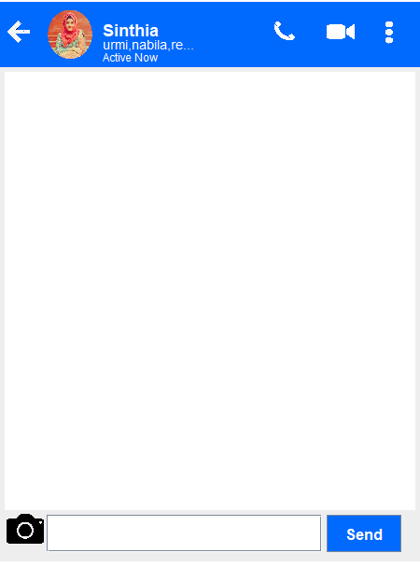
EXIT OPTION
SEND
CLIENT ONE
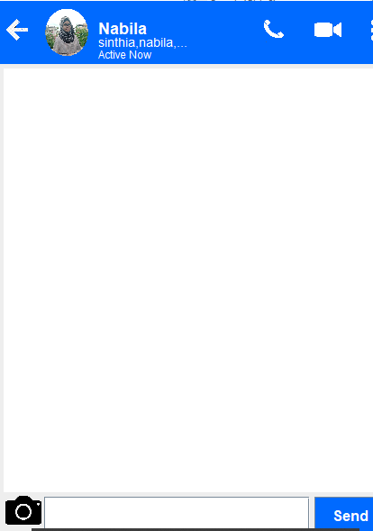
CLIENT TWO
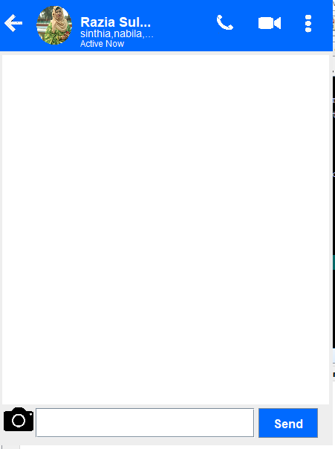
CLIENT THREE

Discussion
This implementation can be further enhanced to provide client the list of current active users so that he can know who all of his friends are online. A simple method can be implemented for this purpose which when invoked prints the names in active list.
we can incorporate network security feature by performing encryption before sending the message over the network.
Primitive techniques such as Caesar cipher or advanced methods such as RSA can be used to perform encryption-decryption. You can try using Java’s RMI (Remote Method Invocation) to perform the same task.
Here, we can leverage the abstraction offered by Java to maximum extent. However, if your primary objective is efficiency, then Socket programming is the best choice. Since it doesn’t require any run time support, it is a bit faster compared to RMI.

References
https://www.geeksforgeeks.org/socket-programming-cc/.
https://www.slideshare.net/asifnoman240/multiuser-chat-application
https://www.freeprojectz.com/dfd/online-chat-application-dataflow-diagram

