මචං - Database Structure

This document will introduce the Database structure of Machan Chat Application

I strongly recommend to read this document for **everyone** related to this Application (actors). This information is described from the ground up so anyone can understand. Also, this information (database structure and other details) is open for discussions.

This information will be updated over time. This document contains a version number and a modified or released date. Up to date version can be found in GitHub repository and it is highly recommended to refer to the updated version. At some point, publishing this document through WhatsApp will be stopped and will only be published through GitHub.

|  |  |
| --- | --- |
| Version | 1 |
| Modified date | - |
| Initial release | 1/26/2021 11:03 AM |

Fallowing image shows the **Entity Relationship** (ER) diagram

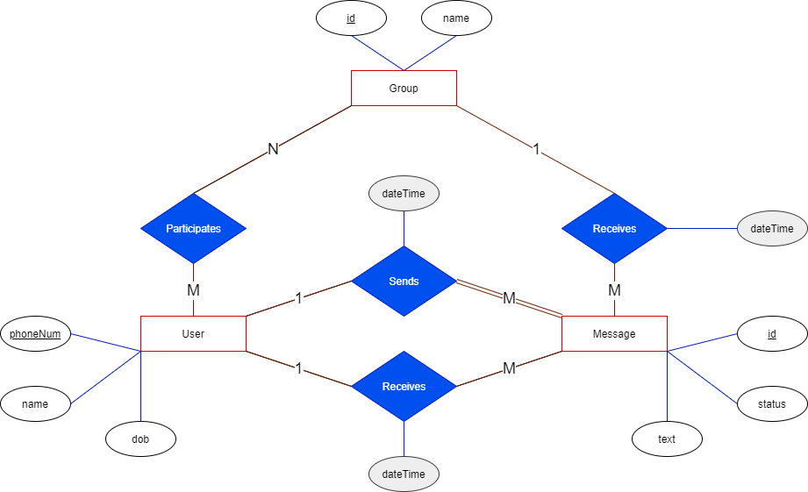

Breaking the **Entity Relationships** into parts,

1. There are 3 entities.
   1. User – a person who uses this app.
   2. Group – a group of users
   3. Message – a text message shared between 2 users or a user and a group
2. A user can be identified using one’s phone number
3. Every group has a unique ID
4. Every message has a unique ID
5. Status of a message status should contain one of the fallowing values, and the value should be forward. Which means a status cannot be in ‘Sent’ status after it has arrived ‘Delivered’ status.
   1. Sent
   2. Delivered
   3. Read

*there is a more reliable way but not efficient. We can add 3 Boolean (true/false) attributes as ‘sent’, ‘delivered’ and ‘read’. ‘delivered’ can be true if and only if ‘sent’ is true and so on…

1. A user can send one or more than one message
2. A message can only be sent by one user
3. A user can receive one or more than one message
4. A group can receive one or more than one message
5. Every message has a sender (user) and a receiver (user/group)
6. When a message is sent, sent date-time is recorded
7. When a message is received, received date-time is recorded
8. A user can participate in one or more than one group
9. A group can have one or more than one users

\***Relational Model** (tables structure) is not developed yet. Above information only describes the entities and their relationships.