2023 AI Pacific Cod Forecasting

Maia S Kapur

2023-11-17

This document describes the analyses performed to produce 15-year projections (‘forecasts’) for three Aleutian Islands Pacific Cod Stock assessments presented to the Groundfish Plan Team in November 2023. I discuss the rationale

The basic models used herein are as follows. I also describe what was indicated in the *original* forecast file included with each model, which was passed to the scenario-building routine and presented to the GPT.

| Model | Description | Reference Points | Forecast Pars |
| --- | --- | --- | --- |
| 23.0a | Time blocks on K in 2003 and 2017 | Biology and selectivity averaged throughout time period for ref-point calculation. | Selectivity averaged from 2000-2019. |
| 23.0b | As 23.0a, with time blocks on fishery selex in 2002, 2012, 2016, and 2019. | as above | as above |
| 23.0c - Base Model | Time block on K in 2003, time block on M in 2015 | as above | as above |

Here’s what the *original* projection trajectories looked like (i.e., Scenario 1):

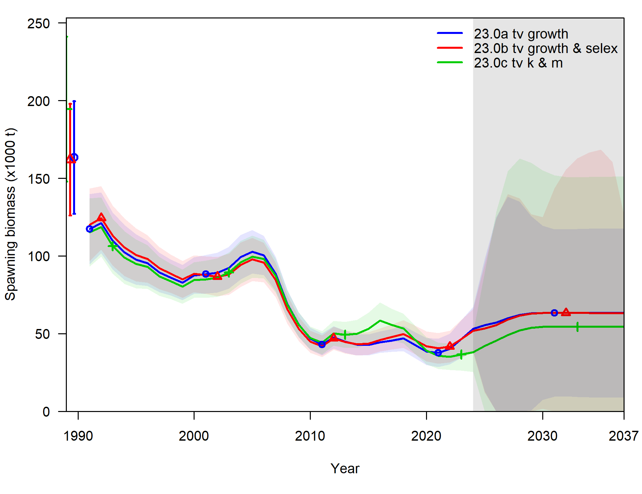

xx

# Updating the SS Forecast file

The original approach averaged quantities (demographic and selectivity) across many blocks. This is unnecessary in certain cases (i.e. model 23.0a does not have time-varying selectivity, so no averaging is needed) and inappropriate in others (forecasts should represent what we reasonably expect to happen in the future, which is probably most similar to the present (versus an average of the past)). Additionally, specifying different time periods and parameter values for the reference points and forecasted values produces confusion when comparing trajectories with targets. For these reasons, my proposal is to instead use the terminal value for all quantities.

In the forecast file itself, this is represented as follows: #_Bmark_years

0 0 0 0 0 0 0 0 0 0

#_Fcast_years:

0 0 0 0 -999 0

Do note that *for this model*, only the first four values in “Bmark_years” and first two values of “Fcast_years” are used, because this model does not have multiple fishing fleets (thus no relF, no movement (thus no recr_dist nor recruits arguments), and no stock-recruit relationship.

# Impacts on Projections (Scenario 1)

The base model 23.0c has a high terminal value of $M$: 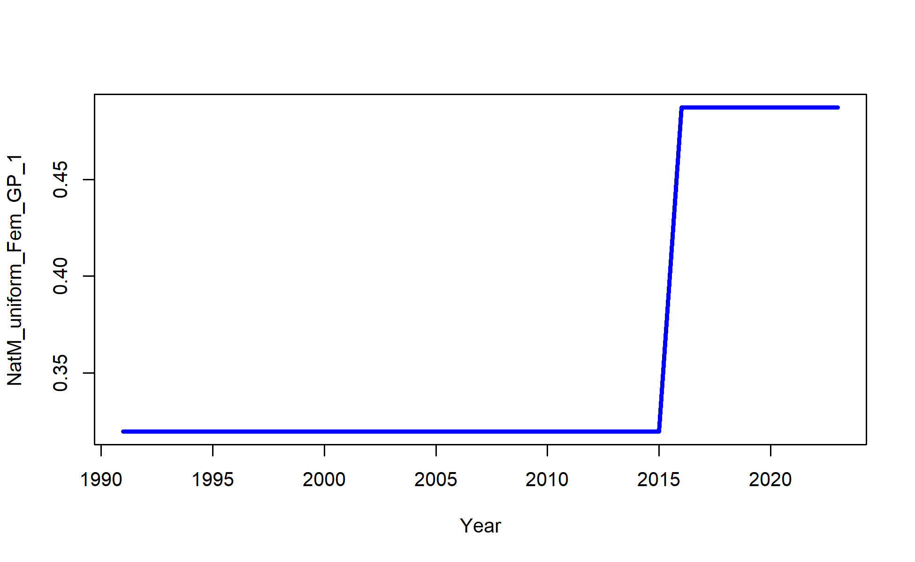

The plot below shows the impact (on SSB) of changing the forecast file to only consider the terminal year for demography and selectivity when calculating reference points and parameterizing forecasts.

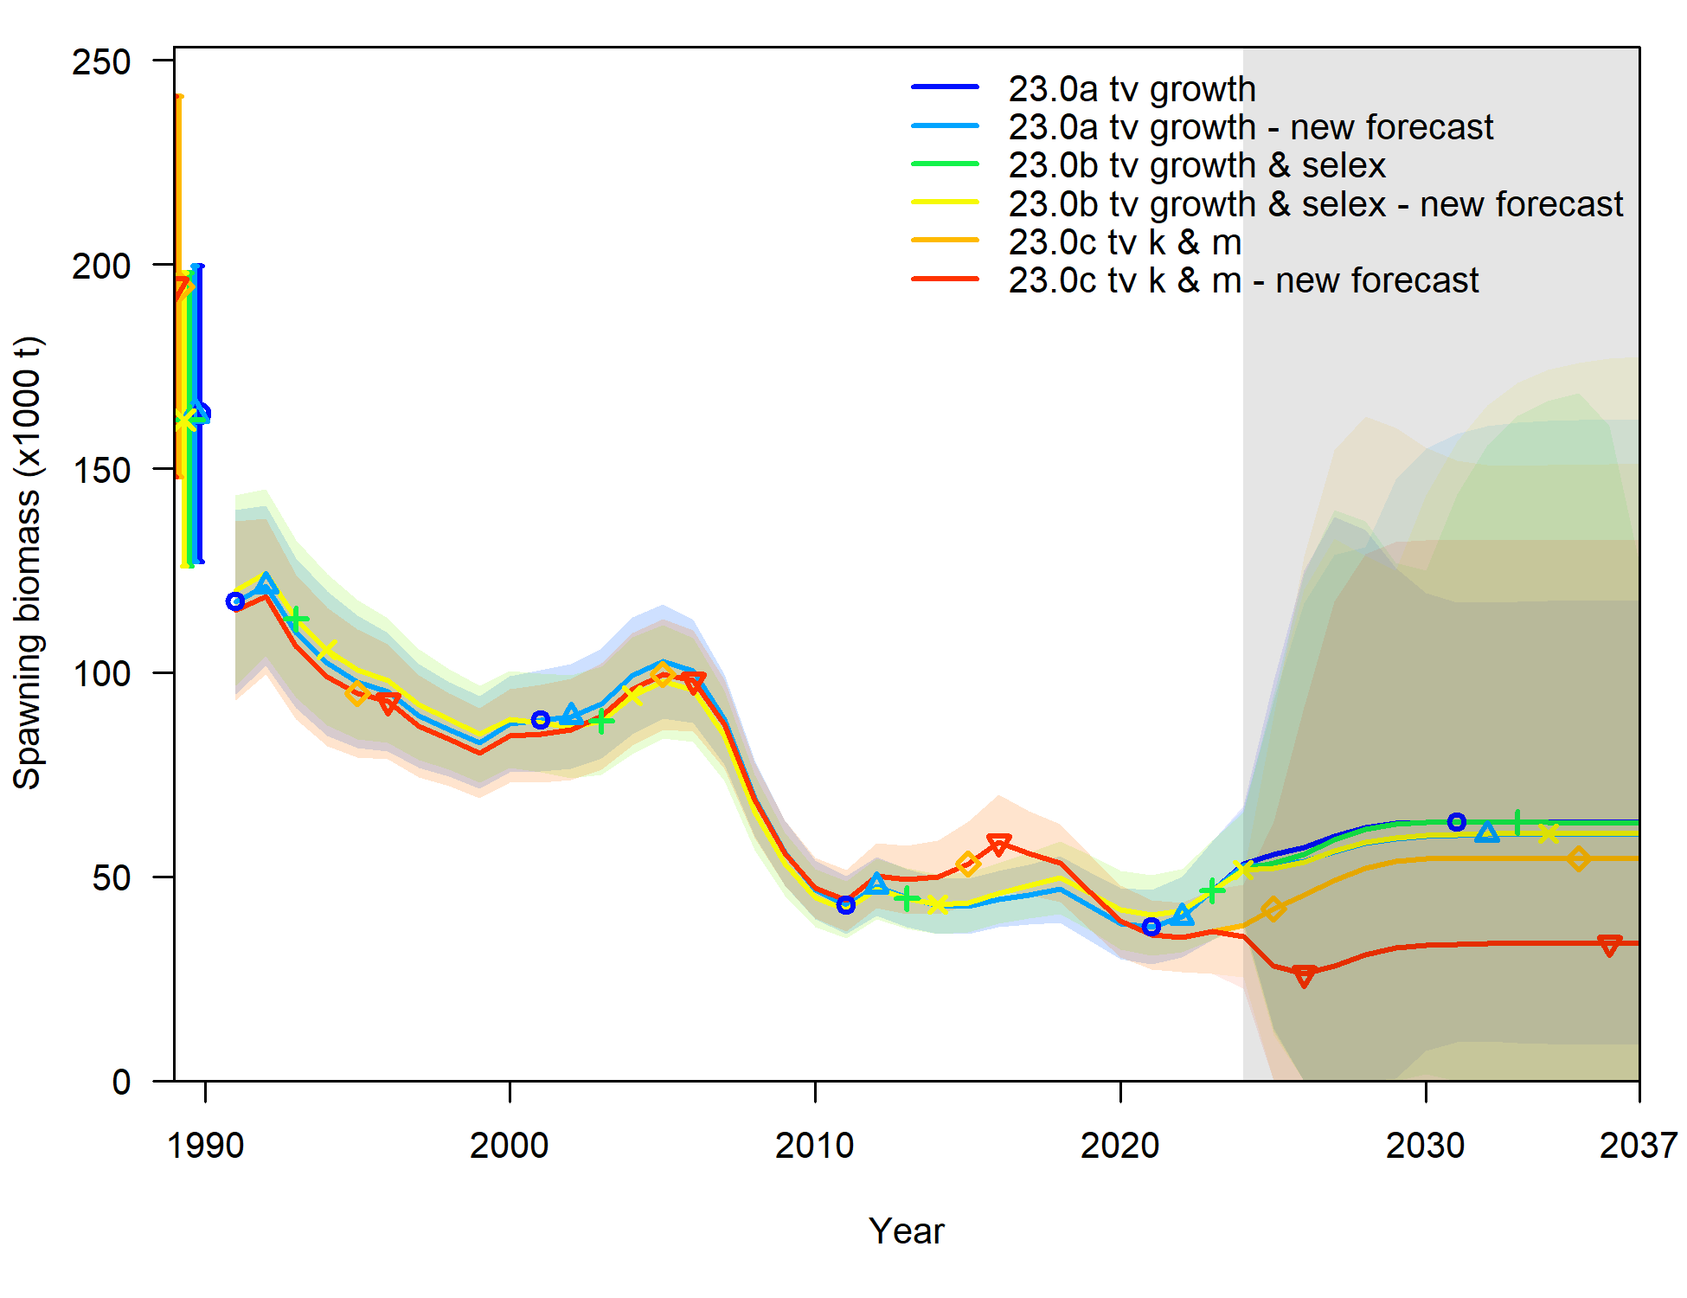

The impact of this change less apparent for the first four models because growth and selectivity are not very different among time blocks – in fact, they are hardly distinguishable:

knitr::include_graphics(here('2023','model_runs','M23.0a','plots','bio22_timevarygrowthsurf_sex1.png'))

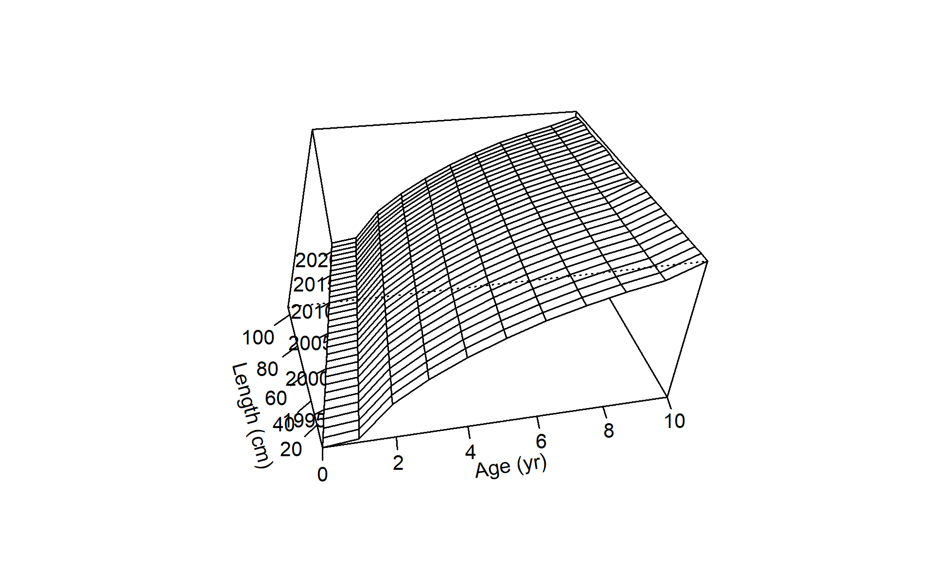

Time-varying Growth in M23.0a, and time-varying fishery selectivity in M23.0b.

knitr::include_graphics(here('2023','model_runs','M23.0b','plots','sel03_len_timevary_surf_flt1sex1.png'))

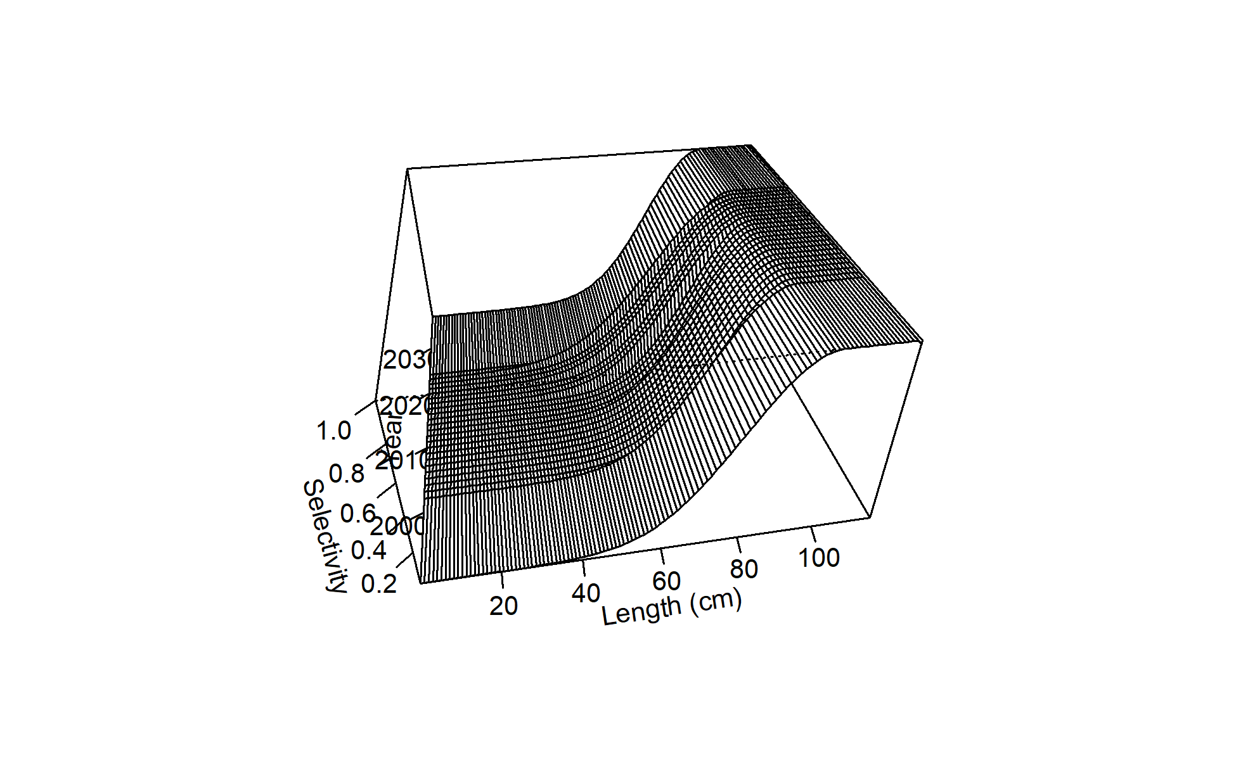

Time-varying Growth in M23.0a, and time-varying fishery selectivity in M23.0b.