# Evaluation of aspects of the EBS pollock stock assessment model and data

Jim Ianelli

September 2019

The following summarizes some of the activities related to EBS pollock that are planned for eventual inclusion within the stock assessment. The section authors are the leads on conducting the various research projects and have publications forthcoming on these topics under the guidance of Jim Thorson and several others.

# Acoustic and bottom trawl survey spatio-temporal modeling—Incorporating vertical distribution in index standardization

Cole Monnahan

Pollock are a semi-pelagic fish that distribute vertically as a complex function of biotic (e.g., size-based) and abiotic (e.g., environmental) conditions that vary in space and time. For the EBS pollock stock, both acoustics (AT) and bottom trawls (BT) data are available and collected following rigorous protocols and standards dating back to the early 1980s. However, these gears sample from distinct, but overlapping, subsets of the water column: the BT covers from bottom to midwater, and AT from midwater to surface. This presents a challenge in understanding population trends because the proportion of fish available to each gear type depends on the vertical distribution, which varies in space and time. In the current assessment, this uncertainty is added as a type of process error. To reduce this, we developed a new method that explicitly models the vertical distribution of fish in discrete, spatially-correlated depth strata. We derive model expectations and data likelihoods appropriate for the unique sampling scenario of vertically-overlapping gears so that the model is informed by both acoustic and bottom trawl data sets simultaneously. These capabilities were added to the spatio-temporal standardization software VAST which provides a convenient analysis platform and allows inclusion of temporal smoothing and environmental covariates, among other features. We used survey data for pollock from 2007 to 2018 as a case study. Simulation testing confirmed that the biases could occur using the current approach where relative vertical distribution is ignored. Spatial patterns of pollock density for some selected years are shown in Fig. 1 and the relative availability to the gear types is shown in Fig. 2). As the results become available, a model configuration using the combined index will be meshed as an alternative survey data treatment/model fitting in the EBS pollock assessment.

**Figure** 1. Estimated log-density (color) of pollock for three select years (rows) for the base case combined model. Columns represent the density available to the gear types, which for the ATS is the sum of strata 2 and 3, and for the BTS is the sum of strata 1 and 2, while the total is the sum of all three.

**Figure** 2. Estimated availability (i.e., fraction of pollock available to a survey gear type) for three select years (rows) for the bottom (BT) and acoustic (AT) trawl surveys (columns) from the combined base case model.

# Developing environmental indices—retrospective analysis of zooplankton abundance in Bering Sea pollock stock recruitment models

E. Yasumiishi

The early life history of pollock is key in determining their survival to the fishery. Large copepods are an important prey item for age-0 pollock in the eastern Bering Sea (Coyle et al. 2011). The energy density of age-0 pollock has been correlated with survival to age-3, but not in recent warm years (Heintz et al 2013, Eisner et al 2013). More recently, the densities of the large copepods, a lipid-rich prey, are linked to the survival of pollock to age-3 (Eisner et al. in prep). The abundance of prey may drive pollock productivity during warm years, when energy demands are high and lipid reserves low. The cold pool index (CPI) for the eastern Bering Sea is a two-dimensional measure of cold (< 2°C) benthic waters on the Eastern Bering Sea shelf observed during the AFSC summer bottom trawl surveys, 1982-2018 (Kotwicki and Lauth 2013, Conner and Lauth 2017). The rationale for this as an environmental index is that cooler summer water temperatures reduce metabolic demands on zooplankton and could increase lipid content. As prey items, the caloric value should thus benefit predators (i.e., juvenile pollock). Other indices included Calanus (copepod) abundance by year (as estimated using the VAST framework; Thorson 2015). For the dependent variable, age-3 pollock from the assessment was compiled along with the ln(age-3/SSB) and regressed against the Calanus index and the cold pool index over different length periods (e.g., 1982-2018 and 2002 – 2018). Models were tested using forward model cross validation and retrospective skill testing. Skill testing requires fitting the model for years 2002 to T (where T<2016), then predicting recruitment in years T+1, T+2, and T+3. These predictions were then compared to the realized assessment estimates. An example result shows that the cold pool index was more consistent with patterns of recruitment (Figure 3).

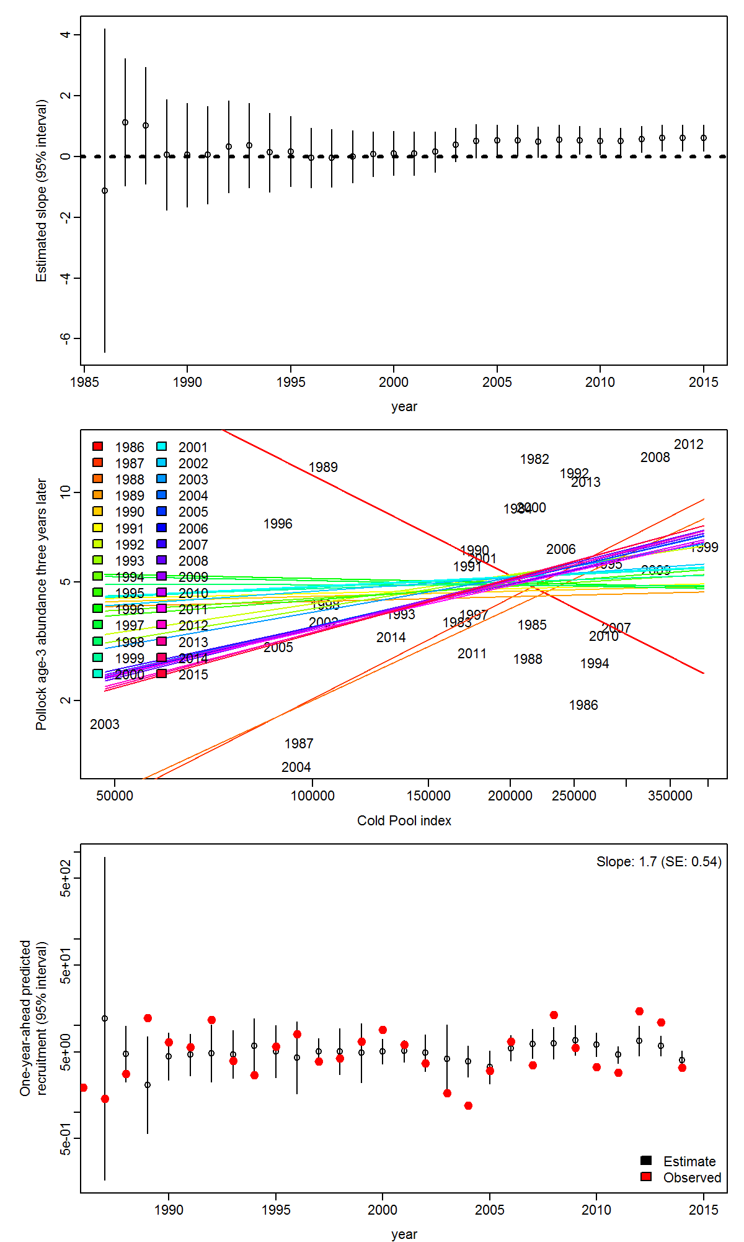

Figure 3. Example result showing the relationship between the Cold pool index and age 3 pollock abundance (#) three years later, 1982-2015.

# Estimating groundfish spatio-temporal patterns

Cecilia O’leary, AFSC

This year a project funded to estimate the relative abundance of pollock and other groundfish species in AFSC bottom trawl surveys using Russian TINRO data in the Western Bering Sea. To date, we have successfully compiled TINRO data, and with the coordination of Dr. Vladimir Kulik, gathered the vessel and gear specifications for the Russian surveys. Using these data, we estimated the fishing power ratio between these two surveys and have produced two versions of a design-based index. The first step was to compare TINRO and AFSC bottom trawls from May to September, within one month between operations, and within zero to five miles (up to 8 km) distant. Applying a nearest neighbor approach we estimated a median fishing power of the Russian vessels relative to the AFSC EBS bottom trawl vessels estimated to be 0.23 ± 0.24 standard deviations. We then used this information to estimate two different design-based indices for pollock in the Eastern, Northern, and Western Bering Sea using the traditional AFSC approach and compared that with a modified nearest neighbor approach using k-means clusters and a local variance estimator (termed ‘local approach’). This provided CPUE estimates to index biomass between the western Bering Sea relative to the Eastern Bering Sea (Fig. 4). Design-based CPUEs so far indicate that between 65 – 100% of the pollock biomass is in the EBS compared to the WBS. Future data requests from TINRO will focus on age- and size-composition and corresponding environmental data. Moving forward, work is focused on developing a model-based index using VAST that combines TINRO and AFSC data.

Conventional

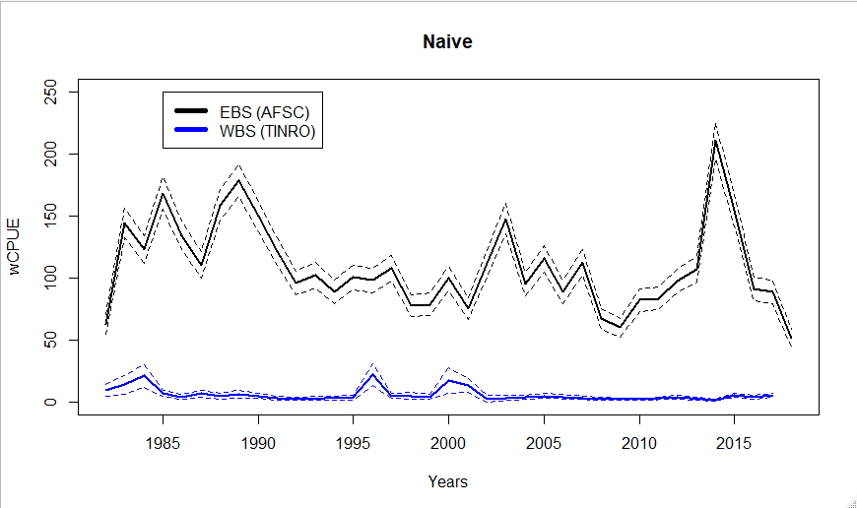

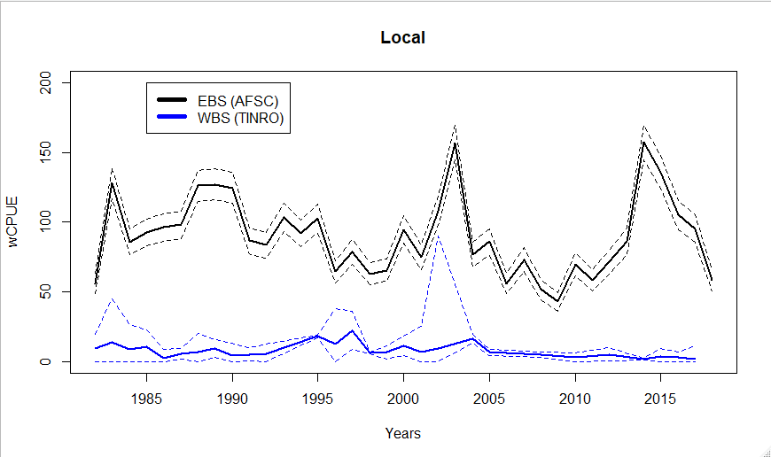

Figure 4. Comparison of EBS (black) and WBS (blue) CPUEs in weight for the local (bottom) and traditional (top) approaches from 1982 - 2018 for pollock. CPUEs (solid line) are surrounded by their confidence intervals (dashed lines).

**Survey age-composition estimation consistent with spatiotemporal indices of abundance for use in stock assessment**

Cecilia O’leary, AFSC

A spatiotemporal model for survey data on pollock was developed to provide key assessment inputs. In Ianelli et al. (2018) an alternative biomass index was provided and included as one model for consideration and as a sensitivity. This index was based on VAST. However, the age-composition data was unchanged (i.e., the estimates were based on the original design-based approach). Here we develop a spatio-temporal approach to obtain age composition estimates to include in the assessment. The second aspect of this work was to develop a model that incorporates all available data sets despite inconsistencies in spatial and temporal coverage (e.g., for years when the survey extended into the northern Bering Sea (NBS). This study provides an alternative method to calculate indices of abundance and age-composition estimates. Both the standard and VAST-developed indices of pollock abundance and age-composition were used in the pollock stock assessment model. We found that design-based and model-based inputs provided stock-assessment parameter estimates consistent with previous approaches (Fig. 5).

Figure 5. Comparison of model results of estimated recruitment fitting the EBS pollock assessment model to the conventional survey index data, then fit to the model-based VAST survey index, finally with both the VAST survey biomass index and the VAST derived estimates of survey age compositions.