# Catch

I did not update catch before 1992. AKFIN is missing 1993 and 1994, and 1992 is way too low compared to your values. **Should I just use your old values for years <1996?**

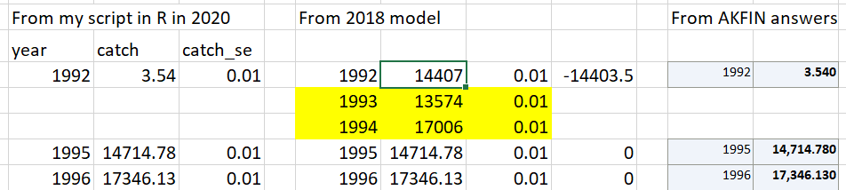

The more recent years are also slightly different. I assume this is normal that they update things? I’m surprised it goes back to 2010 though.

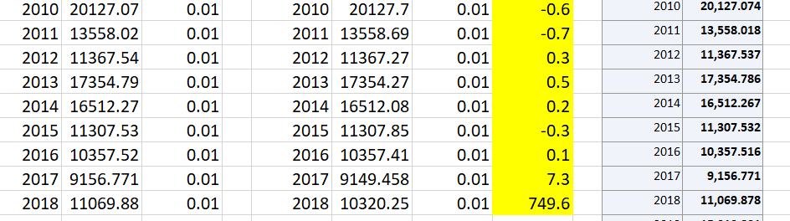

# Survey biomass

These match pretty well with small exceptions in a few years for the biomass. The most concerning thing is that my estimates of SE are almost all slightly higher. **How did you do the linear model to combine the AI and EBS shelf surveys**? I regressed biomass and variance. I also tried SE but that didn’t match either. The differences are very small, however, so nothing of concern there.

# Survey lengths

The years given in assessment don’t match the SAFE – all years were used (i.e., no negative fleets for years with age data as well). **But I think with CAAL this makes sense b/c you’re not double counting you can use the length data when you also have ages, right?**

# Fishery lengths

These match except for a couple of the sample sizes in the earlier years.

|  |  |  |  |
| --- | --- | --- | --- |
| year | 2020 data | 2018 data | Difference |
| 1973 | 1 | 8 | -7 |
| 1975 | 34 | 34 | 0 |
| 1976 | 4 | 4 | 0 |
| 1977 | 138 | 138 | 0 |
| 1978 | 145 | 145 | 0 |
| 1979 | 218 | 219 | -1 |
| 1980 | 90 | 90 | 0 |
| 1981 | 62 | 62 | 0 |
| 1982 | 46 | 46 | 0 |
| 1983 | 47 | 47 | 0 |
| 1984 | 56 | 57 | -1 |
| 1985 | 152 | 152 | 0 |
| 1986 | 55 | 55 | 0 |
| 1987 | 40 | 42 | -2 |
| 1988 | 166 | 168 | -2 |
| 2018 | 2407 | 1310 | 1097 |
| 2020 | 3547 |  | 3547 |

Not sure what’s going on there.

More importantly, the years used in the model do not match the data table in the SAFE. **The model includes years 1973, 1975, 1976, 1995, 1998 but these are excluded in the description in the SAFE**

# Survey conditional age at length

There are two main issues with this data set. **The first is that appears the Bering flounder ages were not removed**. If I compare the CAAL data from the 2018 vs the script run with both species and just FHS the one with “both” matches much better.

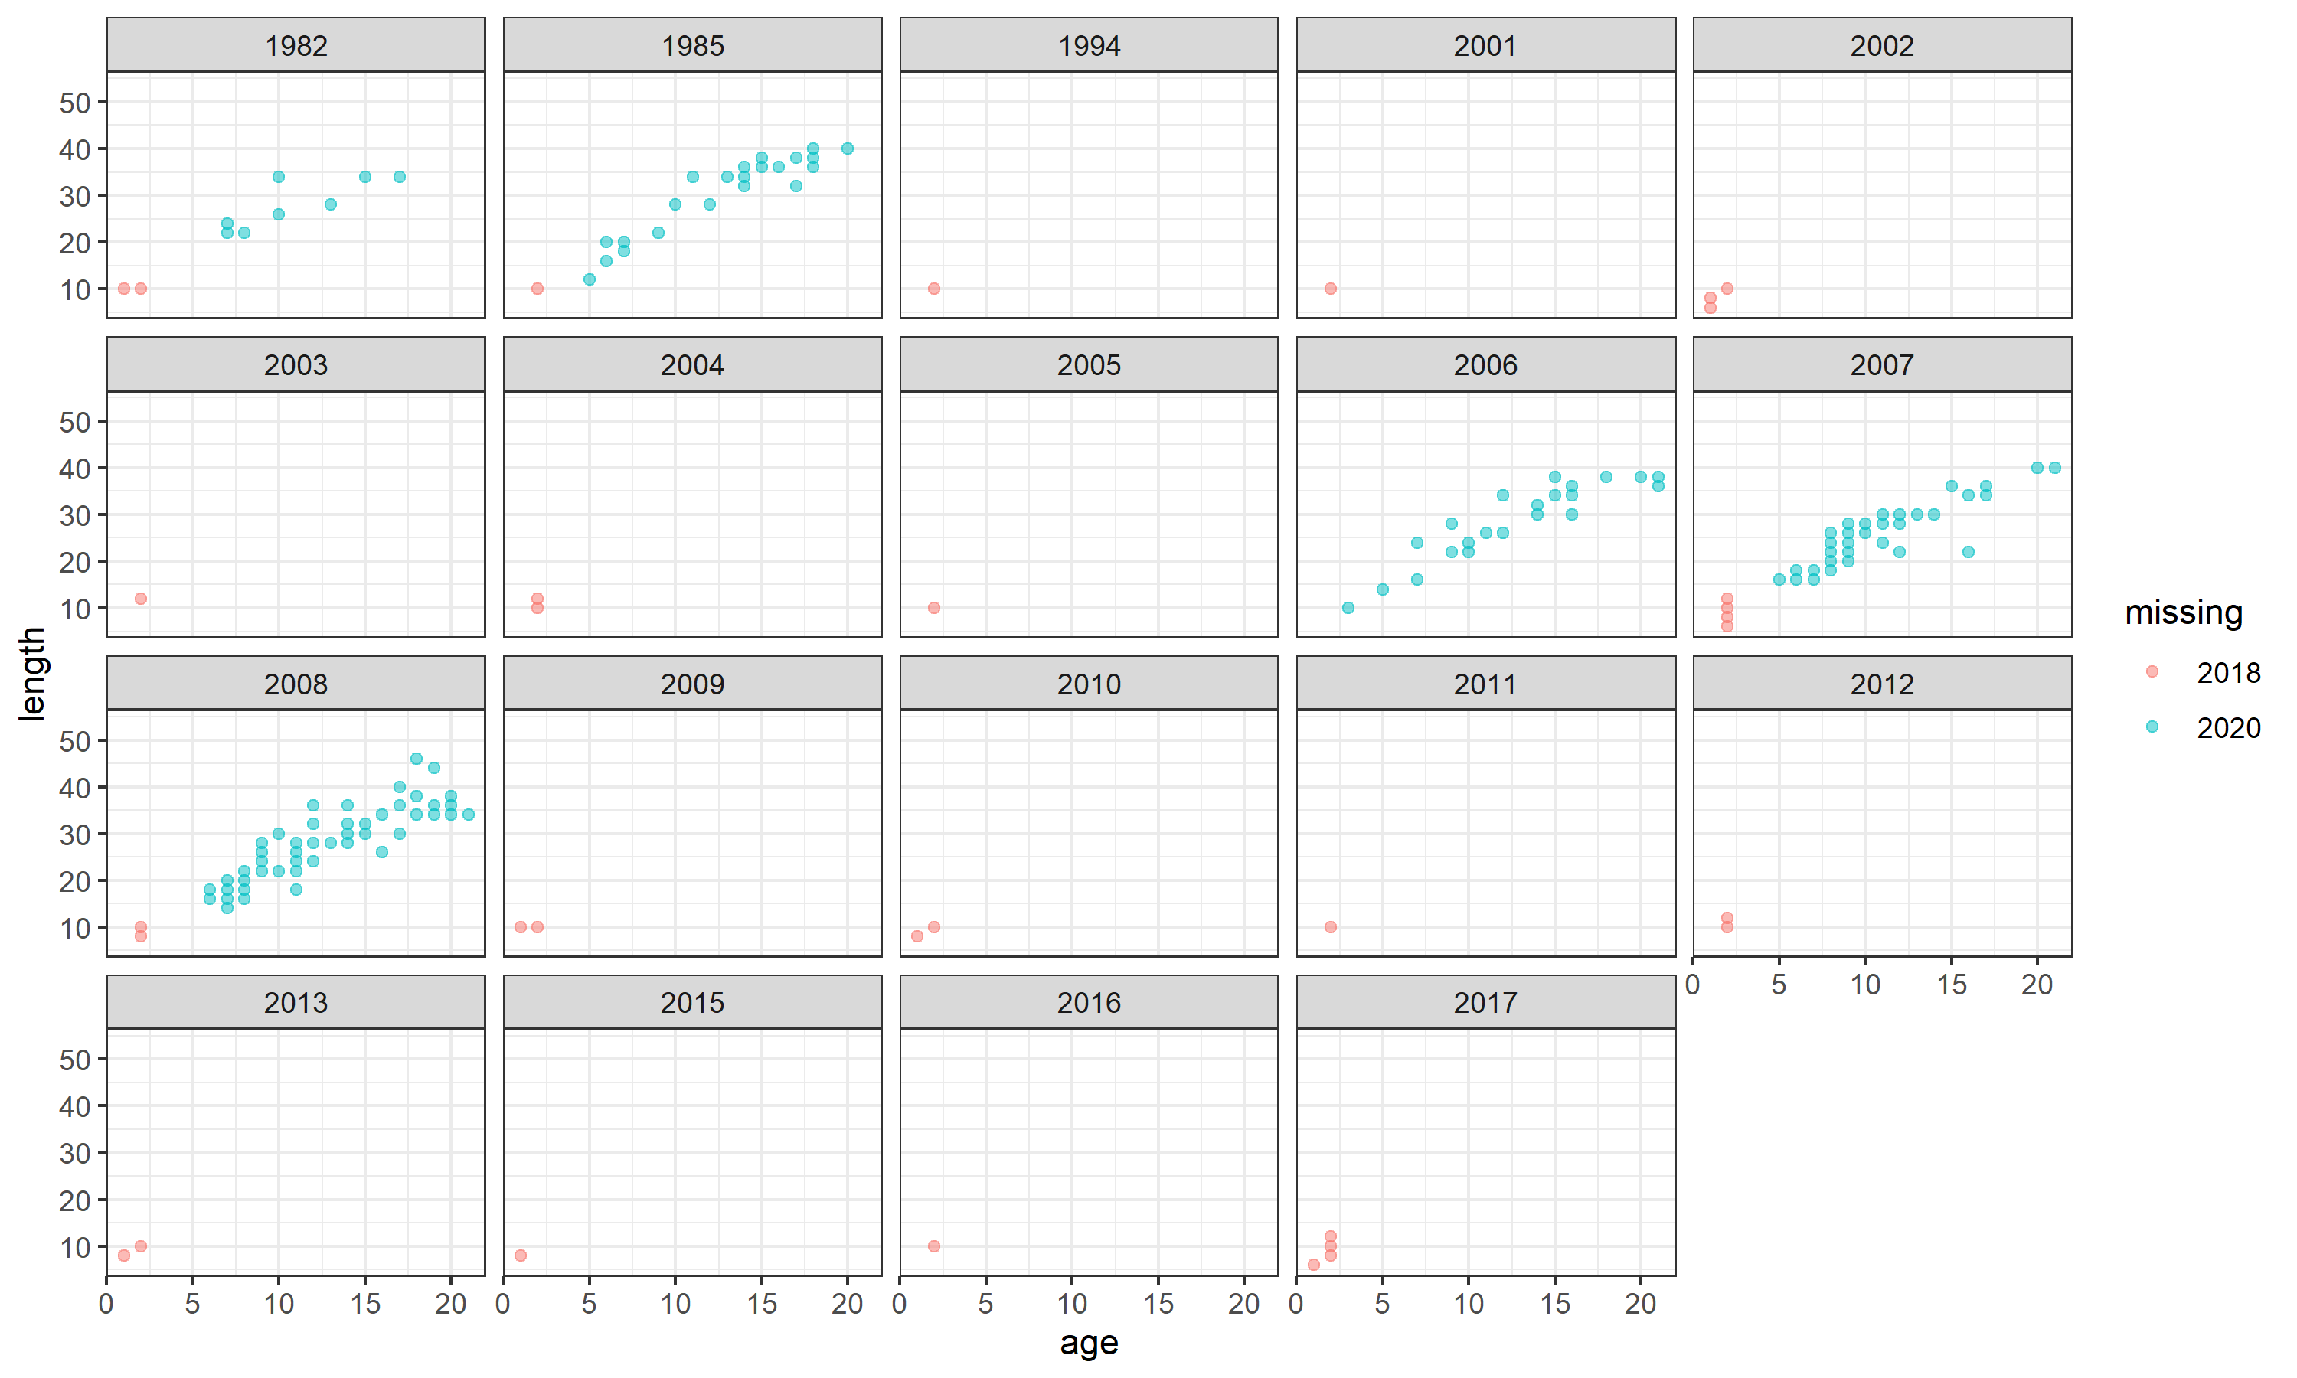

Figure . CAAL data mismatches between 2018 assessment and script run in 2020. The 2020 script uses just FHS. Males only.

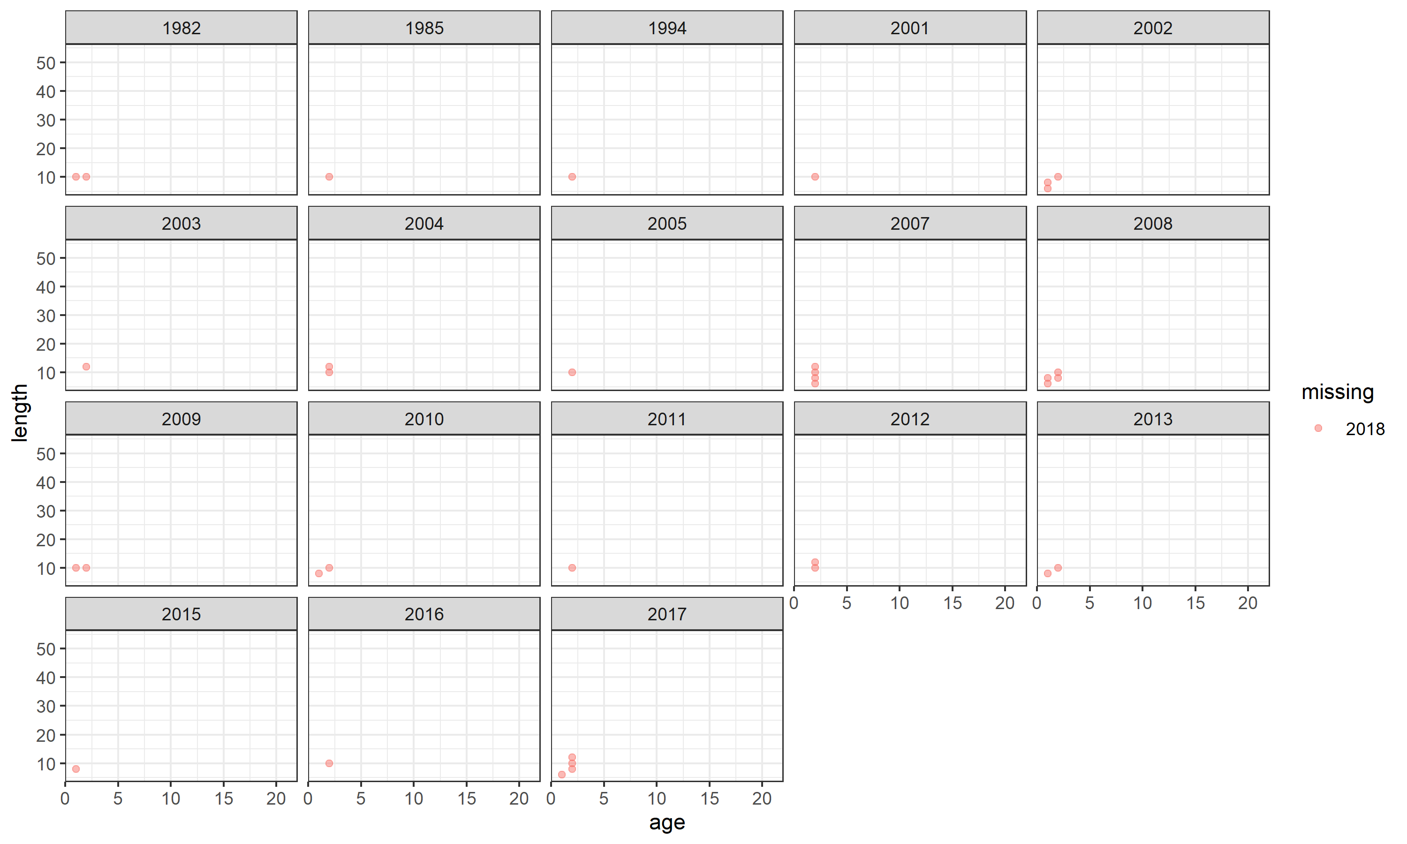

Figure . Same as above but this time run with species as "both" so Bering flounder is included. These match better suggesting the 2018 assessment used the BF age data.

The second issue is with the smallest sizes/ages being missing in the 2018 assessment, which is missing most (but not all) lengths <12 cm. As you can see this is in all years. I suspect this is a mistake in 2018 because the sample sizes are also wrong in some cases. For instance here are the first few rows:

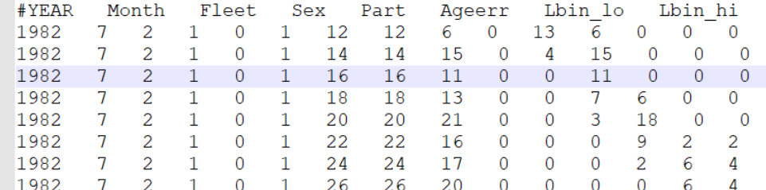

Notice that in the first row Nsamp=6 but there are 19 fish. Nsamp appears to be missing fish <3 years old. So e.g., line three matches because there are no fish age 1 or 2 fish, whereas lines 1 & 2 don’t match.

# Fishery age comps

These match.