10. Assessment of the Flathead Sole-Bering Flounder Stock Complex in the Bering Sea and Aleutian Islands

Maia S. Kapur

November 2023

This report may be cited as:

Authors., Year. Title. North Pacific Fishery Management Council, Anchorage, AK. Available from https://www.npfmc.org/library/safe-reports/

# Executive Summary

“Flathead sole” as currently managed by the North Pacific Fishery Management Council (NPFMC) in the Bering Sea and Aleutian Islands (BSAI) and represents a two-species complex consisting of true Flathead sole (*Hippoglossoides elassodon*) and its morphologically-similar congener Bering flounder (*Hippoglossoides* spp.). This species is currently assessed on a four-year cycle; the most recent full assessment was conducted in 2020 (Monnahan and Haehn, 2020, available at <https://www.npfmc.org/library/safe-reports/> and will be updated in 2024. In years without a full assessment, we present an executive summary to recommend harvest levels for the next two years.

Flathead sole is assessed using an age-structured model and Tier 3 determination. The projection model is run using parameter values from the accepted 2020 assessment model, together with updated catch information for 2020-2022, estimated catches for 2023 and projected catches 2024-2025 (Figure 1), to predict stock status for Flathead sole in 2024-2025, and to make ABC recommendations and set OFL for those years.

## Summary of Changes in Assessment Inputs

To run the projection model to predict ABCs for 2024 and 2025, we used true, observed catches for 2020-2022 and estimates for the total catches in 2023-2025. Note that the 2020 catch used in the last benchmark model was itself an estimate (8,556), about 9% less than the finalized observation used for projections here. The catch for 2023 (8,811 t) was estimated by adding the average catch between 27 September and December 31 over the years 2017-2022 to the 2023 catch as of 2023-09-27. The 2024 and 2025 catches (12,246 t) were estimated as the average catch over the previous 5 years (2017-2022).

Summary of Results

|  | As estimated or *specified last* year for: | | As estimated or *recommended this* year for: | |
| --- | --- | --- | --- | --- |
| **Quantity/Status** | 2023 | 2024 | 2024* | 2025* |
| M | 0.2 | 0.2 | 0.2 | 0.2 |
| Tier | 3a | 3a | 3a | 3a |
| Projected total (3+) biomass (t) | 606,522 | 606,080 | 609,488 | 608,230 |
| Projected Female spawning biomass (t) | 158,962 | 164,594 | 165,629 | 169,452 |
| B100% | 203,658 | 203,658 | 203,658 | 203,658 |
| B40% | 81,463 | 81,463 | 81,463 | 81,463 |
| B35% | 71,280 | 71,280 | 71,280 | 71,280 |
| FOFL | 0.46 | 0.46 | 0.46 | 0.46 |
| *max*FABC | 0.37 | 0.37 | 0.37 | 0.37 |
| FABC | 0.37 | 0.37 | 0.37 | 0.37 |
| OFL (t) | 79,256 | 81,167 | **81,605** | 82,699 |
| *max*ABC (t) | 65,344 | 66,927 | 67,289 | 68,203 |
| ABC (t) | 65,344 | 66,927 | **67,289** | 68,203 |
|  | As determined *last* year for: | | As determined *this* year for: | |
| **Status** | 2022 | 2023 | 2023 | 2024 |
| Overfishing | No | n/a | No | n/a |
| Overfished | n/a | No | n/a | No |
| Approaching Overfished | n/a | No | n/a | No |
| *Projections are based on an estimated catch of 8,811 t for 2023 and estimates of 12,246 t and 12,246 t used in place of maximum permissible ABC for 2024 and 2025. | | | | |

# Tables

Table 10-1. Catch (in tons) of Flathead sole and Bering flounder combined (*Hippoglossoides elassodon*) and Flathead sole only, and Bering flounder only. Observer data of species-specific extrapolated weight in each haul was summed over hauls within each year and used to calculate the proportion of the total *Hippoglossoides* spp. catch that was Flathead sole or Bering flounder. Proportions were multiplied by the total *Hippoglossoides* spp. (Flathead sole and Bering flounder combined) catches reported by AKFIN to obtain total catch of Flathead sole separately from that of Bering flounder. Note that the value for 2023 is the observed catch, current through 2023-09-27; the extrapolated catches used for this year in the projection model are higher.

| Year | Total *Hippoglossoides* spp. | Flathead Sole | Bering Flounder |
| --- | --- | --- | --- |
| 1992 | 4 | 4 | 0 |
| 1995 | 14,715 | 14,710 | 4 |
| 1996 | 17,346 | 17,341 | 5 |
| 1997 | 20,683 | 20,678 | 5 |
| 1998 | 24,387 | 24,381 | 7 |
| 1999 | 18,573 | 18,553 | 20 |
| 2000 | 20,441 | 20,408 | 33 |
| 2001 | 17,811 | 17,795 | 16 |
| 2002 | 15,575 | 15,550 | 25 |
| 2003 | 13,785 | 13,767 | 18 |
| 2004 | 17,398 | 17,374 | 24 |
| 2005 | 16,108 | 16,077 | 31 |
| 2006 | 17,981 | 17,975 | 6 |
| 2007 | 18,958 | 18,952 | 6 |
| 2008 | 24,540 | 24,526 | 14 |
| 2009 | 19,558 | 19,530 | 28 |
| 2010 | 20,127 | 20,101 | 26 |
| 2011 | 13,557 | 13,536 | 20 |
| 2012 | 11,365 | 11,359 | 6 |
| 2013 | 17,353 | 17,272 | 80 |
| 2014 | 16,511 | 16,478 | 33 |
| 2015 | 11,306 | 11,273 | 33 |
| 2016 | 10,313 | 10,301 | 12 |
| 2017 | 9,111 | 9,107 | 3 |
| 2018 | 11,007 | 11,001 | 5 |
| 2019 | 15,880 | 15,879 | 1 |
| 2020 | 9,392 | 9,389 | 3 |
| 2021 | 10,260 | 10,255 | 4 |
| 2022 | 14,690 | 14,687 | 2 |
| 2023 | 7,716 | 7,714 | 2 |

Table 10-2. Survey biomass in tons and coefficient of variation (CV) of *Hippoglossoides spp.* (combined Flathead sole and Bering flounder) across the entire BSAI; Flathead sole only in the Aleutian Islands, *Hippoglossoides spp*. combined in the Eastern Bering Sea (EBS) shelf survey, Flathead sole only in EBS shelf survey, and Bering flounder only in the EBS shelf survey. Slight discrepancies in totals may occur due to rounding.

| Year | Biomass (Total) | CV (Total) | Biomass (AI) | CV (AI) | Biomass (EBS, all) | CV (EBS, all) | Biomass (EBS, flathead) | CV (EBS, flathead) | Biomass (EBS, Bering Flounder) | CV (EBS, Bering Flounder) |
| --- | --- | --- | --- | --- | --- | --- | --- | --- | --- | --- |
| 1982 | 194,495 | 0.09 |  |  | 191,343 | 0.09 | 191,343 | 0.09 | 0 |  |
| 1983 | 271,475 | 0.10 | 1,213 | 0.19 | 270,262 | 0.10 | 251,978 | 0.11 | 18,283 | 0.20 |
| 1984 | 289,521 | 0.08 |  |  | 284,782 | 0.08 | 269,777 | 0.09 | 15,005 | 0.21 |
| 1985 | 269,266 | 0.07 |  |  | 264,865 | 0.07 | 251,534 | 0.08 | 13,332 | 0.12 |
| 1986 | 362,170 | 0.09 | 5,245 | 0.16 | 356,925 | 0.09 | 343,011 | 0.09 | 13,914 | 0.17 |
| 1987 | 399,227 | 0.09 |  |  | 392,657 | 0.09 | 378,525 | 0.10 | 14,132 | 0.14 |
| 1988 | 569,809 | 0.09 |  |  | 560,392 | 0.09 | 537,372 | 0.09 | 23,020 | 0.22 |
| 1989 | 528,394 | 0.08 |  |  | 519,668 | 0.08 | 500,932 | 0.09 | 18,737 | 0.20 |
| 1990 | 601,749 | 0.09 |  |  | 591,798 | 0.09 | 572,543 | 0.09 | 19,256 | 0.15 |
| 1991 | 552,288 | 0.08 | 6,939 | 0.20 | 545,349 | 0.08 | 517,825 | 0.08 | 27,524 | 0.22 |
| 1992 | 626,811 | 0.10 |  |  | 616,443 | 0.10 | 601,311 | 0.11 | 15,131 | 0.21 |
| 1993 | 617,258 | 0.07 |  |  | 607,049 | 0.07 | 584,834 | 0.07 | 22,215 | 0.21 |
| 1994 | 699,446 | 0.07 | 9,935 | 0.22 | 689,511 | 0.07 | 663,853 | 0.07 | 25,658 | 0.19 |
| 1995 | 603,875 | 0.09 |  |  | 593,889 | 0.09 | 578,457 | 0.09 | 15,432 | 0.18 |
| 1996 | 626,314 | 0.09 |  |  | 615,954 | 0.09 | 603,979 | 0.09 | 11,975 | 0.20 |
| 1997 | 794,426 | 0.21 | 11,554 | 0.23 | 782,871 | 0.21 | 768,815 | 0.21 | 14,056 | 0.19 |
| 1998 | 693,723 | 0.20 |  |  | 682,237 | 0.20 | 674,412 | 0.20 | 7,825 | 0.21 |
| 1999 | 407,164 | 0.09 |  |  | 400,462 | 0.09 | 387,311 | 0.09 | 13,151 | 0.18 |
| 2000 | 401,106 | 0.09 | 8,906 | 0.23 | 392,199 | 0.09 | 384,011 | 0.09 | 8,188 | 0.19 |
| 2001 | 522,844 | 0.10 |  |  | 514,211 | 0.10 | 502,853 | 0.11 | 11,358 | 0.21 |
| 2002 | 562,073 | 0.17 | 9,898 | 0.24 | 552,175 | 0.18 | 547,271 | 0.18 | 4,904 | 0.19 |
| 2003 | 522,935 | 0.10 |  |  | 514,300 | 0.10 | 508,617 | 0.11 | 5,684 | 0.21 |
| 2004 | 624,805 | 0.08 | 13,298 | 0.14 | 611,507 | 0.09 | 603,449 | 0.09 | 8,058 | 0.31 |
| 2005 | 622,249 | 0.08 |  |  | 611,956 | 0.09 | 604,878 | 0.09 | 7,078 | 0.28 |
| 2006 | 643,731 | 0.09 | 9,664 | 0.17 | 634,067 | 0.09 | 620,215 | 0.09 | 13,852 | 0.31 |
| 2007 | 571,280 | 0.09 |  |  | 561,838 | 0.09 | 551,415 | 0.09 | 10,423 | 0.21 |
| 2008 | 553,591 | 0.14 |  |  | 544,445 | 0.14 | 534,364 | 0.14 | 10,080 | 0.19 |
| 2009 | 425,216 | 0.12 |  |  | 418,213 | 0.12 | 411,584 | 0.12 | 6,629 | 0.17 |
| 2010 | 506,197 | 0.14 | 11,812 | 0.30 | 494,386 | 0.15 | 487,798 | 0.15 | 6,588 | 0.15 |
| 2011 | 593,351 | 0.18 |  |  | 583,541 | 0.18 | 576,761 | 0.19 | 6,779 | 0.15 |
| 2012 | 386,892 | 0.11 | 5,566 | 0.15 | 381,326 | 0.12 | 374,716 | 0.12 | 6,610 | 0.14 |
| 2013 | 498,784 | 0.17 |  |  | 490,553 | 0.17 | 484,866 | 0.17 | 5,687 | 0.14 |
| 2014 | 532,889 | 0.13 | 13,436 | 0.14 | 519,453 | 0.14 | 509,842 | 0.14 | 9,611 | 0.17 |
| 2015 | 399,247 | 0.11 |  |  | 392,677 | 0.11 | 381,696 | 0.12 | 10,981 | 0.17 |
| 2016 | 452,785 | 0.07 | 6,759 | 0.15 | 446,026 | 0.07 | 433,243 | 0.07 | 12,783 | 0.23 |
| 2017 | 549,293 | 0.08 |  |  | 540,218 | 0.08 | 530,982 | 0.08 | 9,236 | 0.22 |
| 2018 | 494,579 | 0.08 | 6,930 | 0.11 | 487,649 | 0.08 | 484,144 | 0.08 | 3,505 | 0.16 |
| 2019 | 604,109 | 0.14 |  |  | 594,119 | 0.14 | 592,039 | 0.14 | 2,080 | 0.32 |
| 2021 | 670,091 | 0.11 |  |  | 659,000 | 0.11 | 657,321 | 0.12 | 1,679 | 0.31 |
| 2022 | 710,804 | 0.18 | 10,897 | 0.19 | 699,906 | 0.18 | 697,296 | 0.18 | 2,610 | 0.27 |

Table 10-3. Northern Bering Sea survey biomass (t) and coefficient of variation (CV) for Flathead sole, Bering flounder, and the two combined (Hippoglossoides spp.). These data are presented here for reference only and are not used in any assessments.

| Year | Biomass (Total) | CV (Total) | Biomass (NBS, flathead) | CV (NBS, flathead) | Biomass (NBS, Bering Flounder) | CV (NBS, Bering Flounder) |
| --- | --- | --- | --- | --- | --- | --- |
| 2010 | 12,355 | 0.17 | 0 |  | 12,355 | 0.17 |
| 2017 | 19,882 | 0.21 | 79 | 0.65 | 19,804 | 0.21 |
| 2019 | 18,989 | 0.18 | 463 | 0.33 | 18,526 | 0.19 |
| 2021 | 8,523 | 0.21 | 138 | 0.78 | 8,384 | 0.22 |
| 2022 | 6,039 | 0.15 | 126 | 0.61 | 5,913 | 0.15 |
| 2023 | 4,749 | 0.18 | 45 | 0.57 | 4,704 | 0.18 |

# Figures

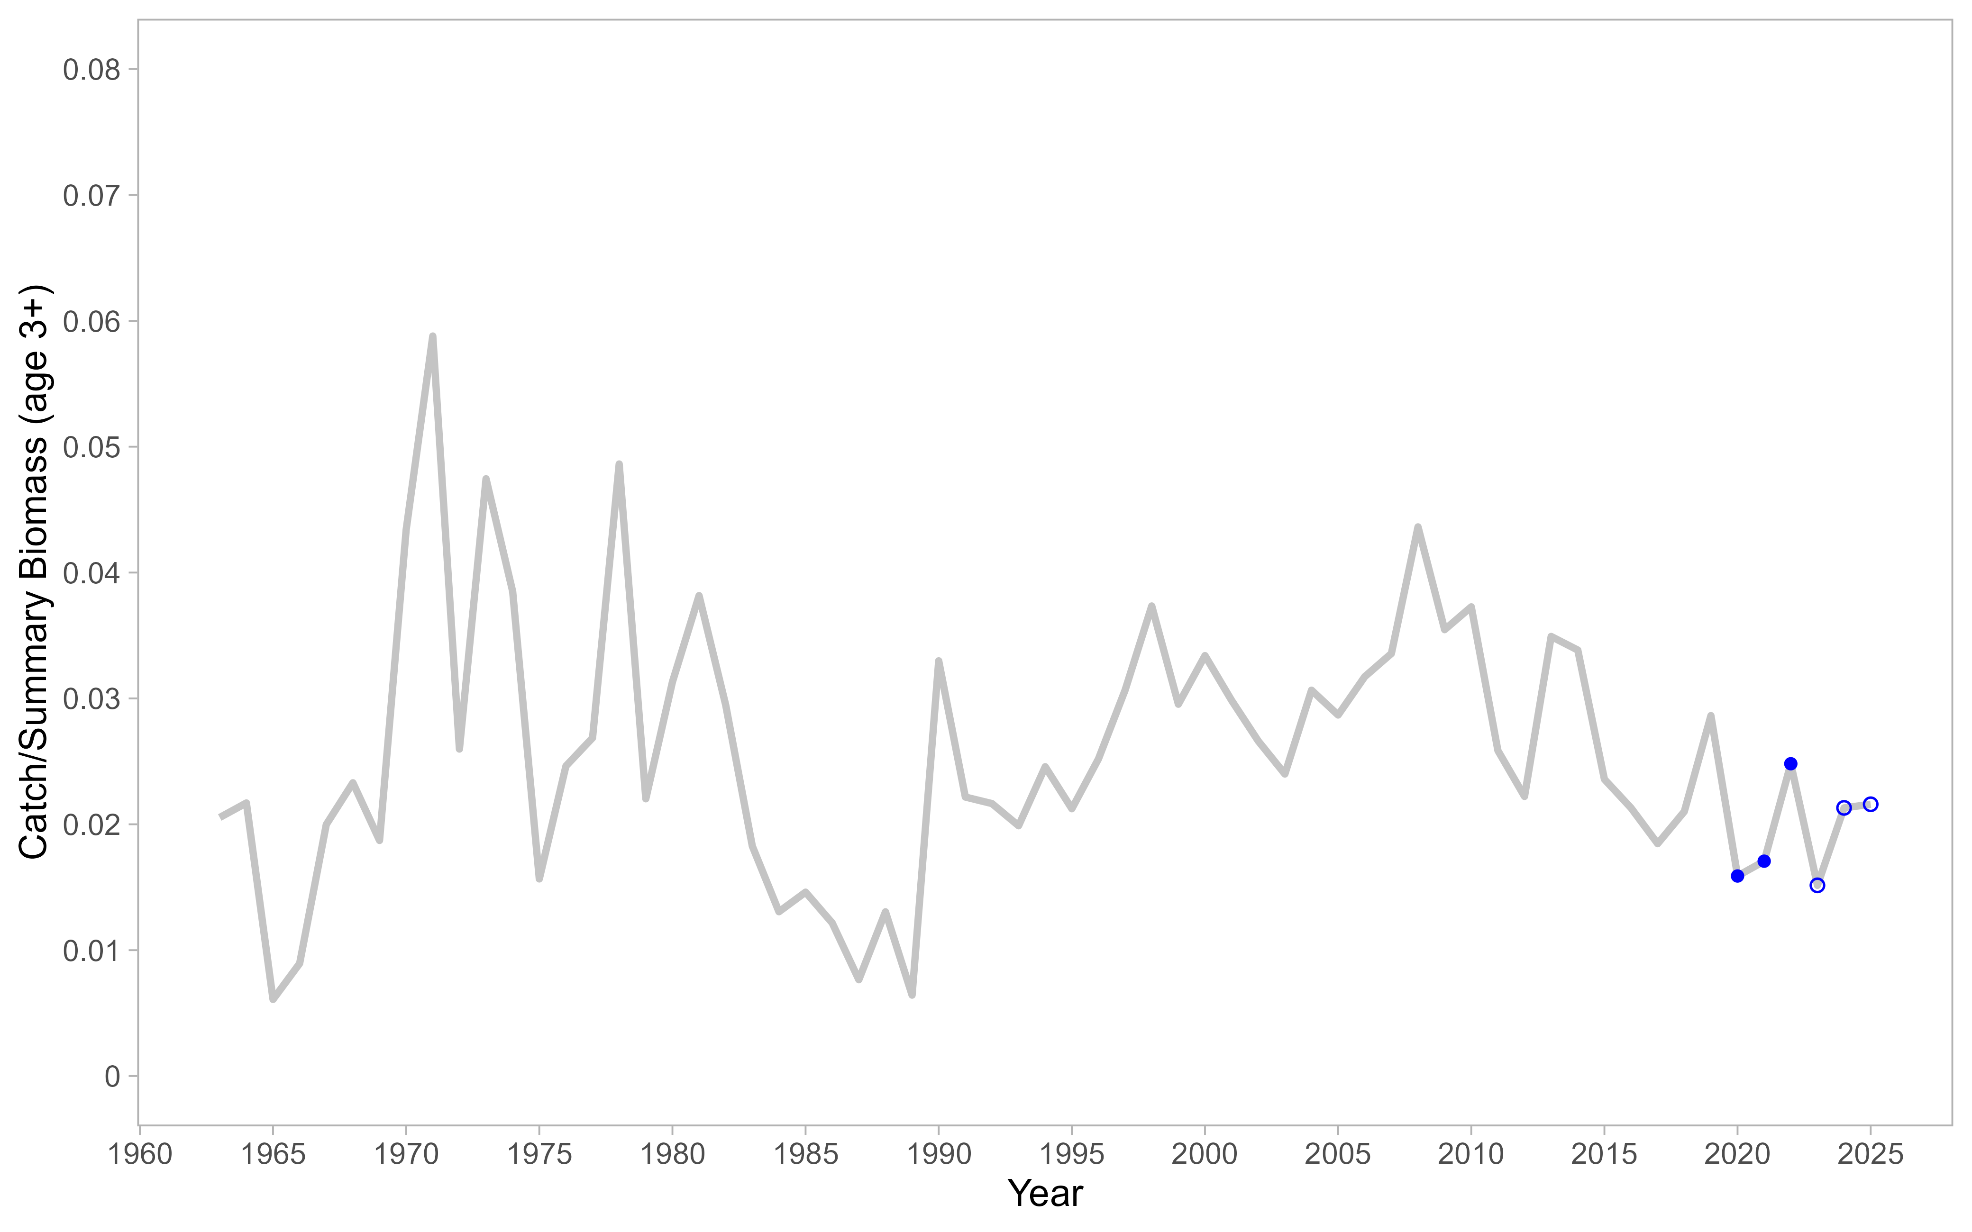

Figure 10-1. Catch to total biomass ratio using total biomass for age 3+ individuals for Flathead sole in the Bering Sea and Aleutian Islands. Blue points are catches included in the projection model; open points are estimated or projected, whereas solid points are complete observed years.

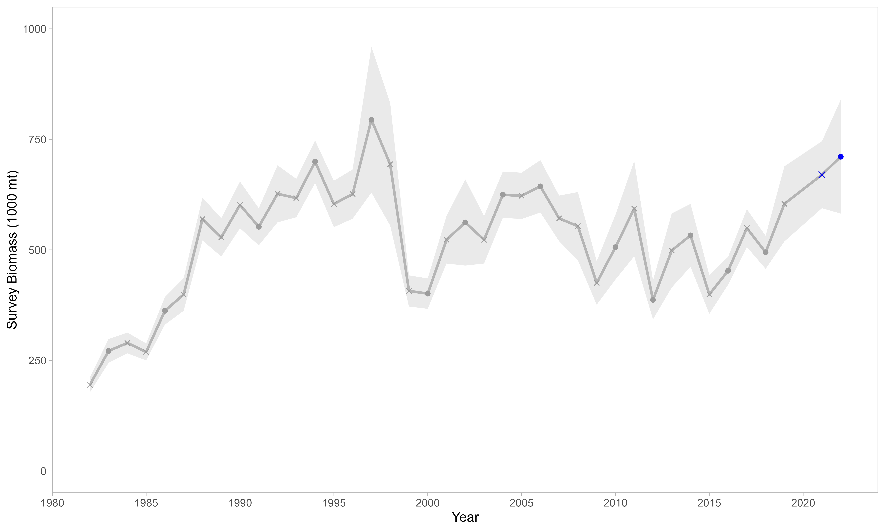

Figure 10-2. Survey biomass from the EBS shelf and Aleutian Islands surveys for station depths less than or equal to 200 meters. Grey and blue points include true observations. A linear regression was used to estimate a relationship between EBS shelf *Hippoglossoides spp*. survey biomass estimates and AI survey biomass estimates in years when no AI survey occurred (‘x’ marks). Grey shading indicates ± 1 standard error. None of the interpolated or observed values from 2020 onwards (blue points/‘x’ marks) are included in the base assessment model, nor the projection; they are provided here for reference only.

Author’s note: Changes have been made to the survey data in the stratum-area files, which affects biomass and abundance estimates for EBS data (all years and species, Duane Stevenson, AFSC). A visual comparison of EBS Flathead survey values from a 2021 data pull vs. the values shown above indicated that the effect of the strata update was negligible. Future benchmark assessments for this species should update the entire survey time series, for consistency.

# References

Kapur, M.S. 2022. Assessment of the Flathead Sole-Bering flounder Stock in the Bering Sea and Aleutian Islands. In Stock Assessment and Fishery Evaluation Report for the Groundfish Resources of the Bering Sea/Aleutian Islands Region. North Pacific Fishery Management Council, P.O. Box 103136, Anchorage, Alaska 99510. Available at <https://apps-afsc.fisheries.noaa.gov/Plan_Team/2022/BSAIflathead.pdf>.

Kapur, M.S. 2021. Assessment of the Flathead Sole-Bering flounder Stock in the Bering Sea and Aleutian Islands. In Stock Assessment and Fishery Evaluation Report for the Groundfish Resources of the Bering Sea/Aleutian Islands Region. North Pacific Fishery Management Council, P.O. Box 103136, Anchorage, Alaska 99510. Available at <https://apps-afsc.fisheries.noaa.gov/refm/docs/2021/BSAIflathead.pdf>.

Monnahan, C., and Haehn, R. 2020.Assessment of the Flathead sole-Bering flounder stock complex in the Bering Sea and Aleutian Islands. In Stock Assessment and Fishery Evaluation Report for the Groundfish Resources of the Bering Sea/Aleutian Islands Region. North Pacific Fishery Management Council, P.O. Box 103136, Anchorage, Alaska 99510. Available at <https://apps-afsc.fisheries.noaa.gov/refm/docs/2020/BSAIflathead.pdf>