9. Assessment of the Flathead Sole-Bering Flounder Stock Complex Stock in the Bering Sea and Aleutian Islands

Maia S. Kapur, and Lee Cronin-Fine

November 2024

This report may be cited as: Kapur, M.S., Cronin-Fine, L. 2024. Assessment of the flathead sole-Bering flounder stock complex in the Bering Sea and Aleutian Islands. North Pacific Fishery Management Council, Anchorage, AK. Available from <https://www.npfmc.org/library/safe-reports/>

# Executive Summary

## Summary of Changes in Assessment Inputs

*Changes in the input data*: This assessment includes updated catch for 2023, assumed catches of 13,506 t for 2024, 10,737 t for 2025 and 10,737 t for 2026 (Figure 1) and see How Future Catch is Specified for details). New input data otherwise include:

* bottom trawl survey biomass for years 2021-2024;
* conditional age-at-length data from the bottom trawl survey for years 2021 and 2022;
* marginal fishery age compositions from 2020 and 2021;
* and marginal fishery length compositions from 2020-2023.

The Age and Growth program was not able to provide marginal fishery age compositions for more recent years due to staffing shortages.

*Changes in the assessment methodology*: The assessment methodology is the same as the most recent full assessment conducted in 2020 (Monnahan and Haehn 2020).

## Summary of Results

For the 2025 fishery, we recommend the maximum allowable ABC of 79,581 t. This ABC is a 16.7% increase from the ABC recommended by last year’s model for 2025 of 68,203 t. The increase is attributed to several years of elevated survey biomass, and that the projection model routine has been updated to use recruitment values from 1977-present to be consistent with programmatic approaches; these are on average higher than the full time series (1964-present), which was previously used.

|  | As estimated or *specified last* year for: | | As estimated or *recommended this* year for: | |
| --- | --- | --- | --- | --- |
| **Quantity/Status** | 2024 | 2025 | 2025* | 2026* |
| M (natural mortality) | 0.2 | 0.2 | 0.2 | 0.2 |
| Tier | 3a | 3a | 3a | 3a |
| Projected total (age 2+) biomass (t) | 609,488 | 608,230 | 792,890 | 823,385 |
| Projected female spawning biomass (t) | 165,629 | 169,452 | 204,328 | 219,898 |
| B100% | 203,658 | 203,658 | 245,942 | 245,942 |
| B40% | 81,463 | 81,463 | 98,376 | 98,376 |
| B35% | 71,280 | 71,280 | 86,080 | 86,080 |
| FOFL | 0.46 | 0.46 | 0.43 | 0.43 |
| *max*FABC | 0.37 | 0.37 | 0.35 | 0.35 |
| FABC | 0.37 | 0.37 | 0.35 | 0.35 |
| OFL (t) | 81,605 | 82,699 | **96,198** | 100,528 |
| *max*ABC (t) | 67,289 | 68,203 | 79,581 | 83,205 |
| ABC (t) | 67,289 | 68,203 | **79,581** | 83,205 |
|  | As determined *last* year for: | | As determined *this* year for: | |
| **Status** | 2023 | 2024 | 2024 | 2025 |
| Overfishing | No | n/a | No | n/a |
| Overfished | n/a | No | n/a | No |
| Approaching overfished | n/a | No | n/a | No |
| *Projections are based on an estimated catch of 13,506 t for 2024 and estimates of 10,737 t and 10,737 t used in place of maximum permissible ABC for 2025 and 2026. | | | | |

## Responses to SSC and Plan Team Comments on Assessments in General

“The SSC requests that all authors fill out the risk table in 2019…” (SSC December 2018)

We provide a risk table in the Harvest Recommendations section. After completing this exercise, we do not recommend ABC be reduced below maximum permissible ABC.

## Responses to SSC and Plan Team Comments Specific to this Assessment

*1. Continue exploration of environmental drivers of FHS stock distribution and behavior, as average summer bottom temperature appears inadequate (SSC, December 2018)*

This is out of scope for the present assessment, but might be addressed for the next Full assessment (2028).

*2. Investigate data from the NBS for Bering Flounder (SSC, December 2018)*

**LEE CRONIN-FINE TO INVESTIGATE AND FILL IN TEXT HERE.**

*3. Consider separately modeling the pelagic trawl fishery with its own selectivity curve (Plan Team, November 2020)*

This request does not seem sensible for this stock, as there is not a pelagic trawl fishery for BSAI Flathead sole. This comment will be removed from future SAFE reports.

# Introduction

Operational Update: The reader is referred to the full operational stock assessment (Monnahan and Haehn 2020) for the description of Flathead sole-Bering flounder biology and life history.

# Fishery

Operational Update: The reader is referred to the last full operational stock assessment assessment (Monnahan and Haehn 2020) for the full description of Flathead sole-Bering flounder fishery history, fishery effort and CPUE, and information regarding discarding.

Table 1 shows a time series of total catch, ABC, TAC, OFL and relevant management measures.

# Data

Operational Update: The data description for Flathead sole-Bering flounder has been truncated to highlight relevant updates or changes made for this cycle. The reader is referred to the last full assessment (Monnahan and Haehn 2020) for the entirety of this section.

The following table summarizes the data used for this assessment.

| **Source** | **Data** | **Species** | **Years** |
| --- | --- | --- | --- |
| NMFS Aleutian Islands Groundfish Trawl Survey | Survey biomass (linear regression used to combine BS shelf survey estimates with AI survey estimates for a single survey biomass index) | Flathead only; no Bering flounder were caught in the Aleutian Islands | 1983, 1986, 1991-2000 (triennial), 2002-2006 (biennial), 2010-2022 (biennial) |
| NMFS Bering Sea Shelf Groundfish Survey (standard survey area only; excludes survey strata 70, 81, 82, 90, 140, 150, and 160) | Survey biomass (linear regression used to combine BS shelf survey estimates with AI survey estimates for a single survey biomass index) | Flathead sole and Bering flounder combined | 1982-2019, 2021-2024 |
| Conditional age-at-length composition | Flathead sole only | 1982, 1985, 1992-1995, 1999-2019, 2021-2023 |
| Marginal length composition | Flathead sole only | 1982-2019, 2021-2023 |
| U.S. trawl fisheries | Catch (pelagic and non-pelagic trawl in the Bering Sea and Aleutian Islands; a very small amount of catch is taken with hook and line and is included in the total catch biomass) | Flathead sole and Bering flounder combined | 1963-2024 (final year is estimated) |
| Marginal age composition (Bering Sea only; non-pelagic trawl only) | Flathead sole only | 2000, 2001, 2004-2007,2009-2021 |
| Marginal length composition (Bering Sea only; non-pelagic trawl only) | Flathead sole only | 1977-1999, 2002-2003, 2008, 2020-2023 |
| Foreign trawl fisheries in the BSAI | Catch (Bering Sea and Aleutian Islands; trawl) | Flathead sole and Bering flounder combined | 1964-1987 |

## Fishery

Catches as used in the model are shown in Table 1; discards are not used in the model. Fishery-dependent compositional data (catch-at-length and catch-at-age, and associated input sample sizes) are shown in Tables 2 through 5.

## Survey

Survey biomass estimates and associated sampling variability (annual CVs) are shown in Table 6. Survey length compositional data are shown in Tables 7 and 8. Survey conditional age-at-length data is prohibitively large to present in this document; readers may access these data electronically [here](https://github.com/afsc-assessments/bsai-fhs/blob/bafa7658d31e0b99fe11d626a58e1c01807c69ee/2024/mgmt/18.2c_2024/2020_BSAI_FHS.dat#L277).

# Analytical approach

Operational Update: The data description for Flathead sole-Bering flounder has been truncated to highlight relevant details and changes made for this cycle. The reader is referred to the last full assessment (Monnahan and Haehn 2020) for the entirety of this section.

## General Model Structure

The model structure used for this Operational Update is unchanged from 2020. The BSAI flathead sole assessment is a two-sex, age-structured statistical catch-at-age model in Stock Synthesis (SS3, Methot and Wetzel (2013)). The assessment model was transitioned from version 3.30.16 to the latest version of SS3 available as of January 2024 (3.30.22). No detectable changes in derived quantities nor likelihoods occurred as a result of this software change. After all data were added to the model, we updated the Francis (2011) compositional data weights to account for the effects on effective sample size of potential time-varying processes that were not explicitly taken into account in the model structure. For more details, see externally-linked document [here](https://afsc-assessments.github.io/bsai-fhs/2024_bridging_analysis.html).

## Description of Base Model

This model is an Operational Update. The configuration matches the accepted model from 2020, with updated data. A full revision to the modeling framework is anticipated in the next cycle (2028). There are no alternative models presented here.

A total of 112 parameters were estimated inside the assessment model, 62 of which were annual recruitment deviations. A description of the treatment of all model parameters (fixed and estimated), their maximum likelihood estimates, and uncertainty intervals are provided in Table 9.

## Parameters Estimated Outside the Assessment Model

The survey catchability, time- and age-invariant natural mortality for females and males, variability of recruitment ($σ_{r}$), the parameters of the maturity ogive, the ageing error matrix, and the weight-length relationship were estimated outside the assessment model.

### Survey Catchability

The survey catchability parameter was set to 1.0.

### Natural Mortality

The natural mortality rates were set to 0.2 for both sexes, and $σ_{r}$ was equal to 0.5, consistent with previous assessments.

### Maturity Ogive

The maturity ogive for flathead sole followed an age-based logistic curve where age at 50% maturity was 9.7 and age at 95% maturity was 12.8 (Figure 11).

### Ageing error matrix

The ageing error matrix was taken directly from the Stock Synthesis model used in assessments prior to 2004 (Spencer and Wilderbuer. 2004).

### Length-Weight Relationship

The same length–weight relationship used in 2020, of the form was estimated by fitting to survey data from 1982-2016 for males and females combined, with parameter estimates a = 0.00298 and b = 3.327 (weight in g, length in cm).

## Parameters Estimated Inside the Assessment Model

### Recruitment

The log of unfished recruitment ($R_{0}$), log-scale recruitment deviations for an early period 1964-1972 and a main period (1973-2020) were estimated. A 1:1 sex ratio is assumed. The age-0 recruitment was fixed to equal mean recruitment for the most recent four years because too few flathead sole are observed at ages 0-3 to estimate recruitment reliably.

### Growth

Sex-specific growth parameters ($L_{amax=21+}$, $L_{amin=3}$, $k$, CV of length-at-age 3, CV of length-at-age 21+) were estimated inside the assessment model.

### Selectivity and fishing mortality

Survey selectivity parameters were estimated using age-based, sex-specific, asymptotic curves that were time-invariant. The double-normal curve was used to easily allow previous and future explorations of alternative survey selectivity forms, but as in 2020 was constrained to mimic a logistic shape because there was no evidence for dome-shaped survey selectivity.

Fishery selectivity parameters for logistic, length-based, sex-specific curves were estimated (the parameters for each curve were the length at 50% selectivity to the fishery and slope of the selectivity curve). Separate fishery selectivity curves were estimated for two distinct time periods (1964-1987 and 1988-present).

Finally, annual fishing mortality rates were estimated (1964-2024).

# Selected Model Results

Operational Update: This section has been condensed to follow the newest guidelines for “Operational Update Assessments” to the best of the Authors’ ability. A minimal set of figures and tables are provided here; links to electronic files for supplementary data (e.g., numbers-at-age from the base model) are included in-text.

The model used in this assessment is the same as the model accepted in 2020 (Model 18.2c (2020)) with updated data and parameter priors. Model 18.2c (2020) with data updated through 2024 (presented as Model 18.2c (2024)) generally results in reasonable fits to the data (see Figures 3 through 8), estimates biologically plausible parameters (see Table 9), and produces consistent patterns in abundance compared to previous assessments (Figure 9).

## Time Series Results

*Definitions:*

* **Spawning biomass** is the estimated weight of mature females, in t.
* **Total biomass** is the estimated weight of all FHS ages 3 and greater, in t.
* **Recruitment** is measured as the number of age-zero individuals.
* **Fishing mortality** is the mortality at the age the fishery has fully selected the fish.

Key results have been summarized in Table 10. Model predictions generally fit the data well (Figures 2 through 3). A comma-separated electronic file containing the estimated numbers-at-age is available [here](https://github.com/afsc-assessments/bsai-fhs/blob/main/2024/mgmt/18.2c_2024/natage.csv).

### Biomass

Spawning biomass was at a low in 1983 of 83,016.6 t, reached a peak in 1998 of 227,163 t, slowly decreased through 2020 and recently increased to a current spawning biomass of 186,885 t in 2024 (Figure 9). These trends correspond to a period of high recruitment from 1980-1990, a period of low recruitment occurred from 2004-2010 (Figure 10) and increasing survey observations since 2015 (Figure 3). The survey data are fit well throughout the time series.

### Fishing Mortality

Historical apical fishing mortality was between 0.009 and 0.056 for the historical period of foreign fleets and the joint venture fishery. The estimates of uncertainty in fishing mortality during this period are artificially small due to the absence of a stock-recruitment relationship. Fishing mortality reached a peak in 1990 at 0.114, and remained between 0.059 and 0.094 in the 1990s and early 2000s. Fishing mortality reached another peak of approximately 0.119 in 2008 and has declined since then (Figure 12).

### Selectivity

Figure 11 shows the estimated length-based fishery selectivity curves and estimated age-based survey selectivity curves for Model 18.2c (2024). The curves suggest that males are caught at smaller lengths than females for both fleets.

The time-blocked fishery survey selectivity curves Model 18.2c (2024) indicate selection of smaller fish of both sexes in the early period (1964-1987) versus the later period (1988-present). The early period is characterized by a paucity of compositional data (Figure 1). The survey data (beginning in 1982) do not suggest that length-at-age was distinct across these time periods. We also do not suspect that the growth curves of fish captured by the fishery vary through time, as the aggregate fits to fishery length data (Figure 5) are satisfactory. This is despite the fact that data from many of those years were not included in the joint likelihood; only the survey data was used to inform growth parameters and variability in growth in the model.

### Recruitment

Recruitment (as measured by age-0 fish) is moderately variable (Figure 9). A period of high recruitments occurred from 1980-1990, and a period low recruitments occurred from 2004-2010 (Figure 10). The age-0 recruitment was fixed to equal mean recruitment for the most recent four years because too few flathead sole are observed at ages 0-3 to estimate recruitment reliably for recent years.

Flathead sole do not seem to exhibit a stock-recruitment relationship because large recruitment has occurred during periods of high and low biomass (Figure 9 and Table 10).Model 18.2c (2024) does not specify an explicit stock-recruitment relationship. The average annual recruitment (in numbers) spawned after 1976 is estimated to be 1.026 million.

## Model Evaluation

### Residual Analysis and Convergence Criteria

The model achieved convergence as defined by an invertible Hessian matrix and a low maximum gradient component (less than 1e-4) which was achieved using the hess_step function in ADMB. Time-series plots of observed and predicted values (e.g. Figure 3), and the time-series of recruitment deviations (Figure 10) did not suggest unusual residual patterns, or different behavior than in previous assessments. The uncertainty around parameter estimates and related derived quantities were in line with previous models (Tables 9 and 10).

### Parameter Estimates and Parameter Uncertainty

Table 9 shows the maximum likelihood estimate (MLE) of key parameters in Model 18.2c (2024) with corresponding 95% credible intervals given by the asymptotic uncertainty. Time series of deviation parameters (fishing mortality rates $F$ and recruitment deviations from 1964-2024 are shown in Figures 9 and 10, respectively.

### Comparison to Previous Model

A comparison of key derived quantities from the base model and the most recent full assessment is shown in Figure 9. Parameter estimates and likelihood values have remained similar to Model 18.2c (2020).

## Harvest recommendations

Operational Update: This section been truncated to provide minimal background and highlight relevant updates or changes made for this cycle. The reader is referred to the last full assessment (Monnahan and Haehn 2020) for the entirety of this section, including details on the projection approach.

### Amendment 56 Reference Points

This stock complex is managed under Tier 3a of Amendment 56. The following table shows the reference points calculated for the 2024 assessment.

| Reference Point | Description | Value |
| --- | --- | --- |
| $B_{100\%}$ | The equilibrium spawning biomass that would be obtained in the absence of fishing | 245,942 t |
| $B_{40\%}$ | 40% of the equilibrium spawning biomass that would be obtained in the absence of fishing | 98,376.5 t |
| $B_{35\%}$ | 35% of the equilibrium spawning biomass that would be obtained in the absence of fishing | 86,079.5 t |
| $F_{40\%}$ | The fishing mortality rate that reduces the equilibrium level of spawning per recruit to 40% of the level that would be obtained in the absence of fishing | 0.35 |
| ABC | Yield at $F_{40\%}$ in 2025 | 79,581 t |
| $F_{35\%}$ | The fishing mortality rate that reduces the equilibrium level of spawning per recruit to 35% of the level that would be obtained in the absence of fishing | 0.43 |
| OFL | Yield at $F_{35\%}$ in 2025 | 96,198 t |

### Specification of OFL and Maximum Permissible ABC

#### Standard Harvest Scenarios (Harvest Projections)

**UPDATE THIS SECTION GIVEN PROJ TEAM GUIDANCE**

A standard set of projections is required for each stock managed under Tier 3 of Amendment 56. Five of the seven standard scenarios support the alternative harvest strategies analyzed in the Alaska Groundfish Harvest Specifications Final Environmental Impact Statement. They are as follows (“max $F_{ABC}$” refers to the maximum permissible value of $F_{ABC}$ under Amendment 56):

* *Scenario 1*: In all future years, $F$ is set equal to max $F_{ABC}$ (Rationale: Historically, TAC has been constrained by ABC, so this scenario provides a likely upper limit on future TACs.)
* *Scenario 2*: The exact calculation of these values is shown below.
* *Scenario 3*: In all future years, $F$ is set equal to 50% of max $F_{ABC}$. (Rationale: This scenario provides a lower bound on $F_{ABC}$ that still allows future harvest rates to be adjusted downward when stocks fall below reference levels.)
* *Scenario 4*: In all future years, $F$ is set equal to the 2018-2022 average F. (Rationale: For some stocks, TAC can be well below ABC, and recent average $F$ may provide a better indicator of FTAC than $F_{ABC}$.)
* *Scenario 5*: In all future years, $F$ is set equal to zero. (Rationale: In extreme cases, TAC may be set at a level close to zero.)

Two other scenarios are needed to satisfy the MSFCMA’s requirement to determine whether a stock is currently in an overfished condition or is approaching an overfished condition. These two scenarios are as follows (for Tier 3 stocks, the MSY level is defined as $B_{35\%}$):

* *Scenario 6*: In all future years, $F$ is set equal to $F_{OFL}$. (Rationale: This scenario determines whether a stock is overfished. If the stock is expected to be above 1) above its MSY level in 2024 or 2) above ½ of its MSY level in 2024 and above its MSY level in 2034 under this scenario, then the stock is not overfished.) While Scenario 6 gives the best estimate of OFL for 2024, it does not provide the best estimate of OFL for 2025, because the mean 2024 catch under Scenario 6 is predicated on the 2024 catch being equal to the 2024 OFL, whereas the actual 2024 catch will likely be less than the 2024 OFL. The executive summary contains the appropriate one- and two-year ahead projections for both ABC and OFL.
* *Scenario 7*: In 2025 and 2026, $F$ is set equal to max $F_{ABC}$, and in all subsequent years $F$ is set equal to $F_{OFL}$. (Rationale: This scenario determines whether a stock is approaching an overfished condition. If the stock is 1) above its MSY level in 2026 or 2) above 1/2 of its *MSY* level in 2026 and expected to be above its MSY level in 2036 under this scenario, then the stock is not approaching an overfished condition.)

#### How Future Catches are Specified for Scenario 2 (Author’s F)

The method for specifying catches in years 2024 to 2026 has not changed from the 2020 assessment.

For Scenario 2 (*Author’s F*); we use pre-specified catches to increase accuracy of short-term projections in fisheries where the catch is usually less than the ABC. We specify 2024 catches as the most current observed catches plus the typical (5-year average) landings through the present date through the end of the calendar year, and the catches for years 2025 and 2026 as the average catch from 2019 to 2023, which is 10,737 t.

Projected catches, spawning biomass, and fishing mortality rates corresponding to the alternative harvest scenarios over a 13-year period are shown in Tables 11 through 13.

## Risk Table and ABC recommendation

**CONFIRM THAT WE DO NOT NEED TO INCLUDE THE RISK TABLE DEFINITIONS AND EXAMPLE TEXT**

The risk table scoring for BSAI FHS has not changed since 2020.

| *Assessment-related considerations* | *Population dynamics considerations* | *Environmental/ecosystem considerations* | *Fishery Performance* |
| --- | --- | --- | --- |
| Level 1: No concern | Level 1: No concern | Level 1: No concern | Level 1: No concern |

An abridged summary of the considerations that led to this determination for each category follows.

### Assessment considerations

Overall, the model fits all the data sets very well. Both the survey index, and survey and fishery composition data show no concerning patterns. All parameters were well estimated, without any convergence issues. Adding the new data had a minimal impact on estimated parameters and management quantities, corroborating the general stability of the model found in previous assessments. *We therefore conclude there are no increased concerns and set this consideration at level 1.*

### Population dynamics considerations

The spawning stock biomass has been above target for the entire time period for which there are data. It is projected to increase into the near future (based on the Scenario 4 projection above) as there was a series of above-average recruitments from 2015-2020 that continue to mature. This increase is already borne out in the estimated age 3+ biomass (Figure 9) and observed index (Figure 3), both of which show a general increase since 2015. *Since we have no increased concerns we set the concern level to 1.*

### Environmental/Ecosystem considerations

**UPDATE FOR 2024**

*Environmental processes*: Following two years of physical oceanographic perturbations, the eastern Bering Sea experienced a return to near-normal climatic conditions in 2020. Summer bottom temperatures and spatial extent of the cold pool were average based on the ROMS hindcast model and observations from the 2020 Dyson cruise. However, summer sea surface temperatures through August were above average in the southern and northern Bering Sea, similar to those observed in 2019 (Siddon, 2020).

Based on the OSCURS model, the 2020 springtime drift pattern was mixed, with an early period of favorable winds consistent with eastward drift followed by a period of unfavorable winds consistent with westward drift (Cooper and Wilderbuer, 2020). This drift pattern appears consistent with years when below-average recruitment occurred for flathead sole (FHS).

*Prey*: The 2020 springtime drift pattern likely retained FHS larvae over the southern middle domain (Cooper and Widerbuer, 2020). In that region, the 2020 spring bloom timing occurred about a week earlier than the long-term mean while production was below the long-term mean (Nielsen et al., 2020). Depending on the spatial and temporal overlap between larvae and available primary production, this can result in a match or mismatch with favorable feeding conditions. Prey resources for adult FHS and Bering flounder include brittle stars (echinoderms), polychaetes, and crustaceans as well as juvenile walleye pollock. Trends in the abundance of motile epifauna remained above the long-term mean in 2019, although decreased 10% from 2018 (Whitehouse, 2019). This indicates sufficient prey availability for adult FHS over the southern Bering Sea shelf. Recent years of pollock recruitment were low, but the 2018 year class appears strong (as age-1 in 2019 assessment; Ianelli et al., 2019), therefore juvenile pollock may have been an available prey resource for FHS and Bering flounder.

In 2019, FHS condition (as measured by weighted length-weight residuals) was near the historical average over the SEBS shelf with positive residuals over the southern portion of the bottom trawl survey area (strata 10, 30, and 50) and negative residuals over the northwest region (strata 40 and 40) (Rohan and Laman, 2020).

*Predators*: Predators of FHS include Pacific Cod, pollock, arrowtooth flounder, Greenland turbot, and halibut. In terms of predation pressure on FHS, we focus on biomass trends over the southern Bering Sea shelf. The biomass within the apex predator guild (including Pacific cod, arrowtooth flounder, Greenland turbot, and halibut) increased slightly (2%) from 2018 to 2019 and remains at the long term mean (Whitehouse, 2019). Pacific cod and arrowtooth flounder are the biomass-dominant components of the guild. Pacific cod biomass has decreased since 2015 and is below its long term mean. In 2019, the biomass of Pacific cod in the standard bottom trawl survey area increased slightly (2%) while the abundance increased dramatically (112%) from 2018. This indicates strong recruitment of age-1 fish. Depending on the eventual year class strength of the 2018 Pacific cod cohort, this could present increased predation risk to FHS in the future. arrowtooth flounder biomass increased 13% from 2018 to 2019.

The biomass of pelagic foragers, dominated by pollock, increased from 2018 to 2019, but remains below the long term mean (Whitehouse, 2019). However, the biomass of pollock increased 75% from 2018 and indicates movement of adult pollock into the region that could present predation risk to FHS (Ianelli et al., 2019). Competitors for FHS prey resources include other benthic foragers, like northern rock sole and yellowfin sole. The trend in biomass of the benthic foragers guild has been declining since approximately 2010 and remained below the long term mean in 2019 (Whitehouse, 2019), suggesting a reduction in prey competition that is supported by the positive length-weight residuals over the southern shelf (strata 10, 30, and 50). *Together, the most recent data available suggest there are no apparent ecosystem concerns, although predation pressure may be rising – level 1.*

### Fishery performance

There is no ESP for this stock complex, but we note that the fishery has consistently caught only a small fraction of the ABC (averaging less than 20% over the last five years). We did not examine CPUE trends nor spatial patterns of fishing. There are no changes in the duration of fishing openings. *Altogether, we see no cause for concern and give this consideration a level 1 as well.*

### Risk Table Summary and ABC recommendation

*Since we rated all four considerations at level 1, we do not believe a reduction from is warranted.*

## Status Determination

The status definitions under the MSFCMA have been truncated from this report.

#### Overfishing

The official catch estimate for the most recent complete year (2023) is 8,988 t. This is less than the 2023 OFL of 48,161 t. *The stock is not subject to overfishing.*

#### Overfished (Harvest Scenario 6)

The minimum stock size threshold (MSST) for BSAI FHS is given by which is 86,080 in 2024. The estimated stock spawning biomass in 2024 is more than double the MSST at 204,328. *The stock is not overfished*.

#### Approaching Overfished (Harvest Scenario 7)

The mean estimated stock spawning biomass in 2037 under Harvest Scenario 7 is greater than (Table 12). *The stock is not approaching an overfished state*.

The using Model 18.2c (2024) that would have produced a catch for 2023 equal to the OFL specified in 2023 for 2023 (48,161) was 0.306.

# Ecosystem Considerations

Operational Update: The Ecosystem Considerations for BSAI FHS are unchanged. The reader is referred to the last full assessment (Monnahan and Haehn 2020) for the entirety of this section, which has been summarized below.

In general, a determination of ecosystem considerations for BSAI FHS is hampered by the lack of biological and habitat information.

## Ecosystem Effects on the Stock

**Prey availability/abundance trends**: Flathead sole occupy an intermediate trophic level in the eastern Bering Sea ecosystem (Aydin and Friday. 2007). They feed upon a variety of species, including juvenile walleye pollock. The 2017 pollock assessment estimated high recruitment in 2014 and 2015 (Ianelli and Fissel 2017). Information about the abundance trends of the benthic infauna of the Bering Sea shelf is sparse, although some benthic infauna are caught in the EBS groundfish trawl survey. The original description of infaunal distribution and abundance by Haflinger (Haflinger 1981) resulted from sampling conducted in 1975 and 1976 and has not been re-sampled since. McConnaughy and Smith (McConnaughy and Smith. 2000) compared the diet between areas with high survey CPUE to that in areas with low survey CPUE for a variety of flatfish species. McConnaughy and Smith (McConnaughy and Smith. 2000) hypothesized that the substrate-mediated food habits of flathead sole were influenced by energetic foraging costs.

**Predator population trends**: The dominant predators of adult flathead sole are Pacific cod and walleye pollock. Arrowtooth flounder, Greenland turbot, walleye pollock, and Pacific halibut comprised other predators. Flathead sole contributed a relatively minor portion of the diet of skates from 1993-1996, on average less than 2% by weight, although flatfish in general comprised a more substantial portion of skates greater than 40 cm. A similar pattern was seen with Pacific cod, where flathead sole generally contribute less than 1% of the cod diet by weight, although flatfish in general comprised up to 5% of the diet of cod greater than 60 cm. In 2017 the survey biomass for EBS Pacific cod declined by 46%, the largest decline of Pacific cod in the history of the survey (Thompson and 2017 2017). There is some evidence of cannibalism for flathead sole. Stomach content data collected from 1990 indicate that flathead sole were the most dominant predator, and cannibalism was also noted in 1988 (Livingston and Yang. 1993).

**Changes in physical environment**: The habitats occupied by flathead sole are thought to be influenced by temperature or the extent of sea ice, which has shown considerable variation in the eastern Bering Sea in recent years. For example, the timing of spawning and advection to nursery areas are expected to be affected by environmental variation. Flathead sole spawn in deeper waters near the margin of the continental shelf in late winter/early spring and migrate to their summer distribution of the mid and outer shelf in April/May. The distribution of flathead sole, as inferred by summer trawl survey data, has been variable. In 1999, one of the coldest years in the eastern Bering Sea, the distribution was shifted further to the southeast than it was during 1998-2002. Bottom temperatures during the 2006-2010 and 2012-2013 summertime EBS Trawl Surveys were colder than average. 2018 was the warmest year recorded in the EBS shelf trawl survey and the only year in the history of the survey in which no cold pool was observed (i.e. no temperatures below 2 deg C were recorded at any survey station). Further exploration of flathead sole behavior in relation to the cold pool is needed. If flathead sole move to avoid the cold pool, there may be an increase in flathead sole habitat with loss of sea ice.

**Fishery Effects on the Ecosystem**: In 2020, the flathead sole fishery in the BSAI contributed 0-12% of the catch of any nontarget species. The flathead sole fishery caught 21% of Opilio tanner (snow) crab and 24% of Bairdi tanner crab in 2020. The proportion of BSAI halibut mortality as PSC that occurred in the directed flathead sole fishery was at 8% in 2019 and 2.5% in 2020 of the halibut mortality as PSC from all fisheries in the BSAI.

# Data Gaps and Research Priorities

Operational Update: The reader is referred to the last full stock assessment (Monnahan and Haehn 2020) for the entirety of the BSAI FHS Data Gaps and Research Priorities section.

# Acknowledgements

# References

Aydin, S.G., K. and Friday., N. (2007) A comparison of the Bering Sea, Gulf of Alaska, and Aleutian Islands large marine ecosystems through food web modeling. *NOAA Tech. Memo. NMFS-AFSC-178.*, 298.

Haflinger, K. (1981) survey of benthic infaunal communities of the southeastern Bering Sea shelf. In: *The eastern bering sea shelf: Oceanography and resources*. (eds D.W. Hood and J.A. Calder). University of Washington Press, pp 1091–1104.

Ianelli, K., J. and Fissel, B. (2017) Assessment of the Walleye Pollock Stock in the Eastern Bering Sea. *Stock Assessment and Fishery Evaluation Report for the Groundfish Resources of the Bering Sea/Aleutian Islands Region*, 55–184.

Livingston, A.W., P. A. and Yang., M.-S. (1993) Groundfish food habits and predation on commercially important prey species in the eastern Bering Sea from 1987 to 1989. *NOAA Tech. Memo. NMFS-AFSC-11.*, 192.

McConnaughy, R.A. and Smith., K.R. (2000) Associations between flatfish abundance and surficial sediments in the eastern Bering Sea. *Can J. Fish. Aquat. Sci.*, 2410–2419.

Methot, R.D. and Wetzel, C.R. (2013) [Stock synthesis: A biological and statistical framework for fish stock assessment and fishery management](https://doi.org/10.1016/j.fishres.2012.10.012). *Fisheries Research* 142, 86–99.

Monnahan, C. and Haehn, R. (2020) Assessment of the flathead sole-Bering flounder stock complex in the Bering Sea and Aleutian Islands. *Stock assessment and fishery evaluation report for the groundfish resources of the Gulf of Alaska as projected for 2020*, 1–91.

Spencer, W., P. D. and Wilderbuer., T.K. (2004) Flathead sole. *Stock Assessment and Fishery Evaluation Document for Groundfish Resources in the Bering Sea/Aleutian Islands Region as Projected for 2005. North Pacific Fishery Management Council, P.O. Box 103136, Anchorage, Alaska 99510.*, 515–616.

Thompson, G. G. and 2017, R.R.Lauth. (2017) Assessment of the Pacific cod stock in the Eastern Bering Sea and Aleutian Islands Area. *Stock Assessment and Fishery Evaluation Report for the Groundfish Resources of the Bering Sea/Aleutian Islands Region*, 55–184.

# Auxiliary Files

A script to reproduce the analyses presented in this assessment is available at <https://github.com/afsc-assessments/bsai-fhs/blob/main/2024/R/2024_analysis.R>.

# Tables

Table 9.1. Total catch, ABC, Final TAC, OFL, and associated management measures for BSAI FHS since 2007. The Total column are the catches used in the assessment and projection model. Catch at age and length are provided in separate tables. Catch Accounting System via AKFIN database.

| Year | Total Catch (t) | ABC | TAC | OFL | Management Measures |
| --- | --- | --- | --- | --- | --- |
| 1986 | 5,208 |  |  |  |  |
| 1987 | 3,595 |  |  |  |  |
| 1988 | 6,783 |  |  |  |  |
| 1989 | 3,604 |  |  |  |  |
| 1990 | 20,245 |  |  |  |  |
| 1991 | 14,197 |  |  |  |  |
| 1992 | 14,407 |  |  |  |  |
| 1993 | 13,574 |  |  |  |  |
| 1994 | 17,006 |  |  |  |  |
| 1995 | 14,715 | 138,000 | 30,000 | 167,000 |  |
| 1996 | 17,346 | 116,000 | 30,000 | 140,000 |  |
| 1997 | 20,683 | 101,000 | 43,500 | 145,000 |  |
| 1998 | 24,387 | 132,000 | 100,000 | 190,000 |  |
| 1999 | 18,573 | 77,300 | 77,300 | 118,000 |  |
| 2000 | 20,441 | 73,500 | 52,652 | 90,000 |  |
| 2001 | 17,811 | 84,000 | 40,000 | 102,000 |  |
| 2002 | 15,575 | 82,600 | 25,000 | 101,000 | Red King crab and halibut caps |
| 2003 | 13,785 | 66,000 | 20,000 | 81,000 | Halibut caps |
| 2004 | 17,398 | 61,900 | 19,000 | 75,200 | Halibut caps, bycatch status, protected species status |
| 2005 | 16,108 | 58,500 | 19,500 | 70,200 | Halibut caps |
| 2006 | 17,981 | 59,800 | 19,500 | 71,800 | " |
| 2007 | 18,958 | 79,200 | 30,000 | 95,300 | " |
| 2008 | 24,540 | 71,700 | 50,000 | 86,000 | Amendment 80 closures; bycatch limited access; incidental catch allowance |
| 2009 | 19,558 | 71,400 | 60,000 | 83,800 | " |
| 2010 | 20,127 | 69,200 | 60,000 | 83,100 | " |
| 2011 | 13,557 | 69,300 | 41,548 | 83,300 | " |
| 2012 | 11,365 | 70,400 | 34,134 | 84,500 | " |
| 2013 | 17,353 | 67,900 | 22,699 | 81,500 | Amendment 80 closures |
| 2014 | 16,511 | 66,293 | 24,500 | 79,633 | " |
| 2015 | 11,306 | 66,130 | 24,250 | 79,419 | " |
| 2016 | 10,313 | 66,250 | 21,000 | 79,562 | " |
| 2017 | 9,111 | 68,278 | 14,500 | 81,654 | " |
| 2018 | 11,007 | 66,773 | 14,500 | 79,862 | " |
| 2019 | 15,880 | 66,625 | 14,500 | 80,918 | " |
| 2020 | 9,392 | 68,134 | 19,500 | 82,810 | " |
| 2021 | 10,260 | 62,567 | 25,000 | 75,863 | " |
| 2022 | 14,690 | 64,288 | 35,500 | 77,967 | " |
| 2023 | 8,988 | 65,344 | 35,500 | 79,256 | " |
| 2024 | 10,737 | 67,289 | 35,500 | 81,605 | " |

Table 9.2. Fishery length frequency data for female BSAI FHS since 2000 used in the model. Input sample sizes are in parentheses.

| Length (cm) | 2002 (811.8) | 2003 (661.5) | 2008 (328.6) | 2020 (181.2) | 2021 (152.7) | 2022 (209.3) | 2023 (132.6) |
| --- | --- | --- | --- | --- | --- | --- | --- |
| 6 | 0.0000 | 0.0000 | 0.0001 | 0.0000 | 0.0000 | 0.0000 | 0.0000 |
| 8 | 0.0000 | 0.0000 | 0.0000 | 0.0000 | 0.0000 | 0.0000 | 0.0000 |
| 10 | 0.0000 | 0.0000 | 0.0000 | 0.0000 | 0.0000 | 0.0000 | 0.0000 |
| 12 | 0.0000 | 0.0000 | 0.0000 | 0.0001 | 0.0000 | 0.0000 | 0.0000 |
| 14 | 0.0001 | 0.0002 | 0.0001 | 0.0002 | 0.0000 | 0.0001 | 0.0000 |
| 16 | 0.0000 | 0.0001 | 0.0000 | 0.0000 | 0.0001 | 0.0002 | 0.0001 |
| 18 | 0.0005 | 0.0001 | 0.0001 | 0.0007 | 0.0010 | 0.0006 | 0.0002 |
| 20 | 0.0006 | 0.0006 | 0.0002 | 0.0024 | 0.0033 | 0.0012 | 0.0018 |
| 22 | 0.0014 | 0.0008 | 0.0006 | 0.0051 | 0.0030 | 0.0033 | 0.0042 |
| 24 | 0.0006 | 0.0027 | 0.0020 | 0.0090 | 0.0102 | 0.0078 | 0.0092 |
| 26 | 0.0021 | 0.0065 | 0.0057 | 0.0217 | 0.0167 | 0.0137 | 0.0190 |
| 28 | 0.0064 | 0.0084 | 0.0089 | 0.0333 | 0.0259 | 0.0264 | 0.0253 |
| 30 | 0.0101 | 0.0158 | 0.0189 | 0.0458 | 0.0489 | 0.0409 | 0.0320 |
| 32 | 0.0183 | 0.0232 | 0.0332 | 0.0486 | 0.0564 | 0.0501 | 0.0396 |
| 34 | 0.0396 | 0.0407 | 0.0546 | 0.0657 | 0.0567 | 0.0502 | 0.0485 |
| 36 | 0.0617 | 0.0615 | 0.0685 | 0.0595 | 0.0521 | 0.0569 | 0.0488 |
| 38 | 0.0750 | 0.0757 | 0.0609 | 0.0536 | 0.0416 | 0.0420 | 0.0438 |
| 40 | 0.1178 | 0.1333 | 0.0788 | 0.0715 | 0.0583 | 0.0496 | 0.0481 |
| 43 | 0.0804 | 0.0913 | 0.0713 | 0.0640 | 0.0571 | 0.0500 | 0.0474 |
| 46 | 0.0458 | 0.0382 | 0.0535 | 0.0505 | 0.0605 | 0.0498 | 0.0542 |
| 49 | 0.0157 | 0.0095 | 0.0191 | 0.0200 | 0.0360 | 0.0322 | 0.0265 |
| 52 | 0.0037 | 0.0022 | 0.0023 | 0.0051 | 0.0095 | 0.0050 | 0.0056 |
| 55 | 0.0012 | 0.0000 | 0.0002 | 0.0007 | 0.0009 | 0.0002 | 0.0002 |
| 58+ | 0.0009 | 0.0003 | 0.0001 | 0.0006 | 0.0003 | 0.0001 | 0.0001 |

Table 9.3. Fishery length frequency data for male BSAI FHS since 2000 used in the model. Input sample sizes are in parentheses.

| Length (cm) | 2002 (811.8) | 2003 (661.5) | 2008 (328.6) | 2020 (181.2) | 2021 (152.7) | 2022 (209.3) | 2023 (132.6) |
| --- | --- | --- | --- | --- | --- | --- | --- |
| 6 | 0.0000 | 0.0000 | 0.0000 | 0.0001 | 0.0000 | 0.0000 | 0.0000 |
| 8 | 0.0000 | 0.0000 | 0.0000 | 0.0000 | 0.0000 | 0.0000 | 0.0000 |
| 10 | 0.0000 | 0.0000 | 0.0000 | 0.0000 | 0.0000 | 0.0000 | 0.0000 |
| 12 | 0.0002 | 0.0000 | 0.0001 | 0.0000 | 0.0000 | 0.0000 | 0.0000 |
| 14 | 0.0001 | 0.0003 | 0.0000 | 0.0001 | 0.0002 | 0.0001 | 0.0000 |
| 16 | 0.0005 | 0.0003 | 0.0000 | 0.0007 | 0.0002 | 0.0001 | 0.0004 |
| 18 | 0.0005 | 0.0001 | 0.0001 | 0.0013 | 0.0015 | 0.0006 | 0.0011 |
| 20 | 0.0017 | 0.0007 | 0.0008 | 0.0038 | 0.0027 | 0.0020 | 0.0024 |
| 22 | 0.0054 | 0.0030 | 0.0020 | 0.0076 | 0.0062 | 0.0057 | 0.0041 |
| 24 | 0.0074 | 0.0071 | 0.0057 | 0.0147 | 0.0118 | 0.0089 | 0.0146 |
| 26 | 0.0113 | 0.0209 | 0.0128 | 0.0278 | 0.0257 | 0.0279 | 0.0247 |
| 28 | 0.0236 | 0.0262 | 0.0266 | 0.0423 | 0.0493 | 0.0493 | 0.0439 |
| 30 | 0.0408 | 0.0359 | 0.0551 | 0.0598 | 0.0645 | 0.0729 | 0.0772 |
| 32 | 0.0710 | 0.0551 | 0.0984 | 0.0660 | 0.0710 | 0.0981 | 0.0923 |
| 34 | 0.1074 | 0.1054 | 0.1096 | 0.0539 | 0.0529 | 0.0769 | 0.0809 |
| 36 | 0.1194 | 0.1137 | 0.0954 | 0.0533 | 0.0494 | 0.0604 | 0.0551 |
| 38 | 0.0761 | 0.0763 | 0.0654 | 0.0479 | 0.0505 | 0.0479 | 0.0563 |
| 40 | 0.0406 | 0.0356 | 0.0381 | 0.0470 | 0.0513 | 0.0526 | 0.0656 |
| 43 | 0.0081 | 0.0054 | 0.0069 | 0.0125 | 0.0147 | 0.0122 | 0.0219 |
| 46 | 0.0030 | 0.0019 | 0.0027 | 0.0019 | 0.0049 | 0.0022 | 0.0035 |
| 49 | 0.0008 | 0.0006 | 0.0012 | 0.0007 | 0.0039 | 0.0013 | 0.0010 |
| 52 | 0.0001 | 0.0002 | 0.0001 | 0.0002 | 0.0007 | 0.0002 | 0.0004 |
| 55 | 0.0000 | 0.0000 | 0.0000 | 0.0000 | 0.0000 | 0.0001 | 0.0000 |
| 58+ | 0.0000 | 0.0000 | 0.0000 | 0.0001 | 0.0000 | 0.0001 | 0.0000 |

Table 9.4. Fishery age frequency data for female BSAI FHS in last ten years used in the model. Input sample sizes are in parentheses.

| Age | 2014 (322) | 2015 (258.8) | 2016 (157.2) | 2017 (231.2) | 2018 (188.7) | 2019 (177.9) | 2020 (191.1) | 2021 (185.3) |
| --- | --- | --- | --- | --- | --- | --- | --- | --- |
| 1 | 0.0000 | 0.0000 | 0.0000 | 0.0000 | 0.0000 | 0.0000 | 0.0000 | 0.0000 |
| 2 | 0.0000 | 0.0000 | 0.0000 | 0.0000 | 0.0000 | 0.0000 | 0.0014 | 0.0000 |
| 3 | 0.0000 | 0.0000 | 0.0000 | 0.0000 | 0.0000 | 0.0012 | 0.0000 | 0.0041 |
| 4 | 0.0000 | 0.0000 | 0.0000 | 0.0000 | 0.0000 | 0.0060 | 0.0225 | 0.0000 |
| 5 | 0.0017 | 0.0022 | 0.0072 | 0.0031 | 0.0014 | 0.0132 | 0.0464 | 0.0108 |
| 6 | 0.0017 | 0.0087 | 0.0103 | 0.0062 | 0.0123 | 0.0132 | 0.0267 | 0.0270 |
| 7 | 0.0120 | 0.0261 | 0.0383 | 0.0201 | 0.0192 | 0.0120 | 0.0267 | 0.0458 |
| 8 | 0.0206 | 0.0326 | 0.0507 | 0.0370 | 0.0233 | 0.0216 | 0.0394 | 0.0391 |
| 9 | 0.0309 | 0.0370 | 0.0507 | 0.0509 | 0.0369 | 0.0276 | 0.0801 | 0.0566 |
| 10 | 0.0498 | 0.0652 | 0.0775 | 0.0386 | 0.0342 | 0.0324 | 0.0225 | 0.0552 |
| 11 | 0.0498 | 0.0630 | 0.0786 | 0.0509 | 0.0588 | 0.0228 | 0.0394 | 0.0364 |
| 12 | 0.0550 | 0.0869 | 0.0848 | 0.0771 | 0.0602 | 0.0348 | 0.0295 | 0.0350 |
| 13 | 0.0533 | 0.0522 | 0.0465 | 0.0602 | 0.0602 | 0.0348 | 0.0408 | 0.0270 |
| 14 | 0.0481 | 0.0261 | 0.0372 | 0.0478 | 0.0697 | 0.0432 | 0.0394 | 0.0323 |
| 15 | 0.0550 | 0.0370 | 0.0321 | 0.0370 | 0.0533 | 0.0432 | 0.0323 | 0.0391 |
| 16 | 0.0292 | 0.0326 | 0.0207 | 0.0247 | 0.0315 | 0.0480 | 0.0295 | 0.0485 |
| 17 | 0.0275 | 0.0239 | 0.0124 | 0.0201 | 0.0438 | 0.0324 | 0.0295 | 0.0283 |
| 18 | 0.0292 | 0.0196 | 0.0145 | 0.0278 | 0.0246 | 0.0324 | 0.0169 | 0.0270 |
| 19 | 0.0223 | 0.0087 | 0.0072 | 0.0124 | 0.0096 | 0.0156 | 0.0183 | 0.0148 |
| 20 | 0.0120 | 0.0130 | 0.0052 | 0.0124 | 0.0096 | 0.0240 | 0.0155 | 0.0175 |
| 21+ | 0.0447 | 0.0326 | 0.0352 | 0.0478 | 0.0424 | 0.0623 | 0.0366 | 0.0229 |

Table 9.5. Fishery age frequency data for male BSAI FHS in last ten years used in the model. Input sample sizes are in parentheses.

| Age | 2015 (258.8) | 2016 (157.2) | 2017 (231.2) | 2018 (188.7) | 2019 (177.9) | 2020 (191.1) | 2021 (185.3) |
| --- | --- | --- | --- | --- | --- | --- | --- |
| 1 | 0.0000 | 0.0000 | 0.0000 | 0.0000 | 0.0000 | 0.0000 | 0.0000 |
| 2 | 0.0000 | 0.0010 | 0.0000 | 0.0000 | 0.0000 | 0.0028 | 0.0000 |
| 3 | 0.0000 | 0.0000 | 0.0016 | 0.0000 | 0.0024 | 0.0014 | 0.0014 |
| 4 | 0.0044 | 0.0052 | 0.0046 | 0.0055 | 0.0132 | 0.0225 | 0.0041 |
| 5 | 0.0022 | 0.0103 | 0.0093 | 0.0068 | 0.0192 | 0.0464 | 0.0445 |
| 6 | 0.0130 | 0.0176 | 0.0247 | 0.0164 | 0.0120 | 0.0281 | 0.0714 |
| 7 | 0.0456 | 0.0248 | 0.0185 | 0.0260 | 0.0324 | 0.0309 | 0.0431 |
| 8 | 0.0283 | 0.0476 | 0.0478 | 0.0164 | 0.0348 | 0.0309 | 0.0256 |
| 9 | 0.0391 | 0.0341 | 0.0417 | 0.0233 | 0.0240 | 0.0394 | 0.0216 |
| 10 | 0.0435 | 0.0290 | 0.0555 | 0.0492 | 0.0300 | 0.0169 | 0.0283 |
| 11 | 0.0565 | 0.0393 | 0.0309 | 0.0424 | 0.0204 | 0.0141 | 0.0094 |
| 12 | 0.0435 | 0.0362 | 0.0432 | 0.0328 | 0.0240 | 0.0141 | 0.0121 |
| 13 | 0.0304 | 0.0321 | 0.0339 | 0.0410 | 0.0204 | 0.0183 | 0.0256 |
| 14 | 0.0283 | 0.0269 | 0.0216 | 0.0315 | 0.0360 | 0.0323 | 0.0189 |
| 15 | 0.0109 | 0.0155 | 0.0154 | 0.0274 | 0.0420 | 0.0253 | 0.0283 |
| 16 | 0.0174 | 0.0155 | 0.0108 | 0.0178 | 0.0456 | 0.0169 | 0.0243 |
| 17 | 0.0065 | 0.0062 | 0.0077 | 0.0109 | 0.0264 | 0.0211 | 0.0189 |
| 18 | 0.0130 | 0.0114 | 0.0108 | 0.0137 | 0.0168 | 0.0070 | 0.0135 |
| 19 | 0.0065 | 0.0083 | 0.0108 | 0.0137 | 0.0096 | 0.0028 | 0.0067 |
| 20 | 0.0022 | 0.0000 | 0.0077 | 0.0109 | 0.0120 | 0.0099 | 0.0054 |
| 21+ | 0.0413 | 0.0300 | 0.0293 | 0.0233 | 0.0587 | 0.0253 | 0.0296 |

Table 9.6. Survey biomass estimates (t) with standard error (SE) for BSAI FHS.

| Year | Biomass (t) | SE |
| --- | --- | --- |
| 1982 | 194,495 | 0.09 |
| 1983 | 271,475 | 0.10 |
| 1984 | 289,521 | 0.08 |
| 1985 | 269,266 | 0.07 |
| 1986 | 362,169 | 0.09 |
| 1987 | 399,227 | 0.09 |
| 1988 | 569,809 | 0.09 |
| 1989 | 528,394 | 0.08 |
| 1990 | 601,749 | 0.09 |
| 1991 | 552,288 | 0.08 |
| 1992 | 626,811 | 0.10 |
| 1993 | 617,258 | 0.07 |
| 1994 | 699,446 | 0.07 |
| 1995 | 603,875 | 0.09 |
| 1996 | 626,314 | 0.09 |
| 1997 | 794,426 | 0.21 |
| 1998 | 693,723 | 0.20 |
| 1999 | 407,164 | 0.09 |
| 2000 | 401,106 | 0.09 |
| 2001 | 522,844 | 0.10 |
| 2002 | 562,073 | 0.17 |
| 2003 | 522,935 | 0.10 |
| 2004 | 624,805 | 0.08 |
| 2005 | 622,249 | 0.08 |
| 2006 | 643,731 | 0.09 |
| 2007 | 571,280 | 0.09 |
| 2008 | 553,591 | 0.14 |
| 2009 | 425,216 | 0.12 |
| 2010 | 506,197 | 0.14 |
| 2011 | 593,351 | 0.18 |
| 2012 | 386,892 | 0.11 |
| 2013 | 498,784 | 0.17 |
| 2014 | 532,889 | 0.13 |
| 2015 | 399,247 | 0.11 |
| 2016 | 452,785 | 0.07 |
| 2017 | 549,293 | 0.08 |
| 2018 | 494,579 | 0.08 |
| 2019 | 604,109 | 0.14 |
| 2021 | 670,091 | 0.11 |
| 2022 | 710,804 | 0.18 |
| 2023 | 604,522 | 0.16 |

Table 9.7. Survey length frequency data for female BSAI FHS for last ten years used in the model. Input sample sizes are in parentheses.

| Length (cm) | 2015 (636.8) | 2016 (883.4) | 2017 (949.9) | 2018 (1476.2) | 2019 (279.8) | 2021 (204.1) | 2022 (333) | 2023 (827.7) |
| --- | --- | --- | --- | --- | --- | --- | --- | --- |
| 6 | 0.0002 | 0.0001 | 0.0002 | 0.0000 | 0.0000 | 0.0000 | 0.0000 | 0.0000 |
| 8 | 0.0006 | 0.0002 | 0.0008 | 0.0002 | 0.0001 | 0.0000 | 0.0001 | 0.0000 |
| 10 | 0.0023 | 0.0020 | 0.0038 | 0.0024 | 0.0005 | 0.0006 | 0.0003 | 0.0005 |
| 12 | 0.0050 | 0.0092 | 0.0103 | 0.0143 | 0.0041 | 0.0036 | 0.0016 | 0.0012 |
| 14 | 0.0155 | 0.0187 | 0.0197 | 0.0273 | 0.0125 | 0.0147 | 0.0074 | 0.0072 |
| 16 | 0.0328 | 0.0240 | 0.0292 | 0.0316 | 0.0257 | 0.0202 | 0.0221 | 0.0126 |
| 18 | 0.0314 | 0.0294 | 0.0308 | 0.0333 | 0.0410 | 0.0225 | 0.0233 | 0.0185 |
| 20 | 0.0315 | 0.0364 | 0.0373 | 0.0336 | 0.0361 | 0.0308 | 0.0276 | 0.0241 |
| 22 | 0.0330 | 0.0361 | 0.0404 | 0.0405 | 0.0302 | 0.0431 | 0.0327 | 0.0270 |
| 24 | 0.0331 | 0.0445 | 0.0389 | 0.0389 | 0.0289 | 0.0386 | 0.0381 | 0.0389 |
| 26 | 0.0248 | 0.0420 | 0.0369 | 0.0418 | 0.0321 | 0.0380 | 0.0436 | 0.0431 |
| 28 | 0.0270 | 0.0347 | 0.0376 | 0.0371 | 0.0349 | 0.0336 | 0.0393 | 0.0444 |
| 30 | 0.0271 | 0.0316 | 0.0319 | 0.0413 | 0.0392 | 0.0339 | 0.0398 | 0.0449 |
| 32 | 0.0285 | 0.0290 | 0.0287 | 0.0343 | 0.0446 | 0.0430 | 0.0392 | 0.0446 |
| 34 | 0.0387 | 0.0303 | 0.0286 | 0.0288 | 0.0389 | 0.0435 | 0.0372 | 0.0402 |
| 36 | 0.0424 | 0.0305 | 0.0263 | 0.0252 | 0.0265 | 0.0292 | 0.0319 | 0.0383 |
| 38 | 0.0336 | 0.0282 | 0.0182 | 0.0176 | 0.0200 | 0.0240 | 0.0235 | 0.0299 |
| 40 | 0.0386 | 0.0328 | 0.0231 | 0.0168 | 0.0258 | 0.0203 | 0.0194 | 0.0204 |
| 43 | 0.0223 | 0.0271 | 0.0216 | 0.0134 | 0.0279 | 0.0162 | 0.0180 | 0.0129 |
| 46 | 0.0114 | 0.0117 | 0.0139 | 0.0103 | 0.0169 | 0.0128 | 0.0172 | 0.0199 |
| 49 | 0.0047 | 0.0058 | 0.0059 | 0.0039 | 0.0066 | 0.0045 | 0.0067 | 0.0097 |
| 52 | 0.0006 | 0.0008 | 0.0012 | 0.0010 | 0.0011 | 0.0005 | 0.0018 | 0.0034 |
| 55 | 0.0000 | 0.0000 | 0.0001 | 0.0000 | 0.0000 | 0.0000 | 0.0000 | 0.0000 |
| 58+ | 0.0001 | 0.0000 | 0.0003 | 0.0000 | 0.0001 | 0.0000 | 0.0001 | 0.0001 |

Table 9.8. Survey length frequency data for male BSAI FHS for last ten years used in the model. Input sample sizes are in parentheses.

| Length (cm) | 2015 (636.8) | 2016 (883.4) | 2017 (949.9) | 2018 (1476.2) | 2019 (279.8) | 2021 (204.1) | 2022 (333) | 2023 (827.7) |
| --- | --- | --- | --- | --- | --- | --- | --- | --- |
| 6 | 0.0002 | 0.0001 | 0.0002 | 0.0001 | 0.0000 | 0.0000 | 0.0000 | 0.0000 |
| 8 | 0.0011 | 0.0007 | 0.0018 | 0.0002 | 0.0001 | 0.0001 | 0.0000 | 0.0000 |
| 10 | 0.0025 | 0.0028 | 0.0062 | 0.0040 | 0.0007 | 0.0017 | 0.0006 | 0.0006 |
| 12 | 0.0054 | 0.0098 | 0.0108 | 0.0133 | 0.0049 | 0.0064 | 0.0031 | 0.0023 |
| 14 | 0.0169 | 0.0206 | 0.0162 | 0.0336 | 0.0145 | 0.0235 | 0.0104 | 0.0083 |
| 16 | 0.0332 | 0.0245 | 0.0328 | 0.0323 | 0.0354 | 0.0284 | 0.0291 | 0.0146 |
| 18 | 0.0344 | 0.0342 | 0.0367 | 0.0380 | 0.0481 | 0.0297 | 0.0302 | 0.0303 |
| 20 | 0.0297 | 0.0399 | 0.0385 | 0.0393 | 0.0396 | 0.0432 | 0.0340 | 0.0340 |
| 22 | 0.0321 | 0.0411 | 0.0427 | 0.0463 | 0.0333 | 0.0514 | 0.0458 | 0.0380 |
| 24 | 0.0338 | 0.0435 | 0.0439 | 0.0480 | 0.0364 | 0.0523 | 0.0507 | 0.0483 |
| 26 | 0.0424 | 0.0435 | 0.0503 | 0.0458 | 0.0396 | 0.0469 | 0.0483 | 0.0618 |
| 28 | 0.0393 | 0.0395 | 0.0475 | 0.0437 | 0.0480 | 0.0461 | 0.0502 | 0.0563 |
| 30 | 0.0450 | 0.0344 | 0.0449 | 0.0487 | 0.0546 | 0.0538 | 0.0558 | 0.0588 |
| 32 | 0.0533 | 0.0440 | 0.0422 | 0.0381 | 0.0469 | 0.0525 | 0.0521 | 0.0591 |
| 34 | 0.0613 | 0.0496 | 0.0389 | 0.0348 | 0.0349 | 0.0323 | 0.0369 | 0.0443 |
| 36 | 0.0439 | 0.0360 | 0.0283 | 0.0196 | 0.0290 | 0.0244 | 0.0254 | 0.0251 |
| 38 | 0.0254 | 0.0199 | 0.0183 | 0.0115 | 0.0216 | 0.0178 | 0.0274 | 0.0180 |
| 40 | 0.0130 | 0.0094 | 0.0120 | 0.0077 | 0.0163 | 0.0127 | 0.0260 | 0.0148 |
| 43 | 0.0016 | 0.0012 | 0.0018 | 0.0012 | 0.0023 | 0.0023 | 0.0024 | 0.0031 |
| 46 | 0.0002 | 0.0002 | 0.0003 | 0.0001 | 0.0001 | 0.0002 | 0.0003 | 0.0001 |
| 49 | 0.0000 | 0.0000 | 0.0000 | 0.0000 | 0.0000 | 0.0001 | 0.0001 | 0.0000 |
| 52 | 0.0000 | 0.0000 | 0.0000 | 0.0000 | 0.0000 | 0.0000 | 0.0000 | 0.0000 |
| 55 | 0.0000 | 0.0000 | 0.0000 | 0.0000 | 0.0000 | 0.0000 | 0.0000 | 0.0000 |
| 58+ | 0.0000 | 0.0000 | 0.0000 | 0.0000 | 0.0000 | 0.0000 | 0.0000 | 0.0000 |

Table 9.9. All parameters from the base model, with 95% credible intervals.

| Purpose | Estimated parameter | Treatment | MLE | 95% Interval |
| --- | --- | --- | --- | --- |
| Growth, Mortality and Maturity | NatM_uniform_Fem_GP_1 | Fixed | 0.2 |  |
| Growth, Mortality and Maturity | L_at_Amin_Fem_GP_1 | Estimated | 14.3 | 14-14.7 |
| Growth, Mortality and Maturity | L_at_Amax_Fem_GP_1 | Estimated | 45.3 | 44.8-45.9 |
| Growth, Mortality and Maturity | VonBert_K_Fem_GP_1 | Estimated | 0.138 | 0.129-0.147 |
| Growth, Mortality and Maturity | CV_young_Fem_GP_1 | Estimated | 0.113 | 0.103-0.124 |
| Growth, Mortality and Maturity | CV_old_Fem_GP_1 | Estimated | 0.0859 | 0.0794-0.0925 |
| Growth, Mortality and Maturity | Wtlen_1_Fem_GP_1 | Fixed | 2.98e-06 |  |
| Growth, Mortality and Maturity | Wtlen_2_Fem_GP_1 | Fixed | 3.33 |  |
| Growth, Mortality and Maturity | Mat50%_Fem_GP_1 | Fixed | 9.7 |  |
| Growth, Mortality and Maturity | Mat_slope_Fem_GP_1 | Fixed | -0.943 |  |
| Growth, Mortality and Maturity | Eggs/kg_inter_Fem_GP_1 | Fixed | 1 |  |
| Growth, Mortality and Maturity | Eggs/kg_slope_wt_Fem_GP_1 | Fixed | 0 |  |
| Growth, Mortality and Maturity | NatM_uniform_Mal_GP_1 | Fixed | 0.2 |  |
| Growth, Mortality and Maturity | L_at_Amin_Mal_GP_1 | Estimated | 14.1 | 13.8-14.5 |
| Growth, Mortality and Maturity | L_at_Amax_Mal_GP_1 | Estimated | 37.9 | 37.5-38.3 |
| Growth, Mortality and Maturity | VonBert_K_Mal_GP_1 | Estimated | 0.212 | 0.2-0.224 |
| Growth, Mortality and Maturity | CV_young_Mal_GP_1 | Estimated | 0.12 | 0.109-0.132 |
| Growth, Mortality and Maturity | CV_old_Mal_GP_1 | Estimated | 0.0721 | 0.0666-0.0775 |
| Growth, Mortality and Maturity | Wtlen_1_Mal_GP_1 | Fixed | 2.98e-06 |  |
| Growth, Mortality and Maturity | Wtlen_2_Mal_GP_1 | Fixed | 3.33 |  |
| Recruitment | CohortGrowDev | Fixed | 1 |  |
| Recruitment | FracFemale_GP_1 | Fixed | 0.5 |  |
| Recruitment | SR_LN(R0) | Estimated | 13.8 | 13.7-13.8 |
| Recruitment | SR_BH_steep | Fixed | 1 |  |
| Recruitment | SR_sigmaR | Fixed | 0.5 |  |
| Recruitment | SR_regime | Fixed | 0 |  |
| Recruitment | SR_autocorr | Fixed | 0 |  |
| Initial Conditions and Scale | Early_InitAge_1 | Estimated | -0.791 | -1.52--0.0615 |
| Initial Conditions and Scale | ForeRecr_2025 |  | 0 |  |
| Initial Conditions and Scale | InitF_seas_1_flt_1Fishery | Estimated | 0.0228 | 0.0204-0.0252 |
| Initial Conditions and Scale | LnQ_base_Survey(2) | Fixed | 0 |  |
| Fishery Size Selectivity | Size_inflection_Fishery(1) | Estimated | 38.4 | 36.8-40 |
| Fishery Size Selectivity | Size_95%width_Fishery(1) | Estimated | 9.66 | 8.51-10.8 |
| Fishery Size Selectivity | SzSel_Male_Infl_Fishery(1) | Estimated | -2.33 | -3.24--1.42 |
| Fishery Size Selectivity | SzSel_Male_Slope_Fishery(1) | Estimated | -0.637 | -1.78-0.505 |
| Fishery Size Selectivity | SzSel_Male_Scale_Fishery(1) | Fixed | 1 |  |
| Survey Age Selectivity | Age_DblN_peak_Survey(2) | Estimated | 6.66 | 6.21-7.12 |
| Survey Age Selectivity | Age_DblN_top_logit_Survey(2) | Fixed | 12 |  |
| Survey Age Selectivity | Age_DblN_ascend_se_Survey(2) | Estimated | 2 | 1.78-2.23 |
| Survey Age Selectivity | Age_DblN_descend_se_Survey(2) | Fixed | 3 |  |
| Survey Age Selectivity | Age_DblN_start_logit_Survey(2) | Fixed | -1,000 |  |
| Survey Age Selectivity | Age_DblN_end_logit_Survey(2) | Fixed | 20 |  |
| Survey Age Selectivity (Male Offset) | AgeSel_2Male_Peak_Survey | Estimated | -0.787 | -1.3--0.277 |
| Survey Age Selectivity (Male Offset) | AgeSel_2Male_Ascend_Survey | Estimated | -0.315 | -0.605--0.0252 |
| Survey Age Selectivity (Male Offset) | AgeSel_2Male_Descend_Survey | Fixed | 0 |  |
| Survey Age Selectivity (Male Offset) | AgeSel_2Male_Final_Survey | Fixed | 0 |  |
| Survey Age Selectivity (Male Offset) | AgeSel_2Male_Scale_Survey | Fixed | 1 |  |
| Fishery Size Selectivity (Time Blocking) | Size_inflection_Fishery(1)_BLK1repl_1964 | Estimated | 23.3 | 19.7-27 |
| Fishery Size Selectivity (Time Blocking) | Size_95%width_Fishery(1)_BLK1repl_1964 | Estimated | 6.69 | 2.68-10.7 |
| Fishery Size Selectivity (Time Blocking) | SzSel_Male_Infl_Fishery(1)_BLK1repl_1964 | Estimated | 0.862 | -3.34-5.07 |
| Fishery Size Selectivity (Time Blocking) | SzSel_Male_Slope_Fishery(1)_BLK1repl_1964 | Estimated | 0.766 | -4.57-6.1 |

Table 9.10. Estimated time series of female spawning biomass, total biomass, fully-selected fishing mortality rate, age 0 Recruitment, for BSAI FHS. Values shown are the median and 95% confidence intervals (parentheses); these are not available for total biomass.

| Year | Spawning Biomss (kt) | Total (3+) Biomass (kt) | Stock Depletion | Fully Selected F | Age 0 Recruits (millions) |
| --- | --- | --- | --- | --- | --- |
| 1964 | 190,931 (178,460-203,402) | 585,824 | 0.796 (0.778-0.815) | 0.0241 (0.0216-0.0266) | 391,839 (224,338-559,340) |
| 1965 | 190,688 (178,226-203,150) | 585,205 | 0.795 (0.777-0.814) | 0.00671 (0.00602-0.0074) | 372,319 (220,882-523,756) |
| 1966 | 193,742 (181,266-206,218) | 586,414 | 0.808 (0.79-0.826) | 0.00979 (0.00879-0.0108) | 359,270 (218,067-5e+05) |
| 1967 | 196,189 (183,713-208,665) | 578,488 | 0.818 (0.8-0.836) | 0.0217 (0.0196-0.0238) | 356,264 (217,223-495,305) |
| 1968 | 196,198 (183,755-208,641) | 557,040 | 0.818 (0.801-0.836) | 0.0251 (0.0228-0.0274) | 368,938 (219,622-518,254) |
| 1969 | 195,209 (182,826-207,592) | 528,210 | 0.814 (0.797-0.831) | 0.0201 (0.0183-0.0218) | 4e+05 (224,180-574,824) |
| 1970 | 194,414 (182,121-206,707) | 498,289 | 0.811 (0.794-0.828) | 0.0473 (0.0431-0.0515) | 430,366 (226,627-634,105) |
| 1971 | 186,851 (174,707-198,995) | 455,665 | 0.779 (0.761-0.798) | 0.0649 (0.0586-0.0711) | 421,914 (225,829-617,999) |
| 1972 | 173,797 (161,670-185,924) | 409,521 | 0.725 (0.701-0.748) | 0.0284 (0.0254-0.0314) | 396,806 (223,125-570,487) |
| 1973 | 164,328 (151,895-176,761) | 381,625 | 0.685 (0.655-0.716) | 0.0529 (0.0469-0.0589) | 352,558 (215,263-489,853) |
| 1974 | 149,049 (136,075-162,023) | 349,635 | 0.622 (0.583-0.66) | 0.0431 (0.0377-0.0485) | 455,471 (226,006-684,936) |
| 1975 | 135,238 (121,828-148,648) | 325,355 | 0.564 (0.519-0.609) | 0.0175 (0.0151-0.0198) | 6e+05 (201,409-997,653) |
| 1976 | 125,635 (112,048-139,222) | 311,211 | 0.524 (0.476-0.572) | 0.0277 (0.0239-0.0315) | 597,126 (201,646-992,606) |
| 1977 | 115,981 (102,490-129,472) | 297,358 | 0.484 (0.434-0.534) | 0.0304 (0.0261-0.0346) | 553,624 (213,199-894,049) |
| 1978 | 107,661 (94,466-120,856) | 287,570 | 0.449 (0.398-0.5) | 0.0563 (0.0483-0.0643) | 797,708 (89,960-1,505,456) |
| 1979 | 98,464 (85,733-111,195) | 276,452 | 0.411 (0.36-0.461) | 0.0255 (0.0218-0.0291) | 930,770 (0-1,895,653) |
| 1980 | 93,878 (81,619-106,138) | 276,562 | 0.392 (0.342-0.441) | 0.0366 (0.0313-0.0418) | 1,028,430 (0-2,208,042) |
| 1981 | 89,367 (77,675-101,060) | 279,662 | 0.373 (0.325-0.421) | 0.0451 (0.0387-0.0516) | 2,226,810 (0-7,764,847) |
| 1982 | 85,144 (74,104-96,185) | 287,155 | 0.355 (0.309-0.401) | 0.0352 (0.0302-0.0402) | 954,037 (0-1,971,968) |
| 1983 | 83,017 (72,657-93,377) | 303,553 | 0.346 (0.303-0.389) | 0.0219 (0.0187-0.0251) | 813,898 (72,030-1,555,766) |
| 1984 | 83,524 (73,841-93,207) | 342,441 | 0.348 (0.308-0.388) | 0.0163 (0.0138-0.0187) | 1,180,110 (0-2,741,934) |
| 1985 | 86,440 (77,400-95,481) | 385,702 | 0.361 (0.323-0.398) | 0.0182 (0.0152-0.0212) | 2,017,510 (0-6,588,570) |
| 1986 | 91,137 (82,662-99,611) | 427,132 | 0.38 (0.345-0.415) | 0.0146 (0.0122-0.0171) | 854,561 (33,319-1,675,803) |
| 1987 | 98,443 (90,356-106,529) | 468,167 | 0.411 (0.377-0.445) | 0.00895 (0.00761-0.0103) | 2,282,770 (0-8,151,027) |
| 1988 | 109,487 (101,479-117,495) | 517,852 | 0.457 (0.422-0.491) | 0.0471 (0.0381-0.056) | 566,623 (204,570-928,676) |
| 1989 | 122,846 (114,561-131,131) | 558,469 | 0.512 (0.476-0.549) | 0.0223 (0.018-0.0266) | 1,009,770 (0-2,161,176) |
| 1990 | 141,754 (132,795-150,713) | 611,840 | 0.591 (0.55-0.632) | 0.114 (0.0917-0.136) | 1,105,960 (0-2,489,080) |
| 1991 | 155,642 (145,789-165,495) | 639,016 | 0.649 (0.603-0.695) | 0.074 (0.0597-0.0883) | 950,157 (0-1,972,441) |
| 1992 | 170,082 (159,433-180,731) | 664,963 | 0.709 (0.659-0.76) | 0.0695 (0.0561-0.0829) | 1,040,990 (0-2,269,764) |
| 1993 | 182,103 (171,063-193,143) | 683,190 | 0.76 (0.707-0.812) | 0.0609 (0.0493-0.0725) | 739,771 (118,367-1,361,175) |
| 1994 | 194,678 (183,393-205,963) | 693,756 | 0.812 (0.758-0.866) | 0.0717 (0.0581-0.0853) | 686,259 (150,764-1,221,754) |
| 1995 | 206,709 (195,078-218,340) | 695,679 | 0.862 (0.805-0.919) | 0.0591 (0.0479-0.0702) | 722,393 (128,203-1,316,583) |
| 1996 | 218,807 (206,799-230,815) | 691,949 | 0.913 (0.853-0.972) | 0.0673 (0.0547-0.0798) | 1,008,430 (0-2,167,920) |
| 1997 | 226,340 (214,004-238,676) | 678,985 | 0.944 (0.883-1.01) | 0.0791 (0.0645-0.0936) | 1,013,090 (0-2,184,939) |
| 1998 | 227,163 (214,616-239,710) | 658,062 | 0.947 (0.886-1.01) | 0.0938 (0.0768-0.111) | 1,017,010 (0-2,199,578) |
| 1999 | 222,052 (209,498-234,606) | 634,256 | 0.926 (0.865-0.987) | 0.0725 (0.0595-0.0855) | 799,174 (67,938-1,530,410) |
| 2000 | 217,782 (205,300-230,264) | 617,728 | 0.908 (0.849-0.968) | 0.0815 (0.067-0.096) | 746,762 (107,588-1,385,936) |
| 2001 | 211,299 (198,934-223,664) | 602,805 | 0.881 (0.824-0.939) | 0.0731 (0.0602-0.0859) | 1e+06 (0-2,151,978) |
| 2002 | 204,971 (192,800-217,142) | 591,450 | 0.855 (0.799-0.911) | 0.0657 (0.0542-0.0772) | 1,143,350 (0-2,641,697) |
| 2003 | 198,051 (186,211-209,891) | 581,456 | 0.826 (0.772-0.88) | 0.0597 (0.0493-0.07) | 1,555,340 (0-4,328,061) |
| 2004 | 191,699 (180,269-203,129) | 575,197 | 0.8 (0.749-0.851) | 0.0773 (0.0638-0.0907) | 341,562 (207,843-475,281) |
| 2005 | 184,924 (173,878-195,970) | 569,689 | 0.771 (0.723-0.82) | 0.0733 (0.0605-0.0861) | 894,288 (0-1,810,950) |
| 2006 | 181,219 (170,419-192,019) | 574,698 | 0.756 (0.709-0.803) | 0.0835 (0.0688-0.0982) | 717,145 (127,666-1,306,624) |
| 2007 | 178,006 (167,363-188,649) | 572,306 | 0.742 (0.696-0.789) | 0.0899 (0.074-0.106) | 496,979 (213,885-780,073) |
| 2008 | 175,229 (164,665-185,793) | 569,608 | 0.731 (0.685-0.776) | 0.119 (0.0979-0.14) | 613,344 (182,160-1,044,528) |
| 2009 | 169,500 (159,053-179,947) | 558,160 | 0.707 (0.662-0.751) | 0.0966 (0.0792-0.114) | 588,863 (191,413-986,313) |
| 2010 | 167,435 (157,058-177,812) | 546,030 | 0.698 (0.655-0.742) | 0.0999 (0.0818-0.118) | 398,021 (216,442-579,600) |
| 2011 | 167,130 (156,715-177,545) | 529,725 | 0.697 (0.653-0.741) | 0.0671 (0.0548-0.0793) | 1,471,280 (0-3,952,384) |
| 2012 | 171,268 (160,665-181,871) | 515,853 | 0.714 (0.67-0.759) | 0.0557 (0.0456-0.0659) | 530,124 (208,010-852,238) |
| 2013 | 175,250 (164,409-186,091) | 499,256 | 0.731 (0.685-0.776) | 0.0856 (0.0701-0.101) | 1,232,870 (0-2,975,039) |
| 2014 | 172,803 (161,875-183,731) | 486,692 | 0.721 (0.676-0.766) | 0.0835 (0.0685-0.0985) | 1,082,920 (0-2,427,064) |
| 2015 | 167,641 (156,819-178,463) | 474,715 | 0.699 (0.655-0.743) | 0.0587 (0.0483-0.0691) | 2,711,440 (0-11,138,095) |
| 2016 | 163,091 (152,487-173,695) | 476,096 | 0.68 (0.638-0.722) | 0.0548 (0.0452-0.0644) | 1,319,490 (0-3,290,735) |
| 2017 | 157,845 (147,520-168,170) | 483,775 | 0.658 (0.618-0.698) | 0.0495 (0.0409-0.058) | 846,500 (45,083-1,647,917) |
| 2018 | 153,148 (143,106-163,190) | 516,596 | 0.639 (0.601-0.677) | 0.0607 (0.0503-0.071) | 1,687,410 (0-4,833,133) |
| 2019 | 149,008 (139,144-158,872) | 554,206 | 0.621 (0.585-0.658) | 0.0885 (0.0734-0.104) | 1e+06 (0-2,091,328) |
| 2020 | 145,821 (135,855-155,787) | 586,534 | 0.608 (0.573-0.644) | 0.0517 (0.0428-0.0606) | 698,097 (172,733-1,223,461) |
| 2021 | 150,086 (139,505-160,667) | 628,589 | 0.626 (0.589-0.663) | 0.054 (0.0446-0.0633) | 971,865 (0-1,943,730) |
| 2022 | 157,977 (146,183-169,771) | 662,623 | 0.659 (0.619-0.699) | 0.0727 (0.0598-0.0856) | 971,865 (0-1,943,730) |
| 2023 | 168,591 (154,839-182,343) | 681,531 | 0.703 (0.657-0.75) | 0.0413 (0.0337-0.0488) | 971,865 (0-1,943,730) |
| 2024 | 186,885 (170,239-203,531) | 696,791 | 0.779 (0.723-0.836) | 0.0426 (0.0347-0.0506) | 971,865 (0-1,943,730) |
| 2025 | 206,843 (186,542-227,144) | 702,659 | 0.863 (0.794-0.932) | 0.0548 (0.0452-0.0644) | 971,865 (0-1,943,730) |

Table 9.11. Table of 13-year projected catches corresponding to the alternative harvest scenarios, using stochastic methods if possible (mean values or other statistics may be shown in the case of stochastic recruitment scenarios). This set of projections encompasses six harvest scenarios designed to satisfy the requirements of Amendment 56, the National Environmental Protection Act, and the Magnuson-Stevens Fishery Conservation and Management Act (MSFCMA). For a description of scenarios see Projections and Harvest Alternatives. All units in t.

| Year | Maximum permissible F | Author’s F* (pre-specified catch) | Half maximum F | 5-year average F | No fishing | Overfished | Approaching overfished |
| --- | --- | --- | --- | --- | --- | --- | --- |
| 2024 | 13,506 | 13,506 | 13,506 | 13,506 | 13,506 | 13,506 | 13,506 |
| 2025 | 10,737 | 10,737 | 10,737 | 10,737 | 10,737 | 96,099 | 79,453 |
| 2026 | 10,737 | 10,737 | 10,737 | 10,737 | 10,737 | 79,205 | 70,194 |
| 2027 | 85,357 | 85,357 | 14,634 | 20,413 | 0 | 64,406 | 72,185 |
| 2028 | 76,051 | 76,051 | 14,888 | 20,551 | 0 | 54,901 | 59,172 |
| 2029 | 61,672 | 61,672 | 15,190 | 20,774 | 0 | 49,744 | 52,160 |
| 2030 | 54,656 | 54,656 | 15,659 | 21,256 | 0 | 48,923 | 50,304 |
| 2031 | 54,086 | 54,086 | 16,350 | 22,069 | 0 | 52,856 | 53,613 |
| 2032 | 57,803 | 57,803 | 17,262 | 23,205 | 0 | 60,127 | 60,497 |
| 2033 | 63,152 | 63,152 | 18,282 | 24,503 | 0 | 68,164 | 68,307 |
| 2034 | 68,346 | 68,346 | 19,360 | 25,886 | 0 | 74,978 | 75,004 |
| 2035 | 72,414 | 72,414 | 20,397 | 27,213 | 0 | 79,721 | 79,697 |
| 2036 | 75,264 | 75,264 | 21,364 | 28,440 | 0 | 82,675 | 82,639 |
| 2037 | 77,019 | 77,019 | 22,171 | 29,450 | 0 | 84,142 | 84,108 |
| 2038 | 77,965 | 77,965 | 22,850 | 30,288 | 0 | 84,609 | 84,582 |

Table 9.12. Table of 13-year projected spawning biomass corresponding to the alternative harvest scenarios, using stochastic methods if possible (mean values or other statistics may be shown in the case of stochastic recruitment scenarios). This set of projections encompasses six harvest scenarios designed to satisfy the requirements of Amendment 56, the National Environmental Protection Act, and the Magnuson-Stevens Fishery Conservation and Management Act (MSFCMA). For a description of scenarios see Projections and Harvest Alternatives. All units in t.

| Year | Maximum permissible F | Author’s F* (pre-specified catch) | Half maximum F | 5-year average F | No fishing | Overfished | Approaching overfished |
| --- | --- | --- | --- | --- | --- | --- | --- |
| 2024 | 187,073 | 187,073 | 187,073 | 187,073 | 187,073 | 187,073 | 187,073 |
| 2025 | 203,938 | 203,938 | 203,938 | 203,938 | 203,938 | 203,938 | 203,938 |
| 2026 | 218,878 | 218,878 | 218,878 | 218,878 | 218,878 | 181,629 | 188,748 |
| 2027 | 228,211 | 228,211 | 228,211 | 228,211 | 228,211 | 162,915 | 173,351 |
| 2028 | 198,679 | 198,679 | 231,401 | 228,685 | 238,311 | 148,880 | 155,046 |
| 2029 | 173,648 | 173,648 | 231,781 | 226,579 | 245,329 | 138,877 | 142,500 |
| 2030 | 158,626 | 158,626 | 231,953 | 224,595 | 251,561 | 133,755 | 135,822 |
| 2031 | 154,325 | 154,325 | 236,429 | 227,258 | 261,420 | 135,847 | 136,953 |
| 2032 | 159,700 | 159,700 | 248,307 | 237,535 | 278,267 | 145,046 | 145,565 |
| 2033 | 170,239 | 170,239 | 265,544 | 253,299 | 300,211 | 157,407 | 157,581 |
| 2034 | 181,692 | 181,692 | 285,333 | 271,613 | 324,754 | 169,026 | 169,026 |
| 2035 | 191,338 | 191,338 | 304,621 | 289,433 | 348,798 | 177,801 | 177,731 |
| 2036 | 198,351 | 198,351 | 322,254 | 305,563 | 371,321 | 183,431 | 183,349 |
| 2037 | 202,577 | 202,577 | 336,628 | 318,547 | 390,271 | 186,232 | 186,162 |
| 2038 | 204,663 | 204,663 | 348,225 | 328,824 | 406,261 | 187,091 | 187,039 |

Table 9.13. Table of 13-year projected fishing mortality rates corresponding to the alternative harvest scenarios, using stochastic methods if possible (mean values or other statistics may be shown in the case of stochastic recruitment scenarios). This set of projections encompasses six harvest scenarios designed to satisfy the requirements of Amendment 56, the National Environmental Protection Act, and the Magnuson-Stevens Fishery Conservation and Management Act (MSFCMA). For a description of scenarios see Projections and Harvest Alternatives. All units in t.

| Year | Maximum permissible F | Author’s F* (pre-specified catch) | Half maximum F | 5-year average F | No fishing | Overfished | Approaching overfished |
| --- | --- | --- | --- | --- | --- | --- | --- |
| 2024 | 0.060 | 0.060 | 0.060 | 0.060 | 0.060 | 0.060 | 0.060 |
| 2025 | 0.040 | 0.040 | 0.040 | 0.040 | 0.040 | 0.440 | 0.360 |
| 2026 | 0.040 | 0.040 | 0.040 | 0.040 | 0.040 | 0.400 | 0.340 |
| 2027 | 0.360 | 0.360 | 0.060 | 0.080 | 0.000 | 0.360 | 0.380 |
| 2028 | 0.360 | 0.360 | 0.060 | 0.080 | 0.000 | 0.330 | 0.340 |
| 2029 | 0.310 | 0.310 | 0.060 | 0.080 | 0.000 | 0.300 | 0.310 |
| 2030 | 0.280 | 0.280 | 0.060 | 0.080 | 0.000 | 0.290 | 0.300 |
| 2031 | 0.270 | 0.270 | 0.060 | 0.080 | 0.000 | 0.300 | 0.300 |
| 2032 | 0.280 | 0.280 | 0.060 | 0.080 | 0.000 | 0.310 | 0.310 |
| 2033 | 0.290 | 0.290 | 0.060 | 0.080 | 0.000 | 0.330 | 0.330 |
| 2034 | 0.300 | 0.300 | 0.060 | 0.080 | 0.000 | 0.350 | 0.350 |
| 2035 | 0.310 | 0.310 | 0.060 | 0.080 | 0.000 | 0.360 | 0.360 |
| 2036 | 0.310 | 0.310 | 0.060 | 0.080 | 0.000 | 0.370 | 0.370 |
| 2037 | 0.310 | 0.310 | 0.060 | 0.080 | 0.000 | 0.370 | 0.370 |
| 2038 | 0.320 | 0.320 | 0.060 | 0.080 | 0.000 | 0.370 | 0.370 |

# Figures

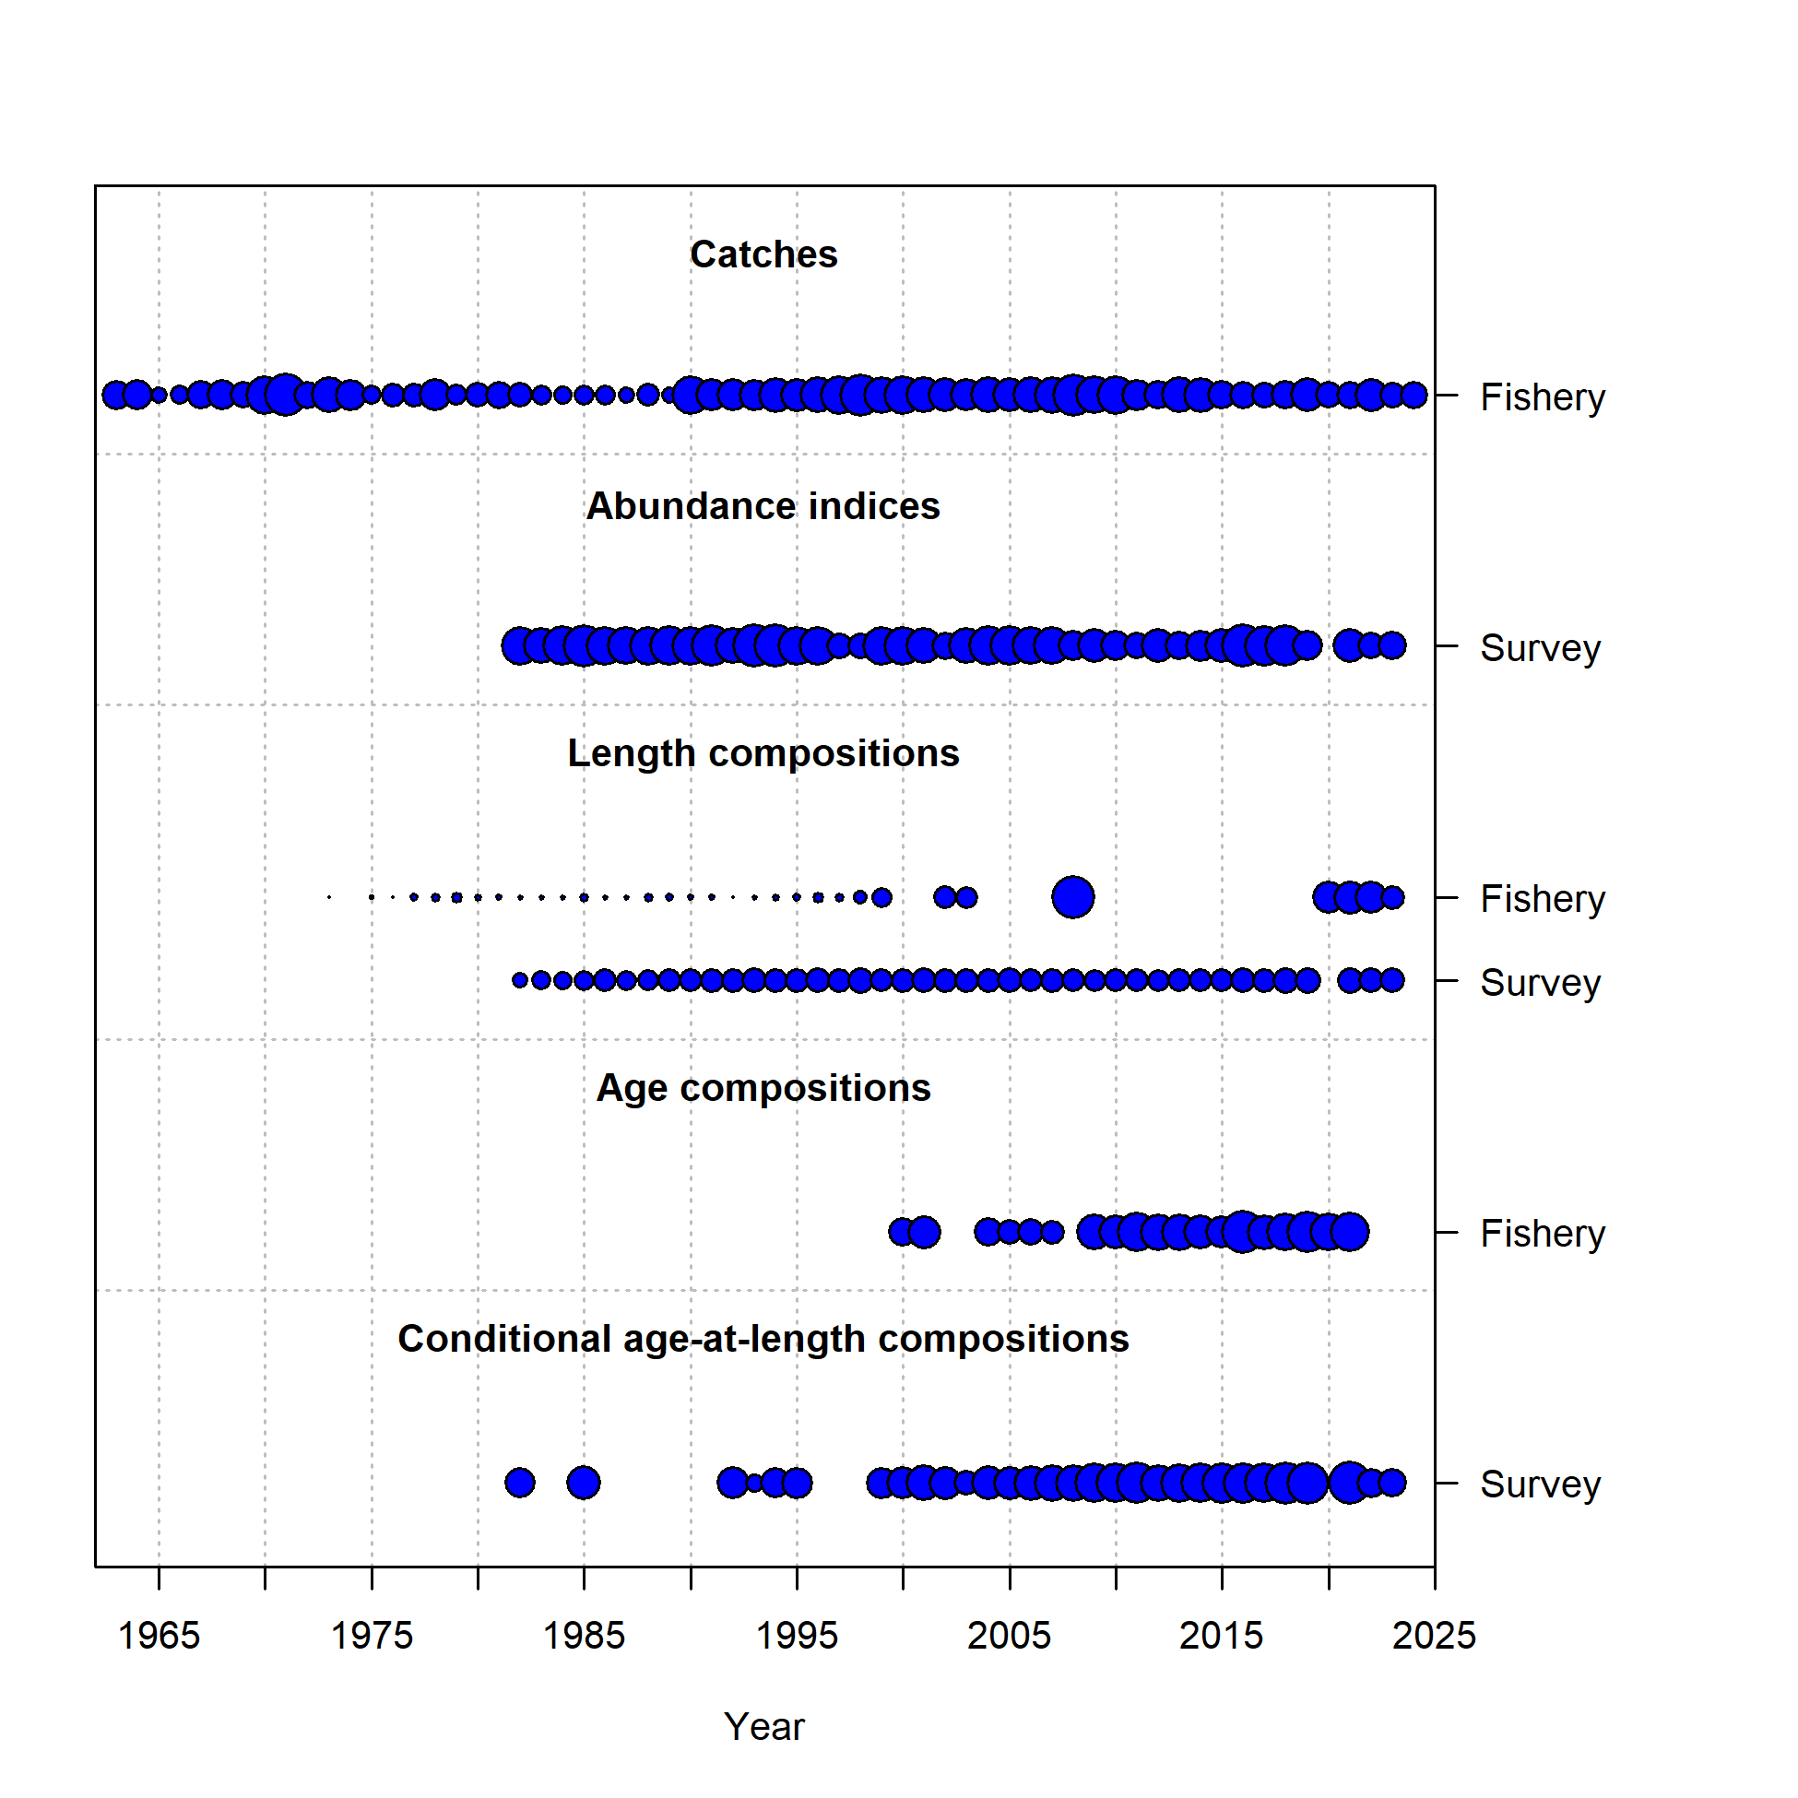

Figure 9.1. Data included in the update assessment, Model 18.2c (2024).

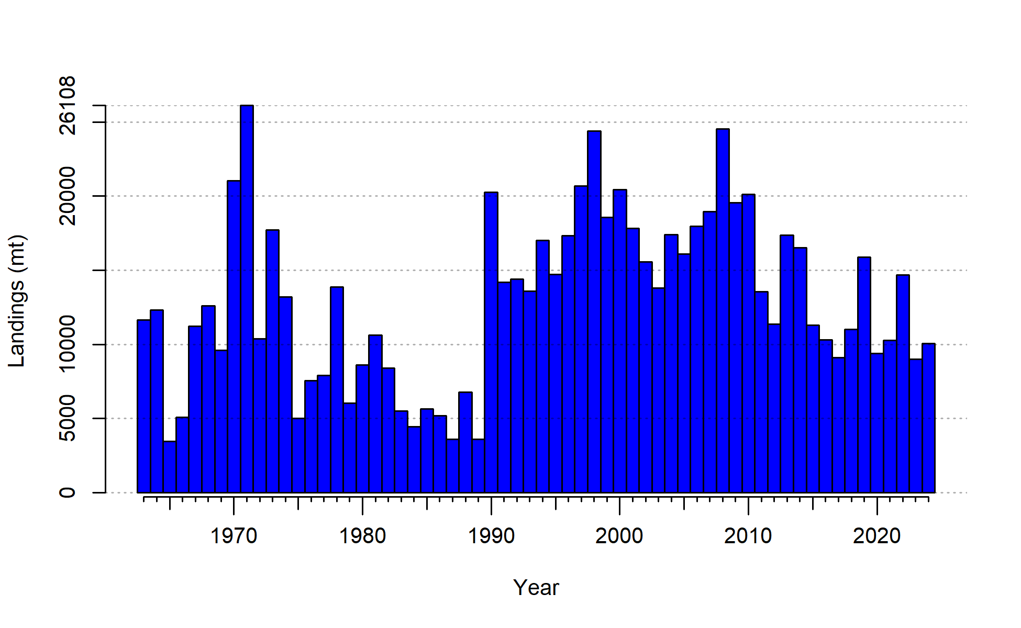

Figure 9.2. Observed catches for BSAI FHS.

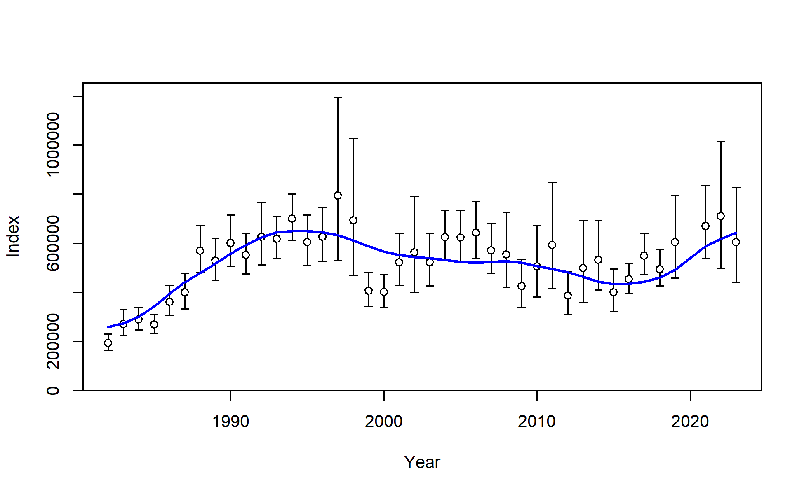

Figure 9.3. BS/AI Combined Trawl Survey observed biomass estimates with 95% sampling error confidence intervals for BSAI FHS (black points and vertical bars). Model expectations are shown in blue.

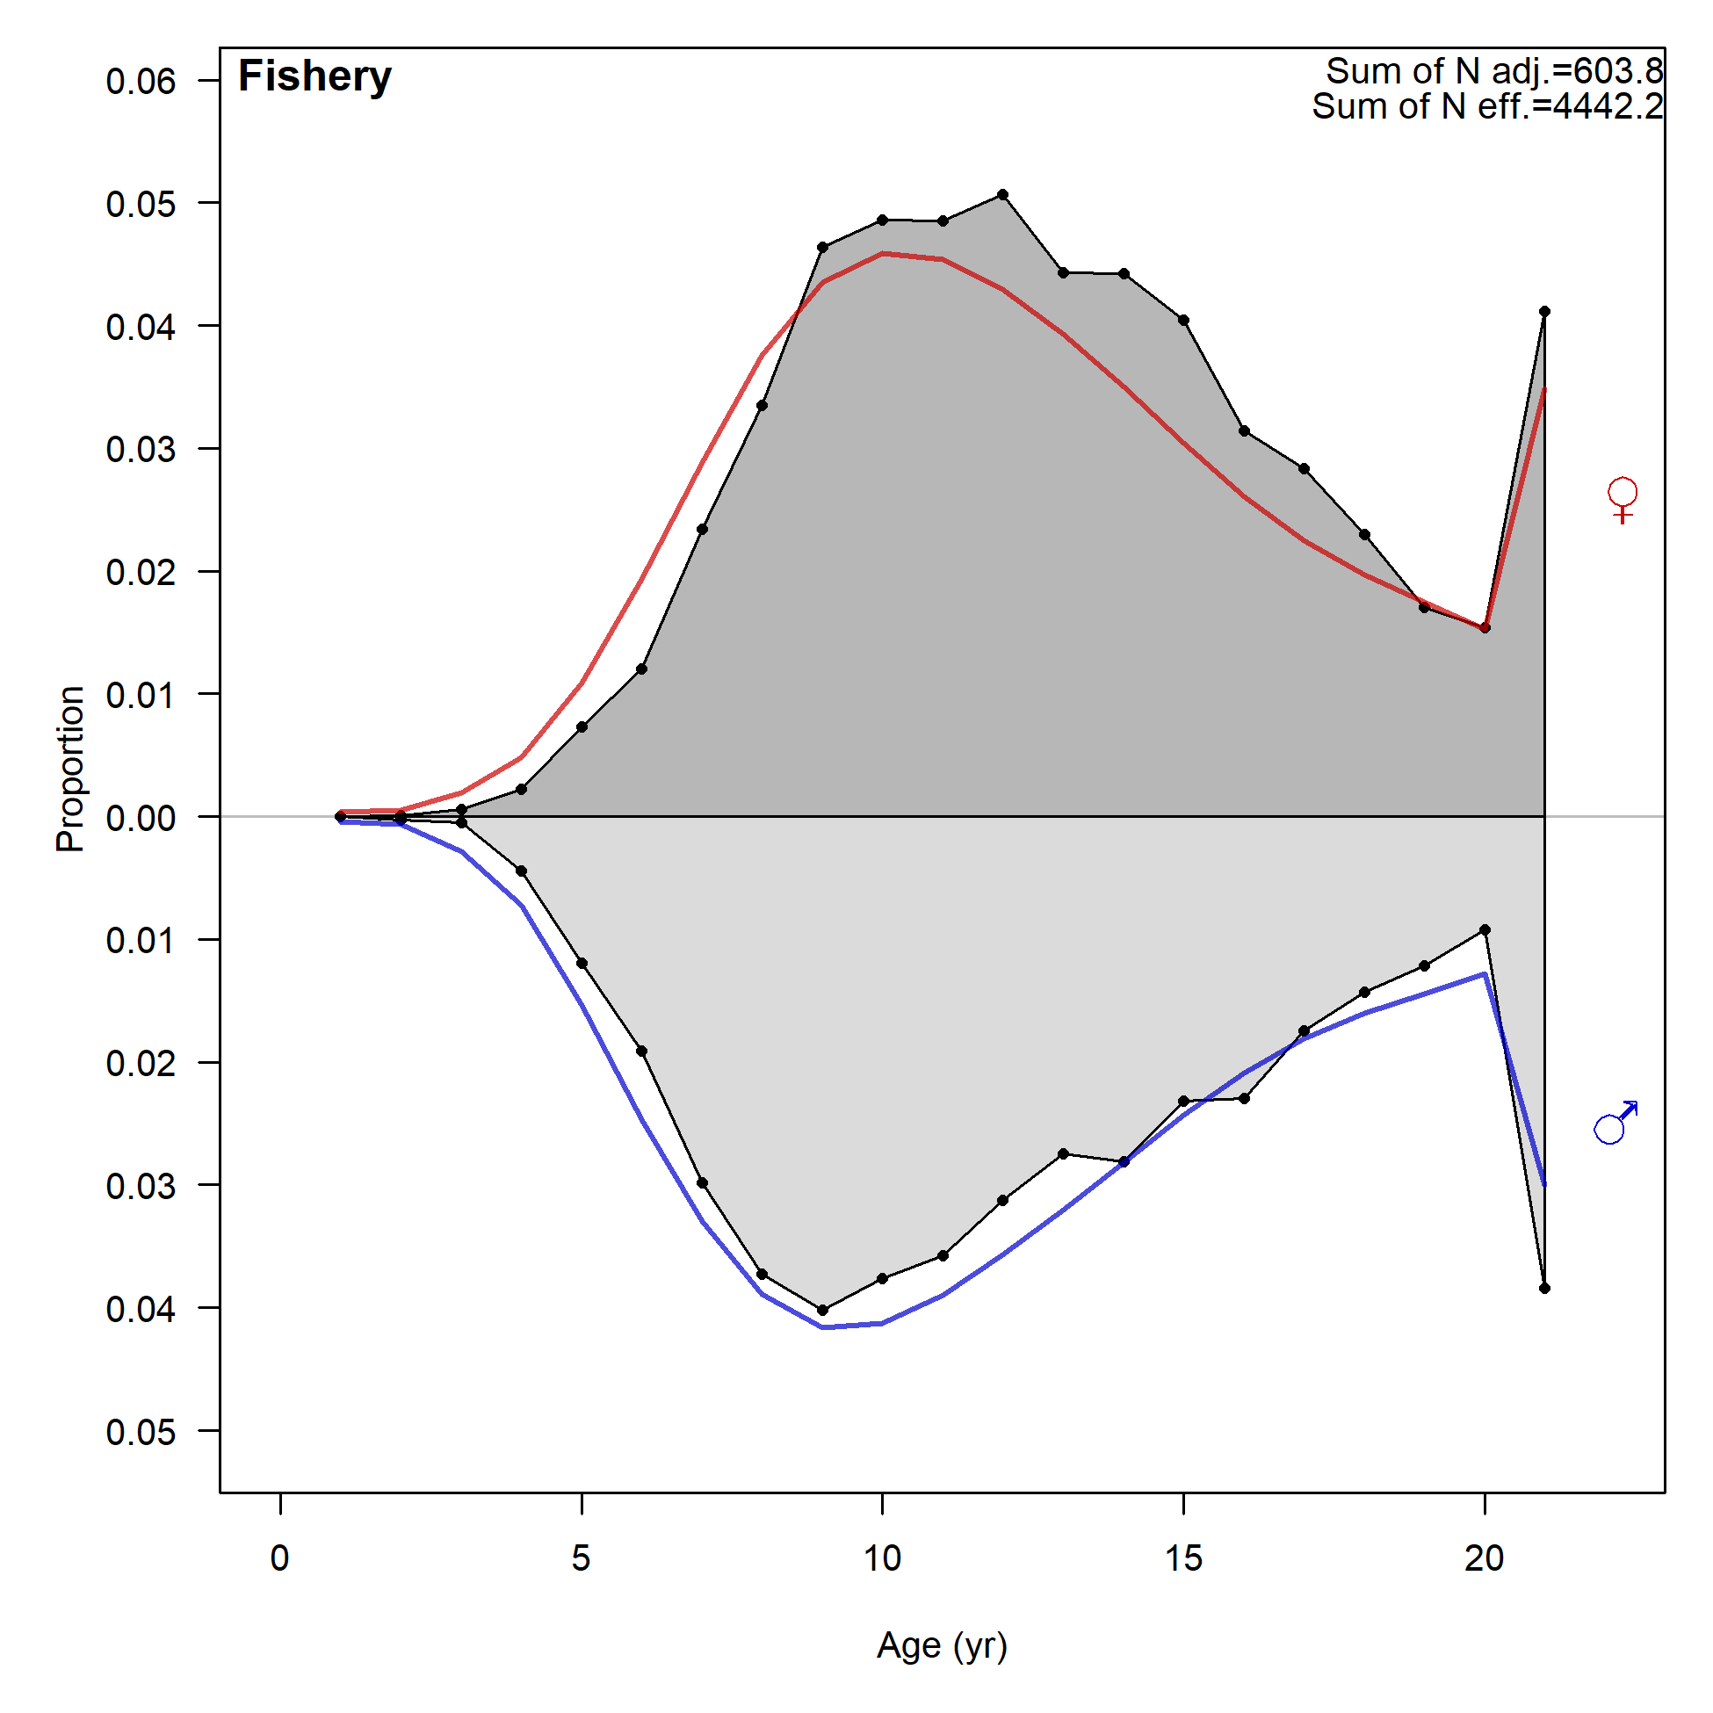

Figure 9.4. Observed (grey polygons) and predicted (colored lines) fishery age compositions for BSAI FHS, aggregated through time.

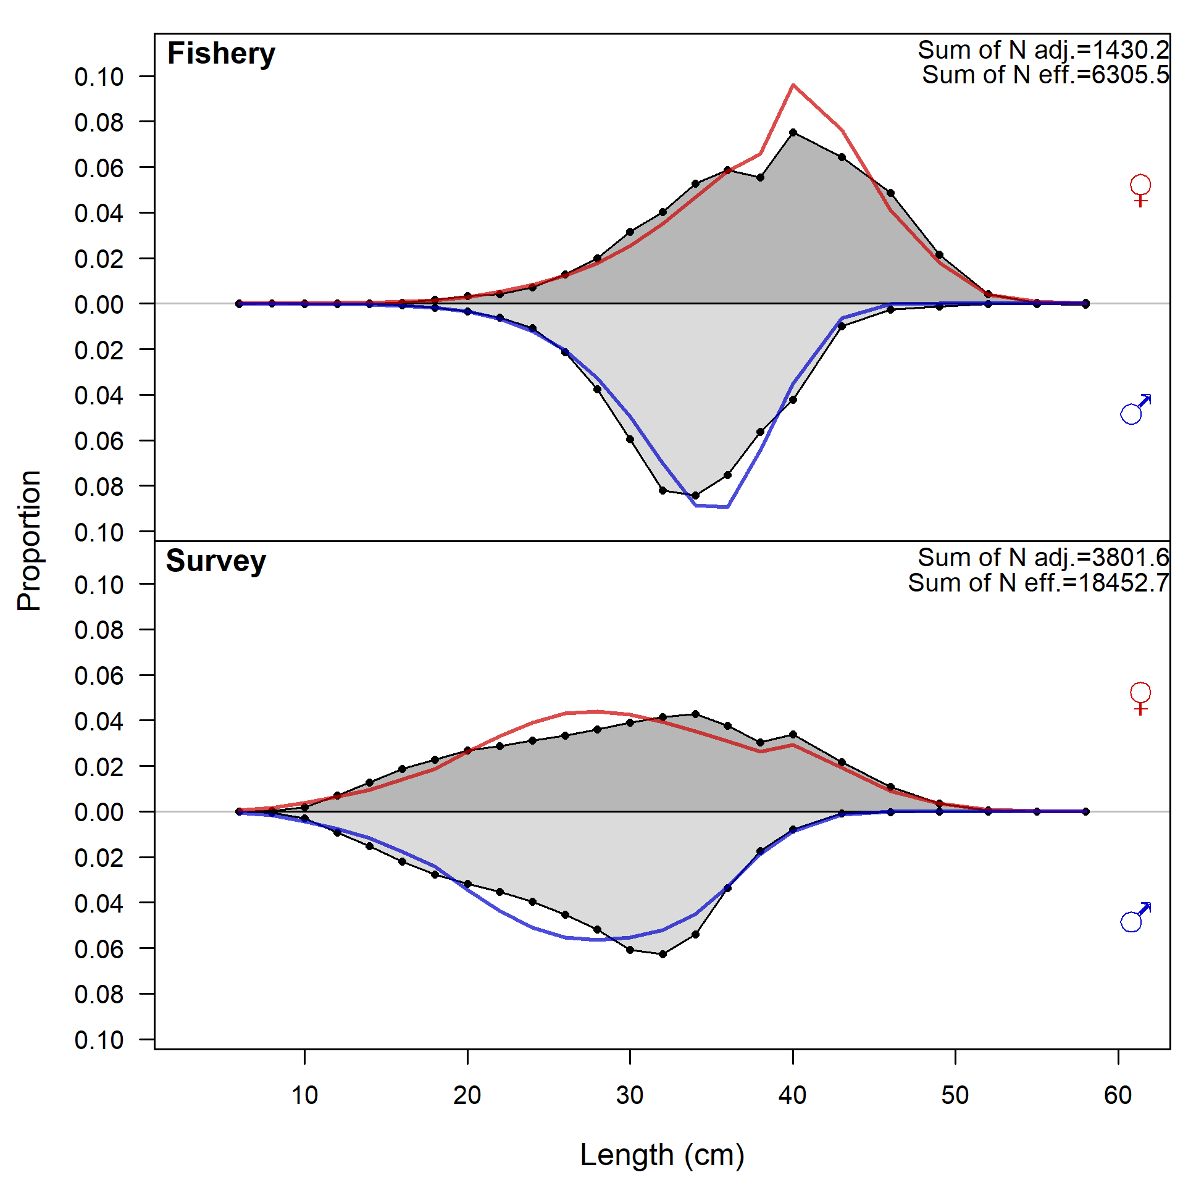

Figure 9.5. Observed (grey polygons) and predicted (colored lines) fishery and survey length (cm) compositions for BSAI FHS, aggregated through time. Note that many years of the Fishery length composition data are not included in the joint likelihood (in lieu of age compositions).

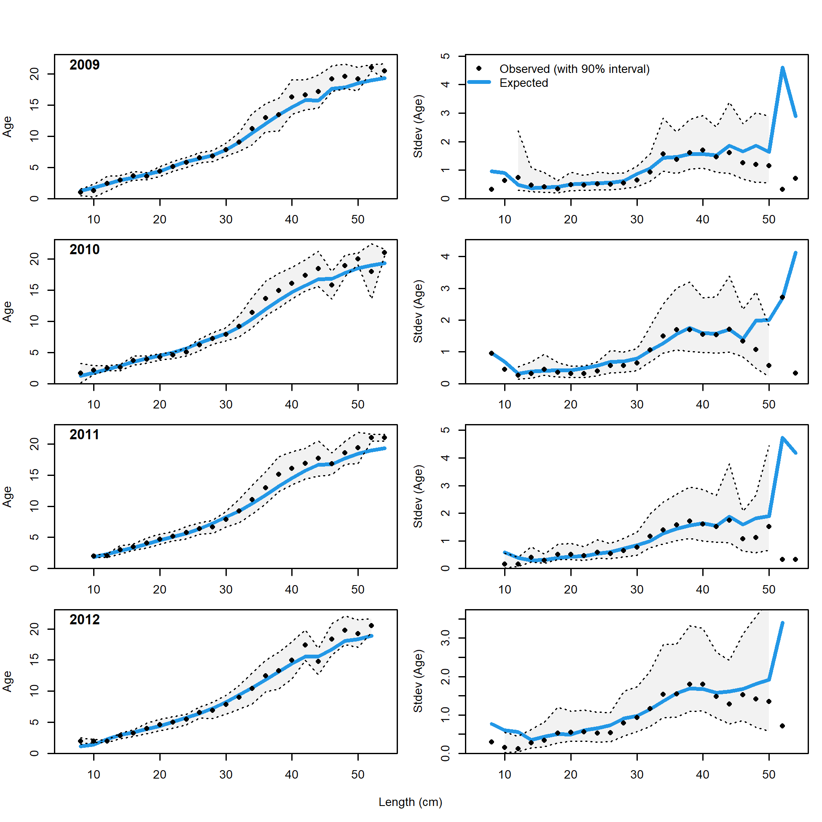

Figure 9.6. Observed and expected mean age-at-length for both females and males with 90% intervals about observed age-at-length (left panels) and observed and expected standard deviation in age-at-length (right panels) for Model 18.2c (2024) for years 2009-2012 (1 of 3).

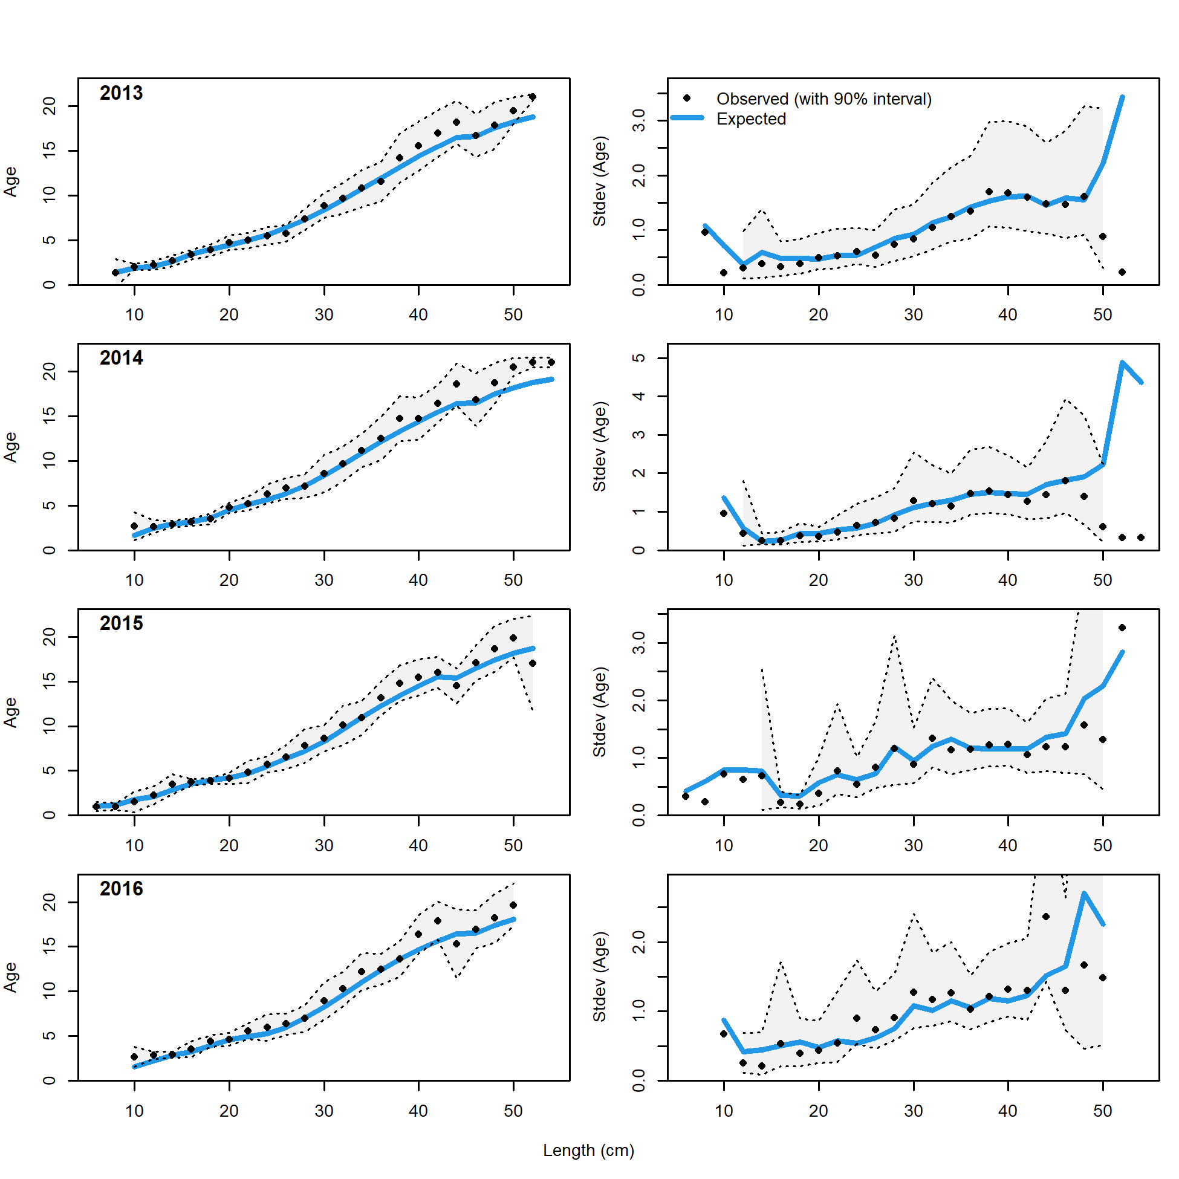

Figure 9.7. Observed and expected mean age-at-length for both females and males with 90% intervals about observed age-at-length (left panels) and observed and expected standard deviation in age-at-length (right panels) for Model 18.2c (2024) for years 2013-2016 (2 of 3).

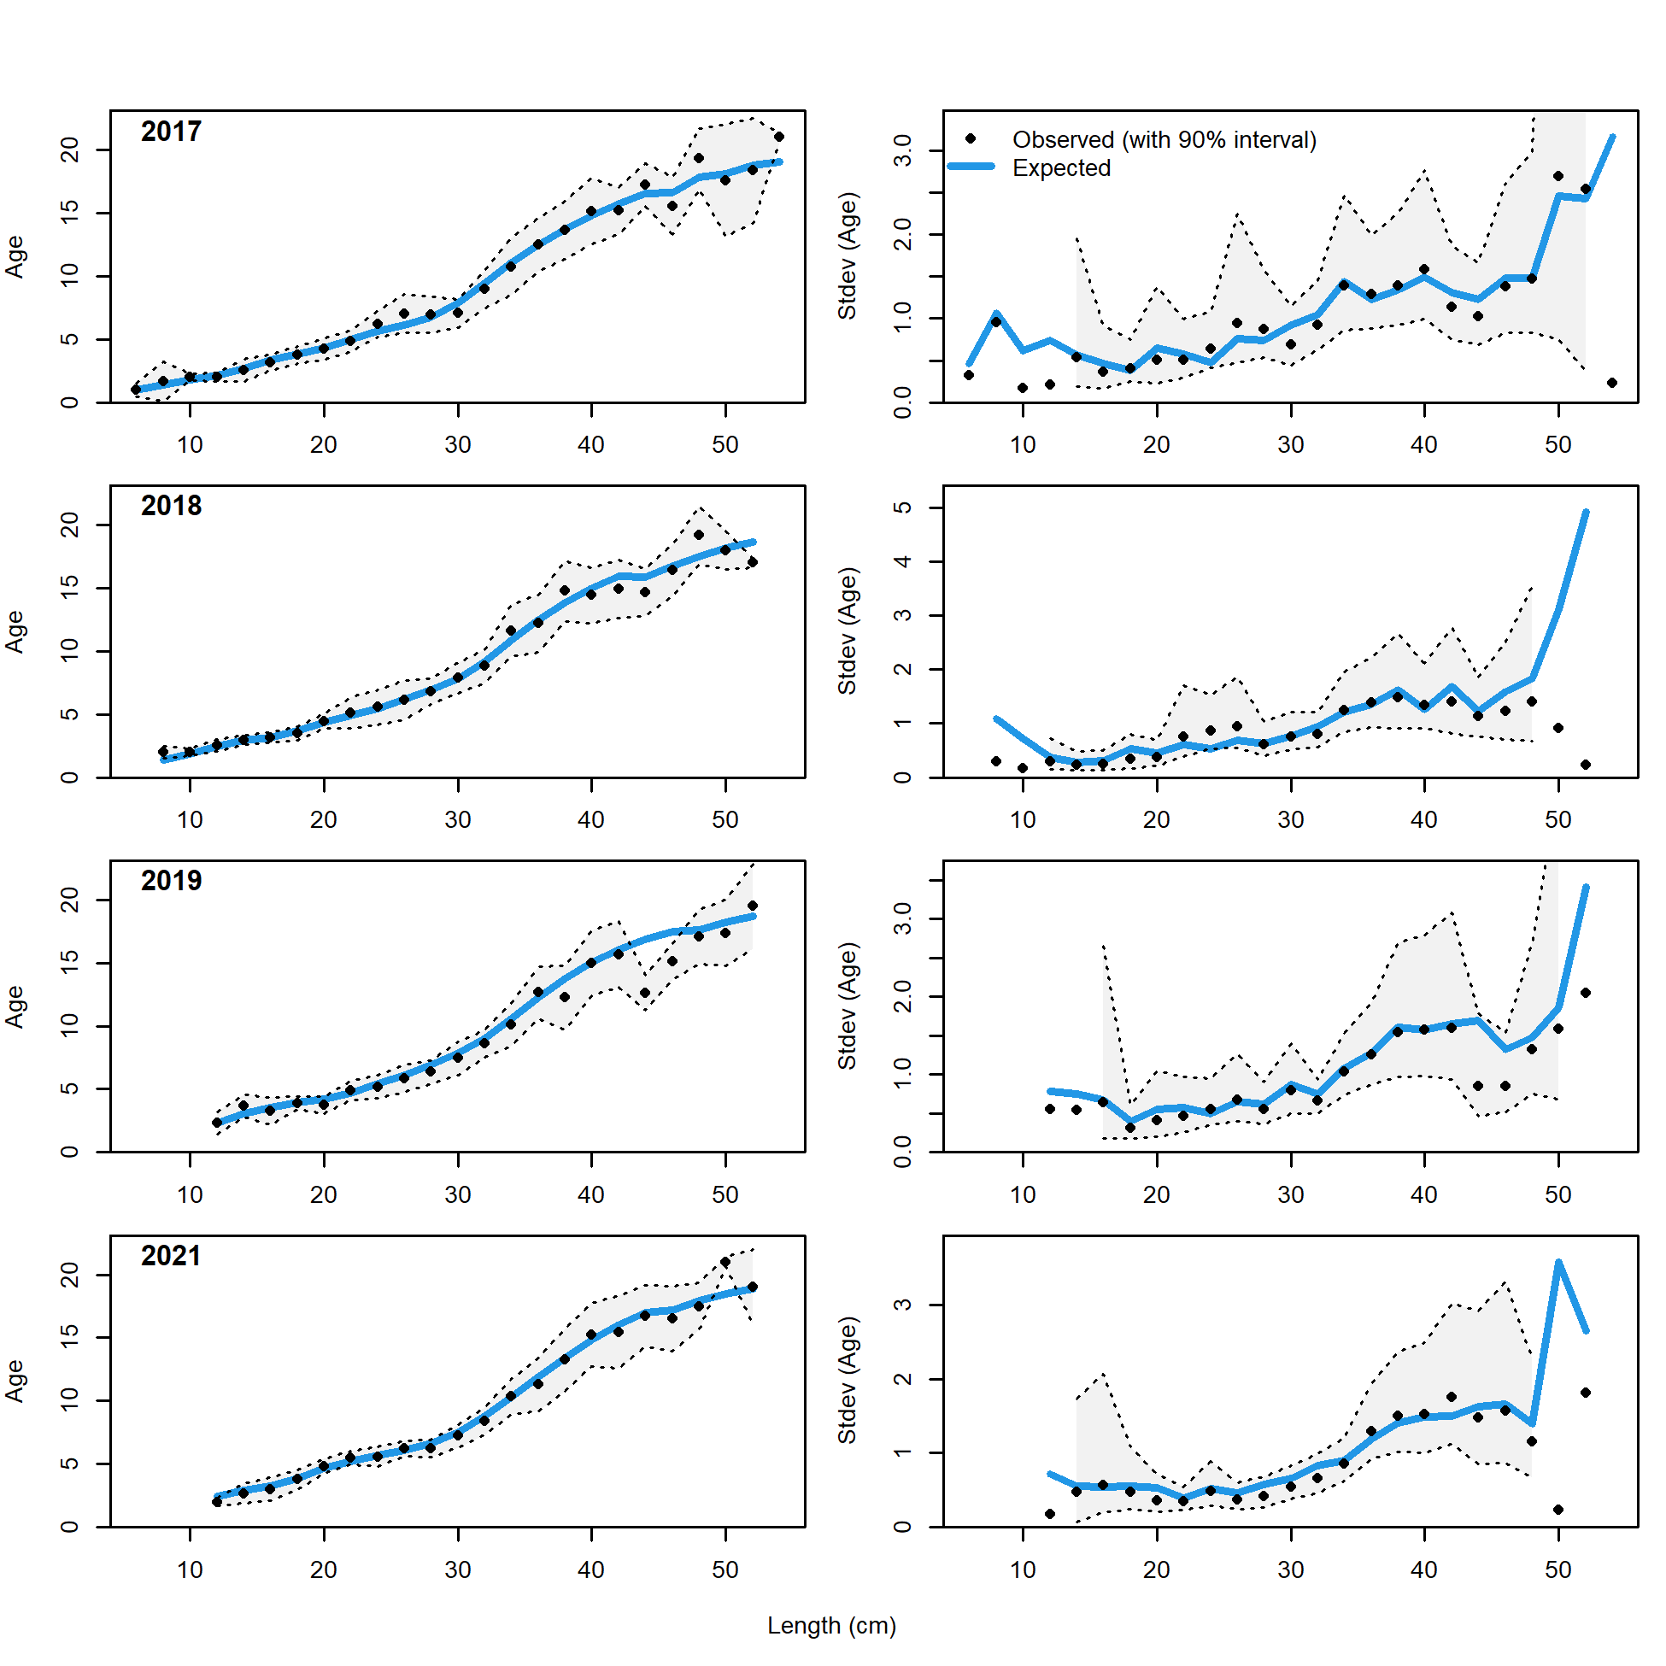

Figure 9.8. Observed and expected mean age-at-length for both females and males with 90% intervals about observed age-at-length (left panels) and observed and expected standard deviation in age-at-length (right panels) for Model 18.2c (2024) for years 2017-2021 (3 of 3).

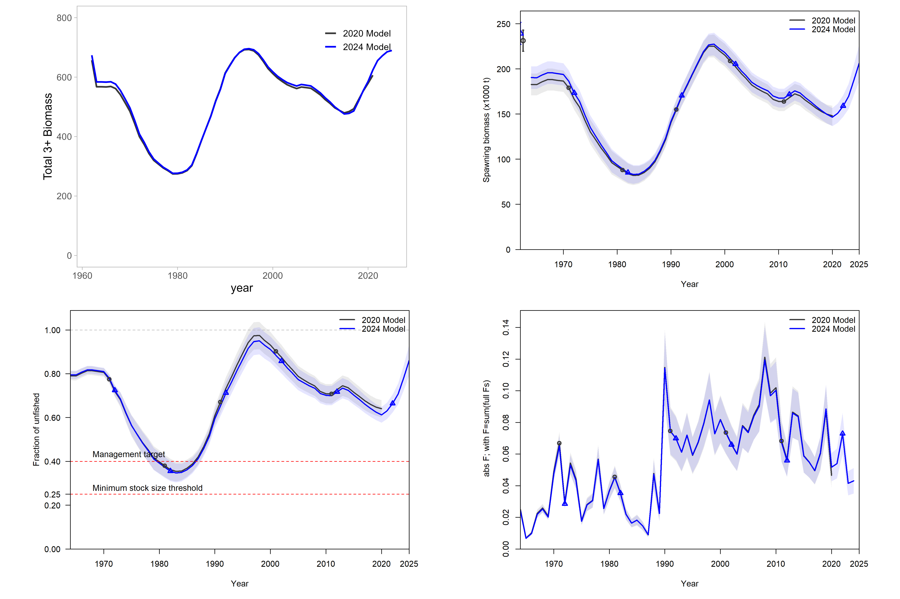

Figure 9.9. Comparison of spawning biomass, fishing mortality rates, and recruitment for the 2024 Update model (blue) and 2020 Full model (grey). The shaded ribbon represents the 95% quantile. Uncertainty intervals not available for total biomass.

|  |
| --- |
| Figure 9.10. Time series of recruitment deviations, from the 2024 base model (blue) and 2021 base model (grey), with 95% intervals. |

Figure 9.10. Time series of recruitment deviations, from the 2024 base model (blue) and 2021 base model (grey), with 95% intervals.

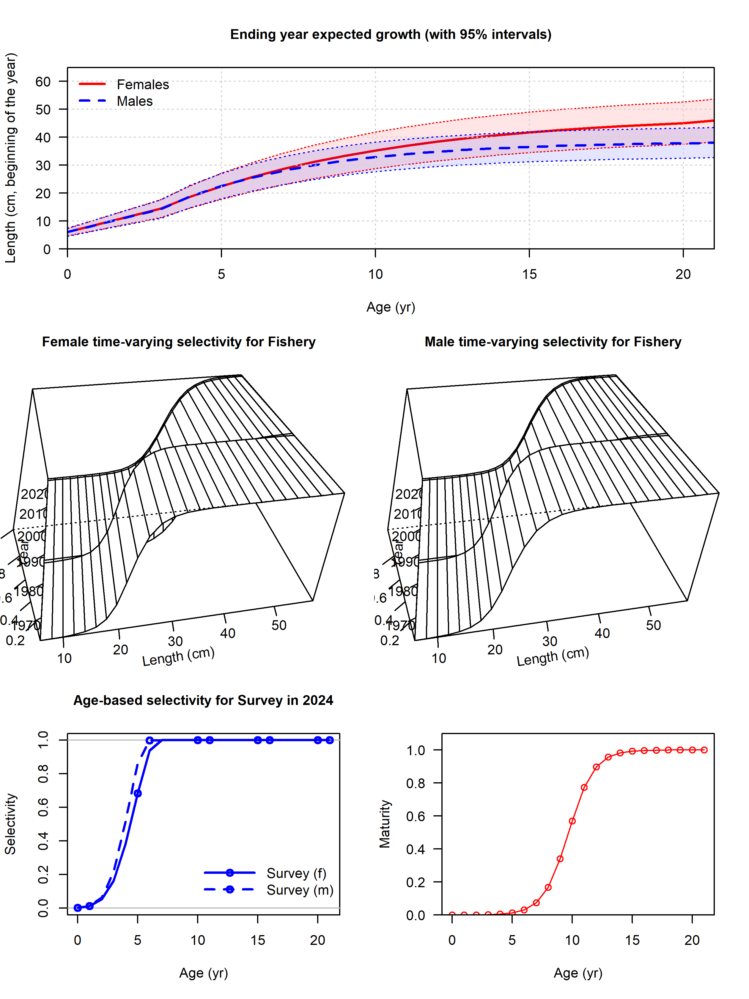

Figure 9.11. Estimated length- or age-based selectivity curves, and female maturity-at-age for BSAI FHS.

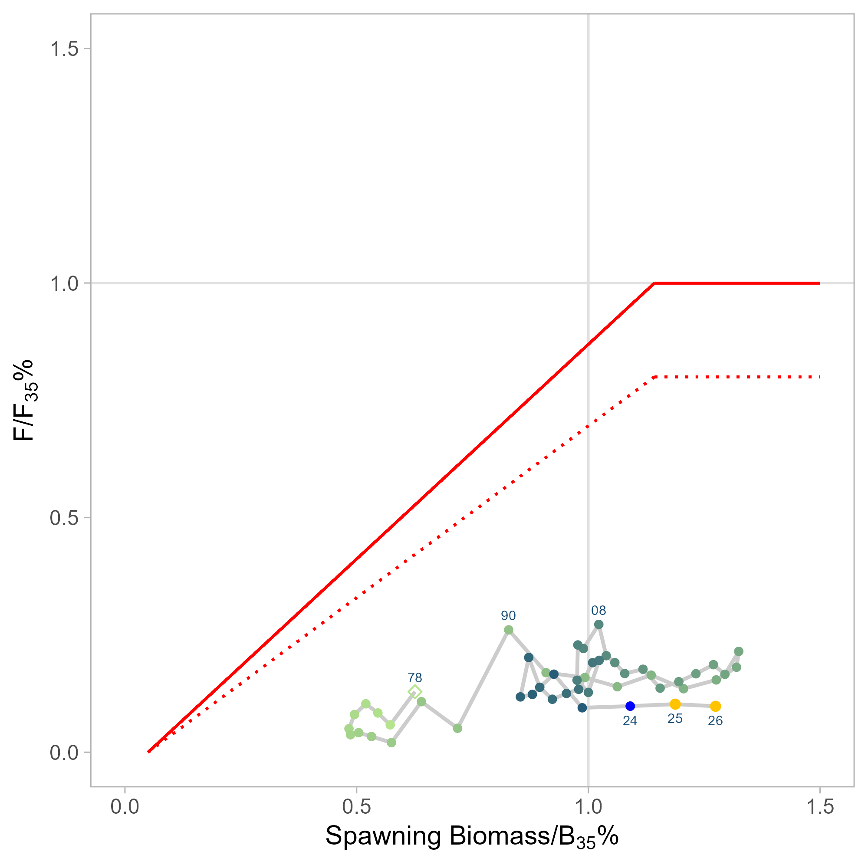

Figure 9.12. Time series of estimated fishing mortality versus estimated spawning stock biomass (phase-plane plot) for 1978-2026, including applicable OFL and maximum FABC definitions for the stock, including 2 years of projected values. Target levels correspond to B35% and F35% for author recommended model.