10. Assessment of the Assessment of the Flathead Sole-Bering Flounder Stock in the Bering Sea and Aleutian Islands Stock in the Gulf of Alaska

Kapur, and Maia S.

November 2023

# Executive Summary

“Flathead sole” as currently managed by the North Pacific Fishery Management Council (NPFMC) in the Bering Sea and Aleutian Islands (BSAI) represents a two-species complex consisting of true Flathead sole (Hippoglossoides elassodon) and its morphologically-similar congener Bering flounder (Hippoglossoides spp.). In 2012, the BSAI Groundfish Plan Team moved Flathead sole to a biennial stock assessment schedule because it has historically been lightly exploited. A full stock assessment report was most recently produced in 2020 (Monnahan and Haehn, <https://apps-afsc.fisheries.noaa.gov/refm/docs/2020/BSAIflathead.pdf>). A full assessment for BSAI Flathead sole was scheduled for 2022, but due to limited staff resources, a partial assessment is presented this year. In partial assessment years, an executive summary is presented to recommend harvest levels for the next two years, along with trends in catch and biomass.

Flathead sole is assessed using an age-structured model and Tier 3 determination. The single species projection model is run using parameter values from the accepted 2020 assessment model, together with updated catch information for 2020-2022 and estimated catches for 2023 and 2024-2025 (Figure 1), to predict stock status for Flathead sole in 2024-2025, and to make ABC recommendations and set OFL for those years.

## Summary of Changes in Assessment Inputs

This assessment used a single survey index of “total” Hippoglossoides spp. biomass that included the EBS “standard” survey areas and AI survey areas for the years 1982-2019 (Table 2). As was done in the 2020 full assessment (Monnohan et. al. 2020) and the 2022 partial assessment (Kapur 2021), we estimated a relationship between EBS shelf Hippoglossoides spp. survey biomass estimates and AI survey biomass estimates in years when no AI survey occurred. The estimation method uses the linear regression to find an AI biomass estimate in a particular year based on the EBS biomass estimate for that year. There were no AI surveys conducted in 2020 nor 2021, and AI biomass for those years was estimated with the linear equation. An Aleutian Islands survey was conducted in 2022, and the 2022 total BSAI estimate was 710,804 t, a roughly 6% increase over the 2021 regression estimate of 670,091 t (Figure 2).

To run the projection model to predict ABCs for 2024 and 2025, we used true, observed catches for 2020-2022 and estimates for the total catches in 2023-2025. Note that the 2020 catch used in the last benchmark model was itself an estimate (8,556), about 9% less than the finalized observation used for projections here. The catch for 2023 (8,811 t) was estimated by adding the average catch between Sep 27 and December 31 over the years 2017-2022 to the 2023 catch as of Sep 27, 2022. The 2024 and 2025 catches (12,246 t) were estimated as the average catch over the previous 5 years (2017-2022).

To ensure consistency with the most recent full assessment (Monnohan and Haehn, 2020), the projection model was parameterized using mean recruitment and stock spawning biomass for all years included in the assessment model (1964 onwards). Future full assessments for BSAI Flathead sole can consider updating these inputs in light of the determination of a regime shift in 1977, and subsequent recommendation that projections of future stock states should be based on year classes 1977 and forward.

# References

Kapur, M.S. 2021. 9. Assessment of the Flathead Sole-Bering flounder Stock in the Bering Sea and Aleutian Islands. In Stock Assessment and Fishery Evaluation Report for the Groundfish Resources of the Bering Sea/Aleutian Islands Region. North Pacific Fishery Management Council, P.O. Box 103136, Anchorage, Alaska 99510. Available at <https://apps-afsc.fisheries.noaa.gov/refm/docs/2021/BSAIflathead.pdf>.

Monnahan, C., and Haehn, R. 2020. 9. Assessment of the Flathead sole-Bering flounder stock complex in the Bering Sea and Aleutian Islands. In Stock Assessment and Fishery Evaluation Report for the Groundfish Resources of the Bering Sea/Aleutian Islands Region. North Pacific Fishery Management Council, P.O. Box 103136, Anchorage, Alaska 99510. Available at <https://apps-afsc.fisheries.noaa.gov/refm/docs/2020/BSAIflathead.pdf>

# Tables

Table 10-1. Catch (in tons) of Flathead sole and Bering flounder combined (Hippoglossoides elassodon) and Flathead sole only, and Bering flounder only. Observer data of species-specific extrapolated weight in each haul was summed over hauls within each year and used to calculate the proportion of the total Hippoglossoides spp. catch that was Flathead sole or Bering flounder. Proportions were multiplied by the total Hippoglossoides spp. (Flathead sole and Bering flounder combined) catches reported by AKFIN to obtain total catch of Flathead sole separately from that of Bering flounder. The 2023 catches are current as of Oct 19, 2023 and the value shown below does not include projections through the end of the year.

| Year | Total Hippoglossoides spp. | Flathead Sole | Bering Flounder |
| --- | --- | --- | --- |
| 1992 | 4 | 4 | 0 |
| 1995 | 14,715 | 14,710 | 4 |
| 1996 | 17,346 | 17,341 | 5 |
| 1997 | 20,683 | 20,678 | 5 |
| 1998 | 24,387 | 24,381 | 7 |
| 1999 | 18,573 | 18,553 | 20 |
| 2000 | 20,441 | 20,408 | 33 |
| 2001 | 17,811 | 17,795 | 16 |
| 2002 | 15,575 | 15,550 | 25 |
| 2003 | 13,785 | 13,767 | 18 |
| 2004 | 17,398 | 17,374 | 24 |
| 2005 | 16,108 | 16,077 | 31 |
| 2006 | 17,981 | 17,975 | 6 |
| 2007 | 18,958 | 18,952 | 6 |
| 2008 | 24,540 | 24,526 | 14 |
| 2009 | 19,558 | 19,530 | 28 |
| 2010 | 20,127 | 20,101 | 26 |
| 2011 | 13,557 | 13,536 | 20 |
| 2012 | 11,365 | 11,359 | 6 |
| 2013 | 17,353 | 17,272 | 80 |
| 2014 | 16,511 | 16,478 | 33 |
| 2015 | 11,306 | 11,273 | 33 |
| 2016 | 10,313 | 10,301 | 12 |
| 2017 | 9,111 | 9,107 | 3 |
| 2018 | 11,007 | 11,001 | 5 |
| 2019 | 15,880 | 15,879 | 1 |
| 2020 | 9,392 | 9,389 | 3 |
| 2021 | 10,260 | 10,255 | 4 |
| 2022 | 14,690 | 14,687 | 2 |
| 2023 | 7,716 | 7,714 | 2 |

Table 10-2. Survey biomass in tons and coefficient of variation (CV) of Hippoglossoides spp. (combined Flathead sole and Bering flounder) across the entire BSAI; Flathead sole only in the Aleutian Islands, Hippoglossoides spp. combined in the Eastern Bering Sea (EBS) shelf survey, Flathead sole only in EBS shelf survey, and Bering flounder only in the EBS shelf survey. Slight discrepancies in totals may occur due to rounding.

| Year | Biomass (Total) | CV (Total) | Biomass (AI) | CV (AI) | Biomass (EBS, all) | CV (EBS, all) | Biomass (EBS, flathead) | CV (EBS, flathead) | Biomass (EBS, Bering Flounder) | CV (EBS, Bering Flounder) |
| --- | --- | --- | --- | --- | --- | --- | --- | --- | --- | --- |
| 1982 | 194,495 | 0.09 |  |  | 191,343 | 0.09 | 191,343 | 0.09 | 0 |  |
| 1983 | 271,475 | 0.10 | 1,213 | 0.19 | 270,262 | 0.10 | 251,978 | 0.11 | 18,283 | 0.20 |
| 1984 | 289,521 | 0.08 |  |  | 284,782 | 0.08 | 269,777 | 0.09 | 15,005 | 0.21 |
| 1985 | 269,266 | 0.07 |  |  | 264,865 | 0.07 | 251,534 | 0.08 | 13,332 | 0.12 |
| 1986 | 362,170 | 0.09 | 5,245 | 0.16 | 356,925 | 0.09 | 343,011 | 0.09 | 13,914 | 0.17 |
| 1987 | 399,227 | 0.09 |  |  | 392,657 | 0.09 | 378,525 | 0.10 | 14,132 | 0.14 |
| 1988 | 569,809 | 0.09 |  |  | 560,392 | 0.09 | 537,372 | 0.09 | 23,020 | 0.22 |
| 1989 | 528,394 | 0.08 |  |  | 519,668 | 0.08 | 500,932 | 0.09 | 18,737 | 0.20 |
| 1990 | 601,749 | 0.09 |  |  | 591,798 | 0.09 | 572,543 | 0.09 | 19,256 | 0.15 |
| 1991 | 552,288 | 0.08 | 6,939 | 0.20 | 545,349 | 0.08 | 517,825 | 0.08 | 27,524 | 0.22 |
| 1992 | 626,811 | 0.10 |  |  | 616,443 | 0.10 | 601,311 | 0.11 | 15,131 | 0.21 |
| 1993 | 617,258 | 0.07 |  |  | 607,049 | 0.07 | 584,834 | 0.07 | 22,215 | 0.21 |
| 1994 | 699,446 | 0.07 | 9,935 | 0.22 | 689,511 | 0.07 | 663,853 | 0.07 | 25,658 | 0.19 |
| 1995 | 603,875 | 0.09 |  |  | 593,889 | 0.09 | 578,457 | 0.09 | 15,432 | 0.18 |
| 1996 | 626,314 | 0.09 |  |  | 615,954 | 0.09 | 603,979 | 0.09 | 11,975 | 0.20 |
| 1997 | 794,426 | 0.21 | 11,554 | 0.23 | 782,871 | 0.21 | 768,815 | 0.21 | 14,056 | 0.19 |
| 1998 | 693,723 | 0.20 |  |  | 682,237 | 0.20 | 674,412 | 0.20 | 7,825 | 0.21 |
| 1999 | 407,164 | 0.09 |  |  | 400,462 | 0.09 | 387,311 | 0.09 | 13,151 | 0.18 |
| 2000 | 401,106 | 0.09 | 8,906 | 0.23 | 392,199 | 0.09 | 384,011 | 0.09 | 8,188 | 0.19 |
| 2001 | 522,844 | 0.10 |  |  | 514,211 | 0.10 | 502,853 | 0.11 | 11,358 | 0.21 |
| 2002 | 562,073 | 0.17 | 9,898 | 0.24 | 552,175 | 0.18 | 547,271 | 0.18 | 4,904 | 0.19 |
| 2003 | 522,935 | 0.10 |  |  | 514,300 | 0.10 | 508,617 | 0.11 | 5,684 | 0.21 |
| 2004 | 624,805 | 0.08 | 13,298 | 0.14 | 611,507 | 0.09 | 603,449 | 0.09 | 8,058 | 0.31 |
| 2005 | 622,249 | 0.08 |  |  | 611,956 | 0.09 | 604,878 | 0.09 | 7,078 | 0.28 |
| 2006 | 643,731 | 0.09 | 9,664 | 0.17 | 634,067 | 0.09 | 620,215 | 0.09 | 13,852 | 0.31 |
| 2007 | 571,280 | 0.09 |  |  | 561,838 | 0.09 | 551,415 | 0.09 | 10,423 | 0.21 |
| 2008 | 553,591 | 0.14 |  |  | 544,445 | 0.14 | 534,364 | 0.14 | 10,080 | 0.19 |
| 2009 | 425,216 | 0.12 |  |  | 418,213 | 0.12 | 411,584 | 0.12 | 6,629 | 0.17 |
| 2010 | 506,197 | 0.14 | 11,812 | 0.30 | 494,386 | 0.15 | 487,798 | 0.15 | 6,588 | 0.15 |
| 2011 | 593,351 | 0.18 |  |  | 583,541 | 0.18 | 576,761 | 0.19 | 6,779 | 0.15 |
| 2012 | 386,892 | 0.11 | 5,566 | 0.15 | 381,326 | 0.12 | 374,716 | 0.12 | 6,610 | 0.14 |
| 2013 | 498,784 | 0.17 |  |  | 490,553 | 0.17 | 484,866 | 0.17 | 5,687 | 0.14 |
| 2014 | 532,889 | 0.13 | 13,436 | 0.14 | 519,453 | 0.14 | 509,842 | 0.14 | 9,611 | 0.17 |
| 2015 | 399,247 | 0.11 |  |  | 392,677 | 0.11 | 381,696 | 0.12 | 10,981 | 0.17 |
| 2016 | 452,785 | 0.07 | 6,759 | 0.15 | 446,026 | 0.07 | 433,243 | 0.07 | 12,783 | 0.23 |
| 2017 | 549,293 | 0.08 |  |  | 540,218 | 0.08 | 530,982 | 0.08 | 9,236 | 0.22 |
| 2018 | 494,579 | 0.08 | 6,930 | 0.11 | 487,649 | 0.08 | 484,144 | 0.08 | 3,505 | 0.16 |
| 2019 | 604,109 | 0.14 |  |  | 594,119 | 0.14 | 592,039 | 0.14 | 2,080 | 0.32 |
| 2021 | 670,091 | 0.11 |  |  | 659,000 | 0.11 | 657,321 | 0.12 | 1,679 | 0.31 |
| 2022 | 710,804 | 0.18 | 10,897 | 0.19 | 699,906 | 0.18 | 697,296 | 0.18 | 2,610 | 0.27 |
| 2023 | 604,522 | 0.16 |  |  | 594,525 | 0.16 | 592,141 | 0.16 | 2,384 | 0.20 |

Table 10-3. Northern Bering Sea survey biomass (t) and coefficient of variation (CV) for Flathead sole, Bering flounder, and the two combined (Hippoglossoides spp.). These data are presented here for reference only.

| Year | Biomass (Total) | CV (Total) | Biomass (NBS, flathead) | CV (NBS, flathead) | Biomass (NBS, Bering Flounder) | CV (NBS, Bering Flounder) |
| --- | --- | --- | --- | --- | --- | --- |
| 2010 | 12,355 | 0.17 | 0 |  | 12,355 | 0.17 |
| 2017 | 19,882 | 0.21 | 79 | 0.65 | 19,804 | 0.21 |
| 2019 | 18,989 | 0.18 | 463 | 0.33 | 18,526 | 0.19 |
| 2021 | 8,523 | 0.21 | 138 | 0.78 | 8,384 | 0.22 |
| 2022 | 6,039 | 0.15 | 126 | 0.61 | 5,913 | 0.15 |
| 2023 | 4,749 | 0.18 | 45 | 0.57 | 4,704 | 0.18 |

# Figures

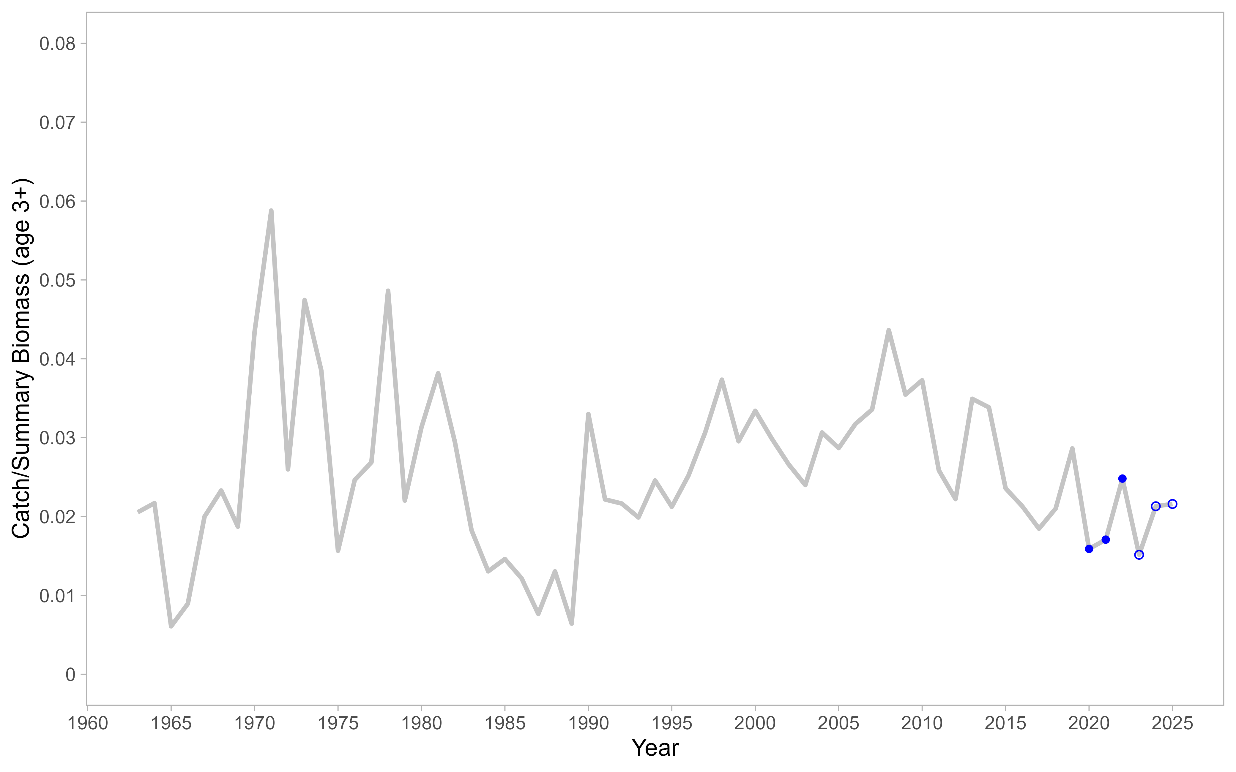

Figure 10-1. Catch to total biomass ratio using total biomass for age 3+ individuals for Flathead sole in the Bering Sea and Aleutian Islands. Points include observed (closed points) or estimated (open points) catches for years 2020-2024.

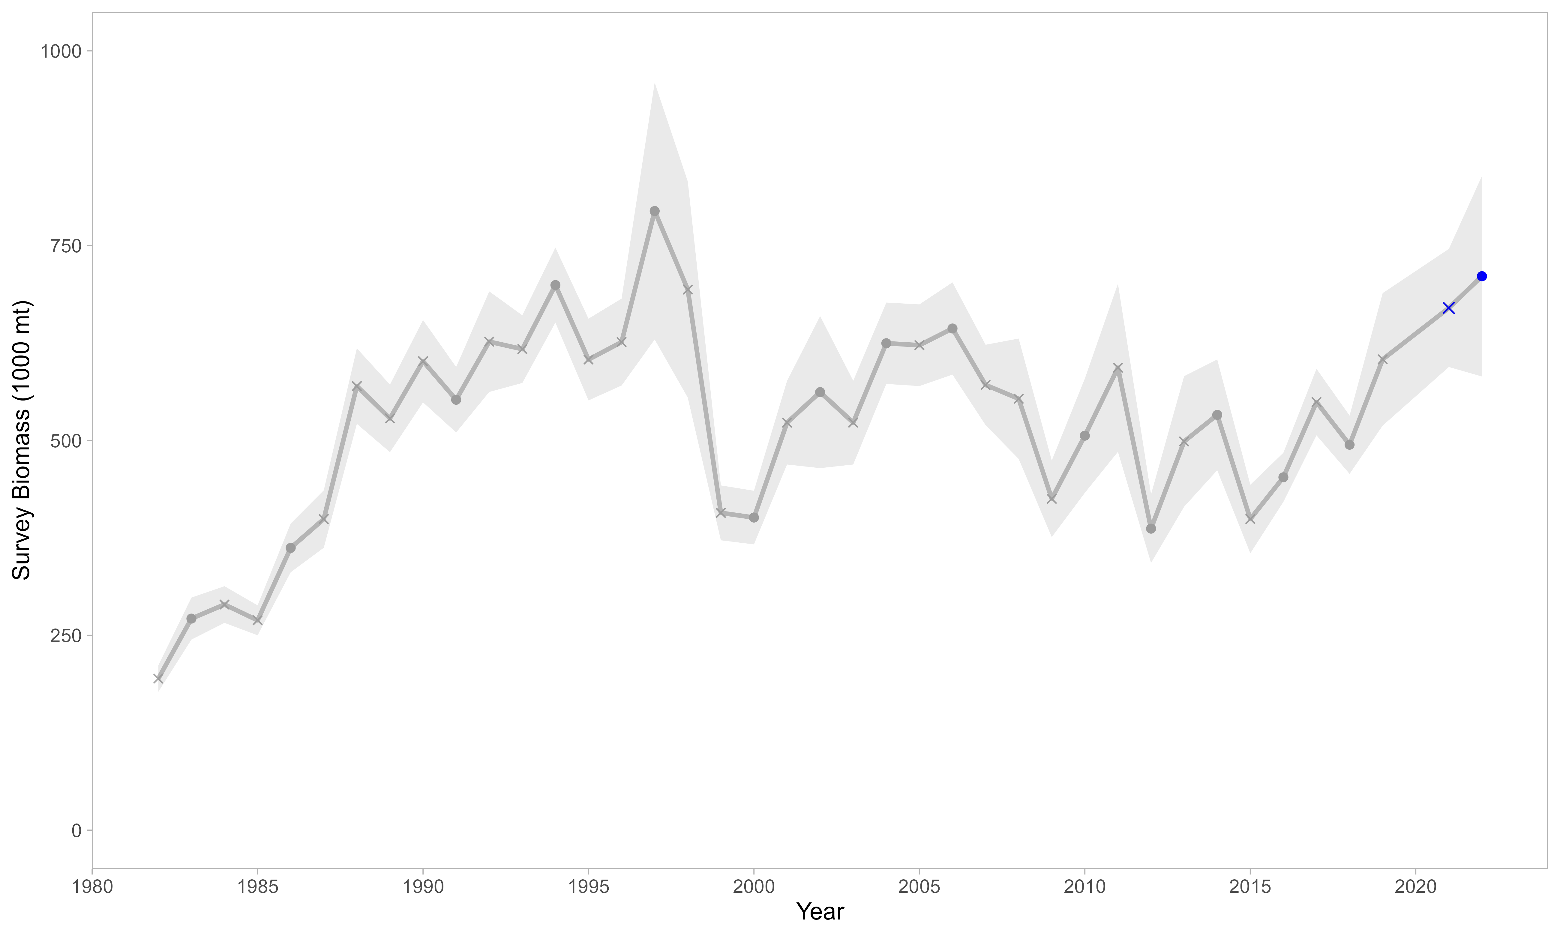

Figure 10-2. Survey biomass from the EBS shelf and Aleutian Islands surveys for station depths less than or equal to 200 meters. Grey and blue points include true observations. A linear regression was used to estimate a relationship between EBS shelf Hippoglossoides spp. survey biomass estimates and AI survey biomass estimates in years when no AI survey occurred (‘x’ marks). Grey shading indicates ± 1 standard error. Blue points and ‘x’ marks indicate the survey biomass in 2021 and 2022.

Author’s note: Changes have been made to the survey data in the stratum-area files, which affects biomass and abundance estimates for EBS data (all years and species, Duane Stevenson, AFSC). A visual comparison of EBS Flathead survey values from a 2021 data pull vs. the values shown above indicated that the effect of the strata update was negligible. Future benchmark assessments for this species should update the entire survey time series, for consistency.