Does temperature affect the growth in Yellowfin Sole?

Ingrid Spies

3/4/2022

## Background

Year-class strength of flatfishes is thought to be determined during the first few years of life between the pelagic egg and benthic settlement (van der Veer et al., 2015). Temperature in the early life stages can affect egg size, larval duration, size at settlement, as well as the size of suitable nursery habitat (Yeung and Cooper 2019). It has been hypothesized that colder bottom temperatures delay migration and spawning in Yellowfin Sole. As a result, mature individuals may reside in nearshore nursery grounds during months in which the NMFS survey occurs, which likely decreases survey biomass estimates during cold years (Nichol et al., 2019; Yeung and Cooper 2019).

YFS may be less sensitive to temperature due to their settlement timing, relative to Northern Rock Sole, which seems to be sensitive to temperature. YFS settle later in summer, when the influence of the cold pool is weaker and nearshore bottom temperature is relatively stable and high (Yeung and Yang, 2018). In contrast, YFS migrate across the shelf to spawn near their nursery habitat, rather than relying on currents for larval transport to nursery habitat (Nichol and Acuna, 2001); therefore, their larvae may be less susceptible to variable currents (Yeung and Cooper 2019).

There is some evidence of temperature-dependent growth by Yellowfin sole (Yeung et al. 2021). It appears that YFS remain in the shallow nearshore nursery areas through at least their first 2 years post-settlement. They begin to disperse offshore age 3-5 and by 5-8 years they follow adult migratory patterns. There is also evidence that Yellowfin Sole have been growing larger in part of a trend over the past 5 decades (Figure 1, Figure 2). There is no strong evidence thus far that Yellowfin sole have shifted distribution in response to climate change. Research on this topic includes beam trawl studies to better sample YFS throughout their distribution. Some tolerance to temperatures may be explained by observations that Yellowfin sole settle later in summer, when the influence of the cold pool is weaker and nearshore bottom temperature is relatively stable and high (Yeung and Cooper 2019). Therefore, an investigation of temperature-mediated growth is warranted as a covariate in the model. Currently, weight at age is incorporated in the model based on survey weight at age data.

Mean survey weight at age shown in Figure 3 seems to correlate closely with temperature anomalies at some ages (4, 5) but not other ages (8 and others not shown) . Why is this?

Compare the size data in agetmp with what you used for cor.tmp

From Matta et al.2010 Final chronologies were compared to annual and monthly climate variables including water temperature, ice cover, the Pacific Decadal Oscillation, and the El Ni o Southern Oscillation. Of the climate indices examined, chronologies were most strongly related to summertime eastern Bering Sea bottom temperatures, with R2 values of 0.81, 0.61, and 0.34 for the yellowfin sole, Alaska plaice, and northern rock sole chronologies, respectively. Thisi s why we compared to Bering Sea bottom temperatures.

# Figures

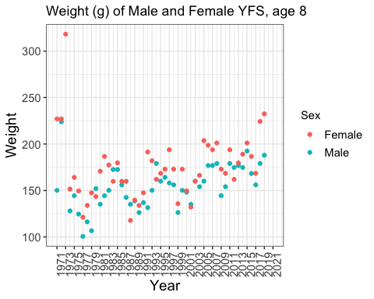

Figure 1: Mean weight at age (g) for Yellowfin Sole Age 8 females and males from the Eastern Bering Sea survey, 1971-2019. High values early in the time series are likely outliers.

Does weight go up over time since 1971? Yes it is significant for males,

##   
## Call:  
## lm(formula = LW2MF8$Weight[1:50] ~ seq(1, 50, 1))  
##   
## Residuals:  
## Min 1Q Median 3Q Max   
## -39.138 -12.227 -0.325 9.503 88.173   
##   
## Coefficients:  
## Estimate Std. Error t value Pr(>|t|)   
## (Intercept) 134.1762 6.2622 21.426 < 2e-16 ***  
## seq(1, 50, 1) 0.7931 0.2158 3.675 0.00062 ***  
## ---  
## Signif. codes: 0 '***' 0.001 '**' 0.01 '*' 0.05 '.' 0.1 ' ' 1  
##   
## Residual standard error: 20.82 on 46 degrees of freedom  
## (2 observations deleted due to missingness)  
## Multiple R-squared: 0.2269, Adjusted R-squared: 0.2101   
## F-statistic: 13.5 on 1 and 46 DF, p-value: 0.0006198

and significant for females

##   
## Call:  
## lm(formula = LW2MF8$Weight[51:100] ~ seq(1, 50, 1))  
##   
## Residuals:  
## Min 1Q Median 3Q Max   
## -54.572 -17.907 -4.146 15.513 150.589   
##   
## Coefficients:  
## Estimate Std. Error t value Pr(>|t|)   
## (Intercept) 166.6828 9.9691 16.720 <2e-16 ***  
## seq(1, 50, 1) 0.3139 0.3471 0.904 0.37   
## ---  
## Signif. codes: 0 '***' 0.001 '**' 0.01 '*' 0.05 '.' 0.1 ' ' 1  
##   
## Residual standard error: 34.36 on 47 degrees of freedom  
## (1 observation deleted due to missingness)  
## Multiple R-squared: 0.01711, Adjusted R-squared: -0.003805   
## F-statistic: 0.8181 on 1 and 47 DF, p-value: 0.3704

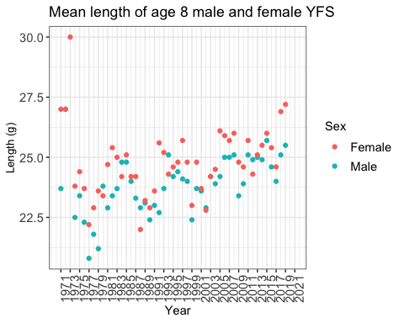

Figure 2: Mean length at age (cm) for Yellowfin Sole Age 8 females and males from the Eastern Bering Sea survey, 1971-2019.

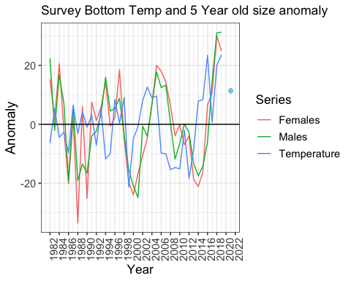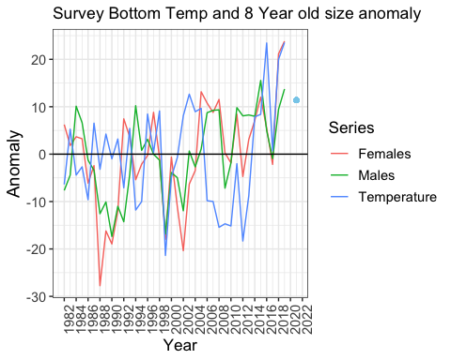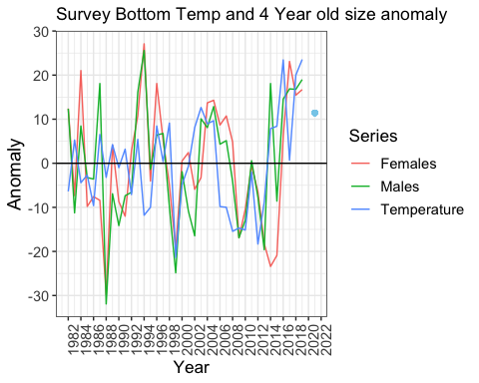

Figure 3: Raw survey weight at age anomalies and temperature anomalies, for ages 4, 5, and 8.