Yellowfin Sole model for Plan Team consideration for the Yellowfin Sole Stock in the Bering Sea and Aleutian Islands

# Executive summary

This document presents a new model for consideration for the 2020 BSAI Yellowfin Sole stock assessment. The data used to explore models are the same as those used in the 2019 assessment.

#### Relative to the 2018 assessment, the models include the following data updates.

1. The 2019 NMFS eastern Bering Sea shelf bottom-trawl survey biomass estimates and standard error were included.
2. The 2018 fishery age composition was added.
3. The 2018 survey age composition was included.
4. Estimates of the retained and discarded portions of the 2018 catch were added.
5. The estimate of the total catch made through the end of 2020 was used.

### Two models are presented here:

1. Model 18.1a: The accepted model used in the 2018 assessment is referred to as Model 18.1a. Model 18.1a used the same natural mortality for males and females, =0.12.
2. Model 18.2: This second model uses a fixed value for female natural mortality (=0.12) and allows male natural mortality to be estimated within the model. Model 18.2 is the preferred model.

## Data

The data used in these models include estimates of total catch, bottom trawl survey biomass estimates and their attendant 95% confidence intervals, catch-at-age from the fishery, and population age composition estimates from the bottom trawl survey. Weight-at-age and proportion mature-at-age are also available from studies conducted during the bottom trawl surveys. Further information on the data used here can be found in the 2019 Yellowfin Sole stock assessment (Spies et al. 2019).

|  |  |
| --- | --- |
| Data source | Year |
| Fishery catch | 1954 - 2019 |
| Fishery age composition | 1964 - 2018 |
| Fishery weight-at-age | Avg. weight at age from 2008-2018 used for 2008-2019 |
| Survey biomass and standard error | 1982 - 2019 |
| bottom temperature | 1982 - 2019 |
| Survey age composition | 1979 - 2018 |
| Annual length-at-age and weight-at-age from surveys | 1979 - 2018 |
| Age at maturity | Combined 1992 and 2012 samples |

## Description of Models

The general model structure is as described in the 2019 Yellowfin Sole stock assessment (Spies et al. 2019). The accepted model used in the 2019 assessment is referred to as Model 18.1a. Model 18.1a used the same natural mortality for males and females, =0.12. A second model is also considered in this assessment (Model 18.2) that uses a fixed value for female natural mortality (=0.12) and allows male natural mortality to be estimated within the model. The 2018 accepted model is referred to as Model 18.1. This was included in some cases for comparison, but is not explicitly compared here, as comparison of Model 18.2 with Model 18.2 was sufficient to understand differences among the two models.

## Parameters Estimated Outside the Assessment Model

Natural mortality () was initially estimated by a least squares analysis where catch at age data were fitted to Japanese pair trawl effort data while varying the catchability coefficient () and simultaneously. The best fit to the data (the point where the residual variance was minimized) occurred at a value of =0.12 (Bakkala and Wespestad 1984). This was also the value which provided the best fit to the observable population characteristics when was profiled over a range of values in the stock assessment model using data up to 1992 (Wilderbuer 1992).

## Parameters Estimated Inside the Assessment Model

There were 452 parameters estimated by Model 18.2, and 453 parameters estimated by Model 18.1a. The number of key parameters are presented below:

In each year, seven additional parameters are generally added to the model; another year of fishery data and the entry of another year class into the observed population, four more sex-specific fishery selectivity parameters, and an additional catchability parameter. Either 1 or two parameters were incorporated for male natural mortality, depending on the model.

# Results (Model Evaluation)

Two models are presented in this document. Model 18.1a was the accepted model used in the 2019 assessment. The second model, Model 18.2, fixed female natural mortality at =0.12 as in previous years, but allowed the model to freely estimate male natural mortality. The model estimated male natural mortality to be higher than female natural mortality (0.135), which is in common with known life history parameters of other Alaska flatfish. In Arrowtooth Flounder, higher natural mortality is assumed for males and is consistent with their skewed sex ratio (Wilderbuer and Turnock 2009). Higher natural mortality for male flatfish has been assumed to flatfish from other regions as well (Maunder and Wong 2011).

The two models differed slightly in several parameter estimates. The trend in survey catchability was similar for Model 18.1a and Model 18.2, but catchability was lower with Model 18.2 (Figure 1). The sex ratio estimate changed slightly in Model 18.2. The proportion female was estimated to be slightly lower in Model 18.1a than Model 18.2, as higher male natural mortality increased the estimated number of males in the population (Figure 2). Female spawning biomass did not change significantly among Model 18.1a and 18.2, but was slightly higher for Model 18.2 (Table 1). A similar pattern was noted for total (age 2+) biomass (Table 2). Recruitment estimates were also higher in Model 18.2, likely due to the higher natural mortality applied to males (Table 3). Overall, the total negative log likelihod was lower for Model 18.2, and provided a better fit to the survey and fishery ages, as well as an improvement to the fit to survey catchability, with the total negative log likelihood reduced from 1,424 in Model 18.1a to 1,356 in Model 18.2 (Table 4, Figure 3, Figure 4, Figure 5, Figure 6).

Table 5 indicates that the ABC values from Model 18.2 for 2020 would be 33,428 t higher than Model 18.1a. This is due to the higher biomass estimate resulting from an increased value of male natural mortality in Model 18.2. Model 18.2 also provided a slightly better fit to survey biomass, but this effect was primarily noticeable during the years 1988-1995. Overall Model 18.2 provided very little change in the fit to survey biomass (Figure 7).

Given the uncertainty of the productivity of Yellowfin Sole at low spawning stock sizes, and because the AFSC policy for reference point time-series selection is to use the post 1977 regime shift values unless there is a compelling reason to do otherwise, the productivity of Yellowfin Sole in these models were estimated by fitting the 1977-2013 spawner-recruit data (Ricker 1958). The resulting stock rescruitment curves are very similar for Model 18.1a and 18.2 (Figure 8 and Figure 9).

Posterior distributions of several key parameters in the model capture variability in posterior distributions of parameter estimates and differences between Model 18.2 and Model 18.1a (Figure 10). Model 18.2 resulted in higher estimates for , total and age 6 biomass and female spawning biomass and recruitment, but similar values to Model 18.1a for . The posterior distribution for female spawning biomass is above the Model 18.2 estimate for (Figure 10).

The data was updated in 2019 to include current values of catch, fishery and survey age compositions from 2018, and the 2019 survey biomass and standard error estimates. The fishery and survey weights-at-age were also changed in a small amount to include the latest year of data. These changes produced Model 18.1a ABC and OFL estimates for 2020 similar to the 2018 assessment (Model 18.1) projections for 2019, 296,060 t and 296,793 t. Model 18.2 produced slightly higher estimates for ABC and OFL than Model 18.1a due to the estimate of higher male natural mortality (Table 5).

The 2018 overall estimate (1982 – 2019) of trawl survey catchability decreased from Model 18.1a to Model 18.2. This resulted in slightly higher model estimates of population numbers at age and biomass for the time-series back to 1992 relative to last year’s assessment and increased the estimated level of female spawning biomass.

The full-selection fishing mortality, , has averaged 0.0717 over the period 2014-2018 (Table 6). Model estimated survey selectivities (Figure 11) show very little difference between Model 18.2 and 18.1a. Both models indicate that both sexes of Yellowfin Sole are 50% selected by the fishery at about age 9 and nearly fully selected by age 13, with annual variability.

A within-model retrospective analysis was included for Model 18.1a and Model 18.2. In this analysis, retrospective female spawning biomass was calculated by sequentially dropping data one year at a time and then comparing the peeled estimate to the reference stock assessment model used in the assessment (Figure 12, Figure 13). Mohn’s rho was -0.219 using Model 18.2 and -0.254 under Model 18.1a; thus the preferred model resulted in a less negative value. Visually, Model 18.2 shows a similar retrospective pattern to Model 18.1a, although both patterns showed a lower level of spawning biomass than the current year’s data in earlier retrospective years (Figure 12, Figure 13). The difference in female spawning biomass was negative for all years, except for the most recent. Model 18.2 improved the retrospective pattern for differences in female spawning biomass (Figure 14,Figure 15).

There is a large amount of variability in the annual survey biomass of Yellowfin Sole due to the temperature-influenced availability to the survey. This large variability can contribute to undesirable retrospective patterns since earlier years do not fit the same highly variable information as the current year. In particular, retrospective model runs are outside the confidence intervals of the assessment model spawning biomass trajectory for about a 17 year period from 1986-2019.

In 2017 the Plan Team recommended that the assessment continue to explore the retrospective patterns in relation to and by profiling over a range of combinations of and and recording the resulting values of Mohn’s rho and also total likelihood. Profiling over and was performed in the 2018 assessment. The best retrospective patterns did not occur at corresponding best model fit values. The retrospective technique may not always be the best tool for model selection, at least for BSAI Yellowfin Sole as there is tension between model fit and good retrospective pattern over the range of parameterization examined.

Given the higher total log likelihood, improved Mohn’s rho, and other results discussed above, Model 18.2 is the preferred model for estimating the Yellowfin Sole stock size and management quantities for the 2021 fishing season.

# Literature Cited

Bakkala, R. G. and V. Wespestad. 1984. Yellowfin sole. In R. G. Bakkala and L. resources of the eastern Bering Sea and Aleutian Islands region in 1983, p. 37-60. U.S. Dep. Commer., NOAA Tech. Memo. NMFS F/NWC-53.

Maunder, M.N. and Wong, R.A., 2011. Approaches for estimating natural mortality: application to summer flounder (*Paralichthys dentatus*) in the US mid-Atlantic. Fisheries Research, 111(1-2), pp.92-99.

Ricker, W. E. 1958. Handbook of computations for biological statistics of fish populations. Bull. Fish. Res. Bd. Can., (119) 300 p.

Wilderbuer, T. K. 1992. Yellowfin sole. In Stock Assessment and Fishery Evaluation Document for Groundfish Resources in the Bering Sea/Aleutian Islands Region as Projected for 1993. North Pacific Fishery Management Council, P. O. Box 103136, Anchorage, Ak 99510.

Wilderbuer, T.K. and Turnock, B.J., 2009. Sex-specific natural mortality of arrowtooth flounder in Alaska: Implications of a skewed sex ratio on exploitation and management. North American Journal of Fisheries Management, 29(2), pp.306-322.

Wilderbuer, T., Nichol, D., and J. Ianelli. 2018. Yellowfin sole. In Stock Assessment and Fishery Evaluation Document for Groundfish Resources in the Bering Sea/Aleutian Islands Region as Projected for 2019, chapter 4. North Pacific Fishery Management Council, P. O. Box 103136, Anchorage, Ak 99510.

Spies, I., Wilderbuer, T., Nichol, D., and J. Ianelli. 2019. Yellowfin sole. In Stock Assessment and Fishery Evaluation Document for Groundfish Resources in the Bering Sea/Aleutian Islands Region as Projected for 2020, chapter 4. North Pacific Fishery Management Council, P. O. Box 103136, Anchorage, Ak 99510.

# Tables

Table 1: Model estimates of Yellowfin Sole female spawning biomass (FSB) in metric tons (t) and upper (HCI) and lower (LCI) 95% confidence intervals from the 2018 and 2019 stock assessments, including Model 18.1, 18.1a and 18.2.

Table 2: Model estimates of Yellowfin Sole age 2+ total biomass (t) from the 2018 and 2019 stock assessments, Model 18.1, Model 18.1a, and 18.2.

Table 3: Model estimates of age 1 recruitment (in billions of fish), 1954-2019, with 95% lower and upper confidence intervals (LCI, HCI) for Model 18.1a and 18.2.

Table 4: Comparison of likelihood values for survey and fishery age, selectivity, survey biomass, recruitment, catchability, and total likelihood for Models 18.1a and 18.2.

Table 5: Comparison of reference points for Model 18.2, 18.1a, and Model 18.1. Values are in metric tons (t).

Table 6: Model estimates of Yellowfin Sole full selection fishing mortality (F) and exploitation rate (catch/total biomass).

# Figures

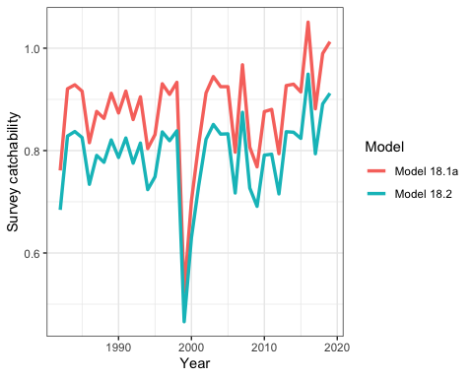 Figure 1: Survey catchability for Model 18.1a and 18.2, 1982-2019.

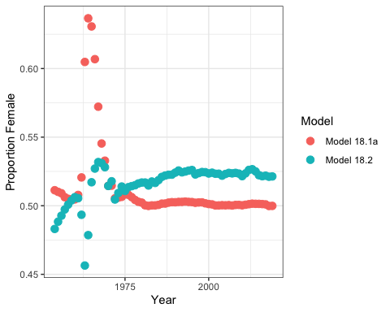 Figure 2: Model estimates of the proportion of female Yellowfin Sole in the population, 1982-2019.

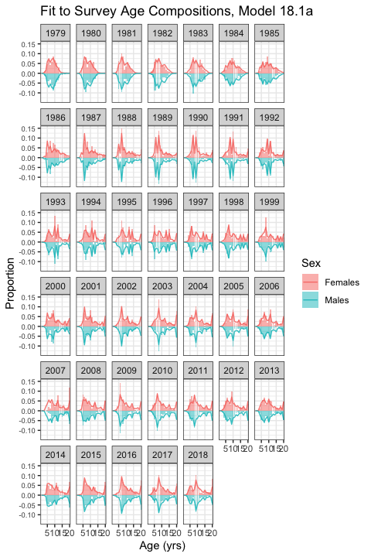

Figure 3: Model 18.1a fit to the time-series of survey age composition, by sex, 1979-2018.

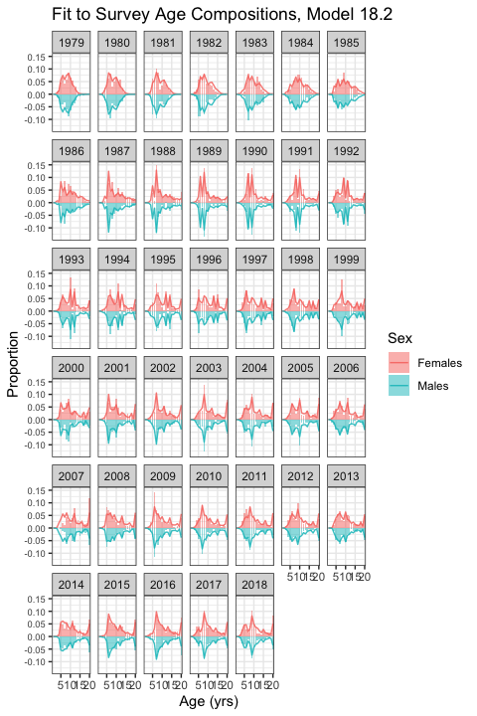

Figure 4: Model 18.2 fit to the time-series of survey age composition, by sex, 1979-2018.

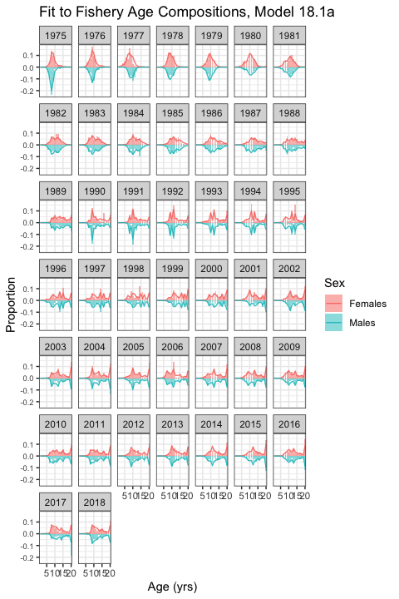

Figure 5: Model 18.1a fit to the time-series of fishery age composition, by sex, 1975-2018.

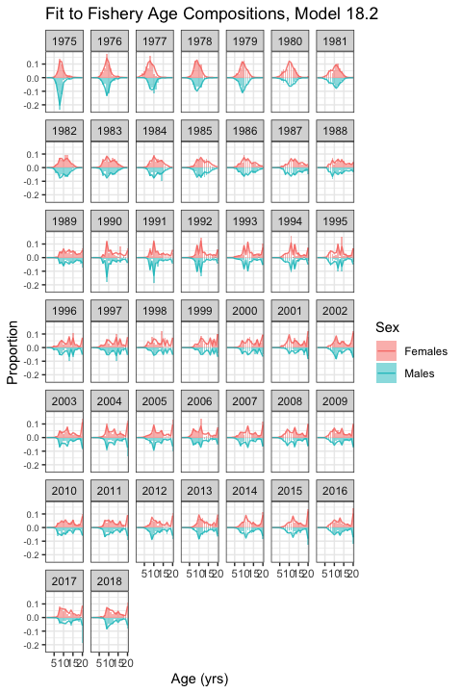

Figure 6: Model 18.2 fit to the time-series of fishery age composition, by sex, 1975-2018.

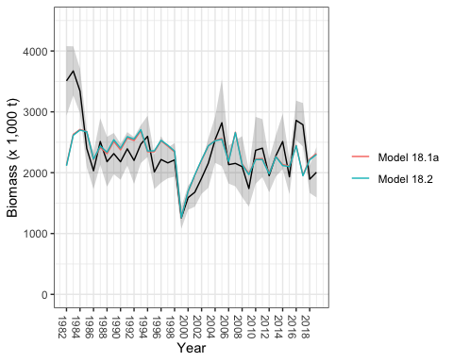 Figure 7: NMFS eastern Bering Sea survey biomass estimates, with 95% confidence intervals and Model 18.1a and Model 18.2 fit to survey biomass estimates, from 1982-2019.

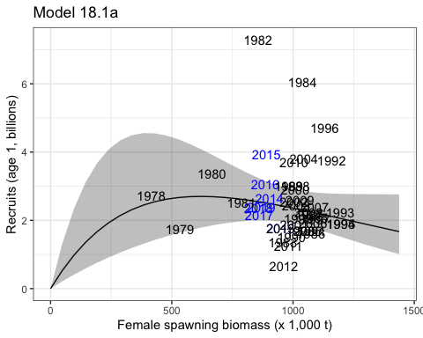 Figure 8: Ricker stock recruitment curve for Model 18.1a with 95% confidence intervals (shaded region) fit to female spawning biomass and recruitment data from 1978-2013. Years in black indicate data used to fit the model.

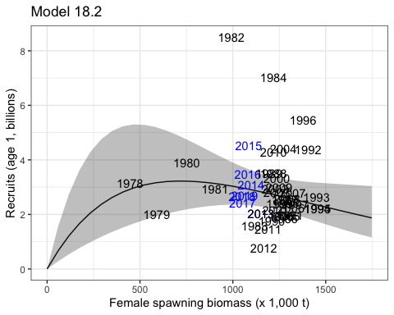 Figure 9: Ricker stock recruitment curve for Model 18.2 with 95% confidence intervals (shaded region) fit to female spawning biomass and recruitment data from 1978-2013. Years in black indicate data used to fit the model.

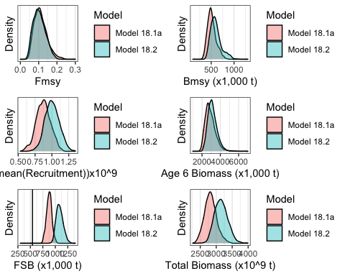 Figure 10: MCMC posterior distributions for Fmsy, Bmsy, log(mean(Recruitment)), Age 6 biomass, female spawning biomass (FSB) for 2019, and total biomass for 2019.

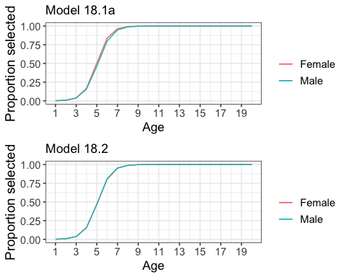

Figure 11: Estimate of survey selectivity for males and females, Model 18.1a upper panel, Model 18.2 lower panel.

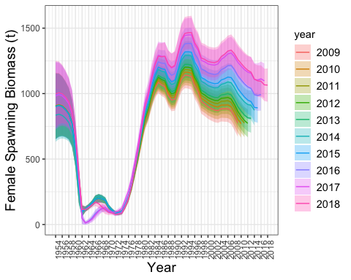 Figure 12: Retrospective plot of female spawning biomass. The preferred model with data through 2019 is shown, and data was sequentially removed through 2009, based on Model 18.2.

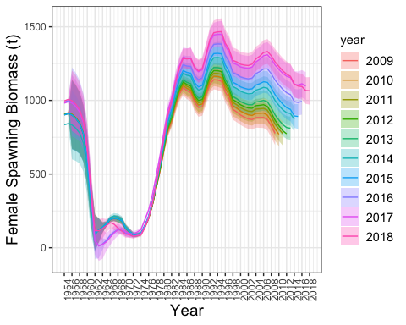 Figure 13: Retrospective plot of female spawning biomass. The preferred model with data through 2019 is shown, and data was sequentially removed through 2009, based on Model 18.1a.

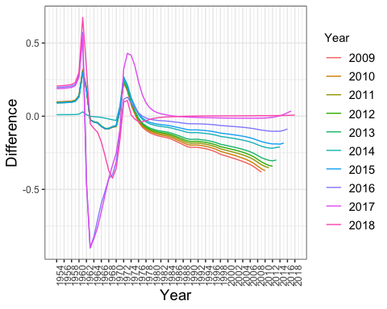 Figure 14: Relative differences in estimates of spawning biomass between the 2019 model and the retrospective model run for years 2018 through 2009, based on 18.2.

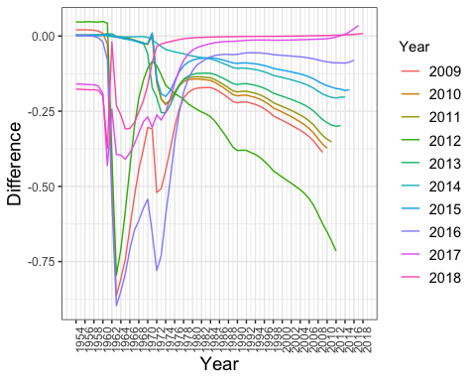 Figure 15: Relative differences in estimates of spawning biomass between the 2019 model and the retrospective model run for years 2018 through 2009, based on 18.1a.