Catch Figures

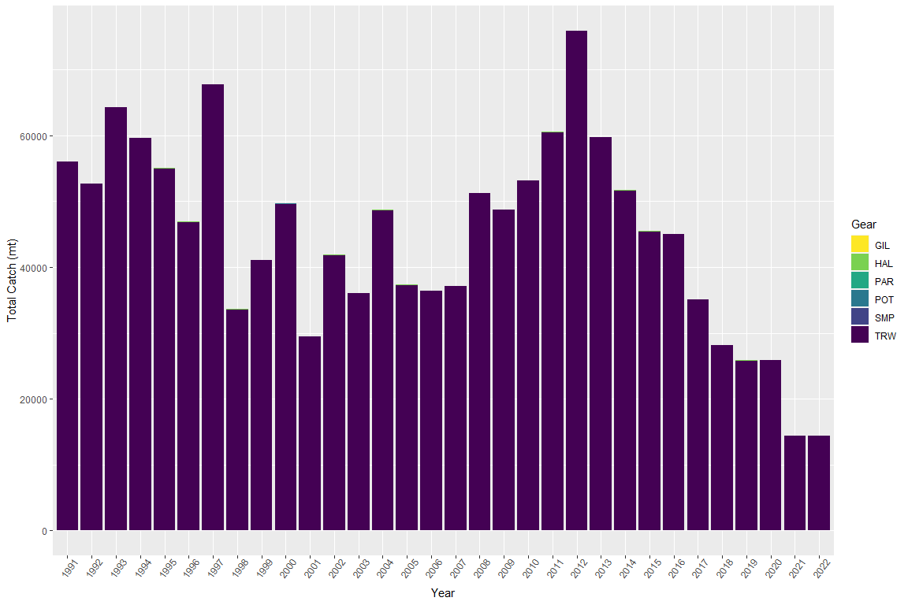

Figure 1. Time series of total catch (mt) by gear. TRW is Trawl, OTH is Other, HAL is Hook and Line, and GLN is Gillnet.