12. Assessment of the Dusky Rockfish Stock in the Gulf of Alaska

Kristen L. Omori and Benjamin C. Williams

November 2023

# Executive Summary

Gulf of Alaska (GOA) dusky rockfish (*Sebastes variabilis*) have historically been assessed on a biennial stock assessment schedule to coincide with the availability of new trawl survey data (odd year surveys). In 2017, the Alaska Fisheries Science Center (AFSC) participated in a stock assessment prioritization process. It was recommended that the GOA dusky rockfish remain on a biennial stock assessment schedule with a full stock assessment produced in even years and a harvest projection produced in odd years. The projection model is updated with new catch information and results are used to recommend harvest levels for the next two years. This incorporates the most current catch information without re-estimating model parameters and biological reference points.

The GOA dusky rockfish is classified as a Tier 3 stock and is assessed using a statistical age-structure model. This assessment consists of a population model, which uses survey and fishery data to generate a historical time series of population estimates, and a projection model, which uses results from the population model to predict future population estimates and recommended harvest levels. The data used in this assessment include total catch biomass, fishery age and size compositions, trawl survey abundance estimates, and trawl survey age compositions.

## Summary of Changes in Assessment Inputs

*Changes in the input data:* There were no changes made to the assessment model inputs as this is an off-cycle year. New data added to the projection model included updated catch data from 2022 (2,586 t) and new estimated catches for 2023-2025. Catch data were queried on 2023-10-10. The 2023 catch was estimated by increasing the observed catch by an expansion factor of 1.04, which accounts for the average fraction of catch taken after October 10 in the last three complete years (2020-2022). This expansion factor remained the same from last year’s expansion factor of 1.04 and resulted in an estimated catch for 2023 of 3,580 t. To estimate future catches, we updated the yield ratio to 0.54, which was the average ratio of catch to ABC for the last three complete catch years. This yield ratio was multiplied by the projected ABCs from the updated projection model to generate catches of 4,124 t in 2024 and 3,752 t in 2025.

## Summary of Changes in Assessment Methodology

There were no changes from the 2022 assessment (Williams *et al.* 2022) as this was an off-cycle year.

## Summary of Results

*ABC recommendation*  
The projected total biomass for 2024 is 103,997 t. The recommend ABC for 2024 is 7,624 t, the maximum allowable ABC under Tier 3a. This ABC is a -4% decrease compared to the 2023 ABC of 7,917 and a 1% increase from the projected 2024 ABC from the last year’s assessment.

The 2024 GOA-wide OFL for dusky rockfish is 9,281 t.

The stock is not being subject to overfishing, is not currently overfished, nor is it approaching a condition of being overfished.

Reference values for dusky rockfish are summarized in the following table with the recommended OFL and ABC in bold:

|  | As estimated or *specified last* year for: | | As estimated or *recommended this* year for: | |
| --- | --- | --- | --- | --- |
| **Quantity/Status** | 2023 | 2024 | 2024* | 2025* |
| M (natural mortality) | 0.07 | 0.07 | 0.07 | 0.07 |
| Tier | 3a | 3a | 3a | 3a |
| Projected total (age 4+) biomass (t) | 107,160 | 104,627 | 103,997 | 100,827 |
| Projected female spawning biomass (t) | 44,651 | 44,651 | 43,197 | 41,200 |
| B100% | 65,565 | 65,565 | 65,565 | 65,565 |
| B40% | 26,226 | 26,226 | 26,226 | 26,226 |
| B35% | 22,948 | 22,948 | 22,948 | 22,948 |
| FOFL | 0.11 | 0.11 | 0.112 | 0.112 |
| *max*FABC | 0.09 | 0.09 | 0.091 | 0.091 |
| FABC | 0.09 | 0.09 | 0.091 | 0.091 |
| OFL (t) | 9,638 | 9,154 | 9,281 | 8,796 |
| *max*ABC (t) | 7,917 | 7,520 | 7,624 | 7,225 |
| ABC (t) | 7,917 | 7,520 | 7,624 | 7,225 |
|  | As determined *last* year for: | | As determined *this* year for: | |
| **Status** | 2022 | 2023 | 2023 | 2024 |
| Overfishing | No | n/a | No | n/a |
| Overfished | n/a | No | n/a | No |
| Approaching overfished | n/a | No | n/a | No |
| *Projections are based on an estimated catch of 3,580 t for 2023 and estimates of 4,124 t and 3,752 t used in place of maximum permissible ABC for 2024 and 2025. | | | | |

## Area Apportionment

The following table shows the recommended ABC apportionment for 2024 and 2025. Please refer to the *Area Allocation of Harvests* section of last year’s assessment (Williams *et al.* 2022) for information regarding the apportionment rationale for GOA dusky rockfish.

|  | | Western | Central | Eastern | Total |
| --- | --- | --- | --- | --- | --- |
| Area Apportionment | | 1.9% | 96.6% | 1.5% | 100% |
| 2024 | ABC (t) | 145 | 7,365 | 114 | 7,624 |
| 2024 | OFL (t) |  |  |  | 9,281 |
| 2025 | ABC (t) | 137 | 6,979 | 109 | 7,225 |
| 2025 | OFL (t) |  |  |  | 8,796 |

Amendment 41 prohibited trawling in the Eastern area east of 140° W longitude. The ratio of biomass still obtainable in the W. Yakutat area (between 147° W and 140° W) is 0.74. This results in the following apportionment to the W. Yakutat area:

|  |  | W. Yakutat | E. Yakutat/Southeast |
| --- | --- | --- | --- |
| 2024 | ABC (t) | 84 | 30 |
| 2025 | ABC (t) | 81 | 28 |

## Responses to SSC and Plan Team Comments on Assessments in General

“The SSC supports the JGPT’s recommendation that stock assessment authors transition from the ADMB RE variants to the rema framework, which implements the same model variants in a single framework with several improvements.”(SSC, Oct 2022)

The REMA model is currently used for catch apportionment to management areas. However, the current REMA model uses design-based regional survey biomass estimates as inputs. As this assessment uses VAST estimated survey biomass (i.e., model-based estimates), instead of design-based, examinations of changing to regional VAST biomass estimates as inputs to the REMA model will be explored in the next full assessment.

## Responses to SSC and Plan Team Comments Specific to this Assessment

“SSC supports the author and GOA GPT recommendation to investigate proper variance attribution of VAST indices within the assessment model, and to explore model sensitivity to data weighting.” (December 2022)

“The SSC continues to recommend research investigating skip spawning.” (December 2022)

“The SSC recommends the authors investigate alternative apportionment methods that provide stability while also satisfying subarea-level biological concerns.” (December 2022)

“Finally, the SSC requests bubble plots of Pearson residuals for all age and length data including the sign and scale of residuals to help in evaluating fit.” (December 2022)

The authors intend to explore the following for next year’s (2024) operational full stock assessment: 1) investigate proper variance attribution of VAST indices, 2) examine model sensitivity to data-weighting, 3) explore uncertainty in recruitment due to skip spawning, and 4) investigate alternative apportionment methods.

The 2024 operational full assessment will include bubble plots of Pearson residuals for age and length data to evaluate the fit.

# References

Williams, B., Hulson, P.-J., Lunsford, C. and Ferriss, B. (2022) Assessment of the dusky rockfish stock in the Gulf of Alaska. In: *Stock assessment and fishery evaluation report for the groundfish resources of the Gulf of Alaska*. North Pacific Fishery Management Council, Anchorage, AK.

# Figures

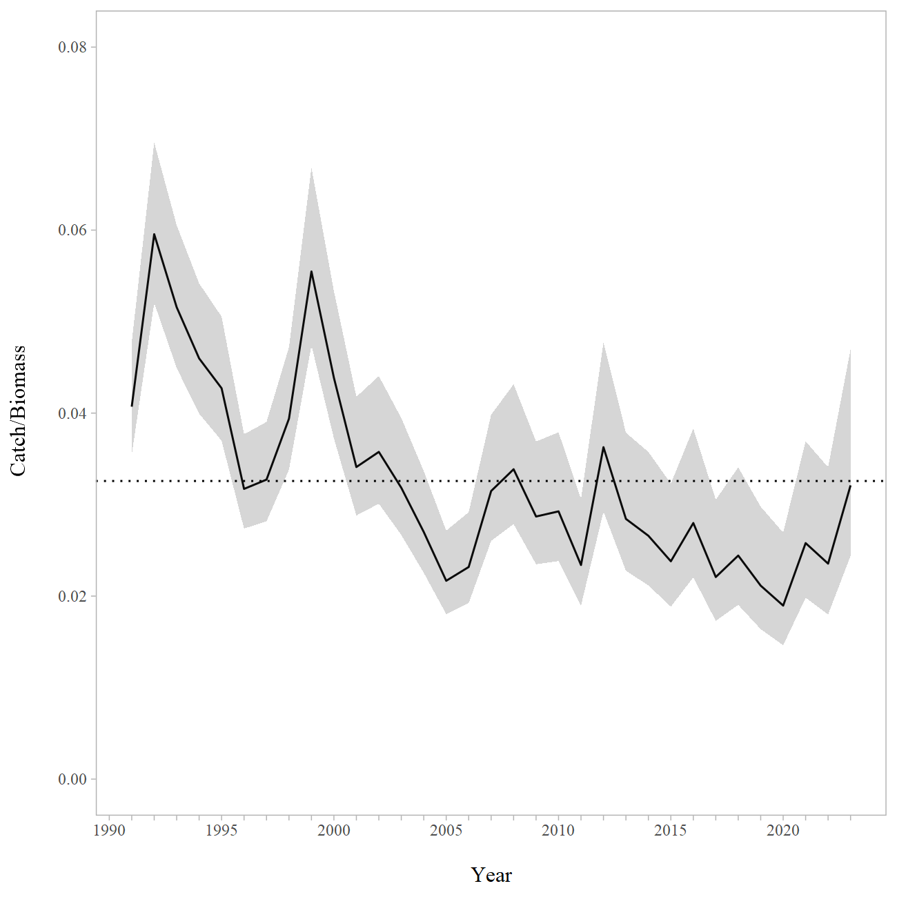

Figure 12-1. Gulf of Alaska dusky rockfish catch/age 4+ biomass ratio with approximate 95% confidence intervals. Observed catch values were used for 1991-2022, the 2023 catch values were estimated using an expansion factor. The horizontal dashed line is the mean value for the entire dataset.

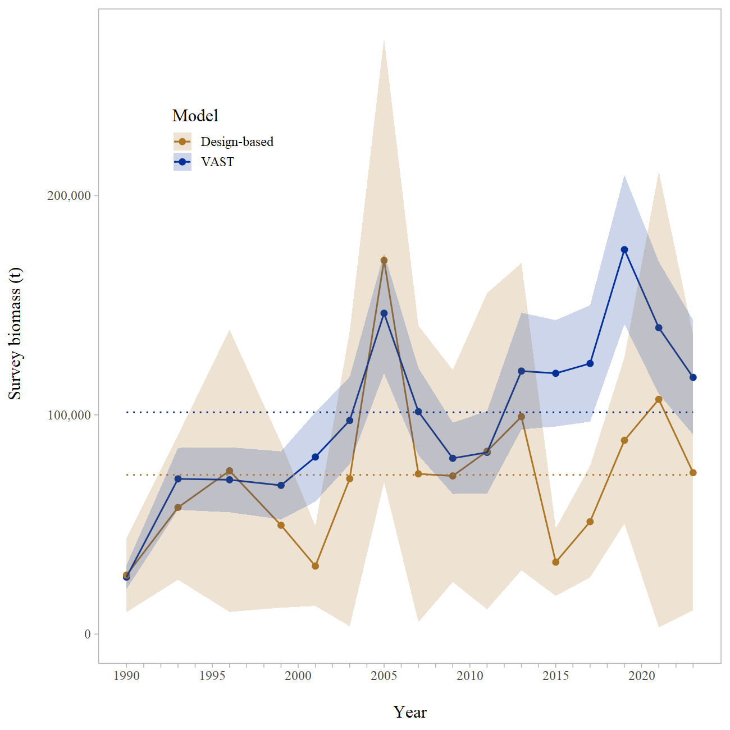

Figure 12-2. Geostatistical model (VAST with lognormal observation error) and design-based model estimates of trawl survey abundance for dusky rockfish in the Gulf of Alaska. Shaded areas are 95% confidence intervals, the dashed lines are the data means.