# 10. Assessment of the Northern Rockfish stock in the Gulf of Alaska

Benjamin C. Williams, Peter-John F. Hulson, Chris R. Lunsford, Curry J. Cunningham

November 2020

## Executive summary

We use a statistical age-structured model as the primary assessment tool for GOA northern rockfish stock which qualifies as a Tier 3 stock. This assessment consists of a population model, which uses survey and fishery data to generate a historical time series of population estimates, and a projection model, which uses results from the population model to predict future population estimates and recommended harvest levels. The data sets used in this assessment include total catch biomass, fishery age and size compositions, trawl survey abundance estimates, and trawl survey age compositions. For a partial assessment, we do not re-run the assessment model, but do update the projection model with new catch information. This incorporates the most current catch information without re-estimating model parameters and biological reference points. Full assessments for northern rockfish are conducted in even years and partial assessments in odd years. For Gulf of Alaska northern rockfish in 2020, we present a full assessment with updated assessment and projection model results to recommend harvest levels for the next two years.

### Summary of Changes in Assessment Inputs

*Changes in input data*: The input data were updated to include survey biomass estimates for 2019, survey age compositions for 2019, final catch for 2018 and 2019, preliminary catch for 2020, fishery age compositions for 2018, and fishery size compositions for 2019. The survey biomass estimate is now based upon the Groundfish Assessment Program’s Vector Autoregressive Spatio-temporal (VAST) model for the GOA. The aging error matrix was updated with data through 2017, the previous matrix had data through 2008.

*Changes in assessment methodology*: The assessment methodology is the same as the 2018 assessment with updated input data.

### Summary of Results

The 2021 projected age 2+ total biomass is **102,715 t**. The recommended ABC for 2021 is **5,358 t**, the maximum allowable ABC under Tier 3a. This ABC is a **20%** increase compared to the 2020 ABC of **4,312 t** and a **23%** increase from the projected 2021 ABC from last year. The 2021 GOA-wide OFL for northern rockfish is **6,396 t**. Reference values for northern rockfish are summarized in the following table.

The stock is not being subject to overfishing, is not currently overfished, nor is it approaching a condition of being overfished. The tests for evaluating these three statements on status determination require examining the official total catch from the most recent complete year and the current model projections of spawning biomass relative to B35% for 2019 and 2021. The official total catch for 2019 is 2,748 t, which is less than the 2019 OFL of 5,402 t; therefore, the stock is not being subjected to overfishing. The estimates of spawning biomass for 2021 and 2022 from the projection model used this year (2022) are 42,791 t and 40,762 t, respectively. Both estimates are above the estimate of B35% at 29,691 t and, therefore, the stock is not currently overfished nor approaching an overfished condition.

Reference values for northern rockfish are summarized in the following table, with the recommended ABC and OFL values in bold.

|  |  |  |  |  |
| --- | --- | --- | --- | --- |
|  | As estimated or | | As estimated or | |
| specified *last* year for: | | recommended *this* year for: | |
| **Quantity** | 2020 | 2021 | 2021 | 20221 |
| *M* (natural mortality) | 0.059 | 0.059 | 0.059 | 0.059 |
| Tier | 3a | 3a | 3a | 3a |
| Projected total (age 2+) biomass (t) | 85,057 | 83,108 | 102,715 | 99,597 |
| Projected female spawning biomass (t) | 34,410 | 32,435 | 42,791 | 40,762 |
| *B100%* | 76,199 | 76,199 | 84,832 | 84,832 |
| *B40%* | 30,480 | 30,480 | 33,933 | 33,933 |
| *B35%* | 26,670 | 26,670 | 29,691 | 29,691 |
| *FOFL* | 0.073 | 0.073 | 0.073 | 0.073 |
| *maxFABC* | 0.061 | 0.061 | 0.061 | 0.061 |
| *FABC* | 0.061 | 0.061 | 0.061 | 0.061 |
| OFL (t) | 5,143 | 4,898 | 6,396 | 6,088 |
| max ABC (t) | 4,312 | 4,107 | **5,358** | 5,100 |
| ABC (t) | 4,312 | 4,107 | **5,358** | 5,100 |
|  | As determined *last* year for: | | As determined *this* year for: | |
| **Status** | 2018 | 2019 | 2019 | 2020 |
| Overfishing | No | n/a | No | n/a |
| Overfished | n/a | No | n/a | No |
| Approaching overfished | n/a | No | n/a | No |

1Projections are based upon an estimated catch of 2,596 and 3,094 t used in place of maximum permissable ABC for 2021 and 2022.

### Area Apportionment

Apportionment is based on the random effects model developed by Plan Team survey averaging working group, which was fit to area-specific design-based biomass indices through 2019 from the bottom trawl survey. The following table provides the recommended apportionment for 2021 and 2022 from the random effects model.

|  |  |  |  |  |
| --- | --- | --- | --- | --- |
| Area | Western | Central | Eastern* | Total |
| Apportionment | 37.8% | 62.2% | 0.0% | 100.0% |
| 2021 Area ABC (t) | **2,023** | **3,334** | **1** | 5,358 |
| 2022 Area ABC (t) | **1,926** | **3,173** | **1** | 5,100 |
| *For management purposes the small ABC in the Eastern area is combined with other rockfish. | | | | |

### Summaries for Plan Team

|  |  |  |  |  |  |  |
| --- | --- | --- | --- | --- | --- | --- |
| Species | Year | Biomass1 | OFL | ABC | TAC | Catch2 |
|  | 2019 | 87,409 | 5,402 | 4,528 | 4,528 | 2,748 |
| Northern Rockfish | 2020 | 85,057 | 5,143 | 4,312 | 4,312 | 2,617 |
|  | 2021 | 102,715 | 5,358 | 5,358 |  |  |
|  | 2022 | 99,597 | 5,100 | 5,100 |  |  |

|  |  |  |  |  |  |  |  |  |  |
| --- | --- | --- | --- | --- | --- | --- | --- | --- | --- |
| Stock/ Assemblage |  | 2020 | | | | 2021 | | 2022 | |
| Area | OFL | ABC | TAC | Catch2 | OFL | ABC | OFL | ABC |
|  | W |  | 1,133 | 1,133 |  |  | 2,023 |  | 1,926 |
| Northern | C |  | 3,178 | 3,178 |  |  | 3,334 |  | 3,173 |
| rockfish | E* |  |  |  |  |  | 1 |  | 1 |
|  | Total | 5,143 | 4,312 | 4,312 | 2,617 | 6,396 | 5,358 | 6,088 | 5,100 |

1Total age 2+ biomass from the age-structured model

2Current as of 2020-10-06, Source: NMFS Alaska Regional Office via the Alaska Fisheries Information Network (AKFIN).

## Responses to SSC and Plan Team Comments on Assessments in General

“The SSC requests that all authors fill out the risk table in 2019…” (SSC December 2018)

“…risk tables only need to be produced for goundfish assessments that are in ‘full’ year in the cycle.” (SSC, June 2019)

“The SSC recommends the authors complete the risk table and note important concerns or issues associated with completing the table.” (SSC, October 2019)

“The SSC requests the GPTs, as time allows, update the risk tables for the 2020 full assessments.

…..The SSC recommends dropping the overall risk scores in the tables.

…..The SSC requests that the table explanations be included in all the assessments which include a risk table for completeness.

….The SSC notes that the risk tables provide important information beyond ABC-setting which may be useful for both the AP and the Council and welcomes feedback to improve this tool going forward.” (SSC December 2019)

As all these comments pertain to the risk table we combine them in our response. As requested, we provide a risk table in the Harvest Recommendations section that provides rationale for each level chosen and we drop the overall risk score. After completing this exercise, we do not recommend ABC be reduced below maximum permissible ABC.

## Responses to SSC and Plan Team Comments Specific to this Assessment

*“The Team recommends evaluating how the definition of the length composition plus group, and alternative data-weighting methods, affect model performance.”* (Plan Team, November 2015); *“Finally, the SSC notes the increasing proportion of fish in the fishery length composition plus-group and looks forward to seeing the results of the ongoing investigations into alternative length composition bin structures. The SSC also agrees with the high priority placed on improving maturity-at-age information for northern rockfish.”* (SSC, December 2018)

*“The Team recommended (1) Examining the delta-GLM approach by survey strata to see if the stratum-specific estimates are affecting the differences in approaches (compared to the results from a GOA-wide model). (2) Exploring using the covariance matrix from VAST in the stock assessment likelihood (i.e., to avoid using some variance inflation outside of the assessment).”* (PT, November 2018); *“The PT suggested that the author could examine the approach by survey strata, though given the large number of potential strata, the SSC suggests that the use of depth and management areas as density covariates might be another approach.”* (SSC, December 2018)

“However, the SSC questioned whether this rescaling is the most appropriate method to address the reduction in variability resulting from the use of the VAST model in estimating biomass.” (SSC, December 2018)

Due to a request for limited model changes the fishery length composition plus-group was not examined this assessment cycle. It is anticipated that alternative length composition binning will be explored for the next assessment cycle.

Examinations of appropriate survey strata to use in VAST models has been taken on by the Groundfish Assessment Program. The assessment authors will continue to evaluate appropriate model weighting structure. These questions are also being explored within the GOA Pacific ocean perch assessment and will be incorporated into a planned POP CIE review in early 2021.

# Introduction

## Biology and distribution

The northern rockfish, *Sebastes polyspinis*, is a locally abundant and commercially valuable member of its genus in Alaskan waters. As implied by its common name, northern rockfish has one of the most northerly distributions among the 60+ species of *Sebastes* in the North Pacific Ocean. It ranges from extreme northern British Columbia around the northern Pacific Rim to eastern Kamchatka and the northern Kuril Islands and also north into the eastern Bering Sea (Allen and Smith 1988). Within this range, northern rockfish are most abundant in Alaska waters, from the western end of the Aleutian Islands to Portlock Bank in the central Gulf of Alaska (Clausen and Heifetz 2002).

Little is known about the life history of northern rockfish. Like other Sebastes species, northern rockfish are presumed to be ovoviviparous with internal fertilization. There have been no studies on fecundity of northern rockfish. Observations during research surveys in the Gulf of Alaska indicate that parturition (larval release) occurs in the spring and is completed by summer. Larval northern rockfish cannot be unequivocally identified to species at this time, even using genetic techniques, so information on larval distribution and length of the larval stage is unknown. The larvae metamorphose to a pelagic juvenile stage, but there is no information on when these juveniles become demersal.

Little information is available on the habitat of juvenile northern rockfish. Studies in the eastern Gulf of Alaska and Southeast Alaska using trawls and submersibles have indicated that several species of juvenile (< 20 cm) red rockfish (Sebastes spp.) associate with benthic nearshore living and non-living structure and appear to use the structure as a refuge (Carlson and Straty 1981; Krieger 1993). Freese and Wing (2003) also identified juvenile (5 to 10 cm) red rockfish (*Sebastes spp*.) associated with sponges (primarily *Aphrocallistes spp.*) attached to boulders 50 km offshore in the GOA at 148 m depth over a substrate that was primarily a sand and silt mixture. Only boulders with sponges harbored juvenile rockfish, and the juvenile red rockfish appeared to be using the sponges as shelter (Freese and Wing 2003). Although these studies did not specifically observe northern rockfish, it is likely that juvenile northern rockfish also utilize similar habitats. Length frequencies of northern rockfish captured in NMFS bottom trawl surveys and observed in commercial fishery bottom trawl catches indicate that older juveniles (>20 cm) are found on the continental shelf, generally at locations inshore of the adult habitat (Pers. comm. Dave Clausen).

Northern rockfish are generally planktivorous. They eat mainly euphausiids and calanoid copepods in both the GOA and the Aleutian Islands (Yang 1993, 1996, 2000). There is no indication of a shift in diet over time or a difference in diet between the GOA and AI (Yang 1996; Yang2000). In the Aleutian Islands, calanoid copepods were the most important food of smaller-sized northern rockfish (< 25 cm), while euphausiids were the main food of larger sized fish (> 25 cm) (Yang 1996). The largest size group also consumed myctophids and squids (Yang 2000). Arrow worms, hermit crabs, and shrimp have also been noted as prey items in much smaller quantities (Yang 1993; Yang1996). Large offshore euphausiids are not directly associated with the bottom, but rather, are thought to be advected onshore near bottom at the upstream ends of underwater canyons where they become easy prey for planktivorous fishes (Brodeur 2001). Predators of northern rockfish are not well documented, but likely include larger fish, such as Pacific halibut, that are known to prey on other rockfish species.

Trawl surveys and commercial fishing data indicate that the preferred habitat of adult northern rockfish in the Gulf of Alaska is relatively shallow rises or banks on the outer continental shelf at depths of about 75-150 m (Clausen and Heifetz 2002). The highest concentrations of northern rockfish from NMFS trawl survey catches appear to be associated with relatively rough (variously defined as hard, steep, rocky or uneven) bottom on these banks (Clausen and Heifetz 2002). Heifetz (2002) identified rockfish as among the most common commercial fish captured with gorgonian corals (primarily *Callogorgia*, *Primnoa*, *Paragorgia*, *Fanellia*, *Thouarella*, and *Arthrogorgia*) in NMFS trawl surveys of Gulf of Alaska and Aleutian waters. Krieger and Wing (2002) identified six rockfish species associated with gorgonian coral (*Primnoa spp*.) from a manned submersible in the eastern Gulf of Alaska. Research focusing on non-trawlable habitats found rockfish species often associate with biogenic structure (Du Preez and Tunnicliffe 2011; Laman *et al.* 2015). However, most of these studies did not specifically observe northern rockfish, and more research is required to determine if northern rockfish are associated with living structure, including corals, in the Gulf of Alaska, and the nature of those associations if they exist. Recent work on black rockfish (Sebastes melanops) has shown that larval survival may be higher from older female spawners (Berkeley *et al.* 2004). The black rockfish population has shown a distinct reduction in the proportion of older fish in recent fishery samples off the West Coast of North America, raising concerns if larval survival diminishes with spawner age. Bruin *et al.* (2004) examined Pacific ocean perch (*S. alutus*) and rougheye rockfish (*S. aleutianus*) for senescence in reproductive activity of older fish and found that oogenesis continues at advanced ages. Leaman (1991) showed that older individuals have slightly higher egg dry weight than their middle-aged counterparts. Some literature suggests that environmental factors may affect the condition of female rockfish that contributes to reproductive success (Hannah and Parker 2007; Rodgveller *et al.* 2012; Beyer *et al.* 2015). However, relationships on fecundity or larval survival at age have not yet been evaluated for northern rockfish or other rockfish in Alaska. Stock assessments for Alaska groundfish have assumed that the reproductive success of mature fish is independent of age.

## Stock structure

Gulf of Alaska northern rockfish grow significantly faster and reach a larger maximum length than Aleutian Islands northern rockfish (Clausen and Heifetz 2002). Also, Aleutian Islands northern rockfish are slightly older (maximum age 72) than Gulf of Alaska northern rockfish (maximum age 67), the difference in age could be due to sampling variability. There have been two studies on the genetic stock structure of northern rockfish. One study of northern rockfish provided no evidence for genetically distinct stock structure when comparing samples from near the western Aleutian Islands, the western Gulf of Alaska, and Kodiak Island (Gharrett *et al.* 2003). The results from that study were considered preliminary, and sample sizes were small. Consequently, the lack of evidence for stock structure did not necessarily confirm stock homogeneity. A more recent study did find spatial structure on a relatively small scale for northern rockfish sampled from several locations in the Aleutian Islands and Bering Sea (Gharrett *et al.* 2012).

Results of an analysis of localized depletion based on Leslie depletion estimators on targeted rockfish catches detected relatively few localized depletions for northern rockfish (Hanselman *et al.* 2007). Several significant depletions occurred in the early 1990s for northern rockfish, but were not detected again by the depletion analysis. However, when fishery and survey CPUEs were plotted over time for a geographic block of high rockfish fishing intensity that contained the “Snakehead” area, the results indicated there were year-after-year drops in both fishery and survey CPUE for northern rockfish. The significance of these observations depends on the migratory and stock structure patterns of northern rockfish. If fine-scale stock structure is determined in northern rockfish, or if the area is essential to northern rockfish reproductive success, then these results would suggest that current apportionment of ABC may not be sufficient to protect northern rockfish from localized depletion. Provisions to guard against serial depletion in northern rockfish should be examined in the Gulf of Alaska rockfish rationalization plan. The extension of the fishing season that has been implemented may spread out the fishery in time and space and reduce the risk of localized serial depletion on the “Snakehead” and other relatively shallow (75 – 150 m) offshore banks on the outer continental shelf where northern rockfish are concentrated.

If there is relatively small scale stock structure (120 km) in Gulf of Alaska northern rockfish, then recovery from localized depletion, as indicated above for a region known as the “Snakehead,” could be slow. Analysis of otolith microchemistry may provide a useful tool, in addition to genetic analysis, for identifying small scale (120 km) stock structure of northern rockfish relative to their overall range. Berkeley *et al.* (2004) suggests that, in addition to the maintenance of age structure, the maintenance of spatial distribution of recruitment is essential for long-term sustainability of exploited rockfish populations. In particular, Berkeley *et al.* (2004) outline Hedgecock’s “sweepstakes hypothesis” to explain small-scale genetic heterogeneity observed in some widely distributed marine populations. According to Berkeley *et al.* (2004), “most spawners fail to produce surviving offspring because their reproductive activity is not matched in space and time to favorable oceanographic conditions for larval survival during a given season. As a result of this mismatch the surviving year class of new recruits is produced by only a small minority of adults that spawned within those restricted temporal and spatial oceanographic windows that offered good conditions for larval survival and subsequent recruitment”. However, Miller and Shanks (2004) found limited larval dispersal (120 km) in black rockfish off the Pacific coast with an analysis of otolith microchemistry. In particular, these results suggest that black rockfish exhibit some degree of stock structure at very small scales (120 km) relative to their overall range. Localized genetic stocks of Pacific ocean perch have also been found in northern B.C. (Withler *et al.* 2001), and (Kamin *et al.* 2013) concluded that fine-scale genetic heterogeneity for Pacific ocean perch in Alaska was not the influence of a sweepstakes effect. Limited larval dispersal contradicts Hedgecock’s hypothesis and suggests that genetic heterogeneity in rockfish may be the result of stock structure rather than the result of the sweepstakes hypothesis.

# Fishery

## Description of the directed fishery

In the Gulf of Alaska, northern rockfish are generally caught with bottom trawls identical to those used in the Pacific ocean perch (*S. alutus*) fishery. Many of these nets are equipped with so-called “tire gear,” in which automobile tires are attached to the footrope to facilitate towing over rough substrates. Most of the catch has been taken during July, as the directed rockfish trawl fishery in the Gulf of Alaska has traditionally opened around July 1. Rockfish trawlers usually direct their efforts first toward Pacific ocean perch because of its higher value relative to other rockfish species. After the TAC for Pacific ocean perch has been reached and NMFS closes directed fishing for this species, trawlers switch and target northern rockfish. With implementation of the Central Gulf Rockfish Pilot Project in 2007, catches have been spread out more throughout the year.

Historically, bottom trawls have accounted for nearly all the commercial harvest of northern rockfish in the Gulf of Alaska. In the years 1990-98, bottom trawls took over 99% of the catch (Clausen and Heifetz 2002). Before 1996, most of the slope rockfish trawl catch (>90%) was taken by large factory-trawlers that processed the fish at sea. A significant change occurred in 1996, however, when smaller shore-based trawlers began taking a sizeable portion of the catch in the Central Gulf for delivery to processing plants in Kodiak. Factory trawlers continued to take nearly all the northern rockfish catch in the Western area during this period.

A study of the northern rockfish fishery for the period 1990-98 showed that 89% of northern rockfish catch was taken from just five relatively small fishing grounds: Portlock Bank, Albatross Bank, an unnamed bank south of Kodiak Island that fishermen commonly refer to as the “Snakehead”, Shumagin Bank, and Davidson Bank (Clausen and Heifetz 2002). The Snakehead accounted for 46% of the northern rockfish catch during these years. All of these grounds can be characterized as relatively shallow (75–150 m) offshore banks on the outer continental shelf.

Data from the observer program for 1990-98 indicated that 82% of the northern rockfish catch during that period came from directed fishing for northern rockfish and 18% was taken as incidental catch in fisheries for other species (Clausen and Heifetz 2002).

### Catch patterns

Total commercial catch (t) of northern rockfish in the GOA for the years 1961-2020 is summarized by foreign, joint venture, and domestic fisheries (Table 10-2 and Figure 10-1). Catches of GOA northern rockfish during the years 1961-1976 were estimated as 5% of the foreign GOA Pacific ocean perch catch in the same years. A Pacific ocean perch trawl fishery by the U.S.S.R. and Japan began in the Gulf of Alaska in the early 1960’s. This fishery developed rapidly with massive efforts by the Soviet and Japanese fleets. Catches peaked in 1965 when a total of nearly 350,000 metric tons (t) were caught, but declined to 45,500 t by 1976 (Ito 1982). Some northern rockfish were likely taken in this fishery, but there are no available summaries of northern rockfish catches for this period. Foreign catches of all rockfish were often reported simply as “Pacific ocean perch” with no attempt to differentiate species. The only detailed analysis of bycatch in slope rockfish fisheries of the Gulf of Alaska is that of Ackley and Heifetz (2001) who examined data from the observer program for the years 1993-95. Consequently, our best estimate of northern rockfish catch from 1961-1976 comes from analysis of the ratio of northern rockfish catch to Pacific ocean perch catch in the years 1993-1995. For hauls targeting on Pacific ocean perch, northern rockfish composed 5% of the catch (Ackley and Heifetz 2001).

Catches of GOA northern rockfish during the years 1977-1983 were available from NMFS foreign and joint venture fisheries observer data. With the advent of a NMFS observer program aboard foreign fishing vessels in 1977, enough information on species composition of rockfish catches was collected so that estimates of the northern rockfish catch were made for 1977-83 from extrapolation of catch compositions from the foreign observer program (Clausen and Heifetz 2002). The relatively large catch estimates for the foreign fishery in 1982-83 are an indication that at least some directed fishing for northern rockfish probably occurred in those years. Joint venture catches of northern rockfish, however, appear to have been relatively modest.

Catches of GOA northern rockfish during the years 1984-1989 were estimated as 8% of the domestic slope rockfish catch during the same years. A completely domestic trawl fishery for rockfish in the Gulf of Alaska began in 1984 but a domestic observer program was not implemented until 1990. Domestic catches of GOA northern rockfish during the years 1984-1989 were estimated from the ratio of domestic northern rockfish catch to domestic slope rockfish catch (8%) reported by the 1990 NMFS observer program:

Catches of GOA northern rockfish during the years 1990-1992 were estimated from extrapolation of catch compositions from the domestic observer program (Clausen and Heifetz 2002). Catch estimates of northern rockfish increased greatly from about 1,700 t in 1990 to nearly 7,800 t in 1992. The increases for 1991 and 1992 can be explained by the removal of Pacific ocean perch and shortraker/rougheye rockfish from the slope rockfish management group. As a result of this removal, relatively low TAC’s were adopted for these three species, and the rockfish fleet redirected more of its effort to northern rockfish in 1991 and 1992.

Catches of GOA northern rockfish during the years 1993-present were available directly from NMFS domestic fisheries observer data. Northern rockfish were removed from the slope rockfish assemblage and managed with an individual TAC beginning in 1993. As a consequence, directly reported catch for northern rockfish has been available since 1993. Catch of northern rockfish was reduced after the implementation of a northern specific TAC in 1993. Most of the catch since 1993 has been taken in the Central area, where the majority of the northern rockfish exploitable biomass is located. Gulf-wide catches for the years 1993-2020 have ranged from 1,836 t to 5,966 t. Annual ABCs and TACs have been relatively consistent during this period and have varied between 3,685 t and 5,760 t. In 2001, catch of northern rockfish was below TAC because the maximum allowable bycatch of Pacific halibut was reached in the central Gulf of Alaska for “deep water trawl species,” which includes northern rockfish. Catches of northern rockfish were near their TAC’s in 2003 – 2016, however in 2017 catch was 48% of the TAC and 2020 projected catch is likely to reach only 61% of the TAC for this year. Consultation with industry representatives suggested the low catch to TAC ratio in 2017 was largely driven by the fleet targeting alternative higher value species. Research catches of northern rockfish have been relatively small and are listed in Table 10A.1 in Appendix 10A.

### Bycatch and discards

The only detailed analysis of incidental catch in slope rockfish fisheries of the Gulf of Alaska is that of Ackley and Heifetz (2001) who examined data from the observer program for the years 1993-95. For hauls targeting on northern rockfish, the predominant incidental species were dusky rockfish, distantly followed by “other slope rockfish,” Pacific ocean perch, and arrowtooth flounder.

Total FMP groundfish catch estimates in the GOA rockfish fishery from 2015-2020 are shown in Table 10-3. For the GOA rockfish fishery during 2015-2020, the largest non-rockfish bycatch groups are arrowtooth flounder (1,197 t/year), walleye pollock (1,061 t/year), Atka mackerel (1,140 t/year), sablefish (801 t/year) and Pacific cod (401 t/year). Non-FMP species catch in the rockfish target fisheries is dominated by giant grenadier and miscellaneous fish (Table 10-4). However, the amounts from hauls targeting northern rockfish are likely much lower as this includes all rockfish target hauls.

Prohibited species catch in the GOA rockfish fishery is generally low for most species. Catch of prohibited and non-target species generally decreased with implementation of the Central GOA Rockfish Program (Hulson *et al*. 2011). The only increase of prohibited species catch observed in 2018 was in Golden King crab and Opilio crab catch (Table 10-5). Chinook salmon catch has been lower than the five year average since 2016.

Gulfwide discard rates (% discarded) for northern rockfish in the commercial fishery for 1993-2019 are as follows:

These discard rates are generally similar to those in the Gulf of Alaska for Pacific ocean perch and dusky rockfish. Discard mortality is assumed to be 100% for GOA northern rockfish.

## Management measures

From 1988-1993, the North Pacific Fishery Management Council (NPFMC) managed northern rockfish in the Gulf of Alaska as part of the slope rockfish assemblage. In 1991, the NPFMC divided the slope rockfish assemblage in the Gulf of Alaska into three management subgroups: Pacific ocean perch, shortraker/rougheye rockfish, and a complex of all other species of slope rockfish, including northern rockfish. In 1993, a fourth management subgroup, northern rockfish, was also created. In 2004, rougheye rockfish and shortraker rockfish were also split and managed separately. These subgroups were established to protect Pacific ocean perch, shortraker/rougheye, and northern rockfish (the four most sought-after commercial species in the assemblage) from possible overfishing. Each subgroup is now assigned an individual ABC (acceptable biological catch) and TAC (total allowable catch). Prior to 1991, an ABC and TAC were assigned to the entire assemblage. In the assessments after 1991 and until this year’s assessment, ABC and TAC for each subgroup, including northern rockfish, is apportioned to the three management areas of the Gulf of Alaska (Western, Central, and Eastern) based on a weighted average of the proportion of biomass by area from the three most recent Gulf of Alaska trawl surveys. In this year’s assessment ABC and TAC is apportioned to the three management areas in the Gulf of Alaska with the random effects model developed by the Plan Team survey averaging working group. Northern rockfish are scarce in the eastern Gulf of Alaska, and the ABC apportioned to the Eastern Gulf management area is small. This translates to a TAC that is too difficult to be managed effectively as a directed fishery. Since 1999, the ABC for northern rockfish apportioned to the Eastern Gulf management area is included in the West Yakutat ABC for “other slope rockfish.”

Amendment 41, which took effect in 2000, prohibited trawling east of 140 degrees W. longitude in the Eastern GOA. However, trawling has not occurred in this area since 1998. Since most slope rockfish, especially Pacific ocean perch, are caught exclusively with trawl gear, this amendment could have concentrated fishing effort for slope rockfish in the Eastern area in the relatively small area between 140 degrees and 147 degrees W. longitude that remained open to trawling. This probably does not have a major effect on northern rockfish populations because their abundance in the Eastern area is low.

In November, 2006, NMFS issued a final rule to implement Amendment 68 of the GOA groundfish Fishery Management Plan for 2007 through 2011. This action implemented the Central GOA Rockfish Pilot Program (RPP). The intention of this Program was to enhance resource conservation and improve economic efficiency for harvesters and processors in the rockfish fishery. An additional objective was to spread out the fishery in time and space, allowing for enhanced market conditions for product and reducing the pressure of what was an approximately two-week fishery in July. The primary rockfish management groups in this program are northern rockfish, Pacific ocean perch, and pelagic shelf rockfish. Potential effects of this program on northern rockfish include: 1) Extended fishing season lasting from May 1 – November 15, 2) changes in spatial distribution of fishing effort within the Central GOA, 3) improved at-sea and plant observer coverage for vessels participating in the rockfish fishery, and 4) a higher potential to harvest 100% of the TAC in the Central GOA region. In a comparison of catches in the four years before the RPP to the four years after, it appears that average catches have increased overall (although, this may be due to increased observer coverage) and have spread out spatially in the western and central Gulf (see Figure 10-1 in Hulson et al. 2013). The authors will continue to monitor the benefits and consequences of this action. A summary of key management measures and a time series of catch, ABC and TAC are provided in Table 10-1.

## Data

The following table summarizes the data used in the stock assessment model for northern rockfish (bold denotes new data for this assessment):

| **Source** | **Data** | **Years** |
| --- | --- | --- |
| NMFS Groundfish survey | Survey biomass | 1984-1999 (triennial), 2001-**2019** (biennial) |
| Age composition | 1984, 1987, 1990, 1993, 1996, 1999, 2003, 2005, 2007, 2009, 2011, 2013, 2015, 2017, **2019** |
| U.S. trawl fishery | Catch | 1961-**2018**, **2019**, 2020 |
| Age composition | 1998-2002, 2004-2006, 2008, 2010, 2012, 2014, 2016, **2018** |
| Length composition | 1991-1997, 2003, 2007, 2009, 2011, 2013, 2015, 2017, **2019** |

### Fishery

#### Catch

Catch of northern rockfish ranges from 185 t to 17,430 t during 1961 to 2020. Detailed description of catch is provided above (within the “*Catch patterns*” section) and in Table 10-2 and Figure 10-1. This is the commercial catch history used in the assessment model. In response to Annual Catch Limits (ACLs) requirements, assessments now document all removals including catch that is not associated with a directed fishery. Estimates of all removals not associated with a directed fishery including research catches are available and are presented in Appendix 10a. In summary, annual research removals have typically been less than 100 t and very little is taken in recreational or halibut fisheries. These levels likely do not pose a significant risk to the northern rockfish stock in the GOA.

#### Age and Size composition

Observers aboard fishing vessels and at onshore processing facilities have provided data on size and age composition of the commercial catch of northern rockfish. Ages were determined from the break-and-burn method (Chilton and Beamish 1982). Length compositions are presented in Table 10-6 and Figure 10-2 and age compositions are presented in Table 10-7 and Figure 10-3; these tables also include associated annual sample sizes and number of hauls sampled for the age and length compositions. The fishery age compositions indicate that stronger than average year-classes occurred around the year 1976 and 1984. The fishery age compositions from 2004 and 2006 also indicate that the 1996-1998 year-classes were strong. The clustering of several large year-classes in each period is most likely due to aging error. Recent fishery length compositions (2003-present) indicate that a large proportion of the northern rockfish catch are found to be larger than 38 cm, which is the current plus length bin.

## Survey

#### Biomass Estimates from Trawl Surveys

Bottom trawl surveys were conducted in the Gulf of Alaska triennially from 1984 – 1999 and biennially from 1999 – 2019. The surveys provide an index of biomass, size and age composition data, and growth characteristics. The trawl surveys have used a stratified random design to sample fishing stations that cover all areas of the Gulf of Alaska out to a depth of 1,000 m (in some surveys only to 500 m). Generally, attempts have been made through the years to standardize the survey design and the fishing nets used, but there have been some exceptions to this standardization. In particular, much of the survey effort in 1984 and 1987 was by Japanese vessels that used a very different net design than what has been the standard used by U.S. vessels throughout the surveys. To deal with this problem, fishing power comparisons of rockfish catches have been done for the various vessels used in the surveys (for a discussion see Heifetz et al. 1994). Results of these comparisons have been incorporated into the biomass estimates listed in this report, and the estimates are believed to be the best available. Even so, the use of Japanese vessels in 1984 and 1987 introduced an element of uncertainty as to the standardization of these two surveys. Also, a different survey design was used in the eastern Gulf of Alaska in 1984, and the eastern Gulf of Alaska was not covered by the 2001 survey. These data inconsistencies for the eastern Gulf of Alaska have had little effect on the survey results for northern rockfish, as relative abundance of northern rockfish is very low in the eastern Gulf of Alaska.

#### Comparison of Trawl Surveys in 1984-2019

Regional and Gulf-wide biomass estimates (with corresponding coefficient of variation in total biomass) for northern rockfish are shown in Table 10-8. Gulf-wide biomass estimates for 1990-2019 and 95% confidence intervals are shown in Figure 10-9. The precision of some of the biomass estimates has been low and is reflected in the high CVs associated with some survey biomass estimates of northern rockfish that are the result of few very large catches during the survey (Table 10-8). In 2001, a single very large survey haul of northern rockfish greatly increased the biomass estimates and resulted in wide confidence bounds. The haul in 2001 was the largest individual catch (14 t) of northern rockfish ever taken during a Gulf of Alaska survey; this tow accounted for 58.7% of total survey catch by mass in that year. In contrast, the 2005 and 2007 survey had several large hauls of northern rockfish in the Central Gulf and confidence bounds were narrower (Table 10-8). The large fluctuations in biomass estimates (Figure 10-9) do not seem plausible given our understanding of northern rockfish as long-lived, slow growing, low natural mortality, late maturity, and the relatively modest level of commercial catch.

#### Age and Size composition

Ages for northern rockfish were determined from the break-and-burn method (Chilton and Beamish 1982). These age compositions (Table 10-9 and Figure 10-6) indicate that recruitment of northern rockfish is highly variable. Several surveys (1984, 1987, 1990, and 1996) show especially strong year-classes from the period around 1975-77; although they differ as to which specific years were greatest, likely due to age determination errors. The 1993, 1996, and 1999 age compositions also indicate that the 1983-85 year-classes may be stronger than average. Recent age compositions (2005, 2007, 2009, and 2011) indicate that the 1996-98 year-classes may also be stronger than average, which is in agreement with recent age compositions obtained from the commercial fishery described above. Trawl surveys provide size composition data for northern rockfish but are not used directly in the current age structured assessment model (Table 10-10 and Figure 10-7). In years with age readings, trawl survey size composition data are multiplied by an age-length key (computed from length-stratified otolith collections) to obtain survey age compositions. Similar to the fishery length compositions discussed above, a large proportion of northern rockfish lengths are greater than the current plus length bin (38 cm); especially in recent years. Also similar to the fishery age compositions, the proportion of older fish older has been increasing since the mid to early 2000s.

#### Maturity data

In previous stock assessments for northern rockfish, age at maturity was based on a logistic curve fit to ovarian samples collected from female northern rockfish in the central Gulf of Alaska (GOA) in the spring of 1996 (*n*=75, C. Lunsford pers. comm. July 1997, Heifetz et al. 2009). A study reevaluating maturity of northern rockfish (Chilton 2007, *n*=157) provides additional information for maturity-at-age. This study collected ovarian samples from female northern rockfish throughout the year in both 2000 and 2001. In a report submitted to the GOA Groundfish Plan Team in September 2010, the two studies were compared and the advantages and disadvantages of the different approaches for studying maturity (histology versus visual inspection) were discussed (Rodgveller et al. 2010). In this year’s assessment, as in the 2018 assessment, we combine the data from both studies to estimate maturity of northern rockfish. Due to the relatively small sample sizes for each study, the close proximity in time for each study (4 years apart compared to the 51 year time series used in this assessment), and the large difference in the age at 50% maturity (12.8 years used in previous assessments compared to 8 years obtained by Chilton 2007), we combine these data and estimate an intermediate maturity-at-age rather than consider time-dependent changes in maturity (Figure 10-8). There could be time-dependent changes in maturity-at-age for northern rockfish, although, additional data would be necessary to evaluate this hypothesis.

## Analytical approach

### General Model Structure

The basic model for Gulf of Alaska northern rockfish is described as a separable age-structured model and was implemented using AD Model Builder software (Fournier et al. 2012). The assessment model is based on a generic rockfish model developed in a workshop held in February 2001 (Courtney *et al.* 2007) and follows closely the GOA Pacific ocean perch model. The northern rockfish model is fit to time series extending from 1961-2020. As with other rockfish age-structured models, this model does not attempt to fit a stock-recruitment relationship but estimates a mean recruitment, which is adjusted by estimated recruitment deviations for each year. The parameters, population dynamics, and equations of the model are shown in Box 1.

### Description of Alternative Models

Three models were examined for the 2020 assessment all of which build incrementally upon the 2018 accepted Model 18.2 (2018). We present these changes in a step-wise manner, building upon each previous model change to arrive at the preferred model for this year’s assessment. Model 18.2 (2020) is equivalent in structure to the 2018 accepted model with updated catch, survey, and composition data. The Vector Autoregressive Spatio-temporal (VAST) model-based bottom trawl survey biomass index was not computed in exactly the same manner as presented in 2018. For 2020 the VAST model had fewer knots (500 vs 1,000) and the deeper strata (>700 m depth) were excluded. The reason for this is that the Groundfish Assessment Group (GAP) has taken on the evaluation of survey models. This structure was used as a bridge from the last assessment that produced quite similar survey biomass results.

Model 18.2a (2020) is the same model configuration as previously stated, though the trawl survey biomass index is based upon the semi-standardized GAP methodology for VAST. See Appendix 10b for full details of the VAST estimate. Model 18.2b (2020) includes updated reader-tester agreement data used to construct the aging error matrix. The following table provides the model case name and description of the changes made to the model.

|  |  |
| --- | --- |
| Model case | Description |
| M18.2 (2018) | 2018 accepted model |
| M18.2 (2020) | Model 18.2, with updated data through 2020, and “bridge” VAST model-based biomass index for the GOA bottom trawl survey |
| M18.2a | Model 18.2, with updated data through 2020, and GAP VAST model-based biomass index for the GOA bottom trawl survey |
| M18.2b | Model 18.2a, with updated data through 2020, GAP VAST model-based biomass index for the GOA bottom trawl survey, and updated ageing error matrix |

### Parameters Estimated Outside the Assessment Model

A von Bertalanffy growth curve was fitted to survey size at age data from 1984-2017 using length-stratified methods (Quinn and Deriso 1999, Bettoli and Miranda 2001). Sexes were combined. An age to size conversion matrix was then constructed by adding normal error with a standard deviation equal to the survey data for the probability of different sizes for each age class. Previous parameters are available from Heifetz and Clausen (1991), Courtney et al. (1999), and Malecha et al. (2007). The estimated parameters for the growth curve from length-stratified methods are shown below:

*L∞* = 41.32 cm *κ* = 0.17 *t0* = -0.21

The previous assessments growth curve parameters were:

*L∞* = 41.34 cm *κ* = 0.17 *t0* = -0.22

Weight-at-age was constructed with weight at age data from the same data set as the length at age. Mean weight-at-age is approximated by the equation: . The estimated growth parameters from length-stratified methods are shown below.

*W∞* = 1047 g *k* = 0.18 *t0* = -0.001 *b* = 3.04

The previous assessments growth parameters for weight were:

*W∞* = 1056 g *k* = 0.18 *t0* = -0.04 *b* = 3.01

Aging error matrices were constructed by assuming that the break-and-burn ages were unbiased but had a given amount of normal error around each age based on between-reader percent agreement tests conducted at the AFSC Age and Growth lab. We fix the variability of recruitment deviations (*σ*r) at 1.5 which allows highly variable recruitment.

### Parameters Estimated Inside the Assessment Model

The estimates of natural mortality (*M*) and catchability (*q*) are estimated with the use of lognormal prior distributions as penalties that are added to the overall objective function in order to constrain parameter estimates to reasonable values and to speed model convergence. Arithmetic means and standard errors ( ) for the lognormal distributions were provided as input to the model. The standard errors for selected model parameters were estimated based on multivariate normal approximation of the covariance matrix. The prior mean for natural mortality of 0.06 is based on the estimate provided by Heifetz and Clausen (1991) using the method of Alverson and Carney (1975). Natural mortality is notoriously a difficult parameter to estimate within the model so we assign a “tight” prior CV of 5%. Catchability is a parameter that is somewhat unknown for rockfish, so while we assign it a prior mean of 1 (assuming all fish in the area swept are captured and there is no herding of fish from outside the area swept, and that there is no effect of untrawlable grounds), we assign it a less precise CV of 45%. This allows the parameter more freedom than that allowed to natural mortality. This is identical to that used in the Gulf of Alaska Pacific ocean perch and dusky rockfish assessments. Maturity-at-age is modeled with the logistic function, similar to selectivity-at-age for the survey and fishery. The fit to the two studies that have provided maturity data for northern rockfish from the model is shown in Figure 10-8. The numbers of estimated parameters from the model are shown below. Other derived parameters are described in Box 1. Given that we are using Bayesian estimation, there is no need to implement any recruitment bias-correction algorithm (e.g., using Methot and Taylor 2011).

|  |  |  |
| --- | --- | --- |
| Parameter | Symbol | Number |
| Natural mortality |  | 1 |
| Catchability |  | 1 |
| Log-mean-recruitment |  | 1 |
| Spawners-per-recruit levels |  | 3 |
| Recruitment deviations |  | 108 |
| Average fishing mortality |  | 1 |
| Fishing mortality deviations |  | 60 |
| Fishery selectivity coefficients |  | 2 |
| Survey selectivity coefficients |  | 2 |
| Maturity-at-age coefficients |  | 2 |
| Total |  | 181 |

Evaluation of model uncertainty has recently become an integral part of the “precautionary approach” in fisheries management. In complex stock assessment models such as this model, evaluating the level of uncertainty is difficult. One way is to examine the standard errors of parameter estimates from the Maximum Likelihood (ML) approach derived from the Hessian matrix. While these standard errors give some measure of variability of individual parameters, they often underestimate their variance and assume that the joint distribution is multivariate normal. An alternative approach is to examine parameter distributions through Markov Chain Monte Carlo (MCMC) methods (Gelman et al. 1995). When treated this way, our stock assessment is a large Bayesian model, which includes informative (e.g., lognormal natural mortality with a small CV) and non-informative (or nearly so, such as a parameter bounded between 0 and 10) prior distributions. In the model presented in this SAFE report, the number of parameters estimated is 181. In a low-dimensional model, an analytical solution might be possible, but in one with this many parameters an analytical solution is intractable. Therefore, we use MCMC methods to estimate the Bayesian posterior distribution for these parameters. The basic premise is to use a Markov chain to simulate a random walk through the parameter space (i.e., Metropolis MCMC algorithm), which will eventually converge to a stationary distribution which approximates the posterior distribution. Determining whether a particular chain has converged to this stationary distribution can be complicated, but generally if allowed to run long enough, the chain will converge (Jones and Hobert 2001). The “burn-in” is a set of iterations removed at the beginning of the chain. This method is not strictly necessary but we use it as a precautionary measure. In our simulations we removed the first 1,000,000 iterations out of 10,000,000 and “thinned” the chain to one value out of every 2,000, leaving a sample distribution of 4,500. Further assurance that the chain had converged was to compare the mean of the first half of the chain with the second half after removing the “burn-in” and “thinning”. Because these two values were similar we concluded that convergence had been attained. We use these MCMC methods to provide further evaluation of uncertainty in the results below including 95% confidence intervals for some parameters.

Multinomial sample sizes are calculated as the square root of the number of hauls multiplied by the number of composition samples in each year, and scaled to a maximum of 100 across years. Sample sizes were calculated in the same way for fishery age and length compositions, and survey age compositions. Effective sample sizes were assumed equal to the input sample sizes and not estimated or iteratively adjusted within the model.

Data weights are used to rescale the total likelihood contribution from select log-likelihoods for the different data sources. The log-likelihood weight on the three composition data types (fishery age, fishery length, and survey age) is 0.5. The log-likelihood weight on the (VAST) model-based bottom trawl survey biomass index is 0.25 in the recommended model.



|  |  |
| --- | --- |
| Equations describing the observed data | **BOX 1 (Continued)** |
|  | Catch equation |
|  | Survey biomass index (t) |
|  | Survey age distribution  Proportion at age |
|  | Survey length distribution  Proportion at length |
|  | Fishery age composition  Proportion at age |
|  | Fishery length composition  Proportion at length |
| Equations describing population dynamics  Start year | Number at age of recruitment  Number at ages between recruitment and pooled age class  Number in pooled age class |
| Subsequent years | Number at age of recruitment  Number at ages between recruitment and pooled age class  Number in pooled age class |

|  |  |
| --- | --- |
| Formulae for likelihood components | **BOX 1 (Continued)** |
|  | Catch likelihood |
|  | Survey biomass index likelihood |
|  | Fishery age composition likelihood  Fishery length composition likelihood  Survey age composition likelihood  Survey size composition likelihood |
|  | Penalty on deviation from prior distribution of catchability coefficient  Penalty on deviation from prior distribution of recruitment deviations |
|  | Penalty on recruitment deviations |
|  | Fishing mortality regularity penalty |
|  | Average selectivity penalty (attempts to keep average selectivity near 1)  Selectivity dome-shaped penalty – only penalizes when the next age’s selectivity is lower than the previous (penalizes a downward selectivity curve at older ages)  Selectivity regularity penalty (penalizes large deviations from adjacent selectivity by adding the square of second differences)  Total objective function value |

## Results

### Model Evaluation

The model used in this assessment is the same as the accepted model in 2018 with updated data. When we present alternative model configurations, our usual criteria for choosing a superior model are: (1) the best overall fit to the data (in terms of negative log-likelihood), (2) biologically reasonable patterns of estimated recruitment, catchabilities, and selectivity, (3) a good visual fit to length and age compositions, and (4) parsimony. Because the changes for the current assessment involve updating data we do not perform the usual model comparison. However, the figure below shows the influence on model estimates of total and spawning biomass compared to Model 2018.2 (the 2018 assessment model with updated data), Model 18.2a and 18.2b include the data updates previously described.

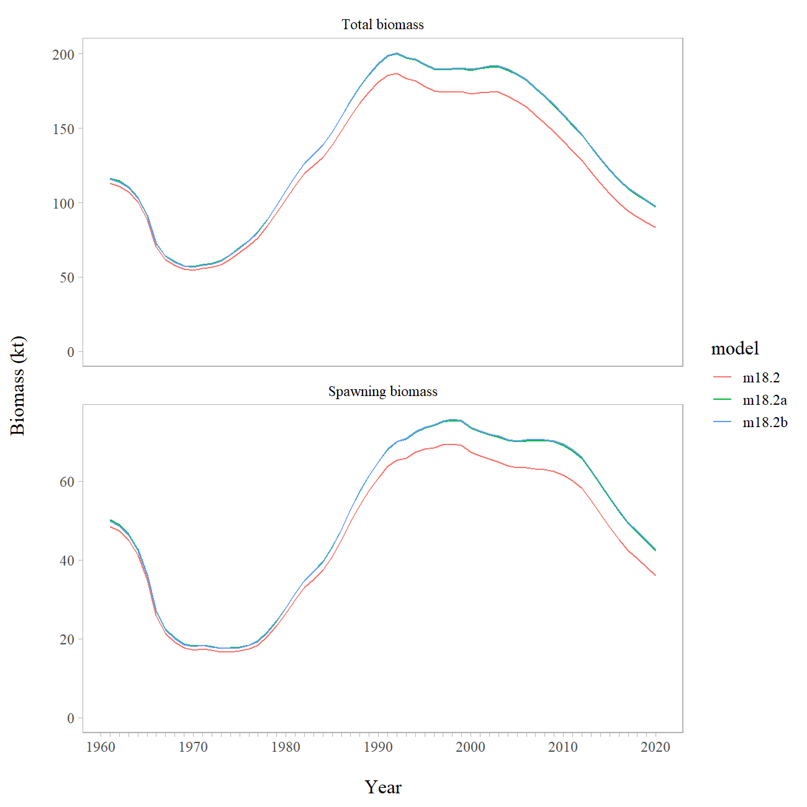

The most substantive difference is the change in VAST estimated trawl survey biomass, which results in an increase in both total and spawning biomass. Updates to the aging error matrix do not appear to change the model output.

Model 18.2b provides a reasonable fit to the biological data, though the length composition estimates could be improved upon. The model underestimates survey biomass, though the survey is down-weighted. The survey retrospective fit shows a general increase in estimated survey abundance through time. Overall, model 18.2b yields reasonable results that are consistent with past assessments and we use it to recommend that 2021 ABC and OFL.

### Time Series Results

#### Definitions

Spawning biomass is the biomass estimate of mature females. Total biomass is the biomass estimate of all northern rockfish age two and greater. Recruitment is measured as the number of age two POP. Fishing mortality is the mortality at the age the fishery has fully selected the fish.

#### Biomass and exploitation trends

The estimates of current population abundance indicate that it is dominated by fish from the 1993 and 1998year-classes (Table 10-12). Since the early 1990s the total biomass estimated in the model has been decreasing from a high of over 189,000 t in 1992. Similarly, the spawning biomass estimated in the model has also been decreasing since 1998. However, the fit to the VAST model-based survey biomass index fails to capture the apparent increase in northern rockfish abundance indicated by point estimates of the 2005, 2007, 2013, and 2017 trawl surveys (Figure 10-4). Higher survey indices in these years may represent significant abundances of northern rockfish that are not fully accounted for in assessed biomass, but may also simply represent variation in survey catchability.

Goodman et al. (2002) suggested that stock assessment authors use a “management path” graph as a way to evaluate management and assessment performance over time. In the management path we plot the ratio of fishing mortality to *FOFL* (*F35%*) and the estimated spawning biomass relative to *B35%*. Harvest control rules based on *F35%* and *F40%* and the tier 3b adjustment are provided for reference. The historical management path for northern rockfish has been above the *FOFL* adjusted limit for only a few years in the 1960s. In recent years, northern rockfish have been above *B35%* and below *F35%* (Figure 10-10).

Parameter estimates from this year’s model were similar to the previous northern rockfish assessment (Table 10-11). The trajectory of fishing mortality has remained below the F*40%* level most of the time and below *F­35%* in all years except 1964-66 during the period of intense fishing for Pacific ocean perch (Figure 10-10). Selectivity estimates for the fishery and the survey are similar, but with the survey selectivity increasing somewhat more gradually with age. Compared to the maturity at age curve that is estimated, selectivity occurs at slightly younger ages than the age of maturity (Table 10-12 and Figure 10-11).

#### Recruitment

Recruitment estimates show a high degree of uncertainty, but indicate several large year-classes in the early and late 1970’s, early 1980’s and mid 1990’s (Table 10-13 and 10-14 and Figure 10-12). Recent recruitment since 2005 has been considerably lower than the 1970 – 2005. Fits to the fishery and survey age compositions were reasonable with this year’s recommended model (Figures 10-3 and 10-6). Increasing proportions of GOA northern rockfish in the plus age or length groups for both survey and fishery composition indicate a substantial number of individuals are successfully surviving natural and fishing mortality to attain old age and large size.

#### Uncertainty results

From the MCMC chains described in *Uncertainty approach*, we summarize the posterior densities of key parameters for the recommended model using histograms (Figure 10-14) and credible intervals (Table 10-15 and 10-16). We also use these posterior distributions to show uncertainty around time series estimates of total and spawning biomass (Figure 10-9), fully selected fishing mortality (Figure 10-10) and recruitment (Figure 10-12).

Table 10-15 shows the maximum likelihood estimate (MLE) of key parameters with their corresponding standard deviation derived from the Hessian matrix. Also shown are the MCMC, mean, median, standard deviation and the corresponding Bayesian 95% credible intervals (BCI). The Hessian and MCMC standard deviations are similar for *M*, but the MCMC standard deviations are larger for the estimates of *q,* *F40%*, ABC, and female spawning biomass.These larger standard deviations indicate that these parameters are more uncertain than indicated by the Hessian approximation. The distributions of these parameters are slightly skewed with higher means than medians for current spawning biomass and ABC, indicating possibilities of higher biomass estimates (Figure 10-14). Uncertainty estimates in the time series of spawning biomass also result in a skewed distribution towards higher values, particularly at the end of the time series and into the 15 year projected times series (Figure 10-15).

A within-model retrospective analysis of the recommended model was conducted for the last 10 years of the time-series by dropping data one year at a time. The revised Mohn’s “rho” statistic (Hanselman et al. 2013) in female spawning biomass was -0.236, indicating that the model increases the estimate of female spawning biomass in recent years as data is added to the assessment. The retrospective female spawning biomass and the relative difference in female spawning biomass from the model in the terminal year are shown in Figure 10-16 (with 95% credible intervals from MCMC). In general, the relative difference in female spawning biomass in recent years ranged from around -27% to around -3%, but there are some large changes in the mid- to late-1970s.

## Harvest recommendations

### Amendment 56 Reference Points

Amendment 56 to the GOA Groundfish Fishery Management Plan defines the “overfishing level” (OFL), the fishing mortality rate used to set OFL (), the maximum permissible ABC, and the fishing mortality rate used to set the maximum permissible ABC. The fishing mortality rate used to set ABC () may be less than this maximum permissible level, but not greater. Because reliable estimates of reference points related to maximum sustainable yield (MSY) are currently not available but reliable estimates of reference points related to spawning per recruit are available, Northern rockfish in the GOA are managed under Tier 3 of Amendment 56. Tier 3 uses the following reference points:, equal to 40% of the equilibrium spawning biomass that would be obtained in the absence of fishing; F35%, equal to the fishing mortality rate that reduces the equilibrium level of spawning per recruit to 35% of the level that would be obtained in the absence of fishing; and F*40%*, equal to the fishing mortality rate that reduces the equilibrium level of spawning per recruit to 40% of the level that would be obtained in the absence of fishing. Estimation of the reference point requires an assumption regarding the equilibrium level of recruitment. In this assessment, it is assumed that the equilibrium level of recruitment is equal to the average of age-2 recruitments between 1979 and 2018. Because of uncertainty in very recent recruitment estimates, we lag 2 years behind model estimates in our projection. Other useful biomass reference points which can be calculated using this assumption are and , defined analogously to . The 2020 estimates of these reference points are:

|  |  |
| --- | --- |
| B100% | 84,832 |
| B40% | 33,933 |
| B35% | 29,691 |
| F40% | 0.061 |
| F35% | 0.073 |

### Specification of OFL and Maximum Permissible ABC

Female spawning biomass for 2020 is estimated at 40,462 t. This is above the B40% value of 33,933 t. Under Amendment 56, Tier 3, the maximum permissible fishing mortality for ABC is F40% and fishing mortality for OFL is F35%. Applying these fishing mortality rates for 2020, yields the following ABC and OFL:

|  |  |
| --- | --- |
| F40% | 0.061 |
| ABC | 5,358 |
|  |  |
| F35% | 0.073 |
| OFL | **6,396** |

A standard set of projections is required for each stock managed under Tiers 1, 2, or 3 of Amendment 56. This set of projections encompasses seven harvest scenarios designed to satisfy the requirements of Amendment 56, the National Environmental Policy Act, and the Magnuson-Stevens Fishery Conservation and Management Act (MSFCMA).

For each scenario, the projections begin with the vector of 2020 numbers at age as estimated in the assessment. This vector is then projected forward to the beginning of 2021 using the schedules of natural mortality and selectivity described in the assessment and the best available estimate of total (year-end) catch for 2020. In each subsequent year, the fishing mortality rate is prescribed on the basis of the spawning biomass in that year and the respective harvest scenario. In each year, recruitment is drawn from an inverse Gaussian distribution whose parameters consist of maximum likelihood estimates determined from recruitments estimated in the assessment. Spawning biomass is computed in each year based on the time of peak spawning and the maturity and weight schedules described in the assessment. Total catch after 2020 is assumed to equal the catch associated with the respective harvest scenario in all years. This projection scheme is run 1,000 times to obtain distributions of possible future stock sizes, fishing mortality rates, and catches.

Five of the seven standard scenarios will be used in an Environmental Assessment prepared in conjunction with the final SAFE. These five scenarios, which are designed to provide a range of harvest alternatives that are likely to bracket the final TAC for 2019, are as follow (“” refers to the maximum permissible value of under Amendment 56):

1. Scenario 1: In all future years, *F* is set equal to . (Rationale: Historically, TAC has been constrained by ABC, so this scenario provides a likely upper limit on future TACs.)
2. Scenario 2: In 2020 and 2021, *F* is set equal to a constant fraction of , where this fraction is equal to the ratio of the realized catches in 2017-2019 to the ABC recommended in the assessment for each of those years. For the remainder of the future years, maximum permissible ABC is used. (Rationale: In many fisheries the ABC is routinely not fully utilized, so assuming an average ratio catch to ABC will yield more realistic projections.)
3. Scenario 3: In all future years, *F* is set equal to 50% of . (Rationale: This scenario provides a likely lower bound on FABC that still allows future harvest rates to be adjusted downward when stocks fall below reference levels.)
4. Scenario 4: In all future years, *F* is set equal to the 2013-2017 average *F*. (Rationale: For some stocks, TAC can be well below ABC, and recent average *F* may provide a better indicator of than .)
5. Scenario 5: In all future years, *F* is set equal to zero. (Rationale: In extreme cases, TAC may be set at a level close to zero.)

Two other scenarios are needed to satisfy the MSFCMA’s requirement to determine whether a stock is currently in an overfished condition or is approaching an overfished condition. These two scenarios are as follows (for Tier 3 stocks, the MSY level is defined as B35%):

1. Scenario 6: In all future years, *F* is set equal to . (Rationale: This scenario determines whether a stock is overfished. If the stock is expected to be 1) above its MSY level in 2018 or 2) above ½ of its MSY level in 2018 and above its MSY level in 2028 under this scenario, then the stock is not overfished.)
2. Scenario 7: In 2020 and 2021, *F* is set equal to max , and in all subsequent years F is set equal to FOFL. (Rationale: This scenario determines whether a stock is approaching an overfished condition. If the stock is 1) above its MSY level in 2020 or 2) above 1/2 of its MSY level in 2020 and expected to be above its MSY level in 2030 under this scenario, then the stock is not approaching an overfished condition.)

Spawning biomass, fishing mortality, and yield are tabulated for the seven standard projection scenarios (Table 10-16). The difference for this assessment for projections is in Scenario 2 (Author’s *F*); we use pre-specified catches to increase accuracy of short-term projections in fisheries where the catch is usually less than the ABC. This was suggested to help management with setting preliminary ABCs and OFLs for two-year ahead specifications.

In addition to the seven standard harvest scenarios, Amendments 48/48 to the BSAI and GOA Groundfish Fishery Management Plans require projections of the likely OFL two years into the future. While Scenario 6 gives the best estimate of OFL for 2020, it does not provide the best estimate of OFL for 2021, because the mean 2020 catch under Scenario 6 is predicated on the 2020 catch being equal to the 2020 OFL, whereas the actual 2020 catch will likely be less than the 2020 OFL. The executive summary contains the appropriate one- and two-year ahead projections for both ABC and OFL.

### Risk Table and ABC recommendation

The SSC in its December 2018 minutes recommended that all assessment authors use the risk table when determining whether to recommend an ABC lower than the maximum permissible. The following template is used to complete the risk table:

|  | ***Assessment-related considerations*** | ***Population dynamics considerations*** | ***Environmental/ecosystem considerations*** | ***Fishery Performance*** |
| --- | --- | --- | --- | --- |
| Level 1: Normal | Typical to moderately increased uncertainty/minor unresolved issues in assessment. | Stock trends are typical for the stock; recent recruitment is within normal range. | No apparent environmental/ecosystem concerns | No apparent fishery/resource-use performance and/or behavior concerns |
| Level 2: Substantially increased concerns | Substantially increased assessment uncertainty/ unresolved issues. | Stock trends are unusual; abundance increasing or decreasing faster than has been seen recently, or recruitment pattern is atypical. | Some indicators showing adverse signals relevant to the stock but the pattern is not consistent across all indicators. | Some indicators showing adverse signals but the pattern is not consistent across all indicators |
| Level 3: Major Concern | Major problems with the stock assessment; very poor fits to data; high level of uncertainty; strong retrospective bias. | Stock trends are highly unusual; very rapid changes in stock abundance, or highly atypical recruitment patterns. | Multiple indicators showing consistent adverse signals a) across the same trophic level as the stock, and/or b) up or down trophic levels (i.e., predators and prey of the stock) | Multiple indicators showing consistent adverse signals a) across different sectors, and/or b) different gear types |
| Level 4: Extreme concern | Severe problems with the stock assessment; severe retrospective bias. Assessment considered unreliable. | Stock trends are unprecedented; More rapid changes in stock abundance than have ever been seen previously, or a very long stretch of poor recruitment compared to previous patterns. | Extreme anomalies in multiple ecosystem indicators that are highly likely to impact the stock; Potential for cascading effects on other ecosystem components | Extreme anomalies in multiple performance indicators that are highly likely to impact the stock |

The table is applied by evaluating the severity of four types of considerations that could be used to support a scientific recommendation to reduce the ABC from the maximum permissible. These considerations are stock assessment considerations, population dynamics considerations, environmental/ecosystem considerations, and fishery performance. Examples of the types of concerns that might be relevant include the following:

1. “Assessment considerations—data-inputs: biased ages, skipped surveys, lack of fishery-independent trend data; model fits: poor fits to fits to fishery or survey data, inability to simultaneously fit multiple data inputs; model performance: poor model convergence, multiple minima in the likelihood surface, parameters hitting bounds; estimation uncertainty: poorly-estimated but influential year classes; retrospective bias in biomass estimates.
2. “Population dynamics considerations—decreasing biomass trend, poor recent recruitment, inability of the stock to rebuild, abrupt increase or decrease in stock abundance.
3. “Environmental/ecosystem considerations—adverse trends in environmental/ecosystem indicators, ecosystem model results, decreases in ecosystem productivity, decreases in prey abundance or availability, increases or increases in predator abundance or productivity.
4. “Fishery performance—fishery CPUE is showing a contrasting pattern from the stock biomass trend, unusual spatial pattern of fishing, changes in the percent of TAC taken, changes in the duration of fishery openings.”

#### Assessment considerations

In recent assessments the GOA northern rockfish assessment model has resulted in a negative retrospective pattern, which is interpreted as the model continually increasing spawning biomass as new data are added (-0.20 in 2018 and -0.24 in the current assessment, Figure 10-16). While the assessment fits to composition data from the survey (age) and fishery (age) are generally adequate (Figures 10-6 and 10-3), the fishery length composition (Figure 10-2) are poorly fit, possibly due to constraining the length bins to too small of a plus size group. Additionally, the assessment model has underestimated all but two survey biomass estimates since 2001. Changing from a design-based model to a VAST-based estimate has made the survey biomass estimates more realistic (less overall fluctuation) though the model continues to fit these data poorly. There is some question as to the efficacy of this trawl survey for developing indices of northern rockfish abundance. The items described here have been an issue for assessing northern rockfish for some time and the concern about them has not changed. For this reason we have the assessment-related concern at Level 1.

#### Population dynamics considerations

Recruitment since 2005 has been considerably lower than in 1970–2005. There is increasing proportions of GOA northern rockfish in the plus age or length groups for both survey and fishery composition indicate a substantial number of individuals are successfully surviving natural and fishing mortality to attain older ages and larger sizes. There is a reduction in body condition in recent years for young rockfish, though how this propagates through time is unclear. Given the continued lack of biological and habitat information for northern rockfish, we scored this category as Level 1, as the level of concern has not changed.

#### Environmental/Ecosystem considerations

Environmental mechanisms for changes in survival remain unknown, though changes in water temperature and currents could have effects on prey abundance and success of transition of rockfish from pelagic to demersal stage. Additionally, changes in bottom habitat due to natural or anthropogenic causes could alter survival rates by altering available shelter, prey, or other functions. Predator effects would likely be more important on larval, post-larval, and small juvenile slope rockfish, but there is insufficient information on these life stages and their predators to inform a conclusion. Given the continued lack of biological and habitat information for northern rockfish, we scored this category as Level 1, as the level of concern has not changed.

#### Fishery performance

Trawlers usually direct their efforts first toward Pacific ocean perch because of its higher value relative to northern rockfish. After the TAC for Pacific ocean perch has been reached and NMFS closes directed fishing for this species, trawlers switch and target northern rockfish. The directed GOA northern rockfish fishery is concentrated on a limited number of highly productive locations. The patterns of fishing and percent of TAC taken have not substantially changed in the last three years, therefore we scored this category as Level 1.

#### Summary and ABC recommendation

| *Assessment-related considerations* | *Population dynamics considerations* | *Environmental/ecosystem considerations* | *Fishery Performance* |
| --- | --- | --- | --- |
| Level 1: No increased concerns | Level 1: No increased concerns | Level 1: No increased concerns | Level 1: No increased concerns |

### Area Allocation of Harvests

Apportionment of ABC and OFL among regulatory areas has been based on the random effects model developed by the survey averaging working group. The random effects model was fit to the survey biomass estimates (with associated variance) for the Western, Central, and Eastern GOA. The random effects model estimates a process error parameter (constraining the variability of the modeled estimates among years) and random effects parameters in each year modeled. The fit of the random effects model to survey biomass in each area is shown in Figure 10-17.

In general the random effects model fits the area-specific design-based survey biomass estimates reasonably well. Based on the random effects estimates the area apportionments for Gulf of Alaska northern rockfish are 37.8% for the Western area (up from 26.28% in 2018), 62.2% for the Central area (down from 73.7% in 2018), and 0.02% for the Eastern area (same as 2018). Overall, the trawl survey biomass only increased in Western area in 2019 compared to 2017. Applying the random effect model apportionments to the recommended ABC for northern rockfish results in 2,023 t for the Western area, 3,334 t for the Central area, and 1 t for the Eastern area. For management purposes, the small ABC of northern rockfish in the Eastern area is combined with other rockfish.

### Status Determination

Under the MSFCMA, the Secretary of Commerce is required to report on the status of each U.S. fishery with respect to overfishing. This report involves the answers to three questions: 1) Is the stock being subjected to overfishing? 2) Is the stock currently overfished? 3) Is the stock approaching an overfished condition?

*Is the stock being subjected to overfishing?* The official catch estimate for the most recent complete year (2019) is 2,748 t. This is less than the 2019 OFL of 5,402 t. Therefore, the stock is not being subjected to overfishing.

Harvest Scenarios #6 and #7 are intended to permit determination of the status of a stock with respect to its minimum stock size threshold (MSST). Any stock that is below its MSST is defined to be overfished. Any stock that is expected to fall below its MSST in the next two years is defined to be approaching an overfished condition. Harvest Scenarios #6 and #7 are used in these determinations as follows:

*Is the stock currently overfished?* This depends on the stock’s estimated spawning biomass in 2020:

* 1. If spawning biomass for 2020 is estimated to be below ½ B35%, the stock is below its MSST.
  2. If spawning biomass for 2020 is estimated to be above B35% the stock is above its MSST.
  3. If spawning biomass for 2020 is estimated to be above ½ B35% but below B35%,the stock’s status relative to MSST is determined by referring to harvest Scenario #6 (Table 10-16). If the mean spawning biomass for 2028 is below B35%, the stock is below its MSST. Otherwise, the stock is above its MSST.

*Is the stock approaching an overfished condition?* This is determined by referring to harvest Scenario #7:

* 1. If the mean spawning biomass for 2022 is below 1/2 B35%, the stock is approaching an overfished condition.
  2. If the mean spawning biomass for 2022 is above B35%, the stock is not approaching an overfished condition.
  3. If the mean spawning biomass for 2022 is above 1/2 B35% but below B35%, the determination depends on the mean spawning biomass for 2032 If the mean spawning biomass for 2032 is below B35%, the stock is approaching an overfished condition. Otherwise, the stock is not approaching an overfished condition. Based on the above criteria and Table 10-16, the stock is not overfished and is not approaching an overfished condition.

The fishing mortality that would have produced a catch for last year equal to last year’s OFL is 0.0641.

# Ecosystem Considerations

In general, a determination of ecosystem considerations for Gulf of Alaska (GOA) northern rockfish is hampered by a lack of biological and habitat information. Northern rockfish do not appear to respond to temperature fluctuations by adjusting depth or distribution to maintain constant temperature. Recent examinations show northern rockfish body condition at the lowest levels on record. YOY rockfish abundance was low in 2017 compared to previous years with a potentially northerly distribution shift based on the center of gravity estimates as well as some range expansion. Unfortunately, there is no information on the food habits of larval or post-larval rockfish to help determine possible relationships between prey availability and year-class strength. Moreover, identification to the species level for field collected larval slope rockfish is difficult. Visual identification is not possible, though genetic techniques allow identification to species level for larval slope rockfish. Some juvenile rockfish found in inshore habitat feed on shrimp, amphipods, and other crustaceans, as well as some mollusk and fish. Adult northern rockfish feed on euphausiids. Euphausiids are also a major item in the diet of walleye pollock. Changes in the abundance of walleye pollock could lead to a corollary change in the availability of euphausiids, which could then impact northern rockfish. The limited information available on temperature and zooplankton indicate average foraging and growing conditions for the zooplanktivorous northern rockfish during 2020. Heat wave conditions occurred during 2020 but were not as severe as 2019 during the summer and fall in the GOA (Barbeaux 2020). Sea surface temperatures were about 1°C above normal in the western GOA and average in the eastern GOA during the 2020 summer (Alaska Center for Climate Assessment & Policy ACCAP, Thoman personal communication). Inside waters of the GOA were slightly more anomalously warm than offshore temperatures (ACCAP). Offshore of Kodiak, waters above the continental shelf along the GAK line remained anomalously warm (0.5°C) at 200-250 m depth in 2020 but cooler than 2019 (Danielson *et al.* 2020). Along the GOA slope, the AFSC Longline Survey Subsurface Temperature Index indicates above average temperatures at the surface and at depth (250 m) in 2020 relative to the 2005-2019 time series and cooler temperatures in 2020 relative to 2019 (Siwicke personal communication). In the inside waters, Prince William Sound has remained warm since 2014 (Danielson *et al.* 2020). However, for the inside waters of the eastern GOA, the top 20 m temperatures of Icy Strait in northern southeast Alaska during summer were slightly below average (8.8°C) in 2020 relative to the 23 year time series (1997-2019) (Fergusson and Rogers 2020). A recent study published in the U.S. West Coast suggests that the warming that occurred during 2014-2016 may have been beneficial for rockfish recruitment (Morgan *et al*. 2019).

The primary prey of the adult northern rockfish are euphausiids. Warm conditions tend to be associated with zooplankton communities that are dominated by smaller and less lipid rich species in the GOA (Kimmel et al. 2019). There was limited information on zooplankton in 2020. In the inside waters of Icy Strait, northern southeast Alaska, total zooplankton densities were at the 24 year mean and the lipid content of all zooplankton taxa combined examined during 2020 was average for the time series (1997-2020) and similar to 2019 (**???**). By taxa, lipid content was above average for the large calanoid copepods, average for hyperiid amphipods, but lower than average for euphausiids, small copepods and gastropods indicating average nutritional quality of the prey field possibly utilized by larval, juvenile, and adult rockfish (Fergusson and Rogers 2020). In the western GOA, the mean biomass of large calanoids and euphausiids averaged over the top 100m south of Seward Alaska during May were about average in 2020 relative to the time series, 1998-2019 (Fergusson and Rogers 2020).

## Fishery Effects on the Ecosystem

*Fishery-specific contribution to bycatch of HAPC biota*: In the Gulf of Alaska, bottom trawl fisheries for pollock, deepwater flatfish, and Pacific ocean perch account for most of the observed bycatch of coral, while rockfish fisheries account for little of the bycatch of sea anemones, sea whips, and sea pens. The bottom trawl fisheries for Pacific ocean perch and Pacific cod and the pot fishery for Pacific cod account for most of the observed bycatch of sponges (Table 10-4).

*Fishery-specific concentration of target catch in space and time relative to predator needs in space and time (if known) and relative to spawning components*: The directed slope rockfish trawl fishery that begins in July is concentrated in known areas of abundance and typically lasts only a few weeks. The annual exploitation rates on rockfish are thought to be quite low. Insemination is likely in the fall or winter, and parturition is likely mostly in the spring. Hence, reproductive activities are probably not directly affected by the commercial fishery.

*Fishery-specific effects on amount of large size target fish*: No evidence for targeting large fish.

*Fishery contribution to discards and offal production*: Fishery discard rates of northern rockfish during 2009-2018 have been 1.5 – 5.0%.

*Fishery-specific effects on age-at-maturity and fecundity of the target fishery*: Unknown.

*Fishery-specific effects on EFH living and non-living substrate*: Unknown, but the heavy-duty “rockhopper” trawl gear commonly used in the fishery can disturb seafloor habitat. Table 10-4 shows the estimated bycatch of living structure such as benthic urochordates, corals, sponges, sea pens, and sea anemones by the GOA rockfish fisheries. The average bycatch of corals/bryozoans (1.09 t), and sponges (5.59 t) by rockfish fisheries are a large proportion of the catch of those species taken by all Gulfwide fisheries.

# Data Gaps and Research Priorities

## Life history and habitat utilization

There is little information on larval, post-larval, or early life history stages of northern rockfish. Habitat requirements for larval, post-larval, and early stages are mostly unknown. Habitat requirements for later stage juvenile and adult fish are anecdotal or conjectural. Research needs to be done on the bottom habitat of the major fishing grounds, on what HAPC biota are found on these grounds, and on what impact bottom trawling may have on these biota.

## Assessment Data

The highly variable design-based biomass estimates for northern rockfish from bottom trawl survey suggest that the stratified random design of the surveys does a relatively poor job of assessing stock condition of northern rockfish and that a different survey approach may be needed to reduce the variability in biomass estimates. In particular, the last CIE review report recommended that assumptions about extending area-swept estimates of biomass in trawlable versus untrawlable grounds may impact catchability assumptions. The AFSC is currently undertaking a study on habitat classifications so that assumptions about catchability, in particular, time-dependent changes in catchability, can be more rigorously established. To address some of these issues the design-based index has been replaced with a model-based survey biomass index generated by a Vector Autoregressive Spatio-Temporal (VAST) model. The benefits of the VAST model-based approach to survey index standardization are that as a delta-model it partitions the likelihood of trawl survey observations between encounter probability and positive catch rate components, and accounts for spatial and spatio-temporal correlations in survey catch rates. However, this model could benefit from continued examination of appropriate parameterization for northern rockfish which are found in highly “patchy” abundances.

Given the substantial influence of maturity-at-age on management quantities (i.e., ABC) we strongly suggest that continued research be devoted to collecting maturity-at-age data for northern and other Gulf of Alaska rockfish. A proposal is currently in the process of being developed that would collect a larger sample size for northern rockfish and compare maturity at age estimates to previous studies. If funded, additional data collected as part of this study would be used to investigate possible time-dependent maturity.

# Literature Cited

Ackley, D.R. and Heifetz, J. (2001) Fishing practices under maximum retainable bycatch rates in Alaska’s groundfish fisheries. *Alaska Fish. Res. Bull.* 8, 22–44.

Allen, M.J. and Smith, G.B. (1988) Atlas and zoogeography of common fishes in the Bering Sea and northeastern Pacific.

Alverson, D. L., and M. J. Carney. (1975) A graphic review of the growth and decay of population cohorts. J. Cons. Int. Explor. Mer 36(2): 133-143.

Barbeaux S. (2020) Fall 2020 marine heatwave. In Ferriss, B., and Zador, S. 2020. Ecosystem Status Report 2020: Gulf of Alaska, Stock Assessment and Fishery Evaluation Report, North Pacific Fishery Management Council, 605 W 4th Ave, Suite 306, Anchorage, AK 99501.

Berkeley, S.A., Hixon, M.A., Larson, R.J. and Love, M.S. (2004) Fisheries sustainability via protection of age structure and spatial distribution of fish populations. *Fisheries* 29, 23–32.

Bettoli, P.W., and L.E. Miranda. (2001) Cautionary note about estimating mean length at age with subsampled data. N. Amer. J. Fish. Man. 21:425-428.

Beyer, S.G., Sogard, S.M., Harvey, C.J. and Field, J.C. (2015) Variability in rockfish (*sebastes* spp.) fecundity: Species contrasts, maternal size effects, and spatial differences. *Environmental Biology of Fishes* 98, 81–100.

Brodeur, R.D. (2001) Habitat-specific distribution of Pacific ocean perch (*Sebastes alutus*) in Pribilof Canyon, Bering Sea. *Continental Shelf Research* 21, 207–224.

Bruin, J.-P. de, Gosden, R.G., Finch, C.E. and Leaman, B.M. (2004) Ovarian aging in two species of long-lived rockfish, *Sebastes aleutianus* and *S. alutus*. *Biology of Reproduction* 71, 1036–1042.

Carlson, H.R. and Straty, R.R. (1981) Habitat and nursery grounds of Pacific rockfish, *Sebastes* spp., in rocky, coastal areas of southeastern Alaska. *Marine Fisheries Review* 43.

Chilton, E., (2007) Maturity of female northern rockfish Sebastes polyspinis in the central Gulf of Alaska. Alaska Fish. Res. Bull. 12:264-269.

Chilton, D.E., and R.J. Beamish. (1982) Age determination methods for fishes studied by the groundfish program at the Pacific Biological Station. Can. Spec. Pub. Fish. Aquat. Sci. 60.

Clausen, D.M. and Heifetz, J. (2002) The northern rockfish, *Sebastes polyspinis*, in Alaska: commercial fishery, distribution, and biology. *Marine Fisheries Review* 64, 1–28.

Courtney, D.L., J. Heifetz, M. F. Sigler, and D. M. Clausen. (1999) An age structured model of northern rockfish, Sebastes polyspinis, recruitment and biomass in the Gulf of Alaska. In Stock assessment and fishery evaluation report for the groundfish resources of the Gulf of Alaska as projected for 2000. Pp. 361-404. North Pacific Fishery Management Council, 605 W 4th Ave, Suite 306 Anchorage, AK 99501.

Courtney, D.L., Ianelli, J.N., Hanselman, D. and Heifetz, J. (2007) Extending statistical age-structured assessment approaches to Gulf of Alaska rockfish (*Sebastes* spp.). In: *Biology, Assessment, and Management of North Pacific Rockfishes*. (eds J. Heifetz, J. DiCosimo, A.J. Gharrett, M.S. Love, O’Connell V.M and R.D. Stanley). Alaska sea Grant, University of Alaska Fairbanks, pp 429–449.

Danielson, S.L., Hill, D.F., Hedstrom, K.S., Beamer, J. and Curchitser, E. (2020) Demonstrating a High-Resolution Gulf of Alaska Ocean Circulation Model Forced Across the Coastal Interface by High-Resolution Terrestrial Hydrological Models. *Journal of Geophysical Research: Oceans* 125, e2019JC015724.

Du Preez, C. and Tunnicliffe, V. (2011) Shortspine thornyhead and rockfish (*Scorpaenidae*) distribution in response to substratum, biogenic structures and trawling. *Marine Ecology Progress Series* 425, 217–231.

Fergusson, E., and M. Rogers. (2020) Zooplankton nutritional quality trends in Icy Strait, Southeast Alaska. In Ferriss, B., and Zador, S., 2020. Ecosystem Status Report 2020: Gulf of Alaska, Stock Assessment and Fishery Evaluation Report, North Pacific Fishery Management Council, 605 W 4th Ave, Suite 306, Anchorage, AK 99501.

Freese, J.F., and B.L. Wing. (2003) Juvenile red rockfish, Sebastes spp., associations with sponges in the Gulf of Alaska. Mar. Fish. Rev. 65(3):38-42.

[Fournier, D.A., H.J. Skaug, J. Ancheta, J. Ianelli, A. Magnusson, M.N. Maunder, A. Nielsen, and J. Sibert. (2012). AD Model Builder: using automatic differentiation for statistical inference of highly parameterized complex nonlinear models. Optim. Methods Softw. 27:233-249.](http://tandfonline.com/doi/abs/10.1080/10556788.2011.597854)

Gelman, A., J.B. Carlin, H.S. Stern, and D.B. Rubin. (1995) Bayesian data analysis. Chapman and Hall, London. 526 pp.

Gharrett, A., Gray, A., Clausen, D. and Heifetz, J. (2003) Preliminary study of the population structure in Alaskan northern rockfish, *Sebastes polyspinis*, based on microsatellite and mtDNA variation. *Fisheries Division, School of Fisheries and Ocean Sciences, University of Alaska Fairbanks, Juneau AK* 99801.

Gharrett, A.J., Riley, R.J. and Spencer, P.D. (2012) Genetic analysis reveals restricted dispersal of northern rockfish along the continental margin of the Bering Sea and Aleutian Islands. *Transactions of the American Fisheries Society* 141, 370–382.

Goodman, D., M. Mangel, G. Parkes, T.J. Quinn II, V. Restrepo, T. Smith, and K. Stokes. (2002) Scientific Review of the Harvest Strategy Currently Used in the BSAI and GOA Groundfish Fishery Management Plans. Draft report. North Pacific Fishery Management Council, 605 W 4th Ave, Suite 306 Anchorage, AK 99501.

Hannah, R. W., and S. J. Parker. (2007) Age-modulated variation in reproductive development of female Pacific Ocean Perch (Sebastes alutus) in waters off Oregon. Pages 1–20 in J. Heifetz, J. DiCosimo, A. J. Gharrett, M. S. Love, V. M. O'Connell, and R. D. Stanley, editors. Biology, assessment, and management of North Pacific rockfishes. University of Fairbanks, Alaska Sea Grant Program, Report AK-SG-07-01, Fairbanks.

Hanselman, D., P. Spencer, K. Shotwell,and R. Reuter. (2007) Localized depletion of three Alaska rockfish species. In: Heifetz, J., DiCosimo J., Gharrett, A.J., Love, M.S, O'Connell, V.M, and Stanley, R.D. (eds.). Biology, Assessment, and Management of North Pacific Rockfishes. Alaska Sea Grant, University of Alaska Fairbanks. pp 493 – 511.

Hanselman, D.H., B. Clark, and M. Sigler. (2013) Report of the groundfish plan team retrospective investigations group, part II: the compilation. Presented at September 2013 Plan Team, 12 pp. http://www.afsc.noaa.gov/REFM/stocks/Plan_Team/2013/Sept/Retrospectives_2013_final3.pdf

Heifetz, J. (2002) Coral in Alaska: distribution, abundance, and species associations. *Hydrobiologia* 471, 19–28.

Heifetz, J., D. Hanselman, J. Ianelli, S.K. Shotwell, and C. Tribuzio. (2009) Assessment of the Northern Rockfish Stock in the Gulf of Alaska. In Stock assessment and fishery evaluation report for the 2010 Gulf of Alaska groundfish fishery, p. 817-874. North Pacific Fishery Management Council, 605 W 4th Ave, Suite 306 Anchorage, AK 99501.

Hopcroft, R., and K. Coyle. (2020) Seward Line: May Large Copepod & Euphausiid Biomass. Ecosystem Status Report 2020: Gulf of Alaska, Stock Assessment and Fishery Evaluation Report, North Pacific Fishery Management Council, 605 W 4th Ave, Suite 306, Anchorage, AK 99501.

Hulson, P.-J. F., D. H. Hanselman, S. K. Shotwell, and J. N. Ianelli, (2011) Assessment of the northern rockfish stock in the Gulf of Alaska. In Stock assessment and fishery evaluation report for the groundfish resources of the Gulf of Alaska, p. 893-970. North Pacific Management Council, 605 W. 4th Avenue, Suite 306, Anchorage, AK 99501.

Ito, D. H., (1982) A cohort analysis of Pacific ocean perch stocks from the Gulf of Alaska and Bering Sea regions. U.S. Dept. Commer. NWAFC Processed Rept. 82-15.

Jones, G.L., and J.P. Hobert. (200). Honest exploration of intractable probability distributions via Markov Chain Monte Carlo. Statistical Science 16(4):312-334.

Kamin, L.M., Palof, K.J., Heifetz, J. and Gharrett, A.J. (2013) Interannual and spatial variation in the population genetic composition of young-of-the-year Pacific ocean perch (*Sebastes alutus*) in the Gulf of Alaska. *Fisheries Oceanography* 23, 1–17.

Kimmel, D., C. Harpold, J. Lamb, M. Paquin, L. Rogers. (2019) Rapid zooplankton assessment in the western Gulf of Alaska. In Zador, S., and Yasumiishi, E., 2019. Ecosystem Status Report 2019: Gulf of Alaska, Stock Assessment and Fishery Evaluation Report, North Pacific Fishery Management Council, 605 W 4th Ave, Suite 306, Anchorage, AK 99501.

Krieger, K. (1993) Distribution and abundance of rockfish determined from a submersible and by bottom trawling. *Fish. Bull.* 91, 87–96.

Krieger, K.J. and Wing, B.L. (2002) Megafauna associations with deepwater corals (*Primnoa* spp.) in the Gulf of Alaska. *Hydrobiologia* 471, 83–90.

Laman, E.A., Kotwicki, S. and Rooper, C.N. (2015) Correlating environmental and biogenic factors with abundance and distribution of Pacific ocean perch (*Sebastes alutus*) in the Aleutian Islands, Alaska. *Fishery Bulletin* 113.

Leaman, B.M. (1991) Reproductive styles and life history variables relative to exploitation and management of *Sebastes* stocks. *Environmental Biology of Fishes* 30, 253–271.

Miller, J.A., and A L. Shanks. (2004) Evidence for limited larval dispersal in black rockfish (Sebastes melanops): implications for population structure and marine-reserve design Canadian Journal of Fisheries and Aquatic Sciences, 61(9) pp. 1723-1735.

Methot, R. D., and I. G. Taylor. (2011) Adjusting for bias due to variability of estimated recruitments in fishery assessment models. Canadian Journal of Fisheries and Aquatic Sciences 68:1744-1760.

Morgan, C.A., B.R. Beckman, L.A. Weltkamp, and K.L. Fresh, (2019) Recent Ecosystem Disturbance in the Northern California Current. Fisheries 44(10):465-474.

Quinn, T. J., and R. B. Deriso. (1999) Quantitative fish dynamics. Oxford University Press, New York, 542 p.

Rodgveller, C., J. Heifetz, and C. Lunsford. (2010) Maturity estimates for Pacific ocean perch (Sebastes alutus), dusky (S. ciliatus), northern (S. polyspinus), rougheye (S. aleutianus), and blackspotted (S. melanostictus) rockfish. Report submitted to the Gulf of Alaska Groundfish Plan Team.

Rodgveller, C.J., Lunsford, C.R. and Fujioka, J.T. (2012) Effects of maternal age and size on embryonic energy reserves, developmental timing, and fecundity in quillback rockfish (*Sebastes maliger*). *Fishery Bulletin* 110, 36–45.

Withler, R., Beacham, T., Schulze, A., Richards, L. and Miller, K. (2001) Co-existing populations of Pacific ocean perch, *Sebastes alutus*, in Queen Charlotte Sound, British Columbia. *Marine Biology* 139, 1–12.

Yang, M.-S. (1993) Food habits of the commercially important groundfishes in the Gulf of Alaska in 1990. 150 pp. U.S. Dep. Commer., NOAA Tech. Memo. NMFS-AFSC-22.

Yang, M.-S. (1996) Diets of the important groundfishes in the Aleutian Islands in summer 1991. 105 pp. U.S. Dep. Commer., NOAA Tech. Memo. NMFS-AFSC-60.

Yang, M.-S. (2000) Food habits of the commercially important groundfishes in the Gulf of Alaska in 1990, 1993, and 1996. 174 pp. U.S. Dep. Commer., NOAA Tech. Memo. NMFS-AFSC-112.

# Tables

Table 10‑1. Summary of key management measures and the time series of catch, ABC, and TAC for northern rockfish in the Gulf of Alaska. 1Catch through 2020-10-06.

|  |  |  |  |  |
| --- | --- | --- | --- | --- |
| Year | Catch (t) | ABC | TAC | Management Measures |
| 1988* | 1,107 |  |  | The slope rockfish assemblage, including northern rockfish, was one of three management groups for Sebastes implemented by the North Pacific Management Council. Previously, Sebastes in Alaska were managed as “Pacific ocean perch complex” or “other rockfish” |
| 1989* | 1,527 |  |  |
| 1990* | 1,716 |  |  |
| 1991* | 4,528 |  |  |
| 1992* | 7,770 |  |  | Slope assemblage split into three management subgroups with separate ABCs and TACs: POP, shortraker/rougheye rockfish, other slope species |
| 1993 | 4,820 | 5,760 | 5,760 |  |
| 1994 | 5,966 | 5,760 | 5,760 | Designated as a subgroup of slope rockfish with separate ABC and TAC |
| 1995 | 5,635 | 5,270 | 5,270 |  |
| 1996 | 3,340 | 5,720 | 5,270 |  |
| 1997 | 2,935 | 5,000 | 5,000 |  |
| 1998 | 3,055 | 5,000 | 5,000 |  |
| 1999 | 5,409 | 4,990 | 4,990 |  |
| 2000 | 3,333 | 5,120 | 5,120 | Eastern GOA divided into West Yakutat and East Yakutat/Southeast Outside due to trawl closure in Eastern GOA. The ABC and TAC for northern rockfish in Eastern GOA allocated to West Yakutat ABC as part of "other slope rockfish". |
| 2001 | 3,133 | 4,880 | 4,880 | Amendment 41 prohibited trawling in the Eastern Gulf (40 degrees W). Preliminary age-structured model results presented to PT |
| 2002 | 3,339 | 4,770 | 4,770 | Assessed with an age structured model using AD Model Builder software. |
| 2003 | 5,256 | 5,530 | 5,530 |  |
| 2004 | 4,811 | 4,870 | 4,870 |  |
| 2005 | 4,522 | 5,091 | 5,091 |  |
| 2006 | 4,958 | 5,091 | 5,091 |  |
| 2007 | 4,187 | 4,938 | 4,938 |  |
| 2008 | 4,052 | 4,549 | 4,549 | Amendment 68 created the Central Gulf Rockfish Pilot Project |
| 2009 | 3,952 | 4,362 | 4,362 |  |
| 2010 | 3,902 | 5,098 | 5,098 |  |
| 2011 | 3,443 | 4,854 | 4,854 |  |
| 2012 | 5,077 | 5,507 | 5,507 | NPFMCs Central GOA Rockfish Program implemented |
| 2013 | 4,879 | 5,130 | 5,130 |  |
| 2014 | 4,277 | 5,324 | 5,324 |  |
| 2015 | 3,944 | 4,999 | 4,999 |  |
| 2016 | 3,437 | 4,004 | 4,004 |  |
| 2017 | 1,836 | 3,786 | 3,786 |  |
| 2018 | 2,288 | 3,685 | 3,685 |  |
| 2019 | 2,748 | 4,528 | 4,528 |  |
| 20201 | 2,617 | 4,312 | 4,312 |  |

* Northern rockfish managed as part of the slope rockfish assemblage and not assigned separate ABC/TAC

Table 10‑2. Commercial catch (t) and management action for northern rockfish in the Gulf of Alaska, 1961-present. The Description of the catch time series Section describes procedures use to estimate catch during 1961-1993. Catch estimates for 1993-2019 are from NMFS Observer Program and Alaska Regional Office updated through 2020-10-06. Amounts less than 1 t are reported as “tr”.

|  |  |  |  |  |  |  |
| --- | --- | --- | --- | --- | --- | --- |
| Year | Foreign | Joint venture | Domestic | Total | TAC | %TAC |
| 1961 | 800 | - | - | 800 | - | - |
| 1962 | 3,250 | - | - | 3,250 | - | - |
| 1963 | 6,815 | - | - | 6,815 | - | - |
| 1964 | 12,170 | - | - | 12,170 | - | - |
| 1965 | 17,430 | - | - | 17,430 | - | - |
| 1966 | 10,040 | - | - | 10,040 | - | - |
| 1967 | 6,000 | - | - | 6,000 | - | - |
| 1968 | 5,010 | - | - | 5,010 | - | - |
| 1969 | 3,630 | - | - | 3,630 | - | - |
| 1970 | 2,245 | - | - | 2,245 | - | - |
| 1971 | 3,875 | - | - | 3,875 | - | - |
| 1972 | 3,880 | - | - | 3,880 | - | - |
| 1973 | 2,820 | - | - | 2,820 | - | - |
| 1974 | 2,550 | - | - | 2,550 | - | - |
| 1975 | 2,520 | - | - | 2,520 | - | - |
| 1976 | 2,275 | - | - | 2,275 | - | - |
| 1977 | 622 | - | - | 622 | - | - |
| 1978 | 553 | - | - | 554 | - | - |
| 1979 | 666 | 3 | - | 670 | - | - |
| 1980 | 809 | tr | - | 810 | - | - |
| 1981 | 1,469 | - | - | 1,477 | - | - |
| 1982 | 3,914 | - | - | 3,920 | - | - |
| 1983 | 2,705 | 911 | - | 3,618 | - | - |
| 1984 | 494 | 497 | 10 | 1,002 | - | - |
| 1985 | tr | 115 | 70 | 185 | - | - |
| 1986 | tr | 11 | 237 | 248 | - | - |
| 1987 | - | 56 | 427 | 483 | - | - |
| 19881 | - | tr | 1,107 | 1,107 | - | - |
| 1989 | - | - | 1,527 | 1,527 | - | - |
| 1990 | - | - | 1,697 | 1,716 | - | - |
| 19912 | - | - | 4,528 | 4,528 | - | - |
| 1992 | - | - | 7,770 | 7,770 | - | - |

*Table 10‑2.* *(continued)* *Commercial catch (t) and management action for northern rockfish in the Gulf of Alaska, 1961-present. The Description of the catch time series Section describes procedures use to estimate catch during 1961-1993. Catch estimates for 1993-2019 are from NMFS Observer Program and Alaska Regional Office updated through 2020-10-06.*

|  |  |  |  |  |  |  |
| --- | --- | --- | --- | --- | --- | --- |
| Year | Foreign | Joint venture | Domestic | Total | TAC | %TAC |
| 19933 | - | - | 4,820 | 4,820 | 5,760 | 84% |
| 1994 | - | - | 5,966 | 5,966 | 5,760 | 104% |
| 1995 | - | - | 5,635 | 5,635 | 5,270 | 107% |
| 1996 | - | - | 3,340 | 3,340 | 5,270 | 63% |
| 1997 | - | - | 2,935 | 2,935 | 5,000 | 59% |
| 1998 | - | - | 3,055 | 3,055 | 5,000 | 61% |
| 1999 | - | - | 5,409 | 5,409 | 4,990 | 108% |
| 2000 | - | - | 3,333 | 3,333 | 5,120 | 65% |
| 2001 | - | - | 3,133 | 3,133 | 4,880 | 64% |
| 2002 | - | - | 3,339 | 3,339 | 4,770 | 70% |
| 2003 | - | - | 5,256 | 5,256 | 5,530 | 95% |
| 2004 | - | - | 4,811 | 4,811 | 4,870 | 99% |
| 2005 | - | - | 4,522 | 4,522 | 5,091 | 89% |
| 2006 | - | - | 4,958 | 4,958 | 5,091 | 97% |
| 20074 | - | - | 4,187 | 4,187 | 4,938 | 85% |
| 2008 | - | - | 4,052 | 4,052 | 4,549 | 89% |
| 2009 | - | - | 3,952 | 3,952 | 4,362 | 91% |
| 2010 | - | - | 3,902 | 3,902 | 5,098 | 77% |
| 2011 | - | - | 3,443 | 3,440 | 4,854 | 71% |
| 2012 | - | - | 5,077 | 5,063 | 5,507 | 92% |
| 2013 | - | - | 4,879 | 4,569 | 5,130 | 89% |
| 2014 | - | - | 4,277 | 4,277 | 5,324 | 80% |
| 2015 | - | - | 3,944 | 3,944 | 4,999 | 79% |
| 2016 | - | - | 3,437 | 3,437 | 4,004 | 86% |
| 2017 | - | - | 1,836 | 1,836 | 3,786 | 48% |
| 2018 | - | - | 2,440 | 2,440 | 3,685 | 66% |
| 2019 | - | - | 2,748 | 2,748 | 4,528 | 61% |
| 2020* | - | - | 2,617 | 2,617 | 4,312 | 61% |
| 1 1988 - Slope rockfish assemblage management implemented by NPFMC. | | | | | |  |
| 2 1991 - Slope rockfish divided into 3 management subgroups: Pacific ocean perch, shortraker/ rougheye, and other slope rockfish. | | | | | | |
| 3 1993 – A fourth management subgroup, northern rockfish, was created | | | | | |  |
| 4 2007 – Central Gulf Rockfish Pilot Project implemented for rockfish fishery.  * Catch through 2020-10-06. | | | | | |  |
|  | |  |  |  |  |  |

Table 10‑3. Incidental catch of FMP groundfish species caught in rockfish targeted fisheries in the Gulf of Alaska for 2016-2020. Conf = Confidential data as the number of vessels or processors was less than three. Source: NMFS AKRO Blend/Catch Accounting System via AKFIN 2020-10-27.

|  |  |  |  |  |  |
| --- | --- | --- | --- | --- | --- |
| Species | 2016 | 2017 | 2018 | 2019 | 2020 |
| Pacific Ocean Perch | 20,394 | 19,045 | 22,172 | 22,258 | 19,922 |
| Northern Rockfish | 3,155 | 1,601 | 2,152 | 2,313 | 2,307 |
| GOA Dusky Rockfish | 3,008 | 2,193 | 2,695 | 2,153 | 2,056 |
| Arrowtooth Flounder | 1,197 | 1,416 | 761 | 732 | 834 |
| Atka Mackerel | 595 | 543 | 1,140 | 824 | 602 |
| Sablefish | 484 | 590 | 708 | 801 | 602 |
| Other Rockfish | 970 | 751 | 994 | 670 | 511 |
| Pollock | 572 | 1,061 | 917 | 686 | 490 |
| GOA Shortraker Rockfish | 294 | 257 | 269 | 269 | 225 |
| GOA Rex Sole | 140 | 112 | 136 | 117 | 188 |
| GOA Thornyhead Rockfish | 337 | 363 | 362 | 177 | 137 |
| Pacific Cod | 364 | 253 | 401 | 322 | 126 |
| Flathead Sole | 26 | 80 | 48 | 40 | 94 |
| GOA Rougheye Rockfish | 351 | 269 | 317 | 320 | 88 |
| Sculpin | 41 | 42 | 65 | 53 | 30 |
| GOA Skate, Longnose | 46 | 42 | 46 | 28 | 23 |
| GOA Shallow Water Flatfish | 14 | 12 | 57 | 34 | 22 |
| Shark | 12 | 39 | 48 | 62 | 20 |
| GOA Deep Water Flatfish | 64 | 64 | 66 | 39 | 19 |
| GOA Demersal Shelf Rockfish | 42 | 41 | 58 | 57 | 12 |
| GOA Skate, Other | 17 | 22 | 28 | 26 | 9 |
| GOA Skate, Big | 7 | 6 | 6 | 5 | 4 |
| Halibut | 0 | 6 | 0 | 0 | 1 |
| Octopus | 2 | 1 | 3 | 9 | 1 |
| Squid | 11 | 22 | 29 | 0 | 0 |

Table 10‑4. Non-FMP species bycatch estimates in tons for Gulf of Alaska rockfish targeted fisheries 2016-2020. Conf = Confidential data as the number of vessels or processors was less than three. Note that birds are estimated in numbers. Source: NMFS AKRO Blend/Catch Accounting System via AKFIN 2020-10-27.

|  |  |  |  |  |  |
| --- | --- | --- | --- | --- | --- |
| Species | 2016 | 2017 | 2018 | 2019 | 2020 |
| Benthic urochordata | 0.50 | 0.20 | 0.07 | 0.40 | 0.12 |
| Birds - Northern Fulmar | 44.00 | Conf. | Conf. | Conf. | 0.00 |
| Birds - Shearwaters | 0.00 | 0.00 | 112.00 | Conf. | 0.00 |
| Bivalves | Conf. | 0.01 | Conf. | Conf. | 0.00 |
| Bristlemouths | 0.00 | 0.00 | 0.00 | 0.00 | Conf. |
| Brittle star unidentified | 0.03 | 0.61 | 0.01 | 0.02 | 0.01 |
| Capelin | Conf. | 0.00 | 0.00 | 0.16 | Conf. |
| Corals Bryozoans - Corals Bryozoans Unidentified | 0.85 | 0.47 | 1.36 | 0.88 | 0.17 |
| Eelpouts | 0.02 | 0.13 | 0.22 | 0.01 | Conf. |
| Eulachon | 0.04 | 0.13 | 0.13 | 0.27 | 0.10 |
| Giant Grenadier | 451.09 | 1048.43 | 1690.57 | 786.53 | 301.70 |
| Greenlings | 5.81 | 3.90 | 4.51 | 9.63 | 3.50 |
| Grenadier - Rattail Grenadier Unidentified | 5.45 | 12.34 | 5.33 | 4.01 | 1.69 |
| Hermit crab unidentified | 0.01 | 0.03 | 0.01 | Conf. | Conf. |
| Invertebrate unidentified | 0.09 | 0.09 | 0.11 | 0.07 | Conf. |
| Lanternfishes (myctophidae) | Conf. | 0.00 | Conf. | 0.06 | 0.02 |
| Misc crabs | 0.35 | 1.10 | 0.38 | 0.14 | 0.09 |
| Misc crustaceans | 0.03 | 0.01 | Conf. | 0.20 | 0.07 |
| Misc deep fish | Conf. | Conf. | 0.00 | Conf. | 0.00 |
| Misc fish | 101.47 | 114.69 | 109.98 | 519.97 | 84.97 |
| Misc inverts (worms etc) | Conf. | 0.00 | 0.00 | 0.00 | Conf. |
| Other osmerids | Conf. | Conf. | 0.00 | Conf. | 0.98 |
| Pacific Hake | Conf. | Conf. | 0.07 | Conf. | Conf. |
| Pandalid shrimp | 0.22 | 0.14 | 0.07 | 0.11 | 0.17 |
| Polychaete unidentified | 0.00 | 0.02 | 0.00 | Conf. | 0.00 |
| Scypho jellies | 8.13 | 0.54 | 0.93 | 8.44 | 3.03 |
| Sea anemone unidentified | 1.27 | 0.72 | 0.47 | 1.57 | 1.24 |
| Sea pens whips | 0.02 | 0.03 | 0.00 | 0.03 | 0.00 |
| Sea star | 1.72 | 3.68 | 3.09 | 1.36 | 1.12 |
| Snails | 0.18 | 0.18 | 5.67 | 1.79 | 0.08 |
| Sponge unidentified | 2.88 | 3.21 | 13.67 | 5.88 | 0.52 |
| Squid | 0.00 | 0.00 | 0.00 | 10.87 | 31.62 |
| State-managed Rockfish | 13.34 | 24.48 | 52.88 | 46.46 | 53.11 |
| Stichaeidae | 0.00 | Conf. | 0.51 | 0.00 | Conf. |
| urchins dollars cucumbers | 0.35 | 0.43 | 0.31 | 0.21 | 0.91 |

Table 10‑5. Prohibited species Catch (PSC) estimates (t) for Pacific halibut, Pacific herring and thousands of animals for crab and salmon, by year, for the Gulf of Alaska rockfish fishery for 2016-2020. Source: NMFS AKRO Blend/Catch Accounting System via AKFIN 2020-10-27.

|  |  |  |  |  |  |
| --- | --- | --- | --- | --- | --- |
| Species | 2016 | 2017 | 2018 | 2019 | 2020 |
| Bairdi Tanner Crab | 0 | 0.76 | 0.32 | 0.06 | 0.24 |
| Blue King Crab | 0 | 0 | 0 | 0 | 0 |
| Chinook Salmon | 0.38 | 0.52 | 0.34 | 0.41 | 0.63 |
| Golden (Brown) King Crab | 0.02 | 0.21 | 0.32 | 0.22 | 0.06 |
| Halibut | 0.12 | 0.13 | 0.10 | 0.12 | 0.09 |
| Herring | 0 | 0 | 0 | 0 | 0 |
| Non-Chinook Salmon | 0.22 | 0.64 | 0.33 | 0.38 | 0.72 |
| Opilio Tanner (Snow) Crab | 0 | 0 | 0 | 0 | 0 |
| Red King Crab | 0 | 0 | 0 | 0 | 0 |

Table 10‑6. Fishery length compositions used in the assessment model for northern rockfish in the Gulf of Alaska (at-sea and port samples combined).

|  |  |  |  |  |  |  |  |  |  |
| --- | --- | --- | --- | --- | --- | --- | --- | --- | --- |
| Length (cm) | 1991 | 1992 | 1993 | 1994 | 1995 | 1996 | 1997 | 2003 | 2007 |
| 15 | 0.000 | 0.000 | 0.000 | 0.000 | 0.000 | 0.000 | 0.000 | 0.000 | 0.000 |
| 16 | 0.000 | 0.000 | 0.000 | 0.000 | 0.000 | 0.000 | 0.000 | 0.000 | 0.000 |
| 17 | 0.000 | 0.000 | 0.000 | 0.000 | 0.000 | 0.000 | 0.000 | 0.000 | 0.000 |
| 18 | 0.000 | 0.000 | 0.000 | 0.000 | 0.000 | 0.000 | 0.000 | 0.000 | 0.000 |
| 19 | 0.000 | 0.000 | 0.000 | 0.000 | 0.000 | 0.000 | 0.000 | 0.000 | 0.000 |
| 20 | 0.000 | 0.000 | 0.000 | 0.000 | 0.000 | 0.000 | 0.000 | 0.000 | 0.000 |
| 21 | 0.000 | 0.000 | 0.000 | 0.000 | 0.000 | 0.000 | 0.000 | 0.000 | 0.000 |
| 22 | 0.000 | 0.000 | 0.000 | 0.000 | 0.000 | 0.000 | 0.000 | 0.000 | 0.000 |
| 23 | 0.000 | 0.000 | 0.000 | 0.000 | 0.001 | 0.000 | 0.000 | 0.000 | 0.000 |
| 24 | 0.001 | 0.000 | 0.000 | 0.000 | 0.002 | 0.000 | 0.002 | 0.001 | 0.000 |
| 25 | 0.002 | 0.000 | 0.000 | 0.000 | 0.004 | 0.000 | 0.007 | 0.001 | 0.000 |
| 26 | 0.003 | 0.000 | 0.001 | 0.000 | 0.007 | 0.000 | 0.014 | 0.001 | 0.000 |
| 27 | 0.004 | 0.000 | 0.001 | 0.001 | 0.009 | 0.001 | 0.020 | 0.002 | 0.001 |
| 28 | 0.007 | 0.001 | 0.002 | 0.002 | 0.008 | 0.002 | 0.021 | 0.003 | 0.002 |
| 29 | 0.010 | 0.003 | 0.005 | 0.004 | 0.010 | 0.003 | 0.021 | 0.007 | 0.002 |
| 30 | 0.023 | 0.006 | 0.010 | 0.007 | 0.013 | 0.007 | 0.019 | 0.012 | 0.007 |
| 31 | 0.041 | 0.015 | 0.024 | 0.017 | 0.015 | 0.006 | 0.014 | 0.031 | 0.009 |
| 32 | 0.072 | 0.032 | 0.046 | 0.030 | 0.021 | 0.013 | 0.015 | 0.045 | 0.023 |
| 33 | 0.123 | 0.053 | 0.079 | 0.070 | 0.043 | 0.028 | 0.029 | 0.071 | 0.038 |
| 34 | 0.180 | 0.094 | 0.109 | 0.116 | 0.081 | 0.058 | 0.054 | 0.075 | 0.060 |
| 35 | 0.196 | 0.139 | 0.156 | 0.175 | 0.127 | 0.122 | 0.115 | 0.084 | 0.085 |
| 36 | 0.145 | 0.157 | 0.166 | 0.199 | 0.156 | 0.177 | 0.159 | 0.075 | 0.105 |
| 37 | 0.091 | 0.154 | 0.127 | 0.171 | 0.164 | 0.189 | 0.173 | 0.083 | 0.124 |
| 38+ | 0.102 | 0.346 | 0.273 | 0.209 | 0.336 | 0.394 | 0.337 | 0.510 | 0.542 |
| # hauls | 147 | 125 | 94 | 90 | 121 | 108 | 73 | 374 | 489 |
| Sample size | 15,321 | 15,207 | 10,732 | 8,138 | 11,537 | 7,942 | 5,261 | 6,025 | 7,101 |

Table 10‑6 (continued). Fishery length compositions used in the assessment model for northern rockfish in the Gulf of Alaska (at-sea and port samples combined).

|  |  |  |  |  |  |  |
| --- | --- | --- | --- | --- | --- | --- |
| Length (cm) | 2009 | 2011 | 2013 | 2015 | 2017 | 2019 |
| 15 | 0.000 | 0.000 | 0.000 | 0.000 | 0.000 | 0.000 |
| 16 | 0.000 | 0.000 | 0.000 | 0.000 | 0.000 | 0.000 |
| 17 | 0.000 | 0.000 | 0.000 | 0.000 | 0.000 | 0.000 |
| 18 | 0.000 | 0.000 | 0.000 | 0.000 | 0.000 | 0.000 |
| 19 | 0.000 | 0.000 | 0.000 | 0.000 | 0.000 | 0.000 |
| 20 | 0.000 | 0.000 | 0.000 | 0.000 | 0.000 | 0.000 |
| 21 | 0.000 | 0.000 | 0.000 | 0.000 | 0.000 | 0.000 |
| 22 | 0.000 | 0.000 | 0.000 | 0.000 | 0.000 | 0.000 |
| 23 | 0.000 | 0.000 | 0.001 | 0.000 | 0.000 | 0.000 |
| 24 | 0.000 | 0.000 | 0.001 | 0.000 | 0.001 | 0.000 |
| 25 | 0.000 | 0.000 | 0.001 | 0.001 | 0.000 | 0.002 |
| 26 | 0.000 | 0.000 | 0.001 | 0.001 | 0.001 | 0.001 |
| 27 | 0.001 | 0.000 | 0.001 | 0.001 | 0.001 | 0.002 |
| 28 | 0.001 | 0.000 | 0.002 | 0.002 | 0.002 | 0.002 |
| 29 | 0.001 | 0.001 | 0.003 | 0.005 | 0.010 | 0.001 |
| 30 | 0.004 | 0.001 | 0.003 | 0.005 | 0.007 | 0.003 |
| 31 | 0.009 | 0.002 | 0.006 | 0.009 | 0.010 | 0.006 |
| 32 | 0.010 | 0.005 | 0.004 | 0.010 | 0.014 | 0.005 |
| 33 | 0.020 | 0.011 | 0.009 | 0.011 | 0.020 | 0.014 |
| 34 | 0.038 | 0.023 | 0.019 | 0.018 | 0.030 | 0.021 |
| 35 | 0.077 | 0.051 | 0.036 | 0.033 | 0.030 | 0.035 |
| 36 | 0.098 | 0.076 | 0.066 | 0.054 | 0.043 | 0.055 |
| 37 | 0.111 | 0.103 | 0.099 | 0.110 | 0.067 | 0.075 |
| 38+ | 0.630 | 0.725 | 0.751 | 0.739 | 0.765 | 0.778 |
| # hauls | 456 | 403 | 500 | 554 | 378 | 439 |
| Sample size | 6,045 | 5,121 | 6,418 | 7,176 | 3,529 | 5,385 |

Table 10-7. Fishery age compositions for northern rockfish in the Gulf of Alaska. All age compositions are based on ‘break and burn’ reading of otoliths.

|  |  |  |  |  |  |  |  |
| --- | --- | --- | --- | --- | --- | --- | --- |
| Age | 1998 | 1999 | 2000 | 2001 | 2002 | 2004 | 2005 |
| 2 | 0.000 | 0.000 | 0.000 | 0.000 | 0.000 | 0.000 | 0.000 |
| 3 | 0.000 | 0.000 | 0.000 | 0.000 | 0.000 | 0.000 | 0.000 |
| 4 | 0.000 | 0.000 | 0.000 | 0.000 | 0.000 | 0.000 | 0.000 |
| 5 | 0.000 | 0.007 | 0.002 | 0.000 | 0.000 | 0.001 | 0.000 |
| 6 | 0.004 | 0.003 | 0.024 | 0.011 | 0.000 | 0.015 | 0.000 |
| 7 | 0.006 | 0.007 | 0.005 | 0.055 | 0.033 | 0.008 | 0.021 |
| 8 | 0.034 | 0.000 | 0.015 | 0.024 | 0.151 | 0.036 | 0.045 |
| 9 | 0.022 | 0.042 | 0.019 | 0.031 | 0.070 | 0.111 | 0.066 |
| 10 | 0.032 | 0.013 | 0.043 | 0.038 | 0.055 | 0.176 | 0.147 |
| 11 | 0.058 | 0.029 | 0.031 | 0.049 | 0.042 | 0.050 | 0.164 |
| 12 | 0.070 | 0.039 | 0.058 | 0.042 | 0.044 | 0.035 | 0.052 |
| 13 | 0.094 | 0.049 | 0.053 | 0.053 | 0.047 | 0.036 | 0.017 |
| 14 | 0.094 | 0.062 | 0.048 | 0.051 | 0.033 | 0.028 | 0.031 |
| 15 | 0.068 | 0.127 | 0.074 | 0.040 | 0.031 | 0.027 | 0.038 |
| 16 | 0.078 | 0.065 | 0.094 | 0.053 | 0.047 | 0.032 | 0.026 |
| 17 | 0.034 | 0.058 | 0.067 | 0.084 | 0.068 | 0.015 | 0.019 |
| 18 | 0.034 | 0.042 | 0.060 | 0.060 | 0.067 | 0.026 | 0.031 |
| 19 | 0.022 | 0.020 | 0.024 | 0.044 | 0.033 | 0.046 | 0.026 |
| 20 | 0.026 | 0.023 | 0.022 | 0.027 | 0.026 | 0.058 | 0.033 |
| 21 | 0.044 | 0.033 | 0.010 | 0.036 | 0.023 | 0.035 | 0.045 |
| 22 | 0.050 | 0.029 | 0.043 | 0.018 | 0.021 | 0.030 | 0.024 |
| 23 | 0.036 | 0.075 | 0.034 | 0.033 | 0.013 | 0.023 | 0.026 |
| 24 | 0.030 | 0.042 | 0.046 | 0.033 | 0.029 | 0.011 | 0.010 |
| 25 | 0.022 | 0.010 | 0.022 | 0.044 | 0.044 | 0.012 | 0.010 |
| 26 | 0.024 | 0.026 | 0.029 | 0.042 | 0.028 | 0.021 | 0.005 |
| 27 | 0.012 | 0.016 | 0.014 | 0.013 | 0.011 | 0.039 | 0.026 |
| 28 | 0.010 | 0.042 | 0.021 | 0.020 | 0.008 | 0.030 | 0.031 |
| 29 | 0.026 | 0.036 | 0.024 | 0.009 | 0.010 | 0.012 | 0.024 |
| 30 | 0.020 | 0.023 | 0.041 | 0.018 | 0.011 | 0.017 | 0.028 |
| 31 | 0.006 | 0.029 | 0.019 | 0.020 | 0.011 | 0.011 | 0.007 |
| 32 | 0.010 | 0.013 | 0.014 | 0.013 | 0.011 | 0.008 | 0.002 |
| 33 | 0.012 | 0.003 | 0.010 | 0.009 | 0.010 | 0.009 | 0.007 |
| 34 | 0.000 | 0.007 | 0.002 | 0.004 | 0.005 | 0.007 | 0.017 |
| 35 | 0.002 | 0.007 | 0.003 | 0.002 | 0.000 | 0.009 | 0.005 |
| 36 | 0.000 | 0.000 | 0.003 | 0.002 | 0.003 | 0.009 | 0.005 |
| 37 | 0.002 | 0.007 | 0.002 | 0.011 | 0.005 | 0.003 | 0.002 |
| 38 | 0.006 | 0.003 | 0.002 | 0.007 | 0.000 | 0.003 | 0.002 |
| 39 | 0.002 | 0.003 | 0.005 | 0.000 | 0.002 | 0.001 | 0.005 |
| 40 | 0.004 | 0.003 | 0.007 | 0.002 | 0.005 | 0.001 | 0.000 |
| 41 | 0.000 | 0.000 | 0.003 | 0.000 | 0.000 | 0.000 | 0.000 |
| 42 | 0.000 | 0.007 | 0.002 | 0.000 | 0.000 | 0.004 | 0.002 |
| 43 | 0.002 | 0.003 | 0.003 | 0.000 | 0.000 | 0.003 | 0.002 |
| 44 | 0.000 | 0.000 | 0.000 | 0.000 | 0.002 | 0.000 | 0.000 |
| 45+ | 0.000 | 0.000 | 0.003 | 0.000 | 0.003 | 0.004 | 0.000 |
| Sample size | 498 | 308 | 585 | 451 | 616 | 746 | 422 |
| # hauls | 51 | 160 | 187 | 156 | 187 | 270 | 211 |

Table 10-7 (continued). Fishery age compositions for northern rockfish in the Gulf of Alaska. All age compositions are based on ‘break and burn’ reading of otoliths.

|  |  |  |  |  |  |  |  |
| --- | --- | --- | --- | --- | --- | --- | --- |
| Age | 2006 | 2008 | 2010 | 2012 | 2014 | 2016 | 2018 |
| 2 | 0.000 | 0.000 | 0.000 | 0.000 | 0.000 | 0.000 | 0.000 |
| 3 | 0.000 | 0.000 | 0.000 | 0.000 | 0.000 | 0.000 | 0.000 |
| 4 | 0.000 | 0.000 | 0.000 | 0.000 | 0.000 | 0.000 | 0.002 |
| 5 | 0.000 | 0.000 | 0.000 | 0.002 | 0.001 | 0.000 | 0.000 |
| 6 | 0.006 | 0.000 | 0.000 | 0.000 | 0.003 | 0.000 | 0.002 |
| 7 | 0.002 | 0.006 | 0.000 | 0.007 | 0.010 | 0.002 | 0.005 |
| 8 | 0.046 | 0.020 | 0.012 | 0.000 | 0.003 | 0.034 | 0.022 |
| 9 | 0.064 | 0.026 | 0.024 | 0.003 | 0.010 | 0.021 | 0.015 |
| 10 | 0.070 | 0.079 | 0.032 | 0.022 | 0.009 | 0.018 | 0.034 |
| 11 | 0.132 | 0.068 | 0.060 | 0.041 | 0.011 | 0.020 | 0.045 |
| 12 | 0.070 | 0.048 | 0.115 | 0.027 | 0.041 | 0.010 | 0.040 |
| 13 | 0.048 | 0.093 | 0.072 | 0.094 | 0.066 | 0.012 | 0.031 |
| 14 | 0.034 | 0.077 | 0.052 | 0.105 | 0.049 | 0.028 | 0.023 |
| 15 | 0.034 | 0.030 | 0.068 | 0.077 | 0.077 | 0.062 | 0.032 |
| 16 | 0.020 | 0.022 | 0.052 | 0.057 | 0.090 | 0.051 | 0.039 |
| 17 | 0.016 | 0.012 | 0.028 | 0.089 | 0.061 | 0.075 | 0.035 |
| 18 | 0.038 | 0.006 | 0.018 | 0.048 | 0.071 | 0.087 | 0.063 |
| 19 | 0.028 | 0.012 | 0.016 | 0.022 | 0.066 | 0.059 | 0.062 |
| 20 | 0.020 | 0.022 | 0.024 | 0.026 | 0.061 | 0.067 | 0.057 |
| 21 | 0.040 | 0.020 | 0.022 | 0.012 | 0.025 | 0.097 | 0.042 |
| 22 | 0.050 | 0.016 | 0.032 | 0.010 | 0.022 | 0.071 | 0.062 |
| 23 | 0.036 | 0.038 | 0.014 | 0.009 | 0.015 | 0.028 | 0.045 |
| 24 | 0.024 | 0.050 | 0.014 | 0.024 | 0.028 | 0.021 | 0.032 |
| 25 | 0.010 | 0.028 | 0.034 | 0.021 | 0.011 | 0.030 | 0.022 |
| 26 | 0.012 | 0.030 | 0.030 | 0.024 | 0.027 | 0.013 | 0.022 |
| 27 | 0.018 | 0.022 | 0.016 | 0.033 | 0.027 | 0.016 | 0.026 |
| 28 | 0.018 | 0.006 | 0.020 | 0.038 | 0.022 | 0.007 | 0.015 |
| 29 | 0.034 | 0.014 | 0.014 | 0.010 | 0.010 | 0.008 | 0.020 |
| 30 | 0.032 | 0.026 | 0.024 | 0.024 | 0.032 | 0.016 | 0.035 |
| 31 | 0.022 | 0.028 | 0.014 | 0.012 | 0.018 | 0.015 | 0.026 |
| 32 | 0.006 | 0.034 | 0.024 | 0.010 | 0.013 | 0.021 | 0.020 |
| 33 | 0.006 | 0.032 | 0.028 | 0.015 | 0.018 | 0.015 | 0.025 |
| 34 | 0.012 | 0.018 | 0.038 | 0.015 | 0.008 | 0.008 | 0.019 |
| 35 | 0.012 | 0.018 | 0.020 | 0.019 | 0.011 | 0.010 | 0.012 |
| 36 | 0.020 | 0.006 | 0.004 | 0.022 | 0.014 | 0.003 | 0.011 |
| 37 | 0.008 | 0.018 | 0.008 | 0.014 | 0.013 | 0.005 | 0.011 |
| 38 | 0.000 | 0.018 | 0.010 | 0.014 | 0.010 | 0.008 | 0.008 |
| 39 | 0.002 | 0.012 | 0.012 | 0.010 | 0.009 | 0.008 | 0.006 |
| 40 | 0.002 | 0.006 | 0.014 | 0.012 | 0.011 | 0.008 | 0.005 |
| 41 | 0.000 | 0.002 | 0.010 | 0.005 | 0.003 | 0.012 | 0.003 |
| 42 | 0.002 | 0.008 | 0.004 | 0.002 | 0.005 | 0.003 | 0.006 |
| 43 | 0.002 | 0.004 | 0.002 | 0.003 | 0.003 | 0.008 | 0.008 |
| 44 | 0.004 | 0.000 | 0.010 | 0.002 | 0.004 | 0.005 | 0.002 |
| 45+ | 0.000 | 0.022 | 0.014 | 0.019 | 0.015 | 0.018 | 0.015 |
| Sample size | 500 | 497 | 503 | 583 | 789 | 610 | 650 |
| # hauls | 206 | 311 | 311 | 420 | 406 | 394 | 351 |

Table 10-8: Biomass estimates (t), by statistical area, for northern rockfish in the Gulf of Alaska based on triennial and biennial trawl surveys. Gulfwide CV’s are also listed. Design-based estimates are presented.

|  |  |  |  |  |  |  |  |
| --- | --- | --- | --- | --- | --- | --- | --- |
| Row Labels | Shumagin | Chirikof | Kodiak | Yakutat | Southeast | Total | CV |
| 1984 | 27,716 | 5,165 | 6,448 | 5 | - | 39,334 | 29% |
| 1987 | 45,038 | 13,794 | 77,084 | 500 | - | 136,417 | 29% |
| 1990 | 32,898 | 5,792 | 68,044 | 343 | - | 107,076 | 42% |
| 1993 | 14,508 | 40,446 | 49,998 | 41 | - | 104,992 | 35% |
| 1996 | 28,114 | 40,447 | 30,212 | 192 | - | 98,965 | 27% |
| 1999 | 45,457 | 29,946 | 166,665 | 118 | - | 242,187 | 61% |
| 2001 | 93,291 | 24,490 | 225,833 |  |  | 343,614 | 60% |
| 2003 | 9,146 | 49,793 | 7,366 | 5 | - | 66,310 | 48% |
| 2005 | 231,111 | 102,605 | 25,123 | 160 | - | 358,999 | 37% |
| 2007 | 114,222 | 86,408 | 20,559 | 38 | - | 221,226 | 38% |
| 2009 | 44,693 | 8,842 | 36,291 | 70 | - | 89,896 | 32% |
| 2011 | 47,082 | 91,774 | 34,757 | 28 | - | 173,642 | 39% |
| 2013 | 42,936 | 304,516 | 22,927 | 76 | - | 370,454 | 60% |
| 2015 | 5,680 | 36,356 | 6,885 | 12 | - | 48,933 | 34% |
| 2017 | 38,426 | 107,618 | 4,262 | 19 | - | 150,326 | 45% |
| 2019 | 37,088 | 44,083 | 5,554 | - | - | 86,725 | 35% |
| aBiomass estimates are not available for the Yakutat and Southeastern areas in 2001 because these areas were not sampled that year. Substitute values are listed in this table and were obtained by averaging the biomass estimates for each of these areas in the 1993, 1996, and 1999 surveys. | | | | | | | |

Table 10-9. Survey age compositions for northern rockfish in the Gulf of Alaska. All age compositions are based on ‘break and burn’ reading of otoliths.

|  |  |  |  |  |  |  |  |  |
| --- | --- | --- | --- | --- | --- | --- | --- | --- |
| Age | 1984 | 1987 | 1990 | 1993 | 1996 | 1999 | 2001 | 2003 |
| 2 | 0.000 | 0.000 | 0.000 | 0.000 | 0.003 | 0.000 | 0.000 | 0.000 |
| 3 | 0.000 | 0.003 | 0.001 | 0.003 | 0.003 | 0.000 | 0.005 | 0.001 |
| 4 | 0.000 | 0.018 | 0.002 | 0.003 | 0.001 | 0.002 | 0.003 | 0.002 |
| 5 | 0.014 | 0.055 | 0.029 | 0.009 | 0.002 | 0.011 | 0.006 | 0.035 |
| 6 | 0.040 | 0.041 | 0.054 | 0.011 | 0.011 | 0.003 | 0.013 | 0.021 |
| 7 | 0.091 | 0.030 | 0.027 | 0.011 | 0.006 | 0.009 | 0.041 | 0.014 |
| 8 | 0.191 | 0.003 | 0.041 | 0.064 | 0.021 | 0.009 | 0.016 | 0.096 |
| 9 | 0.112 | 0.029 | 0.054 | 0.120 | 0.041 | 0.042 | 0.038 | 0.126 |
| 10 | 0.051 | 0.101 | 0.045 | 0.066 | 0.053 | 0.028 | 0.073 | 0.056 |
| 11 | 0.046 | 0.112 | 0.058 | 0.103 | 0.085 | 0.079 | 0.061 | 0.036 |
| 12 | 0.026 | 0.112 | 0.035 | 0.045 | 0.076 | 0.069 | 0.040 | 0.029 |
| 13 | 0.071 | 0.034 | 0.054 | 0.049 | 0.077 | 0.054 | 0.063 | 0.021 |
| 14 | 0.067 | 0.043 | 0.082 | 0.040 | 0.040 | 0.056 | 0.049 | 0.051 |
| 15 | 0.063 | 0.014 | 0.097 | 0.024 | 0.033 | 0.078 | 0.050 | 0.033 |
| 16 | 0.040 | 0.037 | 0.051 | 0.052 | 0.039 | 0.092 | 0.054 | 0.043 |
| 17 | 0.019 | 0.103 | 0.051 | 0.031 | 0.017 | 0.016 | 0.045 | 0.000 |
| 18 | 0.019 | 0.041 | 0.007 | 0.040 | 0.034 | 0.072 | 0.058 | 0.018 |
| 19 | 0.006 | 0.080 | 0.011 | 0.028 | 0.055 | 0.019 | 0.029 | 0.030 |
| 20 | 0.008 | 0.027 | 0.066 | 0.004 | 0.088 | 0.013 | 0.022 | 0.061 |
| 21 | 0.003 | 0.026 | 0.066 | 0.023 | 0.028 | 0.030 | 0.017 | 0.012 |
| 22 | 0.010 | 0.007 | 0.046 | 0.034 | 0.031 | 0.022 | 0.012 | 0.021 |
| 23 | 0.031 | 0.007 | 0.019 | 0.044 | 0.030 | 0.025 | 0.027 | 0.011 |
| 24 | 0.021 | 0.003 | 0.009 | 0.045 | 0.033 | 0.030 | 0.045 | 0.007 |
| 25 | 0.006 | 0.004 | 0.010 | 0.046 | 0.027 | 0.020 | 0.029 | 0.014 |
| 26 | 0.003 | 0.017 | 0.034 | 0.007 | 0.052 | 0.015 | 0.042 | 0.025 |
| 27 | 0.010 | 0.026 | 0.006 | 0.017 | 0.014 | 0.034 | 0.012 | 0.030 |
| 28 | 0.004 | 0.012 | 0.012 | 0.022 | 0.015 | 0.025 | 0.009 | 0.054 |
| 29 | 0.009 | 0.003 | 0.002 | 0.006 | 0.028 | 0.024 | 0.024 | 0.035 |
| 30 | 0.000 | 0.002 | 0.010 | 0.000 | 0.006 | 0.017 | 0.021 | 0.016 |
| 31 | 0.004 | 0.005 | 0.010 | 0.002 | 0.008 | 0.024 | 0.014 | 0.000 |
| 32 | 0.014 | 0.000 | 0.009 | 0.010 | 0.004 | 0.045 | 0.019 | 0.000 |
| 33 | 0.003 | 0.002 | 0.005 | 0.005 | 0.015 | 0.010 | 0.011 | 0.042 |
| 34 | 0.000 | 0.003 | 0.000 | 0.006 | 0.008 | 0.008 | 0.008 | 0.010 |
| 35 | 0.003 | 0.000 | 0.000 | 0.006 | 0.005 | 0.000 | 0.017 | 0.012 |
| 36 | 0.000 | 0.000 | 0.000 | 0.009 | 0.000 | 0.003 | 0.004 | 0.007 |
| 37 | 0.004 | 0.000 | 0.000 | 0.001 | 0.007 | 0.000 | 0.000 | 0.019 |
| 38 | 0.000 | 0.000 | 0.000 | 0.000 | 0.000 | 0.000 | 0.000 | 0.000 |
| 39 | 0.000 | 0.000 | 0.000 | 0.014 | 0.002 | 0.012 | 0.002 | 0.003 |
| 40 | 0.006 | 0.000 | 0.000 | 0.002 | 0.000 | 0.002 | 0.011 | 0.011 |
| 41 | 0.005 | 0.000 | 0.000 | 0.000 | 0.000 | 0.003 | 0.009 | 0.000 |
| 42 | 0.000 | 0.001 | 0.000 | 0.000 | 0.003 | 0.000 | 0.000 | 0.000 |
| 43 | 0.004 | 0.000 | 0.000 | 0.000 | 0.004 | 0.000 | 0.000 | 0.000 |
| 44 | 0.000 | 0.000 | 0.000 | 0.000 | 0.000 | 0.000 | 0.000 | 0.000 |
| 45+ | 0.000 | 0.000 | 0.000 | 0.000 | 0.000 | 0.000 | 0.007 | 0.000 |
| Sample size | 356 | 497 | 331 | 242 | 462 | 278 | 466 | 216 |
| # hauls | 6 | 17 | 12 | 17 | 19 | 27 | 85 | 22 |

Table 10-9 (continued). Survey age compositions for northern rockfish in the Gulf of Alaska. All age compositions are based on ‘break and burn’ reading of otoliths.

|  |  |  |  |  |  |  |  |  |
| --- | --- | --- | --- | --- | --- | --- | --- | --- |
| Age | 2005 | 2007 | 2009 | 2011 | 2013 | 2015 | 2017 | 2019 |
| 2 | 0.000 | 0.000 | 0.000 | 0.000 | 0.000 | 0.000 | 0.000 | 0.000 |
| 3 | 0.000 | 0.000 | 0.000 | 0.000 | 0.000 | 0.000 | 0.000 | 0.000 |
| 4 | 0.001 | 0.000 | 0.000 | 0.001 | 0.000 | 0.000 | 0.000 | 0.000 |
| 5 | 0.001 | 0.001 | 0.003 | 0.000 | 0.000 | 0.000 | 0.001 | 0.003 |
| 6 | 0.014 | 0.007 | 0.000 | 0.000 | 0.001 | 0.001 | 0.002 | 0.002 |
| 7 | 0.037 | 0.004 | 0.007 | 0.000 | 0.004 | 0.006 | 0.002 | 0.004 |
| 8 | 0.052 | 0.029 | 0.015 | 0.002 | 0.004 | 0.006 | 0.009 | 0.010 |
| 9 | 0.047 | 0.091 | 0.022 | 0.003 | 0.002 | 0.006 | 0.008 | 0.020 |
| 10 | 0.061 | 0.058 | 0.051 | 0.015 | 0.006 | 0.023 | 0.003 | 0.038 |
| 11 | 0.047 | 0.074 | 0.071 | 0.019 | 0.023 | 0.011 | 0.015 | 0.014 |
| 12 | 0.033 | 0.063 | 0.053 | 0.023 | 0.028 | 0.007 | 0.015 | 0.023 |
| 13 | 0.011 | 0.083 | 0.060 | 0.040 | 0.032 | 0.012 | 0.011 | 0.025 |
| 14 | 0.021 | 0.031 | 0.063 | 0.039 | 0.038 | 0.020 | 0.011 | 0.009 |
| 15 | 0.012 | 0.018 | 0.038 | 0.021 | 0.052 | 0.050 | 0.014 | 0.013 |
| 16 | 0.020 | 0.026 | 0.034 | 0.029 | 0.070 | 0.055 | 0.030 | 0.025 |
| 17 | 0.032 | 0.020 | 0.021 | 0.059 | 0.044 | 0.073 | 0.043 | 0.032 |
| 18 | 0.031 | 0.010 | 0.034 | 0.017 | 0.070 | 0.055 | 0.038 | 0.043 |
| 19 | 0.008 | 0.020 | 0.033 | 0.016 | 0.031 | 0.030 | 0.037 | 0.046 |
| 20 | 0.039 | 0.028 | 0.027 | 0.024 | 0.037 | 0.045 | 0.040 | 0.039 |
| 21 | 0.046 | 0.033 | 0.016 | 0.022 | 0.013 | 0.066 | 0.056 | 0.079 |
| 22 | 0.019 | 0.038 | 0.010 | 0.029 | 0.023 | 0.022 | 0.040 | 0.032 |
| 23 | 0.013 | 0.049 | 0.027 | 0.021 | 0.030 | 0.027 | 0.044 | 0.046 |
| 24 | 0.012 | 0.011 | 0.041 | 0.039 | 0.033 | 0.014 | 0.014 | 0.050 |
| 25 | 0.021 | 0.012 | 0.046 | 0.031 | 0.030 | 0.025 | 0.023 | 0.038 |
| 26 | 0.025 | 0.014 | 0.027 | 0.015 | 0.011 | 0.020 | 0.014 | 0.024 |
| 27 | 0.022 | 0.027 | 0.017 | 0.047 | 0.033 | 0.023 | 0.027 | 0.012 |
| 28 | 0.037 | 0.028 | 0.014 | 0.034 | 0.032 | 0.024 | 0.026 | 0.015 |
| 29 | 0.036 | 0.030 | 0.030 | 0.018 | 0.035 | 0.017 | 0.026 | 0.016 |
| 30 | 0.038 | 0.033 | 0.014 | 0.027 | 0.015 | 0.027 | 0.013 | 0.006 |
| 31 | 0.023 | 0.024 | 0.012 | 0.023 | 0.038 | 0.021 | 0.014 | 0.015 |
| 32 | 0.040 | 0.016 | 0.025 | 0.022 | 0.002 | 0.029 | 0.046 | 0.026 |
| 33 | 0.018 | 0.010 | 0.022 | 0.025 | 0.014 | 0.025 | 0.034 | 0.027 |
| 34 | 0.046 | 0.020 | 0.011 | 0.030 | 0.024 | 0.014 | 0.021 | 0.018 |
| 35 | 0.027 | 0.014 | 0.012 | 0.052 | 0.009 | 0.021 | 0.041 | 0.028 |
| 36 | 0.024 | 0.023 | 0.021 | 0.036 | 0.031 | 0.018 | 0.035 | 0.007 |
| 37 | 0.011 | 0.009 | 0.019 | 0.035 | 0.036 | 0.035 | 0.026 | 0.010 |
| 38 | 0.005 | 0.014 | 0.028 | 0.039 | 0.017 | 0.010 | 0.025 | 0.030 |
| 39 | 0.011 | 0.005 | 0.013 | 0.017 | 0.020 | 0.020 | 0.030 | 0.012 |
| 40 | 0.011 | 0.010 | 0.010 | 0.019 | 0.012 | 0.035 | 0.030 | 0.024 |
| 41 | 0.004 | 0.004 | 0.008 | 0.030 | 0.018 | 0.018 | 0.017 | 0.021 |
| 42 | 0.000 | 0.001 | 0.007 | 0.028 | 0.023 | 0.012 | 0.011 | 0.011 |
| 43 | 0.004 | 0.002 | 0.005 | 0.014 | 0.007 | 0.009 | 0.013 | 0.016 |
| 44 | 0.013 | 0.003 | 0.007 | 0.008 | 0.003 | 0.016 | 0.030 | 0.022 |
| 45+ | 0.026 | 0.010 | 0.029 | 0.030 | 0.052 | 0.052 | 0.068 | 0.072 |
| Sample size | 417 | 605 | 651 | 430 | 495 | 465 | 462 | 368 |
| # hauls | 72 | 82 | 69 | 74 | 68 | 56 | 80 | 64 |

Table 10-10. Survey length compositions for northern rockfish in the Gulf of Alaska. Note that the number of hauls used for length composition in the current assessment is the number of hauls used to estimate population numbers at length from the NMFS bottom-trawl survey which are limited to good performance survey tows and which may be less than the number of hauls from which specimens were collected for age determination.

|  |  |  |  |  |  |  |  |  |
| --- | --- | --- | --- | --- | --- | --- | --- | --- |
| Length (cm) | 1984 | 1987 | 1990 | 1993 | 1996 | 1999 | 2001 | 2003 |
| 15 | 0.010 | 0.004 | 0.001 | 0.000 | 0.000 | 0.000 | 0.000 | 0.000 |
| 16 | 0.007 | 0.004 | 0.000 | 0.000 | 0.000 | 0.000 | 0.001 | 0.000 |
| 17 | 0.005 | 0.005 | 0.000 | 0.001 | 0.001 | 0.000 | 0.000 | 0.000 |
| 18 | 0.008 | 0.004 | 0.000 | 0.001 | 0.001 | 0.001 | 0.003 | 0.000 |
| 19 | 0.006 | 0.005 | 0.001 | 0.001 | 0.001 | 0.001 | 0.003 | 0.001 |
| 20 | 0.005 | 0.008 | 0.001 | 0.001 | 0.001 | 0.001 | 0.002 | 0.001 |
| 21 | 0.003 | 0.009 | 0.001 | 0.001 | 0.001 | 0.001 | 0.002 | 0.001 |
| 22 | 0.005 | 0.010 | 0.003 | 0.002 | 0.002 | 0.002 | 0.002 | 0.003 |
| 23 | 0.008 | 0.012 | 0.006 | 0.003 | 0.002 | 0.003 | 0.001 | 0.004 |
| 24 | 0.017 | 0.013 | 0.012 | 0.003 | 0.002 | 0.002 | 0.002 | 0.006 |
| 25 | 0.022 | 0.015 | 0.011 | 0.007 | 0.003 | 0.002 | 0.002 | 0.007 |
| 26 | 0.027 | 0.015 | 0.030 | 0.005 | 0.007 | 0.006 | 0.004 | 0.018 |
| 27 | 0.045 | 0.017 | 0.024 | 0.007 | 0.008 | 0.002 | 0.005 | 0.011 |
| 28 | 0.052 | 0.023 | 0.017 | 0.008 | 0.006 | 0.006 | 0.008 | 0.007 |
| 29 | 0.089 | 0.044 | 0.017 | 0.007 | 0.008 | 0.002 | 0.005 | 0.010 |
| 30 | 0.095 | 0.071 | 0.013 | 0.012 | 0.009 | 0.003 | 0.010 | 0.015 |
| 31 | 0.102 | 0.118 | 0.022 | 0.015 | 0.016 | 0.002 | 0.011 | 0.021 |
| 32 | 0.093 | 0.140 | 0.038 | 0.041 | 0.020 | 0.027 | 0.023 | 0.040 |
| 33 | 0.075 | 0.130 | 0.090 | 0.055 | 0.027 | 0.031 | 0.017 | 0.064 |
| 34 | 0.060 | 0.122 | 0.126 | 0.091 | 0.034 | 0.035 | 0.053 | 0.077 |
| 35 | 0.051 | 0.087 | 0.139 | 0.147 | 0.060 | 0.054 | 0.051 | 0.063 |
| 36 | 0.058 | 0.068 | 0.118 | 0.161 | 0.121 | 0.078 | 0.121 | 0.078 |
| 37 | 0.049 | 0.034 | 0.102 | 0.123 | 0.118 | 0.128 | 0.127 | 0.071 |
| 38+ | 0.110 | 0.044 | 0.229 | 0.310 | 0.552 | 0.614 | 0.549 | 0.503 |
| Sample size | 4,235 | 9,584 | 3,091 | 4,384 | 4,239 | 3,471 | 3,810 | 2,941 |
| # hauls | 50 | 82 | 48 | 106 | 131 | 124 | 106 | 126 |

Table 10-10 (continued). Survey length compositions for northern rockfish in the Gulf of Alaska. Note that the number of hauls used for length composition in the current assessment is the number of hauls used to estimate population numbers at length from the NMFS bottom-trawl survey which are limited to good performance survey tows and which may be less than the number of hauls from which specimens were collected for age determination.

|  |  |  |  |  |  |  |  |  |
| --- | --- | --- | --- | --- | --- | --- | --- | --- |
| Length (cm) | 2005 | 2007 | 2009 | 2011 | 2013 | 2015 | 2017 | 2019 |
| 15 | 0.000 | 0.000 | 0.001 | 0.000 | 0.000 | 0.000 | 0.000 | 0.000 |
| 16 | 0.000 | 0.000 | 0.001 | 0.000 | 0.000 | 0.000 | 0.000 | 0.000 |
| 17 | 0.000 | 0.000 | 0.000 | 0.000 | 0.000 | 0.000 | 0.000 | 0.000 |
| 18 | 0.000 | 0.000 | 0.001 | 0.000 | 0.000 | 0.001 | 0.000 | 0.000 |
| 19 | 0.000 | 0.000 | 0.001 | 0.000 | 0.000 | 0.000 | 0.000 | 0.000 |
| 20 | 0.000 | 0.000 | 0.001 | 0.000 | 0.000 | 0.000 | 0.000 | 0.000 |
| 21 | 0.000 | 0.000 | 0.001 | 0.000 | 0.000 | 0.000 | 0.000 | 0.000 |
| 22 | 0.000 | 0.000 | 0.001 | 0.000 | 0.000 | 0.001 | 0.000 | 0.000 |
| 23 | 0.000 | 0.000 | 0.001 | 0.001 | 0.000 | 0.000 | 0.000 | 0.000 |
| 24 | 0.002 | 0.000 | 0.001 | 0.000 | 0.000 | 0.000 | 0.000 | 0.001 |
| 25 | 0.000 | 0.002 | 0.001 | 0.000 | 0.001 | 0.002 | 0.001 | 0.001 |
| 26 | 0.001 | 0.002 | 0.002 | 0.000 | 0.001 | 0.001 | 0.000 | 0.002 |
| 27 | 0.001 | 0.006 | 0.003 | 0.000 | 0.001 | 0.001 | 0.002 | 0.001 |
| 28 | 0.001 | 0.002 | 0.002 | 0.001 | 0.001 | 0.004 | 0.001 | 0.004 |
| 29 | 0.064 | 0.006 | 0.002 | 0.000 | 0.001 | 0.002 | 0.001 | 0.002 |
| 30 | 0.034 | 0.003 | 0.008 | 0.000 | 0.004 | 0.002 | 0.004 | 0.004 |
| 31 | 0.012 | 0.007 | 0.006 | 0.001 | 0.002 | 0.006 | 0.004 | 0.005 |
| 32 | 0.013 | 0.018 | 0.013 | 0.002 | 0.004 | 0.007 | 0.008 | 0.009 |
| 33 | 0.021 | 0.038 | 0.012 | 0.004 | 0.005 | 0.009 | 0.007 | 0.019 |
| 34 | 0.026 | 0.062 | 0.032 | 0.015 | 0.012 | 0.013 | 0.008 | 0.019 |
| 35 | 0.032 | 0.070 | 0.040 | 0.012 | 0.013 | 0.007 | 0.014 | 0.023 |
| 36 | 0.052 | 0.084 | 0.056 | 0.018 | 0.034 | 0.025 | 0.016 | 0.040 |
| 37 | 0.055 | 0.093 | 0.082 | 0.044 | 0.040 | 0.053 | 0.033 | 0.059 |
| 38+ | 0.686 | 0.606 | 0.735 | 0.900 | 0.880 | 0.867 | 0.899 | 0.812 |
| Sample size | 4,556 | 4,723 | 2,849 | 2,460 | 3,138 | 2,325 | 2,570 | 2,237 |
| # hauls | 147 | 139 | 132 | 89 | 86 | 95 | 92 | 74 |

Table 10-11. Summary of results (including likelihood and key parameter estimates) from the 2020 model cases investigated compared with 2018 results.

|  | M18.2  (2018) | M18.2  (2020) | M18.2a  (2020) | M18.2b  (2020) |
| --- | --- | --- | --- | --- |
| Catch | 0.10 | 0.09 | 0.11 | 0.11 |
| Survey biomass | 4.10 | 3.77 | 12.30 | 12.27 |
| Fishery ages | 33.10 | 37.68 | 37.63 | 37.68 |
| Survey ages | 63.25 | 67.61 | 67.96 | 67.80 |
| Fishery sizes | 46.10 | 46.81 | 46.71 | 46.63 |
| Maturity | 70.23 | 70.23 | 70.23 | 70.23 |
| Data Likelihood | 216.88 | 226.19 | 234.94 | 234.72 |
|  |  |  |  |  |
| Penalties/Priors |  |  |  |  |
| Recruitment deviations | 9.22 | 8.90 | 8.89 | 8.89 |
| *F* regularity | 5.54 | 5.51 | 5.56 | 5.58 |
| *σr* prior | 0.40 | 0.50 | 0.22 | 0.22 |
| *M* prior | 0.03 | 0.03 | 0.03 | 0.03 |
| Objective function Total | 232.06 | 241.13 | 249.64 | 249.44 |
|  |  |  |  |  |
| Parameter Estimates |  |  |  |  |
| Active parameters | 176 | 180 | 180 | 181 |
| *q* | 0.67 | 0.64 | 0.74 | 0.74 |
| *M* | 0.06 | 0.06 | 0.06 | 0.06 |
| *σr* | 1.50 | 1.50 | 1.50 | 1.50 |
| Mean Recruitment | 16.33 | 15.90 | 17.34 | 17.35 |
| *F*40% | 0.06 | 0.06 | 0.06 | 0.06 |
| Projected total biomass | 87,376 | 80,295 | 93,914 | 94,385 |
| Bcurrent | 36,363 | 32,888 | 38,860 | 39,065 |
| *B*100% | 76,199 | 73,793 | 80,450 | 80,572 |
| *B*40% | 30,480 | 29,517 | 32,180 | 32,229 |
| *max ABC* | 4,529 | 4,140 | 4,888 | **4,912** |
| *F*35% | 0.07 | 0.07 | 0.07 | 0.07 |
| *OFL*35% | 5,402 | 4,940 | 5,833 | **5,862** |
|  |  |  |  |  |

Table 10-12. Estimated numbers (thousands), fishery selectivity, and survey selectivity of northern rockfish in the Gulf of Alaska based on the preferred model. Also shown are schedules of age specific weight and female maturity.

|  |  |  |  |  |  |  |  |  |  |
| --- | --- | --- | --- | --- | --- | --- | --- | --- | --- |
|  | Abundance | Percent | |  | | Selectivity | | | |
| Age | Thousands | Mature | | Weight | | Fishery | | Survey | |
| 2 | 10,462 | | 0 | | 27.7 | | 0 | | 0.012 | |
| 3 | 9,016 | | 1 | | 73.8 | | 0 | | 0.022 | |
| 4 | 8,197 | | 1 | | 138.4 | | 0.001 | | 0.041 | |
| 5 | 6,501 | | 3 | | 215.1 | | 0.007 | | 0.075 | |
| 6 | 6,458 | | 5 | | 297.6 | | 0.033 | | 0.131 | |
| 7 | 4,568 | | 9 | | 380.9 | | 0.146 | | 0.221 | |
| 8 | 3,542 | | 16 | | 461.4 | | 0.462 | | 0.347 | |
| 9 | 2,643 | | 26 | | 536.8 | | 0.811 | | 0.499 | |
| 10 | 2,952 | | 40 | | 605.8 | | 0.955 | | 0.652 | |
| 11 | 2,682 | | 56 | | 667.7 | | 0.991 | | 0.778 | |
| 12 | 3,184 | | 71 | | 722.5 | | 0.998 | | 0.868 | |
| 13 | 2,861 | | 83 | | 770.6 | | 1 | | 0.925 | |
| 14 | 1,937 | | 90 | | 812.3 | | 1 | | 0.959 | |
| 15 | 1,855 | | 95 | | 848.3 | | 1 | | 0.977 | |
| 16 | 1,050 | | 97 | | 879.1 | | 1 | | 0.988 | |
| 17 | 940 | | 98 | | 905.4 | | 1 | | 0.993 | |
| 18 | 1,802 | | 99 | | 927.8 | | 1 | | 0.997 | |
| 19 | 3,530 | | 100 | | 946.8 | | 1 | | 0.998 | |
| 20 | 2,681 | | 100 | | 962.8 | | 1 | | 0.999 | |
| 21 | 3,323 | | 100 | | 976.3 | | 1 | | 0.999 | |
| 22 | 7,803 | | 100 | | 987.7 | | 1 | | 1 | |
| 23 | 4,171 | | 100 | | 997.3 | | 1 | | 1 | |
| 24 | 3,393 | | 100 | | 1005.3 | | 1 | | 1 | |
| 25 | 5,200 | | 100 | | 1012.1 | | 1 | | 1 | |
| 26 | 7,203 | | 100 | | 1017.7 | | 1 | | 1 | |
| 27 | 1,201 | | 100 | | 1022.5 | | 1 | | 1 | |
| 28 | 1,521 | | 100 | | 1026.4 | | 1 | | 1 | |
| 29 | 1,485 | | 100 | | 1029.8 | | 1 | | 1 | |
| 30 | 2,026 | | 100 | | 1032.5 | | 1 | | 1 | |
| 31 | 900 | | 100 | | 1034.9 | | 1 | | 1 | |
| 32 | 1,967 | | 100 | | 1036.8 | | 1 | | 1 | |
| 33 | 1,573 | | 100 | | 1038.4 | | 1 | | 1 | |
| 34 | 1,044 | | 100 | | 1039.8 | | 1 | | 1 | |
| 35 | 2,063 | | 100 | | 1040.9 | | 1 | | 1 | |
| 36 | 3,728 | | 100 | | 1041.9 | | 1 | | 1 | |
| 37 | 1,034 | | 100 | | 1042.7 | | 1 | | 1 | |
| 38 | 2,293 | | 100 | | 1043.3 | | 1 | | 1 | |
| 39 | 1,397 | | 100 | | 1043.9 | | 1 | | 1 | |
| 40 | 1,133 | | 100 | | 1044.3 | | 1 | | 1 | |
| 41 | 618 | | 100 | | 1044.7 | | 1 | | 1 | |
| 42 | 775 | | 100 | | 1045 | | 1 | | 1 | |
| 43 | 1,636 | | 100 | | 1045.3 | | 1 | | 1 | |
| 44 | 1,917 | | 100 | | 1045.5 | | 1 | | 1 | |
| 45+ | 6,008 | | 100 | | 1045.7 | | 1 | | 1 | |

Table 10-13. Comparison of 2020 estimated time series of female spawning biomass, 6+ biomass (age 6 and greater), catch/(6+ biomass), and the number of age two recruits for northern rockfish in the Gulf of Alaska compared with 2018 estimates.

|  |  |  |  |  |  |  |  |  |
| --- | --- | --- | --- | --- | --- | --- | --- | --- |
|  | Spawning Biomass (t) | | 6+ total biomass (t) | | Catch / (6+ total biomass) | | Age Two Recruits (millions) | |
|
| Year | Current | Previous | Current | Previous | Current | Previous | Current | Previous |
| 1977 | 19,373 | 18,693 | 80,145 | 70,377 | 0.008 | 0.009 | 33.1 | 32.3 |
| 1978 | 21,580 | 20,833 | 88,392 | 75,759 | 0.006 | 0.007 | 55.9 | 49.7 |
| 1979 | 24,436 | 23,579 | 97,871 | 83,367 | 0.007 | 0.008 | 44.5 | 41.7 |
| 1980 | 27,797 | 26,791 | 107,821 | 88,203 | 0.008 | 0.009 | 19.8 | 20.1 |
| 1981 | 31,428 | 30,258 | 117,638 | 96,982 | 0.013 | 0.015 | 14.8 | 14 |
| 1982 | 34,838 | 33,519 | 126,537 | 109,585 | 0.031 | 0.036 | 25.4 | 24.8 |
| 1983 | 37,140 | 35,696 | 132,590 | 118,928 | 0.027 | 0.03 | 29.2 | 26 |
| 1984 | 39,557 | 37,977 | 139,046 | 124,003 | 0.007 | 0.008 | 44.6 | 41.6 |
| 1985 | 43,322 | 41,549 | 147,822 | 129,638 | 0.001 | 0.001 | 18.5 | 19 |
| 1986 | 47,861 | 45,830 | 158,070 | 137,656 | 0.002 | 0.002 | 60.9 | 55.9 |
| 1987 | 52,691 | 50,354 | 168,405 | 145,493 | 0.003 | 0.003 | 30.6 | 28.4 |
| 1988 | 57,372 | 54,727 | 178,118 | 156,425 | 0.006 | 0.007 | 14.1 | 13.6 |
| 1989 | 61,416 | 58,497 | 186,501 | 161,816 | 0.008 | 0.009 | 19.4 | 17.4 |
| 1990 | 64,870 | 61,707 | 193,555 | 174,697 | 0.009 | 0.01 | 22.3 | 20 |
| 1991 | 68,044 | 64,644 | 199,085 | 181,971 | 0.023 | 0.025 | 9.4 | 9.1 |
| 1992 | 70,033 | 66,384 | 200,573 | 182,441 | 0.039 | 0.043 | 19.6 | 17.7 |
| 1993 | 70,716 | 66,807 | 197,549 | 179,402 | 0.024 | 0.027 | 13.2 | 12.1 |
| 1994 | 72,590 | 68,405 | 196,390 | 179,192 | 0.030 | 0.033 | 12.4 | 11.4 |
| 1995 | 73,682 | 69,222 | 192,959 | 174,729 | 0.029 | 0.032 | 9.0 | 8.6 |
| 1996 | 74,313 | 69,600 | 189,996 | 171,735 | 0.018 | 0.019 | 49.9 | 45.1 |
| 1997 | 75,221 | 70,290 | 189,702 | 169,436 | 0.015 | 0.017 | 33.0 | 30 |
| 1998 | 75,614 | 70,508 | 190,131 | 166,884 | 0.016 | 0.018 | 19.7 | 17.5 |
| 1999 | 75,387 | 70,142 | 190,734 | 163,135 | 0.028 | 0.033 | 22.2 | 20.4 |
| 2000 | 73,689 | 68,341 | 189,591 | 165,220 | 0.018 | 0.02 | 37.9 | 32.6 |
| 2001 | 72,754 | 67,316 | 190,666 | 167,307 | 0.016 | 0.019 | 14.8 | 12.9 |
| 2002 | 71,954 | 66,426 | 191,706 | 167,193 | 0.017 | 0.02 | 11.0 | 8.7 |
| 2003 | 71,371 | 65,731 | 192,047 | 167,359 | 0.027 | 0.031 | 13.2 | 10.9 |
| 2004 | 70,458 | 64,659 | 189,628 | 168,431 | 0.025 | 0.029 | 6.2 | 4.5 |
| 2005 | 70,240 | 64,219 | 186,618 | 165,874 | 0.024 | 0.027 | 3.0 | 2 |
| 2006 | 70,417 | 64,132 | 182,763 | 162,150 | 0.027 | 0.031 | 3.0 | 2.2 |
| 2007 | 70,406 | 63,829 | 177,410 | 157,873 | 0.024 | 0.027 | 4.9 | 3.9 |
| 2008 | 70,498 | 63,622 | 171,900 | 152,472 | 0.024 | 0.027 | 4.6 | 3.1 |
| 2009 | 70,223 | 63,057 | 165,808 | 146,024 | 0.024 | 0.027 | 6.2 | 4.2 |
| 2010 | 69,402 | 61,980 | 159,317 | 139,161 | 0.024 | 0.028 | 6.3 | 5.7 |
| 2011 | 67,930 | 60,306 | 152,526 | 132,330 | 0.023 | 0.026 | 4.9 | 3.9 |
| 2012 | 66,014 | 58,260 | 145,978 | 125,613 | 0.035 | 0.04 | 4.9 | 4.1 |
| 2013 | 62,780 | 54,960 | 137,694 | 117,427 | 0.035 | 0.042 | 4.1 | 5.1 |
| 2014 | 59,253 | 51,433 | 129,641 | 109,909 | 0.033 | 0.039 | 5.1 | 6.4 |
| 2015 | 55,813 | 48,039 | 122,323 | 102,807 | 0.032 | 0.038 | 6.2 | 7.4 |
| 2016 | 52,487 | 44,789 | 115,587 | 96,255 | 0.030 | 0.036 | 8.2 | 8.4 |
| 2017 | 49,463 | 41,861 | 109,674 | 90,641 | 0.017 | 0.02 | 7.8 | 8.9 |
| 2018 | 47,296 | 39,819 | 105,725 | 87,162 | 0.022 | 0.028 | 9.2 | 9.9 |
| 2019 | 44,969 |  | 101,639 |  | 0.027 |  | 9.6 |  |
| 2020 | 42,553 |  | 97,615 |  | 0.027 |  | 10.5 |  |

Table 10-14: Estimated time series of number at age 2 recruits (thousands), total biomass, and female biomass with 95% confidence bounds for northern rockfish in the Gulf of Alaska, from this year’s model MCMC results.

|  |  |  |  |  |  |  |  |  |  |
| --- | --- | --- | --- | --- | --- | --- | --- | --- | --- |
|  | Age 2+ Recruits | | | Total biomass | | | Spawning biomass | | |
| Year | Mean | 2.50% | 97.50% | Mean | 2.50% | 97.50% | Mean | 2.50% | 97.50% |
| 1977 | 33,146 | 26 | 4,360 | 80,145 | 54,064 | 115,022 | 19,373 | 11,523 | 30,457 |
| 1978 | 55,933 | 137 | 6,893 | 88,392 | 60,399 | 126,088 | 21,580 | 13,258 | 33,145 |
| 1979 | 44,519 | 54 | 5,296 | 97,871 | 67,748 | 139,394 | 24,436 | 15,520 | 36,691 |
| 1980 | 19,779 | 29 | 3,359 | 107,821 | 75,195 | 152,808 | 27,797 | 18,056 | 40,938 |
| 1981 | 14,800 | 23 | 2,579 | 117,638 | 82,691 | 166,477 | 31,428 | 20,696 | 45,577 |
| 1982 | 25,425 | 40 | 3,264 | 126,537 | 89,066 | 179,149 | 34,838 | 23,108 | 49,862 |
| 1983 | 29,250 | 52 | 4,297 | 132,590 | 92,874 | 189,234 | 37,140 | 24,610 | 53,314 |
| 1984 | 44,604 | 143 | 4,486 | 139,046 | 96,820 | 199,438 | 39,557 | 26,107 | 56,962 |
| 1985 | 18,507 | 25 | 3,482 | 147,822 | 103,672 | 211,711 | 43,322 | 28,879 | 62,465 |
| 1986 | 60,870 | 605 | 5,909 | 158,070 | 111,806 | 225,556 | 47,861 | 32,256 | 68,768 |
| 1987 | 30,640 | 58 | 3,530 | 168,405 | 119,766 | 239,349 | 52,691 | 35,904 | 75,677 |
| 1988 | 14,132 | 28 | 2,267 | 178,118 | 127,449 | 252,758 | 57,372 | 39,402 | 82,103 |
| 1989 | 19,446 | 55 | 2,266 | 186,502 | 134,149 | 264,438 | 61,416 | 42,644 | 87,784 |
| 1990 | 22,324 | 156 | 2,399 | 193,555 | 139,669 | 274,390 | 64,870 | 45,335 | 92,831 |
| 1991 | 9,427 | 23 | 1,488 | 199,085 | 143,968 | 282,592 | 68,044 | 47,722 | 97,334 |
| 1992 | 19,566 | 172 | 2,040 | 200,573 | 144,450 | 285,594 | 70,033 | 48,965 | 100,472 |
| 1993 | 13,190 | 54 | 1,657 | 197,549 | 140,906 | 283,879 | 70,716 | 48,915 | 102,559 |
| 1994 | 12,421 | 57 | 1,442 | 196,390 | 139,372 | 284,295 | 72,590 | 49,920 | 105,836 |
| 1995 | 9,033 | 24 | 1,235 | 192,959 | 135,664 | 281,352 | 73,682 | 50,439 | 108,261 |
| 1996 | 49,863 | 1,385 | 4,327 | 189,996 | 132,318 | 279,320 | 74,313 | 50,552 | 109,735 |
| 1997 | 33,014 | 460 | 3,189 | 189,702 | 131,739 | 279,944 | 75,221 | 51,051 | 111,302 |
| 1998 | 19,708 | 84 | 2,425 | 190,131 | 131,924 | 281,296 | 75,614 | 51,381 | 112,368 |
| 1999 | 22,159 | 149 | 2,417 | 190,734 | 131,916 | 283,891 | 75,387 | 51,143 | 112,195 |
| 2000 | 37,937 | 853 | 3,598 | 189,591 | 130,177 | 284,448 | 73,689 | 49,491 | 110,584 |
| 2001 | 14,800 | 43 | 1,791 | 190,666 | 130,696 | 287,225 | 72,754 | 48,698 | 109,567 |
| 2002 | 10,955 | 34 | 1,459 | 191,706 | 131,306 | 289,928 | 71,954 | 47,918 | 108,953 |
| 2003 | 13,244 | 99 | 1,520 | 192,047 | 131,589 | 291,487 | 71,370 | 47,500 | 108,353 |
| 2004 | 6,205 | 28 | 801 | 189,628 | 128,864 | 291,281 | 70,458 | 46,358 | 108,486 |
| 2005 | 2,966 | 12 | 460 | 186,617 | 125,758 | 289,254 | 70,240 | 45,874 | 109,237 |
| 2006 | 3,027 | 14 | 473 | 182,763 | 122,077 | 284,716 | 70,417 | 45,803 | 110,252 |
| 2007 | 4,862 | 30 | 636 | 177,410 | 117,803 | 280,054 | 70,406 | 45,447 | 111,417 |
| 2008 | 4,613 | 25 | 686 | 171,900 | 113,185 | 273,309 | 70,498 | 45,396 | 112,654 |
| 2009 | 6,201 | 35 | 867 | 165,808 | 107,910 | 266,649 | 70,223 | 44,912 | 112,875 |
| 2010 | 6,301 | 33 | 885 | 159,317 | 102,505 | 259,352 | 69,402 | 43,920 | 112,641 |
| 2011 | 4,873 | 22 | 794 | 152,526 | 96,909 | 250,084 | 67,930 | 42,603 | 110,972 |
| 2012 | 4,936 | 18 | 735 | 145,978 | 91,467 | 241,491 | 66,014 | 40,940 | 108,801 |
| 2013 | 4,075 | 12 | 738 | 137,694 | 84,501 | 231,163 | 62,780 | 38,178 | 104,907 |
| 2014 | 5,081 | 14 | 931 | 129,641 | 77,710 | 221,018 | 59,253 | 35,248 | 100,333 |
| 2015 | 6,151 | 14 | 1,280 | 122,323 | 71,699 | 210,470 | 55,813 | 32,432 | 95,728 |
| 2016 | 8,186 | 14 | 1,802 | 115,587 | 66,196 | 201,350 | 52,487 | 29,671 | 91,256 |
| 2017 | 7,765 | 14 | 2,165 | 109,674 | 61,184 | 193,264 | 49,463 | 27,397 | 87,644 |
| 2018 | 9,228 | 15 | 2,953 | 105,725 | 58,807 | 187,199 | 47,296 | 25,914 | 84,892 |
| 2019 | 9,567 | 16 | 3,223 | 101,639 | 55,825 | 181,198 | 44,969 | 24,233 | 81,128 |
| 2020 | 10,462 | 16 | 5,998 | 97,615 | 52,461 | 176,134 | 42,553 | 22,216 | 77,732 |

Table 10-15. Estimates of key parameters with Hessian estimates of standard deviation , MCMC standard deviations , and 95% Bayesian credible intervals (BCI) derived from MCMC.

|  |  |  |  |  |  |  |  |
| --- | --- | --- | --- | --- | --- | --- | --- |
| Parameter | ** | * *(MCMC) | Median (MCMC) | ** | **MCMC | BCI-Lower | BCI-Upper |
| *q* | 0.74 | 0.81 | 0.76 | 0.16 | 0.26 | 0.46 | 1.50 |
| *M* | 0.05923 | 0.05947 | 0.05944 | 0.002779 | 0.002825 | 0.05405 | 0.06524 |
| F40% | 0.06122 | 0.07053 | 0.06693 | 0.01586 | 0.02093 | 0.03978 | 0.122 |
| 2020 SSB | 39,065 | 40,314 | 38,257 | 12,696 | 13,362 | 19,878 | 72,066 |
| 2020 ABC | 4,912 | 5,733 | 5,304 | 2,029 | 2,632 | 1,796 | 12,098 |

Table 10-16. Set of projections of spawning biomass and yield for northern rockfish in the Gulf of Alaska. This set of projections encompasses six harvest scenarios designed to satisfy the requirements of Amendment 56, the National Environmental Protection Act, and the Magnuson-Stevens Fishery Conservation and Management Act (MSFCMA). For a description of scenarios see Projections and Harvest Alternatives. All units in t. B40% = 30,480 t, B35% = 26,670 t, F40% = 0.061, and F35% = 0.073.

|  |  |  |  |  |  |  |  |  |  |
| --- | --- | --- | --- | --- | --- | --- | --- | --- | --- |
| Year | Maximum permissible F | Author’s F* (prespecified catch) | Half maximum F | 5-year average F | | No fishing | Overfished | Approaching overfished | |
|  |  |  | Spawning biomass (mt) | | | |  | |  | |
| 2020 | 45,143 | 45,143 | 45,143 | 45,143 | | 45,143 | 45,143 | 45,143 | |
| 2021 | 42,421 | 42,791 | 42,851 | 42,927 | | 43,286 | 42,249 | 42,421 | |
| 2022 | 39,079 | 40,462 | 40,677 | 40,967 | | 42,345 | 38,454 | 39,079 | |
| 2023 | 36,136 | 38,068 | 38,739 | 39,221 | | 41,540 | 35,141 | 35,991 | |
| 2024 | 33,610 | 35,363 | 37,064 | 37,722 | | 40,912 | 32,343 | 33,090 | |
| 2025 | 31,546 | 33,095 | 35,673 | 36,497 | | 40,498 | 30,126 | 30,752 | |
| 2026 | 29,987 | 31,309 | 34,572 | 35,566 | | 40,323 | 28,468 | 28,993 | |
| 2027 | 28,897 | 30,025 | 33,782 | 34,952 | | 40,423 | 27,314 | 27,755 | |
| 2028 | 28,255 | 29,215 | 33,312 | 34,688 | | 40,840 | 26,629 | 26,998 | |
| 2029 | 28,033 | 28,846 | 33,155 | 34,795 | | 41,610 | 26,374 | 26,682 | |
| 2030 | 28,171 | 28,856 | 33,357 | 35,253 | | 42,733 | 26,480 | 26,735 | |
| 2031 | 28,569 | 29,143 | 33,789 | 35,994 | | 44,151 | 26,840 | 27,049 | |
| 2032 | 29,114 | 29,593 | 34,387 | 36,920 | | 45,771 | 27,339 | 27,510 | |
| 2033 | 29,715 | 30,113 | 35,332 | 37,939 | | 47,497 | 27,885 | 28,023 | |
|  |  |  | Fishing mortality | |  | |  | |  | |
| 2020 | 0.028 | 0.028 | 0.028 | 0.028 | | 0.028 | 0.028 | 0.028 | |
| 2021 | 0.061 | 0.035 | 0.031 | 0.025 | | - | 0.073 | 0.073 | |
| 2022 | 0.061 | 0.034 | 0.031 | 0.025 | | - | 0.073 | 0.073 | |
| 2023 | 0.061 | 0.061 | 0.031 | 0.025 | | - | 0.073 | 0.073 | |
| 2024 | 0.060 | 0.061 | 0.031 | 0.025 | | - | 0.070 | 0.070 | |
| 2025 | 0.057 | 0.059 | 0.031 | 0.025 | | - | 0.065 | 0.065 | |
| 2026 | 0.054 | 0.056 | 0.031 | 0.025 | | - | 0.061 | 0.061 | |
| 2027 | 0.051 | 0.054 | 0.030 | 0.025 | | - | 0.058 | 0.058 | |
| 2028 | 0.050 | 0.052 | 0.030 | 0.025 | | - | 0.057 | 0.057 | |
| 2029 | 0.050 | 0.051 | 0.029 | 0.025 | | - | 0.056 | 0.056 | |
| 2030 | 0.050 | 0.051 | 0.030 | 0.025 | | - | 0.056 | 0.056 | |
| 2031 | 0.051 | 0.052 | 0.030 | 0.025 | | - | 0.057 | 0.057 | |
| 2032 | 0.052 | 0.052 | 0.031 | 0.025 | | - | 0.058 | 0.058 | |
| 2033 | 0.052 | 0.053 | 0.031 | 0.025 | | - | 0.059 | 0.059 | |
|  |  |  | Yield (mt) |  | |  |  |  | |
| 2020 | 2,596 | 2,596 | 2,596 | 2,596 | | 2,596 | 2,596 | 2,596 | |
| 2021 | 5,358 | 5,358 | 2,719 | 2,246 | | - | 6,396 | 5,358 | |
| 2022 | 4,972 | 5,100 | 2,599 | 2,158 | | - | 5,865 | 4,972 | |
| 2023 | 4,647 | 4,888 | 2,499 | 2,085 | | - | 5,420 | 5,547 | |
| 2024 | 4,331 | 4,592 | 2,416 | 2,026 | | - | 4,807 | 5,030 | |
| 2025 | 3,856 | 4,239 | 2,351 | 1,980 | | - | 4,216 | 4,390 | |
| 2026 | 3,531 | 3,842 | 2,310 | 1,953 | | - | 3,819 | 3,957 | |
| 2027 | 3,356 | 3,612 | 2,275 | 1,957 | | - | 3,603 | 3,715 | |
| 2028 | 3,313 | 3,529 | 2,283 | 1,992 | | - | 3,543 | 3,636 | |
| 2029 | 3,357 | 3,539 | 2,327 | 2,042 | | - | 3,584 | 3,661 | |
| 2030 | 3,458 | 3,610 | 2,389 | 2,098 | | - | 3,691 | 3,756 | |
| 2031 | 3,590 | 3,717 | 2,459 | 2,155 | | - | 3,837 | 3,890 | |
| 2032 | 3,729 | 3,833 | 2,529 | 2,211 | | - | 3,992 | 4,035 | |
| 2033 | 3,862 | 3,947 | 2,600 | 2,266 | | - | 4,143 | 4,178 | |

Table 10-17. Analysis of ecosystem considerations for slope rockfish.

|  |  |  |  |
| --- | --- | --- | --- |
| ***Indicator*** | ***Observation*** | ***Interpretation*** | ***Evaluation*** |
| ***Ecosystem effects on stock*** | | | |
| Prey availability or abundance trends | important for larval and post-larval survival, but no information known | may help to determine year-class strength | possible concern if some information available |
| Predator population trends | Unknown |  | little concern for adults |
| Changes in habitat quality | Variable | variable recruitment | possible concern |
| ***Fishery effects on ecosystem*** | | | |
| Fishery contribution to bycatch |  |  |  |
| Prohibited species | unknown |  |  |
| Forage (including herring, Atka mackerel, cod, and pollock) | unknown |  |  |
| HAPC biota (seapens/whips, corals, sponges, anemones) | fishery disturbing hard-bottom biota, i.e., corals, sponges | could harm the ecosystem by reducing shelter for some species | concern |
| Marine mammals and birds | probably few taken |  | little concern |
| Sensitive non-target species | unknown |  |  |
| Fishery concentration in space and time | little overlap between fishery and reproductive activities | fishery does not hinder reproduction | little concern |
| Fishery effects on amount of large size target fish | no evidence for targeting large fish | large fish and small fish are both in population | little concern |
| Fishery contribution to discards and offal production | discard rates moderate to high for some species of slope rockfish | little unnatural input of food into the ecosystem | some concern |
| Fishery effects on age-at-maturity and fecundity | fishery is catching some immature fish | could reduce spawning potential and yield | possible concern |

# Figures

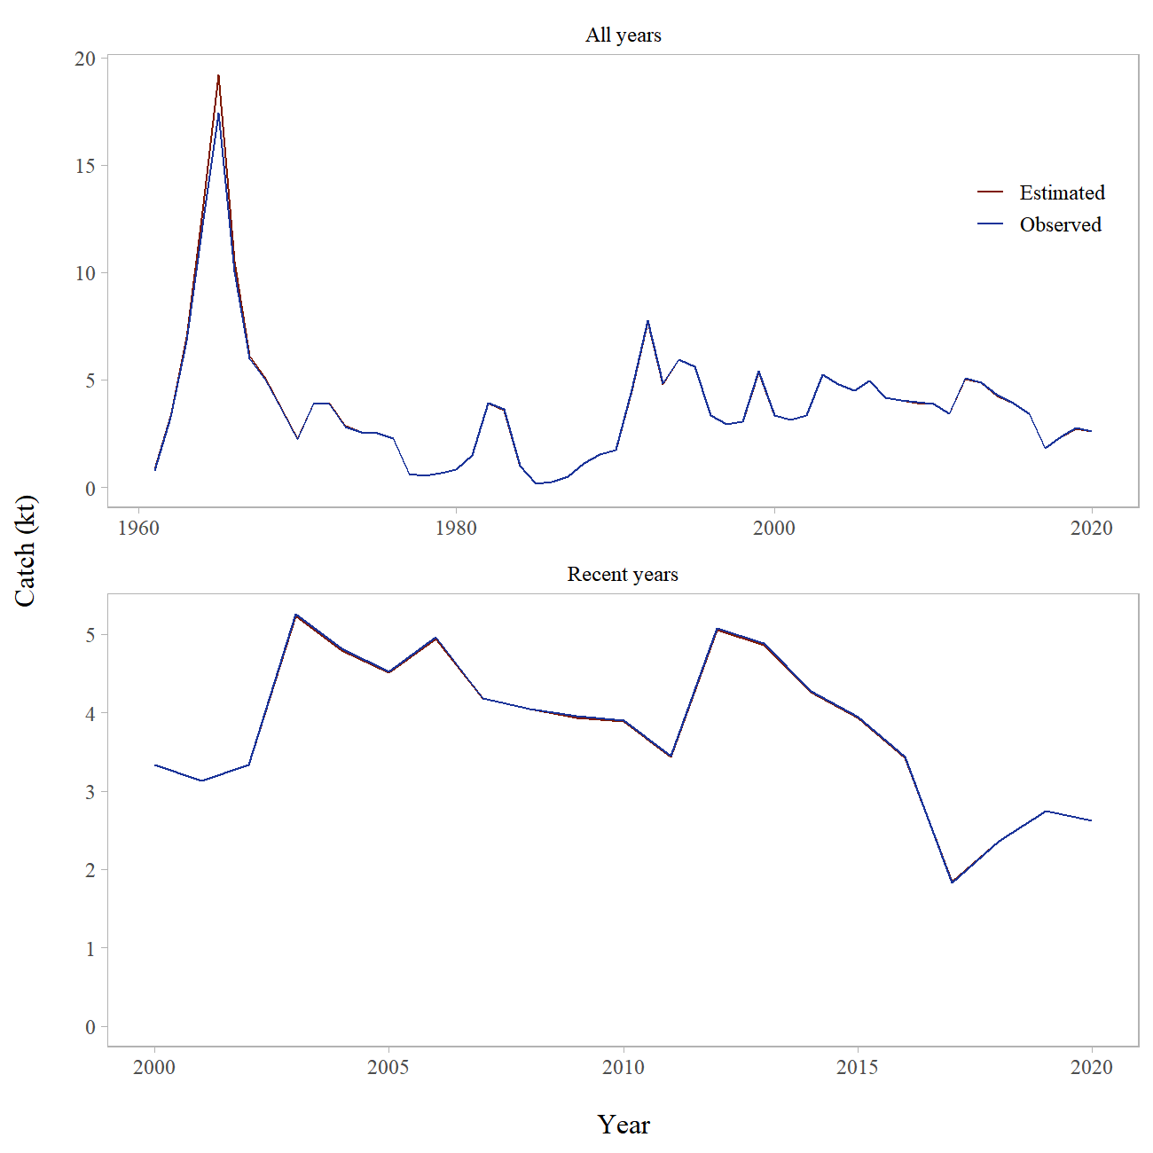

Figure 10-1. Estimated and observed long-term and recent commercial catch of northern rockfish in the Gulf of Alaska.

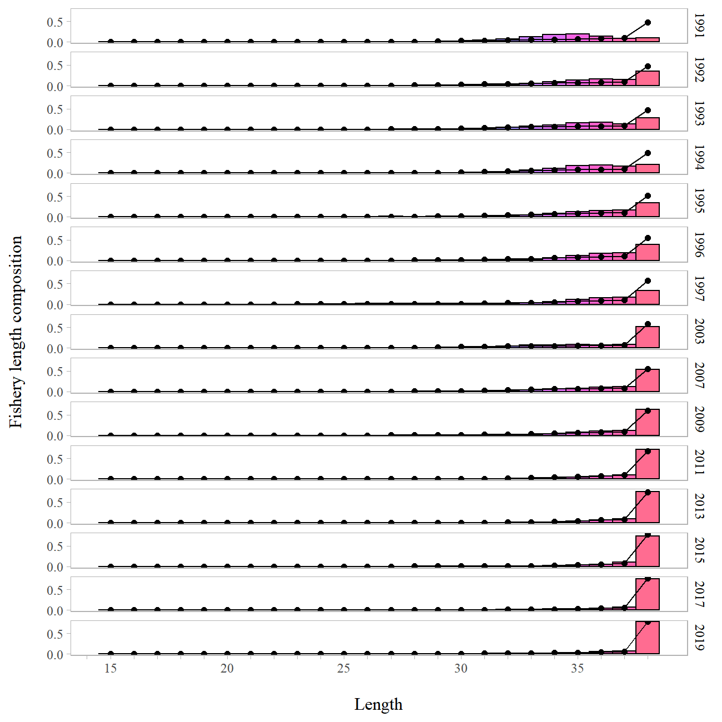

Figure 10-2. Fishery length compositions for GOA northern rockfish. Observed = bars, lines are the predicted lengths from author recommended model.

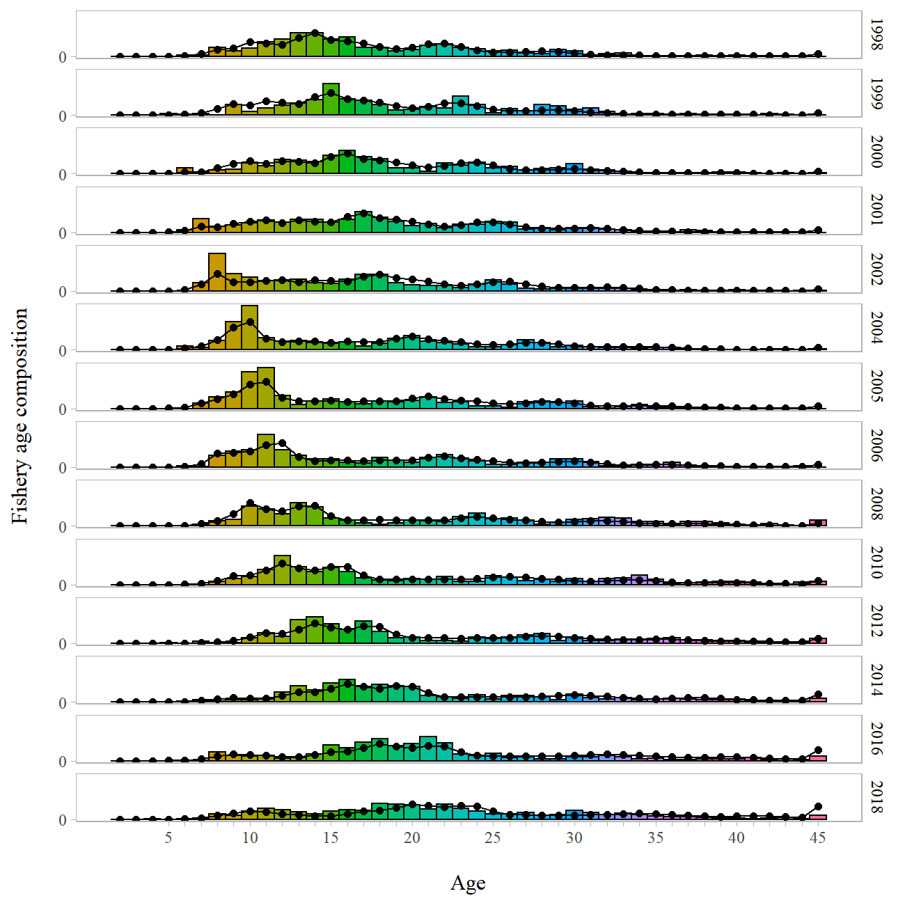

Figure 10-3. Fishery age compositions for GOA northern rockfish. Observed = bars, lines are the predicted lengths from author recommended model.

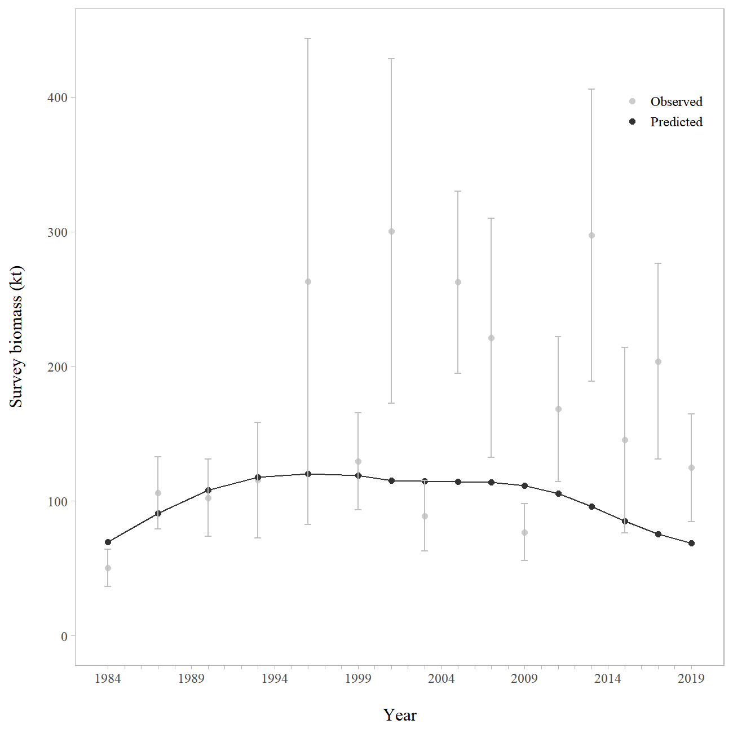

Figure 10-4. Observed and predicted GOA northern rockfish trawl survey VAST model-based index of biomass.

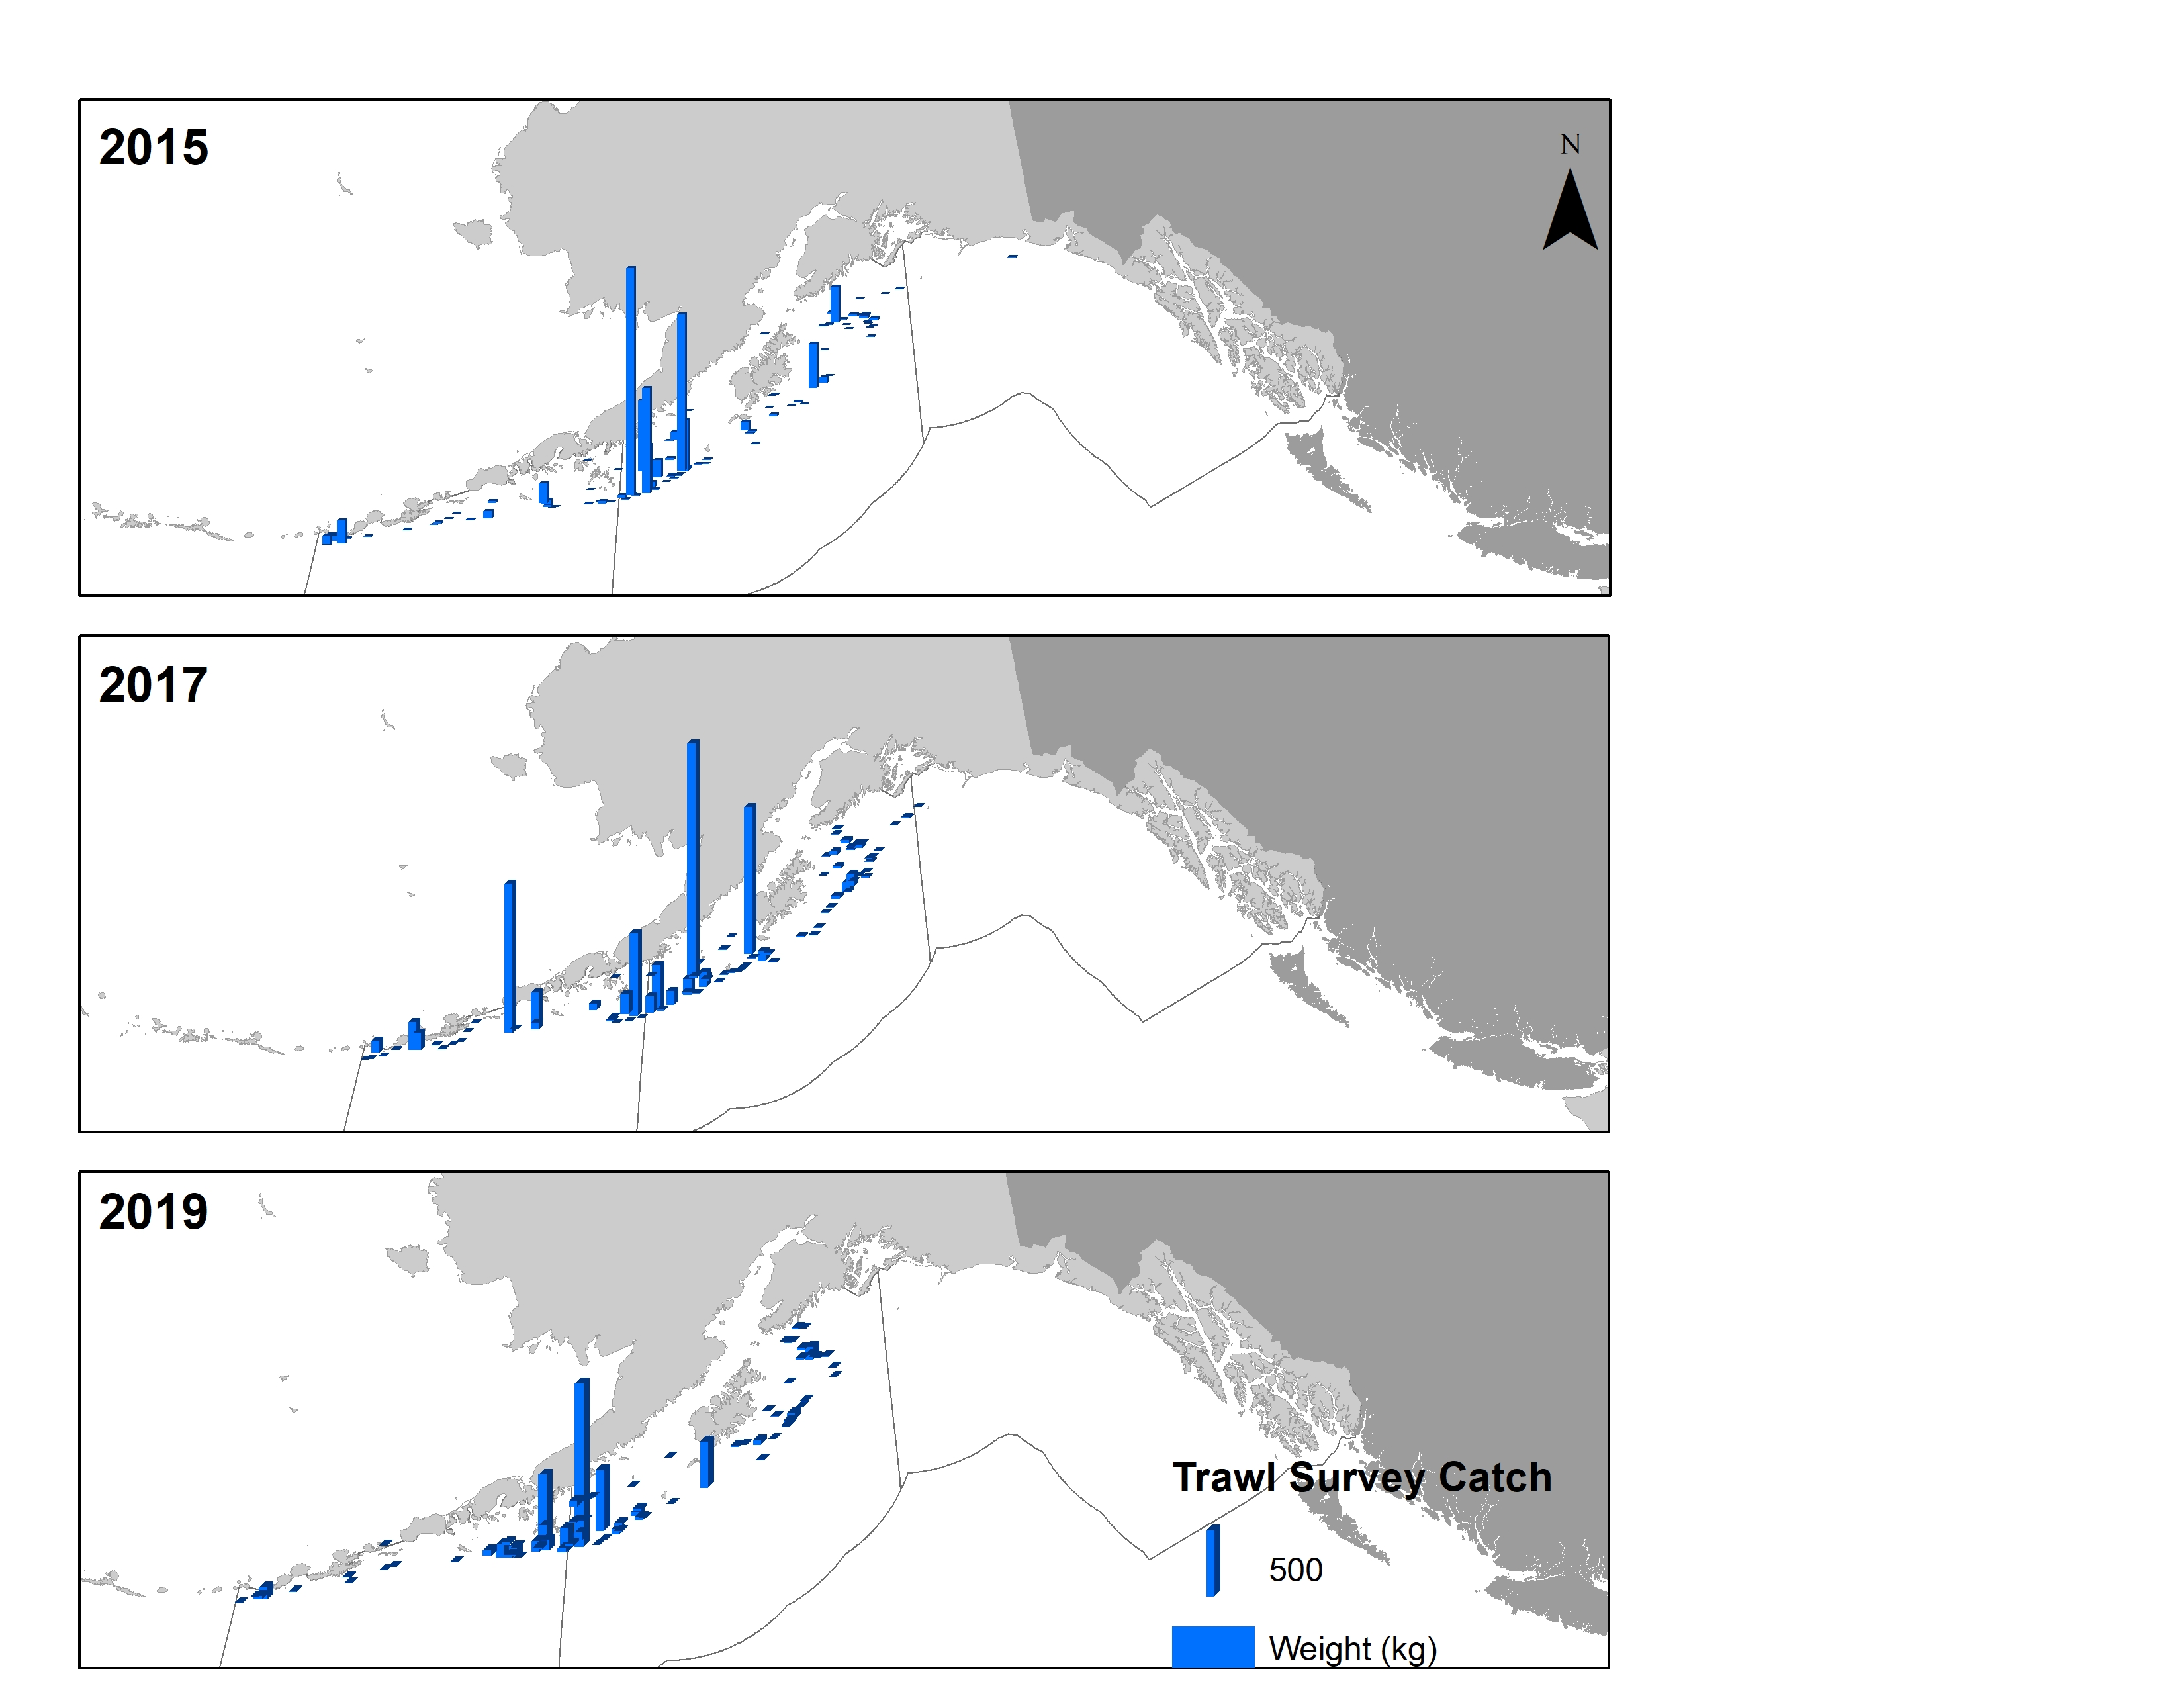

Figure 10-5. Spatial distribution of trawl survey catch for northern rockfish in the Gulf of Alaska .

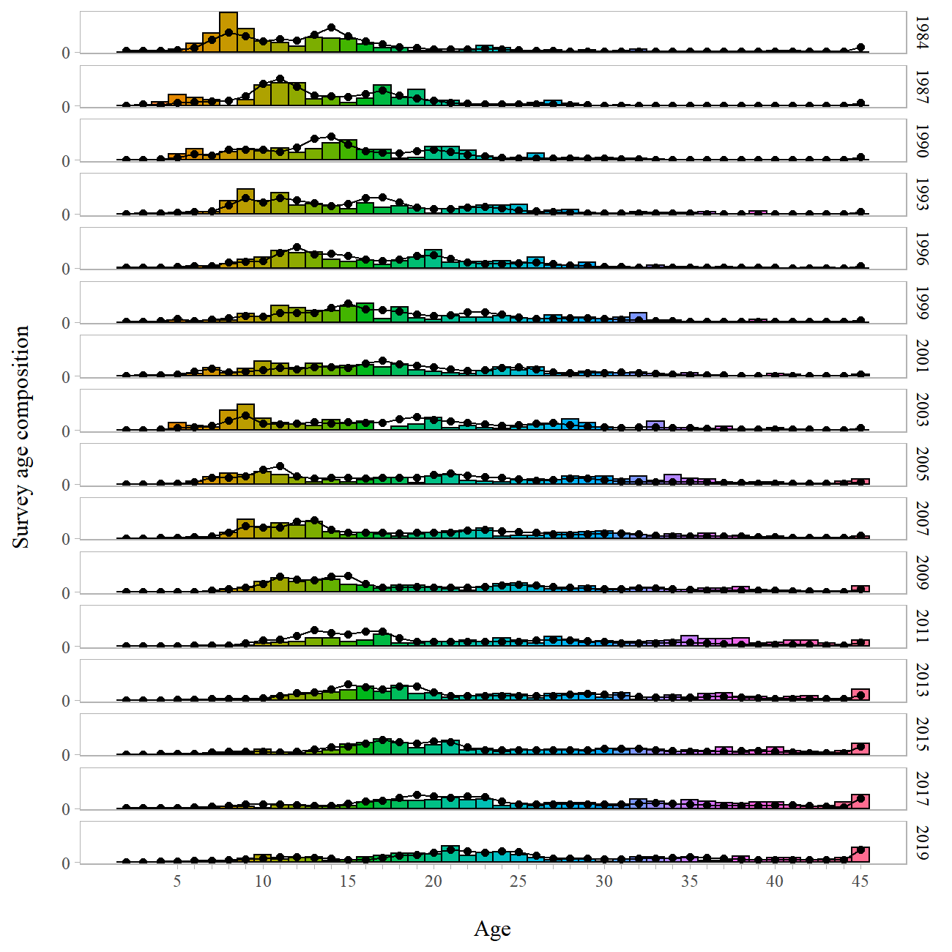

Figure 10-6. Trawl survey age composition by year for GOA northern rockfish. Observed = bars, predicted from author recommended model = line with circles.

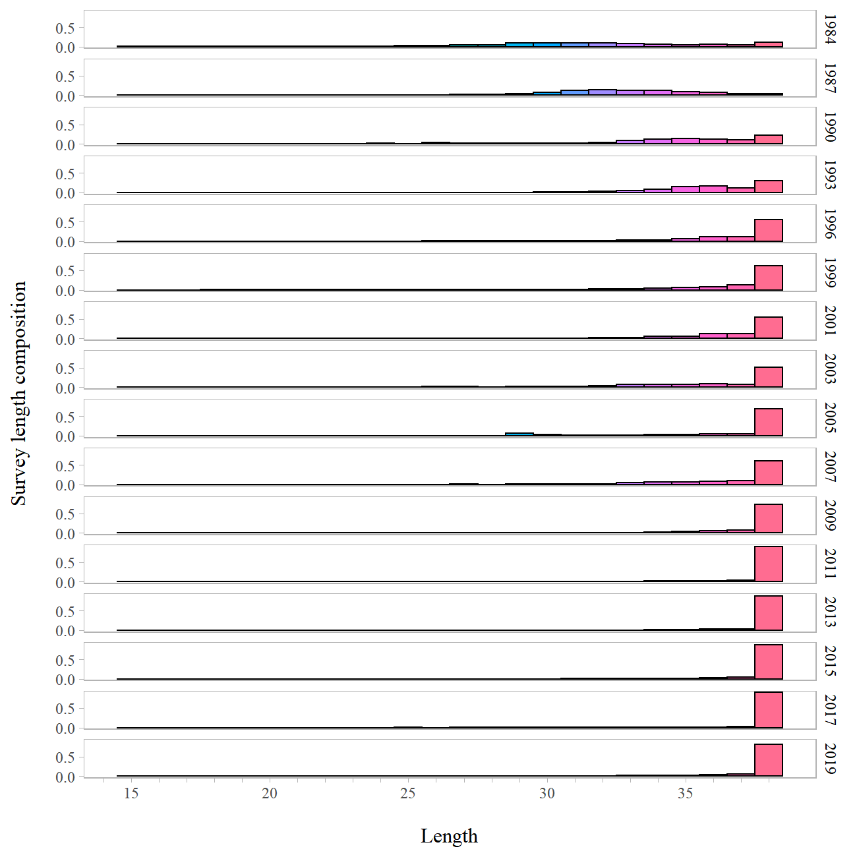

Figure 10-7. Trawl survey length composition by year for GOA northern rockfish. Survey length composition is not used in the model as age composition is available for these years.

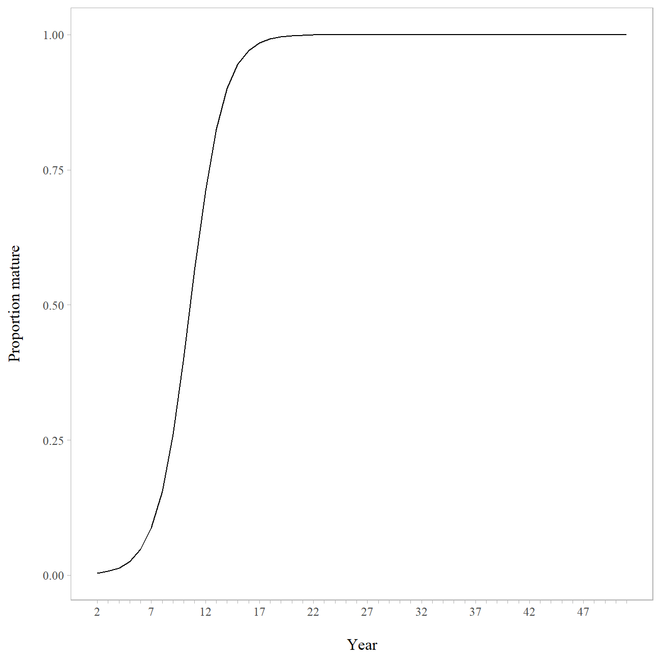

Figure 10-8. Model fit to combined female northern rockfish maturity data.

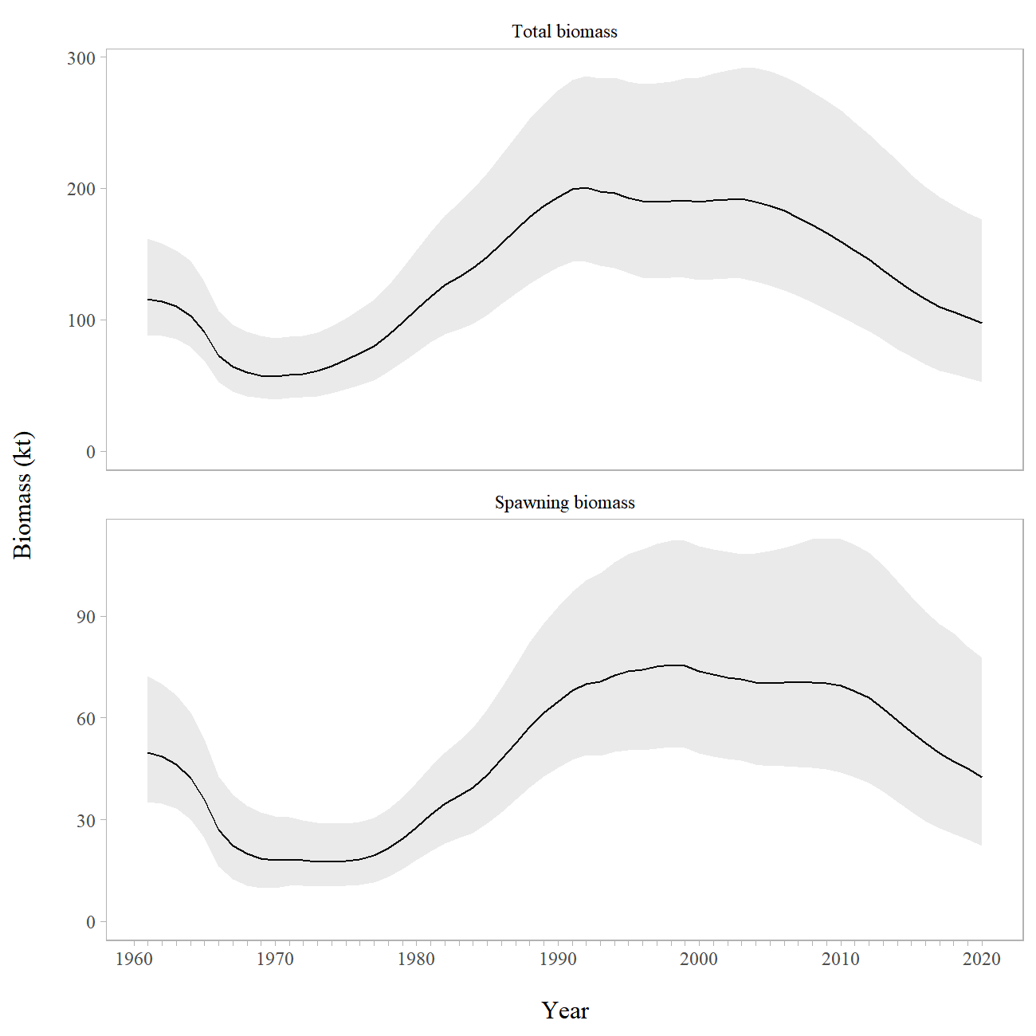

Figure 10-9. Model estimated total biomass and spawning biomass with 95% credible intervals determined by MCMC (shaded) for Gulf of Alaska northern rockfish.

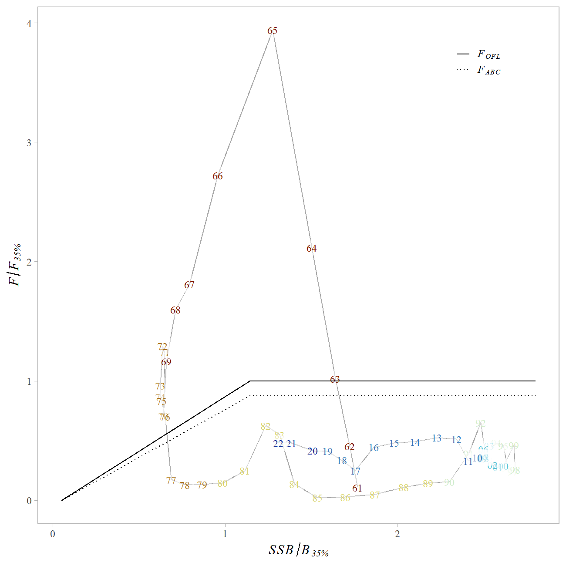

Figure 10-10. Time series of northern rockfish estimated spawning biomass (SSB) relative to and fishing mortality () relative to for author recommended model.

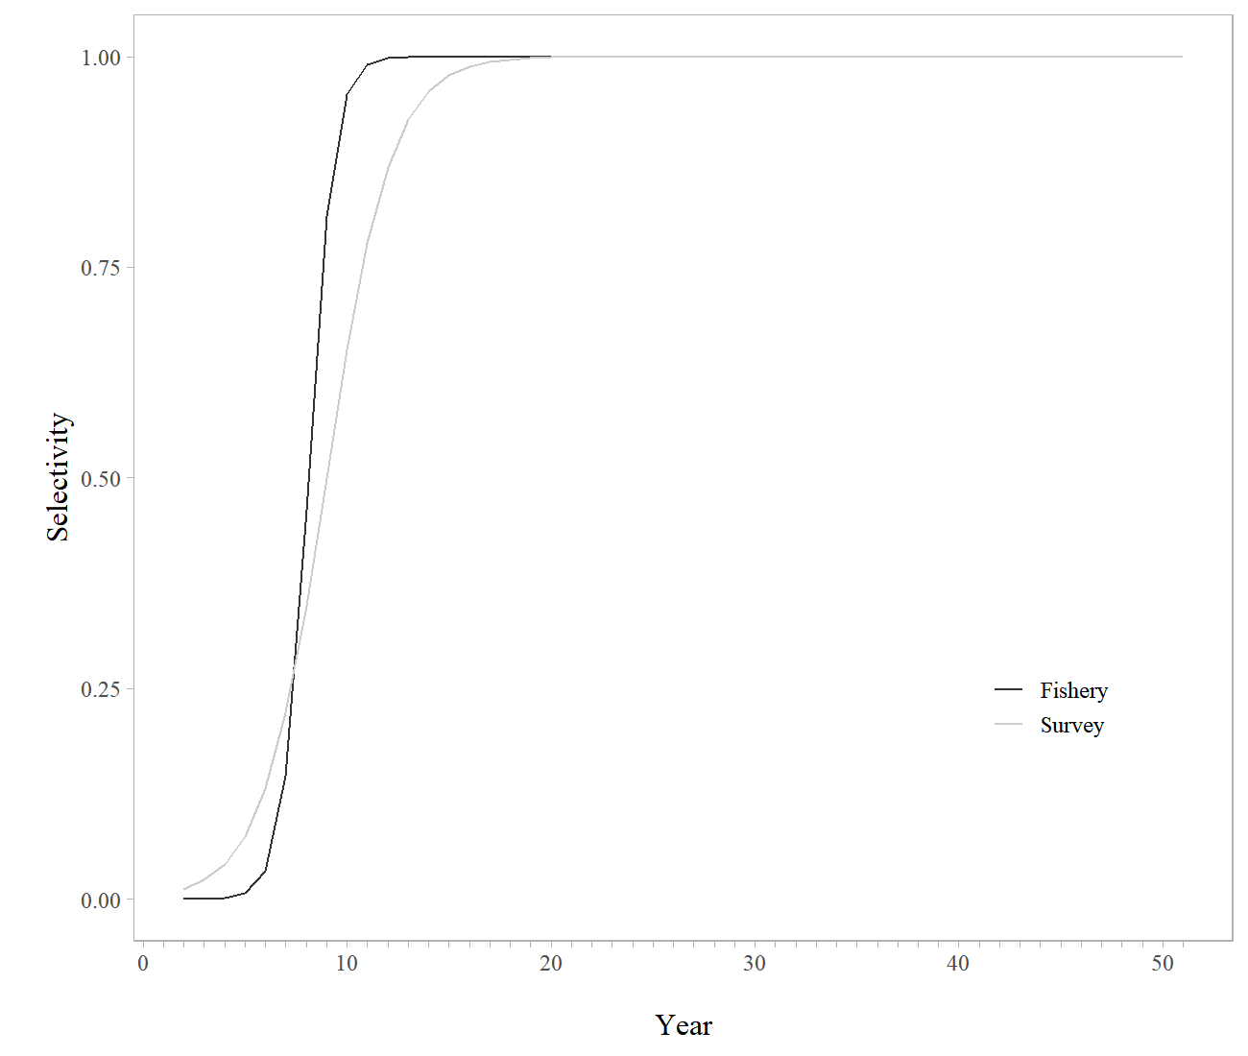

Figure 10-11. Fishery and survey estimates of selectivity for GOA northern rockfish based on the authors recommended model.

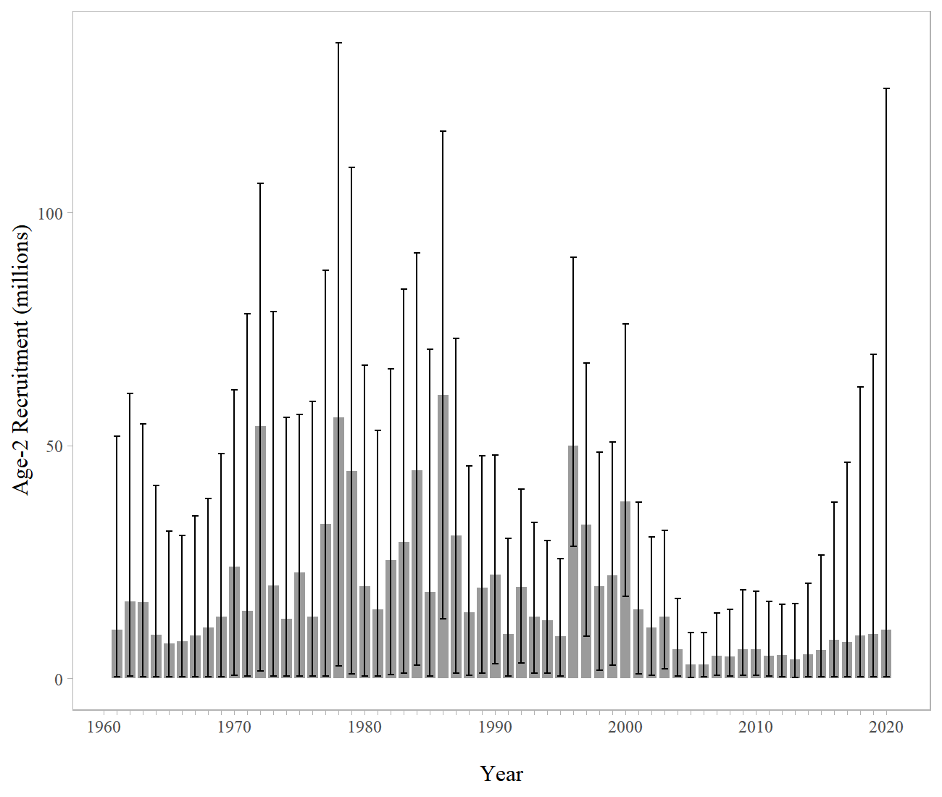

Figure 10-12. Estimates of age-2 recruitment with 95% credible intervals for GOA northern rockfish.

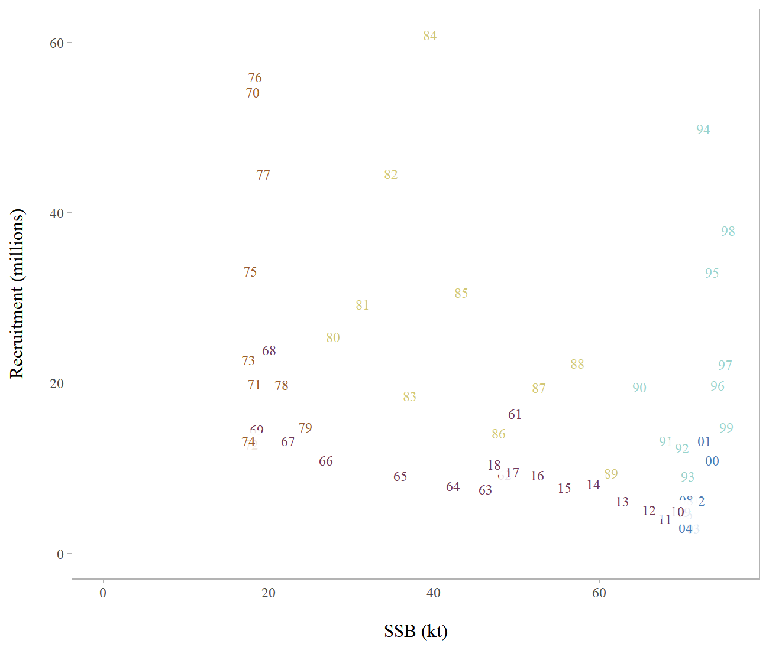

Figure 10-13. Female spawning stock biomass (SSB) and recruitment (by year class) for GOA northern rockfish.

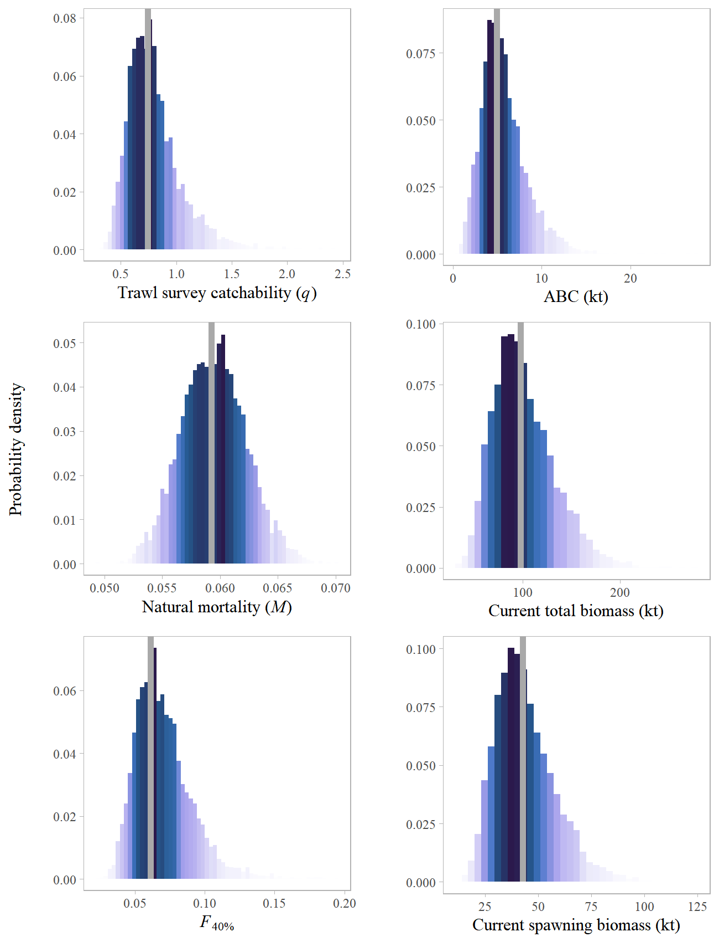

Figure 10-14. Histograms of estimated posterior distributions for key parameters derived from the MCMC for GOA northern rockfish. Vertical lines represent the maximum likelihood estimate for comparison with the MCMC results.

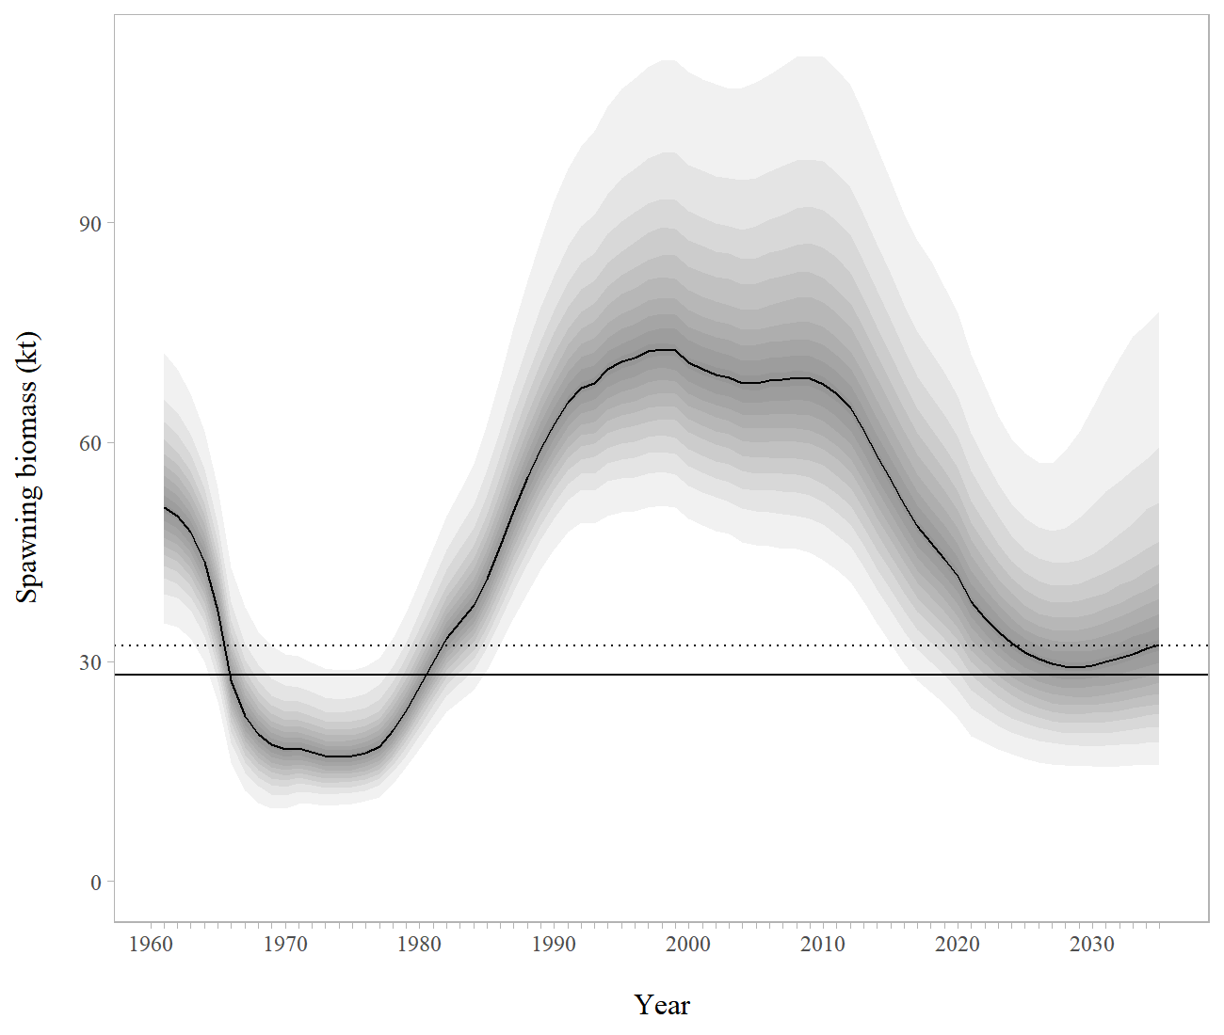

Figure 10-15. Median spawning stock biomass from MCMC simulations with Bayesian credible intervals including projections through 2035, when managing under Scenario 2. Assumes the same average yield ratio forward in time. Dotted horizontal line is and solid horizontal line is based on recruitments from 1977-2018. Each shade is 5% of the posterior distribution.

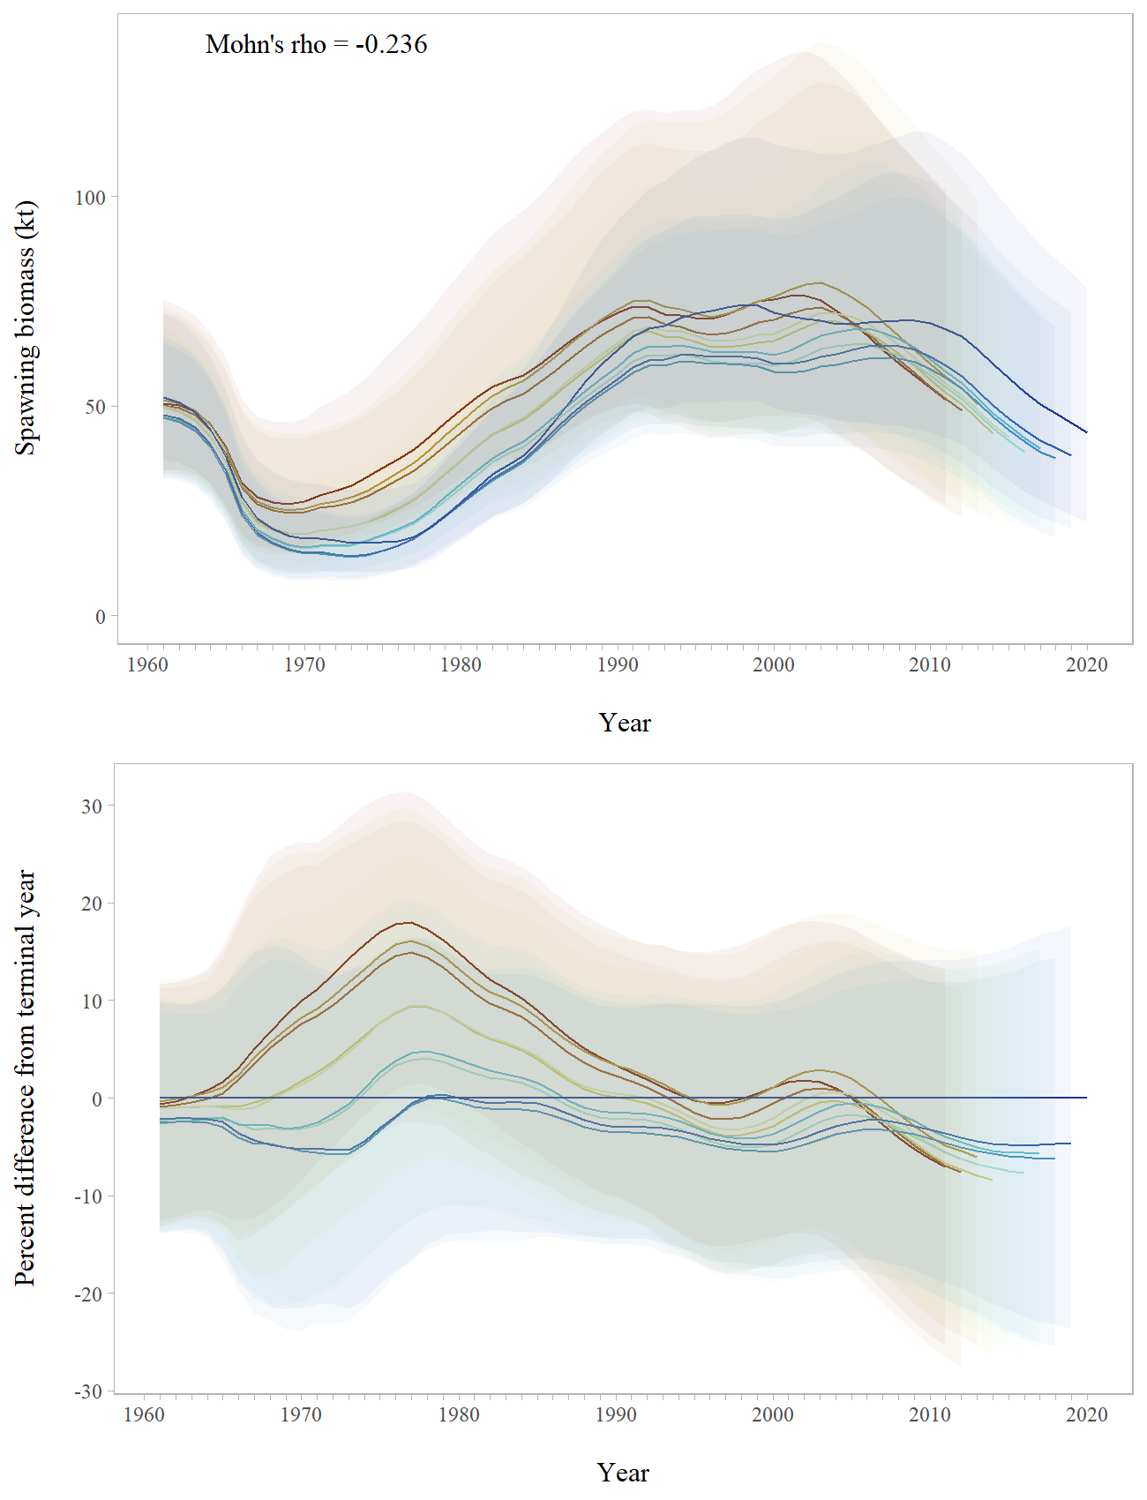

Figure 10-16. Retrospective peels of estimated female spawning biomass for the past 10 years from the recommended model with 95% credible intervals derived from MCMC (top), and the percent difference in female spawning biomass from the recommended model in the terminal year with 95% credible intervals from MCMC.

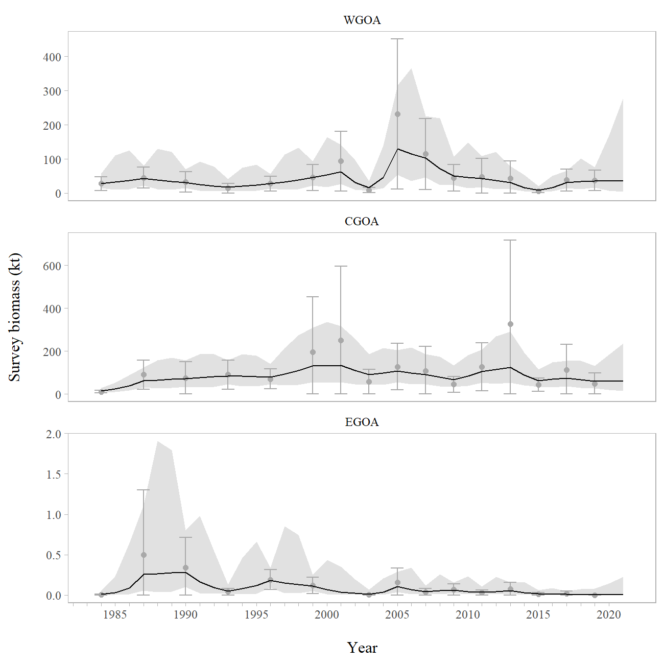

Figure 10-17. Random effects model fit (black line with 95% confidence intervals in light grey) to regional bottom trawl survey biomass (gray points and bar showing 95% sampling error confidence intervals).

# Appendix 10a. Supplemental catch data

In order to comply with the Annual Catch Limit (ACL) requirements, a dataset has been generated to help estimate total catch and removals from NMFS stocks in Alaska. This dataset estimates total removals that occur during non-directed groundfish fishing activities. This includes removals incurred during research, subsistence, personal use, recreational, and exempted fishing permit activities, but does not include removals taken in fisheries other than those managed under the groundfish FMP. These estimates represent additional sources of removals to the existing Catch Accounting System estimates. For Gulf of Alaska (GOA) northern rockfish, these estimates can be compared to the research removals reported in previous assessments (Heifetz et al. 2009; Table 10 A-1). Northern rockfish research removals are minimal relative to the fishery catch and compared to the research removals of other species. The majority of research removals are taken by the Alaska Fisheries Science Center’s (AFSC) biennial bottom trawl survey which is the primary research survey used for assessing the population status of northern rockfish in the GOA. Other research activities that harvest northern rockfish include longline surveys by the International Pacific Halibut Commission and the AFSC and the State of Alaska’s trawl surveys. Recreational harvest of northern rockfish rarely occurs. Total removals from activities other than a directed fishery have been near 10 t for 2010 - 2017. The 2017 other removals is <1% of the 2018 recommended ABC of 4,529 t and represents a very low risk to the northern rockfish stock. Research harvests from trawl in recent years are higher in odd years due to the biennial cycle of the AFSC bottom trawl survey in the GOA and have been less than 10 t except in 2013 when 18 t were removed. These removals do not pose a significant risk to the northern rockfish stock in the GOA.

## References

Heifetz, J., D. Hanselman, J. N. Ianelli, S. K. Shotwell, and C. Tribuzio. 2009. Gulf of Alaska northern rockfish. In Stock assessment and fishery evaluation report for the groundfish resources of the Gulf of Alaska as projected for 2010. North Pacific Fishery Management Council, 605 W 4th Ave, Suite 306 Anchorage, AK 99501. pp. 817-874.

Table 10a-1. Total removals of Gulf of Alaska northern rockfish (t) from activities not related to directed fishing, since 1977. Trawl survey sources are a combination of the NMFS echo-integration, small-mesh, and GOA bottom trawl surveys, and occasional short-term research projects. Other is longline, personal use, recreational, and subsistence harvest.

|  |  |  |  |  |
| --- | --- | --- | --- | --- |
| Year | Source | Trawl | Other | Total |
| 1977 | **Assessment of northern rockfish in the Gulf of Alaska (Heifetz et al. 2009)** | 0 |  | 0 |
| 1978 | 1 |  | 1 |
| 1979 | 1 |  | 1 |
| 1980 | 1 |  | 1 |
| 1981 | 8 |  | 8 |
| 1982 | 6 |  | 6 |
| 1983 | 2 |  | 2 |
| 1984 | 11 |  | 11 |
| 1985 | 11 |  | 11 |
| 1986 | 1 |  | 1 |
| 1987 | 41 |  | 41 |
| 1988 | 0 |  | 0 |
| 1989 | 1 |  | 1 |
| 1990 | 19 |  | 19 |
| 1991 | 0 |  | 0 |
| 1992 | 0 |  | 0 |
| 1993 | 21 |  | 21 |
| 1994 | 0 |  | 0 |
| 1995 | 0 |  | 0 |
| 1996 | 13 |  | 13 |
| 1997 | 1 |  | 1 |
| 1998 | 2 |  | 2 |
| 1999 | 13 |  | 13 |
| 2000 | 0 |  | 0 |
| 2001 | 23 |  | 23 |
| 2002 | 0 |  | 0 |
| 2003 | 7 |  | 7 |
| 2004 | 0 |  | 0 |
| 2005 | 27 |  | 27 |
| 2006 | 0 |  | 0 |
| 2007 | 22 |  | 22 |
| 2008 | 0 |  | 0 |
| 2009 | 7 |  | 7 |
| 2010 | **AKRO** | <1 | <1 | 1 |
| 2011 | 11 | <1 | 11 |
| 2012 | <1 | <1 | 1 |
| 2013 | 18 | <1 | 18 |
| 2014 | <1 | <1 | 1 |
| 2015 | 8 | <1 | 8 |
| 2016 | <1 | <1 | <1 |
| 2017 | 7 | <1 | 7 |
| 2018 |  | <1 | <1 | <1 |
| 2019 |  | 5 | <1 | 5 |

# Appendix 10b: VAST model-based abundance

## Background

Model-based abundance indices have a long history of development in fisheries (Maunder and Punt 2004). We here use a delta-model that uses two linear predictors (and associated link functions) to model the probability of encounter and the expected distribution of catches (in biomass or numbers, depending upon the specific stock) given an encounter (Lo *et al*. 1992; Stefánsson 1996).  
Previous research has used spatial strata (either based on strata used in spatially stratified design, or post-stratification) to approximate spatial variation (Helser *et al*. 2004), although recent research suggests that accounting for spatial heterogeneity within a single stratum using spatially correlated residuals and habitat covariates can improve precision for the wrestling index (Shelton *et al*. 2014).  
Model-based indices have been used by the Pacific Fisheries Management Council to account for intra-class correlations among hauls from a single contract vessel since approximately 2004 (Helser *et al*. 2004).  
Specific methods evolved over time to account for strata with few samples (Thorson and Ward 2013), and eventually to improve precision based on spatial correlations (Thorson *et al*. 2015) using what became the Vector Autoregressive Spatio-temporal (VAST) model (Thorson and Barnett 2017).

The performance of VAST has been evaluated previously using a variety of designs.  
Research has showed improved performance estimating relative abundance compared with spatially-stratified index standardization models (Grüss and Thorson 2019; Thorson *et al*. 2015), while other simulation studies have shown unbiased estimates of abundance trends (Johnson *et al*. 2019).  
Brodie *et al*. (2020) showed improved performance in estimating index scale given simulated data relative to generalized additive and machine learning models.  
Using real-world case studies, Cao *et al*. (2017) showed how random variation in the placement of tows relative to high-quality habitat could be “controlled for” using a spatio-temporal framework, and OLeary *et al*. (2020) showed how combining surveys from the eastern and northern Bering Sea within a spatio-temporal framework could assimilate spatially unbalanced sampling in those regions. Other characteristics of model performance have also been simulation-tested although these results are not discussed further here.

## Settings used in 2020

The software versions of dependent programs used to generate VAST estimates were:

R (>=3.5.3), INLA (18.07.12), TMB (1.7.15), TMBhelper (1.2.0), VAST (3.3.0), FishStatsUtils (2.5.0), sumfish (3.1.22)

We used a Poisson-link delta-model (Thorson 2018) involving two linear predictors, and a gamma distribution for the distribution of positive catch rates. We extrapolated catch density using 3705 m (2 nmi) X 3705 m (2 nmi) extrapolation-grid cells; this results in 36,690 extrapolation-grid cells for the eastern Bering Sea, 15,079 in the northern Bering Sea and 26,510 for the Gulf of Alaska (some Gulf of Alaska analyses eliminated the deepest stratum with depths >700 m because of sparse observations, resulting in a 22,604-cell extrapolation grid). We used bilinear interpolation to interpolate densities from 500 “knots” to these extrapolation-grid cells (i.e, using fine_scale=TRUE feature); knots were distributed spatially in proportion to the distribution of extrapolation-grid cells (i.e., having an approximately even distribution across space) using knot_method = 'grid'. No temporal smoothing was used (i.e. variation was estimated using independent and identically distributed methods). We estimated “geometric anisotropy” (the tendency for correlations to decline faster in some cardinal directions than others), and included a spatial and spatio-temporal term for both linear predictors.  
Finally, we used epsilon bias-correction to correct for retransformation bias (Thorson and Kristensen 2016).

### Diagnostics

For each model, we confirm that the Hessian matrix is positive definite and the gradient of the marginal likelihood with respect to each fixed effect is near zero (absolute value < 0.0001).  
We then conduct a visual inspection of the quantile-quantile plot for positive catch rates to confirm that it is approximately along the one-to-one line, and also check the frequency of encounters for data binned based on their predicted encounter probability (which again should be along the one-to-one line).  
Finally, we plot Pearson residuals spatially, to confirm that there is no residual pattern in positive and negative residuals.

## References

Brodie, S.J., Thorson, J.T., Carroll, G., et al. (2020) Trade-offs in covariate selection for species distribution models: A methodological comparison. Ecography 43, 11–24.

Cao, J., Thorson, J., Richards, A. and Chen, Y. (2017) Geostatistical index standardization improves the performance of stock assessment model: An application to northern shrimp in the Gulf of Maine. Canadian Journal of Fisheries and Aquatic Sciences.

Grüss, A. and Thorson, J.T. (2019) Developing spatio-temporal models using multiple data types for evaluating population trends and habitat usage. ICES Journal of Marine Science 76, 1748–1761.

Helser, T.E., Punt, A.E. and Methot, R.D. (2004) A generalized linear mixed model analysis of a multi-vessel fishery resource survey. Fisheries Research 70, 251–264.

Johnson, K.F., Thorson, J.T. and Punt, A.E. (2019) Investigating the value of including depth during spatiotemporal index standardization. Fisheries Research 216, 126–137.

Lo, N.C.-h., Jacobson, L.D. and Squire, J.L. (1992) Indices of relative abundance from fish spotter data based on delta-lognornial models. Canadian Journal of Fisheries and Aquatic Sciences 49, 2515–2526.

Maunder, M.N. and Punt, A.E. (2004) Standardizing catch and effort data: A review of recent approaches. Fisheries research 70, 141–159.

O’Leary, C.A., Thorson, J.T., Ianelli, J.N. and Kotwicki, S. Adapting to climate-driven distribution shifts using model-based indices and age composition from multiple surveys in the walleye pollock (gadus chalcogrammus) stock assessment. Fisheries Oceanography.

Shelton, A.O., Thorson, J.T., Ward, E.J. and Feist, B.E. (2014) Spatial semiparametric models improve estimates of species abundance and distribution. Canadian Journal of Fisheries and Aquatic Sciences 71, 1655–1666.

Stefánsson, G. (1996) Analysis of groundfish survey abundance data: Combining the GLM and delta approaches. ICES journal of Marine Science 53, 577–588.

Thorson, J.T. (2018) Three problems with the conventional delta-model for biomass sampling data, and a computationally efficient alternative. Canadian Journal of Fisheries and Aquatic Sciences 75, 1369–1382.

Thorson, J.T. and Barnett, L.A. (2017) Comparing estimates of abundance trends and distribution shifts using single-and multispecies models of fishes and biogenic habitat. ICES Journal of Marine Science 74, 1311–1321.

Thorson, J.T. and Kristensen, K. (2016) Implementing a generic method for bias correction in statistical models using random effects, with spatial and population dynamics examples. Fisheries Research 175, 66–74.

Thorson, J.T., Shelton, A.O., Ward, E.J. and Skaug, H.J. (2015) Geostatistical delta-generalized linear mixed models improve precision for estimated abundance indices for West Coast groundfishes. ICES Journal of Marine Science 72, 1297–1310.

Thorson, J.T. and Ward, E.J. (2013) Accounting for space–time interactions in index standardization models. Fisheries Research 147, 426–433.