10. Assessment of the Pacific Ocean Perch Stock in the Gulf of Alaska

Maia S. Kapur, Peter-John F. Hulson, and Ben Williams

November 2023

# Executive Summary

## Summary of Changes in Assessment Inputs

*Changes in the input data*: We updated the catch for 2022 and used preliminary catch estimates for 2023-2025(see Specified catch estimation section), along with 2023 bottom trawl survey biomass, and 2020 fishery age composition.

*Changes in the assessment methodology*: The assessment methodology is the same as the 2022 assessment.

## Summary of Results

For the 2023 fishery, we recommend the maximum allowable ABC of 40,564.1 t. This ABC is a 6% increase from the 2022 ABC of 38,268 t. The increase is attributed to the model continuing to react to five consecutive survey biomass estimates larger than 1 million tons as well as an increase in survey biomass in 2021 compared to 2019. This also resulted in an 11% higher ABC than the 2022 ABC projected last year. The corresponding reference values for Pacific ocean perch are summarized in the following table, with the recommended ABC and OFL values in bold. The stock is not subject to overfishing, is not currently overfished, nor is it approaching a condition of being overfished.

|  | As estimated or *specified last* year for: | | As estimated or *recommended this* year for: | |
| --- | --- | --- | --- | --- |
| **Quantity/Status** | 2023 | 2024 | 2024* | 2025* |
| M (natural mortality) | 0.059 | 0.059 | 0.059 | 0.059 |
| Tier | 3a | 3a | 3a | 3a |
| Projected total (age 2+) biomass (t) | 102,715 | 99,957 | 100,371 | 96,045 |
| Projected female spawning biomass (t) | 42,791 | 40,462 | 40,474 | 37,408 |
| B100% | 84,832 | 84,832 | 84,832 | 84,832 |
| B40% | 33,933 | 33,933 | 33,933 | 33,933 |
| B35% | 29,691 | 29,691 | 29,691 | 29,691 |
| FOFL | 0.073 | 0.073 | 0.073 | 0.073 |
| *max*FABC | 0.061 | 0.061 | 0.061 | 0.061 |
| FABC | 0.061 | 0.061 | 0.061 | 0.061 |
| OFL (t) | 6,396 | 6,088 | 6,143 | 5,874 |
| *max*ABC (t) | 5,358 | 5,100 | 5,147 | 4,921 |
| ABC (t) | 5,358 | 5,100 | 5,147 | 4,921 |
|  | As determined *last* year for: | | As determined *this* year for: | |
| **Status** | 2022 | 2023 | 2023 | 2024 |
| Overfishing | No | n/a | No | n/a |
| Overfished | n/a | No | n/a | No |
| Approaching overfished | n/a | No | n/a | No |
| *Projections are based on an estimated catch of 2,842 t for 2023 and estimates of 3,489 t and 2,884 t used in place of maximum permissible ABC for 2024 and 2025. | | | | |

## Area Allocation of Harvest

The apportionment of harvest for 2023 and 2024 was conducted using the REMA model using the same assumptions as in 2021:

1. Because Amendment 41 prohibited trawling in the Eastern area east of 140° W longitude, the ABC derived from REMA is split between W. Yakutat and E. Yakutat/SE using a weighted average (see Area Allocation of Harvests for a description of this approach)
2. Because concerns regarding stock structure differences in the SEO vs other areas, the OFL for the SEO region remains separate.

The following table shows the recommended apportionment for The apportionment percentages are the same as in the last full assessment.

|  | | Western | Central | Eastern | Total |
| --- | --- | --- | --- | --- | --- |
| Area Apportionment | | 5% | 84.4% | 10.6% | 100% |
| 2023 | ABC (t) | 269 | 4,534 | 569 | 5,372 |
| 2023 | OFL (t) |  |  |  | 8,614 |
| 2024 | ABC (t) | 259 | 4,373 | 549 | 5,181 |
| 2024 | OFL (t) |  |  |  | 8,146 |

Amendment 41 prohibited trawling in the Eastern area east of 140° W longitude. The ratio of biomass still obtainable in the W. Yakutat area (between 147° W and 140° W) is 0.75. This results in the following apportionment to the W. Yakutat area:

|  |  | W. Yakutat | E. Yakutat/Southeast |
| --- | --- | --- | --- |
| 2023 | ABC (t) | 427 | 142 |
| 2024 | ABC (t) | 412 | 137 |

## Responses to SSC and Plan Team Comments on Assessments in General

“The SSC requests that all authors fill out the risk table in 2019…” (SSC December 2018)

We provide a risk table in the Harvest Recommendations section. After completing this exercise, we do not recommend ABC be reduced below maximum permissible ABC.

## Responses to SSC and Plan Team Comments Specific to this Assessment

Several topics have emerged as recommended areas of exploration across multiple cycles of POP. For concision, the following section states each topic once, the date(s) the topic or recommendation was mentioned, and the author response.

Many of these topics were endorsed for consideration in the 2021 CIE review, which is summarized in Appendix 10c. That appendix includes detailed responses to high-priority requests and comments; where applicable, results are briefly summarized below.

*1. Re-evaluation of the age-plus group, as changes to the model and input data have occurred since this was previously evaluated (Plan Team, November 2018; CIE, 2021)*

This was investigated as part of the CIE review and authors did not find large differences in derived quantities when the plus group was reduced from 29 to 25; this is sensible given that growth is stable after age twenty and there is a paucity of data for older individuals.

*2. Continued evaluation of methods for weighting for the compositional data as new models are developed and/or changes are made to input data.(Plan Team, November 2018)*

P. Hulson has completed a technical memoranda…

*3. Investigation of natural mortality, as the current estimate of 0.066 is higher than the expected value from the prior distribution (0.05) and the prior may be constraining the model. (Plan Team, November 2018; SSC, December 2020; CIE, 2021)*

Natural mortality was investigated during this cycle in response to CIE comments (see Appendix 10c for details). The prior on does appear to be constraining in the present ADMB model, but additional explorations suggest the range of from 0.04-0.07 is a) indeed consistent with the data and b) recoverable in an alternative modeling framework, even in the presence of a broader prior on . The new author plans to transition the POP assessment to a Stock Synthesis model in future cycles and eliminate the need for this restrictive prior. For the present Operational Update, we have retained the configuration of the 2021 assessment (including the prior as is).

*4. Incorporation of hydroacoustic information into the assessment as the species are regularly found throughout the water column. Exploration of using the raw acoustic survey lengths, the acoustic abundance weighted length compositions, or using the bottom trawl survey selectivity as a proxy. (SSC, December 2018; September 2019; Plan Team, November 2020; SSC, December 2020)*

POP biomass estimates from the hydro-acoustic survey are availble from 2013 onwards. The authors have elected to continue reporting these values in the SAFE, but as in 2021 these data are not included in the base model. This data source will be considered as POP is transitioned to a new modeling framework by a new author in subsequent cycles.

*5. Re-examination of fishery-dependent information, e.g., how age samples are being collected. (SSC, December 2018; SSC, December 2020)*

This topic has not been revisited this cycle, as the authors suspect that deeper investigations into data weighting will be illustrative of the value of revisiting data collection methods. This comment will be considered as POP is transitioned to a new modeling framework by a new author in subsequent cycles.

*6. Examination of catchability, which has been an ongoing issue for POP and other rockfish species, coupled with selectivity (SSC, December 2018; Plan Team, November 2019; SSC, December 2019; SSC, December 2020)*

A manuscript is currently in preparation by P. Hulson to inform priors for catchability. The authorship team plans to transition to a framework where is calculated analytically and selectivity is estimated with greater flexibility in future cycles. The current cycle has not changed the configuration of from 2021.

* *7. Evaluate the impacts of using a VAST model for POP abundance and/or apportionment. (SSC, December 2018; Plan Team, November 2019; SSC, December 2019)*

Previous investigations have shown the model to be sensitive to the biomass index used (VAST vs. design-based). While the trajectory of both indices is similar (Figure 10.1), the differences between them are are not yet well-understood. Following the CIE panel’s recommendation, the base model used for POP assessment will continue fitting to the design-based estimates. The AFSC’s Groundfish Assessment Program (GAP) has formed a technical working group to resolve model based estimates of trawl surveys. The assessment authors will consider their advice in developing future versions of this model.

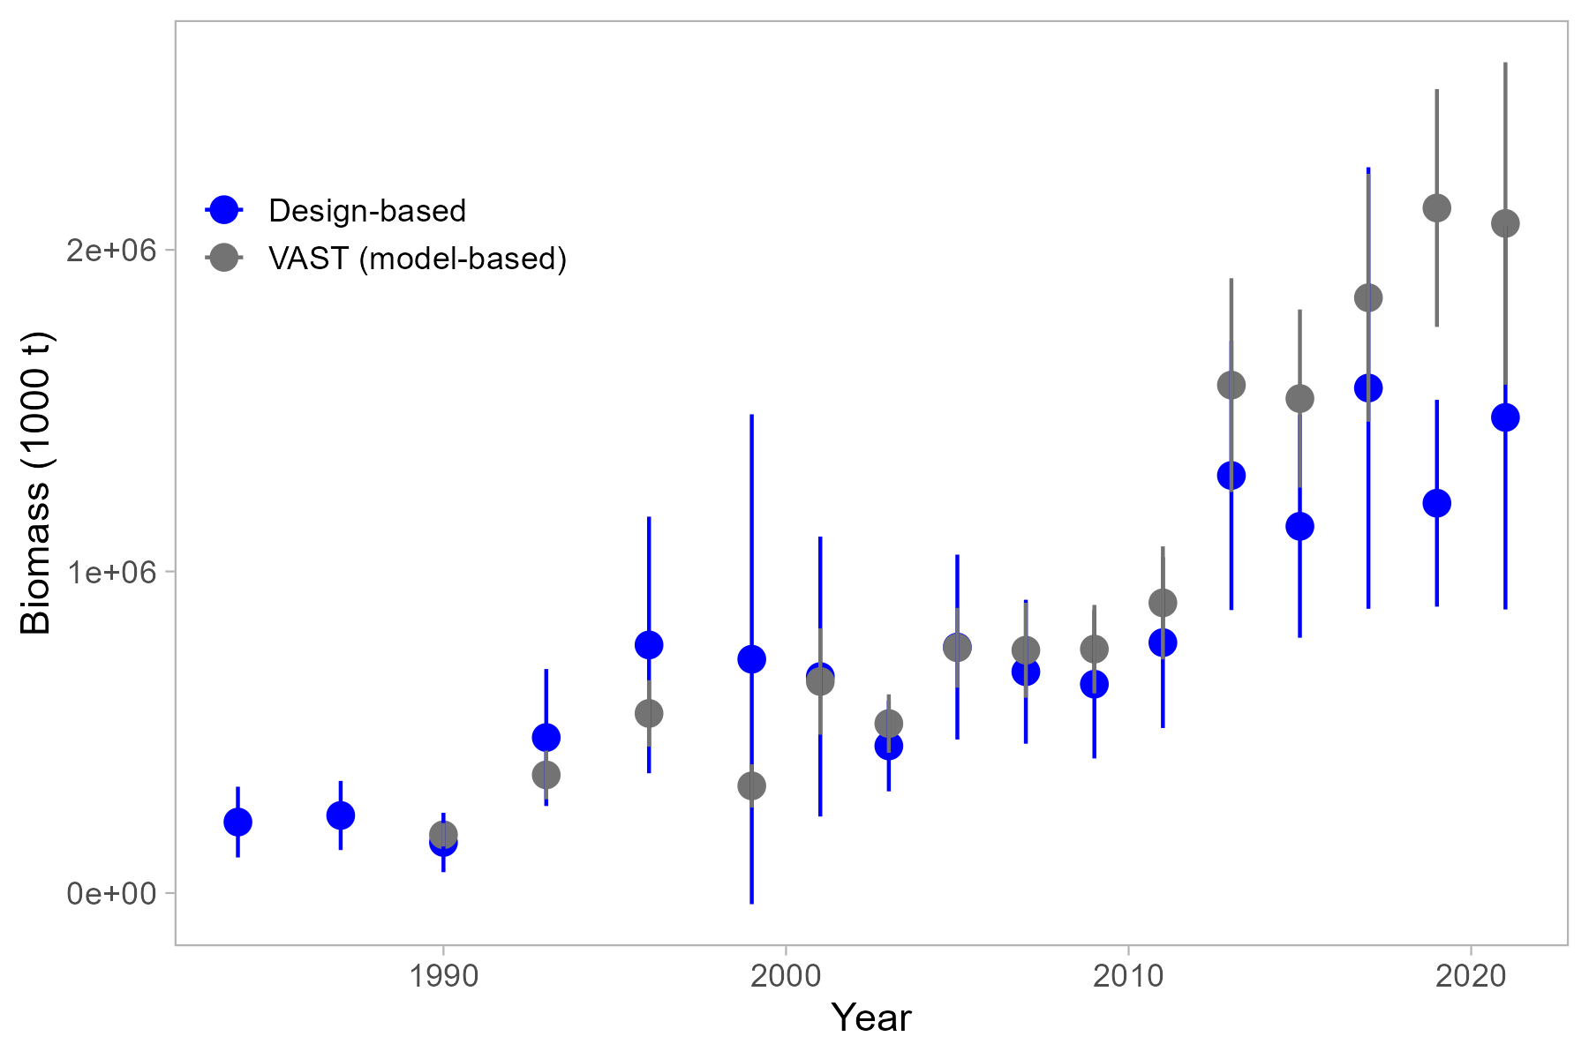

Figure 10.1. Comparison of model-based (VAST) and design-based indices of relative abundance through 2021.

# Introduction

Operational Update: The reader is referred to the full operational stock assessment(Hulson et al., 2021) for the description of the general biology and life history.

# Fishery

Operational Update: The reader is referred to the last full operational stock assessment assessment (Hulson et al., 2021) for the full description of the POP fishery history, fishery effort and CPUE, and information regarding discarding.

Table 1 shows a time series of total catch, total ABC, total OFL and TAC. Relevant management measures are shown in table 2.

# Data

Operational Update: The data description for POP has been truncated to highlight relevant updates or changes made for this cycle. The reader is referred to the last full assessment (Hulson et al., 2021) for the entirety of this section.

The following table summarizes the data used for this assessment (bold font denotes new data to this year’s assessment):

| **Source** | **Data** | **Years** |
| --- | --- | --- |
| NMFS Groundfish survey | Survey biomass | 1984-1999 (triennial), 2001-2019 (biennial) |
| Age composition | 1984, 1987, 1990, 1993, 1996, 1999, 2003, 2005, 2007, 2009, 2011, 2013, 2015, 2017, 2019 |
| U.S. trawl fishery | Catch | 1961-2020 |
| Age composition | 1998-2002, 2004-2006, 2008, 2010, 2012, 2014, 2016, 2018 |
| Length composition | 1991-1997, 2003, 2007, 2009, 2011, 2013, 2015, 2017, 2019 |

## Fishery

Catches as used in the model are shown in Table 1; discards are not used in the model. Fishery-dependent compositional data (catch at age and catch at length, and associated input sample sizes) are shown in Tables 7 and 8.

## Survey

Survey biomass estimates and associated sampling variability (annual CVs) are shown in Table 9. Suvey compositional data (survey catch at age and associated input sample sizes) are shown in Table 10.

A VAST index of relative abundnace has been developed for POP but is not currently used in the assessment. Details on the development of this index, and comparisons to the design-based methods, are available in Appendix B.

## Other time series data used in the assessment

The input size-at-age matrices are time-varying in this assessment, and are updated with the availability of new survey data. The parameters used to inform these matrices, and a comparison between previous and current values, are provided in the Modeling Section.

# Analytical approach

Operational Update: The data description for POP has been truncated to highlight relevant updates or changes made for this cycle. The reader is referred to the last full assessment (Hulson et al., 2021) for the entirety of this section.

## General Model Structure

The model used for this Operational Update is unchanged from 2021. The POP assessment is a single-sex, age-structured statistical catch-at-age model written in AD Model Builder (see Fournier et al. 2012 for recent reference) as described in Courtney et al. (2007). Formulae for the population dynamics, observation, and likelihood components of the assessment model are presented in Appendix 10d.

## Description of Base Model

Given the change in lead authorship and results of the CIE review, this model is an Operational Update. The configuration matches the accepted model from 2021, with updated data. A full revision to the modeling framework is anticipated in the next cycle. There are no alternative models presented here.

## Parameters Estimated Outside the Assessment Model

Values estimated outside the assessment and independently include the parametersof the von Bertalanffy growth curve (, , and ), intercept and slope parameters for a regression of length uncertainty versus age, and weight-at-age parameters (, used to specify size-to-age transition matrices for the 1960s-1970s are unchanged. The values used to specify size-to-age transition matrices for the 1980s onwards are updated using new age and length data from the trawl survey.

A comparison of these values is as follows:

| Symbol, Description | 2021 Value | Updated Value |
| --- | --- | --- |
| , asymptotic length | 41.1 cm |  |
| , growth rate | 0.18 |  |
| , age at length zero | -0.49 |  |
| , asymptotic weight | 901 g |  |
| , weight-at-age growth rate | 0.2 |  |
| , age at weight zero | -0.37 |  |
| , , slope and intercept of linear relationship between sd(length at age) and age, post 1980s | -0.02, 2.18 |  |

## Parameters Estimated Inside the Assessment Model

The parameters estimated conditionally inside the assessment model are listed in the table below.]

Parameters estimated within the assessment model.

| Parameter | Symbol | Number |
| --- | --- | --- |
| Natural mortality |  | 1 |
| Survey catchability |  | 1 |
| log(mean recruitment) |  | 1 |
| Recruitment variability |  | 1 |
| Spawner-per-recruit reference points | ,, | 3 |
| Recruitment deviations |  | 88 |
| Average fishing mortality |  | 1 |
| Fishing mortality deviations |  | 61 |
| Fishery selectivity coefficients |  | 6 |
| Survey selectivity coefficients |  | 2 |
| Maturity-at-age coefficients |  | 2 |
| Total |  | 166 |

Three parameters are estimated with priors: natural mortality (), catchability (), and the uncertainty in recruitment deviations ().

Fishery and survey selectivity is age-based. Fishery selectivity is time-blocked into four periods. The period from 1961-1976 is asymptotic (via a logistic curve), and the three periods from 1977 onwards are dome-shaped (via an averaged logistic gamma for the second block, and a gamma function for the third and fourth blocks). Bottom trawl survey selectivity is estimated to be asymptotic with the logistic curve.

Maturity-at-age is conditionally estimated within the assessmentfollowing the method presented in Hulson et al. (2011). Parameter estimates for maturity-at-age are obtained by fitting two datasets collected on female POP maturity from Lunsford (1999) and Conrath and Knoth (2013). Parameters for the logistic function describing maturity-at-age are estimated conditionally in the model so that uncertainty in model results (e.g., ABC) can be linked to uncertainty in maturity parameter estimates.

# Model Uncertainty

Evaluation of model uncertainty is obtained through a Markov Chain Monte Carlo (MCMC) algorithm (Gelman et al. 1995). The chain length of the MCMC was 10,000,000 and was thinned to one iteration out of every 2,000. We omit the first 1,000,000 iterations to allow for a burn-in period. We use these MCMC methods to provide further evaluation of uncertainty in the results below including 95% credible intervals for some parameters (computed as the 5th and 95th percentiles of the MCMC samples).

# Selected Model Results

The model used in this assessment is the same as the model accepted in 2021 with updated data and parameter priors. Model 20.1 with data updated through 2023 generally results in reasonable fits to the data, estimates biologically plausible parameters, and produces consistent patterns in abundance compared to previous assessments. The assessment model continues to underestimate the trawl biomass since the 2013 survey, although, the retrospective pattern indicates that the model fit is continuing to improve to the trawl survey with additional assessments.

## Model Evaluation

### Evaluation of Model Parameters

Likelihood profile for the proposed model for management over key parameters (e.g., natural morality, stock-recruit steepness (if applicable), survey catchability). The profile should indicate all likelihood values for individual components (e.g., indices by survey, compositional data for each type and fleet).

### Residual Analysis and Convergence Criteria

Residual analysis for the model proposed for management, e.g., residual plots, time series plots of observed and predicted values, etc. Description of other criteria used to evaluate the model, including the role (if any) of uncertainty. Convergence status and convergence criteria for the proposed model for management. Randomization of starting parameter value run (e.g., jitter) results or other evidence of search for global best estimates.

### Parameter Estimates

Table listing all explicit parameters in the stock assessment model used for base model, their purpose (e.g., recruitment parameter, selectivity parameter) and whether or not the parameter was fixed or estimated in the stock assessment model. Include the associated asymptotic standard error estimates or other statistical measures of uncertainty.

### Time Series Results

Tables and figures of time-series of total biomass, 1+ (if age 1s are in the model), summary biomass, and spawning biomass (and/or spawning output), stock depletion, recruitment and fishing mortality. Time-series quantities should be reported/plotted with confidence bounds or other statistical measure of uncertainty. The time series included in this table should end with estimates for the projection year. Include a table(s) and plot(s) that has a set of parallel results for the previously accepted assessment, compared with new results. Define biomass measures used (e.g., age range used in the “age+” biomass). Define recruitment measures used (e.g., numbers at age 3). Table of estimated recruitment time series should include the average of year classes spawned after 1976. Table of estimated numbers at age as an electronic file. Selectivity estimates (if not included elsewhere). Stock-recruitment relationship. Clear description of units for all outputs.

Graph of estimated fishing mortality versus estimated spawning stock biomass (phase-plane plot), including applicable OFL and maximum FABC definitions for the stock. Biomass should be scaled relative to BMSY for Tier 1 stocks and B35% for Tier 3 stocks. Fishing mortality should be scaled relative to the arithmetic mean of FMSY for Tier 1 stocks and F35% for Tier 3 stocks. Include 2 years of projected F and B in the phase-plane plot.

Parameter uncertainty (variance estimation conditioned on a given model, estimation framework, data set choice, and weighting scheme), including likelihood profiles for important assessment parameters (e.g., natural mortality, steepness, and R0). This element for evaluating uncertainty includes expressing uncertainty in derived outputs of the model and estimating CVs using appropriate methods (e.g., bootstrap, asymptotic methods, Bayesian approaches, such as MCMC). Include the uncertainty around the OFL in the first year for which an OFL has not been specified.

### Retrospective and Historical Analysis

Retrospective analysis, where the model is fitted to a series of shortened input data sets, with the most recent years of input data being dropped. Include retrospective analysis extending back 10 years, plot spawning biomass estimates and error bars, plot relative differences, and report Mohn’s “rho” statistic (see Retrospective Working Group report for formula, not Mohn’s 1999 paper). Communicate the uncertainty implied by retrospective variability in biomass estimates. If a retrospective pattern is present, seek to explain what is driving this pattern (e.g. addition of survey data, model misspecification, etc.).

Historical analysis (plot of actual estimates of spawning biomass and stock depletion from current and previous assessments).

#### OLD MATERIAL

## Time Series Results

Key results have been summarized in Tables 9-14 to 9-18. Model predictions generally fit the data well (Figures 10.2 through 10.5)) and most parameter estimates and likelihood functions have remained similar to the last several years using this model (Table 10.11).

### Definitions

Spawning biomass is the biomass estimate of mature females. Total biomass is the biomass estimate of all POP age two and greater. Recruitment is measured as the number of age two POP. Fishing mortality is the mortality at the age the fishery has fully selected the fish.

### Biomass and exploitation trends

Estimated total biomass gradually increased from a low near 85,000 t in 1980 to over 596,000 t at the peak in 2015 (Figure 10.10). MCMC credible intervals indicate that the historic low is reasonably certain while recent increases are not quite as certain. Spawning biomass shows a similar trend (Figure 10.10). These estimates show a rapid increase since 1992, which coincides with an increase in uncertainty. The recent estimates of spawning biomass are nearly at historical levels prior to the 1970s. Age of 50% selection is 5 for the survey and between 7 and 9 years for the fishery (Figure 10.11). Fish are fully selected by both fishery and survey between 10 and 15. Current fishery selectivity is dome-shaped and with the addition of the recent time block after 2007 matches well with the ages caught by the fishery. Catchability is slightly larger (1.82) than that estimated in 2020 (1.8). The high catchability for POP is supported by several empirical studies using line transect densities counted from a submersible compared to trawl survey densities (Krieger 1993 [=2.1], Krieger and Sigler 1996 [=1.3], Jones et al. 2021 [=1.15]). Compared to the last full assessment, spawning biomass and age-6+ total biomass has increased in response to fitting the large trawl survey biomass estimates since 2013 (Table 109, Figure 10.5).

Fully-selected fishing mortality shows that fishing mortality has decreased dramatically from historic rates and has leveled out in the last decade (Figure 10.12). Goodman et al. (2002) suggested that stock assessment authors use a “management path” graph as a way to evaluate management and assessment performance over time. We chose to plot a phase plane plot of fishing mortality to (%) and the estimated spawning biomass relative to unfished spawning biomass (%). Harvest control rules based on % and % and the tier 3b adjustment are provided for reference. The management path for POP has been above the F35% adjusted limit for most of the historical time series (Figure 10.13). In addition, since 2004, POP SSB has been above % and fishing mortality has been below F40% since 1983.

### Recruitment

Recruitment (as measured by age 2 fish) for POP is highly variable and large recruitments comprise much of the biomass for future years (Figure 10.14). Recruitment has increased since the early 1970s, starting with the 1986 year class. Since the 1990s there have been several larger than average year classes, with the largest resulting in 2006. The largest differences in estimated recruitment between the current assessment and the 2020 assessment resulted at the end of the time series (Table 10.14 and Figure 10.14), which should not be unexpected given the influence of additional age composition data on recent recruitment estimates. The survey age data and the large 2013-2019 survey biomass suggests that the 2006-2009, 2010, 2012, and 2016 year classes may be above average (Figure 10.15). However, these recent recruitments are still highly uncertain as indicated by the MCMC credible intervals in Figure 10.15. POP do not seem to exhibit much of a stock-recruitment relationship because large recruitments have occurred during periods of high and low biomass (Figure 9-13).

### Uncertainty results

From the MCMC chains described in Uncertainty approach, we summarize the posterior densities of key parameters for the recommended model using histograms (Figure 10.16) and credible intervals (Table 10.13). We also use these posterior distributions to show uncertainty around time series estimates of survey biomass (Figure 10.5), total and spawning biomass (Figure 10.10), fully selected fishing mortality (Figure 10.12) and recruitment (Figure 10.14).

Table 10.13 shows the maximum likelihood estimate (MLE) of key parameters with their corresponding standard deviation derived from the Hessian matrix. Also shown are the MCMC, mean, median, standard deviation and the corresponding Bayesian 95% credible intervals (BCI). The Hessian and MCMC standard deviations are similar for q, M, and F40%, but the MCMC standard deviations are larger for the estimates of female spawning biomass and ABC. These larger standard deviations indicate that these parameters are more uncertain than indicated by the Hessian approximation. The distributions of these parameters with the exception of natural mortality are slightly skewed with higher means than medians for current spawning biomass and ABC, indicating possibilities of higher biomass estimates (Figure 10.10). Uncertainty estimates in the time series of spawning biomass also result in a skewed distribution towards higher values, particularly at the end of the time series and into the 15 year projected times series (Figure 10.17).

### Retrospective analysis

A within-model retrospective analysis of the recommended model was conducted for the last 10 years of the time-series by dropping data one year at a time. The revised Mohn’s “rho” statistic (Hanselman et al. 2013) in female spawning biomass was -0.16 (slightly larger than the 2020 value of -0.15), indicating that the model increases the estimate of female spawning biomass in recent years as data is added to the assessment. The retrospective female spawning biomass and the relative difference in female spawning biomass from the model in the terminal year are shown in Figure 10.18 (with 95% credible intervals from MCMC). In general the relative difference in female spawning biomass early in the time series is low, in recent years the increases in spawning biomass have been up to 30% compared to the terminal year. This result is not unexpected as given the large trawl survey biomass estimates since 2013; the model is responding to this data by increasing the estimates of biomass in each subsequent year.

## Harvest recommendations

Operational Update: The description of Amendment 56 specifications for POP and details regarding the development of the Risk Table have been truncated to provide minimal background and highlight relevant updates or changes made for this cycle. The reader is referred to the last full assessment (Hulson et al., 2021) for the entirety of this section, including details on the projection approach.

### Amendment 56 Reference Points

POP in the GOA are managed under Tier 3 of Amendment 56. It is assumed that the equilibrium level of recruitment is equal to the average of age-2 recruitments between 1979 and 2021 (i.e., the 1977-2019 year classes). The most recent two years of recruitment are not included in the projection due to uncertainty. This definition of equilibrium recruitment is used to estimate the reference point. Other useful biomass reference points which can be calculated using this assumption are and , defined analogously to .

### Specification of OFL and Maximum Permissible ABC

#### How Future Catches are Specified

The method for specifying catches in years 2023 to 2025 has not changed from the 2021 assessment. This is achieved by: 1. In-year catches are defined as the actual observed catch through ~October 1, plus the average catch taken between October 1 and December 31 of the previous three years (2020 to 2022). The expansion factor for the observed catch through 2023 is XX. 2. For 2024 and 2025, predicted catch is given by the ratio of the lass three catches to their respective TACs, multiplied by the TACs in future year given above (which are generally be the same as the ABCs): . The average catch to TAC ratio in the previous three years was XX; predicted catches for 2024 and 2025 are XX and YY, respectively.

Female spawning biomass for 2024 is estimated at 216,635 t. This is above =132,767 t. Under Amendment 56, Tier 3, the maximum permissible fishing mortality for ABC is and fishing mortality for OFL is . The 2024 estimates of biomass-based reference points, and the resultant ABC and OFL based on the fishing mortality rates are:

| Reference Point | Description | Value |
| --- | --- | --- |
|  | The equilibrium spawning biomass that would be obtained in the absence of fishing | 331,917 t |
|  | 40% of the equilibrium spawning biomass that would be obtained in the absence of fishing | 132,767 t |
|  | 35% of the equilibrium spawning biomass that would be obtained in the absence of fishing | 116,171 t |
|  | The fishing mortality rate that reduces the equilibrium level of spawning per recruit to 40% of the level that would be obtained in the absence of fishing | 0.10 |
| ABC | Yield at in 2024 | 38,268 t |
|  | The fishing mortality rate that reduces the equilibrium level of spawning per recruit to 35% of the level that would be obtained in the absence of fishing | 0.12 |
| OFL | Yield at in 2024 | 45,580 t |

## Harvest Projections

The standard set of Tier-3 harvest projections was applied here.

A description of future catch and scenarios and implementation can be found in the most recent full assessment. Thirteen-year projections for spawning biomass, fishing mortality, and yield are tabulated for the seven standard projection scenarios (Table 1016).

The difference for this assessment for projections is in Scenario 2 (Author’s *F*); we use pre-specified catches to increase accuracy of short-term projections in fisheries where the catch is usually less than the ABC. This was suggested to help management with setting preliminary ABCs and OFLs for two-year ahead specifications.

In addition to the seven standard harvest scenarios, Amendments 48/48 to the BSAI and GOA Groundfish Fishery Management Plans require projections of the likely OFL two years into the future.

While Scenario 6 gives the best estimate of OFL for 2023, it does not provide the best estimate of OFL for 2024, because the mean 2023 catch under Scenario 6 is predicated on the 2023 catch being equal to the 2023 OFL, whereas the actual 2023 catch will likely be less than the 2023 OFL. The executive summary contains the appropriate one- and two-year ahead projections for both ABC and OFL.

During the 2006 CIE review, it was suggested that projections should account for uncertainty in the entire assessment, not just recruitment from the endpoint of the assessment.

We continue to present an alternative projection scenario using the uncertainty of the full assessment model, harvesting at the same estimated yield ratio as Scenario 2, except for all years instead of the next two. This projection propagates uncertainty throughout the entire assessment procedure based on MCMC. The projection shows wide credibility intervals on future spawning biomass (Figure 10.17). The and reference points and future recruitment is based on the 1979-2019 age-2 recruitment, and this projection predicts that the median spawning biomass will eventually tend toward these reference points while at harvesting at .

## Risk Table and ABC recommendation

The SSC in its December 2018 minutes recommended that all assessment authors use the risk table when determining whether to recommend an ABC lower than the maximum permissible. The risk table template and examples of concerns for each level are provided in the most recent full assessment; the risk table scoring for POP has not changed since 2021:

| *Assessment-related considerations* | *Population dynamics considerations* | *Environmental/ecosystem considerations* | *Fishery Performance* |
| --- | --- | --- | --- |
| Level 2: Substantially increased concerns | Level 2: Substantially increased concerns | Level 1: No increased concerns | Level 1: No increased concerns |

An abridged summary of the considerations that led to this determination for each category follows.

### Assessment considerations

The GOA POP assessment model exhibits a negative retrospective pattern (spawning biomass continues to increase with new data).

This is driven by increases in the trawl survey biomass, which has been consistently under-estimated since 2013, and may be suggestive of model-misspecification. This results in a an “assessment considerations” score of level 2, a substantially increased concern.

### Population dynamics considerations

The model estimates above-average recruitment events in the last three decades to account for the increasing survey biomass observations (Figures 10.14 and 10.15). The estimated recruitment events are still insufficient to satisfactorily fit the recent survey data; these increases are not observed in the early time series nor are they typical for an ecosystem that is warming (with the exception of sablefish). The unusual trend of rapid increases in stock size and recruitment estimates results in a *Level 2 (substantially increased concern) population dynamics rating*.

### Environmental/Ecosystem considerations

Ocean thermal conditions have been moderate for adult POP and moderate to below average for larvae. Trends for zooplankton have been mixed. POP are benthic, continental slope (150-300 m depths) dwellers as adults, with a pelagic then inshore benthic juvenile stage (age 1 to 3) in the Gulf of Alaska (GOA) (Carlson and Haight 1976, Love et al. 2002, Rooper and Bolt 2005, Rooper et al. 2007, NPFMC 2010). Spawning occurs during winter and early spring and larvae settle to the benthos within 3-6 months (Love et al. 2002). It is reasonable to expect that the 2021 and predicted 2022 average deeper ocean temperatures will provide good spawning habitat. Average to cooler surface temperatures will contribute to average to below average pelagic conditions for larval rockfish, as warm spring surface waters are conducive to larval survival and positive rockfish recruitment (Moss 2016, Morgan 2019). Ocean temperatures at the surface and at depth on the shelf were around the long-term average in 2021 (AFSC Bottom Trawl Survey, Laman 2021; AFSC EcoFOCI survey, Rogers et al 2021; Seward Line Survey, Danielson 2021), although western GOA started the year with warmer surface waters (satellite data; Watson 2021) and there was slightly above average warmth (5.2 °C) at 200m depth along the outer edge of the shelf during the summer (AFSC Longline Survey; Siwicke 2021). This is within the range of preferred ocean temperatures for adults (4.0-6.5 °C, Major and Shippen 1970). Numerous temperature time series showed signs of cooling from previous surveys (returning to average from recent marine heatwave years 2014-2016, 2019) at the surface and at depth, and 2022 surface temperatures are predicted to continue cooling, in alignment with La Niña conditions and a negative Pacific Decadal Oscillation.

Potential competition levels with juvenile sablefish and pink salmon are unknown. Planktivorous foraging conditions were moderate and regionally variable across the GOA in 2021. The primary prey of the adult Pacific Ocean Perch include calanoid copepods, euphausiids, myctophids, and miscellaneous prey in the GOA (Byerly 2001, Yang and Nelson 2000, Yang 2003). While zooplankton trends were variable, an important observation shows continued decline in POP body condition (i.e. lower weights at length) since 2015 (Bottom Trawl Survey, O’Leary, 2021).Declines are especially pronounced in SEAK and Yakutat regions since the previous survey in 2019. The timing of this declining trend matches the time frame of increasing POP population since the 2014-2016 marine heatwave.

Regionally, zooplankton trends varied from the western to eastern GOA. The western GOA had lower spring biomass of large copepods and approximately average biomass of smaller copepods was around Kodiak, characteristics of previous warm, less productive years (e.g., 2019). Planktivorous seabird reproductive success, an indicator of zooplankton availability and nutritional quality, was below average just north of Kodiak (E. Amatuli Island; Drummond and Renner 2021). Around the eastern edge of WGOA (Seward Line, Middleton Island) the biomass of large copepods was average to above-average (Seward Line Survey, Hopcroft 2021) and planktivorous seabirds had better reproductive success (Middleton Island, Hatch et al. 2021), indicating improved forage conditions. The eastern GOA inside waters of Icy Strait, northern southeast Alaska, had higher than average large copepods and euphausiids (AFSC SECM Survey, Icy Strait, Fergusson 2021), however planktivorous seabirds had mixed reproductive success.

Potential competitors are large year classes of juvenile sablefish (2016, 2018) and a pink salmon which are returning in very high numbers this year (Murphy et al. 2021, Shaul et al. 2021). Predators of juvenile POP include Pacific halibut, arrowtooth flounder, seabirds, rockfish, salmon, and lingcod (Moss 2016, Hulson et al. 2020). Predators of adults include Pacific halibut, sablefish, and sperm whales (Moss 2016, Hulson et al. 2020). Halibut and arrowtooth flounder populations remain low relative to previous levels, and, in general, there is no cause to suspect increased predation pressure on larval or adult demersal shelf rockfish.

*Environmental and ecosystem effects for POP are scored as Level 1 (normal concern)*.

### Fishery performance

The fishery CPUE shows consistent patterns in abundance similar to the bottom trawl survey and there have been no recent changes to spatial distribution of catch, percent of TAC taken, or fishing duration. There are no indications of adverse signals or concerns about the fishery in terms of resource-use, performance, or behavior. We will continue to monitor the fishery performance as it pertains to the COVID-19 pandemic.

*Fishery Performance for POP is scored as Level 1 (normal concern)*.

### Risk Table Summary and ABC recommendation

*We do not recommend a reduction in ABC because the retrospective pattern in this assessment indicates an increasing population abundance.* We acknowledge that the current assessment model does not appropriately explain these dynamics at present.

### Area Allocation of Harvests

#### Overview

Apportionment of ABC and OFL among regulatory areas uses the random effects model (“REMA” version 0.1.0) developed by the survey averaging working group. This model estimates random effects parameters that control the variation of estimated biomass across years and areas, and is fit to the trawl survey biomass estimates (with associated variance) for the Western, Central, and Eastern GOA. The REMA model fits the survey data in each area well (Figure 10.19). Both the observations and predictions indicate that most biomass is in the Central Gulf; biomass has increased in the Central and Western Gulf, and decreased in the Eastern Gulf. The estimated apportionment among areas are as follows: 6.8% for the Western area (up from 4.6% in 2019), 80.5% for the Central area (up from 75.8% in 2019), and 12.7% for the Eastern area (down from 19.6% in 2019). This corresponds to recommended ABC’s of 2,602 t for the Western area, 30,806 t for the Central area, and 4,860 t for the Eastern area.

#### Amendment 41 Downscaling

The Eastern gulf is comprised of two sub-areas for apportionment purposes: the area west of longitude (“West Yakutat”) and the area east and southeast of longitude (“East Yakutat and Southeast Outside”). Amendment 41 prohibited trawling in the latter area, so we re-calculate apportionment rates for the Eastern Gulf to consider the ratio of biomass both within and outside of the closed area. This re-calculation is obtained by:

1. Taking the ratio of estimated biomass between the open and closed area (W. Yakutat versus E. Yakutat/SEO). The ratio for 2023 using biomass from 2019, 2021, 2023 is XX, up/down from the ratio of 0.29 used in 2021.
2. Pete to help clarify: This calculation was based on the team’s previous recommendation that we use the weighted average of the upper 95% confidence interval for the W. Yakutat. We computed this interval this year using the weighted average of the ratio for 2019, 2021 and 2023. We calculated the approximate upper 95% confidence interval using the variance of a weighted mean for the 2017-2021 weighed mean ratio.

Applying the biomass ratio to the ABC for the Eastern Gulf results in an ABC apportionment of 1,409 t to the W. Yakutat area, with 3,451 t unharvested in the E. Yakutat/SEO. The OFL for POP, where = =0.12), is 45,580. Using the same approach as for ABCs, the OFL for the Western Gulf, Central Gulf, and W. Yakutat[1] is 41,470 t and 4,110 t in the SEO area.

### Status Determination

The status definitions under the MSFCMA have been truncated from this report. The status determinations described below are derived from the offical catch estimates and the 2023 projected spawning biomass under (Harvest Scenarios)[#harvestscenarios] 6 and 7.

#### Overfishing

The official catch estimate for the most recent complete year (2022) is r catch %>% filter(Year==year-1) %>% pull(Catch) %>% format(., big.mark = “,”) t. This is less than the 2022 OFL of 5,402 t. *The stock is not subject to overfishing.*

#### Overfished (Harvest Scenario 6)

The minimum stock size threshold (MSST) for POP is given by the which is 116,171 in 2023. The estimated stock spawning biomass in 2023 is above the MSST at 210,257. *The stock is not overfished*.

#### Approaching Overfished (Harvest Scenario 7)

The mean estimated stock spawning biomass in 2025 is above the MSST at 189,598. *The stock is not approaching an overfished state*.

The fishing mortality that would have produced a catch for 2022 equal to the 2022 OFL is 0.0641.

# Ecosystem Considerations

Operational Update: The Ecosystem Considerations for POP are unchanged. The reader is referred to the last full assessment (Hulson et al., 2021) for the entirety of this section, which has been summarized below. The Fishery Impacts on the Ecocystem and GOA Rockfish Economic Performance Report for 2020 have been removed from this document.

In general, a determination of ecosystem considerations for POP is hampered by the lack of biological and habitat information.

## Ecosystem Effects on the Stock

**Prey availability/abundance trends**: Similar to many other rockfish species, stock condition of POP appears to be influenced by periodic abundant year classes. Availability of suitable zooplankton prey items in sufficient quantity for larval or post-larval POP may be an important determining factor of year class strength.

**Predator population trends**: POP are preyed upon by a variety of other fish at all life stages, and to some extent marine mammals during late juvenile and adult stages. Whether the impact of any particular predator is significant or dominant is unknown.

**Changes in physical environment**: Stronger year classes corresponding to the period around 1977 have been reported for many species of groundfish in the GOA, including POP, northern rockfish, sablefish, and Pacific cod. Therefore, it appears that environmental conditions may have changed during this period in such a way that survival of young-of-the-year fish increased for many groundfish species, including slope rockfish. POP appeared to have strong 1986-88 year classes, and there may be other years when environmental conditions were especially favorable for rockfish species. The environmental mechanism for this increased survival remains unknown.

# Data Gaps and Research Priorities

Operational Update: The reader is referred to the last full stock assessment (Hulson et al., 2021) for the entirety of the POP Data Gaps and Research Priorities section. # References

The associated model files to conduct the base assessment model are available at <https://github.com/pete-hulson/goa_pop/tree/main/2023>.

A list naming the required text files (complete parameter and data/input files in the native code of the stock assessment program), model executable, and any other supplementary electronic files that will accompany the assessment document when archived (note: archiving specific instructions will be developed in 2024.)

# Tables

Table 10.1. Commercial catch (t) of POP in the GOA, with Gulf-wide values of acceptable biological catch (ABC) and fishing quotas (t), 1977-2020 (2021 catch as of 9/25/2021). Note: There were no foreign or joint venture catches after 1988. Catches prior to 1989 are landed catches only. Catches in 1989 and 1990 also include fish reported in weekly production reports as discarded by processors. Catches in 1991-2019 also include discarded fish, as determined through a blend of weekly production reports and information from the domestic observer program. Definitions of terms: JV = Joint venture; Tr = Trace catches. Catch defined as follows: 1977, all Sebastes rockfish for Japanese catch, and POP for catches of other nations; 1978, POP only; 1979-87, the 5 species comprising the POP complex; 1988-2019, POP. Quota defined as follows: 1977-86, optimum yield; 1987, target quota; 1988-2019 total allowable catch. Sources: Catch: 1977-84, Carlson et al. (1986); 1985-88, Pacific Fishery Information Network (PacFIN); 1989-2019, National Marine Fisheries Service, Alaska Region. ABC and Quota: 1977-1986 Karinen and Wing (1987); 1987-1990, Heifetz et al. (2000); 1991-2019, NMFS AKRO BLEND/Catch Accounting System via AKFIN database.

| year | catch |
| --- | --- |
| 1999 | 1 |
| 2000 | 2 |

Table 10.2. Management measures since the break out of POP from slope rockfish.

| year | catch |
| --- | --- |
| 1,999 | 1 |
| 2,000 | 2 |

Table 10.3. FMP groundfish species caught in rockfish targeted fisheries in the GOA. Conf. = Confidential because of less than three vessels or processors. Source: NMFS AKRO Blend/Catch Accounting System via AKFIN through 9/25/2021.

| year | catch |
| --- | --- |
| 1,999 | 1 |
| 2,000 | 2 |

Table 10.4. Catch (t) of GOA POP as bycatch in other fisheries. Source: NMFS AKRO Blend/Catch Accounting System via AKFIN through 9/25/2021.

| year | catch |
| --- | --- |
| 1,999 | 1 |
| 2,000 | 2 |

Table 10.5. Non-FMP species bycatch estimates in tons for GOA rockfish targeted fisheries. Conf. = Confidential because of less than three vessels. Source: NMFS AKRO Blend/Catch Accounting System via AKFIN through 9/25/2021.

| year | catch |
| --- | --- |
| 1,999 | 1 |
| 2,000 | 2 |

Table 10.6. Prohibited Species Catch (PSC) estimates reported in tons for halibut and herring, and thousands of animals for crab and salmon, by year, for the GOA rockfish fishery. Source: NMFS AKRO Blend/Catch Accounting System PSCNQ via AKFIN through 9/25/2021.

| year | catch |
| --- | --- |
| 1,999 | 1 |
| 2,000 | 2 |

Table 10.7. Fishery length frequency data for POP in the GOA for the most recent 10 complete years.

| year | catch |
| --- | --- |
| 1,999 | 1 |
| 2,000 | 2 |

Table 10.8. Fishery age compositions for GOA POP.

| year | catch |
| --- | --- |
| 1,999 | 1 |
| 2,000 | 2 |

Table 10.9. Biomass estimates (t) with coefficient of variation (CV) for gulf-wide total biomass for POP in the GOA from trawl surveys after 1990. The 2001 survey did not sample the eastern GOA (the Yakutat and Southeastern areas). Substitute estimates of biomass for the Yakutat and Southeastern areas were obtained by averaging the biomass estimates for POP in these areas in the 1993, 1996, and 1999 surveys, that portion of the variance was obtained by using a weighted average of the three prior surveys’ variance.

| year | catch |
| --- | --- |
| 1,999 | 1 |
| 2,000 | 2 |

Table 10.10. Survey age composition (% frequency) data for POP in the GOA. Age compositions for are based on “break and burn” reading of otoliths.

| year | catch |
| --- | --- |
| 1,999 | 1 |
| 2,000 | 2 |

Table 10.11. Summary of results from the previous recommended model compared to the current recommended model

| year | catch |
| --- | --- |
| 1,999 | 1 |
| 2,000 | 2 |

Table 10.12. Estimated time series of female spawning biomass, 6+ biomass (age 6 and greater), catch/6 + biomass, and number of age two recruits for POP in the GOA. Estimates are shown for the current assessment and from the previous SAFE.

| year | catch |
| --- | --- |
| 1,999 | 1 |
| 2,000 | 2 |

Table 10.13. Estimates of key parameters and associated uncertainty derived from either Hessian or MCMC.

| year | catch |
| --- | --- |
| 1,999 | 1 |
| 2,000 | 2 |

Table 10.14. Estimated time series of recruitment, female spawning biomass, and total biomass (2+) for POP in the GOA. Columns headed with 2.5% and 97.5% represent the lower and upper 95% credible intervals from the MCMC estimated posterior distribution.

| year | catch |
| --- | --- |
| 1,999 | 1 |
| 2,000 | 2 |

Table 10.15. Estimated numbers (thousands) in 2021, fishery selectivity (from the most recent time block), and survey selectivity of POP in the GOA. Also shown are schedules of age specific weight and female maturity.

| year | catch |
| --- | --- |
| 1,999 | 1 |
| 2,000 | 2 |

Table 10.16. Set of projections of spawning biomass and yield for POP in the GOA. This set of projections encompasses six harvest scenarios designed to satisfy the requirements of Amendment 56, the National Environmental Protection Act, and the Magnuson-Stevens Fishery Conservation and Management Act (MSFCMA). For a description of scenarios see Projections and Harvest Alternatives. All units in t. B40% = 132,767 t, B35% = 116,171 t, F40% =0.10, and F35% =0.12.

| year | catch |
| --- | --- |
| 1,999 | 1 |
| 2,000 | 2 |

Table 10.17. Summary of ecosystem considerations for GOA POP.

| year | catch |
| --- | --- |
| 1,999 | 1 |
| 2,000 | 2 |

Table 10.18. GOA rockfish ex-vessel market data. Total and retained catch (thousand metric tons), number of vessels, catcher vessel share of retained catch, value (million US$), price (US$ per pound), Central Gulf’s share of GOA rockfish retained catch, and Pacific ocean perch, northern rockfish, and dusk rockfish share of GOA rockfish retained catch; 2011-2015 average and 2016-2020.

| year | catch |
| --- | --- |
| 1,999 | 1 |
| 2,000 | 2 |

Table 10.19. GOA rockfish first-wholesale market data. Production (thousand metric tons), value (million US$), price (US$ per pound), Pacific ocean perch, northern rockfish and dusky rockfish share of GOA rockfish value and price (US$ per pound), and head-and-gut share of value; 2011-2015 average and 2016-2020. Source: NMFS Alaska Region At-sea Production Reports; and ADF&G Commercial Operators Annual Reports (COAR). Data compiled and provided by the Alaska Fisheries Information Network (AKFIN).

| year | catch |
| --- | --- |
| 1,999 | 1 |
| 2,000 | 2 |

Table 10.20. Rockfish U.S. trade and global market data. Global production of rockfish and Pacific Ocean perch (thousand metric tons), U.S. Pacific ocean perch shares of global production, export volume (thousand metric tons), value (million US$) and price (US$ per pound), China’s share of Pacific Ocean perch export value and the Chinese Yaun/U.S. Dollar exchange rate; 2011-2015 average and 2016-2020

| year | catch |
| --- | --- |
| 1,999 | 1 |
| 2,000 | 2 |

# Figures



Figure 10.2. Estimated and observed long-term (top figure) and short-term (bottom figure) catch history for GOA POP.

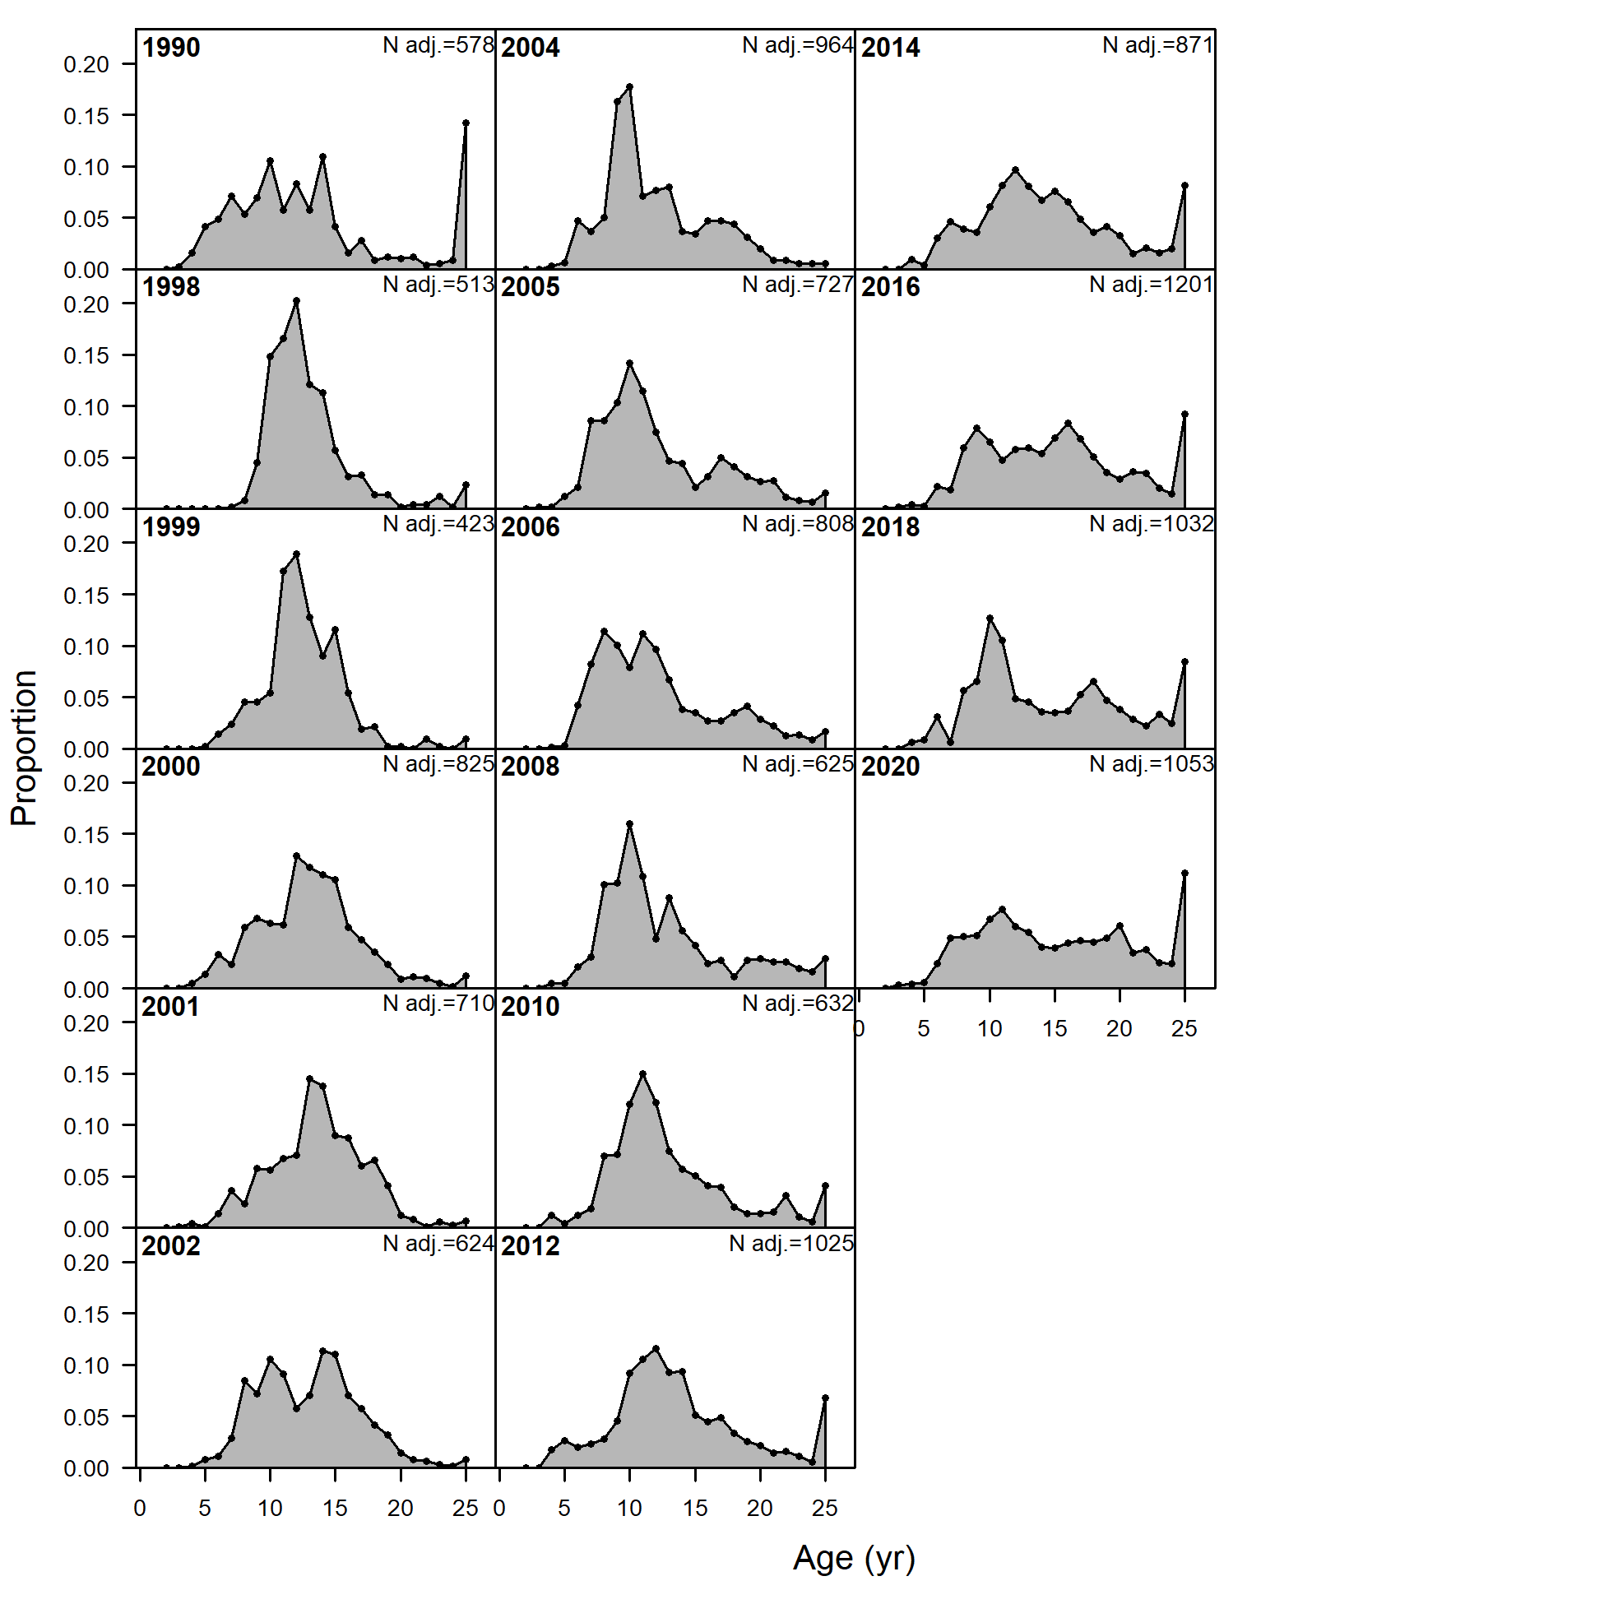

Figure 10.3. Fishery age compositions for GOA POP. Observed = bars, predicted from author recommended model = line with circles. Colors follow cohorts.

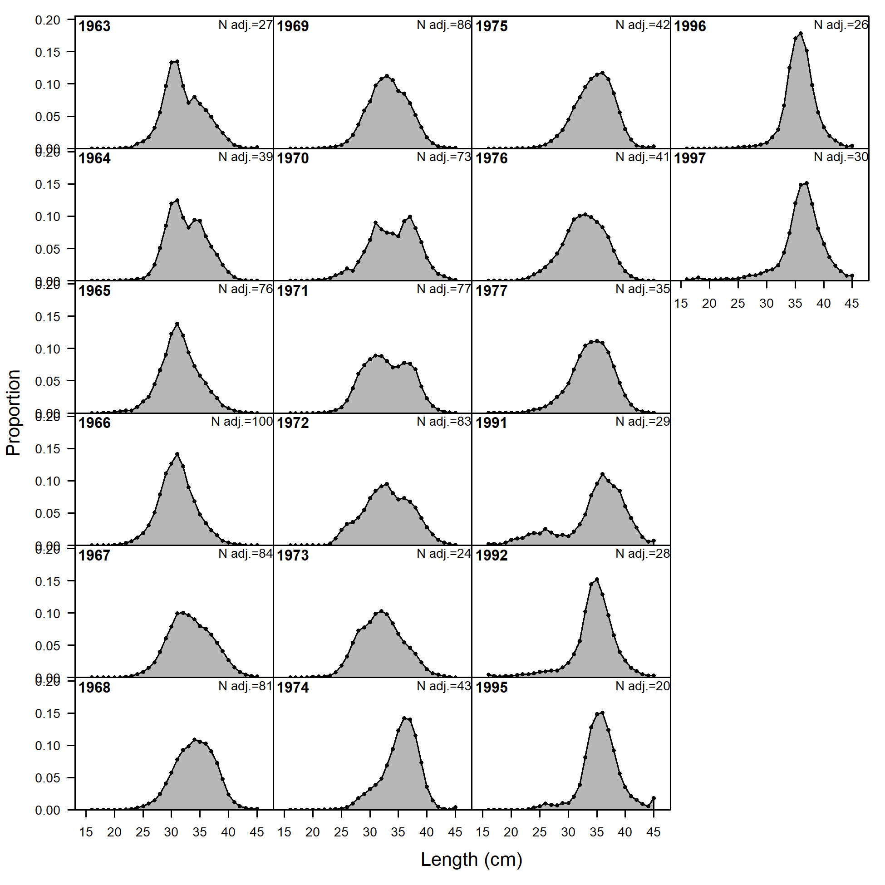

Figure 10.4. Fishery length (cm) compositions for GOA POP. Observed = bars, predicted from author recommended model = line with circles.



Figure 10.5. NMFS Groundfish Survey observed biomass estimates (open circles) with 95% sampling error confidence intervals for GOA POP. Predicted estimates from the recommended model (black line, with 95% confidence intervals shown in grey shaded region) compared with last year’s model fit (green dotted line).

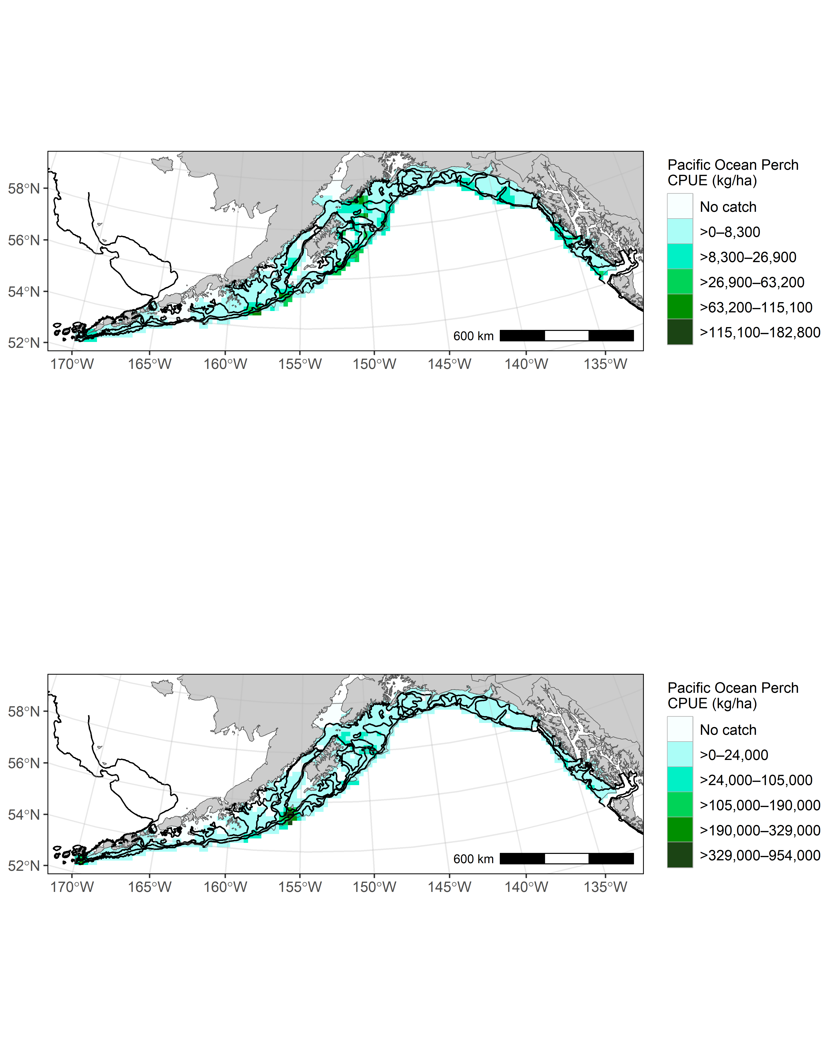

Figure 10.6. Distribution of GOA POP catch per unit effort (CPUE) in the 2021 (top) and 2023 (bottom) GOA groundfish surveys.

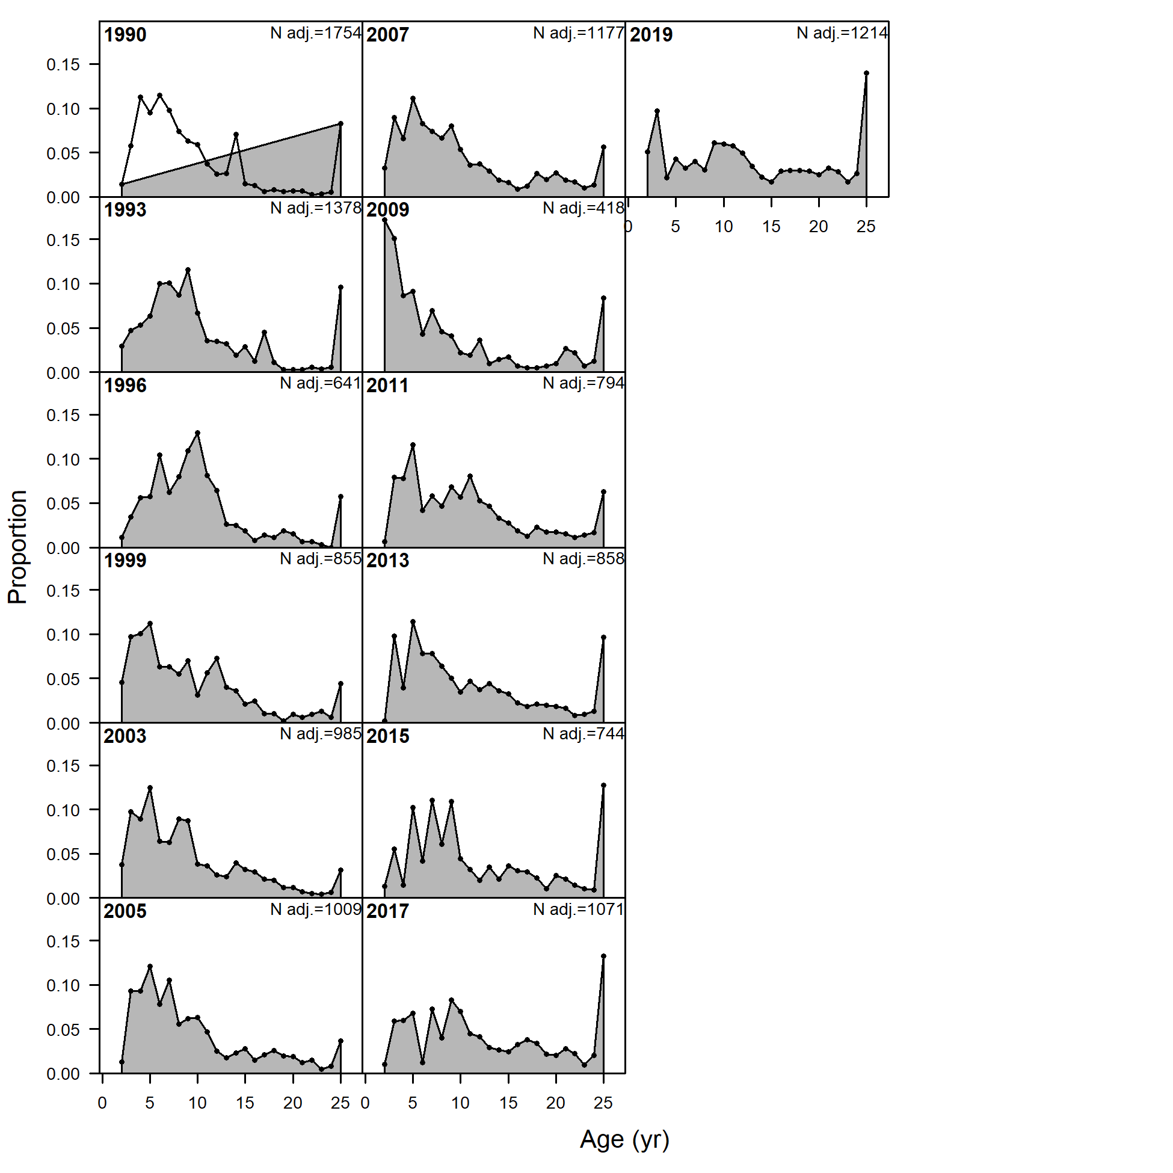

Figure 10.7. Groundfish survey age compositions for GOA POP. Observed = bars, predicted from author recommended model = line with circles



Figure 10.8. Groundfish survey length compositions for GOA POP. Observed = bars. Survey size not used in POP model because survey ages are available for these years.



Figure 10.9. Density (t/nmi2) of POP observed during the previous three GOA acoustic-trawl surveys.



Figure 10.10. Model estimated total biomass (top panel, solid black line) and spawning biomass (bottom panel) with 95% credible intervals determined by MCMC (light grey region) for GOA POP. Last year’s model estimates included for comparison (dashed line).



Figure 10.11. Estimated selectivities for the fishery and groundfish survey with maturity for GOA POP.



Figure 10.12. Estimated fully selected fishing mortality over time with 95% credible intervals determined by MCMC (light grey region) for GOA POP.



Figure 10.13. Time series of POP estimated spawning biomass relative to the target level B35% level and fishing mortality relative to F35% for author recommended model. Top shows whole time series. Bottom shows close up on more recent management path.



Figure 10.14. Estimated recruitment of GOA POP (age 2) by year class with 95% credible intervals derived from MCMC (top). Estimated recruits per spawning stock biomass (bottom). Red circles in top graph are last year’s estimates for comparison.



Figure 10.15. Recruitment deviations from average on the log-scale comparing last cycle’s model (red) to current year recommended model (blue) for GOA POP.



Figure 10.16. Histograms of estimated posterior distributions of key parameters derived from MCMC for GOA POP. The vertical white lines are the recommended model estimates.



Figure 10.17. Bayesian credible intervals for entire spawning stock biomass series including projections through 2030. Red dashed line is B40% and black solid line is B35% based on recruitments from 1979-2015. The white line is the median of MCMC simulations. Each shade is 5% of the posterior distribution.



Figure 10.18. Retrospective peels of estimated female spawning biomass for the past 10 years from the recommended model with 95% credible intervals derived from MCMC (top), and the percent difference in female spawning biomass from the recommended model in the terminal year with 95% credible intervals from MCMC.

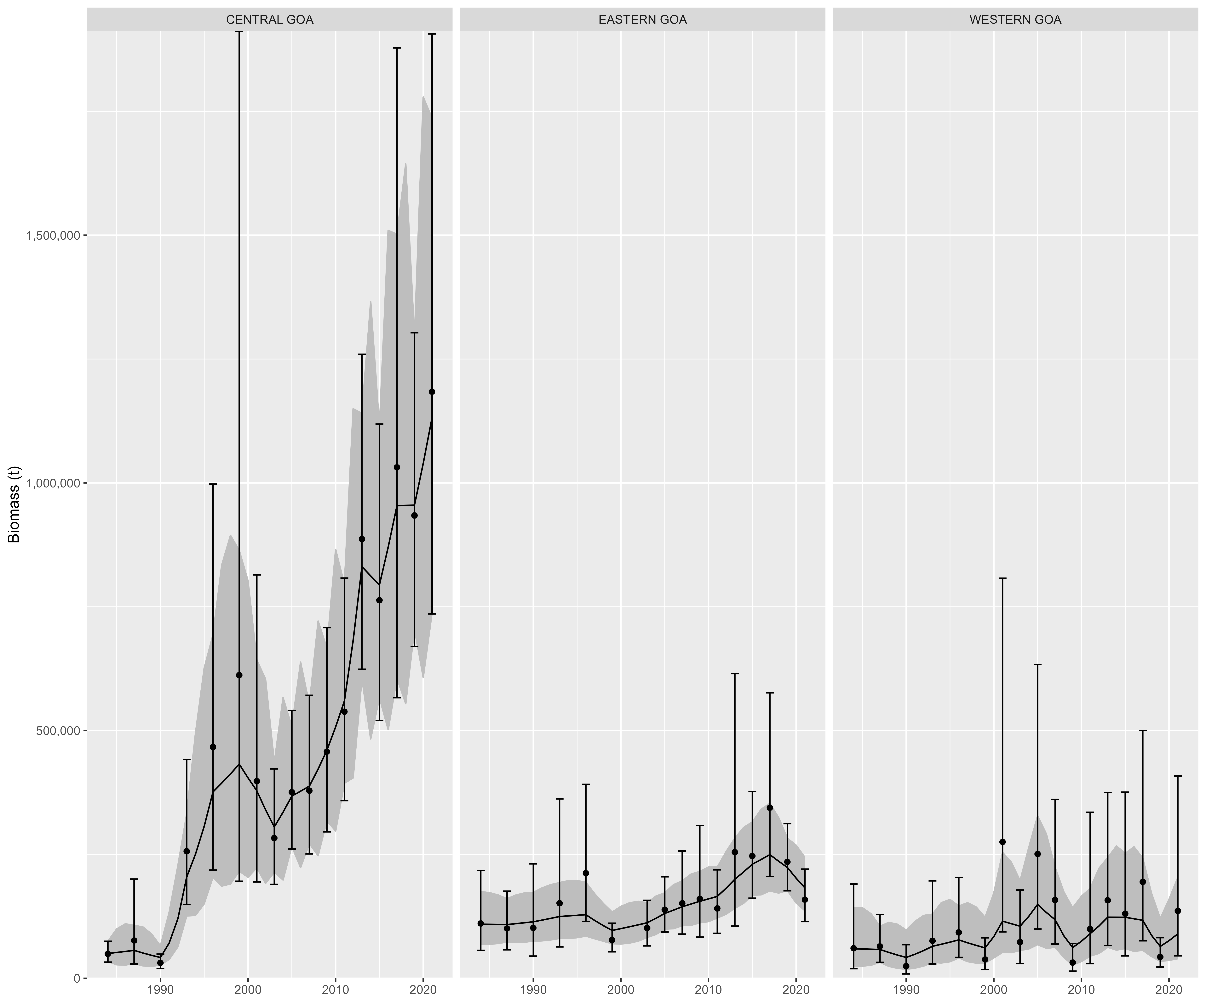

Figure 10.19. Random effects (REMA) model fit (black lines) and 95% confidence interval (grey ribbon) to observed survey biomass (black points) and 95% confidence interval (black error bars)

# Appendix 10a. Supplemental catch data

In order to comply with the Annual Catch Limit (ACL) requirements, a dataset has been generated to help estimate total catch and removals from NMFS stocks in Alaska. This dataset estimates total removals that occur during non-directed groundfish fishing activities. This includes removals incurred during research, subsistence, personal use, recreational, and exempted fishing permit activities, but does not include removals taken in fisheries other than those managed under the groundfish FMP. These estimates represent additional sources of removals to the existing Catch Accounting System estimates. For Gulf of Alaska (GOA) northern rockfish, these estimates can be compared to the research removals reported in previous assessments (Heifetz et al. 2009; Table 10 A-1). Northern rockfish research removals are minimal relative to the fishery catch and compared to the research removals of other species. The majority of research removals are taken by the Alaska Fisheries Science Center’s (AFSC) biennial bottom trawl survey which is the primary research survey used for assessing the population status of northern rockfish in the GOA. Other research activities that harvest northern rockfish include longline surveys by the International Pacific Halibut Commission and the AFSC and the State of Alaska’s trawl surveys. Recreational harvest of northern rockfish rarely occurs. Total removals from activities other than a directed fishery have been near 10 t for 2010 – 2017. The 2017 other removals is <1% of the 2018 recommended ABC of 4,529 t and represents a very low risk to the northern rockfish stock. Research harvests from trawl in recent years are higher in odd years due to the biennial cycle of the AFSC bottom trawl survey in the GOA and have been less than 10 t except in 2013 when 18 t were removed. These removals do not pose a significant risk to the northern rockfish stock in the GOA.

## References

Heifetz, J., D. Hanselman, J. N. Ianelli, S. K. Shotwell, and C. Tribuzio. 2009. Gulf of Alaska northern rockfish. In Stock assessment and fishery evaluation report for the groundfish resources of the Gulf of Alaska as projected for 2010. North Pacific Fishery Management Council, 605 W 4th Ave, Suite 306 Anchorage, AK 99501. pp. 817-874.

# Appendix 10b: VAST model-based abundance

## Background

Model-based abundance indices have a long history of development in fisheries (Maunder and Punt 2004). We here use a delta-model that uses two linear predictors (and associated link functions) to model the probability of encounter and the expected distribution of catches (in biomass or numbers, depending upon the specific stock) given an encounter (Lo *et al*. 1992; Stefánsson 1996).  
Previous research has used spatial strata (either based on strata used in spatially stratified design, or post-stratification) to approximate spatial variation (Helser *et al*. 2004), although recent research suggests that accounting for spatial heterogeneity within a single stratum using spatially correlated residuals and habitat covariates can improve precision for the wrestling index (Shelton *et al*. 2014).  
Model-based indices have been used by the Pacific Fisheries Management Council to account for intra-class correlations among hauls from a single contract vessel since approximately 2004 (Helser *et al*. 2004).  
Specific methods evolved over time to account for strata with few samples (Thorson and Ward 2013), and eventually to improve precision based on spatial correlations (Thorson *et al*. 2015) using what became the Vector Autoregressive Spatio-temporal (VAST) model (Thorson and Barnett 2017).

The performance of VAST has been evaluated previously using a variety of designs.  
Research has showed improved performance estimating relative abundance compared with spatially-stratified index standardization models (Grüss and Thorson 2019; Thorson *et al*. 2015), while other simulation studies have shown unbiased estimates of abundance trends (Johnson *et al*. 2019).  
Brodie *et al*. (2020) showed improved performance in estimating index scale given simulated data relative to generalized additive and machine learning models.  
Using real-world case studies, Cao *et al*. (2017) showed how random variation in the placement of tows relative to high-quality habitat could be “controlled for” using a spatio-temporal framework, and OLeary *et al*. (2020) showed how combining surveys from the eastern and northern Bering Sea within a spatio-temporal framework could assimilate spatially unbalanced sampling in those regions. Other characteristics of model performance have also been simulation-tested although these results are not discussed further here.

## Settings used in 2020

The software versions of dependent programs used to generate VAST estimates were:

R (>=3.5.3), INLA (18.07.12), TMB (1.7.15), TMBhelper (1.2.0), VAST (3.3.0), FishStatsUtils (2.5.0), sumfish (3.1.22)

We used a Poisson-link delta-model (Thorson 2018) involving two linear predictors, and a gamma distribution for the distribution of positive catch rates. We extrapolated catch density using 3705 m (2 nmi) X 3705 m (2 nmi) extrapolation-grid cells; this results in 36,690 extrapolation-grid cells for the eastern Bering Sea, 15,079 in the northern Bering Sea and 26,510 for the Gulf of Alaska (some Gulf of Alaska analyses eliminated the deepest stratum with depths >700 m because of sparse observations, resulting in a 22,604-cell extrapolation grid). We used bilinear interpolation to interpolate densities from 500 “knots” to these extrapolation-grid cells (i.e, using fine_scale=TRUE feature); knots were distributed spatially in proportion to the distribution of extrapolation-grid cells (i.e., having an approximately even distribution across space) using knot_method = 'grid'. No temporal smoothing was used (i.e. variation was estimated using independent and identically distributed methods). We estimated “geometric anisotropy” (the tendency for correlations to decline faster in some cardinal directions than others), and included a spatial and spatio-temporal term for both linear predictors.  
Finally, we used epsilon bias-correction to correct for retransformation bias (Thorson and Kristensen 2016).

### Diagnostics

For each model, we confirm that the Hessian matrix is positive definite and the gradient of the marginal likelihood with respect to each fixed effect is near zero (absolute value < 0.0001).  
We then conduct a visual inspection of the quantile-quantile plot for positive catch rates to confirm that it is approximately along the one-to-one line, and also check the frequency of encounters for data binned based on their predicted encounter probability (which again should be along the one-to-one line).  
Finally, we plot Pearson residuals spatially, to confirm that there is no residual pattern in positive and negative residuals.

## References

Brodie, S.J., Thorson, J.T., Carroll, G., et al. (2020) Trade-offs in covariate selection for species distribution models: A methodological comparison. Ecography 43, 11–24.

Cao, J., Thorson, J., Richards, A. and Chen, Y. (2017) Geostatistical index standardization improves the performance of stock assessment model: An application to northern shrimp in the Gulf of Maine. Canadian Journal of Fisheries and Aquatic Sciences.

Grüss, A. and Thorson, J.T. (2019) Developing spatio-temporal models using multiple data types for evaluating population trends and habitat usage. ICES Journal of Marine Science 76, 1748–1761.

Helser, T.E., Punt, A.E. and Methot, R.D. (2004) A generalized linear mixed model analysis of a multi-vessel fishery resource survey. Fisheries Research 70, 251–264.

Johnson, K.F., Thorson, J.T. and Punt, A.E. (2019) Investigating the value of including depth during spatiotemporal index standardization. Fisheries Research 216, 126–137.

Lo, N.C.-h., Jacobson, L.D. and Squire, J.L. (1992) Indices of relative abundance from fish spotter data based on delta-lognornial models. Canadian Journal of Fisheries and Aquatic Sciences 49, 2515–2526.

Maunder, M.N. and Punt, A.E. (2004) Standardizing catch and effort data: A review of recent approaches. Fisheries research 70, 141–159.

O’Leary, C.A., Thorson, J.T., Ianelli, J.N. and Kotwicki, S. Adapting to climate-driven distribution shifts using model-based indices and age composition from multiple surveys in the walleye pollock (gadus chalcogrammus) stock assessment. Fisheries Oceanography.

Shelton, A.O., Thorson, J.T., Ward, E.J. and Feist, B.E. (2014) Spatial semiparametric models improve estimates of species abundance and distribution. Canadian Journal of Fisheries and Aquatic Sciences 71, 1655–1666.

Stefánsson, G. (1996) Analysis of groundfish survey abundance data: Combining the GLM and delta approaches. ICES journal of Marine Science 53, 577–588.

Thorson, J.T. (2018) Three problems with the conventional delta-model for biomass sampling data, and a computationally efficient alternative. Canadian Journal of Fisheries and Aquatic Sciences 75, 1369–1382.

Thorson, J.T. and Barnett, L.A. (2017) Comparing estimates of abundance trends and distribution shifts using single-and multispecies models of fishes and biogenic habitat. ICES Journal of Marine Science 74, 1311–1321.

Thorson, J.T. and Kristensen, K. (2016) Implementing a generic method for bias correction in statistical models using random effects, with spatial and population dynamics examples. Fisheries Research 175, 66–74.

Thorson, J.T., Shelton, A.O., Ward, E.J. and Skaug, H.J. (2015) Geostatistical delta-generalized linear mixed models improve precision for estimated abundance indices for West Coast groundfishes. ICES Journal of Marine Science 72, 1297–1310.

Thorson, J.T. and Ward, E.J. (2013) Accounting for space–time interactions in index standardization models. Fisheries Research 147, 426–433.

# Appendix 10c: Summary of the 2021 CIE review of Gulf of Alaska Pacific Ocean perch

The Center for Independent Expert (CIE) review for Gulf of Alaska Pacific ocean perch was conducted virtually from March 30 to April 1, 2021. The panel of experts consisted of Drs Noel Cadigan, Saang-Yoon Hyun, and Geoff Tingley. Overall, the review was productive, resulting in a number of recommendations for future development and research into the assessment for GOA POP. By the conclusion of the review the experts found the assessment to be of high quality, and the reviews contained statements like, “The overall outcome of this assessment, as reviewed, is that it meets the description of best available science and exceeds the acceptability quality threshold to be used to inform management.” (Tingley).

Each of the reviewers provided research recommendations that should serve to improve the assessment model for GOA POP. A number of the recommendations focused on a variety of sensitivity analyses, while others involved more in-depth model development. Distilling these comments, the more in-depth recommendations included:

* Investigate data weighting of compositional data
* Develop a state-space model to be run in parallel to the current assessment
* Continue to investigate use of VAST estimates of survey biomass, in particular investigate reasons behind the divergence between design-based and model-based estimates of abundance

As it pertains to the use of VAST estimates of survey biomass, the consensus among the reviewers was that it is still premature to use this index in the assessment until it can be more thoroughly investigated. This was also the consensus with the use of acoustic survey biomass estimates as an additional index to the model. Due to the recommendations that further work be conducted before implementation into the assessment, and in conjunction with the work that the AFSC internal review team performed through 2020 and 2021 (which additionally identified different methods to estimate fishery selectivity as a topic to be considered in the assessment model development), the GOA POP assessment will not incorporate any substantial model changes for the 2021 assessment cycle, but will investigate and continue to develop these various recommendations to be potentially implemented in the next full assessment that will be conducted in 2023.

Tables 10.21 through 10.25 compile the main recommendations suggested by the reviewers and are organized by the terms of reference (TOR) of the review. A subset of these recommendations were addressed for this Update, and responses to those requests or comments follow the tables.

Table 10.21. TOR 1: Evaluate the data used in the assessments, specifically trawl survey estimates of biomass, and recommend how data should be treated within the assessment model.

| Reviewer | Recommendation | Response |
| --- | --- | --- |
| Tingley | Sensitivities to plausible alternative catch histories, particularly for the early years of the fishery, should be run, but only when there are substantive changes to the assessment model structure or major assumptions. | This sensitivity was investigated for the present cycle (see below). |
| Tingley | Continue to explore different approaches to the appropriate weighting of the composition data, by using different statistical approaches but possibly also by careful quality control of these data, excluding data of known poorer quality. | This has been continually evaluated since 2017, and the results are very sensitive to the biomass index used. We will present updated results in September 2022. |
| Tingley | At a future assessment, it is recommended to try and incorporate all of the high-quality length composition data from both the survey and the commercial fishery, at least in a sensitivity. | We plan to investigate this sensitivity in the summer of 2023 |
| Tingley | Prior to or as part of the next assessment, explore whether the plus group should continue to start at age 25 or whether an older plus group starting age is more appropriate. | We have explored this in previous assessments, but will update this analysis in the summer of 2022. |
|  |  | This sensitivity was investigated for the present cycle (see below). |
| Cadigan | Investigate if stock weights-at-age from the survey are significantly (i.e., in the statistical sense) different than fishery weights-at-age. Also, investigate if there is significant temporal variation in both stock and fishery weights-at-age. Provide figures of how mean weight-at-age changes over time, with different panels for groups of ages (i.e., 1-5, 6-10, 10+). Consider using more efficient and less bias methods for analyzing size-at-age from length-stratified age samples (e.g., Perreault et al., 2019). Investigate spatiotemporal variation in weight as a function of length. | We have previously evaluated time-dependent and have compared between the survey and fishery. We will update this analysis in the spring of 2023, in particular with the different groups of ages, as well as new methods of length-stratified sampling. |
|  |  | This sensitivity was investigated for the present cycle (see below). |
| Cadigan | Consider new sampling programs to collect information on POP maturity. | TBD, dependent on funding |
| Cadigan | Investigate a bootstrap re-sampling procedure (e.g., Jourdain et al., 2020) to estimate uncertainty (i.e., covariance) in survey age compositions. This could also be considered for fishery compositions, although I recognize that it may be less straight-forward if there is data-borrowing for unsampled fishery ?strata? (i.e., gears, areas, seasons, etc.). | Currently being investigated by Siskey et al. results for POP will be presented in September 2022 |
| Hyun | If the survey for the POP stock assessment continues to rely on a bottom trawl survey, they should consider increasing the current trawlable area. | The current method for selecting trawl sites will continue to expand our understanding of trawlable and untrawlable grid cells |
| Hyun | They should revise the calculation of the CV of annual bottom trawl survey indices (annual relative population sizes) because they failed to consider the covariances of survey indices from neighboring strata when calculating the variance of the annual survey index. | We will discuss the potential for this calculation with GAP in the spring of 2022. |

Table 10.22. TOR2: Evaluate the stock assessment model for GOA Pacific ocean perch in general and comment on appropriateness of parameter estimates to assess stock status determinations.

| Reviewer | Recommendation | Response |
| --- | --- | --- |
| Tingley | Exploration of additional information to better define the realistic range of M for Pacific ocean perch is recommended. This should consider data available for Pacific ocean perch and for other long-lived rockfish species. | In the 2020 assessment we used Hamel (2015) as the prior for M. We will be performing sensitivities to M in the summer of 2022, as per the SSC request. |
|  |  | This sensitivity was investigated for the present cycle (see below). |
| Cadigan | Investigate a sensitivity model run with an initial age-structure derived using the assumed M and a few years of F like that estimated for 1961. For example, initial cumulative Z = a*M + min(a,3)*Finit will be appropriate if the stock experienced Finit fishing mortality for three years prior to the start of the assessment model. | Within the internal review team we investigated alternative methods to estimate initial age-structure. We will revisit this with this recommendation in the spring of 2023. |
| Cadigan | Consider including a stock-recruit model with autocorrelated errors to improve the fit of the POP assessment model. Investigate possible drivers of patterns in recruitment deviations. | We have been investigating time-dependent mean recruitment, and will revisit this analysis with this suggestion in the summer of 2022. |
| Cadigan | Consider removing priors for F Regularity and sigma-R. | This sensitivity was investigated for the present cycle (see below). |
| Cadigan, Hyun | A research (i.e., exploratory) state-space stock assessment model, run in tandem with the current stock assessment model, should be developed. | We will begin to develop a state-space model after some of the higher priority suggestions have been addressed. |
| Cadigan | Consider including fishery length composition information in off-years when ages are not measured. However, this may not provide much additional information about recent recruitment trends because of the low selectivity of the fishery for ages less than seven. | We will perform this request as a sensitivity run in the summer of 2023. |
| Cadigan | Evaluate the quality of fishery and survey age compositions for tracking cohorts. | This is a common evaluation in our standard assessments. We feel that given the amount of funding and realistic level of sampling, that our age composition data is adequate to track cohorts. |
| Cadigan | Provide a retrospective analysis of current status evaluations. This will provide additional information on the reliability of the status evaluations. | We will perform this sensitivity analysis in the summer of 2023. |
| Cadigan | Provide convergence diagnostics, including the maximum absolute gradient and the results of a jitter test. | This is potentially a broader topic, but we can fairly easily provide these diagnostics in the 2023 SAFE document. |

Table 10.23. TOR 3: Evaluate the strengths and weaknesses in the stock assessment model for GOA Pacific ocean perch, and recommend any improvements to the assessment model.

| Reviewer | Recommendation | response |
| --- | --- | --- |
| Tingley | In the absence of better information about the likely magnitude of M, sensitivities using values of fixed M that bracket the estimated value M should be run in future stock assessments to inform on the level of risk inherent in the current assumptions about M. | We will perform this sensitivity analysis in the summer of 2022 and present the results of this in September 2022 Plan Team meeting. |
| Hyun | They should incorporate the annual fishery cpue?s into the assessment model framework. | Historically, the fishery CPUE data for POP has been highly variable and questionable, which has caused doubt as to its usefulness in the model. |
| Hyun | They should improve the model fit to the survey indices. One of the efficient ways to improve the goodness-of-fit might be to consider process errors in state variables (random effects). | We intend to develop a state-spaced model once more higher priority model developments are completed. |
| Hyun | The penalized likelihood form as the prior of M, q, and | We will investigate this in the summer of 2023 |
|  | must be revised (beyond the typo). The revised form, which I suggest above, might improve the model performance. |  |
| Hyun | They should do formal model validation, setting true values of free parameters, generating pseudo data, feeding those simulated data into the assessment model, estimating parameters, and comparing estimates of free parameters with the corresponding true values. Such model validation would help us to judge the reliability of parameter estimates and the resultant derived quantities made by the model. | Similar to the model convergence and jitter test diagnostics recommended in the previous TOR, this may be a broader diagnostic to consider in AFSC assessments, however, this model validation will be investigated in the summer of 2023. |
| Hyun | For the retrospective error analysis, they should also examine estimates of annual fishing mortality. | We will perform this sensitivity analysis in the summer of 2023. |

Table 10.24. Evaluate and recommend how survey data are used for biomass indices within the assessment. Specifically, advise on trawl survey indices arising from design-based methods versus model-based approaches.

| Reviewer | Recommendation | Response |
| --- | --- | --- |
| Tingley | Continue to exclude the 1984 and 1987 survey biomass estimates and survey composition data from all future assessments as these are clearly not part of the longer survey timeseries due to the use of differences in vessels, trawl gear, tow duration and survey timing. | We will no longer be including these surveys in the POP assessment. |
| Tingley, Cadigan | Exclude the 1990 and 1993 Gulf of Alaska Bottom Trawl Survey biomass estimates and the survey composition data from all future Pacific ocean perch (and other species) assessments (or include them only in sensitivities, possibly including them as a separate timeseries). These two years do not appear to be part of the longer survey timeseries due to different timing, tow duration and survey structure. | We will investigate the model sensitivity to these surveys in the summer of 2022. |
| Tingley | It is recommended that the current approach of estimating the missing eastern data from the 2001 Gulf of Alaska Bottom Trawl Survey is discontinued for all future assessments of Pacific ocean perch and that one of the proposed approaches, or an alternative approach, is used so as to reduce uncertainty in the next assessment. | We will investigate one of the alternatives in the summer of 2022. |
| Tingley | Continue to support the development and application of spatio-temporal models (such as VAST) for use in stock assessments. In order to make this effective, there need to be a rapid development of a suite of informative diagnostics for spatio-temporal models in a fisheries stock assessment context. Until such time as suitable diagnostics are available, it is recommended that these spatio-temporal models are only used in sensitivity model runs and not in the base case from which management advice is developed. | We will be working with GAP to evaluate the VAST model for POP in the spring of 2022. |
| Cadigan | It was premature to use VAST biomass indices in the POP stock assessment. There are several diagnostic analyses that need to be explored. | We will be working with GAP to evaluate the VAST model for POP in the spring of 2022. |
| Cadigan | Provide the stratum size-weighted averages of the VAST ordinary raw residuals. | We will be working with GAP to evaluate the VAST model for POP in the spring of 2022. |
| Cadigan | Provide trawlable biomass values aggregated over survey strata. This should include time-series of maps indicating strata, where each stratum is colored to indicate the area-expanded VAST biomass. Also useful are time-series plots of VAST biomass aggregated over sets of strata for standard depth ranges shown in Table 2. It will also be informative if this could be further divided into trawlable and untrawlable grounds. | We will be working with GAP to evaluate the VAST model for POP in the spring of 2022. |
| Cadigan | Account for potential vessel and tow time effects in a VAST model. Examine the statistical significance of vessel and tow duration effects. Consider including vessel as a random effect. | We will be working with GAP to evaluate the VAST model for POP in the spring of 2022. |
| Cadigan | Consider including the 1984 and 1987 survey catches in the VAST model, to extend the survey biomass indices back to those years. This VAST model should include those effects that were different or less standardized in the 1984 and 1987 surveys. Consider the potential confounding of year effects with other effects. | We will be working with GAP to evaluate the VAST model for POP in the spring of 2022. |
| Cadigan | Investigate methods to produce length and size compositions that are weighted by VAST spatial density estimates. | We will be working with GAP to evaluate the VAST model for POP in the spring of 2022. |

Table 10.25. Evaluate abundance estimates from summer acoustic-trawl data, and recommend how it may be used within the assessment.

| Reviewer | Recommendation | response |
| --- | --- | --- |
| Tingley | It is recommended that attempts to develop an acoustic abundance index for Pacific ocean perch from the MACE Acoustic Survey data for use in assessments should be discontinued until the evidence base supports a substantially increased likelihood that the processed acoustic backscatter represents a reliable abundance index for Pacific ocean perch. | We will be continuing to work with MACE in 2022 and 2023 to investigate the utility of this survey in the POP assessment. |
| Tingley | It is, however, also recommended that the existing MACE acoustic and trawl data are further explored in detail to ascertain whether the backscatter data can be reliably and robustly be decomposed into Pacific ocean perch and other species or not. | We will be continuing to work with MACE in 2022 and 2023 to investigate the utility of this survey in the POP assessment. |
| Cadigan | More years of acoustic survey data are needed before deciding how it could be included in the POP assessment. However, having an additional fishery-independent abundance index, and in particular an acoustic survey of the off-bottom (i.e., 0.5m) water column, can be quite valuable for detecting changes in availability of POP to the bottom-trawl survey. | We will be continuing to work with MACE in 2022 and 2023 to investigate the utility of this survey in the POP assessment. |
| Cadigan | Continue and improve research on the sources of uncertainty and possibly bias listed above. This should include quantification and incorporation of these sources of uncertainty into acoustic biomass and age/size compositions. | We will be continuing to work with MACE in 2022 and 2023 to investigate the utility of this survey in the POP assessment. |

## Responses to Selected CIE Comments from Spring 2021

## Alternative Catch Histories

Tingley: *“Sensitivities to plausible alternative catch histories, particularly for the early years of the fishery, should be run, but only when there are substantive changes to the assessment model structure or major assumptions.”*

**Response:** Revisiting the historical catch reconstruction would be onerous given that no new historical data sources have emerged since this review, and there is little complementary data (aside from the length compositions) for the early period of the model to corroborate any alternative trajectories.

To address this comment, we leveraged the fact that the base model already separates the data weights assigned to the early (pre-1977) and late (1977-2021) catch time series. In the base model, these series are weighted identically. We explored alternative weights for the early time series of 20%, 50%, and 150% of the value used in the base model, effectively investigating the impacts of reducing or increasing the certainty of this data source. The terminal spawning and total biomass estimates from these models ranged by less than 10%. As expected, the early series and uncertainty thereof affects the model’s estimate of initial and unfished biomass, with less certain (down-weighted) trajectories resulting in slightly higher estimates of these values (Figure 10.20).

There were two additional sensitivities run (results not shown) that provide further insight into this topic. Firstly, a sensitivity where the model begins during the “late” period (1975) – ignoring all data (catches & lengths) from the early catch period – resulted in a population trajectory nearly five times as high as the base model (in terms of total and summary biomass). A separate model run where the early length composition data were dropped, but the historical catches and model start year were the same as the base model, resulted in a perception of unfished biomass that was ~50% higher than the base model, though the population trajectory from ~1975 to present was nearly the same as the base model.

These findings suggest that there is indeed information contained within the early catch series regarding model scale, particularly when contextualized by the early length composition data. Reducing the weight of these data results in qualitatively similar population trajectories, with slightly higher notions of unfished biomass; ignoring these data completely result in a much higher perception of stock size. Given these findings, revisiting the historical catch reconstruction is unlikely to be an influential exercise at this time.

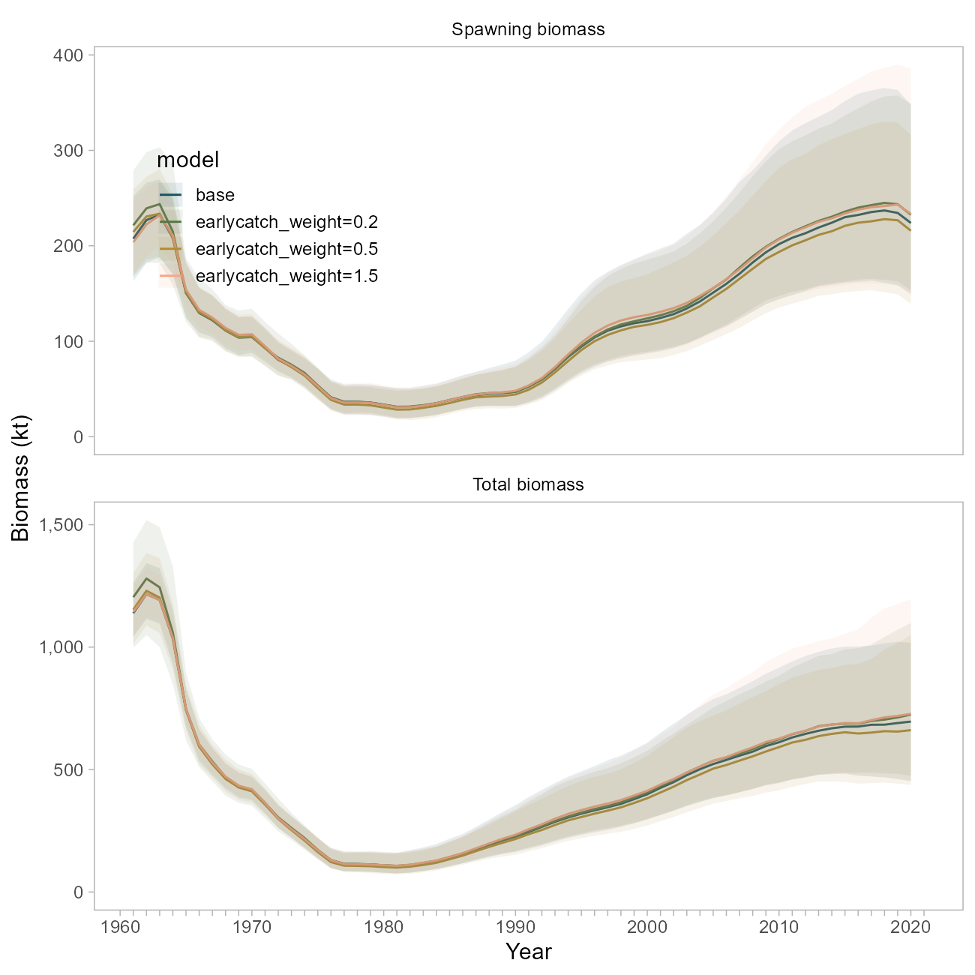

Figure 10.20. Comparison of biomass trajectories between the base model and three sensitivity runs where the early catch time series was weighted at 20, 50 or 150 percent of the weight used in the base model.

## Plus Group

Tingley: *“Prior to or as part of the next assessment, explore whether the plus group should continue to start at age 25 or whether an older plus group starting age is more appropriate.”*

This sensitivity has been explored in previous assessments, and was revisited in a run of the Stock Synthesis version of this model (described below) where the plus group was started at age 29. Model impacts were trivial.

## Stock Weights-at-Age in Survey vs Fishery

Cadigan: *“Investigate if stock weights-at-age from the survey are significantly (i.e., in the statistical sense) different than fishery weights-at-age. Also, investigate if there is significant temporal variation in both stock and fishery weights-at-age. Provide figures of how mean weight-at-age changes over time, with different panels for groups of ages (i.e., 1-5, 6-10, 10+). Consider using more efficient and less bias methods for analyzing size-at-age from length-stratified age samples (e.g., Perreault et al., 2019). Investigate spatiotemporal variation in weight as a function of length.”*

The base model currently uses two size-at-age matrices that represent the probability of a fish of size being age for either an early (pre 1980’s) or late (1980-present) period; both matrices were derived using survey data. Similarly, a single weight-at-age vector developed using survey data is applied to the entire population.

We have previously evaluated time-dependence in size-at-age, and have also previously compared sizes-at-age between the survey and fishery. This analysis is limited by the fact that age records are more sparsely sampled both through time and in terms of overall numbers than the survey (Figure 10.21), which impacts the amount of data available to inform the construction of a separate size-at-age key for the fishery .

To address this comment, we undertook two investigations. First, we ran a model using the original survey-based weight at age vector, but included a new size-at-age matrix for the fishery data only from 1980 onwards. This matrix was defined using the fishery data only, and is more certain as it includes more data from the entire age spectrum (Figure 10.22). This means that fish of all ages, but particularly adults, are more likely to be assigned a length of below 42 cm than the survey-derived matrix would suggest.

The weight-at-age relationship developed using fishery data alone suggests adult fish (ages 20+) to be at a smaller weight in the fishery than in the survey (averaging 742 grams in the fishery vs 891 grams in the survey, Figure 10.23). This would be consistent with discrepancies in selectivity, targeted harvesting, or un-modeled aspects of fisher behavior, *or* could be an artifact of sampling differences between fleets.

Use of this matrix results in slightly lower biomass trajectories (blue line, Figure 10.24), consistent with the notion that the fishery-derived size-at-age matrix assumes a lower probability of larger lengths-at-age.

Separately, we investigated the application of the fishery-derived *weight*-at-age vector (shown in pink in Figure 10.23)). For this sensitivity, the weight-at-age vector was simply replaced with the new values. The biomass trajectory, particularly for spawning biomass, was nearly identical to the base case, much moreso than the sensitivity using the separate size-at-age matrices (green line, Figure 10.24).

This suggests that derived quantities in this model are less sensitive to the weight-at-age parameters than they are to relationship between length and age, and the uncertainty thereof. We believe the survey to be a well-sampled representation of the pouplation, and the associated size-at-age matrix to better represent uncertainty in the growth process for this stock. In this model, this relationship is governed by the size-at-age matrices discussed above, but would be reasonably addressed in a new framework that allows for estimation of von Bertalanffy growth parameters within the model (and the associated variation across ages, or through time).

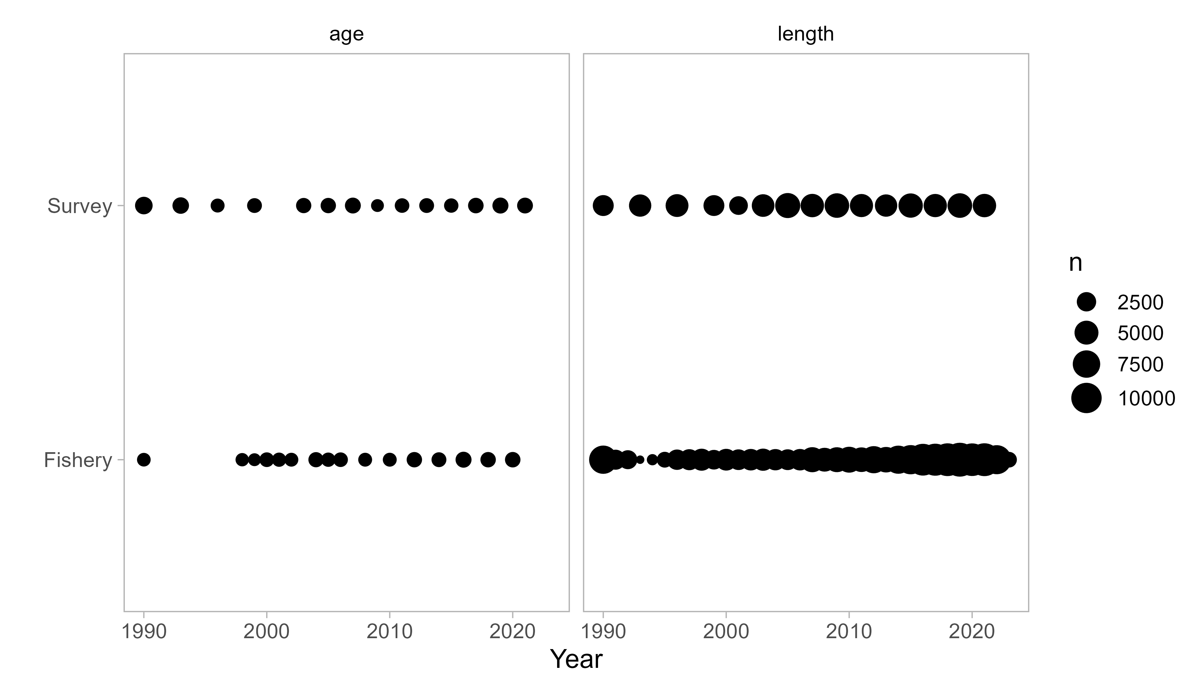

Figure 10.21. Number of raw observations of length and age for the survey and fishery. Note this figure does not represent total data included in the base model, rather the data available for the construction of size-at-age matrices.

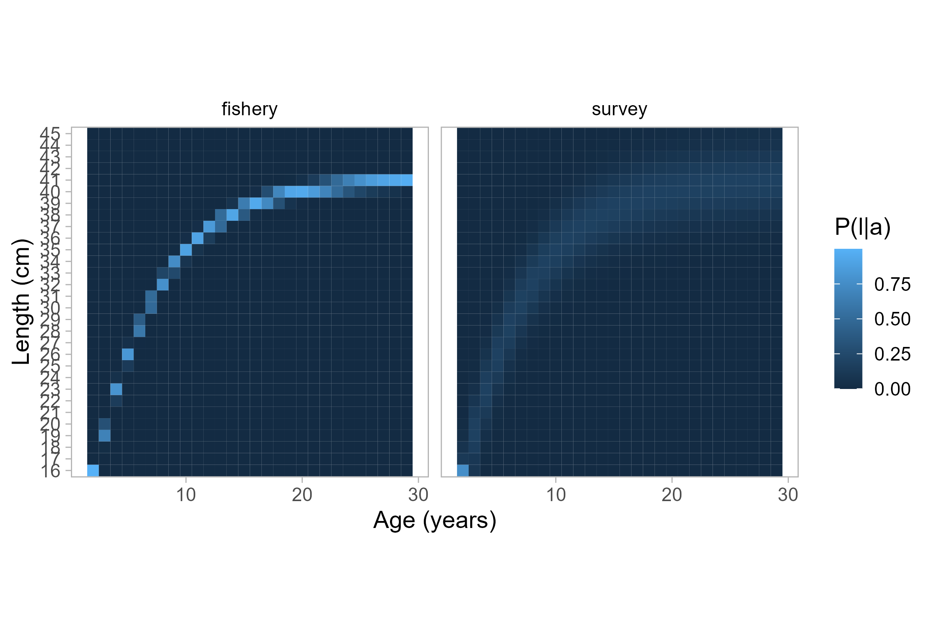

Figure 10.22. Size-at-age probability matrices for each fleet. The matrix on the right is used for all data in the base model.

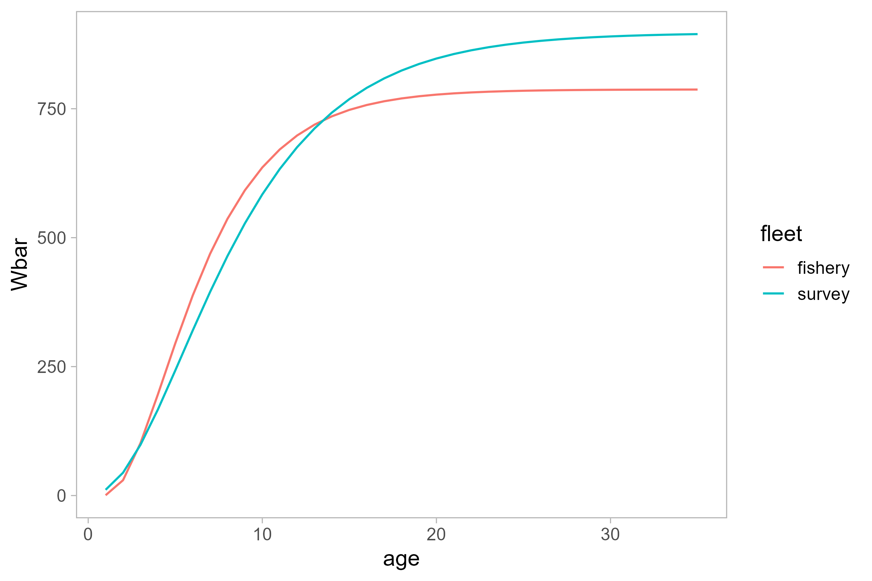

Figure 10.23. Estimated weight-age relationship for two fleets.

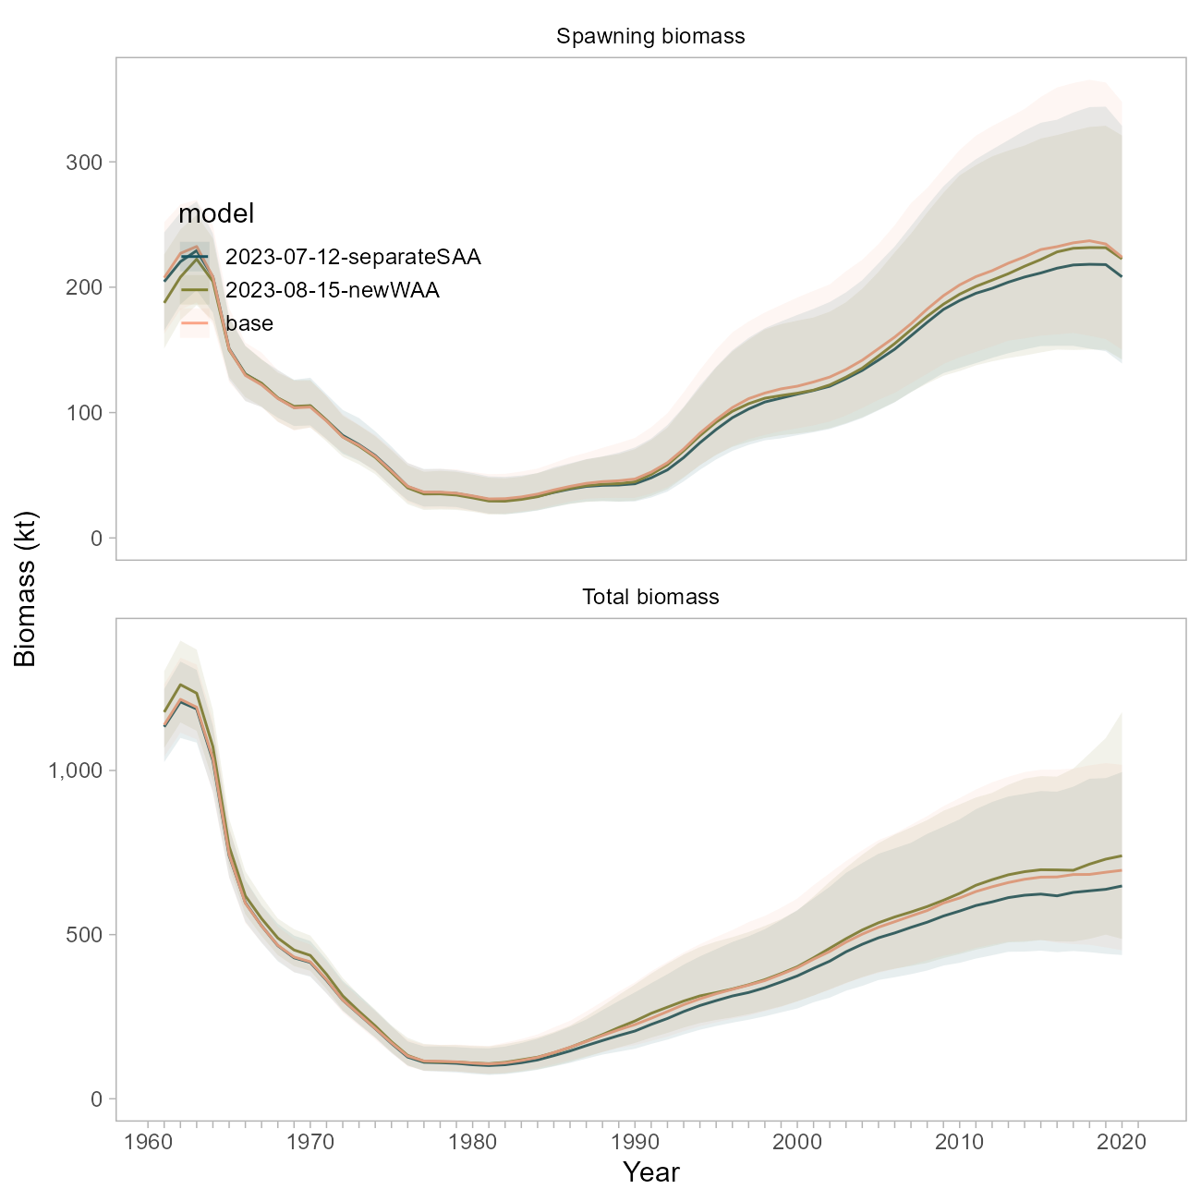

Figure 10.24. Biomass trajectory comparison between the base model, a model using a separate size-at-age matrix for the fishery data from 1980 onwards (‘separateSAA’), and a model using the fishery-derived weight-at-age vector for all population dynamics (‘newWAA’).

## Natural Mortality

Tingley TOR 1: *“Exploration of additional information to better define the realistic range of M for Pacific ocean perch is recommended. This should consider data available for Pacific ocean perch and for other long-lived rockfish species.”*

Tingley TOR 3: *“In the absence of better information about the likely magnitude of M, sensitivities using values of fixed M that bracket the estimated value M should be run in future stock assessments to inform on the level of risk inherent in the current assumptions about M.”*

There has been a fair amount of investigation on this topic; the following response is meant to succinctly describe our findings and is organized into the principal lenses through which was explored in the POP model: through the priors, through likelihood profiles, and through the application of a new modeling framework.

### Priors on M

The current POP base model uses a restrictive maximum-age based Hamel (2015) prior for (a 10% coefficient of variation).

The FishLife R package (Thorson et al., 2023) was recently updated to incorporate morphometric, spawning, behavioral, reproductive and trophic traits from a global database of fish life-history (“FishBase”). This tool enables us to develop an prior for POP that is informed by similar species and therefore better accounts for uncertainty. The prior suggested by the FishLife R package (version 3.0.0) for POP specifically is broader and centered at a higher value (0.0939) base model prior (Figure 10.25). The FishLife prior for the genus *Sebastes* encompasses values from 0 to 0.20. The MLE from the base model (~0.075) is at the ~6th percentile of the POP-specific prior distribution, and the 22nd percentile of the prior distribution for *Sebastes*.

A sensitivity run for the base model using the POP-specific FishLife prior resulted in an even higher estimate of at 0.112 (Figure 10.25). Biomass trajectories from this model (using the broader prior) are higher than the base model (Figure 10.26). The overall NLL from this sensitivity is ~8 units lower than the base model (252.818 vs 260.057 units). The fits to the survey are not visually improved, though the time series of expected survey values is smoother (Figure 10.27).

### Likelihood Profiles on M

We profiled over values of from 0.01 to 0.30 in increments of 0.02 using the base model. This method involves fixing and removing the prior on from the total NLL calculation.

In the absence of the prior, the total likelihood (“objective function”, black line in Figure 10.28) indicates that the MLE for would be much higher than it is in the base model, around 0.15. The data likelihood component (red line in Figure 10.28) is otherwise the most well-defined and suggests an MLE for closer to 0.06, in agreement with the Hamel (2015) prior mean, and consistent with where the base model estimates given the narrow prior and preponderance of information in the data. There was no statistical difference in the data likelihood component for models with values between 0.04 to 0.08.

The fishery size composition data appears to be in conflict with the fishery age composition and survey age and abundance data, whereby the former suggests values much higher than the latter, though both appear to minimize at values outside the tested realm (Figure 10.28).

These observations indicate that the MLE indicated by the data likelihood and the curvature of that profile is probably a compromise between the data sources (survey abundance and ages, fishery ages, and maturity data) that suggest lower, more realistic values for (e.g., less than 0.10) and the one data source (fishery lengths) that suggests a high value for . Data weights are identical for these components, meaning that the higher input sample sizes for the age data are pulling the estimate lower than what the fishery lengths would suggest. The influence of the fishery length data is also reduced in the base model due to the inclusion of multiple other data sources and the specification of the narrow prior.

### Looking at M in a New Modeling Framework

The POP model was transitioned to the Stock Synthesis modeling framework (Methot and Wetzel [2013], v3.30.17). This was *not* undertaken as a full bridging exercise, rather as a learning tool to investigate whether certain issues in the POP model could be resolved or reproduced by changing or simplifying assumptions inherent to the bespoke model framework. This SS model was designed to 1) incorporate all the data that is currently used in the POP base model, 2) better account for uncertainty in key population dynamics processes, with the goal of 3) roughly matching the scale and trend in derived quantities as the base model. *At present, we do not propose the SS model for management use and are not showing extensive model results here*.

Key differences between the 2021 base and SS model include:

* survey catchability is analytical; and
* no size-at-age matrix is used (von Bertalanffy parameters are instead estimated, with attendant uncertainty); and
* *Data Weighting*: we explored a version of the SS model where there are no data weights applied (all data sources’ contributions to the overall objective function are equally weighted, whereas the base model weights all data sources to “1” and the catch data to “50”), as well as a version with three iterations of Francis compositional weights applied. Regardless of whether selectivity was dome-shaped or logistic (see below), the suggested Francis data weights down-weighted all compositional data components. The survey ages were down-weighted the most (between 6% and 9%); the fishery lengths were down-weighted the least (to 16% with logistic selectivity, or 42% with dome-shaped); and the fishery ages were down-weighted in between the two other compositional data sources (to 6% with logistic selectivity and 20% without). The results presented in this appendix use model runs *without* data weights applied. Note that the hessian matrix was invertible for all models, but only upon application of data weights was convergence (maximum gradient < 1e-5) achieved.
* *Fishery Selectivity* is specified differently in the SS model. The functional form is double normal, so that fishery selectivity can be dome shaped , logistic, or somewhere in between (as it is in the base model), given the same four time-blocks as in the base model. We explored either forcing fishery selectivity to be logistic, or allowing the descending limb to form a dome. Dome shaped selectivity resulted in a large increase in model scale (Figure 10.30).

We investigated the influence of in the SS model, using either the original, narrow prior, the broader POP-specific FishLife prior described above, or fixing to the 2021 MLE (0.075, Figure 10.25). These three alternatives were tested against the two selectivity specifications mentioned above.

Several useful findings emerged from this effort:

* The prior seems less influential on model dynamics than does the specification of fishery selectivity, and whether or not data weights are applied. For example, a model using the FishLife prior, logistic fishery selectivity and no data weighting estimated to be 0.032 (Figure 10.29a); when data weighting was enabled for this same model, the estimate agreed more with the prior with an MLE of 0.091 (Figure 10.29b). In an SS model where selectivity was allowed to be dome-shaped, was closer to the 2021 base value at 0.086 (Figure 10.29c)) though the model scale is greatly increased (Figure 10.30).Using the original, restrictive Hamel (2015) prior in a model with logistic fishery selectivity and no data weights resulted in an estimate nearly equivalent to the prior mean (0.061, Figure 10.29d).
* Biomass trajectories across our six experimental runs illustrate that *variation in model scale is most readily described by differences in selectivity* versus the prior or estimate of . Specifically, all models with dome-shaped selectivity exhibited higher biomass trajectories, better fits to the compositional data, and worser fits to the survey data (grey lines, Figures 10.30 and 10.31)), while those with logistic selectivity were closer in scale to the 2021 model, did not fit the compositional data as well, but fit the survey best overall (blue lines, Figures 10.30 and 10.31)). The tradeoffs in model fit are consistent with observations from the base model that there are conflicts between these data types.
* Recall that using the FishLife prior in the base model resulted in an estimate of to be high at 0.11 (Figure 10.25), which was illustrated further using likelihood profiles on the base model (Figure 10.28). The fact that this dynamic ( pushing ever-higher) did not persist in the SS model is likely *due to the increased flexibility of the double-normal curve*; the base model is controlled by the gamma function to be traditionally dome-shaped. This would explain the need to constrain in the base model when the transition to gamma-shaped selectivity was made; the SS model assumes that older fish are indeed selected by the fishery, and there is information in the fishery and survey ages to suggest that is low.
* We ran likelihood profiles on on the experimental SS model(s) (Figure 10.32). The *conflict between survey and age versus length (fishery) data persists*; the recruitment trend would suggest a higher value of , and this was true for models with logistic or dome-shaped selectivity. This indicates that the conflict between these data sources is not an artefact of the bespoke model. The main distinction between the two profiles is that the model with logistic selectivity effectively ignores the prior and estimates a very low value, likely to compensate for the high exploitation of older fish. The reader is advised that *there was a large range of values that were statistically indistinguishable* for both models (between 0.02 and 0.12).

### Conclusions regarding M

Overall, given the framework of the base model, it is apparent that the current prior on is reinforcing the perception that is between 0.04 and 0.07, and that in the absence of this prior (or in the presence of the broader FishLife prior) the base model’s estimate for would be higher. This estimate represents a compromise between the survey index, survey age, and fishery age data (which all suggest low values for ) and the fishery length data, which suggests a high value for . Using a higher and broader prior in the base model resulted in improved likelihood scores, but presented changes in the scale of the population.

Investigations using an alternative modeling framework revealed that the specification of fishery selectivity seems more influential than in model scale and overall fits. We confirmed via likelihood profile that 1) there is conflict between the compositional data sources and 2) there is a broad range of values (from 0.02 to 0.12) that are statistically indistinguishable. The observation regarding a range of values was also found in assessments of POP for the US West Coast (Wetzel et al., 2013).

The data conflict is much more pronounced in the current POP model versus the SS model, both in terms of the range of values that are statistically indistinguishable, the discrepancy between MLEs for for each likelihood component, and the influence of the prior on the overall MLE. A visual inspection of the data reveals that the fishery length compositions appear nearly stable through time, while the age compositions from both sources appear to track cohorts to a greater degree. Secondary to the recommendations below, we will explore data weighting approaches in the new modeling framework. We re-iterate that the magnitude of disagreement between data sources appears less pronounced in the SS model.

*We do not recommend transitioning to the FishLife prior within the current 2021 model framework*. Though the prior on its own is likely a better represents the uncertainty in POP life history, this decision decision should not be made without concurrently revisiting the treatment of *selectivity, and potential re-weighting of compositional data*. Given our findings above, *we recommend this be undertaken within the context of a new modeling framework*, where it has been revealed that the prior is less influential than other factors.

The previous assessment author indicates that the strict prior on in the base model was a necessary compromise when the fishery selectivity was transitioned to the current gamma (dome-shaped) distribution, so it is likely that both selectivity specification and differences in how population dynamics are represented (e.g., recruitment) between the current and SS models are facilitating estimation of . We conclude that it is worthwhile to continue developing the SS model with particular attention on these processes. *The use of the FishLife prior (or a hybrid of the Hamel and FishLife approaches) is likely appropriate, and not unduly influential, within the SS framework*.

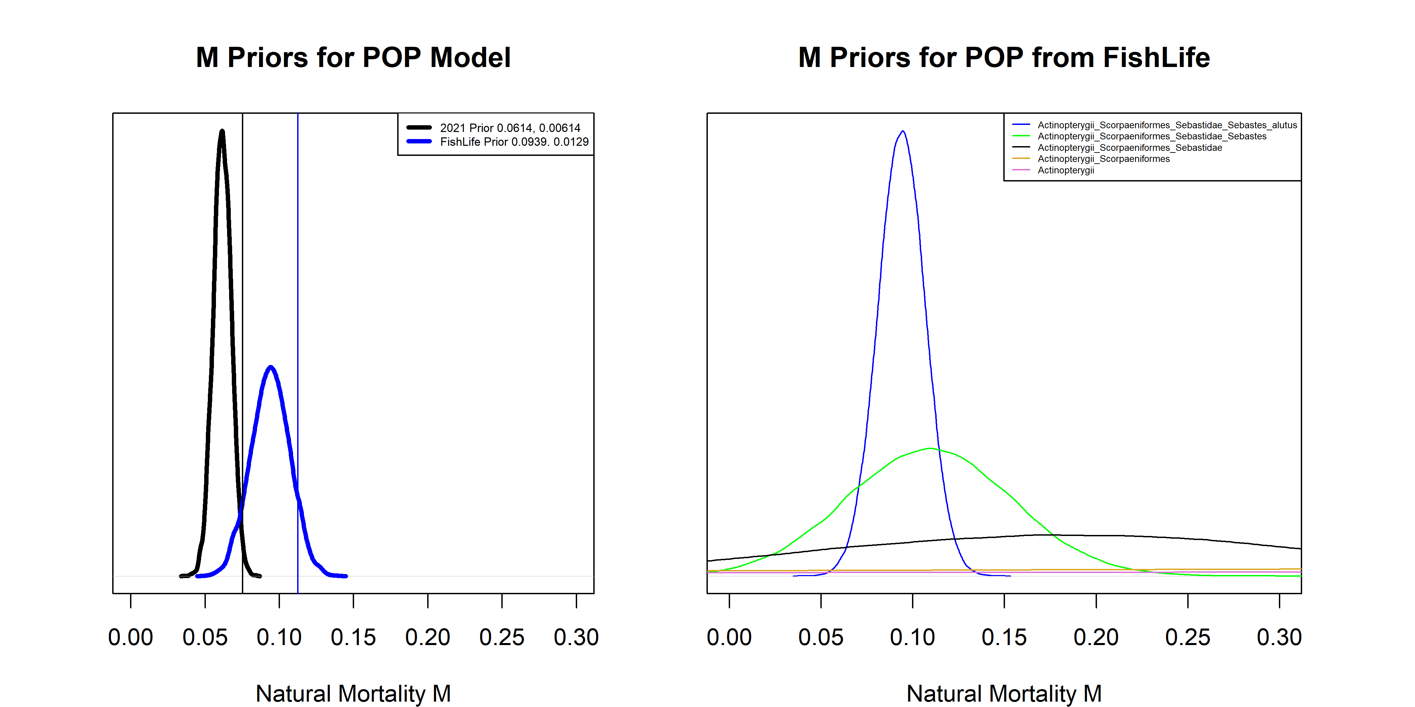

Figure 10.25. Left: Comparison of M priors (thick lines) and maximum likelihood estimates (thin vertical lines) between the base model (black), and the base model using a prior from the FishLife package (blue). Right: M priors from the FishLife package for POP and related taxa.

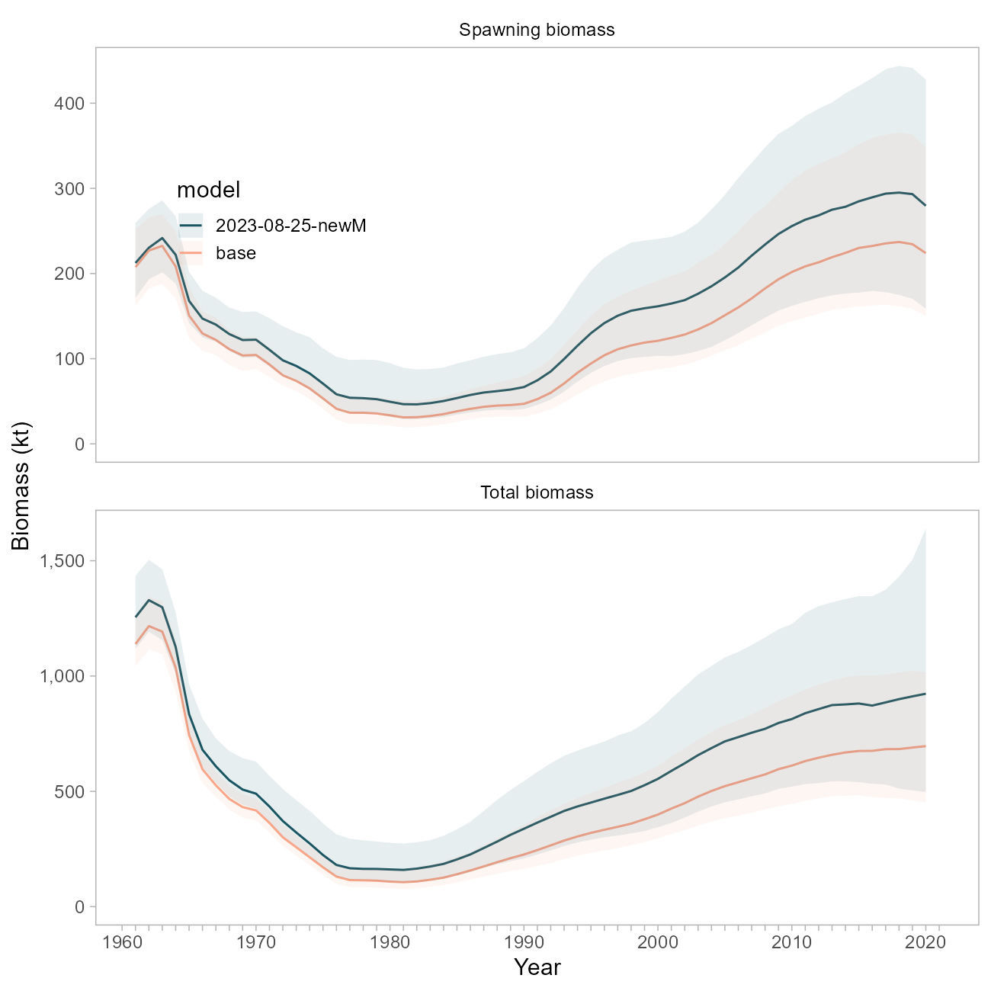

Figure 10.26. Comparison of biomass trajectories between the base model and a model using the FishLife prior for natural mortality.

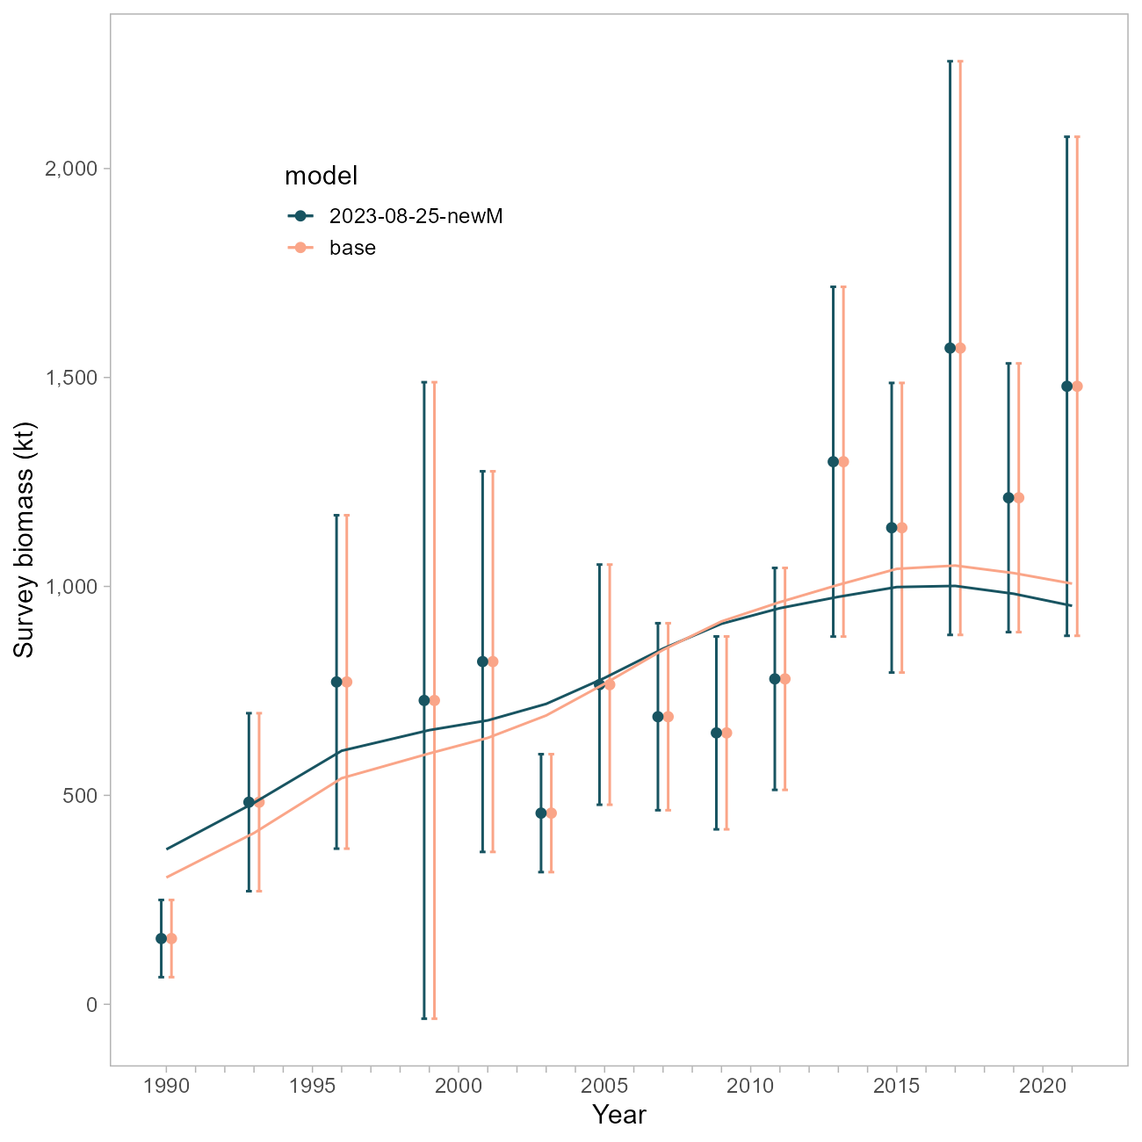

Figure 10.27. Comparison of survey fits between the base model and a model using the FishLife prior for natural mortality.

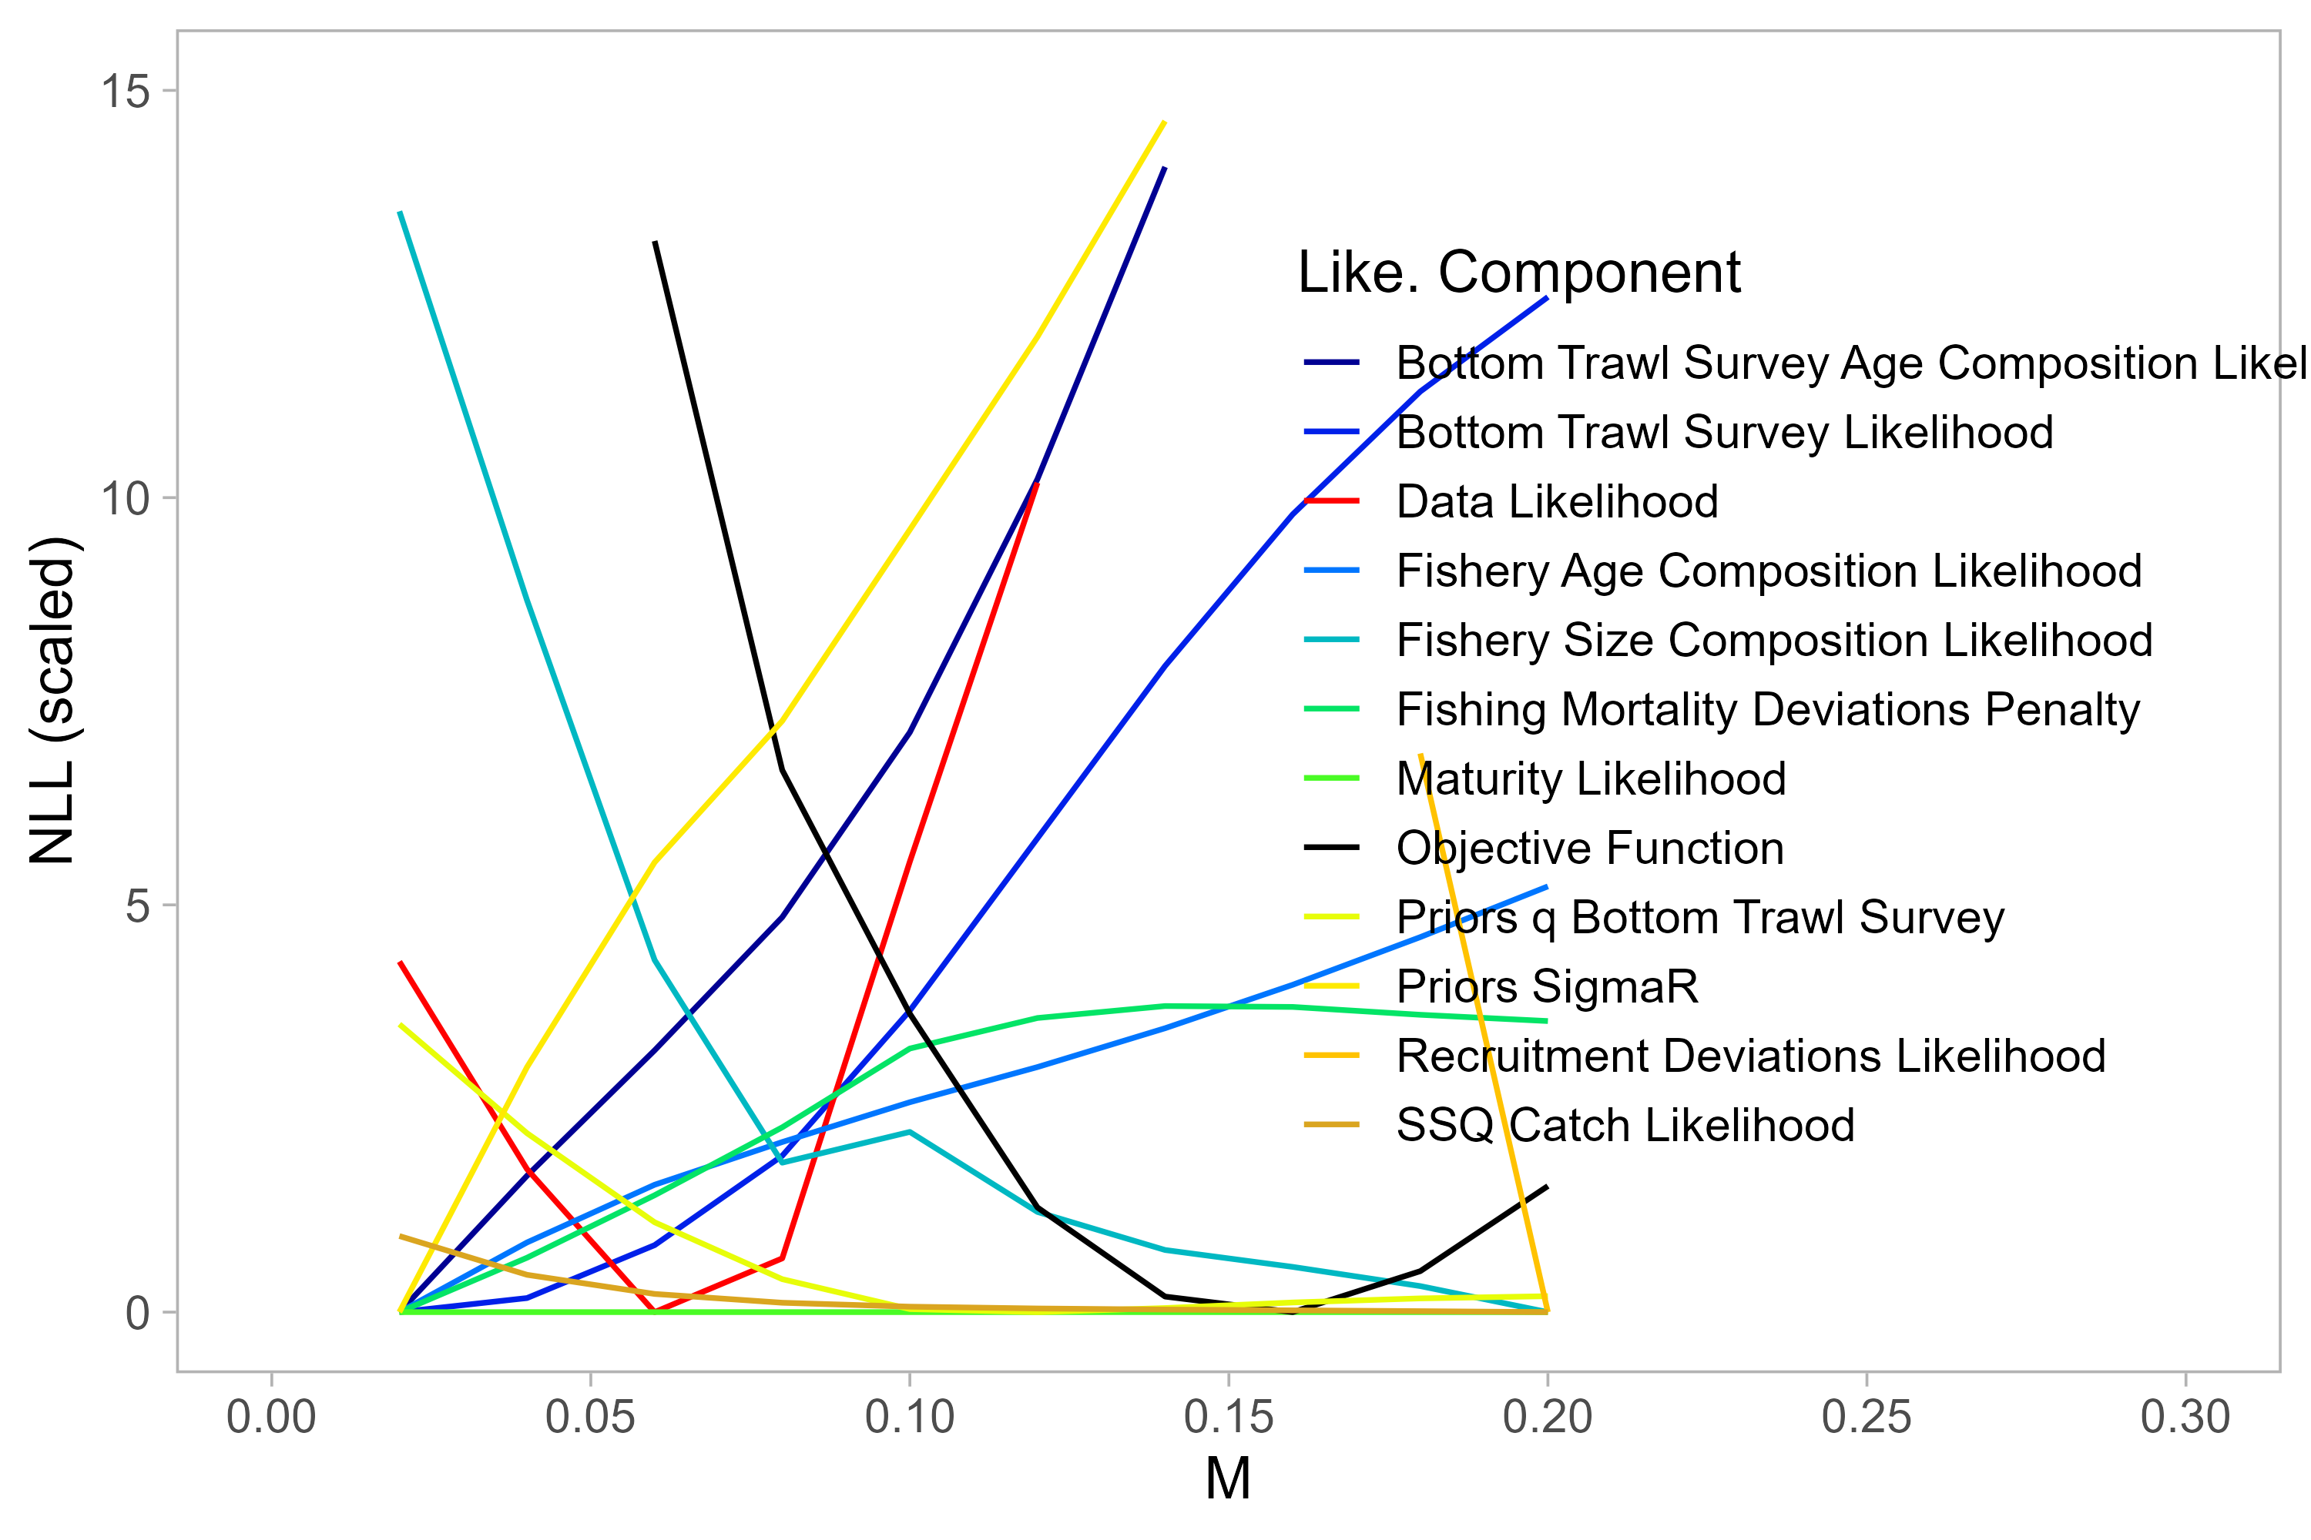

Figure 10.28. Likelihood profile on M using the base model.

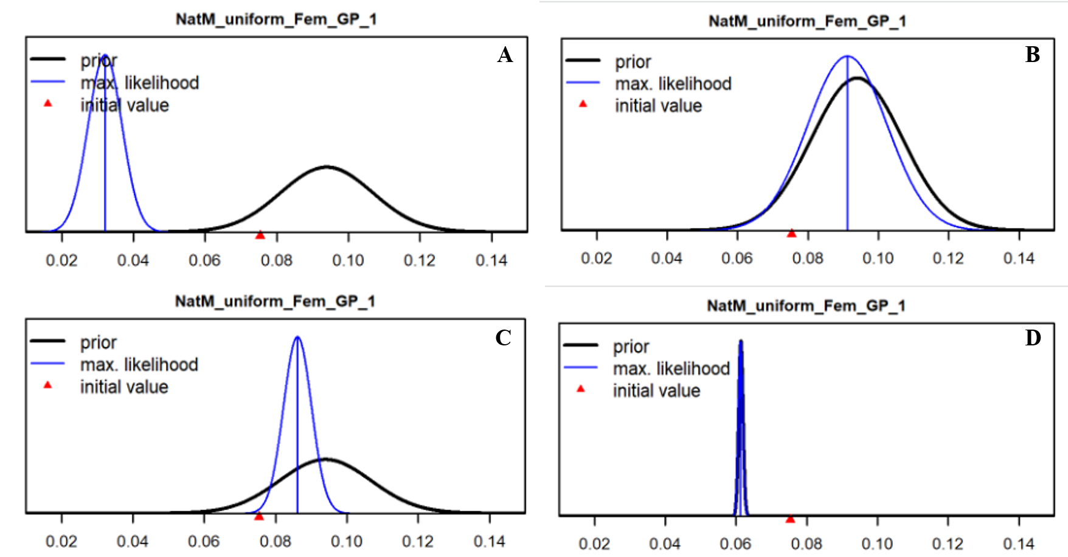

Figure 10.29. Prior (black line) and posterior (blue line) estimates of M using (A-C) the new FishLife prior or D) the original Hamel (2015) prior. Fishery selectivity is forced to be logistic in A, B and D. Tuned compositional data weights using the Francis method have been applied in B.

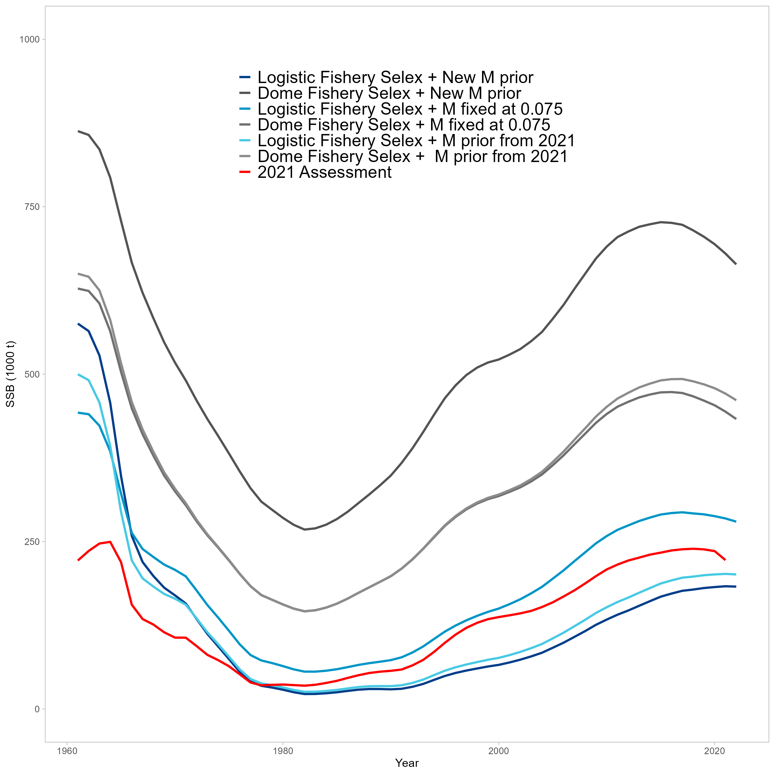

Figure 10.30. Comparison of SSB trajectories for alternative SS configurations implemented for natural mortality explorations. The red line is the 2021 POP Assessment.

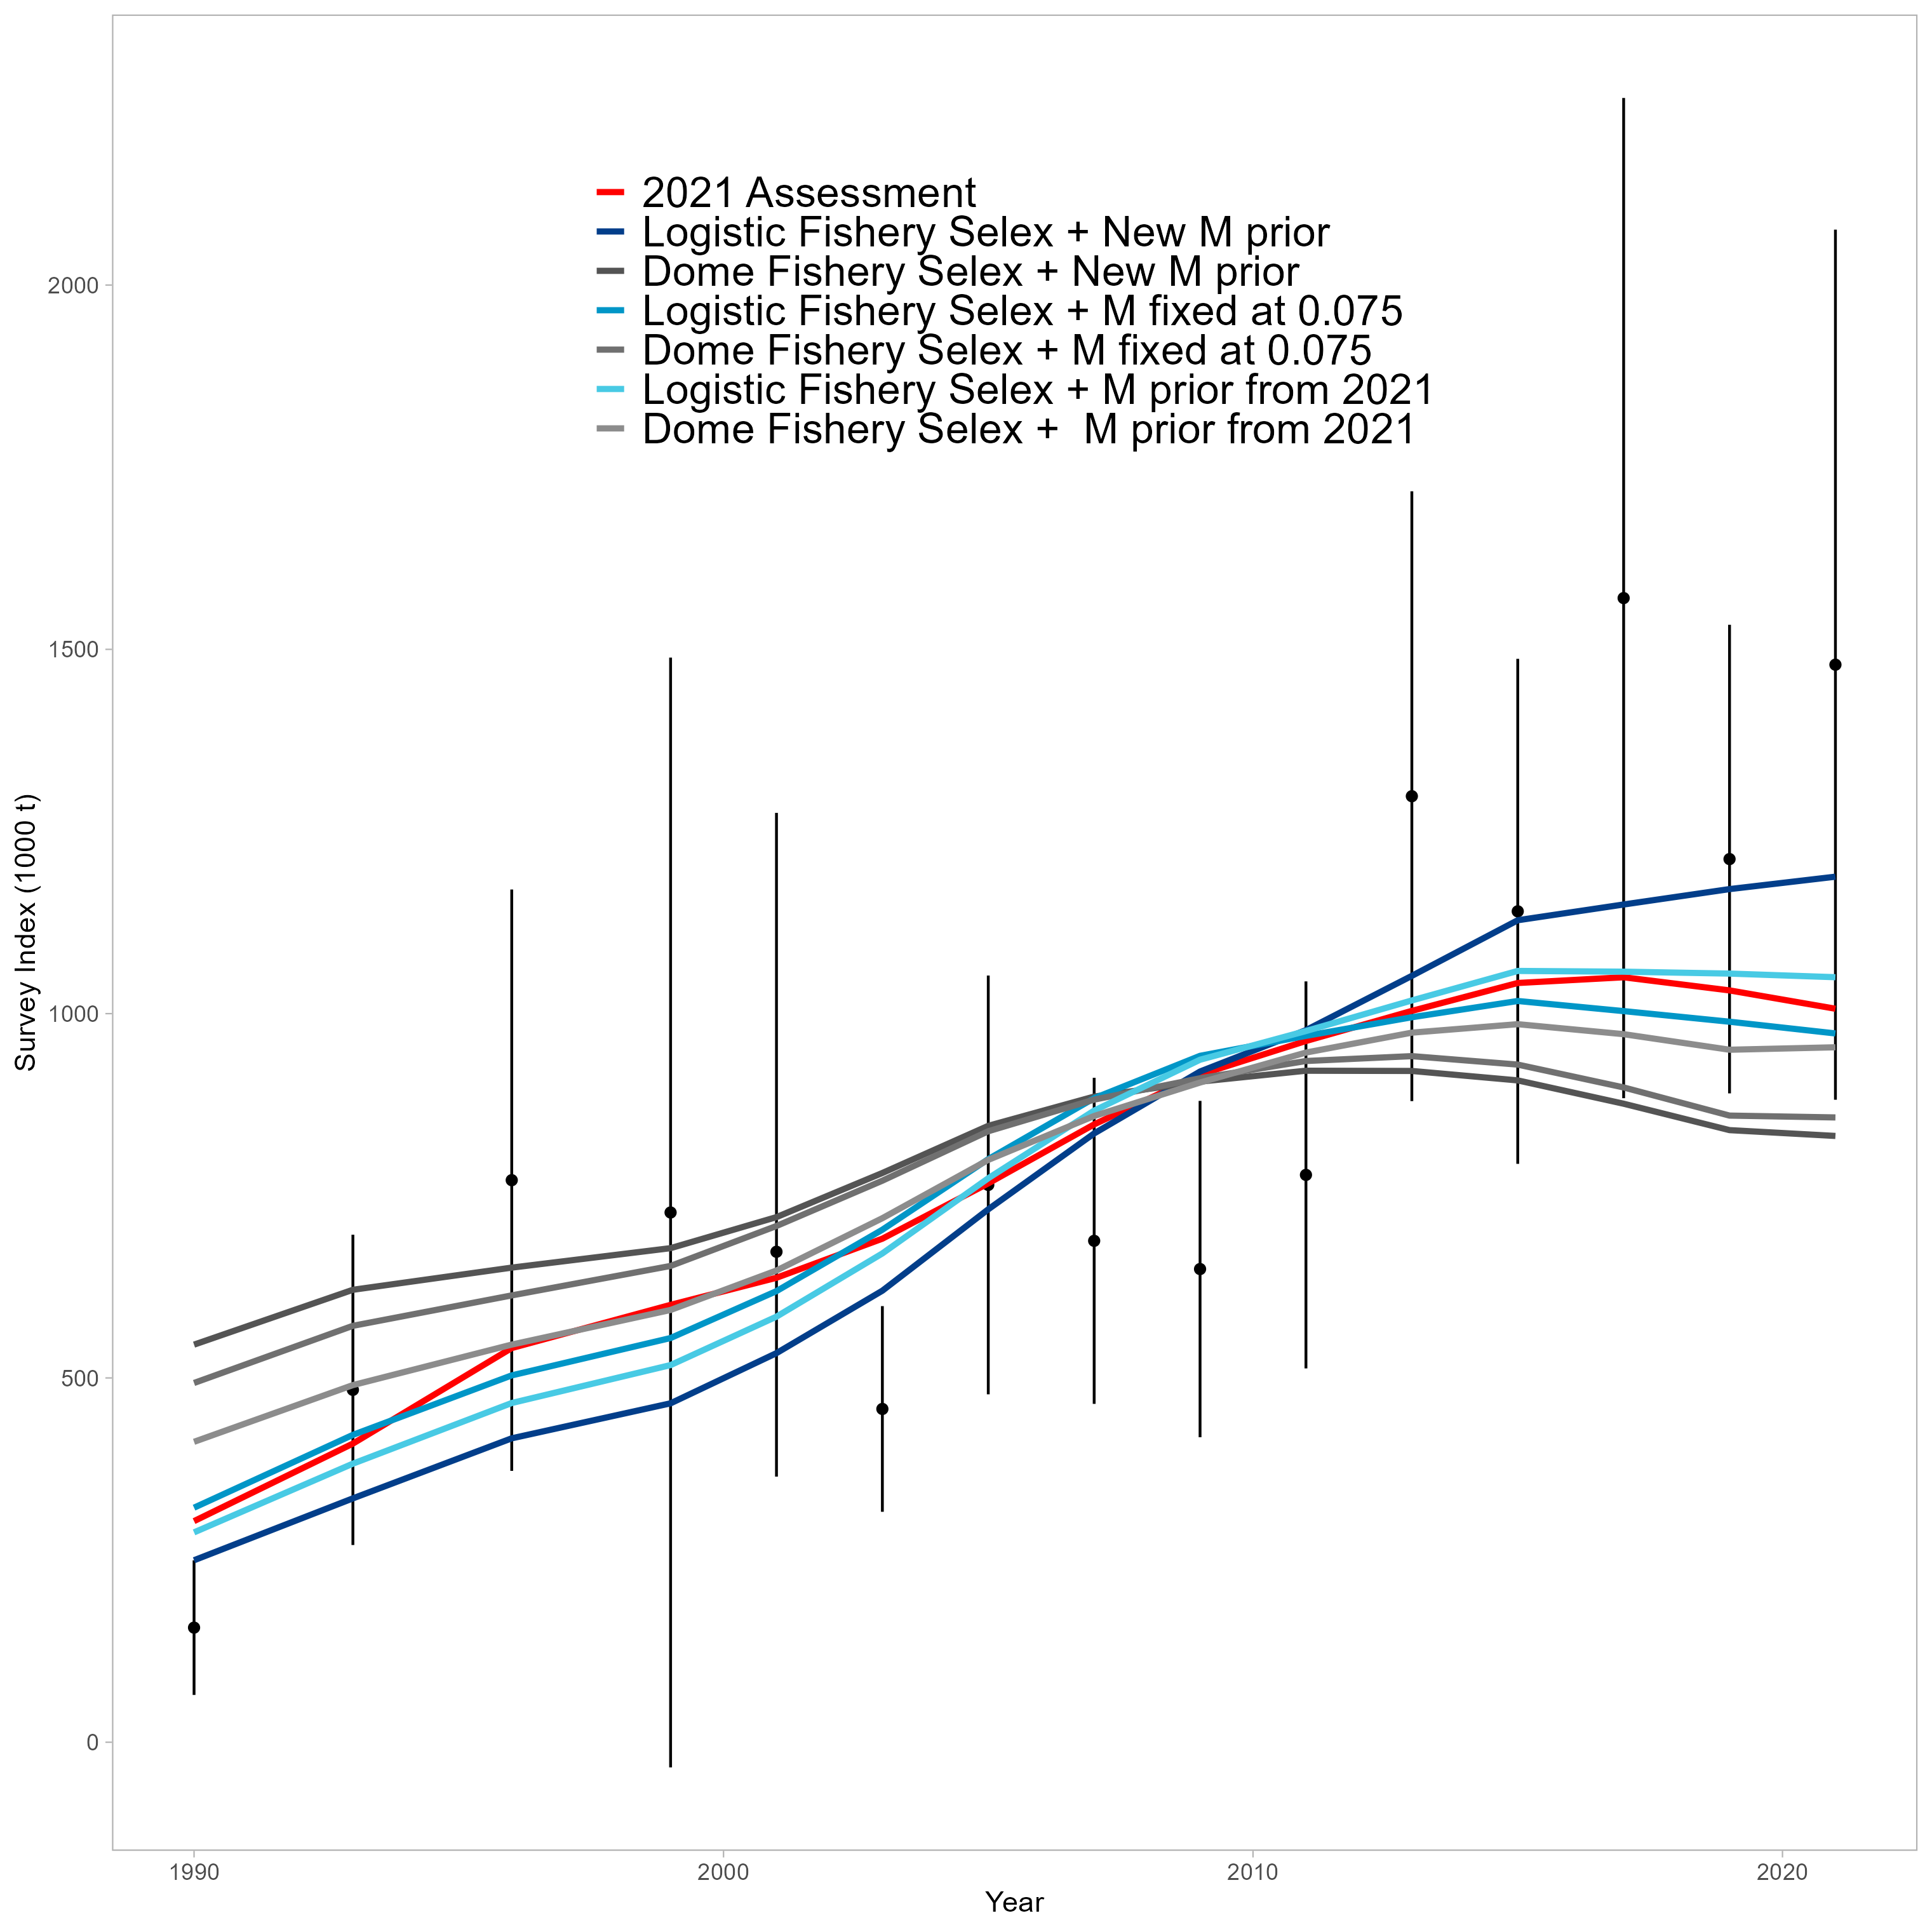

Figure 10.31. Comparison of survey fits for alternative SS configurations implemented for natural mortality explorations. The red line is the 2021 POP Assessment.

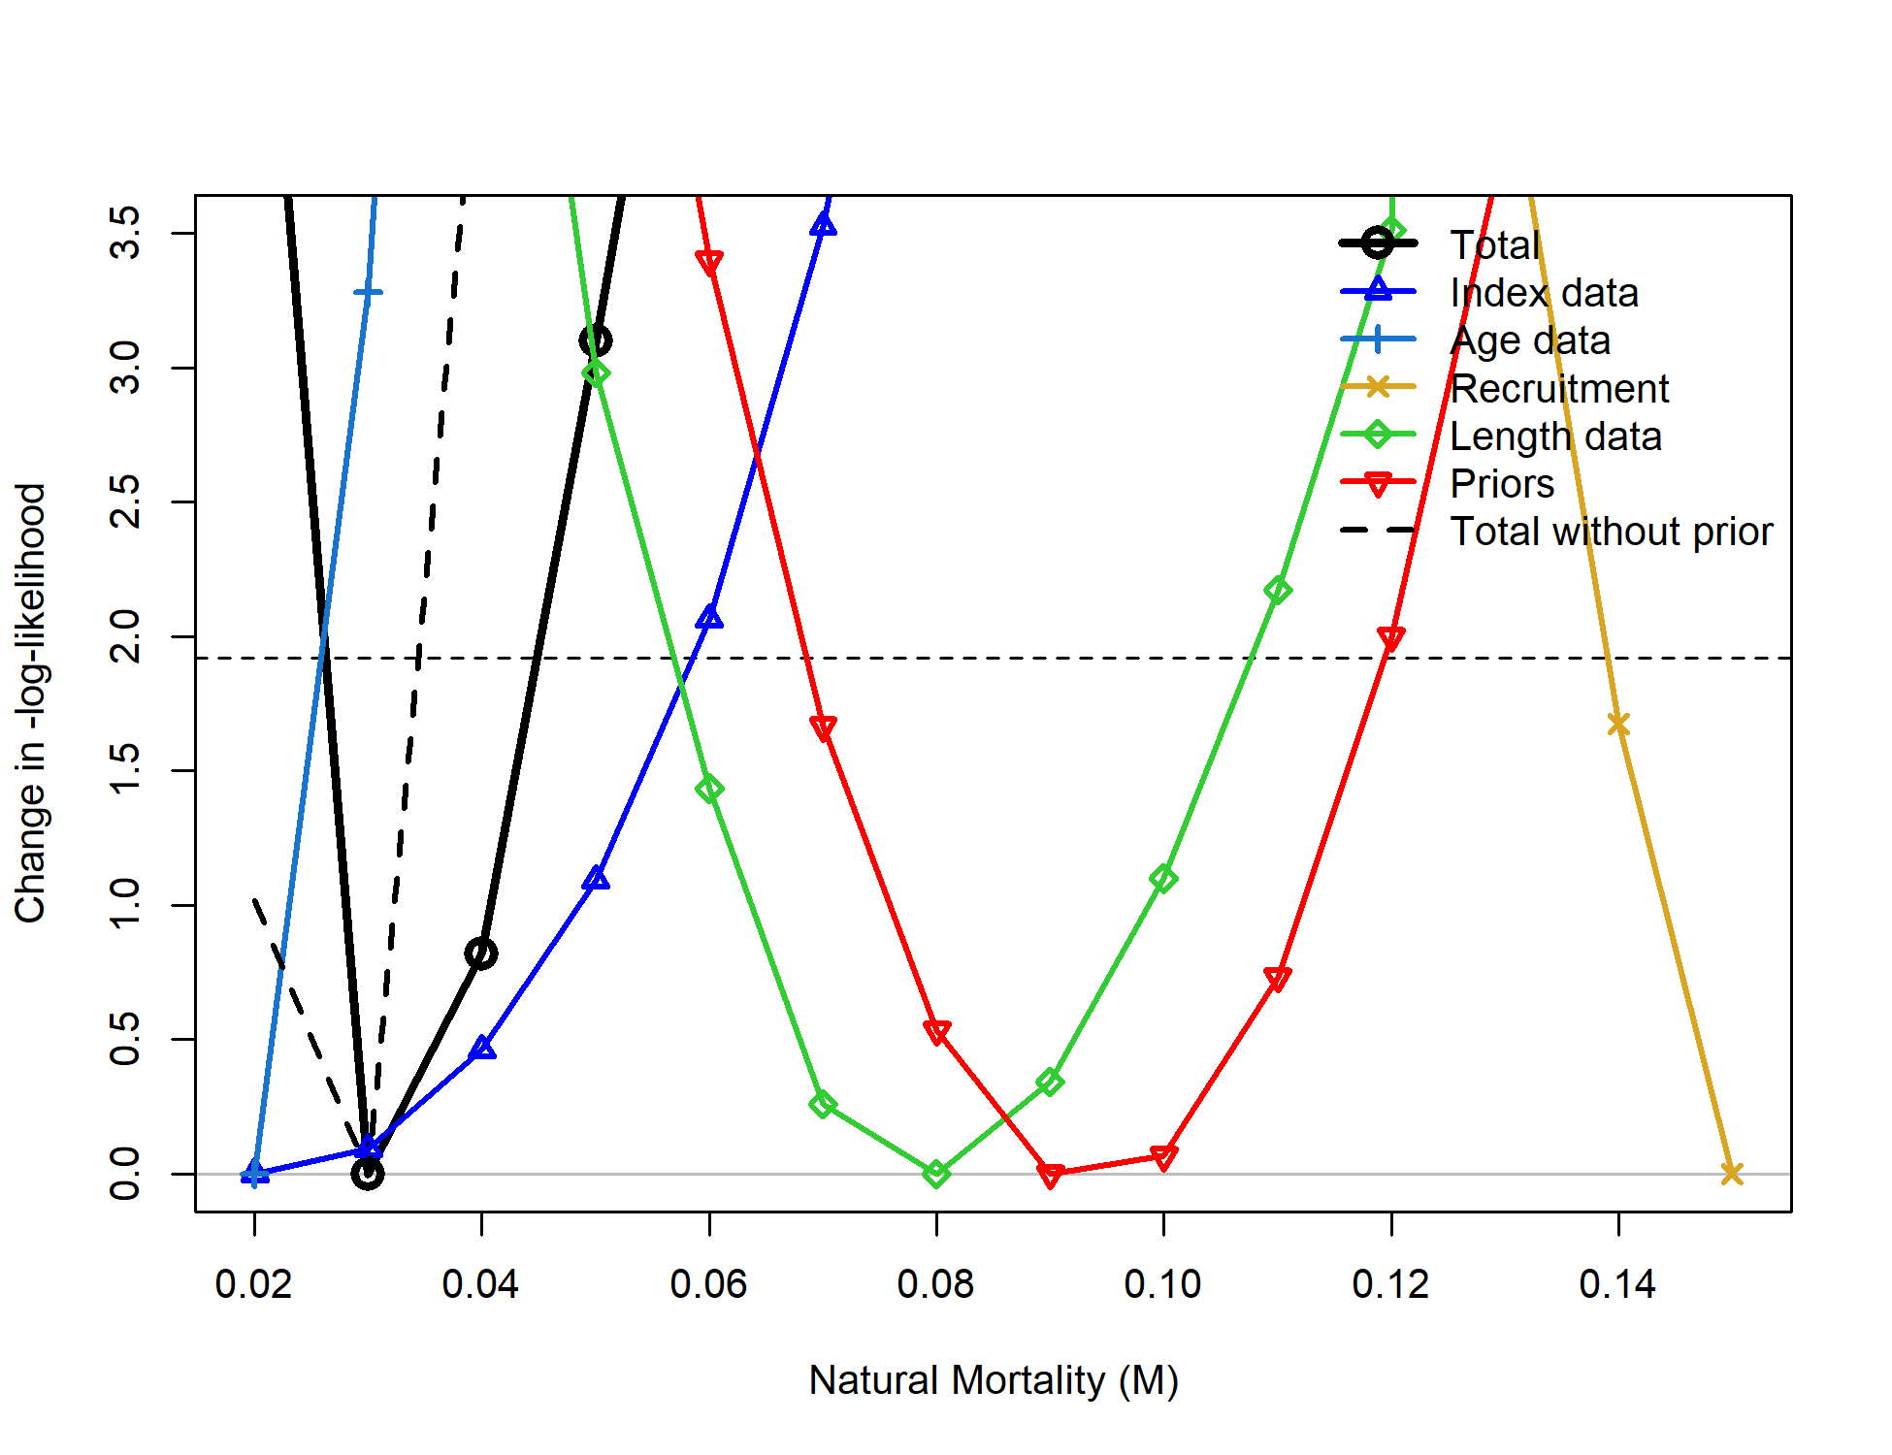

Figure 10.32. Likelihood profile on M using the SS Model. Values below the horizontal dashed line are statistically indistinguishable.

## Priors & Penalties on *F*,

Cadigan: *“Consider removing priors for Regularity and .”*

The “prior for Regularity” a term that penalizes the vector of deviations using the sum-of-squares (in practice, assuming a mean of 0 and a variance of 1). is indeed estimated using a lognormally-distributed prior( ). We addressed this comment by separately disabling each of these functions; additionally, the SS model mentioned above does not involve a prior on nor a penalty for , so comparisons can be made among model frameworks for further information.

Disabling the penalty on did not result in changes to biomass trajectories (Figure 10.33).

Removing the penalty on did result in changes to the biomass trajectories, such that the sensitivity run estimated to be lower and the overall biomass to be higher in the absence of a penalty (Figure 10.34). The SS model, by comparison, estimates to be higher than both ADMB models yet the trajectory is similar (Figure 10.35).

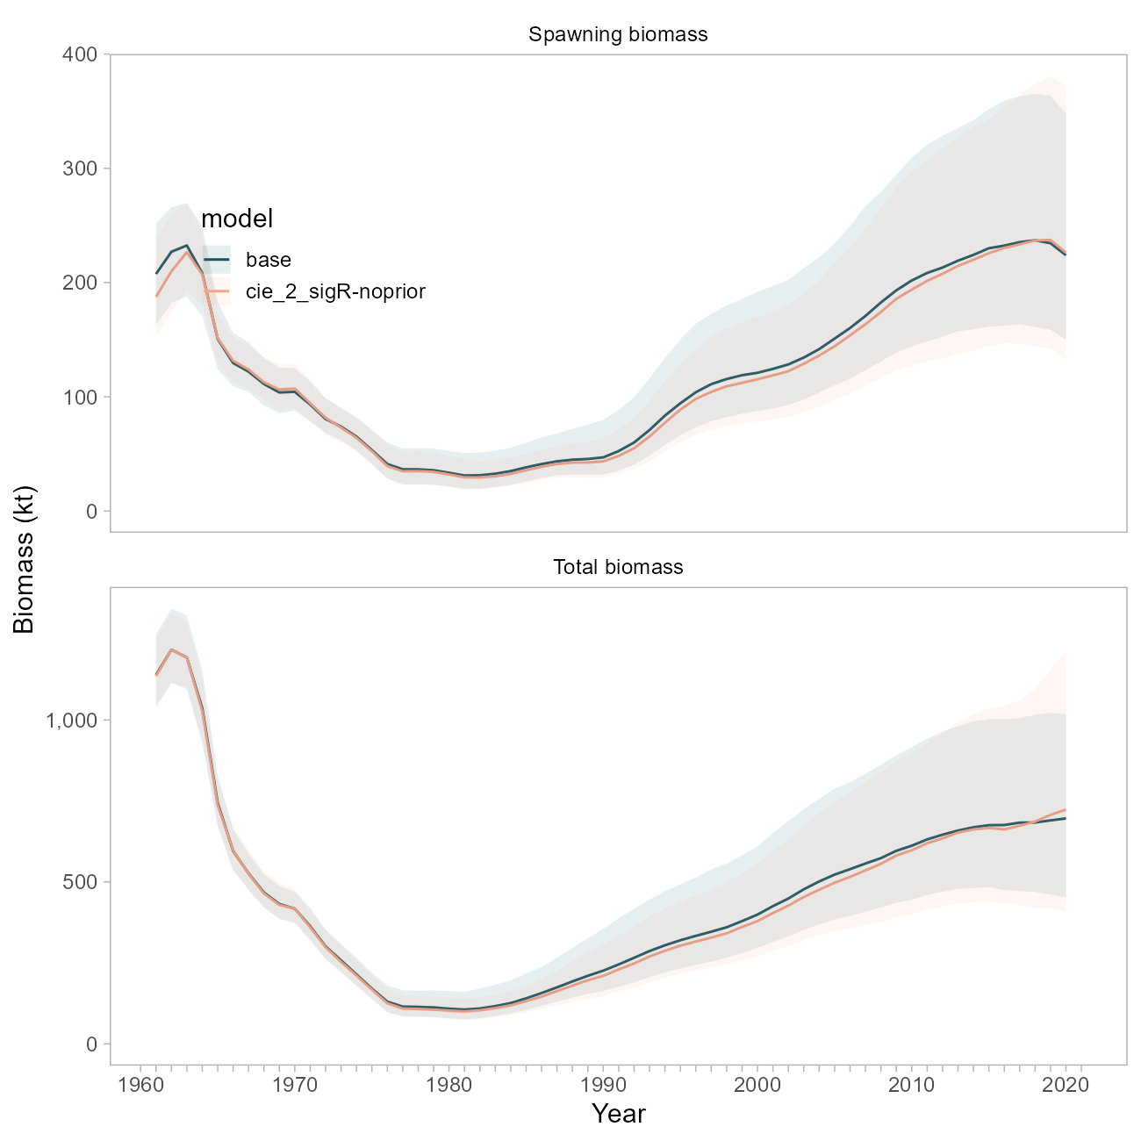

Figure 10.33. Comparison of biomass trajectories between the base model and a model with the prior on sigma-R disabled.

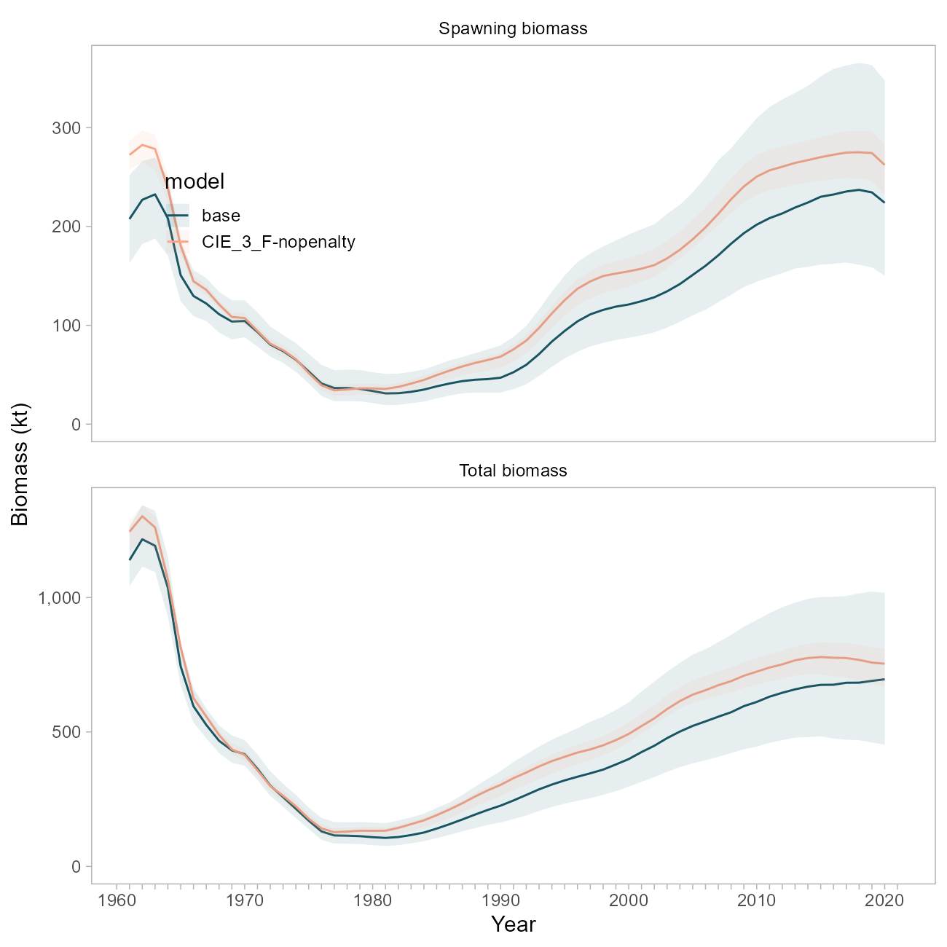

Figure 10.34. Comparison of biomass trajectories between the base model and a model with the regularization penalty on F disabled.

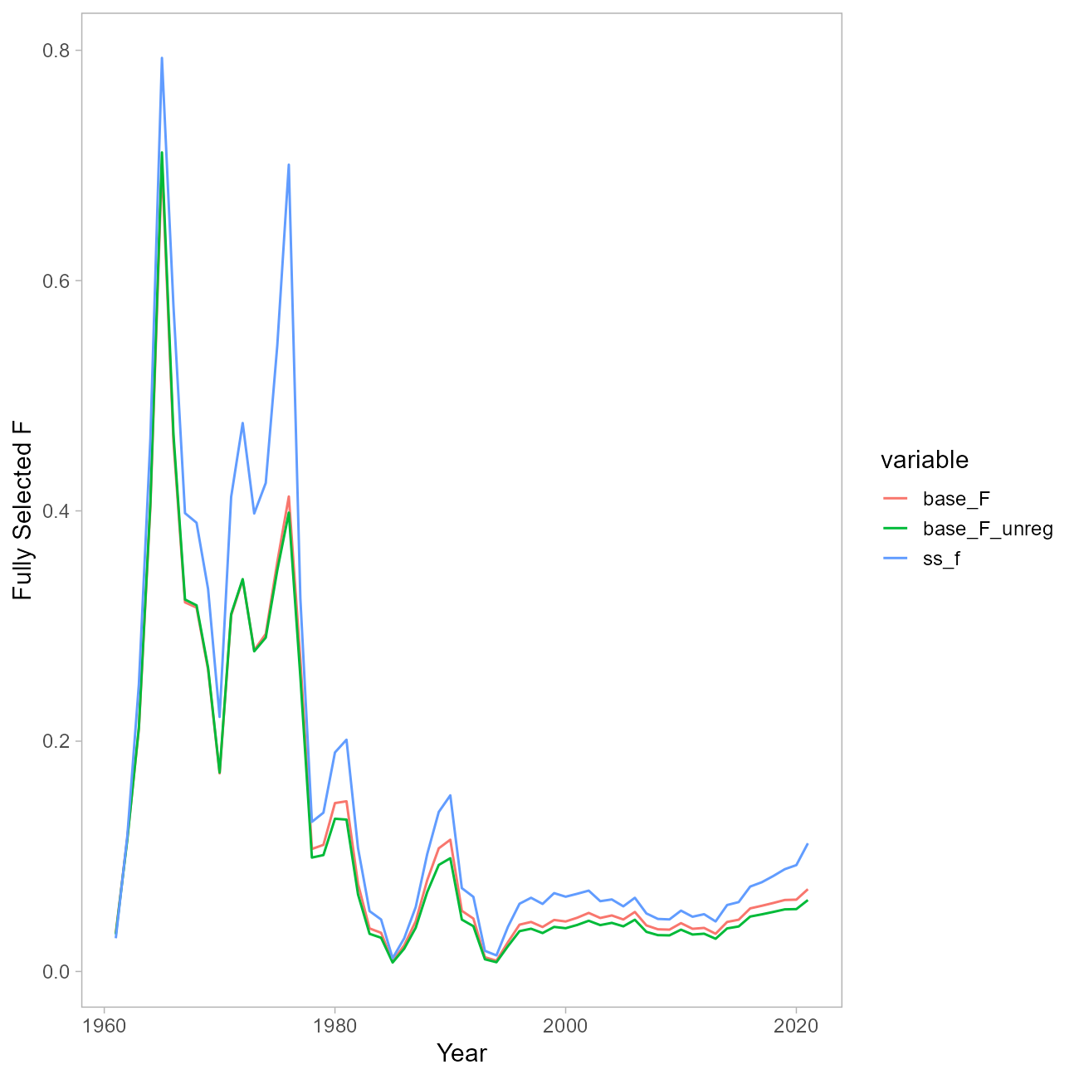

Figure 10.35. Comparison of F trajectories between the base model and a model with the regularization penalty on F disabled, and the SS model.

## References

Methot, R.D., Wetzel, C.R., 2013. Stock synthesis: A biological and statistical framework for fish stock assessment and fishery management. Fisheries Research 142, 86–99. <https://doi.org/10.1016/j.fishres.2012.10.012>

Thorson, J.T., Maureaud, A.A., Frelat, R., Mérigot, B., Bigman, J.S., Friedman, S.T., Palomares, M.L.D., Pinsky, M.L., Price, S.A., Wainwright, P., 2023. Identifying direct and indirect associations among traits by merging phylogenetic comparative methods and structural equation models. Methods Ecol. Evol. n/a. <https://doi.org/10.1111/2041-210X.14076>

# Appendix 10d Model Equations

## Population Dynamics

| Equation | Description | Notation |
| --- | --- | --- |
|  | Annual numbers at age of recruitment (age-2) | year, age average recruitment, annual recruitment deviation |
|  | Annual numbers at age between recruitment age and plus age group | natural mortality, annual fishing mortality at age, annual total mortality at age |
|  | Annual numbers at age in plus group | plus group age (29) |
|  | Annual spawning biomass | maturity at age |
|  | Maturity at age | logistic slope parameter  logistic age at 50% maturity |

## Observation Model

| Equation | Description | Notation |
| --- | --- | --- |
|  | Annual numbers at age of recruitment (age-2) | weight at age, fishery selectivity by age and year |
|  | Annual fishing mortality | annual fishing mortality, average fishing mortality, annual fishing mortality deviation |
|  | Logistic fishery selectivity for 1961-1976 time period | logistic slope parameter  logistic age at 50$ selectivity |
|  | Predicted bottom trawl survey biomass index | bottom trawl survey catchability, bottom trawl survey selectivity |
|  | Bottom trawl survey selectivity | logistic slope parameter  logistic age at 50$ maturity |
|  | Predicted bottom trawl survey age composition | ageing error matrix |
|  | Predicted fishery age composition |  |
|  | Predicted fishery length composition | size-age transition matrix |

## Likelihood Components

The notation indicates the weight assigned to each likelihood component. The value of lambda used is shown in the rightmost column.

| Equation | Component | Notation | Component weight |
| --- | --- | --- | --- |
|  | Catches |  | 50 |
|  | Bottom trawl survey biomass | annual survey sampling error | 1 |
|  | Fishery and bottom trawl survey age composition | square root of sample size | 1 |
|  | Fishery length composition | number of hauls standardized to maximum of 100 | 1 |
|  | Maturity | number of observations at age by dataset | 1000 (penalty on maturity at age 0) |
|  | Prior penalty for natural mortality $M$, survey catchability and recruitment variability | parameter estimate, prior uncertainty, prior mean | N/A |
|  | Recruitment deviation penalty | recruitment variability | 1 |
|  | Fishing mortality deviation penalty |  | 0.1 |

1. In 2012, the Plan Team and SSC recommended combined OFLs for the Western, Central, and West Yakutat areas (W/C/WYK) because the original rationale of an overfished stock no longer applied. However, because of concerns over stock structure, the OFL for SEO remained separate to ensure this unharvested OFL was not utilized in another area. The Council adopted these recommendations.