9. Assessment of the Pacific Ocean Perch Stock in the Gulf of Alaska

Benjamin C. Williams, Maia S. Kapur, and Peter-John F. Hulson

September 2024

This report may be cited as: Williams, B.C., M.S. Kapur, and P-J F. Hulson, 2024. Assessment of the Pacific Ocean Perch Stock in the Gulf of Alaska. North Pacific Fishery Management Council, Anchorage, AK. Available from <https://www.npfmc.org/library/safe-reports/>

# Executive Summary

Gulf of Alaska Pacific ocean perch (*Sebastes alutus*) have historically been assessed on a biennial stock assessment schedule to coincide with the availability of new trawl survey data (odd years). Following stock assessment prioritization recommendations from 2017 and 2023, Gulf of Alaska (GOA) Pacific ocean perch are assessed on a biennial stock assessment schedule with a full operational stock assessment produced in odd years and a harvest projection stock assessment produced in even years. For a harvest projection assessment, the projection model is updated with new catch information and results are used to recommend harvest levels for the next two years. This incorporates the most current catch information without re-estimating model parameters and biological reference points.

Gulf of Alaska Pacific ocean perch are classified as a Tier 3 stock and are assessed using a statistical age-structured model. This assessment consists of a population model, which uses survey and fishery data to generate a historical time series of population estimates, and a projection model, which uses results from the population model to predict future population estimates and recommended harvest levels. The data used in this assessment includes total catch biomass, fishery age and size compositions, trawl survey abundance estimates, and trawl survey age compositions.

## Summary of Changes in Assessment Inputs

*Changes in the input data:* There were no changes made to the assessment model inputs as this is an off-cycle year. New data added to the projection model included updated catch data from 2023 (29,761 t) and new estimated catches for 2024-2026. Catch data were queried on 2024-08-23. The 2024 catch was estimated by increasing the observed catch by an expansion factor of 1.132, which accounts for the average fraction of catch taken after August 23 in the last three complete years (2021-2023). This expansion factor increased from last year’s expansion factor of 1.036 and resulted in an estimated catch for 2024 of 23,831 t. Note that last year’s expansion factor is lower, in part, due to estimating it almost a month later on 2023-09-23. To estimate future catches, we updated the yield ratio to 0.8, which was the average ratio of catch to ABC for the last three complete catch years. This yield ratio was multiplied by the projected ABCs from the updated projection model to generate catches of 31,058 t in 2025 and 29,435 t in 2026.

*Changes in assessment methodology:* There were no changes from the 2023 assessment (Kapur *et al.* 2023) since this is an off-cycle year. The previous operational full assessment is available at the [NPFMC website](https://www.npfmc.org/wp-content/PDFdocuments/SAFE/2023/GOApop.pdf)

## Summary of Results

*ABC recommendation*  
The projected total biomass for 2025 is 637,024 t. The recommended ABC for 2025 is 38,962 t, the maximum allowable ABC under Tier 3a. This ABC is a 1.91% decrease compared to the 2024 ABC of 39,719 and a 1.59% increase from the projected 2025 ABC from the last full assessment. The 2025 GOA-wide OFL for Pacific ocean perch is 46,562 t. The stock is not being subject to overfishing, is not currently overfished, nor is it approaching a condition of being overfished.

Reference values for GOA Pacific ocean perch are summarized in the following table, with the recommended ABC and OFL values in bold.

|  | As estimated or *specified last* year for: | | As estimated or *recommended this* year for: | |
| --- | --- | --- | --- | --- |
| **Quantity/Status** | 2024 | 2025 | 2025* | 2026* |
| M (natural mortality) | 0.074 | 0.074 | 0.074 | 0.074 |
| Tier | 3a | 3a | 3a | 3a |
| Projected total (age 2+) biomass (t) | 650,027 | 628,753 | 637,024 | 617,148 |
| Projected female spawning biomass (t) | 228,030 | 221,384 | 224,800 | 217,966 |
| B100% | 343,618 | 343,618 | 343,618 | 343,618 |
| B40% | 137,447 | 137,447 | 137,447 | 137,447 |
| B35% | 120,266 | 120,266 | 120,266 | 120,266 |
| FOFL | 0.12 | 0.12 | 0.119 | 0.119 |
| *max*FABC | 0.10 | 0.10 | 0.099 | 0.099 |
| FABC | 0.10 | 0.10 | 0.099 | 0.099 |
| OFL (t) | 47,466 | 45,835 | **46,562** | 44,826 |
| *max*ABC (t) | 39,719 | 38,354 | 38,962 | 37,509 |
| ABC (t) | 39,719 | 38,354 | **38,962** | 37,509 |
|  | As determined *last* year for: | | As determined *this* year for: | |
| **Status** | 2023 | 2024 | 2024 | 2025 |
| Overfishing | No | n/a | No | n/a |
| Overfished | n/a | No | n/a | No |
| Approaching overfished | n/a | No | n/a | No |
| *Projections are based on an estimated catch of 23,831 t for 2024 and estimates of 31,058 t and 29,435 t used in place of maximum permissible ABC for 2025 and 2026. | | | | |

## Area Allocation of Catches

The apportionment of catches for 2025 and 2026 was conducted using the REMA model using the same assumptions as in 2021. Details on the workflow to calculate apportionment are provided in Kapur et al. (2023).

Because Amendment 41 prohibits trawling in the Eastern area east of 140° W longitude, the ABC allocation derived from REMA for the Eastern Gulf is split between W. Yakutat and E. Yakutat/Southeast Outside (‘Southeast’ or ‘SEO’) using a weighted average of area-specific biomass ratios obtained from the trawl survey. The OFL for the SEO region was previously separated from the remaining GOA areas. In 2023, the Plan Team and SSC recommended specifying OFL at the GOA-wide level to be consistent with stock status determination criteria and due to the lack of strong rationale of a biological basis for partitioning OFL separately for the SEO region.

| REMA-derived apportionment (%) | |  |  |  | |  |
| --- | --- | --- | --- | --- | --- | --- |
| 4.5 | 72.4 | 23.1 | | 100 |
| Year | Quantity | Western | Central | W. Yakutat | E. Yakutat/SEO | Total |
| 2025 | ABC (t) | 1,753 | 28,209 | 2,070 | 6,930 | 38,962 |
| 2025 | OFL (t) |  |  |  |  | 46,562 |
| 2026 | ABC (t) | 1,688 | 27,156 | 1,993 | 6,672 | 37,509 |
| 2026 | OFL (t) |  |  |  |  | 44,826 |

## Responses to SSC and Plan Team Comments on Assessments in General

1. With regard to the Joint Groundfish Plan Team (JGPT) suggestion that the AFSC consider producing the harvest projections for review at the September Plan Team meeting, the SSC is generally supportive of this suggestion, if the AFSC believes it to be feasible, as there are obvious benefits to the assessment teams. (JPT/SSC 2023)

This harvest projection was produced prior to the September Plan Team meeting, as such the harvest expansion factor through the end of the year is noticeably increased from the previous assessment.

2. The SSC suggests that the previous full assessment links be provided in the harvest projections and catch reports to facilitate review. (JPT/SSC 2023)

A link to the last operational full assessment is provided within.

## Responses to SSC and Plan Team Comments Specific to this Assessment.

1. The SSC supports the GOA GPT recommendation to specify the OFL at the GOA-wide level to reflect the stock area.

The OFL is reported at the GOA-wide level in this assessment.

2. As the research on genetic structure of stocks proceeds, information on stock structure, or lack of it, for GOA POP should be updated.

To be addressed in the next full assessment.

3. The SSC notes that comparing retrospective patterns across rockfish species may provide insight on common drivers (see the General Stock Assessment Comments).

To be addressed in the next full assessment.

4. The SSC appreciates the work being done to address earlier GOA GPT, SSC and CIE comments. Please carry forward how all of these comments are being, or have been, addressed into the next full assessment report.

The status of work addressing previous GOA GPT, SSC, and CIE comments (provided below) that were not addressed in the last full assessment (Kapur *et al.* 2023) will be addressed in the next full assessment.

a. Re-evaluation of the age-plus group, as changes to the model and input data have occurred since this was previously evaluated (Plan Team, November 2018; CIE, 2021)

b. Continued evaluation of methods for weighting for the compositional data as new models are developed and/or changes are made to input data. (Plan Team, November 2018)

c. Investigation of natural mortality, as the current estimate of 0.066 is higher than the expected value from the prior distribution (0.05) and the prior may be constraining the model. (Plan Team, November 2018; SSC, December 2020; CIE, 2021)

d. Incorporation of hydroacoustic information into the assessment as the species are regularly found throughout the water column. Exploration of using the raw acoustic survey lengths, the acoustic abundance weighted length compositions, or using the bottom trawl survey selectivity as a proxy. (SSC, December 2018; September 2019; Plan Team, November 2020; SSC, December 2020)

e. Re-examination of fishery-dependent information, e.g., how age samples are being collected. (SSC, December 2018; SSC, December 2020)

f. Examination of catchability, which has been an ongoing issue for POP and other rockfish species, coupled with selectivity (SSC, December 2018; Plan Team, November 2019; SSC, December 2019; SSC, December 2020)

g. Evaluate the impacts of using a VAST model for POP abundance and/or apportionment. (SSC, December 2018; Plan Team, November 2019; SSC, December 2019)

# References

Kapur, M.S., Hulson, P.-J.F., Williams, B.C. and Ferris, B. (2023) Assessment of the Pacific ocean perch stock in the Gulf of Alaska. In: *Stock assessment and fishery evaluation report for the groundfish resources of the Gulf of Alaska*. North Pacific Fishery Management Council, Anchorage, AK.

# Figures

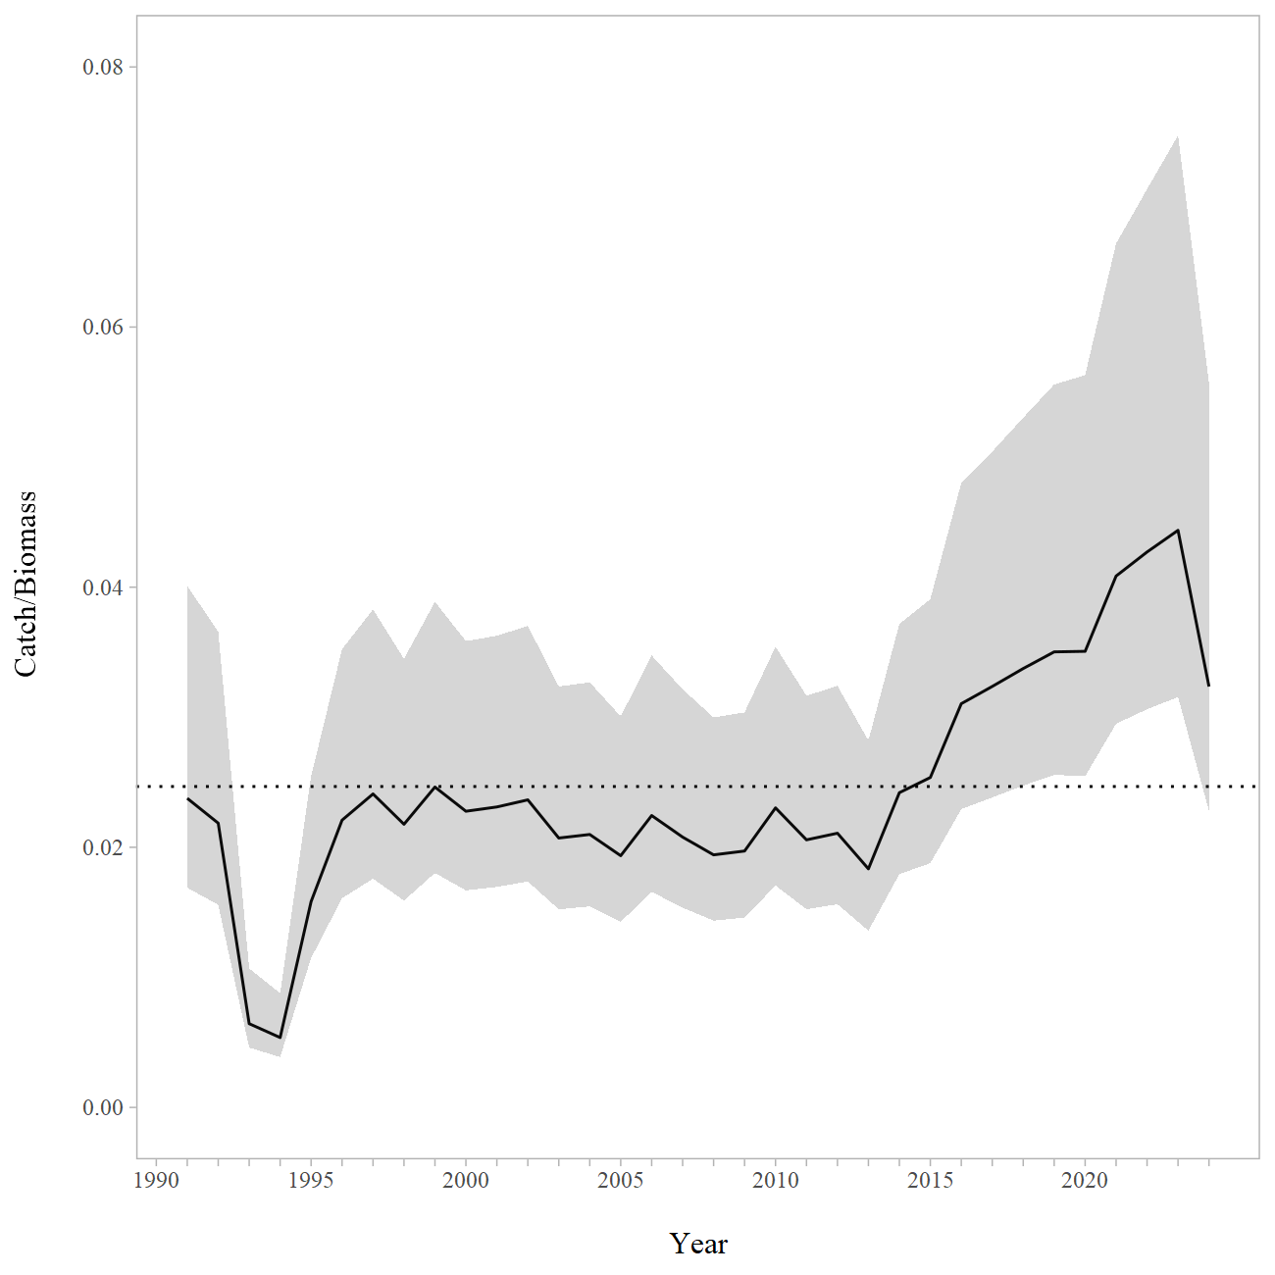

Figure 9-1. Gulf of Alaska Pacific ocean perch catch/age 2+ biomass ratio with approximate 95% confidence intervals. Observed catch values were used for 1991-2023, the 2024 catch values were estimated using an expansion factor. The horizontal dashed line is the mean value for the entire dataset.

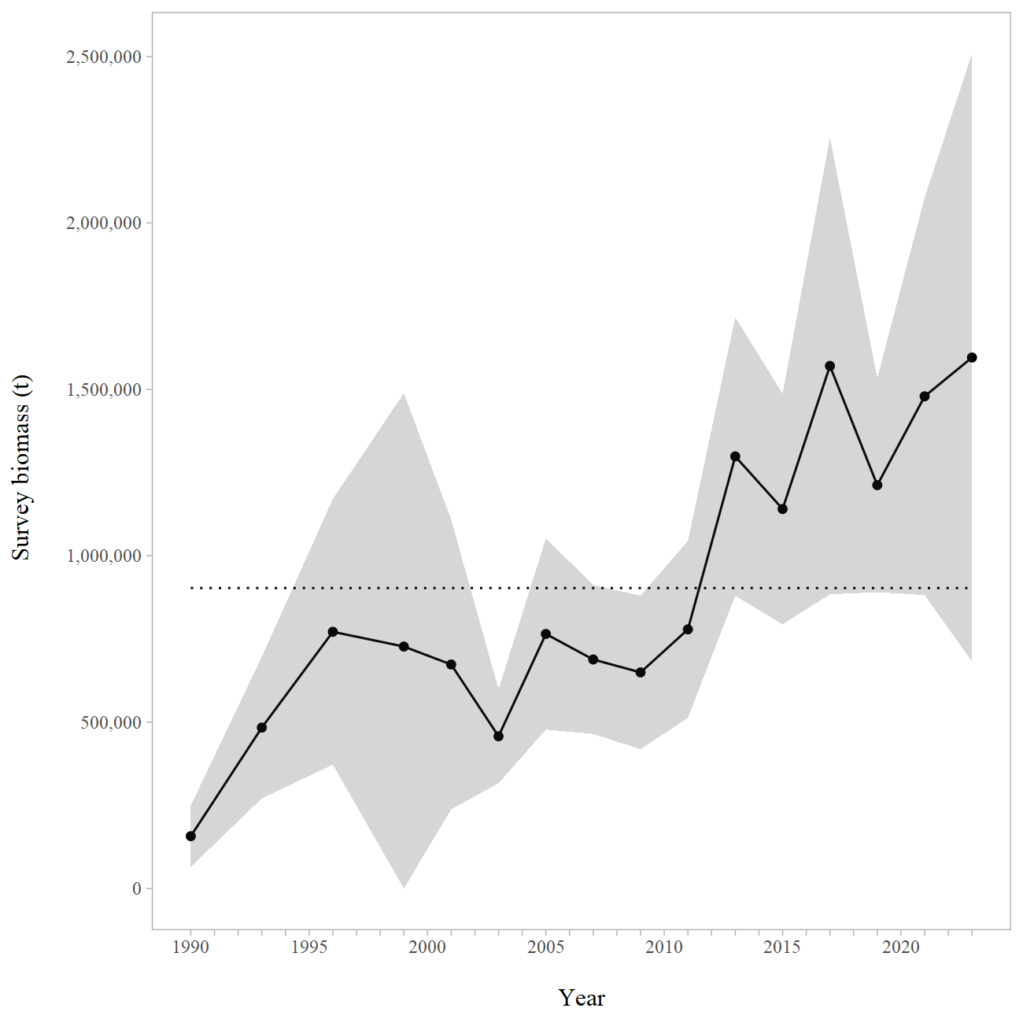

Figure 9-2. Line plot of the design-based model estimates of abundance for Gulf of Alaska trawl surveys. Shaded areas are 95% confidence intervals, the dashed line is the data mean.