A preliminary evaluation on the relationships between ABC and TAC levels for groundfish off Alaskan waters
James Ianelli
Alaska Fisheries Science Center
Seattle WA 98115
Jim.Ianelli@noaa.gov

Background
For the Programmatic Supplemental Environmental Impact Statement (PSEIS) a relatively complex multi-species technical interaction model (MSTIM) was developed to evaluate alternative approaches to groundfish fishery management for federally managed waters in Alaskan waters. One benefit of the MSTIM was that it allows for more realistic catch-levels to be fed into single-species stock projections. Previously, single-species evaluations were typically done in isolation to issues such as regulatory limits on the overall catch level, bycatch constraints, and effort development plans. The data requirements for MSPTIM are extensive and if one goal is to provide a simple approach for providing catch-feedback as a function of ABC levels, development of a simpler approach is warranted. Here a simple model of historical patterns is proposed as an option for estimating future TAC levels given future ABCs. Additionally, the standardized projection model (used for N. Pacific groundfish status determinations and annual Environmental Assessments) was modified to so that a single version was suited for all the current assessment models for N. Pacific groundfish and that if desired, projections of all species could be run simultaneously.

Data
As part of an effort to develop a standardized database for both archival and analytical purposes, information gleaned from SAFE reports, Federal Register notices, NPFMC documents, and NMFS Regional Office was obtained. Specifically, the TAC, ABC, and where possible, OFL levels were compiled by stocks and areas. Some discrepancies between reports were found and where these existed, the numbers in the Federal Register notice were given highest precedence. The initial layout of the database is shown in Table 1. This database allows for straightforward and flexible cross-tabulations (e.g., Table 2).
As a first step in evaluating historical patterns of TAC by species groups, a set of pair-wise plots were constructed. These show that EBS pollock TAC proportion was negatively correlated with flatfish species in addition to others while Pacific cod TAC proportion was largely independent of other TACs (Fig. 1). Since ABC levels are one of the main determinants of TACs by serving as an upper bound, the effect of ABCs are compared to each main species group in Figs. 2-8. Again, Pacific cod TAC levels are relatively independent of the other main species ABCs (except for Pacific cod ABC levels). The inverse relationships between pollock ABCs and flatfish TACs is apparent. Pollock TAC is affected most by pollock ABC up to the limit of about 75% of the overall TAC (2 million t).

TAC Model
Since a goal for compiling these data was to come up with a simple approach for predicting TACs given a suite of ABC levels, a series of models were developed. The fundamental structure of the model was:
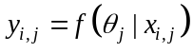
where 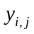 is the TAC in year i for species j, 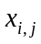 is the ABC level recommended in year i for species j, and 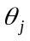 is a vector of parameters for species j. The functional form of the models tried included a linear regression over all species and a Generalized Additive Model (GAM) over a subset of species. The GAM model allowed for non-parametric smooth relationships between ABC levels and the response variable (TAC). Results of the GAM fits relative to the subset of ABC levels are shown in Figs. 9-15. For most stocks, the relationships between TAC and ABC were poorly determined (as indicated by the approximate 95% error bounds). However, the GAM model fits were considerably better than for the multiple regression results (lower right panels) suggesting that a non-linear relationship captures the relationships between ABCs and TAC best.

Projection Model

Input files
Previously, the standardized projection model evolved into a number of different versions to accommodate models with sex-specific natural mortality, growth, and multiple fisheries. Also, the ability to specify future catch scenarios was added along with the standard EA alternatives.

Table 1. Initial database layout (subject to validation and further edits).
Source | Area | Mgt_Area | Name_Quant | Spp | Year | Level | Reclass
SAFE_2004 | BSAI | BSAI | TAC | Atka | 1978 | 24,800 | Atka
SAFE_2004 | BSAI | BSAI | TAC | Atka | 1979 | 24,800 | Atka
SAFE_2004 | BSAI | BSAI | TAC | Atka | 1980 | 24,800 | Atka
…

Table 2. Example cross tabulations from the database (subject to validation and further edits). ABC (top table) and TAC (lower table) levels for BSAI regions.
 | BSAI ABC
Year | Atka | Oflats | OthSpp | Pcod | Pollock | POP | RockFish | RockSole | Sable | Gturb | YfinSole | FheadSole | Arrowtooth | AKPlaice | NrthrnRF | Grand Total
1977 |  | 65,000 |  |  | 950,000 | 21,500 |  |  | 7,400 | 40,000 | 106,000 |  |  |  |  | 1,189,900
1978 |  | 139,000 |  |  | 950,000 | 21,500 |  |  | 6,500 | 40,000 | 106,000 |  |  |  |  | 1,263,000
1979 |  | 61,000 |  |  | 1,100,000 | 21,500 | 7,700 |  | 5,000 | 90,000 | 117,000 |  |  |  |  | 1,402,200
1980 | 24,800 | 61,000 | 74,200 | 148,000 | 1,300,000 | 18,000 | 7,700 |  | 3,700 | 76,000 | 169,000 |  | 20,000 |  |  | 1,902,400
1981 | 24,800 | 92,500 | 94,400 | 160,000 | 1,300,000 | 18,000 | 21,300 |  | 3,700 | 59,800 | 214,500 |  | 16,500 |  |  | 2,005,500
1982 | 24,800 | 92,500 | 94,300 | 168,000 | 1,300,000 | 18,000 | 22,000 |  | 2,900 | 60,000 | 214,500 |  | 16,500 |  |  | 2,013,500
1983 | 25,500 | 119,200 | 61,400 | 298,200 | 1,300,000 | 11,800 | 14,100 |  | 2,900 | 65,000 | 214,500 |  | 20,000 |  |  | 2,132,600
1984 | 25,500 | 150,200 | 61,000 | 291,300 | 1,300,000 | 12,160 | 14,100 |  | 6,185 | 47,500 | 310,000 |  | 20,000 |  |  | 2,237,945
1985 | 37,700 | 150,200 | 51,200 | 347,400 | 1,300,000 | 12,760 | 8,910 |  | 6,080 | 44,200 | 310,000 |  | 20,000 |  |  | 2,288,450
1986 | 30,800 | 137,500 | 35,900 | 249,300 | 1,300,000 | 10,200 | 8,900 |  | 7,200 | 35,000 | 230,000 |  | 20,000 |  |  | 2,064,800
1987 | 30,800 | 193,300 | 49,500 | 400,000 | 1,300,000 | 14,700 | 1,880 |  | 7,700 | 20,000 | 187,000 |  | 30,900 |  |  | 2,235,780
1988 | 21,000 | 331,900 | 54,000 | 385,300 | 1,500,000 | 22,600 | 1,500 |  | 9,200 | 14,100 | 254,000 |  | 99,500 |  |  | 2,693,100
1989 | 21,000 | 155,900 | 59,000 | 370,600 | 1,340,000 | 22,600 | 1,500 | 171,000 | 6,200 | 20,300 | 241,000 |  | 163,700 |  |  | 2,572,800
1990 | 24,000 | 188,000 | 55,500 | 417,000 | 1,450,000 | 22,900 | 1,600 | 216,300 | 2,700 | 7,000 | 278,900 |  | 106,500 |  |  | 2,770,400
1991 | 24,000 | 219,700 | 28,700 | 229,000 | 1,676,000 | 15,345 | 1,325 | 246,500 | 3,100 | 7,000 | 250,600 |  | 116,400 |  |  | 2,817,670
1992 | 43,000 | 199,600 | 27,200 | 182,000 | 1,490,000 | 15,240 | 1,325 | 260,800 | 1,400 | 7,000 | 372,000 |  | 82,300 |  |  | 2,681,865
1993 | 117,100 | 191,000 | 26,600 | 164,500 | 1,340,000 | 17,230 | 1,325 | 185,000 | 1,500 | 7,000 | 238,000 |  | 72,000 |  |  | 2,361,255
1994 | 122,500 | 225,000 | 27,500 | 191,000 | 1,330,000 | 14,210 | 1,135 | 313,000 | 540 | 17,200 | 230,000 |  | 93,400 |  |  | 2,565,485
1995 | 125,000 | 117,000 | 27,600 | 328,000 | 1,250,000 | 13,750 | 1,135 | 347,000 | 1,600 | 7,000 | 277,000 | 138,000 | 113,000 |  |  | 2,746,085
1996 | 116,000 | 102,000 | 27,600 | 305,000 | 1,190,000 | 22,360 | 1,449 | 361,000 | 2,500 | 10,300 | 278,000 | 116,000 | 129,000 |  |  | 2,661,209
1997 | 66,700 | 97,500 | 25,800 | 306,000 | 1,130,000 | 21,948 | 1,087 | 296,000 | 2,675 | 12,350 | 233,000 | 101,000 | 108,000 |  |  | 2,402,060
1998 | 64,300 | 164,000 | 25,800 | 210,000 | 1,110,000 | 18,962 | 1,054 | 312,000 | 2,680 | 15,000 | 220,000 | 132,000 | 147,000 |  |  | 2,422,796
1999 | 73,300 | 154,000 | 32,860 | 177,000 | 992,000 | 20,862 | 1,054 | 309,000 | 3,200 | 14,200 | 212,000 | 77,300 | 140,000 |  |  | 2,206,776
2000 | 70,800 | 117,000 | 31,360 | 193,000 | 1,139,000 | 21,129 | 1,054 | 230,000 | 3,900 | 9,300 | 191,000 | 73,500 | 131,000 |  |  | 2,212,043
2001 | 69,300 | 122,000 | 35,570 | 188,000 | 1,874,270 | 11,930 | 8,829 | 228,000 | 4,060 | 8,400 | 176,000 | 84,000 | 117,000 |  |  | 2,927,359
2002 | 49,000 | 18,100 | 41,070 | 223,000 | 2,138,110 | 14,800 | 2,065 | 225,000 | 4,480 | 8,100 | 115,000 | 82,600 | 113,000 | 143,000 | 6,760 | 3,184,085
2003 | 63,000 | 16,000 | 45,270 | 223,000 | 2,373,470 | 15,100 | 2,561 | 110,000 | 6,000 | 5,880 | 114,000 | 66,000 | 112,000 | 137,000 | 7,101 | 3,296,382
2004 | 66,700 | 13,500 | 48,780 | 223,000 | 2,601,970 | 13,300 | 2,315 | 139,000 | 6,450 | 4,740 | 114,000 | 61,900 | 115,000 | 203,000 | 6,880 | 3,620,535

 | BSAI TAC
Year | Atka | Oflats | OthSpp | Pcod | Pollock | POP | RockFish | RockSole | Sable | Gturb | YfinSole | FheadSole | Arrowtooth | AKPlaice | NrthrnRF | Grand Total
1977 |  | 100,000 | 103,600 | 58,000 | 950,000 | 21,500 |  |  | 7,400 |  | 106,000 |  |  |  |  | 1,346,500
1978 | 24,800 | 159,000 | 111,400 | 70,500 | 950,000 | 21,500 |  |  | 4,500 |  | 126,000 |  |  |  |  | 1,467,700
1979 | 24,800 | 139,000 | 103,600 | 58,000 | 950,000 | 21,500 |  |  | 4,500 |  | 106,000 |  |  |  |  | 1,407,400
1980 | 24,800 | 61,000 | 84,249 | 70,700 | 1,000,000 | 10,750 | 7,727 |  | 5,000 |  | 117,000 |  |  |  |  | 1,381,226
1981 | 24,800 | 61,000 | 84,249 | 78,700 | 1,000,000 | 10,750 | 7,727 |  | 5,000 |  | 117,000 |  |  |  |  | 1,389,226
1982 | 24,800 | 61,000 | 84,249 | 78,700 | 1,000,000 | 10,750 | 7,727 |  | 5,000 |  | 117,000 |  |  |  |  | 1,389,226
1983 | 24,800 | 61,000 | 87,314 | 120,000 | 1,000,000 | 10,750 | 7,727 |  | 5,000 |  | 117,000 |  |  |  |  | 1,433,591
1984 | 35,000 | 111,490 | 48,900 | 210,000 | 1,200,000 | 6,360 | 7,050 |  | 5,340 |  | 230,000 |  |  |  |  | 1,854,140
1985 | 37,700 | 111,400 | 47,980 | 220,000 | 1,200,000 | 4,800 | 6,620 |  | 4,500 |  | 229,900 |  |  |  |  | 1,862,900
1986 | 30,800 | 124,200 | 32,800 | 229,000 | 1,200,000 | 7,625 | 6,625 |  | 6,450 | 33,000 | 209,500 |  | 20,000 |  |  | 1,900,000
1987 | 30,800 | 148,300 | 15,500 | 280,000 | 1,200,000 | 11,025 | 1,880 |  | 7,700 | 20,000 | 187,000 |  | 9,795 |  |  | 1,912,000
1988 | 21,000 | 131,369 | 11,000 | 200,000 | 1,300,000 | 11,000 | 1,500 |  | 8,400 | 11,200 | 254,000 |  | 5,531 |  |  | 1,955,000
1989 | 20,285 | 75,183 | 14,264 | 230,681 | 1,340,000 | 11,000 | 1,500 | 90,763 | 6,200 | 6,800 | 182,675 |  | 6,000 |  |  | 1,985,351
1990 | 21,000 | 60,150 | 5,500 | 227,000 | 1,280,000 | 12,900 | 1,600 | 60,000 | 7,200 | 7,000 | 207,650 |  | 10,000 |  |  | 1,900,000
1991 | 24,000 | 64,675 | 16,000 | 229,000 | 1,300,000 | 15,345 | 1,325 | 90,000 | 6,300 | 7,000 | 135,000 |  | 20,000 |  |  | 1,908,645
1992 | 43,000 | 79,000 | 22,000 | 182,000 | 1,300,000 | 16,640 | 8,215 | 40,000 | 4,400 | 7,000 | 235,000 |  | 10,000 |  |  | 1,947,255
1993 | 64,000 | 79,000 | 28,600 | 164,500 | 1,300,000 | 18,430 | 7,390 | 75,000 | 4,100 | 7,000 | 220,000 |  | 10,000 |  |  | 1,978,020
1994 | 68,000 | 56,000 | 29,500 | 191,000 | 1,330,000 | 14,210 | 8,025 | 75,000 | 3,340 | 7,000 | 150,325 |  | 10,000 |  |  | 1,942,400
1995 | 80,000 | 19,540 | 21,000 | 250,000 | 1,250,000 | 13,610 | 7,223 | 60,000 | 3,800 | 7,000 | 190,000 | 30,000 | 10,227 |  |  | 1,942,400
1996 | 106,157 | 35,000 | 20,125 | 270,000 | 1,190,000 | 21,514 | 1,304 | 70,000 | 2,300 | 7,000 | 200,000 | 30,000 | 9,000 |  |  | 1,962,400
1997 | 66,700 | 50,750 | 25,800 | 270,000 | 1,130,000 | 21,948 | 1,087 | 97,185 | 2,300 | 9,000 | 230,000 | 43,500 | 20,760 |  |  | 1,969,030
1998 | 64,300 | 89,434 | 25,800 | 210,000 | 1,110,000 | 18,962 | 1,054 | 100,000 | 2,680 | 15,000 | 220,000 | 100,000 | 16,000 |  |  | 1,973,230
1999 | 66,400 | 154,000 | 32,860 | 177,000 | 992,000 | 20,362 | 1,054 | 120,000 | 3,200 | 9,000 | 207,980 | 77,300 | 134,354 |  |  | 1,995,510
2000 | 70,800 | 83,813 | 31,360 | 193,000 | 1,139,000 | 21,129 | 1,054 | 137,760 | 3,900 | 9,300 | 123,262 | 52,652 | 131,000 |  |  | 1,998,030
2001 | 69,300 | 28,000 | 28,470 | 188,000 | 1,403,000 | 11,930 | 8,829 | 75,000 | 4,060 | 8,400 | 113,000 | 40,000 | 22,011 |  |  | 2,000,000
2002 | 49,000 | 3,000 | 32,795 | 200,000 | 1,486,100 | 14,800 | 2,065 | 54,000 | 4,480 | 8,000 | 86,000 | 25,000 | 16,000 | 12,000 | 6,760 | 2,000,000
2003 | 60,000 | 3,000 | 34,279 | 207,500 | 1,492,810 | 14,100 | 2,561 | 44,000 | 6,000 | 4,000 | 83,750 | 20,000 | 12,000 | 10,000 | 6,000 | 2,000,000
2004 | 63,000 | 3,000 | 28,480 | 215,500 | 1,493,050 | 12,580 | 1,815 | 41,000 | 6,000 | 3,500 | 86,075 | 19,000 | 12,000 | 10,000 | 5,000 | 2,000,000

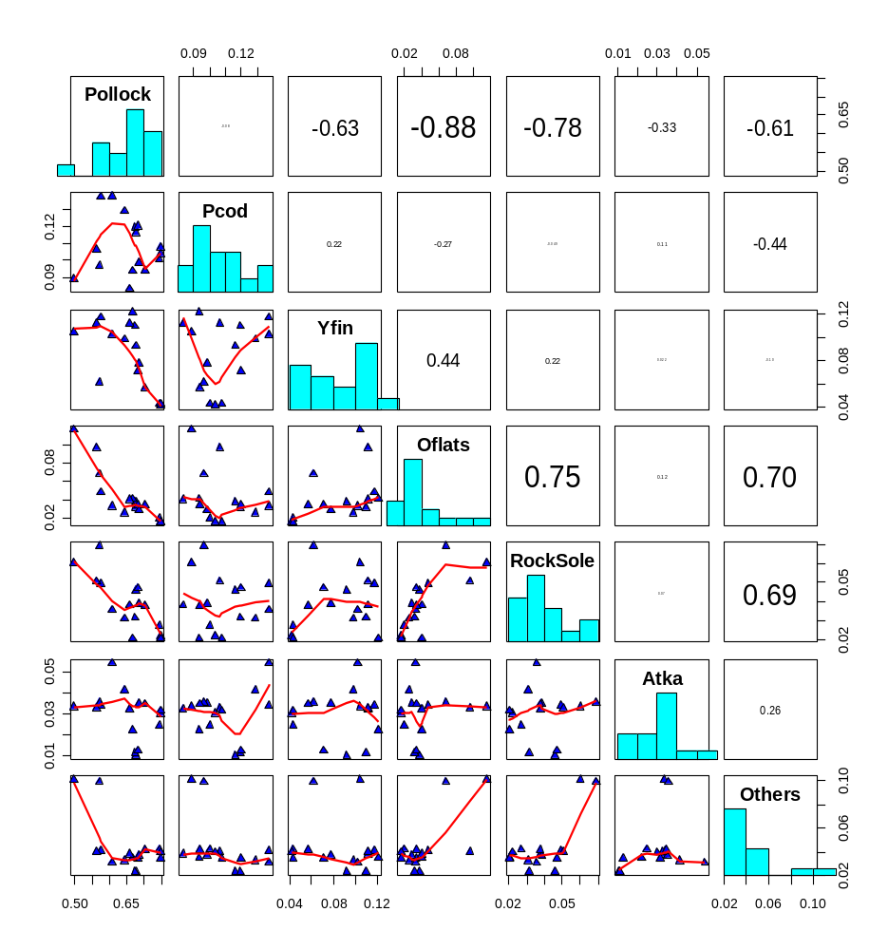

Figure 1. Bivariate plots of BSAI TACs (as a proportion of the sum of TACs) for 1989-2004. Correlations are shown in the upper right triangular portion, lines are smoothed trends, and histograms represent frequencies of TAC proportions.
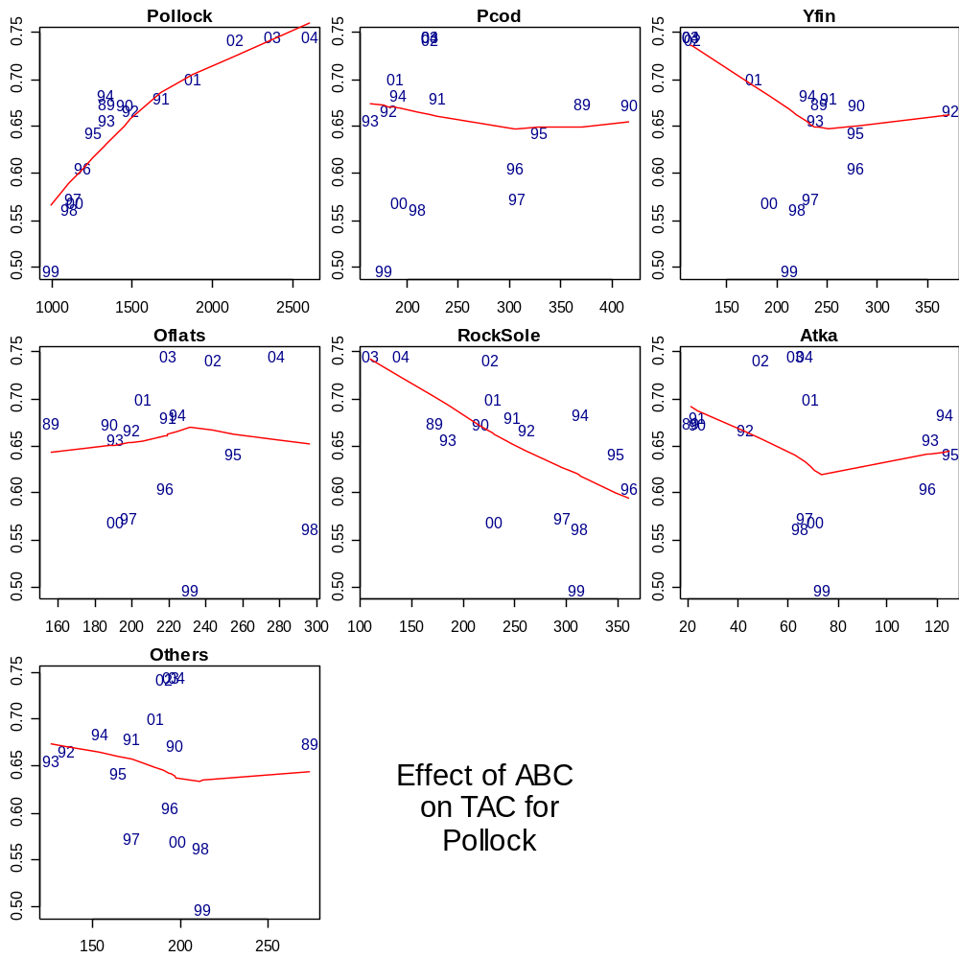
Proportion of TAC

ABC (thousands of t)

Figure 2. The effect of ABC (thousands of t) by species on the TAC (as a fraction of all groundfish stock TACs combined) for EBS pollock.
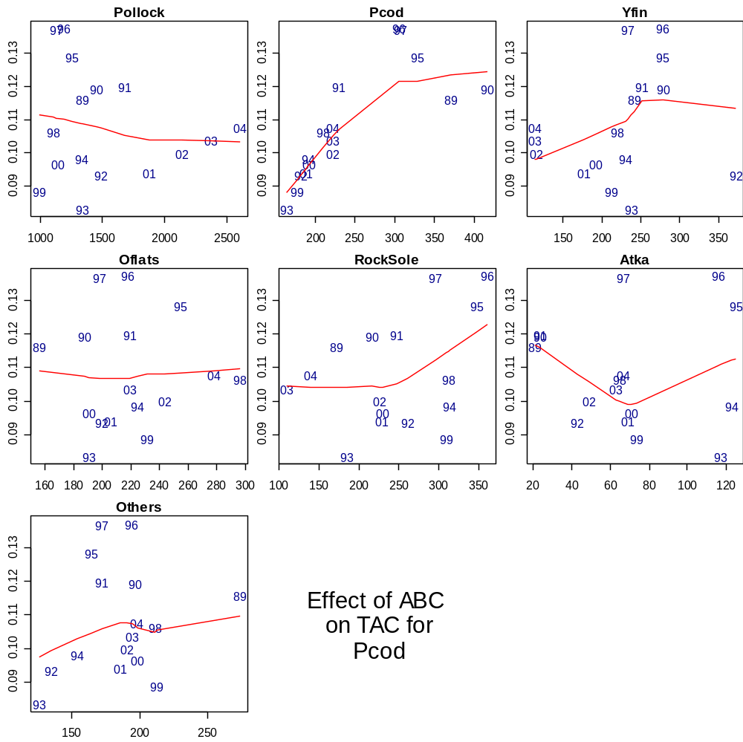
Proportion of TAC

ABC (thousands of t)

Figure 3. The effect of ABC (thousands of t) by species on the TAC (as a fraction of all groundfish stock TACs combined) for Pacific cod.
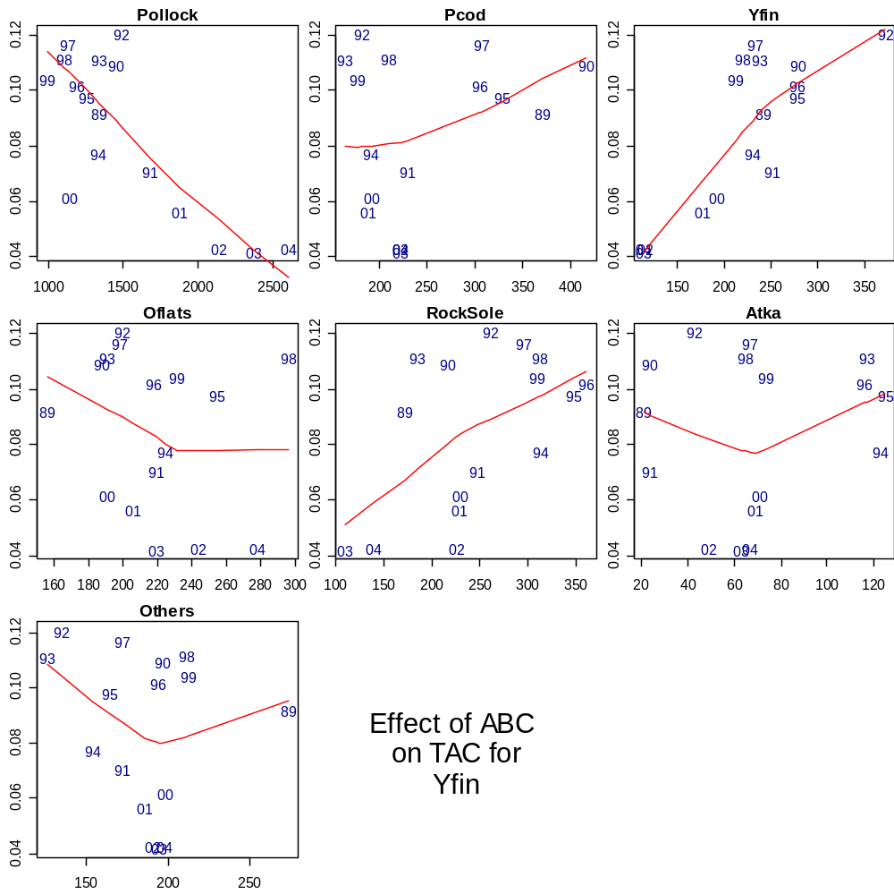
Proportion of TAC

ABC (thousands of t)

Figure 4. The effect of ABC (thousands of t) by species on the TAC (as a fraction of all groundfish stock TACs combined) for EBS yellowfin sole.
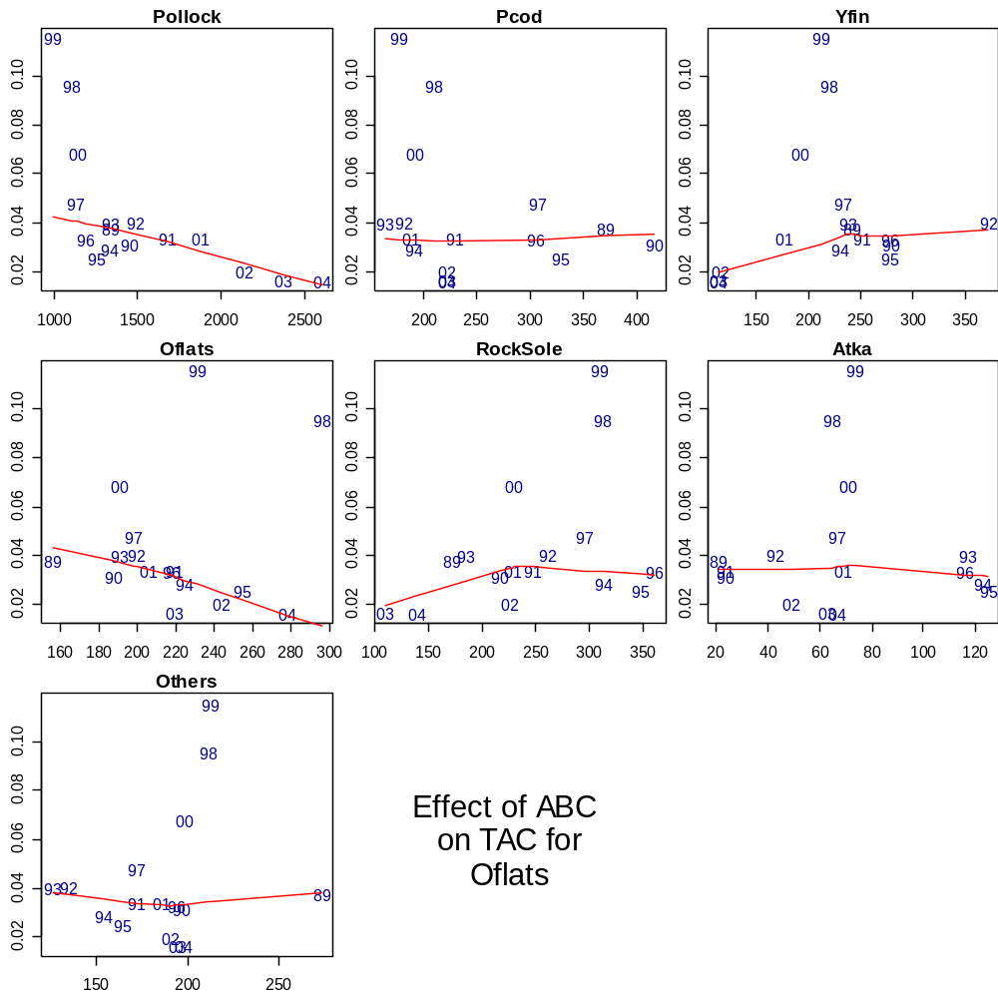
Proportion of TAC

ABC (thousands of t)

Figure 5. The effect of ABC (thousands of t) by species on the TAC (as a fraction of all groundfish stock TACs combined) for other flatfish.
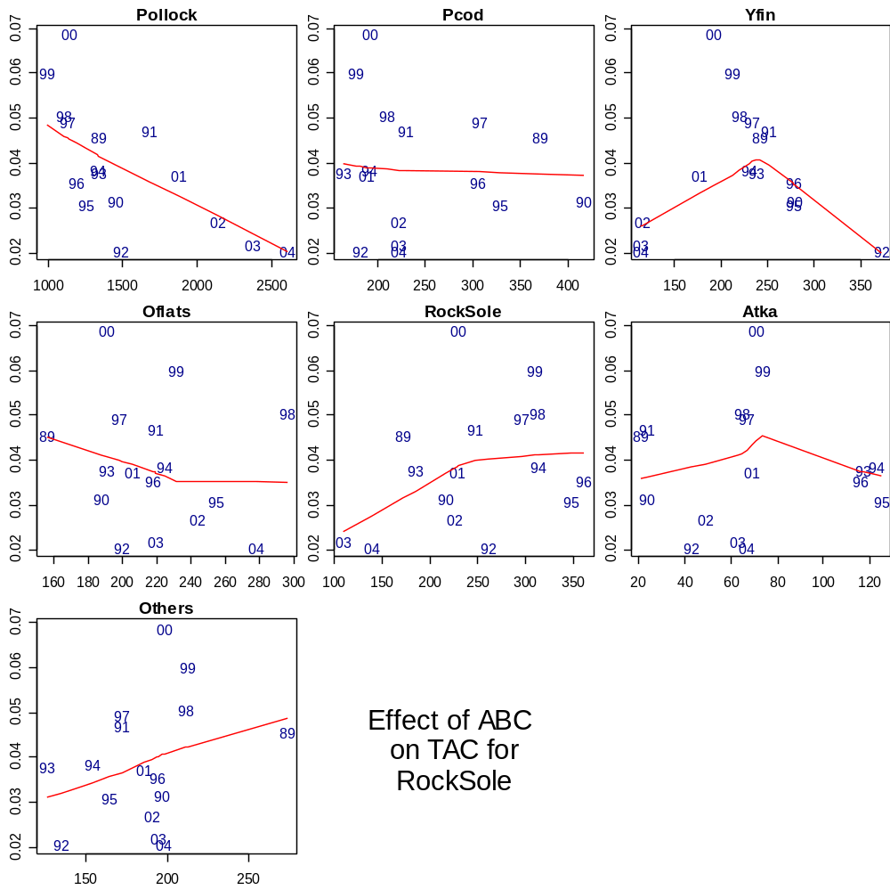
Proportion of TAC

ABC (thousands of t)

Figure 6. The effect of ABC (thousands of t) by species on the TAC (as a fraction of all groundfish stock TACs combined) for rock sole.
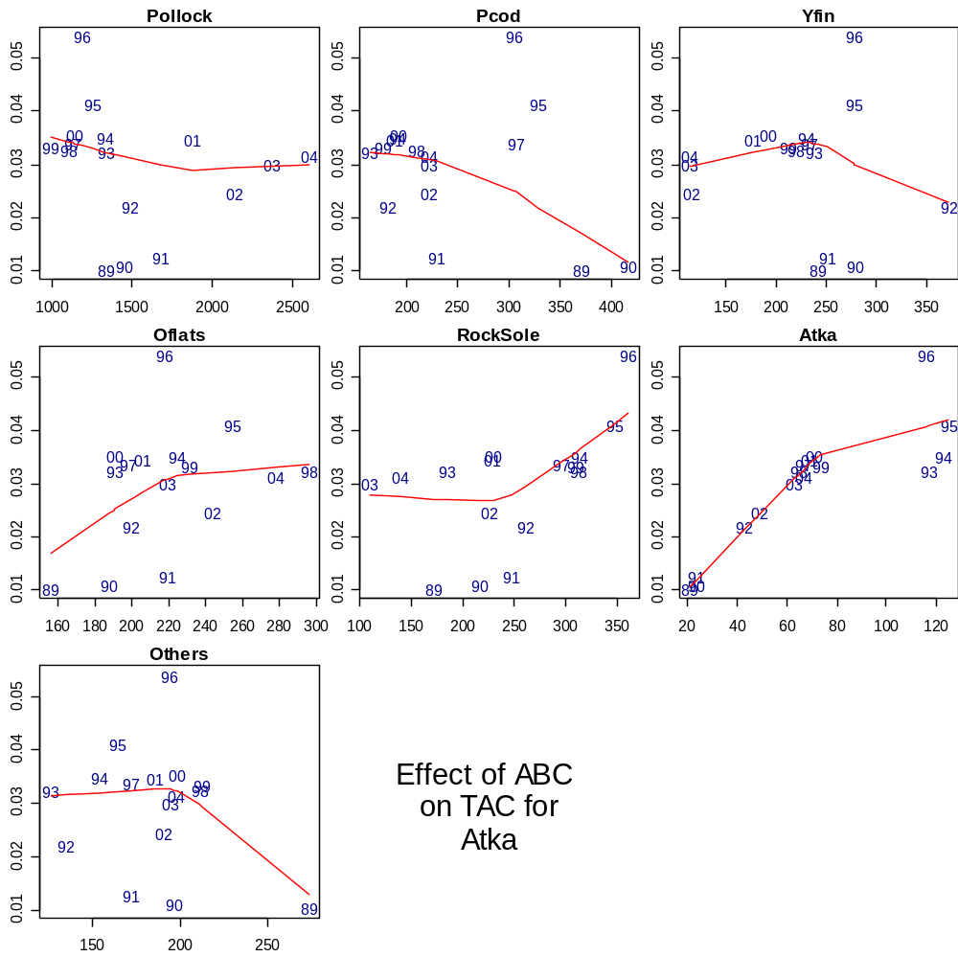
Proportion of TAC

ABC (thousands of t)

Figure 7. The effect of ABC (thousands of t) by species on the TAC (as a fraction of all groundfish stock TACs combined) for Atka mackerel.
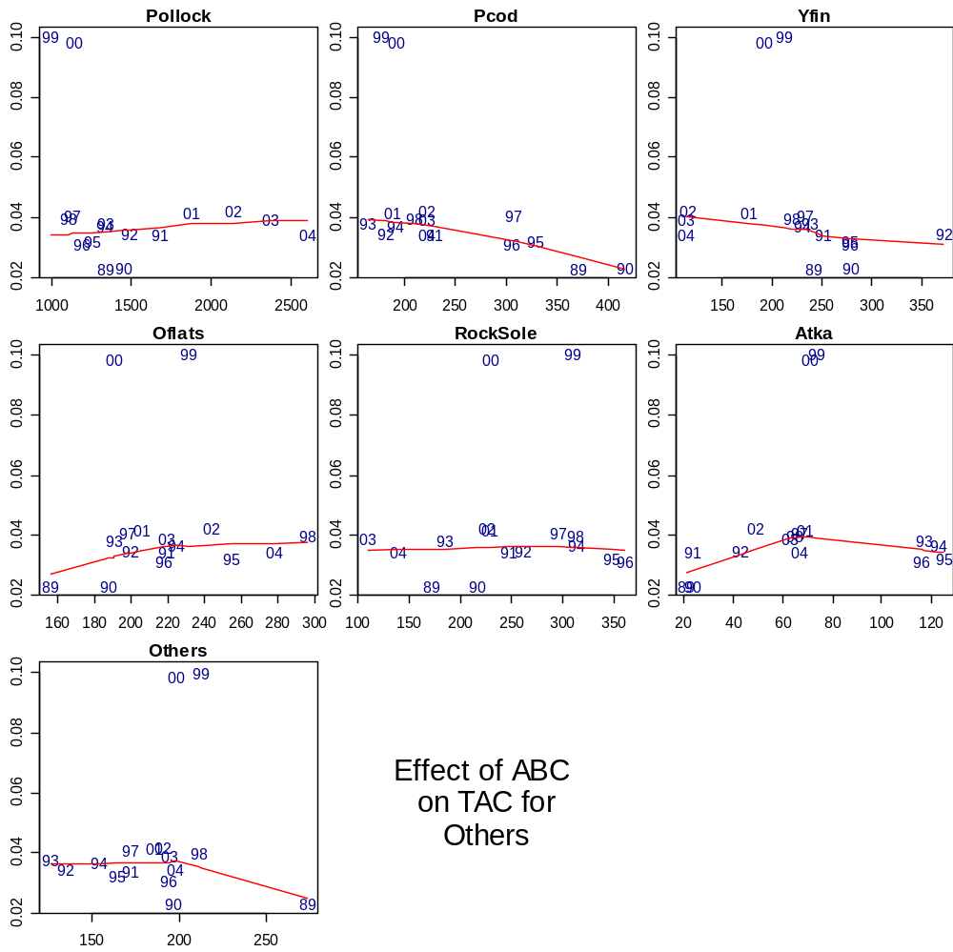
Proportion of TAC

ABC (thousands of t)

Figure 8. The effect of ABC (thousands of t) by species on the TAC (as a fraction of all groundfish stock TACs combined) for all other groundfish stocks.

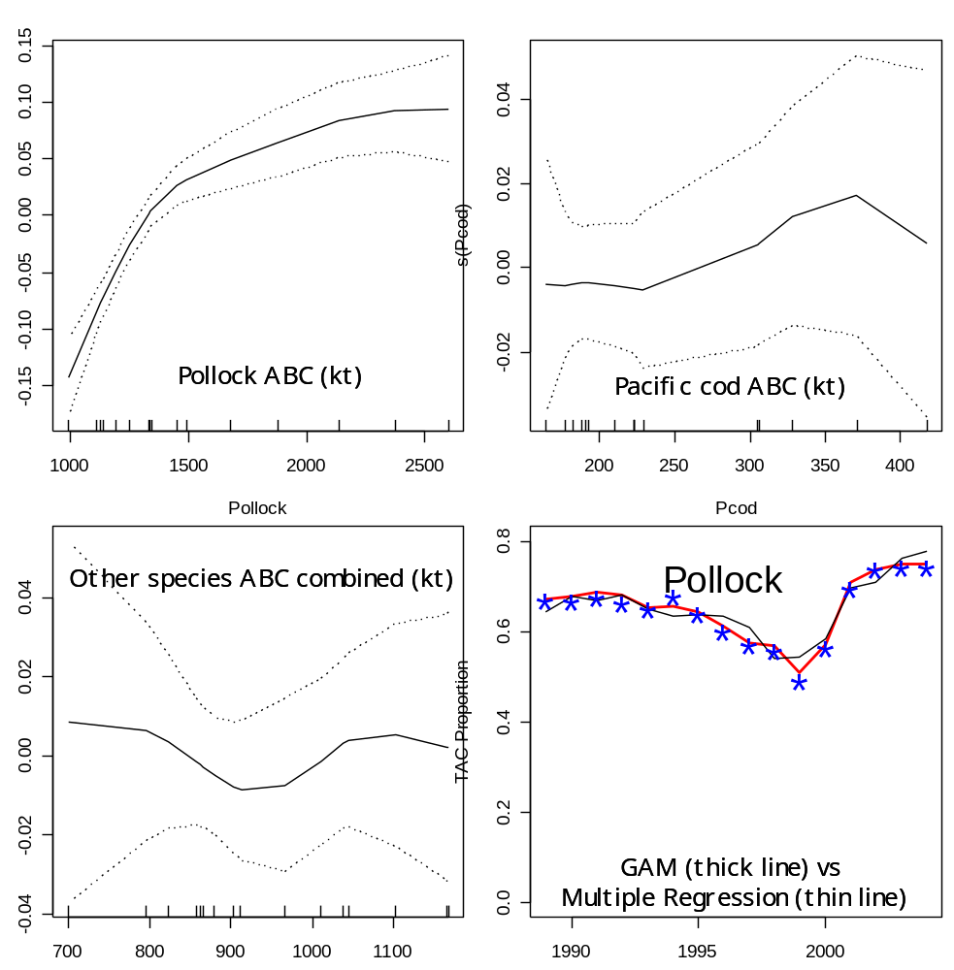

Figure 9. The effect of ABCs (thousands of t) by species group (pollock, Pacific cod, and all other groundfish ABCs summed) on the TAC of pollock.

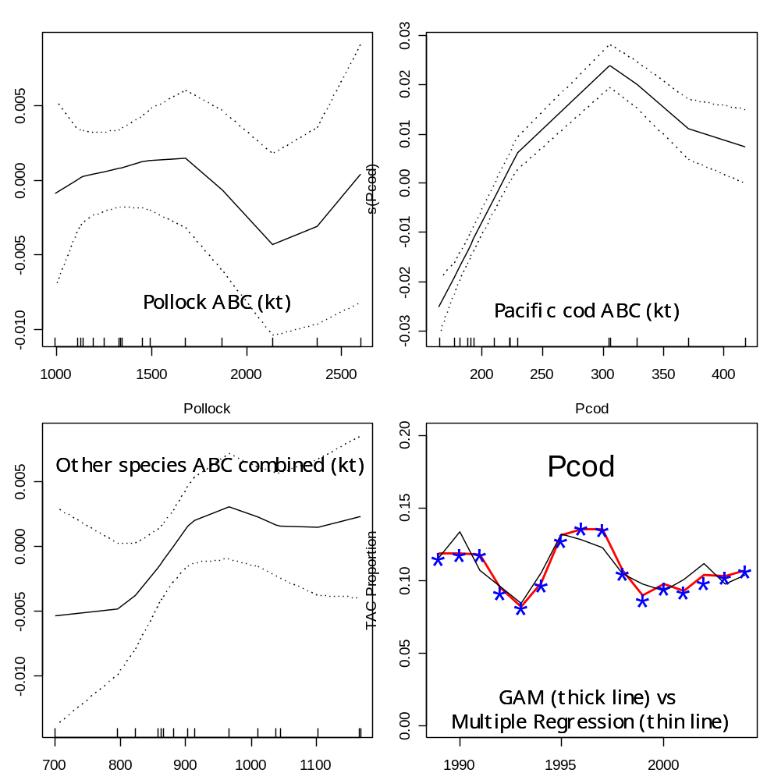

Figure 10. The effect of ABCs (thousands of t) by species group (pollock, Pacific cod, and all other groundfish ABCs summed) on the TAC of Pacific cod.

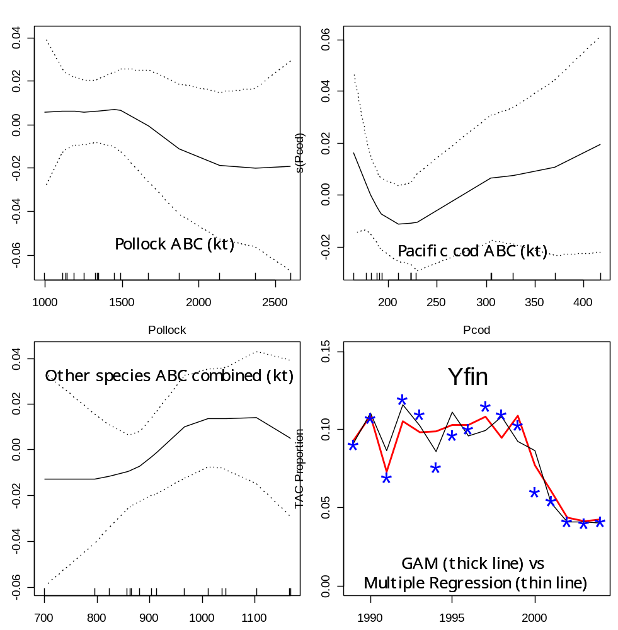

Figure 11. The effect of ABCs (thousands of t) by species group (pollock, Pacific cod, and all other groundfish ABCs summed) on the TAC of yellowfin sole.

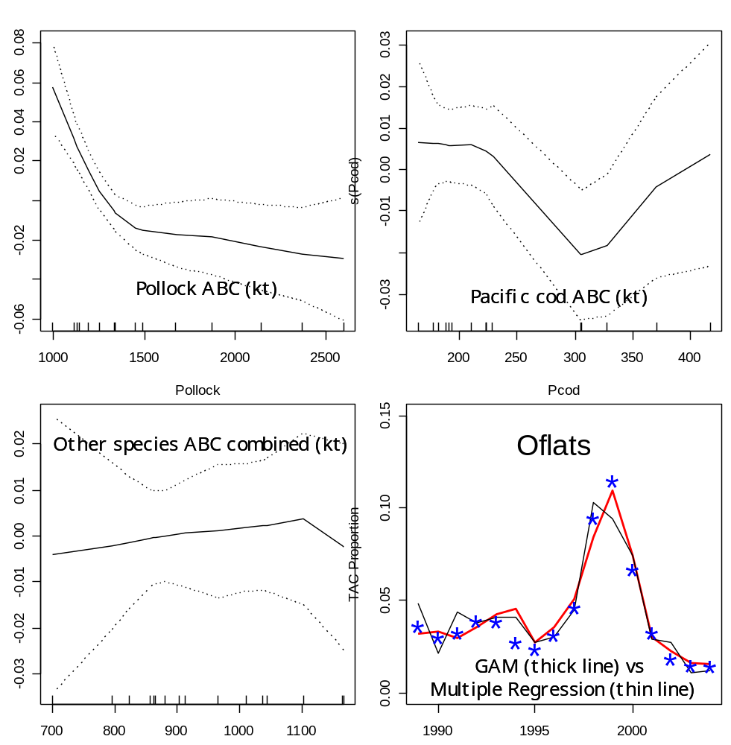

Figure 12. The effect of ABCs (thousands of t) by species group (pollock, Pacific cod, and all other groundfish ABCs summed) on the TAC of other flatfish.

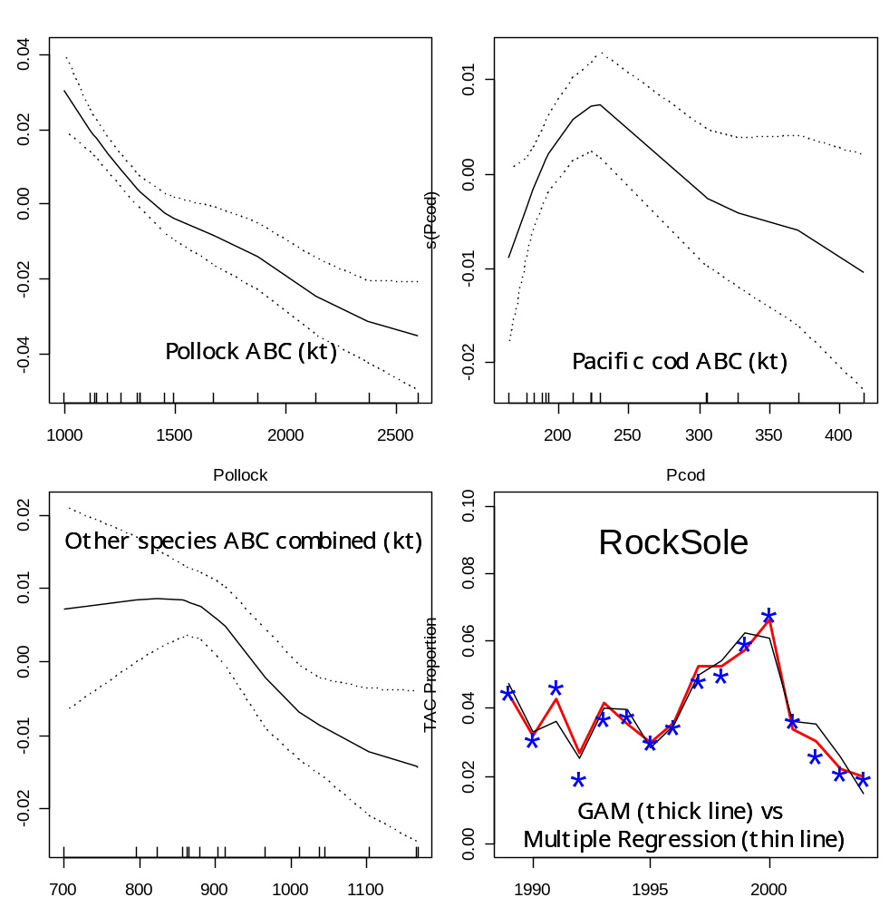

Figure 13. The effect of ABCs (thousands of t) by species group (pollock, Pacific cod, and all other groundfish ABCs summed) on the TAC of rock sole.
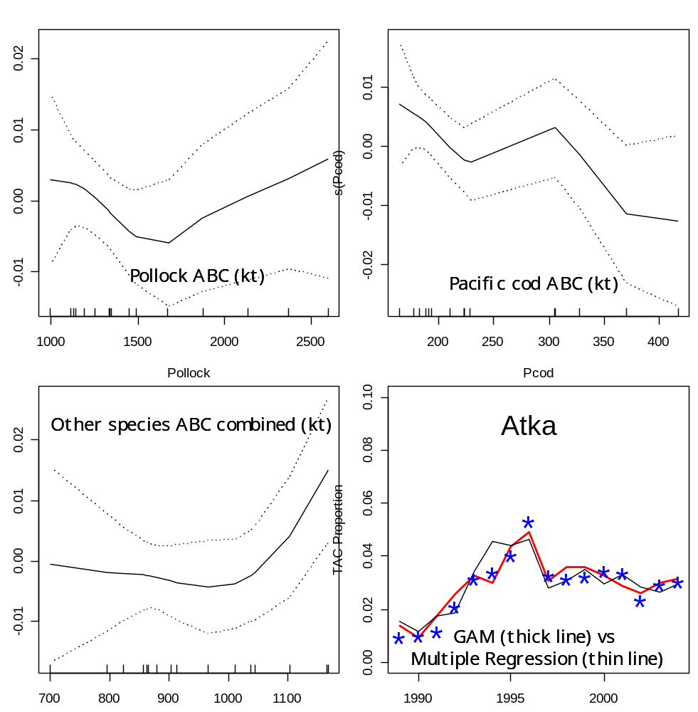

Figure 14. The effect of ABCs (thousands of t) by species group (pollock, Pacific cod, and all other groundfish ABCs summed) on the TAC of Atka mackerel.

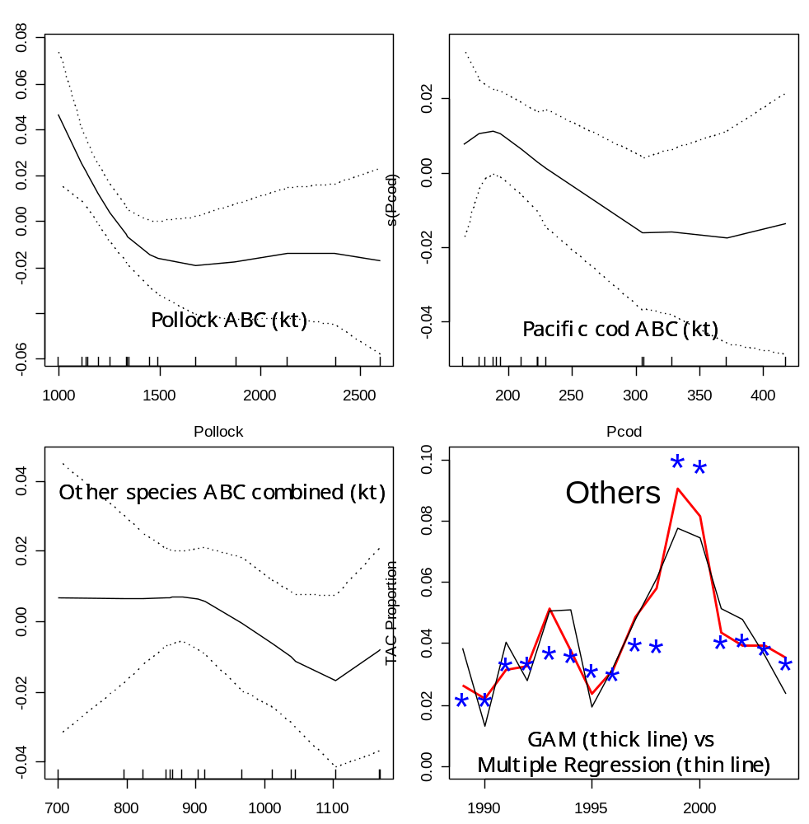

Figure 15. The effect of ABCs (thousands of t) by species group (pollock, Pacific cod, and all other groundfish ABCs summed) on the TAC of other groundfish species.

Master Setup file example
# Run nameRun1 # Number of Alternatives 5 # List of alternatives 1 # List of alternatives 2 # List of alternatives 3 # List of alternatives 4 # List of alternatives 5 # Flag to set TAC equal to ABC (1 means true, otherwise false) 1 # Stock-recruitment type (1=Ricker, 2=Bholt)1 # Recruitment projection (default: 1 = use observed mean and std, option 2 = use est. SRR and sigma R) 1 # Condition that Fmsy == F35%? (0 means no, non-zero means use condition (affects SRR fits) 0 # Condition that there is a prior that mean historical recruitment is similar to expected recruitment0 # Flag to write big file (of all simulations rather than a summary, 0 means don't bother) 1 # Number of projection years 14 # Number of simulations 50 # Begin Year 2004
Species specific file example
EBS_Pollock# Species name
1# SSL Species
0 # Constant buffer of
1 # Number of fisheries
1 # Number of sexes
0.178881 # average 5yr Fishing mortality
1 # Author F multiplier
0.4 # ABC SPR
0.35 # MSY SPR
4 # Month of spawning
15 # Number of ages
1 # Fratio
# Natural mortality at age: 0.9 0.45 0.3 0.3 …
# Maturity at age:0 0.008 0.289 0.641 0.842…
# Avg wt of female spawning:0.0066 0.17 0.384205 0.503487…
# Wt fsh 0.0066 0.17 0.384205 0.503487…
# selectivity Fishery 10.00167197 0.0201642 0.171093 0.462636…
# natage 13532 4513.93 2970.19 7060.6
# Nrec 27
# rec 28254.9 64058.7 26341.3 30002
# SSB21312 23367l …
…
Spp_Catch file example
Number_of_years with specified catch:3
Number of species 7
Data files for each species
goa_wp.dat GOA_pcod.dat GOA_sable.dat GOA_atf.dat GOA_fhs.dat GOA_pop.dat GOA_nrthrns.dat
ABC Multipliers
1111111
Scalars (for population level)
111.3157891000100010001000
Number of TAC model categories
7
TAC model indices (for aggregating)
1234567
Catch in each future year
20047258.619.77368233162747118005000
200585.37654.03320.9736826753.673004.667119435091
200698.00451.53719.60526267543226118094700

Figure 16. Schematic of the general projection model and input files.

