Aleutian Islands Groundfish Condition

Contributed by Ned Laman1, Sean Rohan1  
1 Resource Assessment and Conservation Engineering Division, Groundfish Assessment Program, Alaska Fisheries Science Center, National Marine Fisheries Service, NOAA, Seattle, WA  
**Contact**: [ned.laman@noaa.gov](mailto:ned.laman@noaa.gov)  
**Last updated**: September 2020

**Description of Indicator**: Residual body condition computed from a long-term average of length-weight-based body condition is an indicator of variability in somatic growth (Brodeur et al., 2004) and represents how heavy a fish is per unit body length. As such, it can be considered an indicator of ecosystem productivity. Positive residual body condition is interpreted to indicate fish in better condition (heavier per unit length) than those with negative residual body condition indicating poorer condition (lighter per unit length). Overall body condition of fishes likely reflects fish growth which can have implications for their subsequent survival (Paul and Paul, 1999; Boldt and Haldorson, 2004).

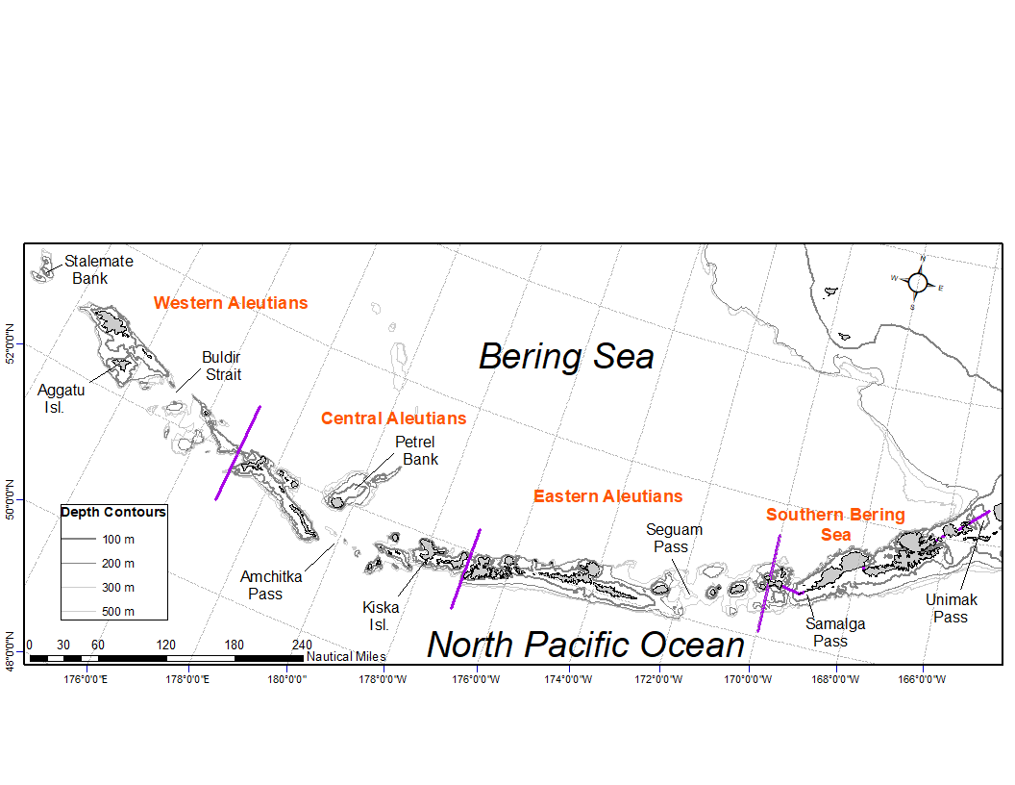

Figure 1. National Marine Fisheries Service (NMFS) Alaska Fisheries Science Center (AFSC) Resource Assessment and Conservation Engineering Groundfish Assessment Program (RACE-GAP) Aleutian Islands summer bottom trawl survey area with International North Pacific Fisheries Commission (INPFC) statistical fishing strata delineated by the purple lines.

Paired lengths and weights of individual fishes were examined from the Alaska Fisheries Science Center biennial Resource Assessment and Conservation Engineering (AFSC/RACE) - Groundfish Assessment Program’s (GAP) bottom trawl survey of the Aleutian Islands (AI). Analyses focused on walleye pollock (*Gadus chalcogrammus*), Pacific cod (*Gadus macrocephalus*), arrowtooth flounder (*Atheresthes stomias*), southern rock sole (*Lepidopsetta bilineata*), Atka mackerel (*Pleurogrammus monopterygius*), northern rockfish (*Sebastes polyspinis*), and Pacific ocean perch (*Sebastes alutus*) collected in trawls with satisfactory performance at standard survey stations. Data were combined in the International North Pacific Fisheries Commission (INPFC) strata; Southern Bering Sea, Eastern Aleutian Islands, Central Aleutian Islands, and Western Aleutian Islands (Figure 1).

Length-weight relationships for each of the seven species were estimated within each stratum from a linear regression of log-transformed values across all years where data were available (1984–2018); the slopes of these relationships were estimated independently in each stratum to account for spatial-temporal variation in growth and bottom trawl survey sampling. Length-weight relationships for 100–250 mm fork length (1–2 year old) walleye pollock were established independent of the adult life history stages caught. Bias-corrected weights-at-length (log scale) were estimated from the model and subtracted from observed weights to compute individual residuals per fish. Length-weight residuals were averaged for each stratum and weighted in proportion to INPFC stratum biomass based on stratified area-swept expansion of summer bottom trawl survey catch per unit effort (CPUE). Average length-weight residuals were compared by stratum and year to evaluate spatial variation in fish condition. Combinations of stratum and year with <10 samples were used for length-weight relationships but excluded from indicator calculations.

**Methodological Changes**: The method used to calculate groundfish condition this year (2020) differs from previous years in that: 1) different regression slopes were estimated for each stratum, 2) a bias-correction was applied when predicting weights prior to calculating residuals, 3) stratum mean residuals were weighted in proportion to stratum biomass, and 4) stratum-year combinations with sample size <10 were not used in indicator calculations. As in previous years, confidence intervals for the condition indicator reflect uncertainty based on length-weight residuals, but are larger due to differences in sample sizes and stratum biomasses among years. Confidence intervals do not account for uncertainty in stratum biomass estimates.

**Status and Trends**: Residual body condition varied amongst survey years for all species considered (Figure 2). The updated computational methods used to calculate this year’s residual body condition indexes returned different values than those reported in the last Aleutian Islands Ecosystem Considerations document (Boldt et al. 2018). The patterns of above or below average residual condition observed in 2018 largely match those generated here from the updated computations, but with notable reductions in the magnitude of the residuals from the latter in most years. The lower magnitude results come from using stratum-specific regression coefficients and samples weighted in proportion to biomass which reduces the influence of spatio-temporal variation in sampling intensity on the residuals. Some exceptions to the pattern tracking observed for the majority of cases are instances when residual condition switched from above to below average (>250 mm pollock in 1993 and 2015 and 100–250 mm pollock in 2010) and an instance when 100–250 mm pollock (2016) condition switched from below average to above. Condition of most species since 2010 has primarily been below the long term average or neutral. Exceptions occur for 100–250 mm walleye pollock in 2016 and Atka mackerel in 2012 where the residual body condition is neutral or slightly positive. Southern rock sole residual body condition is trending positive in the Aleutians since 2012. The period prior to the 2010 AI bottom trawl survey is characterized by body condition indicators cycling between positive and negative values through the years.

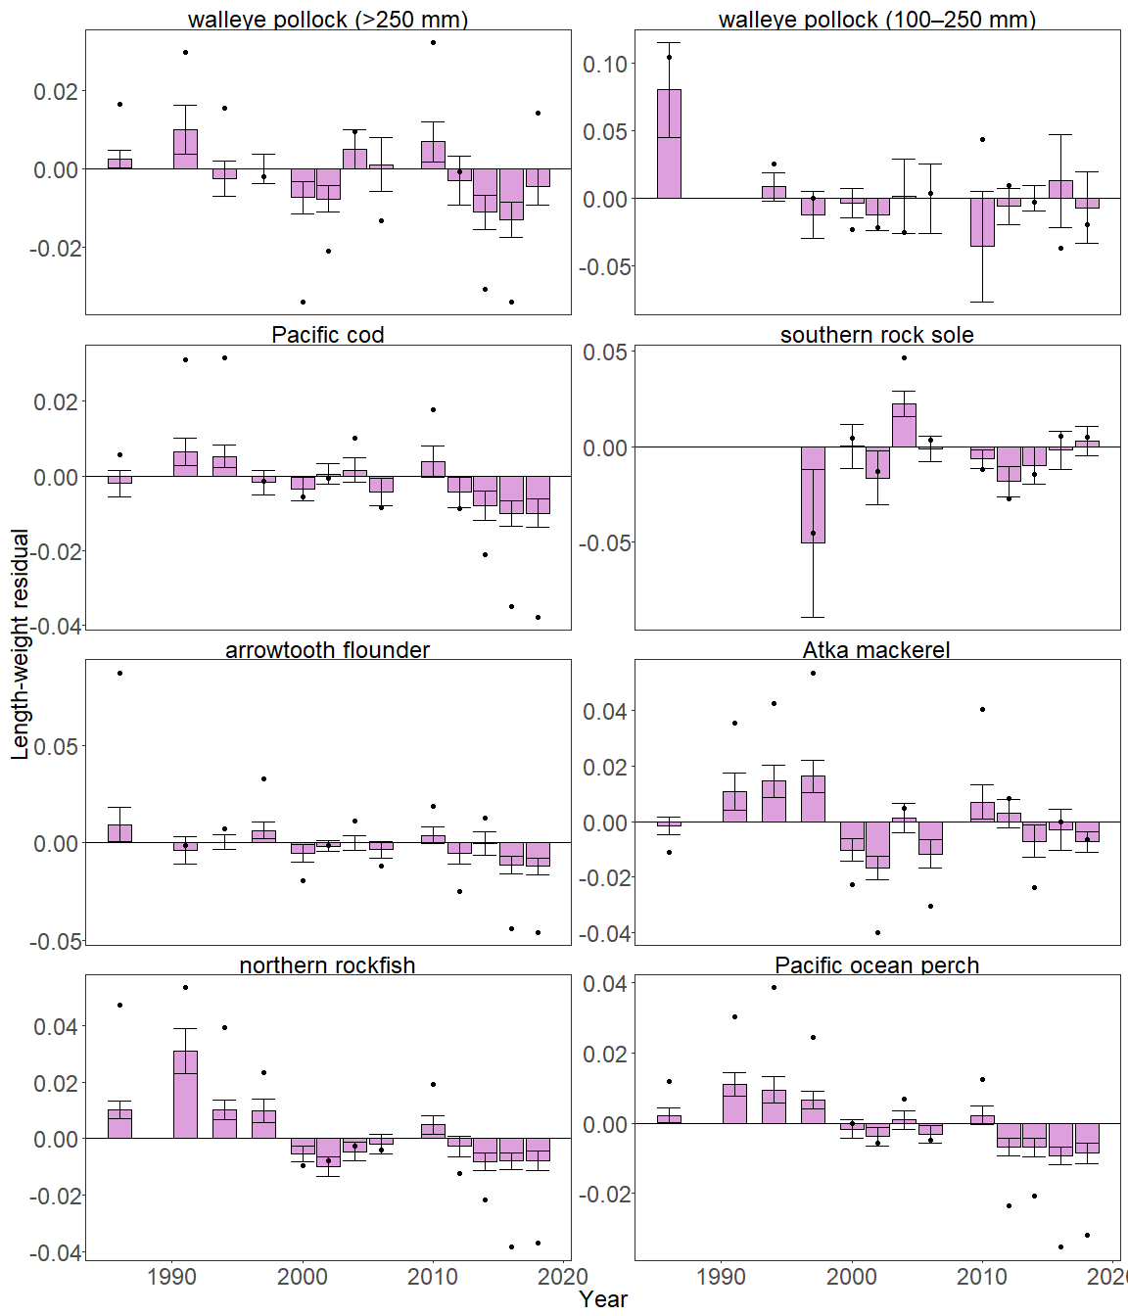

Figure 2. Biomass-weighted residual body condition index across survey years (1984–2018) for seven Aleutian Islands groundfish species collected on the National Marine Fisheries Service (NMFS) Alaska Fisheries Science Center (AFSC) Resource Assessment and Conservation Engineering Groundfish Assessment Program (RACE-GAP) standard summer bottom trawl surve. Filled bars denote weighted length-weight residuals using this year’s indicator calculation, error bars denote two standard errors, points denote the mean of the unweighted length-weight residual from the previous year’s (2018) ESR.

The general pattern of below average residual body condition index across recent survey years for the Aleutian Islands as described above was mostly reflected in the spatial condition indicators across INPFC strata (Figure 3). In some instances, stratum-specific condition was above average when the overall annual condition was below average (e.g., in the Central and Western Aleutians for Atka mackerel in 2014 and for >250 mm walleye pollock in 2016). The relative contribution of stratum-specific residual body condition to the overall trends (indicated by the height of each colored bar segment) does not demonstrate a clear pattern, although for many species, changes in body condition were synchronous amongst strata within years. The strata represented by southern rock sole and 100–250 mm walleye pollock condition indicators varied through time but it is unclear whether this was due to variation in fish distribution or sampling effort.

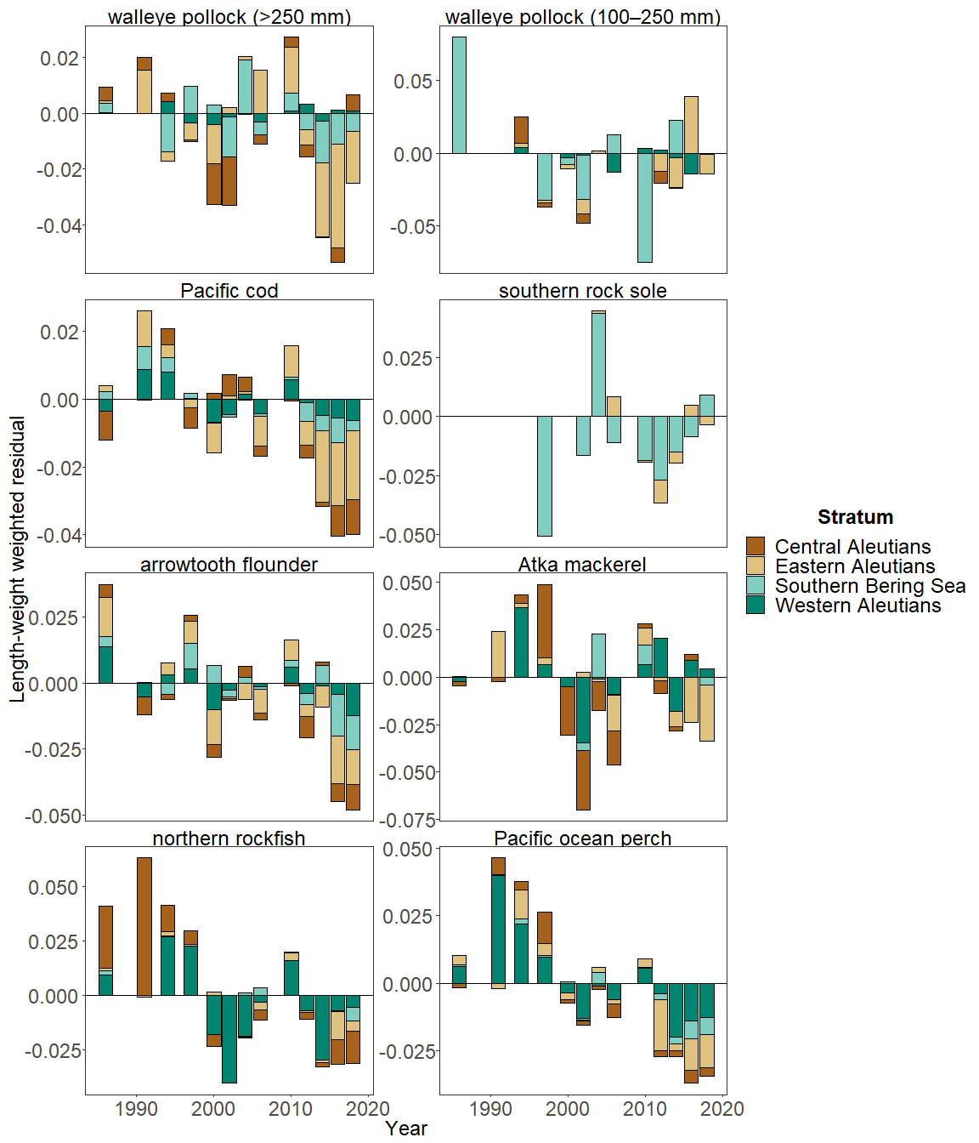

Figure 3. Residual body condition index for seven Aleutian Islands groundfish species collected on the National Marine Fisheries Service (NMFS) Alaska Fisheries Science Center (AFSC) Resource Assessment and Conservation Engineering Groundfish Assessment Program (RACE-GAP) standard summer bottom trawl survey (1984–2018) grouped by International North Pacific Fisheries Commission (INPFC) statistical sampling strata.

**Factors causing observed trends**: Factors that could affect residual fish body condition presented here include temperature, trawl survey timing, stomach fullness, movement in or out of the survey area, or variable somatic growth. Since the Warm Blob in 2014 (Bond et al., 2015; Stabeno et al., 2019), there has been a general trend of warming ocean temperatures in the survey area through 2018 that could be affecting fish growth conditions there. Changing ocean conditions along with normal patterns of movement can cause the proportion of the population resident in the sampling area during the annual bottom trawl survey to vary. The date that the first length-weight data are collected is generally in the beginning of June and the bottom trawl survey is conducted throughout the summer months moving from east to west so that spatial and temporal trends in fish growth over the season become confounded with survey progress. The updated condition analyses presented here begin to, but do not wholly account for spatio-temporal variability in the underlying populations sampled.

**Implications**: Variations in body condition likely have implications for fish survival. In Prince William Sound, the condition of herring prior to the winter may influence their survival (Paul and Paul, 1999). The condition of Aleutian Islands groundfish may similarly contribute to survival and recruitment. As future years are added to the time series, the relationship between length-weight residuals and subsequent survival will be examined further. It is important to consider that residual body condition for most species in these analyses was computed for all sizes and sexes combined. Requirements for growth and survivorship differ for different fish life stages and some species have sexually dimorphic growth patterns. It may be more informative to examine life-stage (e.g., early juvenile, subadult, and adult phases) and sex specific body condition in the future.

The trend toward lowered body condition for many Aleutian Islands species over the last 3–4 RACE/AFSC GAP bottom trawl surveys is a potential cause for concern. It could indicate poor overwinter survival or may reflect the influence of locally changing environmental conditions depressing fish growth, local production, or survivorship. Indications are that the Warm Blob (Bond et al., 2015; Stabeno et al., 2019) has been followed by subsequent years with elevated water temperatures (e.g., Barbeaux et al., 2018; Laman, 2018) which may be related to changes in fish condition in the species examined. As we continue to add years of fish condition to the record and expand on our knowledge of the relationships between condition, growth, production, and survival, we hope to gain more insight into the overall health of fish populations in the Aleutian Islands.

**Research priorities**: Efforts are underway to redevelop the groundfish condition indicator for next year’s (2021) ESR, using a spatio-temporal model with spatial random effects (VAST). The change is expected to allow more precise biomass expansion, improve estimates of uncertainty, and better account for spatial-temporal variation in length-weight samples from bottom trawl surveys due to methodological changes in sampling (e.g. transition from sex-and-length stratified sampling to random sampling). For 2021, revised indicators will be presented alongside a retrospective analysis that compares the historical and revised condition indicator. Currently, research is being planned across multiple AFSC programs to explore standardization of statistical methods for calculating condition indicators, and to examine relationships among morphometric condition indicators, bioenergetic indicators, and physiological measures of fish condition.