Eastern and Northern Bering Sea Groundfish Condition

Contributed by Sean Rohan1 and Bianca Prohaska1  
1 Resource Assessment and Conservation Engineering Division, Alaska Fisheries Science Center, National Marine Fisheries Service, NOAA  
**Contact**: [sean.rohan@noaa.gov](mailto:sean.rohan@noaa.gov) **Last updated**: October 2021

**Description of Indicator**: Length-weight residuals represent how heavy a fish is per unit body length and are an indicator of somatic growth variability (Brodeur et al., 2004). Therefore, length-weight residuals can be considered an indicator of prey availability and growth conditions. Positive length-weight residuals indicate better condition (i.e., heavier per unit length) and negative residuals indicate poorer condition (i.e., lighter per unit length). Fish condition calculated in this way reflects fish growth trajectories which can have implications for biological productivity due to growth, reproduction, and mortality (Paul and Paul, 1999; Boldt and Haldorson, 2004).

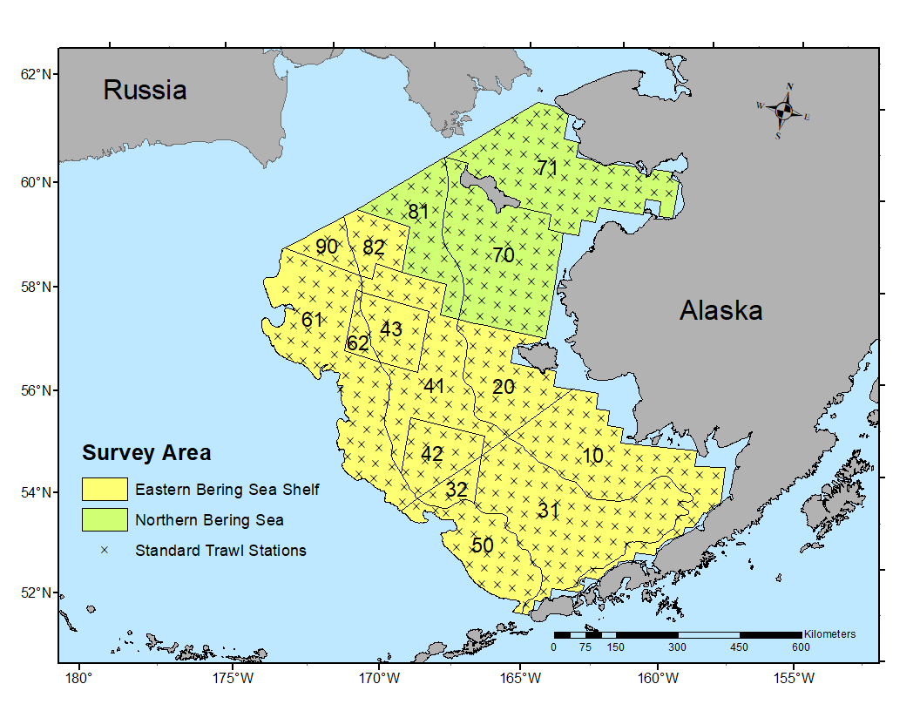

Figure 1. AFSC/RACE GAP summer bottom trawl survey strata (10-90) and station locations (x) on the eastern Bering Sea Shelf and in the Northern Bering Sea.

Paired fork lengths (mm) and weights (g) of individual fishes were collected from the Alaska Fisheries Science Center’s Resource Assessment and Conservation Engineering (AFSC/RACE) - Groundfish Assessment Program’s (GAP) bottom trawl surveys of the eastern Bering Sea (EBS) shelf and northern Bering Sea (NBS). Fish condition analyses were applied to walleye pollock (*Gadus chalcogrammus*), Pacific cod (*Gadus macrocephalus*), arrowtooth flounder (*Atheresthes stomias*), yellowfin sole (*Limanda aspera*), flathead sole (*Hippoglossoides elassodon*), northern rock sole (*Lepidopsetta polyxystra*), and Alaska Plaice (*Pleuronectes quadrituberculatus*) collected in bottom trawls at standard stations (Figure 1). For these analyses and results, survey strata 31 and 32 were combined as stratum 30; strata 41, 42, and 43 were combined as stratum 40; and strata 61 and 62 were combined as stratum 60. Corner stations and non-standard survey strata 82 and 90 were excluded from these analyses. Length-weight relationships were estimated using a linear regression based on a log-transformation of the exponential growth relationship, *W* = *aLb*, where *W* is weight (g) and *L* is fork length (mm) for all areas for the period 1997–2021 (EBS: 1997–2021, NBS: 2010 & 2017–2019, 2021). A different slope (*b*) was estimated for each stratum to account for spatial-temporal variation in growth and bottom trawl survey sampling. Length-weight relationships for 100–250 mm walleye pollock (corresponding with ages 1–2 years) were calculated independently. Bias-corrected weights-at-length (log scale) were estimated from the model and subtracted from observed weights to obtain residuals per fish. Individual length-weight residuals were averaged for each stratum and weighted in proportion to total biomass in the region based on stratum-level area-swept expansion of bottom-trawl survey catch per unit effort (CPUE). Average length-weight residuals were compared by stratum and year on the EBS shelf to evaluate spatial variation in fish condition. The NBS was treated as a single stratum and used a different length-weight regression than the EBS due to the shorter time series. Combinations of species, stratum, and year with sample size <10 were used to fit length-weight regressions but were excluded from calculating length-weight residuals. Code for calculating the condition indicator is available on GitHub at ( <https://www.github.com/sean-rohan-noaa/akfishcondition>).

**Methodological changes**: The method used to calculate groundfish condition this year (2021) is the same as the method that was adopted in 2020, and differs from ESR’s prior to 2019 in that: 1) different regression slopes were estimated for each stratum, 2) a bias-correction was applied to estimated weights prior to calculating residuals, 3) stratum mean residuals were weighted in proportion to stratum biomass, 4) stratum-year combinations with sample size < 10 were not used in indicator calculations, and 5) the NBS has its own length-weight regression.

**Status and Trends**: Fish condition, indicated by length-weight residuals, has varied over time for all species examined (Figure 2 & 3). The updated method for calculating groundfish condition has resulted in changes compared to last year’s condition indicator. Notably, the magnitude of length-weight residuals was much lower using the new method, in part because the new method reduces the influence of spatial variation in length-weight relationships and spatial-temporal variation in sampling effort on length-weight residuals. Last year, it was reported for the EBS that: “with the exception of [100–250 mm walleye pollock], length-weight residuals in 2019 were positive or have continued an upward trend that began in 2017 or 2018.” Based on the new method, an upward trend was still evident for most species relative to 2017–2018 and weighted length-weight residuals were positive relative to historical averages for walleye pollock (>250 mm), northern rock sole, yellowfin sole, arrowtooth flounder, and Alaska plaice. in 2019 (Figure 2). Length-weight residuals were near historical averages for age 1–2 walleye pollock (100–250 mm), Pacific cod, and flathead sole.

Last year, it was reported that: “trends in fish condition [for the NBS] are similar to those on the EBS shelf with length-weight residuals becoming more positive for adult pollock and Pacific cod, although length-weight residuals overall for adult pollock were negative.” (Figure 3). Based on this year’s method with a separate length-weight regression for the NBS, positive residuals were observed in 2019 for walleye pollock (>250 mm), Pacific cod, yellowfin sole, and Alaska plaice. Residuals for walleye pollock (100–250 mm) were neutral.

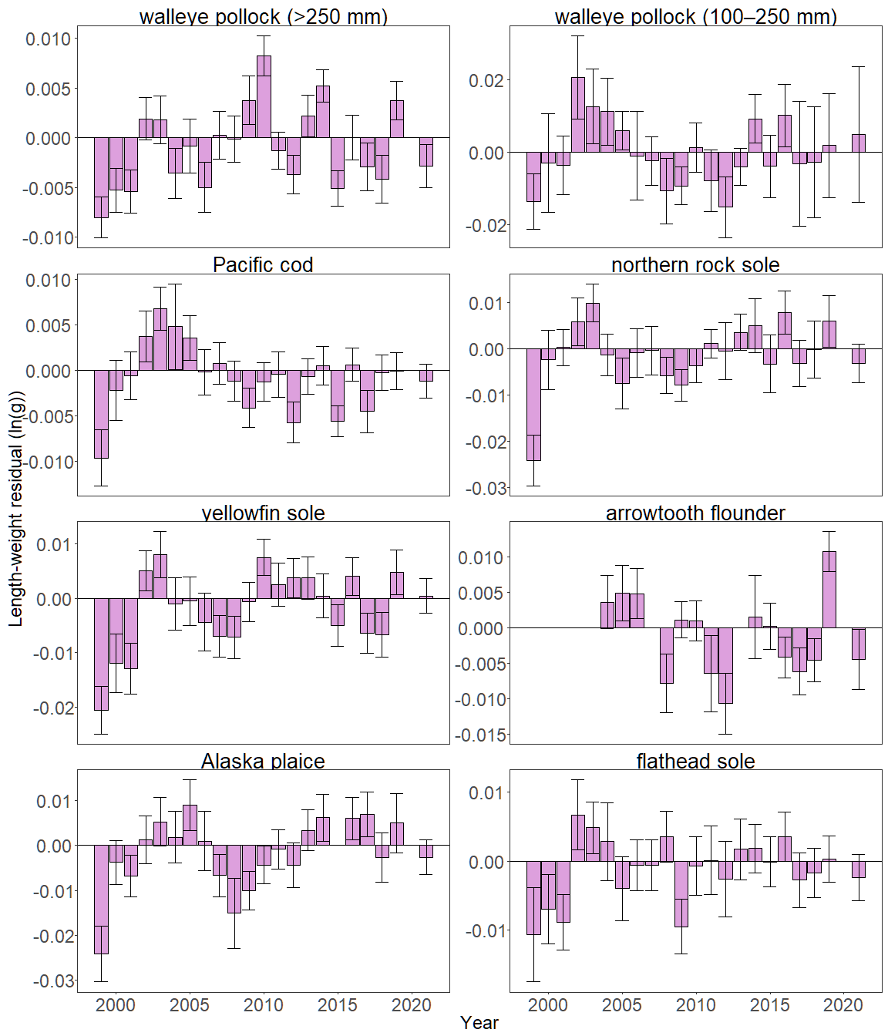

Figure 2. Weighted length-weight residuals for seven groundfish species and age 1–2 walleye pollock (100–250 mm) collected during AFSC/RACE GAP standard summer bottom trawl surveys of the eastern Bering Sea shelf, 1999-2021. Filled bars denote weighted length-weight residuals using this year’s indicator calculation. Error bars denote two standard errors

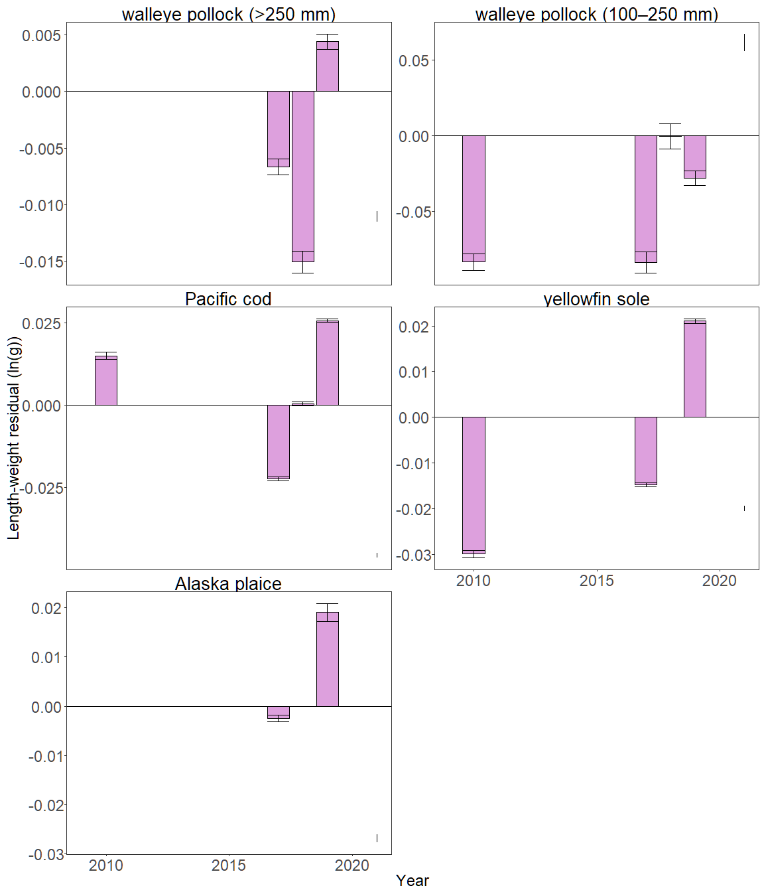

Figure 3. Length-weight residuals for groundfish species and age 1–2 walleye pollock (100–250 mm) collected during AFSC/RACE GAP summer bottom trawl surveys of the Northern Bering Sea, 2010 and 2017–2021. Error bars denote two standard errors.

In previous years, stratum length-weight residuals were strongly influenced by the spatial and temporal distribution of samples. This is because the bottom trawl progresses from southeast inner shelf towards the northwest outer shelf, resulting in a cross-shelf gradient in somatic growth that has accumulated by the time a length-weight sample is collected. Last year, it was noted that: ‘spatial patterns of length-weight residuals over the EBS shelf were apparent for most species’ and that ‘fish were in better condition on the outer shelf (strata 50 and 60) and length-weight residuals were positive for nearly all species in the last 3-5 survey years; gadids tended toward having negative residuals on the inner shelf (strata 10 and 20).’

With this year’s change, all species and strata now show switches between positive and negative residuals over time (Figure 4). Pacific cod condition was generally negative on the outer and northern shelf (Strata 40, 50, and 60) from 2010-2019 and positive from 2001–2005. Large walleye pollock (>250 mm) condition was negative on the inner shelf (strata 10 and 20) from 2015–2019 and positive from 2006–2014. Small walleye pollock (100–250 mm) condition was generally positive on the inner shelf from 2014–2019 and negative from 2006–2013. In 2019, positive residuals occurred in all strata for northern rock sole, yellowfin sole, and arrowtooth flounder. Other species had a mix of positive and negative residuals among strata.

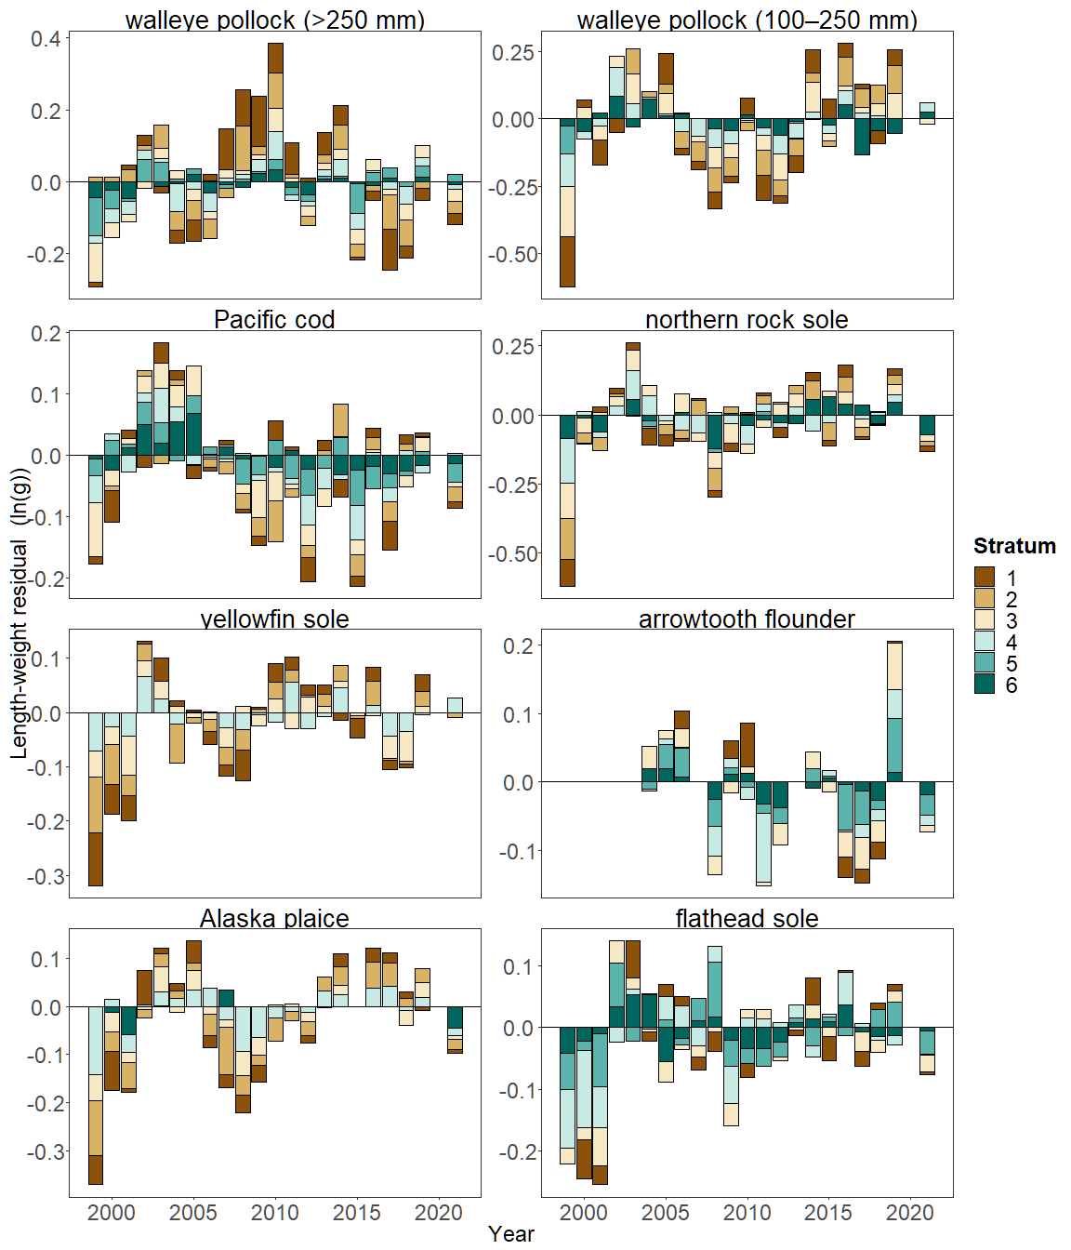

Figure 4. Length-weight residuals by survey stratum (10-60) for seven eastern Bering Sea shelf groundfish species and age 1–2 walleye pollock (100–250 mm) sampled in the AFSC/RACE GAP standard summer bottom trawl survey, 1999-2019. Length-weight residuals are not weighted by stratum biomass.

**Factors influencing observed trends**: There are several factors that may influence the observed temporal and spatial patterns in fish condition over the EBS and NBS shelf. Water temperature could explain some of the spatial and temporal variability in length-weight residuals. Water temperatures during the 1999 survey were particularly cold in the Bering Sea and this corresponded to a year of negative length-weight residuals for all groundfish examined where data existed. Despite the abundant large crustacean zooplankton and relatively high microzooplankton productivity present in 1999 (Hunt et al., 2008), temperature-dependent groundfish spatial distributions may have affected the spatial overlap of fish and their prey thereby impacting fish growth and condition in that year. Cold temperatures may have also affected fish energy requirements in that year. Conversely, recent and continuing warm temperatures across the Bering Sea shelf since the “Warm Blob” (Bond et al., 2015; Stabeno et al., 2019) may be influencing the present positive trend in fish condition for the species examined.

Other factors that could affect length-weight residuals include survey timing, stomach fullness, and fish movement patterns. The starting date of length-weight data collections has varied annually from late May to early June (except 1998, where the first data available were collected in late July). Variation in condition could relate to the timing of collection within stratum. Another consideration that cannot be addressed with the present data set is that the fish weights used in these analyses are typically inclusive of stomach weights so that gut fullness could influence the length-weight residuals. Since feeding conditions likely change over space and time, how much the fish ate at its last meal and the proportion of its total body weight attributable to the gut weight could be an important factor influencing the length-weight residuals. We can also expect some fish to exhibit seasonal or ontogenetic movement patterns during the survey months. For example, seasonal migrations of pollock occur from overwintering areas along the outer shelf to shallow waters (90–140 m) for spawning; Pacific cod concentrate on the shelf edge and upper slope (100–250 m) in the winter and move to shallower waters (generally <100 m) in the summer; and arrowtooth flounder are distributed throughout the continental shelf until age 4, when, at older ages, they disperse to occupy both the shelf and the slope (Witherell, 2000). It is important to note that the data and analyses reported here depict spatial and temporal variation of length-weight residuals for a small subset of the fish species collected in the AFSC/RACE GAP summer bottom trawl surveys of the EBS and NBS and that they do not inform the mechanisms or processes behind the observed patterns.

**Implications**: Fish condition can be considered an indicator of ecosystem productivity with implications for fish survival. In Prince William Sound, the condition of herring prior to the winter may determine their subsequent survival (Paul and Paul, 1999). Thus, the condition of EBS and NBS groundfishes may provide us with insight into ecosystem productivity as well as fish survival and population health. However, survivorship is likely affected by many factors not examined here. We also must consider that, in these analyses, fish condition was computed for all sizes of fishes combined, except in the case of walleye pollock. Examining condition of early juvenile stage fishes not yet recruited to the fishery, or the condition of adult fishes separately, could provide greater insight into the value of length-weight residuals as an indicator of individual health or survivorship.

The positive trend in fish condition observed over the last two to three AFSC/RACE GAP EBS and NBS bottom trawl surveys (i.e., increasingly positive length-weight residuals) could be related to concurrent trends in other ecosystem covariates and needs to be examined further. Trends such as warmer water temperatures following the “Warm Blob” event of 2014-15 (Bond et al., 2015) and reduced sea ice and cold pool areal extent in the eastern Bering Sea (Stabeno et al., 2019) may affect fish condition here in ways that are yet to be determined. As we continue to add years of fish condition indices to the record and expand on our knowledge of the relationships between condition, growth, production, survival, and the ecosystem, these data may increase our insight into the health of fish populations in the EBS and NBS.

**Research priorities**: Due to programmatic constraints, we did not transition the groundfish condition indicator to use a spatio-temporal model with spatial random effects (VAST) in 2021. For next year’s ESR, we aim to transition to VAST, which should allow more precise biomass expansion, improve estimates of uncertainty, and better account for spatial-temporal variation in length-weight samples from bottom trawl surveys. Revised indicators will be presented alongside a retrospective analysis to compare the current condition indicator to a VAST-based condition indicator.