Eastern and Northern Bering Sea Groundfish Condition

Contributed by Bianca Prohaska1 and Sean Rohan1

1Resource Assessment and Conservation Engineering Division, Alaska Fisheries Science Center, National Marine Fisheries Service, NOAA  
**Contact**: [bianca.prohaska@noaa.gov](mailto:bianca.prohaska@noaa.gov) **Last updated**: September 2025

**Description of Indicator**: Length-weight residuals represent how heavy a fish is per unit body length and are an indicator of somatic growth variability (Brodeur et al., 2004). Therefore, length-weight residuals can be considered indicators of prey availability, growth, general health, and habitat condition (Blackwell et al., 2000; Froese, 2006). Positive length-weight residuals indicate better condition (i.e., heavier per unit length) and negative residuals indicate poorer condition (i.e., lighter per unit length) (Froese, 2006). Fish condition calculated in this way reflects realized outcomes of intrinsic and extrinsic processes that affect fish growth, which can have implications for biological productivity through direct effects on growth and indirect effects on demographic processes, such as reproduction and mortality (e.g., (Barbeaux et al., 2020; Rodgveller, 2019)).

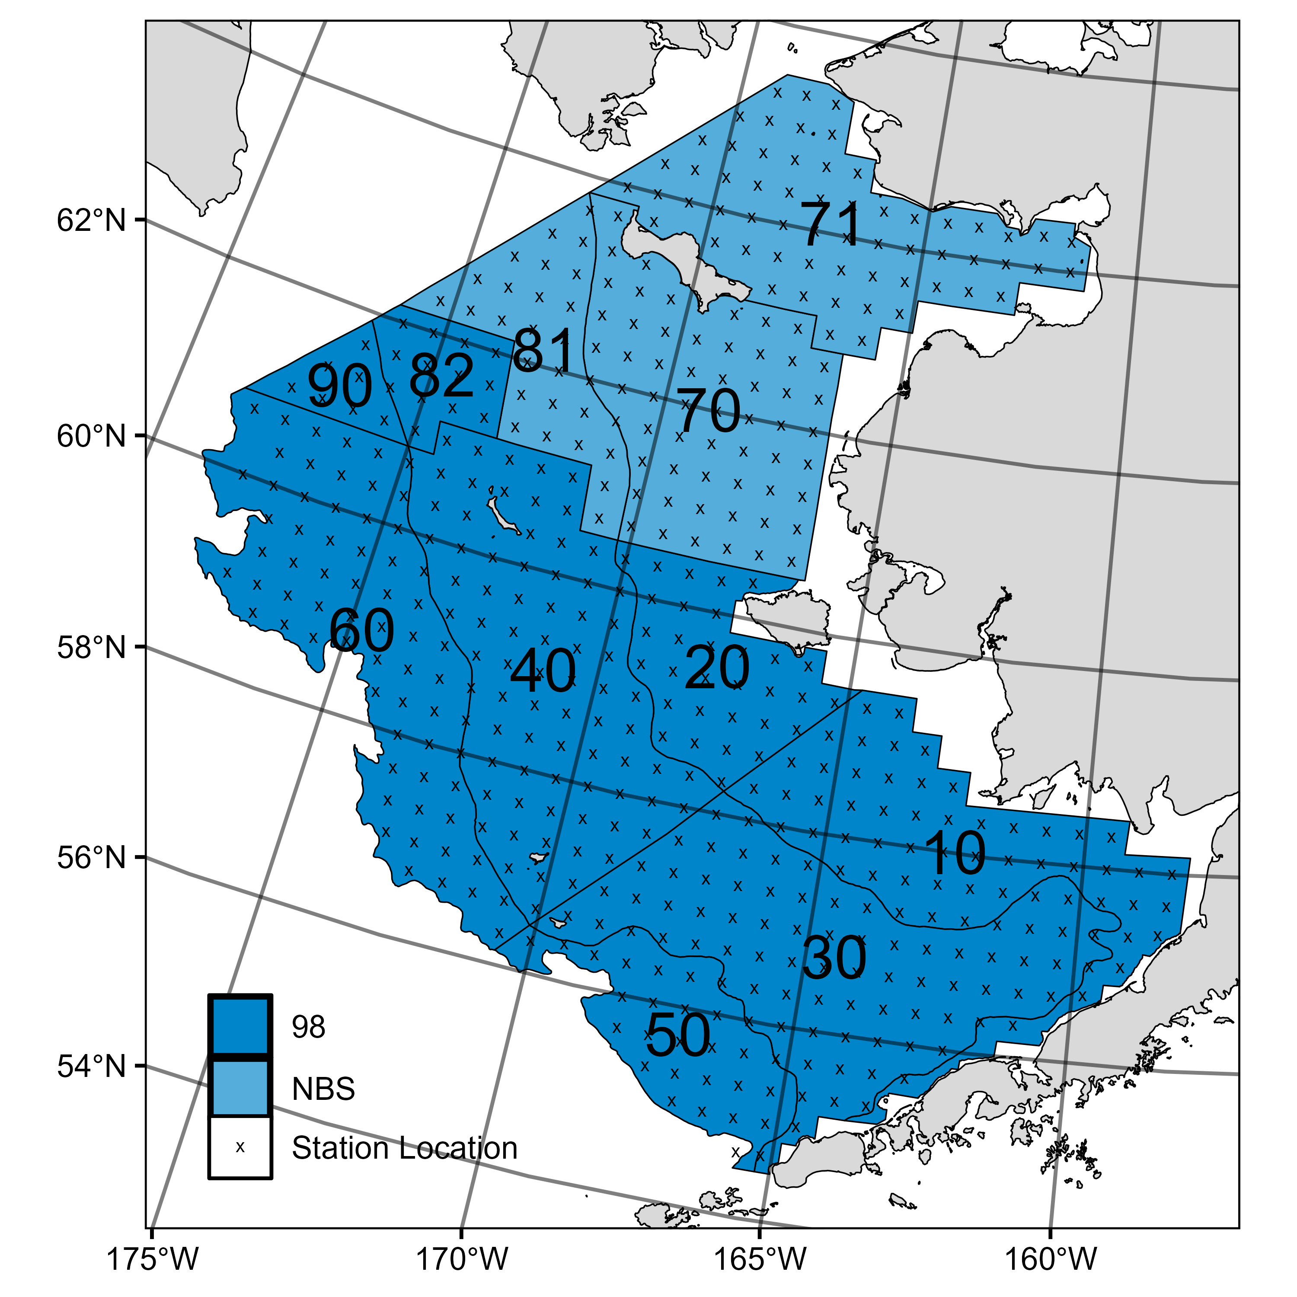

Figure 1. AFSC/RACE GAP summer bottom trawl survey strata (10-90) and station locations (x) in the eastern Bering Sea and northern Bering Sea.

The groundfish morphometric condition indicator is calculated from paired fork lengths (mm) and weights (g) of individual fish that were collected during bottom trawl surveys of the eastern Bering Sea (EBS) shelf and northern Bering Sea (NBS), which were conducted by the Alaska Fisheries Science Center’s Resource Assessment and Conservation Engineering (AFSC/RACE) Groundfish Assessment Program (GAP). Fish condition analyses were applied to walleye pollock (*Gadus chalcogrammus*), Pacific cod (*Gadus macrocephalus*), arrowtooth flounder (*Atheresthes stomias*), yellowfin sole (*Limanda aspera*), flathead sole (*Hippoglossoides elassodon*), northern rock sole (*Lepidopsetta polyxystra*), and Alaska plaice (*Pleuronectes quadrituberculatus*). All species were collected in bottom trawls at standard survey stations (Figure 1). For these analyses and results, survey strata 31 and 32 were combined as stratum 30; strata 41, 42, and 43 were combined as stratum 40; and strata 61 and 62 were combined as stratum 60. Northwest survey strata 82 and 90 were excluded from these analyses.

To calculate indicators, length-weight relationships were estimated from linear regression models based on a log-transformation of the exponential growth relationship, *W* = *aLb*, where *W* is weight (g) and *L* is fork length (mm) for all areas for the period 1999–2025 (EBS: 1999–2025, NBS: 2010, 2017, 2019, 2021-2023, and 2025). Unique intercepts (*a*) and slopes (*b*) were estimated for each species, survey stratum, sex, and interaction between stratum and sex to account for sexual dimorphism and spatial-temporal variation in growth and bottom trawl survey sampling. Length-weight relationships for 100–250 mm fork length walleye pollock (corresponding with ages 1–2 years) were calculated separately from adult walleye pollock (> 250 mm). Residuals for individual fish were obtained by subtracting observed weights from bias-corrected weights-at-length that were estimated from regression models. Length-weight residuals from each stratum were aggregated and weighted proportionally to total biomass in each stratum from area-swept expansion of mean bottom-trawl survey catch per unit effort (CPUE; i.e., design-based stratum biomass estimates). Variation in fish condition was evaluated by comparing average length-weight residuals among years. To minimize the influence of unrepresentative samples on indicator calculations, combinations of species, stratum, and year with a sample size <10 were used to fit length-weight regressions, but were excluded from calculating length-weight residuals for both the EBS and NBS. Morphometric condition indicator time series, code for calculating the indicators, and figures showing results for individual species are available through the *akfishcondition* R package and GitHub repository (<https://github.com/afsc-gap-products/akfishcondition>).

**Status and Trends**:

*Eastern Bering Sea:* Fish condition, measured by length-weight residuals, has varied over time for all species examined in the EBS (Figures 2 & 3). An increase in condition was observed across all species in the EBS (large walleye pollock (>250 mm), small walleye pollock (100-250 mm), Pacific cod, northern rock sole, yellowfin sole, arrowtooth flounder, Alaska plaice, and flathead sole). The increase in condition from the previous year was approximately one standard deviation or greater for every species except for large walleye pollock (>250 mm) and small walleye pollock (100-250 mm). In 2025, mean condition for all species except small walleye pollock (100-250 mm) was at or above the time series mean. The mean condition of small walleye pollock (100-250 mm) was negative in 2025 and marginally increased compared to 2024; however, it remained just below one standard deviation of the historical mean. In 2025, Pacific cod condition reached its highest level since 2005, yellowfin sole condition was the highest observed in the time series, and arrowtooth flounder condition was the second highest in the time series, behind 2019.

In 2025, condition was positive across all strata for most species , with three exceptions: (1) small walleye pollock (100-250 mm) in all strata, (2) large walleye pollock (>250 mm) in all strata except the southern middle shelf (Stratum 30), and (3) northern rock sole in the inner and middle shelf (Strata 10, 20 and 30; Figure 3).

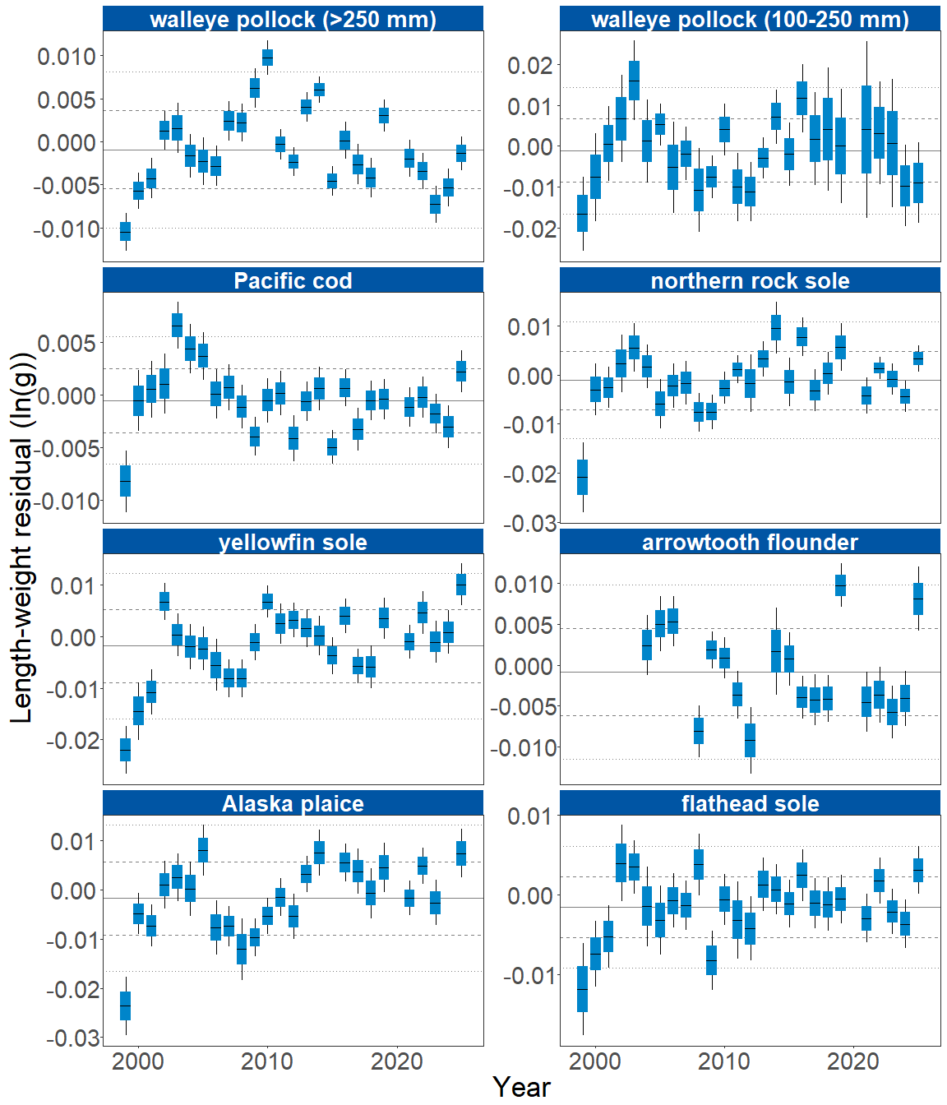

Figure 2. Morphometric condition of groundfish species collected during AFSC/RACE GAP standard summer bottom trawl surveys of the eastern Bering Sea shelf (1999 to 2025) based on residuals of length-weight regressions. The dash in the blue boxes denotes the mean for that year, the box denotes one standard error, and the lines on the boxes denote two standard errors. Lines on each plot represent the historical mean, dashed lines denote one standard deviation, and dotted lines denote two standard deviations.

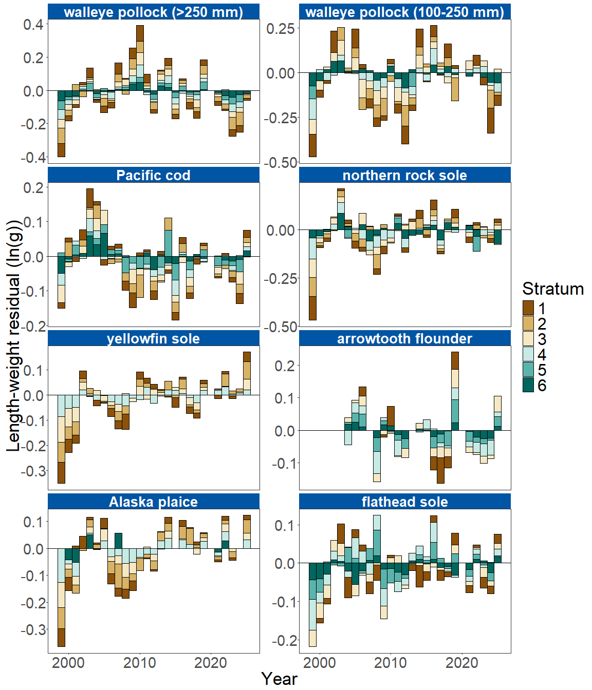

Figure 3. Length-weight residuals by survey stratum (10-60) for seven eastern Bering Sea shelf groundfish species and age 1–2 walleye pollock (100–250 mm) sampled in the AFSC/RACE GAP standard summer bottom trawl survey, 1999-2025. Length-weight residuals are not weighted by stratum biomass.

*Northern Bering Sea:* In the NBS in 2025, positive condition was observed for large walleye pollock (>250 mm), continuing an upward trend observed since 2021. Pacific cod and Alaska plaice exhibited near-average condition in the NBS in 2025, similar to values observed in 2023. Small walleye pollock (100-250 mm) were in below average condition which continued a downward trend since 2021. Yellowfin sole increased slightly from below average condition in 2023 to near-average in 2025 (Figure 4).

In 2025, large walleye pollock (>250 mm) exhibited positive condition across all NBS strata. In contrast, small walleye pollock (100-250 mm) and yellowfin sole were in negative condition in all NBS strata in both 2025 and 2023. Pacific cod condition in 2025 was negative on the outer and inner southern NBS shelf (Strata 71 and 81) but positive on the northern inner NBS shelf and Norton Sound (Stratum 70). Alaska plaice condition in 2025 was positive on the inner southern NBS shelf (Stratum 71) and negative in the other two strata (Strata 70 and 81; Figure 5).

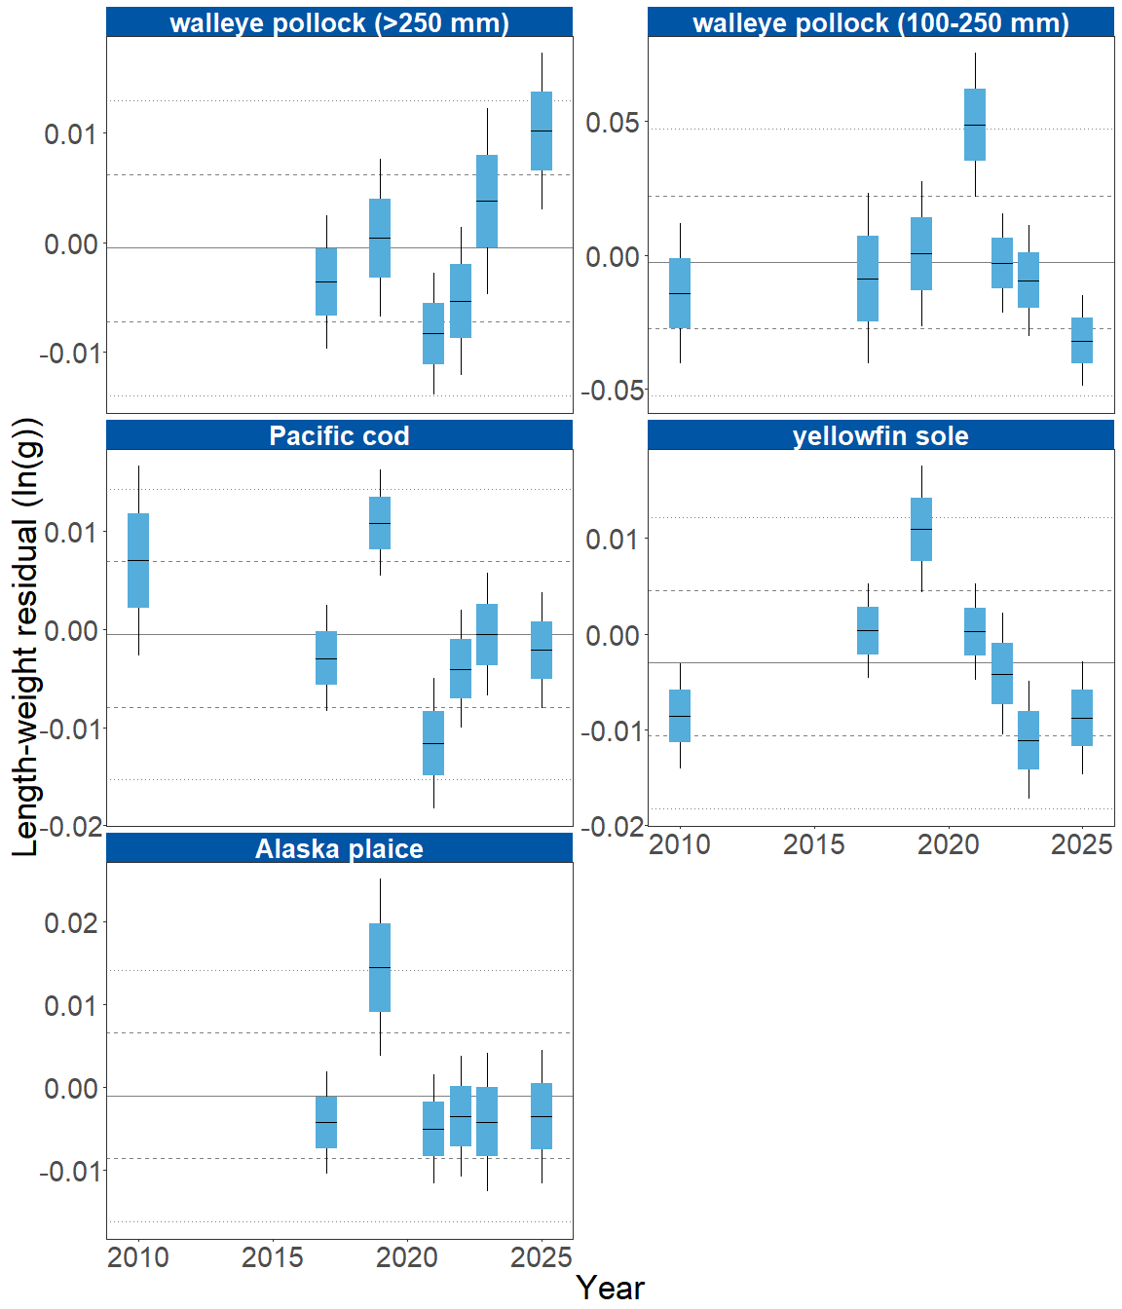

Figure 4. Morphometric condition of groundfish species collected during AFSC/RACE GAP standard summer bottom trawl surveys of the northern Bering Sea shelf (2010, 2017, 2019, 2021-2023 and 2025) based on residuals of length-weight regressions. The dash in the blue boxes denotes the mean for that year, the box denotes one standard error, and the lines on the boxes denote two standard errors. Lines on each plot represent the historical mean, dashed lines denote one standard deviation, and dotted lines denote two standard deviations.

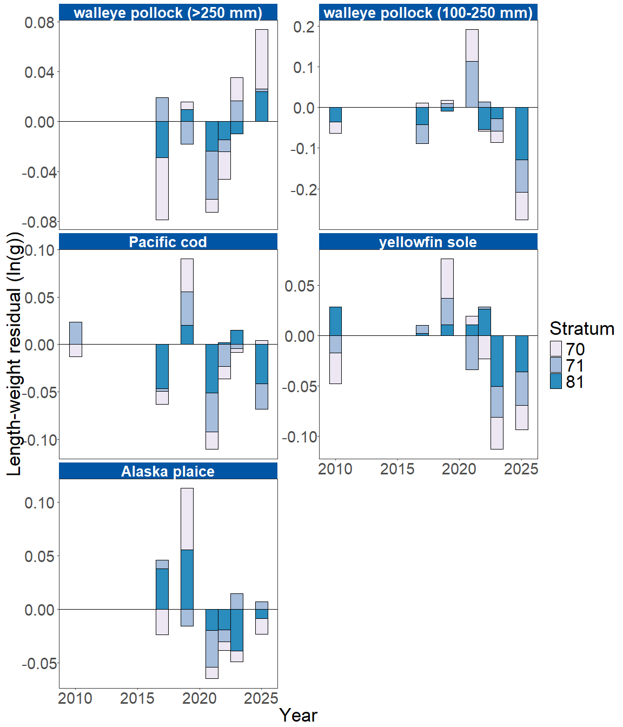

Figure 5. Length-weight residuals by survey stratum (70, 71 and 81) for four northern Bering Sea shelf groundfish species and age 1–2 walleye pollock (100–250 mm) sampled in the AFSC/RACE GAP standard summer bottom trawl survey during 2010, 2017, 2019, 2021-2023 and 2025. Length-weight residuals are not weighted by stratum biomass.

**Factors influencing observed trends**: The warming trend observed since 2023 may have influenced the morphological condition of species in the EBS. Near-average cold pool extent and water temperatures in 2024 were associated with near-average condition (within 1 S.D. of the mean) for all species examined in the EBS that year, while the further warming in 2025 were associated with subsequent increases in fish condition. In the EBS, particularly cold years have historically corresponded with negative condition, while warm years have generally corresponded with positive condition. For example, water temperatures were particularly cold during the 1999 eastern Bering Sea survey, when negative condition was observed for all species sampled. Spatiotemporal factor analyses also suggest the morphometric condition of age-7 walleye pollock is strongly correlated with cold pool extent in the EBS (Grüss et al., 2021). In recent years, warm temperatures across the Bering Sea shelf, following the record low seasonal sea ice extent in 2017–2018 and historical cold pool area minimum in 2018 (Stabeno & Bell, 2019), may have contributed to the positive condition trends observed in several species from 2016 to 2019. However, despite near-average temperatures in 2023 large walleye pollock (>250 mm) condition in the EBS was the second-lowest on record for the time series. In 2024 temperature again remained near-average, and although large walleye pollock (>250 mm) condition was still negative, it was less so than in 2023. By 2025, with continued warming, large walleye pollock (>250 mm) condition improved further and returned to approximately the historical mean. Bottom trawl survey biomass estimates for yellowfin sole in the EBS were near their time series minimum for the third consecutive year, although condition reached a record high. Increasing condition can be an indicator of reduced density-dependent competition when populations decline (Haberle et al., 2023), although there is no direct evidence that this is occurring for yellowfin sole in the EBS.

Although warmer temperatures may increase growth rates if there is adequate prey to offset temperature-dependent increases in metabolic demand, growth rates may also decline if prey resources are insufficient to offset temperature-dependent increases in metabolic demand. The influence of temperature on growth rates depends on the physiology of predator species, prey availability, and the adaptive capacity of predators to respond to environmental change through migration, changes in behavior, and acclimatization. For example, elevated temperatures during the 2014–2016 marine heatwave in the Gulf of Alaska led to lower growth rates and condition of Pacific cod and early life history stages of walleye pollock, because available prey resources did not make up for increased metabolic demand (Barbeaux et al., 2020; Rogers et al., 2021).

Other factors that could affect morphological condition include survey timing, stomach fullness, fish movement patterns, sex, and environmental conditions (Froese, 2006). The starting date of annual length-weight data collections has varied from late May to early June and ended in late July-early August in the EBS, and mid-August in the NBS. Although stratum-specific coefficients in the length-weight models account for some of this variation, condition estimates may still be influenced by survey timing within strata. Survey timing can be further compounded by seasonal fluctuations in reproductive condition with the buildup and depletion of energy stores (Wuenschel et al., 2019). In addition, because weights are taken at sea and include gut content, variation in stomach fullness may influence condition estimates. Since feeding conditions vary over space and time, prey consumption rates and the proportion of total body weight attributable to gut contents may be an important factor influencing the length-weight residuals.

Finally, although the condition indicators characterize temporal variation in morphometric condition for important fish species in the EBS and NBS, they do not inform the mechanisms or processes behind the observed patterns.

**Implications**: Fish morphometric condition can be considered an indicator of ecosystem productivity with implications for fish survival, maturity, and reproduction. For example, in Prince William Sound, the pre-winter condition of herring may determine their overwinter survival (Paul & Paul, 1999), differences in feeding conditions have been linked to differences in morphometric condition of pink salmon in Prince William Sound (Boldt & Haldorson, 2004), variation in morphometric condition has been linked to variation in maturity of sablefish (Rodgveller, 2019), and lower morphometric condition of Pacific cod was associated with higher mortality and lower growth rates during the 2014–2016 marine heat wave in the Gulf of Alaska (Barbeaux et al., 2020). Condition can also be an indicator of stock status relative to carrying capacity because morphometric condition is expected to be high when the stock is at low abundance and low when the stock is at high abundance because of the effects of density-dependent competition (Haberle et al., 2023). Thus, the condition of EBS and NBS groundfishes may provide insight into ecosystem productivity as well as fish survival, demographic status, and population health. However, survivorship is likely affected by many factors not examined here.

Another important consideration is that fish condition was computed for all sizes of fishes combined, except in the case of walleye pollock. Examining condition of early juvenile stage fishes not yet recruited to the fishery, or the condition of adult fishes separately, could provide greater insight into the value of length-weight residuals as an indicator of individual health or survivorship (Froese, 2006), particularly since juvenile and adult walleye pollock exhibited opposite trends in condition in the EBS and NBS this year.

The above-average condition observed in most species in 2025 may reflect the warming bottom temperature trend that began in 2023. However, trends in recent years such as prolonged warmer water temperatures following the marine heat wave of 2014-16 (Bond et al., 2015) and reduced sea ice and cold pool areal extent in the eastern Bering Sea (Stabeno & Bell, 2019) may affect fish condition in ways that have not yet been determined. Additionally, periods of high fishing mortality that reduce population biomass are likely to increase body condition because of the compensatory alleviation of density-dependent competition (Haberle et al., 2023). As we continue to add years of length-weight data and expand our knowledge of relationships between condition, growth, production, survival, and the ecosystem, these data may increase our understanding of the health of fish populations in the EBS and NBS.

## References

Barbeaux, S. J., Holsman, K., & Zador, S. (2020). Marine heatwave stress test of ecosystem-based fisheries management in the Gulf of Alaska Pacific cod fishery. *Frontiers in Marine Science*, *7*, 1–21. <https://doi.org/10.3389/fmars.2020.00703>

Blackwell, B. G., Brown, M. L., & Willis, D. W. (2000). Relative weight (Wr) status and current use in fisheries assessment and management. *Reviews in Fisheries Science*, *8*(1), 1–44. <https://doi.org/10.1080/10641260091129161>

Boldt, J. L., & Haldorson, L. J. (2004). Size and condition of wild and hatchery pink salmon juveniles in Prince William Sound, Alaska. *Transactions of the American Fisheries Society*, *133*(1), 173–184. <https://doi.org/10.1577/t02-138>

Bond, N. A., Cronin, M. F., Freeland, H., & Mantua, N. (2015). Causes and impacts of the 2014 warm anomaly in the NE Pacific. *Geophysical Research Letters*, *42*(9), 3414–3420. <https://doi.org/10.1002/2015GL063306>

Brodeur, R. D., Fisher, J. P., Teel, D. J., Emmett, R. L., Casillas, E., & Miller, T. W. (2004). Juvenile salmonid distribution, growth, condition, origin, and environmental and species associations in the Northern California Current. *Fishery Bulletin*, *102*(1), 25–46.

Froese, R. (2006). Cube law, condition factor and weight-length relationships: History, meta-analysis and recommendations. *Journal of Applied Ichthyology*, *22*(4), 241–253. <https://doi.org/10.1111/j.1439-0426.2006.00805.x>

Grüss, A., Thorson, J. T., Stawitz, C. C., Reum, J. C. P., Rohan, S. K., & Barnes, C. L. (2021). Synthesis of interannual variability in spatial demographic processes supports the strong influence of cold-pool extent on eastern Bering Sea walleye pollock (Gadus chalcogrammus). *Progress in Oceanography*, *194*, 102569. <https://doi.org/10.1016/j.pocean.2021.102569>

Haberle, I., Bavčević, L., & Klanjscek, T. (2023). Fish condition as an indicator of stock status: Insights from condition index in a food‐limiting environment. *Fish and Fisheries*, *24*(4), 567–581. <https://doi.org/10.1111/faf.12744>

Paul, A. J., & Paul, J. M. (1999). Interannual and regional variations in body length, weight and energy content of age-0 Pacific herring from Prince William Sound, Alaska. *Journal of Fish Biology*, *54*(5), 996–1001. <https://doi.org/10.1006/jfbi.1999.0927>

Rodgveller, C. J. (2019). The utility of length, age, liver condition, and body condition for predicting maturity and fecundity of female sablefish. *Fisheries Research*, *216*(October 2018), 18–28. <https://doi.org/10.1016/j.fishres.2019.03.013>

Rogers, L. A., Wilson, M. T., Duffy-Anderson, J. T., Kimmel, D. G., & Lamb, J. F. (2021). Pollock and “the Blob”: Impacts of a marine heatwave on walleye pollock early life stages. *Fisheries Oceanography*, *30*(2), 142–158. <https://doi.org/10.1111/fog.12508>

Stabeno, P. J., & Bell, S. W. (2019). Extreme conditions in the Bering Sea (2017–2018): record-breaking low sea-ice extent. *Geophysical Research Letters*, *46*(15), 8952–8959. <https://doi.org/10.1029/2019GL083816>

Wuenschel, M. J., McElroy, W. D., Oliveira, K., & McBride, R. S. (2019). Measuring fish condition: An evaluation of new and old metrics for three species with contrasting life histories. *Canadian Journal of Fisheries and Aquatic Sciences*, *76*(6), 886–903. <https://doi.org/10.1139/cjfas-2018-0076>