Pacific cod condition for 2020 ESP

Prepared by Sean Rohan1 and Ned Laman1  
1 Resource Assessment and Conservation Engineering Division, Alaska Fisheries Science Center, National Marine Fisheries Service, NOAA  
**Contact**: [sean.rohan@noaa.gov](mailto:sean.rohan@noaa.gov)  
**Last updated**: October 2020

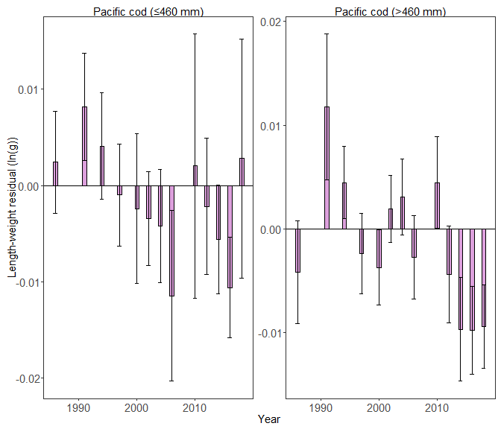

Biomass-weighted residual body condition index across survey years (1984–2018) for Aleutian Islands subadult and adult Pacific cod collected on the National Marine Fisheries Service (NMFS) Alaska Fisheries Science Center (AFSC) Resource Assessment and Conservation Engineering Groundfish Assessment Program (RACE-GAP) standard summer bottom trawl survey. Filled bars denote weighted length-weight residuals, error bars denote two standard errors.

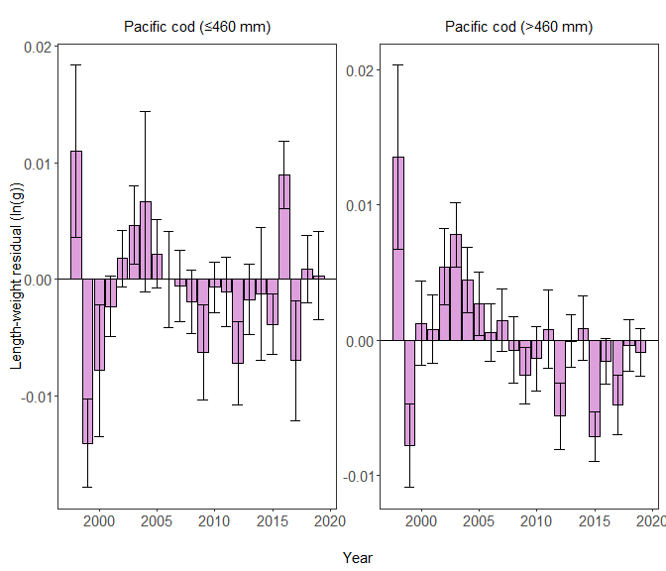

Biomass-weighted residual body condition index across survey years (1997–2019) for Eastern Bering Sea subadult and adult Pacific cod collected on the National Marine Fisheries Service (NMFS) Alaska Fisheries Science Center (AFSC) Resource Assessment and Conservation Engineering Groundfish Assessment Program (RACE-GAP) standard summer bottom trawl survey. Filled bars denote weighted length-weight residuals, error bars denote two standard errors.

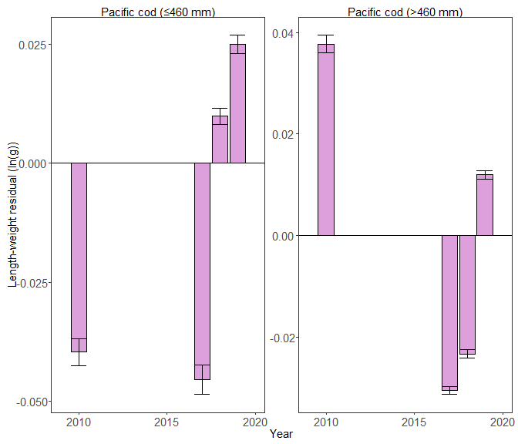

Biomass-weighted residual body condition index across survey years (2010–2019) for Northern Bering Sea subadult and adult Pacific cod collected on the National Marine Fisheries Service (NMFS) Alaska Fisheries Science Center (AFSC) Resource Assessment and Conservation Engineering Groundfish Assessment Program (RACE-GAP) standard summer bottom trawl survey. Filled bars denote weighted length-weight residuals, error bars denote two standard errors.

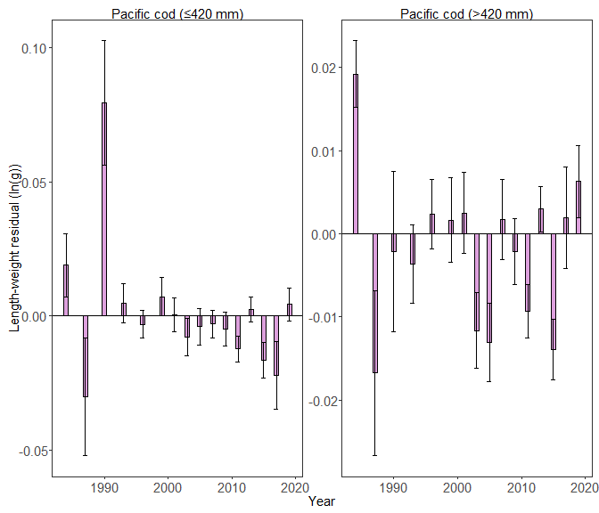

Biomass-weighted residual body condition index across survey years (1984-2019) for Gulf of Alaska subadult and adult Pacific cod collected on the National Marine Fisheries Service (NMFS) Alaska Fisheries Science Center (AFSC) Resource Assessment and Conservation Engineering Groundfish Assessment Program (RACE-GAP) standard summer bottom trawl survey. Filled bars denote weighted length-weight residuals, error bars denote two standard errors.