Morphometric condition of Gulf of Alaska Pacific cod for 2023 Ecosystem and Socioeconomic Profile

# Gulf of Alaska Pacific cod

## Adults (≥42 cm FL)

*Status and Trends:* In 2023, the condition of adult Pacific cod in the GOA was neutral (within one standard deviation of the time series mean), which continues the trend of neutral morphometric condition observed since 2018.

## Juveniles (<42 cm FL)

*Status and Trends:* In 2023, the condition of juvenile Pacific cod in the EBS was neutral (within one standard deviation of the time series mean), which continues the trend of neutral morphometric condition observed since 2017.

## Influential Factors

*Influential Factors:* Many factors contribute to variation in morphometric condition so it is unclear which specific factors contributed to neutral condition of adult Pacific cod in the EBS in 2022. Factors that may contribute to variation in morphometric condition include environmental conditions that affect prey quality and temperature-dependent metabolic rates, survey timing, stomach fullness of individual fish, fish migration patterns, and the distribution of samples within survey strata. Temperature is an important factor that can influence the morphometric condition of Pacific cod by influencing metabolic rates, prey availability, and prey quality. Historically in the eastern Bering Sea (EBS), ‘cold’ years (with a small cold pool) were associated with negative morphometric condition (e.g., 1999, 2012) and warm years (e.g., 2002-2005) were associated with positive morphometric condition. However, during exceptionally warm years from 2018–2021, the morphometric condition of Pacific cod was neutral for adult and juvenile Pacific cod and this trend continued into the average temperature years in 2022-2023. Temperature can negatively affect growth rates if prey resources are insufficient to make up for increased metabolic demand. In GOA, elevated temperatures during the 2014–2016 marine heatwave in the Gulf of Alaska were associated with lower growth rates of Pacific cod and lower morphometric condition in 2015 (adults and juveniles combined), likely because diminished prey resources during the heatwave were insufficient to make up for increased metabolic demand (Barbeaux et al., 2020). Additional information about the groundfish morphometric condition indicator and factors that can influence estimates of morphometric condition are described in the EBS Groundfish Morphometric Condition contribution in the 2023 Eastern Bering Sea Ecosystem Status Report (Prohaska and Rohan, *In prep*).

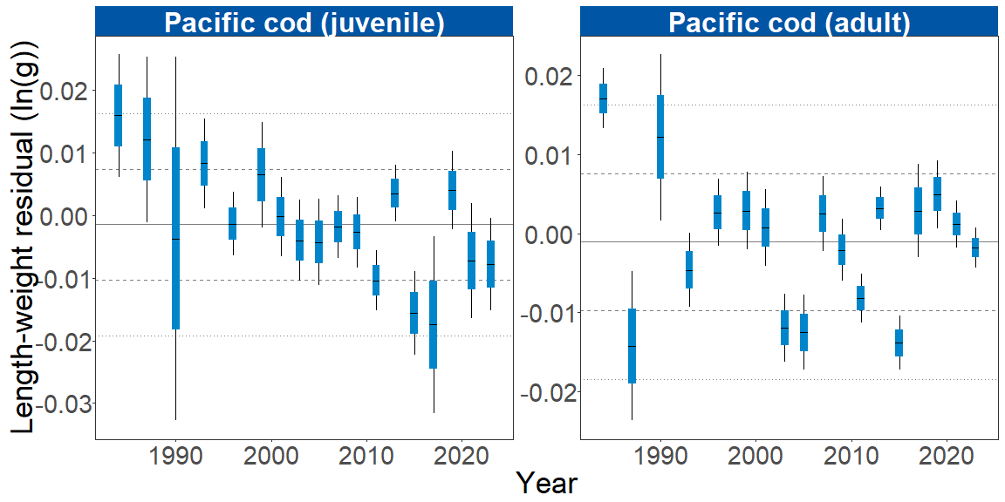

Figure 1. Stratum-biomass weighted morphometric condition of adult and juvenile Pacific cod collected during AFSC/RACE GAP standard summer bottom trawl surveys of the eastern Bering Sea shelf, 1984 to 2023. The dash in the blue boxes denote the mean for that year, the blue box denotes one standard error, and the lines on the boxes denote two standard error. Horizontal lines on each plot represent the historical mean, dashed lines denote one standard deviation, and dotted lines denote two standard deviations.

# References

Barbeaux, S. J., Holsman, K., & Zador, S. (2020). Marine heatwave stress test of ecosystem-based fisheries management in the Gulf of Alaska Pacific cod fishery. *Frontiers in Marine Science*, *7*, 1–21. <https://doi.org/10.3389/fmars.2020.00703>