Eastern and Northern Bering Sea Groundfish Condition
Contributed by Bianca Prohaska¹ and Sean Rohan¹
¹Resource Assessment and Conservation Engineering Division, Alaska Fisheries Science Center, National Marine Fisheries Service, NOAA
Contact: bianca.prohaska@noaa.gov Last updated: September 2026
Description of Indicator: Length-weight residuals represent how heavy a fish is per unit body length and are an indicator of somatic growth variability (Brodeur et al., 2004). Therefore, length-weight residuals can be considered indicators of prey availability, growth, general health, and habitat condition (Blackwell et al., 2000; Froese, 2006). Positive length-weight residuals indicate better condition (i.e., heavier per unit length) and negative residuals indicate poorer condition (i.e., lighter per unit length) (Froese, 2006). Fish condition calculated in this way reflects realized outcomes of intrinsic and extrinsic processes that affect fish growth, which can have implications for biological productivity through direct effects on growth and indirect effects on demographic processes, such as reproduction and mortality (e.g., (Barbeaux et al., 2020; Rodgveller, 2019)).
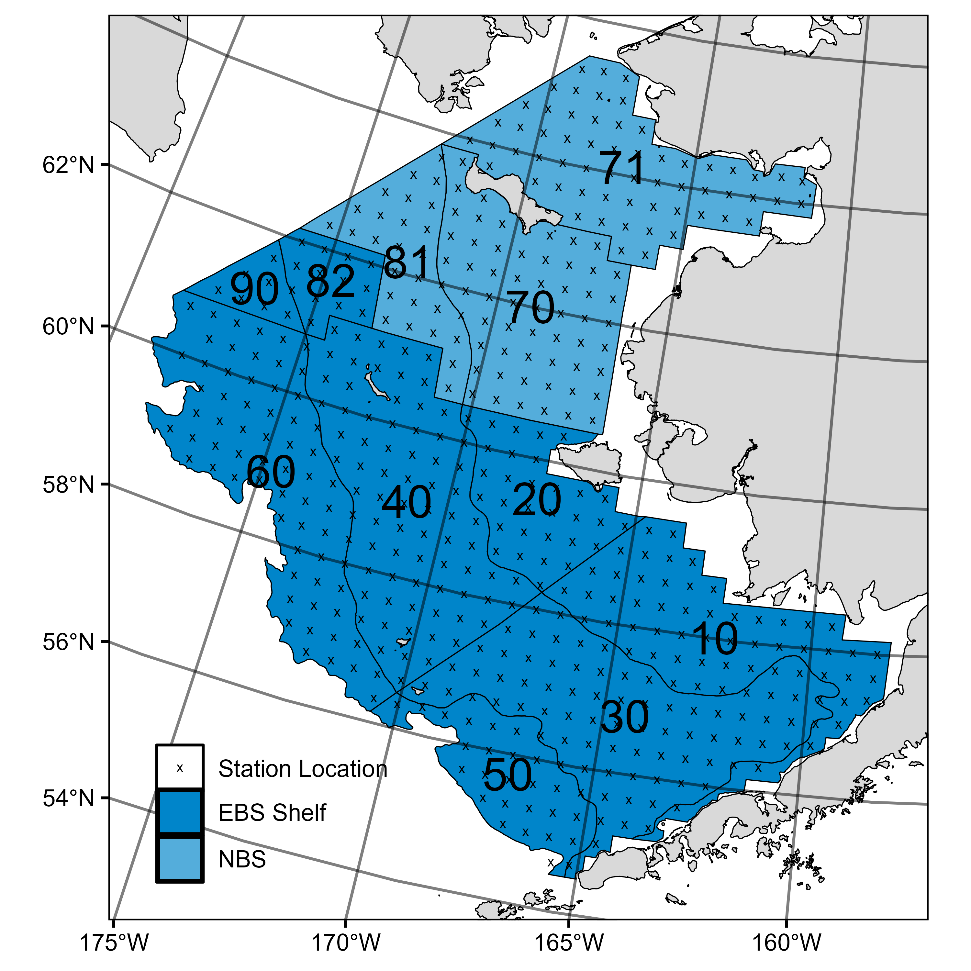
Figure 1. AFSC/RACE GAP summer bottom trawl survey strata (10-90) and station locations (x) in the eastern Bering Sea and northern Bering Sea.
The groundfish morphometric condition indicator is calculated from paired fork lengths (mm) and weights (g) of individual fish that were collected during bottom trawl surveys of the eastern Bering Sea (EBS) shelf and northern Bering Sea (NBS), which were conducted by the Alaska Fisheries Science Center’s Resource Assessment and Conservation Engineering (AFSC/RACE) Groundfish Assessment Program (GAP). Fish condition analyses were applied to walleye pollock (Gadus chalcogrammus), Pacific cod (Gadus macrocephalus), arrowtooth flounder (Atheresthes stomias), yellowfin sole (Limanda aspera), flathead sole (Hippoglossoides elassodon), northern rock sole (Lepidopsetta polyxystra), Alaska plaice (Pleuronectes quadrituberculatus), Greenland turbot (Reinhardtius hippoglossoides), and Kamchatka flounder (Atheresthes evermanni). All species were collected in bottom trawls at standard survey stations (Figure 1). For these analyses and results, survey strata 31 and 32 were combined as stratum 30; strata 41, 42, and 43 were combined as stratum 40; and strata 61 and 62 were combined as stratum 60. Northwest survey strata 82 and 90 were excluded from these analyses.
To calculate indicators, length-weight relationships were estimated from linear regression models based on a log-transformation of the exponential growth relationship, W = aL^{b}, where W is weight (g) and L is fork length (mm) for all areas for the period 1999–2026 (EBS: 1999–2026, NBS: 2010, 2017, 2019, 2021-2023, and 2025). Unique intercepts (a) and slopes (b) were estimated for each species, survey stratum, sex, and interaction between stratum and sex to account for sexual dimorphism and spatial-temporal variation in growth and bottom trawl survey sampling. Length-weight relationships for 100–250 mm fork length walleye pollock (corresponding with ages 1–2 years) were calculated separately from adult walleye pollock (> 250 mm). Residuals for individual fish were obtained by subtracting observed weights from bias-corrected weights-at-length that were estimated from regression models. Length-weight residuals from each stratum were aggregated and weighted proportionally to total biomass in each stratum from area-swept expansion of mean bottom-trawl survey catch per unit effort (CPUE; i.e., design-based stratum biomass estimates). Variation in fish condition was evaluated by comparing average length-weight residuals among years. To minimize the influence of unrepresentative samples on indicator calculations, combinations of species, stratum, and year with a sample size <10 were used to fit length-weight regressions, but were excluded from calculating length-weight residuals for both the EBS and NBS. Morphometric condition indicator time series, code for calculating the indicators, and figures showing results for individual species are available through the akfishcondition R package and GitHub repository (https://github.com/afsc-gap-products/akfishcondition).
Methodological Changes: EBS Greenland turbot and Kamchatka flounder condition is presented in 2026 for the first time.
Status and Trends:
Eastern Bering Sea: Fish condition, measured by length-weight residuals, has varied over time for all species examined in the EBS (Figures 2 & 3). Changes in condition from 2025 to 2026 differed among species. Condition increased for large walleye pollock (>250 mm) and small walleye pollock (100-250 mm), while condition was similar to 2025 observations for Pacific cod, arrowtooth flounder, and flathead sole, and condition decreased for northern rock sole, yellowfin sole, Alaska plaice, Kamchatka flounder, and Greenland turbot. The change in condition from the previous year was approximately one standard deviation or greater for small walleye pollock (100-250 mm) and northern rock sole, and smaller for the remaining species. In 2026, mean condition for all species except small walleye pollock (100-250 mm) and northern rock sole was at or above the time series mean. The mean condition of small walleye pollock (100-250 mm) increased by approximately one standard deviation compared to 2025; however, it remained just below the time series mean. Conversely, large walleye pollock (>250 mm) condition was above the time series mean for the first time since 2019. In contrast, northern rock sole condition decreased to approximately one standard deviation below the time series mean, the lowest level since 2009. Other species remained above the time series mean in 2026: Pacific cod remained at its highest level since 2005, yellowfin sole condition decreased from the highest observed in the time series in 2025 but remained within one standard deviation of the mean, and arrowtooth flounder condition remained the second highest in the time series, behind 2019. Condition of Greenland turbot remained approximately two standard deviations above the time series mean, second only to 2025, and condition of Kamchatka flounder, Alaska plaice, and flathead sole was within approximately one standard deviation above the mean.
In 2026, fish condition was positive across all strata with estimates for yellowfin sole (strata 10, 30, and 40), arrowtooth flounder (strata 30, 40, 50, and 60), Alaska plaice (strata 10 and 40), and Greenland turbot (stratum 60). Condition was negative across all strata with estimates for northern rock sole (strata 10, 20, 30, and 40). For the remaining species, condition differed among strata: large walleye pollock (>250 mm) was positive in strata 20, 40, and 60 but negative in strata 10 and 30; small walleye pollock (100-250 mm) was negative in all strata except the southern middle shelf (stratum 30); Pacific cod was positive in strata 20, 40, 50, and 60 but negative in strata 10 and 30; Kamchatka flounder was positive in strata 40 and 60, but negative in strata 30 and 50; and flathead sole was positive in strata 30 and 40, but negative in strata 10 and 50 (Figure 3).
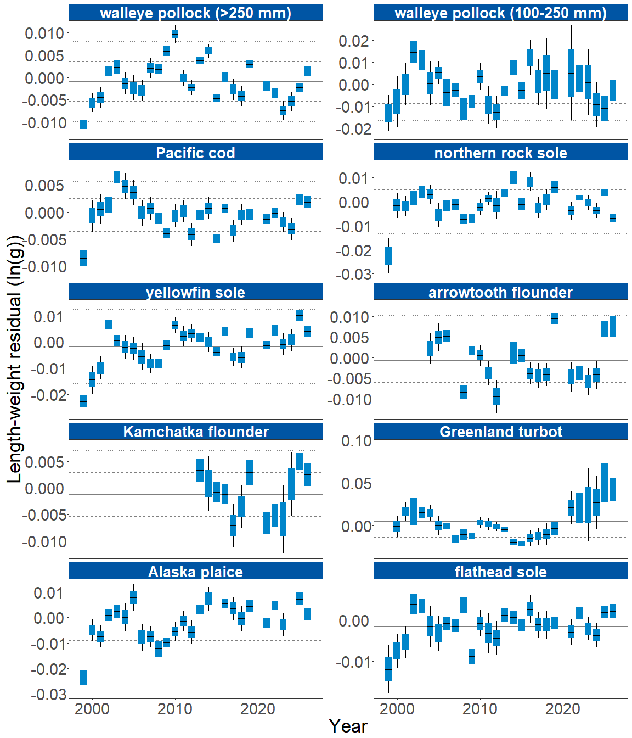
Figure 2. Morphometric condition of groundfish species collected during AFSC/RACE GAP standard summer bottom trawl surveys of the eastern Bering Sea shelf (1999 to 2026) based on residuals of length-weight regressions. The dash in the blue boxes denotes the mean for that year, the box denotes one standard error, and the lines on the boxes denote two standard errors. Lines on each plot represent the historical mean, dashed lines denote one standard deviation, and dotted lines denote two standard deviations.
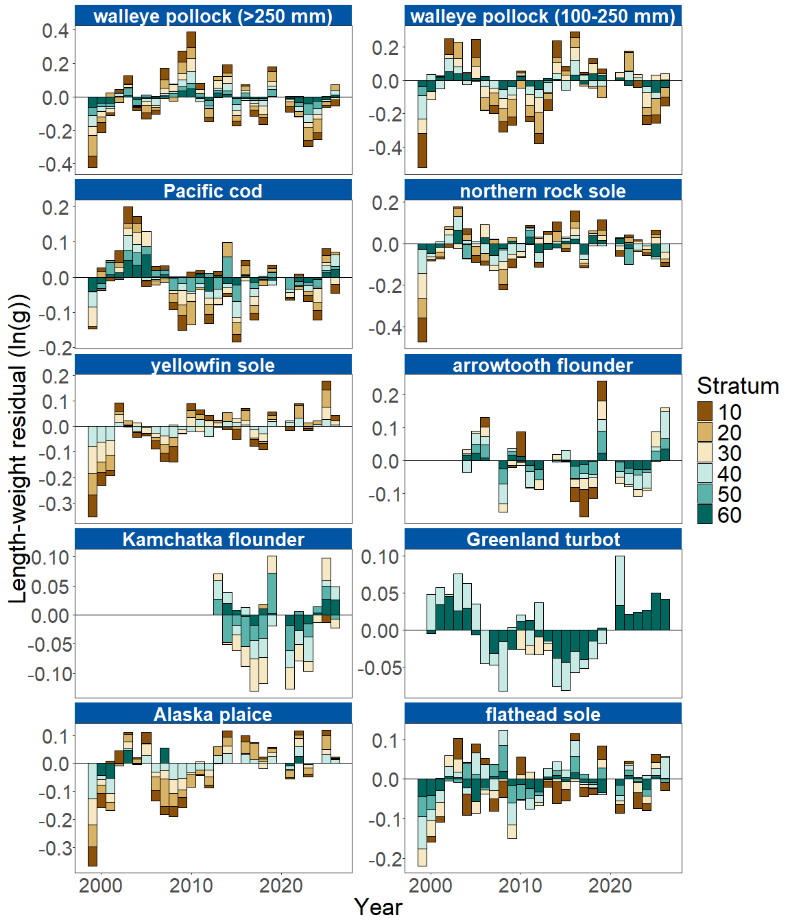
Figure 3. Length-weight residuals by survey stratum (10-60) for nine eastern Bering Sea shelf groundfish species and age 1–2 walleye pollock (100–250 mm) sampled in the AFSC/RACE GAP standard summer bottom trawl survey, 1999-2026. Length-weight residuals are not weighted by stratum biomass.
Northern Bering Sea: The NBS survey was not conducted in 2026, but fish condition results through 2025 are presented here. In the NBS in 2025, positive condition was observed for large walleye pollock (>250 mm), continuing an upward trend observed since 2021. Pacific cod and Alaska plaice exhibited near-average condition, similar to values observed in 2023. Small walleye pollock (100-250 mm) were in below average condition which continued a downward trend since 2021. Yellowfin sole increased slightly from below average condition in 2023 to near-average in 2025 (Figure 4).
In 2025, large walleye pollock (>250 mm) exhibited positive condition in strata 70 and 81, and slightly negative condition in stratum 71. In contrast, small walleye pollock (100-250 mm) and yellowfin sole were in negative condition in all NBS strata in both 2025 and 2023. Pacific cod condition was negative on the outer and inner southern NBS shelf (Strata 71 and 81). Alaska plaice condition was positive on the inner southern NBS shelf (Stratum 71) and negative in the other two strata (Strata 70 and 81; Figure 5).
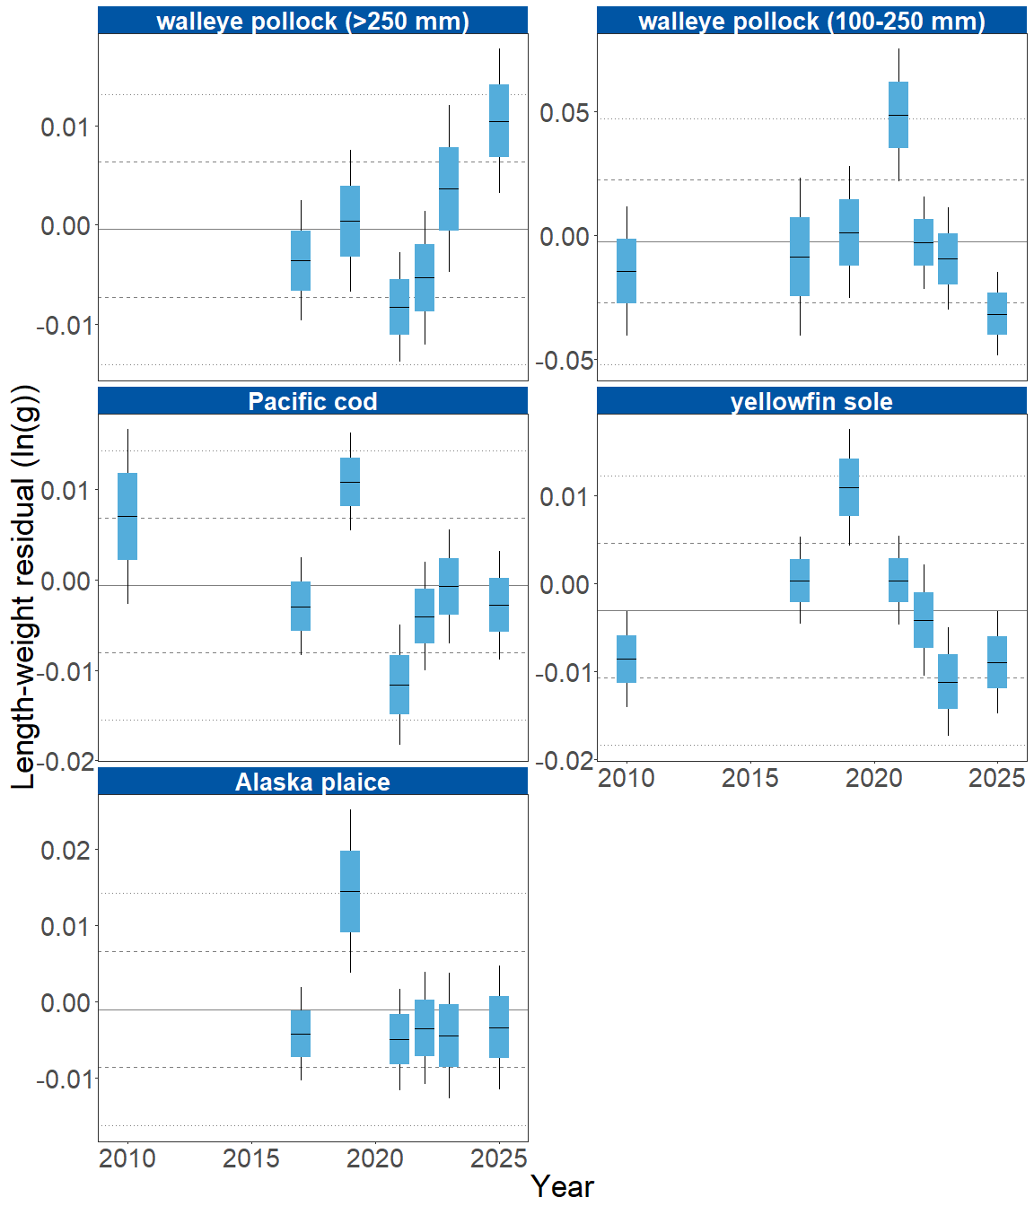
Figure 4. Morphometric condition of groundfish species collected during AFSC/RACE GAP standard summer bottom trawl surveys of the northern Bering Sea shelf (2010–2025) based on residuals of length-weight regressions. The dash in the blue boxes denotes the mean for that year, the box denotes one standard error, and the lines on the boxes denote two standard errors. Lines on each plot represent the historical mean, dashed lines denote one standard deviation, and dotted lines denote two standard deviations.
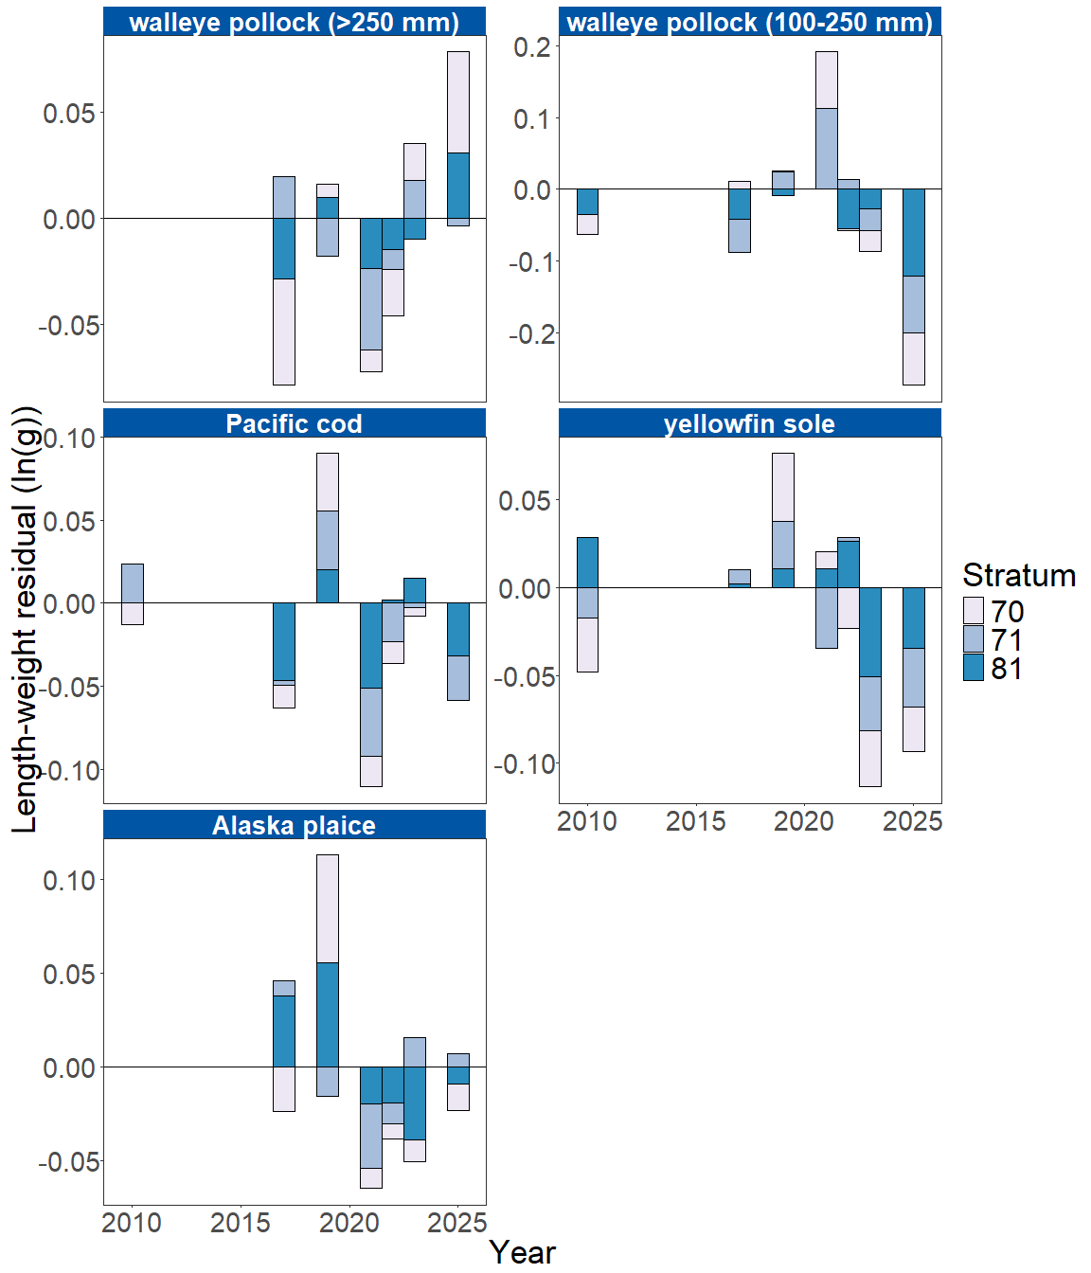
Figure 5. Length-weight residuals by survey stratum (70, 71 and 81) for four northern Bering Sea shelf groundfish species and age 1–2 walleye pollock (100–250 mm) sampled in the AFSC/RACE GAP standard summer bottom trawl survey from 2010–2025. Length-weight residuals are not weighted by stratum biomass.
Factors influencing observed trends: Bottom and sea surface temperatures during the EBS survey have fluctuated over multidecadal timescales, including a prolonged warm stanza from approximately 2014 through 2019, when both were generally more than one standard deviation above their long-term means (Oceanographic synthesis, this ESR; (Bond et al., 2015; Stabeno & Bell, 2019)). Since the 2021 survey, temperatures have generally trended toward or below the long-term mean. Near-average cold pool extent and water temperatures in 2024 were associated with near-average condition (within 1 S.D. of the mean) for all species examined in the EBS that year, while the further warming in 2025 was associated with subsequent increases in fish condition. In the EBS, particularly cold years have historically corresponded with negative condition, while warm years have generally corresponded with positive condition, although this was not the case in 2026, a year featuring the largest survey-observed 2°C cold pool since 2012 and coldest mean bottom temperature since 2013. Spatiotemporal factor analyses suggest the morphometric condition of age-7 walleye pollock is strongly correlated with cold pool extent in the EBS (Grüss et al., 2021). In recent years, warm temperatures across the Bering Sea shelf, following the record low seasonal sea ice extent in 2017–2018 and historical cold pool area minimum in 2018 (Stabeno & Bell, 2019), may have contributed to the positive condition trends observed in several species from 2016 to 2019. However, despite near-average temperatures in 2023, large walleye pollock (>250 mm) condition in the EBS was the second-lowest on record for the time series. In 2024 and 2025, temperatures again remained near-average, and although large walleye pollock (>250 mm) condition was still negative, it was less so than in 2023. By 2026, with continued near-average water temperature, large walleye pollock (>250 mm) condition improved further and is now slightly above the historical mean for the first time since 2019. Bottom trawl survey biomass estimates for yellowfin sole in the EBS were near their time series minimum for the third consecutive year, although condition reached a record high in 2025 despite near-average temperature conditions. Increasing condition can be an indicator of reduced density-dependent competition when populations decline (Haberle et al., 2023), although there is no direct evidence that this is occurring for yellowfin sole in the EBS.
Although warmer temperatures may increase growth rates if there is adequate prey to offset temperature-dependent increases in metabolic demand, growth rates may also decline if prey resources are insufficient to offset temperature-dependent increases in metabolic demand. Therefore, the influence of temperature on growth rates depends on the physiology of predator species, prey availability, and the adaptive capacity of predators to respond to environmental change through migration, changes in behavior, and acclimatization. For example, elevated temperatures during the 2014–2016 marine heatwave in the Gulf of Alaska led to lower growth rates and condition of Pacific cod and early life history stages of walleye pollock, because available prey resources did not make up for increased metabolic demand (Barbeaux et al., 2020; Rogers et al., 2021).
Other factors that could affect morphological condition include survey timing, stomach fullness, fish movement patterns, and environmental conditions (Froese, 2006). The starting date of annual length-weight data collections has varied from late May to early June and ended in late July-early August in the EBS, and mid-August in the NBS. Although stratum-specific coefficients in the length-weight models account for some of this variation, condition estimates may still be influenced by survey timing within strata. Survey timing can be further compounded by seasonal fluctuations in reproductive status with the buildup and depletion of energy stores (Wuenschel et al., 2019). In addition, because weights are taken at sea and include gut contents, variation in stomach fullness may influence condition estimates. Since feeding conditions vary over space and time, prey consumption rates and the proportion of total body weight attributable to gut contents may be an important factor influencing the length-weight residuals.
Finally, although the condition indicators characterize temporal variation in morphometric condition for important fish species in the EBS and NBS, they do not inform the mechanisms or processes behind the observed patterns.
Implications: Fish morphometric condition can be considered an indicator of ecosystem productivity with implications for fish survival, maturity, and reproduction. For example, in Prince William Sound, the pre-winter condition of herring may determine their overwinter survival (Paul & Paul, 1999), differences in feeding conditions have been linked to differences in morphometric condition of pink salmon in Prince William Sound (Boldt & Haldorson, 2004), variation in morphometric condition has been linked to variation in maturity of sablefish (Rodgveller, 2019), and lower morphometric condition of Pacific cod was associated with higher mortality and lower growth rates during the 2014–2016 marine heat wave in the Gulf of Alaska (Barbeaux et al., 2020). Condition can also be an indicator of stock status relative to carrying capacity because morphometric condition is expected to be high when the stock is at low abundance and low when the stock is at high abundance because of the effects of density-dependent competition (Haberle et al., 2023). Thus, the condition of EBS and NBS groundfishes may provide insight into ecosystem productivity as well as fish survival, demographic status, and population health. However, survivorship is likely also affected by many factors not examined here.
Another important consideration is that fish condition was computed for all sizes of fishes combined, except in the case of walleye pollock. Examining condition of early juvenile stage fishes separately from the condition of adult fishes could provide further insight into the value of length-weight residuals as an indicator of individual health or survivorship (Froese, 2006), particularly since large and small walleye pollock have shown diverging condition trends in the NBS in recent years, even though both size classes increased in condition in the EBS in 2026.
The above-average condition observed in most species in 2025 and 2026 does not appear to be explained by survey temperature alone, since bottom and surface temperatures were both slightly below the long-term mean in 2026 even as several species, including large walleye pollock, showed improved condition this year. However, trends in recent years such as prolonged warmer water temperatures following the marine heatwave of 2014-16 (Bond et al., 2015) and reduced sea ice and cold pool areal extent in the eastern Bering Sea (Stabeno & Bell, 2019) may continue to affect fish condition in ways that have not yet been determined. Additionally, periods of high fishing mortality that reduce population biomass are likely to increase body condition because of the compensatory alleviation of density-dependent competition (Haberle et al., 2023). As we continue to add years of length-weight data and expand our knowledge of relationships between condition, growth, production, survival, and the ecosystem, these data may increase our understanding of the health of fish populations in the EBS and NBS.
Research Priorities: Research is underway at the AFSC to examine relationships among putatively similar indicators of fish condition (i.e., morphometric, bioenergetic, physiological). This includes an evaluation of hepatosomatic index, microwave energy meter (fatmeter) measurements, and Fourier-transform near-infrared (FT-NIR) spectroscopy as alternative condition indicators, compared against biochemical measurements of liver lipid content (Prohaska et al., in prep.). Depending on the outcome of this work and the feasibility of collecting the required measurements during surveys, these indicators may be incorporated into future Ecosystem Status Reports (ESRs).

References
Barbeaux, S. J., Holsman, K., & Zador, S. (2020). Marine heatwave stress test of ecosystem-based fisheries management in the Gulf of Alaska Pacific cod fishery. Frontiers in Marine Science, 7, 1–21. https://doi.org/10.3389/fmars.2020.00703
Blackwell, B. G., Brown, M. L., & Willis, D. W. (2000). Relative weight (Wr) status and current use in fisheries assessment and management. Reviews in Fisheries Science, 8(1), 1–44. https://doi.org/10.1080/10641260091129161
Boldt, J. L., & Haldorson, L. J. (2004). Size and condition of wild and hatchery pink salmon juveniles in Prince William Sound, Alaska. Transactions of the American Fisheries Society, 133(1), 173–184. https://doi.org/10.1577/t02-138
Bond, N. A., Cronin, M. F., Freeland, H., & Mantua, N. (2015). Causes and impacts of the 2014 warm anomaly in the NE Pacific. Geophysical Research Letters, 42(9), 3414–3420. https://doi.org/10.1002/2015GL063306
Brodeur, R. D., Fisher, J. P., Teel, D. J., Emmett, R. L., Casillas, E., & Miller, T. W. (2004). Juvenile salmonid distribution, growth, condition, origin, and environmental and species associations in the Northern California Current. Fishery Bulletin, 102(1), 25–46.
Froese, R. (2006). Cube law, condition factor and weight-length relationships: History, meta-analysis and recommendations. Journal of Applied Ichthyology, 22(4), 241–253. https://doi.org/10.1111/j.1439-0426.2006.00805.x
Grüss, A., Thorson, J. T., Stawitz, C. C., Reum, J. C. P., Rohan, S. K., & Barnes, C. L. (2021). Synthesis of interannual variability in spatial demographic processes supports the strong influence of cold-pool extent on eastern Bering Sea walleye pollock (Gadus chalcogrammus). Progress in Oceanography, 194, 102569. https://doi.org/10.1016/j.pocean.2021.102569
Haberle, I., Bavčević, L., & Klanjscek, T. (2023). Fish condition as an indicator of stock status: Insights from condition index in a food‐limiting environment. Fish and Fisheries, 24(4), 567–581. https://doi.org/10.1111/faf.12744
Paul, A. J., & Paul, J. M. (1999). Interannual and regional variations in body length, weight and energy content of age-0 Pacific herring from Prince William Sound, Alaska. Journal of Fish Biology, 54(5), 996–1001. https://doi.org/10.1006/jfbi.1999.0927
Rodgveller, C. J. (2019). The utility of length, age, liver condition, and body condition for predicting maturity and fecundity of female sablefish. Fisheries Research, 216(October 2018), 18–28. https://doi.org/10.1016/j.fishres.2019.03.013
Rogers, L. A., Wilson, M. T., Duffy-Anderson, J. T., Kimmel, D. G., & Lamb, J. F. (2021). Pollock and “the Blob”: Impacts of a marine heatwave on walleye pollock early life stages. Fisheries Oceanography, 30(2), 142–158. https://doi.org/10.1111/fog.12508
Stabeno, P. J., & Bell, S. W. (2019). Extreme conditions in the Bering Sea (2017–2018): record-breaking low sea-ice extent. Geophysical Research Letters, 46(15), 8952–8959. https://doi.org/10.1029/2019GL083816
Wuenschel, M. J., McElroy, W. D., Oliveira, K., & McBride, R. S. (2019). Measuring fish condition: An evaluation of new and old metrics for three species with contrasting life histories. Canadian Journal of Fisheries and Aquatic Sciences, 76(6), 886–903. https://doi.org/10.1139/cjfas-2018-0076

