Aleutian Islands Groundfish Condition
Contributed by Bianca Prohaska¹ and Sean Rohan¹
¹ Resource Assessment and Conservation Engineering Division, Groundfish Assessment Program, Alaska Fisheries Science Center, National Marine Fisheries Service, NOAA, Seattle, WA
Contact: bianca.prohaska@noaa.gov Last updated: September 2026
Description of Indicator: Length-weight residuals represent how heavy a fish is per unit body length and are an indicator of somatic growth variability (Brodeur et al., 2004). Therefore, length-weight residuals can be considered indicators of prey availability, growth, general health, and habitat condition (Blackwell et al., 2000; Froese, 2006). Positive length-weight residuals indicate better condition (i.e., heavier per unit length) and negative residuals indicate poorer condition (i.e., lighter per unit length) (Froese, 2006). Fish condition calculated in this way reflects realized outcomes of intrinsic and extrinsic processes that affect fish growth, which can have implications for biological productivity through direct effects on growth and indirect effects on demographic processes, such as reproduction and mortality (e.g., Rodgveller, 2019; Barbeaux et al., 2020).
The groundfish morphometric condition indicator is calculated from paired fork lengths (mm) and weights (g) of individual fish that were collected during biennial bottom trawl surveys of the Aleutian Islands (AI), which were conducted by the Alaska Fisheries Science Center’s Resource Assessment and Conservation Engineering (AFSC/RACE) Groundfish Assessment Program (GAP). Fish condition analyses were applied to walleye pollock (Gadus chalcogrammus), Pacific cod (Gadus macrocephalus), arrowtooth flounder (Atheresthes stomias), Atka mackerel (Pleurogrammus monopterygius), northern rockfish (Sebastes polyspinis), and Pacific ocean perch (Sebastes alutus). Southern rock sole (Lepidopsetta bilineata) was also analyzed in previous survey years but was not sampled in 2026. All species were collected in trawls with satisfactory performance at stratified random stations within the following subareas: southern Bering Sea, eastern Aleutians, central Aleutians, and western Aleutians (Figure 1).
To calculate indicators, length-weight relationships were estimated from linear regression models based on a log-transformation of the exponential growth relationship, W = aL^{b}, where W is weight (g) and L is fork length (mm) for all areas for the period 1991–2026. Unique intercepts (a) and slopes (b) were estimated for each species, survey stratum, sex, and interaction between stratum and sex to account for sexual dimorphism and spatial-temporal variation in growth and bottom trawl survey sampling. Length-weight relationships for 100–250 mm fork length walleye pollock (corresponding with ages 1–2 years) were calculated separately from adult walleye pollock (> 250 mm). Residuals for individual fish were obtained by subtracting observed weights from bias-corrected weights-at-length that were estimated from regression models. Length-weight residuals from each stratum were aggregated and weighted proportionally to total biomass in each stratum from area-swept expansion of mean bottom-trawl survey catch per unit effort (CPUE; i.e., design-based stratum biomass estimates). Variation in fish condition was evaluated by comparing average length-weight residuals among years. To minimize the influence of unrepresentative samples on indicator calculations, combinations of species, stratum, and year with a sample size <10 were used to fit length-weight regressions, but were excluded from calculating length-weight residuals. Morphometric condition indicator time series, code for calculating the indicators, and figures showing results for individual species are available through the akfishcondition R package and GitHub repository (https://github.com/afsc-gap-products/akfishcondition).
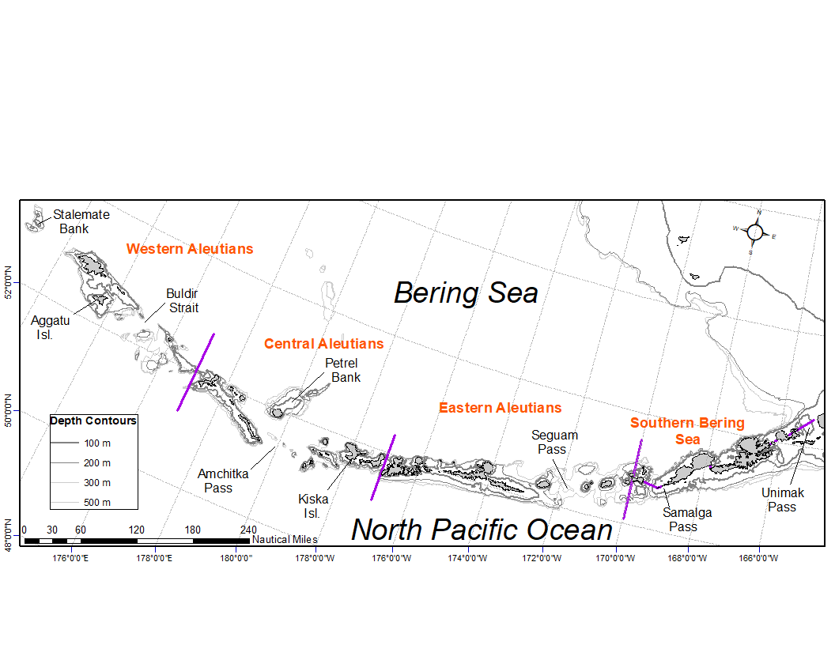
Figure 1. National Marine Fisheries Service (NMFS) Alaska Fisheries Science Center (AFSC) Resource Assessment and Conservation Engineering Groundfish Assessment Program (RACE-GAP) Aleutian Islands summer bottom trawl survey area with International North Pacific Fisheries Commission (INPFC) statistical fishing subareas delineated by the purple lines.
Status and Trends: Body condition has varied among years for all species considered (Figures 2 & 3). Prior to 2010, the condition for most species cycled between positive and negative values through the years. Condition for most species has primarily been near-average (within 1 standard deviation [SD]) or below (> 1 SD) the time series mean since 2012. The exception to this was 100–250 mm walleye pollock in 2024, where the residual body condition was two standard deviations higher than the time series mean. Body condition for walleye pollock > 250 mm has been declining since 2022 and was below the time series mean in 2026, reaching the lowest condition since 2016. In contrast, 100-250 mm walleye pollock were in below average condition in 2022, reached the highest condition of the time series in 2024, and decreased in 2026 to slightly above the time series mean. Atka mackerel was above average in 2010 and has generally shown a decreasing trend since then, but was near-average in 2026. Southern rock sole body condition has been trending positive in the Aleutians since 2012, and was just above the time series mean in 2024. Southern rock sole individual length-weight measurements were not collected in 2026. Pacific cod and arrowtooth flounder were above average condition in 2010, but subsequently had declining condition through 2018 before increasing in 2022. Pacific cod and arrowtooth flounder remained below, but within one SD of the time series mean in 2026. Northern rockfish and Pacific ocean perch condition has shown a decreasing trend since 2010, with both species reaching their lowest values in the time series in 2026. Notably, residual body condition was below the time series mean for all species sampled in 2026 except 100-250 mm walleye pollock, and more than one standard deviation or more below the mean for walleye pollock > 250 mm, northern rockfish, and Pacific ocean perch.
In 2026, condition was negative in every subarea with an estimate for walleye pollock > 250 mm, Pacific cod, arrowtooth flounder, Atka mackerel, northern rockfish, and Pacific ocean perch (Figure 3). For Pacific cod, Atka mackerel, northern rockfish, and Pacific ocean perch, this included all four subareas (southern Bering Sea, eastern Aleutians, central Aleutians, and western Aleutians) in both 2024 and 2026. By comparison, Atka mackerel condition in 2022 was positive in the central and eastern Aleutians but negative in the western Aleutians and southern Bering Sea. Walleye pollock > 250 mm were negative in the western Aleutians, eastern Aleutians, and southern Bering Sea in 2024 and 2026, with the most negative values in the southern Bering Sea in 2026. In contrast, 100-250 mm walleye pollock were in positive condition in the western and eastern Aleutians in 2024 and 2026, the only two subarea with estimates in those years, and in 2022, the only estimate was for the central Aleutians, where condition was negative.
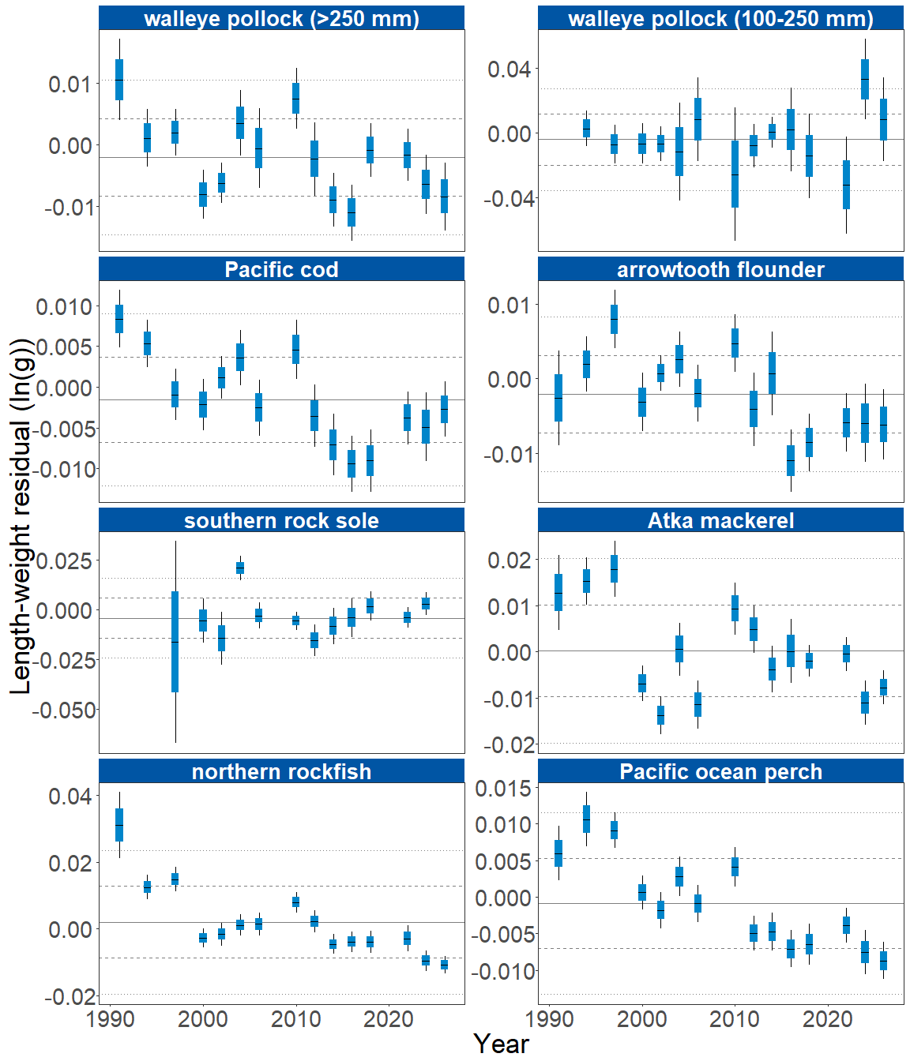
Figure 2. Morphometric condition of groundfish species collected during AFSC/RACE GAP standard summer bottom trawl surveys of the Aleutian Islands (1991 to 2026) based on residuals of length-weight regressions. The dash in the blue boxes denotes the mean for that year, the box denotes one standard error, and the lines on the boxes denote two standard errors. Lines on each plot represent the historical mean, dashed lines denote one standard deviation, and dotted lines denote two standard deviations.
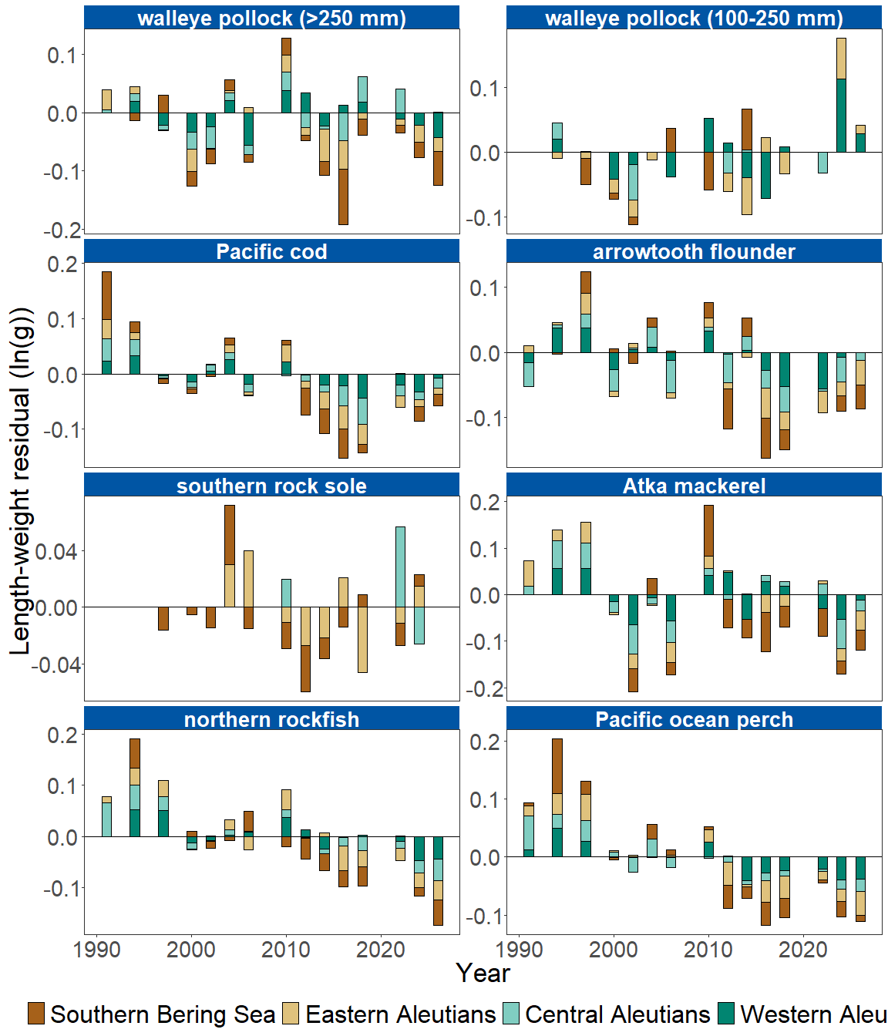
Figure 3. Length-weight residuals by survey subarea for seven Aleutian Islands groundfish species and age 1–2 walleye pollock (100–250 mm) sampled in the AFSC/RACE GAP standard summer bottom trawl survey, 1991-2026. Length-weight residuals are not weighted by subarea biomass.
Factors causing observed trends: Several factors could affect morphological condition, including water temperature. Since the Warm Blob in 2014 (Bond et al., 2015; Stabeno & Bell, 2019), there has been a general trend of warming ocean temperatures in the survey area that could affect fish growth conditions. Summer sea surface temperatures in the Aleutian Islands hovered near the long-time mean in both 2024 and 2026 based on measurements recorded during the bottom trawl survey (Rohan & Howard, this ESR). The influence of temperature on growth rates depends on the physiology of predator species, prey availability, and the adaptive capacity of predators to respond to environmental change through migration, changes in behavior, and acclimatization. For example, elevated temperatures during the 2014-2016 marine heatwave in the Gulf of Alaska led to lower growth rates and condition of Pacific cod and early life history stages of walleye pollock, likely because available prey resources did not make up for increased metabolic demand (Barbeaux et al., 2020; Rogers et al., 2021). Density-dependent competition may also influence condition, as morphometric condition is expected to be high when a stock is at low abundance and low when a stock is at high abundance (Haberle et al., 2023). Thus, the factors underpinning the negative or neutral condition remain unclear.
Other factors that could affect morphological condition include survey timing, stomach fullness, and fish movement patterns (Froese, 2006). Changing ocean conditions along with normal patterns of movement can cause the proportion of the population resident in the sampling area during the annual bottom trawl survey to vary. Effects of survey timing on body condition can be further compounded by seasonal fluctuations in reproductive status with the buildup and depletion of energy stores (Wuenschel et al., 2019). Another consideration is that fish weights sampled at sea include gut content weights, so variation in gut fullness may influence weight measurements since feeding conditions, digestion, and gastric evacuation rates vary over space and time.
Spatial heterogeneity within the Aleutian Islands may also influence morphometric condition. Fish community composition changes abruptly at several of the major passes between islands, and growth rates of some fish species decline toward the west (Hunt & Stabeno, 2005), as has been documented for Atka mackerel (Rand et al., 2010). O’Leary et al. (2026) recently evaluated weight-at-length of six Aleutian groundfish species north and south of the Aleutian passes using survey data through 2022. Pacific ocean perch, northern rockfish, Pacific cod, and arrowtooth flounder were heavier for their length north of the passes, whereas Atka mackerel were heavier south of the passes, and walleye pollock showed no significant north-south difference; overall effect sizes were small. Because samples from both sides of the chain are combined to estimate subarea-specific regression parameters, north-south differences in weight-at-length are not accounted for in the current indicator and could contribute to variability in condition estimates, for example if the proportion of samples collected north versus south of the chain differs among years.
Finally, although condition indicators characterize spatial and temporal variation in morphometric condition of groundfish species in the Aleutian Islands, they do not inform the mechanisms or processes behind the observed patterns.
Implications: Fish morphometric condition can be considered an indicator of ecosystem productivity with implications for fish survival, maturity, and reproduction. For example, in Prince William Sound, the pre-winter condition of herring may determine their overwinter survival (Paul & Paul, 1999), differences in feeding conditions have been linked to differences in morphometric condition of pink salmon in Prince William Sound (Boldt & Haldorson, 2004). variation in morphometric condition has been linked to variation in maturity of sablefish (Rodgveller, 2019), and lower morphometric condition of Pacific cod was associated with higher mortality and lower growth rates during the 2014–2016 marine heat wave in the Gulf of Alaska (Barbeaux et al., 2020). Condition can also be an indicator of stock status relative to carrying capacity because morphometric condition is expected to be high when the stock is at low abundance and low when the stock is at high abundance because of the effects of density-dependent competition (Haberle et al., 2023). Thus, the condition of Aleutian Islands groundfishes may provide insight into ecosystem productivity as well as fish survival, demographic status, and population health. However, survivorship is likely also affected by many factors not examined here.
Another important consideration is that fish condition was computed for all sizes of fishes combined, except in the case of walleye pollock. Examining condition of early juvenile stage fishes separately from the condition of adult fishes could provide further insight into the value of length-weight residuals as an indicator of individual health or survivorship (Froese, 2006), particularly since juvenile and adult walleye pollock exhibited opposite trends in condition in the Aleutian Islands this year.
The decreasing trend in body condition for many Aleutian Islands species suggests growth has decreased, which may have implications for stock assessment. The condition of northern rockfish and Pacific ocean perch, two long-lived and highly abundant planktivores, reached their lowest values in the time series in 2026. Downward trends in body condition could indicate poor overwinter survival or may reflect the influence of locally changing environmental conditions depressing fish growth, local production, or survivorship. Indications are that the 2014–2016 marine heatwave (Bond et al., 2015; Stabeno & Bell, 2019) has been followed by years with elevated water temperatures, which may be related to changes in fish condition in the species examined.
Research priorities: Research is underway at the AFSC to examine relationships among putatively similar indicators of fish condition (i.e., morphometric, bioenergetic, physiological). This includes an evaluation of hepatosomatic index, microwave energy meter (fatmeter) measurements, and Fourier-transform near-infrared (FT-NIR) spectroscopy as alternative condition indicators, compared against biochemical measurements of liver lipid content (Prohaska et al., in prep.). Depending on the outcome of this work and the feasibility of collecting the required measurements during surveys, these indicators may be incorporated into future Ecosystem Status Reports (ESRs).

References
Barbeaux, S. J., Holsman, K., & Zador, S. (2020). Marine heatwave stress test of ecosystem-based fisheries management in the Gulf of Alaska Pacific cod fishery. Frontiers in Marine Science, 7, 1–21. https://doi.org/10.3389/fmars.2020.00703
Boldt, J. L., & Haldorson, L. J. (2004). Size and condition of wild and hatchery pink salmon juveniles in Prince William Sound, Alaska. Transactions of the American Fisheries Society, 133(1), 173–184. https://doi.org/10.1577/t02-138
Bond, N. A., Cronin, M. F., Freeland, H., & Mantua, N. (2015). Causes and impacts of the 2014 warm anomaly in the NE Pacific. Geophysical Research Letters, 42(9), 3414–3420. https://doi.org/10.1002/2015GL063306
Froese, R. (2006). Cube law, condition factor and weight-length relationships: History, meta-analysis and recommendations. Journal of Applied Ichthyology, 22(4), 241–253. https://doi.org/10.1111/j.1439-0426.2006.00805.x
Haberle, I., Bavčević, L., & Klanjscek, T. (2023). Fish condition as an indicator of stock status: Insights from condition index in a food‐limiting environment. Fish and Fisheries, 24(4), 567–581. https://doi.org/10.1111/faf.12744
Hunt, G. L. Jr., & Stabeno, P. J. (2005). Oceanography and ecology of the Aleutian Archipelago: spatial and temporal variation. Fisheries Oceanography, 14(Suppl. 1), 292–306. https://doi.org/10.1111/j.1365-2419.2005.00378.x
O’Leary, A., Cecilia, Zimmerman, M., & Prescott, M. (2026). Spatial Heterogeneity in the Aleutian Islands Influences Groundfish Morphometric Condition Rationale. Fisheries Oceanography, 35(6), 880–890. https://doi.org/10.1111/fog.70062
Paul, A. J., & Paul, J. M. (1999). Interannual and regional variations in body length, weight and energy content of age-0 Pacific herring from Prince William Sound, Alaska. Journal of Fish Biology, 54(5), 996–1001. https://doi.org/10.1006/jfbi.1999.0927
Rand, K. M., Beauchamp, A., David, & Lowe, A., Sandra. (2010). Longitudinal Growth Differences and the Influence of Diet Quality on Atka Mackerel of the Aleutian Islands, Alaska: Using a Bioenergetics Model to Explore Underlying Mechanisms. Marine and Coastal Fisheries, 2(1), 362–374. https://doi.org/10.1577/C09-046.1
Rodgveller, C. J. (2019). The utility of length, age, liver condition, and body condition for predicting maturity and fecundity of female sablefish. Fisheries Research, 216(October 2018), 18–28. https://doi.org/10.1016/j.fishres.2019.03.013
Rogers, L. A., Wilson, M. T., Duffy-Anderson, J. T., Kimmel, D. G., & Lamb, J. F. (2021). Pollock and “the Blob”: Impacts of a marine heatwave on walleye pollock early life stages. Fisheries Oceanography, 30(2), 142–158. https://doi.org/10.1111/fog.12508
Stabeno, P. J., & Bell, S. W. (2019). Extreme conditions in the Bering Sea (2017–2018): record-breaking low sea-ice extent. Geophysical Research Letters, 46(15), 8952–8959. https://doi.org/10.1029/2019GL083816
Wuenschel, M. J., McElroy, W. D., Oliveira, K., & McBride, R. S. (2019). Measuring fish condition: An evaluation of new and old metrics for three species with contrasting life histories. Canadian Journal of Fisheries and Aquatic Sciences, 76(6), 886–903. https://doi.org/10.1139/cjfas-2018-0076

