Aleutian Islands Groundfish Condition

Contributed by Cecilia O’Leary1 and Sean Rohan1  
1 Resource Assessment and Conservation Engineering Division, Groundfish Assessment Program, Alaska Fisheries Science Center, National Marine Fisheries Service, NOAA, Seattle, WA  
**Contact**: [cecilia.oleary@noaa.gov](mailto:cecilia.oleary@noaa.gov)  
**Last updated**: October 2022

**Description of Indicator**: Length-weight residuals represent how heavy a fish is per unit body length and are an indicator of somatic growth variability (Brodeur et al., 2004). Therefore, length-weight residuals can be considered indicators of prey availability, growth, general health, and habitat condition (Blackwell et al., 2000; Froese, 2006). Positive length-weight residuals indicate better condition (i.e., heavier per unit length) and negative residuals indicate poorer condition (i.e., lighter per unit length) (Froese, 2006). Fish condition calculated in this way reflects realized outcomes of intrinsic and extrinsic processes that affect fish growth which can have implications for biological productivity through direct effects on growth and indirect effects on demographic processes such as, reproduction, and mortality (e.g., Rodgveller (2019); Barbeaux et al. (2020)).

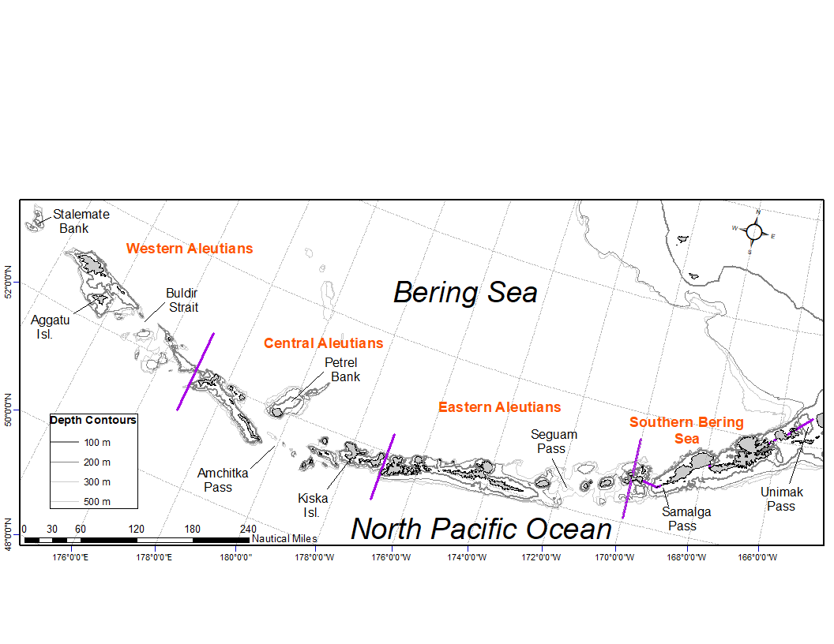

Figure 1. National Marine Fisheries Service (NMFS) Alaska Fisheries Science Center (AFSC) Resource Assessment and Conservation Engineering Groundfish Assessment Program (RACE-GAP) Aleutian Islands summer bottom trawl survey area with International North Pacific Fisheries Commission (INPFC) statistical fishing strata delineated by the purple lines.

The groundfish morphometric condition indicator is calculated from paired fork lengths (mm) and weights (g) of individual fishes that were collected during bottom trawl surveys of the Aleutian Islands (AI) which were conducted by the Alaska Fisheries Science Center’s Resource Assessment and Conservation Engineering (AFSC/RACE) Groundfish Assessment Program (GAP). Analyses focused on walleye pollock (*Gadus chalcogrammus*), Pacific cod (*Gadus macrocephalus*), arrowtooth flounder (*Atheresthes stomias*), southern rock sole (*Lepidopsetta bilineata*), Atka mackerel (*Pleurogrammus monopterygius*), northern rockfish (*Sebastes polyspinis*), and Pacific ocean perch (*Sebastes alutus*) collected in trawls with satisfactory performance at standard survey stations. Data were combined in the International North Pacific Fisheries Commission (INPFC) strata; Southern Bering Sea, Eastern Aleutian Islands, Central Aleutian Islands, and Western Aleutian Islands (Figure 1).

Length-weight relationships for each of the seven species were estimated within each stratum across all years where data were available (1984–2018) from a linear regression of log-transformed exponential growth, *W* = *aLb*, where *W* is weight (g) and *L* is fork length (mm). A different slope was estimated for each stratum to account for spatial-temporal variation in growth and bottom trawl survey sampling. Length-weight relationships for 100–250 mm fork length (1–2 year old) walleye pollock were established independent of the adult life history stages caught. Bias-corrected weights-at-length (log scale) were estimated from the model and subtracted from observed weights to compute individual residuals per fish. Length-weight residuals were averaged for each stratum and weighted in proportion to INPFC stratum biomass based on stratified area-swept expansion of summer bottom trawl survey catch per unit effort (CPUE). Average length-weight residuals were compared by stratum and year to evaluate spatial variation in fish condition. Combinations of stratum and year with <10 samples were used for length-weight relationships but excluded from indicator calculations.

The new model-based condition indicator (VAST relative condition) is the proportional value of the annual allometric intercept, ayear, in the length-weight equation, *W* = *aLb*, relative to the time series mean of a (i.e., $condition=a_{year}/\overline{a}$) . Relative condition greater than one indicates better condition (i.e., heavier per unit length) and relative condition less than one indicates poorer condition (i.e., lighter per unit length) The model-based condition indicator was estimated using a spatiotemporal model with spatial random effects, implemented in the software VAST v3.8.2 (Thorson (2019); (**Gruss2020?**)). Allometric intercepts are estimated as fixed effects using a multivariate generalized linear mixed model that jointly estimates spatial and temporal variation in a and catch per unit effort (numbers of fish per area). Density-weighted average ayear is a product of population density, local a, and area. Spatial variation in ayear was represented using a Gaussian Markov random field. The model approximates ayear using a log-link function and linear predictors ((**Gruss2020?**)). Parameters are estimated by identifying the values that maximize the marginal log-likelihood.

**Methodological Changes**: The historical stratum-biomass weighted residual body condition indicator ((**Rohan2020?**)) and model-based VAST relative condition indicator ((**Gruss2020?**)) are both presented this year to allow comparison between old and new methods. The historical indicator was calculated using the same method as 2020 and 2021, where allometric intercepts were estimated for each stratum by fitting log-linear models to individual length-weight data from summer bottom-trawl surveys, calculating regression residuals from bias-corrected predictions of individual fish weights, and weighing stratum mean residuals in proportion to stratum biomass. Stratum-year combinations with sample size <10 were not used in indicator calculations. Confidence intervals reflect the uncertainty based on length-weight residuals, but are larger due to differences in sample sizes and stratum biomasses among years [FIG]. The new VAST relative condition indicator was estimated using a spatiotemporal model with spatial random effects, as described above Thorson (2019)). The new condition indicator better accounts for spatially and temporally unbalanced sampling that is characteristic of historical bottom trawl survey data. The new indicator also affords more precise expansion of individual samples to the population and more reliable estimates of uncertainty, and accounts for spatial-temporal variation in length-weight samples from bottom trawl surveys due to methodological changes in sampling protocols (e.g., transition from sex-and-length stratified sampling to random sampling).

We evaluated the similarity between the historical length-weight residual indicator and new VAST relative condition indicator using Pearson’s correlations.

**Status and Trends**: Body condition varied amongst survey years for all species considered (Figure 2). Prior to the 2010, the AI bottom trawl survey is characterized by body condition indicators cycling between positive and negative values through the years. Residual condition switched from above to below average (>250 mm pollock in 1993 and 2015 and 100–250 mm pollock in 2010) and an instance when 100–250 mm pollock (2016) condition switched from below average to above. Condition of most species since 2010 has primarily been below the long term average or neutral. Exceptions occur for 100–250 mm walleye pollock in 2016 and Atka mackerel in 2012 where the residual body condition is neutral or slightly positive. Southern rock sole residual body condition is trending positive in the Aleutians since 2012. Notably, in 2022, residual body condition remained at neutral or became slightly more positive than the condition values since 2010 for all species considered, although the body condition of all species besides southern rock sole remain below the long term average for both the historical and model-based index.

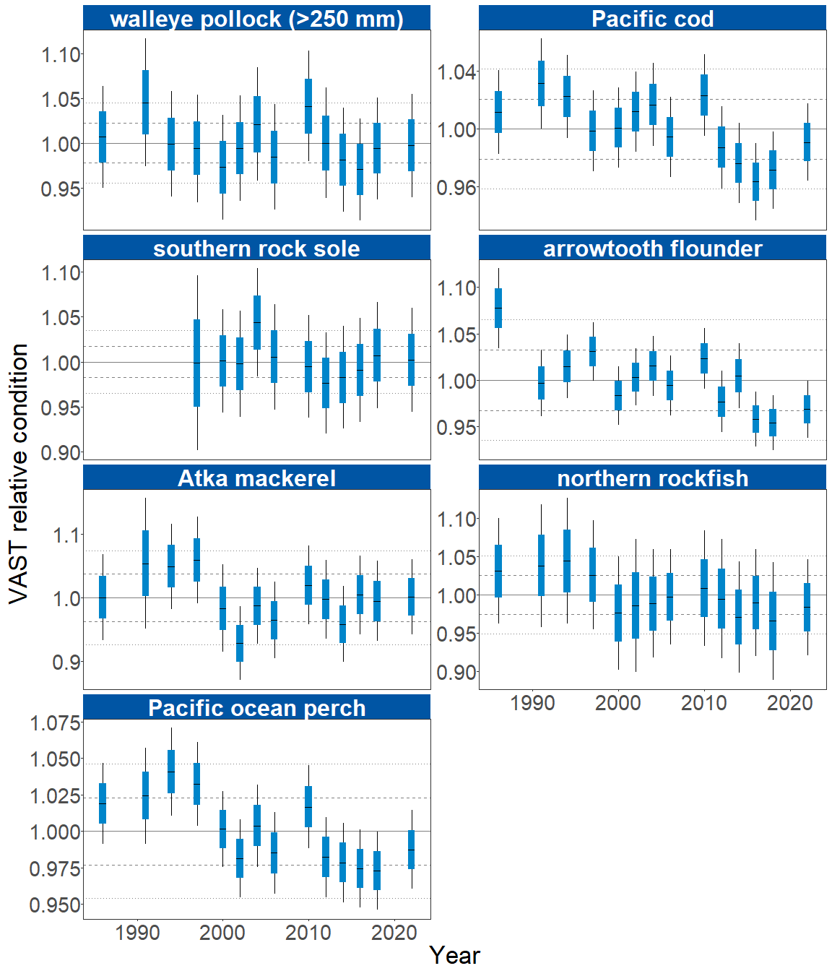

Figure 2. Weighted length-weight residuals for seven groundfish species collected during AFSC/RACE GAP standard summer bottom trawl surveys of the Aleutian Islands, 1986-2022. Filled bars denote weighted length-weight residuals using this year’s indicator calculation. Error bars denote standard errors, thin lines are 2 standard errors and thick lines are 1 standard error.

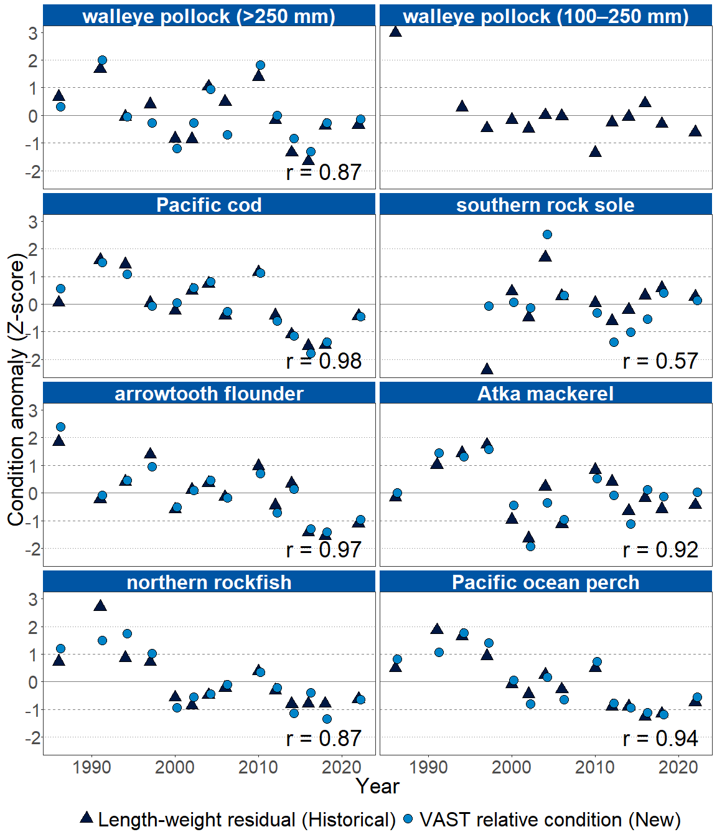

Figure 3. Length-weight residuals for groundfish species and age 1–2 walleye pollock (100–250 mm) collected during AFSC/RACE GAP summer bottom trawl surveys of the ALuetian Islands from 1986-2022. Black triangles denote the historical lenght-weight residual condition indicator and blue circles indicate the VAST relative condition indicator. REported r values are the results of the Pearson’s correlation.

The general pattern for both residual body condition index and model-based body condition for the Aleutian Islands as described above agreed with each other and were highly correlated, with the exception of southern rock sole (r >= 0.87; Figure 3). The divergence in agreement between the historical length-weight residual and VAST relative condition for southern rock sole is likely due to hte highly unbalanced spatial distribution of southern rock sole length-weight data and the ability for the model-based index approach to account for that spatial unbalance. Both methods produced the same trends and values overall for all groundfish species considered in this analysis.

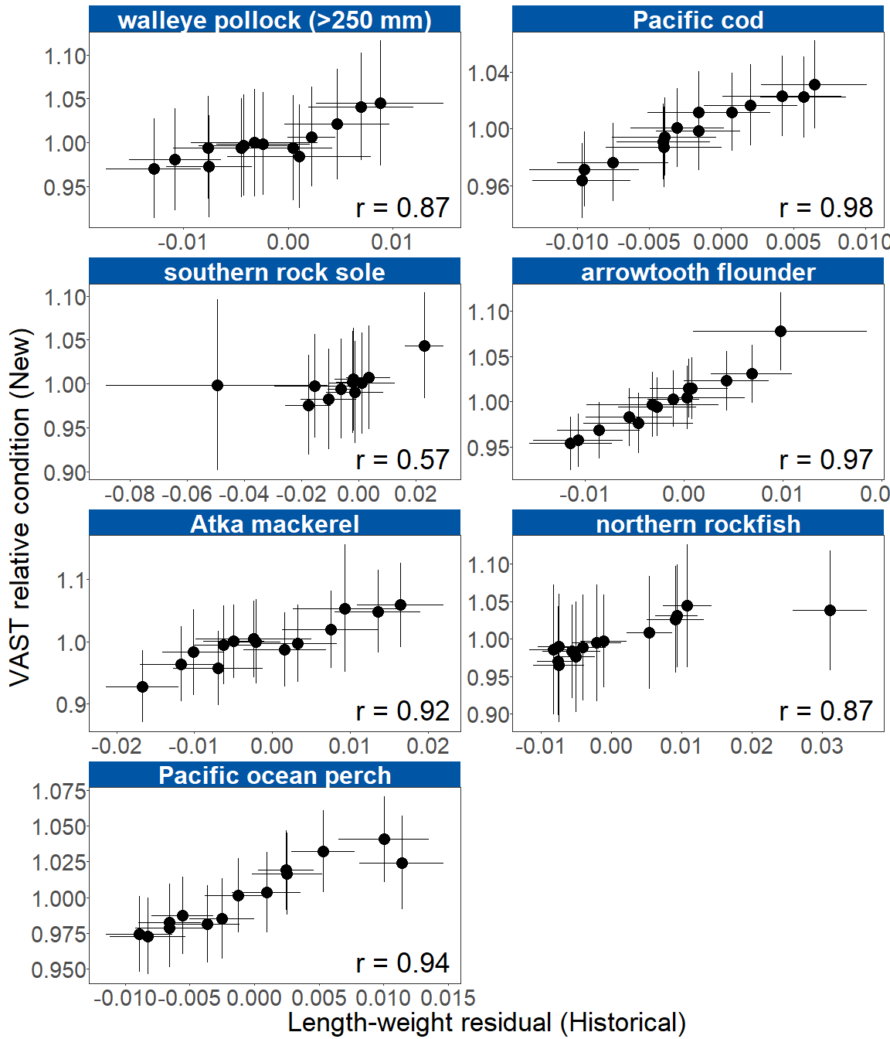

Figure 4. Length-weight residual condition based on length-weight residuals versus VAST condition for the Aleutian Islands. Points denote the mean, error bars denote two standard errors.

**Factors causing observed trends**: Several factors could affect residual fish body condition presented here, including water temperature. Since the Warm Blob in 2014 (Bond et al. (2015); Stabeno & Bell (2019)), there has been a general trend of warming ocean temperatures in the survey area through 2022 that could be affecting fish growth conditions there. The influence of temperature on growth rates depends on the physiology of predator species, prey availability, and the adaptive capacity of predators to respond to environmental change through migration, changes in behavior, and acclimatization. Thus, the factors underpinning the negative or neutral condition remain unclear.

Other factors that could affect length-weight residuals include survey timing, stomach fullness, fish movement patterns, sex, and environmental conditions (Froese, 2006). Changing ocean conditions along with normal patterns of movement can cause the proportion of the population resident in the sampling area during the annual bottom trawl survey to vary. The date that the first length-weight data are collected is generally in the beginning of June and the bottom trawl survey is conducted throughout the summer months moving from east to west so that spatial and temporal trends in fish growth over the season become confounded with survey progress. We can expect some fish to exhibit seasonal or ontogenetic movement patterns during the survey months. Survey timing can be further compounded by seasonal fluctuations in reproductive condition with the buildup and depletion of energy stores (Wuenschel et al., 2019). Another consideration is that fish weights sampled at sea are typically inclusive of stomach content weights so gut fullness may influence the length-weight residuals. Since feeding conditions likely change over space and time, how much the fish ate at its last meal and the proportion of its total body weight attributable to the gut weight could be an important factor influencing the length-weight residuals.

The updated condition analyses presented here account for spatio-temporal variability in the underlying populations sampled. Although the condition indicator characterizes spatial and temporal variation of length-weight residuals for groundfish species in the Aleutians, it does not inform the mechanisms or processes behind the observed patterns.

**Implications**: Fish morphometric condition can be considered an indicator of ecosystem productivity with implications for fish survival, maturity, and reproduction. For example, in Prince William Sound, the pre-winter condition of herring may determine their overwinter survival (Paul & Paul, 1999), differences in feeding conditions have been linked to differences in morphometric condition of pink salmon in Prince William Sound (Boldt & Haldorson, 2004), variation in morphometric condition has been linked to variation in maturity of sablefish (Rodgveller, 2019), and lower morphometric condition of Pacific cod was associated with higher mortality and lower growth rates during the 2014–2016 marine heat wave in the Gulf of Alaska (Barbeaux et al., 2020). The condition of Aleutian Islands groundfish may similarly contribute to survival and recruitment and provide insight into ecosystem productivity, fish survival, demographic status, and population health.

Survivorship is likely affected by many factors not examined here. As future years are added to the time series, the relationship between length-weight residuals and subsequent survival will be examined further. It is important to consider that residual body condition for most species in these analyses was computed for all sizes and sexes combined. Requirements for growth and survivorship differ for different fish life stages and some species have sexually dimorphic growth patterns. It may be more informative to examine life-stage (e.g., early juvenile, subadult, and adult phases) and sex specific body condition in the future for more insight into individual health and survivorship (Froese, 2006).

The trend toward lowered body condition for many Aleutian Islands species over the last 3–4 RACE/AFSC GAP bottom trawl surveys (i.e., increasingly negative length-weight residuals) is a potential cause for concern, however the recent trend in upward body condition in 2022 for all groundfish species might indicate that this will change again. Recent downward trends in body condition could indicate poor overwinter survival or may reflect the influence of locally changing environmental conditions depressing fish growth, local production, or survivorship. Indications are that the Warm Blob (Bond et al. (2015); (**Stabeno2019?**)) has been followed by subsequent years with elevated water temperatures (e.g., (**Barbeaux2018?**); (**Laman2018?**)) which may be related to changes in fish condition in the species examined. As we continue to add years of fish condition to the record and expand on our knowledge of the relationships between condition, growth, production, and survival, we hope to gain more insight into the overall health of fish populations in the Aleutian Islands.

**Research priorities**: The new model-based condition indicator (VAST relative condition) will be further explored for biases and sensitivities to data, model structure, and parameterization. Specifically, the 100-250 mm walleye pollock VAST relative condition indicator model does not converge, and so further model structure and parameterization research is needed. Research is also being planned and implemented across multiple AFSC programs to explore standardization of statistical methods for calculating condition indicators, and to examine relationships among putatively similar indicators of fish condition (i.e., morphometric, bioenergetic, physiological). Finally, we plan to explore variation in condition indices between life history stages alongside density dependence and climate change impacts (Oke et al. (2022)).

## References

Barbeaux, S. J., Holsman, K., & Zador, S. (2020). Marine heatwave stress test of ecosystem-based fisheries management in the Gulf of Alaska Pacific cod fishery. *Frontiers in Marine Science*, *7*, 1–21. <https://doi.org/10.3389/fmars.2020.00703>

Blackwell, B. G., Brown, M. L., & Willis, D. W. (2000). Relative weight (Wr) status and current use in fisheries assessment and management. *Reviews in Fisheries Science*, *8*(1), 1–44. <https://doi.org/10.1080/10641260091129161>

Boldt, J. L., & Haldorson, L. J. (2004). Size and condition of wild and hatchery pink salmon juveniles in Prince William Sound, Alaska. *Transactions of the American Fisheries Society*, *133*(1), 173–184. <https://doi.org/10.1577/t02-138>

Bond, N. A., Cronin, M. F., Freeland, H., & Mantua, N. (2015). Causes and impacts of the 2014 warm anomaly in the NE Pacific. *Geophysical Research Letters*, *42*(9), 3414–3420. <https://doi.org/10.1002/2015GL063306>

Brodeur, R. D., Fisher, J. P., Teel, D. J., Emmett, R. L., Casillas, E., & Miller, T. W. (2004). Juvenile salmonid distribution, growth, condition, origin, and environmental and species associations in the Northern California Current. *Fishery Bulletin*, *102*(1), 25–46.

Froese, R. (2006). Cube law, condition factor and weight-length relationships: History, meta-analysis and recommendations. *Journal of Applied Ichthyology*, *22*(4), 241–253. <https://doi.org/10.1111/j.1439-0426.2006.00805.x>

Oke, K. B., Mueter, F. J., & Litzow, M. A. (2022). Warming leads to opposite patterns in weight-at-age for young versus old age classes of Bering Sea walleye pollock. *Canadian Journal of Fisheries and Aquatic Sciences*. <https://doi.org/10.1139/cjfas-2021-0315>

Paul, A. J., & Paul, J. M. (1999). Interannual and regional variations in body length, weight and energy content of age-0 Pacific herring from Prince William Sound, Alaska. *Journal of Fish Biology*, *54*(5), 996–1001. <https://doi.org/10.1006/jfbi.1999.0927>

Rodgveller, C. J. (2019). The utility of length, age, liver condition, and body condition for predicting maturity and fecundity of female sablefish. *Fisheries Research*, *216*(October 2018), 18–28. <https://doi.org/10.1016/j.fishres.2019.03.013>

Stabeno, P. J., & Bell, S. W. (2019). Extreme conditions in the Bering Sea (2017–2018): record-breaking low sea-ice extent. *Geophysical Research Letters*, *46*(15), 8952–8959. <https://doi.org/10.1029/2019GL083816>

Thorson, J. T. (2019). Guidance for decisions using the Vector Autoregressive Spatio-Temporal (VAST) package in stock, ecosystem, habitat and climate assessments. *Fisheries Research*, *210*, 143–161. <https://doi.org/10.1016/j.fishres.2018.10.013>

Wuenschel, M. J., McElroy, W. D., Oliveira, K., & McBride, R. S. (2019). Measuring fish condition: An evaluation of new and old metrics for three species with contrasting life histories. *Canadian Journal of Fisheries and Aquatic Sciences*, *76*(6), 886–903. <https://doi.org/10.1139/cjfas-2018-0076>