Aleutian Islands Groundfish Condition

Contributed by Cecilia O’Leary1 and Sean Rohan1  
1 Resource Assessment and Conservation Engineering Division, Groundfish Assessment Program, Alaska Fisheries Science Center, National Marine Fisheries Service, NOAA, Seattle, WA  
**Contact**: [cecilia.oleary@noaa.gov](mailto:cecilia.oleary@noaa.gov)  
**Last updated**: October 2022

**Description of Indicator**: Morphometric condition indicators based on length-weight relationships characterize variation in somatic growth and can be considered indicators of prey availability, growth, general health, and habitat condition (Blackwell et al., 2000; Froese, 2006). This contribution presents two morphometric condition indicators based on length-weight relationships: a new relative condition indicator that is estimated using a spatiotemporal model and the historical indicator based on residuals of the length-weight relationship.

To calculate indicators, length-weight relationships were estimated from linear regression models based on a log-transformation of the exponential growth relationship, W = aLb, where W is weight (g) and L is fork length (mm) for all areas for the period 1991–2024. Unique unique intercepts and (a) and slopes (b) were estimated for each survey stratum, sex, and interaction between stratum and sex to account for sexual dimorphism and spatial-temporal variation in growth and bottom trawl survey sampling. Length-weight relationships for 100–250 mm fork length walleye pollock (corresponding with ages 1–2 years) were calculated separately from adult walleye pollock (> 250 mm). Residuals for individual fish were obtained by subtracting observed weights from bias-corrected weights-at-length that were estimated from regression models. Individual length-weight residuals were aggregated and averaged for each stratum, weighted based on the proportion to total biomass in each stratum from area-swept expansion of bottom-trawl survey catch per unit effort (CPUE; i.e., design-based stratum biomass estimates). Variation in fish condition was evaluated by comparing average length-weight residuals among years. To minimize the influence of unrepresentative samples on indicator calculations, combinations of species, stratum, and year with a sample size < 10 were used to fit length-weight regressions but were excluded from calculating length-weight residuals. Morphometric condition indicator time series, code for calculating the indicators, and figures showing results for individual species are available through the akfishcondition R package and GitHub repository (<https://github.com/afsc-gap-products/akfishcondition>).

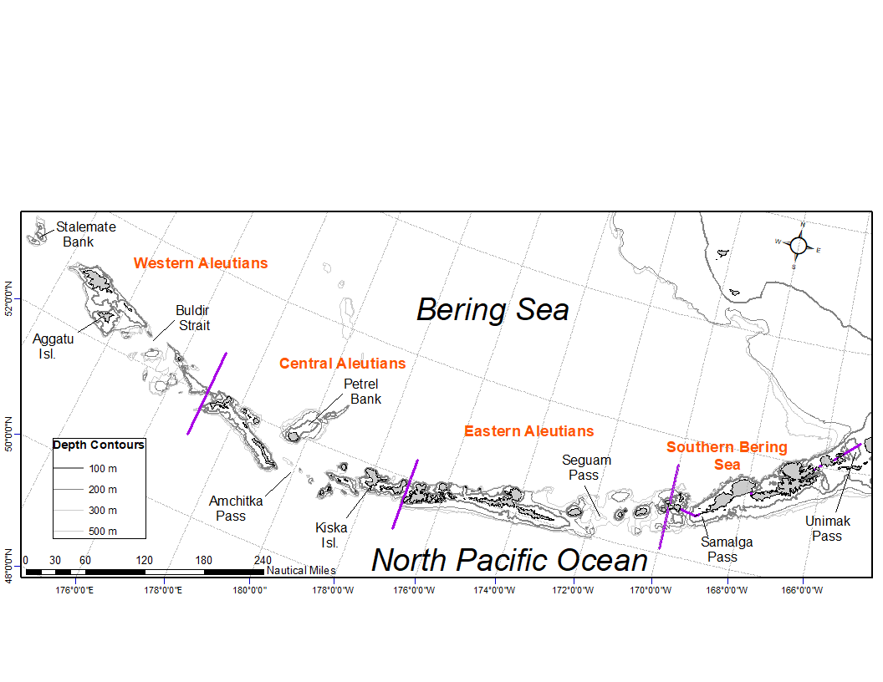

Figure 1. National Marine Fisheries Service (NMFS) Alaska Fisheries Science Center (AFSC) Resource Assessment and Conservation Engineering Groundfish Assessment Program (RACE-GAP) Aleutian Islands summer bottom trawl survey area with International North Pacific Fisheries Commission (INPFC) statistical fishing strata delineated by the purple lines.

**Methodological Changes**: In 2022, historical stratum-biomass weighted residuals condition indicators were presented alongside condition indicators that were calculated using the R package VAST following methods that were presented for select GOA species during the Spring Preview of Ecological and Economic Conditions in May 2020. The authors noted there were strong correlations between VAST and stratum biomass weighted condition indicators for most species (r = 0.79–0.98). The authors received the following feedback about the change from the BSAI Groundfish Plan Team meeting during their November 2022 meeting: “The Team discussed the revised condition indices that now use a different, VAST-based condition index, but felt additional methodology regarding this transition was needed. The Team recommended a short presentation next September to the Team to review the methods and tradeoffs in approaches. The Team encouraged collaboration with the NMFS longline survey team to develop analogous VAST indices.” Based on feedback from the Plan Team, staff limitations, and the lack of a clear path to transition condition indicators for longline species to VAST, the 2024 condition indicator was calculated from stratum-biomass weighted residuals of length-weight regressions.

**Status and Trends**: Body condition varied amongst survey years for all species considered (Figure 2). Prior to 2010, the AI bottom trawl survey was characterized by condition cycling between positive and negative values through the years. Condition of most species since 2012 has primarily been below the long term average or neutral. Exceptions occur for 100–250 mm walleye pollock in 2016 and Atka mackerel in 2012 where the residual body condition is neutral or slightly positive. Overall, walleye pollock have fluctuated around the mean and are near the average in 2022. Walleye pollock > 250 mm had above average condition in 2010 and declined from 2010 - 2016, but were near average condition in 2018 and 2022. Atka mackerel showed above average condition in 2010, declined to below average by 2014, but have been near average since 2016. Southern rock sole residual body condition is trending positive in the Aleutians since 2012. Southern rock sole are near the time series mean in 2022. Pacific cod, northern rockfish, arrowtooth flounder, and Pacific ocean perch were above or near average condition in 2010, but subsequently had declining conditions through 2018. These species were in better condition in 2022 than 2018, but are still below their time series means. Notably, in 2022, residual body condition remained at neutral or became slightly more positive than the condition values since 2010 for all species considered, although the body condition of all species besides southern rock sole remain below the long term average for both the historical and model-based index.

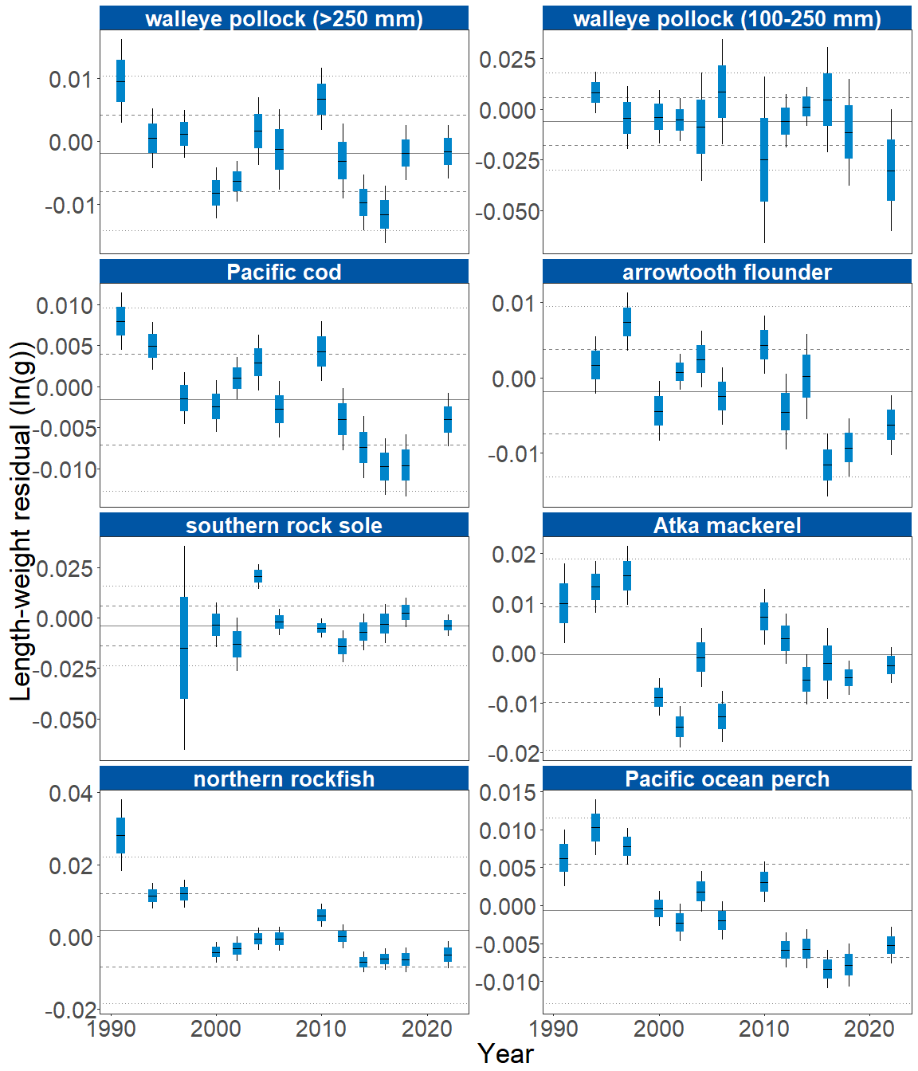

Figure 2. Weighted length-weight residuals for seven groundfish species collected during AFSC/RACE GAP standard summer bottom trawl surveys of the Aleutian Islands, 1991–2024. Filled bars denote weighted length-weight residuals using this year’s indicator calculation. Error bars denote standard errors, thin black lines are 2 standard errors and thick blue boxes are 1 standard error.

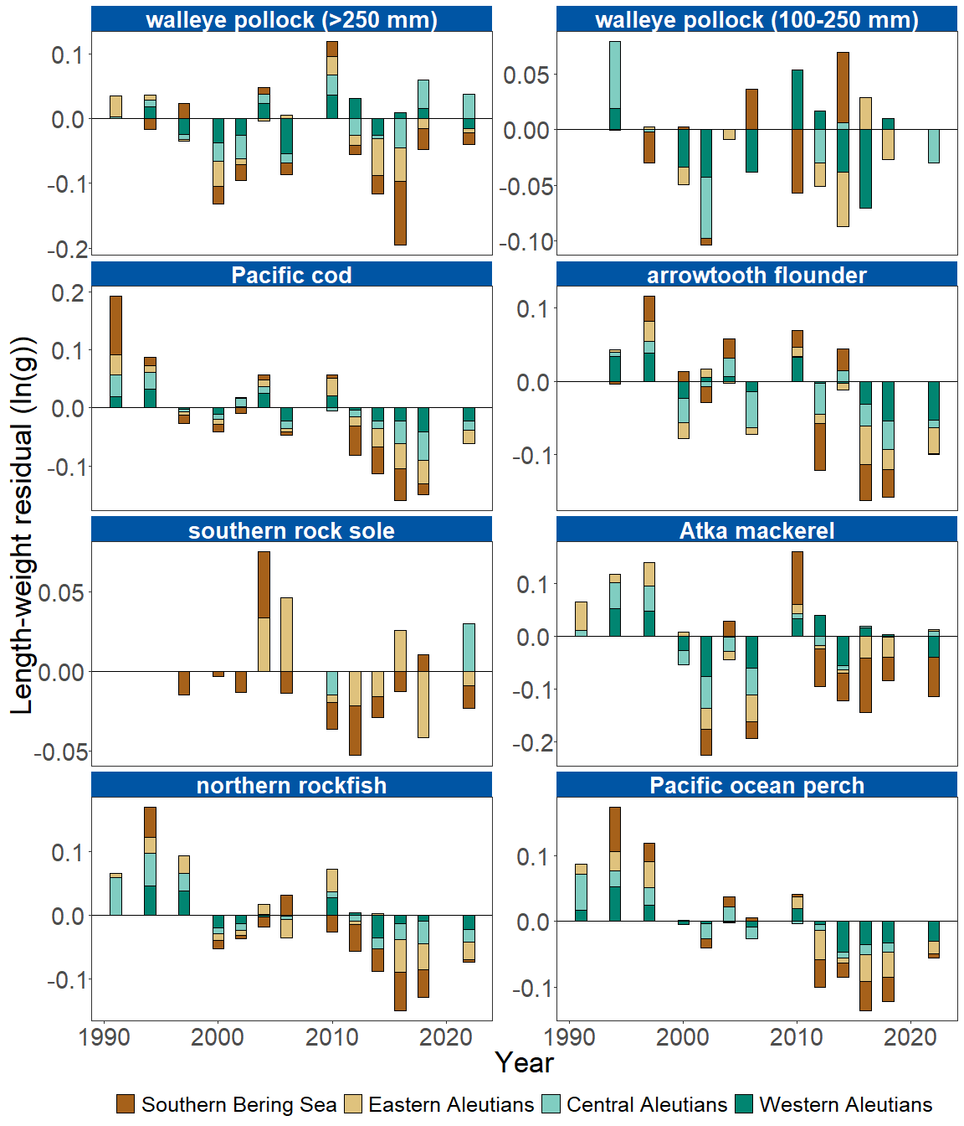

Figure 3. Residual body condition index for Aleutian Islands groundfish species collected on the National Marine Fisheries Service (NMFS) Alaska Fisheries Science Center Resource Assessment and Conservation Engineering (AFSC/RACE) Groundfish Assessment Program (GAP) standard summer bottom trawl survey (1991–2024) grouped by International North Pacific Fisheries Commission (INPFC) statistical sampling strata.

**Factors causing observed trends**: Several factors could affect morphological condition, including water temperature. Since the Warm Blob in 2014 (Bond et al., 2015; Stabeno & Bell, 2019), there has been a general trend of warming ocean temperatures in the survey area through 2022 that could affect fish growth conditions there. The influence of temperature on growth rates depends on the physiology of predator species, prey availability, and the adaptive capacity of predators to respond to environmental change through migration, changes in behavior, and acclimatization. Thus, the factors underpinning the negative or neutral condition remain unclear.

Other factors that could affect morphological condition include survey timing, stomach fullness, fish movement patterns, sex, and environmental conditions (Froese, 2006). Changing ocean conditions along with normal patterns of movement can cause the proportion of the population resident in the sampling area during the annual bottom trawl survey to vary. The date that the first length-weight data are collected is generally in the beginning of June and the bottom trawl survey is conducted throughout the summer months moving from east to west so that spatial and temporal trends in fish growth over the season become confounded with survey progress. We can expect some fish to exhibit seasonal or ontogenetic movement patterns during the survey months. Effects of survey timing on body condition can be further compounded by seasonal fluctuations in reproductive condition with the buildup and depletion of energy stores (Wuenschel et al., 2019). Another consideration is that fish weights sampled at sea include gut content weights so variation in gut fullness may influence weight measurements. Since feeding conditions vary over space and time, prey consumption rates and the proportion of total body weight attributable to gut contents may also be an important factor influencing length-at-weight.

Finally, although condition indicators characterizes spatial and temporal variation in morphometric condition of groundfish species in the Aleutian Islands, it does not inform the mechanisms or processes behind the observed patterns.

**Implications**: Fish morphometric condition can be considered an indicator of ecosystem productivity with implications for fish survival, maturity, and reproduction. For example, in Prince William Sound, the pre-winter condition of herring may determine their overwinter survival (Paul & Paul, 1999), differences in feeding conditions have been linked to differences in morphometric condition of pink salmon in Prince William Sound (Boldt & Haldorson, 2004), variation in morphometric condition has been linked to variation in maturity of sablefish (Rodgveller, 2019), and lower morphometric condition of Pacific cod was associated with higher mortality and lower growth rates during the 2014–2016 marine heat wave in the Gulf of Alaska (Barbeaux et al., 2020). The condition of Aleutian Islands groundfish may similarly contribute to survival and recruitment and provide insight into ecosystem productivity, fish survival, demographic status, and population health. The condition of Aleutian Islands groundfish may similarly contribute to survival and recruitment and provide insight into ecosystem productivity, fish survival, demographic status, and population health.

Survivorship is likely affected by many factors not examined here. As future years are added to the time series, the relationship between length-weight residuals and subsequent survival will be examined further. It is important to consider that residual body condition for most species in these analyses was computed for all sizes and sexes combined. Requirements for growth and survivorship differ for different fish life stages and some species have sexually dimorphic growth patterns. It may be more informative to examine life-stage (e.g., early juvenile, subadult, and adult phases) and sex specific body condition in the future for more insight into individual health and survivorship (Froese, 2006).

The trend toward lowered body condition for many Aleutian Islands species from 2010 to 2018 RACE/AFSC GAP bottom trawl surveys (i.e., increasingly negative length-weight residuals) is a potential cause for concern. However, the increase in body condition for all groundfish species in 2022 may portend a reversal of the trend. Recent downward trends in body condition could indicate poor overwinter survival or may reflect the influence of locally changing environmental conditions depressing fish growth, local production, or survivorship. Indications are that the Warm Blob (Bond et al., 2015; Stabeno & Bell, 2019) has been followed by years with elevated water temperatures (e.g., Barbeaux et al. (2020)) which may be related to changes in fish condition in the species examined. As we continue to add years of fish condition to the record and expand on our knowledge of the relationships between condition, growth, production, and survival, we hope to gain more insight into the overall health of fish populations in the Aleutian Islands.

**Research priorities**: The new model-based condition indicator (VAST relative condition) will be further explored for biases and sensitivities to data, model structure, and parameterization. Specifically, the 100-250 mm walleye pollock VAST relative condition indicator model does not converge, and so further model structure and parameterization research is needed. Research is also being planned and implemented across multiple AFSC programs to explore standardization of statistical methods for calculating condition indicators, and to examine relationships among putatively similar indicators of fish condition (i.e., morphometric, bioenergetic, physiological). Finally, we plan to explore variation in condition indices between life history stages alongside density dependence and climate change impacts (Bolin et al., 2021; Oke et al., 2022).

## References

Barbeaux, S. J., Holsman, K., & Zador, S. (2020). Marine heatwave stress test of ecosystem-based fisheries management in the Gulf of Alaska Pacific cod fishery. *Frontiers in Marine Science*, *7*, 1–21. <https://doi.org/10.3389/fmars.2020.00703>

Blackwell, B. G., Brown, M. L., & Willis, D. W. (2000). Relative weight (Wr) status and current use in fisheries assessment and management. *Reviews in Fisheries Science*, *8*(1), 1–44. <https://doi.org/10.1080/10641260091129161>

Boldt, J. L., & Haldorson, L. J. (2004). Size and condition of wild and hatchery pink salmon juveniles in Prince William Sound, Alaska. *Transactions of the American Fisheries Society*, *133*(1), 173–184. <https://doi.org/10.1577/t02-138>

Bolin, J. A., Schoeman, D. S., Evans, K. J., Cummins, S. F., & Scales, K. L. (2021). Achieving sustainable and climate‐resilient fisheries requires marine ecosystem forecasts to include fish condition. *Fish and Fisheries*, *22*(5), 1067–1084. <https://doi.org/10.1111/faf.12569>

Bond, N. A., Cronin, M. F., Freeland, H., & Mantua, N. (2015). Causes and impacts of the 2014 warm anomaly in the NE Pacific. *Geophysical Research Letters*, *42*(9), 3414–3420. <https://doi.org/10.1002/2015GL063306>

Froese, R. (2006). Cube law, condition factor and weight-length relationships: History, meta-analysis and recommendations. *Journal of Applied Ichthyology*, *22*(4), 241–253. <https://doi.org/10.1111/j.1439-0426.2006.00805.x>

Oke, K. B., Mueter, F. J., & Litzow, M. A. (2022). Warming leads to opposite patterns in weight-at-age for young versus old age classes of Bering Sea walleye pollock. *Canadian Journal of Fisheries and Aquatic Sciences*. <https://doi.org/10.1139/cjfas-2021-0315>

Paul, A. J., & Paul, J. M. (1999). Interannual and regional variations in body length, weight and energy content of age-0 Pacific herring from Prince William Sound, Alaska. *Journal of Fish Biology*, *54*(5), 996–1001. <https://doi.org/10.1006/jfbi.1999.0927>

Rodgveller, C. J. (2019). The utility of length, age, liver condition, and body condition for predicting maturity and fecundity of female sablefish. *Fisheries Research*, *216*(October 2018), 18–28. <https://doi.org/10.1016/j.fishres.2019.03.013>

Stabeno, P. J., & Bell, S. W. (2019). Extreme conditions in the Bering Sea (2017–2018): record-breaking low sea-ice extent. *Geophysical Research Letters*, *46*(15), 8952–8959. <https://doi.org/10.1029/2019GL083816>

Wuenschel, M. J., McElroy, W. D., Oliveira, K., & McBride, R. S. (2019). Measuring fish condition: An evaluation of new and old metrics for three species with contrasting life histories. *Canadian Journal of Fisheries and Aquatic Sciences*, *76*(6), 886–903. <https://doi.org/10.1139/cjfas-2018-0076>