GAP Production Data Documentation
Bering Sea Survey Team
Gulf of Alaska Survey Team
Aleutian Islands Survey Team
Table of contents

1. Survey Background

1.1 What we do

1.2 Who is conducting the research?
Scientists from the Alaska Fisheries Science Center’s Groundfish Assessment Program (GAP) conduct these bottom trawl surveys with participation from the Alaska Department of Fish & Game (ADF&G), the International Pacific Halibut Commission (IPHC), universities, and other organizations. This research is conducted primarily on chartered fishing vessels.

1.3 What is the research objective?
Learn more about the program. The objectives of these surveys are to:
- monitor the population and environmental trends in the marine ecosystem of the Bering Sea, Aleutian Islands, and Gulf of Alaska,
- produce fishery-independent biomass (weight) and abundance (number) estimates for commercially important fish and crab species, and
- collect other biological and environmental data for use in ecosystem-based fishery management.

1.4 Who is conducting the research?
Scientists from the Alaska Fisheries Science Center conduct these bottom trawl surveys with participation from the Alaska Department of Fish & Game (ADF&G), the International Pacific Halibut Commission (IPHC), and universities. This research is conducted on chartered fishing vessels.

1.5 Bottom trawl surveys and regions
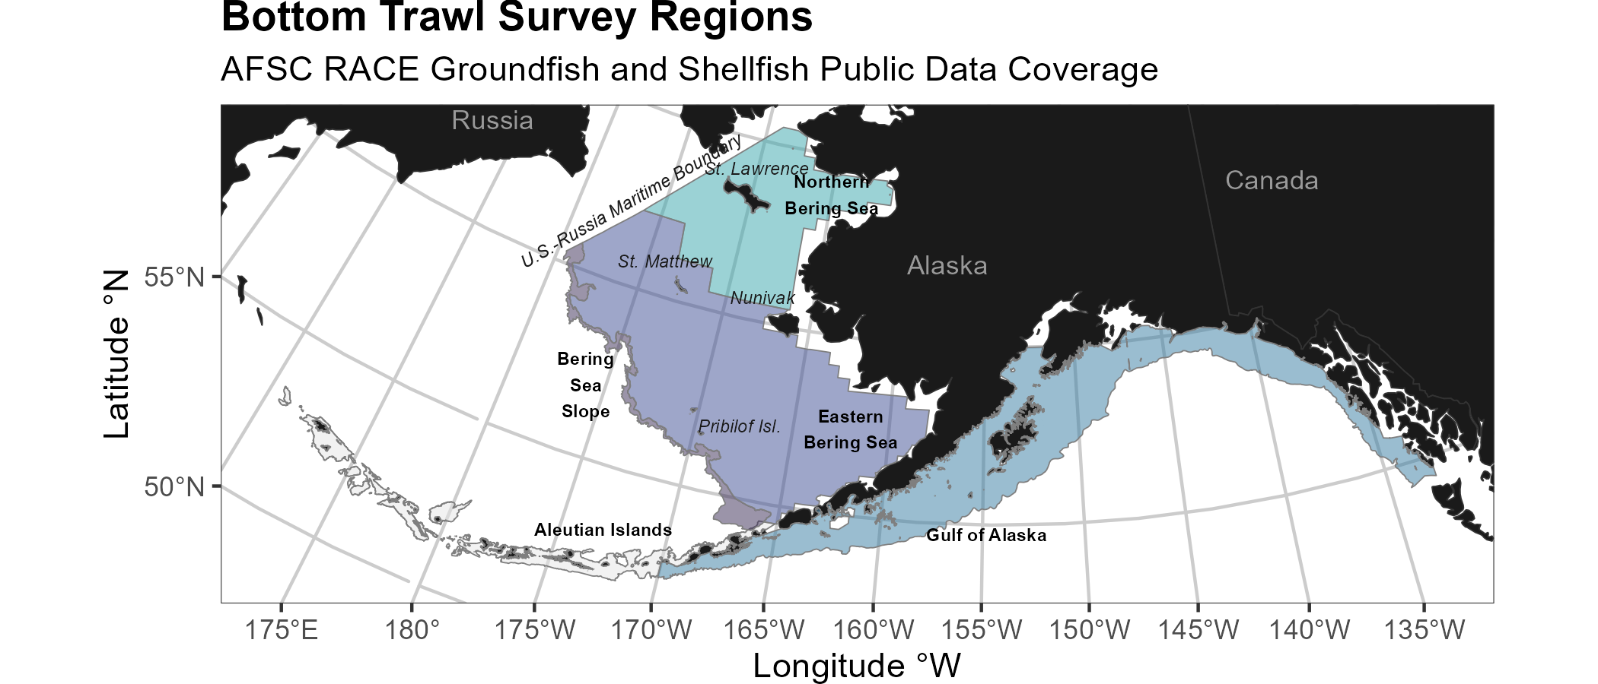
Strata used in the all surveys.
Each survey conducted by the Groundfish Assessment Program are multispecies bottom trawl surveys. We collect environmental and biological data to assess how climate variability and loss of sea ice are affecting bottom-dwelling marine life on the Bering Sea shelf. We monitor trends in the distribution (location and movement patterns) and abundance of groundfish and crab species as well as oceanographic data (e.g., water temperature, depth). We collect biological information such as organism weight, length, stomachs to learn about diets, and otoliths to determine fish ages. We use this information in annual stock assessments and to assess the state of the ecosystem. This research is conducted on fishing industry contract vessels.
Survey | Survey Definition ID | Years | Depth (m) | Area (km2) | # Statistical Areas | # Possible Stations
Aleutian Islands Bottom Trawl Survey | 52 | 2026 - 1991 (15) | 1 - 500 | 64,415.0 | 80 | 1,312
Eastern Bering Sea Slope Bottom Trawl Survey | 78 | 2016 - 2002 (6) | 201 - 1,200 | 32,861.3 | 37
Eastern Bering Sea Crab/Groundfish Bottom Trawl Survey | 98 | 2026 - 1982 (44) | 1 - 200 | 492,989.9 | 28 | 515
Gulf of Alaska Bottom Trawl Survey | 47 | 2025 - 1990 (17) | 1 - 1,000 | 315,501.9 | 37 | 6,939
Northern Bering Sea Crab/Groundfish Survey - Eastern Bering Sea Shelf Survey Extension | 143 | 2025 - 2010 (7) | 1 - 100 | 189,191.4 | 4 | 144

1.5.1 Aleutian Islands
Most recent data report: (Dowlin et al., 2026)
- Upper Continental Slope of the Aleutian Islands from Unimak Pass to Stalemate Bank
- Triennial (1990s)/Biennial since 2000 in even years, since 1992
- Modified Index-Stratified Random of Successful Stations Survey Design
- Important commercial fish species include Atka mackerel, Pacific ocean perch, walleye pollock, Pacific cod, sablefish, and other rockfish species.
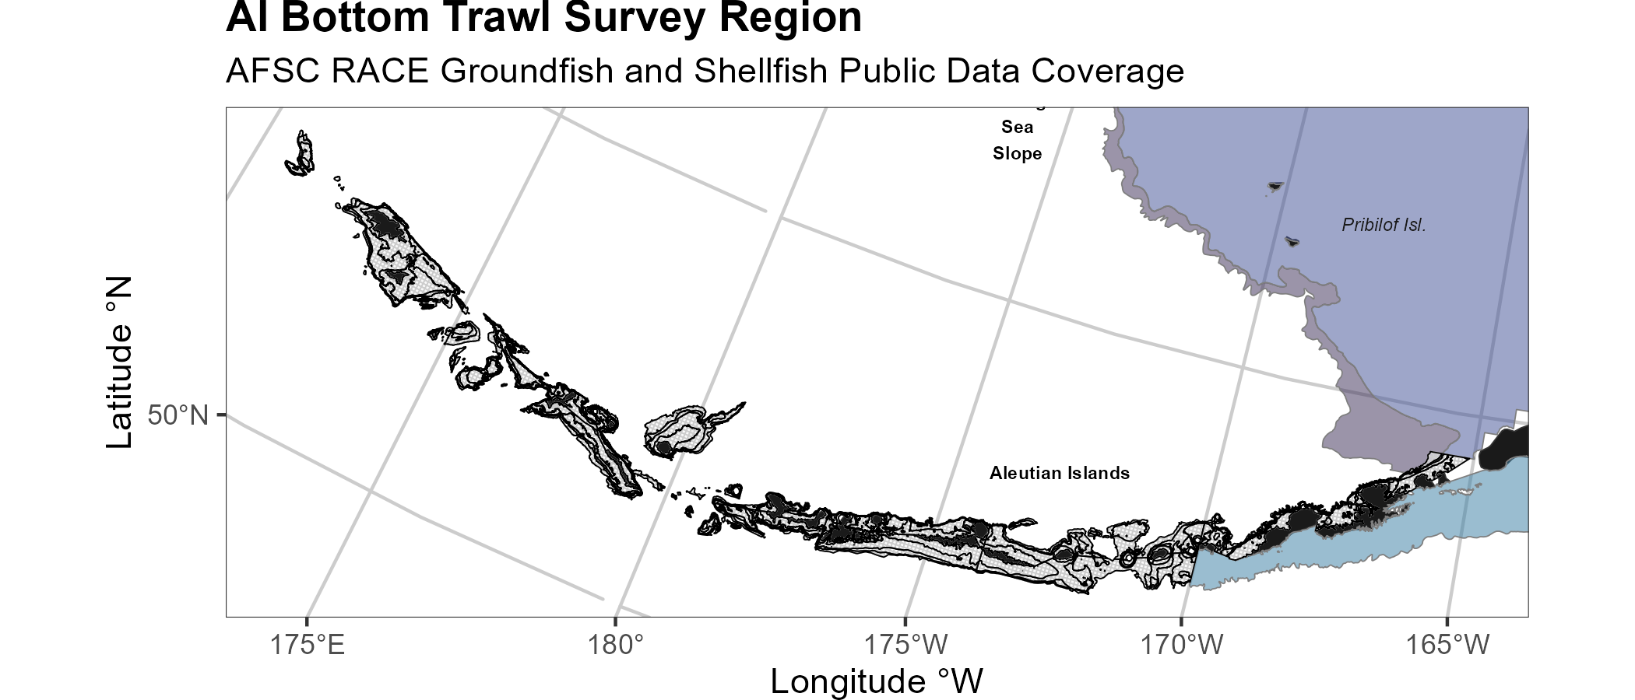
Strata used in the Aleutian Islands bottom trawl survey.

1.5.2 Gulf of Alaska
Most recent data report: (Siple et al., 2026)
- Continental Shelf and Upper Slope of the Gulf of Alaska extending from the Islands of Four Mountains 2,300 km east to Dixon Entrance
- Triennial (1990s)/Biennial since 2001 in odd years, since 1991
- Stratified Random Survey Design
- Important commercial species in the Gulf of Alaska include Pacific ocean perch, walleye pollock, Pacific cod, flatfish, and other rockfish species.
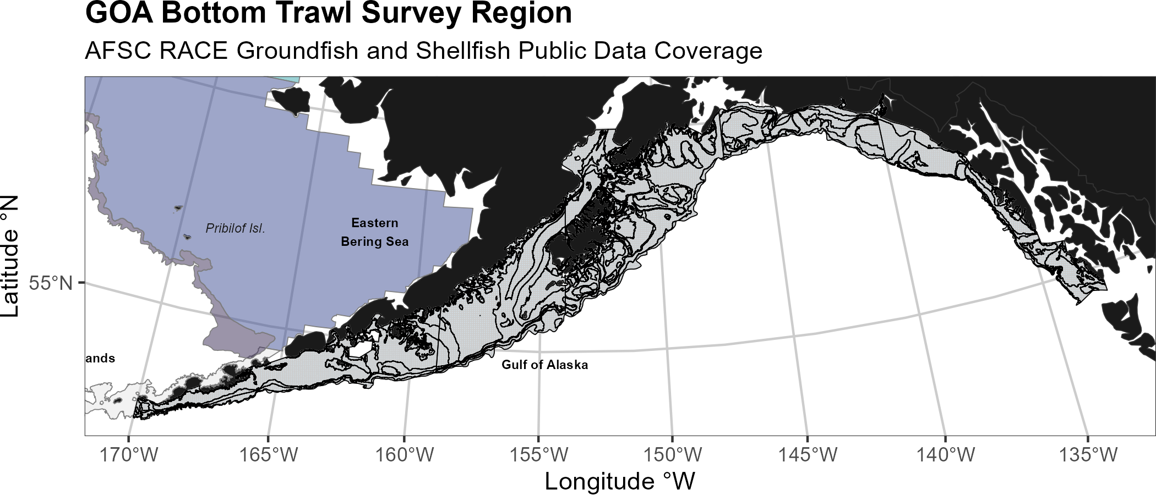
Strata used in the Gulf of Alaska bottom trawl survey.

1.5.3 Eastern Bering Sea Shelf
Most recent data report: (Markowitz et al., 2026)
- The continental shelf of the eastern Bering Sea from the Aleutian Islands to the Bering Strait
- Conducted annually since 1982.
- Uses a stratified systematic sampling survey design with fixed stations at center of 20 x 20 nm grid.
- Similar in design to the northern Bering Sea shelf bottom trawl survey.
- Focus species for the Bering Sea include walleye pollock, Pacific cod, Greenland turbot, yellowfin sole, northern rock sole, red king crab, and snow and Tanner crabs.
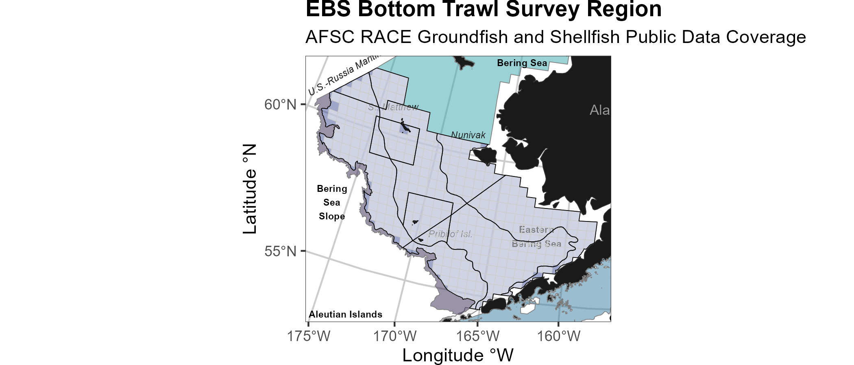
Strata used in the Eastern Bering Sea bottom trawl survey.

1.5.4 Northern Bering Sea
Most recent data report: (Markowitz et al., 2026)
- The continental shelf of the northern Bering Sea, including the area north of St. Lawrence Island and Norton Sound
- Biennial/Annual; conducted intermittently since 2010
- Uses a stratified systematic sampling survey design with fixed stations at center of 20 x 20 nm grid.
- Similar in design to the eastern Bering Sea shelf bottom trawl survey.
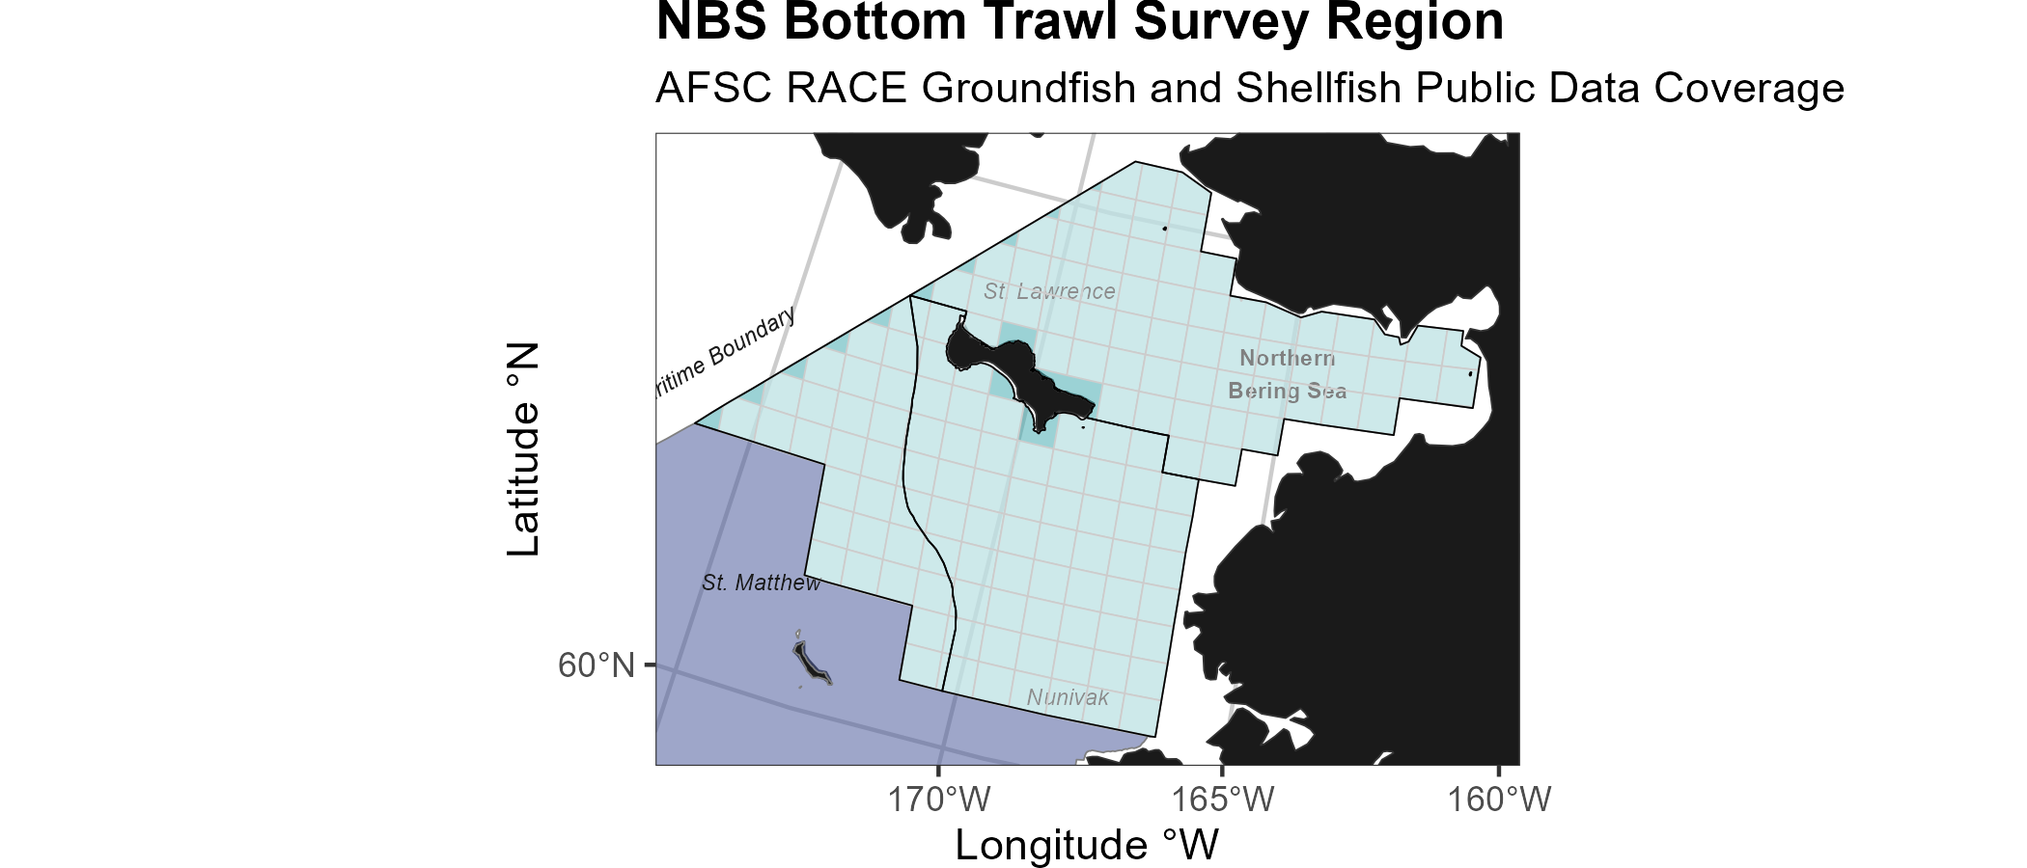
Strata used in the Northern Bering Sea bottom trawl survey.

1.5.5 Eastern Bering Sea Upper Continental Slope
Most recent data report: (Hoff, 2016)
- The eastern Bering Sea upper continental slope survey area extends from Unalaska and Akutan Islands to the U.S.-Russian Maritime Boundary at 61° N near the International Date Line (166° E to 180° W) at depths from 200 to 1,200 m
- Conducted intermittently since 2002 (funding dependent)
- Modified Index-Stratified Random of Successful Stations Survey Design
- Focus species for the Bering Sea slope include giant grenadier, Pacific ocean perch, popeye grenadier, walleye pollock, and arrowtooth flounder.
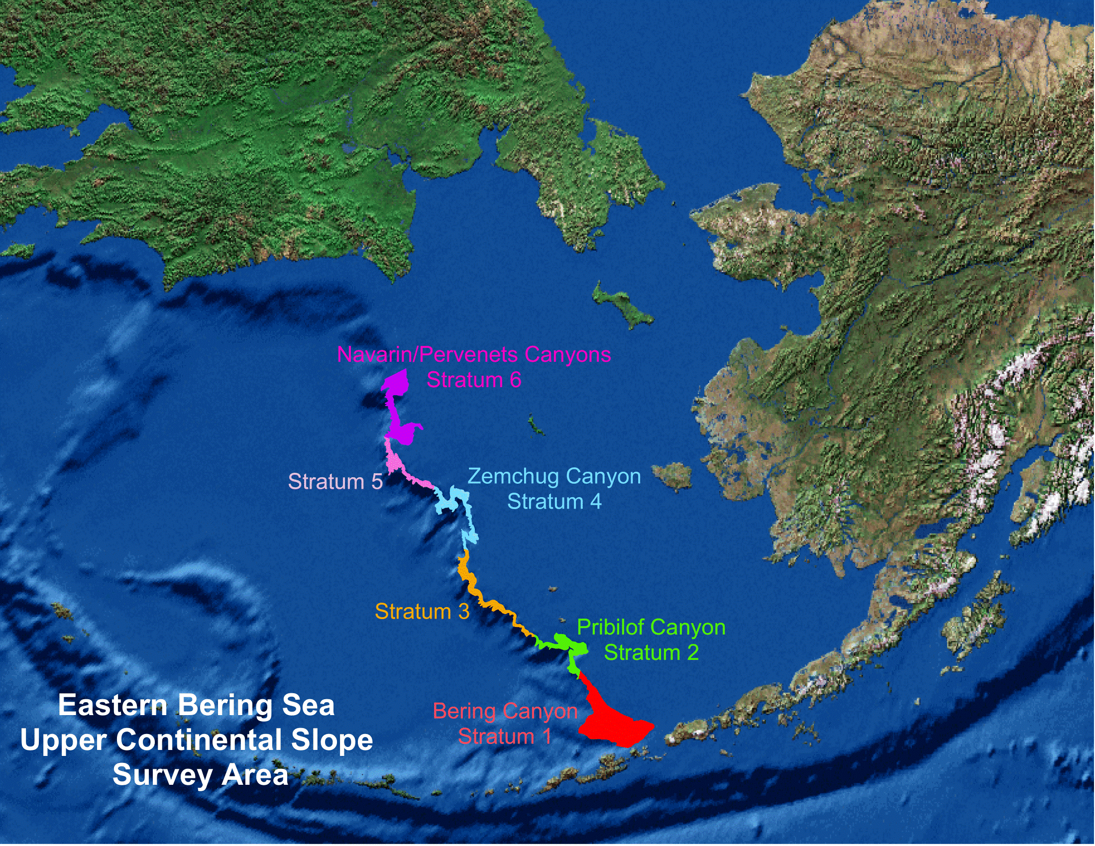
Strata used in the Bering Sea Slope bottom trawl survey.

2. Workflow

2.1 Operational Product Development Timeline
Over the course of the year, the survey team is developing a variety of different data products. Planning and preparation for surveys happens in the late winter and spring, surveys occur in the summer, data validation takes place over the course of the survey and after the survey, and data products are produced through fall and late winter.
 | January | February | March | April | May | June | July | August | September | October | November | December
Surveys |  |  |  |  | 1 | 1 | 1 | 1
Planning | 1 | 1 | 1 |  |  |  |  |  | 1 | 1 | 1 | 1
Development | 1 | 1 | 1 | 1 | 1 |  |  |  |  | 1 | 1 | 1
Deployment (survey deliverables) |  |  |  |  |  |  |  |  | 1 | 1 | 1 | 1
Deployment (survey operations) |  |  |  |  | 1 | 1 | 1 | 1
Triage (fixing bugs and errors) | 1 | 1 | 1 | 1 | 1 | 1 | 1 | 1 | 1 | 1 | 1 | 1
User feedback and brainstorming | 1 | 1 | 1 | 1 | 1 | 1 | 1 | 1 | 1 | 1 | 1 | 1

2.2 Data workflow from boat to production
Organisms first need to be collected aboard the vessel before data can be entered into tablets.
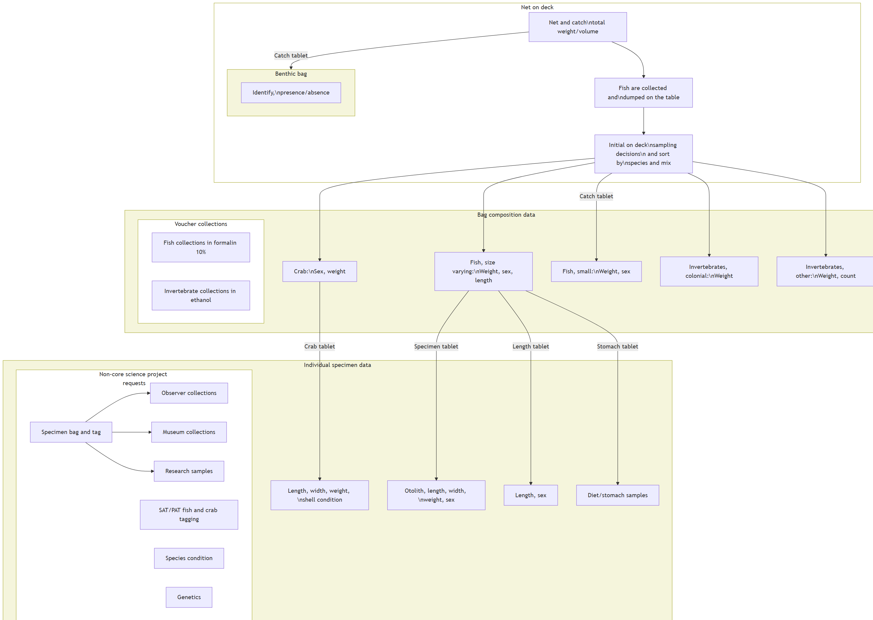
Figure 2.1: Simplified boat deck processing workflow.
The objective of this process is to take raw data, QA/QC and clean these data, curate standard data products for these survey. Please note, through this process we are not providing “data” (what we consider lower level data material; see the data levels section below) but “data products”, which is intended to facilitate the most fool-proof standard interpretation of the data. These data products only use data from standard and validated hauls, and has undergone careful review.
Once survey data collected on the vessel has been checked and validated, the gap_products/code/run.R script is used to orchestrate a sequence of programs that calculate the standard data products resulting from the NOAA AFSC GAP bottom trawl surveys. Standard data products are the CPUE, BIOMASS, SIZECOMP, and AGECOMP tables in the GAP_PRODUCTS Oracle schema. The tables are slated to be updated twice a year: once after the survey season following finalization of that summer’s bottom trawl survey data to incorporate the new catch, size, and effort data and once prior to an upcoming survey to incorporate new age data that were processed after the prior summer’s survey season ended. This second pre-survey production run will also incorporate changes in the data due to the specimen voucher process as well as other post-hoc changes in the survey data.
The data from these surveys constitute a living data set so we can continue to provide the best available data to all partners, stakeholders, and fellow scientists.
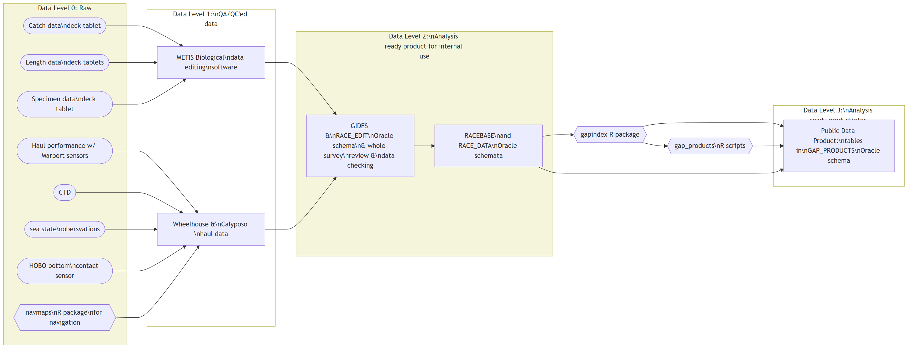
Figure 2.2: Simplified data workflow from boat to production.

2.2.1 During each data product run cycle:
- Versions of the tables in GAP_PRODUCTS are locally imported within the gap_products repository to compare with the updated production tables. Any changes to a production table will be compared and checked to make sure those changes are intentional and documented.
- Use the gapindex R package to calculate the four major standard data products: CPUE, BIOMASS, SIZECOMP, AGECOMP. These tables are compared and checked to their respective locally saved copies and any changes to the tables are vetted and documented. These tables are then uploaded to the GAP_PRODUCTS Oracle schema.
- Calculate the various materialized views for AKFIN and FOSS purposes. Since these are derivative of the tables in GAP_PRODUCTS as well as other base tables in RACEBASE and RACE_DATA, it is not necessary to check these views in addition to the data checks done in the previous steps.
TABLE NAMES | TABLE TYPE | REFRESH FREQUENCY
AGECOMP  BIOMASS  CPUE  SIZECOMP | TABLE | Quarterly: manually updated according to the following schedule  Late Summer: after survey data are finalized for each region surveyed  Early Fall: after Bering Sea pollock otoliths are read  Winter: If there are changes to the taxonomic tables  Late Spring: after Spring ages are updated
CRUISE | HAUL | LENGTH
SPECIMEN | MATERIALIZED VIEW | As needed: Refreshes any time the underlying tables for these queries change
SURVEY_DESIGN  TAXONOMIC_CLASSIFICATION  TAXONOMIC_GROUPS  TAXONOMIC_CHANGES  TAXON_GROUPS | TABLE | Annually (beginning of year): manually updated.
AREA  STRATUM_GROUPS  METADATA_COLUMN  METADATA_TABLE  SPECIES_YEAR | TABLE | As needed: manually updated.
SAMPLE_COUNT | VIEW | When queried.
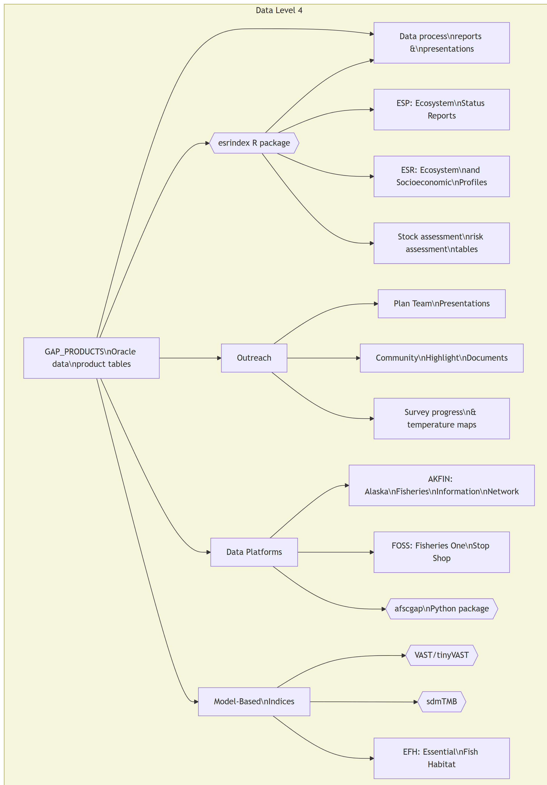
Figure 2.3: Major end-users of the GAP data product tables.

2.3 Data levels
GAP produces numerous data products that are subjected to different levels of processing, ranging from raw to highly-derived. The suitability of these data products for analysis varies and there is ambiguity about which data products can be used for which purpose. This ambiguity can create challenges in communicating about data products and potentially lead to misunderstanding and misuse of data. One approach to communicating about the level of processing applied to data products and their suitability for analysis is to describe data products using a Data Processing Level system. Data Processing Level systems are widely used in earth system sciences to characterize the extent of processing that has been applied to data products. For example, the NOAA National Centers for Environmental Information (NCEI) Satellite Program uses a Data Processing Level system to describe data on a scale of 0-4, where Level 0 is raw data and Level 4 is model output or results from analysis. Example of how NASA remote sensing data products are shared through a public data portal with levels of data processing and documentation.
For more information, see Sean Rohan’s October 2022 SCRUGS presentation on the topic.
- Level 0: Raw and unprocessed data. Ex: Data on the G drive, some tables in RACE_DATA
- Level 1: Data products with QA/QC applied that may or may not be expanded to analysis units, but either not georeferenced or does not include full metadata. Ex: Some tables in RACE_DATA and RACEBASE
- Level 2: Analysis-ready data products that are derived for a standardized extent and account for zeros and missing/bad data. Ex: CPUE tables, some data products in public-facing archives and repositories
- Level 3: Data products that are synthesized across a standardized extent, often inputs in a higher-level analytical product. Ex: Abundance indices, some data products in public-facing archives and repositories
- Level 4: Analytically generated data products that are derived from lower-level data, often to inform management. Ex: Biological reference points from stock assessments, Essential Fish Habitat layers, indicators in Ecosystem Status Reports and Ecosystem and Socioeconomic Profiles

3. News

3.1 News/change logs
– GAP_PRODUCTS ChangeLog (last produced on 2026-10-02) using gapindex v3.1.0: Run completed by: Zack Oyafuso
– GAP_PRODUCTS ChangeLog (last produced on 2026-09-10) using gapindex v3.1.0: Run completed by: Zack
– GAP_PRODUCTS ChangeLog (last produced on 2026-08-28) using gapindex v3.0.3: Run completed by: Duane Stevenson
– GAP_PRODUCTS ChangeLog (last produced on 2026-08-18) using gapindex v3.1.0: Run completed by: Zack Oyafuso
– GAP_PRODUCTS ChangeLog (last produced on 2026-06-26) using gapindex v3.1.0: Run completed by: Zack Oyafuso
– GAP_PRODUCTS ChangeLog (last produced on 2026-06-25) using gapindex v3.1.0: Run completed by: Zack Oyafuso
– GAP_PRODUCTS ChangeLog (last produced on 2026-04-24) using gapindex v3.1.0: Run completed by: Zack Oyafuso
– GAP_PRODUCTS ChangeLog (last produced on 2026-03-13) using gapindex v3.1.0: Run completed by: Zack Oyafuso
– GAP_PRODUCTS ChangeLog (last produced on 2025-09-29) using gapindex v3.0.3: Run completed by: Duane Stevenson
– GAP_PRODUCTS ChangeLog (last produced on 2025-09-22) using gapindex v3.0.3: Run completed by: Duane Stevenson
– GAP_PRODUCTS ChangeLog (last produced on 2025-08-25) using gapindex v3.0.2: Run completed by: Zack Oyafuso
– GAP_PRODUCTS ChangeLog (last produced on 2025-07-15) using gapindex v2.2.0: Run completed by: Zack Oyafuso
– GAP_PRODUCTS ChangeLog (last produced on 2025-06-05) using gapindex v3.0.2: Run completed by: Zack Oyafuso
– GAP_PRODUCTS ChangeLog (last produced on 2025-05-20) using gapindex v3.0.2: Run completed by: Zack Oyafuso
– GAP_PRODUCTS ChangeLog (last produced on 2025-04-30) using gapindex v3.0.2: Run completed by: Zack Oyafuso
– GAP_PRODUCTS ChangeLog (last produced on 2025-03-20) using gapindex v3.0.2: Run completed by: Zack Oyafuso
– GAP_PRODUCTS ChangeLog (last produced on 2024-12-10) using gapindex v3.0.2: Run completed by: Sean Rooney
– GAP_PRODUCTS ChangeLog (last produced on 2024-10-22) using gapindex v2.2.0: Run completed by: Zack Oyafuso
– GAP_PRODUCTS ChangeLog (last produced on 2024-10-21) using gapindex v2.2.0: Run completed by: Duane Stevenson, Ned Laman, Zack Oyafuso
– GAP_PRODUCTS ChangeLog (last produced on 2024-09-05) using gapindex v2.2.0: Run completed by: Ned Laman, Zack Oyafuso
– GAP_PRODUCTS ChangeLog (last produced on 2024-09-03) using gapindex v2.2.0: Run completed by: Ned Laman, Zack Oyafuso
– GAP_PRODUCTS ChangeLog (last produced on 2024-08-29) using gapindex v2.2.0: The additions of previous years’ age data and 2024 EBS catch, effort, and size data
– GAP_PRODUCTS ChangeLog (last produced on 2024-08-20) using gapindex v2.2.0: Initial 2024 post-survey run with new ages since last run and all of EBS Shelf 2024 survey data but none of AI 2024 survey data. While trying to update the records in the GAP_PRODUCTS table, the connection was terminated, partially uploading records in the agecomp tables and outputting NA to the N_HAUL and N_LENGTH fields in the biomass tables. At this point, the GAP_PRODUCTS tables are incomplete. The AKFIN and FOSS tables were NOT updated in this run.
– GAP_PRODUCTS ChangeLog (last produced on 2024-05-04) using gapindex v2.2.0: A development branch version of gapindex called using_datatable uses the data.table package for many dataframe manipulations, which greatly decreased the computation time of many of the functions. There were no major changes in the calculations in this version of the gapindex package and thus the major changes listed below are not related to the gapindex package. The only major change from this run was the addition of GOA 2023 Pacific Ocean perch read otolith data.
– GAP_PRODUCTS ChangeLog (last produced on 2024-04-09) using gapindex v2.2.0: A development branch version of gapindex called using_datatable uses the data.table package for many dataframe manipulations, which greatly decreased the computation time of many of the functions. There were no major changes in the calculations in this version of the gapindex package and thus the major changes listed below are not related to the gapindex package.
– GAP_PRODUCTS ChangeLog (last produced on 2024-02-29) using gapindex v2.2.0: A new version of gapindex 2.2.0 was used for this production run and now accesses taxonomic information from RACEBASE.SPECIES instead of GAP_PRODUCTS.TAXONOMIC_CLASSIFICATION. As a result, there will be some SPECIES_CODE values that are supported due to slight differences between the two tables. Discussion in this github issue #54. As a result there are new cpue records for SPECIES_CODE values 22290 and 22292 and removed cpue records for SPECIES_CODE values 21345, 22200 and 69326.
– GAP_PRODUCTS ChangeLog (last produced on 2024-01-09) using gapindex v2.1.3: A new version of gapindex (v2.1.3) was used to produced these data. Data for SPECIES_CODE 68590 (Chionoecetes hybrids) are now removed, per this issue (https://github.com/afsc-gap-products/gap_products/issues/3). New read otolith data were incorporated into the age compositions. GOA depth subareas are now included in the size comps, and there were some modifications with EBS skate length data that are now incorporated into the length compositions.
– GAP_PRODUCTS ChangeLog (last produced on 2023-11-17) using gapindex v2.1.2: A new version of gapindex (v2.1.2) was used to produced these data. There was a slight change to how subarea biomass totals are calculated that was not fully addressed in v2.1.1. The modified biomass records reflect this change.
– GAP_PRODUCTS ChangeLog (last produced on 2023-11-14) using gapindex v2.1.1: A new version of gapindex (v2.1.1) was used to produced these data. There was a slight change to how subarea biomass totals are calculated. The modified biomass records reflect this change. New 2022 otolith data were available since the last iteration of the GAP_PRODUCTS for Aleutian Island Pacific ocean perch and northern rockifsh and Eastern Bering Sea northern rock sole. Zero-filled CPUE records for four GOA species codes (SPECIES_CODE: 21210, 30010, 30360, 77102, 98101) were added due to how the 1990 data were integrated in the last production run of GAP_PRODUCTS. Two Arctic cod (SPECIES_CODE: 21725) and one plain sculpin (SPECIES_CODE: 21371) count records were modified in the NBS data, which changes the numerical CPUE estimates for those hauls which changes the estimated population abundance and size composition for those species.
– Groundfish Assessment Program Survey Data Serving and Data Improvements: Initial data changes brief distributed to SSMA and other partners by Ned Laman, Zack Oyafuso, and Emily Markowitz
– Run 2023-06-01 gapindex v2.1.0: Initial compiling and planning notes

4. Code of Conduct

4.1 What are Codes of Conduct?
Codes of Conduct are voluntary sets of rules that assist creators, developers, and users of code and data with data protection compliance and accountability in specific sectors or relating to particular processing operations.
Codes can help organizations to ensure all participants follow best practices and rules designed specifically for their sector or processing operations, thus enhancing compliance and collaboration. They are developed and managed by an association or other body (the ‘Code Owner’) which is representative of a sector (or category of data controllers or processors), with the expert and sectoral knowledge of how to enhance data protection in their area.

4.1.1 Code of Conduct from the nmfs-opensci GitHub.

5. NOAA Fisheries Open Science Code of Conduct
This code of conduct was developed and adapted from the Atom code of conduct in October 2021.

5.1 Our Pledge
In the interest of fostering an open and welcoming environment, we as contributors and maintainers pledge to making participation in our project and our community a harassment-free experience for everyone, regardless of age, body size, disability, ethnicity, gender identity and expression, level of experience, nationality, personal appearance, race, religion, or sexual identity and orientation.

5.2 Our Standards
Examples of behavior that contributes to creating a positive environment include:
- Using welcoming and inclusive language
- Being respectful of differing viewpoints and experiences
- Gracefully accepting constructive criticism
- Focusing on what is best for the community
- Showing empathy towards other community members
Examples of unacceptable behavior by participants include:
- The use of sexualized language or imagery and unwelcome sexual attention or advances
- Trolling, insulting/derogatory comments, and personal or political attacks
- Public or private harassment
- Publishing others’ private information, such as a physical or electronic address, without explicit permission
- Other conduct which could reasonably be considered inappropriate in a professional setting

5.3 Our Responsibilities
Project maintainers are responsible for clarifying the standards of acceptable behavior and are expected to take appropriate and fair corrective action in response to any instances of unacceptable behavior.
Project maintainers have the right and responsibility to remove, edit, or reject comments, commits, code, wiki edits, issues, and other contributions that are not aligned to this Code of Conduct, or to ban temporarily or permanently any contributor for other behaviors that they deem inappropriate, threatening, offensive, or harmful.

5.4 Scope
This Code of Conduct applies both within project spaces and in public spaces when an individual is representing the project or its community. Examples of representing a project or community include using an official project e-mail address, posting via an official social media account, or acting as an appointed representative at an online or offline event. Representation of a project may be further defined and clarified by project maintainers.

5.5 Enforcement
Instances of abusive, harassing, or otherwise unacceptable behavior may be reported by contacting the project team. All complaints will be reviewed and investigated and will result in a response that is deemed necessary and appropriate to the circumstances. Further details of specific enforcement policies may be posted separately.

5.6 Attribution
This Code of Conduct is adapted from the Contributor Covenant, version 1.4, available at https://contributor-covenant.org/version/1/4

6. Data Description

6.1 Data tables

6.1.1 AGECOMP
Stratum- and region-level age compositions by sex. This table was created by the Resource Assessment and Conservation Engineering Division (RACE) Groundfish Assessment Program (GAP) of the Alaska Fisheries Science Center (AFSC). The GitHub repository for the scripts that created this code can be found at (https://github.com/afsc-gap-products/gap_products). There are no legal restrictions on access to the data. Last updated on 14 March 2026.
Number of rows: 680,450
Number of columns: 10
Column name from data
Descriptive column Name
Units
Oracle data type
Column description
SURVEY_DEFINITION_ID
Survey ID
ID key code
NUMBER(38,0)
The survey definition ID key code is an integer that uniquely identifies a survey region/survey design. The column survey_definition_id is associated with the srvy and survey columns. Full list of survey definition IDs are in RACE_DATA.SURVEY_DEFINITIONS and in the code books.
YEAR
Survey year
year
NUMBER(10,0)
Year the observation (survey) was collected.
AREA_ID
Area ID
ID key code
NUMBER(38,0)
An ID code representing a broad range of spatial areas from statistical sampling strata to management and regional areas composed of multiple strata.
SPECIES_CODE
Taxon code
ID key code
NUMBER(38,0)
The species code of the organism associated with the common_name and scientific_name columns. For a complete species list, review the code books.
SEX
Sex of a specimen
ID key code
NUMBER(38,0)
Sex of a specimen where “1” = “Male”, “2” = “Female”, “3” = Unsexed.
AGE
Taxon age bin (yrs)
integer
NUMBER(38,0)
Age bin of taxon. Age bin of a taxon in years estimated by the age comp estimate. Age -9 indicates unaged lengths for a particular sex because no otoliths were collected for that sex/length combination. Age -99 indicates a case where no lengths were collected within a stratum for a species/year even though catch numbers were recorded.
POPULATION_COUNT
Estimated population
numeric
NUMBER(38,0)
The estimated population caught in the survey for a species, group, or total for a given survey.
LENGTH_MM_MEAN
Mean length at age weighted by numbers at length
numeric
NUMBER(38,3)
Mean length (millimeters).
LENGTH_MM_SD
Standard deviation of length at age weighted by numbers at length
numeric
NUMBER(38,3)
Variance of mean length.
AREA_ID_FOOTPRINT
Survey Footprint
text
VARCHAR2(4000 BYTE)
Survey footprint, usually equivalent to the SURVEY_DEFINITION_ID with the exception of the Standard and Standard +NW survey footprints in the Eastern Bering Sea shelf bottom trawl survey.

6.1.2 AREA
Information related to the various strata, subareas, INPFC and NMFS management areas, and regions for the Aleutian Islands, Gulf of Alaska, and Bering Sea shelf and slope bottom trawl surveys. This table was created by the Resource Assessment and Conservation Engineering Division (RACE) Groundfish Assessment Program (GAP) of the Alaska Fisheries Science Center (AFSC). The GitHub repository for the scripts that created this code can be found at (https://github.com/afsc-gap-products/gap_products). There are no legal restrictions on access to the data. Last updated on 14 March 2026.
Number of rows: 499
Number of columns: 9
Column name from data
Descriptive column Name
Units
Oracle data type
Column description
DESIGN_YEAR
Design year
year
NUMBER(10,0)
Year ID associated with a given value AREA_ID. This field describes the changes in the survey design over time.
SURVEY_DEFINITION_ID
Survey ID
ID key code
NUMBER(38,0)
The survey definition ID key code is an integer that uniquely identifies a survey region/survey design. The column survey_definition_id is associated with the srvy and survey columns. Full list of survey definition IDs are in RACE_DATA.SURVEY_DEFINITIONS and in the code books.
AREA_ID
Area ID
ID key code
NUMBER(38,0)
An ID code representing a broad range of spatial areas from statistical sampling strata to management and regional areas composed of multiple strata.
AREA_TYPE
Area ID type description
category
VARCHAR2(255 BYTE)
The type of stratum that AREA_ID represents. Types include: STRATUM (the smallest building-block unit of area in these surveys), REGION, DEPTH, SUBAREA, INPFC BY DEPTH, INPFC, SUBAREA BY DEPTH, REGULATORY AREA, NMFS STATISTICAL AREA.
AREA_NAME
Area ID name
text
VARCHAR2(4000 BYTE)
Descriptive name of each AREA_ID. These names often identify the region, depth ranges, or other regional information for the area ID.
DESCRIPTION
Description
text
VARCHAR2(4000 BYTE)
Description of row observation.
AREA_KM2
Area (km2)
kilometers squared
NUMBER(38,3)
Area in square kilometers.
DEPTH_MIN_M
Area ID minimum depth (m)
meters
NUMBER(38,3)
Minimum depth (meters).
DEPTH_MAX_M
Area ID maximum depth (m)
meters
NUMBER(38,3)
Maximum depth (meters).

6.1.3 BIOMASS
Stratum/subarea/region-level mean CPUE (weight and numbers), total biomass, and total abundance with associated variances. This table was created by the Resource Assessment and Conservation Engineering Division (RACE) Groundfish Assessment Program (GAP) of the Alaska Fisheries Science Center (AFSC). The GitHub repository for the scripts that created this code can be found at (https://github.com/afsc-gap-products/gap_products). There are no legal restrictions on access to the data. Last updated on 14 March 2026.
Number of rows: 2,655,773
Number of columns: 16
Column name from data
Descriptive column Name
Units
Oracle data type
Column description
SURVEY_DEFINITION_ID
Survey ID
ID key code
NUMBER(38,0)
The survey definition ID key code is an integer that uniquely identifies a survey region/survey design. The column survey_definition_id is associated with the srvy and survey columns. Full list of survey definition IDs are in RACE_DATA.SURVEY_DEFINITIONS and in the code books.
YEAR
Survey year
year
NUMBER(10,0)
Year the observation (survey) was collected.
SPECIES_CODE
Taxon code
ID key code
NUMBER(38,0)
The species code of the organism associated with the common_name and scientific_name columns. For a complete species list, review the code books.
AREA_ID
Area ID
ID key code
NUMBER(38,0)
An ID code representing a broad range of spatial areas from statistical sampling strata to management and regional areas composed of multiple strata.
CPUE_KGKM2_MEAN
Mean weight CPUE
kilograms per kilometers squared
NUMBER(38,6)
The mean catch weight (kilograms) per unit effort (area swept by the net, units squared kilometers).
CPUE_NOKM2_MEAN
Mean numeric CPUE
count per kilometers squared
NUMBER(38,6)
The mean of numerical catch per unit effort (area swept by the net, units square kilometers).
N_HAUL
Valid hauls
count
NUMBER(38,0)
Total number of hauls.
N_WEIGHT
Hauls with catch
count
NUMBER(38,0)
Total number of hauls with positive catch biomass.
N_COUNT
Hauls with taxon counts
numeric
NUMBER(38,0)
Total number of hauls with positive count data.
N_LENGTH
Hauls with taxon lengths
count
NUMBER(38,0)
Total number of hauls with length data.
BIOMASS_MT
Estimated biomass
numeric
NUMBER(38,6)
The estimated total biomass.
BIOMASS_VAR
Estimated biomass variance
numeric
NUMBER(38,6)
The estimated variance associated with the total biomass.
POPULATION_COUNT
Estimated population
numeric
NUMBER(38,0)
The estimated population caught in the survey for a species, group, or total for a given survey.
POPULATION_VAR
Estimated population variance
numeric
NUMBER(38,6)
The estimated population variance caught in the survey for a species, group, or total for a given survey.
CPUE_KGKM2_VAR
Variance of the mean weight CPUE
kilograms per kilometers squared
NUMBER(38,6)
The variance of mean catch weight (kilograms) per unit effort (area swept by the net, units squared kilometers).
CPUE_NOKM2_VAR
Variance of the mean numeric CPUE
count per kilometers squared
NUMBER(38,6)
The variance of mean numerical catch per unit effort (area swept by the net, units square kilometers).

6.1.4 CPUE
Haul-level zero-filled weight and numerical catch-per-unit-effort. This table was created by the Resource Assessment and Conservation Engineering Division (RACE) Groundfish Assessment Program (GAP) of the Alaska Fisheries Science Center (AFSC). The GitHub repository for the scripts that created this code can be found at (https://github.com/afsc-gap-products/gap_products). There are no legal restrictions on access to the data. Last updated on 14 March 2026.
Number of rows: 22,214,294
Number of columns: 7
Column name from data
Descriptive column Name
Units
Oracle data type
Column description
HAULJOIN
Haul ID
ID key code
NUMBER(38,0)
This is a unique numeric identifier assigned to each (vessel, cruise, and haul) combination.
SPECIES_CODE
Taxon code
ID key code
NUMBER(38,0)
The species code of the organism associated with the common_name and scientific_name columns. For a complete species list, review the code books.
WEIGHT_KG
Sample or taxon weight (kg)
kilograms
NUMBER(38,3)
Total weight (kilograms).
COUNT
Taxon count
count, whole number resolution
NUMBER(38,0)
Total whole number of individuals caught in haul or samples collected.
AREA_SWEPT_KM2
Area swept (km)
kilometers
NUMBER(38,6)
The area the net covered while the net was fishing (kilometers squared), defined as the distance fished times the net width.
CPUE_KGKM2
Weight CPUE (kg/km2)
kilograms per kilometers squared
NUMBER(38,6)
Catch weight (kilograms) per unit effort (area swept by the net, units square kilometers).
CPUE_NOKM2
Number CPUE (no/km2)
count per kilometers squared
NUMBER(38,6)
Numerical catch per unit effort (area swept by the net, units square kilometers).

6.1.5 DIRECTION_CODES
NA
Number of rows: 3
Number of columns: 2
Column name from data
Descriptive column Name
Units
Oracle data type
Column description
DESCRIPTION
Description
text
VARCHAR2(4000 BYTE)
Description of row observation.

6.1.6 ENVIRONMENTAL
NA
Number of rows: 1,583,587
Number of columns: 6
Column name from data
Descriptive column Name
Units
Oracle data type
Column description
HAULJOIN
Haul ID
ID key code
NUMBER(38,0)
This is a unique numeric identifier assigned to each (vessel, cruise, and haul) combination.
DEPTH_M
Depth (m)
meters
NUMBER(38,1)
Bottom depth (meters).

6.1.7 INSTRUMENT_CODES
NA
Number of rows: 5
Number of columns: 2
Column name from data
Descriptive column Name
Units
Oracle data type
Column description
DESCRIPTION
Description
text
VARCHAR2(4000 BYTE)
Description of row observation.

6.1.8 METADATA_COLUMN
This table is used to string together the various field comments for the tables in GAP_PRODUCTS. This table was created by the Resource Assessment and Conservation Engineering Division (RACE) Groundfish Assessment Program (GAP) of the Alaska Fisheries Science Center (AFSC). The GitHub repository for the scripts that created this code can be found at (https://github.com/afsc-gap-products/gap_products). There are no legal restrictions on access to the data. Last updated on 14 March 2026.
Number of rows: 170
Number of columns: 5
Column name from data
Descriptive column Name
Units
Oracle data type
Column description
METADATA_COLNAME
Column name
text
VARCHAR2(4000 BYTE)
Name of the column in a table.
METADATA_COLNAME_LONG
Column name spelled out
text
VARCHAR2(4000 BYTE)
Long name for the column.
METADATA_UNITS
Units
category
VARCHAR2(4000 BYTE)
Units of the column.
METADATA_DATATYPE
Oracle datatype code
text
VARCHAR2(4000 BYTE)
Oracle data type of data column.
METADATA_COLNAME_DESC
Column description
text
VARCHAR2(4000 BYTE)
Description of the column.

6.1.9 SIZECOMP
Stratum/subarea/region-level size compositions by sex. This table was created by the Resource Assessment and Conservation Engineering Division (RACE) Groundfish Assessment Program (GAP) of the Alaska Fisheries Science Center (AFSC). The GitHub repository for the scripts that created this code can be found at (https://github.com/afsc-gap-products/gap_products). There are no legal restrictions on access to the data. Last updated on 14 March 2026.
Number of rows: 3,234,183
Number of columns: 7
Column name from data
Descriptive column Name
Units
Oracle data type
Column description
SURVEY_DEFINITION_ID
Survey ID
ID key code
NUMBER(38,0)
The survey definition ID key code is an integer that uniquely identifies a survey region/survey design. The column survey_definition_id is associated with the srvy and survey columns. Full list of survey definition IDs are in RACE_DATA.SURVEY_DEFINITIONS and in the code books.
YEAR
Survey year
year
NUMBER(10,0)
Year the observation (survey) was collected.
AREA_ID
Area ID
ID key code
NUMBER(38,0)
An ID code representing a broad range of spatial areas from statistical sampling strata to management and regional areas composed of multiple strata.
SPECIES_CODE
Taxon code
ID key code
NUMBER(38,0)
The species code of the organism associated with the common_name and scientific_name columns. For a complete species list, review the code books.
LENGTH_MM
Length of a specimen
millimeters
NUMBER(10,0)
Length bin in millimeters. A length of -9 indicates cases where no lengths were collected within a stratum for a species/year, even though catch numbers were recorded.
SEX
Sex of a specimen
ID key code
NUMBER(38,0)
Sex of a specimen where “1” = “Male”, “2” = “Female”, “3” = Unsexed.
POPULATION_COUNT
Estimated population
numeric
NUMBER(38,0)
The estimated population caught in the survey for a species, group, or total for a given survey.

6.1.10 SPECIES_YEAR
This is a table
Number of rows: 18
Number of columns: 3
Column name from data
Descriptive column Name
Units
Oracle data type
Column description
SPECIES_CODE
Taxon code
ID key code
NUMBER(38,0)
The species code of the organism associated with the common_name and scientific_name columns. For a complete species list, review the code books.

6.1.11 STRATUM_GROUPS
Lookup table for which strata are contained within a given subarea, INPFC or NMFS management area, or region for the Aleutian Islands, Gulf of Alaska, and Bering Sea shelf and slope bottom trawl surveys. This table was created by the Resource Assessment and Conservation Engineering Division (RACE) Groundfish Assessment Program (GAP) of the Alaska Fisheries Science Center (AFSC). The GitHub repository for the scripts that created this code can be found at (https://github.com/afsc-gap-products/gap_products). There are no legal restrictions on access to the data. Last updated on 14 March 2026.
Number of rows: 1,063
Number of columns: 4
Column name from data
Descriptive column Name
Units
Oracle data type
Column description
AREA_ID
Area ID
ID key code
NUMBER(38,0)
An ID code representing a broad range of spatial areas from statistical sampling strata to management and regional areas composed of multiple strata.
SURVEY_DEFINITION_ID
Survey ID
ID key code
NUMBER(38,0)
The survey definition ID key code is an integer that uniquely identifies a survey region/survey design. The column survey_definition_id is associated with the srvy and survey columns. Full list of survey definition IDs are in RACE_DATA.SURVEY_DEFINITIONS and in the code books.
DESIGN_YEAR
Design year
year
NUMBER(10,0)
Year ID associated with a given value AREA_ID. This field describes the changes in the survey design over time.
STRATUM
Stratum ID
ID key code
NUMBER(10,0)
RACE database statistical area for analyzing data. Strata were designed using bathymetry and other geographic and habitat-related elements. The strata are unique to each survey region. Stratum of value 0 indicates experimental tows.

6.1.12 SURVEY_DESIGN
This table contains for a given survey (via SURVEY_DEFINITION_ID) and survey year (YEAR), which version (DESIGN_YEAR) of the AREA_IDs that were used to calculate the various standard data products. This table was created by the Resource Assessment and Conservation Engineering Division (RACE) Groundfish Assessment Program (GAP) of the Alaska Fisheries Science Center (AFSC). The GitHub repository for the scripts that created this code can be found at (https://github.com/afsc-gap-products/gap_products). There are no legal restrictions on access to the data. Last updated on 14 March 2026.
Number of rows: 87
Number of columns: 3
Column name from data
Descriptive column Name
Units
Oracle data type
Column description
SURVEY_DEFINITION_ID
Survey ID
ID key code
NUMBER(38,0)
The survey definition ID key code is an integer that uniquely identifies a survey region/survey design. The column survey_definition_id is associated with the srvy and survey columns. Full list of survey definition IDs are in RACE_DATA.SURVEY_DEFINITIONS and in the code books.
YEAR
Survey year
year
NUMBER(10,0)
Year the observation (survey) was collected.
DESIGN_YEAR
Design year
year
NUMBER(10,0)
Year ID associated with a given value AREA_ID. This field describes the changes in the survey design over time.

6.1.13 TAXONOMIC_CLASSIFICATION
Taxonomic classification information for the current list of SPECIES_CODE values. This table was created by the Resource Assessment and Conservation Engineering Division (RACE) Groundfish Assessment Program (GAP) of the Alaska Fisheries Science Center (AFSC). The GitHub repository for the scripts that created this code can be found at (https://github.com/afsc-gap-products/gap_products). There are no legal restrictions on access to the data. Last updated on 14 March 2026.
Number of rows: 4,872
Number of columns: 22
Column name from data
Descriptive column Name
Units
Oracle data type
Column description
SURVEY_SPECIES
Species used in survey
logical
BINARY_DOUBLE
Designates whether or not species name is accepted/actively used in the RACE surveys
SPECIES_NAME
Scientific name of species
text
VARCHAR2(255 BYTE)
Scientific name of species.
COMMON_NAME
Taxon common name
text
VARCHAR2(255 BYTE)
The common name of the marine organism associated with the scientific_name and species_code columns. For a complete species list, review the code books.
SPECIES_CODE
Taxon code
ID key code
NUMBER(38,0)
The species code of the organism associated with the common_name and scientific_name columns. For a complete species list, review the code books.
ID_RANK
Lowest taxonomic rank
text
VARCHAR2(255 BYTE)
Lowest taxonomic rank of a given species entry.
DATABASE
Database source
category
VARCHAR2(255 BYTE)
Taxonomic database source, either ITIS or WoRMS.
DATABASE_ID
Species ID in database
ID key code
VARCHAR2(255 BYTE)
Species ID key code of a species in the taxonomic “DATABASE” source.
GENUS_TAXON
Genus phylogenetic rank
category
VARCHAR2(255 BYTE)
Phylogenetic latin rank of genus of a given species.
SUBFAMILY_TAXON
Subfamily phylogenetic rank
category
VARCHAR2(255 BYTE)
Phylogenetic latin rank of subfamily of a given species.
FAMILY_TAXON
Family phylogenetic rank
category
VARCHAR2(255 BYTE)
Phylogenetic latin rank of family of a given species.
SUPERFAMILY_TAXON
Superfamily phylogenetic rank
category
VARCHAR2(255 BYTE)
Phylogenetic latin rank of superfamily of a given species.
INFRAORDER_TAXON
Infraorder phylogenetic rank
category
VARCHAR2(255 BYTE)
Infraorder phylogenetic rank. Phylogenetic latin rank of infraorder of a given speices.
SUBORDER_TAXON
Suborder phylogenetic rank
category
VARCHAR2(255 BYTE)
Phylogenetic latin rank of suborder of a given species.
ORDER_TAXON
Order phylogenetic rank
category
VARCHAR2(255 BYTE)
Phylogenetic latin rank of order of a given species.
SUPERORDER_TAXON
Superorder phylogenetic rank
category
VARCHAR2(255 BYTE)
Phylogenetic latin rank of superorder of a given species.
INFRACLASS_TAXON
Infraclass phylogenetic rank
category
VARCHAR2(255 BYTE)
Infraclass phylogenetic rank. Phylogenetic latin rank of infraclass of a given speices.
SUBCLASS_TAXON
Subclass phylogenetic rank
category
VARCHAR2(255 BYTE)
Phylogenetic latin rank of subclass of a given species.
CLASS_TAXON
Class phylogenetic rank
category
VARCHAR2(255 BYTE)
Phylogenetic latin rank of class of a given species.
SUPERCLASS_TAXON
Superclass phylogenetic rank
category
VARCHAR2(255 BYTE)
Phylogenetic latin rank of superclass of a given species.
SUBPHYLUM_TAXON
Subphylum phylogenetic rank
category
VARCHAR2(255 BYTE)
Phylogenetic latin rank of subphylum of a given species.
PHYLUM_TAXON
Phylum phylogenetic rank
category
VARCHAR2(255 BYTE)
Phylogenetic latin rank of phylum of a given species.
KINGDOM_TAXON
Kingdom phylogenetic rank
category
VARCHAR2(255 BYTE)
Phylogenetic latin rank of kingdom of a given species.

6.1.14 TAXON_GROUPS
GAP_PRODUCTS.TAXONOMIC_CLASSIFICATION subsetted for taxonomic classifications accepted by the GAP bottom trawl survey and added GROUP_CODE to denote taxonomic aggregations. This table was created by the Resource Assessment and Conservation Engineering Division (RACE) Groundfish Assessment Program (GAP) of the Alaska Fisheries Science Center (AFSC). The GitHub repository for the scripts that created this code can be found at (https://github.com/afsc-gap-products/gap_products). There are no legal restrictions on access to the data. Last updated on 25 October 2024.
Number of rows: 2,777
Number of columns: 22
Column name from data
Descriptive column Name
Units
Oracle data type
Column description
SPECIES_CODE
Taxon code
ID key code
NUMBER(38,0)
The species code of the organism associated with the common_name and scientific_name columns. For a complete species list, review the code books.
SPECIES_NAME
Scientific name of species
text
VARCHAR2(255 BYTE)
Scientific name of species.
COMMON_NAME
Taxon common name
text
VARCHAR2(255 BYTE)
The common name of the marine organism associated with the scientific_name and species_code columns. For a complete species list, review the code books.
ID_RANK
Lowest taxonomic rank
text
VARCHAR2(255 BYTE)
Lowest taxonomic rank of a given species entry.
DATABASE
Database source
category
VARCHAR2(255 BYTE)
Taxonomic database source, either ITIS or WoRMS.
DATABASE_ID
Species ID in database
ID key code
VARCHAR2(255 BYTE)
Species ID key code of a species in the taxonomic “DATABASE” source.
GENUS_TAXON
Genus phylogenetic rank
category
VARCHAR2(255 BYTE)
Phylogenetic latin rank of genus of a given species.
SUBFAMILY_TAXON
Subfamily phylogenetic rank
category
VARCHAR2(255 BYTE)
Phylogenetic latin rank of subfamily of a given species.
FAMILY_TAXON
Family phylogenetic rank
category
VARCHAR2(255 BYTE)
Phylogenetic latin rank of family of a given species.
SUPERFAMILY_TAXON
Superfamily phylogenetic rank
category
VARCHAR2(255 BYTE)
Phylogenetic latin rank of superfamily of a given species.
INFRAORDER_TAXON
Infraorder phylogenetic rank
category
VARCHAR2(255 BYTE)
Infraorder phylogenetic rank. Phylogenetic latin rank of infraorder of a given speices.
SUBORDER_TAXON
Suborder phylogenetic rank
category
VARCHAR2(255 BYTE)
Phylogenetic latin rank of suborder of a given species.
ORDER_TAXON
Order phylogenetic rank
category
VARCHAR2(255 BYTE)
Phylogenetic latin rank of order of a given species.
SUPERORDER_TAXON
Superorder phylogenetic rank
category
VARCHAR2(255 BYTE)
Phylogenetic latin rank of superorder of a given species.
INFRACLASS_TAXON
Infraclass phylogenetic rank
category
VARCHAR2(255 BYTE)
Infraclass phylogenetic rank. Phylogenetic latin rank of infraclass of a given speices.
SUBCLASS_TAXON
Subclass phylogenetic rank
category
VARCHAR2(255 BYTE)
Phylogenetic latin rank of subclass of a given species.
CLASS_TAXON
Class phylogenetic rank
category
VARCHAR2(255 BYTE)
Phylogenetic latin rank of class of a given species.
SUPERCLASS_TAXON
Superclass phylogenetic rank
category
VARCHAR2(255 BYTE)
Phylogenetic latin rank of superclass of a given species.
SUBPHYLUM_TAXON
Subphylum phylogenetic rank
category
VARCHAR2(255 BYTE)
Phylogenetic latin rank of subphylum of a given species.
PHYLUM_TAXON
Phylum phylogenetic rank
category
VARCHAR2(255 BYTE)
Phylogenetic latin rank of phylum of a given species.
KINGDOM_TAXON
Kingdom phylogenetic rank
category
VARCHAR2(255 BYTE)
Phylogenetic latin rank of kingdom of a given species.
GROUP_CODE
Species or Complex ID
ID key code
NUMBER(38,0)
Equivalent to the SPECIES_CODE if the taxon is reported as a single taxon in GAP_PRODUCTS, otherwise denotes a SPECIES_CODE of a higher taxonomic group to which the taxon is aggregated in the GAP_PRODUCTS CPUE and BIOMASS tables.

6.1.15 VARIABLE_CODES
NA
Number of rows: 12
Number of columns: 4
Column name from data
Descriptive column Name
Units
Oracle data type
Column description
NAME
Name
text
VARCHAR2(4000 BYTE)
Name of ID key code.
DESCRIPTION
Description
text
VARCHAR2(4000 BYTE)
Description of row observation.

6.1.16 CRUISE
snapshot table for snapshot GAP_PRODUCTS.CRUISE
Number of rows: 184
Number of columns: 10
Column name from data
Descriptive column Name
Units
Oracle data type
Column description
CRUISEJOIN
Cruise ID
ID key code
NUMBER(38,0)
Unique integer ID assigned to each survey, vessel, and year combination.
CRUISE
Cruise Name
ID key code
NUMBER(38,0)
This is a six-digit integer identifying the cruise number of the form: YYYY99 (where YYYY = year of the cruise; 99 = 2-digit number and is sequential; 01 denotes the first cruise that vessel made in this year, 02 is the second, etc.).
YEAR
Survey year
year
NUMBER(10,0)
Year the observation (survey) was collected.
SURVEY_DEFINITION_ID
Survey ID
ID key code
NUMBER(38,0)
The survey definition ID key code is an integer that uniquely identifies a survey region/survey design. The column survey_definition_id is associated with the srvy and survey columns. Full list of survey definition IDs are in RACE_DATA.SURVEY_DEFINITIONS and in the code books.
SURVEY_NAME
Survey name official
text
VARCHAR2(255 BYTE)
Long name of the survey conducted
VESSEL_ID
Vessel ID
ID key code
NUMBER(38,0)
ID number of the vessel used to collect data for that haul. The column vessel_id is associated with the vessel_name column. Note that it is possible for a vessel to have a new name but the same vessel id number. For a complete list of vessel ID key codes, review the code books.
VESSEL_NAME
Vessel name
text
VARCHAR2(255 BYTE)
Name of the vessel used to collect data for that haul. The column vessel_name is associated with the vessel_id column. Note that it is possible for a vessel to have a new name but the same vessel id number. For a complete list of vessel ID key codes, review the code books.
DATE_START
Start date
YYYY-MM-DD
DATE
The date (YYYY-MM-DD) of the beginning of the event (e.g., cruise).
DATE_END
End date
YYYY-MM-DD
DATE
The date (YYYY-MM-DD) of the end of the event (e.g., cruise).

6.1.17 HAUL
snapshot table for snapshot GAP_PRODUCTS.HAUL
Number of rows: 35,561
Number of columns: 25
Column name from data
Descriptive column Name
Units
Oracle data type
Column description
PERFORMANCE
Haul performance code
category
NUMBER(38,0)
This denotes what, if any, issues arose during the haul. For more information, review the code books.
DATE_TIME_START
Start date and time
MM/DD/YYYY HH::MM
TIMESTAMP
The date (MM/DD/YYYY) and time (HH:MM) of the beginning of the haul. All dates and times are in Alaska time (AKDT) of Anchorage, AK, USA (UTC/GMT -8 hours).
DURATION_HR
Tow duration (decimal hr)
hours
NUMBER(38,1)
This is the elapsed time between start and end of a haul (decimal hours).
DISTANCE_FISHED_KM
Distance fished (km)
kilometers
NUMBER(38,3)
Distance the net fished (kilometers).
NET_WIDTH_M
Net width (m)
meters
NUMBER(38,1)
Measured or estimated distance (meters) between wingtips of the trawl.
NET_MEASURED
Net measured during haul
logical
BINARY_DOUBLE
Logical, describing if the net was measured (TRUE) or not (FALSE) by wheelhouse and marport programs during the haul.
NET_HEIGHT_M
Net height (m)
meters
NUMBER(38,1)
Measured or estimated distance (meters) between footrope and headrope of the trawl.
STRATUM
Stratum ID
ID key code
NUMBER(10,0)
RACE database statistical area for analyzing data. Strata were designed using bathymetry and other geographic and habitat-related elements. The strata are unique to each survey region. Stratum of value 0 indicates experimental tows.
LATITUDE_DD_START
Start latitude (decimal degrees)
decimal degrees
NUMBER(38,6)
Latitude (one hundred thousandth of a decimal degree) of the start of the haul.
LATITUDE_DD_END
End latitude (decimal degrees)
decimal degrees
NUMBER(38,6)
Latitude (one hundred thousandth of a decimal degree) of the end of the haul.
LONGITUDE_DD_START
Start longitude (decimal degrees)
decimal degrees
NUMBER(38,6)
Longitude (one hundred thousandth of a decimal degree) of the start of the haul.
LONGITUDE_DD_END
End longitude (decimal degrees)
decimal degrees
NUMBER(38,6)
Longitude (one hundred thousandth of a decimal degree) of the end of the haul.
STATION
Station ID
ID key code
VARCHAR2(255 BYTE)
Alpha-numeric designation for the station established in the design of a survey.
DEPTH_GEAR_M
Depth of gear (m)
meters
NUMBER(38,1)
Depth of gear (meters).
DEPTH_M
Depth (m)
meters
NUMBER(38,1)
Bottom depth (meters).
BOTTOM_TYPE
Seafloor bottom type code
ID key code
NUMBER(38,0)
Bottom type on sea floor at haul location. For a complete list of bottom type ID key codes, review the code books.
SURFACE_TEMPERATURE_C
Surface temperature (degrees Celsius)
degrees Celsius
NUMBER(38,1)
Surface temperature (tenths of a degree Celsius); NA indicates removed or missing values.
GEAR_TEMPERATURE_C
Gear temperature (degrees Celsius)
degrees Celsius
NUMBER(38,1)
Temperature recorded by net gear (tenths of a degree Celsius); NA indicates removed or missing values.
WIRE_LENGTH_M
Trawl wire length
meters
NUMBER(38,0)
Length of wire deployed during a given haul in meters.
GEAR
Type of gear used on the net
ID key code
NUMBER(38,0)
Type of gear used on net. For a complete list of gear ID key codes, review the code books.
ACCESSORIES
Type of gear accessories used on the net
ID key code
NUMBER(38,0)
Type of accessories used on net. For a complete list of accessories ID key codes, review the code books.
CRUISEJOIN
Cruise ID
ID key code
NUMBER(38,0)
Unique integer ID assigned to each survey, vessel, and year combination.
HAULJOIN
Haul ID
ID key code
NUMBER(38,0)
This is a unique numeric identifier assigned to each (vessel, cruise, and haul) combination.
HAUL
Haul number
ID key code
NUMBER(38,0)
This number uniquely identifies a sampling event (haul) within a cruise. It is a sequential number, in chronological order of occurrence.
HAUL_TYPE
Haul sampling type
ID key code
NUMBER(38,0)
Type of haul sampling method. For a complete list of haul type ID key codes, review the code books.

6.1.18 LENGTH
snapshot table for snapshot GAP_PRODUCTS.LENGTH
Number of rows: 4,658,896
Number of columns: 7
Column name from data
Descriptive column Name
Units
Oracle data type
Column description
HAULJOIN
Haul ID
ID key code
NUMBER(38,0)
This is a unique numeric identifier assigned to each (vessel, cruise, and haul) combination.
SPECIES_CODE
Taxon code
ID key code
NUMBER(38,0)
The species code of the organism associated with the common_name and scientific_name columns. For a complete species list, review the code books.
SEX
Sex of a specimen
ID key code
NUMBER(38,0)
Sex of a specimen where “1” = “Male”, “2” = “Female”, “3” = Unsexed.
FREQUENCY
Count of observation
count
NUMBER(38,0)
Frequency, or count, of an observation.
LENGTH_MM
Length of a specimen
millimeters
NUMBER(10,0)
Length bin in millimeters. A length of -9 indicates cases where no lengths were collected within a stratum for a species/year, even though catch numbers were recorded.
LENGTH_TYPE
Length type
ID key code
NUMBER(38,0)
How the taxon was measured (e.g., fork length, carapace width). For a complete list of length_type ID key codes, review the code books.
SAMPLE_TYPE
Sample type
ID key code
NUMBER(38,0)
Sampling information on how the taxon was sampled. For a complete list of length_type ID key codes, review the code books.

6.1.19 SPECIMEN
snapshot table for snapshot GAP_PRODUCTS.SPECIMEN
Number of rows: 616,441
Number of columns: 12
Column name from data
Descriptive column Name
Units
Oracle data type
Column description
HAULJOIN
Haul ID
ID key code
NUMBER(38,0)
This is a unique numeric identifier assigned to each (vessel, cruise, and haul) combination.
SPECIMEN_ID
Specimen unique ID
ID key code
NUMBER(38,0)
Each individual examined must have a number assigned to it that is unique within each haul (0001 to 9999), though specimen numbers may be repeated between hauls
SPECIES_CODE
Taxon code
ID key code
NUMBER(38,0)
The species code of the organism associated with the common_name and scientific_name columns. For a complete species list, review the code books.
LENGTH_MM
Length of a specimen
millimeters
NUMBER(10,0)
Length bin in millimeters. A length of -9 indicates cases where no lengths were collected within a stratum for a species/year, even though catch numbers were recorded.
SEX
Sex of a specimen
ID key code
NUMBER(38,0)
Sex of a specimen where “1” = “Male”, “2” = “Female”, “3” = Unsexed.
WEIGHT_G
Specimen weight (g)
grams
NUMBER(38,1)
Weight of specimen (grams).
AGE
Taxon age bin (yrs)
integer
NUMBER(38,0)
Age bin of taxon. Age bin of a taxon in years estimated by the age comp estimate. Age -9 indicates unaged lengths for a particular sex because no otoliths were collected for that sex/length combination. Age -99 indicates a case where no lengths were collected within a stratum for a species/year even though catch numbers were recorded.
MATURITY
Specimen maturity code
ID key code
NUMBER(38,0)
The maturity code or the condition identified by the maturity code.
GONAD_G
Weight of gonads (g)
grams
NUMBER(38,1)
Weight of specimen gonads (grams).
SPECIMEN_SUBSAMPLE_METHOD
Specimen subsample method
ID key code
NUMBER(38,0)
For a complete list of specimen subsample method ID key codes, review the code books.
SPECIMEN_SAMPLE_TYPE
Specimen sample type
ID key code
NUMBER(38,0)
The specimen sample type ID key code as defined in the RACE_DATA.SPECIMEN_SAMPLE_TYPES table. For a complete list of Specimen sample type ID key codes, review the code books.
AGE_DETERMINATION_METHOD
Aging method
ID key code
NUMBER(10,0)
Numeric code corresponding to the method of age determination. For a complete list of age determination codes, review the code books.

6.1.20 NA
NA
Number of rows: NA
Number of columns: NA
Column name from data
Descriptive column Name
Units
Oracle data type
Column description

7. Universal Column Metadata
This table is used to string together the various field comments for the tables in GAP_PRODUCTS. This table was created by the Resource Assessment and Conservation Engineering Division (RACE) Groundfish Assessment Program (GAP) of the Alaska Fisheries Science Center (AFSC). The GitHub repository for the scripts that created this code can be found at (https://github.com/afsc-gap-products/gap_products). There are no legal restrictions on access to the data. Last updated on 14 March 2026.
Column name from data | Descriptive column Name | Units | Oracle data type | Column description
ABUNDANCE_HAUL | Design-based index approved haul | logical | VARCHAR2(255 BYTE) | Logical, describing if this haul was conducted in a standard manner and thus used for design-based index estimates (TRUE) or not (FALSE).
ACCESSORIES | Type of gear accessories used on the net | ID key code | NUMBER(38,0) | Type of accessories used on net. For a complete list of accessories ID key codes, review the [code books](https://www.fisheries.noaa.gov/resource/document/groundfish-survey-species-code-manual-and-data-codes-manual).
ACTION | Database action | text | VARCHAR2(255 BYTE) | Standard action taken to alter current database record
ACTIVE | Vessel active/inactive | logical | VARCHAR2(255 BYTE) | Logical, describing if a vessel is active (TRUE) or not (FALSE).
AGE | Taxon age bin (yrs) | integer | NUMBER(38,0) | Age bin of taxon. Age bin of a taxon in years estimated by the age comp estimate. Age -9 indicates unaged lengths for a particular sex because no otoliths were collected for that sex/length combination. Age -99 indicates a case where no lengths were collected within a stratum for a species/year even though catch numbers were recorded.
AGENCY_ACRONYM | Acronym of listed Agency | text abbreviated | VARCHAR2(255 BYTE) | Abbreviated agencies that are affiliated with the Alaska bottom trawl survey. The column agency_acronym is associated with the agency_short and agency_long columns.
AGENCY_JOIN | Agency ID | ID key code | NUMBER(38,0) | Affiliated agency ID key code.
AGENCY_LONG | Official name of agency | text | VARCHAR2(255 BYTE) | Full official name of affiliated agencies to the Alaska bottom trawl survey. The column agency_long is associated with the agency_acronym and agency_short columns.
AGENCY_SHORT | Agency shorthand name | text | VARCHAR2(255 BYTE) | A sort version of the full official name of affiliated agencies to the Alaska bottom trawl survey. The column agency_short is associated with the agency_acronym and agency_long columns.
AGE_DETERMINATION_METHOD | Aging method | ID key code | NUMBER(10,0) | Numeric code corresponding to the method of age determination. For a complete list of age determination codes, review the [code books](https://www.fisheries.noaa.gov/resource/document/groundfish-survey-species-code-manual-and-data-codes-manual).
AGE_DETERMINATION_METHODS | Age determination method | ID key code | NUMBER(38,0) | A unique ID used to identify this age determination method.
AGE_YEAR | Age bin of taxon | year | NUMBER(38,0) | Age bin of a taxon in years estimated by the age comp estimate.
AREAJOIN | Area polygon ID | ID key code | NUMBER(38,0) | A call sign is a designated sequence of letters and numbers that are assigned when a vessel, whether it be a sailing yacht, motor yacht, rib or commercial vessel, receives its Ship Radio Licence. The vessel also receives its MMSI number, so that each vessel is uniquely identified.
AREA_ID | Area ID | ID key code | NUMBER(38,0) | An ID code representing a broad range of spatial areas from statistical sampling strata to management and regional areas composed of multiple strata.
AREA_ID_FOOTPRINT | Survey Footprint | text | VARCHAR2(4000 BYTE) | Survey footprint, usually equivalent to the SURVEY_DEFINITION_ID with the exception of the Standard and Standard +NW survey footprints in the Eastern Bering Sea shelf bottom trawl survey.
AREA_KM2 | Area (km2) | kilometers squared | NUMBER(38,3) | Area in square kilometers.
AREA_NAME | Area ID name | text | VARCHAR2(4000 BYTE) | Descriptive name of each AREA_ID. These names often identify the region, depth ranges, or other regional information for the area ID.
AREA_SWEPT_KM2 | Area swept (km) | kilometers | NUMBER(38,6) | The area the net covered while the net was fishing (kilometers squared), defined as the distance fished times the net width.
AREA_TYPE | Area ID type description | category | VARCHAR2(255 BYTE) | The type of stratum that AREA_ID represents. Types include: STRATUM (the smallest building-block unit of area in these surveys), REGION, DEPTH, SUBAREA, INPFC BY DEPTH, INPFC, SUBAREA BY DEPTH, REGULATORY AREA, NMFS STATISTICAL AREA.
BIOMASS_MT | Estimated biomass | numeric | NUMBER(38,6) | The estimated total biomass.
BIOMASS_VAR | Estimated biomass variance | numeric | NUMBER(38,6) | The estimated variance associated with the total biomass.
BOTTOM_TEMPERATURE_C | Bottom temperature (degrees Celsius) | degrees Celsius | NUMBER(38,1) | Bottom temperature (tenths of a degree Celsius); NA indicates removed or missing values.
BOTTOM_TYPE | Seafloor bottom type code | ID key code | NUMBER(38,0) | Bottom type on sea floor at haul location. For a complete list of bottom type ID key codes, review the [code books](https://www.fisheries.noaa.gov/resource/document/groundfish-survey-species-code-manual-and-data-codes-manual).
CATALOG_NUM | Catalog number | text | VARCHAR2(255 BYTE) | Museum catalog number associated with record
CATCHJOIN | Catch observation ID | ID key code | NUMBER(38,0) | Unique integer ID assigned to each survey, vessel, year, and catch observation combination.
CLASSIFICATION | Taxonomic classification rank group | category | VARCHAR2(255 BYTE) | Phylogenetic classification group rank for a given species.
CLASS_TAXON | Class phylogenetic rank | category | VARCHAR2(255 BYTE) | Phylogenetic latin rank of class of a given species.
COLLECTED_BY | Person who collected specimen | text | VARCHAR2(255 BYTE) | Initials of person who collected specimen in the field
COMMENTS | Comments | text | VARCHAR2(4000 BYTE) | Comments regarding row observation.
COMMON_NAME | Taxon common name | text | VARCHAR2(255 BYTE) | The common name of the marine organism associated with the scientific_name and species_code columns. For a complete species list, review the [code books](https://www.fisheries.noaa.gov/resource/document/groundfish-survey-species-code-manual-and-data-codes-manual).
COUNT | Taxon count | count, whole number resolution | NUMBER(38,0) | Total whole number of individuals caught in haul or samples collected.
COUNTRY_ID | Country code | ID key code | NUMBER(38,0) | Country ID key code of where a vessel, for example, may be from. For a complete list of country ID key codes, review the [code books](https://www.fisheries.noaa.gov/resource/document/groundfish-survey-species-code-manual-and-data-codes-manual).
CPUE_KGHA | Weight CPUE (kg/ha) | kilograms per hectare | NUMBER(38,6) | Catch weight (kilograms) per unit effort (area swept by the net, units hectares).
CPUE_KGKM2 | Weight CPUE (kg/km2) | kilograms per kilometers squared | NUMBER(38,6) | Catch weight (kilograms) per unit effort (area swept by the net, units square kilometers).
CPUE_KGKM2_MEAN | Mean weight CPUE | kilograms per kilometers squared | NUMBER(38,6) | The mean catch weight (kilograms) per unit effort (area swept by the net, units squared kilometers).
CPUE_KGKM2_VAR | Variance of the mean weight CPUE | kilograms per kilometers squared | NUMBER(38,6) | The variance of mean catch weight (kilograms) per unit effort (area swept by the net, units squared kilometers).
CPUE_NOHA | Number CPUE (no/ha) | count per hectare | NUMBER(38,6) | Numerical catch per unit effort (area swept by the net, units hectares).
CPUE_NOKM2 | Number CPUE (no/km2) | count per kilometers squared | NUMBER(38,6) | Numerical catch per unit effort (area swept by the net, units square kilometers).
CPUE_NOKM2_MEAN | Mean numeric CPUE | count per kilometers squared | NUMBER(38,6) | The mean of numerical catch per unit effort (area swept by the net, units square kilometers).
CPUE_NOKM2_VAR | Variance of the mean numeric CPUE | count per kilometers squared | NUMBER(38,6) | The variance of mean numerical catch per unit effort (area swept by the net, units square kilometers).
CRS | Coordinate reference system | ID key code | VARCHAR2(255 BYTE) | The coordinate reference system (CRS) that shapefiles were created in or areas (like AREA_KM2) are calculated in, as defined by https://spatialreference.org/ (e.g., "+proj=longlat", "EPSG:3338").
CRUISE | Cruise Name | ID key code | NUMBER(38,0) | This is a six-digit integer identifying the cruise number of the form: YYYY99 (where YYYY = year of the cruise; 99 = 2-digit number and is sequential; 01 denotes the first cruise that vessel made in this year, 02 is the second, etc.).
CRUISEJOIN | Cruise ID | ID key code | NUMBER(38,0) | Unique integer ID assigned to each survey, vessel, and year combination.
DATABASE | Database source | category | VARCHAR2(255 BYTE) | Taxonomic database source, either ITIS or WoRMS.
DATABASE_ID | Species ID in database | ID key code | VARCHAR2(255 BYTE) | Species ID key code of a species in the taxonomic "DATABASE" source.
DATE | Date | YYYY-MM-DD | DATE | The date (YYYY-MM-DD) of the event (e.g., cruise).
DATE_END | End date | YYYY-MM-DD | DATE | The date (YYYY-MM-DD) of the end of the event (e.g., cruise).
DATE_START | Start date | YYYY-MM-DD | DATE | The date (YYYY-MM-DD) of the beginning of the event (e.g., cruise).
DATE_TIME | Date and time | MM/DD/YYYY HH::MM | DATE | The date (MM/DD/YYYY) and time (HH:MM) of the haul. All dates and times are in Alaska time (AKDT) of Anchorage, AK, USA (UTC/GMT -8 hours).
DATE_TIME_END | End date and time | MM/DD/YYYY HH::MM | TIMESTAMP | The date (MM/DD/YYYY) and time (HH:MM) of the end of the haul. All dates and times are in Alaska time (AKDT) of Anchorage, AK, USA (UTC/GMT -8 hours).
DATE_TIME_START | Start date and time | MM/DD/YYYY HH::MM | TIMESTAMP | The date (MM/DD/YYYY) and time (HH:MM) of the beginning of the haul. All dates and times are in Alaska time (AKDT) of Anchorage, AK, USA (UTC/GMT -8 hours).
DEPTH_GEAR_M | Depth of gear (m) | meters | NUMBER(38,1) | Depth of gear (meters).
DEPTH_M | Depth (m) | meters | NUMBER(38,1) | Bottom depth (meters).
DEPTH_MAX_M | Area ID maximum depth (m) | meters | NUMBER(38,3) | Maximum depth (meters).
DEPTH_MIN_M | Area ID minimum depth (m) | meters | NUMBER(38,3) | Minimum depth (meters).
DESCRIPTION | Description | text | VARCHAR2(4000 BYTE) | Description of row observation.
DESIGN_YEAR | Design year | year | NUMBER(10,0) | Year ID associated with a given value AREA_ID. This field describes the changes in the survey design over time.
DISTANCE_FISHED_KM | Distance fished (km) | kilometers | NUMBER(38,3) | Distance the net fished (kilometers).
DUMMY | dummy | dummy | VARCHAR2(255 BYTE) | dummy.
DURATION_HR | Tow duration (decimal hr) | hours | NUMBER(38,1) | This is the elapsed time between start and end of a haul (decimal hours).
FAMILY_TAXON | Family phylogenetic rank | category | VARCHAR2(255 BYTE) | Phylogenetic latin rank of family of a given species.
FIELD_ID | Field specimen identification | text | VARCHAR2(255 BYTE) | Field identification for the vouchered specimen
FREQUENCY | Count of observation | count | NUMBER(38,0) | Frequency, or count, of an observation.
GEAR | Type of gear used on the net | ID key code | NUMBER(38,0) | Type of gear used on net. For a complete list of gear ID key codes, review the [code books](https://www.fisheries.noaa.gov/resource/document/groundfish-survey-species-code-manual-and-data-codes-manual).
GEAR_DEPTH_M | Gear depth | meters | NUMBER(38,1) | Depth gear was deployed at (tenths of a meter). Gear depth plus net height equals bottom depth.
GEAR_ID | Gear ID | ID key code | NUMBER(38,0) | Type of trawl or gear deployed. For a complete list of vessel gear type ID key codes, review the [code books](https://www.fisheries.noaa.gov/resource/document/groundfish-survey-species-code-manual-and-data-codes-manual).
GEAR_TEMPERATURE_C | Gear temperature (degrees Celsius) | degrees Celsius | NUMBER(38,1) | Temperature recorded by net gear (tenths of a degree Celsius); NA indicates removed or missing values.
GENUS_TAXON | Genus phylogenetic rank | category | VARCHAR2(255 BYTE) | Phylogenetic latin rank of genus of a given species.
GEOMETRY | Spatial geometry | text | VARCHAR2(255 BYTE) | Spatial geometry information (like points, lines, or polygons) a feature.
GONAD_G | Weight of gonads (g) | grams | NUMBER(38,1) | Weight of specimen gonads (grams).
GROUP_CODE | Species or Complex ID | ID key code | NUMBER(38,0) | Equivalent to the SPECIES_CODE if the taxon is reported as a single taxon in GAP_PRODUCTS, otherwise denotes a SPECIES_CODE of a higher taxonomic group to which the taxon is aggregated in the GAP_PRODUCTS CPUE and BIOMASS tables.
HAUL | Haul number | ID key code | NUMBER(38,0) | This number uniquely identifies a sampling event (haul) within a cruise. It is a sequential number, in chronological order of occurrence.
HAULJOIN | Haul ID | ID key code | NUMBER(38,0) | This is a unique numeric identifier assigned to each (vessel, cruise, and haul) combination.
HAUL_TYPE | Haul sampling type | ID key code | NUMBER(38,0) | Type of haul sampling method. For a complete list of haul type ID key codes, review the [code books](https://www.fisheries.noaa.gov/resource/document/groundfish-survey-species-code-manual-and-data-codes-manual).
ID_RANK | Lowest taxonomic rank | text | VARCHAR2(255 BYTE) | Lowest taxonomic rank of a given species entry.
INFRACLASS_TAXON | Infraclass phylogenetic rank | category | VARCHAR2(255 BYTE) | Infraclass phylogenetic rank. Phylogenetic latin rank of infraclass of a given speices.
INFRAORDER_TAXON | Infraorder phylogenetic rank | category | VARCHAR2(255 BYTE) | Infraorder phylogenetic rank. Phylogenetic latin rank of infraorder of a given speices.
ITIS | Integrated taxonomic information system (ITIS) serial number | ID key code | NUMBER(38,0) | Species code as identified in the Integrated Taxonomic Information System (https://itis.gov/).
KINGDOM_TAXON | Kingdom phylogenetic rank | category | VARCHAR2(255 BYTE) | Phylogenetic latin rank of kingdom of a given species.
LATITUDE_DD | Latitude (decimal degrees) | decimal degrees | NUMBER(38,6) | Latitude (one hundred thousandth of a decimal degree).
LATITUDE_DD_END | End latitude (decimal degrees) | decimal degrees | NUMBER(38,6) | Latitude (one hundred thousandth of a decimal degree) of the end of the haul.
LATITUDE_DD_START | Start latitude (decimal degrees) | decimal degrees | NUMBER(38,6) | Latitude (one hundred thousandth of a decimal degree) of the start of the haul.
LENGTH_MM | Length of a specimen | millimeters | NUMBER(10,0) | Length bin in millimeters. A length of -9 indicates cases where no lengths were collected within a stratum for a species/year, even though catch numbers were recorded.
LENGTH_MM_MEAN | Mean length at age weighted by numbers at length | numeric | NUMBER(38,3) | Mean length (millimeters).
LENGTH_MM_SD | Standard deviation of length at age weighted by numbers at length | numeric | NUMBER(38,3) | Variance of mean length.
LENGTH_TYPE | Length type | ID key code | NUMBER(38,0) | How the taxon was measured (e.g., fork length, carapace width). For a complete list of length_type ID key codes, review the [code books](https://www.fisheries.noaa.gov/resource/document/groundfish-survey-species-code-manual-and-data-codes-manual).
LONGITUDE_DD | Longitude (decimal degrees) | decimal degrees | NUMBER(38,6) | Longitude (one hundred thousandth of a decimal degree).
LONGITUDE_DD_END | End longitude (decimal degrees) | decimal degrees | NUMBER(38,6) | Longitude (one hundred thousandth of a decimal degree) of the end of the haul.
LONGITUDE_DD_START | Start longitude (decimal degrees) | decimal degrees | NUMBER(38,6) | Longitude (one hundred thousandth of a decimal degree) of the start of the haul.
MATURITY | Specimen maturity code | ID key code | NUMBER(38,0) | The maturity code or the condition identified by the maturity code.
METADATA_COLNAME | Column name | text | VARCHAR2(4000 BYTE) | Name of the column in a table.
METADATA_COLNAME_DESC | Column description | text | VARCHAR2(4000 BYTE) | Description of the column.
METADATA_COLNAME_LONG | Column name spelled out | text | VARCHAR2(4000 BYTE) | Long name for the column.
METADATA_DATATYPE | Oracle datatype code | text | VARCHAR2(4000 BYTE) | Oracle data type of data column.
METADATA_SENTENCE | Sentence | text | VARCHAR2(4000 BYTE) | Table metadata sentence.
METADATA_SENTENCE_NAME | Metadata sentence name | text | VARCHAR2(4000 BYTE) | Name of table metadata sentence.
METADATA_SENTENCE_TYPE | Sentence type | text | VARCHAR2(4000 BYTE) | Type of sentence to have in table metadata.
METADATA_UNITS | Units | category | VARCHAR2(4000 BYTE) | Units of the column.
NAME | Name | text | VARCHAR2(4000 BYTE) | Name of ID key code.
NET_HEIGHT_M | Net height (m) | meters | NUMBER(38,1) | Measured or estimated distance (meters) between footrope and headrope of the trawl.
NET_MEASURED | Net measured during haul | logical | BINARY_DOUBLE | Logical, describing if the net was measured (TRUE) or not (FALSE) by wheelhouse and marport programs during the haul.
NET_WIDTH_M | Net width (m) | meters | NUMBER(38,1) | Measured or estimated distance (meters) between wingtips of the trawl.
NEW_ID | New specimen identification | text | VARCHAR2(255 BYTE) | Confirmed taxonomist identification of the vouchered specimen
NEW_SPECIES_CODE | New species code | ID key code | NUMBER(10,0) | Species code associated with new species name
NEW_SPECIES_NAME | New species name | text | VARCHAR2(255 BYTE) | Updated taxonomic name
N_COUNT | Hauls with taxon counts | numeric | NUMBER(38,0) | Total number of hauls with positive count data.
N_HAUL | Valid hauls | count | NUMBER(38,0) | Total number of hauls.
N_LENGTH | Hauls with taxon lengths | count | NUMBER(38,0) | Total number of hauls with length data.
N_SAMPLE | Hauls with sample | count | NUMBER(38,0) | Total number of hauls with positive sample collection.
N_SPECIMENS | Number of specimens in the lot | count | NUMBER(38,0) | Number of specimens in the voucher lot
N_WEIGHT | Hauls with catch | count | NUMBER(38,0) | Total number of hauls with positive catch biomass.
OLD_SPECIES_CODE | Old species code | ID key code | NUMBER(10,0) | Species code associated with old species name
OLD_SPECIES_NAME | Old species name | text | VARCHAR2(255 BYTE) | Taxonomic name previously used in the database
ORDER_TAXON | Order phylogenetic rank | category | VARCHAR2(255 BYTE) | Phylogenetic latin rank of order of a given species.
PERFORMANCE | Haul performance code | category | NUMBER(38,0) | This denotes what, if any, issues arose during the haul. For more information, review the [code books](https://www.fisheries.noaa.gov/resource/document/groundfish-survey-species-code-manual-and-data-codes-manual).
PHYLUM_TAXON | Phylum phylogenetic rank | category | VARCHAR2(255 BYTE) | Phylogenetic latin rank of phylum of a given species.
POLYGON_WKB | Polygon binary string | code string | VARCHAR2(255 BYTE) | Well-known binary (WKB) representation of geometry for a AREA_JOIN polygon. WKB is used to transfer and store the same information in a more compact form convenient for computer processing but that is not human-readable.
POLYGON_WKT | Polygon well known text | code string | VARCHAR2(255 BYTE) | Well-known text (WKT) representation of geometry for a AREA_JOIN polygon. WKT is a text markup language for representing vector geometry objects.
POPULATION_COUNT | Estimated population | numeric | NUMBER(38,0) | The estimated population caught in the survey for a species, group, or total for a given survey.
POPULATION_VAR | Estimated population variance | numeric | NUMBER(38,6) | The estimated population variance caught in the survey for a species, group, or total for a given survey.
PRESERVATIVE | Chemical specimen stored in | text | VARCHAR2(255 BYTE) | Chemical specimen currently stored in
PRINCIPAL_INVESTIGATOR | Principle investigator | text | VARCHAR2(255 BYTE) | First and last name of principal investigator for a project.
PROJECT_TITLE | Title of special project | text | VARCHAR2(255 BYTE) | Special project title.
PROJECT_TITLE_SHORT | Short title of special project | text | VARCHAR2(255 BYTE) | Special project short title (short version of PROJECT_TITLE).
RANK_ID | Taxonomic rank | category | VARCHAR2(255 BYTE) | The taxonomic rank of a taxon identification.
REASON | Reason for taxonomic change | text | VARCHAR2(255 BYTE) | Reason for taxonomic change; pulled directly from online database (i.e. WoRMS or ITIS)
SAMPLE_TYPE | Sample type | ID key code | NUMBER(38,0) | Sampling information on how the taxon was sampled. For a complete list of length_type ID key codes, review the [code books](https://www.fisheries.noaa.gov/resource/document/groundfish-survey-species-code-manual-and-data-codes-manual).
SCIENTIFIC_NAME | Taxon scientific name | text | VARCHAR2(255 BYTE) | The scientific name of the organism associated with the common_name and species_code columns. For a complete taxon list, review the [code books](https://www.fisheries.noaa.gov/resource/document/groundfish-survey-species-code-manual-and-data-codes-manual).
SEX | Sex of a specimen | ID key code | NUMBER(38,0) | Sex of a specimen where "1" = "Male", "2" = "Female", "3" = Unsexed.
SPECIES_CODE | Taxon code | ID key code | NUMBER(38,0) | The species code of the organism associated with the common_name and scientific_name columns. For a complete species list, review the [code books](https://www.fisheries.noaa.gov/resource/document/groundfish-survey-species-code-manual-and-data-codes-manual).
SPECIES_NAME | Scientific name of species | text | VARCHAR2(255 BYTE) | Scientific name of species.
SPECIES_NAME_ACCEPTED | Scientific name used in taxonomic database | text | VARCHAR2(255 BYTE) | Scientific name of species used in taxonomic "DATABASE" column.
SPECIES_NAME_SURVEY | Scientific name used in survey data | text | VARCHAR2(255 BYTE) | Scientific name of species historically or currently used in the survey.
SPECIMEN_ID | Specimen unique ID | ID key code | NUMBER(38,0) | Each individual examined must have a number assigned to it that is unique within each haul (0001 to 9999), though specimen numbers may be repeated between hauls
SPECIMEN_SAMPLE_TYPE | Specimen sample type | ID key code | NUMBER(38,0) | The specimen sample type ID key code as defined in the RACE_DATA.SPECIMEN_SAMPLE_TYPES table. For a complete list of Specimen sample type ID key codes, review the [code books](https://www.fisheries.noaa.gov/resource/document/groundfish-survey-species-code-manual-and-data-codes-manual).
SPECIMEN_SUBSAMPLE_METHOD | Specimen subsample method | ID key code | NUMBER(38,0) | For a complete list of specimen subsample method ID key codes, review the [code books](https://www.fisheries.noaa.gov/resource/document/groundfish-survey-species-code-manual-and-data-codes-manual).
SRVY | Survey abbreviation | text abbreviated | VARCHAR2(255 BYTE) | Abbreviated survey names. The column srvy is associated with the survey and survey_definition_id columns. Northern Bering Sea (NBS), Southeastern Bering Sea (EBS), Bering Sea Slope (BSS), Gulf of Alaska (GOA), Aleutian Islands (AI).
STANDARD_LENGTH_MM | Standard length of specimens (mm) | numeric | VARCHAR2(255 BYTE) | Standard length of specimen or range of lengths if multiple specimens in lot; measured by taxonomists in lab
STATION | Station ID | ID key code | VARCHAR2(255 BYTE) | Alpha-numeric designation for the station established in the design of a survey.
STRATUM | Stratum ID | ID key code | NUMBER(10,0) | RACE database statistical area for analyzing data. Strata were designed using bathymetry and other geographic and habitat-related elements. The strata are unique to each survey region. Stratum of value 0 indicates experimental tows.
SUBCLASS_TAXON | Subclass phylogenetic rank | category | VARCHAR2(255 BYTE) | Phylogenetic latin rank of subclass of a given species.
SUBFAMILY_TAXON | Subfamily phylogenetic rank | category | VARCHAR2(255 BYTE) | Phylogenetic latin rank of subfamily of a given species.
SUBMISSION_DATE | Date | YYYY-MM-DD | DATE | Date special projects were due to be submitted for the upcoming survey season.
SUBORDER_TAXON | Suborder phylogenetic rank | category | VARCHAR2(255 BYTE) | Phylogenetic latin rank of suborder of a given species.
SUBPHYLUM_TAXON | Subphylum phylogenetic rank | category | VARCHAR2(255 BYTE) | Phylogenetic latin rank of subphylum of a given species.
SUPERCLASS_TAXON | Superclass phylogenetic rank | category | VARCHAR2(255 BYTE) | Phylogenetic latin rank of superclass of a given species.
SUPERFAMILY_TAXON | Superfamily phylogenetic rank | category | VARCHAR2(255 BYTE) | Phylogenetic latin rank of superfamily of a given species.
SUPERORDER_TAXON | Superorder phylogenetic rank | category | VARCHAR2(255 BYTE) | Phylogenetic latin rank of superorder of a given species.
SURFACE_TEMPERATURE_C | Surface temperature (degrees Celsius) | degrees Celsius | NUMBER(38,1) | Surface temperature (tenths of a degree Celsius); NA indicates removed or missing values.
SURVEY | Survey name | text | VARCHAR2(255 BYTE) | Name and description of survey. The column survey is associated with the srvy and survey_definition_id columns.
SURVEY_DEFINITION_ID | Survey ID | ID key code | NUMBER(38,0) | The survey definition ID key code is an integer that uniquely identifies a survey region/survey design. The column survey_definition_id is associated with the srvy and survey columns. Full list of survey definition IDs are in RACE_DATA.SURVEY_DEFINITIONS and in the [code books](https://www.fisheries.noaa.gov/resource/document/groundfish-survey-species-code-manual-and-data-codes-manual).
SURVEY_ID | Survey ID raw | ID key code | NUMBER(38,0) | The survey ID uniquely identifies a survey instance.
SURVEY_NAME | Survey name official | text | VARCHAR2(255 BYTE) | Long name of the survey conducted
SURVEY_SPECIES | Species used in survey | logical | BINARY_DOUBLE | Designates whether or not species name is accepted/actively used in the RACE surveys
TAXONOMIST | Taxonomist | text | VARCHAR2(255 BYTE) | Taxonomist(s) who re-identified specimen(s)
TAXON_CONFIDENCE | Taxon confidence rating | category | VARCHAR2(255 BYTE) | Confidence in the ability of the survey team to correctly identify the taxon to the specified level, based solely on identification skill (e.g., not likelihood of a taxon being caught at that station on a location-by-location basis). Quality codes follow: **High**: High confidence and consistency. Taxonomy is stable and reliable at this level, and field identification characteristics are well known and reliable. **Moderate**: Moderate confidence. Taxonomy may be questionable at this level, or field identification characteristics may be variable and difficult to assess consistently. **Low**: Low confidence. Taxonomy is incompletely known, or reliable field identification characteristics are unknown. Documentation: [Species identification confidence in the eastern Bering Sea shelf survey (1982-2008)](http://apps-afsc.fisheries.noaa.gov/Publications/ProcRpt/PR2009-04.pdf), [Species identification confidence in the eastern Bering Sea slope survey (1976-2010)](http://apps-afsc.fisheries.noaa.gov/Publications/ProcRpt/PR2014-05.pdf), and [Species identification confidence in the Gulf of Alaska and Aleutian Islands surveys (1980-2011)](http://apps-afsc.fisheries.noaa.gov/Publications/ProcRpt/PR2014-01.pdf).
TAXON_CONFIDENCE_CODE | Taxon confidence rating | category | NUMBER(38,0) | Confidence in the ability of the survey team to correctly identify the taxon to the specified level, based solely on identification skill (e.g., not likelihood of a taxon being caught at that station on a location-by-location basis). Quality codes follow: **High**: High confidence and consistency. Taxonomy is stable and reliable at this level, and field identification characteristics are well known and reliable. **Moderate**: Moderate confidence. Taxonomy may be questionable at this level, or field identification characteristics may be variable and difficult to assess consistently. **Low**: Low confidence. Taxonomy is incompletely known, or reliable field identification characteristics are unknown. Documentation: [Species identification confidence in the eastern Bering Sea shelf survey (1982-2008)](http://apps-afsc.fisheries.noaa.gov/Publications/ProcRpt/PR2009-04.pdf), [Species identification confidence in the eastern Bering Sea slope survey (1976-2010)](http://apps-afsc.fisheries.noaa.gov/Publications/ProcRpt/PR2014-05.pdf), and [Species identification confidence in the Gulf of Alaska and Aleutian Islands surveys (1980-2011)](http://apps-afsc.fisheries.noaa.gov/Publications/ProcRpt/PR2014-01.pdf).
TRAWLABLE | Trawlable stations | logical | BINARY_DOUBLE | Logical, describing if stations are trawlable (TRUE) or not (FALSE).
VESSEL_CALLSIGN | Vessel call sign | ID key code | NUMBER(38,0) | A call sign is a designated sequence of letters and numbers that are assigned when a vessel, whether it be a sailing yacht, motor yacht, rib or commercial vessel, receives its Ship Radio Licence. The vessel also receives its MMSI number, so that each vessel is uniquely identified.
VESSEL_COAST_GUARD_NUMBER | Vessel coast guard number | ID key code | NUMBER(38,0) | Official Identification number as defined by www.dco.uscg.mil. The Official Number (O/N) is the 6 or 7 digit number awarded to the vessel at the time it is first documented with the US Coast Guard. This number remains with the vessel indefinitely and should be marked in accordance with 46 CFR 67.121.
VESSEL_ID | Vessel ID | ID key code | NUMBER(38,0) | ID number of the vessel used to collect data for that haul. The column vessel_id is associated with the vessel_name column. Note that it is possible for a vessel to have a new name but the same vessel id number. For a complete list of vessel ID key codes, review the [code books](https://www.fisheries.noaa.gov/resource/document/groundfish-survey-species-code-manual-and-data-codes-manual).
VESSEL_IMO | Vessel international maritime organization number | ID key code | NUMBER(38,0) | The International Maritime Organization (IMO) number consists of the letters "IMO" followed by a unique, seven-digit number: the pattern is "NNNNNNN", where N is a single-digit number, e.g., "1234567"
VESSEL_LENGTH_M | Vessel length (m) | meters | NUMBER(38,0) | The length of vessel in meters.
VESSEL_MMSI | Vessel maritime mobile service identities | ID key code | NUMBER(38,0) | Maritime Mobile Service Identities (MMSIs) are nine-digit numbers used by maritime digital selective calling (DSC), automatic identification systems (AIS) and certain other equipment to uniquely identify a ship or a coast radio station.
VESSEL_NAME | Vessel name | text | VARCHAR2(255 BYTE) | Name of the vessel used to collect data for that haul. The column vessel_name is associated with the vessel_id column. Note that it is possible for a vessel to have a new name but the same vessel id number. For a complete list of vessel ID key codes, review the [code books](https://www.fisheries.noaa.gov/resource/document/groundfish-survey-species-code-manual-and-data-codes-manual).
VESSEL_OWNER | Vessel owner | text | VARCHAR2(255 BYTE) | Name of vessel owner or company.
VESSEL_TONNAGE | Vessel tonnage | metric tons | NUMBER(38,0) | The tonnage of vessel in metric tons.
VOUCHER | Voucher number | numeric | NUMBER(38,0) | The voucher number of the specimen within a single haul
WEIGHT_G | Specimen weight (g) | grams | NUMBER(38,1) | Weight of specimen (grams).
WEIGHT_KG | Sample or taxon weight (kg) | kilograms | NUMBER(38,3) | Total weight (kilograms).
WIRE_LENGTH_M | Trawl wire length | meters | NUMBER(38,0) | Length of wire deployed during a given haul in meters.
WORMS | World register of marine species (WoRMS) taxonomic serial number | ID key code | NUMBER(38,0) | Species code as identified in the World Register of Marine Species (WoRMS) (https://www.marinespecies.org/).
YEAR | Survey year | year | NUMBER(10,0) | Year the observation (survey) was collected.
YEAR_CHANGED | Year changed | numeric | DATE | Year change implemented in database

8. Access data via Oracle and R

Access data via Oracle (AFSC only)
AFSC Oracle users can access the database via SQL developer to view and pull the production data directly from the GAP_PRODUCTS Oracle schema. The user can also use SQL developer to view and pull the GAP Products data directly from the GAP_PRODUCTS Oracle schema.

8.0.1 Connect to Oracle from R
Many users will want to access the data from Oracle using R. The user will need to install the RODBC R package and ask OFIS (IT) connect R to Oracle. Then, use the following code in R to establish a connection from R to Oracle:
Here, the user can establish the oracle connection by entering their username and password in the channel <- gapindex::oracle_connect() function. Never save usernames or passwords in scripts that may be intentionally or unintentionally shared with others. If no username and password is entered in the function, pop-ups will appear on the screen asking for the username and password.
After you connect to VPN, you’ll be able to log into Oracle.
library(RODBC)
channel <- gapindex::get_connected()

Data SQL Query Examples:
library(gapindex)
library(RODBC)
library(flextable)
library(ggplot2)
library(magrittr)
library(dplyr)

8.0.2 Ex. Select all data from tables
You can download all of the tables locally using a variation of the code below. Once connected, pull and save the tables of interest into the R environment.
locations <- c(
"GAP_PRODUCTS.AKFIN_AGECOMP",
"GAP_PRODUCTS.AKFIN_AREA",
"GAP_PRODUCTS.AKFIN_BIOMASS",
"GAP_PRODUCTS.AKFIN_CATCH",
"GAP_PRODUCTS.AKFIN_CPUE",
"GAP_PRODUCTS.AKFIN_CRUISE",
"GAP_PRODUCTS.AKFIN_HAUL",
"GAP_PRODUCTS.AKFIN_LENGTH",
"GAP_PRODUCTS.AKFIN_METADATA_COLUMN",
"GAP_PRODUCTS.AKFIN_SIZECOMP",
"GAP_PRODUCTS.AKFIN_SPECIMEN",
"GAP_PRODUCTS.AKFIN_STRATUM_GROUPS",
"GAP_PRODUCTS.AKFIN_SURVEY_DESIGN",
"GAP_PRODUCTS.AKFIN_TAXONOMIC_CLASSIFICATION"
)
for (i in 1:length(locations)) {
print(locations[i])
a <- RODBC::sqlQuery(channel, paste0("SELECT * FROM ", locations[i]))
write.csv(x = a, file = here::here("data", paste0(locations[i], ".csv")))
}
library(odbc)
library(RODBC)
library(dbplyr)
my_spp_codes <- c(
30010, # Sebastolobus sp. thornyhead unid.
30020, # Sebastolobus alascanus shortspine thornyhead
30025, # Sebastolobus macrochir broadfin thornyhead
30330, # Sebastes melanops black rockfish
30430, # Sebastes proriger redstripe rockfish
30470, # Sebastes ruberrimus yelloweye rockfish
30475, # Sebastes babcocki redbanded rockfish
30535, # Sebastes variegatus harlequin rockfish
30560, # Sebastes zacentrus sharpchin rockfish
30600, # Sebastes reedi yellowmouth rockfish
30030, # Sebastolobus altivelis longspine thornyhead
30040, # Sebastes sp. rockfish unid.
30100, # Sebastes brevispinis silvergray rockfish
30150, # NA dusky and dark rockfishes unid.
30152, # Sebastes variabilis dusky rockfish
30170, # Sebastes crameri darkblotched rockfish
30270) # Sebastes helvomaculatus rosethorn rockfish
a <- dplyr::tbl(channel, dplyr::sql('gap_products.akfin_biomass')) |>
dplyr::rename_all(tolower) |>
dplyr::select(survey_definition_id, area_id, species_code, year, biomass_mt, biomass_var) |>
dplyr::filter(species_code %in% my_spp_codes &
area_id %in% 99904 &
year >= 1991) |>
dplyr::collect()
flextable::flextable(head(a)) |>
flextable::fit_to_width(max_width = 6) |>
flextable::theme_zebra()

8.0.3 Ex. CPUE for all EBS and NBS stations with associated haul, cruise, and species information.
a <- RODBC::sqlQuery(channel = channel, # NOT RACEBASE.HAUL
query = paste0(
"
-- Select columns for output data
SELECT
cr.CRUISEJOIN,
cr.CRUISE,
cr.YEAR,
cr.SURVEY_DEFINITION_ID,
cr.SURVEY_NAME,
cr.VESSEL_ID,
cr.VESSEL_NAME,
cp.HAULJOIN,
cp.SPECIES_CODE,
tt.SPECIES_NAME,
tt.COMMON_NAME,
cp.WEIGHT_KG,
cp.COUNT,
cp.AREA_SWEPT_KM2,
cp.CPUE_KGKM2,
cp.CPUE_NOKM2,
hh.HAUL,
hh.STATION
-- Identify what tables to pull data from
FROM GAP_PRODUCTS.AKFIN_HAUL hh
LEFT JOIN GAP_PRODUCTS.AKFIN_CRUISE cr
ON hh.CRUISEJOIN = cr.CRUISEJOIN
LEFT JOIN GAP_PRODUCTS.AKFIN_CPUE cp
ON hh.HAULJOIN = cp.HAULJOIN
LEFT JOIN GAP_PRODUCTS.TAXONOMIC_CLASSIFICATION tt
ON cp.SPECIES_CODE = tt.SPECIES_CODE
-- Filter for EBS and NBS observations
WHERE SURVEY_DEFINITION_ID IN (143, 98) -- 143 NBS, 98 EBS
AND tt.SURVEY_SPECIES = 1
-- Only return the first 3 rows because otherwise this would be a huge table!
FETCH FIRST 3 ROWS ONLY;"))
flextable::flextable(head(a[,2:8])) |>
flextable::fit_to_width(max_width = 6) |>
flextable::theme_zebra()
CRUISE | YEAR | SURVEY_DEFINITION_ID | SURVEY_NAME | VESSEL_ID | VESSEL_NAME | HAULJOIN
198,203 | 1,982 | 98 | Eastern Bering Sea Crab/Groundfish Bottom Trawl Survey | 1 | CHAPMAN | 877
198,203 | 1,982 | 98 | Eastern Bering Sea Crab/Groundfish Bottom Trawl Survey | 1 | CHAPMAN | 877
198,203 | 1,982 | 98 | Eastern Bering Sea Crab/Groundfish Bottom Trawl Survey | 1 | CHAPMAN | 877

8.0.4 Ex. CPUE for all stations contained in the INPFC Shumagin region (AREA_ID = 919) for Pacific cod.
dat <- RODBC::sqlQuery(channel = channel,
query =
"
-- Select columns for output data
SELECT
HAULJOIN,
SPECIES_CODE,
STRATUM,
LATITUDE_DD_START,
LONGITUDE_DD_START,
CPUE_KGKM2,
GEAR_TEMPERATURE_C
-- Identify what tables to pull data from
FROM GAP_PRODUCTS.AKFIN_CPUE cpue
LEFT JOIN GAP_PRODUCTS.AKFIN_HAUL haul
USING (HAULJOIN)
-- Filter for P. Cod observations
WHERE SPECIES_CODE IN (21720)
-- Select all stratum within the area_id 919 (INPFC Shumagin region)
AND haul.STRATUM IN
(
SELECT
STRATUM
FROM GAP_PRODUCTS.AKFIN_STRATUM_GROUPS
WHERE AREA_ID = 919
);")
dat <- dat |>
dplyr::select(HAULJOIN, STRATUM, SPECIES_CODE, LATITUDE_DD_START, LONGITUDE_DD_START, CPUE_KGKM2, GEAR_TEMPERATURE_C) |>
dplyr::mutate(SPECIES_CODE = as.character(SPECIES_CODE),
STRATUM = as.character(STRATUM)) |>
dplyr::arrange(SPECIES_CODE)
flextable::flextable(head(dat)) |>
flextable::fit_to_width(max_width = 6) |>
flextable::theme_zebra()
HAULJOIN | STRATUM | SPECIES_CODE | LATITUDE_DD_START | LONGITUDE_DD_START | CPUE_KGKM2 | GEAR_TEMPERATURE_C
-12,880 | 210 | 21720 | 52.55793 | -169.7829 | 6,863.3672
-12,881 | 10 | 21720 | 52.63840 | -169.7815 | 1,536.8594 | 4.9
-12,882 | 111 | 21720 | 52.67131 | -169.4279 | 10,044.8409 | 4.7
-12,883 | 10 | 21720 | 53.24099 | -168.0725 | 1,937.7294 | 5.2
-12,884 | 10 | 21720 | 53.16771 | -167.9810 | 830.2039 | 5.1
-12,885 | 111 | 21720 | 53.06838 | -167.6713 | 2,891.8092 | 4.9

8.0.5 Ex. EBS Pacific Ocean perch CPUE and akgfmaps map
Pacific Ocean perch catch-per-unit-effort estimates for EBS in 2021 from GAP_PRODUCTS.AKFIN_CPUE and map constructed using akgfmaps. Here, we’ll use AKFIN HAUL and CRUISES data also included in this repo, for convenience, though they are very similar to their RACEBASE analogs.
dat <- RODBC::sqlQuery(channel = channel,
query =
"
-- Select columns for output data
SELECT
(cp.CPUE_KGKM2/100) CPUE_KGHA, -- akgfmaps is expecting hectares, but can take any units
hh.LATITUDE_DD_START LATITUDE,
hh.LONGITUDE_DD_START LONGITUDE
-- Use HAUL data to obtain LATITUDE & LONGITUDE and connect to cruisejoin
FROM GAP_PRODUCTS.AKFIN_CPUE cp
LEFT JOIN GAP_PRODUCTS.AKFIN_HAUL hh
ON cp.HAULJOIN = hh.HAULJOIN
-- Use CRUISES data to obtain YEAR and SURVEY_DEFINITION_ID
LEFT JOIN GAP_PRODUCTS.AKFIN_CRUISE cc
ON hh.CRUISEJOIN = cc.CRUISEJOIN
-- Filter data
WHERE cp.SPECIES_CODE = 30060
AND cc.SURVEY_DEFINITION_ID = 98
AND cc.YEAR = 2021;")
dat |>
dplyr::arrange(desc(CPUE_KGHA)) |>
head() |>
flextable::flextable() |>
flextable::fit_to_width(max_width = 6) |>
flextable::theme_zebra()
CPUE_KGHA | LATITUDE | LONGITUDE
10.1768965 | 57.64871 | -173.3735
6.2734470 | 56.36952 | -169.4604
3.0252034 | 56.66253 | -171.9549
1.8214628 | 57.98912 | -173.4816
0.5535672 | 55.65865 | -168.1804
0.2813533 | 57.32545 | -173.3217
# pak::pak("afsc-gap-products/akgfmaps")
library(akgfmaps)
figure <- akgfmaps::make_idw_map(
x = dat, # Pass data as a data frame
region = "bs.south", # Predefined EBS area
set.breaks = "jenks", # Gets Jenks breaks from classint::classIntervals()
in.crs = "+proj=longlat", # Set input coordinate reference system
out.crs = "EPSG:3338", # Set output coordinate reference system
grid.cell = c(20000, 20000), # 20x20km grid
key.title = "Pacific Ocean perch") # Include in the legend title
[inverse distance weighted interpolation]
[inverse distance weighted interpolation]
figure$plot
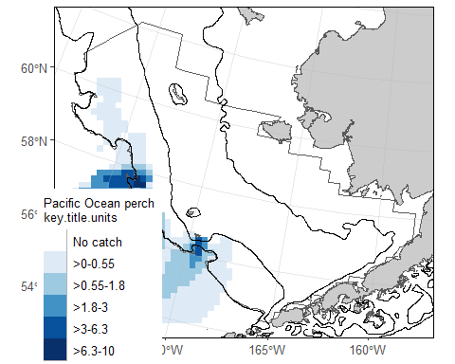
EBS Pacific Ocean perch CPUE and akgfmaps map.

8.0.6 Ex. GOA Pacific Ocean perch biomass and abundance
Biomass and abundance for Pacific Ocean perch from 1990 – 2023 for the western/central/eastern GOA management areas as well as for the entire region.
dat <- RODBC::sqlQuery(channel = channel,
query =
"
-- Manipulate data to join to
WITH FILTERED_STRATA AS (
SELECT AREA_ID, DESCRIPTION FROM GAP_PRODUCTS.AKFIN_AREA
WHERE AREA_TYPE in ('REGULATORY AREA', 'REGION')
AND SURVEY_DEFINITION_ID = 47
-- Use the AREA records associated with the GOA stratification prior to 2025
AND DESIGN_YEAR = 1984)
-- Select columns for output data
SELECT
BIOMASS_MT,
POPULATION_COUNT,
YEAR,
DESCRIPTION
-- Identify what tables to pull data from
FROM GAP_PRODUCTS.AKFIN_BIOMASS BIOMASS
JOIN FILTERED_STRATA STRATA
ON STRATA.AREA_ID = BIOMASS.AREA_ID
-- Filter data results
WHERE BIOMASS.SPECIES_CODE = 30060
AND BIOMASS.YEAR BETWEEN 1990 AND 2023")
dat0 <- dat |>
janitor::clean_names() |>
dplyr::select(biomass_mt, population_count, year, area = description) |>
pivot_longer(cols = c("biomass_mt", "population_count"),
names_to = "var",
values_to = "val") |>
dplyr::mutate(
val = ifelse(var == "biomass_mt", val/1e6, val/1e9),
var = ifelse(var == "biomass_mt", "Biomass (Mmt)", "Population (B)"),
area = gsub(x = area, pattern = " - ", replacement = "\n"),
area = gsub(x = area, pattern = ": ", replacement = "\n"),
type = sapply(X = strsplit(x = area, split = "\n", fixed = TRUE), `[[`, 2)) |>
dplyr::arrange(type) |>
dplyr::mutate(
area = factor(area, levels = unique(area), labels = unique(area), ordered = TRUE))
flextable::flextable(head(dat)) |>
flextable::fit_to_width(max_width = 6) |>
flextable::theme_zebra() |>
flextable::colformat_num(j = "YEAR", big.mark = "")
BIOMASS_MT | POPULATION_COUNT | YEAR | DESCRIPTION
31,073.15 | 60,087,711 | 1990 | CENTRAL GOA - INPFC
100,321.48 | 174,708,361 | 1990 | EASTERN GOA - INPFC
24,435.56 | 79,343,919 | 1990 | WESTERN GOA - INPFC
155,830.19 | 314,139,991 | 1990 | GOA Region: All Strata
256,345.03 | 454,133,028 | 1993 | CENTRAL GOA - INPFC
147,912.16 | 230,314,654 | 1993 | EASTERN GOA - INPFC
# install.packages("scales")
library(scales)
figure <- ggplot2::ggplot(
dat = dat0,
mapping = aes(x = year, y = val, color = type)) +
ggplot2::geom_point(size = 3) +
ggplot2::facet_grid(cols = vars(area), rows = vars(var), scales = "free_y") +
ggplot2::scale_x_continuous(name = "Year", n.breaks = 3) +
ggplot2::scale_y_continuous(name = "Estimate", labels = comma) +
ggplot2::labs(title = 'GOA Pacific Ocean perch biomass and abundance 1990 – 2023') +
ggplot2::guides(color=guide_legend(title = "Region Type"))+
ggplot2::scale_color_grey() +
ggplot2::theme_bw() +
ggplot2::theme(legend.direction = "horizontal",
legend.position = "bottom")
figure
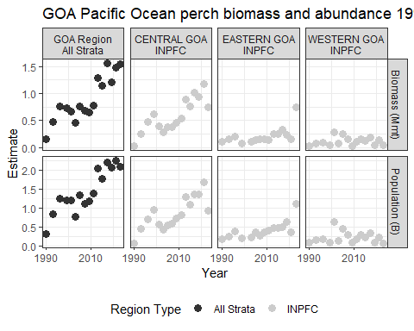
GOA Pacific Ocean perch biomass and abundance.

8.0.7 Ex. AI rock sole size compositions and ridge plot
Northern and Southern rock sole size composition data from 1991 – 2022 for the Aleutian Islands, with Ridge plot from ggridges.
dat <- RODBC::sqlQuery(channel = channel,
query = "
SELECT
YEAR,
LENGTH_MM / 10 AS LENGTH_CM,
SUM(POPULATION_COUNT) AS POPULATION_COUNT
-- Identify what tables to pull data from
FROM GAP_PRODUCTS.AKFIN_SIZECOMP
-- 99904 is the AREA_ID that codes for the whole AI survey region
WHERE AREA_ID = 99904
-- including northern rock sole, southern rock sole, and rock sole unid.
AND SPECIES_CODE IN (10260, 10261, 10262)
-- remove the -9 LENGTH_MM code
AND LENGTH_MM > 0
-- sum over species_codes and sexes
GROUP BY (YEAR, LENGTH_MM)")
dat0 <- dat |>
janitor::clean_names() |>
head() |>
flextable::flextable() |>
flextable::fit_to_width(max_width = 6) |>
flextable::theme_zebra() |>
flextable::colformat_num(j = "year", big.mark = "")
dat0
year | length_cm | population_count
1991 | 23 | 4,625,236
1991 | 38 | 2,254,964
1991 | 42 | 820,614
1991 | 52 | 11,225
1994 | 16 | 741,246
1994 | 26 | 9,762,322
# install.packages("ggridges")
library(ggridges)
figure <- ggplot(dat,
mapping = aes(x = LENGTH_CM,
y = YEAR,
height = POPULATION_COUNT,
group = YEAR)) +
ggridges::geom_density_ridges(stat = "identity", scale = 1) +
ggplot2::ylab(label = "Year") +
ggplot2::scale_x_continuous(name = "Length (cm)") +
ggplot2::labs(title = paste0('Aleutian Islands Rock sole Size Compositions'),
subtitle = paste0(min(dat$YEAR), ' – ', max(dat$YEAR))) +
ggplot2::theme_bw()
figure
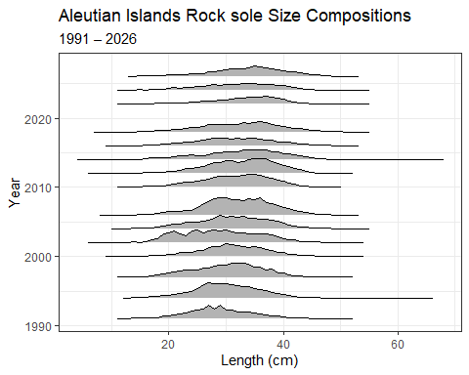
AI Rock sole size compositions and ridge plot.

8.0.8 Ex. 2023 EBS Walleye Pollock Age Compositions and Age Pyramid
Walleye pollock age composition for the EBS standard + NW Area from 2023, with age pyramid plot.
dat <- RODBC::sqlQuery(channel = channel,
query = "
-- Manipulate data to join to
WITH FILTERED_STRATA AS (
SELECT
AREA_ID,
DESCRIPTION
FROM GAP_PRODUCTS.AKFIN_AREA
-- Filter for EBS Standard + NW Area
WHERE AREA_ID = 99900)
-- Select columns for output data
SELECT
AGECOMP.AGE,
AGECOMP.POPULATION_COUNT,
AGECOMP.SEX
-- Identify what tables to pull data from
FROM GAP_PRODUCTS.AKFIN_AGECOMP AGECOMP
JOIN FILTERED_STRATA STRATA
ON STRATA.AREA_ID = AGECOMP.AREA_ID
-- Filter data results
WHERE SPECIES_CODE = 21740
AND YEAR = 2023
AND AGE >= 0")
dat0 <- dat |>
janitor::clean_names() |>
dplyr::filter(sex %in% c(1,2)) |>
dplyr::mutate(
sex = ifelse(sex == 1, "M", "F"),
population_count = # change male population to negative
ifelse(sex=="M", population_count*(-1), population_count*1)/1e9)
flextable::flextable(head(dat)) |>
flextable::fit_to_width(max_width = 6) |>
flextable::theme_zebra()
AGE | POPULATION_COUNT | SEX
1 | 22,060,172 | 1
2 | 123,165,369 | 1
3 | 136,542,625 | 1
4 | 252,538,747 | 1
5 | 964,790,939 | 1
6 | 242,135,720 | 1
figure <- ggplot2::ggplot(
data = dat0,
mapping =
aes(x = age,
y = population_count,
fill = sex)) +
ggplot2::scale_fill_grey() +
ggplot2::geom_bar(stat = "identity") +
ggplot2::coord_flip() +
ggplot2::scale_x_continuous(name = "Age") +
ggplot2::scale_y_continuous(name = "Population (billions)", labels = abs) +
ggplot2::ggtitle(label = "2023 EBS (Standard Area + NW) walleye pollock Age Composition") +
ggplot2::guides(fill = guide_legend(title = "Sex"))+
ggplot2::theme_bw()
figure
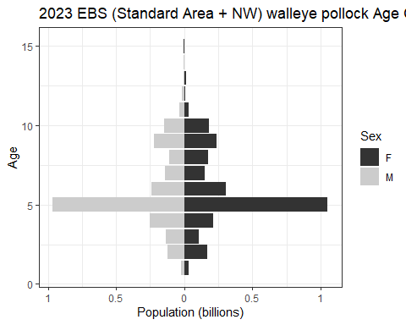
2023 EBS Walleye Pollock Age Compositions and Age Pyramid.

8.0.9 Ex. NBS Pacific cod biomass and abundance
Pacific cod biomass and abundance data for the NBS by stratum.
dat <- RODBC::sqlQuery(channel = channel,
query =
"
SELECT YEAR, AREA_ID AS STRATUM, AREA_NAME, BIOMASS_MT, POPULATION_COUNT
FROM GAP_PRODUCTS.AKFIN_BIOMASS
JOIN ( -- join with area table
SELECT AREA_ID, AREA_NAME
FROM GAP_PRODUCTS.AKFIN_AREA
WHERE AREA_TYPE = 'STRATUM'
AND SURVEY_DEFINITION_ID = 143
AND DESIGN_YEAR = 2022)
USING (AREA_ID)
-- Filter data results to NBS Pacific cod
WHERE SURVEY_DEFINITION_ID IN 143
AND SPECIES_CODE = 21720
ORDER BY YEAR, STRATUM")
dat0 <- dat |>
janitor::clean_names() |>
dplyr::select(year, area_name, biomass_mt, population_count) |>
pivot_longer(cols = c("biomass_mt", "population_count"),
names_to = "var",
values_to = "val") |>
dplyr::mutate(
val = ifelse(var == "biomass_mt", val/1e6, val/1e9),
var = ifelse(var == "biomass_mt", "Biomass (Mmt)", "Population (B)"),
area = factor(area_name, levels = unique(area_name), labels = unique(area_name), ordered = TRUE))
flextable::flextable(dat) |>
flextable::fit_to_width(max_width = 6) |>
flextable::theme_zebra() |>
flextable::colformat_num(j = "YEAR", big.mark = "")
YEAR | STRATUM | AREA_NAME | BIOMASS_MT | POPULATION_COUNT
2010 | 70 | Inner Domain | 7,462.5586 | 4,724,153
2010 | 71 | Inner Domain | 20,983.3757 | 3,928,600
2010 | 81 | Middle Domain | 680.4357 | 250,837
2017 | 70 | Inner Domain | 132,490.1518 | 66,187,245
2017 | 71 | Inner Domain | 147,971.4542 | 65,078,489
2017 | 81 | Middle Domain | 7,089.8740 | 4,191,118
2019 | 70 | Inner Domain | 107,096.7296 | 102,734,142
2019 | 71 | Inner Domain | 194,846.7230 | 73,495,085
2019 | 81 | Middle Domain | 63,061.2786 | 25,926,805
2021 | 70 | Inner Domain | 95,849.9833 | 68,767,498
2021 | 71 | Inner Domain | 53,814.6332 | 17,941,471
2021 | 81 | Middle Domain | 77,917.1083 | 42,991,939
2022 | 70 | Inner Domain | 96,500.6975 | 60,433,135
2022 | 71 | Inner Domain | 26,747.0747 | 10,447,602
2022 | 81 | Middle Domain | 30,487.2782 | 15,157,597
2023 | 70 | Inner Domain | 76,708.4327 | 39,605,860
2023 | 71 | Inner Domain | 19,130.0046 | 8,459,469
2023 | 81 | Middle Domain | 12,507.8566 | 4,128,368
2025 | 70 | Inner Domain | 46,713.1926 | 30,109,199
2025 | 71 | Inner Domain | 10,703.4638 | 4,287,011
2025 | 81 | Middle Domain | 9,276.5797 | 6,970,869
figure <- ggplot2::ggplot(
dat = dat0,
mapping = aes(y = val, x = year, fill = area)) +
ggplot2::geom_bar(position="stack", stat="identity") +
ggplot2::facet_grid(rows = vars(var), scales = "free_y") +
ggplot2::scale_y_continuous(name = "Estimate", labels = comma) +
ggplot2::scale_x_continuous(name = "Year", breaks = unique(dat0$year)) +
ggplot2::labs(title = 'NBS Pacific cod biomass and abundance by stratum') +
ggplot2::guides(fill=guide_legend(title = "Domain Type "))+
ggplot2::scale_fill_grey() +
ggplot2::theme_bw() +
ggplot2::theme(legend.direction = "horizontal",
legend.position = "bottom")
figure
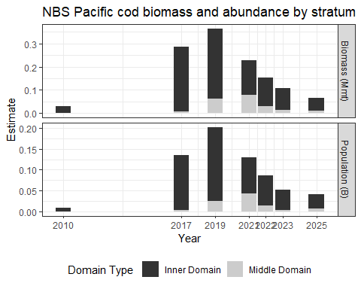
NBS Pacific cod biomass and abundance.

8.0.10 Ex. GOA Pacific Ocean perch biomass and line plot
Pacific Ocean perch biomass totals for GOA between 1984-2021 from GAP_PRODUCTS.AKFIN_BIOMASS
dat <- RODBC::sqlQuery(channel = channel,
query = "
-- Select columns for output data
SELECT
SURVEY_DEFINITION_ID,
BIOMASS_MT / 1000000 AS BIOMASS_MMT,
(BIOMASS_MT - 2 * SQRT(BIOMASS_VAR)) / 1000000 AS BIOMASS_CI_DW,
(BIOMASS_MT + 2 * SQRT(BIOMASS_VAR)) / 1000000 AS BIOMASS_CI_UP,
YEAR
-- Identify what tables to pull data from
FROM GAP_PRODUCTS.AKFIN_BIOMASS
-- Filter data results
WHERE SPECIES_CODE = 30060
AND SURVEY_DEFINITION_ID = 47
AND AREA_ID = 99903
AND YEAR BETWEEN 1990 AND 2023" ) |>
janitor::clean_names()
flextable::flextable(head(dat)) |>
flextable::fit_to_width(max_width = 6) |>
flextable::theme_zebra() |>
flextable::colformat_num(j = "year", big.mark = "")
survey_definition_id | biomass_mmt | biomass_ci_dw | biomass_ci_up | year
47 | 0.1558302 | 0.06181370 | 0.2498467 | 1990
47 | 0.4796687 | 0.26596329 | 0.6933741 | 1993
47 | 0.7651705 | 0.36044598 | 1.1698950 | 1996
47 | 0.7243655 | -0.05238029 | 1.5011113 | 1999
47 | 0.6723673 | 0.22903375 | 1.1157008 | 2001
47 | 0.4543899 | 0.31077353 | 0.5980063 | 2003
a_mean <- dat |>
dplyr::group_by(survey_definition_id) |>
dplyr::summarise(biomass_mmt = mean(biomass_mmt, na.rm = TRUE),
minyr = min(year, na.rm = TRUE),
maxyr = max(year, na.rm = TRUE))
figure <-
ggplot(data = dat,
mapping = aes(x = year,
y = biomass_mmt)) +
ggplot2::geom_point(size = 2.5, color = "grey40") +
ggplot2::scale_x_continuous(
name = "Year",
labels = scales::label_number(
accuracy = 1,
big.mark = "")) +
ggplot2::scale_y_continuous(
name = "Biomass (Mmt)",
labels = comma) +
ggplot2::geom_segment(
data = a_mean,
mapping = aes(x = minyr,
xend = maxyr,
y = biomass_mmt,
yend = biomass_mmt),
linetype = "dashed",
linewidth = 2) +
ggplot2::geom_errorbar(
mapping = aes(ymin = biomass_ci_dw, ymax = biomass_ci_up),
position = position_dodge(.9),
alpha = 0.5, width=.2) +
ggplot2::ggtitle(
label = "GOA Pacific Ocean Perch Biomass 1984-2021",
subtitle = paste0("Mean = ",
formatC(x = a_mean$biomass_mmt,
digits = 2,
big.mark = ",",
format = "f"),
" Mmt")) +
ggplot2::theme_bw()
figure
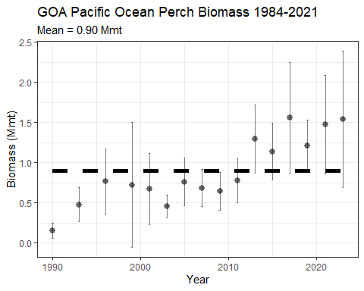
GOA Pacific Ocean perch biomass and line plot.

8.0.11 Ex. 2022 AI Atka mackerel age specimen summary

8.0.11.1 All ages determined:
dat <- RODBC::sqlQuery(channel = channel,
query = "
-- Select columns for output data
SELECT SURVEY_DEFINITION_ID, YEAR, SPECIES_CODE, AGE
-- Identify what tables to pull data from
FROM GAP_PRODUCTS.AKFIN_SPECIMEN
JOIN (SELECT HAULJOIN, CRUISEJOIN FROM GAP_PRODUCTS.AKFIN_HAUL)
USING (HAULJOIN)
JOIN (SELECT CRUISEJOIN, YEAR, SURVEY_DEFINITION_ID FROM GAP_PRODUCTS.AKFIN_CRUISE)
USING (CRUISEJOIN)
-- Filter data results
WHERE GAP_PRODUCTS.AKFIN_SPECIMEN.SPECIMEN_SAMPLE_TYPE = 1
AND SPECIES_CODE = 21921
AND YEAR = 2022
AND SURVEY_DEFINITION_ID = 52") |>
janitor::clean_names()
flextable::flextable(head(dat) |>
dplyr::arrange(age)) |>
flextable::fit_to_width(max_width = 6) |>
flextable::theme_zebra() |>
flextable::colformat_num(j = c("year", "species_code"), big.mark = "")
survey_definition_id | year | species_code | age
52 | 2022 | 21921 | 3
52 | 2022 | 21921 | 3
52 | 2022 | 21921 | 4
52 | 2022 | 21921 | 4
52 | 2022 | 21921 | 4
52 | 2022 | 21921 | 7

8.0.11.2 How many of each age was found:
dat <- RODBC::sqlQuery(channel = channel,
query = "
-- Select columns for output data
SELECT SURVEY_DEFINITION_ID, YEAR, SPECIES_CODE, AGE,
COUNT(AGE) AS COUNTAGE
-- Identify what tables to pull data from
FROM GAP_PRODUCTS.AKFIN_SPECIMEN
JOIN (SELECT HAULJOIN, CRUISEJOIN FROM GAP_PRODUCTS.AKFIN_HAUL)
USING (HAULJOIN)
JOIN (SELECT CRUISEJOIN, YEAR, SURVEY_DEFINITION_ID FROM GAP_PRODUCTS.AKFIN_CRUISE)
USING (CRUISEJOIN)
-- Filter data results
WHERE AGE >= 0
AND SPECIES_CODE = 21921
AND YEAR = 2022
AND SURVEY_DEFINITION_ID = 52
GROUP BY (YEAR, SURVEY_DEFINITION_ID, SPECIES_CODE, AGE)
ORDER BY AGE") |>
janitor::clean_names()
flextable::flextable(dat) |>
flextable::fit_to_width(max_width = 6) |>
flextable::theme_zebra() |>
flextable::colformat_num(j = c("year", "species_code"), big.mark = "")
survey_definition_id | year | species_code | age | countage
52 | 2022 | 21921 | 1 | 1
52 | 2022 | 21921 | 2 | 40
52 | 2022 | 21921 | 3 | 295
52 | 2022 | 21921 | 4 | 119
52 | 2022 | 21921 | 5 | 130
52 | 2022 | 21921 | 6 | 116
52 | 2022 | 21921 | 7 | 108
52 | 2022 | 21921 | 8 | 61
52 | 2022 | 21921 | 9 | 88
52 | 2022 | 21921 | 10 | 73
52 | 2022 | 21921 | 11 | 20
52 | 2022 | 21921 | 12 | 9
52 | 2022 | 21921 | 13 | 1

8.0.11.3 How many otoliths were aged:
Using SQL
dat <- RODBC::sqlQuery(channel = channel,
query = "
-- Select columns for output data
SELECT SURVEY_DEFINITION_ID, YEAR, SPECIES_CODE,
COUNT(AGE) AS COUNTAGE
-- Identify what tables to pull data from
FROM GAP_PRODUCTS.AKFIN_SPECIMEN
JOIN (SELECT HAULJOIN, CRUISEJOIN FROM GAP_PRODUCTS.AKFIN_HAUL)
USING (HAULJOIN)
JOIN (SELECT CRUISEJOIN, YEAR, SURVEY_DEFINITION_ID FROM GAP_PRODUCTS.AKFIN_CRUISE)
USING (CRUISEJOIN)
-- Filter data results
WHERE GAP_PRODUCTS.AKFIN_SPECIMEN.SPECIMEN_SAMPLE_TYPE = 1
AND SPECIES_CODE = 21921
AND YEAR = 2022
AND SURVEY_DEFINITION_ID = 52
GROUP BY (YEAR, SURVEY_DEFINITION_ID, SPECIES_CODE)") |>
janitor::clean_names()
Using dbplyr:
library(odbc)
library(keyring)
library(dplyr)
library(dbplyr)
channel <- DBI::dbConnect(odbc::odbc(), "akfin", uid = keyring::key_list("akfin")$username,
pwd = keyring::key_get("akfin", keyring::key_list("akfin")$username))
dat <- dplyr::tbl(src = channel, dplyr::sql('gap_products.akfin_specimen')) |>
dplyr::rename_all(tolower) |>
dplyr::select(hauljoin, specimen = specimen_id, species_code, length = length_mm,
weight = weight_g, age, sex, age_method = age_determination_method) |>
dplyr::left_join(dplyr::tbl(akfin, dplyr::sql('gap_products.akfin_haul')) |>
dplyr::rename_all(tolower) |>
dplyr::select(cruisejoin, hauljoin, haul, date_collected = date_time_start,
latitude = latitude_dd_start, longitude = longitude_dd_start),
by = join_by(hauljoin)) |>
dplyr::left_join(dplyr::tbl(akfin, dplyr::sql('gap_products.akfin_cruise')) |>
dplyr::rename_all(tolower) |>
dplyr::select(cruisejoin, year, vessel = vessel_id, survey_definition_id),
by = join_by(cruisejoin)) |>
dplyr::filter(year == YEAR &
survey_definition_id == 52 &
species_code %in% spp_codes &
!is.na(age)) |>
dplyr::collect()
Both scripts will produce this table:
flextable::flextable(head(dat)) |>
flextable::fit_to_width(max_width = 6) |>
flextable::theme_zebra() |>
flextable::colformat_num(j = c("year", "species_code"), big.mark = "")
survey_definition_id | year | species_code | countage
52 | 2022 | 21921 | 1,061

9. Access API data via R
AKFIN has developed web services (apis) to distribute GAP data. Like the GAP_PRODUCTS schema, these are under active development. These do not require VPN or an oracle connection but they are protected by Oracle authentication, please contact matt.callahan@noaa.gov for information on how to get an api token to use this option.
The url structure is “https://apex.psmfc.org/akfin/data_marts/gap_products/gap_[base table name]” . For example “https://apex.psmfc.org/akfin/data_marts/gap_products/gap_biomass” is the base url to get data from the akfin_biomass table. Web services linked to large tables have mandatory parameters to reduce data download size. For example to get agecomp data for Bering Sea pollock in area_id 10 in 2022 you would use “https://apex.psmfc.org/akfin/data_marts/gap_products/gap_biomass?survey_definition_id=98&area_id=10&species_code=21740&start_year=2022&end_year=2022”.
If you’re using R to pull data through web services you might find the akfingapdata (pronounced akfin-gap-data not ak-eff-ing-app-data) R package helpful.

9.0.1 Load packages and helpful functions

9.1 Ex. Direct database query in R using the akfingapdata R package README:
Sign into akfin with token (need to request token from AKFIN)
akfingapdata::get_gap_catch()[,1:6] |>
head() |>
flextable::flextable() |>
flextable::theme_zebra()

10. Using the FOSS platform

10.1 Select and filter
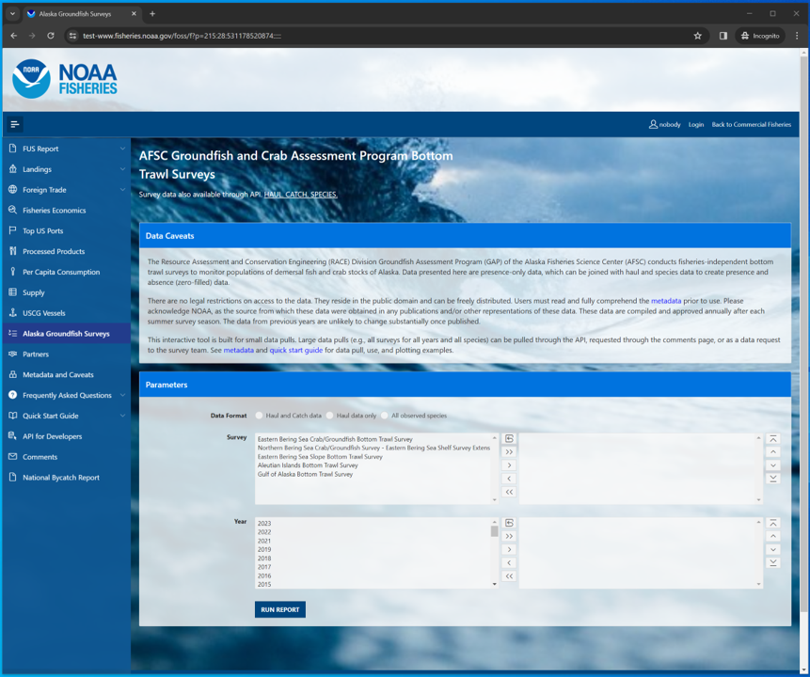
AFSC Groundfish and Crab Assessment Program Bottom Trawl Survey data interface on the Fisheries One Stop Shop platform.
Select, filter, and download this and other NOAA Fisheries data from the Fisheries One Stop Shop (FOSS) platform. A user guide for the FOSS platform can be found here. To begin a report, select the kind of data you need: Haul and catch data, Haul data only, All observed species.
In this example, we’ll select for 2023 eastern Bering Sea Arctic cod data. Here, we used the Search Species box to search for species with the term “cod” in their common names and selected “Pacific cod” from that shortened list.

10.1.1 Catch and haul
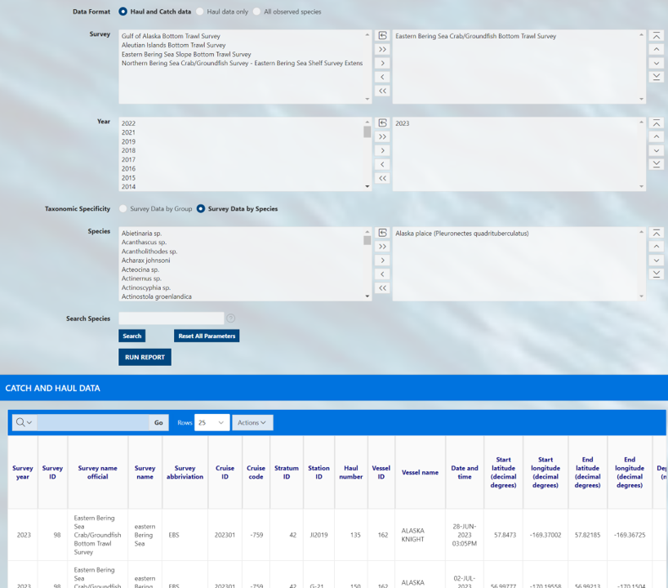
Catch data on the AFSC Groundfish and Crab Assessment Program Bottom Trawl Survey data interface on the Fisheries One Stop Shop platform.

10.1.2 Haul
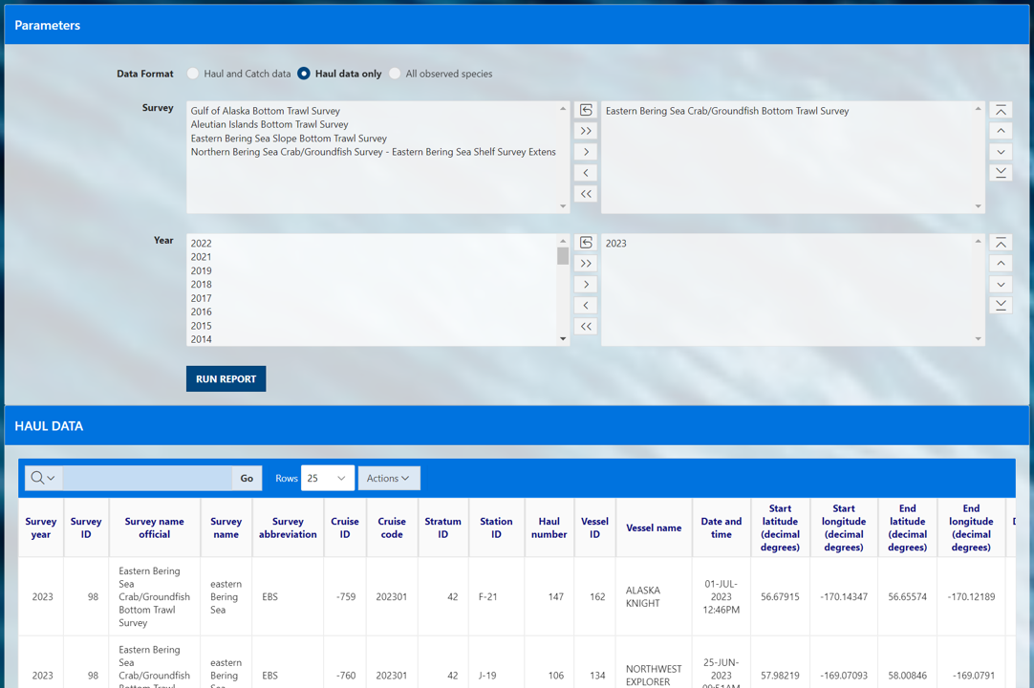
Haul data on the AFSC Groundfish and Crab Assessment Program Bottom Trawl Survey data interface on the Fisheries One Stop Shop platform.

10.1.3 Species
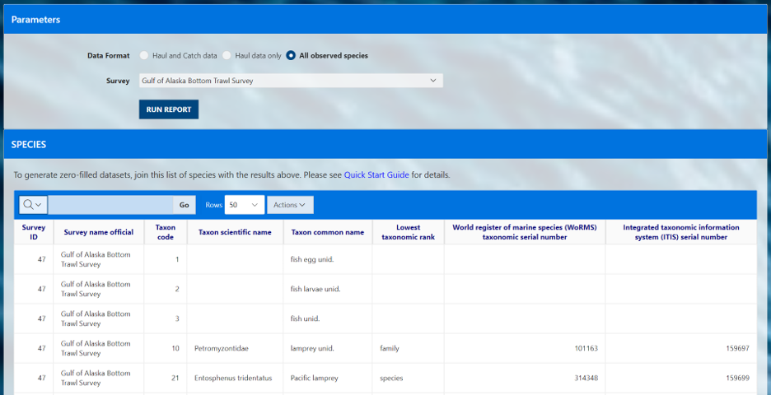
All species observed by survey on the AFSC Groundfish and Crab Assessment Program Bottom Trawl Survey data interface on the Fisheries One Stop Shop platform.

10.2 Search options
The user must select a option in each of the three option boxes as they appear for catch, haul, and species:
- Survey: Each survey has different in design, time series, and history. More information on each survey and their designs can be found in our annual data reports.
- Year: Surveys are not conducted in all years, so only data from the years for which the survey was conducted will be returned.
- Species: Common name of all species ever encountered in the survey. Find more information about these species in our survey code books.
For a given box, select one or a few options from the options box (list on the left) to query. To select multiple options, hold down the CTRL key while clicking on the options of interest, or click and drag down the list. Once the options you wish to be included in your query are highlighted, click the right-pointing arrow (>) to move them into the “selection box” (list on the right). This can also be achieved by double clicking the option item of interest. If you accidentally select an option that you do not want to query, simply select the unwanted option from the selection box and click the left-pointing arrow (<).
If you wish to select all options from the options box and send them to the selection box, simply click the double right-pointing arrow (>>). If you want to unselect all options from the selection box, use the double left-pointing arrow (<<) or the reset icon.
To find a specific species or group more quickly you can use the Search Species option to quickly narrow the options. Search for parts of species common names in the Search Species box by entering a term and clicking the search button. The platform will return a shorter list in the Speices options box of only species that contain a match to that search term.
Use the Reset All Parameters button to reset all parameters for entire form.
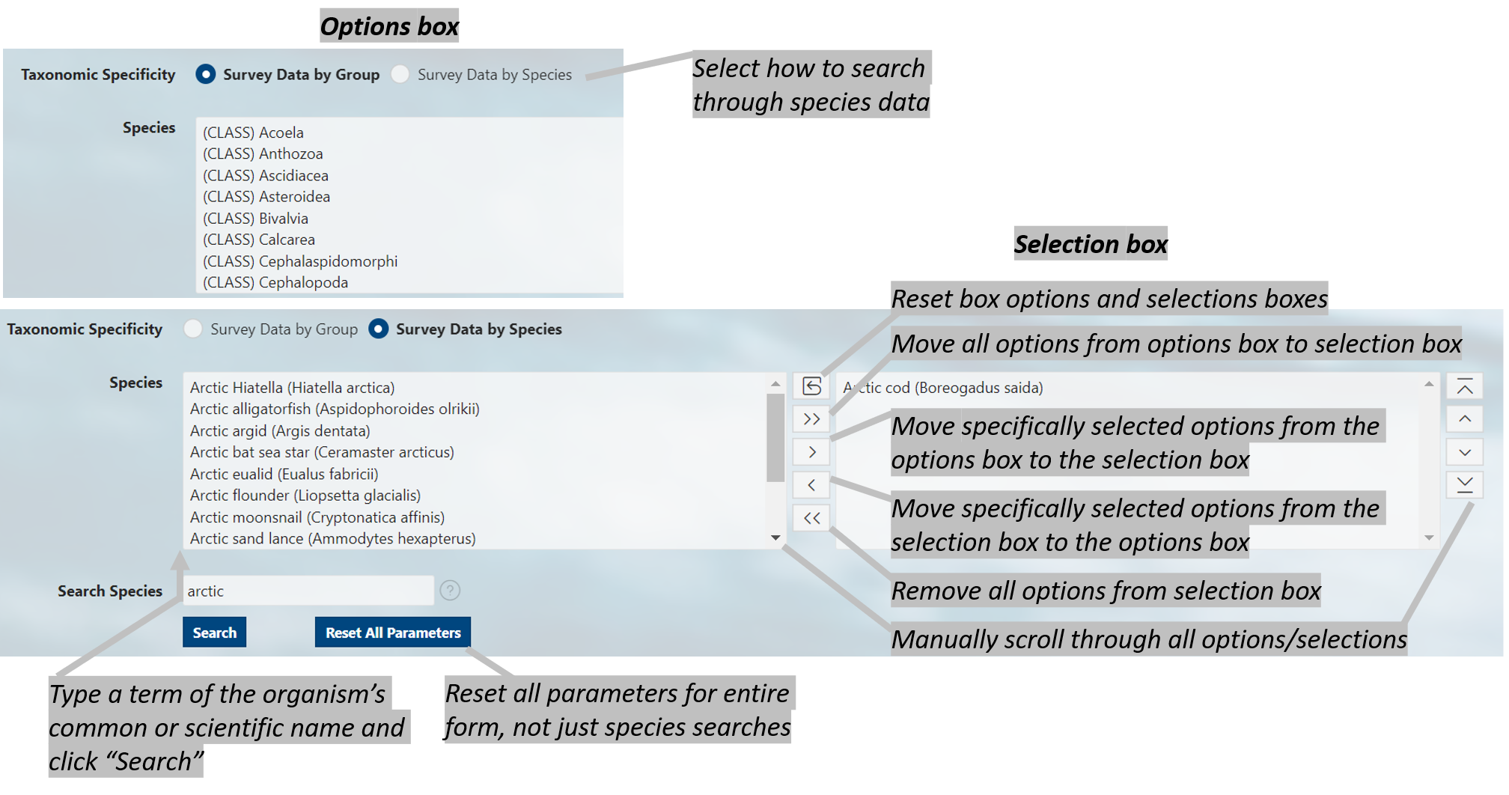
Diagram of selection and search tools available on the FOSS platfrom.

10.3 Run report
Click the RUN REPORT button. Below the select and filter area, the results of your query will appear below the page in the format you selected. To change the format, make a different selection and run the report again. Further modifications to your results can be made by clicking on the Actions button above your data. Here you can download your data, select columns included in your results, and apply a variety of filters and mathematical tools.
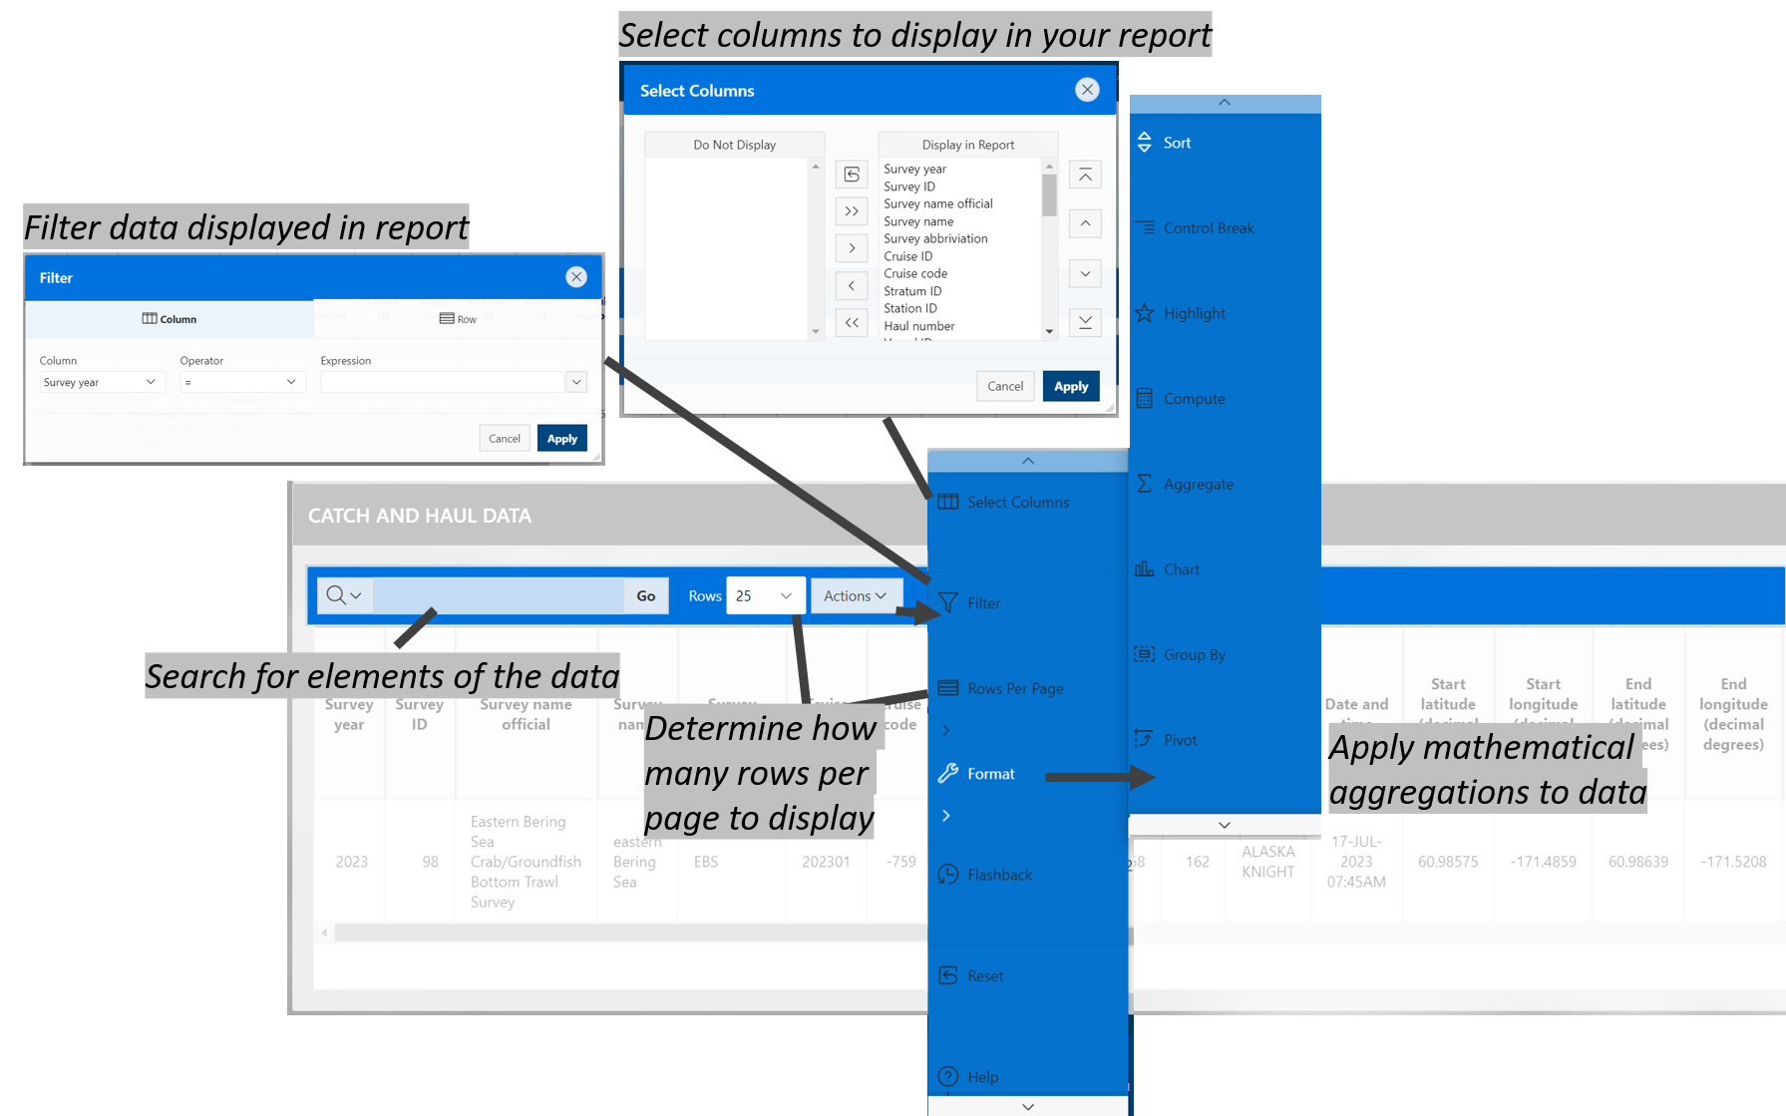
Example data returned from running the report.

10.4 API
APIs, or Application Programming Interfaces, allows users to pull data through a IDE, or integrated development environment, like RStudio or VS Code. Explore the API pages for each of the data pages (Haul and catch data, Haul data only, All observed species).

11. Use data
Learn how to pull and use this data through the
- API and R programming language
- API and python programming language using the afscgap python package
- Oracle and R programming language (AFSC scientists only)

12. Access via API and R
An application programming interface (API) is a way for two or more computer programs to communicate with each other. More information about how to amend API links can be found here. Useful introductions to using APIs in R can be found here.
There are three tables the user can pull from the API. Learn more about them on the FOSS data description page. Here, you can see them in their raw JSON format:
- haul: https://apps-st.fisheries.noaa.gov/ods/foss/afsc_groundfish_survey_haul/
- catch: https://apps-st.fisheries.noaa.gov/ods/foss/afsc_groundfish_survey_catch/
- species: https://apps-st.fisheries.noaa.gov/ods/foss/afsc_groundfish_survey_species/
Here are some examples of how to use the data with R:

12.1 Ex. Load all rows of the catch, haul, and species data tables
Note that without specifying, a basic query to the API will only return 25 entries.

12.1.1 Load haul data
# link to the API
api_link_haul <- 'https://apps-st.fisheries.noaa.gov/ods/foss/afsc_groundfish_survey_haul/'

12.1.1.1 Load first 25 rows of data
res <- httr::GET(url = api_link_haul)
# res ## Test connection
## convert from JSON format
dat <- jsonlite::fromJSON(base::rawToChar(res$content))$items
# Find how many rows and columns are in the data pull
print(paste0("rows: ", nrow(dat), "; cols: ", ncol(dat)))

12.1.1.2 Load all data:
Since the maxim number of rows a user can pull is 10,000 rows in a query, the user needs to cycle through by offsetting to the next 10,000 rows (as is shown here).
dat <- data.frame()
for (i in seq(0, 500000, 10000)){
## find how many iterations it takes to cycle through the data
print(i)
## query the API link
res <- httr::GET(url = paste0(api_link_haul, "?offset=",i,"&limit=10000"))
## convert from JSON format
data <- jsonlite::fromJSON(base::rawToChar(res$content))
## if there are no data, stop the loop
if (is.null(nrow(data$items))) {
break
}
## bind sub-pull to dat data.frame
dat <- dplyr::bind_rows(dat,
data$items |>
dplyr::select(-links)) # necessary for API accounting, but not part of the dataset)
}
Explore the data contents:
# Find how many rows and columns are in the data pull
print(paste0("rows: ", nrow(dat), "; cols: ", ncol(dat)))
# learn about the structure of the data
summary(dat)
# Print the first few lines of the data
dat |>
head(3) |>
flextable::flextable() |>
flextable::colformat_num(
j = c("year", "cruise", "cruisejoin"),
big.mark = "") |>
flextable::theme_zebra()
# save outputs for later comparison
dat_haul_api <- dat

12.1.2 Load catch data
# link to the API
api_link_catch <- 'https://apps-st.fisheries.noaa.gov/ods/foss/afsc_groundfish_survey_catch/'

12.1.2.1 Load first 25 rows of data
res <- httr::GET(url = api_link_catch)
# res ## Test connection
## convert from JSON format
dat <- jsonlite::fromJSON(base::rawToChar(res$content))$items
# Find how many rows and columns are in the data pull
print(paste0("rows: ", nrow(dat), "; cols: ", ncol(dat)))

12.1.2.2 Load all data
Since the maxim number of rows a user can pull is 10,000 rows in a query, the user needs to cycle through by offsetting to the next 10,000 rows (as is shown here).
dat <- data.frame()
# for (i in seq(0, 100000, 10000)){
for (i in seq(0, 1000000, 10000)){
## find how many iterations it takes to cycle through the data
# print(i)
## query the API link
res <- httr::GET(url = paste0(api_link_catch, "?offset=",i,"&limit=10000"))
## convert from JSON format
data <- jsonlite::fromJSON(base::rawToChar(res$content))
## if there are no data, stop the loop
if (is.null(nrow(data$items))) {
break
}
## bind sub-pull to dat data.frame
dat <- dplyr::bind_rows(dat,
data$items |>
dplyr::select(-links)) # necessary for API accounting, but not part of the dataset)
}
Explore the data contents:
# Find how many rows and columns are in the data pull
print(paste0("rows: ", nrow(dat), "; cols: ", ncol(dat)))
# learn about the structure of the data
summary(dat)
# Print the first few lines of the data
dat |>
head(3) |>
flextable::flextable() |>
flextable::colformat_num(
j = c("species_code"),
big.mark = "") |>
flextable::theme_zebra()
# save outputs for later comparison
dat_catch_api <- dat

12.1.3 Load species data
Since there are less than 10,000 rows of species data (and the maxim number of rows a user can pull from this API is 10,000 rows in a query), we can simply call ?offset=0&limit=10000 in our query call.
# link to the API
api_link_species <- 'https://apps-st.fisheries.noaa.gov/ods/foss/afsc_groundfish_survey_species/'
res <- httr::GET(url = paste0(api_link_species, "?offset=0&limit=10000"))
## convert from JSON format
data <- jsonlite::fromJSON(base::rawToChar(res$content))
dat <- data$items |>
dplyr::select(-links) # necessary for API accounting, but not part of the dataset
Explore the data contents:
# Find how many rows and columns are in the data pull
print(paste0("rows: ", nrow(dat), "; cols: ", ncol(dat)))
# learn about the structure of the data
summary(dat)
# Print the first few lines of the data
dat |>
head(3) |>
flextable::flextable() |>
flextable::colformat_num(
j = c("species_code", "worms", "itis"), #
big.mark = "") |>
flextable::theme_zebra()
# save outputs for later comparison
dat_species_api <- dat

12.2 Ex. Create zero-filled data using data loaded in last example
It is important to create and have access to zero-fill (presence and absence) so you can do simple analyses and plot data.
First prepare a table with all combinations of what species should be listed for what hauls/surveys. For zero-filled data, all species caught in a survey need to have zero or non-zero row entries for a haul
comb <- dplyr::full_join(
# find all species that have been caught, by survey
x = dplyr::left_join(dat_catch_api, dat_haul_api, by = "hauljoin") |>
dplyr::select(survey_definition_id, species_code) |>
dplyr::distinct(),
# find all haul events (hauljoins), by survey
y = dat_haul_api |>
dplyr::select(survey_definition_id, hauljoin) |>
dplyr::distinct(),
relationship = "many-to-many",
by = "survey_definition_id"
) |>
dplyr::select(-survey_definition_id) # now, redundant
Explore the data contents:
print(paste0("rows: ", nrow(comb), "; cols: ", ncol(comb)))
comb |> head(3) |>
flextable::flextable() |>
flextable::colformat_num(
j = c("species_code", "hauljoin"),
big.mark = "") |>
flextable::theme_zebra()
Now, using that table of combinations (here, called comb), join data to make a full zero-filled CPUE dataset. When all of the data have been full joined together, there should be the maximum number of rows in comb.
dat <- comb |>
# add species data
dplyr::left_join(dat_species_api) |> # , "species_code"
# add haul data
dplyr::left_join(dat_haul_api) |> # , c("hauljoin")
# add catch data
dplyr::left_join(dat_catch_api) |> # , c("species_code", "hauljoin")
# modify/clean up zero-filled rows
dplyr::mutate(
cpue_kgkm2 = ifelse(is.na(cpue_kgkm2), 0, cpue_kgkm2),
cpue_nokm2 = ifelse(is.na(cpue_nokm2), 0, cpue_nokm2),
count = ifelse(is.na(count), 0, count),
weight_kg = ifelse(is.na(weight_kg), 0, weight_kg))
Explore the data contents:
# Find how many rows and columns are in the data pull
print(paste0("rows: ", nrow(dat), "; cols: ", ncol(dat)))
# learn about the structure of the data
summary(dat)
# Print the first few lines of the data
dat |>
head(3) |>
flextable::flextable() |>
flextable::colformat_num(
j = c("species_code", "hauljoin", "year", "cruise", "cruisejoin", "worms", "itis"), #
big.mark = "") |>
flextable::theme_zebra()
# save outputs for later comparison
dat_zerofill_api <- dat

12.3 Ex. Visualize zero-filled data for 2023 eastern Bering Sea walleye pollock in CPUE data in distribution map
Using the zero-filled data from the previous example, we can make a few plots!
Here is some example data of 2023 through 2019 (year %in% 2019:2023) eastern and northern Bering Sea (srvy %in% c("EBS", "NBS)) walleye pollock (species_code == 21740).
dat <- dat_zerofill_api |>
dplyr::filter(year %in% 2019:2023 &
srvy %in% c("EBS", "NBS") &
species_code == 21740) |>
dplyr::select(year, common_name, longitude_dd_start, latitude_dd_start, cpue_kgkm2)
# Find how many rows and columns are in the data pull
print(paste0("rows: ", nrow(dat), "; cols: ", ncol(dat)))
# # learn about the structure of the data
# summary(dat)
# Print the first few lines of the data
dat |>
head(3) |>
flextable::flextable() |>
flextable::colformat_num(
j = c("year"),
big.mark = "") |>
flextable::theme_zebra()

12.3.1 Plot locations on map
library(ggplot2)
ggplot2::ggplot(data = dat |> dplyr::filter(cpue_kgkm2 != 0),
mapping = aes(x = longitude_dd_start,
y = latitude_dd_start,
size = cpue_kgkm2)) +
ggplot2::geom_point(alpha = .75) +
ggplot2::geom_point(data = dat |> dplyr::filter(cpue_kgkm2 == 0),
color = "red",
shape = 17,
alpha = .75,
size = 3) +
ggplot2::xlab("Longitude *W") +
ggplot2::ylab("Latitude *N") +
ggplot2::ggtitle(label = "CPUE (kg/km^2) of walleye pollock (Weight CPUE; kg/km2)",
subtitle = "Eastern Bering Sea bottom trawl survey") +
ggplot2::scale_size_continuous(name = "Weight (kg)") +
ggplot2::facet_wrap(facets = vars(year)) +
ggplot2::theme_bw()

12.3.2 Plot inverse-distance weighted plot of CPUE
This map is constructed using akgfmaps. To make IDW plots, you must have data from all stations surveyed, even if no fish of interest were found there.
These plots are similar to those published in the annual Bering Sea data reports.
# pak::pak("afsc-gap-products/akgfmaps")
library(akgfmaps)
idw <- akgfmaps::make_idw_stack(
x = dat |>
dplyr::select(COMMON_NAME = common_name,
CPUE_KGHA = cpue_kgkm2,
LATITUDE = latitude_dd_start,
LONGITUDE = longitude_dd_start,
year),
grouping.vars = "year",
region = "bs.all", # Predefined EBS area
set.breaks = "jenks", # Gets Jenks breaks from classint::classIntervals()
in.crs = "+proj=longlat", # Set input coordinate reference system
out.crs = "EPSG:3338", # Set output coordinate reference system
extrapolation.grid.type = "sf")
shps <- akgfmaps::get_base_layers(
select.region = "bs.all",
# include.corners = TRUE,
set.crs = "EPSG:3338")
shps$survey.area$SRVY <- c("EBS", "NBS")
shps$survey.area$SURVEY <- c("EBS", "NBS")
# set.breaks <- akgfmaps::eval_plot_breaks(CPUE = dat$cpue_kgkm2, n.breaks = 5)
# set.breaks <- as.vector(unlist(set.breaks[set.breaks$style == "pretty", -1]))
set.breaks <- c(0, 50000, 100000, 150000, 200000, 250000)
figure_print <- ggplot() +
# add map of alaska
ggplot2::geom_sf(data = shps$akland,
color = NA,
fill = "grey50") +
# add IDW plots
geom_sf(data = idw$extrapolation.stack,
mapping = aes(fill = var1.pred),
na.rm = FALSE,
show.legend = TRUE,
color = NA) +
ggplot2::scale_fill_manual(
name = "walleye pollock\nCPUE (kg/km2)",
values = c("gray90",
viridis::viridis(
option = "mako",
direction = -1,
n = length(set.breaks)-1,
begin = 0.20,
end = 0.80)),
na.translate = FALSE, # Don't use NA
drop = FALSE) +
# seperate plots by year
ggplot2::facet_wrap(facets = vars(year), nrow = 2) +
# add survey area
ggplot2::geom_sf(
data = shps$survey.area,
mapping = aes(color = SURVEY,
geometry = geometry),
fill = "transparent",
linewidth = 1,
show.legend = FALSE) +
ggplot2::scale_color_manual(
name = " ",
values = c("grey30", "grey50"),
breaks = shps$survey.area$SURVEY,
labels = shps$survey.area$SRVY) +
# lat/lon axis and map bounds
ggplot2::scale_x_continuous(name = "Longitude °W",
breaks = seq(-180, -150, 5)) +
ggplot2::scale_y_continuous(name = "Latitude °N",
breaks = seq(50, 65, 5)) + # seq(52, 62, 2)
ggplot2::coord_sf(xlim = sf::st_bbox(shps$survey.area)[c(1,3)],
ylim = sf::st_bbox(shps$survey.area)[c(2,4)]) +
# add theme aesthetics
ggplot2::guides(
fill = guide_legend(
order = 1,
title.position = "top",
label.position = "bottom",
title.hjust = 0.5,
override.aes = list(color = NA),
nrow = 1),
color = "none") +
ggplot2::theme(
panel.background = element_rect(fill = "white", colour = NA),
panel.border = element_rect(fill = NA, colour = "grey20"),
strip.background = element_blank(),
strip.text = element_text(size = 10, face = "bold"),
legend.text = element_text(size = 9),
legend.background = element_rect(colour = "transparent",
fill = "transparent"),
legend.key = element_rect(colour = "transparent",
fill = "transparent"),
legend.position = "bottom",
legend.box = "horizontal",
legend.box.spacing = unit(0, "pt"), # reduce space between legend & plot
legend.margin=margin(0, 0, 0, 0) )
figure_print

12.4 Ex. Show catch data for 2023 eastern Bering Sea Walleye Pollock (one species in one survey region in one year)
Data downloads and joins for just one species, survey, and year are much faster and easier to do.
First, because year is identified in the haul table, we need to identify all of the hauls (or more specifically, hauljoin codes) that were completed in the eastern Bering Sea ("srvy":"EBS") in 2023 ("year":2023).
Note: Check how many rows and columns are in the data pull. The eastern Bering Sea survey (before 2024) has 376 stations in it, and pollock are often found in throughout the region so this should have a similar number of rows.
## query the API link
res <- httr::GET(url = paste0(api_link_haul, '?limit=10000&q={"year":2023,"srvy":"EBS"}'))
## convert from JSON format
data <- jsonlite::fromJSON(base::rawToChar(res$content))
dat <- data$items |>
dplyr::select(-links) # necessary for API accounting, but not part of the dataset
## show summary of data to make sure it is subset correctly
summary(dat |> dplyr::mutate(srvy = as.factor(srvy)))
## Find how many rows and columns are in the data pull.
print(paste0("rows: ", nrow(dat), "; cols: ", ncol(dat)))
# save outputs for later comparison
dat_haul_ex <- dat
# Print the first few lines of the data
dat_haul_ex |>
head(3) |>
flextable::flextable() |>
flextable::colformat_num(
j = c("year", "hauljoin", "cruise"),
big.mark = "") |>
flextable::theme_zebra()

12.4.1 Identify species_code for walleye pollock
In the catch data, we itemize species catches by species_code. To find out which species_code to use, you can check variations on the following code. Note that here the word pollock is case sensitive. All species common_name entries are lower case except for proper nouns (e.g., “Pacific”). The notation for finding a string is to use % around the phrase. Since % is a reserved character in a URL, you have to replace % with %25. Similarly, %20 needs to be used in place of a space (e.g., between “walleye” and “pollock”: "walleye%20pollock"}').
## query the API link. Use:
res <- httr::GET(url = paste0(api_link_species, '?q={%22common_name%22:%22walleye%20pollock%22}'))
# OR
res <- httr::GET(url = paste0(api_link_species, '?q={"common_name":{"$like":"%25pollock%25"}}'))
# OR
res <- httr::GET(url = paste0(api_link_species, '?q={"common_name":"walleye%20pollock"}'))
## convert from JSON format
data <- jsonlite::fromJSON(base::rawToChar(res$content))
# save outputs for later comparison
dat_species_ex <- data$items |> dplyr::select(-links) # necessary for API accounting, but not part of the dataset
# Print the first few lines of the data
dat_species_ex |>
head(3) |>
flextable::flextable() |>
flextable::colformat_num(
j = c("species_code"),
big.mark = "") |>
flextable::theme_zebra()

12.4.2 Then, apply the hauljoins and species_code to catch query
We’ll use the data from the haul and species table we collected before to select 2023 eastern Bering Sea walleye pollock catch data.
## query the API link
# data for all walleye pollock caught in all 2023 eastern Bering Sea survey hauls
dat <- data.frame()
# there must be a better way to select multiple values for one parameter,
# but saving that, we will loop through each hauljoin and collect the data of interest
for (i in 1:nrow(dat_haul_ex)) {
res <- httr::GET(url = paste0(
api_link_catch,
'?q={"species_code":21740,"hauljoin":', dat_haul_ex$hauljoin[i],'}'))
## convert from JSON format
data <- jsonlite::fromJSON(base::rawToChar(res$content))
if (length(data$items) != 0) {
dat <- dplyr::bind_rows(
dat,
data$items |>
dplyr::select(-links)) # necessary for API accounting, but not part of the dataset
}
}
Explore data:
# Find how many rows and columns are in the data pull
print(paste0("rows: ", nrow(dat), "; cols: ", ncol(dat)))
# learn about the structure of the data
summary(dat)
# Print the first few lines of the data
dat |>
head(3) |>
flextable::flextable() |>
flextable::colformat_num(
j = c("hauljoin", "species_code"),
big.mark = "") |>
flextable::theme_zebra()
# save outputs for later comparison
dat_catch_ex <- dat
For reference and to help break down the above query, see these other query examples:
# data for haul -22775 (i.e., one specific haul)?
res <- httr::GET(url = paste0(api_link_catch,
'?offset=',i,'&limit=10000&q={"hauljoin":-22775}'))
# data for all walleye pollock (i.e., one species) caught in all years and surveys
res <- httr::GET(url = paste0(api_link_catch,
'?offset=',i,'&limit=10000&q={"species_code":21740}'))

12.4.3 Create zero-filled data for 2023 eastern Bering Sea walleye pollock and plot
It is important to create and have access to zero-fill (presence and absence) so you can do simple analyses and plot data.
dat <- dplyr::full_join(
dat_haul_ex,
dat_catch_ex) |>
dplyr::full_join(
dat_species_ex) |>
# modify zero-filled rows
dplyr::mutate(
cpue_kgkm2 = ifelse(is.na(cpue_kgkm2), 0, cpue_kgkm2),
cpue_nokm2 = ifelse(is.na(cpue_nokm2), 0, cpue_nokm2),
count = ifelse(is.na(count), 0, count),
weight_kg = ifelse(is.na(weight_kg), 0, weight_kg))
Explore data
# Find how many rows and columns are in the data pull
print(paste0("rows: ", nrow(dat), "; cols: ", ncol(dat)))
# learn about the structure of the data
summary(dat)
# Print the first few lines of the data
dat |>
head(3) |>
flextable::flextable() |>
flextable::colformat_num(
j = c("year", "cruise", "cruisejoin", "species_code"),
big.mark = "") |>
flextable::theme_zebra()

12.4.4 Visualize CPUE data in distribution map
Using the zero-filled data from the previous example, we can make a few plots!

12.5 Plot locations
library(ggplot2)
ggplot2::ggplot(data = dat |> dplyr::filter(cpue_kgkm2 != 0),
mapping = aes(x = longitude_dd_start,
y = latitude_dd_start,
size = cpue_kgkm2)) +
ggplot2::geom_point(alpha = .75) +
ggplot2::geom_point(data = dat |> dplyr::filter(cpue_kgkm2 == 0),
color = "red",
shape = 17,
alpha = .75,
size = 3) +
ggplot2::xlab("Longitude *W") +
ggplot2::ylab("Latitude *N") +
ggplot2::ggtitle(label = "Catches of walleye pollock (Weight CPUE; kg/km2)",
subtitle = "2023 eastern Bering Sea bottom trawl survey") +
ggplot2::scale_size_continuous(name = "Weight (kg)") +
ggplot2::theme_bw()

12.5.1 Plot inverse-distance weighted modeled product of locations
This map is constructed using akgfmaps
# pak::pak("afsc-gap-products/akgfmaps")
library(akgfmaps)
figure0 <- akgfmaps::make_idw_map(
CPUE_KGHA = dat$cpue_kgkm2, # calculates the same, regardless of units.
LATITUDE = dat$latitude_dd_start,
LONGITUDE = dat$longitude_dd_start,
region = "bs.south", # Predefined EBS area
set.breaks = "jenks", # Gets Jenks breaks from classint::classIntervals()
in.crs = "+proj=longlat", # Set input coordinate reference system
out.crs = "EPSG:3338", # Set output coordinate reference system
extrapolation.grid.type = "sf")
figure0$plot + # 20x20km grid
ggplot2::guides(fill=guide_legend(title = "walleye pollock\nCPUE (kg/km2)"))

13. Access via API and Python

13.0.1 {afscgap} Library Installation
author: Sam Pottinger (sam.pottinger@berkeley.edu; GitHub::sampottinger) date: May 13, 2023
The third-party afscgap Python package interfaces with FOSS to access AFSC GAP data. It can be installed via pip:
#The reticulate package provides a comprehensive set of tools for interoperability between Python and R.
library(reticulate)
pip install afscgap
pip install git+https://github.com/SchmidtDSE/afscgap.git@main
For more information on installation and deployment, see the library documentation.

13.0.2 Basic query
This first example queries for Pacific glass shrimp (Pasiphaea pacifica) in the Gulf of Alaska in 2021. The library will automatically generate HTTP queries, converting from Python types to ORDS query syntax.
import afscgap
query = afscgap.Query()
query.filter_year(eq=2021)
query.filter_srvy(eq='GOA')
query.filter_scientific_name(eq='Pasiphaea pacifica')
results = query.execute()
The results variable in this example is an iterator that will automatically perform pagination behind the scenes.

13.0.3 Iterating with a for loop
The easiest way to interact with results is a simple for loop. This next example determines the frequency of different catch per unit effort where Pacific glass shrimp were reported:
import afscgap
# Mapping from CPUE to count
count_by_cpue = {}
# Build query
query = afscgap.Query()
query.filter_year(eq=2021)
query.filter_srvy(eq='GOA')
query.filter_scientific_name(eq='Pasiphaea pacifica')
results = query.execute()
# Iterate through results and count
for record in results:
cpue = record.get_cpue_weight(units='kg/ha')
cpue_rounded = round(cpue)
count = count_by_cpue.get(cpue_rounded, 0) + 1
count_by_cpue[cpue_rounded] = count
# Print the result
print(count_by_cpue)
Note that, in this example, only records with Pacific glass shrimp are included (“presence-only” data). See zero catch inference below. In other words, it reports on CPUE only for hauls in which Pacific glass shrimp were recorded, excluding some hauls like those in which Pacific glass shrimp were not found at all.

13.0.4 Iterating with functional programming
A for loop is not the only option for iterating through results. List comprehensions and other functional programming methods can be used as well.
import statistics
import afscgap
# Build query
query = afscgap.Query()
query.filter_year(eq=2021)
query.filter_srvy(eq='GOA')
query.filter_scientific_name(eq='Pasiphaea pacifica')
results = query.execute()
# Get temperatures in Celsius
temperatures = [record.get_bottom_temperature(units='c') for record in results]
# Take the median
print(statistics.median(temperatures))
This example reports the median temperature in Celcius for when Pacific glass shrimp was reported.

13.0.5 Load into Pandas
The results from the afscgap package are serializable and can be loaded into other tools like Pandas. This example loads Pacific glass shrimp from 2021 Gulf of Alaska into a data frame.
import pandas
import afscgap
query = afscgap.Query()
query.filter_year(eq=2021)
query.filter_srvy(eq='GOA')
query.filter_scientific_name(eq='Pasiphaea pacifica')
results = query.execute()
pandas.DataFrame(results.to_dicts())
Specifically, to_dicts provides an iterator over a dictionary form of the data that can be read into tools like Pandas.

13.0.6 Advanced filtering
Queries so far have focused on filters requiring equality but range queries can be built as well.
import afscgap
# Build query
query = afscgap.Query()
query.filter_year(min_val=2015, max_val=2019) # Note min/max_val
query.filter_srvy(eq='GOA')
query.filter_scientific_name(eq='Pasiphaea pacifica')
results = query.execute()
# Sum weight
weights = map(lambda x: x.get_weight(units='kg'), results)
total_weight = sum(weights)
print(total_weight)
This example queries for Pacific glass shrimp data between 2015 and 2019, summing the total weight caught. Note that most users will likely take advantage of built-in Python to ORDS query generation which dictates how the library communicates with the API service. However, users can provide raw ORDS queries as well using manual filtering.

13.0.7 Zero-catch inference
Until this point, these examples use presence-only data. However, the afscgap package can infer negative or “zero catch” records as well.
import afscgap
# Mapping from CPUE to count
count_by_cpue = {}
# Build query
query = afscgap.Query()
query.filter_year(eq=2021)
query.filter_srvy(eq='GOA')
query.filter_scientific_name(eq='Pasiphaea pacifica')
query.set_presence_only(False) # Added to earlier example
results = query.execute()
# Iterate through results and count
for record in results:
cpue = record.get_cpue_weight(units='kg/ha')
cpue_rounded = round(cpue)
count = count_by_cpue.get(cpue_rounded, 0) + 1
count_by_cpue[cpue_rounded] = count
# Print the result
print(count_by_cpue)
This example revisits the earlier snippet for CPUE counts but set_presence_only(False) directs the library to look at additional data on hauls, determining which hauls did not have Pacific glass shrimp. This lets the library return records for hauls in which Pacific glass shrimp were not found. This can be seen in differences in counts reported:
Rounded CPUE | Count with set_presence_only(True) | Count with set_presence_only(False)
0 kg/ha | 44 | 521
1 kg/ha | 7 | 7
2 kg/ha | 1 | 1
Put simply, while the earlier example showed CPUE counts for hauls in which Pacific glass shrimp were seen, this revised example reports for all hauls in the Gulf of Alaska in 2021.

13.0.8 More information
Please see the API documentation for the Python library for additional details.

14. Open source code

14.1 R Packages

14.1.1 akgfmaps R package
Bttom trawl survey maps layers and plotting examples. POC: Sean Rohan

14.1.2 coldpool R package
Cold pool area and temperature data products for the Bering Sea. POC: Sean Rohan

14.1.3 akfishcondition R package
Groundfish morphometric condition indicators for fish in the Bering Sea, Aleutian Islands, and Gulf of Alaska. POC: Sean Rohan

14.1.4 gapindex R package
Calculation of Design-Based Indices of Abundance and Composition for AFSC GAP Bottom Trawl Surveys. POC: Zack Oyafuso and Margaret Siple

15. Production run notes
Report run date: Monday, October 05, 2026

16. R Version Metadata
R version 4.6.1 (2026-06-24 ucrt)
Platform: x86_64-w64-mingw32/x64
Running under: Windows 11 x64 (build 26100)
Matrix products: default
LAPACK version 3.12.1
locale:
[1] LC_COLLATE=English_United States.utf8
[2] LC_CTYPE=English_United States.utf8
[3] LC_MONETARY=English_United States.utf8
[4] LC_NUMERIC=C
[5] LC_TIME=English_United States.utf8
time zone: America/Los_Angeles
tzcode source: internal
attached base packages:
[1] stats graphics grDevices utils datasets methods base
loaded via a namespace (and not attached):
[1] compiler_4.6.1 fastmap_1.2.0 cli_3.6.6 tools_4.6.1
[5] htmltools_0.5.9 otel_0.2.0 rstudioapi_0.19.0 yaml_2.3.12
[9] rmarkdown_2.32 knitr_1.52 jsonlite_2.0.0 xfun_0.61
[13] digest_0.6.39 rlang_1.3.0 evaluate_1.0.5

16.0.1 NOAA README
This repository is a scientific product and is not official communication of the National Oceanic and Atmospheric Administration, or the United States Department of Commerce. All NOAA GitHub project code is provided on an ‘as is’ basis and the user assumes responsibility for its use. Any claims against the Department of Commerce or Department of Commerce bureaus stemming from the use of this GitHub project will be governed by all applicable Federal law. Any reference to specific commercial products, processes, or services by service mark, trademark, manufacturer, or otherwise, does not constitute or imply their endorsement, recommendation or favoring by the Department of Commerce. The Department of Commerce seal and logo, or the seal and logo of a DOC bureau, shall not be used in any manner to imply endorsement of any commercial product or activity by DOC or the United States Government.

16.0.2 NOAA License
Software code created by U.S. Government employees is not subject to copyright in the United States (17 U.S.C. §105). The United States/Department of Commerce reserve all rights to seek and obtain copyright protection in countries other than the United States for Software authored in its entirety by the Department of Commerce. To this end, the Department of Commerce hereby grants to Recipient a royalty-free, nonexclusive license to use, copy, and create derivative works of the Software outside of the United States.

17. Acknowledgments

18. Community Acknowledgments
We would like to thank the many communities of Alaska and their members who have helped contribute to this body of work. The knowledge, experiences, and insights have been instrumental in expanding the scope of our science and knowledge to encompass the many issues that face this important ecosystem. We appreciate feedback from those residing in the region that are willing to share their insights and participation in an open dialog about how we can improve our collective knowledge of the ecosystem and the region.

19. Land Acknowledgements
We would like to thank the many communities of the Bering Strait region and their members who have helped contribute to this document. The knowledge, experiences, and insights of the people of the Bering Strait region have been instrumental in expanding the scope of our science and knowledge to encompass the many issues that face this important ecosystem. We appreciate feedback from those residing in the region that are willing to share their insights, including the local names used for the species covered by this document, identifying species of interest or concern that should be included in this document, and participation in an open dialog about how we can improve our collective knowledge of the ecosystem and the region.
NOAA Fisheries Alaska Fisheries Science Center’s work is conducted in the waters and along the coastlines of Alaska, which include the traditional home lands and waters of the Inupiat, Yupiit, Siberian Yupiit, Unangax, Alutiiq/Sugpiaq, Eyak, Dena’ina Athabascan, Tlingit, Haida, and Tsimshian who have stewarded their lands and waters since time immemorial. We are indebted to these peoples for their wisdom and knowledge of their lands and waters.
This document was prepared in the greater Seattle area, which are the traditional lands of the Coast Salish people, including the Duwamish people, past and present. We are grateful for their continued sharing of vision, wisdom, values, and leadership.

20. Technical Acknowledgments
This quarto book is based off the NOAA-quarto-book GitHub repo designed by Eli Holmes.
This repo and GitHub Action was based on the tutorial by Openscapes quarto-website-tutorial by Julia Lowndes and Stefanie Butland.

20.1 Partners
Scientists from the Alaska Fisheries Science Center conduct these bottom trawl surveys with participation from the Alaska Department of Fish & Game (ADF&G), the International Pacific Halibut Commission (IPHC), and universities. This research is conducted on chartered fishing vessels.

20.2 Collaborators
Our data are used in many annual publications, including but not limited to the list below:
- Alaska Stock Assessments
- North Pacific Groundfish Stock Assessment and Fishery Evaluation Reports
- Groundfish Economic Status Reports for the Gulf of Alaska and Bering Sea and Aleutian Islands
- Alaska Marine Ecosystem Status Report Database
- Southeast Alaska Coastal Monitoring Survey Reports
- Alaska Fisheries Life History Database
- Essential Fish Habitat Research Plan in Alaska

21. Citations and References

22. Access Constraints
There are no legal restrictions on access to the data. They reside in public domain and can be freely distributed.
User Constraints: Users must read and fully comprehend the metadata prior to use. Data should not be used beyond the limits of the source scale. Acknowledgement of AFSC Groundfish Assessment Program, as the source from which these data were obtained, in any publications and/or other representations of these data, is suggested.

23. References
Dowlin, A. N., Siple, M. C., and Szalay, P. G. von. (2026). Data report: 2024 Aleutian Islands bottom trawl survey (AFSC Processed Rep. 2026-03; p. 190). U.S. Dep. Commer. https://doi.org/10.25923/090j-8132
Hoff, G. R. (2016). Results of the 2016 eastern Bering Sea upper continental slope survey of groundfishes and invertebrate resources (NOAA Tech. Memo. NOAA-AFSC-339). U.S. Dep. Commer. https://doi.org/10.7289/V5/TM-AFSC-339
Markowitz, E. H., Charriere, N. E., Wassermann, S. N., Rohan, S. K., and Stevenson, D. E. (2026). Results of the 2025 eastern and northern Bering Sea continental shelf bottom trawl survey of groundfish and invertebrate fauna (NOAA Tech. Memo. NMFS-AFSC-517; p. 203). U.S. Dep. Commer. https://doi.org/10.25923/eam4-gp93
Siple, M. C., Oyafuso, Z. O., and Dowlin, A. N. (2026). Data report: 2025 gulf of alaska bottom trawl survey (NOAA Tech. Memo. NOAA technical memorandum NMFS-AFSC; 519). U.S. Dep. Commer. https://doi.org/10.25923/z4ta-p697

