Quick Start Guide for TimeZero Professional
Last Update: April 2026, Contact: Sean Rohan

This guide provides instructions for common tasks FPCs will perform at sea. Refer to the TimeZero User Manual in the RACE Survey App, the online TimeZero User Guide, or MyTimeZero YouTube channel for comprehensive documentation and video tutorials.
Contents
FPC Task List 2
Common Tasks for FPCs 3
Start and Stop Track Recording 3
Import Marks and Lines 3
Batch Edit Layer Colors and Symbols 4
Display/Hide Object Names 6
Display/Hide Layers 6
Delete Layers 6
Planning: Bearing and Distance Using the Divider Tool 7
View Tides, Currents, and Sunrise/Sunset Time 7
Right click on a tidal height gauge icon or current arrow icon. 7
Personal Bathymetry Generator 8
Change Bathymetry Raster 8
Export and Backup Data 8
Backup Database 8
Export Data for Poseidon 9
Export Data for Other Applications 9
Troubleshooting 10
No GPS Connection 10
Hidden TimeZero Data Directory 10

FPC Task List
Beginning of the survey
- Delete Layers: Remove old line and mark files from TimeZero.
- Import Marks and Lines: Import current year’s mark and line files into TimeZero.
Beginning of the leg
- Start track recording using the "Track" Button in the Toolbar. The track button turns yellow when track recording is turned on.
During the leg
- Regularly backup the TimeZero database file by copying it to an external drive. Location: C:/ProgramData/TimeZero/DATA/OwnShipRecorder.tzdb
- Daily: Check that the GPS track is recording by inspecting vessel tracks in TimeZero, ensuring that the vessel position is correct, and that there are no GPS signal warning at the top of the TimeZero window.
End of the leg/survey
- Stop track recording using the "Track" Button in the Toolbar. The track button turns grey when track recording is turned off.
- Copy the TimeZero database (.tzdb) file from C:/ProgramData/TimeZero/DATA/OwnShipRecorder.tzdb to your thumb drive or external hard drive.
- Properly archive the TimeZero database file (e.g. on the G drive).

Common Tasks for FPCs

Start and Stop Track Recording
Turn track recording on or off by clicking on the Record Tracks button on the Toolbar on the left side of the screen.
A yellow button indicates that recording is on.

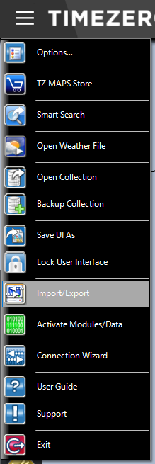
Import Marks and Lines
Survey navigation files are provided in two formats: GPS Exchange (.gpx) for points (i.e., “marks”) and Keyhole Markup Language (.kml) for lines and polygons. Files are included in the RACE Survey App; please ensure you have the latest version of the Survey App since files may be updated after the Poseidon client machine is setup.
To import files:
- Select Import/Export from the Main Menu.
- Select Import Data and click ‘Next’
- Select a file type to import (GPS or KML/KMZ) and click ‘Next’
- Select all files of the chosen type to be imported; click ‘Open’
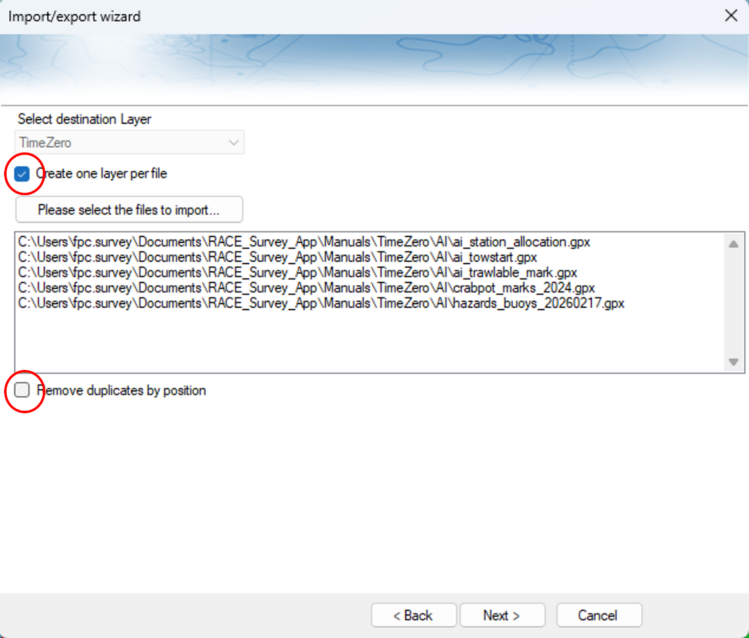
- Uncheck the ‘Remove duplicates by position’ box; leave ‘Create one layer per file’ checked; click Next
- TimeZero runs pre-checks on the data. Review the dialogue box to confirm that layers being imported pass checks, then click Next.
- Repeat the import process for the other file type.
Lock the imported layers so they cannot be accidentally modified:
- In the Fishing or Navigation Panes: Click on the User Objects Drop Down and click on Manage Layers. Or, in the Planning Pane: click on the Lists drop-down menu then Layers List.
- Lock every survey layer using the Lock Button in the Manage Layers window or by checking the ‘Locked’ boxes in the Layers List.
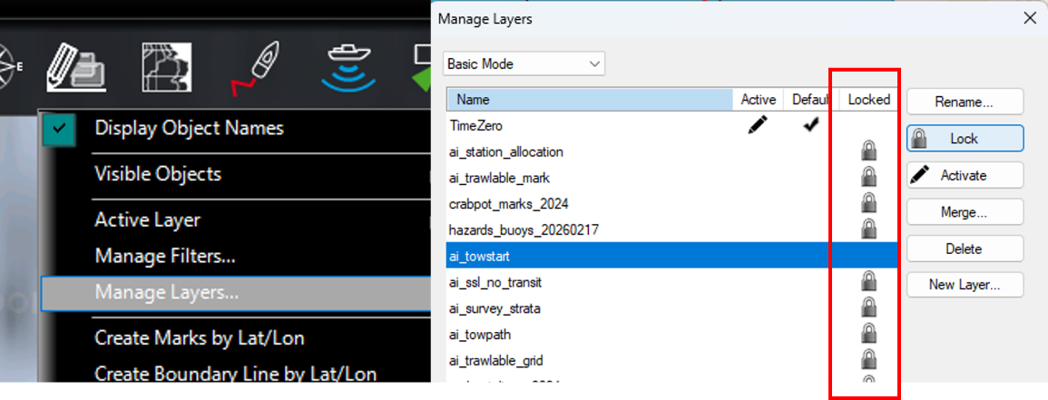

Batch Edit Layer Colors and Symbols
These instructions focus on batch-editing colors and symbols, which is useful for quickly changing a large number of colors. Individual marks/boundaries can also be edited by right-clicking on an object on the chart and the TimeZero User Manual provides information about additional editing options.
To batch edit marks:
- Navigate to the Planning Pane.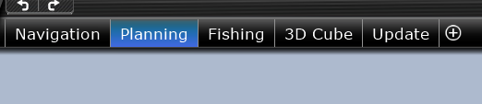
- Open the Boundaries List or Marks List Window by clicking on the Lists drop-down menu.
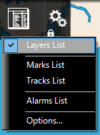
- Click on the Filter button on the right side of the Boundaries/Marks List window.
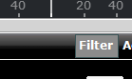
- Use the filter window to select the colors, symbols, and layers to be edited, then click OK.
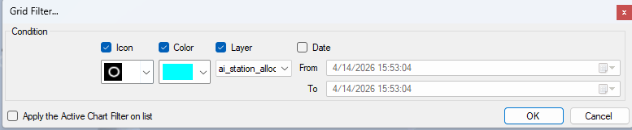
- Filtered objects will appear in the Layer List; select all of them.
- With all of the objects to be edited highlighted, right click on one of the rows to open a drop-down menu.
- Use options in the list (e.g., ‘Mark Symbol’ or ‘Color’) to change the appearance of the layer.
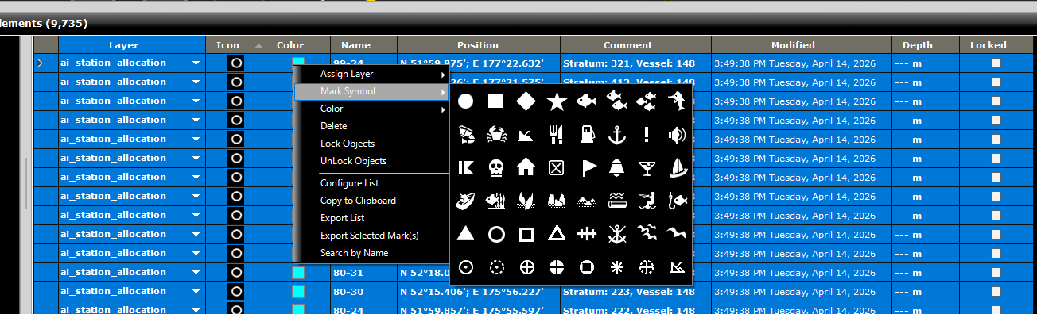

Display/Hide Object Names
Object names can either be displayed for all objects or not displayed at all. They cannot be selectively displayed for individual layers.
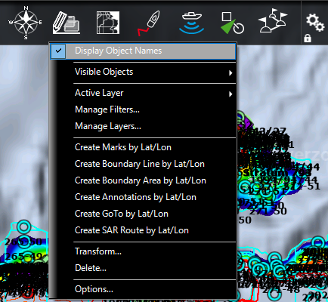
To display/hide object names, check/uncheck Display Object Names in the User Objects drop-down menu.

Display/Hide Layers
To display/hide layers:
- Hover over Visible Objects in the User Objects drop-down menu.
- Check/uncheck the layers to display.
Alternatively, layers in the Planning Pane can modified using the Layers List (Lists -> Layers List).

Delete Layers
To delete layers:
- In the Fishing or Navigation Panes: Click on the User Objects Drop Down and click on Manage Layers.
- In the scroll pane, click on the layer to be deleted and click D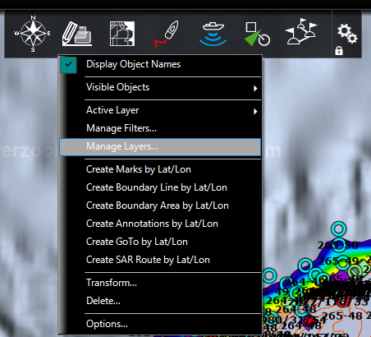elete.
Layers can also be deleted from the Planning Pane:
- In the Planning Pane: Click on the Lists drop-down menu, then Layers List.
- Lock every survey layer using the Lock Button in the Manage Layers window or by checking the ‘Locked’ boxes in the Layers List.

Planning: Bearing and Distance Using the Divider Tool
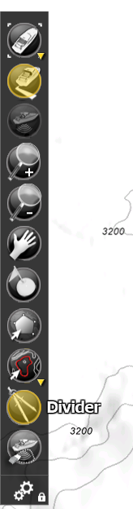
Bearing, distance, and depth profiles can be displayed using the Divider Tool.
To use the divider tool:
- Click on the Divider Tool in the Toolbar.
- Left click on the chart to set a point and click again to end.
- To remove a divider line, right-click on the line and click ‘Erase divider.’ You can also view a depth profile over the path by clicking on ‘Display Profile Window.’

View Tides, Currents, and Sunrise/Sunset Time
Tidal height and current information can be retrieved for select locations. Tidal height pop-up windows also include information sunrise and sunset times.
To view tidal heights and current sites:
- Click on the Chart drop-down menu and check the Tidal Heights and Tidal Currents items.
To view tide or current graphs:

Right click on a tidal height gauge icon or current arrow icon.
- Left click on Open Current Graph or Open Tide Graph
- A chart should appear; by left-clicking and holding on the chart, the graph can be dragged left or right to change the visible time window.
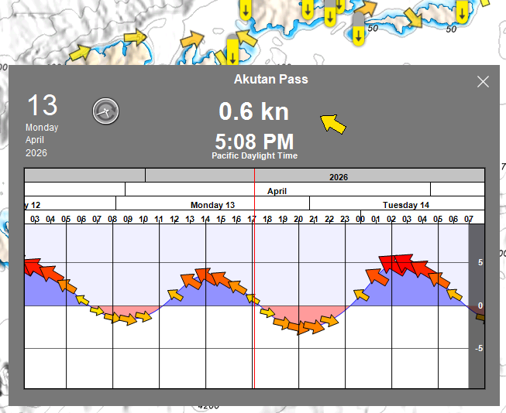

Personal Bathymetry Generator
TBD. Planned for Summer 2026.

Change Bathymetry Raster
TBD. Planned for Summer 2026.

Export and Backup Data

Backup Database
FPCs should regularly backup the TimeZero Track Data and save a copy to the G drive at the end of the leg.
To back up the database:
- Locate the file storage location for TimeZero database files (.tzdb). The location should be Location: C:/ProgramData/TimeZero/DATA/OwnShipRecorder.tzdb. The directory containing the database may be hidden; unhide it if needed.
- Stop track recording.
- Copy .tzdb files in the storage directory to an external drive.
- Start track recording.

Export Data for Poseidon
TimeZero writes track data to a SQLite database file with the extension .tzdb. These data can be used as a backup GPS data source when SCS/Poseidon and Marport/Scala data are not available. GPS data can be extracted from the TimeZero database and written to a .gps file using the convert_tzdb_gps() function in the GAPsurvey R package. The .gps file can then be imported into Poseidon.
To extract data from the TimeZero database:
- Open R Studio
- Load the GAPsurvey library and run the conversion code, replacing the function arguments below with the values for your haul:
library(GAPsurvey)
convert_tzdb_gps(
vessel = 162,
cruise = 202601,
haul = 42,
start = “07/04/2026 14:30:00”,
end = “07/04/2026 16:00:00”
)
Note: Change the inputs to match your selection. The syntax for start and end times must match the example above. Use 24-hour time and enter times in Anchorage Time (UTC-9). The time period for start and end should be a little longer than the start and end times you need for the haul.

- Use pop-up file browser window to select the .tzdb file containing your track data (presumably C: /ProgramData/TimeZero/DATA/OwnShipRecorder.tzdb).
- Console messages will indicate where the .gps file is saved:
- Optional: Open the .gps file in a text editor to verify that contents are correct. Note that times will be shown in UTC.
- Load the data into Poseidon along with other haul data files using the standard file loading process.

Export Data for Other Applications
In some cases, the FPC may need to export mark or track data to share with another vessel or for data records. In such cases, it is recommended to use TimeZero’s built-in data export features that are documented in the TimeZero Professional Manual.

Troubleshooting

No GPS Connection
Take the following steps if you lose your GPS connection:
- Check that the serial cable connecting the GPS to TimeZero is connected.
- Exit and reopen TimeZero and attempt to initiate track recording again.
- Close TimeZero and follow instructions on the survey app for configuring GPS NMEA sentence using SiRF Demo.
- Contact Gary McMurrin and Sean Rohan.

Hidden TimeZero Data Directory
TimeZero data are stored in C:/ProgramData/TimeZero/DATA/OwnShipRecorder.tzdb, but the directory containing the file may be hidden by default.
To unhide the directory:
- Navigate to C:/ in File Browser.
- Use the View tab to show hidden items (View->Show->Hidden Items)

Please contact Sean Rohan if a file fails to import.

