Session-8

Question 1: Create a Flipkart-style product card in HTML and CSS, then use a meta viewport tag to ensure it scales correctly on mobile devices.
Answer:
<!DOCTYPE html>
<html>
<head>
<title>Flipkart Product</title>

<!-- Makes the page responsive on mobile devices -->
<meta name="viewport" content="width=device-width, initial-scale=1.0">

<style>
body {
font-family: Arial;
background-color: #f5f5f5;
}

.product {
width: 600px;
margin: 50px auto;
padding: 20px;
background-color: white;
border: 1px solid gray;
display: flex;
gap: 20px;
}

.product img {
width: 250px;
height: 250px;
}

.details {
padding: 10px;
}

.details h2 {
color: #2874f0;
}

button {
background-color: #ff9f00;
color: white;
padding: 10px 20px;
border: none;
}
</style>
</head>

<body>

<div class="product">

<img src="laptop.webp" alt="Laptop">

<div class="details">

<h2>HP Laptop</h2>

<p>Powerful laptop for study and office work.</p>

<p><b>Price: ₹45,000</b></p>

<button>Buy Now</button>

</div>

</div>

</body>
</html>

Question 2: Add media queries to your product card so that when the screen width is 600px or less, the card layout switches from horizontal (image and details side by side) to vertical (image on top, details below).
Answer:
<!DOCTYPE html>
<html>
<head>
<title>Session 8_2</title>

<meta name="viewport" content="width=device-width, initial-scale=1.0">

<style>
body {
font-family: Arial;
background-color: #f5f5f5;
}

.product {
width: 600px;
margin: 50px auto;
padding: 20px;
background-color: white;
border: 1px solid gray;
display: flex;
gap: 20px;
}

.product img {
width: 250px;
height: 250px;
}

.details {
padding: 10px;
}

.details h2 {
color: #2874f0;
}

button {
background-color: #ff9f00;
color: white;
padding: 10px 20px;
border: none;
}

/* Mobile */
@media only screen and (max-width: 600px) {

.product {
width: 90%;
display: block;
}

.product img {
width: 100%;
height: auto;
}

.details {
padding: 10px 0;
}
}
</style>
</head>

<body>

<div class="product">

<img src="laptop.webp" alt="Laptop">

<div class="details">

<h2>HP Laptop</h2>

<p>Powerful laptop for study and office work.</p>

<p><b>Price: ₹45,000</b></p>

<button>Buy Now</button>

</div>

</div>

</body>
</html>

Question 3: Set up three breakpoints (600px, 900px, 1200px) for your product card and change the card's font size and padding at each breakpoint to improve readability on different devices.<br><br><em><strong>Hint:</strong> Use @media only screen and (max-width: ...) in your CSS for each breakpoint.</em>
Answer:
<!DOCTYPE html>
<html>
<head>
<title>Session 8_3</title>

<meta name="viewport" content="width=device-width, initial-scale=1.0">

<style>
body {
font-family: Arial;
background-color: #f5f5f5;
}

.product {
width: 600px;
margin: 50px auto;
padding: 20px;
background-color: white;
border: 1px solid gray;
display: flex;
gap: 20px;
font-size: 18px;
}

.product img {
width: 250px;
height: 250px;
}

.details {
padding: 15px;
}

.details h2 {
color: #2874f0;
}

button {
background-color: #ff9f00;
color: white;
padding: 10px 20px;
border: none;
}

/* Breakpoint: 1200px */
@media only screen and (max-width: 1200px) {

.product {
padding: 18px;
font-size: 17px;
}
}

/* Breakpoint: 900px */
@media only screen and (max-width: 900px) {

.product {
width: 80%;
padding: 15px;
font-size: 16px;
}
}

/* Breakpoint: 600px */
@media only screen and (max-width: 600px) {

.product {
width: 90%;
display: block;
padding: 12px;
font-size: 15px;
}

.product img {
width: 100%;
height: auto;
}

.details {
padding: 10px 0;
}
}

</style>
</head>

<body>

<div class="product">

<img src="laptop.webp" alt="Laptop">

<div class="details">

<h2>HP Laptop</h2>

<p>Powerful laptop for study and office work.</p>

<p><b>Price: ₹45,000</b></p>

<button>Buy Now</button>

</div>

</div>

</body>
</html>

Question 4: Test your responsive product card by resizing your browser window and taking screenshots at mobile, tablet, and desktop widths; submit the screenshots along with a short note on what changes at each size.
Answer:
Mobile:
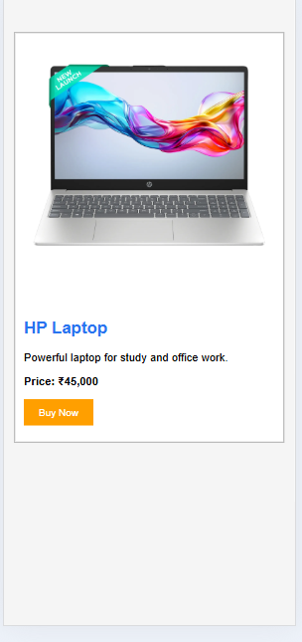

Tablet:
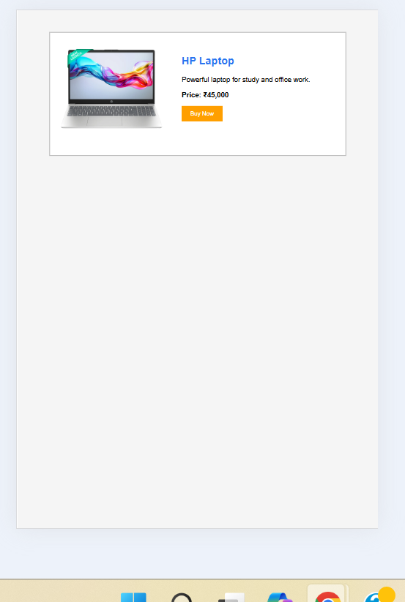

Desktop:
