Session - 1_Theory_Task
Question 1: Install Python (latest version) and VS Code on your computer, then take a screenshot of both the Python installation confirmation and the VS Code welcome screen.
Answer:
Python installation confirmation
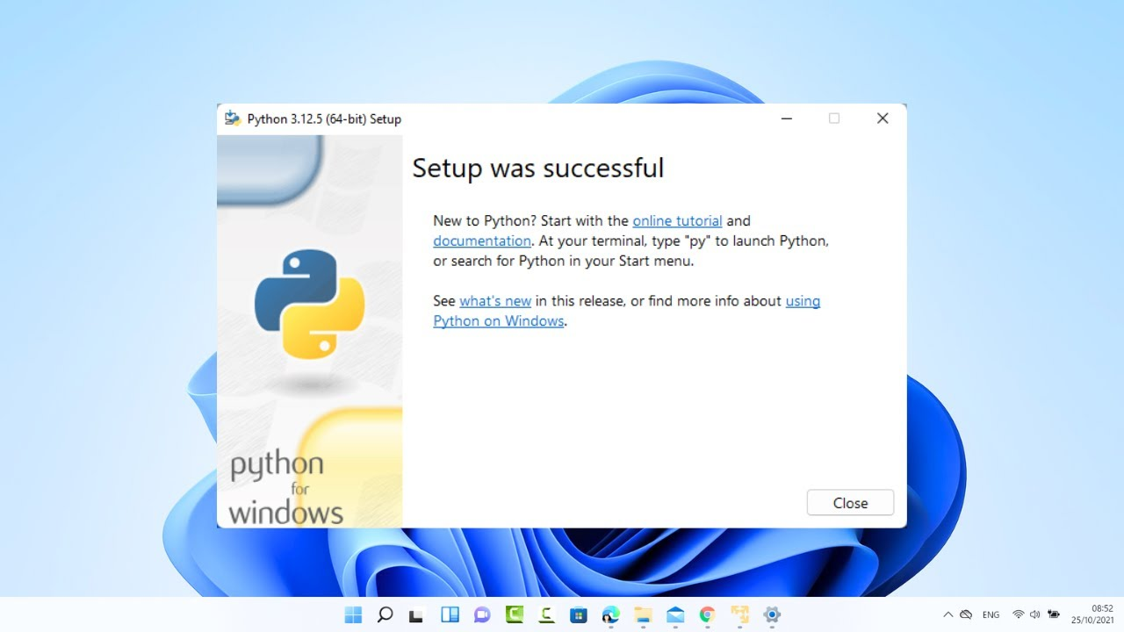
VS Code welcome screen.

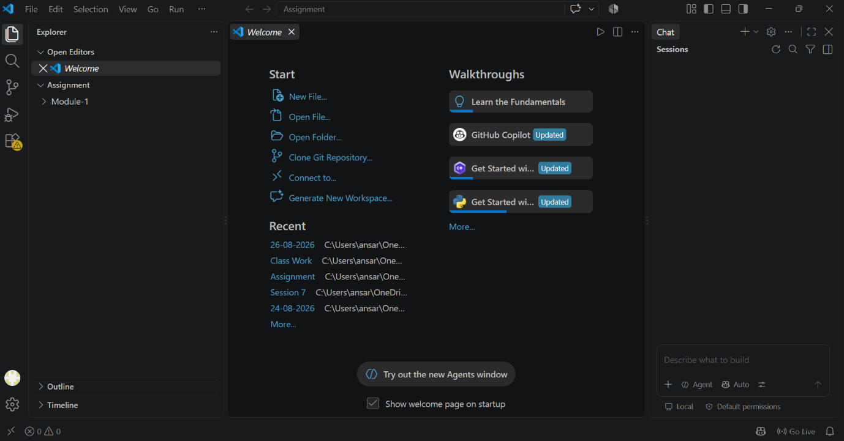
Question 5: Explain the difference between how Python executes code versus how C or Java executes code, using your own words and a simple example for each.
Answer:

C:
C Source Code → Compiler → Machine Code → Run
Example:
#include<stdio.h>
int main()
{
printf(“Hello!!”);
return 0;
}

Java:
Java Source Code → Compiler → Bytecode → JVM → Run
Example:
public class Main
{
public static void main(string[] args)
{
system.out.println(“Hello!!”);
}
}

Python:
Python Source Code → Python Interpreter → Output
Example: print(“Hello!!”)

