**DESIGN SPECIFICATIONS QUESTIONNAIRE:**

1. **Name:**   
   Exact name of your business/organization:   
     
   **Agency/Business Name:** Markalytics   
   **Legal name:** Markalytics ,LLC   
   **Brand Tag-line:** Digital Marketing & Analytics Partners   
   **Marketing Slogan:** Digitally yours
2. **Why? Purpose?**  
   Kindly state the purpose of your website: (Is it a selling/informative website or a personal blog? etc.)

**Purpose:** The main purpose is to build a “Digital Marketing Agency” website that stands out from other Agencies in its Design & Function. This website will act as a Business engine for the entire Agency, as well as a first impression for prospects. We want to make it easy for web visitors to take action on the website i.e. contact us, Schedule Demos/Meetings on calendar, and/ or submit their Project Briefs in Client Portal for discussion.   
**Core Focus of website:** (1) Convert visitors into Agency Leads/Clients (2) Conversion Optimization: Landing Pages, lead magnets, Forms, and valuable content to get more Leads. (3) Increase web traffic via content marketing & Seo (4) Develop High-Domain Authority with content.  
**One-liner / Pitch:** A fully branded, responsive, and unique design, with the website Copy that speaks directly to Target Customers, and addresses their pain points upfront and to the point! Markalytics website will be optimized fully with Lead-Magnets & Call-To-Actions on each page, to ensure maximum conversion rate.

1. **Pages & Navigation:**  
   As per the navigation of your website, kindly state the title of your WebPages: (E.g.: Company Profile, Contact us etc.)

Please find the Sitemap here: <https://www.gloomaps.com/JpvYQNiexl>  
Please find Footer Pages here: <https://www.gloomaps.com/WtEFWtKAze>

1. **Vibe:**  
   What type of overall feeling would you like to project with your new Website Domain? (Corporate, fun, high-tech, etc...) Leave this field blank if you would like us to make this determination.  
     
   **Brand Persona:**   
   **Website Feel/vibe:** Modern, Highly Professional, Eloquent/High End feel, yet So simple and welcoming with language. Mood:   
   **Tone:** Friendly & welcoming  
   **Voice:** Trustable, It must give the feeling to the customer that they have finally landed on a Transparent website that lays out all info, no hidden gimmicks. And this website is there to help them get work done!  
   **Imagery:** Success, Accomplishment, Happiness
2. **Industry / Products:**  
   Please give a brief description of your business: (What type of products or services does your company supply? Etc.  
     
   **Brief Description of Markalytics:** Markalytics is an analytics-first Ecommerce & Digital Marketing agency. It offers signature programs to small and medium B2B enterprises for growing digital presence & increasing online sales. Markalytics is the first of it’s kind Digital marketing agency in DC, Maryland, & Virginia that is helping Healthcare & manufacturing companies go from B2B to D2C, with an analytics-first approach to generating online sales & leads.   
     
   **Products & Services offered:** Main highlight will be our signature programs. Other than that Digital marketing services focused mainly on Ecommerce websites & Website development + Analytics Management.   
     
   **Note:** All services will be packaged as “Productized Services” i.e. with Exact prices, features, deliverables, timeframes, and other benefits. Everything will be displayed on the website clearly. We wan’t to minimize custom solutions, and instead sell Packaged/Productized Services like a Fixed price solution ,for example You pay X amount, you get Y,Z services.
3. **Customers:**  
   State the target audience of your website  
     
   **Segments:** Companies in Virginia, Companies in Maryland, and Companies in DC, companies elsewhere  
     
   **Target Customer:** Healthcare apparel companies, Manufacturing / Industrial sector  
     
   **Our Positioning in Customer’s mind:** Markalytics is a one-stop shop for everything digital + Highest quality work & customer service at Lowest prices. We want to be known by our exceptional customer service, communication, and quick project delivery with great attention to detail.
4. **Design Inspirations:**  
   Do you have any specific design preferences? If yes, please mention a reference: (If you have any particular likes or dislikes regarding any competitor's website etc.) *  
     
   List down Examples with Links:  
   **Color Preferences:**Please create color scheme based on the following reference websites:

<https://ic-creative.co.uk/>  
<https://www.trifectanutrition.com/>  
 **Font/Typography Preference:** Match the fonts on this website or something alike that works better with readability <https://www.trifectanutrition.com/>

**Dislikes:** Please do not use colorful animated/2D characters to depict Agency work  
 **Showcasing Services:**   
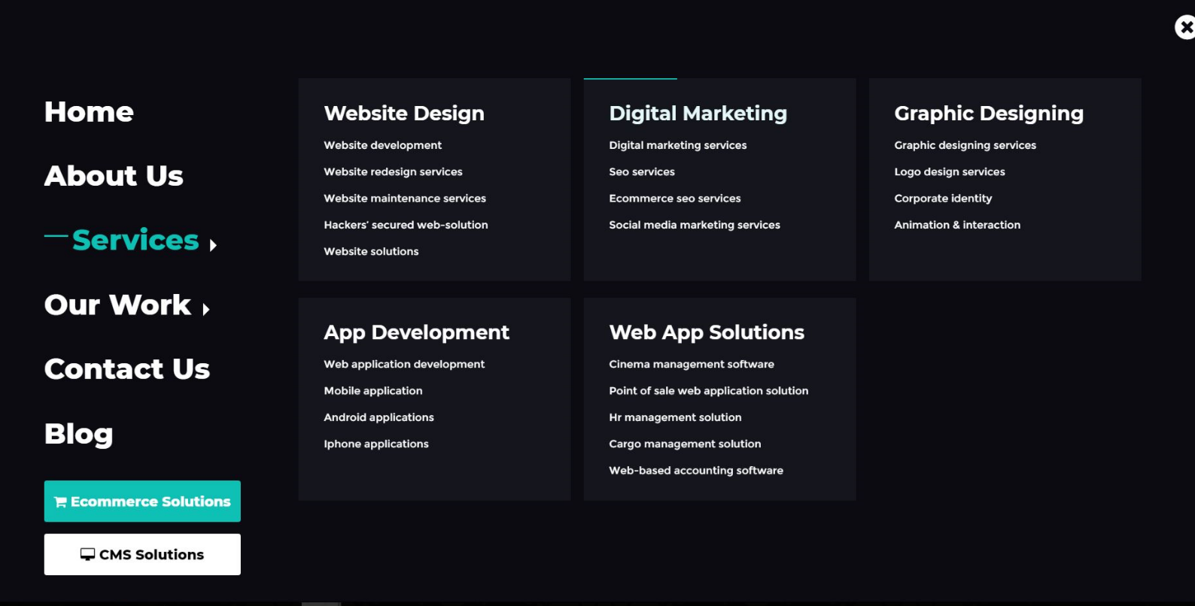

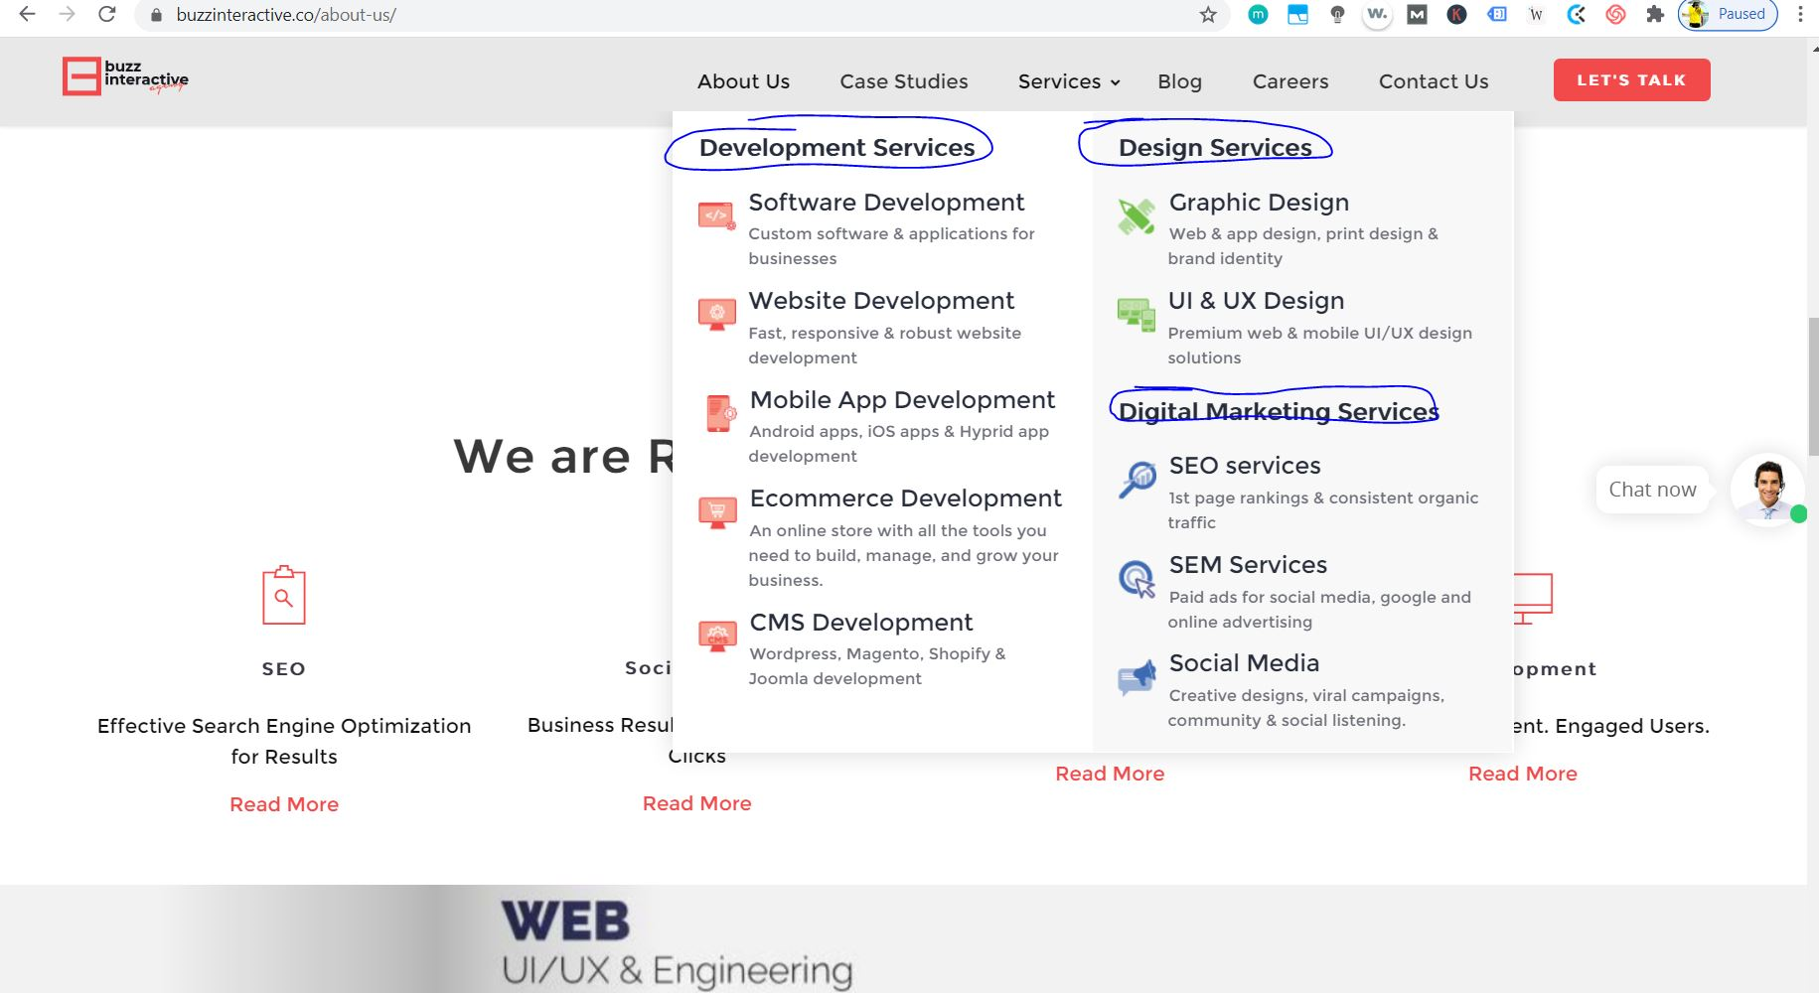

1. **Do you have any additional comments?**List down examples with links:  
     
   1. Keep the design fully responsive and mobile-first.  
   2. Kindly add animations in background, hover effects wherever possible, zoom in over text / section if need be, Basically on each page we want a dynamic look.  
     
   3. Home Page: On the Home page, please try to add some feature that as you scroll down, something keeps going down on the screen and changing at the same time in a fun dynamic way. Some Action effect must show up once the screen reaches the bottom.  
     
   4. I am open to all creative ideas, suggestions and recommendations. Please share wherever needed.
2. **Upload Brief:**