Applying Hybrid NLP and Machine Learning for Consumer Complaint Classification and Monetary Relief Prediction

Afshan Mehmood

A Thesis Submitted in Partial Fulfilment
of the requirements for the
Degree of
Master of Science in Data Analytics



May 2026

Supervisor: Maqsood Hussain Shah

Link for dataset: https://drive.google.com/file/d/1njbqYd641H2w9Yw2jcdw6SHNKOQM1F4o/view?usp=sharing

List of Acronyms

Artificial Intelligence (AI)
Artificial Neural Network (ANN)
Bidirectional Encoder Representations from Transformers (BERT)
Bag of Words (BoW)
Consumer Financial Protection Bureau (CFPB)
Convolutional Neural Network (CNN)
Decision Tree (DT)
Exploratory Data Analysis (EDA)
Financial Bidirectional Encoder Representations from Transformers (FinBERT)
General Data Protection Regulation (GDPR)
Hierarchical Density-Based Spatial Clustering of Applications with Noise (HDBSCAN)
K-Nearest Neighbors (KNN)
Lexicon-Based Approach (LBA)
Latent Dirichlet Allocation (LDA)
Local Interpretable Model-Agnostic Explanations (LIME)
Logistic Regression (LR)
Large Language Model (LLM)
Machine Learning (ML)
Multi-Layer Perceptron (MLP)
Natural Language Processing (NLP)
Organisation for Economic Co-operation and Development (OECD)
Receiver Operating Characteristic – Area Under Curve (ROC-AUC)
Random Forest (RF)
SHapley Additive exPlanations (SHAP)
Support Vector Machine (SVM)
Term Frequency–Inverse Document Frequency (TF-IDF)
Uniform Manifold Approximation and Projection (UMAP)
Explainable Artificial Intelligence (XAI)
Extreme Gradient Boosting (XGBoost)

ACKNOWLEDGEMENTS

I would like to thank My Supervisor Maqsood Hussain Shah for his guidance. I would also like to thank my family for their support.

Table of Contents

ABSTRACT
Chapter 1: Introduction
1.1 Importance of the Complaint Analytics
1.2 Consumer Financial Complaints and the CFPB
1.3 Problem Statement
1.4 Research Aims and Objectives
1.5 Overview of Research Methodology
1.6 Scope and Delimitations
1.7 Contributions of the Study
1.8 Organisation of the Thesis
Chapter 2: Literature Review
2.1 Introduction
2.2 Complaint Analytics Across Industries
2.3 CFPB Complaint Dataset and Financial Context
2.4 Structured Data Models
2.5 Classical NLP Techniques
2.6 Deep Learning Architectures
2.7 Transformer-Based Architectures and Domain Adaptation
2.8 Hybrid and Multimodal Approaches
2.9 Explainable AI in Complaint Analysis
2.10 Research Gap and Study Contribution
2.11 Conclusion
Chapter 3: Research Methodology
3.1 Introduction
3.2 Research Design
3.3 Research Architecture and Pipeline Overview
3.4 Model Development Framework
3.5 Explainable AI (XAI) and Model Interpretation
3.6 Model Validation and Evaluation
3.7 Tools and Technologies
3.8 Ethical and Legal Considerations
3.9 Methodological Limitations
3.10 Conclusion:
Chapter 4: Implementation
4.1 Chapter Overview
4.2 Development Environment
4.3 Data Loading and Preparation
4.4 Exploratory Data Analysis

4.5 Feature Engineering
4.6 Model Implementation
4.7 Explainable AI
4.8 Conclusion:
Chapter 5: Evaluation and Results
5.1 Overview
5.2 Binary Classification Results — Monetary Relief Prediction
5.3 Product Classification Results
5.4 Cross-Task Discussion
5.5 Explainable AI Results
5.6 Conclusion
Chapter 6: Conclusion and Future Work
References

ABSTRACT

Customer complaints and reviews are vital across industries, helping businesses identify service failures, emerging risks, and misconduct, especially in financial markets. However, the rapid transformation of financial services has led to a significant rise in the volume and complexity of consumer complaints, presenting major challenges for regulatory monitoring and institutional complaint management. To address this, the current research develops and evaluates an explainable, hybrid Natural Language Processing (NLP) framework to analyze consumer financial complaints using the Consumer Financial Protection Bureau (CFPB) dataset. The study focuses on three primary predictive objectives: (a) restitution outcome prediction (b) product classification and (c) model decisions’ explanation.
This study systematically evaluates the performance of classical machine learning models (Logistic Regression, XGBoost, and LinearSVC), transformer-based architectures (BERT and FinBERT), and a hybrid framework that integrates contextual text embeddings with structured complaint attributes. The results, however, demonstrate a significant performance contrast across tasks. For binary monetary relief prediction, the hybrid framework outperforms other models in terms of highest macro F1-score of 0.6561 and the strongest minority-class precision. This finding validates the assumption that integrating structured metadata with contextual embeddings provides a more stable predictive performance. In comparison, in the multiclass product classification task, while LinearSVC achieves the highest Macro F1-score (0.6595), due to its robust linear decision boundaries, the transformer-based models show higher Balanced Accuracy (0.77 approx.) and ranking performance, with ROC-AUC scores above 0.95. Additionally, FinBERT, with its domain-specific pre-training, provides enhanced minority-class precision, thus highlighting the benefit of financial-domain semantics. Further, to ensure transparency in modelling decisions, this study integrates Explainable AI (XAI) techniques, including SHAP, LIME and attention visualization. These methods confirm that model predictions are driven by meaningful semantic patterns, with transaction-related language impacting monetary relief outcomes.
Overall, this research presents a scalable and interpretable end-to-end framework that bridges the gap between deep learning performance and regulatory accountability, offering a robust approach for automated complaint management and early risk detection within the financial sector.

Chapter 1: Introduction

1.1 Importance of the Complaint Analytics
The rapid advancement of digital communication platforms has significantly impacted the way consumers engage with organizations and regulatory bodies. Customer complaints and reviews are vital across industries, helping businesses identify service failures, customer dissatisfaction and emerging risks. In finance and regulatory sectors, complaints are particularly useful as they reflect consumer grievances related to unfair treatment, fraud, money disputes and organizational misconduct. As a result, effective complaint analysis has become increasingly important not only to improve service quality and increase customer retention but also to support consumer protection and regulatory oversight.
However, the growing volume, velocity, and variety of complaint data has created significant challenges. In today’s world, organizations receive thousands of complaints through various channels, resulting in huge databases of unstructured text. Considering the vast amount of available data, manual complaint handling is both slow and resource-intensive. Consequently, organizations and regulators are increasingly relying on data-driven tools that can analyze complaints automatically, detect recurring issues, prioritize high risk cases and ensure timely and fair responses.
Early automated complaint analysis systems relied majorly on simple rule-based or keyword driven approaches and statistical text mining techniques that were unable to capture the narrative nuances embedded in complaint text. Although these traditional analytical approaches demonstrated the feasibility of automated analysis, they treated language as isolated tokens and struggled to understand the contextual depth in complaint narratives. This limitation is particularly critical in financial complaint analysis, where nuanced consumer responses often contain signs of financial distress, misconduct, or potential regulatory concerns.
Progress in data analytics and Natural Language Processing (NLP) has greatly enhanced the capacity to process large-scale textual data. Recently, transformer-based NLP models such as Bidirectional Encoder Representations from Transformers (BERT) and its finance-specific variant, Financial BERT (FinBERT) have been used to capture semantic relationships between words in order to understand the context of the complaints more effectively. These models have shown strong performance in multiple areas such as machine translation, text classification, named entity recognition and sentiment analysis. However, despite this progress, their application to financial complaint analysis, particularly within regulatory contexts, remains relatively limited.
Alongside these developments, hybrid modelling approaches also have emerged as a promising direction in machine learning, combining textual representations derived from NLP models with structured tabular features such as metadata, categories, and behavioural indicators. By integrating multiple data sources, hybrid models aim to leverage both the semantic richness of unstructured text and the predictive strength of structured attributes, potentially improving classification performance and robustness in complex decision-making tasks.
Besides modelling, regulatory technology for monitoring and reporting has also become increasingly important. Regulatory technology applications require that Artificial Intelligence (AI) based techniques offer explanations on why a specific classification decision was made to foster transparency and encourage trust towards system output. Since predictive performance alone is not enough, therefore explainability of the model decisions is also needed especially when such decisions can impact consumer outcomes. This has led to the development of Explainable AI (XAI) techniques such as SHapley Additive exPlanations (SHAP), Local Interpretable Model-agnostic Explanations (LIME), and transformer attention visualisation, which help improve transparency by identifying the features that influence model decisions.
The requirement of explainability has also substantially increased in the financial sector due to the rapid growth in fintech platforms, online lending, digital banking and financial products. This advancement has generated new forms of consumer risks and increased the need for regulatory bodies to ensure fairness and transparency. Consequently, the convergence of machine learning, NLP, hybrid modelling, and explainable AI techniques, represents an emerging area of data analytics research with direct implications for consumer financial protection and regulatory governance.

1.2 Consumer Financial Complaints and the CFPB
In the United States, the Consumer Financial Protection Bureau (CFPB) was formulated as an independent federal agency to protect consumers in the financial sector (CFPB, 2025). It maintains a public database of consumer complaints, which gathers and publishes complaints concerning financial services. The complaints cover various topics including debt collection, credit reporting, mortgages, student loans, etc. Apart from structured data, the complaint records also contain textual narratives describing consumer experiences in detail.
The CFPB database constitutes a valuable resource for research as well as regulatory analysis. Using this publicly accessible data, the researchers can investigate consumer issues, financial risks and organizational behavior. Moreover, the dataset reflects real-world consumer problems and regulatory challenges, making it highly relevant for applying machine learning and NLP techniques for trend analysis, complaint classification, outcome prediction, and regulatory decision support.
Early research on CFPB data has majorly revolved around sentiment analysis, topic modelling or complaint classification tasks employing classical machine learning approaches such as Term Frequency Inverse Document Frequency (TF-IDF), Logistic Regression (LR), Latent Dirichlet Allocation (LDA) topic modelling, etc. Although these techniques have demonstrated reasonable predictive accuracy, they produce weak representations of text and fail to capture the contextual richness of consumer narratives.
Parallel research has explored structured attributes in CFPB data to predict complaint outcomes and organizational responses. Although structured variables like product category and issue type can provide reasonable predictive information, they ignore the contextual richness embedded in complaint narratives, such as sentiment, severity, and detailed issue descriptions, and cannot fully represent consumer issues.
More recently, deep learning and transformer based approaches have reshaped CFPB complaint analysis by enabling semantic understanding of narrative text. Self-attention mechanisms allow such models to capture contextual relationships, tone, and domain-specific patterns in the financial complaints, thus achieving improved performance. However, these studies remain limited in number and often focus on either classification or sentiment analysis in isolation, without systematic comparison against strong classical baselines. In addition, hybrid modelling approaches that combine textual embeddings with structured complaint metadata have also emerged as a promising direction in regulatory complaint analysis, but are largely underexplored.
Although prior studies demonstrate the value of applying machine learning and NLP techniques to CFPB complaint data, important methodological and practical limitations still remain, particularly regarding multimodal integration, and explainability, which are discussed in the following section.

1.3 Problem Statement
Despite significant advances in complaint analytics, existing approaches within CFPB research remain limited in their ability to simultaneously capture semantic meaning, integrate structured and unstructured complaint data, and provide transparent explanations, suitable for regulatory decision-making. Prior studies have often relied either on unstructured data or structured attributes alone. For textual analytics, traditional text mining approaches have been used that treat language as isolated word frequencies, thus limiting their ability to capture semantic depth and narrative complexity within financial complaints.
Although transformer-based models have improved contextual understanding, predictive and classification performance, their application within CFPB complaint analytics remains comparatively limited. Moreover, existing studies frequently focus on isolated tasks such as sentiment analysis, topic modelling or complaint classification without systematically integrating structured complaint features alongside textual data. Consequently, the potential benefits of multimodal modelling approaches for improving complaint classification and restitution outcome prediction remain underexplored within financial regulatory environments.
In addition, explainability also remains insufficiently addressed in current CFPB research. Many studies primarily prioritise predictive performance without providing transparent explanations of model decisions. This creates an important limitation for regulatory environments where accountability, transparency, fairness, and interpretability are essential requirements for automated complaint management systems. Regulatory institutions require models whose predictions can be understood, and justified particularly when such predictions may impact complaint prioritisation, supervisory attention, or consumer outcomes.
These limitations create a critical gap in the development of reliable, transparent, and scalable decision-support systems for consumer financial protection. To address this gap, the present study proposes a hybrid framework that combines transformer-based textual embeddings with structured CFPB complaint data for complaint classification and restitution outcome prediction. The framework further incorporates Explainable Artificial Intelligence (XAI) techniques including SHapley Additive exPlanations (SHAP), Local Interpretable Model-agnostic Explanations (LIME), and attention visualisation to improve interpretability and regulatory transparency.

1.4 Research Aims and Objectives
The overall aim of this study is to develop an explainable hybrid NLP framework for analysing Consumer Financial Protection Bureau complaints in order to support transparent and data-driven regulatory analytics.
To achieve this aim, the study addresses the following research objectives:
- To classify CFPB complaints into product categories by systematically comparing classical machine learning and transformer-based NLP models.
- To predict restitution outcomes by combining textual embeddings with structured complaint attributes within a hybrid modelling framework.
- To interpret model predictions using explainable AI techniques such as SHAP, LIME, and transformer attention visualisation in order to ensure transparency within high-stakes regulatory contexts.
These objectives collectively examine both predictive performance and interpretability, enabling evaluation of how different modelling approaches support automated consumer complaint analysis.

1.5 Overview of Research Methodology
This study adopts a quantitative and experimental research design using publicly available CFPB complaint data collected between 2020 and 2025. The analytical framework combines exploratory data analysis, classical machine learning, transformer-based Natural Language Processing (NLP), hybrid modelling, and Explainable Artificial Intelligence (XAI) techniques for complaint classification and restitution outcome prediction.
Classical machine learning models such as Logistic Regression, Linear Support Vector Classification (Linear SVC), and XGBoost are evaluated alongside transformer-based models including Bidirectional Encoder Representations from Transformers (BERT) and Financial Bidirectional Encoder Representations from Transformers (FinBERT). In addition, hybrid architectures are developed by integrating structured complaint features with contextual text embeddings (BERT embeddings) in order to improve predictive performance and capture complementary information from both data modalities.
To ensure interpretability and transparency, the study further applies explainability techniques such as SHapley Additive exPlanations (SHAP), Local Interpretable Model-agnostic Explanations (LIME), and transformer attention visualisation to analyse model behaviour across different architectures.
Model performance is evaluated using metrics suitable for imbalanced classification tasks, including Macro F1-score, balanced accuracy, precision, recall, Area Under the Receiver Operating Characteristic Curve (ROC-AUC) and confusion matrix. Overall, the methodological design emphasises comparative evaluation, and interpretability to ensure relevance for both academic research and regulatory applications.

1.6 Scope and Delimitations
This research is delimited to publicly available complaint data obtained from the CFPB Consumer Complaint Database. The study focuses specifically on exploratory analysis, complaint classification, restitution outcome prediction, hybrid modelling, and explainability within the context of consumer financial complaints.
The research does not attempt to provide legal or economic interpretation of restitution decisions beyond model-based inference. Similarly, the study does not directly evaluate regulatory policy effectiveness, nor does it establish causal relationships between complaint characteristics and institutional behaviour. Instead, the research concentrates on predictive analytics and explainable AI approaches applicable to financial complaint analysis.
Although the findings may have broader relevance for regulatory analytics and complaint management systems, the models are developed and evaluated specifically within the CFPB context. Consequently, generalisability to other regulatory domains, industries, or jurisdictions may require additional validation and domain-specific adaptation.

1.7 Contributions of the Study
This research contributes to the fields of regulatory Natural Language Processing (NLP), complaint analytics, and Explainable Artificial Intelligence (XAI) in several ways. First, it provides a systematic comparison of classical machine learning, transformer-based NLP, and hybrid models for CFPB complaint analysis under consistent experimental conditions. This facilitates a clearer understanding of the relative strengths, limitations, and practical suitability of different modelling approaches for examining financial complaint data.
Second, the research extends existing CFPB literature through the application of transformer-based models such as Bidirectional Encoder Representations from Transformers (BERT) and Financial Bidirectional Encoder Representations from Transformers (FinBERT) to both product classification and restitution outcome prediction tasks. In addition, it develops a hybrid modelling framework that integrates textual embeddings with structured complaint attributes, enabling investigation of how multimodal representations can impact predictive performance.
A further contribution lies in the integration of explainability techniques including SHapley Additive exPlanations (SHAP), Local Interpretable Model-agnostic Explanations (LIME), and transformer attention visualisation across multiple model architectures. By combining predictive analytics with interpretability, the research addresses an important limitation within existing CFPB studies and supports the development of more transparent AI systems suitable for regualtory financial environments.
Finally, the research contributes practical insights regarding the role of contextual embeddings, structured metadata, class imbalance, multimodal learning, and explainable AI within consumer financial complaint analytics. These findings may support future academic research and inform the development of scalable, transparent, and data-driven decision-support systems for consumer financial protection and regulatory analysis.

1.8 Organisation of the Thesis
The remainder of this thesis is organised into seven chapters.
Chapter 2 presents a comprehensive review of the literature related to consumer complaint analytics, Chapter 3 describes the research methodology, Chapter 4 details the system design and implementation, Chapter 5 presents the evaluation, results and interpretability of models and Chapter 6 concludes the thesis by summarising the key findings and discussing the future work.

Chapter 2: Literature Review

2.1 Introduction
Customer complaints can be seen as a form of feedback that expresses the customer’s dissatisfaction with a product or service. They form a critical channel through which consumers disclose service failures, financial loss, and misconduct. From an organizational and regulatory perspective, complaints provide an outlook of the operational incompetencies, systemic risks and gaps in customer experience. Therefore a complaint is an opportunity to not only identify recurring problems and improve service delivery but also to address the customer’s concerns, potentially turning a dissatisfied customer into a loyal one. As noted by Filip (2013), complaints act as key indicators of organisational performance, where effective handling can prevent the loss of a substantial proportion of dissatisfied customers through timely service recovery. This further highlights the importance of responsible organizations to take customer complaints seriously, review them responsibly and respond to them promptly.
Building on this, before the adoption of automated analytics, regulators and firms primarily relied on manual review processes, where operators inspected complaints individually to determine risk or escalation. Although these approaches were helpful in contextual understanding, they were subjective and time consuming. With the advancement in technology and enhanced consumer engagement, there has been a substantial increase in complaint volumes. Since customers express their complaints in text form, the growing volume of textual data makes manual analysis of text and timely resolution of the complaints, increasingly challenging. This highlights the need for businesses to develop systematic, data-driven methods to analyse complaints and take appropriate actions (Helmy, Ashraf and Abdelhamid, 2023).
In response to these challenges, there has been a significant transformation in complaint analytics, transitioning from manual approaches towards automated and data driven techniques. Earlier analytical methods focused on analyzing structured data, however, with the increase in the availability of unstructured text-based data, there has been a considerable rise in the adoption of natural language processing techniques. More recently, transformer based models have further helped in improving complaint analysis and predictive performance as they are able to learn the context and thus meaning by tracking relationships in sequential data. Despite these advancements, the integration of structured and unstructured data is quite challenging, while maintaining model transparency and interpretability.
This chapter critically reviews the literature across these developments. It begins by examining the role of complaint analytics across industries, followed by structured data approaches, classical NLP techniques, transformer-based models, hybrid multimodal systems, and Explainable Artificial Intelligence (XAI) techniques. Moreover, it introduces the Consumer Financial Protection Bureau (CFPB) dataset as the empirical foundation for this study and identifies the key research gaps addressed in this work.

2.2 Complaint Analytics Across Industries

Customer complaint analysis has become an essential area of research across multiple industries, serving as a key indicator of service quality, organisational performance, and customer satisfaction. Across sectors, complaints provide actionable insights into operational failures and customer dissatisfaction, enabling organisations to identify weaknesses and implement corrective measures. Early studies primarily focused on quantifying the complaint volumes and linking them to business outcomes, establishing the foundational importance of complaint analytics.

In traditional service sectors, complaint data has been shown to have a strong influence on organisational performance. For example, in the aviation industry, Birim, Anitsal and Anitsal (2016) proposed a model for analysing customer complaints and their impact on organizational performance, with a focus on variables such as service quality, fees, and economic conditions. The authors used these variables to predict complaints that could affect future ticket purchases thus impacting the company revenue. Likewise, Xu et al. (2018), working in the mobile service sector, constructed a complaint orders classification corpus by combining professional knowledge with a K-means algorithm, achieving a 91% agreement rate among annotators. Their work provides a foundational corpus for training models to automatically categorize and route customer issues.

As industries continue to evolve, the nature and complexity of complaints have also changed.
Epp, Lin and Bezemer (2021) analyzed the Virtual Reality (VR) games market and observed that with the evolution in the market, complaint trends have also shifted from hardware-related problems and VR-comfort issues towards more complex software and game specific issues related to content, software bugs, and pricing. This shift highlights the significance of analyzing unstructured textual feedback as structured variables alone are often insufficient for capturing detailed customer experiences. Moreover, their work also highlighted that although manual classification can result in high accuracy, it lacks scalability when dealing with large volumes of complaint data.

Besides the above industries, complaints analytics plays a significant role in the financial sector as well; considering it is linked to risk management, regulatory compliance, institutional performance and consumer protection. Cotugno and Stefanelli (2023) conducted a comprehensive study of the Italian banking sector, demonstrating that an increased number of complaints leads to a measurable reduction in bank performance, thus highlighting complaints as early indicators of financial instability. Similarly, Estelami and Liu (2024) examined American consumers’ complaints about credit card frauds and found that procedural shortcomings, including delayed responses and ineffective communication, often lead to greater customer dissatisfaction than the financial loss itself.

More recent research by Couto et al. (2024) analyzed complaints about investment fintechs using the topic modeling approach combined with large language models. They demonstrated the effectiveness of these techniques in identifying problems related to customer service, such as service disruptions and platform accessibility issues that are not detectable through structured data alone. However, despite these advancements, the existing literature remains fragmented, as many studies continue to rely on either structured or unstructured data instead of integrating both approaches.

Table 2.1 Cross-Industry Complaint Analytics Literature

Author(s) | Year | Domain | Method/Analysis | Key Finding | Limitation
Birim, Anitsal and Anitsal | 2016 | Aviation | Conceptual modelling | Complaints predict financial performance | No granular analysis
Xu et al. | 2018 | Telecom | K-Means clustering + expert rules | AI needs domain knowledge for accuracy | Limited generalisability
Epp, Lin and Bezemer | 2021 | VR/Tech | Empirical study and manual classification | Complaint types evolve with technology | Not scalable
Cotugno & Stefanelli | 2023 | Banking | Panel data model and Generalized Method of Moments (GMM) | Complaints reduce bank performance | Limited behavioural depth
Estelami & Liu | 2024 | Finance | Content analysis and logistic regression | Procedural issues drive dissatisfaction | Small dataset
Couto et al. | 2024 | Fintech | NLP / topic modelling / LLMs | Hidden systemic issues identified | Domain-specific

Table 2.1 gives a summary of the complaint analytics across different industries. It can be seen from the table that the research on complaint analytics varies in both analytical approaches and analytical depth, depending on the domain and the specific research objective. While earlier studies focussed on manual or conceptual modeling in order to examine the impacts of complaints on performance, the recent studies, in contrast, have been incorporating more advanced computational approaches, such as clustering, regression analysis, and natural language processing. Across these studies, structured analytical methods generally prioritize quantifiable outcomes, such as complaint frequency , issue types, etc., whereas studies incorporating textual analysis aim to capture more detailed insights embedded within complaint narratives.

Despite these methodological advancements, the literature shows a lack of integrated analytical frameworks that combine various forms of complaint data within a single model. This limitation affects the generalizability of these studies and reduces their applicability to large scale complaint datasets. Moreover, this gap is particularly significant in the analysis of financial complaints where the integration of both structured features and unstructured native text is essential for thorough and contextual understanding and regulatory analytics.

2.3 CFPB Complaint Dataset and Financial Context

With regards to complaint data, the Consumer Financial Protection Bureau (CFPB) provides one of the most comprehensive public datasets for analysing financial consumer complaints (CFPB, 2025). CFPB is a government organization and regulatory body dedicated to safeguarding consumer rights and promoting fair practices in the financial industry. It maintains a large complaint database containing millions of records submitted by consumers regarding financial products and services, including credit cards, mortgages, loans, and banking services. Each record includes both structured attributes alongside unstructured narrative text describing the consumer’s experience. This dual structure makes the dataset particularly suitable for machine learning and natural language processing applications. However, as noted in the previous section, existing literature (e.g. Estelami and Liu, 2024) often treats these data types in isolation thus limiting the ability to fully understand the semantic context of complaint data. This creates a significant research gap: the need for a hybrid analytical framework that integrates structured financial attributes with textual representations to enable scalable and transparent analysis of consumer distress, as discussed in Chapter 1.

2.4 Structured Data Models
Early research in complaint analytics largely focussed on structured features such as category labels, time stamps and response indicators, mainly due to lower computational requirements and limitations of unstructured data availability in early complaints along with the scarcity of textual complaint narratives for analysis. While structured-only prediction is computationally efficient, it lacks contextual depth to understand the underlying root causes of customer dissatisfaction.
In this regard, Vaishnav et al. (2024) applied supervised machine learning algorithms like Random Forest (RF) and Decision Tree (DT) for predictive analysis of CFPB complaints using structured features; thereby forecasting both the likelihood and type of company response; offering a more comprehensive view of complaint resolution. Likewise, Onunkwo (2019) used structured variables from consumer complaint data (CFPB) to model the likelihood of a consumer disputing a financial service provider's response. He compared Naive Bayes, Random Forest and Logistic Regression, and identified Random Forest as the best-performing classifier for handling the high-dimensional categorical data commonly found in regulatory datasets.
This dependence on structured data extends beyond the financial domain. Within the telecommunications sector, Choi (2018) analyzed structured billing and service-usage data of 10,000 Korean subscribers and applied Artificial Neural Networks (ANNs) to provide the most accurate prediction, thereby offering telecom companies a method to proactively identify at-risk customers for targeted retention efforts.
Despite the effectiveness of these structured approaches, all these studies share a key limitation: they ignore the contextual richness embedded in complaint narratives, such as sentiment, severity, reasoning behind dissatisfaction, and detailed issue descriptions. This limitation suggests that structured-only models cannot fully capture the multifaceted nature of financial complaints, highlighting the need to incorporate textual information and integrate Natural Language Processing (NLP) techniques, which are explored in the following section.

2.5 Classical NLP Techniques
To incorporate textual information, early complaint analytics turned to traditional text mining and classical machine learning (ML) approaches. Techniques such as Bag-of-Words, Term Frequency-Inverse Document Frequency (TF-IDF), and n-grams were used to convert text into numerical representations for statistical classifiers. Although these methods are computationally efficient, they rely on the independence assumption, treating words as isolated tokens, thus failing to capture semantic relationships or word order. This in turn restricts their ability to understand complex textual narratives.
The effectiveness of these approaches is demonstrated by Alarifi, Rahman, and Hossain (2023) who followed the same TF-IDF-based classification pipeline, converting CFPB complaint text into numerical vectors before applying classical machine learning techniques like Logistic Regression and Support Vector Machine (SVM). Their analysis showed that SVM achieves the highest classification accuracy (up to 90.4%) for short (one‑month) datasets, while logistic regression performs best on longer (three‑month) data. This fluctuation in performance across temporal windows suggests sensitivity to shifts in complaint distribution and evolving language patterns. Similarly, Krishna et al. (2019) conducted sentiment analysis of customer complaints from Indian banks using TF-IDF, embedding models like Word2Vec and psycho-linguistic methods like Linguistic Inquiry and Word Count (LIWC). These textual representation techniques were implemented alongside machine learning models such as Random Forest, SVM, and XGBoost. Their findings revealed that traditional frequency-based and psycho-linguistic feature representations often perform better than Word2Vec embeddings across multiple banking datasets, demonstrating the continued effectiveness of classical NLP approaches for complaint analysis. This perspective is further supported by Blümel and Zaki (2022) who compared multiple NLP techniques for automatically prioritising customer complaints to support efficient service allocation and reduce customer friction. Using textual representations such as TF-IDF and Word2Vec, they evaluated deep learning approaches against a wider set of classical models and found that TF-IDF paired with robust statistical classifiers like logistic regression provides strong baseline performance for complaint priority classification. However, their results also showed that such approaches struggle to capture long-range dependencies and nuanced contextual relationships within complaint narratives. Similarly, Rohidas Jondhale et al. (2024) also developed a machine learning framework for predicting disputed consumer complaints using CFPB complaint narratives. Their study employed traditional text representation methods, including Bag-of-Words (BoW) and TF-IDF, in combination with classifiers such as Naive Bayes, SVM, and Random Forest. The authors further compared these approaches with neural architectures such as Bi-LSTM, demonstrating that classical NLP methods remain effective and computationally scalable for large-scale financial complaint datasets. However, the study also acknowledged the growing importance of contextual deep learning models for capturing more nuanced semantic relationships within complaint narratives.

Besides the financial sector, classical models are often preferred in other domains, especially where interpretability is critical such as healthcare and regulatory environments. For instance, Li et al. (2025) developed an intelligent system to automatically classify patient complaints using
machine learning (ML) and natural language processing (NLP) techniques. Their work utilised SVM and Naive Bayes classifiers, achieving high accuracy while allowing for feature-level interpretability that supported administrative decision making. However, their work also highlighted the limitation of frequency based representations, as their attempt to improve contextual understanding using n-gram features resulted in only marginal performance improvement. Similarly, in the domain of telecommunication, Senthurvelautham and Hettiarachchi (2018) analyzed customer complaints to improve customer experience. They developed the SentScore system utilizing a combination of ML and NLP techniques across three functional areas: key word extraction using rule based linguistic approach, root cause classification using SVM and sentiment analysis using Lexicon Based Approach (LBA). Overall, the model was quite effective for real-time sentiment summarization however, its reliance on predefined dictionaries limited its ability to capture sarcasm, ambiguity and domain-specific nuances.

Table 2.2 shows the comparison of come classical NLP techniques. It can be inferred from the summary that traditional NLP approaches remain computationally efficient and highly interpretable, making them suitable as baseline models for text classification tasks. However, the literature also highlights the limitation of these techniques in capturing deeper semantic and contextual relationships within complex complaint narratives. Although using n-grams and hybrid feature representations can provide incremental improvement, these gains are only marginal, while static embeddings are unable to capture context dependent meanings of words.
Collectively, these studies highlight the core limitations of classical approaches: they treat words independently, struggle to interpret sentiment intensity, lack semantic understanding, and cannot capture contextual or long-range dependencies. As a result, their performance plateaus on complex financial complaint narratives, motivating the shift towards more advanced, context-aware NLP models. In this regard, some studies have proposed deep learning and transformer-based architectures for overcoming these limitations. These developments are explored in the following section.

Table 2.2 Comparison of classical NLP methodologies

Study | Text Representation | Model(s) | Task | Strength | Limitation
Alarifi et al. (2023) | TF-IDF | SVM, Logistic Regression | Product category prediction | Demonstrates strong scalability on large CFPB datasets | Ignores sentence structure and context
Li et al. (2025) | Word & n-gram TF-IDF | SVM, Multinomial Naive Bayes, Logistic Regression | Patient complaint categorization | High interpretability via feature importance | Limited contextual understanding despite n-grams
Jaya Krishna et al. (2018) | TF-IDF, Word2Vec | XGBoost, Random Forest, SVM | Banking complaint sentiment analysis | Strong performance for categorical tasks | Static embeddings lack contextual adaptability
Blümel & Zaki (2022) | TF-IDF, Word2Vec | Logistic Regression, SVM, Random Forest, CNN, BiLSTM, BERT | Complaint prioritisation | Establishes strong baseline performance | Cannot capture long-range dependencies
Senthurvelautham (2018) | BoW, SentiWordNet | SVM, Lexicon  based | Aspect extraction / sentiment scoring | Fast and interpretable scoring | Dependent on predefined lexicons
Jondhale et al. (2024) | BoW, TF-IDF | Naive Bayes, SVM, Random Forest, Bi-LSTM | Dispute prediction | Scalable hybrid NLP pipeline | Limited contextual understanding

2.6 Deep Learning Architectures
In order to address the limitations of classical NLP techniques, research shifted towards deep learning (DL) architectures as they show superior performance on large unstructured datasets such as images and text, and high accuracy in complex tasks. Moreover, they are able to capture the long term dependencies and contextual meaning in complaint narratives. Unlike Bag-of-Words (BoW) representations, these models encode text as dense vectors enabling them to model the semantic relationships between words beyond simple frequency counts.
The shift towards deep learning began with the integration of neural embeddings as demonstrated by Bautista, Aló, and Wang (2020). They worked with narrative consumer complaint data in order to analyze sentiment and identify patterns related to predatory lending within financial services. Their study employed text-based lexicons and Word2Vec representations to move beyond keyword matching and identify semantically related financial expressions and emotional patterns in banking practices. However, this approach remained limited in modeling contextual flow as complaint narratives are inherently sequential and the meaning often depends on word order.
Similarly, Adike and Priscila (2024) proposed a deep learning based framework for predicting automotive customer complaints. They utilized a hybrid model combining clustering with Long Short Term Memory (LSTM) networks for capturing the sequential progression of textual complaints along with sentiment and temporal pattern analysis. Although their approach was effective in handling class imbalance inherent in the complaint data, it suffered from challenges like inability to capture long-term dependencies and difficulty in processing vague, context-poor reviews.
This application of deep learning approaches is also seen in the research work of Tong et al. (2018) who developed a specialized architecture for complaint text classification utilizing character-Ievel convolutional networks. The study employed a Negative Elements Removal (NER) module that uses lexicons to denoise complaint texts, followed by a character-level Convolutional Neural Network (CNN) to reduce effects of semantic and grammatical errors and learn character level patterns. While this approach helped the model in focusing on the actual causes of complaints, operating at the character level limited its ability to capture higher-level semantic relationships.
Besides the above methods, more advanced architectures also employ attention mechanisms to improve contextual understanding. Singh et al. (2022) proposed a Bidirectional Gated Recurrent Unit (BiGRU) based model with attention mechanisms and external commonsense knowledge integration through AffectiveSpace. Extending this work, Singh, Nazir and Saha (2022) proposed a multi-task learning framework to improve complaint identification. In their work, they utilized an intra-model attention-based BiGU architecture and adversarial training strategy that combined complaint detection with related tasks such as sentiment, emotion, and sarcasm detection, thus enabling the model to better recognise complex and sarcastic complaints that are often difficult for traditional sentiment-only models to classify accurately.
Table 2.3 Comparative Analysis of Deep Learning Methodologies

Study | Model | Text Representation | Task | Strength | Limitation
Bautista, Aló, and Wang (2020) | Recurrent Neural Network (RNN) | Word2Vec | Complaint pattern detection | Captures semantic similarity between financial terms | Does not account for word order or narrative structure
Adike & Priscila (2024) | LSTM | Sequence vectors | Complaint classification | Captures temporal dependencies and narrative flow | Limited long-range memory due to sequential processing
Tong et al. (2019) | Char-CNN | Character-level encoding | Root-cause classification | Robust to noise, typos, and informal user language | Limited high-level semantic and abstract understanding
Singh et al. (2022) | BiGRU + Attention | AffectiveSpace | Sentiment and complaint detection | Improved focus via attention | Highly dependent on external, static knowledge sources

Table 2.3 gives a brief summary of the papers that worked on deep learning approaches. As shown in the table, deep learning architectures address the key limitations of classical NLP models by incorporating sequence modelling and semantic representations. Such developments improve the ability to handle narrative structure, sentiment variation and noisy input in complaint data. However, these models are also prone to some limitations e.g. Recurrent Neural Networks (RNNs) such as Long Short Term Memory (LSTMs) networks struggle with long range dependencies while Convolutional Neural Networks (CNNs) lack the ability to capture global context. Even though attention mechanisms help in improving model focus, many implementations depend on static textual embeddings or external knowledge sources, which in turn reduces their adaptability. Further, combining multiple architectures also results in increased model complexity and computational cost. All in all, these challenges highlight a fundamental limitation in pre-transformer deep learning models, which is their inability to capture both local and global dependencies within long textual sequences. This limitation led to the development of transformer based architectures which employ self attention mechanisms to model relationships between words in a sequence. These architectures are discussed in the following section.

2.7 Transformer-Based Architectures and Domain Adaptation
The evolution of transformer based models from recurrent neural networks depicts a major advancement in automated complaint analysis. Transformers utilize self attention mechanisms, which enable them to capture long range dependencies and semantic relationships that previous sequential models often overlooked. The literature suggests that performance of these models, particularly in the financial sector, is dependent on three factors such as pre-processing methods, domain-specific adaptation and techniques to handle class imbalance.
For instance, Er et al. (2023) demonstrated that transformers outperform traditional NLP in sentiment, intent, and target classification in Turkish-language tourism feedback, highlighting their robustness in domains involving nuanced complaints. They applied transformers like Bidirectional Encoder Representations from Transformers (BERT), Robustly optimized BERT approach (RoBERTa), Efficiently Learning an Encoder that Classifies Token Replacements Accurately (ELECTRA) and Distilled version of BERT (DistilBERT) to analyse after-stay surveys and classify customer reviews, finding that BERT achieved the best overall performance. The authors also highlighted the importance of preprocessing strategies, showing that preserving capitalization through cased preprocessing enabled the Cased-BERT model to achieve 92% accuracy in distinguishing actionable grievances from general feedback. Similarly, Munot et al. (2022) developed an automated system for handling, monitoring, and assessing the concerns of rural inhabitants and assisting them in resolving these complaints. They utilized a multiclass classification algorithm using BERT with TensorFlow hub to classify complaints into administrative domains. While the model proved to be effective in routing and automated sorting of complaints, however, being a general purpose transformer, it was observed that such models lack the semantic understanding to capture complex financial contexts. To address this issue, Correa and Correa (2022) evaluated text classification on a corpus of over 2,600,000 consumer financial complaints from CFPB, using classical and recent large language machine learning models including FinBERT. Their study showed that the Financial BERT (FinBERT) transformer model obtained an accuracy of 88.05% as compared to DistilBERT and Bi-LSTM models. One of the highlights of their work was the use of label consolidation strategy to reduce data sparsity by merging infrequent product categories, which in turn improved classification stability.
To address the ‘black-box’ nature of transformers, Das et al. (2024) proposed an interpretable transformer-based framework for complaint and sentiment detection, and emotion recognition tasks. They utilized Twitter-based financial complaint dataset and employed dyadic attention mechanism with the RoBERTa model to improve explainability by identifying the underlying causes of service failures. This in turn helped in enhancing automated complaint resolution; however, the authors also noted that the linguistic brevity and context-limited nature of social media text reduces the effectiveness of attention mechanisms.
One of the final stages of transformer evolution involves the trade-off between generalization capability and operational efficiency. The research by Güllü et al. (2025) and Mahendran et al. (2025) compared BERT/FinBERT against Large Language Models (LLMs) like Llama 3.1. Güllü et al. (2025) applied Llama 3.1 across different telecom and financial datasets and established an empirical benchmark demonstrating that Llama 3.1 achieved stronger generalization with an f1-score of around 89% as compared to standard non-fine tuned BERT models. However, this improved performance came at the cost of higher computational requirements. Conversely, Mahendran et al. (2025) worked specifically on financial sentiment analysis (FSA) and contended that although LLMs offer better adaptability, FinBERT is more suitable for handling high precision financial tasks as it is pretrained on specialized financial corpora helping it to capture domain-specific terminologies. Nevertheless, their study also identified inference latency as a major limitation, particularly in real-time applications where processing efficiency is vital.
Table 2.4 Comparative Analysis of Transformer-Based Approach

Study | Model | Context / Dataset | Key Findings | Strength | Limitation
Munot et al. (2022) | BERT | Rural citizen feedback | Automated sorting of grievances into administrative domains | Workflow integration; bridges user apps with admin tracking | Limited semantic depth; misses cause extraction
Correa and Correa (2022) | FinBERT | CFPB subset | FinBERT outperformed Bi-LSTM in regulatory tasks | Label consolidation, stabilizing accuracy by merging rare classes | Data sparsity; performance relies on merging the classes of rare issues
Er et al. (2023) | BERT / ELECTRA | Tourism surveys | Cased- preprocessing achieved higher accuracy in feedback targeting | Intent resolution; separates general feedback from actionable complaints | Preprocessing sensitivity; accuracy drops if capitalization is ignored
Das et al. (2024) | Roberta | Financial twitter dataset | Multitask learning improves the accuracy of cause extraction | Explainability highlights the reason for a complaint | Linguistic brevity, as lack of context in short posts limits attention efficacy
Güllü et al. (2025) | LLMs / BERT/ FinBERT | Telecom and finance | LLMs offer higher generalization than standard non-tuned BERT | Benchmark clarity a it provides an empirical LLM versus transformer baseline | Resource constraints as there are high GPU/memory costs for real-time inference
Mahendran et al. (2025) | LLMs / BERT/ FinBERT | Financial news/reports | FinBERT reduces domain bias compared to general language models | Vocabulary optimization as utilized model pre-trained on financial corpora | Inference latency, trade-off between model complexity and real-time speed

To summarize the findings, Table 2.4 highlights that transformer architectures provide better performance than classical approaches in capturing contextual understanding and semantic relationships within complaints text. However factors like pre-processing strategies, class imbalance, computational constraints and domain adaptation influence their effectiveness.
Overall, it can be inferred from the literature that despite improved performance, transformers suffer from limitations. These limitations suggest that relying on textual features alone may be inefficient in robust complaint analysis. Therefore, recent research has increasingly explored hybrid/multi-modal approaches that combine textual embeddings with structured metadata. Such integration allows the models to utilize both structured attributes as well as the linguistic information, thus leading to improved predictive accuracy.

2.8 Hybrid and Multimodal Approaches
As discussed in the previous section, the recent research in complaint analytics has transitioned towards mutil-model and hybrid models that combine structured features with unstructured text data in order to provide more elaborate understanding of complaint scenarios. In contrast to single modality approaches, these methods combine text data with structured metadata to improve predictive performance. In this regard, Bonnier (2024) demonstrated the effectiveness of multimodal transformers that process text through the Tabular-Text Transformer (TTT), a dual-stream multimodal model that processes text through a transformer encoder and structured variables through a separate transformer stream, with joint attention, thus, enabling stronger predictive performance than either modality alone.
Similarly, Kiefer, Reimann and Mitschang (2019) used automobile industry dataset and showed that integrating structured attributes with text improves the degree of new information extracted from text fields. They used a hybrid information extraction framework in which they grouped complaint narratives using structured attributes and removed redundant information before applying clustering techniques, thus enabling the extraction of more meaningful patterns from textual data. However the model’s dependence on accurate preprocessing strategies limited its performance. An article by Majka (2024) further highlighted that integrating multiple data types, including structured and unstructured financial data, consistently outperforms traditional forecasting models in complex predictive tasks. He discussed the role of multi-layer perceptrons (MLPs) in modelling non-linear relationships between structured features and textual data suggesting that such architectures enable the fusion of muti-modal data and offer a more comprehensive representation of complex financial systems.
More recent work has extended hybrid approaches into the development of end-to-end multimodal platforms. For example, Rajkumar et al. (2026) proposed a multimodal framework for civic grievance management that integrates text and voice processing within a unified pipeline. The system uses MobileBERT to understand and route written complaints, while recurrent neural networks with Connectionist Temporal Classification (CTC) are used to convert spoken complaints into text across multiple languages. The system is also able to assess urgency and detect abusive content, improving the efficiency and reliability of complaint processing. However, the framework does not include image-based inputs and was evaluated on a relatively small dataset, limiting its generalisability to larger real-world applications.
Further, this hybrid approach has also been adopted in Civic Dock, a multimodal, AI based, multilingual civic grievance redressal platform, developed by Khan et al. (2025). This platform uses speech to text processing, transformer-based NLP models, and AI routing algorithms, thus enabling it to not only understand citizens’ complaints but also identify affected departments, autonomously route those complaints and incorporate their real time tracking. The system incorporates CNN-based image verification and multilingual transformer models such as mBERT to enhance accessibility and routing efficiency. However, even with the improved responsiveness in complaint handling, the model suffers from limitations such as dependence on reliable digital infrastructure and higher computational resources.
Table 2.5 Comparative Analysis of Hybrid and Multimodal Approaches

Study | Architecture | Data Modalities | Key Finding | Strength | Limitation
Bonnier (2024) | TTT (Dual-stream Transformer) | Tabular and Text | Outperformed fusion baselines across datasets | Joint cross-modal attention | High computational cost
Kiefer et al. (2019) | Hybrid Information Extraction | Structured and Text | Improved discovery of novel complaint insights | Reduces redundancy in text | Rule-based dependency
Rajkumar et al. (2026) | Multimodal platform (MobileBERT + RNN) | Speech and Text | High routing accuracy and low latency using a zero-shot approach | Highly scalable and inclusive; supports multilingual rich voice inputs | No image support; limited multimodal sample size
Khan et al. (2025) | Multimodal Platform | Voice, Text and Image | Improves routing accuracy | Rich multimodal, multilingual representation | High system complexity

To summarize these findings, Table 5 highlights that multimodal approaches provide improved predictive performance by combining different types of data. While earlier research primarily focussed on combining textual narratives with structured features, more recent studies extend this integration to incorporate other modalities such as audio and visual data.
However, this progression comes with a trade-off. As models become more advanced, they become more complex and less interpretable. Although these approaches result in high predictive accuracy, they often lack transparency, making it difficult to identify the rationale behind model decisions, particularly in financial and regulatory environments. This challenge of interpretability highlights the importance of Explainable Artificial Intelligence (XAI), which aims to enhance model transparency while maintaining predictive performance. The role of XAI in addressing these constraints is discussed in the next section.

2.9 Explainable AI in Complaint Analysis
As discussed earlier, with the increased complexity of models, the need for transparency also becomes vital. This is particularly desired in the financial domain where model interpretability is a fundamental requirement for accountability and compliance. In this realm, Explainable Artificial Intelligence (XAI) provides a framework to make complex ‘black-box’ models more interpretable.
Among the most common XAI techniques is SHAP (SHapley Additive exPlanations), introduced by Lundberg and Lee (2017). SHAP is based on cooperative game theory and works by assigning each feature a value by evaluating its impact across all possible feature combinations. This enables both global and local interpretability, making it suitable for analyzing feature importance in hybrid models that combine textual data with structured features.
In addition to SHAP, LIME (Local Interpretable Model-Agnostic Explanations), proposed by Ribeiro et al. (2016), is another technique that works by approximating model behavior locally using simple, interpretable surrogate models. LIME identifies key features in the data by perturbing input data and observing the changes in predictions. This is particularly useful for auditing model decisions in financial applications such as identifying specific words in complaint text that drive specific outcomes.
Besides these post-hoc methods, transformer models also offer an inherent interpretability through attention mechanisms. Researchers can use the attention weights to get insights into which tokens contributed to a prediction. However, such explanations are model-dependent and often lack causal reliability when compared with model agnostic approaches like SHAP.
Extending this concept, Li et al. (2025) integrated SHAP with multimodal physiological data to enhance transparency in industrial safety monitoring systems. By quantifying the contribution of physiological signals like heart rate, SHAP enabled the identification of critical thresholds and feature interactions associated with high-risk worker states.
In financial and regulatory contexts, the importance of interpretability has been emphasised by Michael Siering (2022), who proposed a RegTech framework for automating the monitoring and classification of financial consumer complaints. The model was guided by information diagnosticity theory and used bag-of-words text representations together with ensemble learning methods to identify complaints that may require regulatory action. Overall, the framework achieved strong predictive performance while maintaining transparency and regulatory accountability.
More recent advancements have further integrated XAI with large language models, as seen in the study by Zhao et al. (2026). They proposed context-aware weighting mechanisms for enhancing both predictive accuracy as well as bias detection. Their findings suggest that XAI is moving beyond conventional interpretability toward improving model fairness and robustness.
Table 2.6 Comparison of XAI Techniques

Method | Type | Scope | Strength | Limitation
SHAP | Model agnostic; based on game theory | Global and Local | Mathematically rigorous; fairly distributes feature weights using game theory | Higher computational cost for large datasets
LIME | Model agnostic | Local (Instance) | Simplicity as it can explain any black-box model by learning a local linear proxy | Instability; explanations can vary due to the random sampling/perturbation process
Attention | Model specific (Transformers) | Token-level | Granularity as it can directly identify influential words in a narrative | Lacks causal reliability

Table 2.6 gives a brief summary of different XAI techniques. As can be inferred from the table, different techniques offer varying forms of interpretability. SHAP provides both global and local level explanation of feature contribution while LIME gives local level interpretation of a particular prediction. Attention mechanisms, on the other hand, provide intuitive insights into textual patterns, however, it is to be noted that high attention weights may not always correlate with high influence on the final prediction.
Moreover, It can also be seen in the literature that most existing research explains structured and textual features in isolation rather than interpreting their combined influence within an integrated framework. This limitation is particularly critical in the context of CFPB complaint data, where prediction outcomes depend on both text data as well as structured metadata such as product categories, issues, etc. Thus, there is a growing need for integrated XAI approaches capable of explaining multimodal predictions in a coherent and regulated manner. This necessity to bridge the gap between hybrid/multimodal modeling and its interpretability, forms the foundation for the research gaps identified in the next section.

2.10 Research Gap and Study Contribution
Overall, the literature on complaint analytics shows a progression from classical machine learning and structured-data approaches to transformer-based NLP and emerging hybrid models. Despite these advances, several key gaps remain, particularly in the context of the Consumer Financial Protection Bureau (CFPB) dataset. First, most existing studies focus on classification tasks such as predicting product or issue categories. However, limited attention has been given to predicting consumer-relevant outcomes such as restitution, which better reflects financial impact and regulatory effectiveness.Second, although transformer-based models have improved textual understanding, CFPB research rarely integrates transformer-derived text representations with structured complaint metadata in a unified framework. As a result, interactions between narrative content and structured variables remain underexplored. Third, while Explainable AI (XAI) methods are widely recognised as important in financial applications, their use in hybrid NLP models remains limited. Existing studies typically provide separate explanations for text or structured models rather than unified interpretability across both modalities. To address these gaps, this study proposes a hybrid framework combining transformer-based embeddings (BERT embeddings) with structured CFPB features for both complaint classification and restitution prediction. The model is further enhanced using SHAP and LIME to ensure interpretability across text and structured inputs.

2.11 Conclusion
This chapter has reviewed the evolution of complaint analytics from classical models to hybrid architectures. While these approaches have substantially improved the ability to process large-scale textual data, each approach presents limitations related to either contextual understanding, scalability, or interpretability.
The review further highlights the growing importance of multimodal modelling approaches that combine structured and unstructured data to improve predictive performance. However, their application within financial complaint analysis, particularly in the CFPB context, remains limited. Moreover, the integration of explainability techniques within hybrid frameworks remains an emerging area of research, despite their importance for regulatory environments.
Overall, these observations highlight the need for models that not only achieve strong predictive performance but also provide transparent and interpretable insights into decision-making processes. In response, this study proposes a hybrid, explainable modelling framework that integrates transformer-based text representations with structured data features for complaint classification and restitution prediction.
The following chapter outlines the research methodology, detailing the design, implementation, and evaluation of the proposed framework.

Chapter 3: Research Methodology

3.1 Introduction
This chapter outlines the methodological framework adopted to investigate the adoption of hybrid modeling framework for financial complaint analysis. Building on the research gaps identified earlier, this work aims to develop an integrated modelling approach that combines structured features with transformer-based textual representations to improve predictive performance while maintaining interpretability.
The study focuses on two complementary tasks. First, a binary classification task is conducted to predict restitution outcomes, which serves as a measure for consumer impact and regulatory significance. The second task is based on multi-class classification (product task), which is performed to predict complaint product categories, thus enabling the evaluation of the model’s ability to capture semantic relationships in complaint narratives. This dual task design aligns with the gaps seen in previous research, where most studies have been focussing on general classification rather than financially meaningful outcomes (Correa and Correa, 2022; Estelami and Liu, 2023).
The research revolves around the analysis of publicly available data from the Consumer Financial Protection Bureau (CFPB), which provides a rich combination of structured metadata along with unstructured textual complaints (CFPB,2025). As discussed in Chapter 2, the dual nature of this dataset makes it particularly suitable for evaluating hybrid modelling approaches that combine multiple data modalities (Couto et al., 2024; Bonnier, 2024).
To address the limitations of existing approaches, particularly the fragmentation between structured and text-based modelling, along with the lack of explainability in complex architectures, this study proposes a framework that integrates transformer-based embeddings with structured attributes. This framework also incorporates Explainable Artificial Intelligence (XAI) techniques, including SHAP and LIME, to provide both local and global interpretability of model predictions (Lundberg and Lee, 2017; Ribeiro et al., 2016).
The overall methodological workflow is broadly aligned with the Cross-Industry Standard Process for Data Mining (CRISP-DM) framework, providing a structured and iterative process encompassing data understanding, preprocessing, modelling, evaluation, and interpretation. The study adapts this framework to a machine learning–driven experimental design tailored for multimodal analysis. This also ensures a systematic, transparent and reproducible approach to model development and analysis.
This chapter is structured as follows: Section 3.2 outlines the research design and key methodological choices. Section 3.3 details the research architecture while Section 3.4 explains the model development framework, followed by Section 3.5, which describes the explainability techniques. Section 3.6 discusses evaluation while Section 3.7 describes the tools used, followed by Section 3.8 that discusses ethical considerations. Section 3.9 presents limitations while Section 3.10 delivers the conclusion.

3.2 Research Design
This section presents and justifies the key methodological decisions taken in this study. The research design is aligned with quantitative data science principles ensuring consistency between research objectives, data characteristics, and selected analytical approaches. Table 3.1 summarizes the research design approaches.

Table 3.1 Research Design Summary
Dimension | Choice
Philosophy | Positivist
Approach | Deductive
Strategy | Quantitative
Data Type | Secondary
Time Horizon | Cross-sectional

3.2.1 Research Philosophy
This study is grounded in a positivist research philosophy, which assumes that reality is objective, measurable, and can be analysed through observation, data and scientific analysis. This approach is well suited as the current study emphasizes on predictive modelling using both structured and unstructured data and identifying relationships and patterns in complaint data using statistical analysis and machine learning techniques.

3.2.2 Research Approach
The study adopts a deductive research approach, in which existing theories and methodologies, identified in the literature, are applied and tested and evaluated within a new research context. For example, previous research has demonstrated the effectiveness of classical machine learning, deep learning, and transformer-based models for text classification tasks (Alarifi et al., 2023; Blümel and Zaki, 2022; Correa and Correa, 2022).
Building on these foundations, this study evaluates the hypothesis that integrating structured attributes and textual narratives from CFPB data can improve predictive performance. Thus, the study seeks to extend existing approaches via empirical analysis rather than develop new theories.

3.2.3 Research Type
The research design adopted in this study is quantitative since it involves the use of numerical data and statistical analysis for evaluating the model. For both classification tasks, it is needed to transform the text and categorical data into numerical features, followed by model training and evaluation using quantitative metrics. Overall, this design is suitable for datasets like the CFPB complaint database, where computational techniques enable efficient and objective analysis.

3.2.4 Research Strategy
An experimental research strategy is employed in this work in order to compare different modelling techniques under controlled conditions. The study involves the implementation and evaluation of multiple models, including classical machine learning algorithms, transformer-based models, and hybrid frameworks. This enables controlled variation in model inputs and configurations allowing for rigorous evaluation of the models and their impact on predictive performance.

3.2.5 Time Horizon
The research predominantly employs a cross-sectional time horizon, analyzing financial complaint data using a static modelling framework. However, as the dataset selected spans over six years, exploratory data analysis incorporates a temporal dimension for identifying high level trends over time. Nevertheless, temporal dynamics is not the major focus of this work, rather it emphasizes on cross sectional relationships between variables.

3.2.6 Sampling Strategy
The research uses a subset of CFPB dataset based on data availability and requirements of the pre-processing stage. Therefore it employs a non-probability sampling approach, since the data is derived from an existing database rather than collected through random sampling.

3.2.7 Data Collection
The dataset used in this research is obtained from the CFPB’s Open Data Portal, which provides over 4 million anonymous consumer complaints spanning 2011–2024. CFPB is a federal agency that acts as an intermediary for disputes between financial institutions in the United States and the consumers receiving their services. The dataset includes both structured variables (e.g. product, issue, company response, tags) and unstructured complaint narratives.
All the data is taken from secondary sources since CFPB itself collects data through several specialized channels. This includes gathering information from consumers, financial institutions, and other government agencies for the purpose of market monitoring and policy enforcement.

3.3 Research Architecture and Pipeline Overview
This study adopts a structured, end-to-end machine learning pipeline for analysing financial complaint data using both structured and unstructured data. The proposed architecture combines classical machine learning, transformer-based, and hybrid models to achieve the desired research objectives. The aim is to predict restitution outcomes, classify complaints into product categories and explain model behaviour for enhancing regulatory transparency.
The modelling framework is summarized in Figure 3.1. Key steps in the workflow are: 1. Data acquisition, 2. Exploratory data analysis, 3. Preprocessing and feature engineering, 4. Model training, 5. Explainability through XAI techniques, and 6. Model evaluation and validation. This workflow ensures that both semantic information from textual narratives and quantitative patterns from structured features are captured effectively thus enabling robust restitution prediction and product classification.

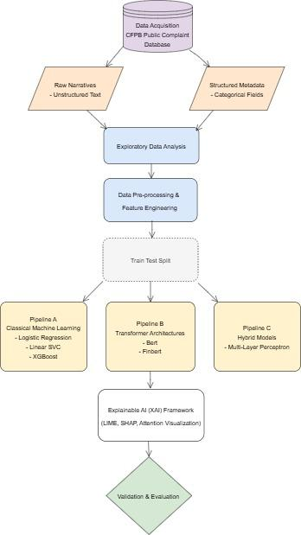
Figure 3.1: Proposed Hybrid Modelling Framework

3.3.1 Data Acquisition and Justification
As mentioned in section 3.2, the dataset is obtained from the CFPB, which publicly collects and lists consumer complaints against financial services companies. This study employs data spanning over six years from 2020 to 2025, giving roughly around 300,000 complaints data. These records are filtered to ensure they contain both a consumer narrative and a documented company response, providing the multimodal depth required for the proposed hybrid framework.
Rationale for selection: The CFPB dataset is chosen for this study because it provides real-world consumer complaints that are directly relevant to financial product classification and restitution outcome prediction. The dataset is publicly accessible, anonymized, and well-documented, ensuring compliance with ethical standards. Moreover, it has been widely used in academic research on Natural Language Processing (NLP) and machine learning, making it a robust benchmark for model development.
It includes following fields:
- Complaint ID: A unique ID number for the complaint.
- Date received: The date the CFPB received the complaint.
- Date sent to company: The date the complaint was sent to the company for response.
- Product: The broad category of financial product or service involved (e.g., ‘Mortgage’).
- Sub-product: A more specific description within the product category (e.g., ‘Conventional adjustable mortgage’).
- Issue: The specific problem the consumer identified (e.g., ‘Incorrect information on the report’).
- Sub-issue: A more specific description of the issue.
- Company: The name of the financial institution the complaint is about.
- State: The consumer's reported mailing state.
- ZIP code: The consumer's reported 5-digit mailing ZIP code.
- Tags: Demographic tags applied to the complaint (e.g., ‘Older American’, ’Servicemember’).
- Consumer complaint narrative: The description of the complaint written by the consumer (only included if the consumer consented to publication).
- Company public response: An optional, public-facing response from the company.
- Company response: How the company categorized its resolution (e.g., ‘Closed with monetary relief’ , ‘Closed with explanation’).
- Timely response: Whether the company responded within the required timeframe (Yes or No).
- Consumer disputed: Whether the consumer disagreed with the company's response (Yes or No).
- Submitted via: The channel through which the complaint was submitted.

3.3.1.1 Secondary Search:
As discussed earlier, all the data used in this study has been taken from the CFPB database, making the research entirely based on secondary data without conducting any surveys or interviews. One of the earliest empirical examinations of this dataset was done by Ayres, Lingwall and Steinway (2014) who used the complaint records for analyzing institutional responses and identifying systemic disparities in complaint outcomes, thus demonstrating the suitability of this dataset for empirical financial research. Following this approach, the current study applies the same secondary CFPB data for restitution prediction and complaint classification. Recent studies further validate the suitability of this approach as CFPB data has been used for various research methodologies such as statistical reporting, predictive modelling, textual analysis and topic modelling. (Vaishnav et al., 2024; Jou et al., 2026; Burton and Al Moubayed, 2023).
Recent research further validates the effectiveness of this approach, showing that CFPB data supports advanced predictive modelling, AI-driven behavioural analysis, and hybrid fusion models that combine textual narratives with structured metadata (Vaishnav et al., 2024; Alarifi, Rahman, and Hossain, 2023; Burton and Al Moubayed, 2023). Collectively, these studies establish the CFPB database as a reliable and reproducible resource for conducting research in the financial domain. Table 3.1 shows the key papers that support the use of secondary data.
Table 3.2 Literature Summary: Use of Secondary Data

Author (Year) | Subject | Methodological Relevance to this Study
Kuilboer and Stull (2021) | Text Analytics and Big Data in the Financial Domain | Demonstrates a scalable Spark-NLP pipeline for processing text and applies topic modelling and TF-IDF to identify mismatches between corporate SEC filings and actual consumer complaints.
Vaishnav et al. (2024) | Predictive Analysis of CFPB Data | Validates the use of secondary data for predicting resolution types (e.g. Closed with relief) and extracting thematic trends via machine learning
Burton & Al Moubayed (2023) | Multimodal Hybrid Modelling | Demonstrates the fusion of unstructured secondary text with structured metadata to improve model accuracy.
Siering (2022) | RegTech & Diagnosticity | Establishes the regulatory requirement for information diagnosticity ensuring secondary data analysis is transparent and explainable.

3.3.1.2 Data Variable Selection
The CFPB dataset contains a wide range of complaint records however only records containing narrative text are retained, considering that textual information is essential for modelling. To achieve the research objectives, the study utilizes both unstructured consumer narratives and a selective set of structured variables to predict two distinct targets:
Task 1: Restitution outcome (binary classification)
Task 2: Product category (multi-class classification)
Moreover, the features used for modelling are selected based on their relevance to complaint outcomes, consistent with prior studies (Vaishnav et al., 2024; Onunkwo, 2019).
The mapping of these variables is summarized in Table 3.3.

Table 3.3: Mapping of Features to Research Tasks

Variable | Type | Role | Justification
Consumer Narrative | Unstructured | Primary Input | Semantic data used for both tasks
Product | Structured/ Categorical | Dual Role | Target for task 1; Predictor for task 2
Issue | Structured/ Categorical | Predictor | Provides specific context for both tasks
Tags | Structured/ Categorical | Predictor | Represents demographic data for task 2
Monetary Relief | Binary | Target | The outcome label for the restitution prediction task

As shown in Table 3.2, the variable 'Product' serves a dual role; it acts as an independent variable (predictor) in task 1 and target variable in the second task. Moreover, monetary relief is the target variable for the first task.

Justification for variable choice: The variables listed in the table have been chosen based on their high predictive power and relevance to regulatory accountability. The inclusion of ‘Product’ and ‘Issue’ provides the necessary categorical context that text narratives alone often lack. Furthermore, including ‘Tags’ as a structured feature allows the model to account for demographic context, and acts as a predictor for product classification. By narrowing down from the 17 raw fields to these key features, the model minimizes dimensionality noise and focuses on the intersection between consumer grievances and corporate response behavior.
3.3.2 Exploratory Data Analysis (EDA)
Exploratory Data Analysis (EDA) is conducted to examine the underlying structure, distribution, and characteristics of the CFPB complaint dataset, informing subsequent steps of preprocessing, feature engineering, and modelling decisions. The analysis considers both structured and unstructured features to provide a comprehensive understanding of the data.
Structured analysis focuses on the distribution of key variables such as issue types, product categories, etc. This helps to identify the dominant complaint categories and potential class imbalances, which are important considerations for selecting the correct modelling strategies and evaluation metrics.
For unstructured data, textual analysis is performed to examine the characteristics of complaint narratives. This includes assessing text length, identifying noise such as informal language and abbreviations, and analyzing sentiment patterns for understanding the emotional tone of complaint narratives. Sentiment analysis is conducted using the Valence Aware Dictionary and sEntiment Reasoner (VADER) lexicon-based approach, which generates polarity scores for complaint narratives. VADER is a rule-based sentiment analysis tool specifically tuned to sentiments expressed in social media and works by calculating sentiment intensity, providing scores for positive, negative, and neutral sentiment, with a compound score ranging from -1 (very negative) to 1 (very positive).
In addition, temporal analysis is also performed for examining seasonality and trends in complaint volume over time. Since the selected data spans over six years, such analysis helps to provide contextual insight into changes in consumer behaviour. Together these steps inform feature engineering and class weighting, and provide contextual understanding to support subsequent model development and interpretation.
In addition to sentiment and temporal analysis, topic modelling is performed using Bidirectional Encoder Representations from Topic (BERTopic) in order to uncover the semantic themes and contextual patterns within complaint narratives. In contrast to the traditional probabilistic models such as Latent Dirichlet Allocation (LDA,) which relies on word frequency, BERTopic is a modern topic modeling framework that uses transformer-based embeddings to understand the semantic meaning of documents (Sangaraju et al., 2022). BERTopic is chosen here, as it provides vital insights by identifying major themes/topics of complaints, revealing emerging issues not captured by CFPB category labels and highlighting overlapping complaint types. It also helps reveal topic imbalance, supporting decisions around class weighting thereby strengthening the research narrative and contextual understanding.
There are four key components used in BERTopic. They are: sentence-level embeddings, dimensionality reduction using Uniform Manifold Approximation and Projection (UMAP), density-based clustering via Hierarchical Density-Based Spatial Clustering of Applications with Noise (HDBSCAN), and topic representation through Class-based Term Frequency–Inverse Document Frequency (c-TF-IDF). A brief explanation of these steps is given below:

Step 1: Text to Sentence Transformer Embedding
It involves transforming raw text into numerical representations (embeddings) using the Sentence Transformer library. Embeddings capture semantic meaning, so complaints with similar meaning have vectors close together in multidimensional space. This step results in high-dimensional embeddings.

Step 2: Dimensionality Reduction using UMAP
Next UMAP is applied to the high dimensional embeddings in order to reduce dimensions to make them suitable for clustering. This is done to preserve local structure (similar complaints stay close) and global structure (overall distribution remains meaningful), improve computational efficiency and highlight the inherent relationships between complaints.

Step 3: Density-Based Clustering using HDBSCAN
In the next step, HDBSCAN clustering is applied to the reduced dimensional embeddings in order to group the points (complaints) based on density; dense areas form clusters and sparse areas are considered noise. In contrast to K-Means clustering, this does not require predefining the number of clusters and also helps in detecting outliers, which may represent unusual or rare complaint types. Moreover, HDBSCAN can uncover natural groupings in complaints, helping in identifying patterns that might not be obvious from raw text.

Step 4: Topic Representation through c-TF-IDF
Once clusters are established, class-based TF-IDF (c-TF-IDF) is calculated for each cluster to determine the most representative words, producing interpretable topic labels that summarize the underlying themes and inform EDA insights.
Overall, this whole process of embedding, dimensionality reduction, density-based clustering, and c-TF-IDF facilitates the extraction of coherent topics from large-scale complaint data. Figure 3.2 shows the process summary.
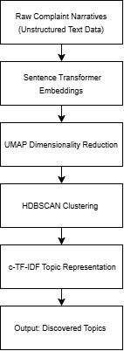
Figure 3.2. Summary of BerTopic components
3.3.2.1 Data Characteristics and Modelling Implications
The exploratory data analysis reveals several important characteristics of the dataset that directly inform modelling decisions. First, the data exhibits severe class imbalance, particularly in restitution outcomes, where positive cases that result in monetary relief, are less frequent. This necessitates the use of balancing techniques like resampling (oversampling/undersampling) and class-weighting along with the selection of suitable evaluation metrics such as Macro F1-score. Second, complaint narratives are inherently noisy, often containing informal language, and domain-specific terminologies. These characteristics justify the use of transformer architectures such as Bidirectional Encoder Representations from Transformers (BERT) and Financial Bidirectional Encoder Representations from Transformers (FinBERT), which are capable of capturing contextual meaning in complaints.
Finally, the presence of both structured attributes and rich textual narratives highlights the suitability of hybrid modelling approaches. By combining these data modalities, the proposed framework aims to capture both quantitative patterns and contextual nuances, thereby improving predictive performance and interpretability.

3.3.2.2 Data Selection and Sampling
Given the large scale of the CFPB data, the dataset used in this study is restricted to a temporal window spanning 2020 to 2025, allowing the analysis to focus on consumer grievances, company responses and recent regulatory trends over a period of six years.
To further manage data volume, a stratified sampling approach is employed to obtain a working dataset of approximately 300,000 records. Instead of random sampling, the data is stratified based on both Product category and Year before sampling is done. This approach ensures computational efficiency and preserves the proportional distribution of financial products and temporal patterns observed in the original dataset. As a result, the likelihood of introducing category-specific or temporal bias is significantly reduced in the modelling process.
3.3.3 Data Preprocessing and Feature Engineering
Data preprocessing and feature engineering is a critical step in the modelling framework, required to transform raw complaint data and structured features into formats suitable for machine learning, transformer-based, and hybrid modelling pipelines. Since the dataset comprises both structured attributes and unstructured complaint narratives, therefore, each modality is processed separately before integration. Prior studies have also highlighted the impact of effective preprocessing to improve model robustness and predictive performance, particularly in the domain of text analytics (Alarifi et al., 2023; Li et al., 2025). The pre-processing and feature engineering steps for both these modalities are discussed below:

3.3.3.1 Unstructured Data Preprocessing and Feature Engineering
The unstructured textual narratives need to be refined so that the raw text can be transformed into numerical representations suitable for classical, transformer and hybrid models. To achieve this, a domain-aware pre-processing strategy is applied to reduce noise and preserve the contextual meaning of narratives.
In this regard, only records with a complaint narrative are retained in order to maintain only text-rich entries. This is critical as textual data constitutes the primary input for transformer-based models such as BERT and FinBERT. Next, a minimal cleaning approach is applied to the textual narratives in order to retain the context and semantic patterns within the data. This cleaning step involves removal of non-informative elements (such as URLs, emails, punctuation, etc.) and privacy-related artefacts along with the preservation of meaningful symbols to enable better understanding of financial domain language.
After cleaning, the text data is transformed using two complementary approaches. For classical machine learning models, TF-IDF vectorization is applied which transforms raw text into numerical feature vectors that these models can understand. However, for transformer-based models, transformer-specific tokenisation and contextual embeddings are generated using BERT and FinBERT. These embeddings help in capturing the contextual dependencies, semantic patterns and domain-specific terminologies within complaint narratives. Moreover, these embeddings have also been shown to give better performance than traditional frequency-based representations in complex text classification tasks (Devlin et al., 2019; Blümel and Zaki, 2022).
Finally, after the pre-processing steps, the processed narratives are sent to different modelling pipelines, as discussed in section 3.2.

3.3.3.2 Structured Data Preprocessing and Feature Engineering
The structured features in the dataset also undergo a few preprocessing and feature engineering steps to ensure compatibility with hybrid pipeline, thus maintaining consistency.
Initially, missing data is handled and feature selection is performed.
For the restitution prediction task, records with undefined target outcomes are removed to ensure reliable classification labels. Similarly, features with a high level of missing data or near zero-variance (e.g. consumer consent provided? consumer disputed, etc.) are also dropped to reduce noise and sparsity in data. Moreover, the binary target variable, called Monetary Relief, is derived from the company response field to differentiate between monetary and non-monetary outcomes. In this case, 1 indicates monetary compensation and 0 indicates otherwise.
For both classification tasks, the product feature is required, in which categories exhibit taxonomy fragmentation, therefore, target variable is refined by merging similar product categories into unified labels. This not only reduces label sparsity but also improves the ability of the models to generalize across product domains. Moreover, the product variable is label-encoded when being used as a target variable in the product classification task.
For hybrid modeling, the categorical variables such as issue, tags and product, are transformed using one-hot encoding to ensure their compatibility with the modelling pipeline and enable the structured features to be effectively combined with dense textual embeddings.
Besides this, temporal features such as year and month are extracted from the date feature to identify trends and seasonality in complaint behavior as part of temporal analysis.
Collectively, these preprocessing and feature engineering steps enable the structured data to provide meaningful context that complements the textual embeddings within the hybrid modelling framework (Onunkwo, 2019; Vaishnav et al., 2024).

Table 3.4 Preprocessing and Feature Engineering Summary

Stage | Data Type | Key Techniques | Purpose
Feature Engineering | Structured | Category mapping (taxonomy consolidation) | Reduce label sparsity, improve generalisation
Data Cleaning | Text | RegEx cleaning, masking | Remove noise, preserve financial context
Feature Encoding | Structured | One-hot encoding, label encoding | Convert categorical variables
Feature Creation | Structured | Target variable, temporal features | Support classification and prediction
Text Processing | Text | TF-IDF, BERT/FinBERT tokenisation | Prepare inputs for ML and transformers
Feature Learning | Text | Contextual embeddings | Capture semantic relationships
Exploratory Signals | Text/Time | Sentiment + temporal analysis | Support interpretation and modelling

3.4 Model Development Framework
As discussed earlier, this study adopts a multi-level modelling framework comprising three complementary pipelines: classical machine learning models, transformer-based models, and a hybrid multimodal architecture. This design enables a systematic comparison between traditional feature-based approaches, contextual deep learning models, and integrated multimodal systems, thereby addressing the research objective of evaluating the effectiveness of hybrid modelling in financial complaint analysis.
3.4.1 Class Imbalance Mitigation Strategy
Since there is class imbalance within the restitution outcome as well as the product classes, therefore, it requires the implementation of balancing strategies during model training.
To resolve this issue,a hybrid resampling strategy is applied to the training data combining undersampling of majority classes with oversampling of minority classes. This helps to reduce skew, preserve enough training distributions and prevent data leakage into the test set. Besides this, a weighted loss function is employed during training to ensure that minority classes contribute proportionally to the learning process, preventing the model from being biased toward majority classes and improving performance on underrepresented complaint categories. Moreover, stratified train-test sampling is also applied to preserve class distributions across training and testing subsets.

3.4.2 Classical Machine Learning Models
Classical machine learning models like SVM, LR and XGBoost are trained as a baseline for both complaint classification and outcome prediction, using TF-IDF features derived from the complaint narratives. These models provide interpretable results, establish performance benchmarks, and enable comparison with transformer-based approaches (Blümel and Zaki, 2022; Athira et al., 2025). A brief description of the models and their applicability is given below:
1. Logistic Regression:
Logistic Regression is a supervised, machine learning algorithm used for classification problems. It is a linear model that estimates class probabilities using a logistic function and is widely used because of its simplicity and interpretability. Prior studies (Alarifi et al., 2023; Blümel and Zaki, 2022) have shown its effectiveness when combined with TF-IDF features, making it a strong baseline for NLP tasks.
In this research, Logistic Regression is applied to TF-IDF features extracted from CFPB complaint narratives for both classification tasks. Its coefficients provide insights into which terms are most predictive of each category in a classification task, which is particularly valuable in regulatory contexts. Although computationally efficient, its linear nature may limit its ability to capture complex semantic relationships in complaint narratives, making it more suitable as a benchmark against more advanced models (Li et al., 2025).
2. Support Vector Machine (LinearSVC):
LinearSVC, a specialised version of SVM, is an algorithm specifically effective for text classification tasks. It identifies an optimal decision boundary that separates the classes in the input data enabling strong performance in high-dimensional and sparse feature spaces. Prior studies (Senthurvelautham and Hettiarachchi, 2018) demonstrate that SVMs are well suited to handle the sparsity of TF-IDF vectors in text classification problems.
In this study, LinearSVC is also applied to TF-IDF representations of textual complaint narratives for both product classification and binary classification tasks. Its robustness to overfitting in high-dimensional environments together with its ability to handle large vocabularies and sparse matrices, makes it well-suited for modelling complaint text data. However, in contrast to linear models such as Logistic Regression, SVMs do not inherently produce probabilistic outputs and provide limited interpretability thus restricting their suitability in explainable regulatory settings.

3. XGBoost:
XGBoost is a gradient boosting framework based on decision trees, designed to model complex non-linear relationships through iterative learning. It has been widely adopted in structured data modelling and has shown strong performance in classification tasks (Chen and Guestrin, 2016), with successful applications in diverse financial and industrial domains (Jaya Krishna et al., 2018).
In this study, XGBoost is applied to TF-IDF representations of complaint narratives for both multi-class product classification and binary restitution prediction, enabling comparison with other baseline linear models. Its ability to capture interactions between variables makes it particularly useful for modelling relationships between complaint attributes and restitution outcomes. While TF-IDF creates high-dimensional sparse input, XGBoost can effectively handle this data and also provide feature importance measures, which are useful in this study for understanding which words or structured variables most influence complaint outcomes.
Despite its predictive strength, XGBoost is less interpretable than simpler models and may require additional explainability techniques such as SHAP to provide meaningful insights into model decisions. It is therefore positioned as a high-performance benchmark within the modelling framework.
Table 3.5 Feature comparison of classical models
Feature | Logistic Regression | Linear SVC | XGBoost
Model Type | Linear Classifier | Maximum Margin Classifier | Gradient Boosted Trees
Role in Study | Baseline interpretable model | Strong sparse text classifier | Advanced non-linear benchmark
Key Strength | Interpretability | High-dimensional performance | Captures complex patterns
Complexity | Low | Moderate | High
Decision Mechanism | Probabilistic | Geometric margin separation | Tree-based ensemble learning
Handles Non-linearity | No | No | Yes

3.4.3 Transformer Models (BERT & FinBERT)
Transformers are a type of advanced deep learning architecture designed to process sequential data such as text. Contrary to the traditional TF-IDF methods, transformer-based models use self-attention mechanisms to capture long-range dependencies and semantic relationships within text data, as proposed in the original Transformer architecture by Vaswani et al. (2017).
In this study, the NLP based transformer models like BERT and FinBERT are used to perform text-driven classification of CFPB complaint narratives. Transformers enable contextual comprehension of long complaint narratives, capturing subtle cues such as tone, sequence of events, and financial terminology that simpler models fail to detect. These models are used to perform both binary restitution prediction as well as product classification and to generate deep semantic embeddings that feed into the hybrid modeling stage. A brief description of the models and their applicability is given below:
1.BERT:
Bidirectional Encoder Representations from Transformers (BERT) is a natural language processing model that understands the context of words in a sentence by analyzing text in both directions. It serves as a strong and widely adopted baseline model for English language NLP tasks. It is pretrained on a massive general-domain corpus (Wikipedia + BookCorpus), enabling it to capture grammatical, syntactic, and contextual patterns applicable to many text classification tasks.
In this research, BERT is fine-tuned on complaint narratives for assessing financial text without domain-specific pretraining. BERT-base is used for both classification tasks and provides a baseline for comparison against domain-specific models like FinBERT as well as the classical models.
Even though BERT has not been explicitly trained on financial corpora, its contextual encoding capabilities enable it to capture semantic meaning within complaint narratives more effectively than TF-IDF-based representations.
2. FinBERT:
FinBERT is a state-of-the-art NLP model designed specifically for financial sentiment analysis. It is built by pre-training the BERT language model on financial text sources, including corporate reports and financial sentiment datasets.
Since Finbert is designed to understand financial terminologies, and CFPB complaints are financial narratives describing issues related to mortgages, credit cards, debt collection, etc therefore, it provides a theoretically justified and empirically supported choice for modeling regulatory consumer complaint data, particularly when semantic nuances affect classification. Invert is used for both the classification tasks as well and is expected to capture domain specific terminologies more effectively than general BERT.

3.4.4 Hybrid Model (Structured Data + Transformer Embeddings)
The hybrid modelling stage involves integrating structured features with unstructured text data to capture relationships that are not identifiable using text-only or structured-only methods (Kiefer et al., 2019). It is designed to evaluate whether such integration improves classification accuracy, making this approach particularly suitable for CFPB complaint analysis.
In this study, hybrid modelling is done for both multi-class product classification and binary restitution prediction. The transformer embeddings from BERT are combined with structured features to jointly learn from linguistic patterns and administrative features, in order to improve predictive performance and analytical depth.
The selection of the structured features for both tasks is done on the basis of Cramer's V Test. It is a post-hoc test used to measure how strongly two categorical fields are associated.It produces a value between 0 and 1, where 0 indicates no association and 1 indicates perfect association. Based on this test, issue and product features are selected for restitution prediction in the hybrid pipeline. While, issue and tags are chosen as structured features for the product classification task.
Overall, by merging both modalities, the hybrid model detects complex relationships, such as how complaint severity related to product type, or how certain narrative patterns correlate with organizational responses.
Table 3.6 Feature comparison of Transformer-based and Hybrid Models
Feature | BERT-Base | FinBERT | Hybrid MLP (Proposed)
Pre-training Corpus | General (Wikipedia) | Financial (Reports/News) | Fine-tuned BERT
Input Modality | Unstructured Text | Unstructured Text | Multimodal (Text + Tabular)
Semantic Context | General Context | Financial Semantics | Domain + Institutional Context
Handling of Metadata | No | No | Yes (via Late Fusion)

Model Configuration

In this work, Multi-Layer Perceptron (MLP) / Dense Neural Network is used for hybrid modelling. Its performance is evaluated against classical as well transformer-based models to assess the added value of multimodal integration.

Multi-Layer Perceptron (MLP) Architecture

Multi-Layer Perceptron (MLP) is selected for hybrid modeling as it can efficiently combine heterogeneous inputs, i.e. continuous text embeddings (from BERT) and categorical/numeric structured fields. Moreover, it can model non-linear interactions that tree-based models may miss, scale efficiently with large embedding vectors, and provide a flexible architecture that can be tuned for balanced performance and interpretability.
In this work, for both the tasks, the text embeddings generated from BERT are concatenated with selected structured features after preprocessing. The resulting combined feature vector is then passed through fully connected layers of the neural architecture to learn joint representations of text and structured data.

Model Tuning
Hyperparameter tuning involves experimenting with key architectural components, including the number of hidden layers, number of neurons per layer, learning rate, and dropout rate to optimize performance and prevent overfitting. This process involves empirical optimization, where architecture depth and regularization are iteratively refined to stabilize the multimodal fusion of text and structured data.

ReLU activation function is in the hidden layers to introduce non-linearity and enable efficient gradient propagation, while the output layer applies (binary classification) or softmax (multi-class classification) activation functions. The model is trained using the AdamW optimizer, which is well-suited for neural networks as it provides stable convergence and effective weight regularisation.

3.5 Explainable AI (XAI) and Model Interpretation
Besides predictive performance, transparency of the generated predictions also needs to be evaluated. In this regard, explainability is a critical component of regulatory environments, where understanding model decisions is needed to ensure fairness and accountability.
In this study, the following three complementary XAI techniques are applied:
- SHAP (SHapley Additive exPlanations): SHAP assigns each feature a fair contribution value, quantifying how much it influences the model’s predictions both at the individual (local) and overall (global) level (Lundberg and Lee, 2017).
- LIME (Local Interpretable Model-Agnostic Explanations): Lime works by creating simple surrogate models around a specific prediction to show which features most influence that individual outcome (Ribeiro et al., 2016).
- Attention Visualization: Attention visualization highlights which words or phrases receive the highest attention weights in transformer models.
In this study, for both the classification tasks, different models require tailored explanation methods based on their architecture and input types. Table 3.7 gives a summary of the XAI techniques which have been applied to different models.
Table 3.7 Summary of XAI Methods

Model Type | Explanation Method
Classical ML (LR, XGB, SVM) | LIME , SHAP
Transformers (BERT, FinBERT) | Attention visualisation
Hybrid (MLP) | SHAP

Among classical machine learning models, SHAP is applied to both Logistic Regression and XGBoost to provide feature-level explanations. For logistic regression, SHAP Linear Explainer is used as it is specifically designed for linear models to estimate how individual features contribute to model decisions. On the other hand, SHAP Tree Explainer is employed for XGBoost as it is specifically designed for tree-based ensemble architectures to capture non-linear feature interactions. In contrast to SHAP, LIME is used by LinearSVC to identify influential words or phrases driving individual predictions. This is because SVM-based models do not inherently provide easily interpretable probabilistic explanations.
For transformer-based models, attention visualization is used to reveal which tokens the model focuses on internally, thus offering a model-intrinsic perspective of textual semantics.
For the hybrid model, SHAP DeepExplainer is employed to attribute contributions from both types of inputs (structured + unstructured ) to the model’s binary output predictions.
Using this combination of SHAP, LIME, and attention-based visualizations ensures a comprehensive interpretability framework: SHAP captures global trends, LIME explains individual predictions, and attention maps provide insight into the textual semantics learned by transformers. Together, these techniques allow both regulators and researchers to verify that models are making fair, unbiased, and contextually meaningful decisions, enhancing trust and facilitating actionable insights from the modeling pipelines.

3.6 Model Validation and Evaluation
The dataset is divided into training and test sets using an 80-20 split, with stratified sampling applied to preserve class distribution across training and testing sets. This is done to ensure that the evaluation is representative of the original distribution of the CFPB data, which is particularly important for imbalanced datasets. Performance of the hybrid model is compared against classical and transformer-based models in a unified evaluation framework. This type of framework ensures fair and interpretable comparisons, demonstrating whether hybrid modeling offers meaningful predictive gains over single-modality approaches. Such a comparative approach is essential, as no single modelling technique is universally optimal; rather, performance must be assessed across multiple dimensions.
For the evaluation stage in this study, multiple metrics are employed to provide a comprehensive assessment of model performance across both the classification tasks. Since the data is imbalanced, macro-f1, balanced accuracy, roc-auc and confusion matrix are the preferred chosen metrics. These metrics are defined as follows:
F1-Score (Macro): The harmonic mean of precision and recall, calculated for each class and then averaged. It balances false positives and false negatives, especially in imbalanced datasets.
Precision indicates the proportion of correctly predicted positive cases among all cases predicted as positive while recall measures the proportion of actual positive cases correctly identified by the model.
Balanced accuracy: The average of recall obtained on each class. Unlike standard accuracy which measures the proportion of correct predictions over all instances, it does not favor the majority class and instead measures how well the model performs across all classes equally. This makes it particularly useful when class distributions are skewed.
ROC-AUC (Area under the Receiver Operating Characteristic Curve): Measures the model’s ability to distinguish between classes across different classification thresholds. It evaluates the trade-off between true positive rate and false positive rate. High values indicate good separability between classes, making it useful for assessing model discrimination even under imbalance.
Confusion Matrix: A tabular representation showing true vs. predicted class counts for each category. Helps visualize where the model is misclassifying and which classes are confused.

3.7 Tools and Technologies
In this study, the whole implementation is done in the Python programming environment, which is widely used for machine learning and natural language processing tasks. Python provides a flexible framework in which classical machine learning, transformer-based, and XAI techniques, can all be integrated together, within a unified analytical pipeline. For computational efficiency, the experiments are carried out in Google Colab using GPU.
Natural Language Toolkit (NLTK) and Regular Expressions (Regex) are used to preprocess CFPB complaint narratives, particularly to handle noise such as punctuation, stopwords, and anonymised placeholders (e.g., “XXXX”), ensuring consistent input representation across models.
For classical machine learning models, Scikit-learn (Pedregosa et al., 2011) and XGBoost libraries (Chen and Guestrin, 2016) are utilized to ensure efficient and scalable implementation of baseline models. Similarly, for transformers-based models, the HuggingFace Transformers library is used, which provides access to models such as BERT and FinBERT along with their corresponding tokenizers (Wolf et al., 2020).
For explainability, SHAP and LIME are included to ensure interpretability across both global and local levels. SHAP provides theoretically grounded feature attribution based on cooperative game theory (Lundberg and Lee, 2017), while LIME enables local surrogate explanations for individual predictions (Ribeiro, Singh and Guestrin, 2016).
Finally, Matplotlib and Seaborn libraries are used to visualise evaluation outputs, including confusion matrices, ROC curves, and feature importance plots, thereby enhancing interpretability of model performance.
Table 3.8 gives an outlook for the tools and technologies employed in this study.

Table 3.8 Tools and Technologies Used (optional)
Tool / Library | Category | Role in Study
Python | Programming Language | Core implementation environment
Pandas / NumPy | Data Handling | Data cleaning, preprocessing, matrix operations
HuggingFace | Deep Learning | Pre-trained BERT and FinBERT models with tokenizers
Scikit-learn | Machine Learning | Logistic Regression and Linear SVC baselines
XGBoost | Gradient Boosting | Structured data baseline model
SHAP / LIME | Explainability | Global and local model interpretability
Matplotlib / Seaborn | Visualization | Model evaluation plots (ROC, confusion matrix, SHAP plots)
NLTK / Regex | Text Preprocessing | Cleaning complaint narratives and handling redacted text
Jupyter Notebook | Development Environment | Experimentation, training, and visualization

3.8 Ethical and Legal Considerations
This study utilises the CFPB complaint dataset, which is publicly available, fully anonymized and released under an open-data license. It also complies with the CFPB’s Terms of Use and Open Data Policy, as well as relevant legal frameworks including the General Data Protection Regulation (GDPR). Moreover, ethical considerations in this study focus on data privacy, bias mitigation, and responsible use of AI.

3.8.1 Data Privacy and GDPR Compliance
The dataset is anonymised prior to release, after removing all personally identifiable information. No attempts are made to re-identify individuals, and all findings are reported in aggregated form. The study uses the data strictly for academic purposes, thus complying with GDPR principles of data minimisation and purpose limitation (European Union, 2016). Moreover, to prevent any unauthorised access or security breach, all the data is stored safely and processed within controlled environments.

3.8.2 Fairness and Bias Mitigation
Another ethical concern in predictive modeling is algorithmic bias. Machine learning models may learn and reinforce imbalances in data, including disparities in complaint distribution or company responses.
To mitigate these risks, stratified sampling is applied to preserve class distributions, while weighted loss functions ensure adequate representation of minority classes during training. Moreover, resampling techniques including oversampling and undersampling are also applied, where needed, to address class imbalance. Further, model performance is evaluated at the class level to prevent the majority classes from dominating the model.
In addition, Explainable Artificial Intelligence (XAI) techniques such as SHAP and LIME are used to examine model behaviour, explain the modelling decisions and identify potential sources of bias in predictions (Lundberg and Lee, 2017; Ribeiro et al., 2016). These methods thus improve transparency by highlighting the features influencing predictive outcomes.

3.8.3 Research Integrity and Responsible AI Use
This study complies to the principles of research integrity through transparency, reproducibility, and responsible explanation of results. All preprocessing, modelling and evaluation steps are clearly documented to enable reproducibility and critical assessment.
To prevent data leakage and assess true generalization performance, training and test data are strictly separated. Model performance is evaluated using out of sample testing to ensure that results reflect real world predictive performance rather than being affected by overfitting to know data. All results are reported objectively and interpreted cautiously, including those that do not align with initial expectations; acknowledging the limitations of machine learning models and the broader societal implications of predictive analytics. Moreover, interpretability is also prioritised to ensure transparency.
Although artificial intelligence techniques are used in this study, they are applied solely for analytical purposes and are not deployed in decision-making systems. The study recognises potential issues related to automation and biased decision-making, and emphasises responsible use of predictive insights to support equitable financial practices.

3.9 Methodological Limitations
This study proposes a unified framework that integrates classical, transformer-based, and hybrid models for analyzing CFPB complaint data. Although the proposed methodology is designed to enhance both predictive performance and interpretability, several limitations exist due to computational constraints, data characteristics and modelling choices. These limitations are discussed below.

Data Availability and Selection Bias
Since all CFPB records do not contain complaint narratives, they are excluded, which introduces bias, because such complaints could systematically differ from the excluded ones. However, this is also essential and justified since all the models need text as input. Although, the inclusion of multimodal models partially mitigates this limitation by ensuring that structured features are still incorporated as input for analysis.

Class Imbalance and Representativeness
There is an inherent class imbalance in the dataset, especially in certain product categories e.g. Credit reporting, which dominate the sample. This can bias model predictions in favor of majority classes and affect representativeness.
As already discussed, in order to mitigate this, resampling techniques, stratified sampling and weighted loss functions are employed. Moreover metrics like macro f1 and balanced accuracy are chosen to ensure balanced performance evaluation across all classes.
Although class imbalance cannot be fully eliminated, it reflects real world data distributions, thereby maintaining the practical relevance of the dataset.

Proxy Variable for Restitution
The ‘Company Response’ variable acts as proxy and is used to derive the ‘Monterey Relief’ feature for predicting restitution outcomes. Although it cannot directly measure customer satisfaction or financial compensation, it still acts as a consistent and scalable indicator.
This limitation is acknowledged as a trade-off between maintenance of real-world data representation and achievement of precise outcomes.
Computational Constraints
Transformer fine-tuning techniques are computationally intensive, particularly when applied to large-scale textual datasets. This limits the extent of hyperparameter tuning and the number of experimental iterations that can be conducted.
To address this, pre-trained models such as BERT and FinBERT are utilised, enabling high performance. Moreover, a smaller number of samples are taken for training or visualization. Further, reduced number of hyperparameters and training epochs are also applied to ensure feasibility within hardware constraints. In this study, some of the transformer layers are also frozen to facilitate training. This however affects the performance of transformers and hybrid models which take transformer embeddings as input.
Thus these choices limit exhaustive optimisation, but they reflect realistic deployment conditions and maintain methodological validity.

Model Interpretability Trade-offs
Although XAI techniques such as SHAP, LIME, and attention visualisation are employed, interpretability in transformer-based models remains inherently challenging. This is because attention weights only show where the model is focusing, not necessarily what actually caused a particular prediction. Moreover, not all explanation methods are suitable for all models, thus limiting their applicability.
Despite these limitations, the combination of different XAI techniques provides different perspectives and thus improves transparency and interpretation of model decisions.

Overall Justification
The above limitations reflect necessary trade-offs between computational feasibility, and methodological rigour. Mitigation strategies are applied where possible, to minimise their impact. Despite these constraints, the study maintains its value by providing a unified architecture that balances predictive accuracy with interpretability.
Moreover, the use of CFPB data, together with different modelling approaches, ensures that the findings remain relevant, scalable, and applicable within financial and regulatory environments.

3.10 Conclusion:
This chapter has established the methodological framework for analyzing CFPB consumer complaint data spanning a six-year period from 2020 to 2025. The study adopts a positivist, deductive, and quantitative approach and is structured according to the CRISP-DM framework to ensure a systematic workflow.
For modeling, three pipelines are developed and compared for both product classification and restitution prediction tasks: 1. Classical machine learning models using TF-IDF features, 2. Transformer-based models including BERT and FinBERT, and 3. A hybrid multimodal model that combines structured data with contextual embeddings through a Multi-Layer Perceptron (MLP). This framework is then interpreted using XAI techniques like SHAP, LIME and attention visualization.
Finally, all models are evaluated using a set of metrics suitable for imbalanced data, including confusion matrix, macro f1 score, balanced accuracy and roc-auc score. Overall, the methodology balances predictive performance, interpretability, and practical applicability.
The following chapter details the specific steps taken for model implementation and empirical evaluation.

Chapter 4: Implementation

4.1 Chapter Overview
This chapter outlines the practical implementation of the proposed modelling framework to analyze CFPB consumer complaints. It details the complete pipeline, including data collection, preprocessing, exploratory data analysis, feature engineering, model development, and evaluation stages.
The implementation follows a systematic workflow for minimizing data leakage, and ensuring consistency and reproducibility across all the modelling approaches. Special consideration is given to managing class imbalance, large-scale textual data, and combining structured and unstructured features.
The following sections describe the whole pipeline in detail.

4.2 Development Environment
The whole implementation is developed in Python 3.12 using Google Colaboratory (Colab) as the primary development environment. Colab provides access to NVIDIA GPU acceleration (CUDA), which is required to efficiently fine-tune transformer-based models as well as large-scale text processing tasks that are computationally intensive.
All experiments are performed in a structured notebook environment for supporting reproducibility and sequential execution of the complete workflow.
As discussed earlier, specialized libraries are utilized to support the different stages of the workflow. Pandas, Numpy, Scikit-learn, Matplotlib, Seaborn, XGBoost and HuggingFace Transformers library are used along with the Pytorch framework. Some additional tools include BERTopic and sentence-transformers along with Natural Language Toolkit (NLTK).
Finally, to ensure reproducibility and prevent data leakage, all preprocessing, resampling and feature transformation steps are fitted on the training data while the test set is only transformed later using learned parameters,

4.3 Data Loading and Preparation
The raw CFPB data is loaded and processed through a few filtering steps. The records without any consumer complaint narrative are dropped. This is followed by filtering of data to keep records from the year 2020 to 2025 only. From this filtered dataset, a stratified sample of 300,000 complaints is extracted. This sampling is performed proportionally across both product category and year while ensuring that neither temporal trends nor product distributions are distorted.
The final dataset comprises 299,967 records spanning 11 product categories over the period of six years.

4.4 Exploratory Data Analysis
Exploratory data analysis is conducted across different dimensions of the dataset to identify its structural properties, variable distributions, and textual characteristics. The analysis is performed on the raw dataset before performing preprocessing or feature engineering.

4.4.1 Data Quality Assessment
An assessment of the data quality is carried out to evaluate completeness and consistency across all variables. Table 4.1 gives a summary of the missing values by column as well as the corresponding handling strategies.
Table 4.1: Missing Values by Column
Column | Missing Count | Missing % | Action
Consumer disputed? | 299,967 | 100.0% | Dropped since no valid entries
Tags | 274,542 | 91.5% | Retained for hybrid modelling
Company public response | 135,166 | 45.1% | Retained — not used in modelling
Sub-issue | 18,432 | 6.1% | Retained — not used in modelling
State | 1,037 | 0.3% | Retained — not used in modelling
All other columns | 0–5 | less 0.01% | No action required

The initial analysis shows that some columns have a lot of missing data or they lack variance. The ‘Consumer disputed?’ feature contains no valid data and is therefore excluded from analysis. The ’Company public response’ field is missing almost 45% of data showing that companies do not publish responses majority of the time. The ‘Tags’ column comprises special designations such as Servicemember and Older American while almost 91% data is missing. Similarly, two columns such as ‘Consumer consent provided?’ and ‘Submitted via’ have only one unique value and show no variance, thus making them useless for analysis.

4.4.2 Class Distribution Analysis
Since monetary relief prediction (binary classification) and product classification are the two research objectives of this study, therefore, it is important to analyze their respective distributions in raw data.

Product Distribution:
Figure 4.1 presents the raw product category distribution before consolidation of the labels. Two structural issues can be observed from the figure.
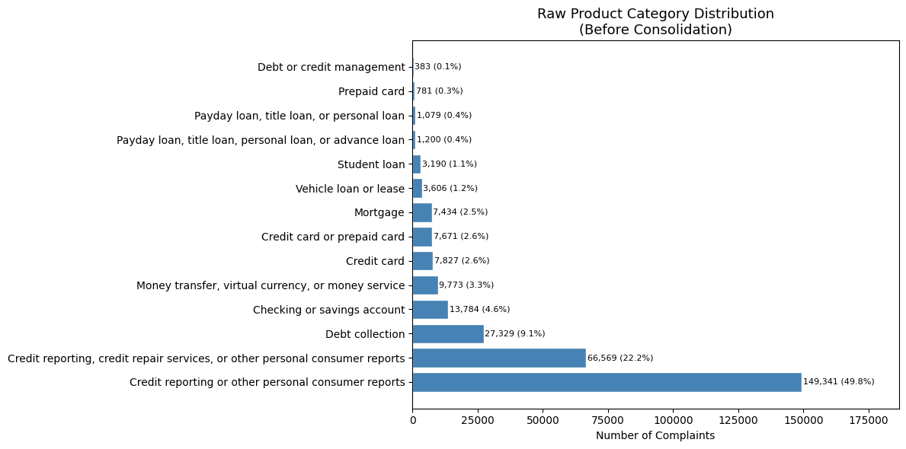
Figure 4.1 Product distribution
Firstly, the dataset exhibits a severe class imbalance, with credit reporting-related categories dominating overall complaint volume while categories such as ‘Debt or credit management’ containing extremely few records. This extreme imbalance in product categories directly motivates the multi-layer resampling strategy described in Section 4.7.
Secondly, product categories exhibit naming inconsistency where similar categories appear under different labels as CFPB may have adopted different naming conventions over time. This is particularly seen in credit reporting and loan related categories, where similar products appear under different labels. This inconsistency leads to label consolidation strategy discussed in section 4.7.
Company Response Distribution:
Figure 4.2 presents the distribution of company response types.
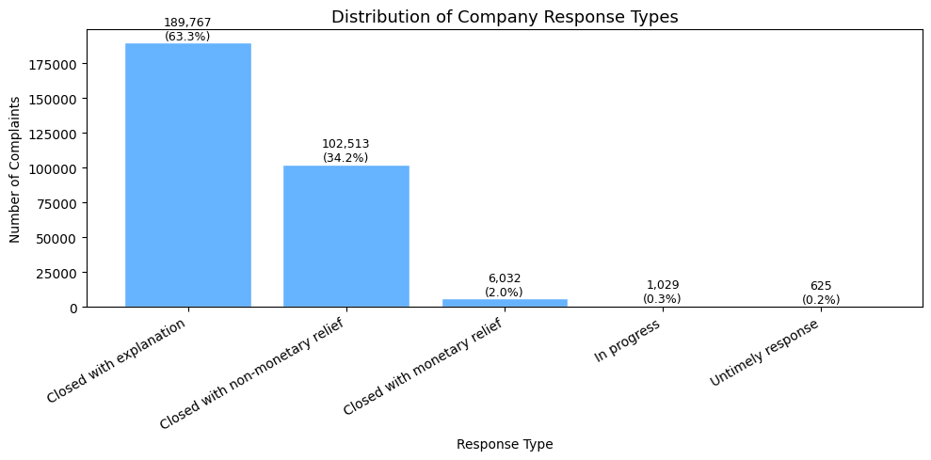
Figure 4.2 Company response distribution bar chart
It can be seen from the figure that the majority of complaints were closed with explanation, followed by the ones closed with non-monetary relief. Moreover, monetary relief was awarded to only 6,032 cases making up to only 2% of the data. An extremely small percentage of the complaints remained in progress (0.3%) or received an untimely response (0.2%).
This rarity of monetary relief outcomes indicates a high class imbalance in the target variable of restitution prediction and points out the financial compensation prediction as a fairly challenging classification problem.

4.3.3 Temporal Analysis
Temporal analysis is conducted as part of EDA to see the trends and seasonality in complaint data over the period of six years. Figure 4.3 shows the annual and monthly complaint trends across the study period.

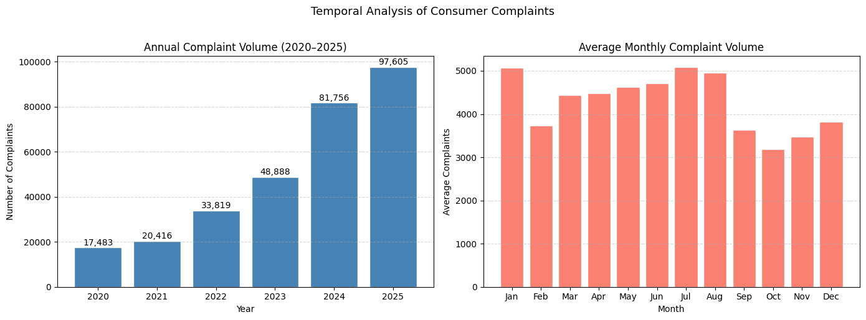
Figure 4.3 Annual and Average Monthly complaint volume distribution
Figure 4.3 (left) presents the yearly complaint volume between 2020 and 2025, revealing a strong upward trend. It can be seen that complaints grew from 17,483 in 2020 to 97,605 in 2025, depicting an almost 458% increase in complaint volume over the six year period. This growth shows a rise in the awareness of the consumers regarding the CFPB complaint process, together with the increasing growth of digital financial services in the post-covid era. Moreover, a particular upward drift in complaint volume from 2022 onwards corresponds with the higher growth of fintech platforms along with the increased regulatory scrutiny of consumer financial products.
Figure 4.3 (right) presents average monthly complaint volume across the six years. The distribution exhibits a bimodal pattern across the years with peaks observed in the months of January and July/August. Complaint volumes decline in February before gradually increasing throughout the spring months, indicating that post-holiday financial pressures may contribute to elevated complaint activity at the beginning of the year, while mid-year increases could be linked to disputes associated with summer spending patterns and annual account assessments. A notable decline is evident during the final quarter, with October showing the lowest average complaint volume, followed by a modest increase in December. Overall, this seasonal trend suggests that although complaint activity is predominantly influenced by long-term growth patterns, as identified in the annual volume analysis, a secondary seasonal effect is also present, with consumers appearing more likely to submit complaints during the early and middle parts of the calendar year than during the autumn period.

4.3.4 Sentiment Analysis
Sentiment analysis is conducted to provide insights into the tone and emotional valence of consumer narratives. It is performed using the VADER lexicon-based model, which assigns each complaint a compound sentiment score, ranging from −1 (most negative) to +1 (most positive).
Figure 4.4 shows a pie chart depicting the proportional distribution of complaint sentiments.

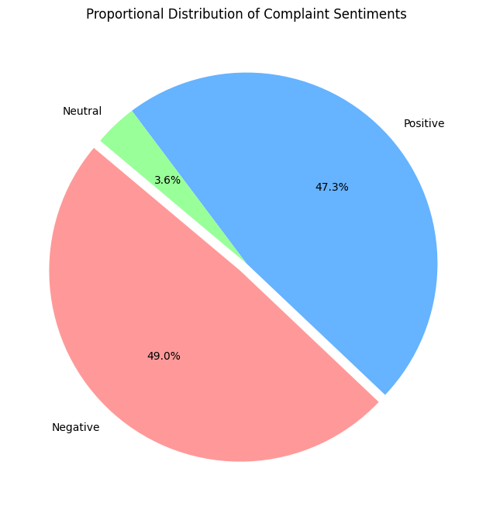
Figure 4.4 Sentiment pie chart
The pie chart shows relatively similar proportions of negative and positive sentiments, making up 49.0% and 47.3% of complaints, respectively while neutral complaints comprise only 3.6%. Such a distribution is unusual since complaints are generally supposed to have a higher proportion of negative sentiment as they explain the consumer grievances. However, this result reflects that VADER is not a suitable tool for CFPB’s financial complaint data, which contains a mixture of factual reporting and emotional language, rather than uniformly negative expressions. It can also be inferred that VADER fails on this data because of its reliance on social media slang rather than financial terminology; often missing the negative sentiment in formal and factual language of financial complaints.
Thus, even though VADER excels at detecting raw emotional intensity, it still struggles with specialized financial context because of its dependence on general-purpose lexicons.

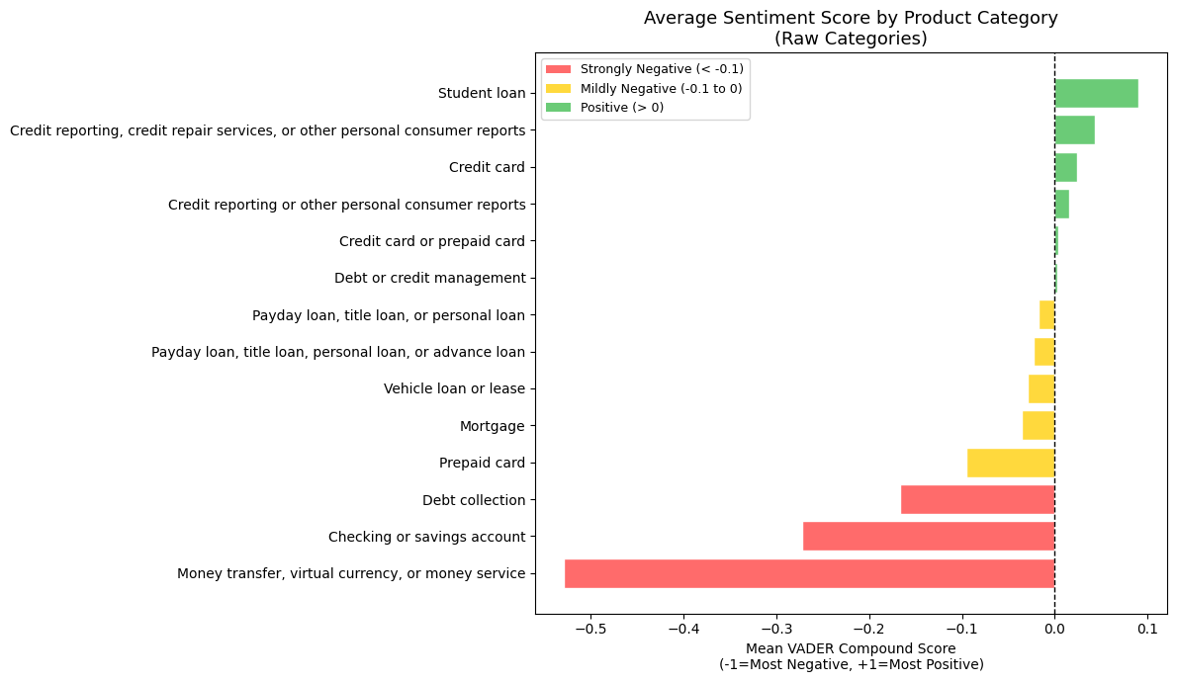
Figure 4.5 Sentiment by product
Figure 4.5 shows average sentiment scores by product category. A considerable variation is seen across the different product categories, indicating that consumer frustration in a complaint differs meaningfully by product domain. While product categories like ‘money transfer, virtual currency, or money service’ depict extremely negative sentiment; complaints across the category of ‘student loan’ exhibit somewhat positive sentiment with a vader compound score of almost +0.1. Similarly, ‘credit card or prepaid card’ complaints are observed to be comparatively neutral. This variation indicates that sentiment may provide additional useful signals for product classification beyond traditional bag-of-words features.

4.3.5 Text Characteristics’ Analysis
Since narrative text is used as input for both classification tasks in this study, therefore it is required to observe its characteristics as well. Figure 4.6 shows the analysis of complaint narrative length.
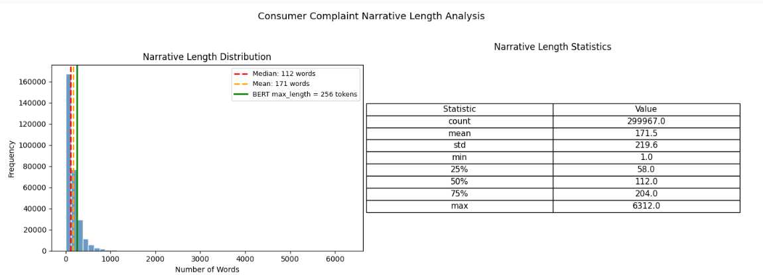
Figure 4.6 Narrative length distribution
The left part of the figure presents the distribution while the right part displays the descriptive statistics of the complaint narrative length across 299,967 complaints. It can be seen that the distribution is highly right-skewed, with the majority complaints having length of less than 500 words. The median is 112 words and the mean is around 171 words. The variation in these values confirms the skewed nature of the data, with a few lengthy complaints contributing to increased value of the mean. The interquartile range varies from 58 to 204 words demonstrates that the central 50% of the complaints are considerably short. This suggests that consumers typically express their grievances in a concise manner instead of elongated narratives.
The green vertical line at 256 words shows the maximum token length adopted for BERT and FinBERT fine-tuning. Since almost 75% of the complaints are less than 204 words, therefore this threshold of 256 is considered appropriate since such a limit of tokens not only captures the complete text of the majority of complaints but also remains computationally efficient. Also because only a small proportion of longer complaints are truncated during transformer tokenisation, this truncation is acceptable considering that the major distinguishing vocabulary appears in the initial part of a complaint.
4.3.6 Word frequency Analysis
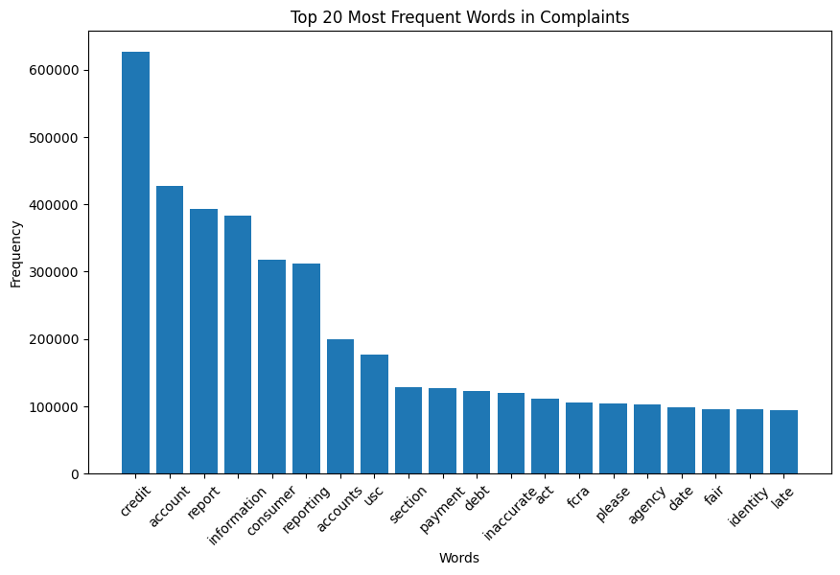
Figure 4.7 Word frequency plot for top 20 complaints
Figure 4.7 presents the 20 most frequent terms in all the complaints. For a meaningful analysis, a few cleaning steps are applied like stopword removal, lowercasing, removal of numbers, punctuations and redaction placeholders (xxx); distinct from the full preprocessing pipeline. It can be seen that credit related terms such as ‘credit’, ‘report’, ‘account’ are the most common, confirming ‘credit reporting’ as the most dominant product category. On the other hand, words like ‘fair’, ‘fcra’, ‘agency’ have the lowest frequency showing the contribution of regulatory vocabulary in the complaints.

4.3.7 Topic Modelling
In order to identify the inherent themes/topics within the consumer complaints, BERT-based topic modelling (BERTopic) is applied to a stratified sample of 20,000 complaints, without the need for predefined labels. This sample is selected for balancing semantic coverage with computational feasibility, as BERTopic embedding generation and clustering are computationally intensive on large corpora.
BERTopic is a topic modelling framework that uses transformer-based embeddings and clustering techniques to discover topics from text data. As compared to traditional Latent Dirichlet Allocation (LDA) which relies on word frequency counts, BerTopic is preferred as it focuses on capturing the semantic meaning of documents.
In this study, prior to topic modelling, a dedicated text normalisation pipeline is applied to complaint text that includes lowercasing, removal of email addresses, URLs, numbers, CFPB redaction placeholders, punctuation, stopwords and tokens shorter than three characters. This cleaning strategy is kept more aggressive than the preprocessing pipeline, as topic modelling requires clean semantic tokens rather than almost complete vocabulary, needed for predictive modelling.
As discussed in the Methodology section, there are four key components used in BERTopic including transformer embeddings, dimensionality reduction, clustering and topic representation. The ‘all-mpnet-base-v2’ embedding model is used from the Hugging Face Sentence Transformers library for generating semantic embeddings of the text data. Initial modelling produces 34.1% outliers i.e. those complaints that can not be confidently assigned to any topic. However, for reducing outliers, Class-Based Term Frequency–Inverse Document Frequency (C-TF-IDF) strategy is applied that reassigns outlier documents to their nearest topic by measuring word importance within clustered documents relative to other topics. This reduces outliers from 34.1% to 3.6% i.e. 728 complaints. Lastly topic reduction is applied resulting in retention of 12 total topics, yielding 11 interpretable complaint themes.
Table 4.2: Final Topic Summary

Topic | Custom Label | Count
-1 | Miscellaneous | 728
0 | Credit reporting & FCRA regulatory disputes | 16,483
1 | Credit bureau disputes (Equifax / Experian / TransUnion) | 1772
2 | Wells Fargo banking & account closure issues | 194
3 | Medical billing & insurance debt collection issues | 177
4 | Credit freeze & identity security management | 64
5 | Chime fintech transaction & dispute issues | 57
6 | Discover card fraud & account reporting disputes | 51
7 | Midland debt collection & credit reporting disputes | 49
8 | Bank of America (BoA) fraud & account claim issues | 39
9 | Venmo account freezing & digital wallet issues | 14
10 | Formal disputes, FTC filings & regulatory complaints | 12
Table 4.2 summarizes the major themes/topics identified in the complaints. From the counts, it is seen that ‘Credit reporting & FCRA regulatory disputes is the most dominant topic of discussion in all the consumer complaints followed by those related to credit bureau disputes. This is actually verifiable from the analysis of the features in the dataset, especially the product category, in which credit reporting is the most dominated category. In contrast, lowest count is for ‘Formal disputes, FTC filings & regulatory complaints’ and ‘Venmo account freezing & digital wallet issues’, depicting them as the weakest themes in complaint narratives i.e. complaints have least amount of grievances related to these topics.
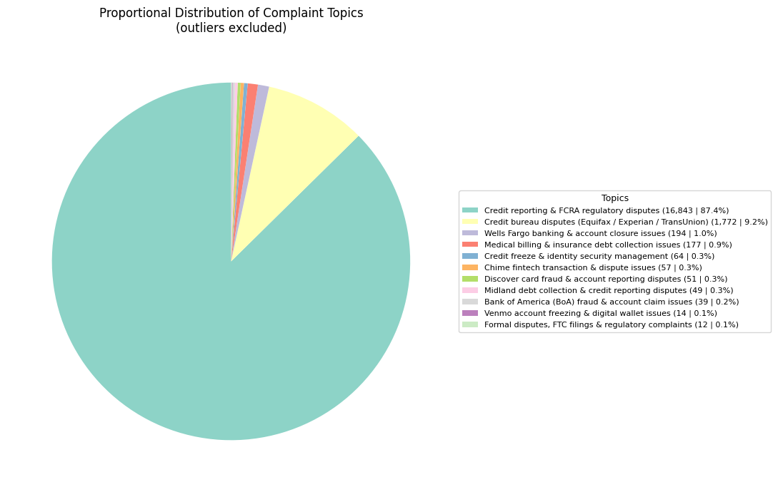
Figure 4.8 Topic distribution pie chart
Figure 4.8 presents the final topic distributions showing ‘Credit reporting and FCRA regulatory disputes’ to comprise 87.4% of classified complaints.
A few findings are particularly noteworthy for contextualising the dataset within the 2020–2025 study period. Topics 5 and 9 (numbering according to table) identify fintech-specific complaint patterns for Chime and Venmo respectively, reflecting the growth of non-traditional financial service providers during the study period and representing complaint themes not observable in earlier CFPB datasets. Moreover, company-specific topics (Topic 2: Wells Fargo) suggest that certain institutions generate disproportionate complaint volumes, consistent with CFPB enforcement priorities during this period.

4.4 Data Preprocessing
The insights from EDA inform the preprocessing steps so that the data remains consistent and suitable for applying classical, transformer-based and hybrid models. These steps include text cleaning, product category consolidation, and binary target derivation.

4.4.1 Text Cleaning
In order to understand the context of complaints, a minimal cleaning strategy is applied so that noise is removed while preserving the semantic meaning. Unlike traditional NLP pipelines, aggressive preprocessing steps such as stopword removal and lemmatization are intentionally avoided, as they may degrade contextual representations required by transformer-based models.
Table 4.3 summarises the seven preprocessing operations applied sequentially to each narrative.
Table 4.3: Text Preprocessing Steps
Step | Operation | Rationale
1 | Lowercasing | Standardises vocabulary
2 | URL removal | Hyperlinks carry no complaint relevant meaning
3 | Email removal | Personal contact details not predictive
4 | Number masking to [NUM] | Reduces vocabulary sparsity and noise while preserving numeric presence
5 | Punctuation removal (retain $, %) | Dollar and percentage symbols carry financial meaning
6 | Redaction placeholder removal | CFPB anonymises data with 'xxxx' sequences carrying no semantic content
7 | Single character token removal | Removes isolated letter artefacts

The effect of this preprocessing pipeline is illustrated through the following transformation example:
Before | On XX/XX/2022, I disputed account #4521 with Equifax. The charge of $450.00 was incorrect (see attached xxxx document).
After | on [NUM] [NUM] [NUM] disputed account [NUM] with equifax the charge of $[NUM] was incorrect see attached document

The above cleaning strategy removes noise, identifiable personal information and redaction artefacts while preserving sentence structure, financially meaningful terms and monetary references.

4.4.2 Product Category Consolidation
The exploratory data analysis identifies naming inconsistencies in the raw product categories therefore, product labels are consolidated / mapped into unified categories. The mapping strategy is shown in Table 4.4.
Table 4.4: Product Category Mapping
Original CFPB Label | Consolidated Label
Credit reporting, credit repair services, or other personal consumer reports / Credit reporting or other personal consumer reports | Credit reporting
Credit card or prepaid card | Credit card
Payday loan, title loan, personal loan, or advance loan / Payday loan, title loan, or personal loan | Payday/personal loan
This consolidation reduces the number of product categories from 14 to 11, eliminating fragmentation caused by administrative renaming rather than actual product differences. The resulting 11-category product feature forms the target variable for the multi-class product classification task.
Figure 4.9 presents the product category distribution after label mapping, indicating that ‘Credit reporting’ still remains the highest category at 72%, and ‘Debt or credit management’ the lowest.

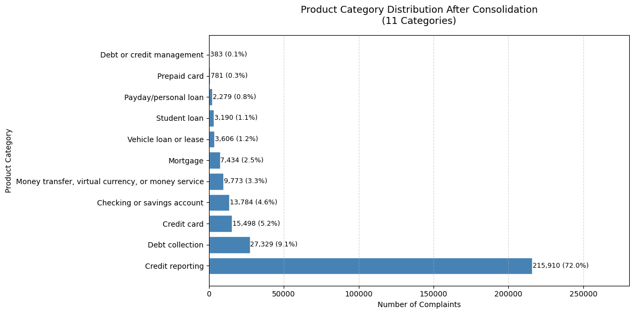
Figure 4.9 Product category distribution bar chart

4.4.3 Binary Target Variable Derivation
The binary target variable for monetary relief prediction is derived from the ‘Company response to consumer’ field. This field contains six values but only complaints with a definitive closed outcome are retained. The records marked "In progress" are dropped as their outcome remains unknown at data collection time. Table 4.5 presents the handling of each response value.
Table 4.5: Binary Target Variable Construction
Response Value | Binary Label | Rationale
Closed with monetary relief | 1 | Financial compensation awarded
Closed with explanation | 0 | Resolved but no money awarded
Closed with non-monetary relief | 0 | No financial remedy
Untimely response | 0 | Closed case but no relief awarded
In progress | Excluded | Outcome unknown at data collection
Missing (NaN) | Excluded | No information available
The reason for retaining ‘Untimely response’ class 0 is that it represents closed cases where no monetary relief has been awarded. On the other hand, complaints marked 'In progress' are excluded, since such records introduce label noise. The final resolved dataset comprises 298,937 complaints with clear binary outcomes. Figure 4.10 presents the resulting class distribution:

Binary variable distribution
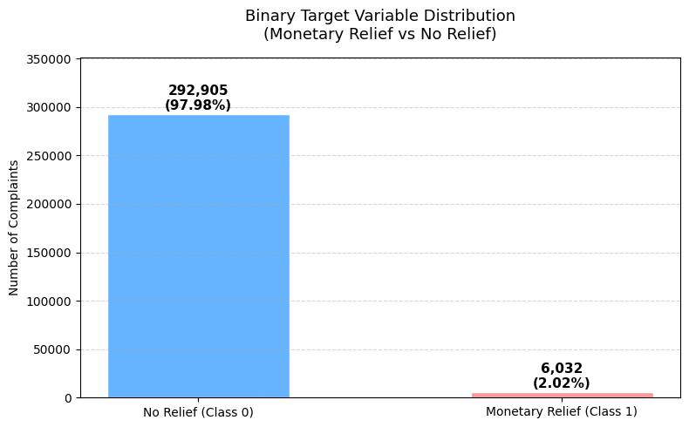
Figure 4.10 Binary target distribution
The figure shows a major class difference (49:1) between monetary and non-monetary relief cases. A naive majority-class classifier on this data would achieve 97.98% accuracy while failing to identify monetary relief cases; highlighting the inadequacy of overall accuracy as an evaluation metric and motivating the use of macro-averaged F1, balanced accuracy and ROC-AUC as performance metrics.
The class imbalance is addressed through the combined resampling and class weighting strategy described in Section 4.6.

4.5 Feature Engineering
Feature engineering is performed for transforming cleaned and preprocessed text narratives and categorical features into numerical representations suitable for classical machine learning, transformer-based and hybrid models. Three distinct feature preparation strategies are employed as follows:

4.5.1 TF-IDF Vectorisation for Classical Models
Term Frequency–Inverse Document Frequency (TF-IDF) vectorisation is used for converting complaint narratives into numerical representations needed for classical machine learning models. TF-IDF increases the weights of terms that are distinctive within individual complaints and decreases the weights of those that appear frequently across the entire corpus. This property makes it well-suited for classification of financial complaints where domain-specific terms such as ‘credit bureau’ or ‘debt collector’ carry strong discriminative value. Table 4.6 details the vectorisation parameters applied.
Table 4.6 TF-IDF Vectorisation Parameters
Parameter | Value | Rationale
max_features | 15,000 | Captures sufficient vocabulary without excessive dimensionality
ngram_range | (1, 2) | Includes bigrams to capture compound financial terms
sublinear_tf | True | Applies logarithmic scaling to term frequency, reducing the impact of highly repeated words
stop_words | english | Removes uninformative common words
min_df | 5 | Excludes terms in fewer than 5 documents
max_df | 0.85 | Excludes terms in more than 85% documents

To prevent data leakage, TF-IDF vectorisation is fitted exclusively on training data and applied to transform test data, ensuring that vocabulary statistics from the test set do not influence feature representation. The resulting sparse matrix of 15,000 weighted term features constitutes the primary input for the classical machine learning models across both classification tasks.
4.5.2 Target Variable Encoding
For both classification tasks of monetary prediction and product classification, the target variables are encoded into numerical representations for compatibility with model training pipelines. For the product classification task, the 11 consolidated product categories are encoded using label encoding while for the binary monetary relief task, the target variable is derived and encoded as a 0 or 1.

4.5.3 Tokenisation for Transformer Models
For the transformer models (BERT and FinBERT), complaint narratives are processed using model-specific WordPiece tokenisation. This method splits text into subword units on the basis of each model’s pre-trained vocabulary, thus preserving the semantic meaning that traditional bag-of-words approaches cannot capture. Table 4.7 provides a summary of the tokenisation configuration.
Table 4.7 Transformer Tokenisation Configuration
Parameter | Value | Rationale
Tokeniser (BERT) | BertTokenizer (bert-base-uncased) | Native tokeniser matching BERT pre-training vocabulary
Tokeniser (FinBERT) | BertTokenizer (ProsusAI/finbert) | Native tokeniser matching FinBERT pre-training vocabulary
max_length | 256 tokens | Captures complete text for 75% of complaints
truncation | True | Sequences exceeding 256 tokens are truncated
padding | Dynamic per batch | Sequences padded to the longest one in each batch only

Dynamic padding is applied using HuggingFace Transformer's ‘DataCollatorWithPadding’ utility, which pads data dynamically, according to the longest sequence, per batch, rather than padding all inputs to a global maximum length. This approach significantly reduces memory usage avoiding memory crashes.

4.5.4 Structured Feature Encoding for Hybrid Model
The hybrid model requires numerical representations of structured complaint data alongside textual embeddings. The structured features are selected for each classification task using Cramer’s V Test, describing their relevance to the target and absence of data leakage risk, as discussed in the Methodology chapter.
For the binary monetary relief task, product and issue are selected, while for the product classification task, tags and issue are chosen for hybrid modeling. Moreover, all the selected features are one-hot encoded. OneHotEncoder is configured with handle_unknown='ignore' to ensure unseen categories in the test set are handled as zero vectors, without causing errors.
Tables 4.8 and 4.9 present these features and their encoding.
Table 4.8 Structured Features — Binary Task (Monetary Relief)

Feature | Distinct Values | Encoded Dimensions
Product_clean | 11 | 11
Issue | 91 | 91

Table 4.9 Structured Features — Product Classification Task
Feature | Distinct Values | Encoded Dimensions
Issue | 91 | 91
Tags | 4 | 4

4.5.5 Feature Integration for Hybrid Model
The hybrid model combines BERT textual embeddings with one-hot encoded structured features.
This implies that BERT acts as a feature extractor, processing each complaint narrative and producing a 768-dimensional dense vector known as the [CLS] embedding. This vector is extracted from the final encoder layer and represents a compressed semantic summary of the complete complaint text. This embedding is then combined with the one-hot encoded structured feature vector (from corresponding classification tasks) to form a single combined input vector. This integrated representation is then passed into a Multi-Layer Perceptron classifier (neural architecture), which learns to map this combined information jointly to the target classification outcome.

4.6 Model Implementation
This section describes the implementation of all classification models across both tasks. Three modelling pipelines are implemented: classical machine learning models, transformer-based models, and hybrid models. All experiments follow the preprocessing and feature engineering strategies described in Sections 4.4–4.5

4.6.1 Classical Machine Learning Models — Binary Classification

Data Preparation
The binary classification pipeline is constructed on the preprocessed complaint dataset of 298,937 complaints.
The stratified train-test split is applied with a ratio of 80-20 using random_state=42 to preserve the natural 49:1 class distribution across both partitions and to ensure reproducibility, respectively. The training set comprises 239,150 complaints and the test set 59,787 complaints.
Following splitting, the three-layer class imbalance strategy, described in the Methodology chapter, is applied exclusively to the training partition. Random undersampling reduces the majority class, and random oversampling increases the minority class samples, yielding a balanced training set with 2:1 ratio for the binary task. The test set remains unchanged at the original 49:1 distribution to ensure that the evaluation reflects original complaint proportions.
Class weights are subsequently computed on the balanced training labels using compute_class_weight with the balanced setting, yielding weights of {0: 0.75, 1: 1.50} to provide additional penalization of minority class misclassification during training.

Hyperparameter Optimization
Hyperparameter optimization is conducted for all three classical models using GridSearchCV with 3-fold cross-validation, allowing the models to be evaluated across multiple data splits to improve the robustness and generalisability of the selected parameters while maintaining computational efficiency. During tuning, macro-averaged F1 is used as the selection criterion for optimization. Macro F1-score is used for imbalanced data because it treats all classes equally; calculating for each class independently before averaging them. Unlike accuracy, it ensures that the model's performance on minority classes is not overshadowed by the majority class, providing a fair evaluation of performance across all categories.
Table 4.10 summarises the hyperparameter search spaces evaluated.
Table 4.10: Hyperparameter Search Space — Binary Classification
Model | Parameter | Values Evaluated | Selection Criterion
Logistic Regression | C (regularisation) | 0.1, 1.0 | Macro F1 (3-fold CV)
LinearSVC | C (regularisation) | 0.1, 1.0 | Macro F1 (3-fold CV)
XGBoost | learning_rate | 0.05, 0.1 | Macro F1 (3-fold CV)
The search space is deliberately constrained to key regularisation parameters to balance thoroughness with computational feasibility. For Logistic Regression and LinearSVC, the regularisation parameter C controls the trade-off between margin maximisation and training error (smaller values apply stronger regularisation while larger values allow more complex decision boundaries). For XGBoost, learning rate and tree depth are identified as the most influential parameters for text classification tasks.
Table 4.11 shows the selected tuned hyperparameters.
Table 4.11: Hyperparameter Tuning Results — Binary Classification
Model | CV Macro F1 | Best C / lr
Logistic Regression | 0.9214 | C = 1.0
LinearSVC | 0.9535 | C = 1.0
XGBoost | 0.8924 | lr=0.1

Here, CV F1 is used solely as a selection criterion to identify optimal parameters, not as a performance measure.

Model Configurations

Three classical machine learning models are trained on TF-IDF features for the binary monetary relief prediction task, namely Logistic Regression, LinearSVC and XGBoost.
Logistic Regression:
Logistic Regression is implemented using the saga solver with a maximum iteration limit of 1,000 to support convergence on the sparse TF-IDF feature space. Class imbalance is handled using the computed class_weight dictionary {0:0.75, 1:1.50}. The regularisation parameter C is tuned with values of 0.1 and 1.0 to balance model simplicity and flexibility with C=1.0 selected as optimal through 3-fold GridSearchCV.
LinearSVC:
LinearSVC is implemented with a maximum iteration limit of 2,000 and class weighting enabled using the computed class_weight dictionary. Since LinearSVC does not natively produce probability estimates, the classifier is wrapped with CalibratedClassifierCV to enable ROC-AUC computation. The regularisation parameter C is tuned using values of 0.1 and 1.0 with C=1.0 selected as optimal.
XGBoost:
XGBoost does not natively accept a class_weight dictionary so the imbalance is instead handled through the scale_pos_weight parameter, set to 2.0. This instructs XGBoost to treat each positive sample as equivalent to two negative samples during tree construction. The model uses the histogram-based tree construction for efficient training on sparse TF-IDF features. Moreover, it uses logloss as an evaluation metric, which defines the loss function used internally for evaluation during training (Logloss measures how well predicted probabilities match actual labels). Hyperparameter tuning evaluates learning rates of {0.05, 0.1}, with learning rate=0.1, max depth=4 and number of estimators=100 selected as the final configuration.

4.6.2 Classical Machine Learning Models — Product Classification

Data Preparation
The product classification pipeline is constructed on the preprocessed complaint data with 11 consolidated product categories. The same stratified train-test split ratio of 80-20 with random_state=42 is applied, yielding training and test sets with proportional class distribution.
The same multi-layer resampling strategy described in the Methodology chapter is applied to the training partition.
Instead of fully balancing classes (which would distort real-world structure), the majority class is reduced. The extreme dominance of Credit reporting is reduced using RandomUnderSampler, but in a controlled, domain-preserving manner, from 172,728 to 25,000 samples. After undersampling, only the extreme minority classes are oversampled using RandomOverSampler. This avoids excessive duplication and overfitting. The minority classes are selectively oversampled as follows: Payday/personal loan is increased from 1,823 to 2,500, Prepaid card from 625 to 2,000, and Debt or credit management from 307 to 2,000. These thresholds are deliberately chosen to ensure that each class is expanded only to a learnable but non-dominant size, while preserving the natural ranking among categories and minimising the risk of overfitting caused by excessive duplication. In contrast, classes with moderate frequency (e.g., Student loan and Vehicle loan) are intentionally left unchanged, as they already contain sufficient representational signal. This resampling yields a balanced training set at a 12.5:1 largest-to-smallest ratio.
Due to memory limitations and to ensure fair and computationally consistent comparison across models for multi-class classification (product) task, a stratified 30000 subset is subsequently extracted from the balanced dataset, maintaining proportional class distributions, while reducing computational cost, preserving the underlying data structure, and ensuring identical training data for all models by using random_state=42.
TF-IDF vectorisation is applied on the 30,000 training subset, and class weights are recomputed accordingly.

Hyperparameter Optimisation
The same GridSearchCV configuration (3-fold CV, macro F1 optimisation) is used as in the binary task, with identical search spaces adapted for multi-class classification.
Table 4.12 shows the selected tuned hyperparameters.
Table 4.12 Hyperparameter Tuning Results — Product Classification (30k samples)

Model | CV Macro F1 | Best C / lr
Logistic Regression | 0.7576 | C = 1.0
LinearSVC | 0.7915 | C = 1.0
XGBoost | 0.7008 | lr=0.1

The lower CV F1 scores compared to the binary task reflect the increased complexity of 11-class classification relative to binary prediction, particularly given the persistent imbalance between majority and minority product categories even after resampling.

Model Configurations
The same three classical models are applied to the product classification task using configurations identical to the binary task, with task-specific modifications related to imbalance handling and multi-class optimisation.
Logistic Regression and Linear SVC:
Logistic Regression and LinearSVC retain the same solver, regularisation parameter, iteration limits and CalibratedClassifierCV wrapper as for the binary task. Class weights are recomputed on the 30,000-sample balanced product training labels rather than the binary labels, yielding different weight values appropriate to the 11-class distribution.
XGBoost:
XGBoost scale_pos_weight parameter used in binary classification is replaced with per-sample weights passed via the sample_weight argument, as XGBoost's multiclass implementation does not support class_weight directly. Second, the XGBoost evaluation metric is changed from logloss (binary cross-entropy) to mlogloss (multiclass log loss) to match the 11-class prediction objective. All remaining parameters remained unchanged.
For the multi-class task, XGBoost replaces scale_pos_weight with sample-level weights passed via the training function as XGBoost's multiclass implementation does not support class_weight directly. The evaluation metric is changed from logloss (binary cross-entropy) to mlogloss (multiclass log loss) to match the 11-class prediction objective and enable better optimization. All remaining parameters remained unchanged.

4.6.3 Transformer Models — BERT and FinBERT

Overview
As part of the second modeling pipeline, transformer-based models are implemented. Two pre-trained transformer models are fine-tuned for both classification tasks: BERT-base-uncased, a general-purpose bidirectional encoder pre-trained on BookCorpus and English Wikipedia, and ProsusAI/FinBERT, a domain-adapted variant, pre-trained on financial text corpora. Both models are implemented using the HuggingFace Transformers library with PyTorch as the underlying deep learning framework.
Unlike classical models which receive TF-IDF feature vectors as input, transformer models process raw tokenised complaint text directly, enabling contextual representation of complaint language through self-attention mechanisms.
Figure 4.11 illustrates the transformer fine-tuning pipeline implemented for both BERT and FinBERT models. Raw complaint narratives are first tokenised using the model-specific WordPiece tokenizer and converted into input IDs and attention masks. The tokenised sequences are then passed through the 12-layer transformer encoder, where lower encoder layers remain frozen to preserve general linguistic representations learned during pre-training, while higher encoder layers are fine-tuned for the downstream complaint classification tasks.
The contextual representation of the special [CLS] token produced by the final encoder layer is passed to a task-specific classification head, generating either binary monetary relief predictions or 11-class product category predictions depending on the task configuration.

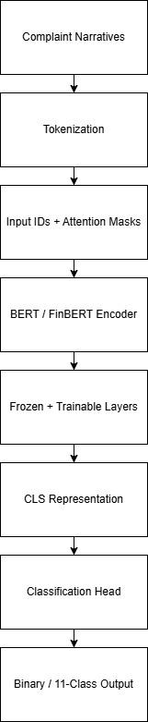

Figure 4.11 Basic Transformer Architecture Pipeline

Class Imbalance Handling
For all transformer-based experiments, class imbalance is addressed at the loss function level through a custom Trainer subclass. The default HuggingFace Trainer does not natively support weighted loss functions; it applies standard unweighted CrossEntropyLoss regardless of class distribution. To incorporate class weighting, a custom Weighted Trainer subclass is created by overriding the compute_loss method, replacing the default loss with PyTorch's CrossEntropyLoss instantiated with class weight tensors.
For binary classification, class weights are computed from the balanced training labels using compute_class_weight with the balanced setting (the same approach applied to classical models), yielding weights of {0: 0.75, 1: 1.50}. These weights are converted to a PyTorch tensor and moved to the GPU to match the model device. During each training step, the custom loss function applies a penalty of 0.75 for misclassified No Relief cases and 1.50 for misclassified Monetary Relief cases thus making minority class misclassification twice as costly and preventing the model from defaulting to majority class predictions.
For product (multi-class) classification tasks, class weights are recomputed from the 30,000-sample product training labels using compute_class_weight, yielding 11 class-specific weights achieving equal effective influence across all product categories; consistent with the class weighting strategy applied to classical models for product classification. As with the binary task, weight tensors are transferred to the GPU prior to training to ensure device compatibility.
This weighted-loss approach provides an additional imbalance correction layer complementary to the resampling strategies described earlier.

4.6.4 BERT Fine-Tuning — Binary Classification (Monetary Relief)

Data Preparation
The BERT model is trained on the balanced training set, identical to the classical ML binary experiments, ensuring direct comparability between modelling pipelines. The test set comprises 59,788 complaints at the natural 49:1 class distribution, consistent with all other binary task experiments.
Complaint narratives are tokenised using BERT's native WordPiece tokeniser with a maximum sequence length of 256 tokens. Sequences exceeding this limit are truncated, while shorter sequences are padded dynamically per batch using HuggingFace's DataCollatorWithPadding rather than upfront padding of the entire dataset. This dynamic padding strategy substantially reduces memory consumption.

Model Architecture and Layer Configuration
As discussed in the overview, BERT-base-uncased comprises 12 transformer encoder layers, 12 attention heads and 110 million parameters. For the binary task, a two-class classification head is appended to the pre-trained model, replacing BERT's original masked language modelling objective with a binary classification objective. Moreover, a selective layer freezing strategy is employed, as discussed earlier.
Training Configuration and Hyperparameters
Training is conducted using the HuggingFace Trainer API with the AdamW optimiser applied by default. AdamW is an optimiser that updates model parameters efficiently while applying improved regularisation to reduce overfitting during transformer fine-tuning. A weight decay value of 0.01 is applied, penalising large model weights during training to reduce overfitting risk without aggressively constraining the model's capacity to learn task-specific patterns. The default dropout rate of 0.1 from the BERT pre-trained configuration is retained without modification.
The learning rate is set to 3×10⁻⁵ keeping it within the range of 2×10⁻⁵ to 5×10⁻⁵ as recommended by Devlin et al. (2018) for BERT fine-tuning. A low learning rate is essential for transformer fine-tuning since large parameter updates risk overwriting the generalised language representations. A warmup ratio of 0.1 is applied to stabilize optimisation during early training.
Mixed precision training is enabled via the fp16 flag, storing activations and gradients as 16-bit floating point values rather than the standard 32-bit representation. This halves GPU memory requirements without meaningful loss of numerical precision. Additionally, dataloader_pin_memory is set to False to reduce RAM consumption during data loading.
Training is conducted for 3 epochs with a batch size of 32 to maintain a balance between computational efficiency and memory constraints

Table 4.13 BERT Training Configuration — Binary Task
Parameter | Value | Rationale
Base model | bert-base-uncased | General-purpose pre-trained encoder
Batch size | 32 | GPU memory constraint
Epochs | 3 | Sufficient convergence
Learning rate | 3×10⁻⁵ | Standard BERT fine-tuning range
Warmup ratio | 0.1 | Stabilise early training
Weight decay | 0.01 | L2 regularisation
fp16 | True | GPU half-precision, reduces memory
Padding strategy | Dynamic per batch | Reduces memory consumption
Loss function | Weighted CrossEntropyLoss | Imbalance correction

4.6.5 BERT Fine-Tuning — Product Classification

Data Preparation
The product classification BERT model is trained on a stratified subsample of 30,000 complaints drawn from the balanced training pool, the same subset used for classical models, ensuring that the models receive identical training complaints with architecture as the sole differentiating factor.
The test set comprises 59,994 complaints at the natural class distribution across all 11 product categories, consistent with the previous product classification experiments. Tokenization and dynamic padding follow the same configuration as the binary task.

Model Architecture and Layer Configuration
The same BERT-base-uncased architecture is used for product classification with one structural modification i.e. the classification head is configured for 11 output classes rather than 2, corresponding to the consolidated product taxonomy defined earlier. Moreover, the same selective layer freezing strategy is applied as in the binary classification task.

Training Configuration and Hyperparameters
The product classification configuration follows the same settings as the binary task with the exception of training epochs, which are increased to 5.
Table 4.14 summarises the product classification configuration.
Table 4.14 BERT Training Configuration — Product Task
Parameter | Value
Base model | bert-base-uncased
Batch size | 32
Epochs | 5
Learning rate | 3×10⁻⁵
Warmup ratio | 0.1
Weight decay | 0.01
Loss function | Weighted CrossEntropyLoss (11 weights)

4.6.6 FinBERT Fine-Tuning — Binary Classification (Monetary Relief)
Data Preparation
FinBERT is fine-tuned following the same pipeline as BERT with three differences: the use of pre-trained model (ProsusAI/finbert rather than bert-base-uncased), a lower learning rate (2×10⁻⁵ rather than 3×10⁻⁵) to preserve financial domain knowledge, and replacement of FinBERT's original 3-class sentiment head with a new 2-class classification head using ignore_mismatched_sizes=True.
Overall, FinBERT binary classification uses identical training and test data to the BERT binary task. Complaint narratives are tokenised using FinBERT's native WordPiece tokeniser with the same configuration, maximum sequence length and dynamic padding configuration, as BERT.

Model Architecture and Layer Configuration
FinBERT is a domain-adapted variant of BERT, pre-trained on financial corpora including financial news articles and analyst reports, providing specialised financial language representations. The model shares the same architecture as BERT-base-uncased thus enabling direct architectural comparison between the two models. The original FinBERT sentiment classification head is replaced with a 2-class output layer using ignore_mismatched_sizes=True, as FinBERT's original pre-trained head contains 3 output neurons corresponding to its sentiment classification objective. Moreover, the same selective layer freezing strategy is applied as the BERT binary task.

Training Configuration and Hyperparameters
The training configuration closely follows the BERT binary task with one key difference i.e. the learning rate is reduced to 2×10⁻⁵ compared to 3×10⁻⁵ for BERT. This lower learning rate is selected to preserve FinBERT's financial domain representations during fine-tuning. All other hyperparameters remain identical to the BERT binary configuration.

4.6.7 FinBERT Fine-Tuning — Product Classification

Data Preparation
FinBERT product classification uses identical training and test data to the BERT product task. Tokenization, however, follows the same configuration as the FinBERT binary task i.e. FinBERT WordPiece tokenization with a maximum sequence length of 256 tokens and dynamic padding per-batch.

Model Architecture and Layer Configuration
The same ProsusAI/finbert architecture is applied to product classification with one structural modification: the classification head is replaced with an 11-class output layer (corresponding to the consolidated product taxonomy) using ignore_mismatched_sizes=True in order to handle the mismatch between FinBERT's original 3-class sentiment head and the 11-class product objective. Moreover, the same layer freezing strategy applied as before.

Training Configuration and Hyperparameters
The FinBERT product configuration uses learning rate 3×10⁻⁵ matching BERT's product configuration and seven training epochs. All other hyperparameters remain consistent with previous transformer configurations.

4.6.8 Hybrid Multimodal Model
The hybrid multimodal model extends the transformer-based architecture by combining text representations extracted from BERT with structured complaint metadata features, enabling the model to exploit both unstructured narrative content and structured administrative information simultaneously. The hybrid model is implemented for both classification tasks where, BERT [CLS] embeddings are concatenated with one-hot encoded structured features and passed to a Multilayer Perceptron (MLP) classifier.

4.6.8.1 Hybrid MLP — Binary Classification (Monetary Relief)

Data Preparation
The hybrid binary model is trained on the same balanced training set used by all other binary models, ensuring direct comparability. The original dataset is split using an identical stratified 80/20 train-test split with random_state=42, producing training and test complaints with the same class proportions as all other binary experiments. The same three-layer resampling strategy described earlier is applied exclusively to the training partition.
For the binary classification task, two structured features, issue and product, are selected based on the Cramer’s V Test, discussed in the Methodology chapter. Following one-hot encoding, the final structured feature matrix comprises 102 dimensions per complaint.

Model Architecture and Layer Configuration
The hybrid model combines two feature streams i.e. BERT embeddings and one-hot encoded structured features via a Multilayer Perceptron (MLP) classifier.
The fine-tuned BERT model is loaded in evaluation mode with the classification head removed, and [CLS] embeddings are extracted for all complaints. Structured features are standardised using StandardScaler fitted on training data only. This is done in order to align their scale with BERT embedding values and prevent structured dimensions from dominating the MLP's learning signal. The standardised structured vector (102 dimensions) is concatenated with the BERT embedding (768 dimensions) to produce a combined input vector of 870 dimensions per complaint, which is then fed into the MLP.
The MLP architecture comprises two hidden layers with ReLU activations and dropout regularisation:

Class Imbalance Handling
Class imbalance is addressed using weighted loss functions. For binary classification, BCEWithLogitsLoss is implemented with the pos_weight parameter computed from the resampled training labels using compute_class_weight.

Training Configuration and Hyperparameters
The MLP architecture defines two hidden layers with 256 and 128 neurons, with a relatively high dropout rate of 0.5 applied after each hidden layer to reduce overfitting by randomly deactivating neurons during training. ReLU activation functions introduce non-linearity, while the model is trained using the Adam optimiser with a very small learning rate of 1e−5, ensuring stable but slow convergence. A weight decay of 1e−4 is included as L2 regularisation to further penalise large weights and improve generalisation. Binary classification uses BCEWithLogitsLoss with class weighting, batch size 64 and a maximum of 20 training epochs. Early stopping with patience of 5 epochs is applied based on validation loss, preventing overfitting and unnecessary computation.

4.6.8.2 Hybrid MLP — Product Classification

Data Preparation
The hybrid product model is trained on the same 30,000-sample stratified subset used by all other product models. The product pipeline variables are reused directly, with structured features matched to these samples.
Two structured features are selected for the product task, based on Cramer’s V Test: Issue and Tags, both are used for hybrid modeling after one hot encoding.

Model Architecture and Layer Configuration
The hybrid product model follows the same feature combination approach as the binary task i.e. BERT CLS embeddings concatenated with scaled structured features, with a modification reflecting the increased task complexity. The output layer is configured for 11 classes, using CrossEntropyLoss with 11-dimensional class weight tensors, computed from the 30,000-sample balanced training labels using compute_class_weight, replacing the binary BCEWithLogitsLoss formulation.
The MLP is configured with the same hidden layers to accommodate the increased output dimensionality.

Training Configuration and Hyperparameters
The hybrid product model retains the same MLP architecture as the binary task with an 11-class output layer. Training is conducted using the Adam optimiser with learning rate 1×10⁻⁵, weight decay 1×10⁻⁴, batch size 64, and maximum 30 training epochs. However, early stopping with a patience of 5 epochs is employed to terminate training when validation loss ceases to improve, thereby preventing overfitting and improving generalisation.
Class imbalance is handled using CrossEntropyLoss with class weight tensors computed from the balanced product training labels.

4.7 Explainable AI
Explainability is applied to all model configurations across both the classification tasks to provide interpretable insight into model decision-making at both global and local levels. Different explainability techniques are applied to each model, selected on the basis of architectural compatibility rather than uniformity, as different model types require different explanation approaches.
Table 4.15 summarises the XAI method assigned to each model and the rationale for selection.
Table 4.15: XAI Method Selection
Model | Task | XAI Method | Rationale
Logistic Regression | Binary/Product | SHAP LinearExplainer | Exact Shapley values for linear models
XGBoost | Binary/Product | SHAP TreeExplainer | Purpose-built for tree-based models
LinearSVC | Binary/Product | LIME | SHAP incompatible with CalibratedClassifierCV
BERT/FinBERT | Binary/Product | Attention Visualization | Uses intrinsic transformer attention
Hybrid | Binary/Product | SHAP DeepExplainer | Approximates feature contributions for deep learning models

SHAP is applied to Logistic Regression (LR) and XGBoost as both models have dedicated SHAP explainers that efficiently compute exact Shapley values. However, LIME is applied to LinearSVC because the calibrated LinearSVC pipeline used for probability estimation is not directly compatible with SHAP explainers.Transformer models are interpreted using attention visualisation, leveraging the self-attention mechanism learned during fine-tuning. Hybrid models also use a different SHAP explainer variant that makes computations faster and more scalable for high-dimensional inputs.
4.7.1 Classical Models’ Explainability
Table 4.16 and 4.17 summarises the complete configuration applied across all SHAP and LIME analyses for both classification tasks using classical models.
Table 4.16: SHAP Configuration — Binary and Product Tasks
Parameter | LR Binary | XGB Binary | LR Product | XGB Product
Explainer type | LinearExplainer | TreeExplainer | LinearExplainer | TreeExplainer
Sample size | 200 | 500 | 200 | 200
Features displayed | 20 | 20 | 15 | 15
Table 4.17: LIME Configuration — Binary and Product Tasks
Parameter | LinearSVC Binary | LinearSVC Product
Explainer | LimeTextExplainer | LimeTextExplainer
Features per explanation | 10 | 10
Labels displayed | Both classes | Top predicted class only
Samples explained | 1 correct + 1 misclassified | 1 correct + 1 misclassified
The XAI techniques are applied to models as follows:
Logistic Regression — SHAP
SHAP LinearExplainer is applied to Logistic Regression models to quantify global feature importance in both classification tasks. LinearExplainer is selected as it is specifically designed for linear models, enabling the computation of exact Shapley values by leveraging the model’s coefficient structure rather than relying on sampling-based approximation. This makes the approach both computationally efficient and mathematically precise for this architecture.
Feature names are extracted from the TF-IDF vectoriser using the get_feature_names_out() method. The vectoriser is trained exclusively on the training corpus and configured with a maximum vocabulary size of 15,000 features and an ngram_range of (1,2), resulting in a feature space containing both unigrams and bigrams. For the explanation of both tasks, SHAP values are computed on 200 sampled complaints, to quantify how the presence of each word shifts an individual prediction relative to the baseline prediction.
For the binary task, the summary plot presents the top 20 features by default, ranked according to their mean absolute SHAP values across the sampled instances, thereby identifying the most influential terms globally.
For the product classification task, SHAP LinearExplainer is applied to the product classification LR model trained on the 30,000-sample balanced training subset. As the product task involves 11 classes rather than 2, SHAP produces class-specific explanations across all 11 classes.
The Credit reporting category is selected for visualisation due to its dominance within the dataset and regulatory importance and the top 15 features are displayed for readability.
XGBoost — SHAP
SHAP TreeExplainer is applied to XGBoost for both classification tasks. TreeExplainer is purpose-built for tree-based models, computing exact Shapley values by traversing the decision tree structure rather than approximating, and requiring no background dataset unlike LinearExplainer. The vectoriser is configured with a maximum vocabulary size of 15,000 features and an ngram_range of (1,2), resulting in a feature space containing both unigrams and bigrams.
For the binary task, 500 test complaints are used; a larger sample than LR, as TreeExplainer is computationally efficient on tree models, enabling a more representative global view of feature importance. In this task, XGBoost is a binary classifier with two output classes so SHAP returns values for both classes. For visualization, the summary plot displays the top 20 features.
For the product task, 200 complaints are used for consistency with Logistic Regression comparisons. As with Logistic Regression, the Credit reporting class is selected for multi-class visualisation in the product task.
LinearSVC — LIME
LIME is applied to calibrated LinearSVC models for both binary and product classification tasks. Since LinearSVC does not naturally produce probability outputs, CalibratedClassifierCV is used to obtain probabilistic predictions compatible with LIME.
LIME generates local explanations by perturbing complaint text and fitting a local surrogate linear model around individual predictions. explain_instance is the core LIME function that generates these local explanations. In this work, explanations are restricted to the 10 most influential words contributing to each prediction.
For both tasks, one correctly classified and one misclassified complaint are analysed to compare reliable and erroneous model behaviour.
For the binary task, a LimeTextExplainer is initialised with class names "No Relief" and "Monetary Relief", ensuring that explanations are directly interpretable in the context of the classification objective.
For the product classification task, explanations are generated only for the top predicted class (using parameter top_labels=1) to maintain interpretability across the 11-class setting. Moreover, to maintain interpretability, the parameter top_labels=1. Overall, word-level importance weights for a particular product category indicate whether a term supports or opposes that predicted class.
4.7.2 Transformer Models — Attention Visualization
Attention visualization is applied to all the transformer models i.e. BERT and FinBERT for both binary and product classification tasks, as the primary explainability technique. Unlike SHAP and LIME, which operate as post-hoc, model-agnostic methods, attention visualization leverages the transformer's intrinsic interpretability mechanism: the self-attention weights learned during fine-tuning. This enables explanations to be derived directly from the model's internal representations rather than approximated through external perturbation or sampling.
Table 4.19 summarises the attention visualization configuration applied consistently across all transformer models.
Table 4.19 Attention Visualization Configuration — All Transformer Models
Parameter | Value | Rationale
Attention layer | Final encoder layer (layer 12) | Captures most task-specific representations
Head aggregation | Average across all 12 heads | Produces a single interpretable importance score
Token focus | CLS token row | Represents sequence-level decision signal
Subword handling | Merge and average | Reconstructs full words from WordPiece tokens
Noise filtering | Common stop words removed | Focus on semantically meaningful terms
Word length filter | > 1 character | Removes non-informative tokens
Top words displayed | 15 | Balances detail and readability
Samples explained | 1 correct + 1 misclassified | Enables comparison of success vs failure
Implementation | attn_implementation="eager" | Ensures attention weights are returned

Implementation Overview
The attention-based explanation pipeline follows a consistent sequence across all transformer models. Each model is first reloaded from its saved checkpoint with attention outputs explicitly enabled; output_attentions=True and attn_implementation="eager" are specified at load time rather than inference time, as setting these after loading does not reliably activate attention weight capture. The model is set to evaluation mode to disable dropout and produce stable predictions.
Prediction probabilities are generated by passing the test dataset through the loaded model and applying softmax to the output logits. Predicted labels are compared with ground truth labels to identify correctly classified and misclassified samples.
For each selected complaint, attention weights are extracted from the final encoder layer and averaged across all attention heads. Since WordPiece tokenisation operates at the subword level, subword fragments are merged to reconstruct full words and their attention scores averaged accordingly. Common stop words and non-informative single-character tokens are removed prior to visualisation to retain only semantically meaningful terms.
The top 15 words by averaged attention weight are visualised with true and predicted labels for immediate interpretability.
Attention Mechanism Difference Across Models
The same attention visualisation pipeline is applied consistently across BERT and FinBERT across all classification tasks however, a few differences between implementations are limited to the checkpoint loaded, tokenizer used, output class configuration and prediction outputs used for sample selection.
For product classification tasks, the model is trained on a 30,000-sample balanced dataset with 11 output classes. Moreover, class labels are retrieved from the label encoder to display human-readable product categories.
Limitation of Attention-Based Explanations
While attention visualization provides intuitive insights into transformer model focus, it is important to recognise its limitations. Attention weights indicate where the model is focusing but do not necessarily represent causal influence on the final prediction i.e. a token receiving high attention may not be the primary driver of the classification decision. Consequently, attention patterns are interpreted as indicative contextual signals rather than definitive causal explanations.
This limitation also highlights the complementary role of SHAP and LIME in the classical and hybrid modelling pipeline, providing a more comprehensive and triangulated approach to interpretability across different model architectures.

4.8 Conclusion:
This chapter presents the implementation of the proposed multimodal complaint analysis framework for CFPB consumer complaints. The complete experimental pipeline is described, including data preprocessing, feature engineering, class imbalance handling, model development, hyperparameter configuration, and explainability integration across all modelling approaches.
Classical machine learning models are implemented using TF-IDF feature representations, while transformer-based approaches utilise contextual embeddings derived from fine-tuned BERT and FinBERT architectures. In addition, hybrid multimodal models combine transformer-derived textual embeddings with structured complaint metadata through MLP-based architectures to investigate the complementary predictive value of structured and unstructured data sources.
To ensure fair architectural comparison, consistent train-test splits, resampling strategies, and evaluation datasets are maintained across experiments wherever applicable. Furthermore, explainability techniques including SHAP, LIME, and transformer attention visualisation are applied to provide both global and local interpretability across different model families.
The next chapter presents the experimental results and comparative evaluation of all classical, transformer-based, and hybrid modelling approaches across the binary monetary relief prediction and multi-class product classification tasks.

Chapter 5: Evaluation and Results

5.1 Overview
This chapter presents the classification performance of all the models across two tasks: binary monetary relief prediction and multi-class product classification, as part of the first phase. After evaluation of all models, the second phase of interpreting and explaining the results using Explainable Artificial Intelligence (XAI) techniques, is implemented.
Model performance is assessed using four evaluation metrics selected for robustness under class imbalance. Macro-averaged F1 score serves as the primary metric, treating all classes equally regardless of support size and preventing the dominant categories from impacting results. Balanced accuracy, the average recall per class, is reported as a secondary metric to assess whether minority classes are identified at comparable rates to majority classes. Macro-averaged ROC-AUC is reported to measure ranking quality across all decision thresholds, providing a threshold-independent assessment of discriminative ability. Per class precision, recall and F1 scores are reported through classification reports in order to identify specific category level failures, distinguishing data scarcity limitations from modelling weaknesses. Confusion matrices are additionally presented for the best-performing model in each task to show the misclassification patterns between categories. Metrics like overall accuracy and weighted-average F1 are excluded, as both are dominated by the majority class and would misrepresent minority class performance; these metrics are replaced instead by balanced accuracy and macro-averaged F1 as primary metrics.
For the binary task, all the models are trained on balanced complaints and evaluated on a shared held-out test set of complaints at the natural 49:1 class distribution. For the product classification task, in the fair architecture comparison experiment, all the models are trained on an identical stratified subset of 30,000 complaints.
For interpretability , all the models are explained using different XAI approaches such as LIME, SHAP and attention visualization.
The results are arranged as follows: first section evaluates all models for the task of monetary relief prediction (binary classification), second section evaluates all models for product classification (multi-class classification) and last section explains results of all the models across both the classification tasks using XAI techniques.

5.2 Binary Classification Results — Monetary Relief Prediction

5.2.1 Classical Machine Learning Models
Table 5.1 presents binary classification results for the three classical models following hyperparameter optimization via GridSearchCV with 3-fold cross-validation.
Table 5.1: Classical ML Results — Binary Task (Monetary Relief)
Model | Macro F1 | Balanced Accuracy | ROC-AUC | Minority F1 | Minority Recall | Minority Precision
LR | 0.6142 | 0.9014 | 0.9595 | 0.2784 | 0.8964 | 0.1648
LinearSVC | 0.6520 | 0.7975 | 0.9475 | 0.3311 | 0.6410 | 0.2232
XGBoost | 0.5846 | 0.8945 | 0.9505 | 0.2343 | 0.9096 | 0.1345

The evaluation of classical machine learning models on the binary classification task reveals that while the models demonstrate high discriminative power, they are significantly impacted by the underlying dataset imbalance. Models such as Logistic Regression (LR) and XGBoost have exhibited exceptional sensitivity toward the minority class, achieving Minority Recall scores of 0.896 and 0.901, respectively, alongside robust ROC-AUC values exceeding 0.95. This indicates that these classifiers are highly effective at capturing positive instances of monetary relief. However, this aggressive pursuit of recall has resulted in a severe increase of false positives, as evidenced by exceptionally low Minority Precision scores (0.134 for XGBoost and 0.164 for LR). In practice, deploying these models would result in a high volume of false alarms, potentially misallocating resources or requiring extensive manual vetting.
In contrast, the Linear Support Vector Classifier (LinearSVC) offers a more structurally balanced alternative. Although its Minority Recall has decreased to 0.641, it has achieved the highest Minority Precision (0.22) and a superior Macro F1-score (0.6520). This suggests that LinearSVC establishes a more robust decision boundary under imbalanced conditions, mitigating the false positive rate better than its counterparts.
The models are further analyzed using confusion matrices as discussed below:

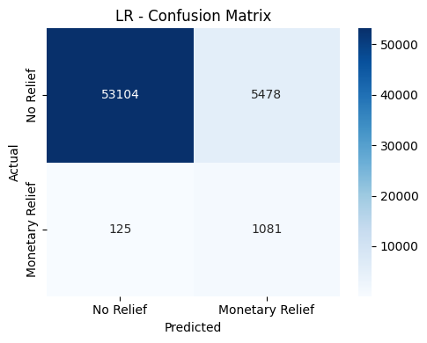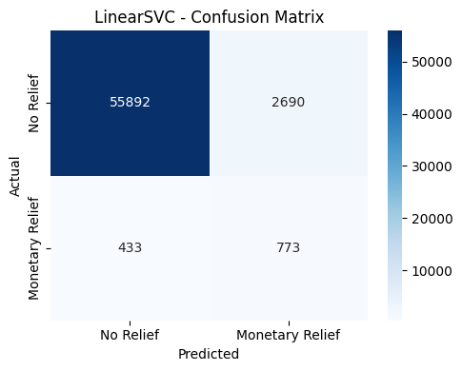
- Logistic Regression (b) Linear SVC
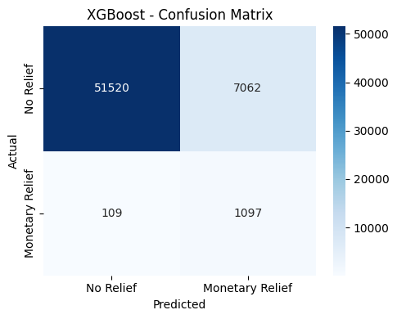
(c) XGBoost
Figure 5.1 Confusion matrices for classical models - Binary Task
A granular evaluation of the confusion matrices exposes the impact of the extreme class imbalance, where the majority class heavily shadows the minority monetary relief class. Both XGBoost and Logistic Regression (LR) prioritize minimizing False Negatives (FN), with XGBoost failing to identify only 109 true relief cases (FN = 109) and LR missing only 125 (FN = 125). While this yields a highly desirable situation for capturing eligible applicants, it triggers an overwhelming volume of False Positives (FP). XGBoost incorrectly has classified 7062 majority instances as requiring monetary relief, while LR has incorrectly flagged 5477 instances. In a real-world deployment, this can result in massive administrative burden, yielding precision rates so low that the vast majority of flagged cases would be false alarms.
Conversely, the Linear Support Vector Classifier (LinearSVC) adopts a notably more conservative decision boundary. It successfully mitigates the false positive issue, reducing false alarms (minority predictions) to 2690, achieving a reduction of over 60% compared to XGBoost. However, this optimization for precision compromises the model's sensitivity, causing it to miss 433 true positive instances (FN= 433).
This trade-off demonstrates that classical machine learning frameworks struggle to establish equilibrium inherently on a 49:1 class imbalance without explicit cost-sensitive adjustments. For institutional frameworks where missing a valid relief case carries severe legal or ethical penalties, XGBoost remains the optimal safer choice despite its inefficiency. However, when computational resources are limited and false positive predictions are costly to process, LinearSVC provides a more efficient balance between performance and operational practicality.

5.2.2 Transformer Models
Table 5.2 presents the performance of the transformer-based models following fine-tuning on the binary monetary relief task.
Table 5.2: Transformer Results — Binary Task (Monetary Relief)
Model | Macro F1 | Balanced  Accuracy | ROC-AUC | Minority F1 | Minority Recall | Minority Precision
BERT | 0.6480 | 0.8733 | 0.9565 | 0.3308 | 0.8101 | 0.2079
FinBERT | 0.6370 | 0.8860 | 0.9555 | 0.3135 | 0.8449 | 0.1925

The implementation of transformer-based architectures, specifically BERT and FinBERT, has yielded a more balanced performance profile as compared to classical machine learning approaches when dealing with the extreme 49:1 class imbalance. Both models maintain exceptionally high discriminative capacity, with ROC-AUC scores exceeding 0.95 and Balanced Accuracies approximately around 88%. Importantly, the transformers have mitigated the severe false-positive issue observed in classical models like XGBoost and Logistic Regression. While classical models suffered with minority precision rates as low as 0.1345, BERT and FinBERT have enhanced the Minority Precision to 0.2079 and 0.1925, respectively. This suggests that transformer models, through contextual embeddings and self-attention mechanisms, can better distinguish minority-class cases from other categories. Consequently, they reduce false alarms while still accurately identifying minority class cases.
A comparative evaluation between the two transformer architectures reveals the impact of domain specific pre-training. FinBERT, which is specialised for financial language, demonstrates better performance in detecting minority class cases, achieving a higher Minority Recall (0.8449) than BERT (0.8101) i.e. FinBERT is able to correctly detect a larger proportion of true monetary relief cases. This suggests that FinBERT’s contextual understanding is in accordance with the linguistic indicators associated with financial distress and monetary relief eligibility. However, this increased sensitivity comes with a marginal increase in false positives i.e. it incorrectly labels slightly more ‘no relief’ complaints as ‘relief’ (false positives). Consequently, BERT tends to take over FinBERT in terms of better Macro F1-score of 0.6480.
Ultimately, these findings demonstrate that while transformer models do not entirely eliminate the issues caused by severe data imbalance, their superior feature extraction capabilities provide a much more operationally viable and balanced deployment profile than traditional classifiers.
For analyzing the results further, confusion matrices are visualized in the form of heat maps for all both the transformer models.

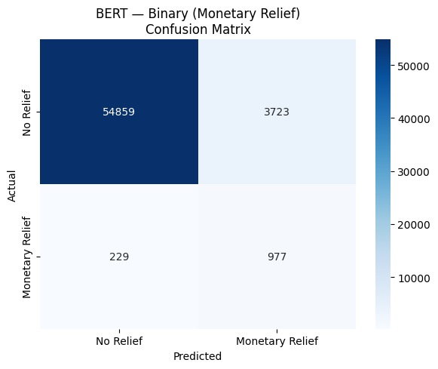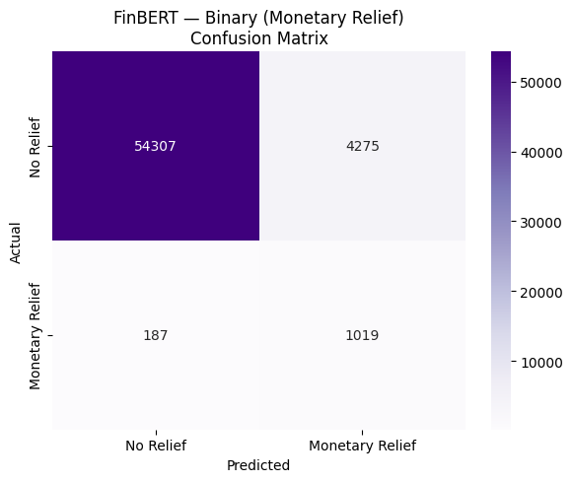
(a)BERT (b) FinBERT
Figure 5.2: Confusion Matrices for transformer models - Binary Task
In comparing BERT and FinBERT for the binary monetary relief task, as seen in Figure 5.2, both models demonstrate a strong ability to identify the majority ‘No Relief’ class while struggling with the precision-recall trade-off for the minority ‘Monetary Relief’ class. According to the confusion matrices, FinBERT achieves a higher sensitivity for the minority signal, correctly identifying 1019 relief cases compared to BERT (977). However, this increased recall for FinBERT comes at the cost of a higher false-alarm rate, as it misclassifies 4275 non-relief cases as relief, whereas BERT is more conservative with only 3723 such errors. Effectively, while BERT proves to be slightly more precise in its relief predictions, FinBERT’s domain-specific pre-training appears to make it more aggressive in pointing out potential relief cases, resulting in fewer missed opportunities at the expense of lower precision.
Next, the training and validation losses are visualized for both transformer models. The table 5.3 is presented to monitor the learning behaviour of the models across 3 training epochs.
Table 5.3: Transformer Training Losses — Binary Task
Epoch | BERT  Training Loss | BERT  Validation Loss | FINBERT  Training Loss | FINBERT  Validation Loss
1 | 0.2186 | 0.2736 | 0.2107 | 0.2887
2 | 0.1524 | 0.2347 | 0.1871 | 0.2192
3 | 0.0941 | 0.2181 | 0.1231 | 0.2267

It can be seen from the table that the training and validation loss trajectories for BERT and FinBERT show a stable and effective convergence process, even in the presence of severe class imbalance. Both architectures exhibit a consistent reduction in both training and validation loss over the three epochs. BERT has displayed a more rapid adaptation to the training corpus, with training loss decreasing from 0.2186 to 0.0941. However, validation loss has decreased from epoch 1 to epoch 2 and then continued to decline marginally into epoch 3 (0.218), indicating convergence without overfitting.
For FinBERT, training loss also has decreased consistently, however, validation loss has declined substantially from epoch 1 to epoch 2 (0.289 to 0.219) before rising slightly at epoch 3 (0.227), suggesting a marginal onset of overfitting, thus reaching its optimal validation performance at Epoch 2. This slight increase in FinBERT’s validation loss during Epoch 3, despite a continuing drop in training loss, indicates that the domain-specific model reached its peak generalizable state earlier than the base BERT model. Moreover, the relatively narrow margin between training and validation metrics for both models confirms that the self-attention mechanisms have been successfully capturing nuanced linguistic features of the minority class rather than merely converging on a majority class bias. These dynamics justify the use of early stopping or limited epochs and even a reduced learning rate as an effective regularization strategy for transformer-based classification in imbalanced financial contexts.

5.2.3 Hybrid Model
Table 5.4 presents the performance of the hybrid MLP model combining BERT CLS embeddings with structured features.
Table 5.4: Hybrid Results — Binary Task (Monetary Relief)
Model | Macro F1 | Balanced  Accuracy | ROC-AUC | Minority F1 | Minority Recall | Minority Precision
Hybrid MLP | 0.6561 | 0.8659 | 0.9588 | 0.3341 | 0.7894 | 0.2200
The hybrid model gives the most statistically robust performance across the binary classification task, achieving the highest overall Macro F1-score (0.6561) and a superior Minority Precision of 0.22 as compared to previous models. This indicates that the model is more reliable when predicting relief cases, producing fewer false positive predictions than previous approaches. While the hybrid model has exhibited a marginal reduction in Minority Recall (0.7894) as compared to standalone transformer models, it has successfully established a more balanced and operationally practical decision boundary by drastically reducing false-positive rates under extreme 49:1 data imbalance conditions.
The success of the Hybrid model highlights a critical thematic conclusion for this research: text embeddings capture the semantic nuance of complaints, while structured metadata provides additional contextual and categorical information that helps improve prediction reliability and model stability . For example, specific product categories or issue types inherently carry distinctive statistical probabilities of shifting toward monetary relief. Consequently, this multimodal fusion approach demonstrates that integrating structured complaint features with transformer-based textual representations is the most effective methodology for mitigating severe class imbalance, improving prediction reliability while maintaining strong detection capability for minority relief cases.
Next, the confusion matrix is visualized in the form of a heat map for the hybrid model.
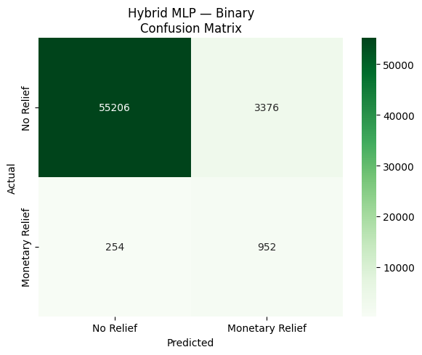
Figure 5.3: Confusion Matrix for hybrid model - Binary Task
Figure 5.3 presents the hybrid model confusion matrix. The confusion matrix reveals a significant class imbalance, where the ‘No Relief’ majority class far outweighs the ‘Monetary Relief’ instances. While the model demonstrates strong negative predictive value by correctly identifying 55206 ‘No Relief’ cases, its effectiveness on the minority class shows a distinct trade-off i.e. it achieves a fine recall of approximately 79% (capturing 952 out of 1206 actual relief cases), but struggles with a low precision of roughly 22%, which is although still better than other models as discussed earlier. This suggests that although the hybrid model successfully identifies most monetary relief cases, it also produces a relatively high number of false positive predictions. This indicates that further threshold adjustment or stronger class weighting may help the model better distinguish minority-class patterns from the dominant majority class.
After confusion matrix, training and validation loss table is presented to monitor the learning behaviour of the models and assess potential overfitting or generalisation performance across training epochs. It is to be noted that for the hybrid model, an early stopping strategy was applied keeping the patience value of 5.

Table 5.5: Hybrid Model Training Losses — Binary Task
Epoch | Training Loss | Validation Loss
1 | 0.2519 | 0.1730
2 | 0.0961 | 0.1747
3 | 0.0893 | 0.1755
4 | 0.0869 | 0.1794
5 | 0.0854 | 0.1765
6 | 0.0845 | 0.1751
Table 5.5 presents the training trajectory across six epochs. The training loss demonstrates a sharp initial descent, declining from 0.2519 to 0.0845, which indicates the hybrid model is successfully learning the training patterns. However, the validation loss remains comparatively stagnant, hovering around the 0.175 mark and failing to follow the training curve downward despite continued reductions in training loss, prompting early stopping at epoch 6.
Given the extreme class imbalance shown in the confusion matrix, this plateau suggests the model quickly found a safe local minimum, likely by prioritizing the majority class and struggled to generalize further without capturing more noise.
This pattern, where generalisation peaks immediately after the first epoch while training loss continues to decrease, indicates that the model's predictive capacity was determined primarily by the quality of the pre-trained BERT embeddings rather than the model’s continued optimisation. This is relatable since the textual embeddings from BERT are the main feature contributors towards model predictions. This will be shown in the explainability section later.
5.2.4 Overall Binary Task Comparison
Table 5.6 shows the comparison of all the models for the binary classification task.
Table 5.6: Complete Binary Task Results — All Models
Model | Macro F1 | Balanced Accuracy | ROC-AUC | Minority F1 | Minority Recall | Minority Precision
LR | 0.6142 | 0.9014 | 0.9595 | 0.2784 | 0.8964 | 0.1648
LinearSVC | 0.6520 | 0.7975 | 0.9475 | 0.3311 | 0.6410 | 0.2232
XGBoost | 0.5846 | 0.8945 | 0.9505 | 0.2343 | 0.9096 | 0.1345
BERT | 0.6480 | 0.8733 | 0.9565 | 0.3308 | 0.8101 | 0.2079
FINBERT | 0.6370 | 0.8860 | 0.9555 | 0.3135 | 0.8449 | 0.1925
HYBRID | 0.6561 | 0.8659 | 0.9588 | 0.3441 | 0.7894 | 0.2200

The hybrid model emerges as the most effective architecture for binary classification tasks, leading with a Macro F1 score of 0.6561 and the highest Minority F1 of 0.3441. These metrics indicate that the hybrid approach is uniquely capable of navigating the extreme class imbalance, providing the most reliable balance between the majority ‘No Relief’ class and the critical ‘Monetary Relief’ minority class. While the specialized FinBERT and standard BERT models also perform better, they are slightly shadowed by the hybrid model’s integrated structure, which appears more suitable for capturing the specific linguistic and structural nuances required to distinguish relief-related content.
A deeper look at the metrics reveals a significant ‘Precision-Recall’ trade-off across the different model types. Logistic Regression (LR) and XGBoost achieve the highest Minority Recall (reaching approx 0.9), which means they catch nearly every instance of ‘Monetary Relief’ but suffer from a high rate of false positives. In contrast, the hybrid and LinearSVC models are more selective; although they miss a larger portion of the minority class, they achieve the highest Minority Precision. This indicates that although all models achieve strong ROC-AUC scores, largely influenced by the dominance of the majority class, this metric alone does not fully reflect performance under class imbalance. The optimal model therefore depends on the objective: broader detection of potential relief cases is better supported by models such as XGBoost and Logistic Regression, whereas the hybrid model is more suitable when higher precision and reliability of predicted relief cases are required.

5.3 Product Classification Results

5.3.1 Classical Machine Learning Models
Table 5.7 presents the performance of the classical machine learning models on the fair 30,000-sample product classification experiment.
Table 5.7: Classical ML Results — Product Task
Model | Macro F1 | Balanced Accuracy | ROC-AUC
LR | 0.6234 | 0.7487 | 0.9650
LinearSVC | 0.6595 | 0.6971 | 0.9574
XGBoost | 0.5590 | 0.7169 | 0.9490
In the product classification task, the performance of classical ML models reflects the significant challenges posed by the 11-category structure and overlapping terminologies.
It can be seen from the table that XGBoost yields the lowest Macro F1-score (0.5590). This decline suggests that the complex, non-linear partitions created by gradient boosting trees are highly affected by ‘label noise’ and majority-class dominance when the number of target categories increases. Conversely, the Linear Support Vector Classifier (LinearSVC) achieves the superior Macro F1-score of 0.6595. This indicates that high-dimensional linear decision boundaries provide more robust separation between linguistically similar product categories. Compared to probabilistic and tree-based models, they are less influenced by class imbalance and better resist bias toward the majority class in ambiguous cases.
A significant finding across all models is the difference in the high ROC-AUC values and the comparatively lower Macro F1-scores. This gap highlights a critical distinction in model performance: while the classifiers possess a high theoretical capacity to rank the correct product category above others, they struggle to establish an optimal decision threshold for 11 simultaneous classes. This is particularly evident in Logistic Regression (LR), which achieved the highest Balanced Accuracy (0.7487) but a lower Macro F1 (0.6234) than LinearSVC, indicating a tendency to prioritize recall over precision.
Ultimately, these results conclude that for multiclass financial product classification, LinearSVC provides the most stable and balanced architectural framework, offering the best protection against class-based performance degradation in an imbalanced, multi-label environment.
Next, confusion matrices are visualized in the form of heat maps for all the models in Figure 5.4.

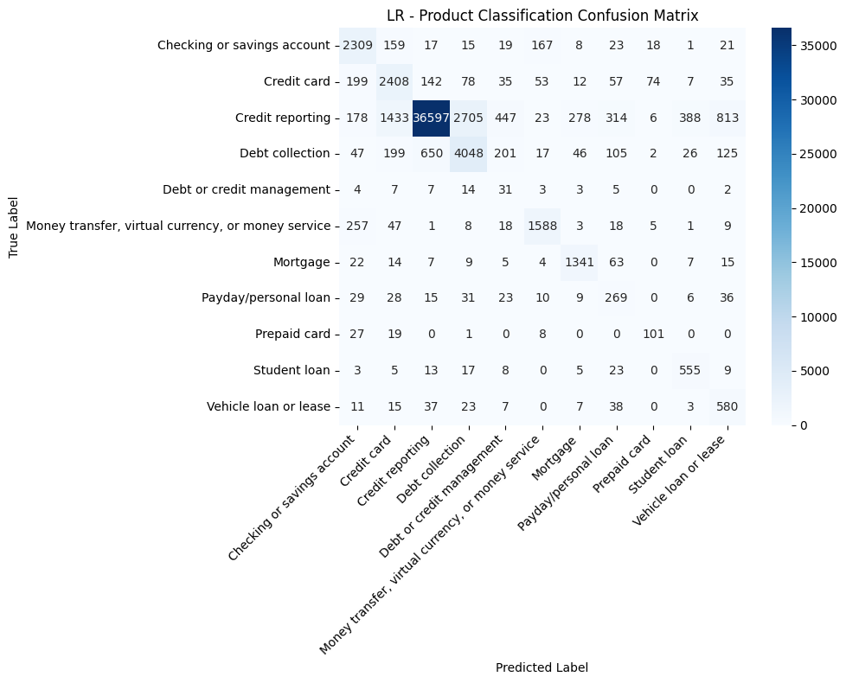

Figure 5.4 (a) Logistic Regression

Figure 5.4 presents confusion matrices for all three models where (a) represents Logistic Regression, (b) represents Linear SVC and (c) represents XGBoost matrix, respectively.
The confusion matrix for the Logistic Regression (LR) model on the product classification task highlights the immense difficulty of distinguishing between 11 categories with overlapping semantic features. While the model shows a strong diagonal for dominant categories like ‘Credit reporting’ (correctly identifying over 36,000 instances), it suffers from significant ‘leakage’ into neighboring classes. For example, there is substantial confusion between ‘Credit card’ and ‘Credit reporting’, as well as ‘Debt collection' and ‘Credit reporting’, likely due to the shared financial terminology (like ‘credit’, ‘account’, and ‘payment’) that exists across these domains. This confirms that the high ROC-AUC seen in the results Table 5.7 is primarily supported by the model's ability to identify these massive, dominant clusters, while the extremely low Minority Precision (0.0390) is a direct result of rare products being engulfed by these larger, linguistically similar categories. For instance, 'Debt or credit management' sees only 13 correct classifications amidst a sea of false negatives.
This shows that, while LR remains an efficient baseline, its performance on this 11-class task is heavily biased toward the majority distribution, making it insufficient for identifying low-frequency product categories without advanced resampling or cost-sensitive weighting strategies.
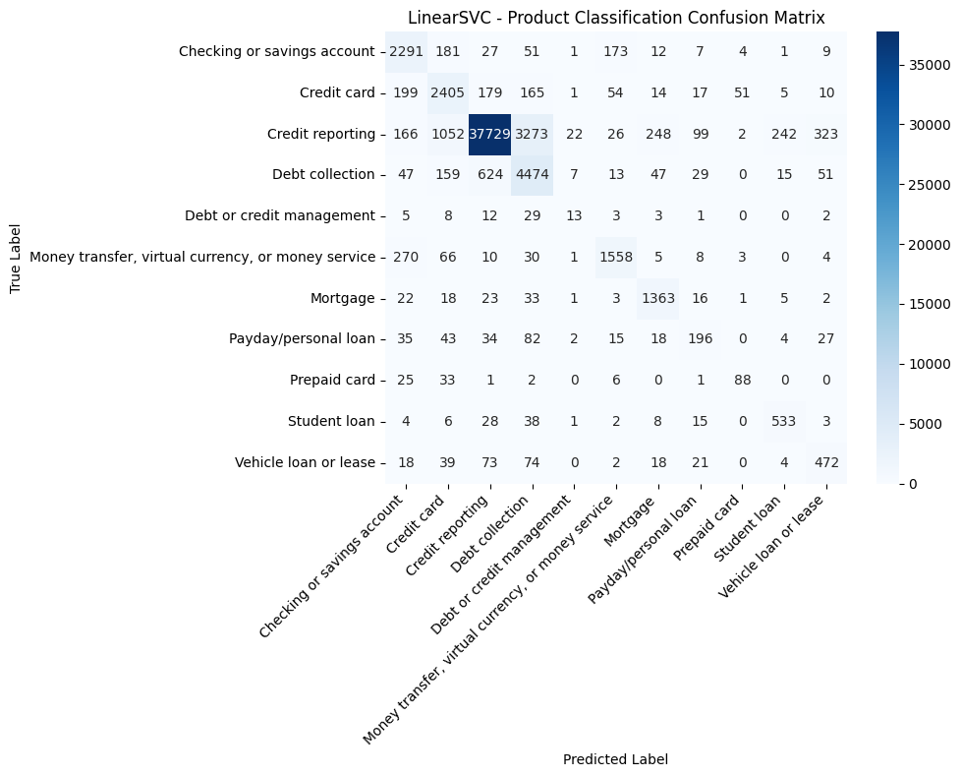
Figure 5.4 (b) Linear SVC

On the other hand, the performance of the LinearSVC on the 11-category product classification task highlights the challenges of semantic overlapping (the loss of distinct boundaries between conceptual categories) in high dimensional financial text data. The confusion matrix reveals a dominant diagonal for the ‘Credit reporting’ class (37729), indicating high accuracy for the majority category. However, a significant degree of inter class leakage is observed between ‘Credit reporting’, ‘Credit card’, and ‘Debt collection’. Specifically, 1052 credit card complaints and 624 debt collection complaints have been misclassified as ‘Credit reporting’. This suggests that the linguistic features such as ‘interest rates’, ‘reporting errors’, and ‘account balances’ are present across multiple product categories, causing classification ambiguity. In such cases, the model tends to default to the majority class, particularly when the input is unclear or semantically overlapping with multiple categories.
Furthermore, the model struggles significantly with extreme minority classes. ‘Debt or credit management’ yields only 13 correct predictions, while ‘Prepaid card’ yields 88, suggesting that the LinearSVC’s decision boundaries were overwhelmed by the statistical dominance of the larger classes. These results conclude that while a linear classifier is efficient for high-volume categories, it lacks the contextual discriminative power to separate closely related financial sub-categories without advanced feature engineering or class weighting. The high concentration of errors in the credit related triangle indicates that the model is capturing broader financial themes rather than granular product distinctions, which may necessitate more complex contextual models.

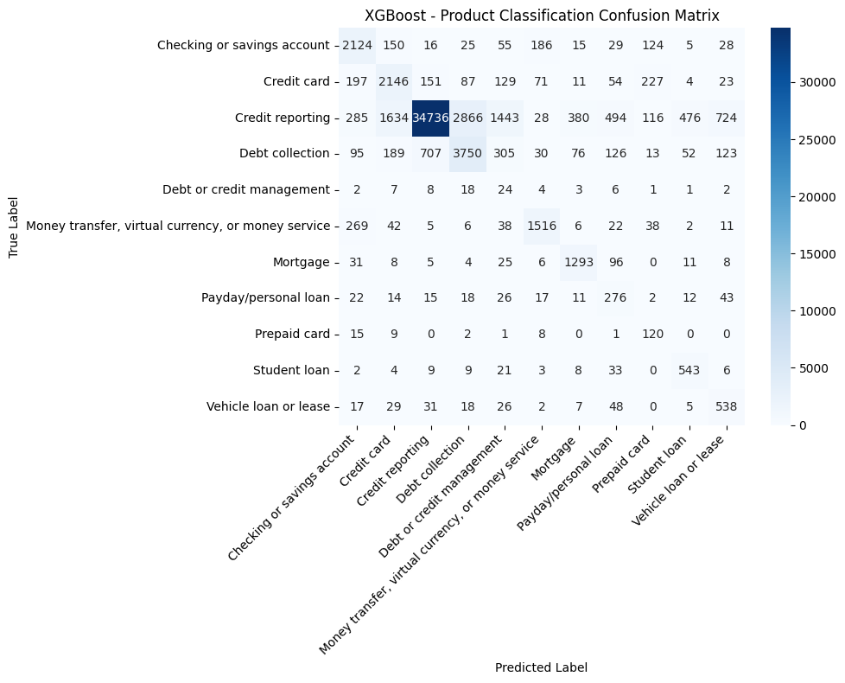
Figure 5.4 (c) XGBoost
Figure 5.4 Confusion matrices for classical models - Product Task
Finally, the confusion matrix heatmap of XGBoost demonstrates both the strengths of gradient boosting in capturing niche patterns and its limitations under extreme class imbalance. The model successfully isolates specific features for distinct minority classes, correctly identifying 543 ‘Student loan’ and 538 ‘Vehicle loan’ instances which suggests that XGBoost’s tree-based architecture performs a little better and is more suitable for capturing the non-linear, keyword-specific interactions that define these categories.
However, the model remains significantly burdened by the ‘Credit reporting’ majority class (34736). The confusion matrix also reveals a leakage pattern, where XGBoost incorrectly absorbs 707 instances of ‘Debt collection’ and 151 instances of ‘Credit card’ into the ‘Credit reporting’ label. Furthermore, for extremely low categories such as ‘Debt or credit management’, the model only achieves 24 correct predictions, proving that the high-frequency dominance of ‘Credit reporting’ continues to overshadow rare classes. Overall, while XGBoost offers better granularity for some categories, it does not inherently solve the majority class bias. For a production-ready system, these results suggest that the architecture requires either advanced re-sampling strategies or a hierarchical classification framework to prevent minority categories from being engulfed by the dominant financial themes.

5.3.2 Transformer Models
Table 5.8 presents the performance of the transformer-based models following fine-tuning on the multii-class product classification task.
Table 5.8 Transformer Results — Product Task

Model | Macro F1 | Balanced  Accuracy | ROC-AUC
BERT | 0.6144 | 0.7708 | 0.9554
FinBERT | 0.6217 | 0.7608 | 0.9601

The evaluation of BERT and FinBERT on the 11-category product classification task reveals a high level of discriminative capability, yet highlights the inherent difficulty of multiclass assignment in imbalanced financial datasets. Both models achieve robust ROC-AUC scores exceeding 0.95, indicating that the transformer architectures are highly effective at ranking the correct product category within their top probabilistic outputs. However, the difference between these high ROC-AUC values and the moderate Macro F1-scores (0.6144 for BERT and 0.6217 for FinBERT) suggests that although the models achieve strong ROC-AUC scores, indicating effective overall class separability, the moderate Macro F1-scores show that accurately distinguishing between all eleven product categories remains challenging. This highlights difficulty in establishing precise decision boundaries across closely related classes.
A comparative look at the models shows that FinBERT provides a more stabilized performance across the different categories, yielding the highest Macro F1-score of 0.6217. While BERT achieves a marginally higher Balanced Accuracy of 0.7708, FinBERT’s superior F1-score indicates a more effective balance between precision and recall, likely facilitated by its domain-specific pre-training on financial corpora. This suggests that for complex multiclass tasks where product categories share significant linguistic overlap, the specialized embeddings in FinBERT offer a more reliable framework for maintaining categorical integrity. Ultimately, these results show that while both transformers significantly outperform classical baselines in contextual understanding, FinBERT is the more mathematically consistent model for multi-product classification environments.
For further comparison, confusion matrices are visualized in the form of heat maps for all both the transformer models.
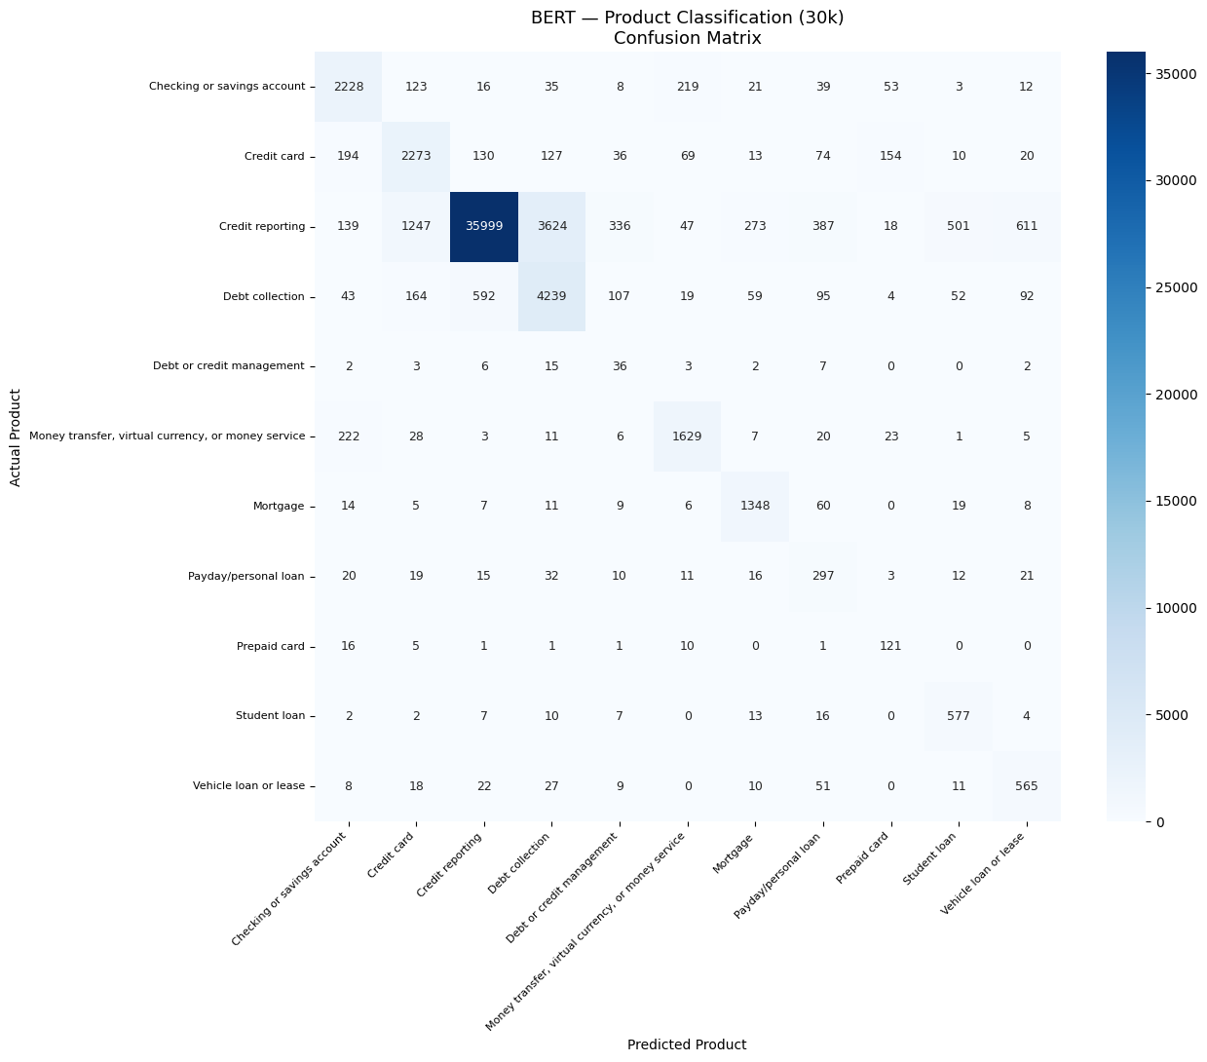
Figure 5.5 Confusion Matrices for transformer models - Product Task (a) FinBERT
Figure 5.5 presents the BERT confusion matrices for transformer models with Figure 5.5 (a) representing BERT and Figure 5.5 (b) representing FinBERT.
The confusion matrix for the BERT-based multiclass classification task provides critical insight into how transformer architectures manage semantic overlap and class imbalance. A key strength observed in Figure 5.5 (a) is BERT’s ability to form clear diagonal concentration for mid-sized categories such as ‘Student loan’ (577) and ‘Vehicle loan or lease’ (565), indicating relatively strong classification performance in these classes. This represents a significant improvement over classical baselines, suggesting that BERT’s bidirectional attention mechanisms are highly effective at capturing unique contextual cues that distinguish specific loan types. However, this granular success is overshadowed by the ‘Credit reporting’ majority class, which serves as a major source of confusion between classes. The model misclassifies 3624 instances of credit reporting as debt collection, and conversely, absorbs 1247 credit card instances into the credit reporting label.
These misclassification patterns illustrate that even deep contextual models struggle to maintain precise decision boundaries when financial terminology overlaps across 11 competing categories. Furthermore, the matrix highlights the persistent difficulty in identifying extreme minority classes; for instance, ‘Debt or credit management’ achieves only 36 correct diagonal assignments, with the vast majority of its samples being absorbed by the more statistically prevalent labels. Overall, BERT confusion matrix validates that while transformers offer superior feature extraction for niche categories, the underlying dataset imbalance continues to drive a majority-class bias. For operational deployment, these results suggest that contextual embeddings must be paired with advanced resampling to prevent rare product categories from being semantically engulfed by dominant financial categories.
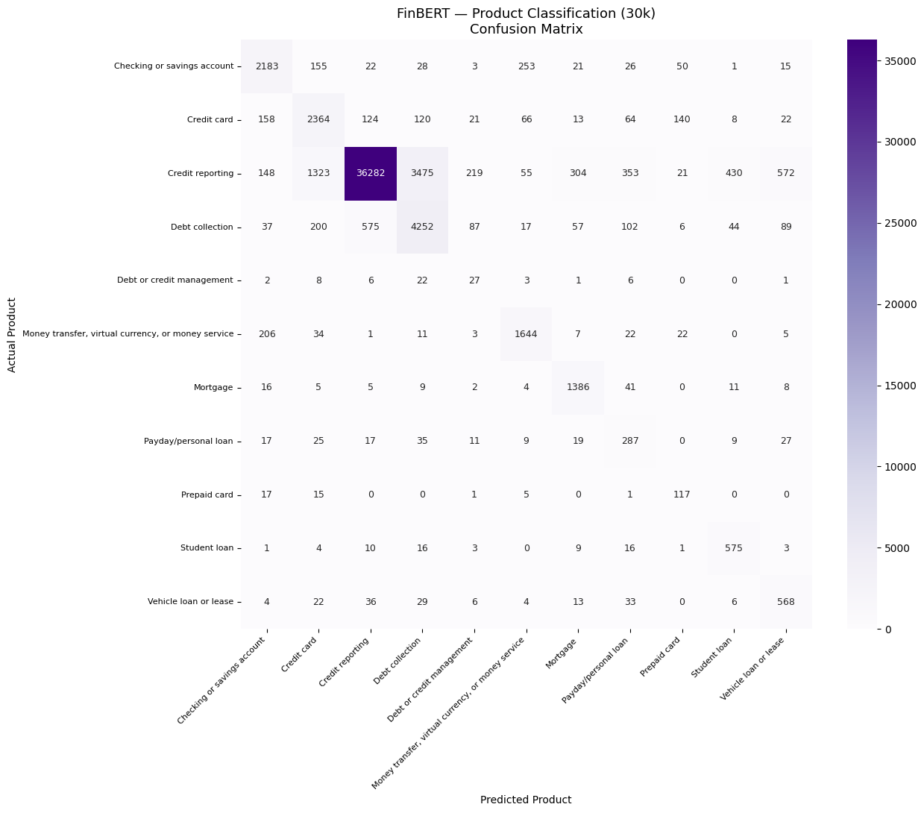
Figure 5.5 Confusion Matrices for transformer models - Product Task (b) FinBERT
The confusion matrix for the FinBERT provides a detailed map of how domain-specific contextual embeddings manage financial terminologies. FinBERT demonstrates a strong capacity to identify mid-sized categories, evidenced by strong diagonal values for ‘Money transfer’ (1644) and ‘Mortgage’ (1386). This suggests that pre-training on financial corpora allows the model to better distinguish technical keywords that are unique to these domains. However, the matrix also exposes a high degree of semantic overlap between the ‘Credit reporting’, ‘Credit card’ and ‘Debt collection’ categories. The fact that over 1,300 credit card instances are wrongly labeled as credit reporting indicates that the model struggles to resolve ambiguity when complaints involve overlapping themes of account history and payment reporting.
Furthermore, the visualization validates that the extreme imbalance of the 11-category split severely impacts the detection of minority products. For classes like ‘Debt or credit management’, the model has been unable to establish a reliable decision boundary, yielding only 27 correct classifications.
Ultimately, the FinBERT confusion matrix concludes that while specialized transformers offer the most reasonable categorical separation among the tested architectures, the model's performance remains affected by the statistical dominance of the majority class.
For practical implementation, these results suggest that domain-specific embeddings are most effective when combined with data-level balancing techniques to preserve the learning capabilities of low-frequency and linguistically complex categories.
Further, BERT and FinBERT are evaluated over different numbers of epochs and the resulting training and validation losses are given in Table 5.9.
Table 5.9: Transformer Training Losses — Product Task
Epoch | BERT  Training Loss | BERT  Validation Loss | FINBERT  Training Loss | FINBERT  Validation Loss
1 | 0.9519 | 0.9779 | 1.017 | 0.9723
2 | 0.7803 | 0.7147 | 0.7974 | 0.7859
3 | 0.6266 | 0.6978 | 0.6673 | 0.7249
4 | 0.5632 | 0.6734 | 0.5679 | 0.7042
5 | 0.4486 | 0.6318 | 0.4455 | 0.6457
6 | - | - | 0.3655 | 0.6289
7 | - | - | 0.2887 | 0.6239

Table 5.9 presents the training trajectory across different epochs for both transformers. BERT has been trained for five epochs, with training loss decreasing consistently (approx. 0.952 to 0.449) and validation loss also following a broadly downward trajectory, reaching 0.632 at epoch 5. The continued reduction in validation loss at the final epoch suggests that further training may have yielded marginal improvement.
FinBERT, on the other hand, has been trained for seven epochs, with training loss decreasing steadily from 1.018 to 0.289. Validation loss has also declined substantially reaching its minimum at epoch 7 (0.624). The longer training trajectory of FinBERT suggests that the model requires additional epochs to fully converge compared to standard BERT. This extended optimization may partly explain its marginally higher Macro F1-score. However, it also indicates a trade-off, as FinBERT requires more training time and computational resources to reach convergence.
Furthermore, the eleven-class product classification task clearly demands more training iterations than the binary task, where both models had converged within three epochs, reflecting the greater complexity of multi-class decision boundaries.

5.3.3 Hybrid Model
The final phase of the multiclass evaluation involves a Hybrid MLP architecture, which integrates contextual text embeddings from BERT with structured metadata features. Table 5.4 presents the performance of the hybrid MLP model.
Table 5.10: Hybrid Results — Product Task
Model | Macro F1 | Balanced  Accuracy | ROC-AUC
Hybrid MLP | 0.6066 | 0.7693 | 0.9565

It can be seen that the hybrid/multimodal approach has achieved a highly balanced performance profile, characterized by a Macro F1-score of 0.6066 and a Balanced Accuracy of 0.7693. Most notably, the model has maintained an exceptional ROC-AUC of 0.9565, indicating that the fusion of unstructured text and structured data creates a highly discriminative feature space. By concatenating BERT’s semantic depth with the logic of structured metadata (issue and tags features), the Hybrid MLP successfully mitigates some of the semantic overlapping seen in single modality models, providing a more stabilized decision boundary across the 11-category distribution.
The performance of the Hybrid MLP highlights the necessity of a multimodal approaches in complex financial domains. While transformer models like BERT are good at capturing the sentiment and context of customer narratives, they may struggle with the strict and discrete nature of administrative product classification tasks.
The inclusion of structured features helps stabilize the model by grounding contextual text embeddings within clear institutional and categorical boundaries. Consequently, these results show that the Hybrid modelling offers the most consistent and operationally reliable methodology for multiclass tasks, effectively leveraging the strengths of both deep learning and domain-specific metadata to provide a balanced, high-precision classification system.
Next, the confusion matrix is visualized in the form of a heat map for the hybrid model.

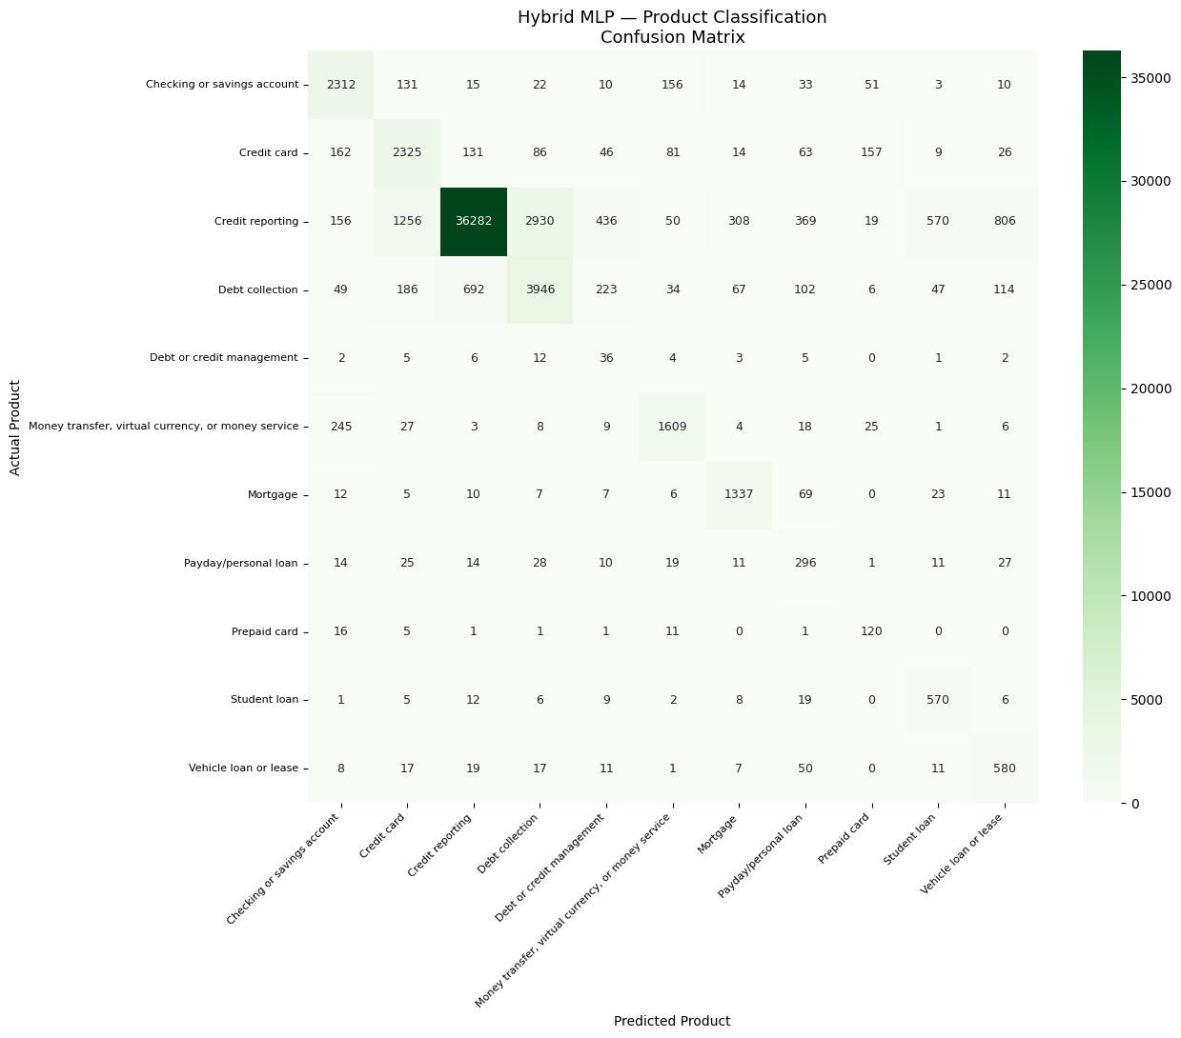Figure 5.6: Confusion Matrices for hybrid model - Product Task
The confusion matrix for the Hybrid MultiLayer Perceptron (MLP) highlights the benefits of multimodal fusion in resolving semantic ambiguity. A primary observation in Figure 5.6 is the model’s refined ability to classify mid-sized products; achieving high diagonal concentrations for ‘Checking or savings account’ (2312) and ‘Money transfer’ (1609). This suggests that structured features act as categorical constraints, reducing the model’s tendency to default to the majority class when complaint narratives contain generic financial terminology.
However, the matrix also shows that even the multimodal model remains influenced by the dominance of the ‘Credit reporting’ majority class, causing some minority categories to be incorrectly classified into this class. Significant leakage persists between ‘Credit card’ and ‘Credit reporting’ as well as between ‘Debt collection’ and ‘Credit reporting’. Furthermore, the extreme-minority ‘Debt or credit management’ class remains largely undetectable, with only 36 correctly predicted values.
Overall, the Hybrid MLP confusion matrix demonstrates that while multimodal integration significantly improves the separability of decision boundaries for mid-sized categories, it does not fully eliminate the bias inherent in imbalanced classes. To address the persistent imbalance despite resampling, future research can consolidate semantically similar products (e.g., merging ‘Credit Reporting’ and ‘Debt Collection’) to reduce feature overlap, or implement a hierarchical classification approach that first isolates majority classes before performing fine-grained minority prediction.
After confusion matrix, training and validation loss table is presented to monitor the learning behaviour of the model and assess potential overfitting or generalisation performance across training epochs. It is to be noted that for the hybrid model, an early stopping strategy was applied keeping the patience value of 5, similar to binary tasks.
Table 5.11: Hybrid Model Training Losses — Product Task

Epoch | Training Loss | Validation Loss
1 | 2.1816 | 1.8603
2 | 1.6219 | 1.1741
3 | 1.0889 | 0.8027
4 | 0.7653 | 0.6859
5 | 0.6326 | 0.6606
6 | 0.5705 | 0.6604
7 | 0.5302 | 0.6637
8 | 0.5157 | 0.6654
9 | 0.4987 | 0.6674
10 | 0.4849 | 0.6696
11 | 0.4794 | 0.6743
The table shows that training loss has decreased substantially and consistently from epoch 1 to epoch 11 (2.182 to 0.479), reflecting effective multi-class learning. Validation loss has also declined rapidly through the first six epochs, reaching its minimum at epoch 6 (0.660), before leveling and marginally increasing across epochs 7 through 11, triggering early stopping (due to patience value of 5). This divergence between continuously declining training loss and ultimately stagnating validation loss from epoch 7 onward indicates mild overfitting of the MLP head on top of fixed BERT embeddings. Therefore the best model from epoch 6 is loaded for evaluation.
5.3.4 Overall Product Task Comparison
Table 5.12 shows the comparison of all the models for the product classification task.
Table 5.12: Complete Binary Task Results — All Models
Model | Macro F1 | Balanced Accuracy | ROC-AUC
LR | 0.6234 | 0.7487 | 0.9650
LinearSVC | 0.6595 | 0.6971 | 0.9574
XGBoost | 0.5590 | 0.7169 | 0.9490
BERT | 0.6144 | 0.7708 | 0.9554
FINBERT | 0.6214 | 0.7608 | 0.9601
HYBRID | 0.6066 | 0.7693 | 0.9565

The results across the multiclass task demonstrate a clear trade-off between linear stability and contextual depth. LinearSVC has achieved the highest Macro F1 (0.6595), indicating that a rigid linear boundary is more effective at separating the 11 classes without being overly influenced by the statistical dominance of the majority class. In contrast, XGBoost has lagged significantly with a Macro F1 of 0.5590, suggesting that gradient-boosted trees may struggle with the high-dimensional sparse features of financial text when divided across 11 labels.
The deep learning models i.e. BERT, FinBERT, and the Hybrid MLP have provided the highest Balanced Accuracy, with BERT leading at 0.7708. This indicates that transformer architectures are more successful in their predictive power across the various product categories as compared to Logistic Regression or XGBoost. The exceptionally high ROC-AUC scores (0.95–0.96) across all models prove that the classifiers possess the theoretical capacity to identify the correct product; however, the lower Macro F1 scores (0.55–0.66) reflect the difficulty of setting optimal thresholds in an imbalanced data for 11 products’ categorization.
Thus we can say that LinearSVC’s success in Macro F1 is a result of its rigid linear decision boundaries, which effectively demonstrate the separation between categories and resist the statistical noise of the majority class. However, this rigidity comes at the cost of broader class recognition.
Conversely, FinBERT and the Hybrid MLP represent the most stable modern alternatives, achieving high ROC-AUC and Balanced Accuracy scores across the 11 product categories. Although their Macro F1-scores are slightly lower than LinearSVC, these models better capture the semantic meaning of complaint narratives. FinBERT benefits from financial-domain pre-training, while the Hybrid MLP combines textual embeddings with structured metadata to reduce ambiguity in classification. As a result, these models offer a more balanced distribution of performance across both majority and minority classes, making them more suitable for practical financial complaint analysis where contextual understanding is important alongside predictive accuracy.

5.4 Cross-Task Discussion
Several broader findings emerge across both classification tasks.
First, all models exhibit substantial difficulty predicting monetary relief outcomes (binary task) despite strong ROC-AUC performance (often exceeding 0.95). This consistent convergence across architectures, where models rank classes effectively but struggle with hard decision boundaries, suggests a task-level performance ceiling. This is likely due to the temporal nature of the data, as consumer narratives are authored before the company's final resolution decision is made.
Second, sparse TF-IDF linear classifiers remain highly competitive with transformer-based architectures, particularly in categorical separation. LinearSVC has achieved the strongest Macro F1 (0.6595) in the product task, outperforming both BERT and FinBERT, which suggests that rigid linear boundaries are more effective at resisting majority-class dominance than more flexible probabilistic models. However, this comes at the cost of broader class recognition, where transformers lead in Balanced Accuracy.
Third, in the product task, while FinBERT’s financial domain pre-training yields the highest ROC-AUC (0.9601) over base BERT, it does not provide a big change in Macro F1 performance. This indicates that while specialized financial semantics help in ranking and precision, CFPB complaint classification still relies heavily on clear lexical indicators that are captured well by general-purpose models.
Finally, the Hybrid MLP architecture, incorporating structured features, has succeeded in stabilizing performance by achieving a high Balanced Accuracy (0.7693) but it has not consistently surpassed the simpler LinearSVC in Macro F1, for product tasks. Thus the hybrid approach has proved to be the most robust and modern alternative, leveraging structured metadata as a semantic anchor to improve minority class sensitivity in highly imbalanced environments.

5.5 Explainable AI Results

5.5.1 Overview of Explainability Framework
Explainable AI (XAI) techniques are applied to all classification models to interpret both global and local decision-making behaviour across both the classification tasks. Given the heterogeneous nature of the models used in this study, different explanation techniques are adopted: SHAP is used for Logistic Regression, XGBoost and the Hybrid MLP model; LIME is used for LinearSVC; and attention visualisation is used for transformer-based models (BERT and FinBERT). These methods provide complementary perspectives on model interpretability, ranging from global feature attribution to local instance-level explanations.

5.5.2 SHAP Analysis — Classical Models
SHAP (SHapley Additive exPlanations) is applied to Logistic Regression and XGBoost models to quantify global feature importance across both binary and product classification tasks. LinearExplainer is used for Logistic Regression due to its efficiency for linear models, while TreeExplainer is used for XGBoost due to its ability to efficiently compute exact Shapley values for tree-based structures. In both cases, 200–500 randomly sampled test complaints are used depending on computational feasibility. Each point represents one complaint, with position on the horizontal axis indicating the direction and magnitude of that feature's influence on the prediction. Color indicates feature value intensity, with red denoting high word frequency and blue denoting low frequency.
5.5.2.1 Binary Task — Logistic Regression (SHAP)
SHAP LinearExplainer is applied to 200 randomly selected test complaints. The summary plot displays the top 20 features ranked by mean absolute SHAP value, representing the most influential words across all sampled complaints.
Figure 5.1 presents the SHAP summary plot for Logistic Regression on the binary monetary relief prediction task. In the figure, positive SHAP values push toward Monetary Relief and negative values push toward No Monetary Relief.
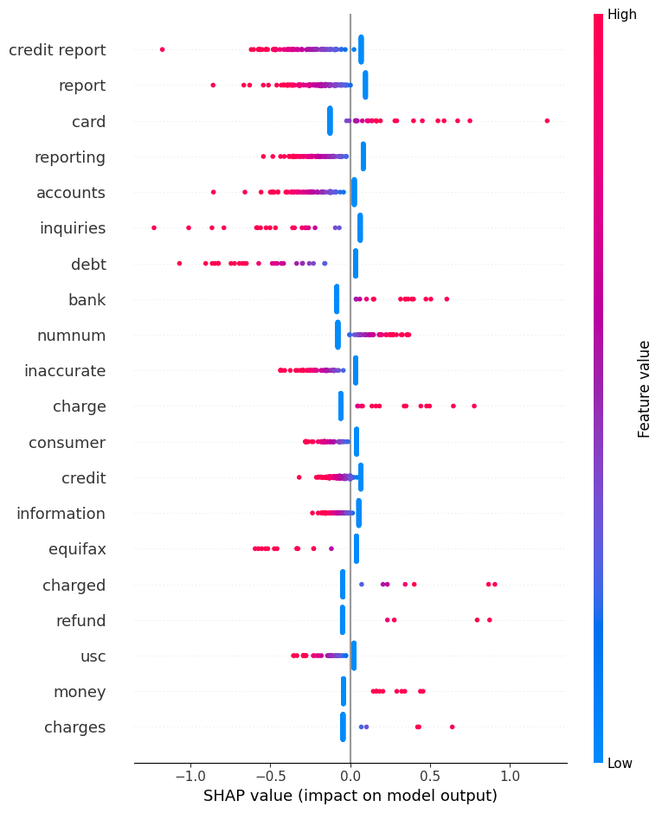
Figure 5.1: SHAP plot for logistic regression - Binary Task
The plot reveals a clear and interpretable pattern, indicating that the model's predictions are driven primarily by a small set of domain-specific terms that distinguish credit reporting disputes from transaction disputes.
The strongest negative predictors i.e. words pushing toward No Monetary Relief are ‘credit report’, ‘report’, ‘reporting’, ‘inquiries’ and ‘equifax’, etc. all appearing in red at high frequency on the negative side. This indicates that complaints frequently referencing credit bureau terminology are strongly predicted as unlikely to receive monetary relief. This finding is consistent with the nature of credit reporting disputes, which typically involve administrative corrections to credit bureau records rather than financial restitution. The presence of ‘equifax’ ( a major credit bureau) specifically confirms that the model has learned to associate bureau-specific complaints with non-monetary outcomes. Similarly other terms like ‘Inaccurate’, ‘accounts’, ‘consumer’, and ‘usc’ push toward No Monetary Relief, reflecting the administrative and regulatory language common in credit dispute related complaints.
The strongest positive predictors i.e. words pushing toward Monetary Relief are ‘card’, ‘charge’, ‘refund’, ‘money’, appearing on the positive side. This indicates that complaints referencing financial transactions, money and refund requests are more likely to receive monetary outcomes. This is a logically consistent finding since these complaints directly involve financial losses rather than administrative grievances. ‘numnum’ also pushes toward Monetary Relief but it represents redacted numerical values such as amounts or account numbers, suggesting that complaints containing specific financial figures are associated with monetary outcomes.
Notably, some features cluster tightly near zero with limited spread, while others like ‘card’ and ‘credit report’ demonstrate a wider horizontal range, indicating that these two terms are among the most influential individual predictors in the model. It can be inferred that the model has effectively learned a single primary distinction i.e. credit bureau dispute language predicts No Monetary Relief, while transaction and charge related language predicts Monetary Relief. This finding is consistent with the regulatory context since CFPB complaint resolution is substantially determined by the nature of the complaint category rather than its linguistic complexity.
5.5.2.2 Binary Task — XGBoost (SHAP)
For XGBoost, SHAP TreeExplainer is applied to 500 randomly selected test complaints; a larger sample is taken than Logistic Regression as TreeExplainer is computationally efficient for tree-based models, enabling a more representative global view of feature importance. The summary plot displays the top 20 features ranked by mean absolute SHAP value.

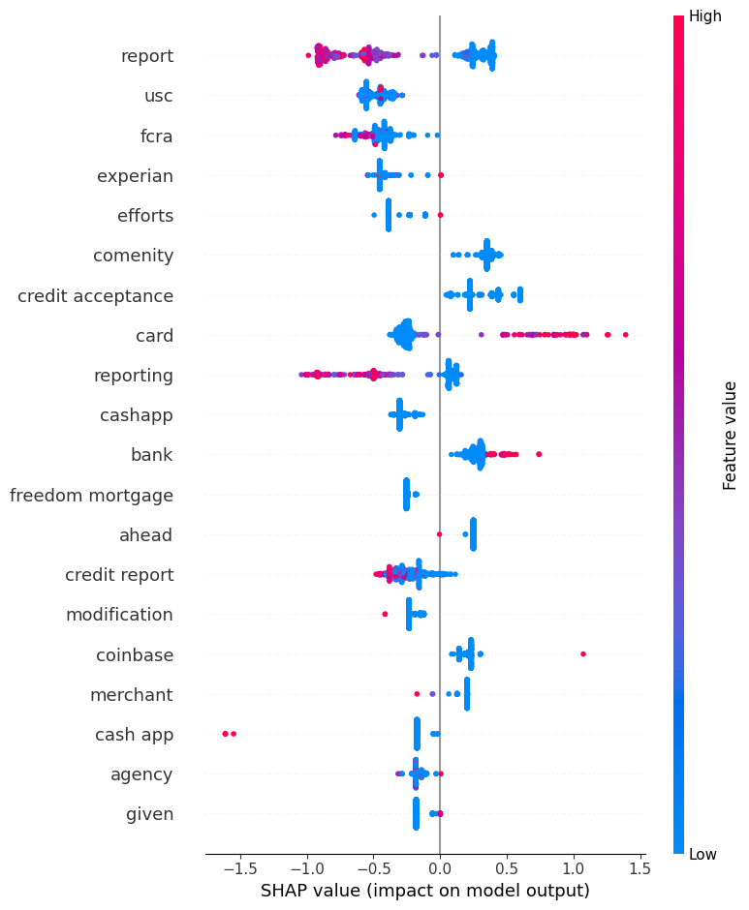
Figure 5.2: SHAP plot for xgboost - Binary Task

Figure 5.2 presents the SHAP summary plot for XGBoost on the binary monetary relief prediction task with positive SHAP values pushing toward Monetary Relief and negative values pushing toward No Relief; and color indicating feature value intensity
The plot reveals both consistent and distinctive patterns as compared to Logistic Regression. At the broadest level, the same fundamental distinction is preserved i.e. credit bureau terminology predicts No Monetary Relief while transaction language predicts Monetary Relief thus confirming that this is a genuine signal in the data rather than a model-specific artefact.
The strongest negative predictors are ‘report’ and ‘reporting’, appearing in red at high frequency on the negative side, which is consistent with Logistic Regression (LR) findings. Distinctively, XGBoost highlights some regulatory terminology which is absent from the LR plot. For example, ‘fcra’ (Fair Credit Reporting Act) and ‘experian’ (a credit reporting company) push strongly toward No Monetary Relief, suggesting the model has learned that complaints explicitly citing consumer protection legislation or specific credit bureaus are administrative disputes that are unlikely to result in monetary restitution. Similarly, ‘usc’ also appears as a negative predictor, reflecting that legal citation language is more common in credit dispute related complaints.
The strongest positive predictor is ‘card’, exhibiting the widest horizontal spread extending to approximately +1.5, which is again consistent with Logistic Regression results and confirms that card-related complaints are the most reliable indicator of monetary outcomes across both models. Distinctively, XGBoost surfaces some specific financial company names as meaningful predictors e.g. ‘comenity’, ‘credit acceptance’, ‘cashapp’, thus highlighting the tree based model's ability to isolate rare but highly discriminative references through hierarchical splits. Since ‘comenity’ and ‘credit acceptance’ push toward Monetary Relief, this suggests that complaints against these specific companies disproportionately result in monetary outcomes. Moreover, ‘bank’ also pushes toward Monetary Relief, consistent with LR findings on transaction-related terminology.
By comparing the two SHAP plots, a key insight emerges that Logistic Regression learns generalised vocabulary patterns across the full feature space, while XGBoost isolates specific company names and regulatory citations that Logistic Regression cannot detect. Both models converge on the same primary distinction between credit bureau disputes and transaction disputes, however XGBoost provides a more granular view of which specific entities drive predictions. This consistency confirms the importance of applying SHAP across multiple model architectures.
5.5.2.3 Product Task — Logistic Regression (SHAP)
SHAP LinearExplainer is applied to 200 randomly selected test complaints from the product classification test set. Moreover, all product classification models are trained on the identical 30,000-sample balanced training subset described in the Methodology chapter, ensuring direct architectural comparison across classical and transformer models. As the product task involves 11 classes rather than 2, SHAP produces a separate set of values for each class and quantifies how much each word pushes a complaint toward or away from that specific product category.
For visualization purposes, one product category ‘Credit reporting’ is chosen as it is the most significant category comprising 72% of the test set. The summary plot displays the top 15 features ranked by mean absolute SHAP value for the Credit reporting class.
Figure 5.3 presents the SHAP summary plot for Logistic Regression on the ‘Credit reporting’ product class for 200 samples. As TF-IDF is configured with both unigrams and bigrams (ngram_range=(1,2)), features include both single words and two-word phrases. For example 'credit report' in the plot is a bigram feature representing the two-word combination treated as a single feature.
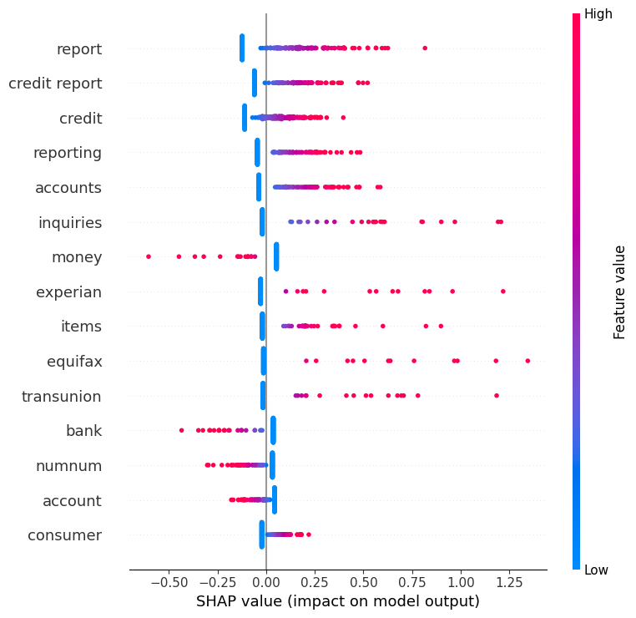
Figure 5.3: SHAP plot for logistic regression- Product Task
The plot indicates that the model has learned a clear and semantically meaningful decision boundary between credit bureau administrative disputes and other financial complaint categories. The strongest positive predictors i.e. words pushing toward Credit reporting include ‘report’, ‘credit report’, ‘credit’, ‘reporting’, ‘inquiries’; all appearing in red at high frequency on the positive side. This confirms that credit bureau terminology is the dominant signal for this category, consistent with the nature of credit reporting complaints which involve disputes about credit bureau records rather than financial transactions. Notably, all three major US credit bureaus appear as positive predictors i.e. ’experian’, ‘equifax’ and ‘transunion’ giving a onsistent signal for this category.
On the other hand, the strongest negative predictors i.e. words pushing away from ‘Credit reporting’ toward other product categories are ‘money’, ‘bank, ‘account’. The presence of these terms as negative predictors confirms that financial transaction language reliably signals towards alternative classes such as ‘Credit card’ or ‘Debt collection’ rather than ‘Credit reporting’. 'Numnum' (representing two consecutive redacted numerical sequences) pushes away from ‘Credit reporting’, suggesting that complaints containing dense numerical information are more characteristic of transaction-based categories such as than administrative bureau disputes
The overall pattern is directly consistent with the binary task SHAP findings; the same credit bureau vocabulary that predicts No Monetary Relief in the binary task also defines the ‘Credit reporting’ class in the product task. This convergence across two independently trained models and two different classification objectives confirms that these linguistic signals are stable and genuine features of the underlying complaint data rather than model-specific artefacts, and reflects the real-world regulatory issues.
5.5.2.4 Product Task — XGBoost (SHAP)
SHAP TreeExplainer is applied to 200 test complaints for the Credit reporting class, consistent with the Logistic Regression product task analysis, enabling direct comparison of feature importance patterns across both classical models, trained on the identical 30,000-sample balanced training subset. As with the LR plot, features include both unigrams and bigrams e.g. 'complaint error', 'victim identity', etc.
Figure 5.4 presents the SHAP summary plot for XGBoost on the ‘Credit reporting’ product class where positive SHAP values push toward a ‘Credit reporting’ prediction and negative values push toward other product categories.

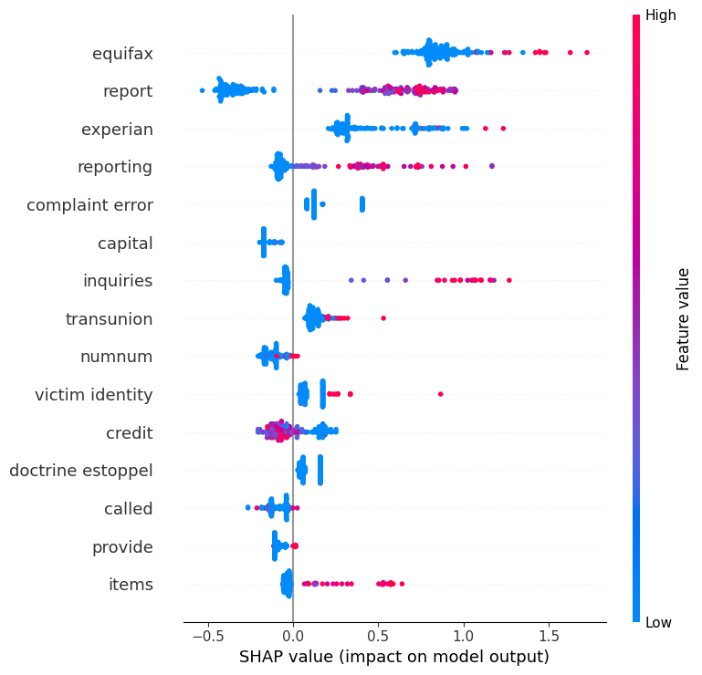
Figure 5.4: SHAP plot for xgboost- Product Task
The plot reveals both consistent and distinctive patterns as compared to Logistic Regression. The core credit bureau vocabulary is preserved i.e. ‘report’, ‘experian’, ‘reporting’, ‘inquiries’, etc. all appear as positive predictors consistent with LR findings. Moreover, ‘equifax’ has the strongest positive predictor value (almost +1.75), even surpassing its influence in the LR plot, suggesting that equifax-related complaints are an even more reliable signal for ‘Credit reporting’ in the tree model's hierarchical decision structure.
Distinctively, XGBoost also highlights a few complaint patterns absent from the LR plot. For example, ‘complaint error’ and ‘victim identity’ appear as positive predictors, reflecting XGBoost's ability to isolate meaningful bigrams through tree splits.
Identity theft complaints are usually filed against credit bureaus making ‘victim identity’ a discriminative signal for the ‘Credit reporting’ class, which LR's generalised weighting cannot isolate.
The negative predictors, on the other hand, include ‘capital’ (likely referencing Capital One which is a credit card issuer company) pushing away from ‘Credit reporting’ towards other classes. Similarly, 'Numnum' (representing redacted sequences) also pushes away from ‘Credit reporting’, suggesting that complaints containing dense numerical information are more characteristic of transaction-based categories (such as Credit card or Debt collection) than administrative bureau disputes.
Comparing the two classical model SHAP plots for the ‘Credit reporting’ class, it can be seen that both models converge on the same core vocabulary including credit bureau names and dispute terminology. Moreover, XGBoost additionally identifies some specific complaint patterns and legal terminologies that reflect the tree model's capacity for fine-grained feature isolation. This shows that credit bureau terminology is a genuine and stable signal for the ‘Credit reporting’ category across different model architectures.
5.5.2.5 Comparative SHAP Discussion
Overall, it can be seen that XGBoost demonstrates higher sensitivity to rare entity based features, whereas Logistic Regression primarily captures distributed lexical patterns. Moreover, the product task introduces greater semantic overlap between classes compared to the binary task, making interpretability more sensitive to contextual rather than lexical differences.

5.5.3 LIME Analysis — LinearSVC
LIME (Local Interpretable Model-Agnostic Explanations) is applied to the LinearSVC model to generate local explanations for individual predictions. Unlike SHAP, which provides global feature importance, LIME constructs a local surrogate model around a specific prediction to identify which features most influenced that decision.
5.5.3.1 Binary Task — LinearSVC (LIME)
LIME is applied to LinearSVC rather than SHAP, as CalibratedClassifierCV, required to generate probability outputs from LinearSVC's decision function, is not directly compatible with SHAP's LinearExplainer. By generating local surrogate models around individual predictions, LIME identifies which words most influence each specific classification decision.
For visualization purposes, two complaints are examined; one correctly classified the other misclassified for comparing the model's behaviour on reliable and unreliable predictions.
Correct Example:

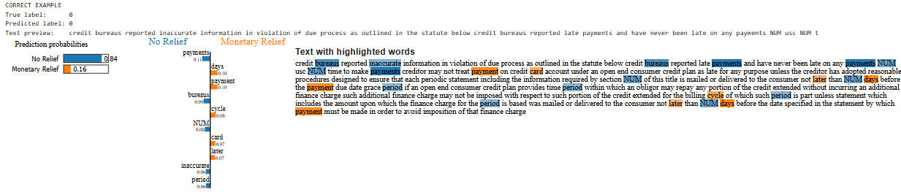
Figure 5.5 LIME plot for correct example - Linear SVC BinaryTask
Figure 5.5 shows a lime plot of a correctly predicted instance where the baseline Linear SVC model confidently classifies a consumer complaint narrative under the ‘No Relief’ category (Label 0) with an 84% probability, versus a 16% probability for ‘Monetary Relief’. The local feature attribution highlights distinct semantics within the text as credit reporting and data accuracy terms like ‘payments’ (0.11 contribution), ‘bureaus’ (0.09), and ‘inaccurate’ (0.06) act as the primary drivers of ‘No Relief’ (in blue color). In contrast, transactional and temporal terms like ‘days’ (0.10), ‘payment’ (0.10), ‘cycle’ (0.08), and ‘card’ (0.07) push slightly toward "Monetary Relief" (in orange color). Thus, the dominance of the credit reporting terms like ‘bureaus’ allows the model to accurately determine ‘No Relief ‘ by learning the complaint focuses on standard bureau inaccuracies rather than a billing dispute that might favor financial restitution.
Misclassified Example:
Figure 5.6 presents the LIME explanation for a misclassified complaint. The plot illustrates how the Linear SVC model erroneously predicts ‘Monetary Relief’ (Label 1) with a high confidence of 84%, despite the true outcome being ‘No Relief’ (Label 0). The visualization exposes a classic limitation of bag-of-words or simple lexical models i.e. a lack of contextual and sequential awareness. The model is deceived by the tokens ‘acceptance’ (0.61 contribution) and ‘credit’ (0.29), highlighting them heavily (in orange). In reality, these words point towards ‘credit acceptance’ (auto finance company) targeted by the complaint. Since the linear model cannot read these tokens together as a single entity, it mistakenly treats the word ‘acceptance’ as a strong indicator of a financial settlement or payout.
On the other hand, some minor contextual cues also push towards ‘No Relief’ like ‘vehicle’ (0.07) and ‘processing’ (0.07). But overall, the misclassification terms are dominant and reveal an important limitation. The model is applying a learned association between this lender's name and monetary resolutions; a pattern that holds globally but fails here. Thus this case illustrates the fundamental constraint of all models in this study: complaint narratives are authored prior to resolution, and the linguistic content does not always reliably encode the eventual company decision regardless of how compelling the complaint appears.
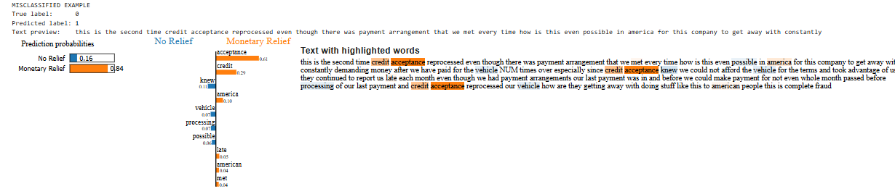
Figure 5.6 LIME plot for misclassified example - Linear SVC BinaryTask
5.5.3.2 Product Task — LinearSVC (LIME)
LIME is applied to LinearSVC for the product classification task, consistent with the binary task approach. Two complaints are examined, one correctly classified and one misclassified, to contrast the model's behaviour on reliable and unreliable predictions across the 11 product categories.
Correct Example:
Figure 5.7 presents the LIME explanation for a correctly classified ‘Credit reporting’ complaint with prediction probability 0.82. The complaint describes a dispute about inaccurate and misleading account balances being incorrectly reported, repeatedly referencing ‘balance owed $NUMNUM deptednelnet’ throughout the narrative.
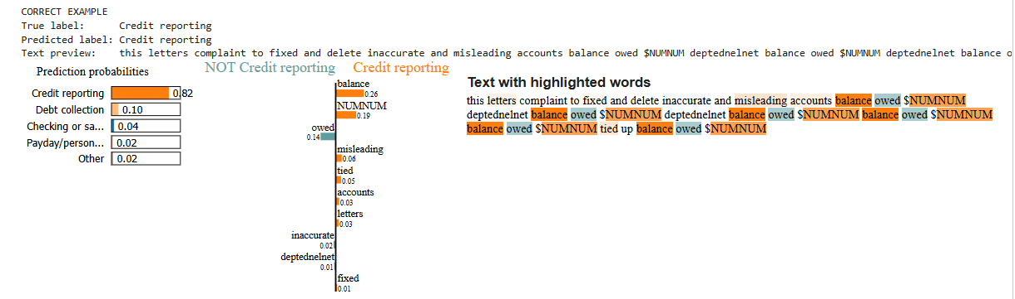
Figure 5.7 LIME plot for correct example - Linear SVC Product Task
The dominant positive predictors pushing toward Credit reporting are ‘balance’ (0.26), ‘NUMNUM’ (0.19), ‘misleading’ (0.06), ‘accounts’ (0.03), altogether reflecting credit bureau dispute terminology about incorrectly reported account balances. "NUMNUM" appears as a positive predictor despite being a redaction placeholder meaning that the model has learned that this specific pattern of numerical redactions along with account terminology is statistically associated with ‘Credit reporting’ complaints. On the other hand, terms like ‘owed’ (0.14) and ‘inaccurate’ (0.02) push away from ‘Credit reporting’ toward other categories. This may be because debt-owed language also appears in Debt collection complaints. Despite these negative signals, the dominant bureau-dispute terminology yields strong model confidence of 0.82, correctly predicting the correct class. The prediction probability breakdown reflects the model's strong confidence however, Debt collection remains a plausible alternative given the overlapping terminology.
Misclassified Example:
Figure 5.8 presents the LIME explanation for a misclassified complaint where the true label ‘Credit reporting’ is wrongly predicted as ‘Credit card’ with probability 0.76. The complaint describes late payment remarks appearing incorrectly on a credit report despite the consumer consistently making timely payments, indicating a Credit reporting dispute about inaccurately recorded payment history on a bureau report.

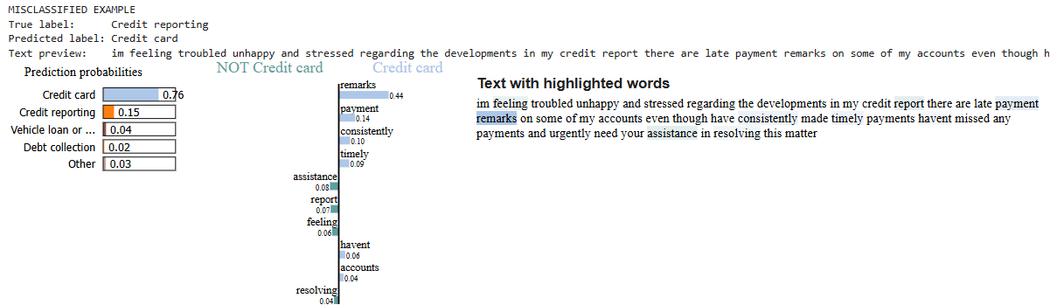
Figure 5.8 LIME plot for misclassified example - Linear SVC Product Task
The features pushing toward ‘Credit card’ are ‘remarks’ (0.44), ‘payment’ (0.14), ‘accounts’ (0.04). The dominant signal is ‘remarks’, a term the model has associated with Credit card billing remarks rather than credit bureau records. Moreover, payment behaviour language like ‘consistently’ and ‘timely’ further reinforces the ‘Credit card’ signal as these terms commonly appear in Credit card billing disputes.
However, a few features push away from ‘Credit card’ toward other categories such as "assistance" (0.08), ‘report’ (0.07), and ‘resolving’ (0.04). Notably ‘report’ pushes away from Credit card, consistent with its role as a ‘Credit reporting signal in the SHAP analysis but here its weight is insufficient to override the dominant payment terminology pushing toward ‘Credit card’ and predict the correct class. This misclassification reveals a fundamental limitation of lexical TF-IDF features for product classification. Some semantically ambiguous terms appear in both ‘Credit reporting’ and ‘Credit card’ complaints but with different contextual meanings; in a ‘Credit card context’ they describe billing issues, while in a ‘Credit reporting’ context they describe inaccurately recorded payment history on a bureau report. LinearSVC cannot distinguish these contexts as it assigns uniform weights to terms across all complaints regardless of surrounding meaning, product classification as a harder task than binary classification. The complaint language frequently crosses product category boundaries and clarity requires contextual understanding beyond keyword matching that linear TF-IDF models cannot provide.
5.5.4 Attention Visualization — Transformer Models
5.5.4.1 Methodology
Attention visualisation is applied to BERT and FinBERT models in order to examine token-level focus during classification. CLS token attention weights from the final encoder layer are extracted and averaged across all attention heads. While attention does not represent causal feature importance, it provides insight into contextual token prioritisation.
5.5.4.2 Binary Task — BERT
Attention visualization is applied to the BERT binary classification model and the top 15 words by averaged attention are visualised. Two complaints are examined; one correctly classified and one misclassified in order to compare the model's contextual focus on reliable and unreliable predictions.
Correct Example:
Figure 5.9 presents the attention visualization for a correctly classified Monetary Relief complaint at index 22. It illustrates a correct classification for the category ‘Monetary Relief’ (Index 22), demonstrating how the model relies on high-signal keywords to drive its prediction. The horizontal bar chart tracks the importance weights, revealing a skewed attention distribution where financial terminologies dominate the decision-making process.The top attended tokens are ‘tax’ (0.15), ‘cash’ (~0.054), ‘purchase’ (0.04) and ‘credit’ (~0.028) alongside weaker one like ‘capitalonexxxxx’, ‘shopping’, etc. This vocabulary collectively describes a Capital One travel rewards or cashback credit card dispute involving tax on purchases or a pretax benefit indicating a transaction complaint that is correctly classified as Monetary Relief. This vocabulary collectively describes a Capital One travel rewards or cashback credit card dispute involving tax on purchases or a pretax benefit; a transaction complaint that is correctly classified as Monetary Relief. Therefore, BERT attends strongly to transaction and financial terms and correctly predicts Monetary Relief, aided by the surrounding context that provides sufficient signal to identify it as a transactional complaint. This shows BERT’s ability to utilize semantic knowledge to correctly classify complaints.
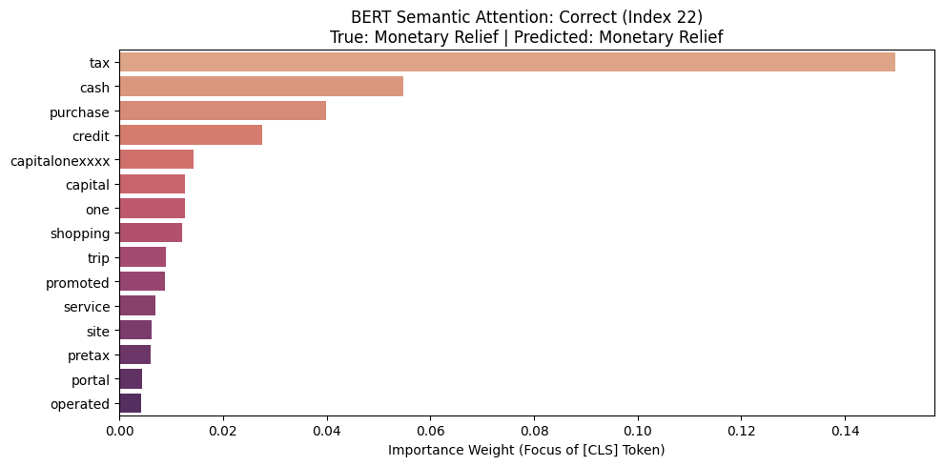
Figure 5.9 Attention plot for correct example - BERT Binary Task
Misclassified Example:
Figure 5.10 presents the attention visualization for a misclassified complaint at index 0 — true label No Relief, predicted as Monetary Relief. The CLS token attends most strongly to ‘repay’ (0.062), ‘credit’ (0.044), ‘charge’ (0.033), ‘bureaus’ (0.026) and ‘payments’ (0.020); a mixed signal pattern combining debt repayment language and credit bureau terminology.

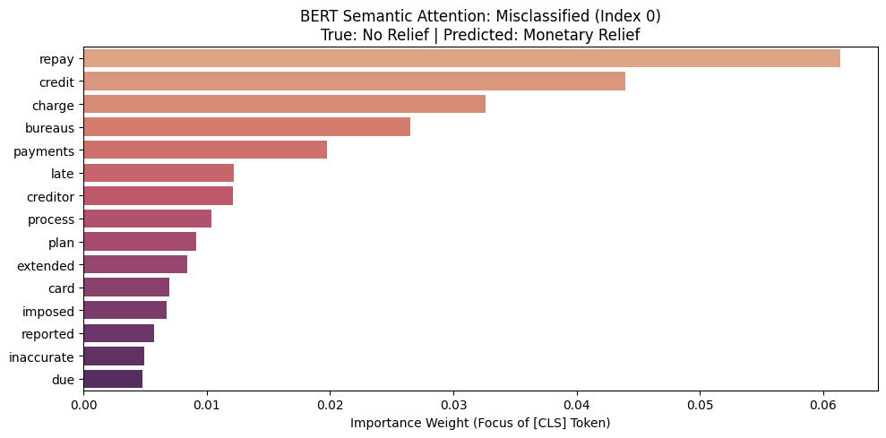
Figure 5.10 Attention plot for misclassified example - BERT Binary Task
The complaint appears to involve late payment charges being incorrectly reported on a credit bureau i.e. a cross-categorical complaint describing both a creditor dispute and a bureau reporting issue. However, with the presence of transaction terms such as ‘charge’, ‘card’, and ‘credit’ , BERT incorrectly predicts Monetary Relief. This reveals a disconnect between the model's attention pattern and its final classification decision, consistent with the known limitation of attention-based explanations. The complaint involves specific financial terms that make BERT to wrongly associate it with monetary outcomes. This misclassification illustrates that BERT's contextual representations, while generally stronger than TF-IDF keyword matching, are not immune to errors on complaints involving niche financial product terminology.
5.5.4.3 Product Task — BERT
Attention visualization is applied to the BERT product classification model using the same approach as the binary task with the top 15 words being using one correctly classified and one misclassified complaint.
Correct Example:
Figure 5.11 presents the attention visualization for a correctly classified ‘Credit reporting’ complaint at index 0. The top attended tokens are ‘accounts’ (0.095), ‘deptednelnet’ (0.028), ‘delete’ (0.026), ‘misleading’ (0.025), ‘inaccurate’(0.021), followed by weaker tokens. By prioritizing these specific tokens, the model effectively identifies the core semantic intent of the narrative, a dispute over the validity and accuracy of reported financial data, which distinguishes credit reporting issues from other products. This demonstrates that BERT is not just performing simple word matching, but is successfully aggregating contextually relevant terminology into the [CLS] embedding to drive its correct predictive decision.
True: Credit reporting. Predicted: Credit reporting

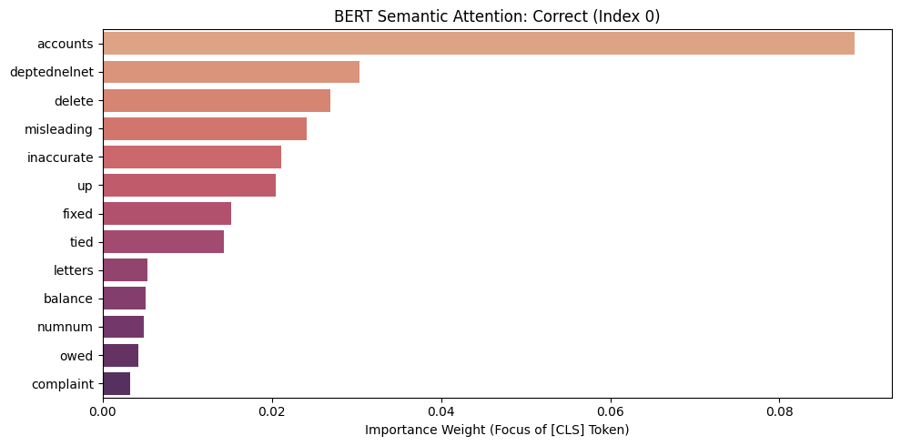
Figure 5.11 Attention plot for correct example - BERT Product Task
Misclassified Example:
Figure 5.12 presents the attention visualization for a misclassified complaint at index 12 where the true label ‘Credit reporting’, has been predicted as ‘Vehicle loan or lease’. The model shows a dominant focus on ‘car’ ( 0.14) and ‘payment’ ( 0.136), followed by ‘credit’ (0.11). This concentration of attention suggests that the model has focussed more on asset based and transactional terms, likely causing it to confuse the complaint with a ‘Vehicle loan or lease’ category rather than its true label. While relevant terms like ‘reports’, and ‘balance’ are present, their significantly lower importance weights relative to ‘car’ are insufficient to steer BERT decision towards the correct classification. This reveals a common weakness in transformer models where the presence of a strong, specific subject noun can overshadow the broader regulatory context of the narrative.
True: Credit reporting, Predicted: Vehicle loan or lease
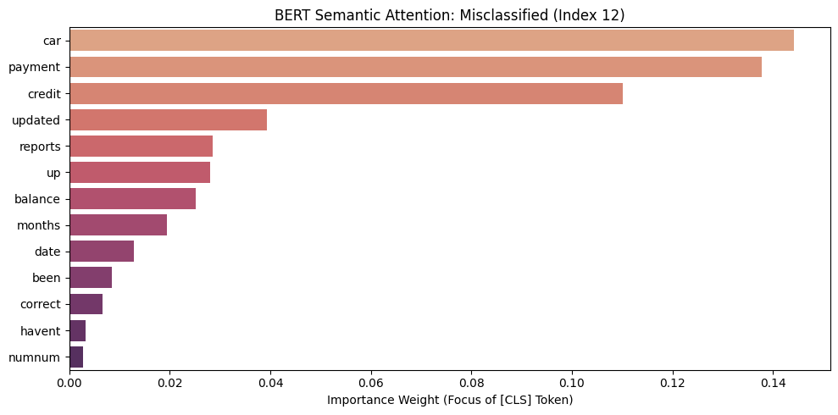
Figure 5.12 Attention plot for misclassified example - BERT Product Task
5.5.4.4 Binary Task — FinBERT
Attention visualization is applied to the retrained FinBERT binary classification model using the identical approach as BERT and the top 15 words in the way, examining one correctly classified and one misclassified complaint.
Correct Example:
Figure 5.13 presents the attention visualization for a correctly classified No Relief complaint at index 0. The CLS token attends most strongly to ‘plan’ (0.08) and ‘repay’(0.065) followed by terms like ‘additional’, ‘inaccurate’, ‘bureaus’ and ‘credit’ indicating that the model is effectively filtering the narrative to focus on the core issues of payment arrangements and credit reporting accuracy. The surrounding context depicts a legal and regulatory language common in credit bureau disputes and appears to reference a credit reporting dispute rather than a direct transaction complaint.
True: 0, Predicted: 0

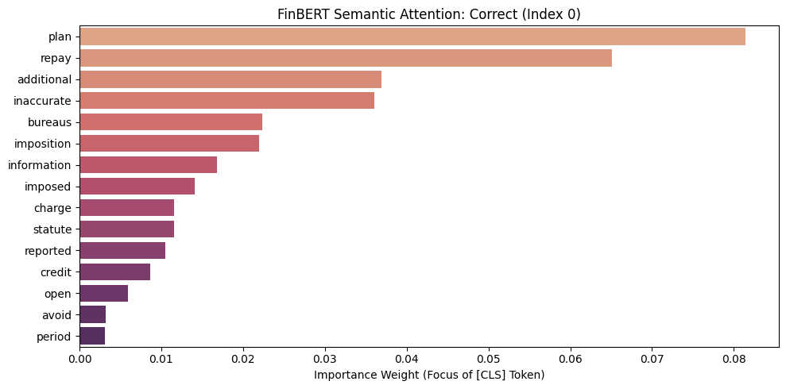
Figure 5.13 Attention plot for correct example - FinBERT Binary Task
This suggests that FinBERT's financial domain pre-training enables more nuanced contextualisation of ambiguous terms i.e. a concentrated focus on high-impact financial terminology allows it to capture a specialized semantic representation, distinguishing the complaint's unique regulatory context more effectively than a general-purpose model and ensuring a correct classification.
Misclassified Example:
Figure 5.14 presents the attention visualization for a misclassified complaint at index 3 where the true label of No Relief is predicted as Monetary Relief. The top attended tokens are ‘acceptance’ (0.115), ‘demanding’ (0.032), ’credit’(0.03) and ‘afford’ (0.028). This concentration of attention suggests that the model has focussed more on the semantic weight of ‘acceptance’, potentially misinterpreting it as an indicator of a financial agreement or resolution rather than recognizing it as part of a proper term (such as the company ‘credit acceptance’). While other relevant terms like ‘arrangement’, ‘fraud’, and ‘report’ are identified, their relatively low weights are insufficient to overcome the dominant influence of the high value tokens, ultimately leading to an incorrect predictive outcome.
True: 0, Predicted: 1

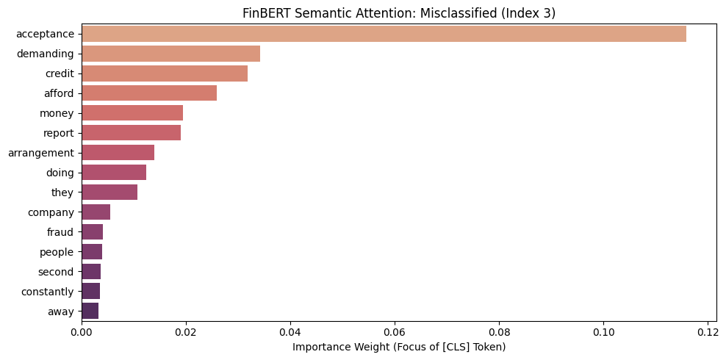
Figure 5.14 Attention plot for misclassified example - FinBERT Binary Task
5.5.4.5 Product Task — FinBERT
Attention visualization is applied to the FinBERT product classification model using the identical approach as all previous transformer analyses with one correct and one misclassified example.
Correct Example:
Figure 5.15 presents the attention visualization for a correctly classified Credit reporting complaint at index 0. It illustrates another instance where FinBERT correctly classifies a complaint by focusing on high-impact semantic terms. The visualization shows that the [CLS] token places its highest importance on the word ‘misleading’ (0.13), followed by ‘delete’ ( 0.08) and ‘fixed’ ( 0.04) followed by other terms such as ‘deptednelnet’, ‘accounts’, and ‘inaccurate’. This specific distribution of weights highlights the model's ability to identify the core intent of a credit reporting dispute, where a consumer is typically asking to have ‘misleading’ or ‘inaccurate’ information ‘fixed’ or ‘deleted’ from their ‘accounts’. By prioritizing these domain-specific action words and descriptors, FinBERT constructs a precise semantic representation that leads to a successful and interpretable classification.
True: Credit reporting, Predicted: Credit reporting
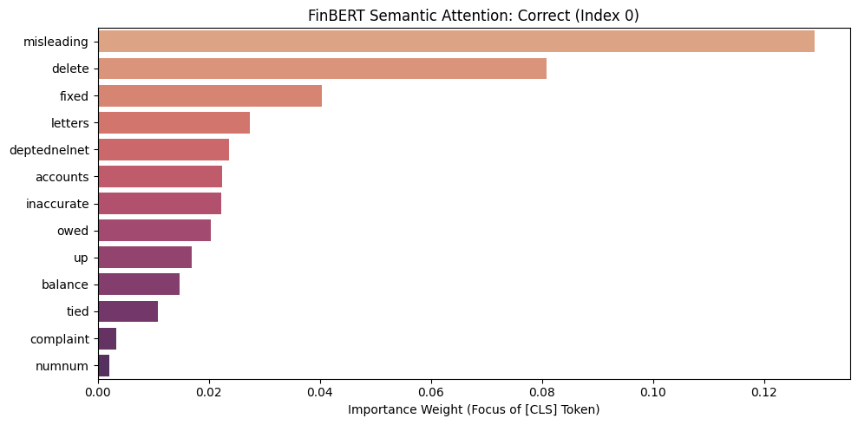
Figure 5.15 Attention plot for correct example - FinBERT Product Task
This also reflects FinBERT's financial domain pre-training as it recognises and prioritises financial reporting specifics over the conversational and relational language that BERT focuses on. Both models correctly identify Credit reporting but through different contextual focus, demonstrating that transformer models can arrive at correct predictions through different internal reasoning pathways; a finding that would not be visible without cross-model attention comparison.
Misclassified Example:
Figure 5.16 presents the attention visualization for a misclassified complaint at index 0 where true label Credit reporting is predicted as Credit card. It shows that the [CLS] token has assigned its highest importance weight to the word ‘payment’ (0.15), followed by ‘accounts’ (0.08) and ‘report’ (0.06). While other relevant terms like ‘remarks’, and ‘credit’ are present in the top fifteen features, the dominant weight assigned to ‘payment’ suggests the model may have put focus on payment-related issues, potentially confusing a credit reporting dispute with categories like ‘Debt collection’ or ‘Credit card’ where payment status is a primary feature. This failure highlights how a single high-weight token can misguide the model and lead to an incorrect classification despite the presence of other contextually appropriate terms.
True: Credit reporting, Predicted: Credit card
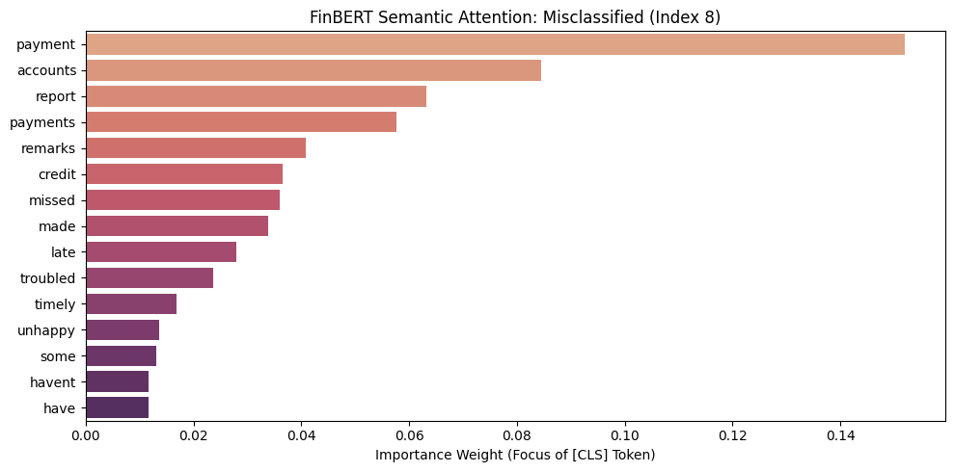
Figure 5.16 Attention plot for misclassified example - FinBERT Product Task
This misclassification reveals an important limitation of attention visualization as an explanation method. Despite the CLS token attending most strongly to Credit reporting vocabulary, FinBERT predictsCredit card demonstrating a disconnect between what the model attends to and what it ultimately predicts. The wordings in the complaint text overlap between both product categories of Credit reporting and Credit card thus confusing the model by giving mixed signals. This confirms the known limitation of attention-based explanations: high attention weight does not guarantee causal influence on the final classification decision i.e. just because a word gets high attention weight doesn’t mean that word actually caused the prediction.
Comparing the two transformer models suggests that FinBERT's financial pre-training creates stronger internal representations of credit related terminologies that influences the final classification decision independently of the surface-level attention pattern. Overall, both models fail sometimes for different internal reasons, but still give a better semantic representation than classical models.

5.5.5 SHAP Analysis — Hybrid Multimodal MLP
5.5.5.1 Methodology
SHAP DeepExplainer is applied to both Hybrid MLP models for both binary and product classification to attribute prediction contributions across the two feature streams: 768-dimensional fine-tuned BERT text embeddings and structured metadata features. DeepExplainer is selected over KernelExplainer as it is designed for neural networks, computing Shapley values by propagating gradients through the network structure.
Given that individual BERT embedding dimensions are not inherently interpretable, the analysis is performed at two levels: 1. Aggregate contribution of the full embedding vector, and 2. Individual contribution of structured features. This grouped interpretation enables meaningful insight into how the model balances semantic information from text with explicit administrative signals.
To ensure computational feasibility, SHAP values are computed on a subset of 50 test samples using 100 background training samples. While this is sufficient to reveal consistent interpretability patterns, the results should be interpreted as indicative rather than fully representative of global model behaviour.
5.5.5.2 Binary Task
Figure 5.17 presents the mean absolute SHAP contribution of each feature group across 50 binary test complaints. The data clearly indicates that BERT embeddings (768 dimensions) are the primary driver of the model's predictions, yielding a significantly higher mean absolute SHAP value (approximately 0.0045) compared to the Structured features (102 dimensions), which contribute a much lower value (under 0.001). This disparity suggests that the high-dimensional textual representations captured by BERT hold substantially more predictive power or influence within this specific hybrid architecture than the traditional structured data inputs. This means that administrative metadata such as product category, and issue type, provides lower discriminative signals for predicting monetary relief outcomes than textual complaint content.
Overall, Fine-tuned BERT embeddings capture the nuances in complaints more effectively, whereas structured features describe complaint context rather than monetary outcome, resulting in weaker predictive influence.
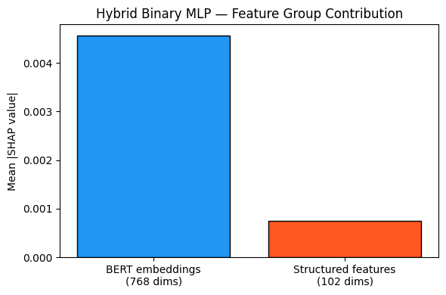
Figure 5.17— Group Contribution Bar Chart (Binary task)
Figure 5.18, on the other hand, presents the signed mean SHAP values for the top 20 structured features in the binary task with red bars indicating features pushing toward Monetary Relief and blue bars indicating features pushing toward No Relief.

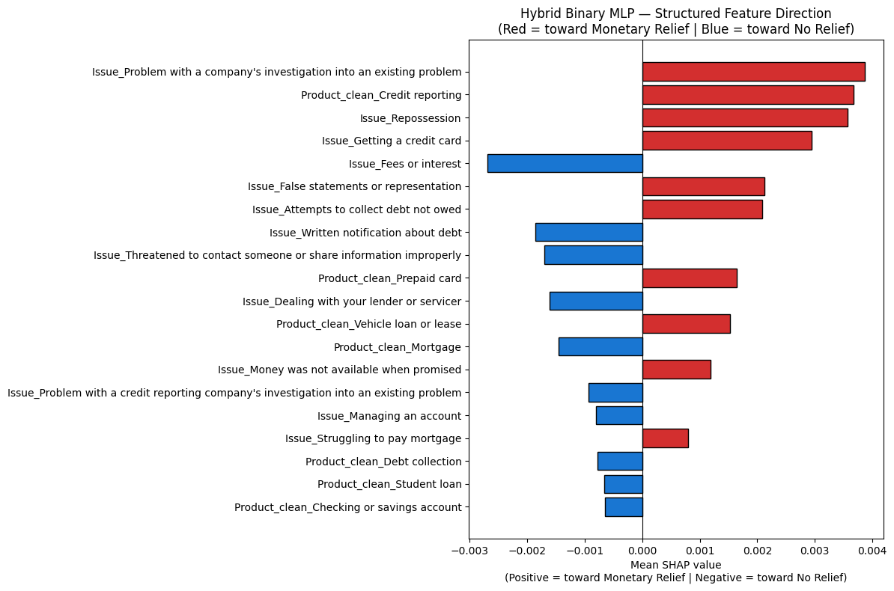
Figure 5.18 — Structured Feature Direction Plot (Binary task)
The strongest positive predictors are Issue_Problem with a company’s investigation into an existing system (0.0036) and Product_clean_Credit reporting (0.035), pushing toward Monetary Relief followed by other predictors including Issue_Money was not available when promised. This finding is counterintuitive, in the classical model SHAP analyses, Credit reporting language consistently pushed toward No Relief through text features. The hybrid model, however, pushes in the opposite direction, suggesting that when Credit reporting is identified through administrative metadata rather than text, it co-occurs with specific investigation and false statement issue types, associated with monetary outcomes in the training data.
The strongest negative predictors, pushing toward No Relief, are Issues related to Fees or interest (-0.0026), and Written notification about debt (-0.002). This pattern is consistent with classical model SHAP findings where No Relief complaints involved similar terms, confirming these as stable signals in the CFPB dataset.
Thus the hybrid SHAP binary analysis reveals a finding unique to multimodal modelling; structured metadata and text embeddings do not always agree on the direction of prediction. Credit reporting signals push toward No Relief through text but toward Monetary Relief through structured features. This cross-stream signal conflict may partially explain the hybrid binary model's lower performance relative to transformer models. The Multilayer Perceptron (MLP) must reconcile conflicting signals from two feature streams rather than learning from a unified representation.
5.5.5.3 Product Task
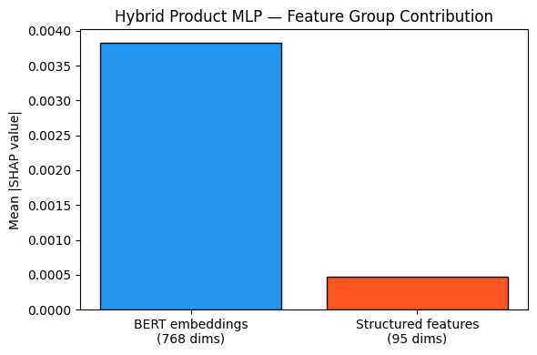
Figure 5.19— Group Contribution Bar Chart (Product task)
Figure 5.19 presents the mean absolute SHAP contribution of each feature group across 50 complaints for the product classification task. Similar to the binary setting, BERT embeddings dominate with a mean absolute SHAP value of 0.0037 as compared to structured features (0.0005). This reflects that fine-tuned BERT embeddings capture the semantic cues more effectively, and structured features result in weaker predictive influence i.e. overall the textual representations dominate product category identification.

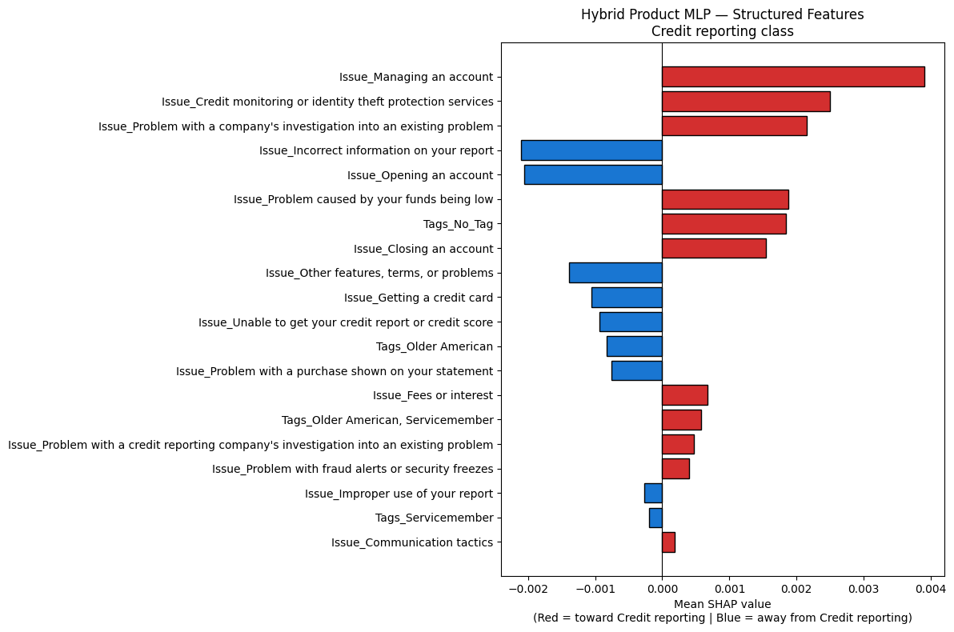
Figure 5.20 — Structured Feature Direction Plot (Product task)
Figure 5.20 presents the structured feature SHAP values specific to the Credit reporting product class, the most dominant category comprising 72% of the test set. Red bars indicate features pushing toward Credit reporting classification and blue bars indicate features pushing away.
The strongest positive predictor is Issue_Managing an account (0.004), suggesting that account-related issues frequently co-occur with Credit reporting complaints. Issue_Credit monitoring or identity theft protection services (0.0025) also pushes toward Credit reporting, which is consistent with its semantic meaning and issue terminology.
However, several findings are counterintuitive: Incorrect information on your report, from the issue category exhibits a negative contribution despite being conceptually central to Credit reporting. This indicates that this feature appears across multiple product categories, reducing its discriminative power for this class.
The small absolute SHAP values throughout the product task analysis confirm the group contribution finding i.e. the structured features provide minimal directional influence for product classification compared to BERT text embeddings. This has an important implication for future hybrid modelling on product classification tasks; structured feature selection should focus on features more directly predictive of product category.
Future work should prioritise more directly informative attributes, such as company identifiers or sub-issue categories.
5.5.5.4 Overall Hybrid Interpretation
Importantly, the overall magnitude of SHAP values in hybrid tasks is extremely small, confirming that structured features provide minimal directional influence relative to BERT embeddings. This suggests that future hybrid approaches for monetary relief as well as product classification should prioritise more directly informative structured variables while excluding near-constant or weakly informative features to avoid spurious importance attribution.
5.5.6 Summary of Explainability Findings
Across all models and explanation techniques, several consistent patterns emerge. Transaction-related language such as ‘card’, ‘refund’, and ‘charged’ consistently predicts Monetary Relief. Transformer models provide improved contextual understanding of ambiguous complaints but still struggle with overlapping categories such as Credit reporting and Debt collection. Credit reporting terminology is sometimes associated with relief outcomes in the binary task but strongly defines the Credit reporting class in the product task.
Hybrid modelling results further indicate that feature importance is task-independent in this case, with textual embeddings dominating both binary and product classification.

5.6 Conclusion

Based on the comprehensive results and the explainability analysis for both classification tasks, the following conclusion for the results chapter can be formulated: The evaluation of classification performance across binary and multi-class tasks reveals a distinct paradox between classical machine learning and deep learning architectures. For the binary monetary relief task, the Hybrid MLP has achieved the highest overall Macro F1-score (0.6561) and the strongest Minority F1 (0.3441) , establishing it as the most statistically robust and operationally practical model for predicting rare financial outcomes. However, in the multiclass product task, LinearSVC has emerged as the leader with a Macro F1 of 0.6595. This suggests that while linear classifiers provide the most disciplined categorical separation in high-dimensional multiclass spaces , hybrid architectures are uniquely capable of navigating the extreme imbalance of binary outcomes by integrating structured metadata as a semantic support for transformer-based embeddings.
Despite these variations in Macro F1, the transformer-based models have consistently demonstrated superior Balanced Accuracy. This, combined with high ROC-AUC scores exceeding 0.95 across nearly all architectures, indicates that modern models possess a high theoretical capacity to rank complaints correctly.
Apart from evaluation results, explainability findings from SHAP and LIME further validate these results, confirming that the models learn stable, semantically meaningful signals such as transaction-related language predicting relief, and credit bureau terminology predicting administrative outcomes.
Ultimately, while task-specific performance ceilings exist due to narratives being authored before company resolutions, a hybrid approach combining domain-specific embeddings with structured features provides the most reliable methodology for identifying minority outcomes in complex financial datasets.

Chapter 6: Conclusion and Future Work
The study has implemented and evaluated an explainable hybrid modeling framework for analysing financial complaints data from the Consumer Financial Protection Bureau (CFPB). The study focuses on three objectives: 1. To predict restitution outcomes by combining textual embeddings with structured complaint attributes in a hybrid modeling framework. 2. To classify CFPB complaints into product categories using classical (Logistic Regression, Linear Support Vector Classifier (Linear SVC), XGBoost), transformer (BERT and FinBERT) and hybrid approaches 3. To interpret model predictions through explainable AI techniques such as SHAP, LIME, and attention visualization to ensure transparency in high-stakes regulatory contexts.
The findings of this study indicate that consumer complaint narratives provide significant predictive value beyond structured metadata alone. For the binary task of predicting monetary relief prediction, the results highlight a performance contradiction. Although the classical models like Logistic Regression and XGBoost achieve the highest recall for minority class (monetary relief), they suffer from high positive false rates thus restricting their operational efficiency. On the other hand, hybrid models (combining structured features and transformer embeddings) outperform all other models in this task, achieving the highest values of macro F1 (0.6561) and minority F1 (0.3441). Thus by integrating structured variables in CFPB data ( product and issue) with contextual BERT embeddings, the hybrid model is able to provide a more stable predictive and unified framework than either modalities alone. This validates our initial assumption that multimodal/hybrid models can outperform other models monetary relief outcomes. Moreover, multimodal fusion can prove to be useful for navigating the extreme class imbalance.
For the 11-category multiclass product classification task, the results indicate the challenge of defining strict decision boundaries across semantically overlapping financial categories. Among the classical models, Linear SVC achieves the highest macro F1 score (0.6595), highlighting high dimensional linear boundaries are more effective in overcoming majority class dominance as compared to transformer based approaches. However, BERT and FinBERT do achieve better performance in terms of Balanced Accuracy (approx. 0.77) and ranking quality with ROC AUC scores going beyond 0.95. This shows that while linear models are better for categorical assignment, transformers are more effective at identifying a broader spectrum of categories. In this regard, FinBERT utilizes its domain specific learning to improve Minority Precision as compared to base BERT with a score of 0.0705.
Overall, hybrid modelling is identified as the most robust approach across all classification tasks and architectures. Although models like Linear SVC and FinBERT may lead in specific metrics for product classification, the hybrid approach offers the most balanced combination of contextual understanding and structural logic. By using transformer embeddings as rich feature representations and structured attributes as stabilizing inputs, the hybrid models effectively reduces semantic overlapping between related product categories.For the purpose of institutional deployment, this hybrid approach is the most suitable option, though future work should explore class consolidating strategies to cater for the limitations introduced by class imbalance in the data.
Besides model evaluation, another key object of this research is explainability. This study uses XAI techniques like SHAP, LIME and attention visualization to get both global and local understanding of modelling decisions. These approaches show that model predictions are not only influenced by textual nuances of financial grievance, disputes or reporting issues, but also by structured attributes that shape outcome probabilities. The explainability results further show that hybrid models tend to generate more stable and semantically meaningful decision patterns than either modalities alone. This is particularly important in regulatory environments where transparency and accountability are vital.
The research also contributes methodologically by presenting a complete pipeline for large-scale financial complaint analytics. The study combines exploratory data analysis, topic modelling, classical NLP pipelines, transformer-based approaches, multimodal fusion, and explainable AI within a single unified framework. In doing so, it addresses several gaps identified in existing literature, particularly the limited use of hybrid models and the lack of explainability in CFPB complaint analysis.

Future Work
Future research can extend this work by exploring more advanced multimodal architectures for financial complaint analytics. Although the hybrid framework has successfully combined transformer embeddings with structured metadata in this study, future systems can combine additional modalities such as temporal complaint behaviour, company-level financial information, macroeconomic indicators or external market sentiment signals. Recent literature highlights that multimodal AI systems improve performance by capturing broader behavioural and structural relationships across financial datasets. Future work may therefore investigate architectures such as ensemble hybrid systems, or hierarchical complaint classification frameworks that are capable of modelling complex interactions between complaint narratives, structured variables, and external contextual information.
Another important direction involves improving adaptability and deployment realism. This study has relied on static historical CFPB data; however, complaint patterns and financial behaviours evolve continuously over time. Future research could therefore investigate real-time or continual learning frameworks capable of adapting dynamically to emerging complaint trends, new financial products or regulatory changes. Additionally, advanced imbalance-handling techniques such as cost-sensitive learning, focal loss functions, synthetic minority generation, or hierarchical classification can further improve minority-class discrimination and improve predictive accuracy. Further, incorporating causal AI and counterfactual explainability methods may also strengthen regulatory transparency by allowing analysts to simulate how changes in specific complaint characteristics influence model outcomes.
Finally, future studies should continue expanding explainability and governance mechanisms for high-stakes financial AI systems. While SHAP, LIME, and attention visualizations provide valuable interpretability in this work, future work may explore deeper integration of global and local explainability techniques alongside fairness, auditing, bias detection, and regulatory systems. Given the increasing regulatory expectations surrounding transparent and accountable AI in finance, explainable hybrid architectures that balance predictive performance with transparency remain a critical area for future investigation.

References

- Filip, A. (2013) ‘Complaint management: A customer satisfaction learning process’, Procedia - Social and Behavioral Sciences, 93, pp. 271–275.
- Helmy, Y., Ashraf, M. and Abdelhamid, L. (2023) The role of effective complaint handling for business sustainability: a review paper, JGBC, 18(Suppl 1), pp. 54–65. doi: 10.1007/s42943-023-00088-w.
- Birim, S., Anitsal, M.M. and Anitsal, İ. (2016) A model of business performance in the US airline industry: how customer complaints predict performance? Business Studies Journal, 8(2).
- Xu, J., Zhao, J., Zhao, N., Xue, C., Fan, L., Qi, Z. and Wei, Q. (2018) The research and construction of complaint orders classification corpus in mobile customer service, in Lecture Notes in Computer Science (Lecture Notes in Artificial Intelligence), vol. 11109, pp. 351–361. Springer. doi: 10.1007/978-3-319-99501-4_31.
- Epp, R., Lin, D. and Bezemer, C.-P. (2021) ‘An empirical study of trends of popular virtual reality games and their complaints’, IEEE Transactions on Games, 13(3), pp. 275–286. Available at: https://doi.org/10.1109/TG.2021.3057288 (Accessed: 8 May 2026).
- Cotugno, M. and Stefanelli, V. (2023) ‘Management customer complaints and performance: banks, be careful!’, Journal of Management & Governance, 27(1), pp. 371–412. Available at: https://doi.org/10.1007/s10997-021-09616-3 (Accessed: 8 May 2026)
- Estelami, H. and Liu, K. (2023) Content analysis of American consumers’ credit card fraud complaints filed with the Consumer Financial Protection Bureau, Journal of Financial Crime, 31(3), pp. 618–628.
- Couto, M.L., Menezes, P.H.C., Reinhold, O., Marcacini, R., Jacob, A.F.L. and Lobato, F.M.F. (2024) ‘Complaint analysis in fintech domain: A case study in Brazilian brokerage firms’, in 2024 IEEE/WIC International Conference on Web Intelligence and Intelligent Agent Technology (WI-IAT). Bangkok, Thailand: IEEE, pp. 485–490. Available at: https://doi.org/10.1109/WI-IAT62293.2024.00078 (Accessed: 8 May 2026).
- Consumer Financial Protection Bureau (2025) Consumer Complaint Database. Consumer Financial Protection Bureau. Available at: https://www.consumerfinance.gov/data-research/consumer-complaints/ (Accessed: 19 November 2025).
- Vaishnav, D., Neethinayagam, M., Khaire, A. and Woo, J. (2024) Predictive analysis of CFPB consumer complaints using machine learning. arXiv. doi: 10.48550/arXiv.2407.06399.
- Onunkwo, C. (Year) A classification-based approach for modelling disputed responses based on consumer complaint on financial products. MSc Research Project, School of Computing, National College of Ireland.
- Choi, C. (2018) Predicting customer complaints in the mobile telecom industry using machine learning algorithms. M.S. Thesis. Purdue University.
- Alarifi, G., Rahman, M. & Hossain, M.S., 2023. Prediction and Analysis of Customer Complaints Using Machine Learning Techniques. International Journal of e-Business Research, 19, pp.1–25. https://doi.org/10.4018/IJEBR.319716.
- Krishna, G.J., et al. (2019) ‘Sentiment classification of Indian banks’ customer complaints’, in TENCON 2019 - 2019 IEEE Region 10 Conference (TENCON). Kochi, India: IEEE, pp. 429–434. Available at: https://doi.org/10.1109/TENCON.2019.8929703 (Accessed: 8 May 2026).
- Blümel, J. and Zaki, M. (2022) Comparative analysis of classical and deep learning-based natural language processing for prioritizing customer complaints. doi: 10.24251/HICSS.2022.236.
- Jondhale, R., Patil, S., Shinde, A., Ajalkar, D. and Biradar, S. (2024) ‘Predicting consumer complaint disputes in finance using machine learning (AIOPS)’, in 2024 Second International Conference on Advances in Information Technology (ICAIT). Chikkamagaluru, Karnataka, India: IEEE, pp. 1–7. Available at: https://doi.org/10.1109/ICAIT61638.2024.10690778 (Accessed: 8 May 2026)
- Li, X., Shu, Q., Kong, C., Wang, J., Li, G., Fang, X., Lou, X. and Yu, G. (2025) ‘An intelligent system for classifying patient complaints using machine learning and natural language processing: Development and validation study’, Journal of Medical Internet Research, 27, e55721. Available at: https://doi.org/10.2196/55721 (Accessed: 8 May 2026).
- Senthurvelautham, S. and Hettiarachchi, S. (2018) SentScore: autonomous text sentiment scoring and summarizing system related to complaint management, 2018 4th International Conference for Convergence in Technology (I2CT), Mangalore, India, pp. 1–8. doi: 10.1109/I2CT42659.2018.9058199.
- Bautista, Y.J.P., Aló, R. and Wang, N. (2020) ‘Deep learning, cloud computing for credit/debit industry analysis of consumer behavior’, in 2020 7th IEEE International Conference on Cyber Security and Cloud Computing (CSCloud) / 2020 6th IEEE International Conference on Edge Computing and Scalable Cloud (EdgeCom). New York, NY, USA: IEEE, pp. 1–7. doi: 10.1109/CSCloud-EdgeCom49738.2020.00010.
- Adike, A.K. and Priscila, S.S. (2024) ‘Data-driven insights into automotive customer complaints: A machine learning approach to predictive analytics’, in 2024 International Conference on Innovative Computing, Intelligent Communication and Smart Electrical Systems (ICSES). Chennai, India: IEEE, pp. 1–7. doi: 10.1109/ICSES63760.2024.10910793.
- Tong, X., Wu, B., Wang, S. and Lv, J. (2018) ‘A complaint text classification model based on character-level convolutional network’, in 2018 IEEE 9th International Conference on Software Engineering and Service Science (ICSESS). Beijing, China: IEEE, pp. 507–511. doi:10.1109/ICSESS.2018.8663873.
- Singh, A., Saha, S., Hasanuzzaman, M. et al. (2022) ‘Multitask learning for complaint identification and sentiment analysis’, Cognitive Computation, 14, pp. 212–227. doi:10.1007/s12559-021-09844-7.
- Singh, A., Nazir, A. and Saha, S. (2022) ‘Adversarial multi-task model for emotion, sentiment, and sarcasm aided complaint detection’, in Hagen, M. et al. (eds.) Advances in Information Retrieval. ECIR 2022. Lecture Notes in Computer Science, vol. 13185. Cham: Springer. doi:10.1007/978-3-030-99736-6_29.
- Er, A., Özçelik, Ş.T. & Yöndem, M.T. (2023) Leveraging transformer-based language models for enhanced service insight in tourism. In: 2023 4th International Informatics and Software Engineering Conference (IISEC), Ankara, Turkiye, 2023, pp. 1–6. DOI: 10.1109/IISEC59749.2023.10391041.
- Munot, D., Wakharde, D., Vispute, S., Kamble, V., Potdar, C. and Rajeswari, K. (2022) ‘An automated system for rural people complaint handling, monitoring and analysis using data analytics’, in 2022 6th International Conference on Computing, Communication, Control and Automation (ICCUBEA). Pune, India: IEEE, pp. 1–7. doi:10.1109/ICCUBEA54992.2022.10010933.
- Correa, N. and Correa, A. (2022) ‘Neural text classification for digital transformation in the financial regulatory domain’, in 2022 IEEE ANDESCON. Barranquilla, Colombia: IEEE, pp. 1–6. doi:10.1109/ANDESCON56260.2022.9989638.
- Das, S., Singh, A., Saha, S. & Maurya, A. (2024) Negative review or complaint? Exploring interpretability in financial complaints. IEEE Transactions on Computational Social Systems, pp. 1–10. DOI: 10.1109/TCSS.2023.3338357.
- Güllü, M., Atagün, E., Biroğul, S. & Barışçı, N. (2025) Customer complaint classification with large language models. In: 2025 International Conference on Artificial Intelligence, Computer, Data Sciences and Applications (ACDSA), Antalya, Turkiye, 2025, pp. 1–6. DOI: 10.1109/ACDSA65407.2025.11166338.
- Mahendran, M.B., Gokul, A.K., Lakshmi, P. and Pavithra, S., 2025. Comparative Advances in Financial Sentiment Analysis: A Review of BERT, FinBERT, and Large Language Models. Proceedings of the Third International Conference on Intelligent Data Communication Technologies and Internet of Things (IDCIoT-2025), IEEE, pp.39-44. doi:10.1109/IDCIOT64235.2025.10914764.5.
- Bonnier, T., 2024. Revisiting Multimodal Transformers for Tabular Data with Text Fields. In: Findings of the Association for Computational Linguistics: ACL 2024, Bangkok, Thailand, pp.1481–1500. Association for Computational Linguistics.
- Kiefer, C., Reimann, P. and Mitschang, B. (2019) ‘A hybrid information extraction approach exploiting structured data within a text mining process’, in BTW 2019. Bonn: Gesellschaft für Informatik, pp. 149–168. doi:10.18420/btw2019-10.
- Majka, M., 2024. The Impact of Machine Learning on Financial Modeling.
- Rajkumar, S.C., Yuvasini, D., Selvarajan, S. et al. (2026) ‘A zero-shot LLM framework for multimodal grievance classification, urgency scoring, and abuse detection in civic feedback systems’, Scientific Reports, 16, p. 2299. doi:10.1038/s41598-025-32079-7.
- Khan, R., Sathe, S., Rambhad, R. and Shinde, U. (2025) ‘Civic Dock: A smart, multilingual, voice-text-image enabled platform for effective civic complaint routing and tracking’, in 2025 International Conference on Future Technologies (ICFT). Sangli, India: IEEE, pp. 1–8. doi:10.1109/ICFT66708.2025.11336300.
- Lundberg, S. & Lee, S.-I., 2017. A unified approach to interpreting model predictions. arXiv. doi:10.48550/arXiv.1705.07874.
- Ribeiro, M.T., Singh, S. & Guestrin, C., 2016. “Why should I trust you?”: Explaining the predictions of any classifier. arXiv. Available at: https://doi.org/10.48550/arXiv.1602.04938.
- Li, X., Zhang, S., Li, X. et al. (2025) ‘SHAP-driven insights into multimodal data: behavior phase prediction for industrial safety applications’, Scientific Reports, 15, p. 34965. doi:10.1038/s41598-025-18889-9.
- Siering, M. (2022) ‘Explainability and fairness of RegTech for regulatory enforcement: Automated monitoring of consumer complaints’, Decision Support Systems, 158, p. 113782. doi:10.1016/j.dss.2022.113782.
- Zhao, H., Hu, J., Yang, M. and Lai, Y. (2026) ‘Leveraging LLMs and explainable AI to decode citizen complaints for neighborhood respiratory health prediction’, Health & Place, 97, p. 103606. doi:10.1016/j.healthplace.2025.103606.
- Ayres, I., Lingwall, J. and Steinway, S. (2014) ‘Skeletons in the database: An early analysis of the CFPB’s consumer complaints’, Fordham Journal of Corporate & Financial Law, 19(2), pp. 343–376. Available at: Fordham Journal of Corporate & Financial Law (Accessed: 10 May 2026).
- Kuilboer, J.-P. and Stull, T. (2021) ‘Text analytics and big data in the financial domain’, in 2021 16th Iberian Conference on Information Systems and Technologies (CISTI). Chaves, Portugal: IEEE, pp. 1–4. doi:10.23919/CISTI52073.2021.9476434.
- Burton, J. & Al Moubayed, N., 2023. SHAP Explanations for Multimodal Text-Tabular Models. doi:10.21203/rs.3.rs-3405528/v1.
- Pedregosa, F., Varoquaux, G., Gramfort, A., Michel, V., Thirion, B., Grisel, O., Blondel, M., Prettenhofer, P., Weiss, R., Dubourg, V. and VanderPlas, J. (2011) ‘Scikit-learn: Machine learning in Python’, Journal of Machine Learning Research, 12, pp. 2825–2830.
- Chen, T. and Guestrin, C. (2016) XGBoost: A Scalable Tree Boosting System. In: Proceedings of the 22nd ACM SIGKDD International Conference on Knowledge Discovery and Data Mining (KDD ’16), San Francisco, CA, USA, 13–17 August 2016. New York, NY: Association for Computing Machinery, pp. 785–794. https://doi.org/10.1145/2939672.2939785.
- Vaswani, A., Shazeer, N., Parmar, N., Uszkoreit, J., Jones, L., Gomez, A.N., Kaiser, Ł. and Polosukhin, I. (2017) ‘Attention is all you need’, Proceedings of the 31st International Conference on Neural Information Processing Systems (NeurIPS 2017), Curran Associates Inc., Red Hook, NY, USA, pp. 6000–6010.
- Devlin, J., Chang, M.W., Lee, K. and Toutanova, K., 2019, June. Bert: Pre-training of deep bidirectional transformers for language understanding. In Proceedings of the 2019 conference of the North American chapter of the association for computational linguistics: human language technologies, volume 1 (long and short papers) (pp. 4171-4186).
- Lin, Y.-C., Chen, S.-A., Liu, J.-J. and Lin, C.-J. (2023) ‘Linear classifier: An often-forgotten baseline for text classification’, Proceedings of the 61st Annual Meeting of the Association for Computational Linguistics (Volume 2: Short Papers), pp. 1876–1888, Toronto, Canada: Association for Computational Linguistics.
- Sangaraju, V.R., Bolla, B.K., Nayak, D.K. and Jyothsna, K.H. (2022) Topic modelling on Consumer Financial Protection Bureau data: an approach using BERT-based embeddings, 2022 IEEE 7th International Conference for Convergence in Technology (I2CT), Mumbai, India, pp. 1–6. doi: 10.1109/I2CT54291.2022.9824873.

