Please download the Eclipse IDE version

Eclipse Java EE IDE for Web Developers.

Version: Helios Release

1. Create a project - student
2. Import file system

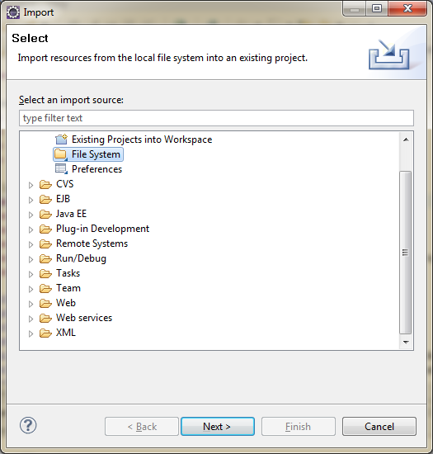

1. Double click File system

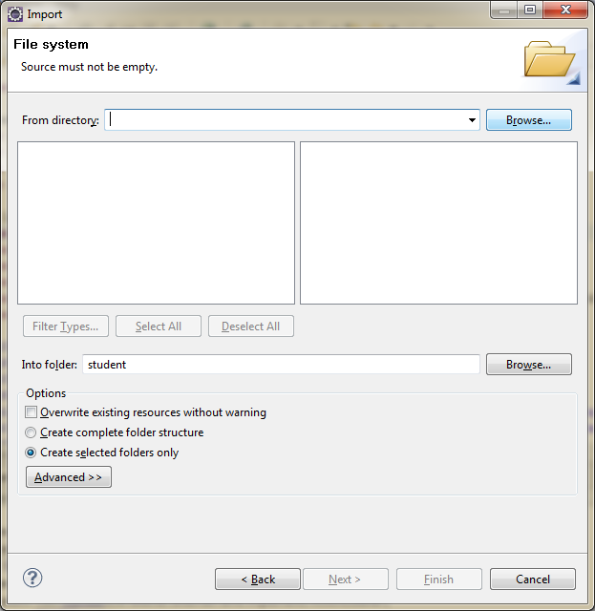

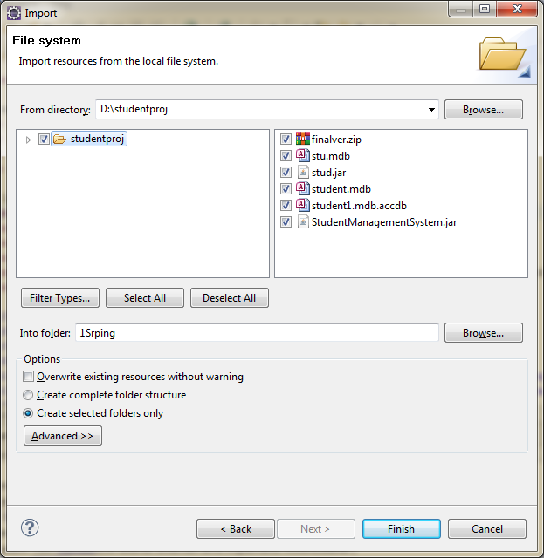

1. Click **Finish**
2. JRE version in build path

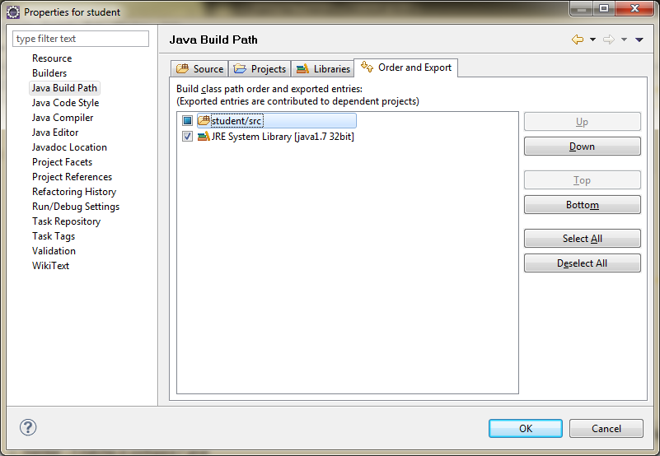

Place this student.mdb Access DB file in the below location

D:\studentproj\**student.mdb**

**student.mdb file already in project**

* Project has 2 menus – Student details and view
* “Student Details” – Has 4 sub menu items

1. New Registration – To add new student personal details (all values are mandatory)
2. Edit Registration – To edit existing student details.

Enter valid roll no and click “View” button

All details appear in screen. Required field can be edited and “Update”

1. Delete Registration - To edit existing student details.

Enter valid roll no and click “View” button

Proceed to “Delete”

1. Edit Marks – Marks can be added for 3 exams (MID TERM , TERM 1 AND ANNUAL)

5 subjects per exam are available

* “View” – To view Mark list of a student with roll no as input

To view Student full list