Overview
Welcome to the RTLshow REST API! using this service, you can get current show and it’s cast. The API stors the data in SQL dababase. Using Postman tool to add or to get the data form the rtlshowDb database. The API is developed with VS 2019 using 3.1 framework.

Authentication
Currently there is no authentication required for accessing the RTLshow REST API.

Rate Limiting
Currently requests are limited to roughly 1 per second. you can keep track of your usage by

The code of the API Controler includs 2 method:
Get and Post.
The Get method presents a list of shows and it’s cast in json format.
The Post method add the shows and it’s cast in Json format.

Post

Responses/Get
some notes on responses from this API:
- All responses default to JSON format, and only some endpoints will support other format.
- If you want to easily visualize a json response in a browser.
- All successful requests will have 2 response code

Example Resource URL
https://tvMaz/api/RTLshow

The Post method with in PostMan tool
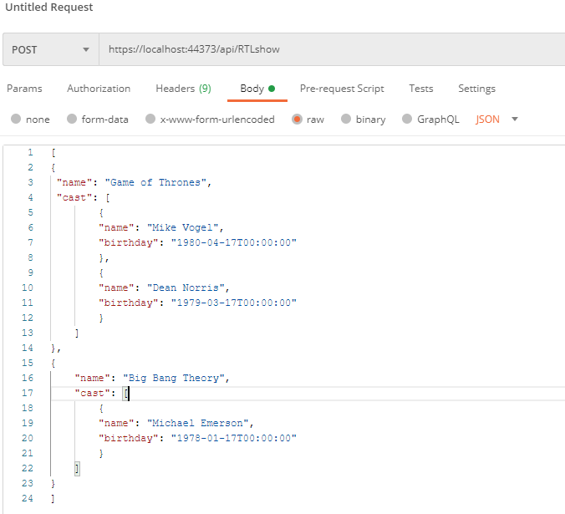
The Response method with in PostMan tool

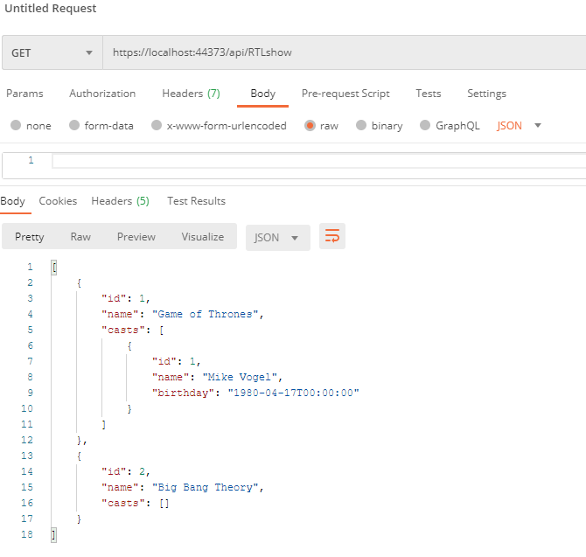

Database migration:
pm>add-migration init
pm>update-database -verbos

