Vignette Title

Vignette Author

2020-06-26

## Tidal Prioritization

### Intention

This document is meant to outline and document the workflow of the data and methods used in the prioritization metrics of the tidal crossings assessed under TNC’s methods. These methods are applied to all the crossings uniformly. Metrics specific to an individual crossing, will be based on the output from this code combined with other information useful to partners.

### Starting Data source

Data are currently sourced from 2 locations. The primary geographic data are found in a hosted feature layer on AGOL. These point geographies contain general spatial information on each crossing (town, cross roads etc.) along with the desktop assessment portion of the prioritization. Data were migrated to this platform from the original field datasheets for increased data QA and processing effeciencies. With that transfer desktop data found in the field data sheets are to be considered incomplete.  
Field data are currently maintained in excel spreadsheets hosted in the team’s shared Box folder. These data include all field assessement data for those sites that were visited. This data will likely be transitioned to a more robust managed database structure. These data were collected primarily under the TNC-NH/NHDES Coastal Program protocol [^Resilient Tidal Crossings]. Deviations from these methods are documented here and will be described in more detail in other project documents. Data extracted from Tidal Crossings Field workbooks using a suite of functions found in */functions* directory. To save memory and time a seperate script runs the extraction process and saves an output file (.rds) to the */data* folder within this working directory. These data can then be called in as needed here. Alternatively, running rmdSetup.R will source all functions and run updates on data if *‘dataUpdate = TRUE’*, currently the default, found near top of code chunk.

## Ecological Benefit

### E1. Salt marsh complex size

Scoring assigned by manually classifying crossings based on proximity to marsh complexes. Crossings in or adjacent to large complexes (>~15 acres in size) scored 5, crossings in or adjacent to smaller complexes were scored a 3, and crossings disconnected from any marsh complex were scored a 1. Manual classification was used due to inconsistent spatial relationships between the crossing locations and the marsh complexes. Often crossings are found on the edges or outside of the boundary of the marsh complex but are in important waterways connecting these complexes.

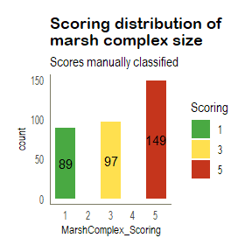

### E2. Salt marsh size upstream (whole catchment not just eval unit)

*TODO:*  
- Confirm scoring for the size of marsh in the catchment.

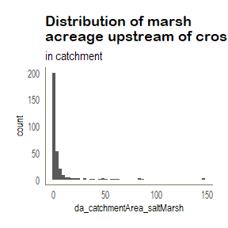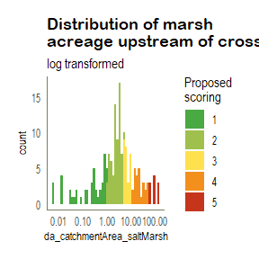

To produce scoring that is distributed across the range of values, I created breaks by using log-transformed salt marsh area, which normalized the distribution, then roughly took equal intervals across the log-transformed x axis adjusting the break values to be whole numbers. Similar approaches were taken for other metrics with skewed distributions.

Which yielded the following:

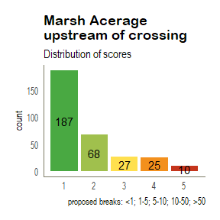

### E3. Degree of Tidal Restriction and AOP

Consists of 3 *sub-metrics* that when averaged yield the score for degree of tidal restriction. These sub-metrics described below are:  
- E3a: Tidal Range Ratio  
- E3b: Crossing Ratio  
- E3c: Erosion Classification

#### E3a. Tidal Range Ratio

Ratio of the upstream tidal range to downstream tidal range. Tidal range is estimated from the difference in elevation from the high water indicator stain and low tide elevation at the time of the assessment. A ratio of 0.5 would indicate that the downstream tidal range is twice as large as the upstream tidal range. A 1:1 ratio would mean that the tidal ranges are equal on both sides of the crossing.

Are the crossings with large (>1) ratios considered impounded?

Followed NH documnetation [^Resilient Tidal Crossings]: Table 7:

*QA NEEDS* Crossing 62 has data that needs to be checked (Low tide elevation is 5’ above road….) Currently filtering values below 0. *TO DO* Should we consider using both the HWI stain and the wrack? Some crossings have only one of the two. *DECIDED ON* likely not to included since it measures

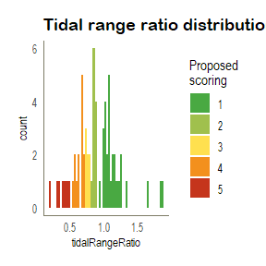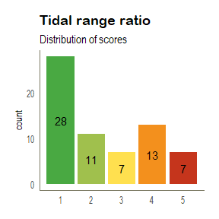

There are many sites that do not have enough data to calculate the tidal range ratios. **66** crossings have tidal range ratios calculated.

#### E3b. Crossing Ratio

Crossing ratio is calculated from the greater of 2 ratios. The ratio of crossing structure to the stream section, for both the up and downstream sides. **A wide river with a small structure opening will score high, indicating a restriction**.

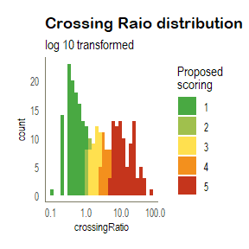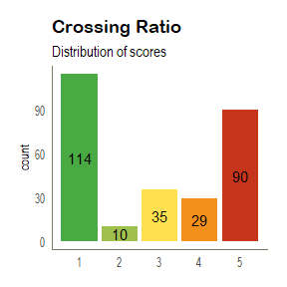

#### E3c. Erosion Classification

The ratio of scour pool width to channel width for both up and down stream sections. A large ratio indicates a larger scour pool. The final Erosion Classification score is based on the *LARGER* of the 2 ratios (up and downstream)

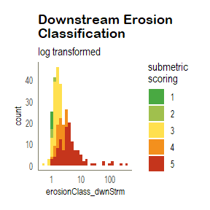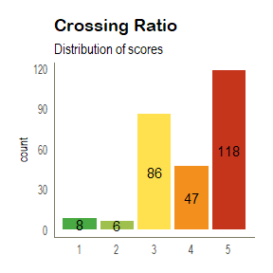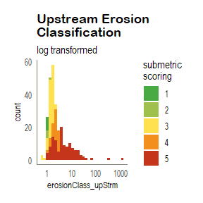

#### Degree of Tidal Restriction Scoring

Average of 3 submetrics (E3a, E3b, E3c)

Combining the scores of the tidal range ratio, Crossing ratio, erosion classification to yield Degree of Tidal Restriction score. Resulting averages are then rounded to the nearest whole integer value for the final score. *TO DO* Check in with team that this is preferred method.

This set of plots are a bit of an eye-twister, but is the distribution of each of the ‘submetrics’ that are then color coded by their final score. i.e. There’s 10 crossings that scored a 1 for the tidal range ratio, but a 3 for the final DOTR overall score. There aren’t any strong correlations across these submetrics (see correlation matrix below).

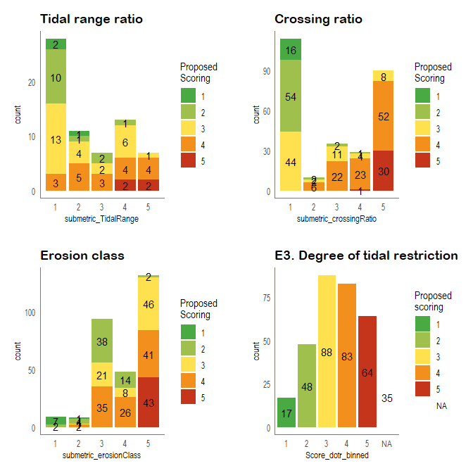

### E4. Vegetation Score

Field assessed classification of vegetation at the crossing. Based on NH methods. Scored by presence/absence of invasives and species composition upstream and downstream of crossing. This assumes that the crossing structure impacts the hydrology to varying degrees, which results in species composition differences on either side of the crossing. Additionally, the presence of invasive species are considered.

Currently we don’t have an ‘official’ scoring method for the vegetation score. NH follows the scoring below, which is based on a 0-5 range. Vegetation scoring matrix

Their approach is to essentially drop any crossings that have invasives, by scoring them a 0 and adding them to a sort of ‘restoration’ list. This seems to make sense as they have another restoration project prioritization tool that they seem to be referring to in the documentation. For us though, probably not relevant. My propsed scoring is below and represented in the plot that follows. *We’ll need to resolve this before final scoring.*

vegMatChoice == “1A” = 1, # native only, same both sides  
vegMatChoice == “2A” = 1, # invasives through out, same both sides  
vegMatChoice == “2B” = 2, # invasives through out, up and down stream communtites are slightly different vegMatChoice == “1B” = 3, # native only, different species on either side but appear similar (high marsh - low marsh)  
vegMatChoice == “3A” = 3, # invasives on one side, tidal marsh on both sides  
vegMatChoice == “2C” = 4, # invasives through out, up and down stream communities represent different marsh types vegMatChoice == “3B” = 4, # invasives on one side, similar species/marsh type on either side  
vegMatChoice == “3C” = 5 # invasices on one side, up and down stream different species  
vegMatChoice == “1C” = 5, # native only, tidal species one side, fresh species the other.

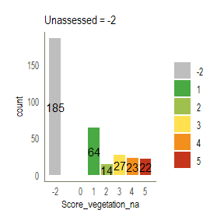

## Total Ecological Benefit Score

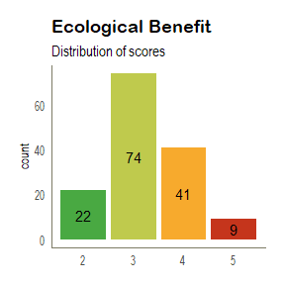

## Resilience Benefit

### R1. Risk of sea level rise inundation to the road

Risk of sea level rise inundation is

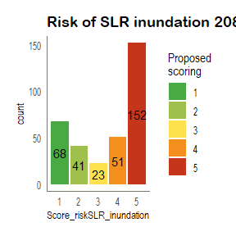

### R2. Risk of storm surge inundation to the road

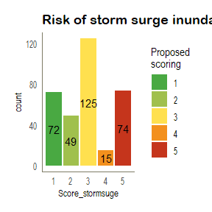

### R3. Heavy rainfall flood risk of the catchment

Following the freshwater prioritization scoring break down:

% Imper | Score|

|……..:|:…..| | >40% | 5 | | 30-40% | 4 | | 20-30% | 3 | | 10-20% | 2 | | <10% | 1 |

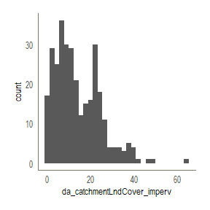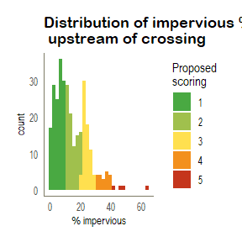

### R4. Area of potential tidal marsh advancement upstream of restriction

proposed breaks: <1; 1-7, 7-25, 25-75, >75 Same breaks as the marsh size

Distribution of marsh migration potentianl across catchments.

Untransformed distribution skewed heavily as expected

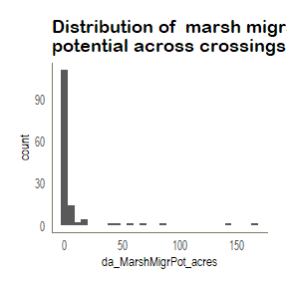

Log transformed values, ~normally distributed.

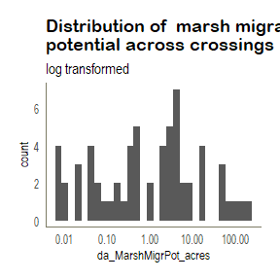

Scoring of log-transformed data

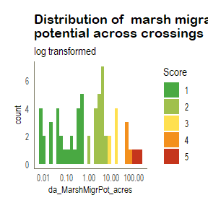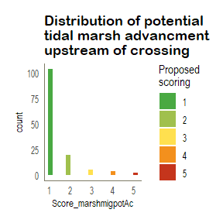

### Total Resilience Benefit Score

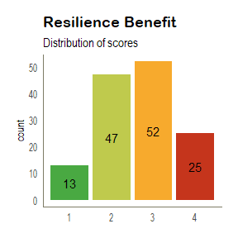

## Transportation Benefit

### T1. Road Functional Classification

NYSDOT Road functional class data were spatially joined to each crossings. Crossings not aligned with NYSDOT road data (i.e. on foot paths or small unpaved roads) were classified manually, using aerial imagery, field notes, and NYSDOT road data layers as guidance.

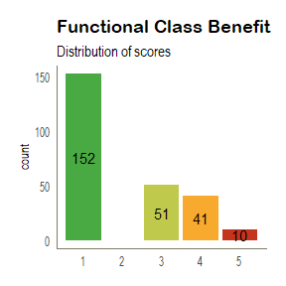

### T2. Evacuation Route

NYSDOT Road Evacuation routes were spatially joined to crossings, and reviewed for completeness and accuracy. Scores were  
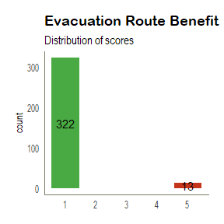

### Total Transportation Benefit Score

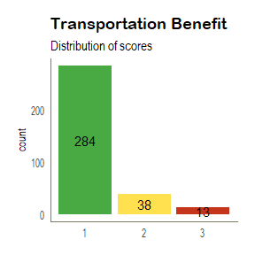

## Infrastructure Condition Benefit

### C1. Crossing Condition

*Current crossing condition* evaluates several components of the crossing structure to effectively summarize the overall condition. Structure condition, such as headwall and wingwall condition. Scour has been removed as that condition is found in *Eroision Classification*.

#### Testing condition scoring with and without scour scores.

Following the NH protocol the first version of scoring includes the severity of scour (eval_crossCondition). eval_crossCondition_v2 only includes the conditions of the 5 components of the crossings. See prioritization functions for details.

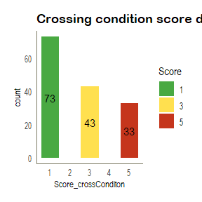

### C2. Partner priority

Partner priority provided to TNC 2018-2019.

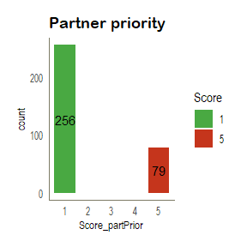

### C3. High water risk: Lack of clearance

Not all crossings have sufficient data to calculate this metrc. In those cases, crossings are scored a NA and are not included in the averaging of the Infrastructure Condition benefit scores.

TODO: make these formuals 2 unique ones for each metric. hwi-loc ratio:

$$scaleAdjust^{highwater}=minimum(hwi^{stain}| road center height)$$

$$scaleAdjust^{lack of clearance}=minimum(hwi^{stain}| ceiling of structure)$$

$$highwater clearance risk ratio=scaleAdjust+(hwi^{wrack}|hwi^{wrack})/scaleAdjust+Road Height$$

This yeilds a value that’s been adjusted to the be

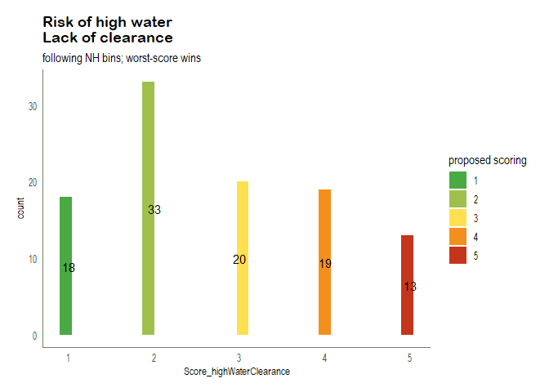

### C4. Erosion classification

The ratio of scour pool width to channel width for both up and down stream sections. A large ratio indicates a larger scour pool. Score is based on the larger of the 2 ratios.

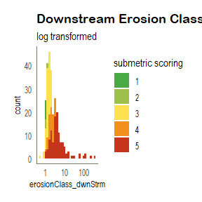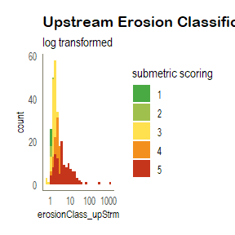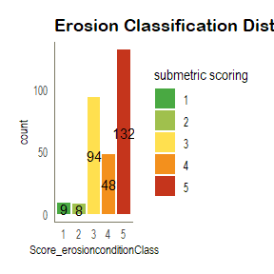

### Total Infrastructure Condition Benefit Score

*NOTE:* Does not include the High water risk/Lack of clearance metrics for *ALL* crossings.

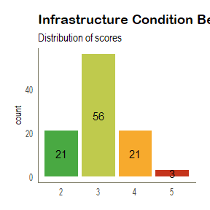

## Final Prioritization Scoring

Now that’s a distribution if I’ve ever seen one…

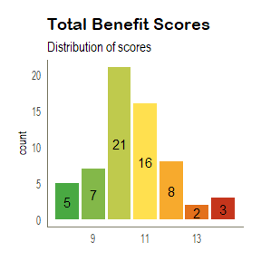

### Correlation Analysis

Exploring relationships between model parameters. prefixed values of ‘Score’ are benefit scores, ‘submetric’ are calculated components that feed into benefit scoring.

#### Ecological Benefit Scores

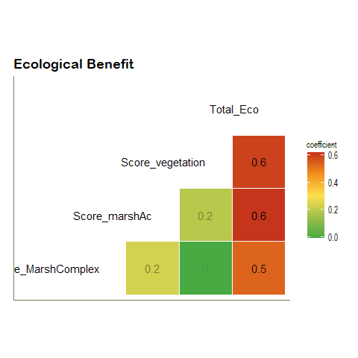 #### Resilience Benefit Scores

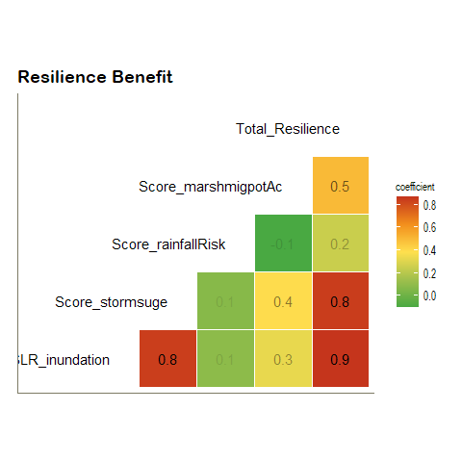 #### Transportation Benefit  
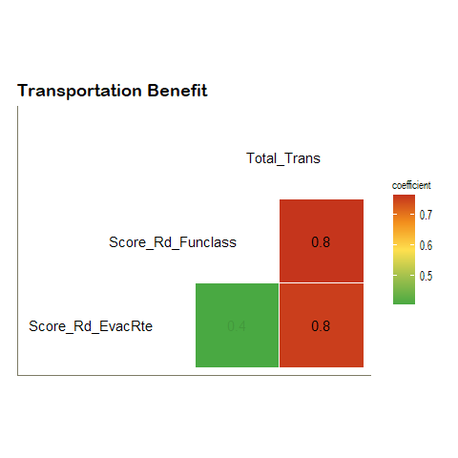

#### Infrastructure Condition Benefit

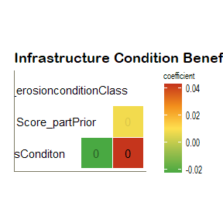

#### Across all categories

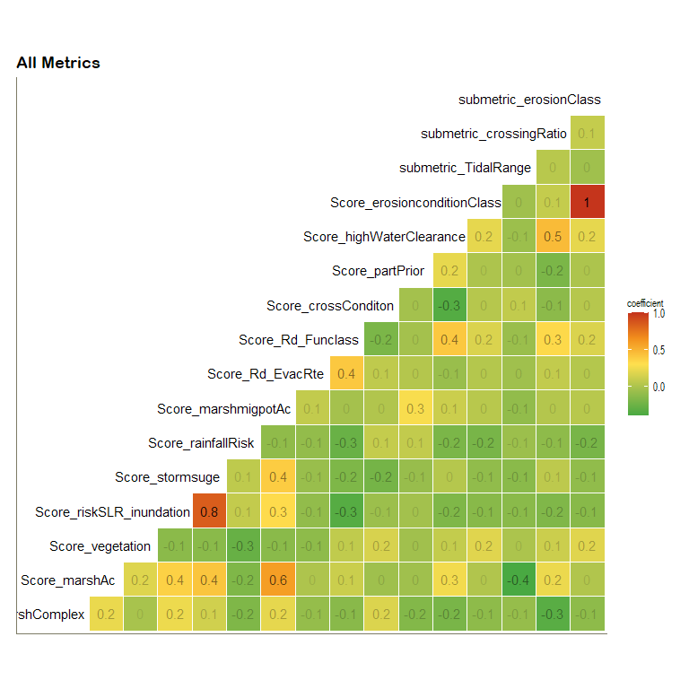

### References:

[^Resilient Tidal Crossings]: New Hampshire Department of Environmental Services. 2019. “Resilient Tidal Crossings:An Assessment and Prioritization to Address New Hampshire’s Tidal Crossing Infrastructure for Coastal Resilience”. R-WD-19-20. Portsmouth, NH. Available online at: <https://www.des.nh.gov/organization/divisions/water/wmb/coastal/resilient-tidal.htm>