README

1. Please run the script using your favorite IDE or from command-line using the command

**py aftab.py** from the correct destination, as follows

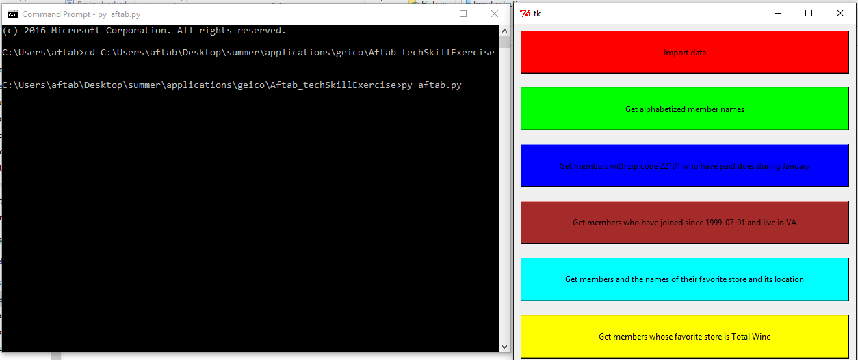

1. Please note that query d, “List the names of all members and the names of their favorite store and its location”, requires a join between Members.csv and Stores.csv. So, I have designed the application such that, if Stores.csv is not already uploaded, it will prompt you to upload the file, by clicking the Import data button.