**Introduction**

The social construction of gender is a fundamental concept in gender studies that explores how society shapes and defines gender roles, identities, and expectations. This concept delves into the nature versus nurture debate, examining the extent to which gender is influenced by biological factors versus socialization and cultural norms. Theories surrounding this concept offer various perspectives, ranging from essentialist views, which emphasize biological determinism, to constructionist views, which highlight the role of social and cultural influences.

**Nature vs. Nurture Debate**

The nature versus nurture debate is central to understanding the social construction of gender. It involves two primary perspectives:

1. **Nature (Biological Determinism):**
   * Proponents argue that gender differences are rooted in biological and physiological differences between males and females.
   * This view suggests that hormonal differences, genetic makeup, and reproductive functions significantly influence gender-specific behaviors and roles.
   * Example: Simon Baron-Cohen's work on prenatal testosterone's effect on brain development, suggesting that higher levels in males lead to more systemizing traits, while lower levels in females lead to more empathizing traits.
2. **Nurture (Social Constructionism):**
   * Advocates argue that gender is primarily a social construct, shaped by cultural, social, and environmental factors.
   * This perspective emphasizes the role of socialization processes, such as family upbringing, education, media, and peer interactions, in forming gender identities and roles.
   * Example: Margaret Mead's ethnographic studies in Samoa and New Guinea, which showed that gender roles vary significantly across different cultures, challenging the notion of universal gender roles.

**Theories of Social Construction of Gender**

Several theories contribute to the understanding of the social construction of gender:

1. **Social Learning Theory:**
   * Proposed by Albert Bandura, this theory suggests that gender roles are learned through observation, imitation, and reinforcement.
   * Children observe and mimic the behaviors of same-gender models (e.g., parents, teachers) and receive feedback that reinforces gender-appropriate behavior.
   * Case Study: A study by Lytton and Romney (1991) found that parents reinforce gender-typical behaviors in their children through toys, activities, and chores, thus shaping their gender identities.
2. **Cognitive Development Theory:**
   * Developed by Lawrence Kohlberg, this theory posits that children actively construct their gender identities as they mature cognitively.
   * According to this view, children go through stages of gender identity development, starting with gender labeling, followed by gender stability, and finally achieving gender constancy.
   * Case Study: Research by Slaby and Frey (1975) demonstrated that children who understood gender constancy were more likely to engage in gender-typed activities, supporting Kohlberg's theory.
3. **Gender Schema Theory:**
   * Introduced by Sandra Bem, this theory combines elements of social learning and cognitive development theories.
   * It suggests that children develop gender schemas—cognitive structures that organize information about gender—and use these schemas to guide their behavior and perception of the world.
   * Example: Bem's research showed that children with strong gender schemas are more likely to remember gender-consistent information and distort or forget gender-inconsistent information.
4. **Performative Theory:**
   * Developed by Judith Butler, this theory argues that gender is not something one is, but something one does—an ongoing performance influenced by social norms and expectations.
   * Butler contends that gender identities are enacted through repeated behaviors and performances, challenging the binary understanding of gender.
   * Quote: "Gender is not something that one is, it is something one does, an act, a 'doing' rather than a 'being.'" – Judith Butler

**Case Studies and Facts**

1. **The Case of David Reimer:**
   * David Reimer was born biologically male but was raised as a female after a botched circumcision. Despite being socialized as a girl, Reimer struggled with his gender identity, ultimately transitioning back to male in adolescence.
   * This case highlights the complex interplay between biological factors and socialization in gender identity formation.
2. **The Influence of Media:**
   * Studies have shown that media plays a significant role in reinforcing gender stereotypes. For instance, a study by Smith et al. (2013) found that female characters in children's TV shows are often portrayed in nurturing roles, while male characters are depicted as adventurous and assertive.

**Graphs and Charts**

**Graph 1: Gender-Typed Toy Preferences in Children**

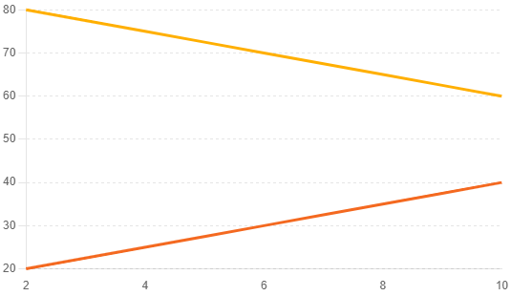

This graph shows the percentage of boys and girls who prefer gender-typed toys (e.g., trucks for boys, dolls for girls) at different ages. It illustrates how socialization influences toy preferences over time.

**Graph 2: Gender Representation in Media**

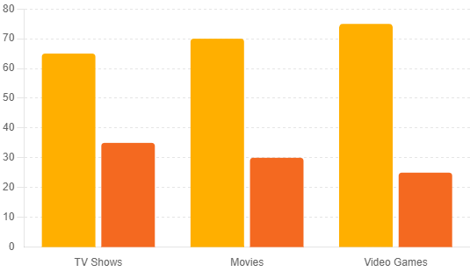

This chart displays the representation of male and female characters in various media forms (TV shows, movies, video games), highlighting the prevalence of gender stereotypes.

**Conclusion**

The social construction of gender is a multifaceted concept shaped by both biological and social factors. While the nature versus nurture debate continues, it is evident that socialization plays a crucial role in forming gender identities and roles. Theories such as social learning, cognitive development, gender schema, and performative theory provide valuable insights into how gender is constructed and enacted in society. Understanding this concept is essential for challenging and deconstructing harmful gender stereotypes, promoting gender equality, and fostering a more inclusive society.