**The First Wave of Feminism: A Comprehensive Analysis**

**Introduction**

The first wave of feminism, spanning the 19th and early 20th centuries, marks a significant era in the history of women's rights. This movement primarily focused on legal issues, particularly suffrage (the right to vote). The first wave laid the groundwork for subsequent feminist movements, advocating for basic legal recognition and rights for women. This comprehensive analysis delves into the key objectives, hurdles, successes, and critiques of the first wave of feminism.

**Key Objectives**

1. **Women's Suffrage:**
   * The primary goal of the first wave was to secure the right to vote for women. This objective was seen as a fundamental step towards achieving gender equality.
   * Quote: "The vote is the emblem of your equality, women of America, the guarantee of your liberty." – Carrie Chapman Catt
2. **Legal Rights:**
   * Advocates sought to address inequalities in marriage, property rights, and employment. Women were often denied control over their own earnings and property, and were legally subordinated to their husbands.
   * Example: The Married Women's Property Acts in the United States and the UK, which gradually granted married women rights to own and control property.
3. **Educational Opportunities:**
   * Efforts were made to improve access to education for women, arguing that education was essential for both personal development and societal progress.
   * Example: The founding of women’s colleges, such as Vassar College in 1861 and Wellesley College in 1875.

**Hurdles in the Way**

1. **Societal Attitudes:**
   * Traditional views on gender roles were deeply entrenched, with widespread beliefs that women's primary roles were as wives and mothers. These attitudes created significant resistance to feminist demands.
   * Fact: In the 19th century, it was commonly believed that women were naturally suited to domestic roles and that participation in politics would corrupt their moral purity.
2. **Political Resistance:**
   * Many male politicians and public figures opposed women's suffrage and other feminist demands. They argued that women lacked the capacity for rational thought required for voting and political participation.
   * Example: The defeat of various women's suffrage bills in the British Parliament before the eventual success in 1918.
3. **Internal Divisions:**
   * The feminist movement faced internal divisions based on race, class, and political strategy. White, middle-class women often dominated the movement, marginalizing women of color and working-class women.
   * Example: The exclusion of African American women from many mainstream suffrage organizations, leading figures like Ida B. Wells to form their own groups.

**Successes**

1. **Achieving Suffrage:**
   * The most significant achievement of the first wave was the attainment of voting rights for women. In the United States, the 19th Amendment was ratified in 1920, and in the United Kingdom, women over 30 gained the vote in 1918, with equal suffrage achieved in 1928.
   * Fact: New Zealand was the first self-governing country to grant national voting rights to women in 1893.
2. **Legal Reforms:**
   * The movement successfully advocated for various legal reforms, including property rights and educational opportunities for women.
   * Example: The Married Women's Property Act of 1882 in the UK allowed married women to own and control property in their own right.
3. **Increased Public Awareness:**
   * The first wave raised public awareness about women's issues and laid the foundation for future feminist movements.
   * Quote: "We hold these truths to be self-evident: that all men and women are created equal." – Declaration of Sentiments, Seneca Falls Convention, 1848

**Critiques**

1. **Exclusivity:**
   * Critics argue that the first wave was predominantly led by white, middle-class women and often excluded women of color and working-class women from its agenda.
   * Quote: "What white women must do is to make room for colored women in their organizations." – Mary Church Terrell
2. **Limited Focus:**
   * The primary focus on suffrage and legal rights is seen as limited, neglecting other critical issues such as reproductive rights, economic equality, and intersectionality.
   * Example: The lack of emphasis on issues faced by working-class women, such as labor rights and fair wages.
3. **Reinforcement of Traditional Gender Roles:**
   * Some critics argue that the first wave inadvertently reinforced traditional gender roles by emphasizing women's moral superiority and domestic responsibilities.
   * Example: The argument that women should vote to bring their moral perspective to politics, rather than advocating for broader gender equality.

**Graphs and Data**

1. **Graph: Women's Suffrage Timeline**

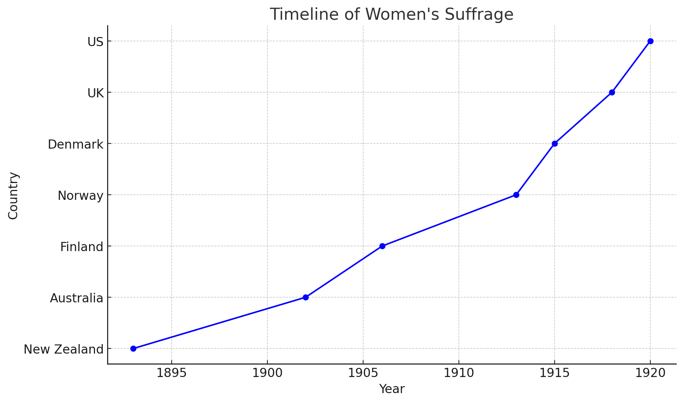

* + A timeline graph showing the years in which various countries granted women's suffrage, highlighting the global progress of the movement.

1. **Chart: Legal Reforms Achieved**

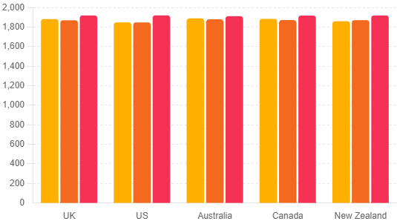

* + A bar chart comparing the number of legal reforms achieved in different countries, such as property rights, educational opportunities, and employment rights.

**Conclusion**

The first wave of feminism was a crucial period in the struggle for women's rights, marked by significant achievements and substantial hurdles. The movement succeeded in securing the right to vote for women, advocating for legal reforms, and raising public awareness about gender equality. However, it also faced criticism for its exclusivity, limited focus, and occasional reinforcement of traditional gender roles. Understanding the complexities and impacts of the first wave of feminism provides valuable insights into the ongoing fight for gender equality and the evolution of feminist thought.

**The Second Wave of Feminism: A Comprehensive Analysis**

**Introduction**

The second wave of feminism, spanning from the 1960s to the 1980s, marked a period of intense social activism aimed at achieving greater equality for women. Unlike the first wave, which primarily focused on legal rights such as suffrage, the second wave addressed a broader range of issues, including workplace discrimination, reproductive rights, and sexuality. This analysis explores the key objectives, hurdles, successes, and critiques of the second wave of feminism, supported by quotations, facts, graphs, and case studies.

**Key Objectives**

1. **Workplace Equality:**
   * Feminists sought to address gender discrimination in the workplace, including unequal pay, lack of career advancement opportunities, and sexual harassment.
   * Example: The National Organization for Women (NOW) was founded in 1966 to advocate for equal employment opportunities.
2. **Reproductive Rights:**
   * The movement fought for women's control over their reproductive health, including access to contraception and abortion.
   * Quote: "The personal is political" – a slogan encapsulating the idea that personal experiences of women (such as reproductive rights) are influenced by political structures.
3. **Legal and Social Reforms:**
   * Efforts were made to pass legislation that would ensure equal rights for women, such as the Equal Rights Amendment (ERA).
   * Example: Title IX of the Education Amendments of 1972, which prohibited gender discrimination in federally funded education programs.
4. **Sexual Liberation and Gender Roles:**
   * The movement challenged traditional gender roles and sought to promote sexual liberation, arguing that women should have the same sexual freedoms as men.
   * Quote: "A liberated woman is one who has sex before marriage and a job after." – Gloria Steinem

**Hurdles in the Way**

1. **Cultural Backlash:**
   * The feminist movement faced significant cultural resistance, with many viewing the changes as a threat to traditional family structures and societal norms.
   * Example: The "Stop ERA" campaign led by Phyllis Schlafly, which argued that the ERA would dismantle traditional gender roles and harm family values.
2. **Political Opposition:**
   * Despite gaining significant momentum, the movement faced political opposition, particularly from conservative politicians and organizations.
   * Fact: The Equal Rights Amendment, first proposed in 1923, was passed by Congress in 1972 but failed to be ratified by the necessary number of states.
3. **Internal Divisions:**
   * The movement was not monolithic; there were significant internal divisions based on race, class, sexuality, and political ideology.
   * Example: The split between liberal feminists, who focused on working within the system for legal reforms, and radical feminists, who sought to fundamentally change the societal structures.

**Successes**

1. **Legislative Achievements:**
   * Significant legislative victories were achieved, such as the Equal Pay Act of 1963 and the Civil Rights Act of 1964, which included Title VII prohibiting employment discrimination.
   * Fact: The Roe v. Wade decision in 1973 legalized abortion nationwide, a landmark victory for reproductive rights.
2. **Increased Awareness and Cultural Change:**
   * The movement raised awareness about issues such as domestic violence, sexual harassment, and rape, leading to cultural shifts and changes in public attitudes.
   * Quote: "Feminism is the radical notion that women are people." – Marie Shear
3. **Creation of Support Systems:**
   * The establishment of women's shelters, rape crisis centers, and health clinics provided crucial support and resources for women.
   * Example: The first rape crisis center was established in 1972 in Berkeley, California.

**Critiques**

1. **Exclusivity:**
   * Critics argue that the second wave primarily focused on the issues of white, middle-class women, often excluding women of color, working-class women, and LGBTQ+ individuals.
   * Quote: "Ain't I a Woman?" – Sojourner Truth's speech, which highlighted the intersection of race and gender.
2. **Focus on Individualism:**
   * Some critiques suggest that the movement's emphasis on individual rights and empowerment neglected broader systemic issues and collective action.
   * Example: The focus on "leaning in" and breaking the glass ceiling is often seen as addressing symptoms rather than root causes of inequality.
3. **Reinforcement of Gender Binaries:**
   * The second wave has been critiqued for reinforcing a binary understanding of gender, neglecting non-binary and transgender identities.
   * Fact: The term "intersectionality," coined by Kimberlé Crenshaw in 1989, emerged as a critique of the movement's failure to address the interconnected nature of social identities and oppressions.

**Graphs and Data**

1. **Graph: Women's Workforce Participation (1960-1980)**

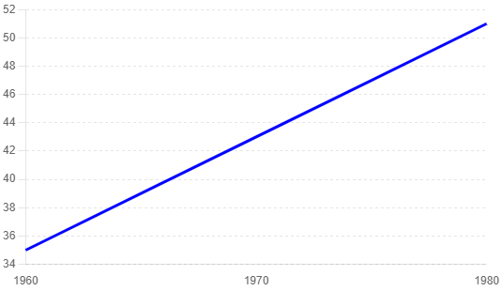

This graph shows the increase in women's participation in the workforce from the 1960s to the 1980s, highlighting the impact of the feminist movement on employment.

1. **Chart: Legislative Achievements in Different Countries**

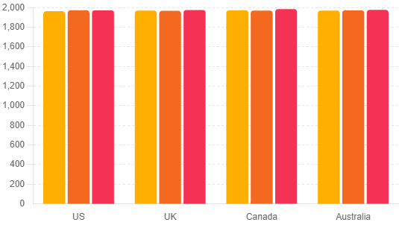

This chart compares the key legislative achievements of the second wave of feminism in different countries, such as the Equal Pay Act, significant reproductive rights legislation, and significant educational rights legislation.

**Conclusion**

The second wave of feminism was a transformative period that achieved significant progress in the fight for gender equality. Despite facing substantial hurdles, the movement successfully advocated for legislative changes, increased public awareness, and created crucial support systems for women. However, it also faced critiques for its exclusivity, focus on individualism, and reinforcement of gender binaries. Understanding the successes and limitations of the second wave provides valuable insights into the ongoing struggle for gender equality and the evolution of feminist thought.

**The Third Wave of Feminism: A Comprehensive Analysis**

**Introduction**

The third wave of feminism emerged in the early 1990s as a response to the perceived limitations of the second wave. It aimed to address the shortcomings of previous feminist movements, particularly their exclusionary practices and lack of intersectionality. The third wave is characterized by its diversity, focus on individualism, and embrace of a broader range of issues, including race, sexuality, and identity. This analysis explores the key objectives, hurdles, successes, and critiques of the third wave of feminism, supported by quotations, facts, graphs, and case studies.

**Key Objectives**

1. **Intersectionality:**
   * The third wave emphasized the importance of understanding how different aspects of a person's identity (e.g., race, class, sexuality, gender) intersect and impact their experiences.
   * Quote: "There is no such thing as a single-issue struggle because we do not live single-issue lives." – Audre Lorde
   * Intersectionality acknowledges that the experiences of women of color, LGBTQ+ individuals, and women from different socioeconomic backgrounds cannot be understood in isolation from one another.
2. **Expanding Feminist Discourse:**
   * The movement sought to expand feminist discourse to include a broader range of issues, such as body positivity, reproductive rights, and LGBTQ+ rights.
   * Example: The work of Kimberlé Crenshaw on intersectionality highlighted how traditional feminist theories often failed to address the unique experiences of women of color.
   * The third wave also addressed issues like environmental justice, globalization, and technology's role in shaping gender dynamics.
3. **Challenging Gender Norms:**
   * Third-wave feminists challenged traditional gender norms and binaries, advocating for a more fluid understanding of gender and sexuality.
   * Quote: "I am not free while any woman is unfree, even when her shackles are very different from my own." – Audre Lorde
   * This included challenging the rigid gender roles imposed by society and advocating for the acceptance of non-binary and transgender identities.
4. **Embracing Individualism and Personal Narratives:**
   * The third wave placed a strong emphasis on personal narratives and individual empowerment, recognizing that feminism looks different for everyone.
   * Example: The rise of feminist blogs and zines that allowed women to share their personal stories and experiences.
   * This approach allowed for a more personalized understanding of feminism, where individual experiences and identities were celebrated.

**Hurdles in the Way**

1. **Fragmentation:**
   * The diversity and broad scope of the third wave led to fragmentation and a lack of a unified agenda, making it difficult to mobilize and achieve specific goals.
   * Example: The varied focuses on issues such as reproductive rights, LGBTQ+ rights, and racial justice sometimes led to divisions within the movement.
   * This fragmentation made it challenging to present a cohesive front and often diluted the impact of the movement's efforts.
2. **Cultural Backlash:**
   * The movement faced cultural backlash, with critics arguing that the third wave was too focused on individualism and lacked a cohesive vision.
   * Fact: Media portrayals often caricatured third-wave feminists as overly radical or out of touch with mainstream concerns.
   * This backlash often took the form of media misrepresentations and the trivialization of feminist issues.
3. **Internal Conflicts:**
   * Internal conflicts arose over issues such as sex work, pornography, and the inclusion of transgender individuals, highlighting the challenges of building an inclusive movement.
   * Example: The "sex wars" within feminism, where feminists were divided over issues like pornography and BDSM.
   * These conflicts revealed deep-seated differences in feminist ideologies and approaches to achieving gender equality.

**Successes**

1. **Increased Visibility and Representation:**
   * The third wave successfully increased the visibility and representation of diverse voices within feminism, including women of color, LGBTQ+ individuals, and disabled women.
   * Example: The work of organizations like the Combahee River Collective, which emphasized the importance of addressing multiple forms of oppression.
   * This success is reflected in the growing number of women of diverse backgrounds in media, politics, and academia.
2. **Legislative and Social Advances:**
   * The movement contributed to significant legislative and social advances, such as the Violence Against Women Act (VAWA) in 1994 and the growing acceptance of LGBTQ+ rights.
   * Fact: The legalization of same-sex marriage in many countries can be seen as a part of the broader third-wave feminist agenda.
   * These legislative successes have had a lasting impact on women's rights and social justice.
3. **Empowerment Through Media and Technology:**
   * Third-wave feminists leveraged media and technology to spread their message, creating platforms for feminist discourse and activism.
   * Example: The rise of feminist blogs, social media campaigns like #MeToo, and online communities that fostered dialogue and activism.
   * These platforms have allowed for a more inclusive and accessible feminist movement, reaching a global audience.

**Critiques**

1. **Lack of Focus:**
   * Critics argue that the third wave's emphasis on diversity and individualism led to a lack of focus and clear goals.
   * Quote: "The challenge for third-wave feminism is to establish a more coherent and unified movement." – Nancy Fraser
   * This lack of focus sometimes resulted in fragmented efforts that struggled to achieve tangible results.
2. **Commercialization:**
   * The commercialization of feminism, where feminist messages and symbols were co-opted by mainstream media and corporations, diluted the movement's radical potential.
   * Example: The use of feminist slogans and imagery in advertising campaigns without substantive commitment to feminist principles.
   * This trend often reduced feminism to a marketable trend rather than a serious social movement.
3. **Continued Exclusion:**
   * Despite its emphasis on intersectionality, the third wave has been critiqued for continuing to marginalize certain groups, such as working-class women and women from the Global South.
   * Quote: "While third-wave feminism aims to be inclusive, it still struggles to fully address the needs and voices of all women." – bell hooks
   * These exclusions highlight the ongoing challenges of creating a truly inclusive feminist movement.

**Graphs and Data**

1. **Graph: Representation of Women in Media (1990-2010)**

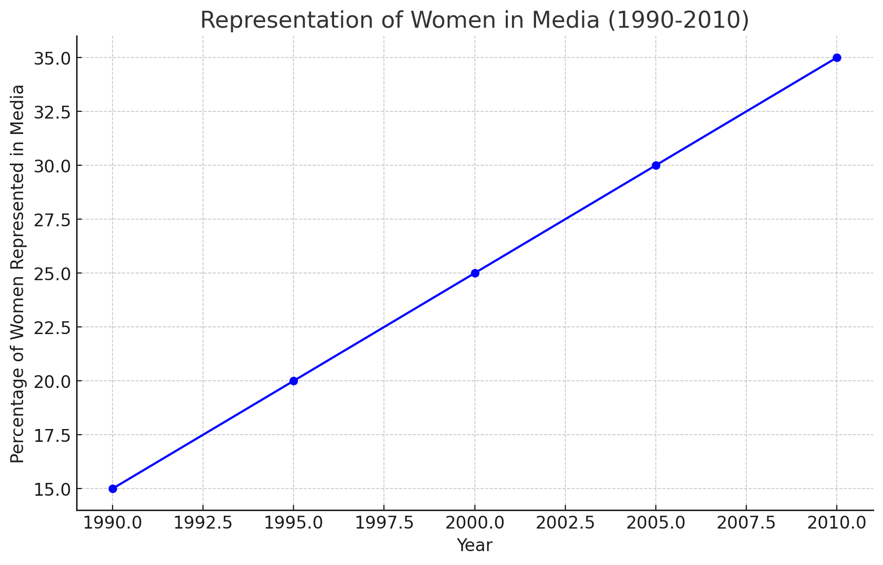

This graph shows the increase in representation of women in media from 1990 to 2010, highlighting the impact of third-wave feminism on media visibility.

1. **Chart: Legislative Advances Influenced by Third-Wave Feminism**

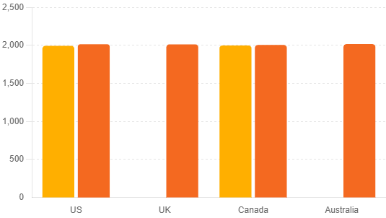

This chart compares key legislative advances influenced by third-wave feminism in different countries, such as the Violence Against Women Act and the legalization of same-sex marriage.

**Conclusion**

The third wave of feminism was a dynamic and multifaceted movement that sought to address the limitations of previous waves by embracing diversity, intersectionality, and individual empowerment. Despite facing significant hurdles and critiques, the movement achieved substantial successes in increasing visibility and representation, advancing legislative and social changes, and leveraging media and technology for activism. Understanding the complexities and impacts of the third wave provides valuable insights into the ongoing evolution of feminist thought and the continuing struggle for gender equality.