# MOTIVATION FORM FOR ROBOTICS ENGINEERING

**General Instructions (please read carefully)**

To show your motivation for the M.Sc. in Robotics Engineering, please fill out this motivation form.

There are 2 parts that you must fill out. Failing to use this mandatory form properly will lead in obtaining a low grade on the motivation criterion.

Use font size 11 or 12.

# PART I – You and your motivations

Instructions:

This part helps us understand who you are as a person and maybe as a future JEMARO student. You do not need to address anyone with an introductory phrase such as “To whom it may concern” or “Dear…”

Simply answer each question one by one like in a regular form. There is no need to use connecting words between the answers to each question. The size of these boxes should not be changed.

**1) Personal introduction (300-500 characters, spaces not included).**

**2)**

**State in short why you want to apply for the M.Sc. in Robotics Engineering at the**

**University of Genoa (300-500 characters, spaces not included).**

**3)**

**Develop your strongest qualifications, past experiences and qualities that will help**

**you to succeed (500-1000 characters, spaces not included).**

**4)**

**Develop what will be your professional project after getting your master’s degree**

**(300-500 characters, spaces not included).**

**PART II – Your background**

## Instructions:

This part comes as an additional tool to your transcripts. It is meant to help us understand your academic background and how it relates to Robotics Engineering.

Fill out the tables 1 & 2 following the indications given.

## Table 1 – Recall of your studies

|  |  |
| --- | --- |
| **Undergraduate degree title (if you also obtained a master, mention it too)** |  |
| **Mention minor/major or specialization if any** |  |

**Table 2 – Links between your curriculum and Robotics Engineering**

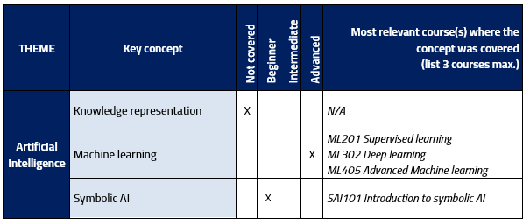Example on how to fill out the table (the matrix to fill out is on the next 2 pages, in red):

**Dipartimento di Informatica, Bioingegneria, Robotica e Ingegneria dei Sistemi**

dibris.unige.it

P. IVA 00754150100

|  |  |  |  |  |  |  |
| --- | --- | --- | --- | --- | --- | --- |
| **THEME** | **Key concept** | **Not covered** | **Beginner** | **Intermediate** | **Advanced** | **Most relevant course(s) where the concept was covered**  **(list 3 courses max.)** |
| **Artificial Intelligence** | **Knowledge representation** | ☐ | ☐ | ☐ | ☐ |  |
| **Machine learning** | ☐ | ☐ | ☐ | ☐ |  |
| **Symbolic AI** | ☐ | ☐ | ☐ | ☐ |  |
| **Computer Engineering** | **Digital and embedded systems** | ☐ | ☐ | ☐ | ☐ |  |
| **Object-oriented programming** | ☐ | ☐ | ☐ | ☐ |  |
| **Operating systems** | ☐ | ☐ | ☐ | ☐ |  |
| **Control Engineering** | **Controllers** | ☐ | ☐ | ☐ | ☐ |  |
| **Laplace transform** | ☐ | ☐ | ☐ | ☐ |  |
| **Linear systems** | ☐ | ☐ | ☐ | ☐ |  |
| **Non-linear systems** | ☐ | ☐ | ☐ | ☐ |  |
| **Stability** | ☐ | ☐ | ☐ | ☐ |  |
| **Mechanics** | **Mechanical design methods** | ☐ | ☐ | ☐ | ☐ |  |
| **Theory of mechanism and machines**  **(kinematic and dynamic modelling)** | ☐ | ☐ | ☐ | ☐ |  |

|  |  |  |  |  |  |  |
| --- | --- | --- | --- | --- | --- | --- |
| **THEME**  **Mathematics** | **Key concept** | **Not covered** | **Beginner** | **Intermediate** | **Advanced** | **Most relevant course(s) where the concept was covered**  **(list 3 courses max.)** |
| **2D/3D geometry** | ☐ | ☐ | ☐ | ☐ |  |
| **Differential calculus** | ☐ | ☐ | ☐ | ☐ |  |
| **Linear and matrix algebra** | ☐ | ☐ | ☐ | ☐ |  |
| **Logics** | ☐ | ☐ | ☐ | ☐ |  |
| **Numerical methods** | ☐ | ☐ | ☐ | ☐ |  |
| **Programming** | **C/C++** | ☐ | ☐ | ☐ | ☐ |  |
| **MATLAB** | ☐ | ☐ | ☐ | ☐ |  |
| **Python** | ☐ | ☐ | ☐ | ☐ |  |
| **Robotics** | **Industrial robotics** | ☐ | ☐ | ☐ | ☐ |  |
| **Manipulators modelling** | ☐ | ☐ | ☐ | ☐ |  |
| **Mobile robots** | ☐ | ☐ | ☐ | ☐ |  |
| **Robotic control** | ☐ | ☐ | ☐ | ☐ |  |
| **Robotic software programming** | ☐ | ☐ | ☐ | ☐ |  |